Introduction
This document provides an overview of the implementation of the Bluetooth AVDTP protocol and GAVDP profile, with some words on the A2DP profile (collectively the “Distribution Plane”). A separate document discusses the Bluetooth AVCTP protocol and AVRCP profile (collectively the “Control Plane”).
It is intended to outline requirements, features, design and some details about their implementation and usage.

Use-cases

Present use-cases

Phone acts as audio source, phone connects to headset
At least AVDTP Command, GAVDP INT and A2DP Source roles required

Phone acts as relay of audio source from web page, phone connects to headet
Transcoding likely (most web-content not in SBC format)

Phone mixes comfort-tone into audio stream
=> all audio data is to be at least decoded into PCM. Since all Sinks support SBC the subsequent encoder will be SBC: this is computationally lightweight and royalty-free.

Phone acts as music source, Bluetooth headset connects to phone
AVDTP Response and GAVDP ACP roles required (this reflected in A2DP spec)

Headset / phone exchange remote control information
For more, see Control-plane specification[**]
L2CAP Multiplexing required - already present within SymbianOS Bluetooth subsystem

Phone forwards incoming phone call to ‘universal’ headset
Requires simultaneous RFCOMM connection. Requires reliable L2CAP datalink – requires L2CAP Flow and Error Control (or suboptimally, no flushing on the Media channel).

Phone streams a second audio file after initial audio file
Inter-track streaming should be as seemless as possible.

Future-proof usecase
These use-cases are provided to ensure that the present implementation can cater for use-cases that might arise in the future.

Phone acts as Video sink
This implies that AVDTP and GAVDP shall be agnostic to A2DP/VDP Source/Sink roles.

Phone acts as source to multiple remote devices (eg. Stereo speakers)
Enable multiple stream support now (bandwidth requirement on future Bluetooth hardware)

Requirements
Analysis of the above use-cases results in the following Requirements. To reflect the split between various subsystems involved in the delivery of the “Stereo Headset” usecase the following Requirements list only those applicable to the Bluetooth subsystem (as defined by Perforce location). Other Requirements forming the main usecase are to be contributed by other SymbianOS subsystems – the overall requirements and features then become the convolution of them all.

Stream management
The SymbianOS Bluetooth subsystem shall allow AV streams over Bluetooth to multiple remote devices
The SymbianOS Bluetooth subsystem shall allow multiple AV streams over Bluetooth from a single application to a single remote device
The SymbianOS Bluetooth subsystem shall allow multiple AV streams over Bluetooth from multiple applications to a single remote device
The SymbianOS Bluetooth subsystem shall allow multiple stream creation simultaneously.

Protocol support
The SymbianOS Bluetooth subsystem shall support all Mandatory features of the AVDTP protocol specification
The SymbianOS Bluetooth subsystem shall support the the Specification-Optional AVDTP Reconfigure command in INT and ACP roles.[Item 5 in AVDTP PICS Table 4 and Table 10]
The SymbianOS Bluetooth subsystem shall support the the Specification-Optional AVDTP Suspend command in INT and ACP roles.[Item 4 in AVDTP PICS Table 5 and Table 11]
The SymbianOS Bluetooth subsystem shall support the Specification-Optional AVDTP Multiplexing service as described in the AVDTP specification [Item 4 in AVDTP PICS Table 14 and 15]
The SymbianOS Bluetooth subsystem shall support the Specification-Optional AVDTP Reporting service as described in the AVDTP specification [Item 2 in AVDTP PICS Table 14 and 15]
The SymbianOS Bluetooth subsystem shall support the Specification-Optional AVDTP Recovery service as described in the AVDTP specification. (The SymbianOS Bluetooth subsystem will not however utilise this service until The SymbianOS Bluetooth subsystem supports Recovery information encapsulation in RTP-FEC packets). [Item 3 in AVDTP PICS Table 14 and 15].
The SymbianOS Bluetooth subsystem shall support the Specification-Optional AVDTP Content Security-control service described in the AVDTP specification (Item 1 in AVDTP PICS Table 6 and 12).

Logical Channel management
The SymbianOS Bluetooth subsystem shall use L2CAP Flow and Error Control on AVDTP Signalling Channels when supported by the remote L2CAP entity.
The SymbianOS Bluetooth subsystem shall use L2CAP Flushing on AVDTP Media Channels when supported by the remote L2CAP entity.
The SymbianOS Bluetooth subsystem shall configure the L2CAP packet and baseband sizes bearing the AVDTP Media Channels to optimise performance.

API
The SymbianOS Bluetooth subsystem GAVDP API shall allow for future use of the AVDTP Recovery service with no further change to the GAVDP API.
The SymbianOS Bluetooth subsystem shall not support invocation of the AVDTP protocol other than via the published GAVDP API.

Link management
The SymbianOS Bluetooth subsystem shall not immediately terminate bearer connections upon closure of a Stream.
The SymbianOS Bluetooth subsystem shall allow for non-streaming GAVDP connections to be placed into a Bluetooth low power mode.

Supported realtime protocols
SymbianOS shall support conveying of Media packets via RTP
SymbianOS shall support conveying of Reporting packets via RTCP
The SymbianOS Bluetooth subsystem shall support RTP bearing via the RSocket interface.
The SymbianOS Bluetooth subsystem shall support RTCP bearing via the RSocket interface,

Profile support
The SymbianOS Bluetooth subsystem GAVDP interface shall support source and sink roles of higher profiles, including A2DP and VDP. No reference VDP shall be implemented within GT190.
The SymbianOS Bluetooth subsystem shall support all Mandatory features of the GAVDP profile specification
The SymbianOS Bluetooth subsystem shall support the GAVDP Specification-Optional feature of Stream Suspension.

A2DP
The GAVDP API may be used in conjunction with RTP and an SBC codec to provide an A2DP source.
A GAVDP session would be created to a remote sink, and an appropriate SEP selected using GAVDP services. Once a remote SEP is configured, the GAVDP can create the appropriate sessions and provide handles to them in the form of sockets. Once these sockets have been created the GAVDP client can hand them over to RTP.
RTP packets are then created and filled with SBC data. RTP will then deliver the packet on the Media socket at the client’s request.
As mentioned earlier, a user-plane “wrapper” API from GAVDP is not provided – this is to minimise the number of function calls made in the user-plane. Therefore to fully implement A2DP, the GAVDP and RTP APIs need to be called in conjunction with operation of a software or hardware codec.
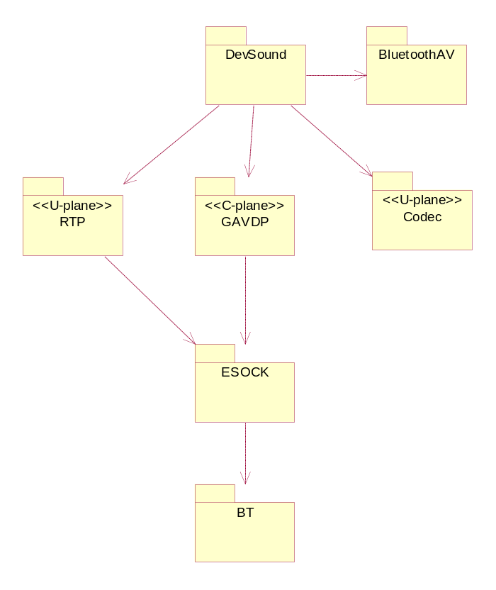

Addressing
To send AVDTP commands (or equally to call GAVDP services) to a given remote SEP, the SEP ID needs to be provided for each service. This is the SEID as mentioned in the spec, and is retrieved from an initial GAVDP DiscoverSEPs procedure. The SEID forms part of the TAvdtpSockAddr – see later.

Server-based implementation
Initially thought was given to implementing a GAVDP server – mainly to fulfil the requirement to allow multiplexing of multiple AV apps to the same remote device. Multiplexing generally requires some singleton point at which the multiplexer can reside, and this tends to imply a server in a single process.
It can be seen that a ‘singleton’ point exists behind the ESOCK server and this allows for signalling multiplexing to be performed there rather than in a dedicated server. Additionally this provides for one fewer IPC call (this is very important in the user-plane), and is a good place semantically for AVDTP to reside as ESOCK deals with protocols (although we note that AVDTP is more session-like than datalink-like, and thus requires a client DLL to assist in mapping Session primitives onto the socket interface).
The present design for GAVDP/AVDTP optimises the performance (reduction of IPC calls) and ease of use (allowing multiplexing).

GAVDP
GAVDP provides services via an API similar to that described in the GAVDP specification, and is the only supported way to access AVDTP. It is a static DLL.
Clients will typically be MMF Devsound objects that wish to render Audio via Bluetooth. The Devsound object would therefore use the GAVDP API in this case.
GAVDP is agnostic of the Source/Sink roles in A2DP, and the nature of the data flowing over it.

Design
To allow an AV app to negotiate and create streams, GAVDP must allow for the client to engage in AVDTP/GAVDP negotiations. A mixin class is provided which clients must implement. This class maps onto the AVDTP and GAVDP Indication and Confirm services.
The RSocket class used as the handle to AVDTP does not provide good protocol Indication support. To allow for unsolicited Indications GAVDP continuously queues Ioctls on its signalling socket. An internal ‘language’ is used between AVDTP and GAVDP. Once an Ioctl completes, GAVDP decodes the internal language and calls the appropriate MGavdpUser method.
GAVDP has a number of internal helper objects liasing with AVDTP in addition to the one providing the Indication service.
Provision of GAVDP in this way assists in providing long-term Interface Compatibility as flexibility remains in deciding the best way for the lower-interface of GAVDP and AVDTP to interact.
Clients of GAVDP must provide a session of the socket server (“Esock”) to GAVDP. GAVDP can then be instructed by the client to created user-plane bearer sockets for conveying Transport Session data (Media, Reporting, Recovery packets). Such sockets created by GAVDP are placed on the client’s socket server session. These sockets may spontaneously be created (and the client notified) if the remote has Opened in stream as an INT. GAVDP itself uses its own socket server session for its own internal AVDP sockets.
The GAVDP library shall not provide a user-plane API to wrap RTP. This decision is based on the need for maximising performance and that RTP has a complex API that the AV application must examine and use optimally for the nature of the streams they are supporting.

Usage
The two main user classes exported from the GAVDP library are RGavdp and MGavdpUser.
RGavdp represents a single (signalling) session to a remote device. The RGavdp class provides a method to actively create a GAVDP session to a remote device. This method takes a Bluetooth device address. This has a number of implications –the RGavdp class represents a (signalling) session to a single remote device. For GAVDP connections to another device another RGavdp object needs to be used. Secondly, the client should have established the device address to connect to – this may be via some “headset installer” app, or a registry of A2DP headsets or an SDAP operation.
The MGavdpUser class exports callbacks that must be implemented by the GAVDP client. It allows the AV client to be involved in SEP Configuration (as GAVDP and AVDTP themselves cannot determine the semantics of all the SEP capabilities).
The GAVDP Client shall register at least one SEP - this will form the endpoint of a stream that is instantiated either by the local AV application or that of the remote. The client is panicked if they attempt GAVDP operations without having registered at least one SEP. Upon registering of the SEP AVDTP allocated a SEP ID (‘SEID’) to the SEP; the client application can inspect the SEID to maintain their own record of which SEP if providing which AV ‘service’.
The GAVDP client shall expect to be in ACP role for a signalling procedure at any point in a signalling session. This means for example that upon opening an RGavdp, the client may have an inbound signalling connection made by a remote device before the RGavdp client called Connect().
If a client wishes to support listening of another incoming connection after the initial RGavdp class instance becomes connected (either passively or actively) then another RGavdp instance should be used.
A typical use of GAVDP to provide an A2DP sink is (this is to be read in conjunction with the GAVDP and A2DP profile specifications)
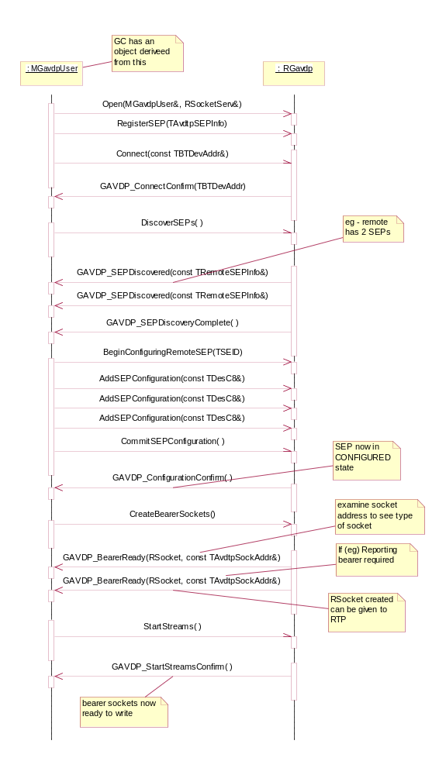

AVDTP

Overview
The AVDTP protocol provides for point-point distribution of AV data; it has a control plane and user plane. The control plane allows for the discovery of stream endpoints (SEPs) on a remote device, configuration and connection of SEPs. The user plane encapsulates codec data (in RTP packets) into L2CAP packets. Optionally the AVDTP specification allows AVDTP to multiplex data from the same or different streams into one L2CAP packet thereby optimising the usage of Bluetooth baseband packets.
The AVDTP specification describes a number of optional services: Multiplexing, Fragmentation and Robust Header Compression. The The SymbianOS Bluetooth subsystem implementation implements the Multiplexing service.
This document does not discuss further what can be found in the AVDTP specification.

Design
AVDTP is implemented in Symbian OS within the Bluetooth protocol module (bt.prt), and therefore is within an ESOCK plugin. As a result access to AVDTP is via the RSocket interface. However, this is a very raw interface for a protocol as complex as AVDTP; so as per the GAVDP specification, the “service interface” of the AVDTP Control Plane is made via GAVDP which has been implemented as a static DLL and operates AVDTP sockets on behalf of the GAVDP client.
AVDTP sockets are effectively handles to Transport Sessions as described in the AVDTP specification, additionally an AVDTP socket can be a handle to a Signalling ‘Session’ (this is not described in the specification). Since The SymbianOS Bluetooth subsystem is open we cannot determine a priori the number of streaming applications wishing to stream to the same remote device. This usecase is not discussed in the specification – however, it forms a requirement for the AVDTP implementation. The design caters for this by representing each GAVDP C-plane user via a ESOCK-side Signalling session, and multiplexing each of this objects over one Signalling Channel (that is discussed in the AVDTP spec). The multiplexing is undertaken in the AVDTP protocol implementation via use of the Transaction Label in each AVDTP signalling packet.
The AVDTP protocol exposes a complex ‘language’ of Ioctls and Get/SetOpts: these are only intended for use by GAVDP and are not for public use.
As a Stream may consist of between 1 and 3 transport sessions, a Stream in The SymbianOS Bluetooth subsystem may be accessed from between 1 and 3 AVDTP sockets: 1 at least for conveying Media packets (in A2DP these are RTP packets); supplementary sockets convey Reporting packets (in A2DP these are RTCP packets) and Recovery packets (in A2DP these are RTP-FEC packets)
The stream would have been created via an AVDTP ‘signalling’ socket owned by GAVDP. The user-plane sockets are created on the GAVDP client’s socket-server session by a factory within GAVDP. These can then be written to (by for example RTP).
AVDTP is agnostic of the Source/Sink roles in A2DP. GAVDP defines “Initiator” (INT) and “Acceptor” (ACP) roles, and these map onto issuing and receiving AVDTP Command signalling packets respectively.
The AVDTP spec suggests that support for each Signalling command/response is Optional. However, the GAVDP and A2DP profiles override this and effectively make each command/response Mandatory (except for Suspend).
The AVDTP Multiplexing service is not exposed outside of the protocol module. If the remote side supports Multiplexing then AVDTP elects to use it.
The AVDTP spec prescribes a complex arrangement for the creation of L2CAP (‘logical’) channels: this is greatly complicated by running on an open platform such as SymbianOS. A class dedicated to the correct ordering of L2CAP channels required for Signalling or Stream purposes has been created – additionally it tracks inbound L2CAP channels and allows for asynchronous request and collection of such inbound channels. This contributes to the requirement for allowing arbitrary connection of AVDTP logical channels – any combination of direction, cardinality and remote device can be used.
AVDTP maintains a cache of remote discovered SEPs and their capabilities – this contributes to the requirement of reducing the time taken to bring a stream up after an initial discovery procedure. These details are aged and purged after some time to prevent cache bloat.
Within the AVDTP protocol module the SAP is merely a conduit for interaction with the socket (typically within ESOCK). It delegates its methods to an instance of the Transport Session class as shown below. This is required since a SAP’s type cannot be changed dynamically after construction, whereas at construction time it is not known for which session the SAP is required. Therefore a lazily-constructed delegate pattern is used, in which the delegate is the Transport Session. The type of transport session is decided when the SAP is told of the address it is using.
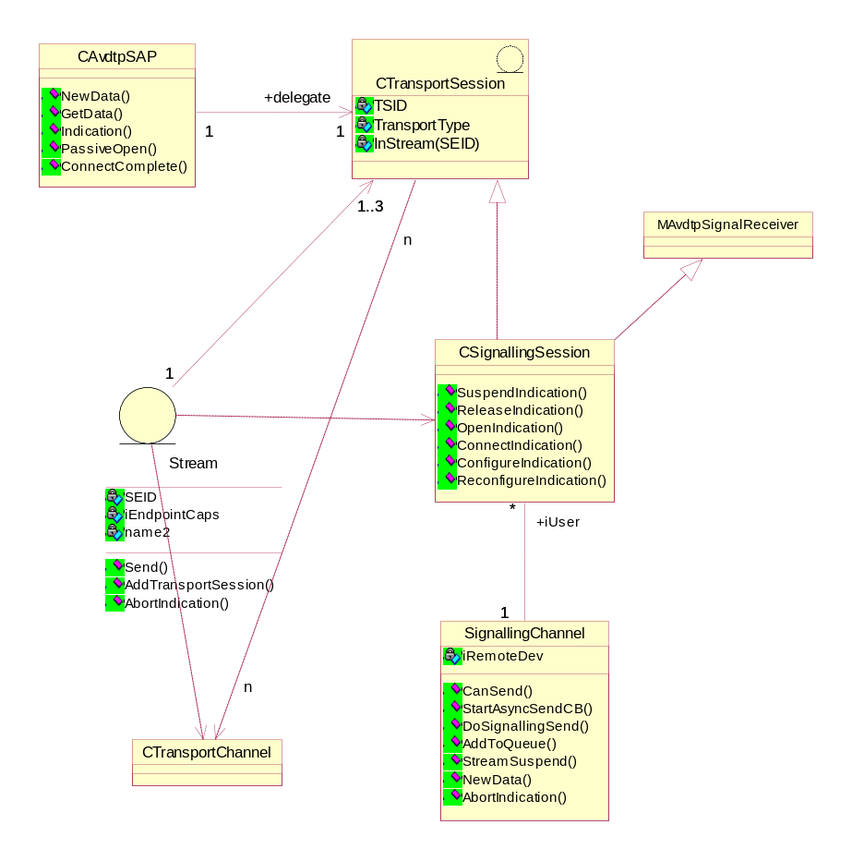
The diagram also shows that the protocol models streams, and that these are composed of between 1 and 3 transport sessions. Note that multiplexing of the Signalling Channel is achieved by representing each user of the GAVDP object via a Signalling Session. Multiple signalling sessions to the same remote device can then be multiplexed down the same signalling channel by use of the AVDTP signalling message transaction label.
Inbound commands form indications which are handled as far as possible within AVDTP prior to any interaction with GAVDP. Commands containing a SEID can be processed by the relevant signalling session that has the idle SEP indicated by the SEID.
An inbound Discover command is entirely processed in AVDTP. All idle SEPs from signalling sessions are advertised.

User classes

Addresses
Information about the sockets that are created by GAVDP for the User-plane is required. An AVDTP socket address is the <BluetoothDeviceAddress, SEID, Session> triple. Session is either ESignalling, EMedia, EReporting or ERecovery.
The TAvdtpSockAddr class is used when forming or querying AVDTP socket addresses.

SEP Capabilities
To enable clients to easily handle SEP capabilities, The SymbianOS Bluetooth subsystem provides a number of classes representing each SEP capability. The The SymbianOS Bluetooth subsystem BluetoothAV subsystem constructs these capabilities as it parses the AVDTP packets. The capability classes provide useful getter and setter methods to more easily take part in SEP configuration - the base class is TAvdtpServiceCapability.
A client can query the base class to determine which derived class it should cast. After casting relevant high-level methods can be used to set and retrieve capability settings.

Further Information

People
Role | Person / People
Reviewers
Contributors
Distribution

References
No. | Document Reference | Version | Description
[R1]
[R2]

Open Issues

This document doesn’t reflect the absolute latest design of the GAVDP work.

Glossary
Term | Definition

Document History
Date | Version | Status | Author | Description
dd-mm-yyyy | 1.0 | Issued | <Name>
dd-mm-yyyy | 0.1 | Draft | <Name> | First draft based on SGL.PPS001.500 Lightweight Document Template Rev 8.5

