Bluetooth HCI v2 Design Specification

Status: | Issued
Version: | 1.1
Security Classification | Symbian Confidential
Team/Department : | Shortlink/Core
Contents
1 Introduction 3
1.1 Purpose and Scope 3
2 HCI Architecture 4
2.1 Exported header files 4
2.2 Packaging View 6
2.3 Start-up 9
2.4 Shutdown 14
2.5 Hard Reset 14
2.6 Initialising the Controller 16
2.7 Power Control 18
2.8 Flow Control to the HCTL 19
2.9 Command Path 22
2.10 Data Path 27
2.11 HCI Server 28
2.12 Future Proofing 29
3 PREQ Design Considerations 30
3.1 Platform Security 30
3.2 MCL Configurability 31
3.3 Ease of Customisation 33
3.4 Ease of Deployment 36
3.5 Design Patterns Used 36
4 Symbian Component Designs 39
4.1 Command Queue Design 39
5 Reference Component Designs 73
5.1 Queue Decision Plugin Design 73
5.2 Commands and Events Design 94
5.3 Core HCI Design 104
5.4 HCTL Design 119
5.5 Controller Initialisation Design 140
6 Cross-component Design Areas 148
6.1 Controller Management Design 148
7 Further Information 157
7.1 References 157
7.2 Open Issues 157
7.3 Glossary 158
8 Appendices 161
Appendix A Where are the headers? 161
Appendix B Two Component Configurability 162
Appendix C Design Alternatives 163

Introduction

Purpose and Scope
This document contains the complete design of the HCI components necessary to implement PREQ750 and its REQs briefly described below. In addition the necessary changes to the design of the Symbian Bluetooth protocol stack are also described.
In order to prevent repetition of information, this document assumes that the reader has digested the Bluetooth Architectural Description [R9] and Bluetooth Functional Description [R10]
The target audience of this document are members of the same technical area, defect fixers, users, testers, and licensees.

Requirements
PREQ750 | Bluetooth HCI improvements
REQ4056 | Bluetooth Reference HCI Portability Improvements
REQ4056.1 | Bluetooth HCI Command Queue Access
REQ4056.2 | Host Controller Initialisation Framework
REQ4056.3 | Bluetooth Reference HCI Re-organisation
REQ4056.4 | Stack Interface For Existing Physical and Synchronous Links
REQ4058 | Bluetooth HCI Command Tracking
REQ4058.1 | Handling Unacknowledged HCI Commands
REQ4058.2 | Handling Errors In Events Associated With Creating Physical Links
REQ4059 | Provision of support for all Bluetooth HCI Commands and Events
REQ4061 | Bluetooth HCI Porting Guide
REQ4104 | Bluetooth Power Control
REQ4659 | HCI Logging Tool
For the full description of the requirements see the entries in the Focal Point system.

HCI Architecture
This section presents the components of the solution and describes some aspects of how they collaborate to achieve the goals set by the requirements above.

Exported header files
The APIs of the new HCI architecture are laid out in a set of exported header files. The reader is advised to look through these header files and/or the corresponding Developer Library documentation to gain an understanding of these APIs.
See Appendix A for a details of where to find the headers below.

Stack
LinkMuxNotifier.h
PhysicalLinksState.h
HardResetInitiator.h

HCI Command Queue
hcicommandqitem.h
hcicommandqueue.h
hcicommandqueueclient.h
hcicmdqcontroller.h

QDP
hcicmdqueuedecisioninterface.h
hcicmdqueuedecisionplugin.h

Commands and Events
Command.h
Event.h
commandcompleteevent.h
vendordebugcommand.h
VendorDebugEvent.h
VendorDebugCompleteEvent.h

Core HCI
corehci.h
corehciplugin.h
hcicommandallocator.h
hcidataeventobserver.h
hcicommandeventobserver.h
hcidataframer.h
hcidataobserver.h
hcierrors.h
hcievents.h
hciframe.h
hcitypes.h

Controller Initialisation
controllerinitialisationinterface.h
controllerinitialisationplugin.h
controllerinitialisationobserver.h

HCTL
hctlchannelobserver.h
hctlbase.h
hctldataobserver.h
hctleventobserver.h
hctlinterface.h
hctluartbase.h
qdpplugininterfacefinder.h
hctlpowerinterface.h
controllerstateobserver.h

BTPowerControl

btpowercontrol.h

HCI Server Client
hciserverclient.h

Packaging View

DLL Overview
Name | Brief Description
ESockSvr.dll | The main executable of the Socket Server, responsible for loading the Bluetooth protocol support. Runs in the context of the process associated with C32EXE.EXE.
bt_v2.prt | The Bluetooth protocol module
HCICmdQ.DLL | Provides the HCI Command Queue functionality
corehci_base.dll | Provides the base class for the CoreHci Plug-in required as part of the ECOM framework.
qdp_base.dll | Provides the base class for the QDP Plug-in required as part of the ECOM framework.
initialisor_base.dll | Provides the base class for the Controller Initialisation Plug-in required as part of the ECOM framework.
hctl_base.dll | Provides the base class for the HCTL Plug-in required as part of the ECOM framework.
commandsevents.dll | Static library contaning CHCICommandBase, THCIEventBase and derived classes. Used both by Symbian and Licensee components.
corehci_hardware | Provides the hardware-specific Core HCI plug-in which will be loaded via ECOM
qdp_hardware.dll | Provides the hardware- specific QDP (Queue Decision Plug-in) plug-in which will be loaded via ECOM
initialisor_hardware.dll | Provides the hardware- specific Controller Initialisation component which will be loaded via ECOM
hctl_transport.dll | Provides the transport-specific HCTL plug-in which will be loaded via ECOM
hciutil.dll | Utility class for HCI components
hciserverclient.dll | Client-side access to the HCI Server
btpowercontrol.dll | Client-side access API for the power control functions in the HCI Server.
Orange – Symbian DLLs
Black – Reference DLLs.

The Command Queue functionality which used to exist within bt.prt has now been extracted into a separate component, HCICmdQ.DLL. This has been done so that licensee components can access that functionality without the need to link to bt.prt. This solution avoids the risk of imposing constraints on the future development of bt.prt itself, which is important as it is the main DLL in the Bluetooth Subsystem.
Each implementation of an ECOM interface is in its own DLL. This design enables the choice of the appropriate plug-in at ROM build time. ECOM would allow us to combine all the plugins in a single DLL but to get the same flexibility at ROM build time, it would be necessary to build
Num(QDPs) * Num(Initialisors) * Num(HCTLs) * Num(Core HCIs)
different variant DLLs instead of
Num(QDPs) + Num(Initialisors) + Num(HCTLs) + Num(Core HCIs)
Since the latter creates fewer variants and is easier to manage that is the solution which has been adopted.

MRP Component Layout
The V2 HCI source is partly owned by Symbian and partly owned by licensees. Hence we need at least two components to provide these two groups of code separately. To see why imagine that all the code is in one component. For the licensee to obtain a refresh of the Symbian code, they would have to get the whole component which might overwrite the changes they have already made to the licensee-owned section – clearly an undesirable scenario.
Since there is no need for a more complex structure, we have the following two components:
- bluetooth_hci_v2_framework.mrp (Symbian-owned)
- bluetooth_hci_v2_implementations.mrp (Licensee-owned)

Code Layout
The rules for the file layout are as follows:
- There will be a single folder per DLL.
- Each variant DLL folder lives directly under the component folder of which it is a variant.
- Each DLL folder has the following branches:
- BWINS – for the Win32 def files (where applicable)
- EABI – for the EABI def files (where applicable)
- group – for the DLL bld.inf and DLL mmp file
- inc – internal headers to be included by USERINCLUDE.
- interface – for exported headers to be included by SYSTEMINCLUDE. This folder will only be present in Symbian owned DLLs not the reference DLLs.
- src – for the cpp files
- The base plugin DLLs own the APIs for their respective ECom plug-ins.
- The layout groups code for each mrp component into a single top-level folder, e.g. hci_v2\framework, hci_v2\implementations.
This gives the following structure for the V2 HCI code
- hci_v2
- framework
- CommandsEvents
- hctl
- corehci
- initialisor
- qdp
- implementations
- CommandsEvents
-symbian
- hctls
- uart_orignial
- bcsp
- ti
- corehcis
- symbian
- initialisors
- symbian
- ti
- qdps
- symbian

Note:
- Each folder that is not further sub-divided represents a DLL. The single exception is the framework folder for CommandsEvents which only serves to define the interface but does not correspond to an executable component.
- The folders shown in bold above have an interface folder. Those not in bold do not.

Start-up

Loading the components
The diagram below shows the order in which the PREQ750 components are loaded. The numbers indicate the order while the lines indicate which component is performing the load and which is being loaded. The orange boxes are Symbian components whereas the yellow are reference components.
Static loading in the context of this diagram means not only linking to a component using a LIBRARY statement in the mmp file but also the act of creating an instance of the controlling class of the component being loaded via a call to the appropriate NewL factory function.
Dynamic loading in the context of this diagram happens when an ECOM plug-in base DLL makes a call to ECOM which causes ECOM to dynamically load the plug-in DLL and to call the NewL factory method within the plug-in to instantiate an object of the appropriate type.
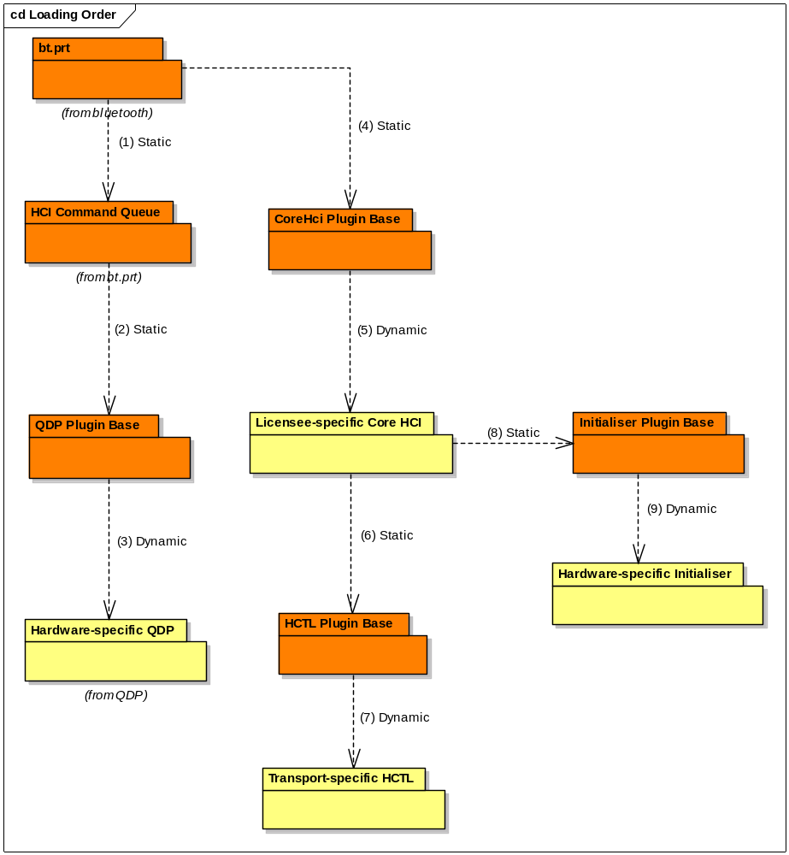
Figure 1 Loading Order

Note that although the Initialiser is intended to be used by the Stack rather than by the Core HCI, it is loaded by the Core HCI. Likewise the responsibility for loading the HCTL is given to the Core HCI. The reason for this is that it gives the licensees flexibility of implementation. Although the reference implementations of Controller Initialisation and of the HCTL are ECOM plug-ins, licensees are not constrained to follow this example. They could even choose, for example, to provide all the functionality of the Core HCI, the HCTL and the Controller Initialiser together in a single component.
There are two details omitted from the diagram above:
- In addition to acting as a normal plug-in base dll, corehci_base.dll contains a set of exported APIs which are used by various components via static linkage.
- commands_events.dll is also used by various components via static linkage, both Symbian- and licensee-owned.
See Figure 46 and Figure 52 for diagrams showing these details.

Providing APIs
When a component has been loaded as described above, it must be provided with pointers to the interfaces it needs to use. Also it will be queried for the interface which it supports itself, and pointers to those interfaces will be provided to those components that need them.
The following diagrams illustrate the most important steps of this process

Acquisition of APIs by the Stack
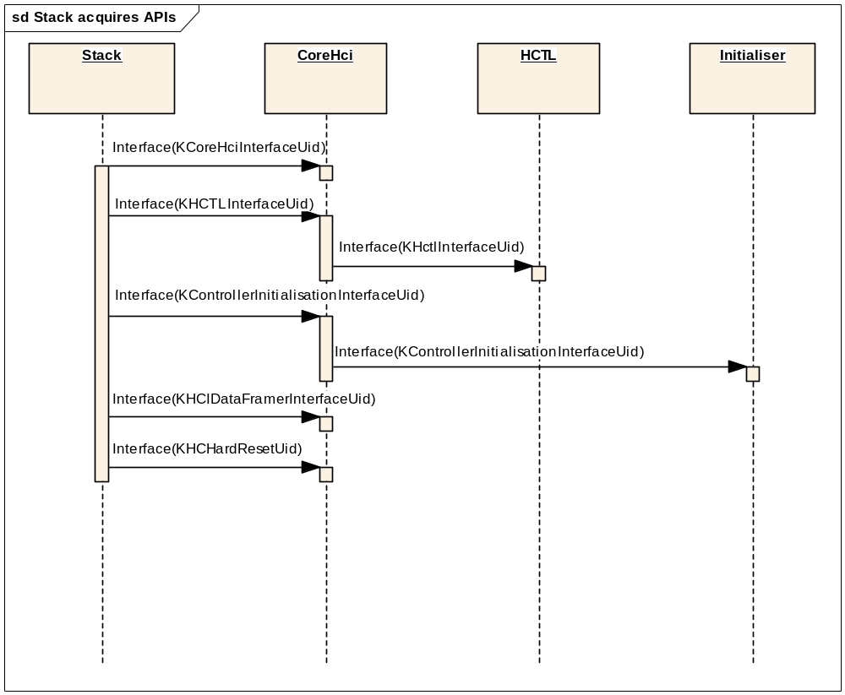
Figure 2 Stack acquires APIs

Provision of APIs Implemented by the Stack
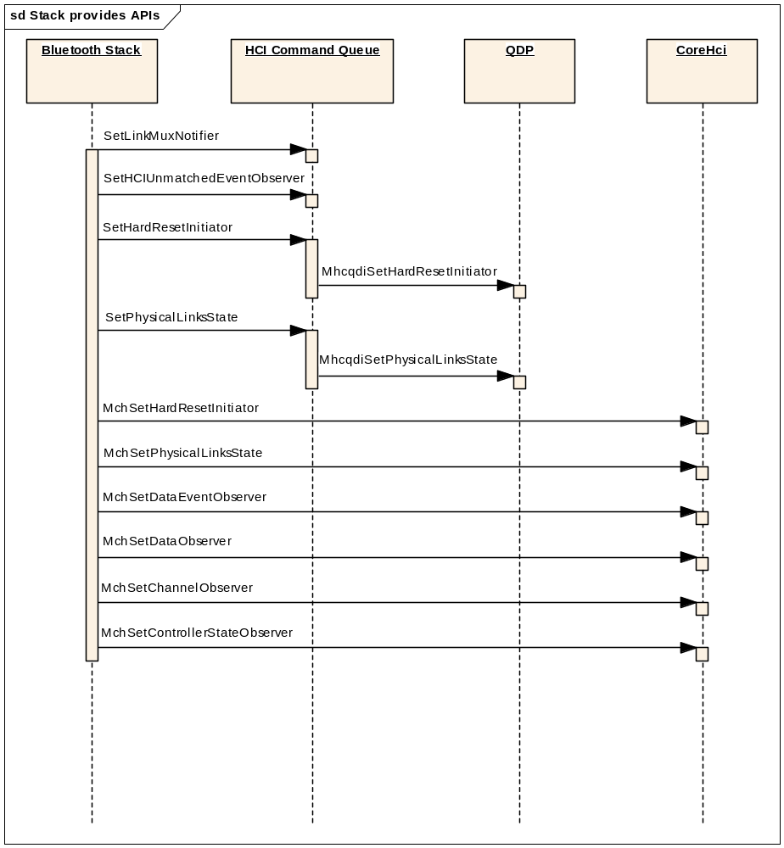
Figure 3 Stack provides APIs implemented by itself

Stack Connects CommandQueue, Core HCI and Controller Initialisation
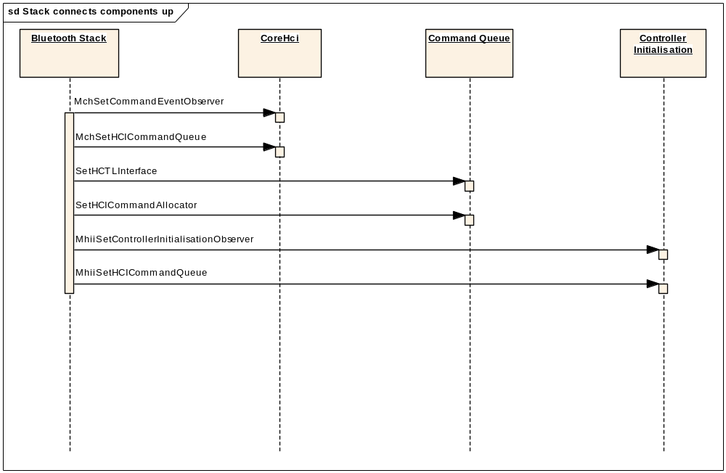
Figure 4 Stack connects components up

Shutdown
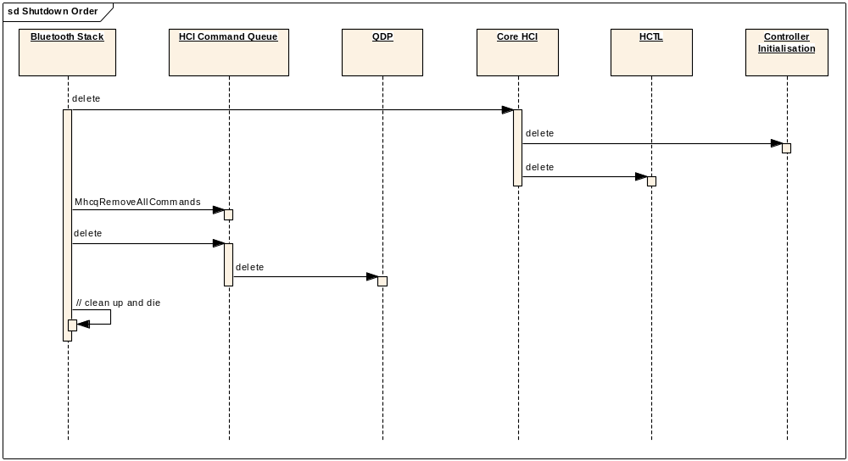
Figure 5 Shutdown Order

Hard Reset

Introduction
A Hard Reset is needed if it is determined that the Bluetooth Controller has hung or is behaving in a corrupt fashion. The term implies some kind of intervention on the Controller which will reset it to a known clean state as if it had just been powered up.

How is it done?
This is protocol- and/or controller-dependent. In the case of the reference HCTL implementation for the BCSP protocol, the reference code attempts to initiate a reset of the controller using a BCSP-specific command designated for that purpose. In the other reference HCTL implementations a place-holder function is provided in which the licensee should place the code which actually initiates the reset. This code could take one of the following approaches:
- Power-off and then power-on the chip, allowing sufficient time between these two actions
- ‘Tweak’ a hard reset line on the controller
- Send some kind of controller-specific reset command to the controller, and only if that fails try one of the above

Informing The Stack
The stack needs to be informed whenever the controller has effectively been “brought down” (not necessarily powered off) and when it has been been “brought back up” again.
When the stack is informed that the controller has been brought down it needs to reset its state (to reflect the fact that there are now no physical links, logical channels etc. present), and to reset the command and data queues to an empty state. It informs the user via LinkManager protocol.
When the stack is told that the controller has been brought back up, it starts the controller initiatialisation procedure as discussed in section 2.6.
The above behaviours are just the same as the behaviours of the Stack used with the V1 HCI when informed that the host controller’s power has gone down/come up.

Sequence
In this scenario it is assumed that the need for a hard reset has been determined by the QDP.
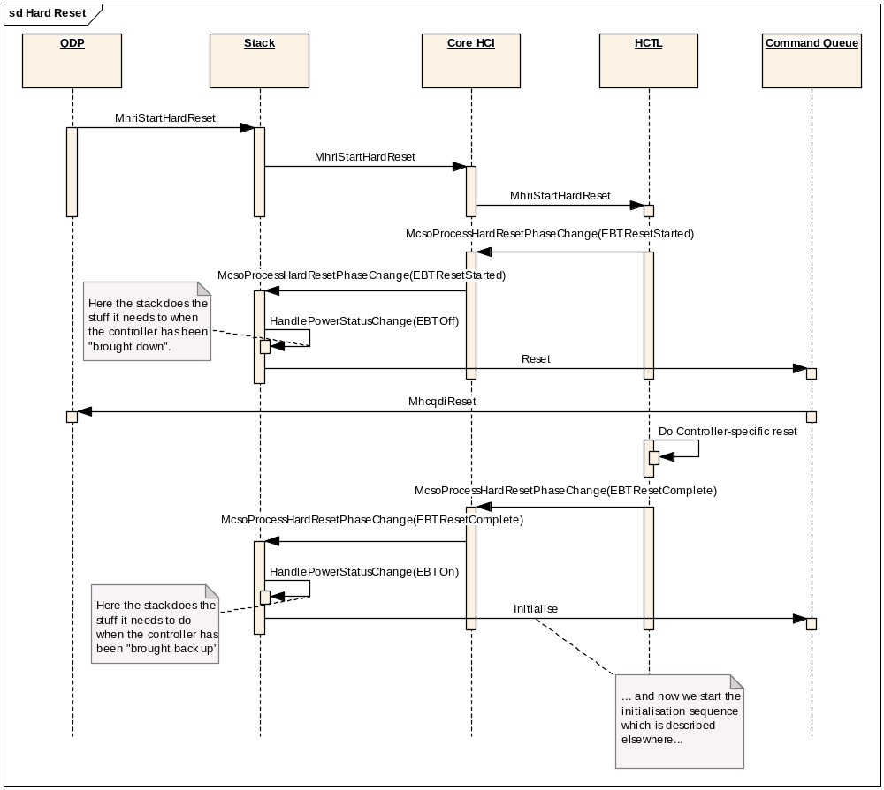
Figure 6 Hard Reset

Initialising the Controller
After the Bluetooth Controller has booted or been reset it is necessary to perform controller initialisation. This occurs both when the Bluetooth stack is first loaded and when the Hard Reset operation (see section 2.5 has occurred. One standard action that must always be performed at this stage is to send the Bluetooth SIG-specified HCI command “Reset”. This is done by the Stack. However any individual controller may need commands, possibly vendor-specific commands, to be sent before sending the Reset command (e.g. to garner state information), and to be sent after sending the Reset command (to initialise the Controller). For instance for a cheaper ROM based controller, the controller would need to be sent its Bluetooth device address immediately after being sent the Reset command.
The Controller Initialisation plug-in component provides a means for the licensee to customize this “pre-“ and “post-reset” functionality according to the needs of their hardware.
The details of how this is achieved are covered in section 5.5. The following diagram from that section provides a view of one scenario showing how this can be done.
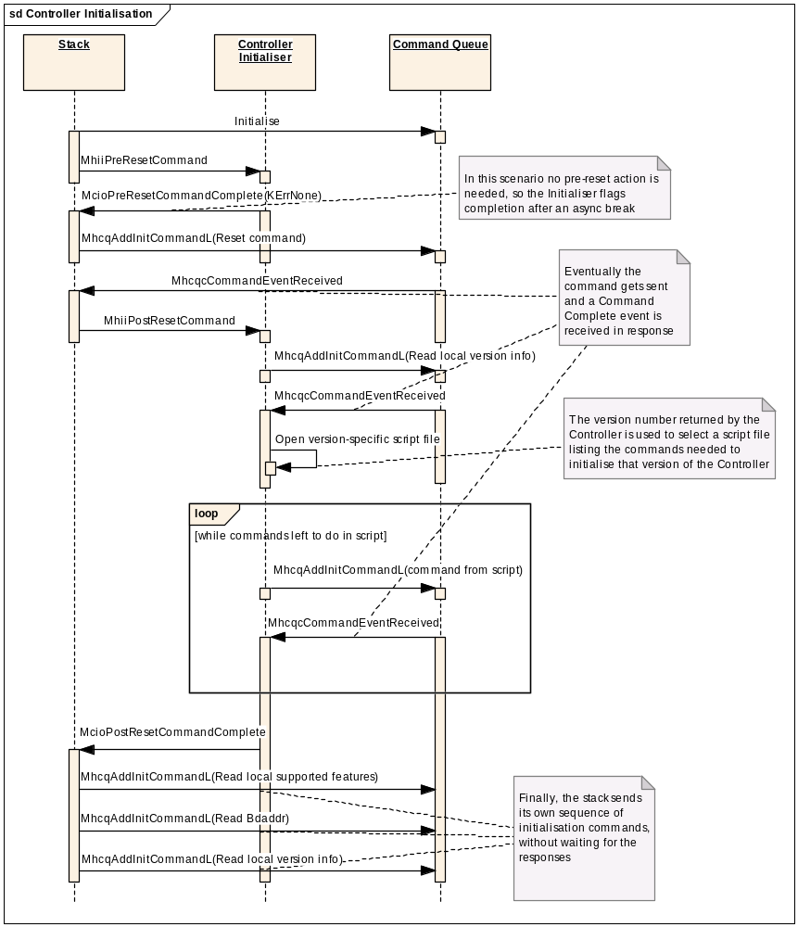
Figure 7 A Controller Initialisation scenario
(copy of Figure 81)

Power Control
Power Control provides a mechanism that allows licensees to directly monitor and set the on/off status of the Bluetooth baseband hardware. This is implemented as part of the HCI session server and provides a client/server structure defining simple API commands for the client side, resulting in configurable actions within the HCTL on the server side.
The RBTPowerControl class has two member fuctions which allow the setting and getting of the boolean TBTPowerState for the designated Bluetooth hardware. These are;

void SetPower(TBTPowerState aState, TDes8* aDesc, TRequestStatus &aStatus)
TInt GetPower(TBTPowerState& aState, TDes8* aDesc)

These two methods use the API socket component implemented by RHCIServerSession. As can be seen by their declarations, the SetPower() occurs asynchronously and the GetPower() is managed synchronously. Because of the unkown element of hardware interaction, power status is maintain by the server side management. Thus a get power state will return the last accepted set state.
The Power Control server is able to handle handle multiple clients, so user’s applications should be aware of this dynamism and be designed accordingly.

Flow Control to the HCTL
There are three levels of flow control that concern the HCTL
- Whether or not the transport channel is open.
This reflects whether we have a route to the hardware and is an indication of whether or not it is powered up or down.
- Whether or not one of the sub-channels is open.
This is a useful way of subdividing the channel mentioned above into three separate subchannels for ACL data, Synchronous (SCO) data and for Commands. This would allow the flow on each of those subchannels to be controlled individually. This is not something that is present in the HCTL specifications ([R12], [R13] etc), nor is it currently used in any of the reference implementations, but it is designed into the framework and supported within the Symbian components so that it is available should a licensee choose to use it.
- Whether the controller is prepared to accept another object on a particular sub-channel.
This is the specification-defined flow control of command credits (on the command sub-channel) and data credits (on the data sub-channel).

It makes sense for one object within the Symbian components to be in charge of first two levels of flow control – channel and sub-channel flow control. The object chosen is the CLinkMuxer which is part of the Link Manager within the Stack . The following diagram attempts to show how this works:
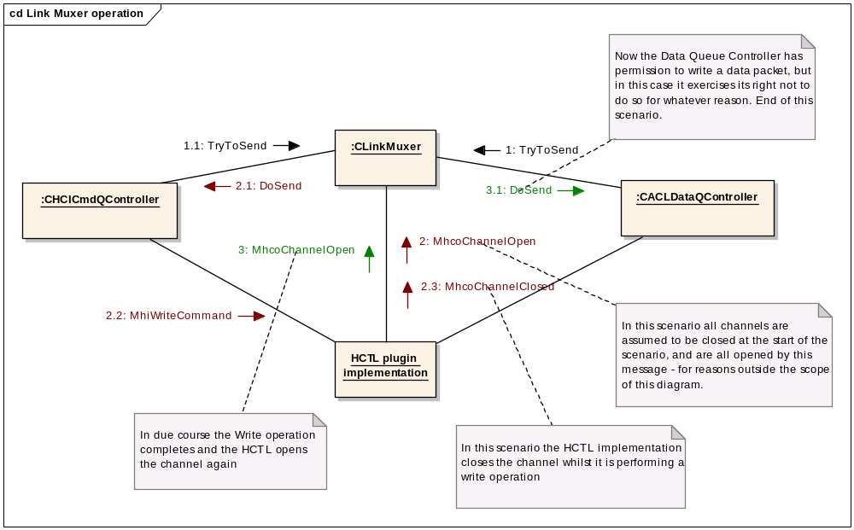
Figure 8 Link Muxer operation

- When one or other or both of the CHCICmdQController and the CACLDataQController has something to send it will inform the Link Muxer by making a TryToSend call. In this scenario they both raise a request to send, but for the purposes of this scenario we are assuming that the channel state is initially closed, so no command or data can be sent at this time.
- The Link Muxer (CLinkMuxer object) in the stack will receive a notification from the HCTL through the MHCTLChannelObserver interface whenever one or more of the subchannels goes up or down. The Link Muxer will keep a record of the current state of each subchannel. In our scenario the HCTL sends a notification that all subchannels are now open.
When it receives a channel open notification or when it receives a TryToSend call, the CLinkMuxer will set-up an asynchronous call-back to determine whether it is possible to permit a send operation. This call-back is included to help de-couple the layers of the protocol stack to avoid the otherwise common problem of a synchronous call being made down the entire protocol stack and so blocking other activity on the thread for an excessive period of time.
If the command sub-channel is open then CHCICmdQController is the first to be given permission to send a command. This is done by calling CHCICmdQController::DoSend, which is allowed to send a single command; it must do this synchronously within the call. Note that commands are given preference over data.
If the data sub-channel is (still) open then CACLDataQController::DoSend is called and is allowed to synchronously send a single packet.
However, in our scenario, the act of writing a command to the HCTL causes the HCTL to close all channels, so the Link Muxer is unable to authorize the sending of data at this time.
- When the command has been written over the serial interface the HCTL will signal to the Link Muxer that the channel is open again, and the Link Muxer calls DoSend on the Data Queue Controller to authorize it to send a data packet.
Note the following points:
- A DoSend() call does not mean that a write must be made. Whether a write is made or not is up to the class in question though if one is made it must be made synchronously within the DoSend() function. The policy of whether a send is possible / legitimate is encapsulated in the sending class – CHCICmdQController will not actually request TryToSend unless it has a command that can now be sent, so it will always perform a write in its DoSend method, but CACLDataQController may not.
- When CHCICmdQController or CACLDataQController calls MhiWriteCommand on the HCTL to send a packet, the HCTL is liable to make a call back to MhcoChannelClosed on the Link Muxer to close the channel until the write operation is completed. Thus if TryToSend requests are pending for both commands and data then the sending of the command is likely to cause the channel to be closed and the data will have to wait until the command has been sent out. However this scenario would not apply in the same way in the case of an HCTL implementation which maintains a frame buffer such as the reference BCSP HCTL for example.
The Link Muxer does not perform the level of flow control which concerns itself with command and data credits. Because there are separate mechanisms for commands and for data, this is best left to CHCICmdQController and CACLDataQController. These classes also implement their own additional flow control mechanisms e.g. QDP-initiated command blocking within the Command Queue.
In order to allow CHCICmdQController and CACLDataQController to manage flow control at the level of command/data credits, it is necessary that command-credit-bearing events be passed to the Command Queue, and data-credits-bearing events to the Data Queue Controller as shown below:
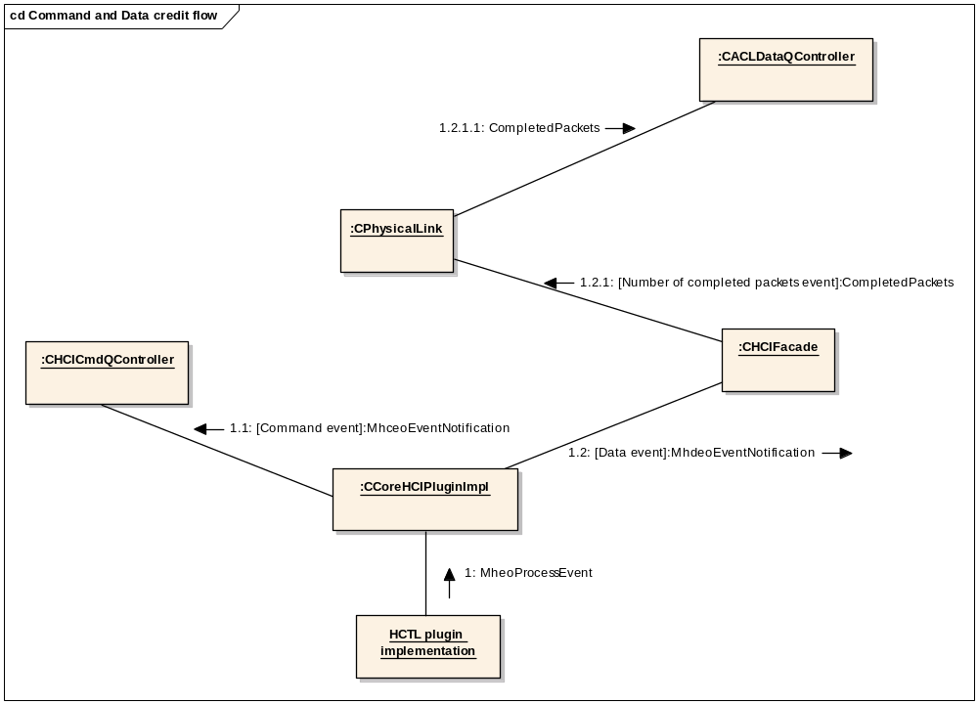
Figure 9 Command and Data Credit Flow
Note that the data-credit-bearing event is not passed directly from the Core HCI to the ACL data queue controller but the information is routed through a couple of intermediate objects within the Stack. The details of these objects need not concern us here; they have been included in the diagram solely for accuracy – to avoid misleading and possibly confusing the reader.

Command Path

Command Representations
CHCICommandQItem acts as the mediating class between the Stack and the HCI components. It encapsulates two ways of representing a command:
- An on-the-wire representation (as given by CHctlCommandFrame)
- A set of parameters required by the command (as given by CHCICommandBase).
The normal sequence for sending a command and receiving a response works like this:
- The Stack calls the static NewL factory method on the CHCICommandBase-derived class representing the specific command it wants to send. We will call the object thus created CB. All the parameter values needed for the command are passed as parameters to the NewL method.
- The Stack passes CB to the Command Queue using one of the “Add Command” methods of CHCICmdQController. The Command Queue takes ownership of CB.
- The Command Queue component calls the factory method CHCICommandQItem::NewL to create a command queue item object A to contain the CHCICommandBase object. During the construction of A, the CHctlCommandFrame object F is also allocated, but not yet populated with the command data to represent the parameters of the command.
- At some point later the Command Queue determines that A is able to be sent to the HCTL. Firstly it calls the FormatFrame method on A which causes A to use the command parameters stored in CB to populate F in the appropriate on-the-wire format. Then the payload data of F is passed to the HCTL for sending while A remains on the command queue controller’s sent queue. F is still owned by A.
- At some point later the Core HCI receives an event packet from the HCTL. It creates a THCIEventBase-derived object E to represent the event, determines that it is a command-related event and passes it to the Command Queue via the observer class MHCICommandEventObserver.
- The Command Queue searches its Sent Queue for a command matching event E. It turns out that event E is the response to command A, so the Command Queue finds A in the Sent Queue. It extracts from A both CB and a reference to the Command Queue Client (MHCICommandQueueClient object) which originated the command. It passes both CB and E to the Command Queue Client. In this case the Command Queue client is the stack. A is still owned by the Command Queue. If event E is considered to signal the termination of the command then the Command Queue will now delete A, otherwise A will remain on the Sent Queue until a command-terminating event is received for it.

Note that each CHCICommandBase- derived class embodies the knowledge of how to format on-the-wire representation of the command into the CHctlCommandFrame object.

Sending a Command
The following two sections provide a view of the sequence of events involved in sending a command. Note that in both of these sequences, the interaction with the Link Muxer described in section 2.8 are omitted here for clarity.

Normal method
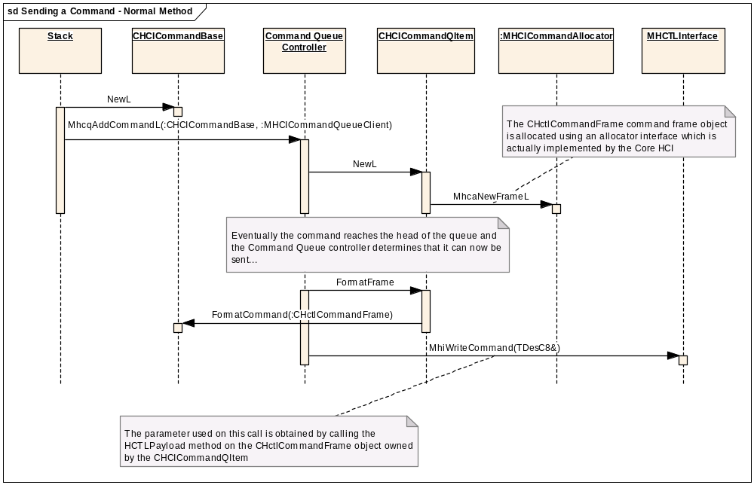
Figure 10 Sending a Command - Normal Method

Method using a pre-allocated Command Queue item
This method may be used to avoid the risk out-of-memory conditions arising at an inconvenient time, for example when trying to send a Disconnect after an error has occurred. Note however that this approach is not used in the current code-base.
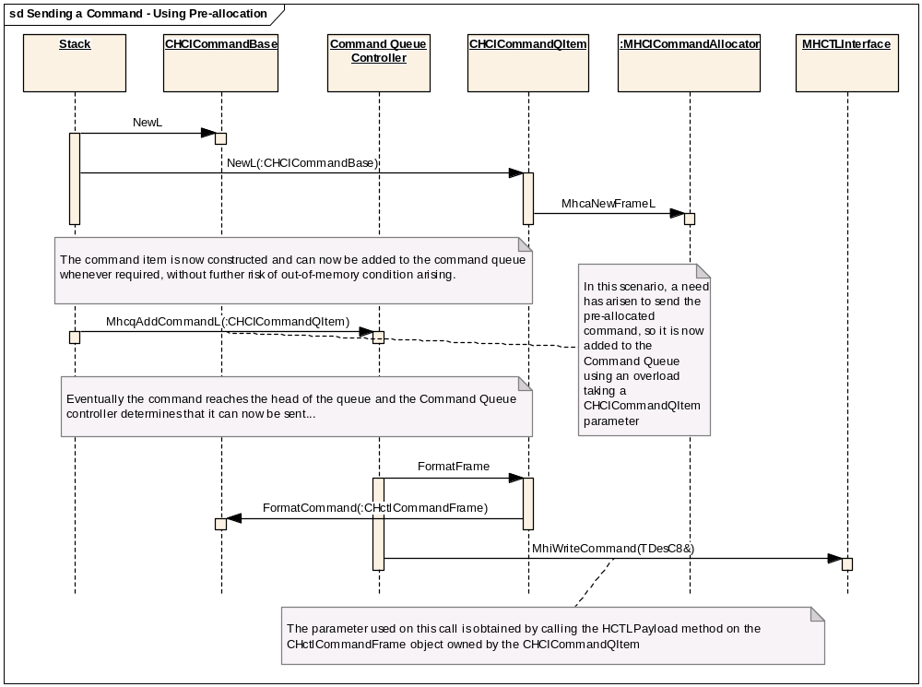
Figure 11 Sending a Command using Pre-allocation

Note that the CHCICommandBase-derived classes each provide a Reset method which allows the parameters of the command to be altered dynamically. This means that the parameters of a pre-allocated command do not need to be determined until the client actually decides to add the command to the queue. However, since each different Command opcode corresponds to a different derived class, it is not possible to change the opcode in a command object in this way.

Receiving Events
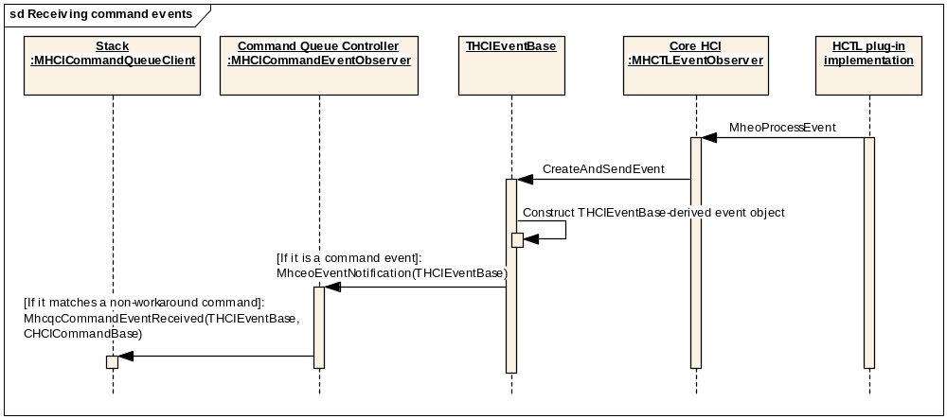
Figure 12 Receiving Events

- The HCTL assembles a packet of data from the wire. It parses the data sufficiently to determine that it is an event and passes the whole packet to the Core HCI.
- The HCI uses Commands and Events to set up a THCIEventBase-derived object to contain the data. At this point only the event code and the error code (if appropriate) is parsed out of the data. This information will always be needed but the rest of the event data will only be accessed on as-needed basis for reasons of efficiency.
- If the event code indicates that it is a command-related event then it will be passed to the Core HCI’s Command Event Observer, which is the Command Queue.
- The Command Queue component determines which if any of the commands on the Sent Queue matches the event. It then passes both the event and the matched command to the client associated with that command – in this case the Stack.
- The client can then use the THCIEventBase-derived object to parse out the remaining parameters if needed or can refer to the parameter values in the command object instead.

Note that just as each CHCICommandBase-derived object embodies the knowledge of how to format the specific command it represents, so does each THCIEventBase-derived object embody the knowledge of how to parse the specific event which it represents.

Completing a Command
When the command queue component informs the MHCICommandQueueClient of events, it provides when possible, a reference to the original command that caused the event. This allows the client easily to determine the context and handle the event appropriately and efficiently.
If the event was not matched to a command then of course no such original command exists; in this case the Command Queue passes the event to a special instance of MHCICommandQueueClient called the unmatched event handler.

Receiving Command Credits
The Command Queue component receives command credits through the normal inbound event path via either a Command Status or a Command Complete event.
Note that command credits are referred to as Num_HCI_Command_Packets in the Bluetooth Specification [R11].

Data Path
This section outlines the processes involved in sending data, receiving data, and receiving a data-related event.

Outbound Data Path
Note that in this sequence the interaction with the Link Muxer described in section 2.8 is omitted for the sake of clarity.
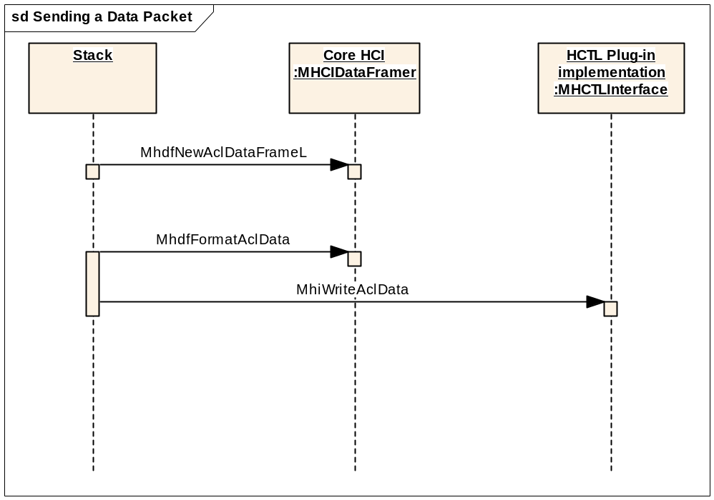
Figure 13 Sending a Data Packet
The diagram above shows only the major API calls and does not attempt to show all the detail of how they are used. For instance the Stack keeps a pool of ACL Data frames which are reused which means that there is not actually call made to MhdfNewAclDataFrameL for each call to MhdfFormatAclData.

Inbound Data Path
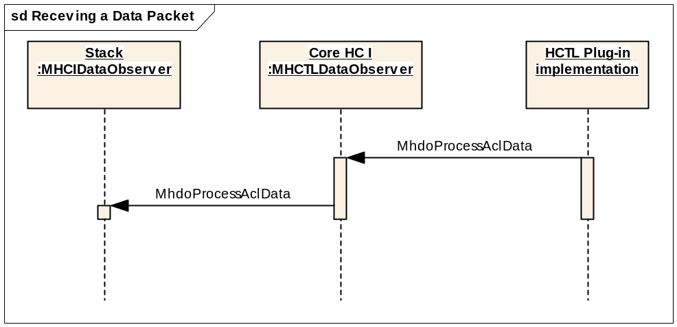
Figure 14 Receiving a Data Packet
Note that although the method names are identical, the two calls in the above diagram belong to two different interface classes and the parameters also differ. The Core HCI method receives an HCI packet from which it strips the HCI packet header containing the connection handle and flags. It then calls the method on the stack passing three parameters: the connection handle, the flags, and the HCI packet payload.

Receiving a Data Event
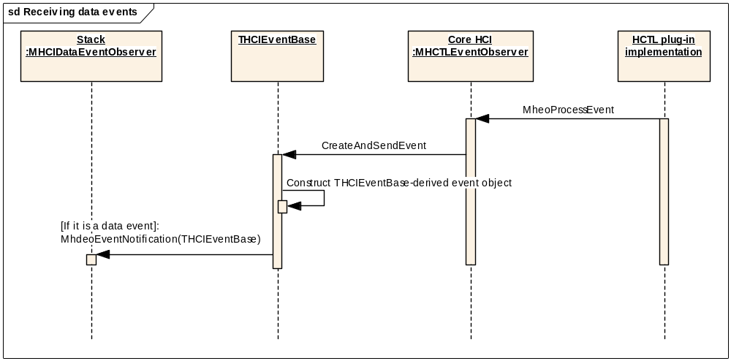
Figure 15 Receiving a Data Event

The number of data events is quite limited and consists solely of the following unsolicited events:
- Number_Of_Completed_Packets Event
This is the event through which the Stack receives data credits. Note that data credits are referred to as “HC_Num_Of_Completed _Packets” in the Bluetooth Specification [R11].
- Flush_Occurred Event
- Data_Buffer_Overflow Event
- QoS_Violation Event

HCI Server
The HCI Server provides a new mechanism for external applications to communicate with the HCI itself. Previously, requests intended for HCI consumption were tunnelled through an appropriate RSocket Ioctl. The Ioctl method is now deprecated, and it is recommended that the HCI Server is used instead.

The HCI Server is provided as part of the CoreHCI implementation and is therefore a reference component. It provides implementations for performing powercontrol and also a direct access implementation that will send raw vendor debug commands, licensees are at liberty to modifiy it as appropriate. The remainder of this section discusses the reference implementation as delivered by Symbian.

There is a common client-side interface to the HCI Server, the RHCIServerSession, this is used by RBTPowerControl and the updated RHCIDirectAccess. RHCIServerSession provides a set of interfaces that are similar to the original Ioctl mechanism to ease porting of previous HCI direct access implementations.

In general the HCI Server contains a set of services (currently power control and direct access), each service is assigned a unique UID that is provided when a client opens a RHCIServerSession. The HCI Server only allows a single client to open a given service session, at any one time, this is to simplify the logic as it is assumed that there will only ever be one client application interested in any service at any one time.

Internal to the HCI Server, a service is a class derived from a CHCIServerRequestManager, and must implement the DoServiceL() and HasCapabilities() methods. The service is responsible for policing the capabilities it requires, and so the implementer must take care to ensure the client has sufficient priviledges to perform the service request, HasCapabilities() is called on a ServiceL() and only if ETrue is returned is the DoServiceL() called. The DoServiceL implements the actual functions performed by the service, the function requested by the Symbian RHCIServerSession is encoded in the first IPC message parameter, i.e. "Int0()". The reason for this is that the IPC message received by a service will normally have a function number with the "server specific request" enum value, which is used by the CHCISession to distinguish the request from an "open interface request". A "open interface request" message is used by the CHCISession to request a pointer to an appropriate CHCIServerRequestManager from the CHCIServer. Once this pointer is obtained the CHCISession will then forward any "server specific request" messages to the CHCIServerRequestManager instance it is bound to. As the pointer is effectively a token given out by the CHCIServer such that it that can only be used by one session, upon destruction the session must not delete but rather release the resource (i.e. the CHCIServerRequestManager) it has been bound to.

Future Proofing
The most critical question of future-proofing which arises in the HCI components is the possible future expansion of the set of commands and events in a future version of the Bluetooth Specification. The design of the Version 1 HCI was particularly poorly adapted in this respect as it used a single very wide interface for transmission and reception of commands and events. This interface needed to be extended each time a new command or event was defined, and it was found in practise to be very difficult to maintain compatibility across versions.
The design of our Version 2 of the HCI is better positioned to meet these challenges. Each command is managed by a class derived from CHCICommandBase and each event is managed by a class derived from THCIEventBase. The key interfaces MHCICommandQueue, MHCICommandQueueClient, MHCICommandEventObserver and MHCIDataEventObserver use method parameters defined in terms of these base classes. This means that if new commands and events are invented in the future and the corresponding derived classes are added to the licensee-owned Commands and Events component, there will not be any need to change the above interfaces to support the new derived classes.
However, various challenges would still arise should it be necessary to provide support for a new level of the specification. The key issue is, if the Stack were to be upgraded to support a future HCI specification including use of new commands and events, how is it possible to arrange for it to interwork gracefully with (a) Controllers which do not support the new HCI specification and/or (b) licensee Core HCI (and other plug-in) implementations which do not support the new HCI commands and events?
One approach to this problem is outlined in Appendix C.6.

PREQ Design Considerations

Platform Security
From a security point of view, we start from the following assumptions:
- The C32EXE.EXE process has a fairly high level of capabilities which includes system capabilities (i.e. those that are given to 3rd parties on a restricted case-by-case basis).
- A process cannot load a DLL with a smaller set of capabilities than itself. (See [R6]).
- Rule II applies equally irrespective of the means used to load the DLL into the process:
- Static linkage
- Loaded using RLibrary::Load
- Loaded using REComSession::CreateImplementationL
- A process which loads a DLL with a greater set of capabilities than itself does not acquire any extra capabilities as a result. (See [R6]).
- All the components of this PREQ including bt.prt are designed to run as DLLs in the context of the C32EXE.EXE process and are loaded into that process using one of the three above methods.
- There is no known requirement for any of the components of this PREQ to run within the context of any other process than C32EXE.EXE or with any other set of process capabilities.

Capabilities to be assigned to the PREQ750 DLLs
From the assumptions above we can infer the following:
- All the components of this PREQ must have at least the same set of capabilities as C32EXE.EXE. [This follows from (II, III, and V)].
- There is no reason or benefit for any of the components of this PREQ to have any additional capabilities which are not present in C32EXE.EXE. [This follows from (IV, V and VI)].
Conclusion: all the components of PREQ750 should have the same set of capabilities as C32EXE.EXE. [Follows from (a) and (b)].

Behavioural requirements
In general terms the requirement is to ensure that our code justifies the trust implied by having the above level of capabilities. Our code should not abuse the resources that these capabilities give us access to. We should use precious resources only as needed e.g. we should not open COM ports except as needed, we should not open Trusted UI dialogs that are not related to Bluetooth, and so on. Basically, deserving a capability is more or less a case of careful design and implemention as should be normal practise in any case.
Note that it would be possible for a process with less capabilities than ours to load and use our DLLs. This raises the question of whether we might therefore need to police our APIs with specific code to allow for this possibility. However, [R6] tells us that we should only police a set of APIs if they directly provide access to a precious resource. We do not need to provide security for our APIs that access a precious resource indirectly such as a COM port, for instance. This is because the APIs for the indirectly accessed resource will check that process has the required capabilities, and as stated in assumption IV above, the process does not acquire any extra capabilities by loading a DLL with more capabilities than itself. To put it another way, a process with sufficient capabilities to be able to use our DLLs to abuse access to the COM port would also have sufficient capabilities to abuse access to the COM port directly without needing to use our DLLs to do so. Hence our DLLs do not present a security weakness.
However, PREQ750 also provides functionality through a client server interface: the HCI Server. In this case the client is running in a different process which may well have low capabilities, but we are running with the capabilities of C32EXE.EXE i.e. probably a much higher set of capabilities. In this situation it is a definite requirement for us to police the client-server interface to make sure that the client should be allowed to perform the function they are requesting. But to do this definitively is not possible since the HCI Server is reference code designed to be easily extensible by the licensee to meet future requirements. Without knowing the details of the functionality which might be required in the future it is not possible to say what the security requirements will be. What we can say is that since the server is resident in the Bluetooth thread it is to be expected that a high level of capabilities will be needed to access this API. The reference code for the HCI Server provides APIs for HCI Direct Access and for Controller Power Control – both of these APIs are policed on a function by function basis but most of the functions check that the client has the Network Control capability.

MCL Configurability
The PREQ750 work needs to be configurable to allow licensees to migrate over to the new APIs at a time of their choosing. This is because PREQ750 breaks compatibility with previous versions – we need to allow a situation where licensee developers of the client software for the Bluetooth stack can be using the old APIs whilst at the same time the licensee developers working on the HCI layer are working to port to the new APIs. Since the nature of a configurability strategy is by its nature temporary this section describes the state of the MCL (Master Code Line) from the time when the PREQ750 code is added to the time when the HCI V1 APIs are removed which will be when a qualified Bluetooth code line is created using the PREQ750 codebase.

- We will provide the HCI V2 source code in Bravo, in addition to the HCI V1 code.
This is because it is already a well established practice in Symbian to include source from the next release in the current release. The inclusion of source in a shipment does not grant the licensee the right to use it in a product.

- We will only provide HCI V1 binaries for Bravo, not the HCI V2 binaries.
The reason for this stipulation is that we do not wish to slow down the build system unnecessarily (bt.prt is quite large, coming in at around 150KB, whether HCI V1 or HCI V2).
Also, the time when licensee developers are likely to start using the HCI V2 binaries is when they start preparing their code to use the new HCI V2 APIs and we would expect them to do that after they have moved on to a release including the HCI binaries as well as source. In any case, if the licensee has a real need to use the V2 binaries in the Bravo timeframe, they will have the HCI V2 code so they could build the HCI V2 binaries themselves.

- The identifier SYMBIAN_HCI_API_V2 will be used to provide conditional determination of which version of the HCI API will be used. It may be tested in any of the following:
- bld.inf files
- .mmp files
- source files (.cpp and .h)
- .iby files (which specifiy the contents of a ROM build)
In addition to allowing us to control the build process for the Bluetooth Stack this can also be used in any areas of the licensees’ code which needs to be HCI-version-aware.

- SYMBIAN_HCI_API_V2 #define will be active in the Ohgma .hrh and subsequent codelines. The HCIv2 source will be available in Bravo onwards but the #define will be inactive by default.

- Both versions will be built at compile/link time (bt.prt, bt_v2.prt, hci.dll, corehci_base.dll etc).

- The supplied .iby files will use the SYMBIAN_HCI_API_V2 switch to determine which version of the HCI components to place in the ROM. Licensee ROM builders will thus get HCI V2 as default in Intulo and if they remove the SYMBIAN_HCI_API_V2 #define from the .hrh temporarily then when they build a ROM they will get the HCI V1 files.

- The SYMBIAN_HCI_API_V2 switch will be used in config\bld.inf to determine which version of the bt .esk file to export. This file controls which executable files are used when the Bluetooth Stack is loaded. The name of the .esk file is not absolutely fixed but must match the file-mask “bt.*.esk” – if not it will be inored.

- If SYMBIAN_HCI_API_V2 is not defined, then the HCI V1 .esk file will be exported as bt.bt.esk. This matches the file-mask “bt.*.esk” so this file will be used to control the loading of the Bluetooth Stack and the HCI V1 version of the stack will be loaded.
- If SYMBIAN_HCI_API_V2 is defined, then the HCI V2 .esk file will be exported as bt.bt_v2.esk. This matches the file-mask “bt.*.esk” so this file will be used to control the loading of the Bluetooth Stack and the HCI V2 version of the stack will be loaded. As a convenience to the licensee, the HCI V1 .esk file will also be exported, but as bt_v1.esk. This does not match the file-mask so it will not be used. However, it makes it easy for the licensee to switch between versions of the Stack simply by renaming these two .esk files.
- There would be no point providing two versions of the .esk file if SYMBIAN_HCI_API_V2 is not defined, since in this case the HCI V2 binaries will not have been built (see above).

- Forcing licensees to move from the V1 APIs in Bravo to the V2 APIs by the time Argus is released is acceptable due to the long time scales involved and the large expected change from Bravo to Argus across the OS. Note that if this is was not to be acceptable then we would be forced to support two qualified stacks in Argus which would be a considerable maintenance and financial burden.

- All V1 binaries retain their original name (i.e. no _V1 suffix is used).
This is to avoid confusion. We will be retaining the old hci.dll binary “as is” to avoid compatibility problems for licensees and so if we wish to use a common pattern on names across the board, this forces us to retain all the original V1 names.
Note that the DLLs for HCI V2 do not have names in common with the DLLs for HCI V1 and therefore will not nee a “_V2” suffix to distinguish them apart from “bt.prt” which becomes “bt_v2.prt” in HCI V2.

- The existing CBR component will contain the HCI V1 code; new CBR components will contain the HCI V2 code. The reasons for this is are as follows:
- Less change to the V1 HCI, i.e. less risk that we’ll break the V1 HCI
- It means we have an obvious vehicle to provide the V2 source code.
- Developers (particularly those in the Shortlink team) may wish to mark the V1 HCI as an excluded component in order to save time downloading a CBR.
Note however that the intention is not to use the existence of separate CBR components to provide the ability to switch between the HCI V1 and HCI V2 code when using the emulator or building a ROM. This switching will be done using the techniques described in points 6 and 7 above.

- There will be two CBR components for HCI V2 – one for Symbian framework code and one for reference/licensee implementations. See section 2.2.2.
The behaviour of each of these components will be as follows:
- With SYMBIAN_HCI_API_V2 not defined:
- No binaries produced
- No exports
- The CBR command GetSource works

- With SYMBIAN_HCI_API_V2 defined:
- Binaries produced
- Headers exported
- The CBR command GetSource works

- What is the role of the file Bluetooth\bld.inf? (bld.inf in the top-level directory of the Bluetooth source tree)
Facts:
  - This file is not used to produce a CBR
  - This file is used within the Shortlink team as a handy way of building all the subsystem components in one go
  - This file can be obtained by calling GetSource on bluetooth_common.mrp so could potentially be used by licensees.
  - This file is used by the automated build and test machines for the same reason as in point (2).

Conclusion:
- If SYMBIAN_HCI_API_V2 is not defined, then the only version of the HCI built by the file will be HCI V1.
- If SYMBIAN_HCI_API_V2 is defined, then this file will (amongst other things) build both HCI V1 and HCI V2.

The advantage of this is that it is the same as what happens when a full OS CBR is made; the automated build and test machines will not have to ensure the V1 code builds; also we can be sure we will not cause a build break by doing this. However the drawback is that the Shortlink team will have to build the V1 bt.prt unnecessarily. Since bt.prt takes some time to build this is a time waster but this is the price to pay for the decreased risk of breaking the MCL.

Ease of Customisation

Ini Files
There will be six ini files relating to the HCI components: stack.ini, cmdq.ini, corehci_<implementation>.ini and hctl_<implementation>.ini, where <implementation> will be substituted in the file name by the identifier for the implementation of the plug-in to which the ini file relates. Thus the files provided by Symbian are as follows:
stack.ini
cmdq.ini
corehci_symbian.ini
hctl_uart_original.ini
hctl_bcsp.ini
hctl_ti.ini
These ini files need to be in a data cage. Therefore they should be in ESock’s private folder in a Bluetooth subdirectory: Z:\private\101f7989\Bluetooth on target and \epoc32\winscw\c\private\101f7989\Bluetooth for the emulator. To support Over-The-Air updates to the components, the HciUtil library needs to search for the ini files in a particular order. Firstly it should search C:\System\Data but only in UDEB (this will help debugging on device.) Secondly it should search the data cage on C: (i.e. C:\private\101f7989\Bluetooth), and then if not found it should look in the Z: location.
Both corehci_<implementation>.ini and hctl_<implementation>.ini are only used by reference components so their presence and format is not mandated for licensees.
In the following descriptions of the .ini file formats, xxx marks places where a suitable value should be entered.

stack.ini
This .ini file allows the stack to determine which Core HCI implementation to load. Since this file is used by Symbian-owned code, it must follow the format shown below if it is present. If it is not present, then the Stack will load the one and only implementation of the Core HCI plug-in which is available; if ECOM finds zero or more than one implementation then a Panic will occur.
[CoreHci]
EcomUid = xxx

cmdq.ini
This .ini file allows the Command Queue to determine which QDP implementation to load. Since this file is used by Symbian-owned code, it must follow the format shown below if it is present. If it is not present, then the Command Queue will load the one and only implementation of the QDP plug-in which is available; if ECOM finds zero or more than one implementation then a Panic will occur.
MaxHciCommandTimeout defines the largest value in milliseconds that the QDP is allowed to specify for a command timeout, see section 4.1.3.2.11.1.
QueueStarvationTimeout defines the period in milliseconds to be used for the Queue Starvation timeout, see section 4.1.3.2.11.2.
[QDP]
EcomUid = xxx
MaxHciCommandTimeout= xxx
QueueStarvationTimeout= xxx

corehci_<implementation>.ini
This is only the usage of the corehci_symbian reference implementation of the Core HCI. This is not mandated on the licensees.
This .ini file is used by the Core HCI to identify the HCTL and Controller Initialisation plug-ins. If it is not present then there must be one and only one HCTL plug-in available, and zero or one ControllerInitialisation plug-in available – otherwise a Panic will occur.
Its format is as follows:
[Plugins]
hctl_uid = xxx
initialisation_uid = xxx

hctl_<implementation>.ini
This .ini file is used by CHctlUartBase to determine which port to open and with what characteristics. Although it is not mandated on the licensee, it will be required for any UART-based HCTL implementation which derives from CHCTLUartBase because this base class is provided in the Symbian-owned HCTL plug-in base dll.
[hctl]
port= xxx
baud_rate= xxx

Patchable Plug-ins
All of the plug-ins described in this document (QDP, Core HCI, Controller Initialisation and the HCTL) will be patchable. The following use-case shows how this could happen:
- A licensee produces a phone in which all four plug-ins are given an ECOM version number of 1.0
- At some point later after the phone has shipped the licensee discovers a defect in one of the plug-ins. Say the QDP.
- The licensee fixes the QDP and produces a new version of the QDP plug-in which he gives an ECOM version number of 1.1. Note that the licensee does not need to produce a new cmdq.ini file to point to the new QDP plug-in implementation since the implementation UID will remain the same.
- The licensee distributes (via download, on media card etc) the newer plug-in to phones already in the market place. This means the new plug-in implementation is copied to a drive on the phone. The old plug-in and ini file will unchanged remain on the ROM.
- The next time the stack loads, ECOM finds the newer version of the QDP on the device and provides that to the command queue component when it tries to load a QDP.
- The new QDP plug-in is used and the defect is fixed.
The main advantage of patchable plug-ins is that phones do not have to be recalled at great expense for a defect to be fixed in a licensee HCI component.
Implementing patchable plug-ins is done by each plug-in loader but they each do it in the same way as follows.
- Find the appropriate ini file that specifies the ECom implementation to load.
- Get the ECom plug-in specified in the ini file using REComSession::CreateImplementationL(…) specifying RomOnlyResolverUid (see [R14]). Using this Resolver means that a patch (with a higher version than the one in the ROM) even on removable media could be returned here. If no such patch is present then the original one from ROM is returned.
Note that ECom provides notification of new plug-ins becoming available. This would allow us to install a patched plug-in dynamically at a time when the Bluetooth stack was already up and running. However, we will not take advantage of this facility since it increases the complexity of the code and would create problems with how to unload one plug-in and load up the new one to the same state as the old. So a new plug-in will only be picked up when the stack is reloaded. This might require users to reboot their phones to pick up a new plug-in (in the worst case) but this should not be a problem as they will know they are applying a patch and a reboot is to be expected in this situation.

Patches and Security
An obvious question when considering whether or not to allow patchable plug-ins was whether it would be secure, e.g. does ECOM check signatures etc. or do we have to provide the security implementation?
The answer to this is as follows:
- PlatSec provides ‘install-time signing checks’. Anything the installer allows you to install may be assumed to be trusted.
- For any DLL to be loaded by a process, it must have sufficient capabilities- this is enforced by the DLL loader which forms part of the Trusted Computing Base (TCB).
- When an executable is installed to a removable drive, a cryptographically secure hash of the executable is created and stored by the TCB. The card may of course be removed, tampered with, and reinserted. But the TCB will only load binaries if the executable correctly matches the stored hash.
- This level of security is provided by the TCB without any need for additional security support in the product.
So the conclusion is that ECOM and the TCB provide all the security we need.

Ease of Deployment

hci.iby
The HCI component exports an hci.iby file that is #included by Bluetooth.iby.
The reason for this indirection is that Bluetooth.iby is a file owned by Symbian and hence if it included the lines to put the HCI components into the ROM then licensees would have to branch that file if they needed to change the names of any of those components. Instead the only requirement on the licensee is that they export a file called hci.iby which should pull in all the HCI component DLLs.

Optional Plug-ins and .ini Files
The Controller Initialisation plug-in is optional and does not need to be present in a ROM. If it is not present the no pre- or post-reset commands will be sent to the Controller.
In addition neither stack.ini, cmdq.ini nor (in the reference implementation) corehci_symbian.ini need to be in the ROM. If they are not present then the plug-ins can still be loaded successfully as long as ECOM finds exactly one implementation of the plug-in.

Design Patterns Used

Plugin Pattern

Pattern Participants
- Plugin Loader
Has no specific characteristic other than depending on ECom and linking statically to the Plugin Base.
- Plugin Base
A DLL, usually small, that provides the base plugin that Plugin Loaders statically link to. This DLL provides the dynamic link to the Plugin Functionality Provider. This is Symbian owned code and exports all of the Symbian-owned APIs for the Plugin Functionality Provider.
- Plugin Implementation
A DLL that provides the implementation of the APIs exported by the Plugin Interface. This is reference code.

Advantages of using this pattern
- The Plugin Base provides a convenient and intuitive location from which to export Symbian-owned APIs.
- Since the Plugin Loader does not directly link to the Plugin Implementation, licensees are allowed remarkably free reign on where they situate the various Plugin Implementations. For example, they could all go in separate DLLs as in the reference code, or the could all go in one monolithic DLL.
Figure 16 shows one way of organising the classes in an implementation of a plug-in. This is the dominant paradigm in the supplied reference code.
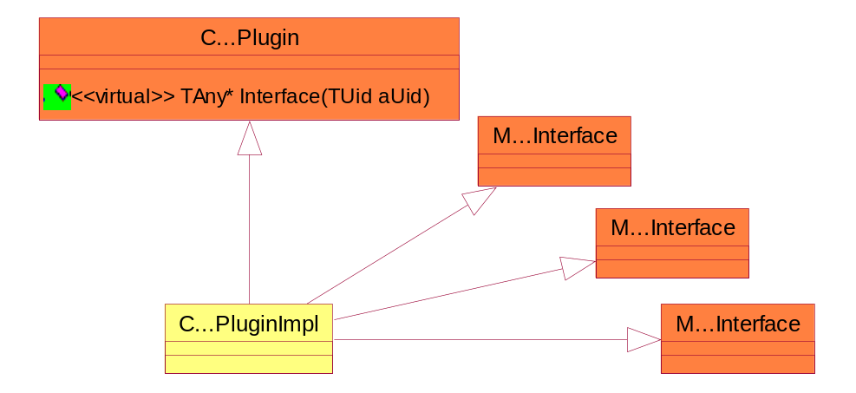
Figure 16 Plug-in implementation - normal approach

However, alternative designs are possible. Figure 17Illustrates one such alternative design:
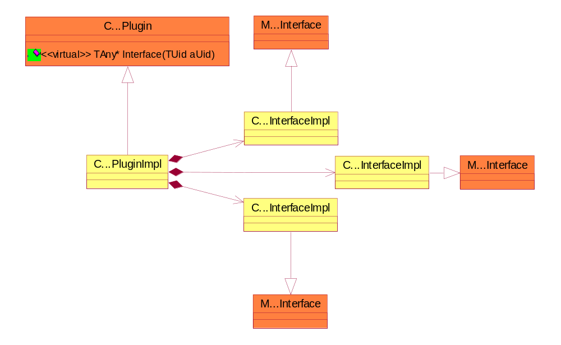
Figure 17 Plug-in implementation - alternative approach
In each diagram orange denotes Symbian code and yellow denotes licensee/reference code.
Note that the class names used do not always strictly conform to the above patterns. For example, the Plugin Base for the HCTL uses the class name of CHCTLBase instead of CHCTLPlugin, the Plugin Implementation for the reference QDP is CHCISymbianQdp instead of CHCICmdQueueDecisionPluginImpl and so on.

Disadvantages of using this pattern
- The number of DLLs in the HCI layer is increased by at least one for each Plugin. Since the reference code uses a separate DLL for each Plugin Implementation that means two extra DLLs per plugin using the reference code. This is not a serious disadvantage.
- A plug-in system is naturally more complex and slower than static linkage of all the DLLs. This is however a small price to pay for the advantages detailed above.
- The C…Plugin API is fixed and cannot be extended as adding any more virtual functions would break the Plugin Functionality Providers. However, this is not a problem as the class does not provide the plugin interface directly but simply provides a generic method of obtaining an interface class via the pure virtual Interface method. For more information refer to the plug-in base headers under hci_v2\implementations\...\interface or in the Developer Library.

Reasons for Design Decisions
- Choice of a separate DLL per Plugin Base
The first design idea was to have a single DLL providing all the Plugin Interfaces so as to keep the number of DLLs to a minimum and because each Plugin Interface DLL is so small. However, the fact that only two of the four plugins are required by the framework meant that if would be advantageous to have at least three DLLs so that the optional plugins could be removed at ROM build time. At this point it became clear that four DLLs would provide a clearer picture than three DLLs for hardly any extra cost.
- Choice of separate DLL per Plugin Implementation
This choice was made for Ease of Customisation as it means that each aspect of the HCI framework can be independently replaced at ROM build time. See Section 2.2.1 DLL Overview.

Symbian Component Designs

Command Queue Design

Introduction to the Command Queue and the QDP

Motivation for the Changes
The original HCI had several limitations from the perspective of the handling commands and events:
- Commands and events were passed over a wide interface between the Stack and the HCI – i.e. there was a function for each command and event. This meant that adding in any new commands (e.g. for Bluetooth 2.0) resulted in a source break between the Stack and the HCI.
- Events were handled independently of commands, so an event received by the HCI would be passed straight to the Stack. For error events the Stack had no way of knowing what command generated the event, as the HCI specification [R11] allows error events to be incomplete. For example: there are three physical links, one of which has requested a Mode Change. A Mode Change error event is received, but the Stack has no way to know to which physical link this event applies as it does not have the original command.
- If the HCI needed to send extra commands to accommodate the hardware, the HCI writer had no real choice but to implement a second command queue (in addition to the one in the Stack) to handle the command credits, writing to the HCTL, etc.
- Any hardware dependent handling of commands (e.g. resends, timeouts) had to be handled in the duplicate command queue rather than the Stack’s
The new design of the Command Queue aims to resolve these problems:
- Commands and events will be derived from base classes CHCICommandBase and THCIEventBase. Pointers to these classes will be passed between the Stack (via the Command Queue) and the HCI via thin interfaces, easily allowing for future new commands and events to be added.
- Events will be passed back through the Command Queue to be matched up to originating commands, where possible.
- The Command Queue will be separated out from the Stack to allow other DLLs to use it (e.g. the HCI).
- The creation of a “Queue Decision Plug-in” (QDP) to the Command Queue. The QDP DLL is provided by the HCI writer, and is used by the Command Queue to make hardware specific decisions relating to commands and events.
The Command Queue is part of the Bluetooth Stack and is Symbian-owned code. The QDP is a licensee-written ECOM plug-in implementing the Symbian defined interface MHCICmdQueueDecisionInterface. The Command Queue uses this interface to obtain decisions on commands that could be influenced by hardware factors.

What to Read Next
By their nature, the Command Queue and the QDP are quite tightly bound together.
If you only wish to know about sending commands and receiving events: read the next two sections of this document: the overview (section 4.1.2), and the description of the various interfaces to the Command Queue (section 4.1.3.1).
If you wish to know about the implementation of the Command Queue: ensure that you have read section 5.1 on the QDP design before going on to read section 4.1.3.2 which describes the Command Queue implementation. This is because the internal logic of the Command Queue is very dependent upon the requirements of the QDP interface.
If you wish to know about the QDP: read section 5.1 on the QDP design first, and refer back to the Command Queue sections as necessary.

Command Queue Design Overview
The main function of the Command Queue is to accept representations of HCI commands and arrange for these to be formatted and sent. Command-related events resulting from execution of these commands in the Bluetooth hardware are received by the Command Queue from the HCI, matched to the initiating command and both are forwarded to the originator of the command. The Command Queue also deals with unsolicited events which can occur without a prior command being sent, e.g. Mode Change Events.
The functionality of the Command Queue is augmented by a Queue Decision Plug-in (QDP), which allows licensees to make decisions on workarounds for specific-hardware.
The description of the design is split into three sections:
- This overview describing the classes used by the Command Queue and the basic rules for sending a command
- Section 4.1.3.1, describing the public interfaces of the Command Queue: MHCICommandQueue, MHCICommandQueueClient, CHCICmdQController
- Section 4.1.3.2, discussing the implementation of the Command Queue: CHCICmdQController and CHCICommandQItem

Command Queue Classes
The implementation of the Command Queue will be in a single DLL - hcicmdq.dll – which will be statically linked from the stack (bt.prt)(see section 2.3).
Section 2.9 describes the “command path” - how the commands are passed between client of the Command Queue, the Command Queue and the HCI.
Figure 18 hows the key classes which make up and which interact with the Command Queue component.
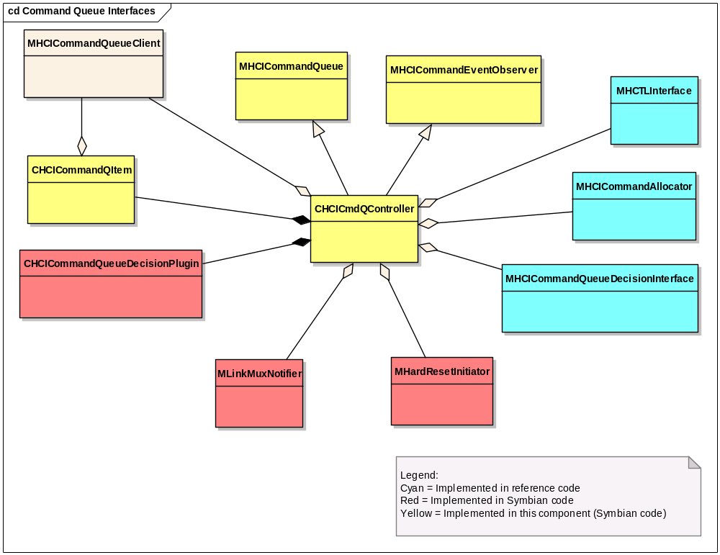
Figure 18 Command Queue Interfaces
Symbian defines all the interfaces used by the Command Queue. However, some of the implementations are reference code, and some are Symbian code. The exception is MHCICommandQueueClient, used to notify a command’s originator of events related to that command, which is implemented by any client of the Command Queue, either reference (HCI) or Symbian (Bluetooth Stack).
Function-level documentation of these classes can be found in the Symbian OS Library.
Symbian Implemented Classes
- MHCICommandQueue is the client interface to the command queue. Clients use this interface to add commands to the queue. These clients are notified of events or errors generated by the command via their implementation of the MHCICommandQueueClient.
- CHCICmdQController is the main class in the Command Queue. It implements MHCICommandQueue and also presents a fuller interface to the Stack to allow the Stack to initialise, set-up and control the Command Queue.
- MHCICommandEventObserver is implemented by CHCICmdQController and is the interface the Core HCI uses to give command-related events to the Command Queue for processing.
- CHCICommandQItem is the main class passed around the Command Queue. It wraps up the high-level representation of a command (CHCICommandBase), used by the Queue’s clients, and the low-level representation (CHCICommandFrame), used by the HCTL, along with information on the state of the command item within the Queue.
- CHCICmdQueueDecisionPlugin is used to obtain the hardware specific QDP plug-in interface (MHCICmdQueueDecisionInterface).
- MLinkMuxNotifier is implemented in the Stack and is used by the Command Queue to get permission to write a command to the HCTL.
- MHardResetInitiator is an interface provided to the Command Queue by the stack in the first instance, and is used to trigger a hard reset. For more information on the hard reset sequence, see sections 2.5 and 6.1.2.1.
Licensee Implemented Classes
- MHCICmdQueueDecisionInterface is the interface which must be implemented by the Queue Decision Plug-in, and is used by the Command Queue to obtain hardware- and licensee-specific workaround decisions for commands. See section 5.1.2.2 for more information on this interface.
- MHCICommandAllocator is used to obtain new CHCICommandFrame objects of the correct size for the command.
- MHCTLInterface is the interface used to write commands to the Bluetooth Controller.
Figure 19 shows the relationships between some of the interfaces implemented and used by the Command Queue.
STACK

COMMAND QUEUE
HCI
MHCICommandQueueClient
MHCICommandQueue
MHCICommandEventObserver
CHCICmdQContoller
MHCICommandQueueClient
Commands from Stack
Command Queue control

Command results
Commands from HCI
Command results
Event notifications (from HCTL)
Figure 19 Principal interfaces of the Command Queue
The above diagram shows that the HCI can act as a Command Queue Client – it can send commands to the command queue and receive events relating to those commands through the interface MHCICommandQueueClient. Note however that the reference implementation of the Core HCI component supplied by Symbian does not actually do this – in this respect the diagram above therefore reflects a potential licensee implementation not the Symbian reference code.

Command Rules
This section aims to summarise the rules that form the basis of the Command Queue logic as an aid to the reader. The rational for these rules is explained in various sections of the Command Queue and QDP designs.
Requirements for Sending a Command
- The HCTL command channel is open
- The Command Queue has enough command credits
- There are no commands with the same op-code that have been sent but have not yet completed
- The QDP allows the command (MhcqdiCanSend interface)
Resends
- Resends take priority over everything
- Workarounds can only be interrupted by resends (not by priority commands)
- Only one active resend at a time (blocking between resend commands)
Events
- Events matched to a command go back to the originator – which is not necessarily the stack
- Events not matched to a command will go back to the unmatched event observer (the stack).
Workarounds
- Only one active workaround at a time
- Each command of a workaround must complete before the next one is sent (workaround blocking)
- Only one-level of workaround (No grand-children are allowed)
Reset and Initialisation
- When the Command Queue is reset, only initialisation commands will be sent until the Command Queue is started
Command Order
- Normal and Initialization commands are sent in FIFO order
- Priority commands are sent in “first available” order (skip commands that would block)

Detailed Design

The Interfaces

MHCICommandQueue
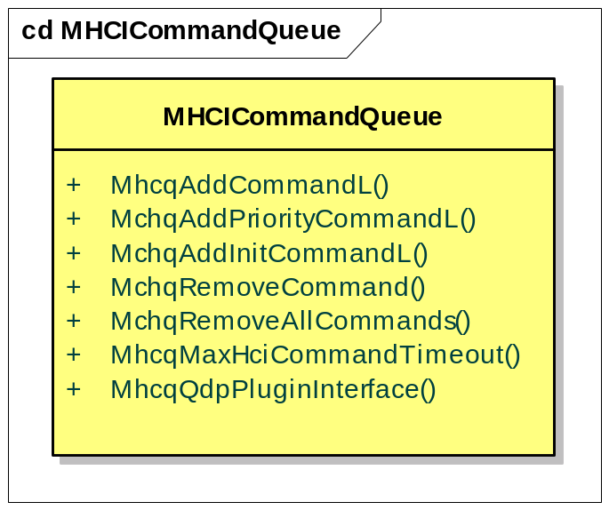

This class is owned by Symbian. Detailed function-level documentation can be found in the Symbian OS Library.
This mixin interface is used so that licensee components (e.g. HCI, Initialiser) access the Command Queue via a v-table rather than forcing them to statically link to hcicmdq.dll (although static linking may be needed in order for the user to construct a CHCICommandQItem object – each of the “Add Command” methods has one overload which takes such an object as a parameter). This also keeps the full CHCICmdQController interface exclusive to the Stack, preventing any client resetting the Queue, removing commands for a whole link, etc. A pointer to MHCICommandQueue is passed to the various clients by the Stack on initialisation (see section 2.3.2.3).
The functions to add commands come in two overloads. One overload takes a CHCICommandBase-derived command and creates a CHCICommandQItem. The other overload takes an already-existing CHCICommandQItem. This allows clients to avoid out-of-memory problems by pre-allocating important commands (e.g. Reset). All these functions take ownership of the command objects that are passed to them.
There are three ways to add commands to the queue:
- MhcqAddCommandL to add normal, non-priority commands.
- MhcqAddPriorityCommandL to add priority commands.
- MhcqAddInitCommandL to add initialisation commands.
Normal commands and initialisation commands are sent in the order they are added to the queue. Priority commands are sent ahead of non-priority commands, not necessarily in the order they are added to the queue. If a priority command would block (i.e. insufficient credits, QDP says it can’t be sent or there’s a duplicate in flight), then the scheduling logic skips it and considers subsequent commands on the queue, until one that can be sent is found or end of the queue is reached. Priority commands do not interrupt workarounds as child commands only make sense in the order they are given. Interspersing other commands amongst them may damage the workaround they are trying to implement. This also simplifies the implementation and is similar to how the V1 HCI architecture operates.
The rationale for the different priority command scheduling policy is because the command queue is intended to be used by multiple different distinct clients both within the stack and the licensee HCI and QDP. As such without this policy one client could deadlock the priority queue and thus potentially cause failed connections through timeouts. Priority queue provides a lower latency for commands to be sent, but they lack any ordering. This is a reasonable requirement as low latency commands will normally be in response to a request (1-to-1 mapping) - whereas other commands should be put on the normal command queue. The key benefit is that an individual client of the command queue does not need to have system-wide knowledge about other clients who may use the priority queue and deadlock it. Currently there might not be a case where this might happen - only replying to authentication based requests from the controller is where priority is needed. However the command queue is intended to be agnostic to commands and events (as much as it can be), as there may be other uses in future.

Initialisation commands are used by the Stack and HCI after a reset to re-initialise the Bluetooth Controller. They can only be added while the Command Queue is in its reset state (see section 4.1.3.2.3). Initialisation commands are sent in the order they are added to the queue (with workarounds and resends operating as normal.)
Adding a command will return a command ID that can be used to later identify the command (e.g. when requesting its removal from the Queue, or internally for monitoring the head of the pending queue for watchdog purposes). The Command ID is a TUint generated by incrementing a TUint each time another ID is required. Eventually the TUint will wrap around to 0 but by that time the previous command with ID 0 will have gone. Creating an ID when the CHCICommandQItem is created could have been done, however pre-allocated items may last for a long time which would increase the chances of reusing the same ID, so it is better to create the ID on addition to the Command Queue.
A client adding a command passes a pointer to a MHCICommandQueueClient so that it can be notified of the events and errors generated by the command. This allows non-Stack clients (e.g. the HCI) to receive events generated by their commands.
MhcqRemoveCommand allows the command queue client to remove a pending command with a given ID from the queue.
MhcqRemoveAllCommands enables the MHCICommandQueueClient that was provided to the MHCICommandQueue interface to be safely deleted. This should always be done so as to prevent the possibility that the commands added by the client are still in the command queue, where if this call is not made they ultimately would try to call back to the client on an invalid pointer.
MhcqMaxHciCommandTimeout is a getter to allow the QDP to determine the maximum allowable timeout it can specify for a command. This constant is obtained at runtime rather than compile time to avoid potential compatibility problems if the value changes.
MhcqQdpPluginInterface is a forwarding function which passes the command client’s request for an interface on to the QDP. This would allow licensee code in for example the Core HCI to interact with an additional licensee-defined interface implemented in the QDP – it is not permitted to request the MHCICommandQueueDecisionInterface itself, since this is designed to be used by the Command Queue only.

MHCICommandQueueClient
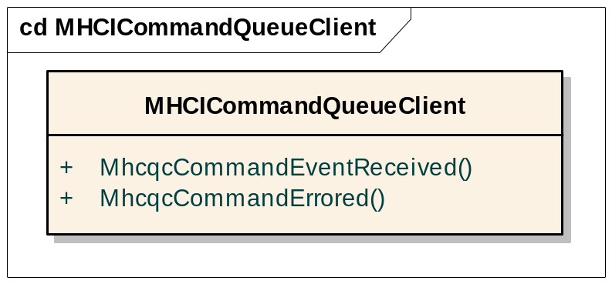

This class is owned by Symbian. Detailed function-level documentation can be found in the Symbian OS Library.
This class is the pair to MHCICommandQueue, as it receives the notifications of events and errors generated by a command
MhcqcCommandEventReceived is used as follows:
- If an event is received which can be matched to a command, then MhcqcCommandEventReceived will be called on the MHCICommandQueueClient object associated with that command. The event may be either anerror event or a non-error event. The event and the command to which it has been matched will both be passed as parameters to the function.
- If an event is received which cannot be matched to a command, then MhcqcCommandEventReceived will be called on the unmatched event observer associated with the command queue (see section 4.1.3.1.3). In this case the event will be passed as one parameter to the function but the command parameter will be NULL, since there is no command able to be associated with this event.
- At the end of a work-around sequence, the QDP may supply faked “unsolicited events” which will then be passed by the Command Queue to its unmatched event observer via a call to MhcqcCommandEventReceived. The command parameter will again be NULL. See section 4.1.3.2.6.
MhcqcCommandErrored is used as follows:
- When the QDP rejects a command with an error code. In this case the attempt to send the command will be failed (see section 5.1.2.6). The error code and the CHCICommandBase-derived command object are passed as parameters.
- When the QDP has determined that a timeout should be applied to a command, and no event to complete that command has been received within the timeout interval specified by the QDP. See sections 4.1.3.2.11.1and 5.1.2.7. The error code used in this case will be EHardwareFail, the CHCICommandBase-derived command object will also be supplied as a parameter.
- When a command has been scheduled for sending but the HCTL returns an error while writing the command frame. The error code returned by MhiWriteCommand and the CHCICommandBase-derived command object are passed as parameters.

CHCICmdQController
cd CHCICmdQController
MHCICommandEventObserver
MHCICommandQueue
CHCICmdQController
+
SetHCTLInterface()
+
SetHCICommandAllocator()
+
SetLinkMuxNotifier()
+
SetHCIUnmatchedEventObserver()
+
SetHardResetInitiator()
+
SetPhysicalLinksState()
+
Initialise()
+
Reset()
+
Start()
+
DoSend()

This class is owned by Symbian entirely. Detailed function-level documentation can be found in the Symbian OS Library.
The exported interface of CHCICmdQController allows the Stack to reset and initialise the Command Queue.
- The Set functions are used during Stack boot-up to tell the Command Queue about other parts of the HCI (see section ).
- Reset purges the Command Queue of commands and puts it into a state where no commands may be added to the queue. Reset is performed with an asynchronous break, as described in section 4.1.3.2.3.
- Initialise is used to put the Command Queue into a state where initialisation commands only may be added to the queue. It must be called after Reset has been called, but may be either before or after the asynchronous completion of the Reset operation (which is done by the internal method DoReset).
- Start instructs the Command Queue to start accepting any commands. It may only be called after both Initialise has been called and the full completion of the Reset operation (i.e. when DoReset has been called).
- DoSend forms part of the HCTL flow control mechanism described in section and is called once the HCTL channel is ready to be written to.

CHCICommandQItem
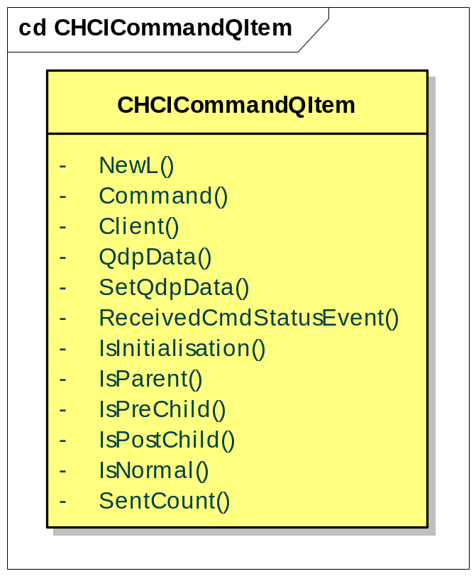
This class is owned by Symbian entirely. Detailed function-level documentation can be found in the Symbian OS Library.
The exported public interface to CHCICommandQItem consists of a NewL to create a new item and getter/setter functions for data items and status conditions that components using these items need to access. The full interface contains other public, non-exported method for use by the Command Queue only. The implementation of this class is described later, in section 4.1.3.2.1.3.
The NewL factory method takes the following parameters:
- an MHCICommandAllocator which is used to create a new CHCICommandQueueFrame which will be the low-level representation of the command.
- an MHCICommandQueueClient which is stored for later use in sending events and errors back to the originator of the command.
- a CHCICommandBase-derived command object which is the high-level representation of the command to be sent.

The Implementation

Queue Structure

The Queues
The Command Queue internally maintains six queues:
Normal Queue. Commands are added to the normal queue by the MhcqAddCommandL method of MHCIComandQueue. Commands are added to the tail of the queue. The queue is in send order, with the next command to be sent at the head of the queue.
Priority Queue. Commands are added to the priority queue by the MhcqAddPriorityCommandL method of MHCIComandQueue. Commands are added to the tail of the queue. The send order is determined dynamically. The scheduling loop walks the queue from front to tail seeking for the first command that would not block and sends that command.

Resend Queue. When a command fails and the QDP requests a resend, the command is placed on a specific resend queue. The reasons for having a separate queue are:
- Resends can easily be processed ahead of items on the other queues, without upsetting their current state.
- It is possible that several commands might fail, and require resending. If we are not able to resend immediately, this may lead to a situation where we have more than one command waiting to be resent at the same time.
- We may be unable to resend immediately if the Command Queue is blocked for any reason.
- Even if the Command Queue is not blocked, there is an asynchronous break between a LinkMuxer::TryToSend call and the subsequent DoSend call which allows us to send the command. During this break another event may occur which completes a command with error, and triggers another resend.
The queue is in send order, with new commands added to the tail of the queue – i.e. commands are resent first-in, first-out. However, if a command fails for a second time and is again resent, it will then be added to the front of the queue. Each item on the resend queue will be re-sent until it succeeds or the QDP gives up. See section 4.1.3.2.10.4 for more information on processing error events and resends.
Sent Queue. Once a command has been sent it is placed at the tail of the sent queue so that the event processor can find commands to match to events. This queue could be ordered by op-code to optimise the search when matching commands with events or looking for duplicate op-codes. However, the number of commands on the send queue will be of the order of the largest number of command credits the controller gives the Command Queue. Since this size will often just be one and is highly unlikely be in double figures, the extra complexity and processing to order the queue is not worth the effort. Also it is likely that most commands will complete in send order, so a search from oldest to newest item on the queue should be reasonably efficient.
Commands will be removed from the Sent Queue once they have concluded (the final event or error has been received for the command).
There are certain commands which do not generate a corresponding event to complete the command. These commands also have the property that they do not consume any command credits. Therefore commands which consume zero command credits will not be added to the Sent Queue, otherwise they would accumulate in the queue, which could grow indefinitely as a result.
Initialisation Queue. This is a variation of the Normal Queue solely for initialisation commands. Commands are added to this queue using the method MhcqAddInitCommandL. It is processed by the Command Queue in exactly the same way the Normal Queue is, but only between calls to Initialise() and Start(). Having a separate Initialisation Queue allows normal commands to be accepted onto the Normal and Priority Queues while the Stack and HCI are still setting up the controller. See section 4.1.3.2.3 for more details.
Workaround Queue. Commands are moved to the workaround queue when the scheduling logic chooses a command for execution and QDP deems it in need of a workaround. Commands are added to the tail of the queue, though with the current design there can only be one workaround in progress - no command from the other queues, except for resends, will be scheduled until the workaround sequence is finished. The queue is in send order, with the next command to be sent at the head of the queue.

and Figure 21 show examples of the queue structure in action. For more examples on how the queues get manipulated, see the sections on workarounds (4.1.3.2.1.2) and resend/error processing (4.1.3.2.10.4).

A
Pending Normal Queue
Sent Queue
B
Pending Normal Queue
A
Sent Queue
B
A
Pending Normal Queue
Sent Queue
Command B is added to queue
Command A is sent
Pending Normal Queue
B
A
Sent Queue
Pending Normal Queue
B
Sent Queue
Command B is sent
Command A concludes

Figure 20 Queue Example: Two Commands

B
A
Pending Normal Queue
Sent Queue
Pending Normal Queue
B
A
Sent Queue
B
Pending Normal Queue
A
Sent Queue
Command A is sent
Command B is send
Pending Normal Queue
B
Sent Queue
Pending Normal Commands
A
B
Sent Commands
Command A fails
QDP says resend
Command A is resent
A
Resend
Queue
Resend
Queue
Figure 21 Queue Example: Resend

Workaround Handling
Section 5.1.2.4 describes the workaround facility and interface of the QDP.
The Command Queue needs to keep track of commands which the QDP decides to pad with “child” commands. This workaround handling could be quite complicated; fortunately there can only be one active workaround in the system at any one time, because the Command Queue must wait for the result of the previous workaround command before sending the next one and the Workaround queue has higher priority then the Priority, Normal and Initialisation queues, which means they will not be looked at by scheduling logic until the Workaround queue is empty. Since at any given moment there is at most one active parent and one child the Command Queue does not need to keep pointers between the two to link them together.

A
Pending Normal Queue
Sent Queue
A_{P}

B_{C}

Pending Normal Queue
Sent Queue
A_{P}
Pending Wrkrnd Queue
Sent Queue
QDP determines
QDP returns pre-child B
A requires a workaround – A is moved to the Wrkrnd Q
A requires a workaroundB is inserted at the head
does not need a workaround
QDP determines Z
Z_{N}

C is sent
Z
Client adds command Z
Command Queue waits for result of A
Z
QDP returns no more pre-children
B completes
A_{P}

Z_{N}

Z
Z
A_{P}

Sent Normal Queue
Sent Wrkrnd Queue
Sent Sent Queue
Sent Normal Queue
Sent Wrkrnd Queue
Sent Sent Queue
A
Pending Wrkrnd Queue
A
Pending Normal Queue
A_{P}

B_{C}

Pending Wrkrnd Queue
A_{P}

C_{C}

B_{C}

A_{P}

Z is not sent as the Command Queue is waiting for the result of A

Z is sent
Z is not sent as the Command Queue is waiting for the result of C
Z

C completes
QDP returns no more post-children, returns no faked unsolicited events
A completes
QDP returns post-child C
Z

A is sent

Command Queue waits for result of B
B is sent

C_{C}

A_{P}

Figure 22 Queue Example: Workaround Handling

Command Queue Items (CHCICommandQItem)

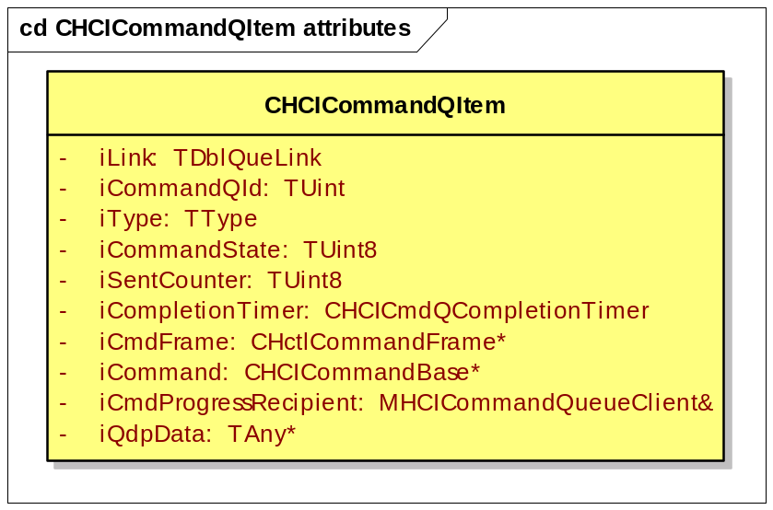

CHCICommandQItems are the objects that are passed round the Command Queue. The figure above shows the data held by a CHCICommandQItem – the interface contains get/set methods to access this data.
As well as the command ID, the low-level (CHCICommandFrame) and high-level (CHCICommandBase) descriptions of the command, the class contains a link object to use with the various queues and a type to indicate the command’s state within the queue (unknown, normal, parent, pre- or post- child).
Having two representations of the command is not memory efficient; however it decouples the requirements of the Stack, which is interested in the parameters of the command, from the HCI which is interested in the hardware specific, over-the-wire format of the command. See also section 2.9.1.
iCompletionTimer can be used at the QDP’s request to ensure that action is taken if the command does not conclude in a certain time.
iCommandState is used to hold status flags about the command, this could be:
- ECmdSent, indicates that the command has been sent.
- ECmdResent, indicates that the command has been resent at least once.
- EReceivedCmdStatusEvent, used as a check on asynchronous events, where a Command Status Event should always be received before any other event related to the command. This is provided to help the QDP determine if the hardware is behaving incorrectly.
- EDuplicatedOpcode, set for a command on the sent queue when an attempt is made to send another command but it is blocked because it has the same opcode. Triggers re-evaluation of the block on the other command when the “duplicated opcode” command is completed.
- EInitialisationCmd, used to differentiate a command added as an initialisation command using MhcqAddInitCommandL.
iQdpData is provided for the QDP to maintain any state it requires on a per-command basis
iCommand can only be set at construction as CHCICommandQItem is not designed to be reused. Reusing these objects for different HCI commands was considered but is too complicated for the possible benefits owing to the varying size of the underlying CHCICommandBase and CHCICommandFrame classes.
iCmdProgressRecipient identifies the Command Queue Client which should be notified of any events associated with this command.
iSentCounter is a count of how many times this command has been sent. It may be used by the QDP to impose a limit on the number of retry attempts for a given command.

Queue Flow
Figure 23 shows the overall high-level flow of the Command Queue - how the controller processes commands and events. Table 1 explains the various functional blocks.
The queue works as an asynchronous loop, triggered by adding a command, receiving an event or requesting a reset, repeating until there are no more commands to send or the next command to send is blocked. In these cases the loop will be restarted by a new command or an event to clear the block.
Run Queue is called asynchronously, so any code that alters the state of the queue (e.g. command addition, reset, command completion) triggers the asynchronous call-back. This prevents continuous looping around the queue in one call stack. For example an event could cause the loop to repeat several times if the QDP rejects all the remaining commands on the pending queue. As Event Processing will itself be running from a CActive::RunL it is undesirable to spend too long in that call-stack performing the loop.
The other asynchronous jump is between Try To Send and Do Send, as the Command Queue asks permission to send from the link multiplexer (MLinkMuxNotifier). See section .
Run Queue
Key
Add Command
OK to send command?
Setup Next Workaround Command
Try To Send
Do Send
Command Timeout
uses/calls
synchronous flow
asynchronous flow
Start
Reset
No – QDP rejects the command
Yes
HCTL Event handling
Stop

No – blocked
Figure 23 Simplified Command Queue Flow

Function | Purpose
Add Command | Handles new commands coming in from clients. Places them at the appropriate point on the normal, priority or initialisation queue.
Start | Puts the Command Queue into a state where commands other than initialisation commands can be sent.
Reset | Clears the internal queues. By the time the asynchronously operating second phase of the reset process (DoReset) is executed, it is possible that Initialise has been called and initialisation commands added, hence the need for Reset to asynchronously trigger Run Queue.
HCTL Event Handling | Handles events from the HCTL. Matches events to commands, notifies the QDP and the client/stack, clears blocks as appropriate
Command Timeout | Activated if a command is not completed within the time specified by the QDP. Notifies the QDP and the client/stack, clears blocks as appropriate.
Run Queue | Tries to find a command to be sent on the pending queue/initialisation queue/resend queue. Uses “OK to Send Command” to assist with the decision as to whether a command can be sent.
Setup Next Workaround Command | Used to select the next workaround command – called when a command requiring workaround is identified, and whenever a workaround command, child or parent, has concluded (hence why it is used in several places).
OK to Send Command | Helps “Run Queue” to decide if a particular command can be sent. Checks blocks, command credits, QDP if it is possible to send the command now. Possible results:  - command blocked, stop flow until next event  - command rejected, delete it and re-schedule Run Queue to check for next command  - command OK to send, try to send command
Try To Send | Calls MLinkMuxNotifier::TryToSend in the Stack to request permission to send the command. There is only ever one outstanding call to TryToSend at any time.
Do Send | Called once MLinkMuxerNotifier has determined the HCTL is ready to receive the command. Writes the command to the HCTL
Table 1 Functional Blocks of the Command Queue

Initialisation and Reset
When the Stack creates the Command Queue controller, using CHCICmdQController::NewL, the Command Queue will:
- create the normal, priority, workaround resend and sent queues
- create CHCICmdQueueDecisionPlugin to load a QDP
- use the CHCICmdQueueDecisionPlugin::Interface to obtain a MHCICmdQueueDecisionInterface pointer
- initiate the reset process (described below)
The QDP can be updated, so although only one QDP implementation will be used, there can be multiple versions available, of which ECOM will select the latest. (See section 3.3.2)
If the Command Queue cannot find a QDP to load, it will panic. If more than one implementation is present, the entry specified in cmdq.ini will be used, which if not present will result in the Command Queue panicking.
After the stack has created the Command Queue Controller, it will supply it with references to the other HCI interfaces (see section 2.3.2.3).
When CHCICmdQController::Reset is called, the command queue enters “EResetting” state, the ends of the normal, priority, workaround and initialisation queues recorded and an asynchronous call is triggered to the DoReset method. This method completes the reset operation as follows:
- purge the sent and resend queues completely
- purge the normal, priority, workaround and initialisation queues to the markers
- inform the QDP of the reset
- reset any other state, including clearing all blocks
- record the initial number of command credits supplied by the QDP
The reason for using an asynchronous reset mechanism is to avoid the Command Queue becoming re-entrant if the QDP triggers an HCI reset.
Once CHCICmdQController::Reset has been called, CHCICmdQController::Initialise may be called to place the Command Queue in an initialisation state where only items added to the initialisation queue will be sent. If this is done whilst we are still in EResetting state, then we will go into EResetInit state and subsequently into EInitialising when DoReset runs. The other scenario is that the Command Queue may transition from EResetting to EUnitialised state when DoReset runs, and subsequently into EInitialising when Initialise is called. In either case, the initialisation states EResetInit and EInitialising allow the Stack and HCI to set-up the controller without interference from other clients, without having to rejecting any commands.
The initialisation state will exit when CHCICmdQController::Start is called. Note that subsequently trying to add initialisation commands will cause a panic.

Adding Commands
As described in 4.1.3.1.1, client of the Command Queue can add commands to the queue using the one of the “Add Command” method variants.
MchqAddCommandL simply adds a CHCICommandQItem to the tail of the Normal Queue.
MhcqAddInitialisationCommandL adds commands to the tail of the Initialisation Queue only while the Command Queue is in an initialisation state (after Initialise but before Start), otherwise it will panic.
MhcqAddPriorityCommand has a behaviour identical to MchqAddCommandL, only that it adds the commands to the Priority Queue.
Two overloads are available for each of the routines, one which will create the CHCICommandQItem object from supplied parameters and one which accepts a ready-created CHCICommandQItem object as a parameter. If the caller supplies a ready-made CHCICommandQItem (to avoid the risk of an out-of-memory condition) and does not attempt to add commands before Initialise is called, then they are guaranteed not to Leave.

Run Queue
The main aim of Run Queue (implemented by CHCICmdQController::TryToSend in the code, not to be confused with MLinkMuxNotifier::TryToSend) is to try to identify a command that can be sent. Depending upon the current state, this command may come from one of the regular queues (initialisation and normal queue), the priority, workaround and resend queues.
If there are commands present on the resend queue then these will take precedence. However, if there are no commands on the resend queue, or if it is not possible to try to send one of them at this time, then we will try the workaround queue. If the workaround queue is not empty, then its first command will be scheduled for sending or, if that command can not be sent, Command Queue will block and Run Queue will exit. If the workaround queue is empty, then the next queue to consider depends on current state. If the state is Initialising, then we will go straight to the Initialisation queue. If the state is Started, then we’ll process the priority queue, and then the normal queue if priority queue was empty.
The normal, initialisation and workaround queues are processed in strict FIFO order and if the head can not be sent, Comand Queue blocks. The priority queue however is processed with a different algorithm: it is scanned from its head in the search of the first command that would not block. The first such command is sent. If no priority command can be sent, then Run Queue exits.
If a suitable command is identified which can be sent then a request will be raised to the Link Muxer to try to send the command.
The decision as to whether a given command can be sent is largely implemented in Ok To Send Command, which is described separately. However, the boundary between Run Queue and OK To Send Command in the implementation is somewhat more complex than we will represent here – the reader should consult the code if a detailed understanding of the implementation is required.
Run Queue is scheduled to run whenever the state of the Command Queue has changed:
- command has been added
- reset actionned
- Start method called
- event received
- command sent/rejected
- command timed out
To assist with this logic to determine whether a command can be sent or not, the Command Queue maintains a set of flags called “blocks”. The following table shows three of the blocks (the remaining blocks will be coverered in the discussion of OK To Send Command):

Flag | Set | Cleared
Workaround block | When a workaround command is sent | When a workaround command concludes (in Set Up Next Workaround Command)
Resend block | When a resend command sent | When a resend command concludes (in Event Processing or Command Timeout)
Try to Send block | When a call to the Link Muxer is made to request permission to send a command to the HCTL. | When the Link Muxer calls our DoSend method to give us permission to send the command.
Table 2 Process Queue Block Flags
The Workaround block is to serialise workaround commands to ensure that the workaround is carried out in a more deterministic order, enabling the QDP to implement much simpler logic. However the Workaround block does not block commands from being resent.
The Resend block enforces a single resend at a time, so as to prevent the potential corner case where commands are live-“lock”-ing each other, and also to provide the QDP with a guarantee of order. The Resend block also prevents any non-resend commands (both normal and workaround) from being sent before the Resend is complete.
The Try to Send block serialises requests to the Link Muxer for permission to send a command, and is required for correct operation of the Link Muxer.
Note that there are further block flags which may be set by OK To Send Command (see Table 3 OK To Send Command Block Flags). These are used to cache the results of checks made within OK To Send Command, thus allowing us to save the cost of a call to OK To Send Command in the case where one of this set of block flags is set. These flags should not be be thought of as reflecting the true state of Command Queue, because they are only a sort of cache: if a flag is set, then the corresponding condition is true, but not the other way. This means that if one of these flags is not set, the corresponding condition has to be computed for the code to really know how it evaluates. This computation is done be OK To Send Command. Do not confuse these flags with the block flags in Table 2 Process Queue Block Flags which each act as the sole record of the corresponding blocking condition.
One particular thing needs to be done during workaround queue processing - command “set up”. This will happen if the head command has not been “set up” already, i.e. if it has an undefined state, which means that it is a command which has just been moved to the workaround queue. This happens when, during processing of the Normal, Initialisation or Priority Queue QDP returns True from MhcqdiDoesCommandRequireWorkaround. If the return from this call is true the current command will be moved to the Workaround queue, marked as a parent and the workaround handling invoked (see Set Up Next Workaround Command). This may lead to a pre-child work-around command being inserted at the head of the queue.
The logic described in OK To Send Command will then be used to determine whether the current command can be sent.
If it can be sent, then the logic described in Try to Send will be used to raise a request to the Link Muxer for permission to sent the command to the HCTL.
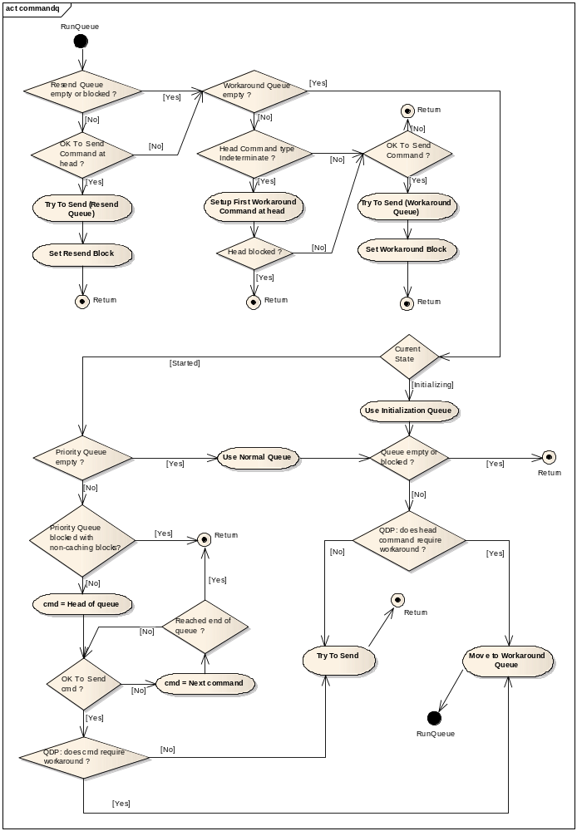
Figure 25 Run Queue

Set Up Next Workaround Command
This part of the command queue handles workaround related commands. It is invoked whenever the QDP identifies a command as needing a workaround, and every time a workaround completes. As the QDP interface needs to be passed the concluding event of each workaround command, and events are used synchronously and have a limited lifetime, this means workaround handling has to be done at the same time as the event processing
The aim of the Set Up Next Workaround Command is to ensure that the head of the workaround queue contains the next command in the workaround. It also tidies up and deletes commands and provides faked events as necessary. Child commands are deleted once their events have been reported to the QDP. The parent command lives until the end of the workaround, even after it’s removed from the workaround queue. Faked events supplied by the QDP must persist with valid data until at least the next time a faked event is requested of the QDP.

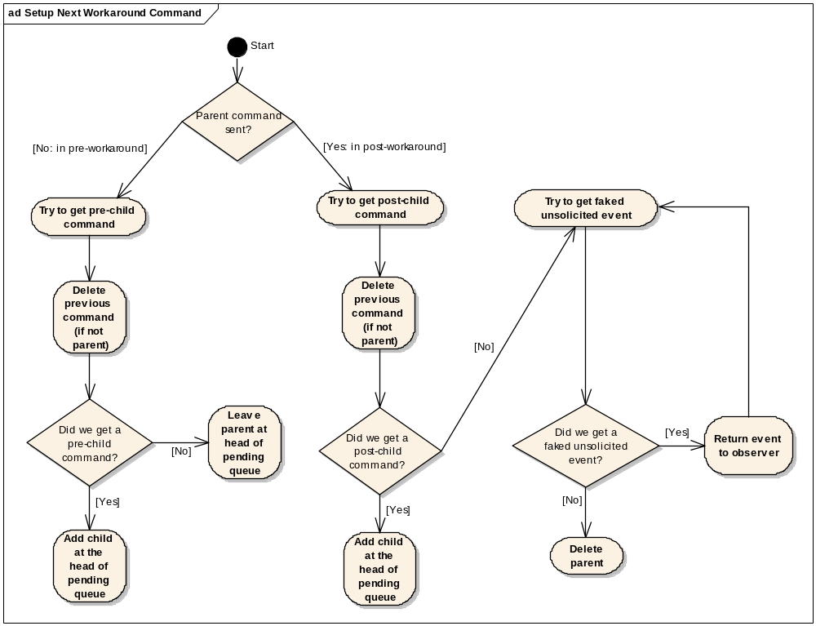
Figure 26 Set Up Next Workaround Command

OK To Send Command
This functional block carries out further checks to decide whether it is allowed to send the given command.
We have already discussed three blocking conditions checked by Run Queue in section 4.1.3.2.5. OK To Send Command checks for three further blocking conditions:
- Not enough command credits
- A command of the same op-code has been sent but has not yet completed
- MhcqdiCanSend returns EBlock
MhcqdiCanSend is called after the other checks (command credit and duplicate) so that the QDP has the opportunity to block and/or modify a command’s parameters when it would have otherwise been sent.
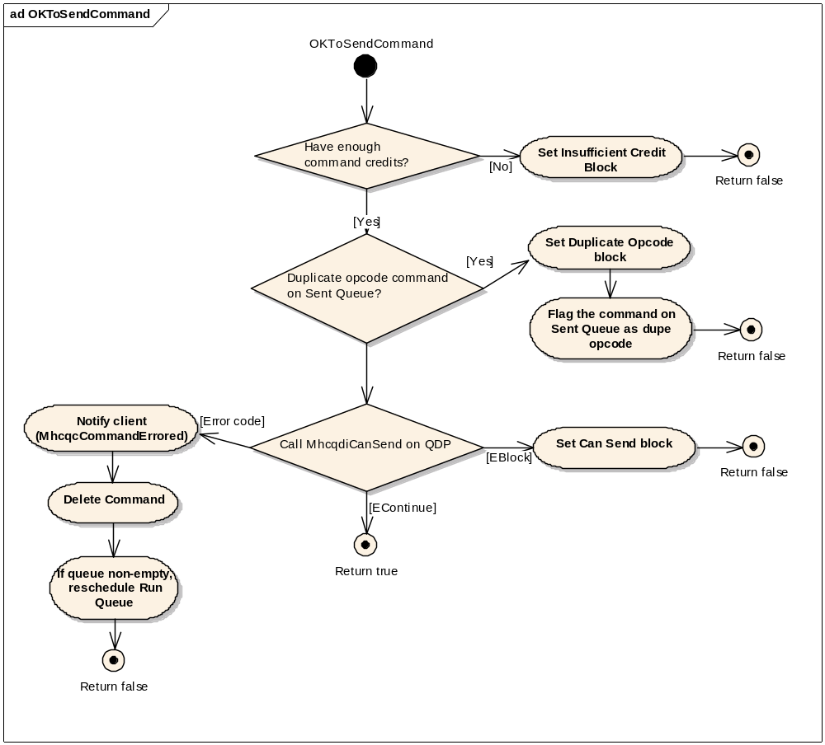
Figure 27 OK To Send Command
To avoid having to re-check for these conditions too often, the Command Queue will maintain flags, shown in Table 3, indicating if any of these conditions apply. If any of these “blocks” are set, Run Queue will bypass the call to OK To Send Command because it already knows the command is blocked. Once all the blocks have been cleared Run Queue again start calling OK To Send Command, which will re-check the block conditions. Clearing one of this set of blocks when it should not have been cleared is therefore not dangerous, it will just be less efficient. In fact, this is what the Priority queue processing does: every time a command is sent from this queue, the flags are cleared, because they don’t make sense for priority commands. Priority commands are sent in “first available” order, which means there is no real “head” of the queue, which is what the caching block flags pertain to. OK To Send Command needs to be called for each command on the queue separately, no matter what the cached flags say. Note however that this is not true of the set of blocks listed in Table 2 Process Queue Block Flags, which are not re-evaluated in OK To Send Command and must therefore only be cleared when it is certain that the condition causing the block no longer applies.

Block | Set | Cleared
Credit | If there are no command credits available, and the command to be sent requires command credit.  When an event is received which carries zero credits | Available command credits change  Head of the pending queue changes (e.g. priority command added)  Resend queue changes  Reset  Error event received  Command timeout
Duplicate Op-code | If the current command to send has the same op-code as a command that is on the sent queue | Event concludes the command on the sent queue with the duplicate op-code  Head of the pending queue changes (e.g. priority command added)  Reset  Error event  Command timeout
Can Send | When MhcqdiCanSend returns EBlock | Any event other that a command status event is received.  Head of the pending queue changes (e.g. priority command added)  Reset  Error event  Command timeout
Table 3 OK To Send Command Block Flags
Note that if the QDP returns EBlock and the sent queue is empty (putting the queue into a permenant block) the Command Queue will panic. See section 5.1.2.6.
MhcqdiCanSend can also return an error code which indicates that the command is to be rejected. In this case the command queue will notify the client of the command using the supplied error code, will delete the command, and if there are more commands pending on the queue, will reschedule Run Queue to process the queue again.

Try to Send
This function removes the command to be sent from its position on the queue. This command now becomes the current Sending Command.
A call is then made to the TryToSend method of the Link Muxer. This will result in an asynchronous call back to our DoSend method when the Link Muxer has established that the HCTL channel needed is available to us.
The TryToSend block is set, which means that no further send operations may be instigated until the Link Muxer has actionned the call back to DoSend.

Do Send
This function is called asynchronously from the Link Muxer when the channel to the HCTL is available for us to send the command.
The current Sending Command will be formatted for transmission and written to the HCTL. As the QDP can dynamically change the parameters of a command in MhcqdiCanSend (even between resends of the same command), the Command Queue will always reformat the command frame from the command before writing to the HCTL as the parameters are not fixed until this point.

The QDP is then asked whether a timeout should be applied to the completion of this command. This is done by a call to the method MhcqdiTimeoutRequired. If required, a call is made to CHCICommandQItem::StartCompletionTimer method on the current Sending Command. See also section (see 4.1.3.2.11.1).
The number of available command credits is decremented by the number needed for this particular command, and the command is moved from being the Sending Command, to the Sent Queue. The exception to this that commands consuming zero command credits will not normally receive any event in response, and will therefore be deleted rather than moved to the Sent Queue. An example of this is the Number of Host Complete Packets command.
If there are any commands still waiting to be sent, Run Queue will now be rescheduled.
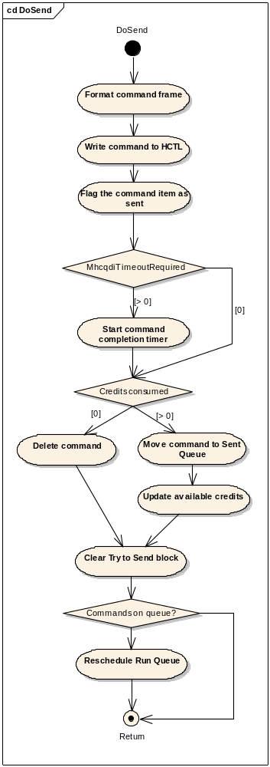
Figure 28 Do Send

Events (Event Processing)

Matching to commands
The Command Queue delegates the matching of events to the commands. On receiving an event the processor will iterate through the sent queue passing the event to the Match method of each command (CHCICommandBase::Match). The event is given to the command, rather than the other way round as this matches the way the Bluetooth specification is written; also there are more commands than events so each command has to check fewer op-codes.
This scheme puts the matching functionality into the reference code and allows the licensee to perform deep parsing to match events. The Symbian reference command code will not deep parse except for Mode Changes Events, which will be parsed to match them to the Commands that can cause them (e.g. Sniff Mode Command will match a Mode Change Event into Sniff Mode).
The Match function will also indicate if the event concludes a command – i.e. if the event is the final one for the command.
The event matching logic also needs to handle the following situations:
Inquiry Cancel Command: The Inquiry Cancel Command will cancel the current Inquiry Command without generating an Inquiry Command Complete Event. Thus the Inquiry Cancel’s Command Complete Event will have to match both Inquiry Cancel Command and Inquiry Command to prevent a leak in the sent queue. The upshot of this is that the Match function needs to return whether the event processor should continue looking for matches as well as if it matches the given command.
Periodic Inquiry Mode: This command completes immediately, resulting in unsolicited Inquiry Result/Complete events – which would get sent to the Stack by default, rather than the originator of the command. Rather than keeping the Period Inquiry Mode Command on the sent queue until it is cancelled (Exit Periodic Inquiry Mode), the Command Queue will conclude it when its Command Complete Event is received and let the QDP handle informing the correct client, if required.
Event matches command?
Error event
Process Event
Yes
No
Yes
No
Process Error Event
Continue matching?
Yes
No
Iterate through sent queue
Next command
End of queue
Process command credits
A
A
Notify QDP of Event
New Event Received

Figure 29 Matching Commands to Events

Unmatched events
If an event cannot be matched to a command the Command Queue will inform the QDP and send it to the unmatched event observer (the stack). (See section 5.1.2.5.) The QDP may wish to perform some validation of this, as some events should only be generated in response to a command being sent; if no command can be found to match these events this is an indication of hardware problems.
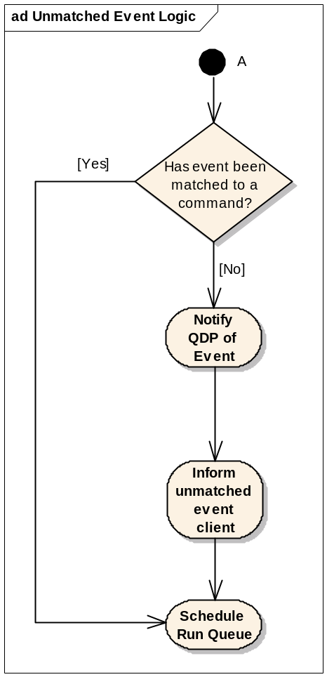

Figure 30 Unmatched Event Logic

Processing matched non-error events
If an event is matched to a command the Command Queue will inform the command’s client using the item’s MHCICommandQueueClient member. If the event concludes the command it will be removed from the sent queue and deleted. There is no need to store commands after they conclude with the exception of a parent command, which is required since the parent’s iQdpData could be being used by the QDP to store information on the current workaround.
Note that for workaround commands the client is not informed of the results of child commands as it would not be expecting the result. The QDP does not need to be notified of child-events through the client interface as it is informed of all events anyway and concluding child-events via the GetXXXChildCommand interface.
Event concludes command?
Workaround command?
Delete command
Yes
No
No
Cancel completion timer
Update blocks
Is command a child?
No
Yes
Notify client of event
Yes
Stop
Setup next workaround command
Figure 31 Processing a Non-error Event

Processing matched error events
Error events that are matched to a command are passed to MhcqdiMatchedErrorEventReceived for the QDP to decide whether to resend the command, or to continue and pass the error onto the client.
If the command is to be resent it is placed at the tail of the resend queue (or at the head, if this is a resend of a command that has already been resent one or more times). Items on the resend queue take priority over anything on the pending queue. If there is a blocked command at the head of the pending queue, the blocks will be cleared and the resend command processed in preference.
This policy means that it is possible for re-sends to interrupt workarounds (see section 5.1.2.7), implicitly re-order sequences of commands and interrupt sequences of priority commands.

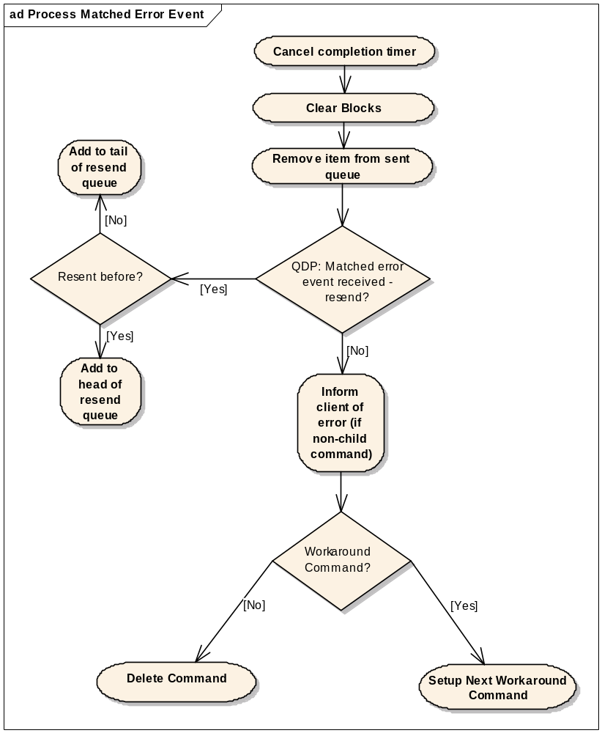
Figure 32 Processing a Matched Error Event

Notifying the Command’s Client of an event
To clarify when MHCICommandQueueClient is called:
- A non-error event is matched to a non-child command
- An error event is matched to a non-child command and the QDP does not require a resend
- An event is not matched to a command (call is made to the unmatched event observer)
For Vendor Debug events, it is up to the writer of the commands and events object to ensure that new events get matched to relevant commands. Matched Vendor Debug events will be passed on to the client of the Command Queue that issued the command. Typically this would be HCI Proxy which will pass the event on to its client. Unmatched Vendor Debug events would be processed as described above, so it is up to the HCI writer to write the QDP/Commands/Events to produce the desired behaviour.

Timeouts
The Command Queue manages two watch-dog timers to attempt to catch hardware failure or programming errors.

Command Completion Timer
Once a command has been sent, MhcqdiTimeoutRequired is called to allow the QDP to request that a timeout be set for the command. (see section 5.1.2.7).
If the timeout fires the Command Queue will process it as outlined in Figure 33. The call to MhcqdiCommandTimedOut allows the QDP to determine whether a resend attempt is made (QDP returns EResendTimedOutCommand) or whether the client is informed of the error (QDP returns EContinueWithTimeoutEvent).
If the QDP decides that the timeout indicates a fatal hardware error and initiates a Hard Reset, it should return EContinueWithTimeoutEvent.
MhcqdiCommandTimedOut is also responsible for determining the number of command credits to be refunded when a command has timed out. In order to be able to make this decision, the function is passed two additional parameters:
- the Command Queue’s record of the current number of command credits
- the current contents of the Sent Queue
If a timeout occurs whilst a work-around is in progress, the work-around sequence will be continued as normal with a call to MhcqdiGetPreChildCommand or MhcqdiGetPostChildCommand. The aPreviousCmdResult parameter supplied on this call will be NULL, since an associated event does not exist.

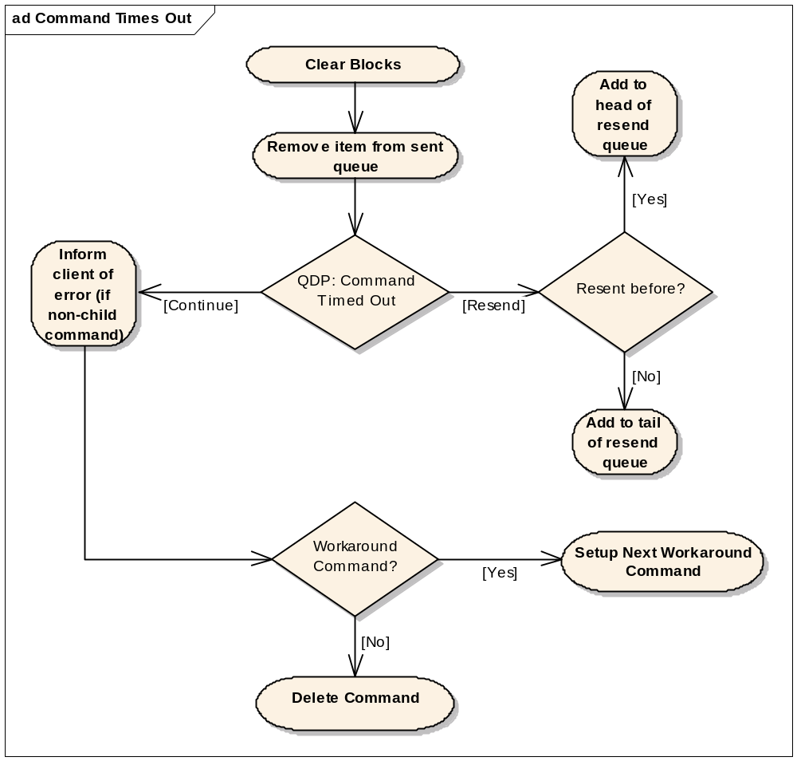

Figure 33 Processing a Command Timeout
The command completion timer is implemented as follows:
- Each CHCICommandQItem contains a timer object that can be activated as required.
- The timer is activated by a call to CHCICommandQItem:: StartCompletionTimer when the QDP has requested that a timeout be set.
A copy of the timeout object will therefore exist in every CHCICommandQItem object even though it may not be used – the additional memory cost of this design is accepted as a trade-off for reducing code complexity.

Queue Starvation Timer
A badly behaved QDP could deadlock the Command Queue:
- by continually returning EBlock from MhcqdiCanSend
- by continually asking commands to be resent (starving the pending queue)
- by continually rejecting commands
The final case is very difficult to catch (as to the Command Queue it is happily processing commands on the pending queue and it is not its job to monitor how many actually get sent) but the other two situations can be caught by a timer that monitors the head of the pending queue.
If the head of the pending queue has not changed during the period of the timer, this indicates that something is wrong. The timer will be active if there are any items on the pending, initialisation or resend queue – this catches the case where there was only one command that is continually being resent.
If the pending queue has not changed, the Command Queue should be able to diagnose the problem to raise a specific panic depending on how the queue is blocked (CanSend or Resend block)
The starvation timer should never expire before a command timer, as timeouts as a result of hardware failure should take precedence over programming errors in the QDP. For example the starvation timer might be 2 minutes whereas a command timer could be 10 seconds. This value can be a multiple of the maximum command timeout, with the relevant constants placed in a header that licensees can branch if required.
The starvation timer monitors the pending queue by Command ID rather than by reference to avoid the problems of the command in question having been completed and deleted before the timer expires. This should never happen but using the ID enables the Command Queue to raise an orderly Panic rather than to attempt to reference invalid memory locations which is to be considered a very serious error.

Performance
The largest factor affecting the performance of the Command Queue is how long the QDP takes to decide what to do with a given command (see 5.1.2.9). Where possible the Command Queue logic has been kept simple rather than deal with all the possible combinations of workarounds and command failures.
The asynchronous main loop will prevent the Command Queue hogging the thread when there are several commands and events to process, which helps give priority to the data path.

Component Future Work
None identified.

Reference Component Designs

Queue Decision Plugin Design

QDP Overview
The main purpose of the Queue Decision Plug-In (QDP) is to adjust the behaviour of the Command Queue for HCI commands in certain situations. This allows licensees to make hardware-specific decisions on how to deal with commands as a way of solving hardware defects without having to re-write the Command Queue.
Symbian owns the QDP interfaces, but it is up to the licensee to provide a QDP implementation tailored to their hardware. One QDP is provided by Symbian as reference code (section 5.1.3.1) – this contains a basic minimum subset of QDP functionality and may be used on devices for which there are no special workaround requirements. It has been tested against the CSR Casira pod and the TI Bluetooth controller on the OMAP H4 reference board but this is reference code only and it remains the licensees responsibility to ensure correct operation on any hardware platform.
This design is split into three sections:
- This introduction, explaining the motivation behind having a QDP, what the QDP can do and an overview of the QDP classes
- Description of the detailed design of the QDP framework, including the interface MHCICmdQueueDecisionInterface, and its intended use (section 5.1.2).
- A description of the reference QDP implementation provided by Symbian (section 5.1.3).

What the QDP Can Do
The use cases referenced here can be found in [R2].

Provide Workarounds (Use Case 5)
For some commands to work properly on a given hardware platform they have to be wrapped in other commands – i.e. there has to be a work-around.
It is the responsibility of the QDP to detect commands that require special treatment and provide the relevant work-around commands to the Command Queue.

Timeouts (Use Cases 3, 8)
For any command that is sent to the controller, the Command Queue asks the QDP if it wants to start a completion timer (and if so, how long should it set the timeout). If the timer fires before the command has completed, the QDP will be informed so it can take action as appropriate (e.g. resend the command, reset the hardware).

Resends (Use Cases 6, 6a, 7)
For any command that fails, the QDP can ask the Command Queue to resend it.

Command Blocking (Use Case 15)
Some hardware objects to more commands being sent while certain commands are still being processed, usually by erroring commands with “Command Disallowed”. The Command Blocking facility allows the QDP to prevent the Command Queue sending any more commands until the blocking command has completed.
This is achieved by calling the QDP before a command is sent, passing as a parameter the current queue of sent, but non-completed, commands. The QDP can then decide, on a command-by-command basis, whether to allow the Command Queue to send the command now or wait until another command completes.

Process Stray Events (Use Case 9)
If an event comes into the Command Queue which cannot be matched to an outstanding command, the Command Queue will inform the QDP. If the QDP determines that this is an event which ought always to be matched to a command, then this may be considered a stray event and may be taken to indicate a controller failure. Thus the QDP may initiate a reset of the controller if it considers that the stray event indicates a problem.

Reject Commands (Use Case 1)
The QDP can prevent commands being sent, and instead send an error back to the stack.

Change Command Parameters (Use Case 1)
The QDP can change the parameters of a command before it is sent. This should be used for dynamic workarounds – i.e. when parameters need to be changed owing to the current hardware/link state. If a command parameter always needs to be adjusted, this should be done using the setter functions on the specific Commands/Events class. See Section 5.2.2.2.4

Reset the Controller (Use Cases 8, 9)
The QDP is notified of every event and timeout that occurs in the Command Queue. Based on this information, if the QDP detects that the Controller is in an illegal state, it can ask the Stack to reset the Controller.

What the QDP Cannot Do

Permanently Block the Command Queue
The Command Queue will run a watch-dog timer to ensure that the queue is not dead-locked, so the QDP cannot continually block or resend commands. For more details on the Command Queue watch-dog see section (see section 4.1.3.2.11.2).

Make Decisions Based on Command Credits
The QDP does not need any visibility of command credits (apart from when it is required to refund the credits for a command that has timed out), as it is the Command Queue’s responsibility to ensure that it has enough credits before sending a command. Giving the QDP the ability to arbitrarily change the number of command credits would risk the QDP violating the HCI specification [R11] by accident.
If the QDP wishes to serialise commands (making hardware that gives multiple credits behave like it only gives one at a time), it can use the command blocking facility to block the Command Queue while there are uncompleted commands on the sent queue.

Handle Nested Commands in a Workaround
As the Command Queue waits for the result of each command in a workaround before sending the next (see section 5.1.2.4), it will deadlock if one of those workarounds requires another command to be sent before it can complete.

General QDP Design Considerations
The QDP works very closely with the Command Queue and the interface between the two has been designed so that the Command Queue contains as much of the complexity as possible. This means licensees only need to code the appropriate workaround information, helping to minimise the time to port an HCI to a new piece of hardware and the learning curve for this component.
The QDP interface was designed with the following aims in mind:
- A synchronous interface
The QDP is asked to make numerous small decisions, for which a synchronous interface is faster and less cumbersome.
- A one-way interface.
Making the interface to the QDP one-way from the Command Queue to the QDP ensures that the Command Queue remains in charge of sending commands while the policy is provided by the QDP.
This helps clarify the responsibilities of each component – the Command Queue performs the processing and logic, the QDP passively provides the decisions to drive the logic.
Note however that the interface is not completely one-way – the QDP holds a reference to the MHCICommandQueue interface on the Command Queue so is able to call methods on that interface as it sees fit.
- Flexibility policy.
The purpose of the QDP is to prevent licensees having to re-implement large parts of the Command Queue/HCI to provide workarounds for buggy hardware. Thus the QDP interface must be flexible enough to provide the majority of those workarounds.
- Ease of implementation.
Hardware problems are often found late in the development cycle, so the QDP should be designed to make it easy for workarounds to be inserted.
- Prioritise the flow of normal commands above commands that require workarounds.
The number of commands requiring workarounds should be much smaller than the number of normal commands. Hence keeping the sequence simpler for normal commands compared to workaround should get the best performance. Phones with good hardware should not be penalised.

QDP classes
Figure 34 outlines the main classes used by a QDP implementation. The base class for a QDP is CHCICmdQueueDecisionPlugin, which provides the ECOM interface that the Command Queue uses to load a QDP. MHCICmdQueueDecisionInterface is the mixin class used by the Command Queue to query the QDP. Both are described in more detail in section 5.1.2.
MHCICmdQueueDecisionInterface
(from QDP)
CHCICmdQueueDecisionPlugin
(from QDP)
MHCICommandQueue
(from HCI Command Queue)
MPhysicalLinksState
(from LinkLayer)
CHCISymbianQdp
MHardResetInitiator
(from LinkLayer)
Reference implementation
Symbian provided classes
Other classes used
Figure 34 Overview of QDP related classes
(derived from [R8] / Logical View / Design Classes / HCI / QDP / Hardware Specific QDP)
Other interfaces available to the QDP:
- MHCICommandQueue – to allow the QDP to obtain information from the Command Queue.
- MPhysicalLinksState – to provide access to the Stack’s information on the current physical links so that the QDP can determine whether a workaround is required.
- MHardResetInitiator – to allow the QDP to start a reset cycle of the Bluetooth subsystem.

QDP Detailed Component Design

Overview
The QDP follows the pattern of ECOM plug-ins across the HCI component as described in section 3.5.1.
CHCICmdQueueDecisionPlugin forms qdp_base.dll. The Command Queue statically links to this DLL and calls the static factory method CHCICmdQueueDecisionPlugin::NewL which causes the specific QDP DLL to be dynamically loaded. It then calls the Interface method on the object thus created to obtain a pointer to an MHCICmdQueueDecisionInterface.
Both the interface and implementation of CHCICmdQueueDecisionPlugin are owned by Symbian. The interface of MHCICmdQueueDecisionInteface interface is owned by Symbian but its implementations are reference code (see section 5.1.3 for more information on the reference QDP).
The detailed function-level documentation of these classes can be found in the Symbian OS Library. The header files are exported from //EPOC/master/common/generic/bluetooth/latest/bluetooth/hci_v2/framework/qdp/interface/.

MHCICmdQueueDecisionInterface
This class forms the interface between the Command Queue and the QDP and its implementation is the heart of a hardware specific QDP. The interface splits into several functional groups shown in Table 4; the following sections discuss how these functions are used by the Command Queue to query the QDP.
Functions | Purpose
MhcqdiDoesCommandRequireWorkaround  MhcqdiCanSend  MhcqdiTimeoutRequired  MhcqdiCommandAboutToBeDeleted | Called while processing all commands
MhcqdiGetPreChildCommand  MhcqdiGetPostChildCommand  MhcqdiGetFakedUnsolicitedEvent | Processing workaround commands
MhcqdiMatchedEventReceived  MhcqdiUnmatchedEventReceived | Event notification
MhcqdiCommandTimedOut  MhcqdiMatchedErrorEventReceived | Error processing
MhcqdiSetPhysicalLinksState  MhcqdiSetHardResetInitiator  MhcqdiSetHCICommandQueue  MhcqdiReset  MhcqdiSetTimeouts | Initialisiation, functions to give the QDP links to other parts of the HCI
Table 4 MHCICmdQueueDecisionsInterface Functions

Start-up, Initialisation and Reset
On start-up the Command Queue will attempt to load a QDP specified in the cmdq.ini file (see section 3.3.1.2) by calling CHCICmdQueueDecisionPlugin::NewL (see section 2.3)and to access the MHCICmdQueueDecisionInterface using the Interface method. Once loaded the Command Queue will use the setter functions to inform the QDP of other interfaces of the sub-system: for getting information on physical links, for resetting the HCI, and a client interface to the Command Queue (see section above).
A QDP must exist in the system; if the Command Queue cannot find a QDP plug-in it will panic. The QDP implementation must exist in ROM; ECOM will allow this to be overridden by a version of the plug-in in writeable storage. For example, this could be used by operators to send out over-the-air updates to the QDP as they become available. This is the functionality of ECOM known as a “ROM-only resolver”.
When the Command Queue is started or reset it will call MhcqdiReset to allow the QDP to reset its state. The return from this call is the initial number of command credits for the Command Queue. This is required because, although the HCI specification states that Hosts should start off with one credit, some Controllers assume the Host starts off with zero credits and send a NOP Command Status to seed the number of credits. Hence the initial number of command credits is hardware specific. See also section 4.1.3.2.3.

Workarounds and Child-commands
The workaround facility of the QDP allows extra commands to be sent before and after any command that has been added to the Command Queue. The command being worked around is called the parent; commands sent before are pre-child commands, those after are post-child commands.
Figure 35 shows a simplified flow for workaround commands. As the Command Queue prepares each command to be sent, it will pass it to the QDP in MhcqdiDoesCommandRequireWorkaround. If the QDP says yes, the Command Queue will use the MhcqdiGetPreChildCommand, MhcqdiGetPostChildCommand and MhcqdiGetFakedUnsolicitedEvent functions to get a pointer to next command to send or event to return. A NULL return from these functions indicates that that phase of the workaround has finished.
Note that child commands are not sent to MhcqdiDoesCommandRequireWorkaround, so there is only one level of workaround (i.e. no grandchildren). Allowing grandchildren would introduce more complexity into the Command Queue for little benefit, since the QDP has a large degree of freedom in what commands it can supply in a workaround.
Workarounds are blocking; the next command in the workaround will not be requested until the previous one has completed and the Command Queue will not send the next command in the pending queue until the workaround has finished. (Workarounds can be interrupted by resend – see section 5.1.2.7)
The MhcqdiGetXXXChildCommand functions are passed the previous workaround command and its concluding event. This allows workarounds to be dynamic, so the QDP does not have to decide what the next command is until it knows the success or failure of the previous command.
For example, if the outcome of the previous child command is not what the QDP is expecting it may decide to undo the workaround by issuing commands to revert the change of state caused by the execution of the partial workaround. Alternatively it may try to continue with the workaround with some adjustments to the subsequent child commands.

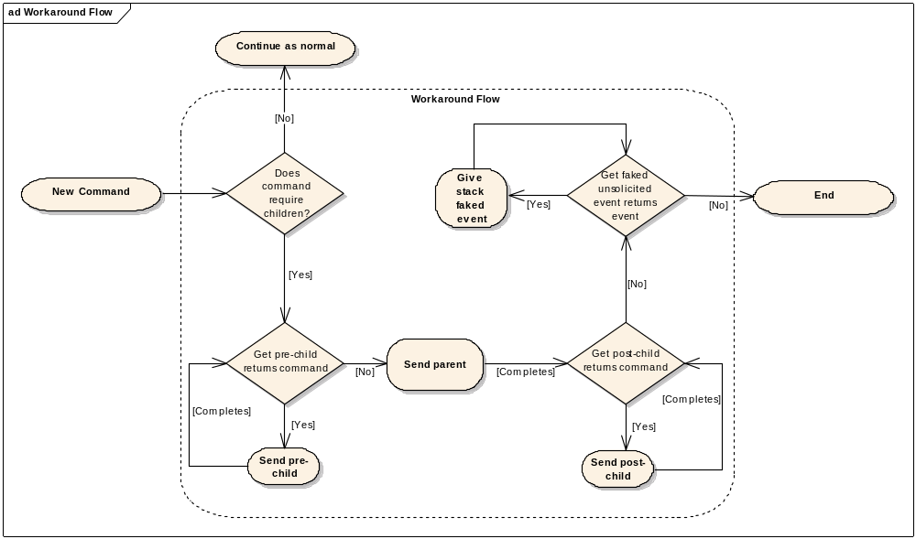
Figure 35 Work-around Flow

The Command Queue will not inform the stack of the result of child commands. If required, the QDP can use the MhcqdiGetFakedUnsolicitedEvent stage to attempt to correct any state imbalance between controller and stack.
Each child command will be deleted once it has completed; before deletion the QDP is notified of the result via MhcqdiGetXXXChildCommand. If the QDP wishes to keep track of every child command sent, and its status, it should implement the functionality itself. The parent command will not be deleted until the workaround has finished.
An error event for a workaround command results in the QDP being asked if a resend is required (just like a normal command). If an error occurs during a pre-child command the QDP has the opportunity to abandon the workaround by returning NULL from the next MhcqdiGetXXXChildCommand call and then disallowing the command when the parent is passed to MhcqdiCanSend – see section 5.1.2.10.8.

Events
The QDP is notified by the Command Queue of all non-error events via MhcqdiMatchedEventReceived or MhcqdiUnmatchedEventReceived. In the case of a matched event, the notification includes the command that caused the event. This allows the QDP to keep its state up to date.
The QDP cannot change the commands in the notification functions. If licensee needs to alter the parameters of an event, they can do in the core HCI or the event class itself.

Blocking and Rejecting Commands (MhcqdiCanSend)
Some commands sent to the controller will cause subsequent commands to error, often with the “Command Disallowed” error code. The solution is to prevent these subsequent commands from being sent until the problematic command has completed – i.e. to block the queue.
The previous (9.2 and earlier) HCI implementation uses a compile time macro (COMMAND_BLOCKING) that closes the command channel for specific commands until specific events are received (see Table 5). To provide a flexible run-time implementation as an alternative to the static compile time COMMAND_BLOCKING, the QDP provides the MhcqdiCanSend method.
Blocking Command | Unblocking Event
Remote Name Request | Remote Name Request Complete
Create ACL Connection | Connection Complete  PIN Code Request  Link Key Request
Hold Mode  Sniff Mode  Exit Sniff Mode  Park Mode  Exit Park | Mode Change
Switch Role | Role Change
QOS Setup | QOS Setup Complete
Table 5 COMMAND_BLOCKING Commands used in 9.2 HCI
MhcqdiCanSend is called by the Command Queue when it is ready to send the command. It provides the QDP with the current list of commands on the sent queue (commands that have been sent but not completed) and the command the Command Queue wishes to send. The QDP can iterate through the sent queue to look for commands that might cause a problem.
Table 6 shows the possible responses from a MhcqdiCanSend call which tell the Command Queue what to do with the command.
Response | Meaning
EContinue (KErrNone) | Send command
EBlock | Block command until sent queue changes
An error code (any negative value) | Disallow command and send the error back to the client
Table 6 MhcqdiCanSend Responses
If MhcqdiCanSend returns EBlock then the command will be delayed until the Command Queue unblocks. Unblocking will occur when:
- The head of the Pending Queue changes
- The Command Queue is reset
- A matched event occurs, other than a command status event
- A matched error event occurs
- A command completion timeout occurs
Note that the block will not be lifted on receipt of a successful Command Status event, as there has been no change in the state of any of the commands.
When the block is cleared, MhcqdiCanSend will be called again (provided the command could still be sent) and the QDP can check again whether to send the command or delay it further. There is no other way (e.g. by a call back into the Command Queue Controller) for the QDP to change its mind and decide a command can be sent.
A sequence diagram demonstrating command blocking can be found in section 5.1.2.10.3 (Command Blocked by MhcqdiCanSend).
MhcqdiCanSend can also issue an error code (any negative value) to prevent the command being sent. This will cause the command to be removed from the queue and deleted. It will also cause a call to be made to MhcqcCommandErrored on the client for that command. The supplied error code will be passed on unchanded to the client. Thus, if the client is also in licensee code, the error code may convey whatever information the licensee sees fit. If the client is the stack then the error is handled as if a command status event - with error - had been received for this command. The HCI error code assumed for this command status event will be taken to be ECommandDisallowed, unless the error code supplied by the QDP lies in the range of HCI error codes as mapped to Symbian error codes (i.e. in the range KHCIErrorBase-1 to KHCIErrorBase- ERoleSwitchFailed) in which case the corresponding HCI error code will be used.
The API is structured so that QDP is always asked whether to block, as opposed it saying when to unblock. This is to keep the Command Queue/QDP interface as one way as possible and keeps the intelligence in the framework and not in the plug-in.
A badly behaved QDP could starve the Command Queue by continually returning EBlock and never allowing any commands to be sent. The Command Queue prevents this by:
- Running a watch-dog timer so the Command Queue is notified if it has not had the opportunity to send any new commands for a given period. See section 4.1.3.2.11.2 for more information.
- Panicking if the QDP blocks when there are no outstanding commands (and hence no events could be generated to unblock the queue)

Errors, Timeouts and Resends
When any command fails, the Command Queue will inform the QDP through the MhcqdiMatchedErrorEventReceived function. From this, if the QDP returns EResendErroredCommand, the command will be queued for resending. Resend commands take priority over other commands and will be sent in the order in which the commands failed. (See the Command Queue design for more details on the resend logic and implementation.)
Since the HCI specification does not guarantee that commands will complete in the order they are sent, this means that commands can be implicitly reordered depending on when they fail and whether the QDP asks them to be resent. As a result work-around sequences could be interrupted by the Command Queue resending a command that had been sent prior to the work-around but failed after the workaround started, as shown in Figure 36.
B
A
Pending Commands
Sent Commands
B
Pending Commands
C
A
Sent Commands
B
Pending Commands
A
Sent Commands
Command A is sent
Command B has pre-child C
C is sent
B
A
Pending Commands
C
Sent Commands
B
Pending Commands
A
C
Sent Commands
Command A fails
QDP says resend
Command A is resent between
parent B and child C
Figure 36 Resend Interrupt a Workaround Sequence
If reordering or interrupting workarounds could be an issue the QDP can use the blocking facility:
- to ensure that only one command is outstanding at any time
- or to ensure that the first command of the workaround is not sent until there are no outstanding commands
Each CHCICommandQItem will keep track of the number of times it has been sent, which the QDP can use to help to determine when to abandon resend attempts. The Command Queue should not impose how to determine whether a resend is required on a QDP. If the QDP continually asks for a single command to be resent, the Command Queue’s watch-dog timer will eventually fire (@see section 4.1.3.2.11.2).
After each command has been sent, the Command Queue will call MhcqdiTimeoutRequired. This function has two purposes:
- it notifies the QDP that a command has actually been sent (so that it may track it if required)
- returning a non-zero value to the Command Queue will start a completion timer for the command
The timer will be reset if the command completes successfully or with an error.
If a command times out, the Command Queue will treat the situation as an error event and will call MhcqdiCommandTimedOut, giving the QDP the three options:
- return EResendTimedOutCommand, which result in the command being resent.
- return EContinueWithTimeoutEvent, which will result in the Command Queue returning a EHardwareFailed error to the originator of the command
If the QDP decides that the timeout error is a fatal condition and initiates a Hard Reset operation, it should return EContinueWithTimeoutEvent, although the notification to the originator of the command may not actually be needed (since the whole stack will be in reset anyway).
It is during this function call that the QDP is required to provided the number of command credits to be refunded to the Command Queue (as through the timeout the credits may have been lost.)
When processing a timeout event, the MhcqdiGetXXXChildCommand event parameters will be NULL to indicate that no event was received. See section 4.1.3.2.11.1 for more information on the Command Queue implementation of command timeouts.

QDP Data
Each CHCICommandQItem in the command queue component contains a TAny* which belongs to the QDP to store its private data associated with the command. As each CHCICommandQItem is deleted MhcqdiCommandAboutToBeDeleted will be called to allow the QDP to clean up or move the private data before the reference is lost.
Normally a command is deleted as soon as has completed. The exception is parent commands of workarounds, which are not deleted until the final post-child has completed.

Performance
To provide the fastest flow for a command that does not need workarounds or resends the API has been structured to minimise the number of calls into the QDP (which involves a virtual function call) in the normal case. For example it is not necessary to have MhcqdiDoesCommandRequireWorkaround as the QDP could simply return NULL from MhcqdiGetXXXChildCommand to indicate that no workaround commands are required. However that would involve an extra three virtual function calls per normal command; whereas MhcqdiDoesCommandRequireWorkaround means that there would only be a single extra virtual function call per normal command and three per parent command. See also section 5.1.1.3.
As MhcqdiDoesCommandRequireWorkaround and MhcqdiCanSend are called for every single command, they can have a large effect the performance of the HCI. QDP writers should attempt to implement the decision logic as efficiently as possible.

Sequence Diagrams
The aim of the following sequence diagrams is to show how MHCICmdQueueDecisionInterface is exercised by the Command Queue.
These sequences are not intended to show the detailed interaction between the Command Queue and the rest of the HCI (see the Command Queue design for more information on that subject). They also do not show every path from a given QDP decision – the aim is to show how the QDP will be called for common situations and the resulting calls from common QDP decisions.
Unless otherwise stated on the diagrams the commands do not have children, are sent immediately (not blocked) and do not require a timeout, i.e.:
- MhcqdiDoesCommandRequireWorkaround return EFalse
- MhcqdiCanSend returns EContinue (KErrNone)
- MhcqdiTimeoutRequired returns KNoTimeoutRequired
These diagrams can be found in [R8] under Logical View/Design Classes/HCI/QDP.

Normal Command and Event
This diagram shows the basic sequence for sending a command that does not require children or blocking and completes without error.
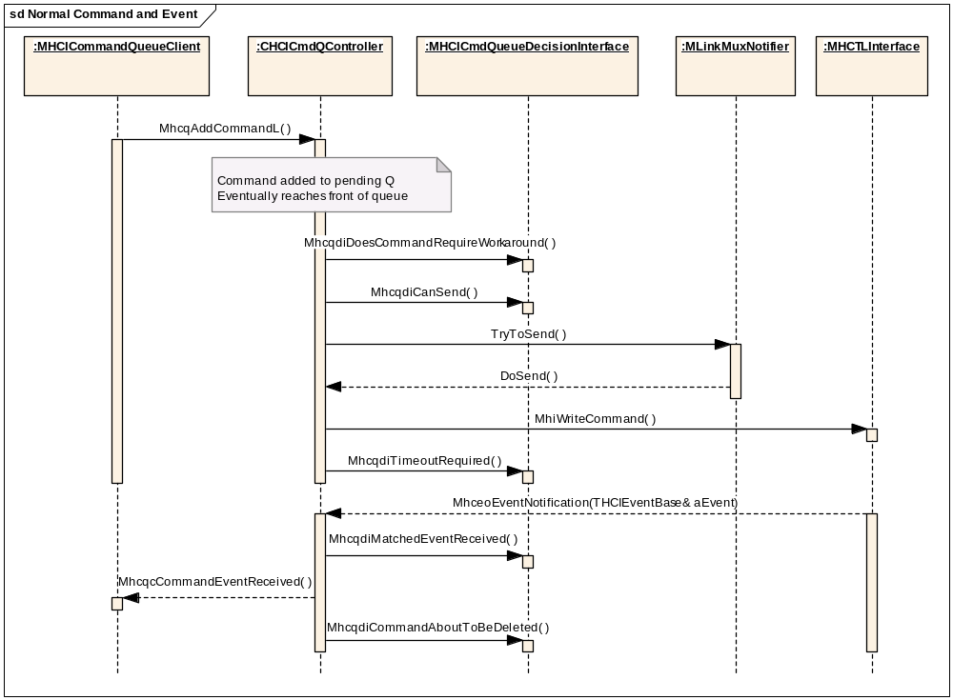
Figure 37 Normal Command and Event

Normal Command and Resend
This sequence demonstrates a call sequence when a command completes with an error event and the QDP requests the command is resent once. When the command fails a second time, the Command Queue passes the error code back to the client.

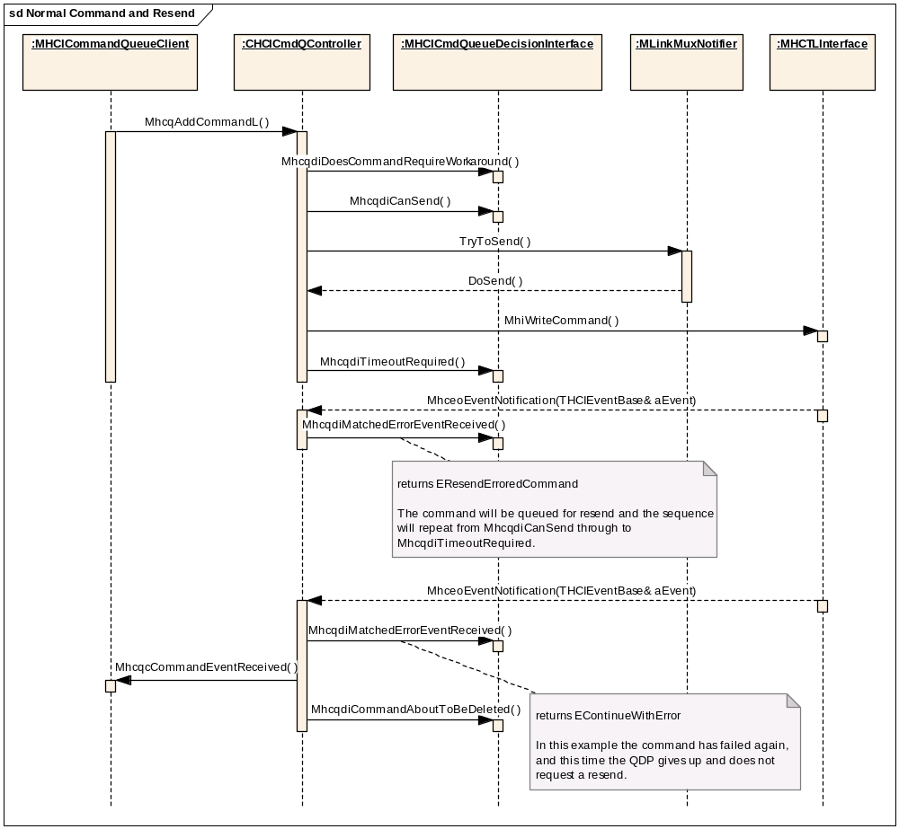

Figure 38 Normal Command and Resend

Command Blocked by MhcqdiCanSend
This sequence shows what happens if the QDP return EBlock from a MhcqdiCanSend call. When the block is cleared by an event, the Command Queue calls MhcqdiCanSend again. In the sequence the block is cleared by an unsolicited event, but this could also be an error, a command complete event or a command timeout.
sd CanSend Blocks
Sequence continues as in the
previous scenarios...
An event comes in that
unblocks the queue
:MHCTLInterface
:MLinkMuxNotifier
:MHCICmdQueueDecisionInterface
:CHCICmdQController
:MHCICommandQueueClient
Command added to
the pending queue.
Eventually it reaches
the front of the queue.
return EBlock
The QDP has detected
some reason why the
command cannot be
sent now.
return EContinue
This time the QDP
allows the command to
be sent
MhcqAddCommandL( )
MhcqdiDoesCommandRequireWorkaround( )
MhcqdiCanSend( )
MhceoEventNotification(THCIEventBase& aEvent)
MhcqdiMatchedEventReceived( )
MhcqcCommandEventReceived( )
MhcqdiCanSend( )
TryToSend( )
Figure 39 Command Blocked by MhcqdiCanSend

Command Rejected by MhcqdiCanSend
This sequence demonstrates how MhcqdiCanSend can prevent a command from being sent.

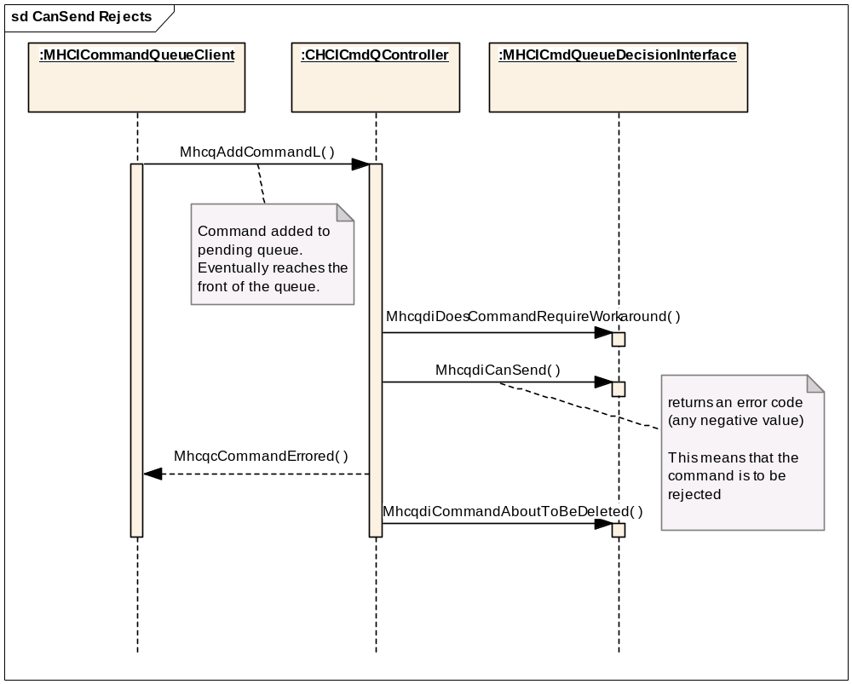
Figure 40 Command Rejected by MhcqdiCanSend

Unmatched Event
This sequence shows how the QDP is queried when the Command Queue receives an event that it cannot find a matching command for. The QDP passes the event up to the unsolicited event observer (which is usually the stack).

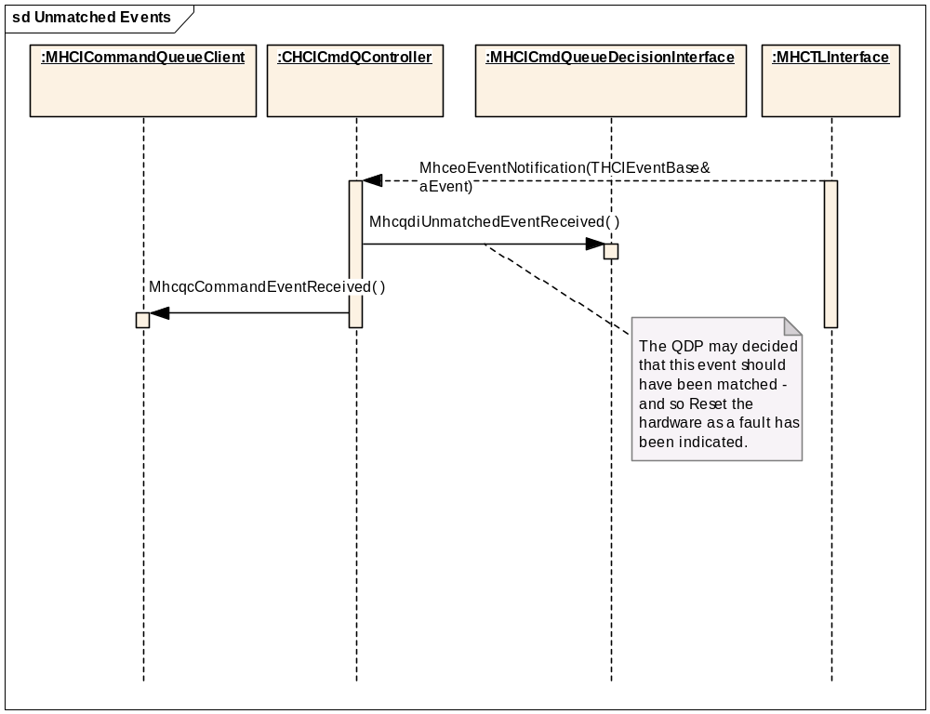
Figure 41 Unmatched Event

Command Times Out
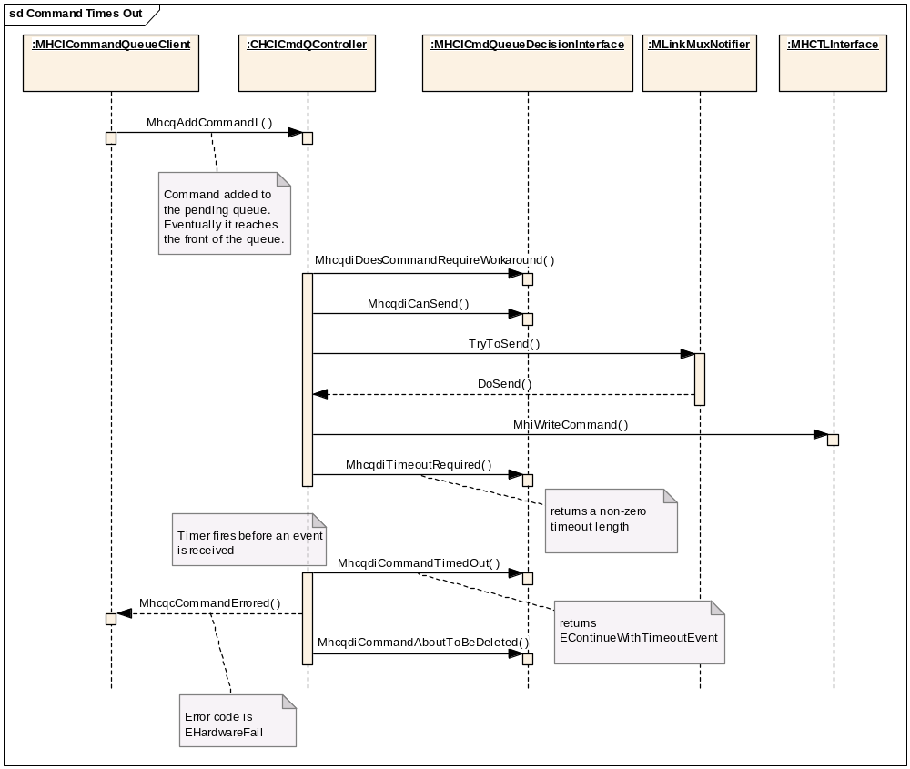
Figure 42 Command Times Out

Successful Workaround
This sequence shows a workaround with one pre-child and one post-child. There are no errors, blocks or other complications. The CanSend/TryToSend/DoSend sequence that occurs for the second and subsequent commands sent in this diagram has been substituted by a comment for clarity.
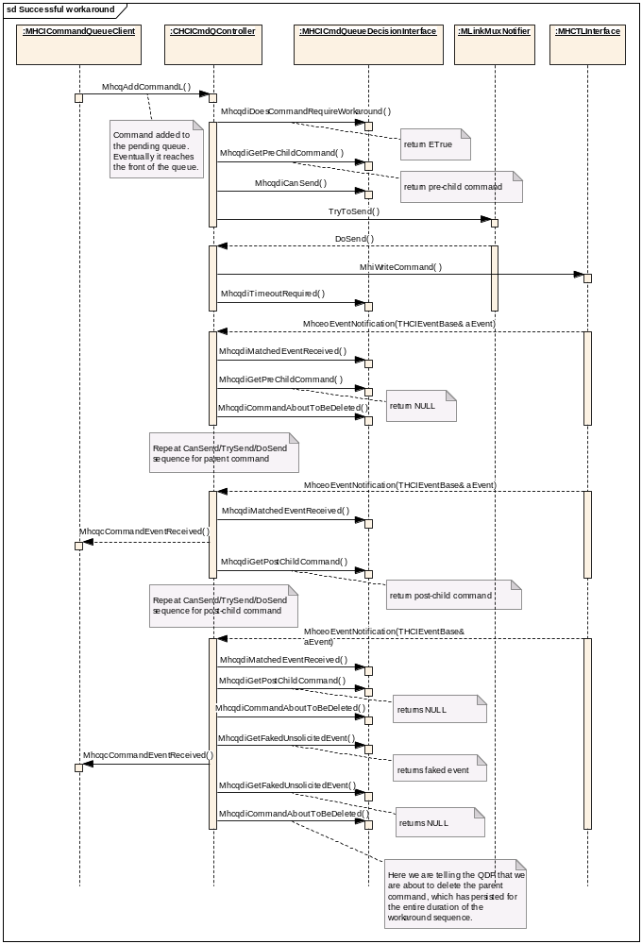
Figure 43 Successful Workaround

Pre-child Fails
This sequence demonstrates how the QDP can force a command with children to be abandoned when the pre-child fails. The same sequence does not apply for when a post-child fails as by then the result of the parent command has already been sent to the client.
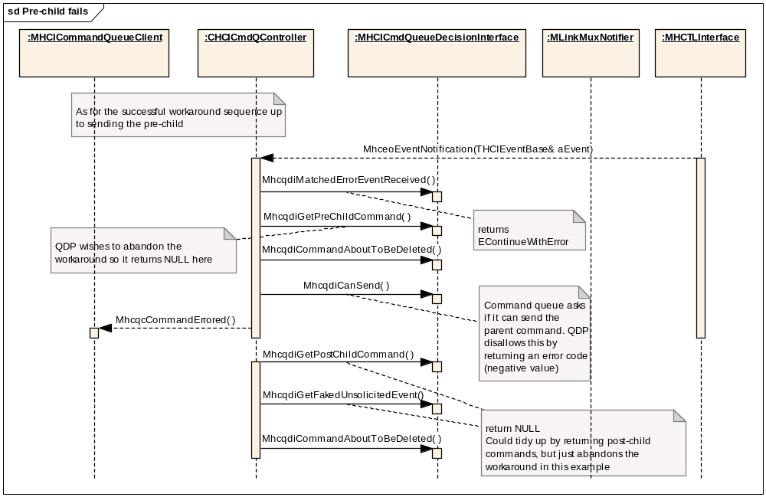
Figure 44 Pre-child Fails

Reference QDP Implementations

Symbian QDP

Component Design Overview
This component provides reference code for licensees. It contains a basic minimum subset of QDP functionality and may be used on devices for which there are no special workaround requirements. It has been used on the CSR Casira pod and the TI Bluetooth controller on the OMAP H4 reference board but this is reference code only and it remains the licensees responsibility to ensure correct operation on any hardware platform.

Detailed Component Design
This component is built as qdp_symbian.dll and contains the implementation of the single class CHCISymbianQdp.

CHCISymbianQdp

Overview
This derives from CHCICmdQueueDecisionPlugin and can be loaded as a QDP plug-in.
It also derives from MHCICmdQueueDecisionInterface so the Interface method can simply return a this pointer when asked for an instance of MHCICmdQueueDecisionInterface.
It implements a basic minimum set of QDP functionality.

UML Diagram
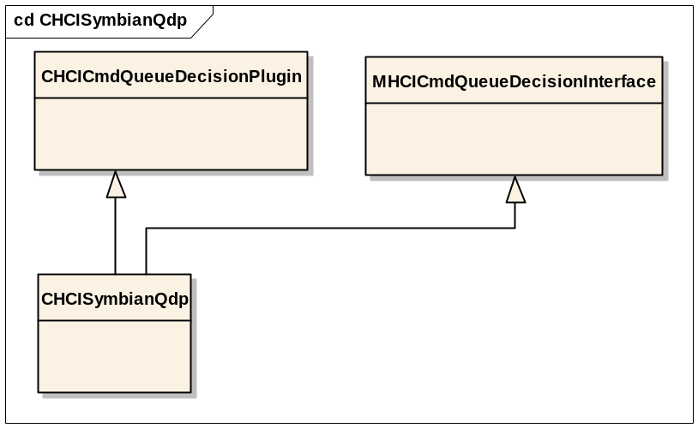
Figure 45 CHCISymbianQdp

Design Unit Behaviour
The only workaround applied in this implementation of the QDP is Command Blocking for those opcodes that would otherwise cause a subsequent command to be errored while these commands are being dealt with in the controller.
The Command Blocking opcodes are:
Remote Name Request
Create ACL Connection
Hold Mode
Sniff Mode
Exit Sniff Mode
Switch Role
Park Mode
Exit Park
QOS Setup
The queue will be blocked whenever one of these opcodes is found in the command in last position on the Sent Queue, i.e. when the last command sent was one of the above commands.
The behaviour of the QDP is summarized in the table below:

Method | Return | Policy
MhcqdiDoesCommandRequireWorkaround | EFalse | No workarounds required
MhcqdiCanSend | EContinue or EBlock | Block commands when the last entry on the Sent Queue is one of the Command Blocking opcodes (see above)
MhcqdiTimeoutRequired | KNoTimeoutRequired | No command timeouts required
MhcqdiCommandTimedOut | EContinueWithTimeoutEvent | Should not happen because timeouts will not be used.
MhcqdiMatchedErrorEventReceived | EContinueWithError | Always send an error to the client if the command errors
MhcqdiGetPreChildCommand  MhcqdiGetPostChildCommand  MhcqdiGetFakedUnsolicitedEvent | NULL | These functions should not be called.
MhcqdiMatchedEventReceived  MhcqdiUnmatchedEventReceived  MhcqdiCommandAboutToBeDeleted | - | Notification functions – no need to do anything
MhcqdiSetPhysicalLinksState  MhcqdiSetHardResetInitiator  MhcqdiSetHCICommandQueue  MhcqdiSetTimeouts |  | Setter functions – no need to do anything
MhcqdiReset | KHCIDefaultCommandCredits  (= 1) | No need for any action on reset. Normal controller behaviour assumes 1 initial command credit.

Table 7 ‘Symbian QDP’ Behaviour

Performance
This is a light-weight implementation of the QDP and is not expected to have a significant effect on performance.

Component Future Work
None identified

Commands and Events Design

Commands and Events Design Overview

Introduction
The Commands and Events component is responsible for embodying detailed knowledge about the commands which may be sent to the Bluetooth Controller and the events which may be received from it.
The following statistics are included to indicate the scope of this component. They relate to the Bluetooth v2.0 specification:

- 114 commands are defined:
28 Link Control Commands
13 Link Policy Commands
58 Controller & Baseband Commands
6 Informational Parameter commands
6 Status Parameter commands
3 Testing Commands
- 36 events are defined.
The component is implemented as a statically-linked DLL and is used by the Stack, the Command Queue, and the Core HCI. It may additionally be used by Controller Initialisation.
The implementation of the Commands Events component is owned by the licensee. However, the interface is owned by Symbian. This is a very extensive interface since it includes a class to represent each different command and event type. The licensee’s implementation is obliged to conform to this interface, since Symbian components are dependent upon it. This interface and the expected behaviours of the Commands and Events component are described in section 5.2.2.
One reference implementation of the Commands and Events component is provided, Symbian Commands and Events. This is covered in section 5.2.3.1.

Interfaces

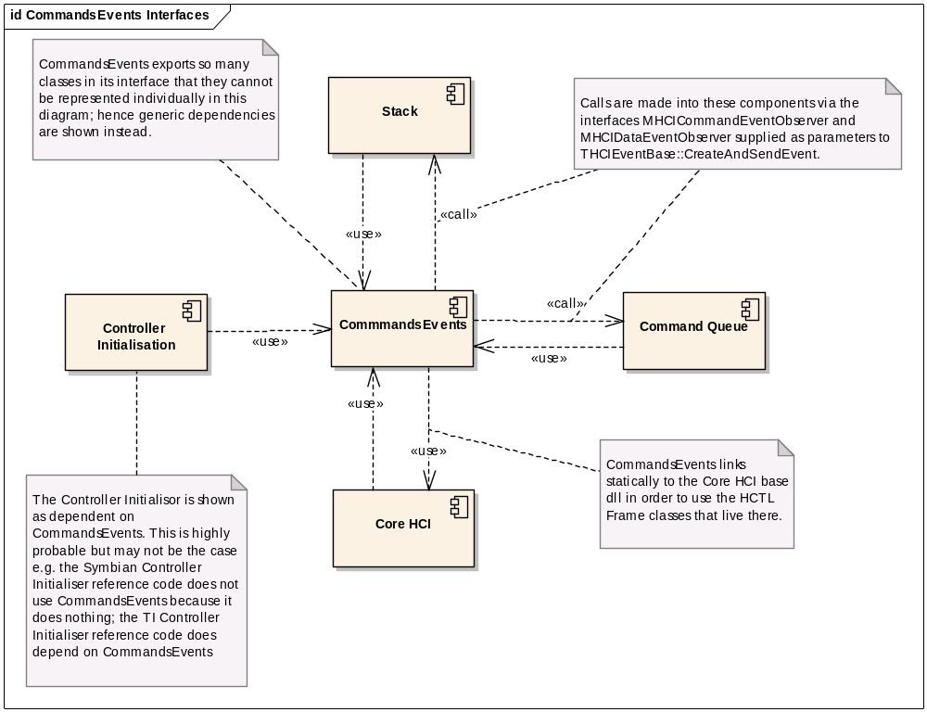
Figure 46 Commands and Events Interfaces

Commands and Events Detailed Component Design

Interface
The interface to which the implementation must conform is owned by Symbian, and it is embodied in a number of ways, as described in the following subsections.

Header files
The classes making up the interface to this component are defined in a set of Symbian-owned header files which may be found under hci_v2/framework/CommandsEvents/interface/. They are exported from there by hci_v2/framework/CommandsEvents/group/bld.inf.
The licensee-owned implementation of the component must provide implementations of all the command and event classes defined in these header files.

Freeze files
The interface to be provided is also defined at the level of DLL exports. This is defined in the two files hci_v2/framework/CommandsEvents/BWINS/commandseventsU.def and hci_v2/framework/CommandsEvents/EABI/commandseventsU.def. These are also exported by hci_v2/framework/CommandsEvents/group/bld.inf and should be referenced at their exported location by a DEFFILE statement in the implementation’s .mmp file. This is to ensure that the implementation supplies the correct binary interface.

Import table
The Commands and Events framework also generates an import table (e.g. .lib file) against which dependent components can link. This ensures that there is no build-time dependency of Symbian-owned components on the reference Commands and Events implementation. It is achieved by building the project hci_v2/framework/CommandsEvents/group/commandseventsbase.mmp. This uses “TARGETTYPE IMPLIB” – the effect of this is that nothing is built other than the import table (e.g. .lib file) which is derived from the contents of the Freeze files described in section 5.2.2.1.2 above.

Command Classes

Overview
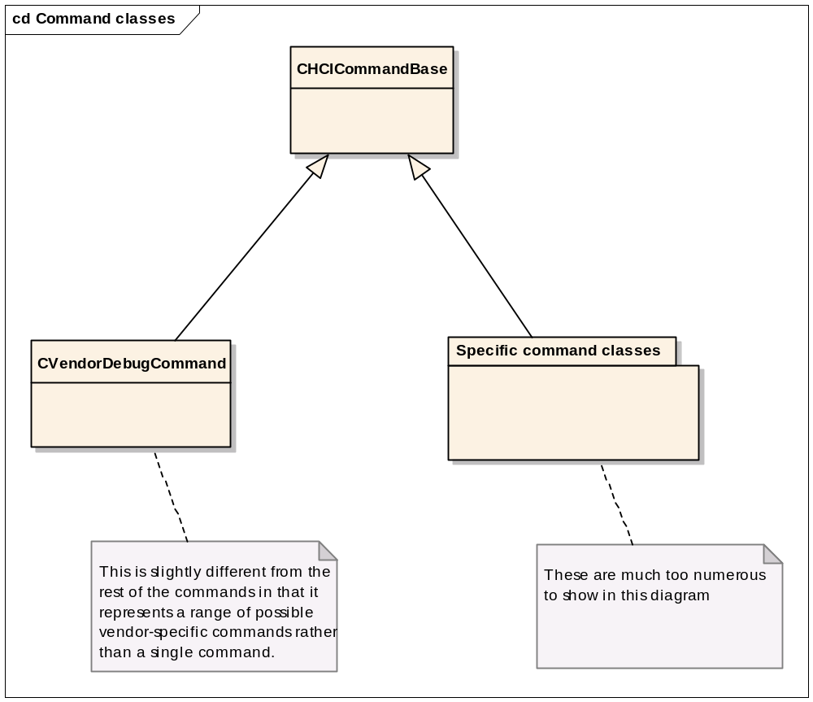
Figure 47 Command Classes

CHCICommandBase
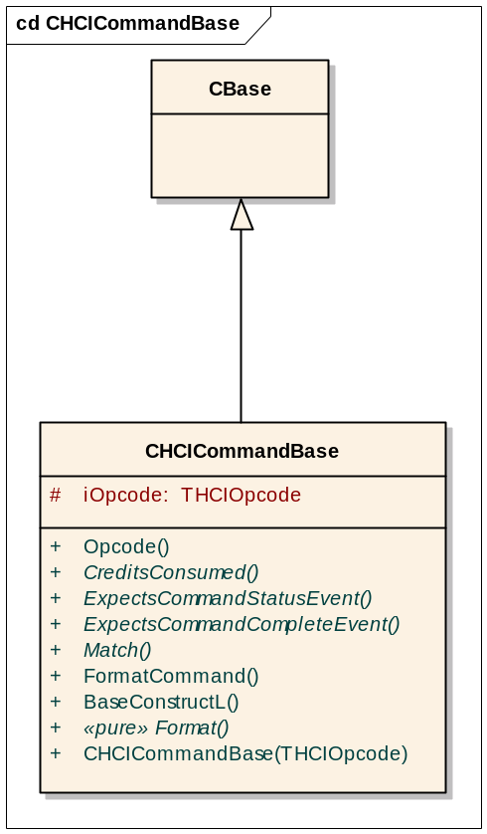
Figure 48 CHCICommandBase

This is the base class for all HCI commands. The methods are as follows:

Opcode | Getter for the opcode
CreditsConsumed | Virtual method returning 1 as a default. To be overridden in the derived class if the number of command credits consumed by this command is not 1.
ExpectsCommandStatusEvent | Virtual method returning ETrue. To be overridden in the derived class if the command is not expected to cause a corresponding Command Status event to be returned.
ExpectsCommandCompleteEvent | Virtual method returning ETrue. To be overridden in the derived class if the command is not expected to cause a corresponding Command Complete event to be returned.
Match | Virtual method used to determine whether this command matches an event supplied as a parameter. A default implementation is supplied which may be overridden for commands requiring specific matching logic. See section 4.1.3.2.10.1 for details of how events are matched to commands.
FormatCommand | Method for formatting the command into an HCTL command frame ready to be passed to the HCTL for transmission to the Controller. Delegates most of the work to the pure virtual method Format.
BaseConstructL | Second-phase constructor which must be called from ContructL in the derived classes.
Format | Pure virtual which implements command-specific handling to format parts of the HCTL command frame which are specific to each command.
CHCICommandBase | First-phase constructor, protected, requires opcode parameter.

CVendorDebugCommand
This class represents a range of commands rather than a single command. Vendor-specific commands are identified by the opcode lying within a specific range of codes (high-order six bits of opcde on). This class derives from CHCICommandBase. Up to 255 bytes of vendor-specific data may be present for the command; the Command() method returns a non-const TDes8& referencing the buffer holding this data and thus allows the user of the class to exert complete control over the contents of the data for the command.

Specific Command classes
There is a class for each of the commands in the Bluetooth Specification (except vendor-specific commands). Each of these classes is derived from CHCICommandBase. Methods to be provided include overrides of the virtuals of CHCICommandBase (see above), factory method and constructors, getters for the specific attributes of this command and a Reset method to assign new values to those attributes.

Event Classes

Overview
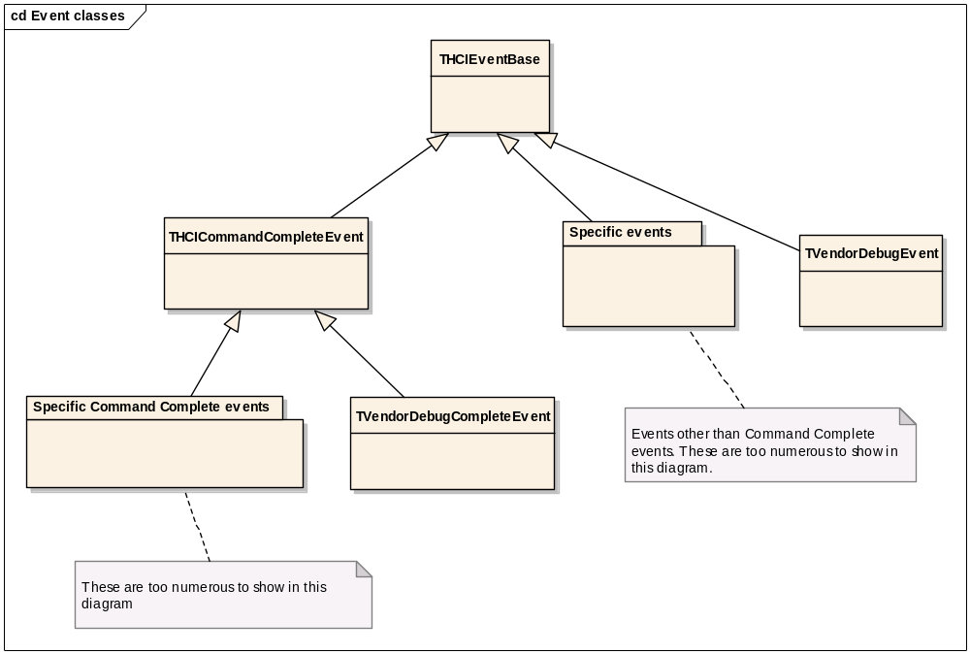
Figure 49 Event classes

THCIEventBase
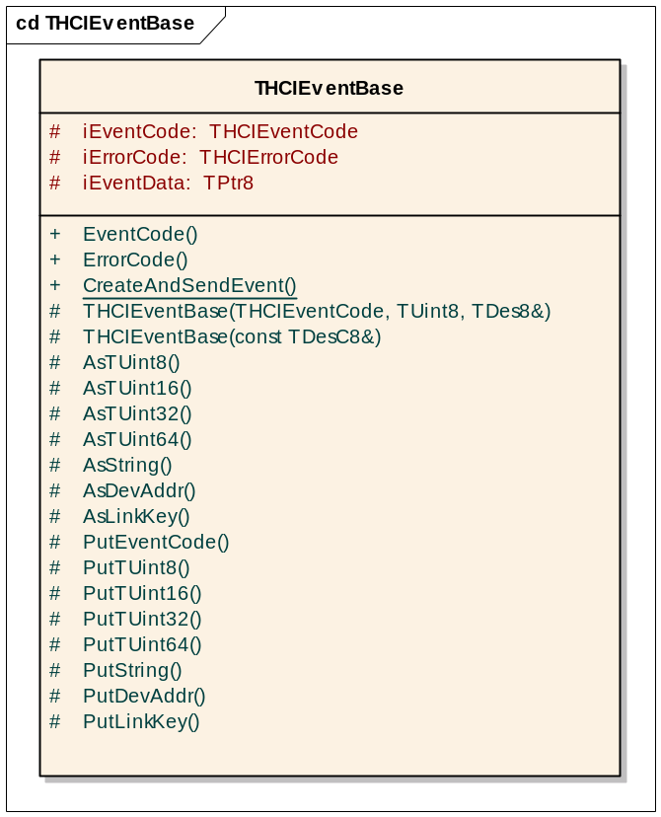
Figure 50 THCIEventBase

The attributes of the class are as follows:
iEventCode | This is the code identifying the event, as defined in the Bluetooth Specification
iErrorCode | Many events contain an associated error code. However, not all events do. For simplicity of the code using the object, this attribute is defined in the base class and will be available in all event objects. For those events which do not define an error code, the constructor in the base class will default this attribute to an “OK” value.
iEventData | This is the raw event data as received from the HCTL (or as faked), encapsulated in a descriptor.

The operations are as follows:
EventCode | Getter for the event code
ErrorCode | Getter for the error code
CreateAndSendEvent | This is a static method which takes as its first parameter a raw event buffer as supplied by the HCTL. Its job is to identify the type of event and create the appropriate derived-type event object (a very large switch statement is involved here). Having created the object, it then passes it for handling to the Command Event Observer supplied as second parameter, if it is a command-related event, or to the Data Event Observer supplied as the third parameter, if it is a data event. The knowledge of whether each event is a command event or a data event is built into this method.

There are two constuctors:
THCIEventBase(const TDesC8& aEventData) | The “normal” constructor, used when an event is received from the Controller/HCTL. aEventData is the buffer of raw event data received, and a THCIEventBase-derived object is being created to represent this.
THCIEventCode aEventCode, TUint8 aParameterTotalLength, TDes8& aEventData | This constructor is used when an event is being “faked”. In this case aEventData must reference an empty desciptor big enough to hold the event data for the event being faked.  The constructor then uses the aEventCode and aParameterTotalLength fields to start populating the supplied event data buffer (these fields appear at the start of every event), and the derived class constructor will not only populate the remainder of the buffer, but must also set the internal member iEventData (a TPtrC) to point to aEventData. The using code must therefore ensure that aEventData references a buffer that will persist for the lifetime of the event object.
As… methods | These protected methods are used to extract data from a given offset within the raw event data buffer and return it as the data type implied by the method name. Overloads are provided which allow indexing into arrays of elements within the event data buffer.
Put…methods | These protected methods are used when faking an event to populate the event data buffer with the appropriate data to correspond with the supplied parameters.

THCICommandCompleteEvent
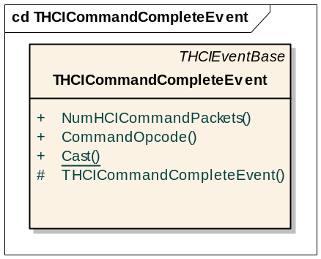
Figure 51 THCICommandCompleteEvent
This class is a base class for a set of events denoting completion of a command previously sent to the controller. These events all share a common event code but are distinguished by the Command_Opcode field within the event (as defined in the Bluetooth Specification [R11]). The remaining data in the event varies according to the command, so this is the base class for a family of event types, one derived class per command opcode.
The operations of this class are as follows:
NumHCICommandPackets | Getter for the number of command credits - the Num_HCI_Command_Packets field.
CommandOpcode | Getter for the associated command opcode
Cast | This is a static method which converts a THCIEventBase reference to a THCICommandCompleteEvent reference. It ASSERTs that the actual type of the object is the type being casted to. It also casts away constness.  The same method is found in all derived event classes in this component. It is one of the basic idioms of the component.
THCICommandCompleteEvent | As with the THCIEventBase base class, there are two overloads of the constructor, one for use when creating an event to encapsulate existing event data received from the Controller/HCTL, and one for use when faking up an event. Each constructor call the corresponding constructor in the base class.

Specific Event classes
There is an event class for each event type (other than the Command Complete event). Each of these classes is derived from THCIEventBase. Typically the will have the following types of methods:
Getters | Methods which use knowledge of the layout of the event data to extract a requested field
Constructors | As with the THCIEventBase base class, there will be two overloads of the constructor, one for use when creating an event to encapsulate existing event data received from the Controller/HCTL, and one for use when faking up an event. Each constructor call the corresponding constructor in the base class.
Cast | This is a static method which converts a THCIEventBase reference to a derived class reference. It ASSERTs that the actual type of the object is the type being casted to. It also casts away constness.

TVendorDebugEvent
This is an event carrying the specific event code designatedfor use for a vendor-specific event. The layout of the event data is left to the user of the class and is made available with simple accessor methods. This class derives from THCIEventBase. As with the THCIEventBase base class, there will be two overloads of the constructor, one for use when creating an event to encapsulate existing event data received from the Controller/HCTL, and one for use when faking up an event. Each constructor call the corresponding constructor in the base class.

Specific Command Complete Event classes
There is an event type for each Command Complete event type. These events all have the same event code which marks the event as a Command Complete event, but are distinguished by the Command_Opcode field of the event which identifies of which command this event marks the completion. All Command Complete events also share in common the Num_HCI_Command_Packets field. The remainder of the event data layout varies according to the original command – hence the need for a family of classes rather than a single class.
These classes all derive from THCICommandCompleteEvent rather tha THCIEventBase. Otherwise they follow the same pattern as the specific event classes for non-Command-Complete events, see section 5.2.2.3.4.

TVendorDebugCompleteEvent
This is the Command Complete event corresponding to a Vendor Debug command, see section 5.2.2.2.3. This class derives from THCICommandCompleteEvent. The layout of the event data is left to the user of the class and is made available with a simple accessor method.

Commands and Events Reference Implementations

Symbian Commands and Events

Component Design Overview
This component provides reference code for licensees. It contains an implementation of all the interface classes described in section 5.2.2 above.

Detailed Component Design
This component is built as commandsevents.dll. It is designed to be statically linked to any component which needs to use it, and it exports the methods for each command and event class which the using component will need to access. The build process verifies that the correct set of exports is provided by referencing the freeze files described in section 5.2.2.1.2 above.
Since the classes provided by this component have already been described in section 5.2.2 above, and since the implementation conforms to the expected behaviours already described, there is no need for further description of the implementation in this section.

Commands and Events Generator
Much of the code for both the framework and implementation of Commands and Events has been generated automatically using a batch file and a set of Python scripts.
Since this process updates Symbian- as well as Licensee-owned components, it is intended primarily for Symbian internal use.
The Generator is to be found at bluetooth\hci_v2\framework\commandsevents\generator. This directory not only includes all the Python scripts, templates and other associated files, but also a Word document describing the Generator. This document should be consulted for more detailed information.

Core HCI Design

Core HCI Overview

Introduction
The Core HCI is the central component in the new Bluetooth HCI layer architecture being provided by PREQ750. It has a number of roles:
- Distributes incoming events and data to either the Stack or the Command Queue as appropriate.
- Acts as a manager for the HCTL and Initialisation plug-ins.
- Provides an HCI server component to handle RHCIDirectAccess and other client interfaces.
- Provides an API to frame outgoing data packets.
- Provides an API to allocate command frames.
- Provides a set of classes to represent HCTL frames.
The component is implemented as an ECOM plug-in, following the Plug-in Pattern as described in section 3.5.1. The plug-in base dll (corehci_base.dll) is owned by Symbian and is statically linked from the Bluetooth stack.
However, note that the base dll has a dual role – it not only acts as plug-in base but also provides a set of classes to represent HCTL frames. Components which need to use these classes link statically to the plug-in base DLL.
The implementation of the Core HCI plug-in itself is owned by the licensee, but since it interacts with Symbian-owned components, namely the Stack and the Command Queue, it must implement and use a number of Symbian-owned interfaces. These interfaces and the expected behaviours of the Core HCI component are described in section 5.3.2.
One reference implementation of the Core HCI is provided, the Symbian Core HCI. This is covered in section 5.3.3.1.
The HCI Server function, although forming part of the responsibilities of the Core HCI, is documented separately – see Section 6.1.3.

Interfaces
Figure 52, below, shows the interfaces implemented by and used by the Core HCI component. The Bluetooth stack exercises ownership of the Core HCI through the CCoreHCIPlugin interface; the Core HCI in turn exercises ownership of the HCTL and the Initialisor through the CHCTLBase and CControllerInitialistaionPlugin interfaces respectively.
More information about these interfaces will be presented in the detailed design section 5.3.2.1.

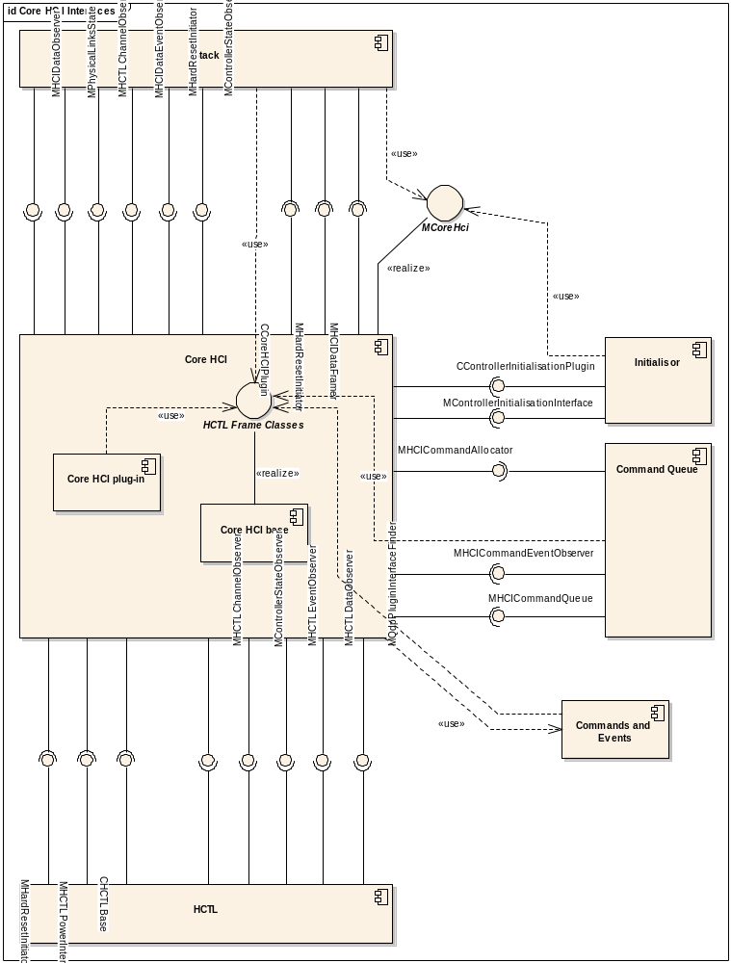
Figure 52 Core HCI Interfaces

Data flows through the component
As an aid to understanding the positioning of the Core HCI within the archicitecture, we will present here an overview of the data flows through the component.

Outgoing Data Flow

1
2
3
A
B
Stack
Command Queue
Core HCI
HCTL
QDP
Stack places command on queue.
Queue uses Core HCI to allocate CHctlCommandFrame
Command Queue sends command directly to HCTL.
Stack uses Core HCI to frame an ACL or synchronous data packet.
Stack sends framed data packet directly to HCTL
Figure 1 Outgoing traffic

Figure 1 shows the Core HCI’s role in sending outgoing traffic. The Core HCI is not responsible for passing outgoing traffic to the HCTL, the Command Queue and the Stack access the HCTL directly.

Incoming Data Flow

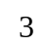
1
2a
A
B
Stack
Command Queue
Core HCI
HCTL
QDP
HCTL passes event to Core HCI.
Core HCI determines where event should be sent, either the Command Queue or the Stack.
Command Queue determines if event should be passed to Stack.
HCTL passes ACL or synchronous data to Core HCI.
Core HCI passes data straight to Stack.
3
2b

Figure 2 Incoming traffic

Figure 2 shows the Core HCI’s role in handling incoming traffic. In this role the Core HCI passes ACL and Synchronous data packets straight through to the Stack, but must determine where an event needs to be routed to.

Core HCI Detailed Component Design

The Base Dll
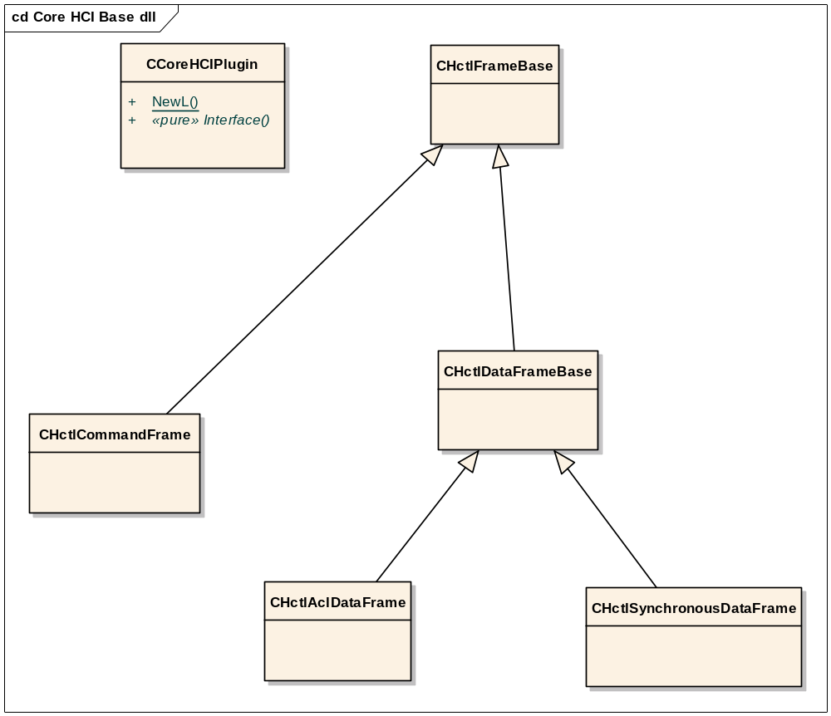
Figure 53 corehci_base.dll

The base DLL not only supports standard plug-in base functionality but also provides a set of classes for dealing with HCTL frames. Note that since this functionality is provided in the base dll it forms part of the Symbian-owned code. The classes are not accessed through a mixin interface – instead the component wishing to use these classes should link statically to corehci_base.lib.
These functions do not logically form part of the Core HCI base, and have been included here rather than in a utility DLL for reasons of development expediency. We will not discuss the usage of these classes here. The reader should consult the header files and the Developer Library for details of exported methods and functionality supplied.

Interfaces
This section describes the interfaces which must be provided by the Core HCI and those which it uses.
All these interfaces are owned by Symbian. Some of the implementations are Symbian code, some are implemented in reference code – the detailed description of each interface below will provide this information.

CCoreHCIPlugin
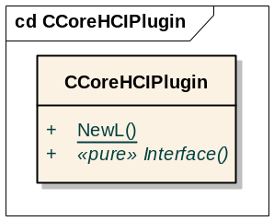
Figure 54 CCoreHCIPlugin

CCoreHCIPlugin derives from CBase, and acts as the plug-in base class for the Core HCI. See section 3.5.1 for a discussion of the Plug-in Pattern used.
The implementation of this class forms part of the plug-in base dll corehci_base.dll. This DLL is owned by Symbian. It is statically linked to the Stack. The Stack creates the Core HCI by calling CCoreHCIPlugin::NewL with the UID of the Core HCI implementation to be used, if available. If not, it calls an overload of NewL which does not take an implementation UID parameter, and it is then required that there exist one and only one implementation of the Plug-in. NewL then uses ECOM to find and load the correct plug-in.
The implementation of the plug-in itself is licensee-owned code. A reference implementation is provided by Symbian, see section 5.3.3.1.
The following comments refer to the implementation of the derived class in the plug-in.
The plug-in must be implemented as a C-class, derived from CCoreHCIPlugin, and must implement its own NewL and an override of the pure virtual Interface method.
The NewL of the derived class will be called from ECOM to create an instance of the object after the plug-in has been located.
The Interface method will then be called from the Stack to obtain pointers for interfaces supported by the plug-in. It should provide all of the following interfaces:
- MCoreHci
- MHCIDataFramer
- MHCICommandAllocator
- MHardResetInitiator
- MHCTLInterface (should be obtained from the HCTL)
- MControllerInitialisationInterface (should be obtained from the Controller Initialiser)
The plug-in implementation is responsible for supporting the usage of these interfaces and routing traffic between the various components as is described throughout this section of the design document.

MCoreHci
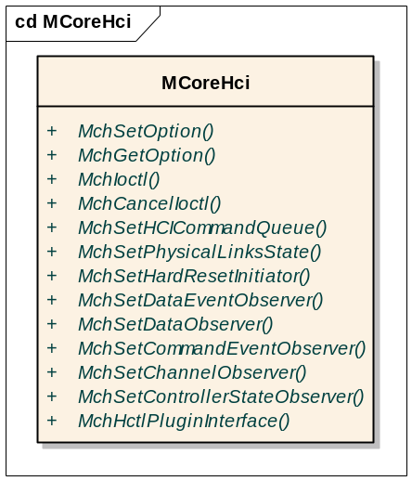
Figure 55 MCoreHci
MCoreHci is an interface implemented by the Core HCI. The interface is owned by Symbian but the licensee is responsible for the implementation. The Stack uses this interface to configure the Core HCI on start-up with pointers to objects implementing the interfaces that the Core HCI requires, and to obtain from the Core HCI pointers to object implementing the interfaces that it in turn can provide, directly or indirectly. MCoreHci also provides functions for getting and setting options, and handling Ioctls.
- MchSetOption can be used to set generic options using a keyword/value pair.
- MchGetOption can be used to get the settings of generic options.
- MchIoctl
- MchCancelIoctl
- MchSetHCICommandQueue is used by the Stack to pass the Core HCI a reference to the Command Queue’s MHCICommandQueue interface. This interface would allow the Core HCI to add commands to the queue should it need to do so. The Core HCI should however provide this interface to the HCI Server and should use it to support MQdpPluginInterfaceFinder::MqpifQdpPluginInterface.
- MchSetPhysicalLinksState is used by the Stack to provide the Core HCI with a reference to an implementation of the MPhysicalLinksState interface, which may be used to obtain information about the current state of links to remote Bluetooth devices. However, this interface is not used by the reference implementation of the Core HCI.
- MchSetHardResetInitiator is used by the Stack to pass the Core HCI a reference to an MHardResetInitiator object. If the Core HCI itself wishes to initiate a reset, it should make a call on this interface. The Stack then has the opportunity of resetting its own internal state and will then make a call on MHardResetInitiator on the Core HCI, which is itself also an MHardResetInitiator. In response to this call, Core HCI should in turn make a call on MHardResetInitiator in the HCTL, which is where the resetting of the Bluetooth Controller should actually be implemented.
- MchSetDataEventObserver is used by the Stack to pass the Core HCI a reference to an MHCIDataEventObserver object – see section 5.3.2.2.6 below.
- MchSetDataObserver is used by the Stack to pass the Core HCI a reference to an MHCIDataObserver object – see section 5.3.2.2.5 below.
- MchSetCommandEventObserver is used by the Stack to pass the Core HCI a reference to an MHCICommandEventObserver object – see section 5.3.2.2.7 below.
- MchSetChannelObserver is used by the Stack to pass the Core HCI a reference to an MHCTLChannelObserver object. The Core HCI must ensure that calls can be made on this interface by the HCTL to notify the Stack when it may or may not initiate the writing of commands and/or data to the Controller. See section 5.3.2.2.12.
- MchSetControllerStateObserver is used by the Stack to pass the Core HCI a reference to an MControllerStateObserver. The Core HCI should provide notifications of changes to controoler state using this interface.
- MchHctlPluginInterface may be used to query the HCTL plug-in for any supported interface, by interface UID.

MHCIDataFramer
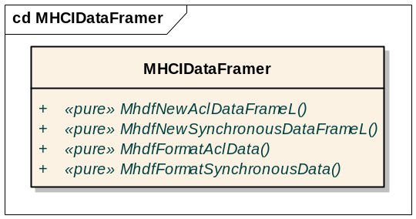
Figure 56 MHCIDataFramer

MHCIDataFramer is an interface to be implemented by the Core HCI. The interface is owned by Symbian but the licensee is responsible for the implementation. It provides two methods to create new (empty) data frame objects of a specified size, and two methods to format data in to a previously allocated frame. This interface is used by the Stack.

MHCICommandAllocator
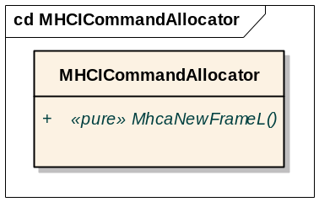
Figure 57 MHCICommandAllocator
MHCICommandAllocator is an interface to be implemented by the Core HCI. The interface is owned by Symbian but the licensee is responsible for the implementation. It is used by the Command Queue to create a new command frame object for a given command opcode. The interface does not provide a method to format command parameters into a command frame. The formatting functionality is provided by the CHCICommandBase-derived object that is used to represent the command in the Command Queue. Further information on how the Command Queue represents commands can be found in section 4.1.3.2.1.3.
Ownership of a newly allocated frame is passed to the Command Queue when the method returns.

MHCIDataObserver
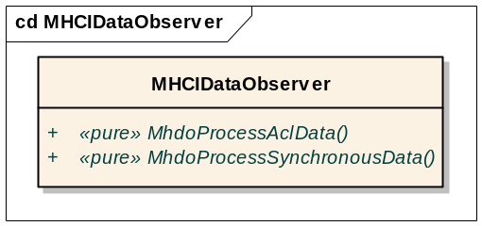
Figure 58 MHCIDataObserver

MHCIDataObserver is an interface implemented by the Stack. Both the interface and its implementation are owned by Symbian. Its two functions are called by the Core HCI to pass incoming data to the Stack.

MHCIDataEventObserver
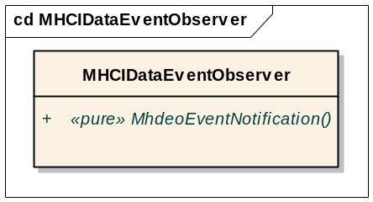
Figure 59 MHCIDataEventObserver

MHCIDataEventObserver is an interface implemented by the Stack. Both the interface and its implementation are owned by Symbian. It is used by the Core HCI to inform the stack about reception of HCI Events that are associated with sending ACL or Synchronous data. The following unsolicited data events should be passed via this interface:
    - Number_Of_Completed_Packets Event
    - Flush_Occurred Event
    - Data_Buffer_Overflow Event
    - QoS_Violation Event
Note that events that seem data related but are in fact the result of a command (e.g. QoS Setup Command) do not follow the path described above and go to MHCICommandEventObserver instead.
The logic to allow an event to be correctly routed is actually implemented in the separate Command and Events component – see Section 5.2

MHCICommandEventObserver
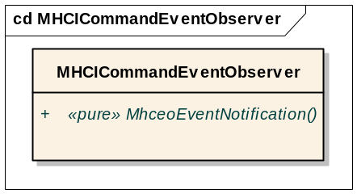
Figure 60 MHCICommandEventObserver
MHCICommandEventObserver is an interface implemented by the Command Queue. Both the interface and its implementation are owned by Symbian. It is used by the Core HCI to pass command related events to the Command Queue.

MHCTLEventObserver
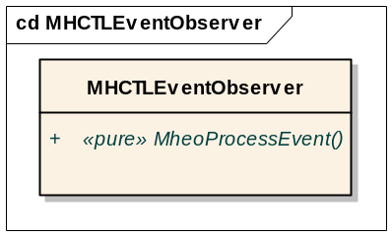
Figure 61 MHCTLEventObserver
The MHCTLEventObserver interface should be implemented by the Core HCI. The interface is owned by Symbian but the implementation is the responsibility of the licensee. It is used by the HCTL to pass events to the Core HCI.
The HCTL passes the event as an descriptor containing the raw data. The Core HCI must parse the raw data and create an appropriate THCIEventBase derived object. The Core HCI must also determine whether the event is to be be passed to the MHCIDataEventObserver interface on the Stack, or the MHCICommandEventObserver interface on the Command Queue. The Core HCI may choose to delegate all the above tasks to the separate Commands and Events component – see section 5.2.
Note, events are passed from HCTL through the Core HCI as synchronous calls. In the case of events that have descriptor type parameters, the THCIEventBase object will reference the descriptor owned by the HCTL.

MHCTLDataObserver
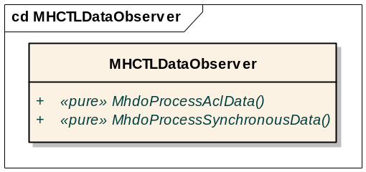
Figure 62 MHCTLDataObserver
The MHCTLDataObserver interface should be implemented by the Core HCI. The interface is owned by Symbian but the implementation is the responsibility of the licensee. It is used by the HCTL to pass incoming data packets to the Core HCI.
The Core HCI will then route the packets to the MHCIDataObserver interface on the Stack. Note that MHCTLDataObserver and MHCIDataObserver are two different interfaces, in spite of the fact that they have identically named methods.

MHostControllerStateObserver
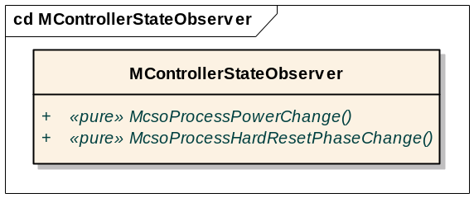
Figure 63 MControllerStateObserver

The MHostControllerStateObserver interface should be implemented by the Core HCI. It is also implemented by the stack. The interface - and the implementation within the Stack - are owned by Symbian, but the implementation in the Core HCI is the responsibility of the licensee. It is used by the HCTL to notify the Core HCI of power and hard reset phase changes.
The Core HCI must pass the notifications on to the Stack using the implementation of the same interface in the Stack. It should also use the notifications to complete HCI Server requests as appropriate – see section 6.1.3.

MHCTLInterface
MHCTLInterface is implemented by the HCTL. The interface is owned by Symbian but the implementation is the responsibility of the licensee.
See Table 8 for details of this interface.
It is the main interface used by other components to communicate with the HCTL. Since commands are sent directly from the Command Queue, and data is sent directly from the Stack, the Core HCI only uses this interface to provide interfaces to the HCTL and to obtain the HCTL header and trailer sizes (using the three MhiGet...TransportOverhead methods).

MHCTLChannelObserver
The MHCTLChannelObserver interface should be implemented by the Core HCI. It is also implemented by the stack. The interface - and the implementation within the Stack - are owned by Symbian, but the implementation in the Core HCI is the responsibility of the licensee. It is used by the HCTL to notify when the channels for sending commands and data change status from open to closed or vice versa. This information is used by the Link Muxer entity within the Stack which is always consulted before any write requests are made to the HCTL.
The Core HCI must pass the channel notifications on to the Stack using the implementation of the same interface in the Stack.

MHardResetInitiator
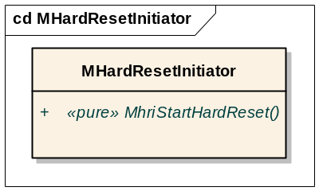
Figure 64 MHardResetInitiator
This interface is implemented in the stack, and should also be implemented in the Core HCI and in the HCTL. The interface itself and the implementation in the Stack are owned by Symbian, but the implementations in the Core HCI and in HCTL are the responsibility of the licensee.
Code within the Core HCI or elsewhere which needs to initiate a hard reset should call the method on the Stack. This in turn will call MhriStartHardReset in the Core HCI, which must relay the call to the implementation of the same method in the HCTL – this is the one which actually knows how to reset the Controller.

CControllerInitialisationPlugin
This is the plug-in base class for the Controller Initialisation Plug-in, see section 5.5. The interface and implementation of this class are both owned by Symbian.
The Core HCI uses this class to create and to destroy the Controller Initialisation plug-in, and to obtain a pointer to its MControllerInitialisationInterface through a call to the pure virtual Interface method.

MControllerInitialisationInterface
This interface should be implemented by the Controller Initialisation Plug-in, see section 5.5. The interface is owned by Symbian but the implementation is the responsibility of the licensee.
The Core HCI should use this interface to provide the Controller Initialisation plug-in with a pointer to the Core HCI’s MCoreHci interface.

MHCICommandQueue
This interface is implemented by the Command Queue. Both the interface and its implementation are owned by Symbian.
This interface would allow the Core HCI to add commands to the queue should it need to do so. The Core HCI should however provide this interface to the HCI Server (see section 6.1.3) and should use it to support MQdpPluginInterfaceFinder::MqpifQdpPluginInterface.

MQdpPluginInterfaceFinder
This interface should be implemented by the Core HCI. The interface is owned by Symbian but its implementation is the responsibility of the licensee.
It is used by the HCTL. Its purpose is to relay from the HCTL to the Command Queue an interface request for an interface on the QDP.

CHCTLBase
This is the plug-in base class for the HCTL Plug-in, see section 5.4.2.2.1. The interface and implementation of this class are both owned by Symbian.
The Core HCI uses this class to create and to destroy the HCTL plug-in, and to obtain pointers to its interfaces by calling the pure virtual Interface method.

MHCTLPowerInterface
MHCTLInterface is optionally implemented by the HCTL. The interface is owned by Symbian but the implementation is the responsibility of the licensee.
It may be used by the Core HCI to provide power control functionality which can be accessed through the HCI Server.

Startup/Shutdown
Section 2.3 describes the sequence of operations during the initialisation of the Core HCI and related components.
provides more explanation of the sequencing.
The Core HCI component is an ECOM plug-in following the pattern defined in section 3.5.1. The plug-in base DLL corehci_base.dll is statically linked with the Bluetooth stack (bt.prt), and this base dll provides a NewL static factory method for loading the ECOM plugin.
The Core HCI is in turn responsible for starting up the HCTL and Controller Initialisor components. Both of these use the same Plug-in Pattern as does the Core HCI, and may be loaded by calling the appropriate NewL with the UID for the plug-in.
The Core HCI retains ownership of the HCTL and Initialisor instances throughout the lifetime of the Core HCI. It must ensures that they are properly closed down.

HCI Server
The Core HCI is also responsible for providing the HCI Server functionality. An implementation of this is provided in the reference implementation, see section 5.3.3.1.
Although the HCI Server function is the responsibility of the Core HCI, it is not documented in this section. Instead, it is covered in the “cross-component” section under the topic of Controller Management: see section 6.1.3.3.

Core HCI Reference Implementations

Symbian Core HCI

Component Design Overview
This component provides reference code for licensees. It contains a basic minimum subset of Core HCI functionality as needed to support the external interfaces of the Core HCI component as described in the sections above.
The reference implementation of the Core HCI also includes the implementation of the HCI Server component – however this is documented separately in Section 6.1.3.

Detailed Component Design
This component is built as corehci_symbian.dll and the main implementation class contained therein is CCoreHCIPluginImpl.

CCoreHCIPluginImpl

Overview
This derives from CCoreHCIPlugin and is capable of being loaded as a Core HCI plug-in.
It also derives from each of the interfaces that the Core HCI is required to support, so its Interface method can simply return a this pointer when asked for an instance of one of these interfaces.
It implements a basic minimum set of Core HCI functionality.

UML Diagram
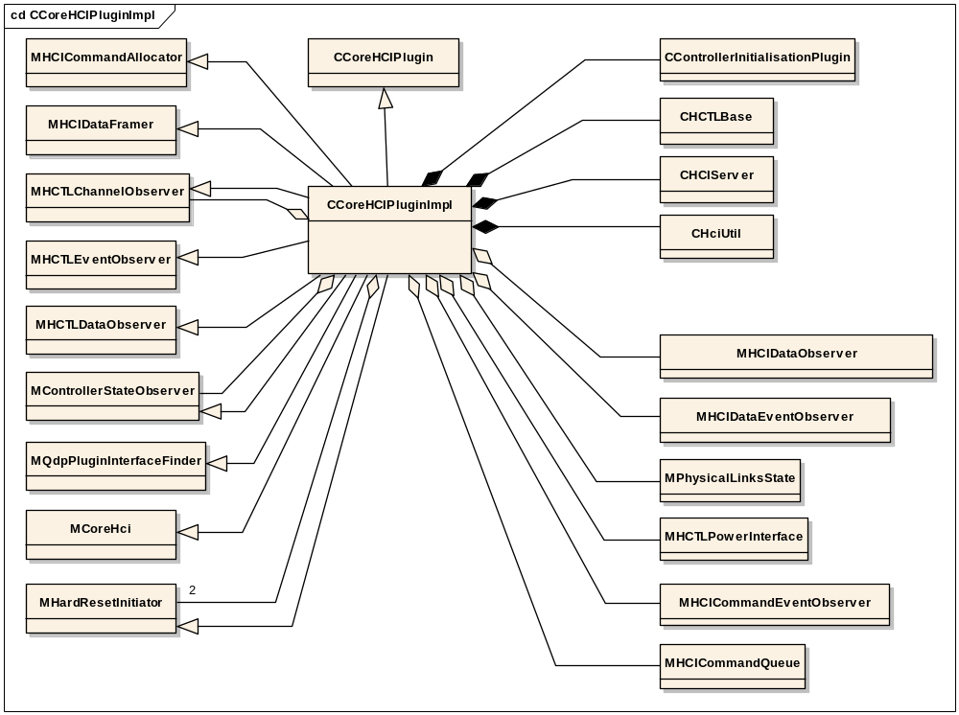
Figure 65 CCoreHCIPluginImpl

Design Unit Behaviour
This implementation performs the basic minimum requirements of a Core HCI implementation as laid out in sections 5.3.1 and 5.3.2.

Initialisation
CCoreHCIPluginImpl::ConstructL is responsible for loading and initialising the Controller Initialiser and HCTL plug-in components. See section 2.3 for general about the initialisation sequence for the HCI components.
It obtains the UIDs for the ECOM plug-in implementations for the Controller Initialiser and the HCTL from the file corehci_symbian.ini which is exported from the Core HCI implementation at bluetooth/hci_v2/implementations/corehcis/symbian/group/corehci_symbian.ini.
The layout of corehci_symbian.ini is as follows:
[Plugins]
hctl_uid= 0x102056BC
initialisation_uid= 0x1027407D
The UIDs used in this example are those for the UART Original HCTL and the Symbian Controller Initialiser.
If ConstructL is unable to obtain the UID from the file, then it will still attempt to load the plug-in, but this will then only be successful if there is one and only one implementation of that plug-in on the device. If the UID was obtained from the file however, then the specified implementation must be present for a successful load to occur (in this case it does not matter if other implementations are also present).
If unable to load the HCTL plug-in, a Leave will occur which means that the Bluetooth stack cannot be loaded.
The Controller Initialiser plug-in is optional, so no Leave will occur if we are unable to load it, unless an initialisation_uid was found in the .ini file, in which case a missing implementation is clearly an error and so again a Leave will occur and the Bluetooth stack will not be loaded.

Performance
This is a minimal implementation of the Core HCI and is not expected to have a significant effect on performance.

Component Future Work
None identified

HCTL Design

HCTL Overview
The HCTL is the component responsible for communicating with the Bluetooth Controller hardware. The interfaces to the HCTL are owned by Symbian, but it is the licensee’s responsibility to provide an HCTL implementation tailored to their hardware. Three implementations of the HCTL are provided by Symbian as reference code:
- uart_original, for the very simple H4 protocol
- BCSP, for the BlueCore Serial Protocol
- TI, an extension of uart_original
The HCTL uses the plug-in architecture described in section 3.5.1. Symbian provides the implementation of the statically-linked plug-in base DLL, hctl_base.dll as part of the framework. As well as the standard ECOM functionality, this DLL also contains common code which will be of use to UART-based HCTL implementations. It is the licensees responsibility to provide the dynamically-loaded plug-in itself, which should implement support for the licensee-specific hardware and protocols.
Note however that the HCTL is loaded by the Core HCI, which is also a licensee-owned component. Therefore it is open to the licensee to implement an alternative method of loading the HCTL rather than using hctl_base.dll and the plug-in archtitecture as described above. For example, the HCTL could be implemented in the same DLL as the Core HCI. The constraint remains that the interfaces in the API described below are visible beyond the confines of the Core HCI – they are used by Symbian-owned components - these interfaces must therefore be provided as described.
This design is split into three sections:
- This introduction, which provides an overview of the HCTL
- Description of the detailed design of the HCTL framework, including the interface MHCTLInterface, and its intended use (section 5.4.2).
- A brief description of the reference HCTL implementations provided by Symbian (section 5.4.2.3.1).
Some aspects of HCTL functionality are described in more detail under the cross-component topic of Controller Management Design, see section 6.1.

HCTL structure
HCTL, as the lowest level of Symbian OS Bluetooth implementation, can be itself divided into four layers, as shown in Figure 66. The implementation does not have a clear mapping of these four layers because the actual abstraction used is more concerned with code re-use. The division of layers here just helps to understand the scope of HCTL.

The top two are data related layers and should be similar in all HCTL implementations. The lower two are hardware specific layers among different types of hardware.

Data Parsing
Raw Data
HCTL Protocols
Hardware Adaptation
Figure 66 HCTL Layers

The Hardware Adaptation layer is concerned with hardware specific information. Each type of HCTL gets hardware specific information from its own ini file. For example, UART based HCTLs would get the port number and baud rate from “hctl_uart.ini”.

The HCTL Protocols Layer is concerned with how to interact with the controller. This is the bulk part of HCTL implementation. The protocol specification defines the major blocks and important state machines. The implementations may deviate on some of the details, but they have to strictly conform to the interfaces.

The Raw Data Layer just cares about sending and receiving data. It does not know anything about the nature of the data. In spite of the simplicity, this layer has an important responsibility: it has to notify the stack about the channel availability. This information is an important part of the flow control in HCI and the stack.

The Data parsing Layer parses the incoming data into several meaningful data types: Events, ACL data and Synchronous data (Synchronous data is not currently supported. It is implemented at hardware level by the licensee). However, the HCTL does not interpret the semantics of the events. The events are pushed up to the HCI as raw frames.

HCTL Class Overview
The layout of the principal HCTL classes is shown in Figure 67.
CHCTLBase is the base class responsible for loading the HCTL plug-in using ECOM.
CHCTLUartBase provides hardware adaptation layer functionality appropriate for HCTL implementations using UART-based hardware. This class derives from CHCTLBase and forms part of the framework DLL hctl_base.dll.
Symbian provides reference implementations for Uart_original, BCSP and TI protocols. All of these are based on UART hardware. Therefore each of the three classes for these three implementations derives from CHCTLUartBase.
Other components including the stack, command queue and HCI can access the HCTL via the MHCTLInterface mixin. HCTL can also communicate with its users through the three observer classes: MHCTLChannelObserver, MHCTLEventObserver and MHCTLDataObserver.
The TI reference implementation includes additional functionality to allow the TI Controller Initialisor plug-in to change the port configuration, and hence derives additionally from MHctlConfigInterface.
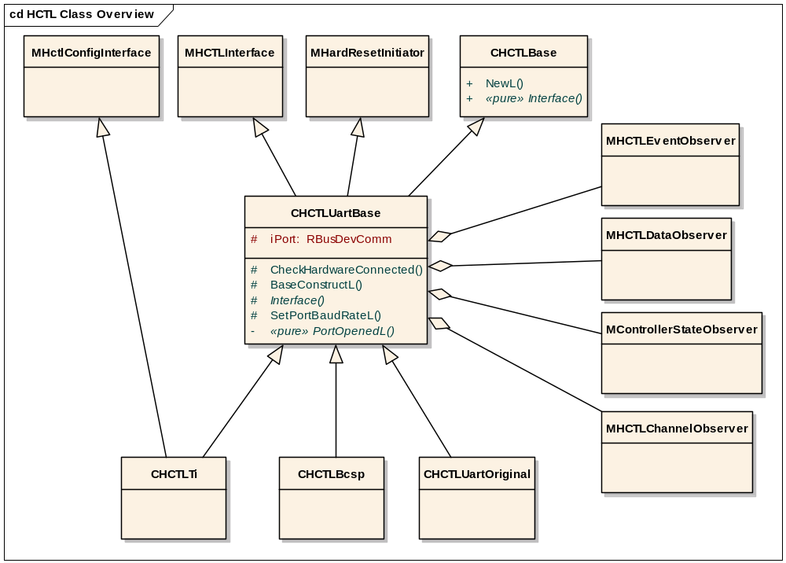
Figure 67 HCTL Class Overview

HCTL Detailed Component Design

Overview
The HCTL follows the pattern of ECOM plug-ins as described in section 3.5.1.
CHCTLBase and CHCTLUartBase make up HCTL_base.dll. The reference Core HCI component statically links to this DLL and calls the static factory method CHCTLBase::NewL which causes the specific HCTL DLL to be dynamically loaded. It then calls the Interface method on the object thus created to obtain a pointer to an MHCTLInterface.
Both the interface and implementation of CHCTLBase and CHCTLUartBase are owned by Symbian. The interface of MHCTLInterface is owned by Symbian but its implementations are reference code (see section 5.4.2.3.1 for more information on the reference HCTLs).
The detailed function-level documentation of these classes can be found in the Symbian OS Library. The header files are exported from //EPOC/master/common/generic/bluetooth/latest/bluetooth/hci_v2/framework/HCTL/interface/.

Interfaces

CHCTLBase
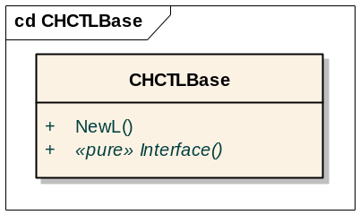
Figure 68 CHCTLBase
This is the plug-in base class for the HCTL ECom plug-in. The two overloads of its NewL method cause the HCTL plug-in to be located and dynamically loaded by the ECom framework. It also defines the pure virtual function Interface which is over-ridden in the plug-in implementation and is responsible for providing an appropriate interface pointer according to the interface UID supplied as a parameter.
See section 3.5.1 for a discussion of the Plug-in pattern used.

CHCTLUartBase
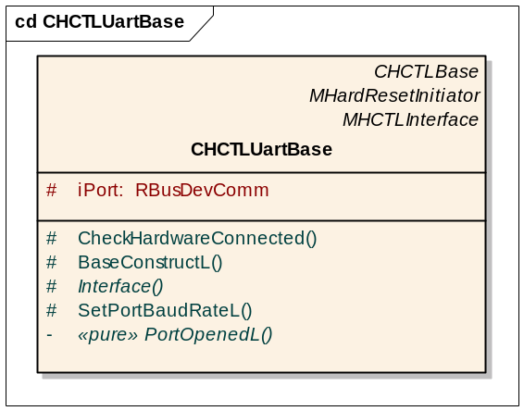
Figure 69 CHCTLUartBase
This class derives from CHCTLBase, is included in the build of HCTL_base.dll, and provides common functionality appropriate for a UART-based HCTL implementation.
The derived class for the specific HCTL implementation should call BaseConstructL from its second-phase constructor. This will cause the port to be opened, and then a call-back will be made on the pure virtual PortOpenedL method to allow the derived class to perform initialisations on the newly-opened port.
An implementation of the interface method is also supplied. This must be overridden in the derived class if any interfaces additional to MHCTLInterface are to be supported by the component.

MHCTLInterface
This is the principal interface provided by the HCTL component. Typically the interface will be obtained by the Core HCI making a call to the Interface method supplying the UID KHCTLInterfaceUid. The implementation of this interface must be provided by the licensee.
The Stack uses this interface to write data. The Command Queue uses it to write commands. Core HCI uses it to get the transport overhead (HCTL header and trailer size) in order to calculate the frame size for commands and data.
Although this interface is supplied in the first instance to the Core HCI which is also licensee-owned code, it is also used by Symbian-owned code and therefore must be implemented by all HCTLs. However, the Get…TransportOverhead functions are used only by the Core HCI and may therefore be coded as dummy functions if the licensee chooses
The functions are shown in the table below:

Functions | Purpose
MhiWriteCommand | Writing commands and data
MhiWriteAclData | Writing commands and data
MhiWriteSynchronousData | Writing commands and data
MhiGetAclDataTransportOverhead | Get HCTL header and trailer size
MhiGetSynchronousDataTransportOverhead | Get HCTL header and trailer size
MhiGetCommandTransportOverhead | Get HCTL header and trailer size
MhiSetDataObserver | Setters for the observers that are interested in HCTL events
MhiSetEventObserver | Setters for the observers that are interested in HCTL events
MhiSetChannelObserver | Setters for the observers that are interested in HCTL events
MhiSetControllerStateObserver | Setters for the observers that are interested in HCTL events
MhiSetQdpPluginInterfaceFinder | Setter for MQdpPluginInterfaceFinder
Table 8 MHCTLInterface

The exported header hctlinterface.h documents each method in detail.
MQdpPluginInterfaceFinder is an interface which may be provided to the HCTL and which the HCTL may then use to query the QDP for addional interfaces (not MHCICmdQueueDecisionInterface). Since the QDP and HCTL are both licensee code, this allows a channel of communication to be set up between the two licensee components for such purposes as the licensee sees fit.

MHCTLChannelObserver
This observer interface allows the HCTL to provide notifications when a channel is opened or closed. Calls on this interface are relayed from Core HCI reference code to the Stack, and the interface is provided to the HCTL via MHCTLInterface::MhiSetChannelObserver.
There are three separate channels: Command, ACL Data and SCO Data. If the HCTL notifies the observer that a particular channel is closed then the observing component must respect the notification and not attempt to send commands/data of that type.

MHCTLDataObserver
This is a sink interface for data (ACL or SCO) received from the controller. It is implemented in the Core HCI reference code and the interface is provided to the HCTL via MHCTLInterface::MhiSetDataObserver.
Caution: the mixin class MHCIDataObserver has identically named methods to those in this interface, which could cause confusion.

MHCTLEventObserver
This is a sink interface for incoming events received from the controller. It is implemented in the Core HCI reference code and the interface is provided to the HCTL via MHCTLInterface::MhiSetEventObserver.

CDelay
This is a timer utility class for use within the HCTL. It is provided as part of the HCTL framework and lives under hci_v2/framework/HCTL/. It is intended to promote code re-use and is used in the build for each of the reference HCTLs supplied by Symbian.

RBusDevComm
This class is used by UART-based HCTL implementations to communicate over the serial interface to the controller. The iPort data member of CHCTLUartBase is an instance of this class. It is fully documented in the Developer Library.

Behaviours
This section documents the expected sequence of the main interactions involving the HCTL and other components.

Initialisation
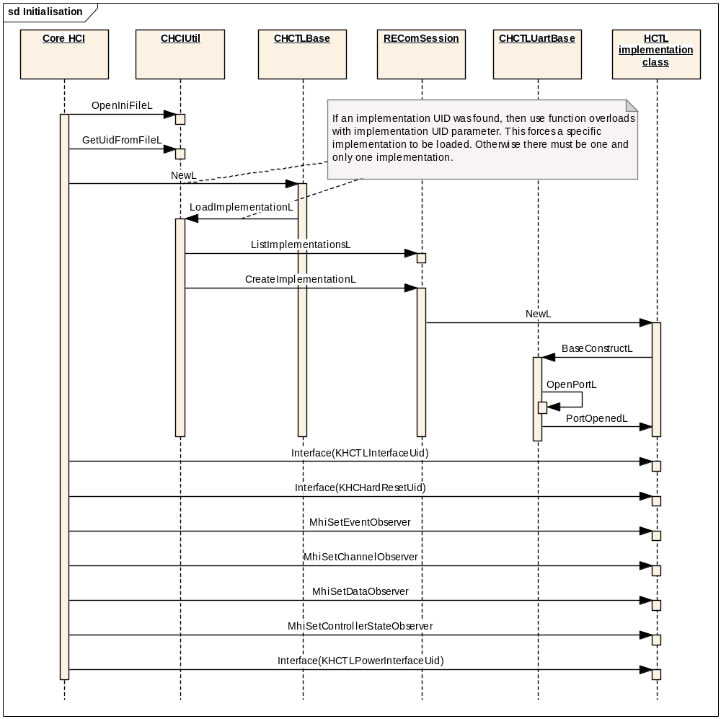
Figure 70 HCTL Initialisation
Note that the power interface MHCTLPowerInterface is part of the cross-component Controller Management functionality which is described in more detail in section 6.1.

Writing ACL Data
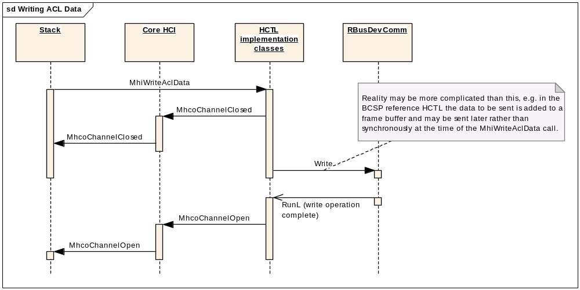
Figure 71 Writing ACL Data
The organisation of the classes within the HCTL implementation is not shown here because it between the three supplied reference implementations. Typically however the responsibility for writing data will be delegated to an Active Object “writer” class. In the case of the BCSP protocol the picture is somewhat more complex than is shown here due to the operation of a frame queue, sequencer and windowing operation withing the protocol. This may mean that the Write operation to RBusDevComm is carried out asynchronously with respect to the call to MhiWriteAclData. It also means that the channel observer may not be notified of channel closed each time a write is done, only when the frame buffer goes full.

Writing SCO Data
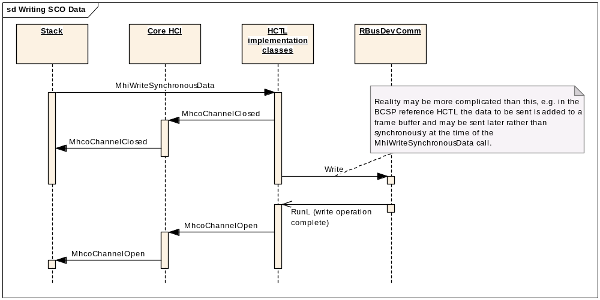Figure 72 Writing SCO Data
See also the comments to Figure 71 Writing ACL Data which apply equally here.

Writing Commands
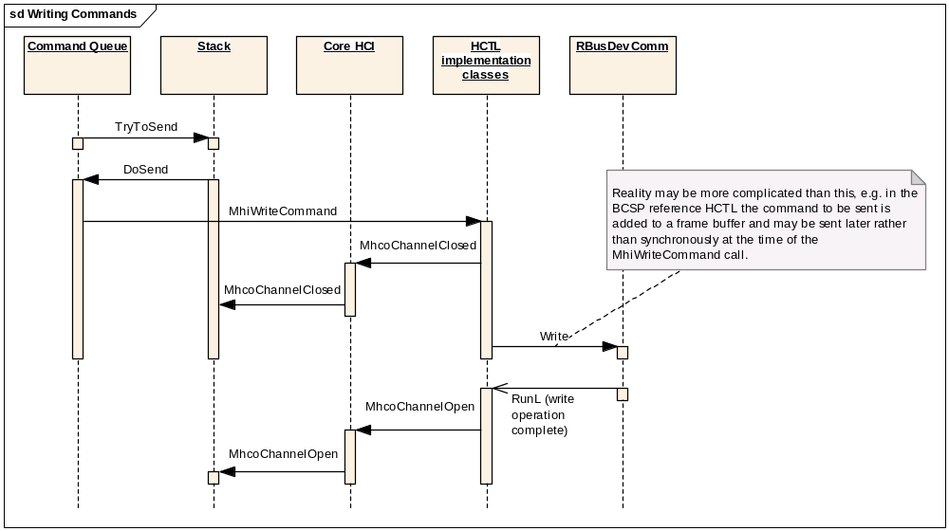Figure 73 Writing Commands
See also the comments to Figure 71 Writing ACL Data which apply equally here.

Incoming ACL Data
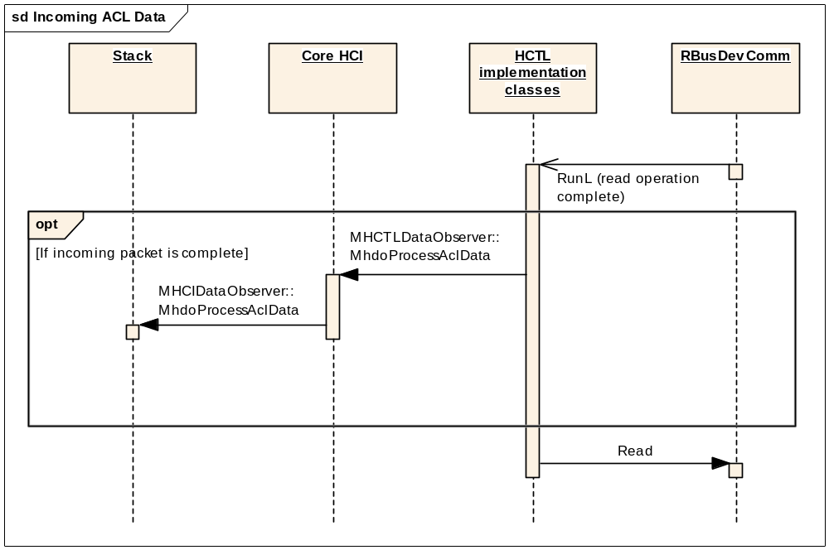
Figure 74 Incoming ACL Data
Again, this is a somewhat simplified representation, particularly with respect to the BCSP implementation which is of considerable complexity.

Incoming SCO Data

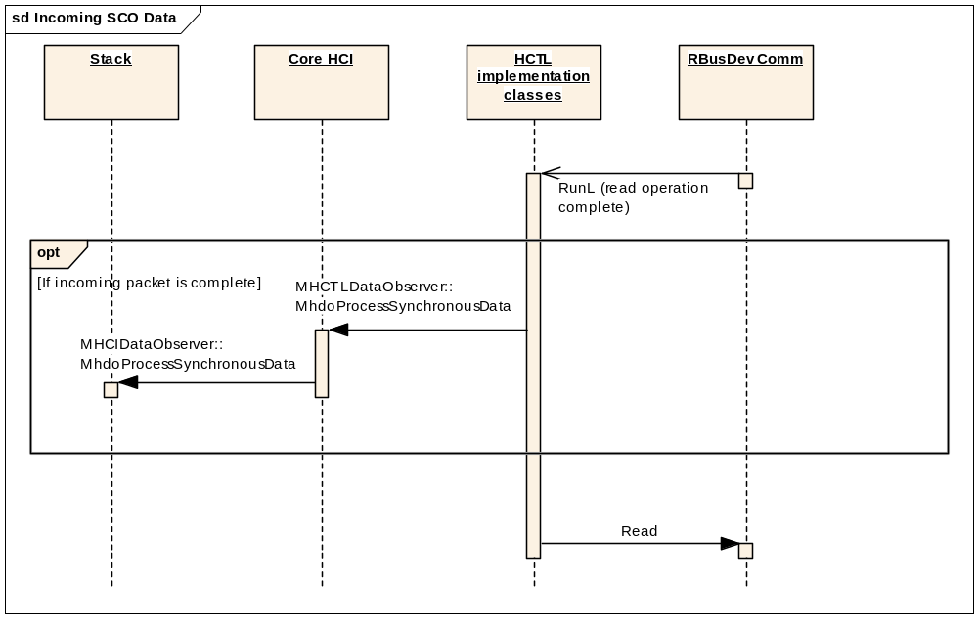
Figure 75 Incoming SCO Data

Again, this is a somewhat simplified representation, particularly with respect to the BCSP implementation which is of considerable complexity.

Incoming Events

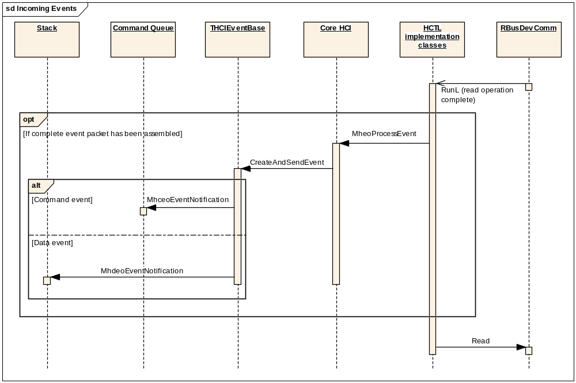
Figure 76 Incoming events
Again, this is a somewhat simplified representation, particularly with respect to the BCSP implementation which is of considerable complexity.

Reference HCTL Implementations
This section briefly describes the three reference HCTL implementations provided by Symbian: Uart_original, BCSP and TI.

Uart_original HCTL

Component Overview
This component implements the basic H4 HCTL protocol. This is a UART-based implementation.
This is reference code only and it remains the licensees responsibility to ensure correct operation on any hardware platform.
It is built as hctl_uart_original.dll and contains the implementation of the class CHCTLUartOriginal and supporting classes.

UML Diagram
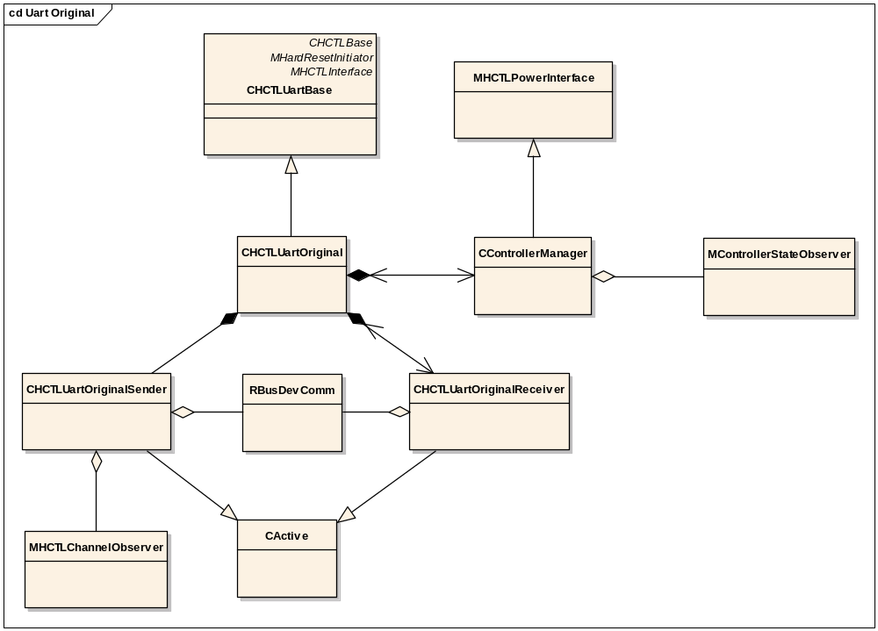
Figure 77 UART Original HCTL

Classes

CHCTLUartOriginal
This derives from CHCTLUartBase and can be loaded as an HCTL plug-in.
It implements support of the basic H4 protocol, using the Sender and Receiver active objects (see below) to manage the serial link.
It provides an override of the pure virtual Interface method from CHCTLBase to return the interfaces provided by this component:
- MHCTLInterface, supported by this class
- MHardResetInitiator, supported by this class
- MHCTLPowerInterface, supported by CControllerManager
It also provides an implementation of the pure virtual method PortOpenedL from CHCTLUartBase – this method is responsible for initialisation and configuring the parameters of the serial port.
It uses the HCTL observer interfaces associated with the CHCTLUartBase base class to forward incoming data and events from the Receiver on to the rest of the HCI.

CHCTLUartOriginalSender
This is a simple active object class which will perform write operations on the serial link. It is provided with a reference to the RBusDevComm object owned by CHCTLUartBase for this purpose. It also has a reference to the MHCTLChannelObserver interface so that it can take responsibility for providing channel open/closed status notifications as it initiates write operations and is notified of their completion.

CHCTLUartOriginalReceiver
This is a simple active object class which reads data over the serial link and assembles it into packets. It is provided with a reference to the RBusDevComm object owned by CHCTLUartBase for this purpose. It also has a back-reference to its owning CHCTLUartOriginal object so that it can make calls to pass data and event packets up to it, and can initiate a hard reset if it detects a fatal error.
This class runs as a state machine which embodies knowledge of the expected packet structure and allows it to assemble a complete packet for onward despatch.

CControllerManager
This class implements MHCTLPowerInterface which contains MhpiGetPower and MhpiSetPower methods to allow control over Controller power. Section 6.1 discusses the contexts in which this may be used. Note that MhpiSetPower is a skeleton method only, since the actual method which might be used to perform the power-down or power-up operation on the Controller is not available. This would need to be filled in by the licensee with the appropriate code for their particular hardware configuration.
CControllerManager also contains the method, HardReset, to perform a hard reset. However, like MhpiSetPower, this is a skeleton method only, since the actual method which might be used to perform a hard reset on the Controller is not available. This would need to be filled in by the licensee with the appropriate code for their particular hardware configuration. The MHardResetInitiator interface is actually supported by CHCTLUartOriginal rather than by this class, but its MhriStartHardReset method merely relays the call to our HardReset method.
CControllerManager is provided with a back-reference to its owning CHCTLUartOriginal object so that it can query its current power state and notify it of changes.
It also has a reference to the MControllerStateObserver interface on which the HCTL provides Controller state change information. It is responsible for providing updates over this interface.

BCSP HCTL

Component Overview
This component provides an implementation of the HCTL using the BlueCore™ Serial Protocol. This is a more complex protocol than that of the other reference HCTLs. It is beyond the scope of this document to describe the implementation of the protocol in detail. A brief overview of the implementation will be provided only. For further information the reader should consult the BlueCore protocol description (see [R15]) and refer to the code.
This is a UART-based implementation. It is built as hctl_bcsp.dll and contains the implementation of the class CHCTLBcsp and supporting classes.
This is reference code only and it remains the licensees responsibility to ensure correct operation on any hardware platform.

UML Diagram
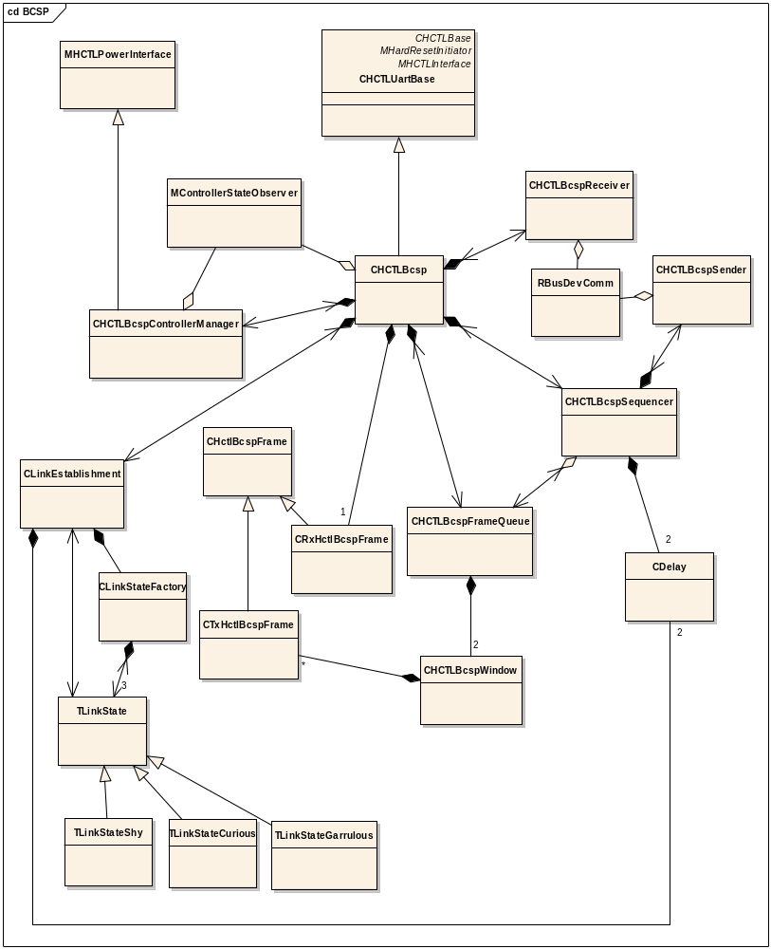
Figure 78 BCSP HCTL Classes

Classes

CHCTLBCSP
This derives from CHCTLUartBase and can be loaded as an HCTL plug-in.
It provides an override of the pure virtual Interface method from CHCTLBase to return the interfaces provided by this component:
- MHCTLInterface, supported by this class
- MHardResetInitiator, supported by this class
- MHCTLPowerInterface, supported by CControllerManager
It implements support of the basic BlueCore Serial Protocol (BCSP) in conjunction with the set of helper classes detailed below.
It implements the methods of MHCTLInterface. The write methods pass the data on to the Frame Queue object CHCTLBcspFrameQueue. In addition, a further write method, WriteBcCommand is provided to allow the Controller Manager (CHCTLBcspControllerManager) to send BlueCore-specific controller management commands to the Controller – these commands are likewise passed to the Frame Queue.
It also provides an implementation of the pure virtual method PortOpenedL from CHCTLUartBase – this method is responsible for initialisation and configuring the parameters of the serial port.
In the implementation of the BCSP protocol, this class plays the role of Packet Router. This functionality is provided by the PacketRouter method which receives incoming packets from the Sequencer (CHCTLBcspSequencer). In addition to the normal HCI categories of ACL data, Synchronous data and Events, which are passed on to the HCTL observer classes associated with the CHCTLUartBase base class, the Packet Router handles two additional types of packets:
- BlueCore controller management packets which are passed to the Controller Manager.
- Link Establishment packets, which are passed to the Link Establishment (CLinkEstablishment) object.
It also provides a number of methods which have to do with flow control, relaying function calls between the BCSP helper classes described below and generally acting as the “glue” for the component.

CHCTLBCSPSender
This is a simple active object class which will perform write operations on the serial link. It is provided with a reference to the RBusDevComm object owned by CHCTLUartBase for this purpose. It also has a reference to the Sequencer so that it can kick off further activity as appropriate when a write operation is completed.

CHCTLBCSPReceiver
This is a simple active object class which reads data over the serial link. It is provided with a reference to the RBusDevComm object owned by CHCTLUartBase for this purpose. It does not perform packet assembly – the assumption is that RBusDevComm will provide exactly one packet per read request. It also has a back-reference to its owning CHCTLBCSP object so that it can make calls to pass received data up to it (to be forwarded on to the Sequencer). Errors on the serial interface will be ignored; unlike the other HCTL implementations, the BCSP implementation will not initiate a hard reset in this case.

CHctlBcspFrame
This is a base class for a pair of classes used to represent a BCSP frame.

CRxHctlBcspFrame
This class represents a received BCSP frame. It provides a method which establishes an association between this object and a received data block, and for validating and Slip-decoding it. See the BCSP specification at [R15] for more details.

CTxHctlBcspFrame
This class supports creation of a BCSP frame suitable for transmission to the Controller.

CHCTLBcspSequencer
This class provides the Sequencing layer as described in the BCSP specification at [R15].

CHCTLBcspWindow
Manages a queue of frames for transmission, with support for windowing in accordance with the BCSP specification (see [R15]).

CHCTLBcspFrameQueue
Supports methods to allow frames to be queued for transmission. It owns two CHCTLBcspWindow objects which are used to provide two queues; one for reliable frames and one for unreliable frames. See the BCSP specification [R15] for more details.

CHCTLBcspLinkEstablishment
This class manages the initial establishment of a link between the host and the controller. It supports the three link states shy, curious and garrulous as per the BCSP specification [R15]. It uses the Link State Factory class CHCTLLinkStateFactory to generate state objects to represent these three states.

CHCTLLinkStateFactory
This is the State Factory class used for link establishment.

TLinkState
This is the base class for the three supported link states

TLinkStateShy
Derived link state class defining state transitions applicable when in Shy state.

TLinkStateCurious
Derived link state class defining state transitions applicable when in Curious state.

TLinkStateGarrulous
Derived link state class defining state transitions applicable when in Garrulous state.

CHCTLBcspControllerManager
This class implements MHCTLPowerInterface which contains MhpiGetPower and MhpiSetPower methods to allow control over Controller power. Section 6.1 discusses the contexts in which this may be used.
CHCTLBcspControllerManager also contains the method, HardReset, to perform a hard reset.
The MHardResetInitiator interface is actually supported by CHCTLBcsp rather than by this class, but its MhriStartHardReset method merely relays the call to our HardReset method.
In this implementation, both the power management and hard reset functionality are implemented using BlueCore-specific controller management commands sent over the serial interface to the controller. See the BlueCore specification [R15] and the code for this class for further details.
CControllerManager is provided with a back-reference to its owning CHCTLBCSP object so that it can write BlueCore controller management commands and so that it can reset the HCTL.
It also has a reference to the MControllerStateObserver interface on which the HCTL provides Controller state change information. It is responsible for providing updates over this interface.

TI HCTL

Component Overview
This component implements an extension of the H4 HCTL protocol for TI hardware. This is a UART-based implementation, that was designed for the H4 reference board.
This is reference code only and it remains the licensees responsibility to ensure correct operation on any hardware platform.
It is built as hctl_ti.dll and contains the implementation of the class CHCTLTi and supporting classes.

UML Diagram

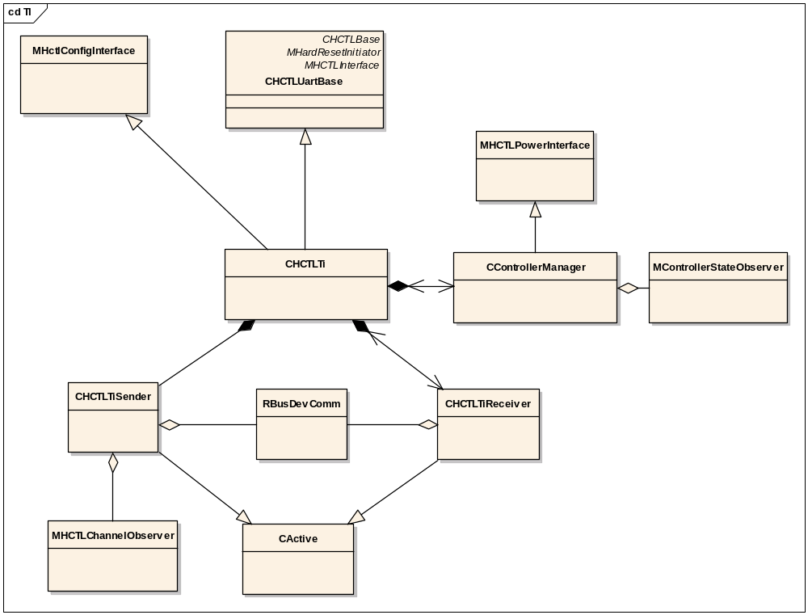
Figure 79 TI HCTL

Classes

CHCTLTi
This derives from CHCTLUartBase and can be loaded as an HCTL plug-in.
It implements support of the HCTL protocol for TI hardware, using the Sender and Receiver active objects (see below) to manage the serial link.
It provides an override of the pure virtual Interface method from CHCTLBase to return the interfaces provided by this component:
- MHCTLInterface, supported by this class
- MHardResetInitiator, supported by this class
- MHCTLPowerInterface, supported by CControllerManager
- MHctlConfigInterface, supported by this class
It also provides an implementation of the pure virtual method PortOpenedL from CHCTLUartBase – this method is responsible for initialisation and configuring the parameters of the serial port.
The implementation of MHctlConfigInterface consists of a single method MhciUpdateBaudRate which allows the baud rate configured for the serial port to be controlled from outside this component.

CHCTLTiSender
This is a simple active object class which will perform write operations on the serial link. It is provided with a reference to the RBusDevComm object owned by CHCTLUartBase for this purpose. It also has a reference to the MHCTLChannelObserver interface so that it can take responsibility for providing channel open/closed status notifications as it initiates write operations and is notified of their completion.

CHCTLTiReceiver
This is a simple active object class which reads data over the serial link and assembles it into packets. It is provided with a reference to the RBusDevComm object owned by CHCTLUartBase for this purpose. It also has a back-reference to its owning CHCTLTi object so that it can make calls to pass data and event packets up to it, and can initiate a hard reset if it detects a fatal error.
This class runs as a state machine which embodies knowledge of the expected packet structure and allows it to assemble a complete packet for onward despatch.

CControllerManager
This class implements MHCTLPowerInterface which contains MhpiGetPower and MhpiSetPower methods to allow control over Controller power. Section 6.1 discusses the contexts in which this may be used. Note that MhpiSetPower is a skeleton method only, since the actual method which might be used to perform the power-down or power-up operation on the Controller is not available. This would need to be filled in by the licensee with the appropriate code for their particular hardware configuration.
CControllerManager also contains the method, HardReset, to perform a hard reset. However, like MhpiSetPower, this is a skeleton method only, since the actual method which might be used to perform a hard reset on the Controller is not available. This would need to be filled in by the licensee with the appropriate code for their particular hardware configuration. The MHardResetInitiator interface is actually supported by CHCTLTi rather than by this class, but its MhriStartHardReset method merely relays the call to our HardReset method.
CControllerManager is provided with a back-reference to its owning CHCTLTi object so that it can query its current power state and notify it of changes.
It also has a reference to the MControllerStateObserver interface on which the HCTL provides Controller state change information. It is responsible for providing updates over this interface.

Component Future Work
None identified

Controller Initialisation Design

Controller Initialisation Overview

Introduction
Note: the terms “Controller Initialisation” (component) and “Controller Initialiser” are synonyms for the same component and will be used interchangeably.
The main function of the Controller Initialisation plug-in component is to allow licensees to perform controller tasks at the moment that a controller has just booted or re-booted. One standard action that must always be performed at this stage is to send the Bluetooth SIG-specified HCI command “Reset”. However any individual controller may need commands, possibly vendor-specific commands, to be sent before sending the Reset command (e.g. to garner state information), and to be sent after sending the Reset command (to initialise the Controller). For instance for a cheaper ROM based controller, the controller would need to be sent its Bluetooth device address immediately after being sent the Reset command.
This plug-in provides a means for the licensee to implement such “pre-” and “post-reset” functionality.
It is implemented as an ECOM plug-in, following the Plug-in Pattern as described in section 3.5.1. The plug-in base dll (initialisor_base.dll) is owned by Symbian and is statically linked from the Core HCI component. It will, however, be accessible to the Stack which will have the responsibility for calling its API
- when it itself is first loaded
- when it is informed that a Controller reboot has occurred
The implementation of the Controller Initialisation plug-in itself is owned by the licensee, but since it interacts with Symbian-owned components - namely the Stack, the Command Queue, and the Core HCI - it must implement and use a number of Symbian-owned interfaces. These interfaces and the expected behaviours of the Controller Initialisation component are described in section 5.5.2.
Two reference implementations of the Controller Initialisation component are provided: the Symbian Initialisor and the TI Inititialisor. These are described in section 5.5.3.

Interfaces
Figure 80, below, shows the interfaces implemented by and used by the Controller Initialisation component. The Core HCI exercises ownership of the Controller Initialiser through the CControllerInitialiserPlugin interface.
More information about these interfaces will be presented in the detailed design section 5.5.2.1.
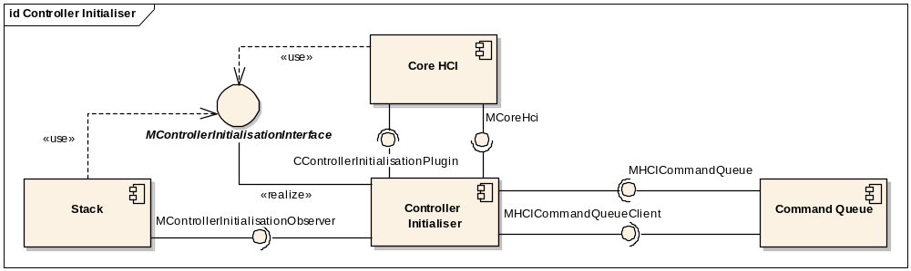

Figure 80 Controller Initialiser Interfaces

Usage Scenario
The following sequence diagram illustrates one possible usage scenario. In this scenario, the Initialiser sends a sequence of post-reset commands. The first of these commands is a Get Local Version Info command – the results of this command are used to select a version-specific command script file which determines the remaining initialisation commands which need to be sent. This is a somewhat simplified version of the behaviour of the reference TI Initialisor implementation (see section 5.5.3.2).
Figure 81 A Controller Initialisation scenario

Controller Initialisation Detailed Component Design

Interfaces
This section describes the interfaces which must be provided by the Controller Initialisation component and those which it uses.
All these interfaces are owned by Symbian. Some of the implementations are Symbian code, some are implemented in reference code – the detailed description of each interface below will provide this information.

CControllerInitialisationPlugin
CControllerInitialisationPlugin derives from CBase, and acts as the plug-in base class for the Controller Initialisation component. See section 3.5.1 for a discussion of the Plug-in Pattern used.
The implementation of this class forms the plug-in base dll initialisor_base.dll. This DLL is owned by Symbian. It should be statically linked to the Core HCI. The Core HCI creates the Controller Initialiser by calling CControllerInitialisationPlugin::NewL. The Controller Initialisor is an optional component and the Bluetooth Stack can function in its absence so long as the Bluetooth Controller in use does not actually require any custom initialisation actions.
The implementation of the plug-in itself is licensee-owned code. Two reference implementations are provided by Symbian, see section 5.5.3.
The following comments refer to the implementation of the derived class in the plug-in.
The plug-in must be implemented as a C-class, derived from CControllerInitialisationPlugin, and must implement its own NewL and an override of the pure virtual Interface method.
The NewL of the derived class will be called from ECOM to create an instance of the object after the plug-in has been located.
The Interface method will then be called from the Stack to obtain pointers for interfaces supported by the plug-in. It should provide the MControllerInitialisationInterface.

MControllerInitialisationInterface
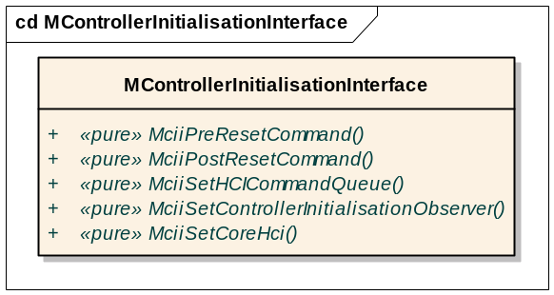
Figure 82 MControllerInitialisationInterface

MControllerInitialisationInterface is an interface implemented by the Controller Initialiser. The interface is owned by Symbian but the licensee is responsible for the implementation. Core HCI uses this interface to provide the Controller Initialiser with a reference to its own MCoreHci interface. The Stack uses it to provide the Initialiser with the other interfaces that it needs, and to initiate the provision of pre- and post-reset command sequences.

MControllerInitialisationObserver
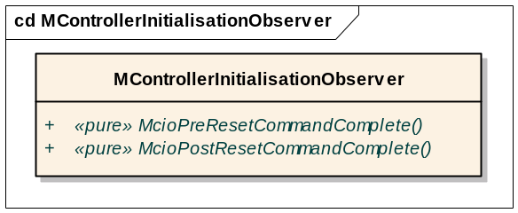
Figure 83 MControllerInitialisationObserver
MControllerInitialisationObserver is an interface implemented by the Stack. The interface and implementation are both owned by Symbian.
This is an observer interface used to provide notification of completion of the operations started by calling MControllerInitialisation::MciiPreResetCommand and MControllerInitialisation::MciiPostResetCommand. Both these operations operate asynchronously.

MCoreHci
MCoreHci is an interface implemented by the Core HCI. The interface is owned by Symbian but the licensee is responsible for the implementation.
This interface is provided to the Initialiser to allow it to interact with the Core HCI and related components such as the HCTL. See section 5.3.2.2.2 for details of this interface.

MHCICommandQueue
MHCICommandQueue is an interface implemented by the Command Queue. The interface and implementation are both owned by Symbian.
This interface is provided to the Initialiser to allow it to queue commands to be sent to the Controller. The commands should be queued as initialisation commands. See section 4.1.3.1.1 for more information on this interface.

MHCICommandQueueClient
This interface is implemented by the Initialiser in order to receive notifications of events relating to the commands that it has caused to be sent.
This interface is owned by Symbian and is implemented in various components, both licensee- and Symbian-owned. The implementation in the Initialiser is the responsibility of the licensee.

Controller Initialisation Reference Implementations

Symbian Controller Initialisation

Component Design Overview
This component provides reference code for licensees. It contains a basic minimum subset of Controller Initialisation functionality as needed to support the external interfaces of the Controller Initialisation component as described in the sections above.
This implementation does not actually perform any pre- or post-reset initialisation operations. Thus it does not need to be present. It is included solely to provide a reference framework as a starting point for licensees to develop their own implementations of this plug-in.

Detailed Component Design
This component is built as initialisor_symbian.dll and the main implementation class contained therein is CControllerInitialisationPluginImpl.

CControllerInitialisationPluginImpl

Overview
This derives from CControllerInitialisationPlugin and is capable of being loaded as a Controller Initialisation plug-in.
It also derives from MControllerInitialisationInterface, so its Interface method can simply return a this pointer when asked for an instance of that interface.
It implements a basic minimum set of Controller Initialisation functionality.

UML Diagram
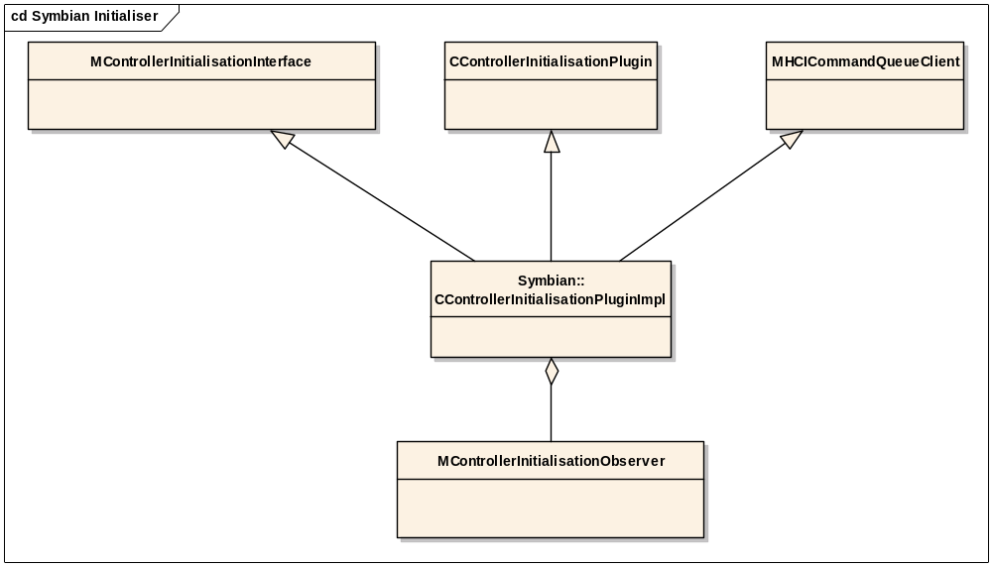
Figure 84 CControllerInitialisationPluginImpl - Symbian Initialiser

Design Unit Behaviour
This implementation performs the basic minimum requirements of a Controller Initialisation implementation as laid out in sections 5.3.1 and 5.3.2.

Initialisation

Performance
This is a minimal implementation of the Controller Initialisation plugin and is not expected to have a significant effect on performance.

TI Controller Initialisation

Component Design Overview
This component provides reference code for licensees. It contains an implementation intended to support the TI BRF6300 Controller on the daughter-board to the H4 reference board.
This is reference code only and it is the responsibility of the licensee to ensure correct operation on any specific hardware.

Detailed Component Design
This component is built as initialisor_ti.dll and the main implementation class contained therein is CControllerInitialisationPluginImpl. Note that although this class name is the same as that used in the Symbian Initialiser plug-in reference component, this is a different source file and different code.

CControllerInitialisationPluginImpl

Overview
This derives from CControllerInitialisationPlugin and is capable of being loaded as a Controller Initialisation plug-in.
It also derives from MControllerInitialisationInterface, so its Interface method can simply return a this pointer when asked for an instance of that interface.
It provides a script-based set of post-reset initialisation operations needed for certain TI Controllers.

UML Diagram
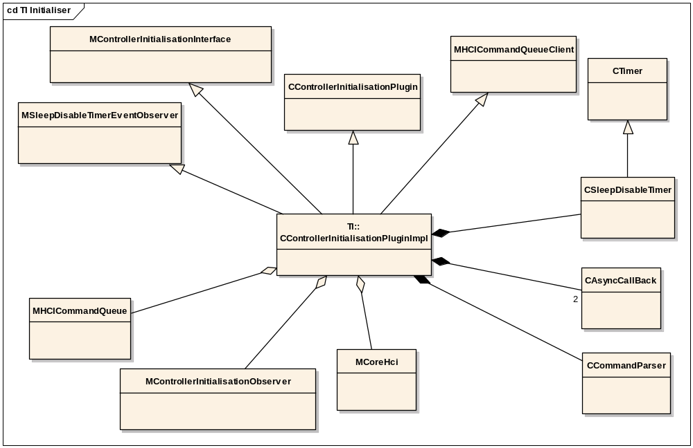
Figure 85 CControllerInitialisationPluginImpl - TI Initialiser

Design Unit Behaviour
The TI controllers require need post-reset functionality. This functionality consists of patch commands and a baud rate setting read from a script. The patch commands depend on the version of the BRF controller, and the patches that TI have discovered to be necessary for that controller at the time of use. The set of required patches is upgraded by replacing the script file – likewise the baud rate.

Performance
This is not expected to have a significant effect on performance.

Component Future Work
None identified

Cross-component Design Areas

Controller Management Design

Introduction

Purpose and Scope
This document describes those parts of Symbian owned and Symbian reference code that have to do with the ‘management’ of the Bluetooth controller (elsewhere referred to as the Bluetooth hardware, the host controller, the pod etc). This management includes power management and controller resets (in effect reboots).
It is not intended to cover the details of the controller initialisation procedure here, merely an overview.

Design Overview

Controller Reset/Hard Reset
A controller reset refers to the act of resetting the controller to the state it is in when it is newly powered up before it is initialised (with for example the HCI “Reset” command). How a controller reset is performed is controller specific. Some may require a power cycle (power down | pause | power up), and some may allow you to send a reset signal down a GPIO (general purpose) line. Some may be able to perform a reset synchronously, some not. (The same is true with power up. It is likely, though not certain, that a power down can be performed synchronously.)
A hard reset refers to a controller reset followed by a controller initialisation.
The OEM (licensee) provided QDP can elect to trigger a reset when it detects an error such as timeout when expecting a response to a command. (e.g. Command sent. Timeout on associated event. Command resent. Timeout on associated event. Request hard reset.). Though we do not believe that an HCI component will want to perform a hard reset, we will make it available to the core HCI whence it can be passed on through internal HCI component interfaces.
The sequence\route for hard reset is as follows.
“->” means “command passed on to”.
- QDP initiates hard reset -> stack
- Stack calls reset on the command queue (empty\no credits\command queue in initialising state)
- Stack passes hard reset -> HCI -> HCTL
- Asynch
- HCTL sends “Controller reset started” to HCI -> stack
- Stack reacts as it does in the old HCI for a power down notification, resetting the command queue again (belt and braces may be!), the data queue, and removing all physical links \ logical links \ logical connections. In the current implementation no channel blocking takes place once all the above has taken place.
- Asynch
- HCTL sends “Controller reset complete” to HCI -> stack
- Stack reacts as it does in the old HCI for a power up notification, together with a new call to the Controller Initialiser component to perform any controller specific initialisation (e.g. scripted vendor specific initialisation commands).
- Bluetooth is ready for service again. Any stored commands on the HCICmdQ (since “Controller reset started”) may now be sent.

Power Management
The old HCI provided a power notifier which watched the UART ClearToSend (CTS) line. If the voltage on this went down and stayed down for ten seconds (stat) then power to the controller was deemed to be off (or so low that Bluetooth activity was off). If the voltage on the CTS line came up, then power to the controller was deemed to be on. The ten second delay has to do with the fact CTS can go down for flow control as well. This power notifier however really only works in a ‘developer’ environment. On an actual phone\dev board with on-board controller, controller power can be held ‘low’ for long periods, for example whilst any existing Bluetooth connections remain inactive. This low power allows sniffing for remote activity. The moment activity starts on a Bluetooth connection (either host initiated or remote initiated) the power is brought back up. To honour this low power facility, which would mean that the voltage on the CTS line could remain low for a long time even though Bluetooth was alive, the old HCI allowed a compiler option not to notify apparent power changes.
The new (V2) HCI, however, is required to manage proactive power requests from a (suitably capable) Bluetooth client. How an HCI does this very much up to the HCI writer’s interpretation of power state. For example, “power off” could be interpreted as switch off power to the controller, or (less drastically) stop any page scanning, something in between. If is likely that the HCI writer will need to use a controller specific driver or controller (vendor) specific HCI commands to switch power to the controller off/down and on/up. In reference code, we anticipate providing examples of using such controller specific facilities for Casiras (in the BCSP HCTL) and TI hardware (in a TI specific HCTL). The TI example will only be created if we can solve associated IPR (intellectual property) issues. Any other reference HCTLs (currently just the HCTL_Uart_Original) will merely provide a framework code within their controller manager classes. Example code for the “page scan off” interpretation of “power off” will be provided in a how to document.
Further to requesting power state changes, a Bluetooth client will be able to request a snapshot of the current power state. This could be built on a facility to query the controller as to its power state, though more probably it will be built on caching the result of the last power request, and the assumption that the controller starts in power state “on”.
Finally we need to manage two successive power on requests from different clients. Technically, it is up to the HCI writer whether he should ignore a second power on request or not. However the stack is not currently equipped to handle two power on notifications which are not interspersed with a power off notification. On receipt of the second power on notification, the stack will perform a second controller initialisation when the second power on completes thereby pulling down any existing physical links, but it will not reset its state. Therefore an HCTL on receiving a power on request when power is already on should immediately complete the second request to inform the relevant client of its success, but also insure the stack knows that this power on notification, if it must receive it at all, is “non-fatal” i.e. no controller initialisation is required. The same type of notification is required if power state is being handled merely by switching page scan on and off. Indeed here we need to extend ‘non fatal’ to power off – i.e. if a non-fatal power off notification is sent, either this is not passed by the HCI to the stack, or it is in such a way that the stack knows it is non fatal, and so will not follow its standard resetting procedure. To accommodate this problem the controller state notifier API will provide a ‘fatality’ indicator when notifying a power change.
The sequence\route for power management is as follows.
“->” means “command passed on to”.
- Bluetooth client calls power on/off –(client\server)-> HCI -> HCTL (HCTL Controller Manager)
- Asynch
- HCTL sends “Controller power state change” to HCI -> stack (telling stack if change is ‘fatal’)
- If power change is ‘fatal’, the stack reacts as it does in the old HCI for relevant power state change.,(power off: resets the command queue (empty\no credits), the data queue, and removing all physical links \ logical links \ logical connections. Power on: call to the Controller Initialiser component to perform any controller specific initialisation (e.g. scripted vendor specific initialisation commands).
Also
- Bluetooth client calls request power state –(client\server)-> HCI -> HCTL (HCTL Controller Manager)
- HCTL (HCTL Controller Manager) replies with state (which it is has cached) -> HCI –(client\server)-> Bluetooth client

HCI Client Server Mechanism – Detailed Design
(@todo: This section is not only to do with controller state management, it covers all aspects of the HCI client server mechanism, one use of which is to provide a conduit for controller power requests.)
Symbian will provide the basis of a simple generic client server link (or “pipe”) between a Bluetooth client and an HCI implementation. The basis for this pipe shall consist of an internal client side interface, together with an HCI server name, and a set of categories.
Symbian will also provide two published partner client side APIs that will be implemented by calling into the generic internal API. These two published partner APIs will be for the controller power state facility and for the HCI direct access facility. The specified categories provided with the internal pipe consist of UIDs for the two published partner APIs and a UID for an asynchronous request cancellation. These will be used to indicate to the internal pipe which of our published partner APIs is using it, and whether one of them is using it to cancel an asynchronous request. Since we are currently providing just two published partner APIs, and the power control one does not include a cancellation facility, a cancellation may be assumed by an HCI writer to refer to the one asynchronous command effectively allowed by the HCI direct access API. However for future proofing the HCI direct access client will send its own category in the first IPC slot, so that an HCI writer can (and should) check that it is indeed the HCI direct access client that is cancelling the request.
Note: we are deliberately not, for a cancellation, sending the published partner API UID as the IPC number (value returned by RMessage2.Function()), and the cancellation UID in the first IPC slot. This is so as to keep the number space of the first slot clean for licensees using HCI direct access requests which use the HCI Direct Access category UID as their IPC number.

External Client APIs (Available to partners only)

RHCIDirectAccess
In (post March 2005 versions of) the old HCI this was implemented using ESock. Consequently we are encumbered by an existing ESock style API (“Ioctl” etc) that needs to be maintained. So that new users do not need to use the ESock API, we are extending the API to a non ESock style API (e.g. AsyncMessage as an alternative to Ioctl). So that RHCIDirectAccess can still be used with an old HCI – old HCIs will be supported for some time yet – the new implementation of the old API will try to find an HCI server and if it fails will revert to using ESock. This implementation will be held in a compiler MACRO, so that it may easily be removed when support for old HCIs is ‘turned off’.

RBTPowerControl
RBTPowerControl contains an API for altering the controller power state. This API is will use an enum for the power state it wants so it can be extended – for example to EAuto. RBTPowerControl also contains an API to query the power state.

Internal Client API

RHCIServerSession
The actual client side class for the new client\server routing of the partner client APIs. The API is as generic as possible without just using synchronous and asynchronous RSessionBase::SendReceives, and an Open that attempts to find an HCI server. The IPC slots are filled with int, ptr, ptr, int. This allows two slots that may be used for returning values.

Reference HCI Server
The assumption is that this need not be complex, and is likely only to have sessions opened on it by a licensee managing app.
Therefore it is designed round the concept that for each of the two external client APIs, only one outstanding asynchronous request will be handled at anyone time. Consequently server sessions hand server requests (from their “ServiceL”s) to the singleton server object which passes them to one of two owned manager objects. Of these two manager objects, one represents power control, and the other HCI direct access.

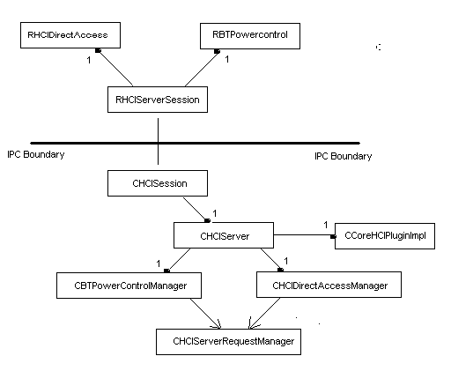

CHCISession
CHCISession session receives RHCIServerSession client session requests. CHCISession passes these requests onto the CHCIServer.

CHCIServer
CHCIServer is the hub of the HCI server. It creates new CHCISessions when requested by clients, and it passes requests on from a CHCISession to the appropriate request manager. (See below.) It also passes HCI server related events from the rest of the core HCI back to their appropriate managers.

CHCIServerRequestManager
CHCIServerRequestManager is the base class for CHCIDirectAccessManager, and CBTPowerControlManager. It manages all generic aspects to these, such as blocking, unblocking etc.

CHCIDirectAccessManager
This contains the nuts and bolts of managing HCI Direct Access….except that these cannot be really known to a reference implementation. However it does attempt to manage cancellation of HCI Direct Access requests. For example it tracks which session called the current asynch task, and only cancels that task if the calling session is requesting the cancel. See open issues.

CBTPowerControlManager
This contains the nuts and bolts of managing BT power control. It passes power requests to the core HCI which passes them down to the loaded HCTL. The reference HCI\HCTL do not use the info parameter, which a client could elect to supply.

Controller Management Detailed Design
This is section describes the classes involved in controller management. It should be noted that classes have been referenced by their prototype names. Certain names are likely to change. Any file\class that refers to “Host Controller” or “HC” will have that part of its name changed to “Controller”. Bluetooth v2.0 and after no longer refers to the “Host Controller” but to the “Bluetooth Controller”. (BC is not a good acronym. “Binary Compatibility”, “Before Compatibility”, “Before Christ” spring to mind.)

API classes

TBTHardResetState
This is an enum for notification of controller reset states. It allows for future extension of the reset phase notications. E.g. We might want reset aborted, or reset delayed.

TBTPowerState
This is an enum for notification of controller power states. It exists in the current code.

MHostControllerStateObserver
This is used for upcalls (notifications) of controller power state changes and controller reset ‘phase’ changes (currently EBTResetStarted and EBTResetComplete). It also provides an error code and a controller change type indicating the ‘fatality’ of the state change – e.g. “does power off imply the stack needs to respond by resetting everything or not”. If the error code is not ‘KErrNone’ then the notification is saying “an attempt was to made to move to controller state ‘foo’, but failed”.

MHCHardResetInitiator
This is the “down” call mixin class to pass a reset request to the HCTL. As reset requests are passed via the stack, CHCIFacade derives from MHCHardResetInitiator. So also do CCoreHCIPluginImpl and CHCTLBase.

Implementation Classes
The HCTL implementation classes for the controller manager facility fall into two varieties, only one of which will be compiled into a given HCTL DLL binary (depending on a #define in the HCTL’s .mmp file).
One variety is useful for development using an exterior controller (e.g. a Casira or a BRF6350 dev kit), and revolves around the class CDeveloperControllerManager. Because there is no actual way to switch power off or on this relies on a debug build and the __DEBUGGER() macro, which stops program execution whilst a tester manually unplugs power to the controller. The CDeveloperControllerManager does use a ClearToSend (CTS) line watcher which is used to determine whether power to the controller is on or off as described in the Design Overview above.
The other variety uses a CControllerManager which attempts to provide a generic base for the implementation of a ‘real life’ (in phone, internal controller on ref board) controller manager. This does not use CTS notification, but provides stubbs for a controller device driver to sends down power on/off, controller reset commands.
The BCSP HCTL uses a different system using a CBCSPDeveloperControllerManager, or a CBCSPControllerManager. BCSP has a link establishment procedure which affects how controller management needs to be implemented.

TControllerManagerPanic

CControllerManager
This is the class which manages controller specific requests in the HCTL. It is the class that should be used for controller management on an actual phone, or on a ref board with internal controller. It is the class that sets up and manages power change requests, and controller reset requests. It is designed round the concept that there should be an asynchronous break between:
- A controller reset being called, and an acknowledgement that this reset has started (See open issues at the end of doc.)
- An acknowledgement that a reset has started, and a notification that the reset is complete
- A request to switch power on or off, and a notification that the power change request has completed.
In practice these calls maybe synchronous (particularly power off) and a simple CAsyncCallBack facility (or one microsecond timer) could be used to make them appear asynchronous. It may be an unnecessary precaution but it seems wise to allow the stack to believe that notifications of say power up and power down will never happen in the same call stack.
Arbitration: Arbitration will be provided. Essentially if a power request comes in before a previous one has completed, it will be completed with KErrInUse even if the both power requests request the same thing. (The alternative, in this case, would be to keep an array of all power on request messages that come in whilst a power on is being performed, and complete them all when the power on request completes.) If a power on request comes in whilst a hard reset is being performed, the power on will be completed when the hard reset completes. If a power off request comes in whilst a hard reset is being performed, the power off will be performed and completed when the hard reset completes.

CControllerReset
This is an active object owned by CControllerManager which manages a controller reset request. It is currently implemented with a short timer, which can be replaced if the actual driver call to reset is asynchronous.

MControllerResetObserver
This is the mixin base class for CControllerManager that is used by CControllerReset to call back to the CControllerManager when it has completed its reset.

CControllerPowerOn
This is an active object owned by CControllerManager which manages a controller power up request. It is currently implemented with a short timer, which can be replaced if the actual driver call to power up is asynchronous.

MControllerPowerOnObserver
This is the mixin base class for CControllerManager that is used by CControllerPowerOn to call back to the CControllerManager when it has switched controller power on.

CBCSPControllerManager
This is the class which manages controller specific requests in the BCSP HCTL. It follows the principles set out in CControllerManager. However it attempts to:
- Reset BCSP where appropriate
- Use BlueCore (e.g. Casira) vendor specific commands to perform hard resets etc.
- Manage link establishment events appropriately if the CBCSPControllerManager is performing a task.
Furthermore this class will be used to perform a controller reset if BCSP fails.
The anticipated sequence of events for a BCSP reset is…
- Reset BCSP
- Asynch
- Write BlueCore ‘ColdReset’ VSC (Vendor Specific Command).
- Asynch? (detect command sent or use timer or both)
- Reset BCSP
- Asynch
- Callback to CBSCPControllerManager (Reset Complete)
Note: If any of the above fail, the stack will believe that hardware is unavailable. However we may want another route to notify that hardware will never be available again with out a manual reboot from the user.

CDeveloperControllerManager
This is the class which manages controller specific requests in a development HCTL. It is the class that should be used for controller management on an external development controller (such as a Casira or BRF6350 dev kit). It is the class that sets up and manages power change requests, and controller reset requests. Controller reset requests are managed by doing a power cycle. Power on/off is managed, given no controller\UART driver exists to turn power on and off, by stopping code execution (in debug mode) so that a tester can manually switch the controller’s power on and off. Finally CDeveloperControllerManager also provides a power notification facility, based on observing the voltage on the UART CTS line. As CControllerManager, CDeveloperControllerManager is designed round the concept that there should be an asynchronous break between:
- A controller reset being called, and an acknowledgement that this reset has started (See open issues at the end of doc.)
- An acknowledgement that a reset has started, and a notification that the reset is complete
- A request to switch power on or off, and a notification that the power change request has completed.
In practice these asynchronous breaks all involve manually switching the power off or on on the controller. Code wise the CDeveloperControllerManager waits for notification of the power change so these asynchronous breaks occur naturally.
The CDeveloperControllerManager has a CTS line notifier. (See CClearToSendNotifier below.) It responds to notification of changes in voltage on the CTS line as follows:
Voltage goes up – power is on. Voltage goes down, start a timer. If the timer times out, power has gone down. (Otherwise CTS voltage down resulted from Flow Control Off.) At any one time either the CClearToSendNotifier is active or the timer is active.

CBCSPDeveloperControllerManager
This is similar to CDeveloperControllerManager, except that it takes BCSP link establishement into account, managing link establishment events as appropriate if performing some task.

MClearToSendObserver
This is the mixin base class for CDeveloperControllerManager (or CBCSPDeveloperControllerManager) that is used by CClearToSendNotifier to call back to the CDeveloperControllerManager when it observes a change in the voltage on the CTS line.

CClearToSendNotifier
This is an active object owned by CDeveloperControllerManager (or CBCSPDeveloperControllerManager) which is used to notify changes in voltage on the CTS line.

Further Information

RHciDirectAccess server (snipped from core hci section)
In the original HCI RHciDirectAccess was implemented by passing Ioctls down through the stack. In order to by-pass the stack, in HCIv2 RHciDirectAccess will be implemented by a server provided by the Core HCI.
The server implementation will be owned by the Core HCI, and started-up when the Core HCI is started. The server could be implemented as an ECOM plug-in, but in for the reference implementation this was deemed unnecessary.
The client for RHciDirectAccess will derive from RSessionBase, and utilise RSessionBase::SendReceive() to pass data to the server in the HCI layer. To maintain compatability with the RHciDirectAccess provided by the original HCI, the RSessionBase derived object may be owned by a base class that does not derive from anything.
The RHciDirectAccess server will be responsible for parsing the messages received from the client and taking appropriate action. The first phase of parsing will involve looking at the function number provided in the message.
One use of RHciDirectAccess will be pass power control messages from a device’s Bluetooth client down to the Core HCI. Power control will be allocated its group of function codes. Core HCI will parse the information out of the power messages. By implementing this parsing phase in the Core HCI licensees can implement the power control commands as they see require.

@todo A proper description of the whole RHciDirectAccess stuff.

Open Issues
The following issues need to be resolved before this document is completed;
- Asynchronousness of reset calls and corresponding notifications. Similar for power control. Does the stack implementation depend upon the same asynchronous breaks between downcalls and upcalls. E.g. between the down call “StartHardReset”, the upcall “ResetStarted” and the upcall “ResetComplete”. Design review: answer ‘yes’…at least it might – so keep those asynch breaks. But new issue here. If two ‘power on’ notifications reach the stack without an intervening ‘power off’, the stack will call the reset command without resetting its state to “no physical links\logical channels” or resetting the command queue (thereby putting the command queue into an ‘initialisation state). This should be dealt with….or HCIs must be clearly instructed to ensure two successive power on notifications do not get passed to the stack without an intervening ‘power off’ notification. (unless their controller change type is non-fatal). See note 4.
- Should we reset the command queue at the same time that (or in the same callstack as) we make the “StartHardReset” request. This should prevent unwanted commands\data being passed to the HCTL when it knows it is about to perform a controller reset. Does it actually matter if a rogue command reaches the controller before it is reset? Design review: answer ‘yes’
- When the command queue is reset, its command credits need to be zeroed. If this is done at the point of performing a controller reset, no event should pass up to the command queue giving it command credits until the reset is complete, and the reset command has been sent as part of the initialisation procedure. Is this watertight? Do we need a BlockCommandQueue API on the command queue for use by the stack? Design review: answer CmdQ::Reset effectively blocks command Q. Also spec allows an initial command credit when a controller is reset\switched on to allow the ResetCommand to be sent. The ControllerInitialisation code needs to cope here with rogue controller in its PreResetCommand method.
- Does the CControllerManager need to be able to query the power state of the controller (or somehow keep a record of this state)? If not if a Bluetooth client requests power on when power is already on, then the stack will be notified that power has ;come up’ and will consequently reset the controller. NOT GOOD!
- Arbitration. i) What if the Bluetooth client makes a power request when the controller is being reset. ii) What if a reset request comes in whilst a power on/off is being performed. We need some form of arbitration, or caching of the power request (in case i). This exists in current design.
- We have elected not to allow the Bluetooth client have notification of controller power changes. Can we guarantee/do we need to guarantee that a power request has been honoured – e.g for flight mode. Maybe this is up to the licensee. Further without notification do we need to do anything to manage the fact that there will be a delay between a power up request and Bluetooth being available?
- Vocabulary. The word reset can refer to a controller reset, when the controller is power cycled, or its dedicated reset line is ‘tweaked’. It can refer to the controller initialisation phase when, for example, the reset command is sent, or it can refer to both. I have slightly randomly used controller reset, initialisation and hard reset. We may need to find better terms, but we must be clear and differentiate between these three meanings. Design review. Leave as is.
- Stack management of initialisation. The stack provides its initialisation in Init functions in two classes. CHCIFacade::InitL and CLinkMgrProtocol::InitL. Only the first of these is called in the current power management facility when power is observed to have come back on. (Both are called when the stack is loaded.) In the new HCI, this will extend to the completion of a hard reset. That is during the initialisation period after a controller reset, only CHCIFacade::InitL will be called. This means for example that page scanning will not be re-instated as it was prior to the hard reset. When this issue was last raised it was recommended that such power management details would be dealt with under the umbrella of a forthcoming power management PREQ. Design review. This will be dealt with in power control PREQ 1299.
- In our only-switch-page-scan-off-if-we-receive-a-power-down example, should we attempt to block page scan commands coming through the HCTL or may we assume that the managing app (BT client) will ensure no page scan commands are allowed. Is this possible? That is, can page scan be switched on from the socket? If so how can we prevent this from the HCTL….or would the BT client managing app have to use P&S page scan off rather than power control so that info gets to stack. Talk with TA. This code should be only supplied as example code in a porting doc. However the following implementation was agreed upon. HCTL uses P&S to switch page scan off. It then communicates with the loaded QDP telling it via an implementation API that power is down – whereupon the QDP blocks any WriteScanEnables that would switch page scan on. QDP also told when power comes up so as to stop this blocking.
- The BlueCore vendor specific command for power on is ‘ColdReset’. If the controller has had ‘ColdHalt’ called on it BCSP may be down, so that that ‘ColdReset’ may need to be called directly over the UART. If the Casira is set-up for BCSP would this work? Still awaiting reply from CSR.
- Do we want a way of telling the stack of unrecoverable hardware errors? Note: Hard Reset event notifications (and power notifications) now come back with an error field. Hard Reset failure, or a power on failure could be used in this context.
- The RBTPowerControl GetPower interface is synchronous, reflecting a quick snapshot. Is there any good reason to make it asynchronous, or provide an extra interface “IsControllerReallyDead” which is implemented using a vendor specific ping on the controller?
- Should HCI server only allow session that made a request to cancel it?

Further Information

References
No. | Document Reference | Version | Description
[R1] | “UML Explained” |  | by Kendall Scott  (http://www.amazon.co.uk/exec/obidos/tg/stores/detail/-/books/0201721821/toc/202-4456432-1159001)
[R2] | PREQ750 Use Cases |  | //EPOC/development/pan/integ/Documentation-In-Progress/Bluetooth/latest/Internal_Documents/PREQ750 Use cases.doc
[R3] | V1 HCI Workarounds |  | \\Camfiler01\symbiancamb\softeng\Projects\GT_0259_Shortlink_Intulo\Technical\Restricted documents\ HCI v1 Workarounds.doc
[R5] | PREQ750 Design and Documentation Guidelines |  | \\Camfiler01\softeng\Projects\GT_0259_Shortlink_Intulo\Technical\PREQ750 Design and Documentation Guidelines.doc
[R6] | Platform security engineering guide |  | Can be found in the DevLib under Symbian OS guide » Platform security
[R7] | Placement new |  | Description: http://www.inquiry.com/techtips/cpp_pro/10min/10min0999.asp  Discussion: http://www.thescripts.com/forum/thread59703.html
[R8] | UML Model |  | //EPOC/development/pan/integ/Documentation-In-Progress/Bluetooth/latest/Internal_Documents/UML_Models/EA/bt.eap
[R9] | Bluetooth Architectural Description |  | //EPOC/master/common/generic/159luetooth/latest/documentation/Bluetooth_Architectural_Description.doc
[R10] | Bluetooth Functional Specification.doc |  | //EPOC/master/common/generic/159luetooth/latest/documentation/Bluetooth_Functional_Specification.doc
[R11] | Bluetooth Specification | 2.0 | \\camfiler01\softeng\Departmental\PAN\Public\Bluetooth Specifications\2.0\Core v2.0 + EDR.pdf
[R12] | HCI UART Transport Specification |  | \\camfiler01\softeng\Departmental\PAN\Public\Bluetooth Specifications\HCTLs\ HCI_UART.pdf
[R13] | HCI USB Transport Specification |  | \\camfiler01\softeng\Departmental\PAN\Public\Bluetooth Specifications\HCTLs\ HCI_USB.pdf
[R14] | ECom.h Global variables |  | Symbian OS v9.2 DevLib » Symbian OS reference » C++ component reference » Syslibs ECom » ECom.h Global variables
[R15] | BlueCore Serial Protocol (bcore-sp-012Pb) | July 2004 | https://www.csrsupport.com/Transports

Open Issues
The following issues need to be resolved before this document is completed;
- If we change the IPR files to be replaceable Optional, we will need to change all the places that talk about reference code to be called replaceable code.

Glossary
The following technical terms and abbreviations are used within this document.
Term | Definition
(Host) Controller | A host controller is the name given to the Bluetooth “hardware” containing a radio and the Bluetooth firmware that controls it.
HCTL | Host Controller Transport Layer  This is one of a number of specified transport protocols used to convey HCI messages to the host controller, and controller events back to the HCI.
Transport | HCTL
HCI Commands | An instruction sent by the Host via the HCI to the Controller.
HCI Events | A notification sent by the Controller to the Host via the HCI
Synchronous HCI command | This is a command that is completed quickly (in one stage via a Command Complete Event)  The implication is that it sets something in the controller or gets some information from the controller. It does NOT ask the controller to communicate (via Link Manager Protocol commands) with a remote device, seeking a response from that device.
Asynchronous HCI command | This is a command that may take some time to complete. Such a command will initially be responded to by a Command Status Event.  If the Command Status Event is successful, then the HCI needs to wait for the associated named complete event. It is possible that other events may precede that named complete event which may require the HCI to send out other intermediary commands. These intermediary commands may well be asynchronous as well. In this situation you would have nested command/named event pairs.  It is perfectly possible to get overlapping command / event pairs (provided there are sufficient command credits available)
Command Complete Event | This is an event that follows a synchronous HCI command, providing information requested by that command or just telling the HCI that that business with that synchronous command has concluded.
Command Status Event | A Command Status Event tells the HCI that an asynchronous command is in progress (or that, if an error is returned, the controller cannot proceed with the command).
Named (Complete) Events | Each asynchronous command has an associated “named” complete event. This will tell the HCI that business with that asynchronous command has concluded.
Command Conclusion Event | This is any event that tells the HCI that business with a command has concluded. This could be a Command Complete Event, a Named Complete Event, or an errored Command Status Event. N.B. This name has been created for internal use only – IT IS NOT IN THE SPEC.
Idle hardware | A controller is said to be idle if it is NOT processing a command. An example of non-idle hardware is one that is doing an “inquiry” command which may take a long time to process because it may involve temporarily connecting to large number of remote Bluetooth devices in order to discover Bluetooth information from them required by the HCI. Idle hardware could have a connected physical link.
HCI Command States | This is a PREQ750 internal concept appertaining to the command queue component. The following states have to date been recognised / considered.  - ‘pending’ – a command in the command queue component that has not yet been sent.  - ‘sent’ – a command that has been sent but not completed. I.e. no event that represents conclusion of business with that command has been received.  - ‘complete’ – a command for which the event that represents conclusion of business with that command has been received.  - ‘held’ – the whole command queue component is blocked from sending despite there being enough command credits which allow a command to be sent. This is probably because there is another command on the command queue in state ‘sent’ with the same opcode.
Workaround | Within scope of the new HCI, this is the facility that permits for a given HCI command the dynamic addition “Child” commands both before and after “Parent” command
Parent command | A command added to the command queue component by a MhciCommandQueueClient but one that is deemed by the QDP to require other commands as part of a workaround for that command.
Normal command | A command added to the command queue component by a MhciCommandQueueClient but is NOT a parent command.
Child commands | These are commands that the command queue sends to aid the processing of a parent command.
Pre Child Commands | A child command that is sent before the parent command
Post Child Commands | A child command that is sent after the parent command
Non ROM-Based Bluetooth Hardware | This hardware is made such that its Bluetooth address and other characteristics unique to a specific piece of hardware are incorporated directly into the hardware.
ROM-Based Bluetooth Hardware | This hardware is made such that its Bluetooth address and other characteristics unique to a specific piece of hardware are NOT incorporated directly into the hardware and as such this type of hardware requires a more extensive initialisation sequence than non ROM-based hardware.
QDP | Queue Decision Plug-in
Unexpected Event | An event that required a command to have been previously sent to solicit the event as a response. The event is unexpected because the command wasn’t sent.
Unsolicited Event | An event that occurs without the need for a command to have been send previously, e.g. a Mode Change Event. Note that these events could be responses to commands under different circumstances.
Nested commands | Commands such as connection request (in secmode3) that required further commands to be sent before they can complete. If we were to only allow a single command to be outstanding at a time these nested commands would deadlock.
C32 Capabilities | The capabilities as given in Bluetooth\latest\bluetooth\stack\common\bt.mmp
SSB | Steady State Branch
DUT | Device Under Test

Appendices
- Where are the headers?
All of the exported headers are in epoc32\bluetooth\hci\...
Note however this assumes you have a build containing the PREQ750 headers. Check the .hrh file in epoc32\INCLUDE\variant\ for your OS for the presence of the following line (not commented out).
#define SYMBIAN_HCI_API_V2
If this is missing or commented out then your OS doesn’t contain the correct headers.
All of the exported and internal headers will be in the relevant Bluetooth subsystem directory in Perforce.
The MCL subsystem is here:
//EPOC/master/common/generic/bluetooth/latest/bluetooth/…
The GT259 subsystem is here:
//EPOC/development/pan/projects/gt259/…
- Two Component Configurability
This was discussed as a possible way of achieving configurability but was NOT used.
It would’ve been implemented as follows:
- Have two different configuration components: bluetooth_config_hciV1.mrp and bluetooth_config_hciV2.mrp which export various bt.hciV1.esk files and various bt.hciV2.esk files respectively.
(Note to do the same with the .iby file without the use of a #define we'd need to have two versions of the current bluetooth_rom.mrp component)

- By default we would have the V1 component(s) in the Bravo GTComponents.txt but the V2 component(s) in the Intulo GTComponents.txt
Then licensees could change the master build we give them to switch the default from V1 -> V2 for Bravo or V2 -> V1 for Intulo if they wished. Then normal developers would be accommodated. If the normal licensee developer wanted to be different from the rest of that licensee's company, he/she could use RemoveRel / GetRel on the V1 / V2 components to switch between them.

The problem with this implementation is as follows:
Given the fact we need a #define anyway, a drawback of the two config / rom components solution to the configuration problem is that to change defaults from HCI_V1 to HCI_V2, two switches need to be changed
- the #define in the .hrh
- the switch of component via changing GTComponents.txt or using the CBR tools.
The difficulty of ensuring these are always done together was the deciding factor in not using this configurability implementation.
- Design Alternatives
This appendix contains discussions of various alternative approaches considered during the design. Since the implementation is now complete, it is felt that it will be most helpful to the reader that the main body of the document should describe the design as it has been implemented. To include in the main body design alternatives which have been rejected risks causing confusion. Such material has therefore been relegated to this appendix.
  - Workaround Handling
This discussion relates to section 4.1.3.2.1.2.
Two alternatives were considered for how the Command Queue keeps track of the child commands:
Idea 1 – Maintain separate pointers to workaround commands
The Queue would be put into a series of states: “pre-workaround”, “send parent” and “post-workaround”. For each state the Queue would know which command it was processing: parent, pre-child or post-child.
This has the advantage of being explicit about how the workaround is progressing, but could potentially lead to more convoluted code as the Command Queue would have to check several variables (pending queue, parent pointer, child pointer) to get hold of the current command as well as maintaining them correctly.
Idea 2 – Put all child commands on the pending queue
Each command item keeps track of the type of command it is, allowing the Command Queue to process it accordingly. Commands start off as “indeterminate” until they reach the head of the pending queue and are passed to the QDP to check for workarounds (MhcqdiDoesCommandRequireWorkaround). These commands would then be either “normal” or “parent”.
As each workaround command is provided it is put at the head of the pending queue (in front of the parent command in the case of pre-children) and handled as normal. The events for that command are processed, the Command Queue can look at the command to decide what to do given its type (e.g. events are not sent to the client for child commands). Figure 22 shows an example sequence for this set-up.
Advantages:
- All sent items are on the sent queue. Similarly all pending items are on the pending queue. Hence fewer places to look for commands.
- More generic code, as every command is sent in the same way.
- Simplifies resend and event processing.
Disadvantages:
- By keeping state in every command rather than in the controller there is a greater RAM hit
- As the head of the pending queue can be tied up with workaround commands the addition of priority commands become slightly more complicated as they need to be inserted behind the parent command (as opposed to always at the head of the queue).
Analysis of the two ideas suggested that idea 2 would result in simpler logic, and hence code, so this approach was chosen.
  - Command Completion Timer
This discussion relates to section 4.1.3.2.11.1.
This timer could have been implemented in several ways
Idea 1: Each CHCICommandQItem contains a timer object that can be activated as required.
This is the simplest to implement, but comes at the cost of increasing the size of CHCICommandQItem by a whole object, regardless of whether the timer is being used (which it will not be when it is on the pending queue)
Idea 2: Command Queue owns the number of completion timers to match the maximum number of outstanding commands
If a command requires a timer, it will be assigned one from the QDP’s pool. This is more memory efficient than 1, but it is not clear that the Command Queue will ever know for certain what the maximum number of outstanding commands will be.
Idea 3: Command Queue maintains one completion timer and orders the queue according to which command will timeout first.
This is the most RAM efficient method as the CHCICommandQItem will only need to store the difference in timeout between itself and the pervious command to timeout. However, maintaining this timer will result in more complex code.
It was decided that Idea 1 is the method that would be used when the design was implemented.
  - Work-arounds and child commands
This discussion relates to section 5.1.2.4.
Allowing non-blocking workarounds (i.e. just giving all the workaround commands to be sent in one go) were considered, but was excluded for the following reasons:
- The main use-case for non-blocking workarounds was nested commands (where one command will not complete until another was sent). These are few and unlikely to be used in a workaround so complicating the QDP and Command Queue was not deemed worth the effort for such a rare case.
- The HCI specification does not guarantee that commands will complete in the order they are sent to the controller. This means that if one command out of several sent in a workaround fails the QDP will have to decide whether to orphan the remaining outstanding commands. The interface to do this, and keep track of the potential error paths, would be non-trivial.
- Consultation with licensees and technical consulting showed that the blocking variant was required but the non-blocking scheme was not.

  - Add a stack QDP in addition to the licensee one
The following discussion relates to the general design of the QDP, see section 5.1.1.
This option would ease the situation where the QDP/HCI has more power over the command queue than the stack since only licensee code can add children.
There are two specific use-cases for a stack QDP:
- LMP Collisions – resend for this particular error. See defect INC051002 for an example of where the QDP functionality would’ve been useful.
- Role switching an encrypted link: add decrypt and encrypt children commands round a role-switch because it is currently not possible to do a role switch when a link is encrypted.
In the situation where we have two QDPs (one from the stack and one from the HCI) we need to make the following distinctions clear:
- The stack QDP should only be used to implement workarounds for specification 'problems' (such as the role switch not allowed on an encrypted link) so any commands that this QDP sets up / allows through should be expected to work on all hardware as is.
- The licensee QDP should be used to fix commands that should work on the specific hardware but don't.
- The stack QDP should be allowed to set-up children before the licensee QDP. The reason for this is that if it was the other way round then the extra commands generated by the stack QDP might not work ‘as is’ on the specific hardware being used hence the Command Queue would need to ask the licensee QDP if the grandchildren required children, resulting in an infinite loop.
Consider the two QDPs as being at different layers. The stack QDP should create a state where all the commands should work for all hardware. The licensee QDP then drills down further so that all the commands work on the hardware being used.

Open issues:
- This idea would result in children on children. Not recursively but at least grandchildren. How much more difficult is this?
- Each command queue item would probably need a pointer/reference to the QDP that added the child so as to know which QDP to ask for what decision. Parents may not necessarily point to the same QDP as their children.
- Would the Command Queue ASSERT if there were fewer than 2 QDPs?
- Having TAny* iQdpData; for use by a QDP in CHciCommandQItem creates problems if there are multiple QDPs since only one QDP could use this pointer. It could be stipulated that the data is for the licensee QDP only and the stack QDP would have to make do without this to get round the problem.
Reasons for not doing the work:
This is too complex to do on top of the current QDP design, in the time given for PREQ750.
  - Commands and Events design issues
The following discussion relates to the general design of the Commands and Events component, see section 5.2.1.1.
- The NetMeta component used in the Comms-Infras and Networking subsystems was considered as a way of implementing the CHCICommandBase- and THCIEventBase- derived objects but because it enforces its classes to be C- classes, it wasn’t sufficiently flexible for the needs of the event classes which we wished not to have to allocate on the inbound path.

- The classes THCIEventBase and CHCICommandBase allows the C style Event Observer M classes to be rewritten in terms of a single extensible function instead of the easily broken design in which each specific event was signalled by calling a matching function. The removal of all the virtual functions would be a ROM benefit. However it might be outweighed by the fact that each time an object saw an instance of THCIEventBase it would have to cast it to the appropriate derived class.
  - Future-proofing for a future version of the HCI specification
The following discussion relates to issue of future-proofing against HCI specification changes as discussed in section .
Consider that we wished to support a future V3.0 HCI specification; we would have to do the following things:

- Provide APIs for the new V3.0 commands and events.
- Provide a reference implementation of the new V3.0 commands and events.
- Design the stack so that it uses the V3.0 commands if they are available in the licensee implementation but otherwise falls back to some supported command / not do the requested operation.
The problem here is that the stack would not know if the Controller supports the new specification but also would not know if the CommandsEvents.dll it is linked to provides implementations of the new V3.0 commands and events. To allow the BT stack to determine whether it can use a command the following needs to be done:
- The Core HCI needs to ensure that the information returned by the appropriate command complete event for the Read_Local_Version_Information command reflects the state of the HCI software as well as that of the controller (i.e. the results reflect only what is supported by both HCI software and hardware).
- If the HCI Version supported is 1.1 or lower then the Read_Local_Supported_Commands command is not supported and the HCIFacade (in the BT Stack) should assume that all the V1.1 HCI specified commands are supported but no others.
- If the HCI Version supported is 1.2 or higher then the Read_Local_Supported_Commands command is supported and the HCIFacade (in the BT Stack) should send this command during its initialisation to get the bit mask of supported commands. Hence the CoreHci needs to ensure that the Read_Local_Supported_Commands command reflects the state of the HCI software as well as that of the controller in the same way as for the Read_Local_Version_Information command.
- Since the information returned by Read_Local_Version_Information and Read_Local_Supported_Commands can not be changed until the Bluetooth subsystem is unloaded, these commands only need to be sent once during the lifetime of the HCIFacade hence the HCIFacade should store this information.
- The HCIFacade should then provide an internal static helper function that wraps up the bit mask of supported commands which determines whether a particular opcode is supported as follows:
static TBool DoesHCISupport(THCIOpcode aOpcode);
This function should then be called within the HCIFacade before attempting to send any command. (Note despite the fact that the reference code will support V2.0 HCI commands, licensees with hardware that only supports a V1.2 HCI might reduce their ROM size by removing implementations of the extra V2.0 commands so we cannot assume V2.0 commands are supported.)
- What happens when a particular command is found to be unsupported depends on the command in question. This may be to immediately return an error or to actually use a command from a lower specification.

  - Plug-in Design Pattern
The following discussion relates to the disadvantages of the Plug-in Design Pattern, see section 3.5.1.3.
One additional API on the Plugin Interface that was considered was the following:
/**
Used to supply an API to the plugin.
These APIs will typically be observer interfaces provided by instances who want
notifications/data to be passed to them by the plugin.

@param aApiIdentifier UID of the API being provided.
@param aApi A pointer to an object instance that implements the API. Ownership is not transfered.
@return Error.
*/
virtual TInt SetApiReference(TUid aApiIdentifier, TAny* aApi) = 0;
This API gives a future-proof way of supplying any API to a Plugin Implementation using only the API of the Plugin Loader. However, this was considered to be an over-engineered solution to the problem. Hence the design chosen here is that any Plug-in that needs to be given an interface will have an explicit interface setter function on its own interface, e.g. MCoreHci includes the method MchSetHCICommandQueue which the Stack uses to provide Core HCI with a reference to the Command Controller.
The disadvantage of this is that if we ever have to move up to MHCICommandQueueV2, for example, then we will need to also upgrade all MCoreHci to provide a setter for MHCICommandQueueV2. This is not however as much of an overhead as it would seem, because you would expect any interface that used the old MHCICommandQueue to need change in any case.

Except in the case of work-around processing, see Section 4.1.3.2.6
except the client-side API components for the HCI Server which are not covered in this discussion
except for test harnesses which we can ignore for the purposes of this discussion
Bluetooth Specification v2.0, Volume 2, Part E, Section 7.1.2 Inquiry Cancel Command
The diagram is somewhat simplified for the sake of clarity. The decision as the the routing of an incoming event is actually delegated, at least in the reference implementation, to the separate HCI Commands and Events component. See section 5.2.

