Pan Agent Design Document

Status: | Issued
Version: | 1.0
Team/Department : | Bluetooth / Shortlink

Contents
1 Introduction 3
1.1 Purpose and Scope 3
2 Design Overview 3
2.1 Design Goals 3
2.1.1 Hiding the complexity of PAN roles from the user 3
2.1.2 Multi-profile operation 3
3 Detailed Design 3
3.1 Role State Machine 4
3.1.1 Overview 4
3.1.2 UML Diagram 4
3.1.3 Design Unit Behaviour 4
3.2 Remote Device State Machine 5
3.2.1 Overview 5
3.2.2 UML Diagram 5
3.2.3 Design Unit Behaviour 6
3.3 Outgoing Connection Starter 6
3.3.1 Overview 6
3.3.2 UML Diagram 6
3.3.3 Design Unit Behaviour 6
3.4 Incoming Connection Listener 7
3.4.1 Overview 7
3.4.2 UML Diagram 7
3.4.3 Design Unit Behaviour 7
4 Scenarios 7
5 Design Considerations 7
6 Further Information 7
6.1 References 7
6.2 Open Issues 8
6.3 Glossary 8

Introduction

Purpose and Scope
This document aims to give an overview of the PAN agent design.

Design Overview
PAN agent works in conjunction with the BNEP packet driver, bnep.drv, which plugs into the ethernet nif; and the PAN helper server, which provides asynchronous access to various Bluetooth services such as device discovery, registration of records in the local SDP database, and the ability to query the SDP databases of remote devices. PAN agent has various modes of operation - depending on how it is configured; it can create connections to single or multiple devices, support incoming connections from devices, or a combination of the two. Currently it supports two of the three PAN profile roles - U and GN (NAP support may be added at a later date).

Design Goals

Hiding the complexity of PAN roles from the user
PAN agent aims to hide the complexity of PAN profile from the user, by attempting not to expose the various PAN roles to the user. This is possible in the case of U and GN roles; however, when dealing with NAP it becomes more problematic. This is because U and GN roles provide one type of service - a private network - whereas NAP provides a different type of service - access to an external network. Therefore when dealing with a device advertising multiple roles in SDP, it may become necessary to force them into the NAP role by setting the remote role explicitly in commdb. The reason for this design trade off is covered below.

Multi-profile operation
The PAN spec requires any device operating in a multi-user GN or NAP role (i.e. a role where >1 user can connect) to act as the piconet master. Since some hardware currently in use does not support scatternet operation, this means that the only device which can connect to more than one other device is the one in GN or NAP role. Given that Symbian OS can typically be expected to be used in an environment where there are other Bluetooth devices attached (eg. headsets), it is advantageous to a Symbian device to remain in master role for as long as possible. However, it is recognised that the remote device may also be in this situation. In order to delay the point at which one device be in the master role, Symbian OS will try to create U-U connections whenever possible, potentially allowing either device to perform a baseband role switch and hence connect to another device using another profile.

Detailed Design
The bulk of PAN agent is contained in two state machines - the role state machine, and the remote device state machine. The role state machine handles the selection of local and remote roles, creation and destruction of new connections, and owns the remote device objects. The remote device state machine deals with the connection to a single remote device, and handles performing SDP queries, connecting sockets, and sending and receiving role requests and responses.
The two other elements of interest in PAN agent are the outgoing connection starter and the incoming connection listener. Their roles are evident from their names, and are covered in more detail below.
Priority of fixed remote roles and SDP queries
Note that setting a valid fixed remote role (U, GN or NAP) will cause the SDP query to be suppressed, no matter what the setting of the DisableSdpQuery field in commdb.

Role State Machine

Overview
The role state machine is designed along the lines of the classic GOF state machine pattern. The state machine, CPanAgent, has a series of states, each derived from CPanAgtStateBase.

UML Diagram
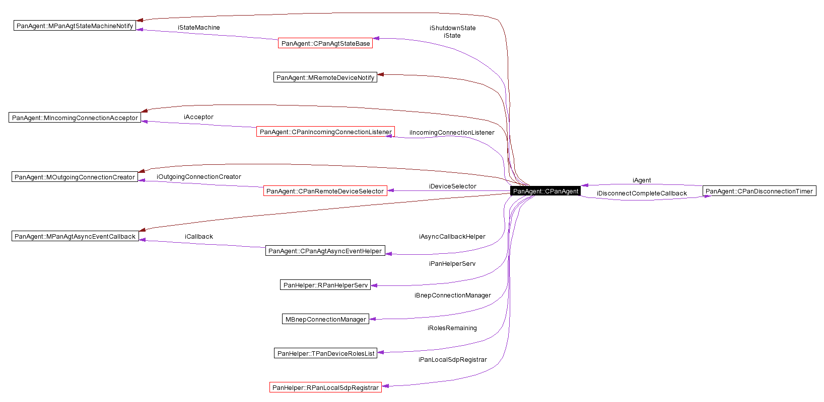
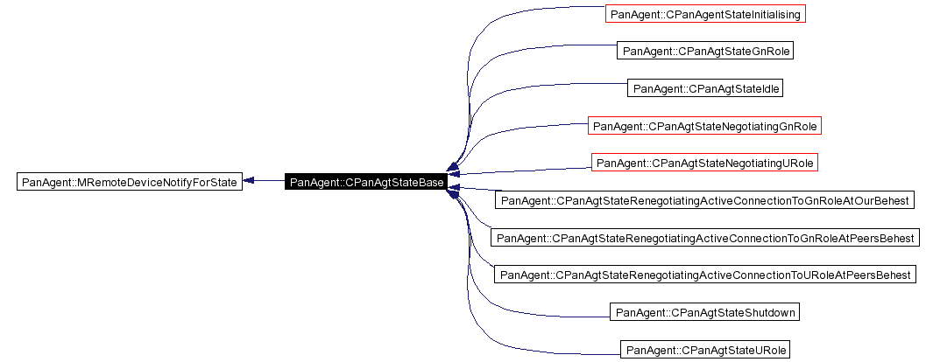

Design Unit Behaviour
As well as implementing the role selection logic, the role state machine owns all the remote device state machines. It implements the MOutgoingConnectionCreator and MIncomingConnectionAcceptor interfaces, and when receiving a call on one of these interfaces, creates a new CPanRemoteDevice to manage the new connection.
The state machine has a helper class, CPanAgtAsyncEventHelper, which allows the states to perform asynchronous actions using what appears to them to be the state machine as an active object. In the remote device state machine, this is the case; however, since the role state machine also implements the agent interface, CAgentBase, it needs a separate active object that it can proxy these requests off to. This is the purpose of CPanAgtAsyncEventHelper.
Note that the role state machine is only concerned with our local role - it does not persist the remote device roles between states (it forgets about them after processing a role request). This is because it is not necessary to have knowledge of the remote roles to make role decisions (indeed it is beneficial not to, as we then don't make decisions such as "oh, they're GN, we can't be GN"). Instead, we attempt to renegotiate with the remote device to see if we can swap roles. This may work in certain circumstances (e.g. the rest of their devices have detached).
With regards to PAN role switching, Symbian OS performs aggressive role upgrade and lazy role downgrade. That is to say that as soon as a second device attaches, the role state machine attempts to upgrade its role to GN with regards to the first device before processing the new connection (an "aggressive" role upgrade). Conversely, if all but one device detaches when we are in a GN-U relationship, we will remain as GN, but accept a change of roles (either to U-U, or U-GN) if the remote device requests it (a "lazy" role downgrade).
Role selection logic
When presented with a number of possible roles for the remote and local device - which is typically the case for outgoing connections - the role state machine follows the principle of least privilege in selecting a role. That is to say that given a device offering U, GN, and NAP, the role state machine as the remote device to act in U role. If only GN and NAP were offered, it would ask the remote device to be GN. The reasoning behind this is described in Design goals section.

Remote Device State Machine

Overview
The remote device state machine is designed along the same lines as the role state machine. In this case, the state machine is CPanRemoteDeviceStateMachine, and each of the states is derived from CPanRemDevStateBase.

UML Diagram

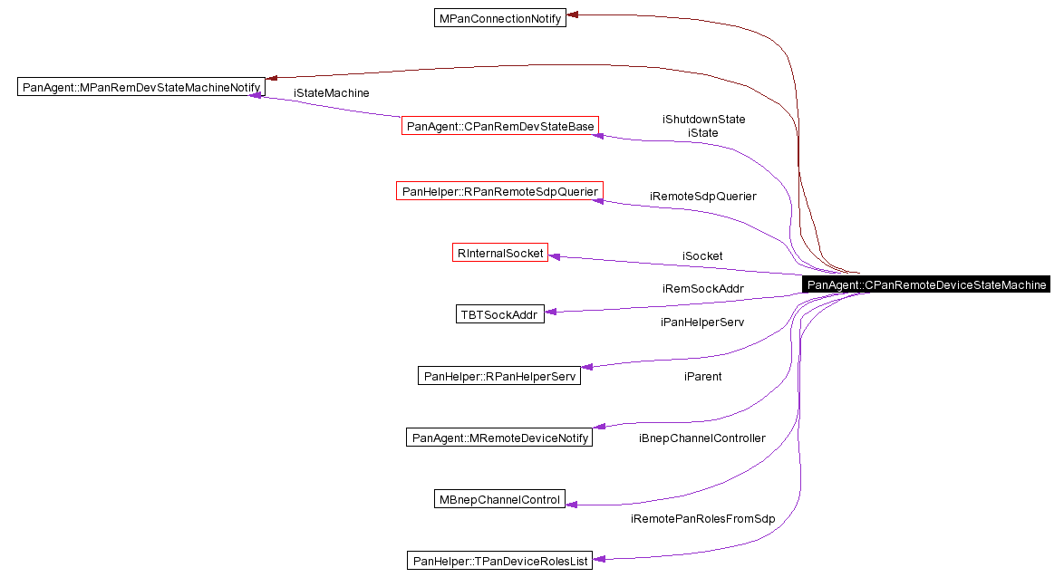
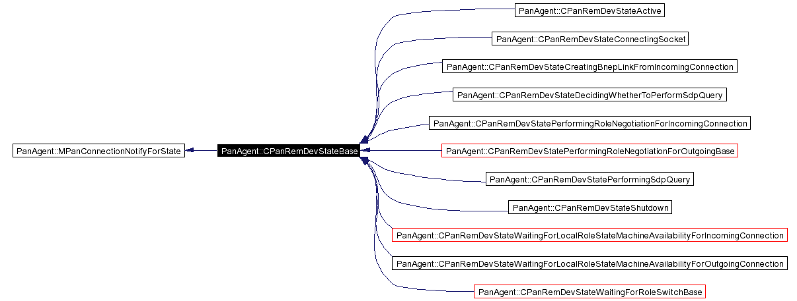

Design Unit Behaviour
The remote device state machine maintains the handle to the corresponding link in the BNEP packet driver, sending and receiving commands as appropriate.

Outgoing Connection Starter

Overview
The outgoing connection starter, CPanRemoteDeviceSelector, can get information about which connections to start from one of two places. Either information can be read from commdb, or a notifier can be used to prompt the user. For each outgoing connection that needs to be created, the role state machine is notified through the MOutgoingConnectionCreator interface.

UML Diagram
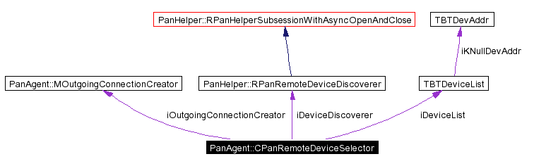

Design Unit Behaviour
In the case of reading information from commdb, one of two options is available, depending on the number of addresses provided. If a single address is provided then a connection is created to that device. If multiple addresses are provided, a device discovery is performed, and one of the devices from the list is selected. This allows use cases where multiple devices providing the same service are present (e.g. devices acting as a NAP to a corporate network), and we must choose one of them.
In the case where information is provided by a notifier, the notifier can return one or more addresses. In this case, the agent will attempt to connect to all the provided addresses. This allows use cases where we want to connect to multiple remote devices simultaneously (e.g. connecting to several other devices for multi-player gaming).

Incoming Connection Listener

Overview
The incoming connection listener, CPanIncomingConnectionListener, opens a L2CAP socket listening on the BNEP PSM. Each time an incoming connection is received, the role state machine is notified through the MIncomingConnectionAcceptor interface.

UML Diagram
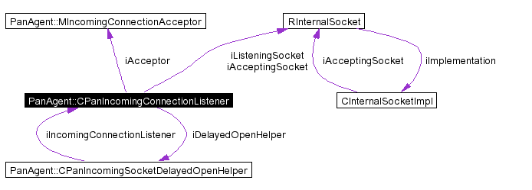

Design Unit Behaviour
The incoming connection listener is very basic - implementing a basic Listen()/Accept() loop, and passing off each new connection to the role state machine. No processing is done to handle the incoming connection in any way.

Scenarios

Design Considerations

Further Information

References
No. | Document Reference | Version | Description
[R1] | Bluetooth PAN profile specification | v1.0

Open Issues
The following issues need to be resolved before this document is completed;

Glossary
The following technical terms and abbreviations are used within this document.
Term | Definition

