BNEP Implementation Description

Security Classification: | <Security Classification>
Document Reference: | SGL.GT0189.103
Status: | Draft
Version: | 0.2
Last Revised Date: | 15/12/04
Team/Department : | Cambridge Shortlink
Author(s): | J. Pavier
Owner(s): | Cambridge Shortlink

Approver(s): | TBD | Distribution: | TBD

Contents
1 Introduction 4
1.1 Purpose 4
1.2 Scope 4
1.3 Special Notes 4
1.3.1 Documentation vs Code – generative differences 4
1.3.2 Maintenance 4
2 Design 5
2.1 BNEP - Architectural Context 5
2.2 BNEP Arrangements & Static Relationships 5
2.2.1 BnepUtils and TBnepTls 6
2.2.2 Bridge, Links and Controllers 6
2.2.3 Bridge, Links and Controllers - additional dependencies 7
2.2.4 Filters 8
2.2.5 Inheritance Relationships 9
2.2.6 Links and Sockets 10
2.3 BNEP Behavioural Descriptions 10
2.3.1 Create a Connection 11
2.3.2 Deliver BNEP Data Packet Locally 11
2.3.3 Deliver BNEP Data Packet to Remote Device 12
2.3.4 Deliver Ethernet Packet into PAN Network 13
2.3.5 Executing BNEP Controls - Filter Setup Requests 14
2.3.6 Executing BNEP Controls - Responding to Unrecognised Controls 14
2.3.7 Executing BNEP Controls - Setup Connection Request part 1 15
2.3.8 Executing BNEP Controls - Setup Connection Request part 2 16
2.3.9 Instantiation 16
2.3.10 Receiving a BNEP Packet - High Level 17
2.3.11 Receiving a BNEP Packet - Parsing and Processing Controls 18
2.3.12 Responding to a BNEP Control 19
2.4 BNEP Packet Driver Classes 19
2.4.1 BnepUtils 20
2.4.2 CBTAddrSubscriber 21
2.4.3 CBnepBridge 22
2.4.4 CBnepChannelController 24
2.4.5 CBnepLink 26
2.4.6 CBnepLocalDevice 27
2.4.7 CBnepLog 28
2.4.8 CBnepPktDrvFactory 29
2.4.9 CMultiAddrFilterTable 30
2.4.10 CNetTypeFilterTable 31
2.4.11 CSocketReader 32
2.4.12 CSocketWriter 33
2.4.13 MBnepChannelControl 34
2.4.14 MBnepConnectionManager 34
2.4.15 MLinkManager 35
2.4.16 MPanConnectionNotify 36
2.4.17 MPanDevice 37
2.4.18 MPanDeviceOwner 38
2.4.19 RBnepControl and derivations 39
2.4.20 RBnepFrame 40
3 Further Information 42
3.1 People 42
3.2 References 42
3.3 Open Issues 42
3.4 Glossary 42
3.5 Document History 42
3.6 Document Review Date 42

Introduction

Purpose
The purpose of this document is to describe the structure and behaviour of the Bluetooth Network Encapsulation (BNEP) component of PAN Profile sufficiently for the code to be maintained by non-expert developers.

Scope
The scope of this document is limited to the BNEP part of PAN Profile. In particular it should be noted that no attempt is made, in this document, to describe the PAN Agent, Ethint.NIF or the L2CAP part of the Bluetooth stack; components which are the subjects of other documents.

Special Notes

Documentation vs Code – generative differences
This document is generated from the information inserted into the BNEP object model. The C++ class structure to implement the model’s design is also generated from the same source. There are certain conventions of which the reader should be aware when this is the case.
- Not all class attributes have accessors. By default, the properties of the code generator are set to never generate default accessors for attributes unless explicitly requested to do so. Within the modelling tool, this is done by setting properties on the attribute. Simple accessors thus generated appear in the code but not in the UML diagrams that make up the model. More complex accessors that do not follow the rules of simple code generation are explicitly declared on the class and therefore appear both in the code and the diagrams. In either case Symbian coding standards and naming conventions for accessors are enforced.
- For all class attributes, or where an aggregation relationship exists (e.g. Has-by-value or Has-by-reference), the attribute has a name. In the output from the code generator, these attributes are augmented with the i-prefix as specified in the Symbian Coding Standard. Thus, for example, a class may have an attribute called Thing, but is implemented as iThing in the code. Accessors are thus Thing() and SetThing(). These model-level property specifications enforce these elements of the Symbian Coding Standard.

Maintenance
- The object model generates the code structure. This means that changes to class structures, interfaces or relationships can be modified in the model by updating the UML specifications and then regenerating some or all of the classes out as C++. The code, however, is not dependant on this process or on the model. Changes to the code structure can be made outside the model, but to do so breaks the connection and could render the model obsolete. If the model is used as the master it is possible to maintain both design, structural implementation and documentation in one place.
- Changes to the internal logic of a method require an IDE or editor; they require no change to the model, although documentation may be updated if desired.

Design

BNEP - Architectural Context
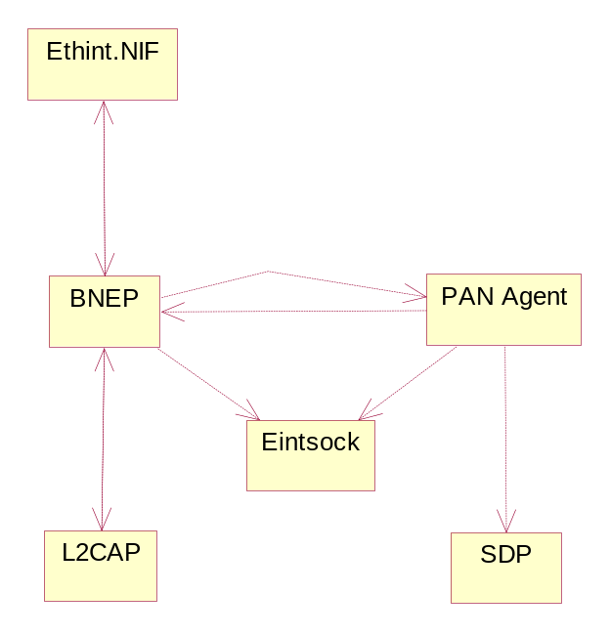

Figure 1: BNEP - Architectural Context
As the diagram shows, the BNEP packet driver sits beneath Ethint.NIF and above the Bluetooth L2CAP stack component. The basic purpose of BNEP is both to unwrap Bluetooth-transported Ethernet packets and push them up through the Ethernet stack, and also to wrap Ethernet packets into Bluetooth-compatible frames and push them out via the Bluetooth stack.
All service discovery and link construction is handled by the PAN Agent, which delivers links, as sockets, to BNEP as they are required. BNEP is implemented as a packet driver, bnep.drv, loaded into the ESOCK thread within the c32 process. This means that RInternalSocket handles have to be used instead of RSockets. PAN Agent is ultimately responsible for allocating and controlling the roles within the PAN Profile, therefore BNEP is almost completely unaware of PAN roles.
BNEP is also required to recognise and handle a set of BNEP control messages. When control messages are delivered to BNEP, it is BNEP's responsibility to handle them appropriately by either implementing the request, delegating the request to PAN Agent or declining the request. In all cases, BNEP is required to respond to the requesting device.
The full set of BNEP control messages are defined in [1].
BNEP-specific panic codes are only generated from within UDEB builds. In UREL builds, BNEP is implemented to fall over gracefully without taking any other components with it as it goes.

BNEP Arrangements & Static Relationships
The following information attempts to describe the structure of key parts of the software such that the maintainer can understand the relationships between the classes.

BnepUtils and TBnepTls
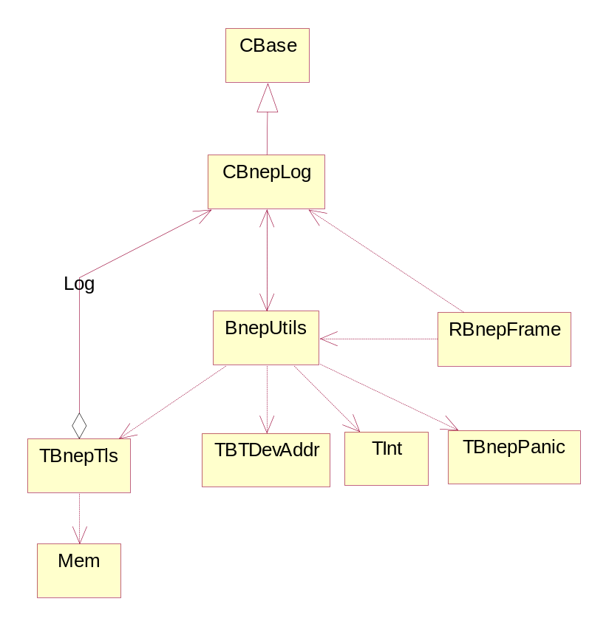

Figure 2: BnepUtils and TBnepTls
The relationships and dependencies shown here only fully exist for UDEB builds. For UREL builds there is no requirement for TBnepTls (thread-local storage) or CBnepLog. Therefore the only dependency that exists on BnepUtils in a released driver is that from RBnepFrame, which needs to use the IsMulticast() method.

Bridge, Links and Controllers
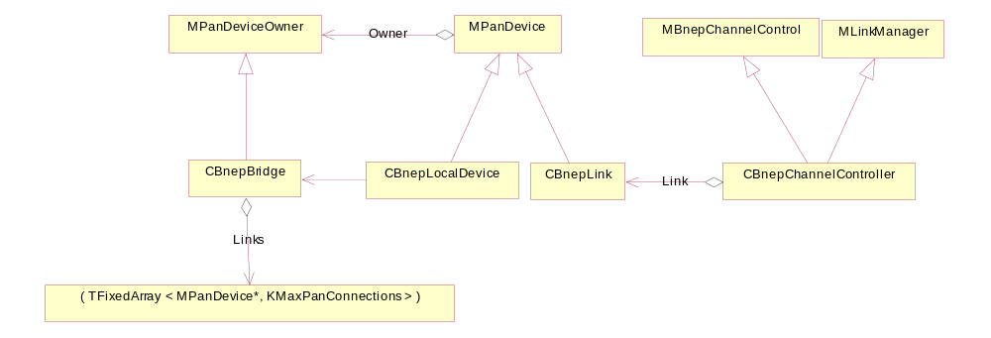

Figure 3: Bridge, Links and Controllers
This diagram shows the implementation relationships that exist between the bridge, links and channel controller objects.
The bridge is responsible for maintaining a fixed-length array of all the MPanDevices that it is currently talking to. These consist of the local device (of which there can be only one) and several links. Each MPanDevice is passed a reference to the MPanDeviceOwner it when it is constructed. It is possible, in the implementation, to instantiate a link, informing it of the bridge to which it might expect to be attached, and then need to delete the link before that attachment has been successfully made (e.g. when attempting to attach a 9th device into a fully-subscribed piconet of 8). As part of the link's destruction, it is required to notify the bridge that it is being torn down. If the bridge is unaware of the link in the first place, this notification is has no effect.

Bridge, Links and Controllers - additional dependencies
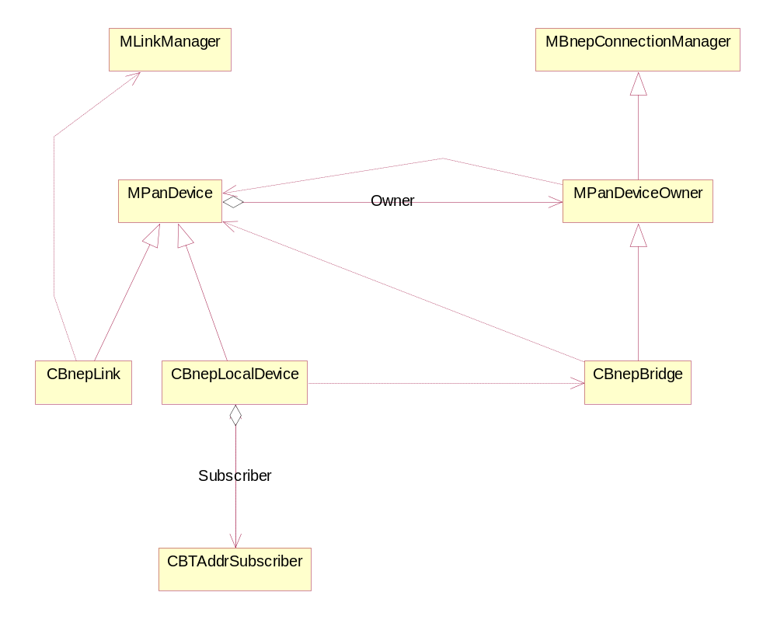

Figure 4: Bridge, Links and Controllers - additional dependencies
This diagram illustrates some of the coupled dependencies that exist in the code.

Filters
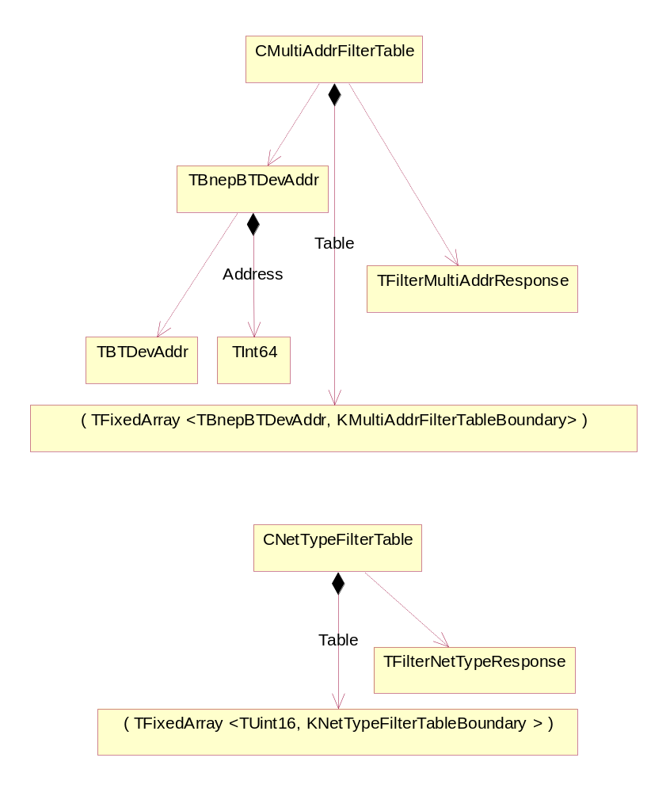

Figure 5: Filters
This diagram gives the detail of the two filter table types, used by links to conserve bandwidth across the Bluetooth network. They are essentially wrappers around fixed-length arrays of range specifications. The arrays are exactly twice as long as the permitted set of filter specifications, wherein the even-indexed entries represent the start value for the range and the subsequent odd-indexed entry represents the end value for the range. The boundaries of the fixed-length arrays represent a compromise between what is permissible and what may be practical. Each boundary is independently modifiable in the code should changes be required.
To enable faster comparison and searching, the Multicast Address Filter Table uses an internal TInt64 representation of the 48-bit Bluetooth address. The normal representation is not optimised for arithmetic operations. This may use slightly more memory in operation, but the simplicity and speed of access and comparison is enhanced.

Inheritance Relationships
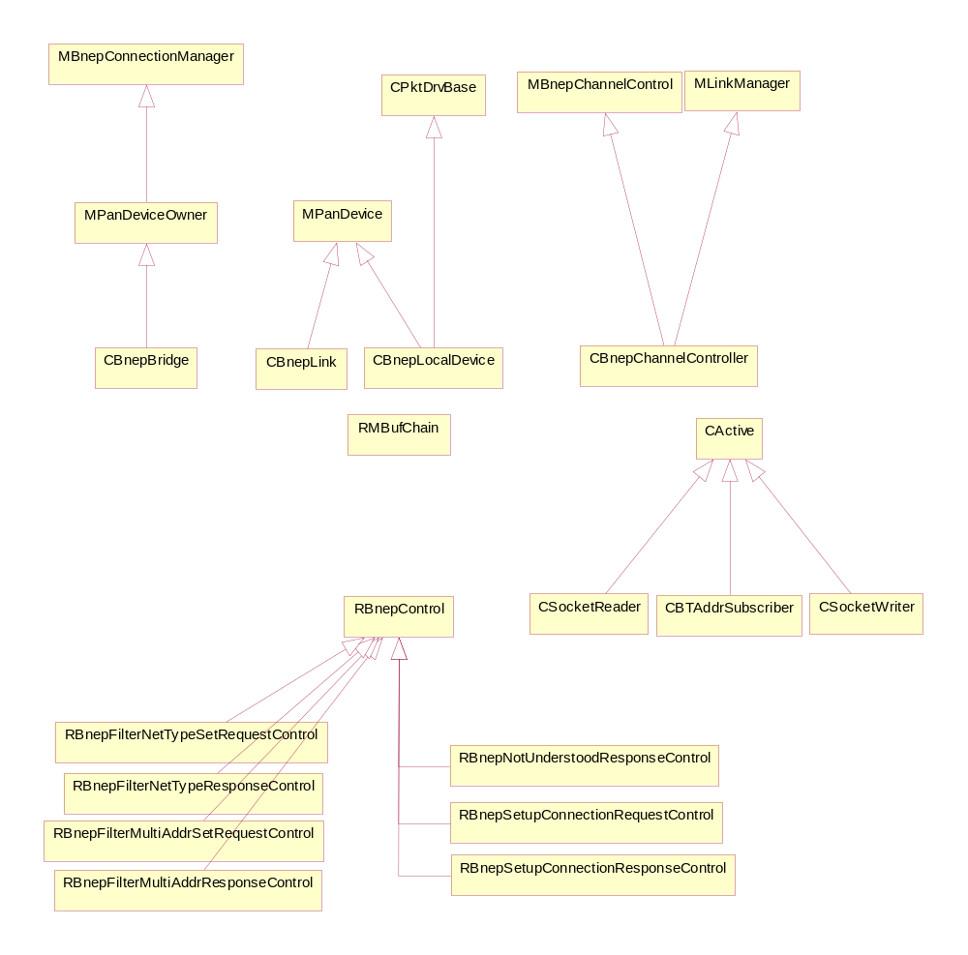

Figure 6: Inheritance Relationships
This diagram shows all the main inheritance relationships involved in the BNEP implementation. There are three Active Objects; the socket reader and writer used in CBnepLink, and the CBTAddrSubscriber used by CBnepLocalDevice to keep track of the device address property during the separate instantiation ordering scenarios of this driver and the Bluetooth stack.
All RBnepControls are actually RMBufChains, which means that special care should be taken to ensure their correct resource freeing and destruction to avoid MBuf manager memory leakage.

Links and Sockets
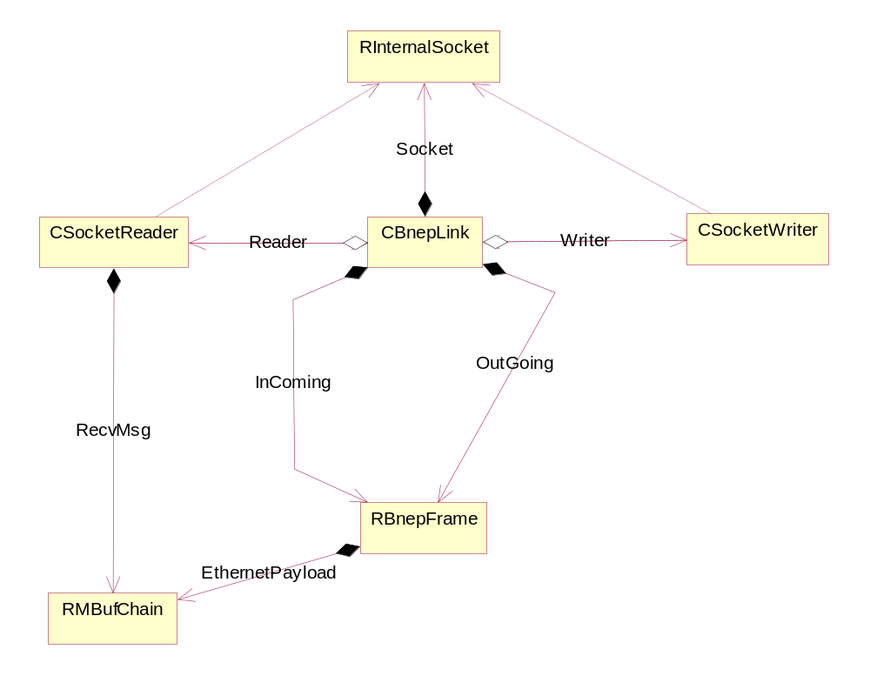

Figure 7: Links and Sockets
This diagram shows how a CBnepLink uses the socket that is passed to it during construction. The link assumes ownership of the socket during construction and then delegates the use of it to an active reader and an active writer. The link never relinquishes ownership, however, and is responsible, during destruction, for closing the socket down.
Here it can also be seen that RBnepFrames are used to enforce the separation of input and output sides of the link; InComing representing the input side and OutGoing the output side. This means that it is the InComing frame that is used to parse the input RecvMsg from the socket reader, whilst it is the OutGoing frame whose build methods are used to construct BNEP frames and Ethernet packets for onward delivery.

BNEP Behavioural Descriptions
The following section presents a set of scenario/sequence diagrams that describe basic behavioural subsets of BNEP operation.

Create a Connection
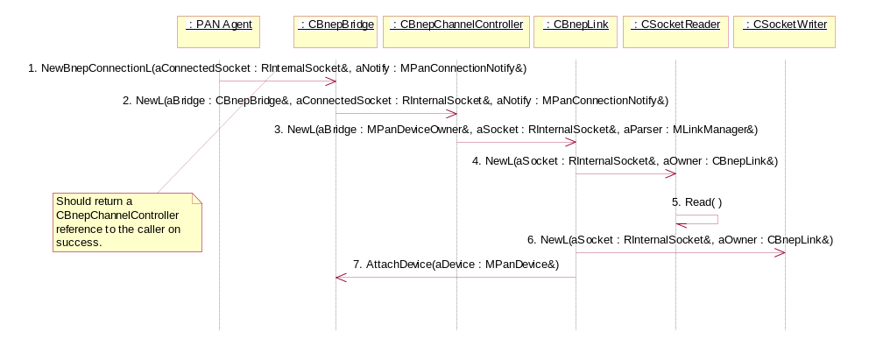

Figure 8: Create a Connection
PAN Agent requests a new connection from CBnepBridge, passing it a socket and a reference back to itself (1). The bridge creates a CBnepChannelController for the connection which in turn creates a CBnepLink object for the connection (2,3).
The first thing the link object has to do is take ownership of the socket, from which it constructs two active objects. The first is a dedicated input object, CSocketReader, upon which is then queued an asynchronous Read() waiting for input (4,5). The other active object is a dedicated output object, CSocketWriter, which has no immediate work to do (6). Finally the link uattaches to the bridge (7). If the bridge is already fully loaded with connections, this attempt will force a leave and the link has to be deleted.
On successful completion, CBnepBridge will return a reference to the CBnepChannelController, through which PAN Agent can make link-specific requests via the MBnepChannelControl interface.

Deliver BNEP Data Packet Locally
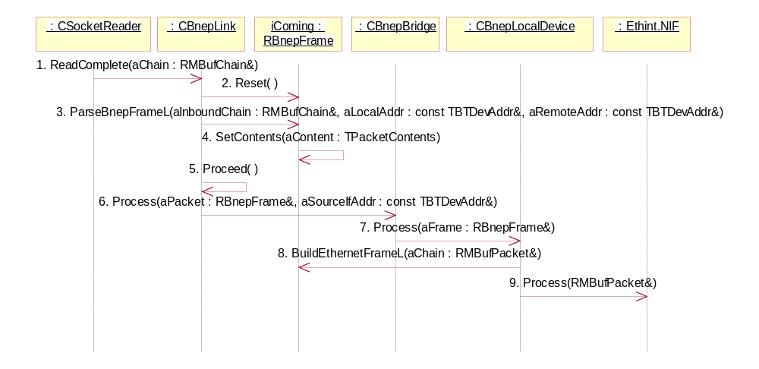

Figure 9: Deliver BNEP Data Packet Locally
This scenario describes the sequence involved in reading a data packet on a BNEP link and passing it up to the Ethernet stack.
The socket reader RunL() is invoked as the asynchronous read request completes and the links ReadComplete() method is called to process the packet (1). The link resets the InComing frame to ensure a known start state (2) and parses the frame (3). During the parsing process, the contents of the frame are set to indicate that it contains data (4).
Having parsed the packet into the InComing frame, the link invokes it's own Proceed() method to deal with the frame contents (5). As the frame is a data frame, it is forwarded to the bridge for processing (6). At this point the bridge will identify the destination as the local device and deliver it for processing (7). The local device will then build the RMBufPacket for output by using the frame's factory helpers (8). Once the RMBufPacket is fully constructed, it is delivered to Ethint.NIF (9) .

Deliver BNEP Data Packet to Remote Device
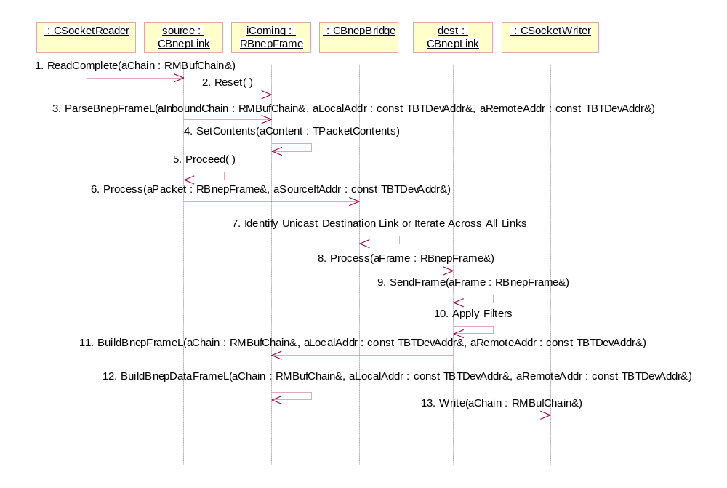

Figure 10: Deliver BNEP Data Packet to Remote Device
This scenario describes the sequence for reading a data packet on one BNEP link and routing it through to either a specified Unicast device or all the available links as a Multicast. The fundamentals of the sequences for both eventualities are the same with one distinction which is documented below.
The socket reader RunL() is invoked as the asynchronous read request completes and the link's ReadComplete() method is called to process the packet (1). The link resets the InComing frame to ensure a known start state (2) and parses the packet into the frame (3). During the parsing process, the contents of the frame are set to indicate that it contains data (4).
Having parsed the packet into the InComing frame, the link invokes it's own Proceed() method to deal with the frame contents (5). As the frame is a data frame, it is sent to the bridge for processing (6). At this point the bridge will either select the destination link for the packet (in the case of a Unicast packet) or iterate across all of its extant links (for a Multicast packet) for processing (7). Each valid destination link will receive the frame and will attempt to send it (8,9).
During a send request, any filters present will be applied appropriately (10). The link will then use the frame helper BuildBnepFrameL to populate a RMBufChain (11,12). Once the RMBufChain is fully constructed, it is written out via the Socket Writer (13).

Deliver Ethernet Packet into PAN Network
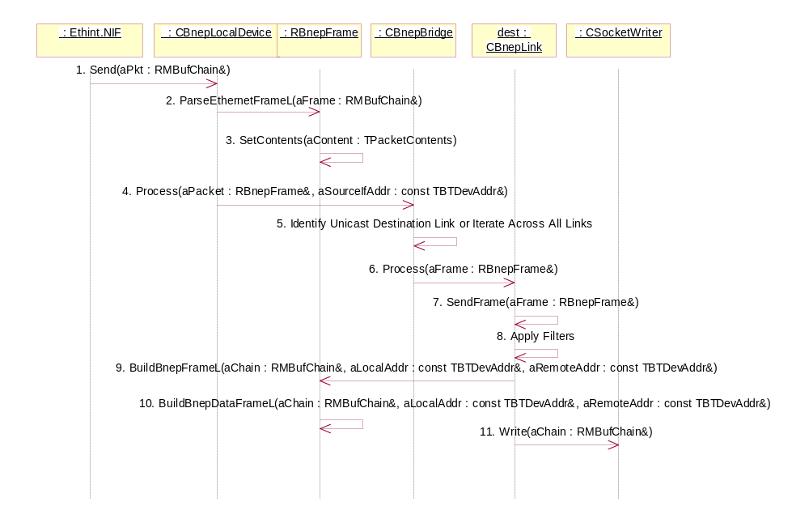

Figure 11: Deliver Ethernet Packet into PAN Network
This scenario describes the sequence delivering an Ethernet packet into the local device and routing it through to either a specified Unicast device or all the available links as a Multicast. The fundamentals of the sequences for both eventualities are the same with one distinction which is documented below.
Ethint.NIF sends the packet to the local device (1). The local device parse the packet into a RBnepFrame (2). During the parsing process, the contents of the frame are set to indicate that it contains data (3).
The frame is forwarded to the bridge for processing (4). At this point the bridge will either select the destination link for the packet (in the case of a Unicast packet) or iterate across all of its extant links (for a Multicast packet) for processing (5). A valid destination link will receive the frame for processing and it will attempt to send the frame (6,7).
During this attempt, any filters present will be applied appropriately (8). The link will then use the frame helper BuildBnepFrameL to populate a RMBufChain (9,10). Once theR MBufChain is fully constructed, it is written out on the Socket Writer (11).

Executing BNEP Controls - Filter Setup Requests
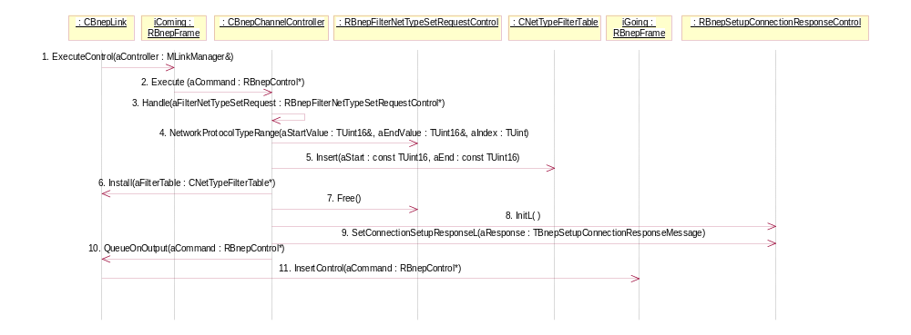

Figure 12: Executing BNEP Controls - Filter Setup Requests
The example shown is the sequence that responds to a network protocol type filter request. However, a multicast address filter request is essentially the same with different control/response types.
The link is in the Proceed() method and calls on the InComing RBnepFrame to execute the controls in it's queue (1). The frame pops the first control from the queue and passes it to the channel controller for execution (2). On identifying the control type, the channel controller delegates the processing to a dedicated handler for that type of object(3). The handler extracts the pair of values representing the start and end points of the permitted range, and inserts them into a filter table newly created for the purpose (4,5). This sequence is repeated until the control object's set of filter specifications is depleted. Having reached the end of the filter specification with a valid set of ranges, the table is installed on the link, replacing any previous table that may have existed (6).
The original control message is freed and deleted at this point, as it is no longer needed (7). A new response is created and set to the appropriate response value (8,9) and then placed on the link's output queue in preparation for transmission back to the requestor (10,11).

Executing BNEP Controls - Responding to Unrecognised Controls
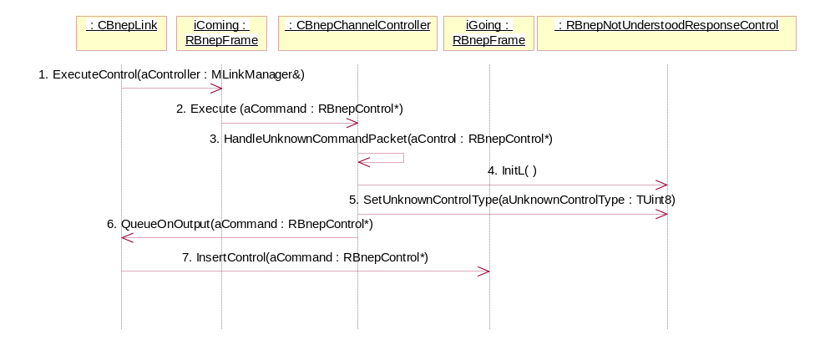

Figure 13: Executing BNEP Controls - Responding to Unrecognised Controls
The link is executing the Proceed() method and calls on the InComing RBnepFrame to execute the controls in it's queue (1). The frame pops the first control from the queue and passes it to the channel controller for execution (2). On failing to identify the control type, the channel controller delegates the processing to a dedicated handler for unknown types (3). A Not Understood Response Control is instantiated and queued on the link output for subsequent transmission (4,5,6,7).

Executing BNEP Controls - Setup Connection Request part 1
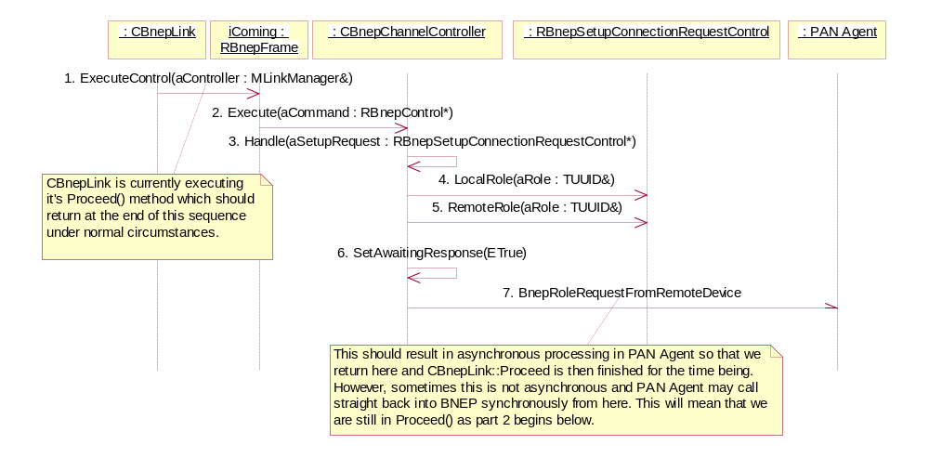

Figure 14: Executing BNEP Controls - Setup Connection Request part 1
Within the CBnepLink::Proceed() execution, the link instructs the InComing RBnepFrame to execute the controls on it's queue (1). The first control (a Setup Connection Request in this scenario) is popped off the queue and passed to the channel controller for execution (2) - note that the channel controller now owns the control object and is ultimately responsible for disposing of it correctly. On recognising the control type, the channel controller delegates the processing to a specific control handler (3). The handler obtains role information from the control (4,5).
Before notifying the PAN Agent, the controller sets an internal flag indicating a state change(6). While this flag is set, the link will process no further controls from the input queue. Finally, the controller notifies PAN Agent of the role request (7).

Executing BNEP Controls - Setup Connection Request part 2
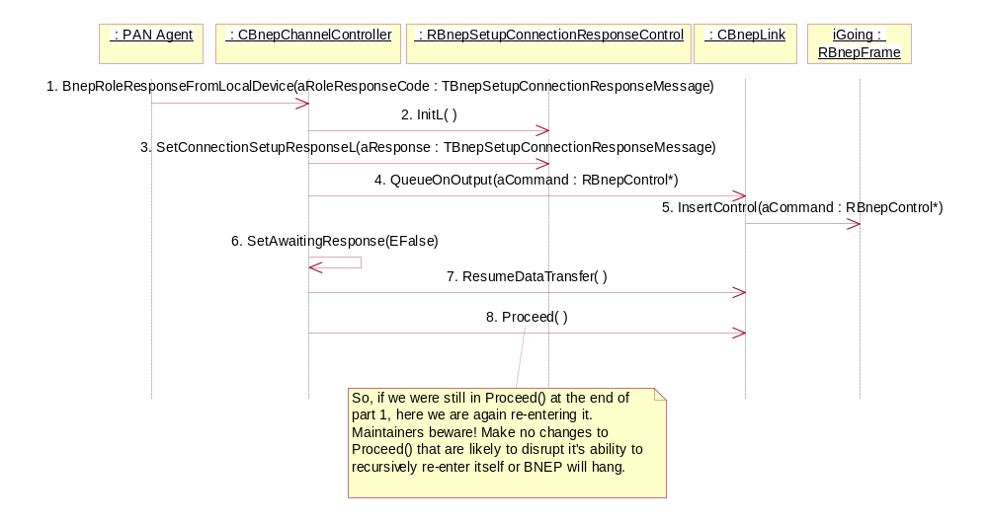

Figure 15: Executing BNEP Controls - Setup Connection Request part 2
Having determined it's response to a request for connection, PAN Agent calls back into the channel controller (1). The channel controller creates a Setup Connection Response Control object and sets the response value according to what PAN Agent has passed it (2,3). The response control object is passed out of channel controller and onto the command queue of the OutGoing RBnepFrame held by the link (4,5). The channel controller changes state such that it can continue processing input controls (6) and re-enables data transfer in case it was suspended during role negotiations (7). At this point, the channel controller then calls back into the link and retriggers the Proceed() method (8), which is why this method must support synchronous recursive calls.

Instantiation
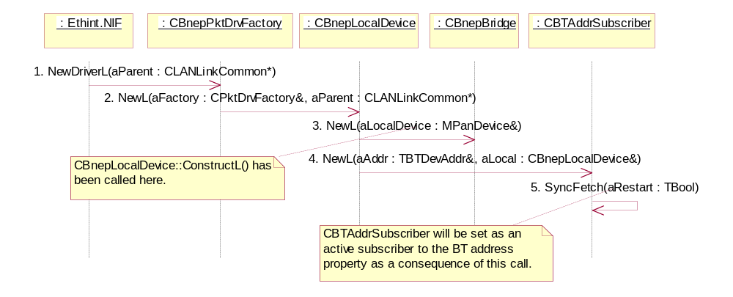

Figure 16: Instantiation
This diagram shows the normal sequence of calls that result in the correct instantiation of the BNEP packet driver. The sequence is driven by Ethint.NIF requesting a new driver from CBnepPktDrvFactory (1). The factory immediately constructs the CBnepLocalDevice (2). During construction, the local device invokes the construction of the CBnepBridge and the CBTAddrSubscriber (3,4).
As part of initialisation CBTAddrSubscriber will attempt to fetch the device's Bluetooth address as a synchronous call (5). As part of that call, the subscriber will schedule the active object and subscribe to the RProperty such that it will be notified if the property changes (i.e. if the Bluetooth stack was not present but was later created and published an update to the address property).
At the end of this sequence, Ethint.NIF should have recieved a pointer to CBnepLocalDevice, as a CPktDrv-derived object, and a copy of this pointer will also have been attached to the bridge array of links in the space reserved for the local device.

Receiving a BNEP Packet - High Level
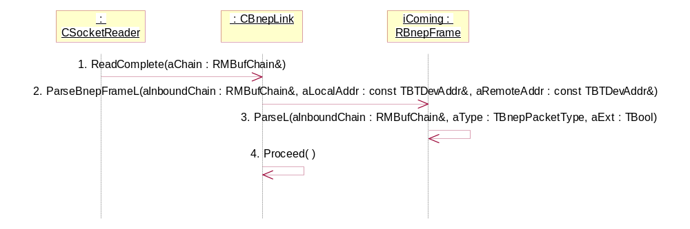

Figure 17: Receiving a BNEP Packet - High Level
When new input arrives across the socket, the CSocketReader::RunL() executes and passes the input into the link using the ReadComplete() method (1). The link passes the buffer to its dedicated input handling RBnepFrame (InComing) via the ParseBnepFrameL() method (2). For a BNEP Control, this method is able to extract sufficient information to determine the presence of a control, extensions and/or data.
After this first-pass inspection the remains of the buffer are passed to an internal handler ParseL() which can extract control information in a form that can be executed by later stages of the process (3) [this detail is covered in the Parsing and Processing Controls scenario description]. Having parsed the input, the link is then able to call Proceed() which will take the appropriate actions based on the contents of InComing (4).

Receiving a BNEP Packet - Parsing and Processing Controls
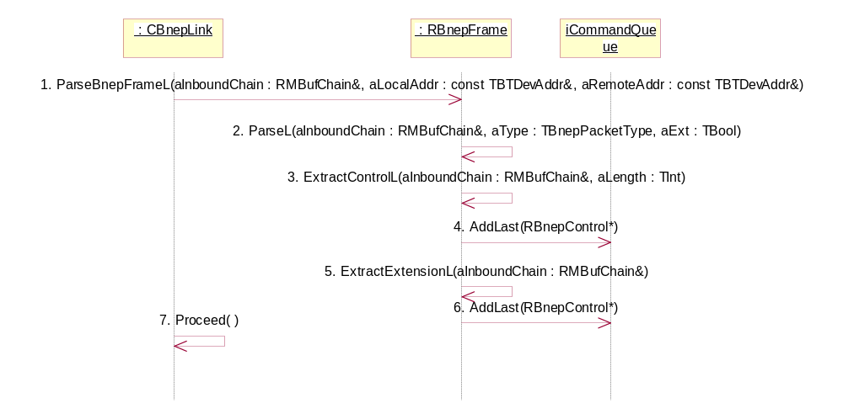

Figure 18: Receiving a BNEP Packet - Parsing and Processing Controls
When parsing a BNEP frame for control messages, itis important to remember that there are three possible scenarios allowed by the BNEP specification [1].
A - A pure control frame.
B - A data frame with one or more extension headers.
C - A control frame with one or more extension headers.
The ParseBnepFrameL() method performs a first-pass inspection of the input buffer to determine the presence of a control frame and/or extensions (1). This information is then passed to the helper ParseL() so that it can process correctly (2). There are two lower-level helper methods on RBnepFrame, ExtractControlL() and ExtractExtensionL() which are used in the appropriate combinations to pull out all the controls present in the frame.
For scenario A, ExtractControlL() is used in isolation to create a RBnepControl object and place it on the command queue of the iComing RBnepFrame.
For scenario B, ExtractExtensionL() is called repeatedly until all the extensions have been converted into RBnepControl objects and placed on the command queue.
For scenario C, ExtractControlL is called followed by repeated calls to ExtractExtensionL() until the control contents of the frame are exhausted.
It should be noted that scenario C is explicitly tested in the BNEP Test Cases [3] wherein a maximal control plus extensions combination is processed through a BNEP link. Given the limited set of defined control messages available, a maximal control message would contain a setup request (which must be a control and never an extension) plus two filter setup requests: one for a multicast address filter and one for a network protocol type filter.
Once ParseL() is complete (and note that all the helpers have the potential to leave if the frame has been incorrectly constructed by the sender at any level), the link calls its own Proceed() method which processes the controls in the input command queue in the order in which they were inserted(7).

Responding to a BNEP Control
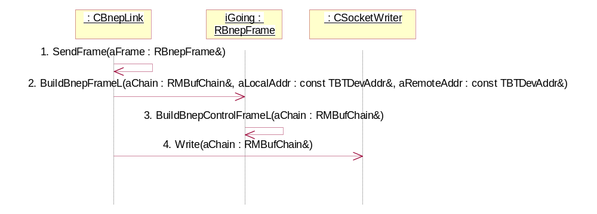

Figure 19: Responding to a BNEP Control
From within the Proceed() method, the link calls the SendFrame() method, passing the OutGoing frame as the parameter (1). From within the SendFrame method, the OutGoing frame is instructed to build a BNEP output frame into a RMBufChain (2) which, in this case, triggers a call to the helper function responsible for building a BNEP Control frame (3). Once the RMBufChain is completely populated, it is written out to the Socket Writer (4) for delivery to the remote device.

BNEP Packet Driver Classes
What follows is a set of diagrammatic and textual descriptions of the classes developed for BNEP.

BnepUtils
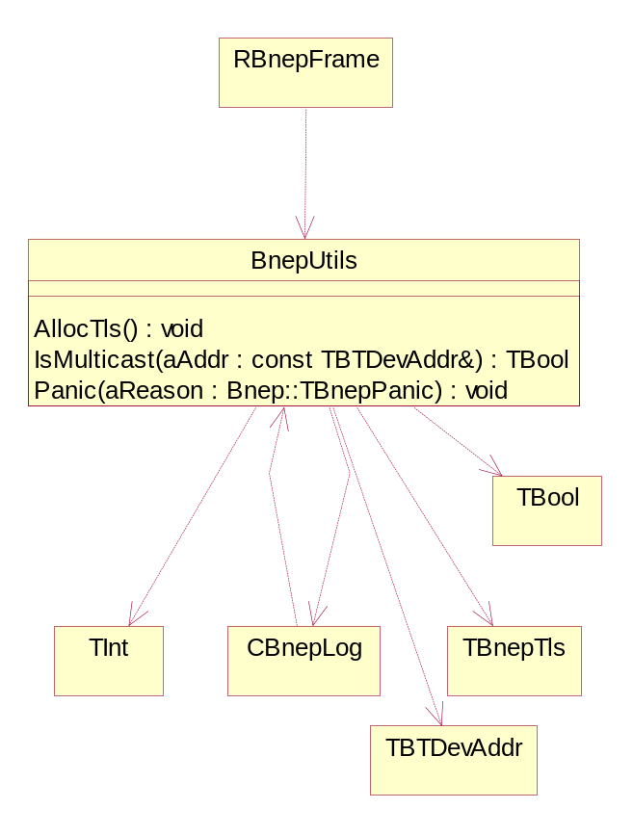

Figure 20: BnepUtils
BnepUtils is a catch-all class for colocating a set of what would otherwise be unencapsulated functions.
BnepUtils provides two global services, implemented as static methods.
The first is concerned with acquiring and allocating thread-local storage. The method is primarily of interest in UDEB builds since only the logging system uses TLS in this driver.
The second method is a simple test to determine whether a Bluetooth address is set for multicast address or not.

CBTAddrSubscriber
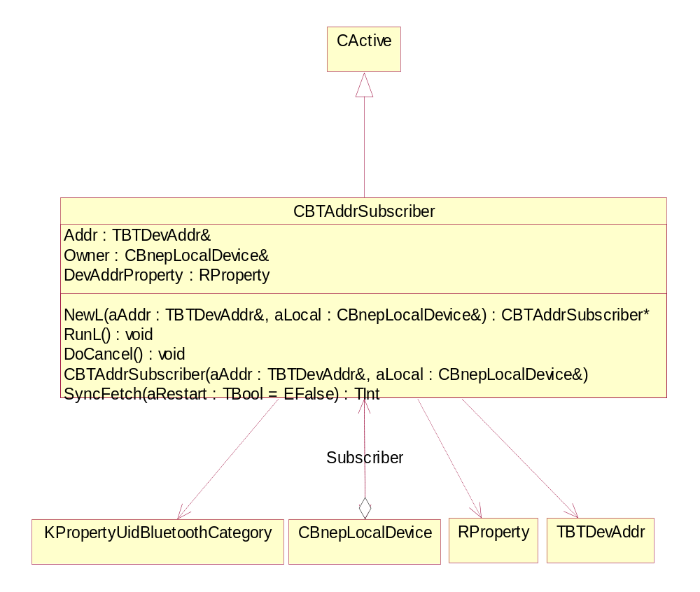

Figure 21: CBTAddrSubscriber
CBTAddrSubscriber is an active observer of the local Bluetooth device address property which is published by the Bluetooth stack. BNEP depends on the Bluetooth stack being in place for its underlying transport. However, BNEP has no knowledge or control over when the stack is instantiated; it may already be in place or it may not be up during BNEP initialisation. By subscribing to the local address proprty via the kernel Publish & Subscribe interfaces, CBTAddrSubscriber is notified if the subscribed property changes (i.e. the property has been assigned a new value on the instantiation of the Bluetooth stack). If this happens, it is the responsibility of the object to notify the CBnepLocalDevice.
The notification is a one-shot; that is, the property is only expected to change once during the lifetime of the BNEP. It is not likely to change again during the lifetime of the packet driver, and even if it did, neither BNEP or the upper layers of the ethernet stack have the facilities to deal with a later change. This means that once the notification has been posted, this object will become inactive.

CBnepBridge
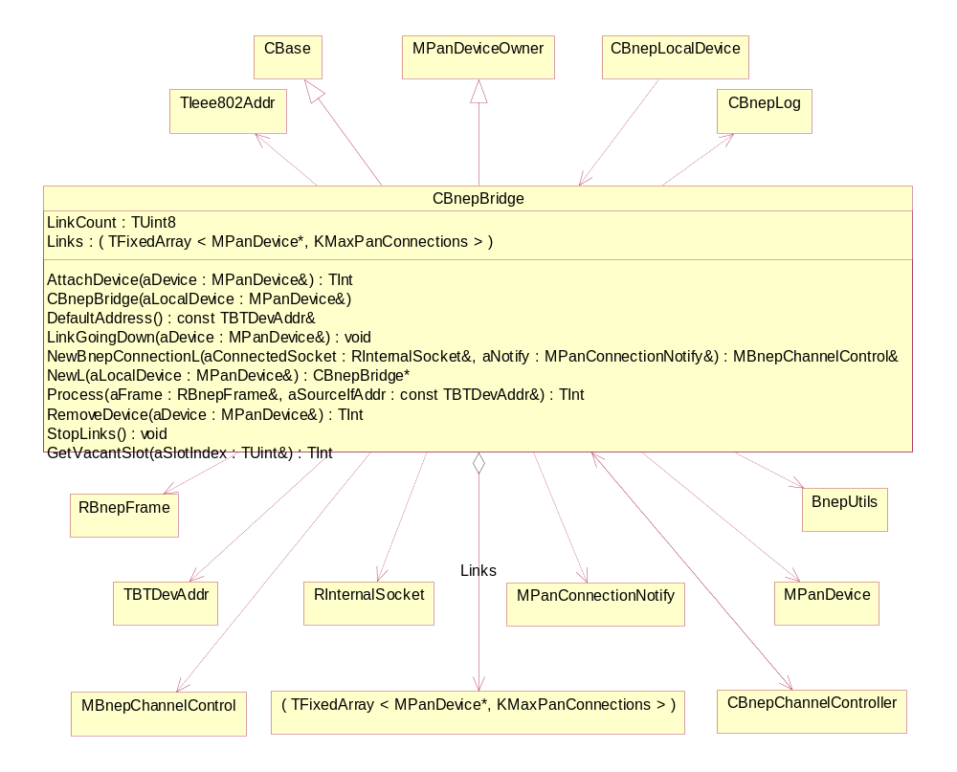

Figure 22: CBnepBridge
CBnepBridge is a container for MPanDevice-derived objects (i.e. CBnepLinks). Except that it does not own the device references it contains, which makes it slightly more confusing, because removing a device from the bridge ends up being a much circuitous endeavour than merely deleting it.
Additionally, the bridge is responsible for routing packets to specific device addresses, groups of addresses or applying top-level filtering (e.g. ensuring that packets are not redistributed to their originators). Furthermore, the bridge has embedded in it's Process() method certain assumptions about PAN Profile roles and what it's role is likely to be in the event that it has no direct path to a unicast destination.
In the implementation, CBnepBridge is a child of MPanDeviceOwner and a grandchild of MBnepConnectionManager, which suggests that there is a category error in the analysis; there exists too much ambiguity between the concept of a PAN Device Owner and a BNEP Connection Manager.
In this implementation, CBnepBridge manages an array of MPanDevice references. The array length is constrained by the requirements of the BNEP specification which determines that any one device can connect to a maximum of 7 (seven) others. However, this implementation also reserves space for the local device as a special case of MPanDevice and, in fact, CBnepBridge cannot be constructed without a local device. Therefore the internal managed array of devices is actually 8 (eight) since it also includes the local device.
It is important to note that the local device is stored at the element specified by KLocalDeviceArrayId. For the earliest implementation this was set to 0 (zero), but this was then assumed in later code. Maintainers should never assume that the device at index zero is guaranteed to be the local device for all time. Defective code that did assume this has been repaired and it is now legitimate to set KLocalDeviceArrayId to be equal to any value between 0 to (KMaxPanConnections-1) and there is a performance argument to suggest the later bound could be preferable under certain situations.
External entities (e.g. PAN Agent) construct new connections in the bridge using NewBnepConnectionL(). If successful, the entity should obtain a handle to the channel controller for the newly created link.

CBnepChannelController
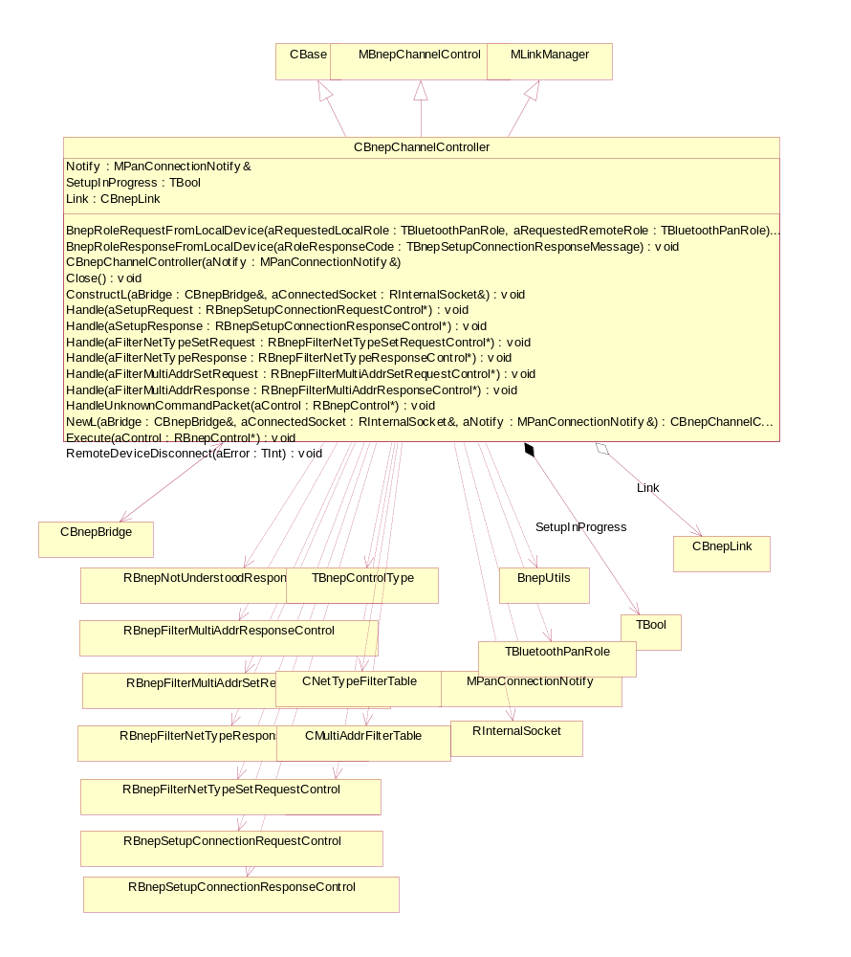

Figure 23: CBnepChannelController
CBnepChannelController objects are closely and mutually coupled to CBnepLinks. The external entity (e.g. PAN Agent) obtains a pointer to a CBnepChannelController object for every CBnepLink that is successfully created and attached into CBnepBridge. It is through the two BnepRole methods that the PAN Agent makes synchronous calls into CBnepChannelController. The PAN Agent can also Close() the channel, effectively tearing down the link, at any time. This the normal way links are expected to be deleted.
CBnepChannelController is also responsible for executing controls that come in from a remote device on it's peer link. It has a set of private handling methods, one for each possible type of incoming control message and a catch-all for any controls unknown to it. Controls, once parsed, are passed directly from the link into it's channel controller for processing. The controller is responsible for constructing and queueing the responses in preparation for transmission back to the remote device.
Notice that the Channel Controller is also a Link Manager, which confuses understanding, since we also find that CBnepBridge is a Connection Manager.

CBnepLink
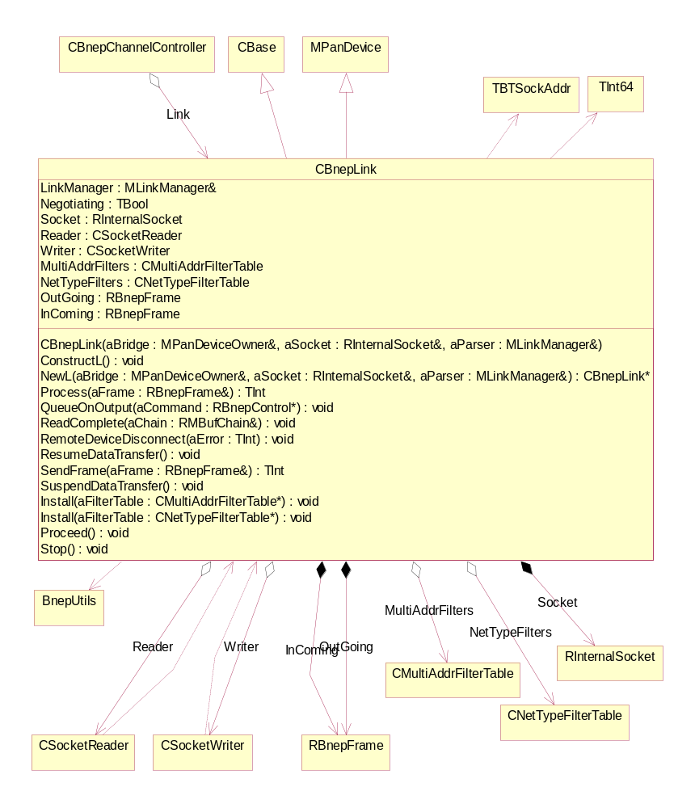

Figure 24: CBnepLink
A CBnepLink exists for every connection that is made between BNEP and a remote device. The link serves as the driver, or engine, for processing packets in both directions. The link is responsible for the ownership of the socket it is passed during construction. As part of the construction process, the link will use the socket to create two active objects (CSocketReader and CSocketWriter) to seperately implement asynchronous input and output operations. It is responsible for initiating the parsing mechanisms in the RBnepFrame dedicated to input processing, the results of which are then executed through the link's associated channel controller such that BNEP controls can be honoured. The link is then responsible for initiating the marshalling activities of the output-dedicated RBnepFrame prior to transmission.
All packet filtering is implemented in the link, which can respond to requests from remote devices to implement multicast address and/or network protocol type filtering such that Bluetooth bandwidth can be conserved. However, since this version of BNEP cannot emit filter requests because the higher-layer support mechanisms do not exist, a piconet can only make use of this facility on links where the far end is both something other than a Symbian device and capable of emitting filter requests.

CBnepLocalDevice
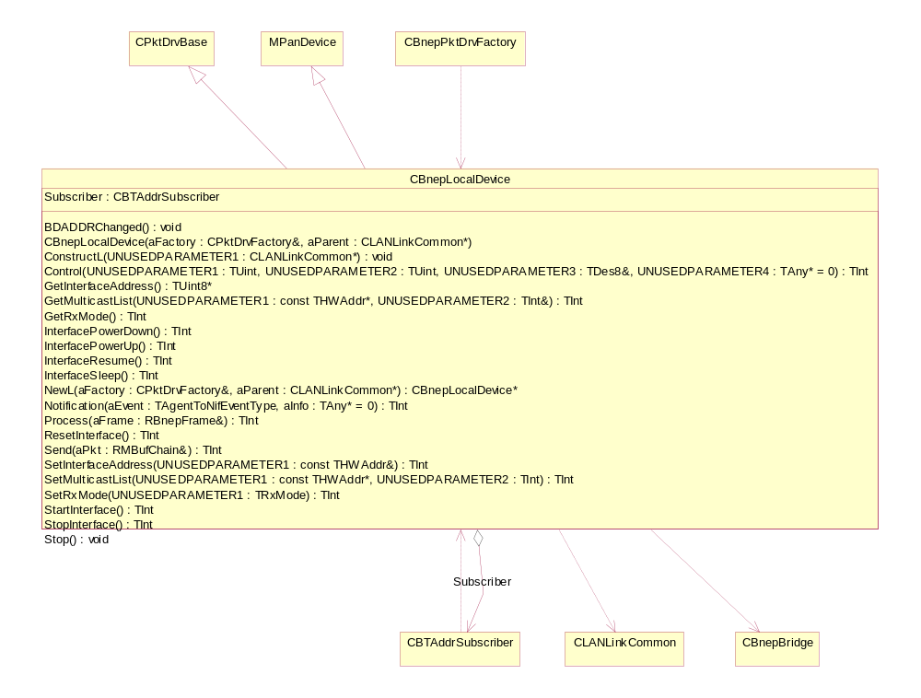

Figure 25: CBnepLocalDevice
CBnepLocalDevice is a specialisation of MPanDevice that represents the particular device upon which a BNEP instance resides. It is also derived from CPktDrvBase because it provides the interface and underlying implementation to sit beneath Ethint.NIF as a packet driver. Ethernet packets pushed down into the PAN network are delivered via CBnepLocalDevice.
As a packet driver, it provides implementation for a wide range of interfaces that it does not, in fact, support; interfaces such as InterfacePowerDown(), GetRxMode(), etc.
The interfaces of direct interest for BNEP are the static NewL() constructor (called by the packet driver factory to trigger the instantiation of the driver) and the two data delivery interfaces.
The first, Send(), is the method called by the higher layer (Ethint.NIF) to push packets down into the PAN network.
The second, Process(), is the method called by the bridge to push data up out of the PAN network and into Ethint.NIF.

CBnepLog
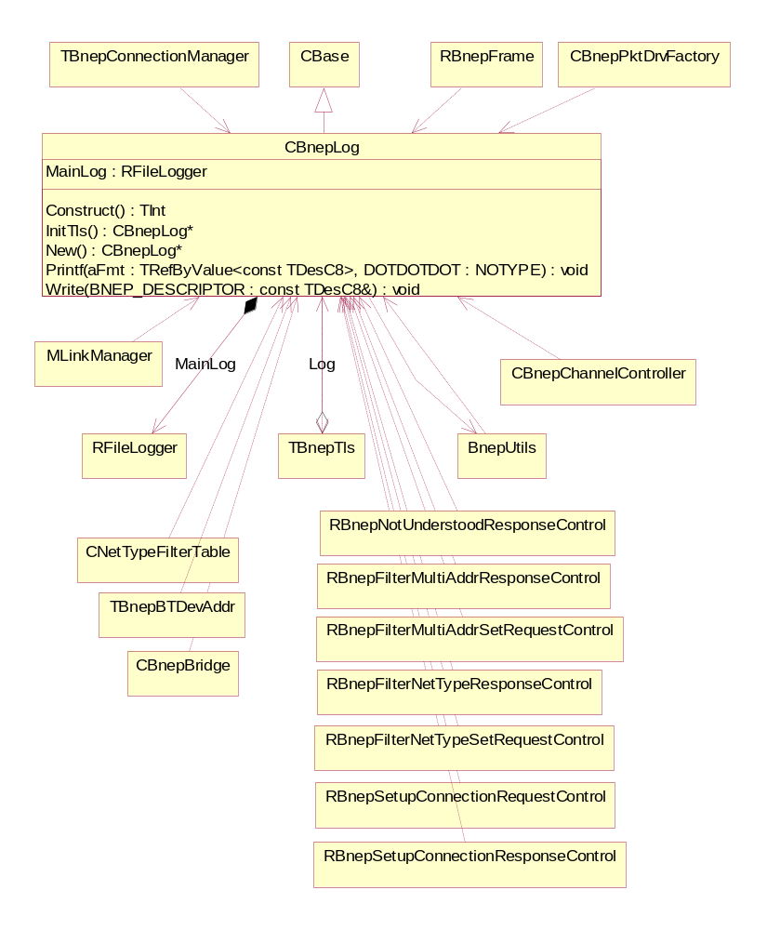

Figure 26: CBnepLog
CBnepLog is only instantiated and used in UDEB builds. It is usually accessed through the BNEPLOG or INSTRUMENT macros defined in CBnepLog.h. The static method CBnepLog::Printf() is also accessible for direct use, but has no meaning in a non-debug build. CBnepLog uses RFileLogger and requires its own piece of thread-local storage, hence the dependencies on TBnepTls and BnepUtils.
Naturally every class whose implementation includes some debug logging has a dependency on CBnepLog.

CBnepPktDrvFactory
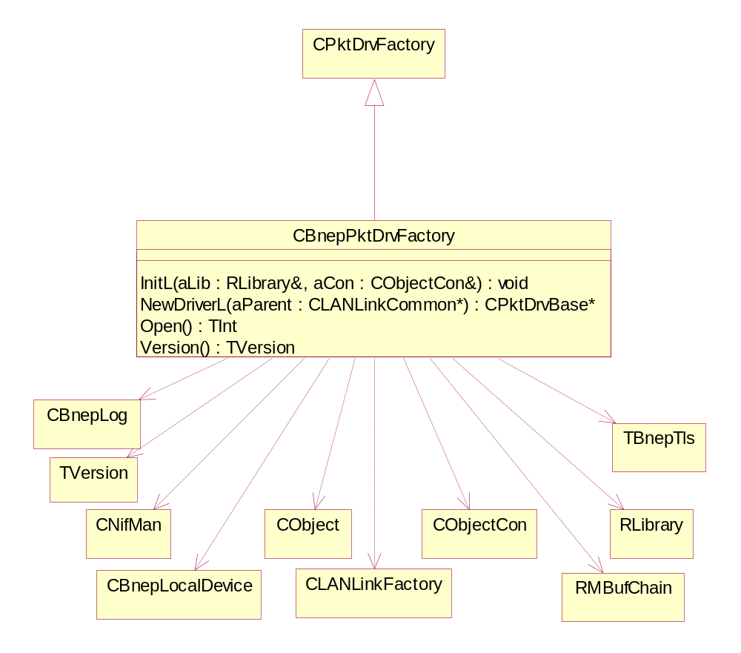

Figure 27: CBnepPktDrvFactory
CBnepPktDrvFactory is the main point of access for Ethint.NIF and is the BNEP specialisation of a general packet driver factory for this framework. The static method NewDriverL() should hand back a pointer to an object derived from CPktDrvBase, which in this case is CBnepLocalDevice.

CMultiAddrFilterTable
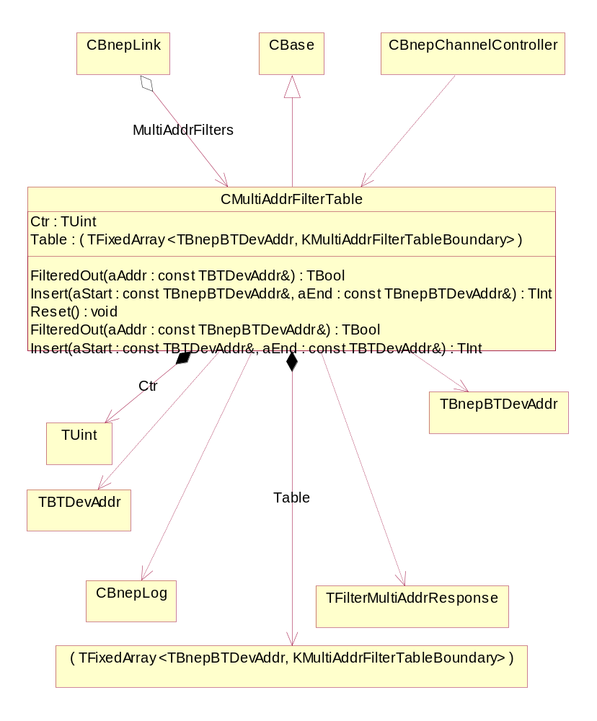

Figure 28: CMultiAddrFilterTable
CMultiAddrFilterTable is a representation of a list of filter specification ranges that permit the transmission of multicast packets through a particular link. The table is implemented as a fixed-length array of addresses, representing the start- and end-points of a limited set of ranges.
The practical limit of the filter specifications permitted on any one link is determined by the constant KMaxMultiAddrFilters, which is currently set to an arbitrary value of 10. Theoretically the BNEP specification supports the allocation of up to 140 filter ranges for multicast address filtering. However, any link burdened with the task of checking every multicast packet against a set of 140 potentially non-overlapping address ranges to see if it can pass is likely to suffer from extreme performance degradation.
Filter specifications are stored in ascending order of start value, using an insertion sort as they are put into the table. The advantage of using this inefficient insertion algorithm is that it speeds up the searching mechanism when FilteredOut() is called. If the start value of the next range to be tested is higher than the address under test, the rest of the table can automatically be discounted and the search terminated immediately.
Both FilteredOut() and InsertL() are overloaded for TBTDevAddr and TBnepBTDevAddr. The latter is an internal representation that compresses the TBTDevAddr mulit-byte implementation of a 48-bit address down into TInt64 values. This speeds up the direct numeric comparisons that have to be made during searches and sorts. The TBTDevAddr versions of the aforementioned methods are merely conversion wrappers that call the TBnepBTDevAddr versions after conversion.

CNetTypeFilterTable
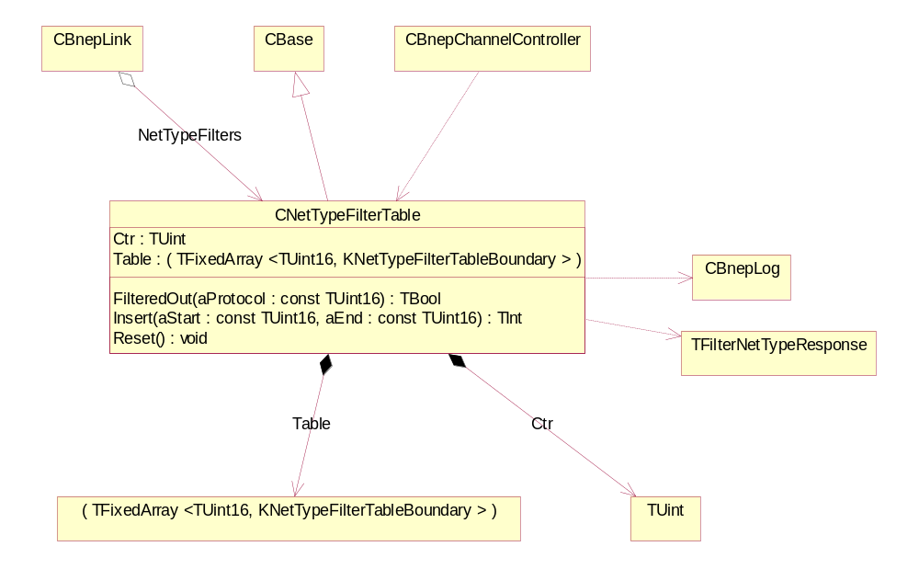

Figure 29: CNetTypeFilterTable
CNetTypeFilterTable is a representation of a set of filter specifications relating to the network protocol types that are of interest to a particular link. The table is implemented as a fixed-length array of protocol types, representing the start- and end-points of a limited set of ranges. InsertL() allows the user to insert a range specification. Range specifications can be added up to the specified KMaxNetTypeFilters (currently set to 10). The method uses an insertion sort in a similar fashion to that used by CMultiAddrFilterTable::InsertL() so that similar search optimisations can be exploited.
FilteredOut() will test the supplied protocol number to establish whether it should be filtered out or not.

CSocketReader
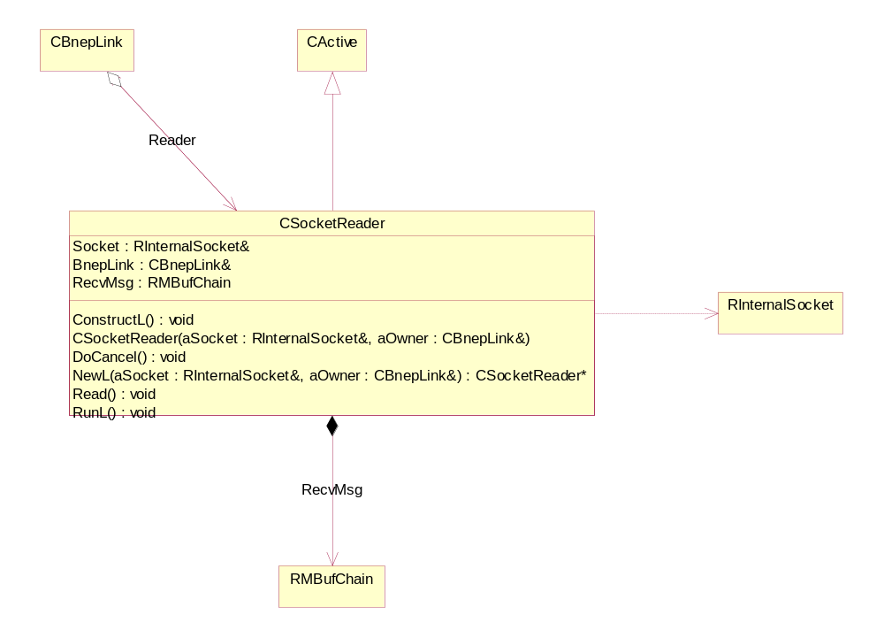

Figure 30: CSocketReader
CSocketReader is an active object tasked with monitoring the input side of the link socket. On receipt of some input from the Bluetooth stack, the RunL() is triggered, driving the logic associated with the link for parsing and acting on the messages it receives. For a Bluetooth-transported BNEP frame, this is where everything begins. Once a message has been ingested, the Read() method is called which triggers an asynchronous read request on the socket and activates the object ready for the next delivery. This sequence runs endlessly until the link is deleted.

CSocketWriter
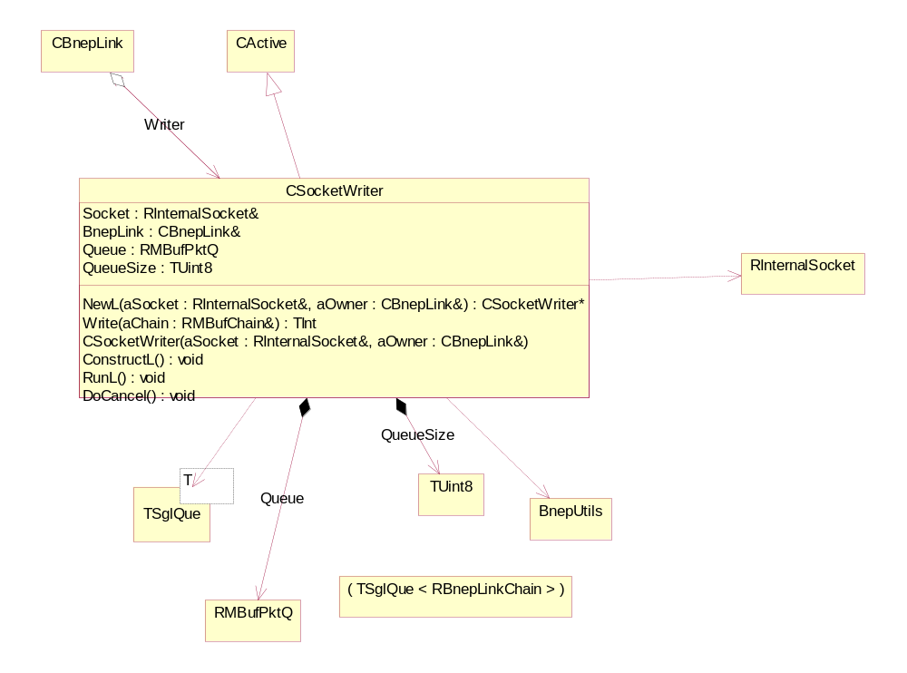

Figure 31: CSocketWriter
CSocketWriter is the active object mirroring the output side of the link socket. All messages destined for Bluetooth transportation are passed through this object. This is much simpler than the reader in that the frame is just passed down to the socket and an asynchronous send is queued. Once the send is complete, the work is over until the next write is requested; the RunL() of this active object essentially does nothing in this implementation.

MBnepChannelControl
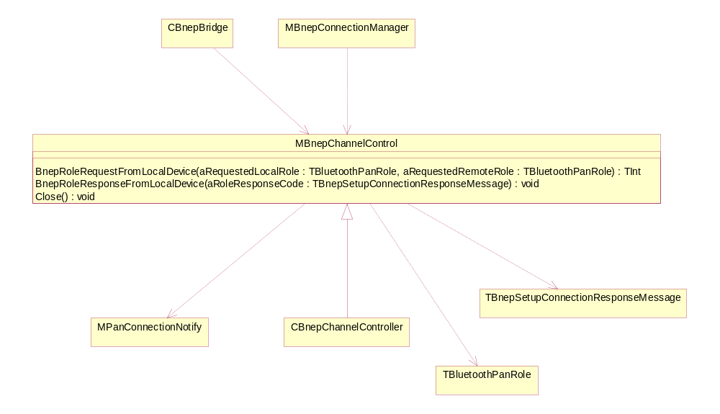

Figure 32: MBnepChannelControl
MBnepChannelControl provides the interface specification for part of the API used by the PAN Agent for driving CBnepChannelControllers when handling local and remote role requests for PAN Profile.

MBnepConnectionManager
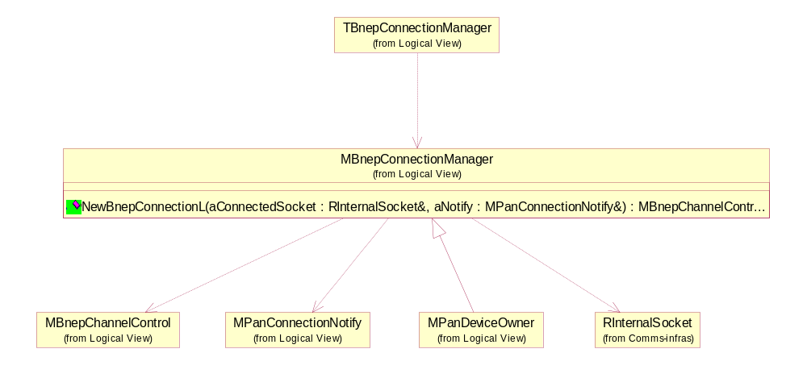

Figure 33: MBnepConnectionManager
MBnepConnectionManager is a mixin that provides the interface specification for PAN Agent to request the establishment of a new BNEP connection. There is no direct implementation class that represents a BNEP connection manager, since there is also the concept of a PAN Device Owner, codified in the mixin MPanDeviceOwner. MPanDeviceOwner derives from MBnepConnectionManager which suggests that between them, the two classes represent the responsibilities associated with the "bridge", which ultimately descends from both.

MLinkManager
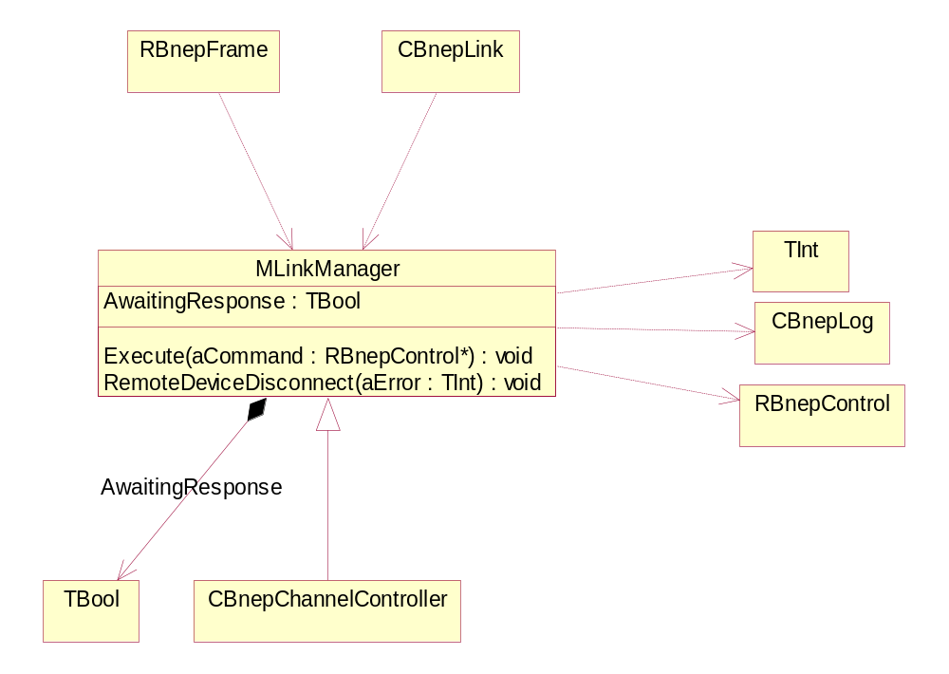

Figure 34: MLinkManager
MLinkManager is a mixin that establishes the interface used by a BNEP Link to call into its Channel Controller.

MPanConnectionNotify
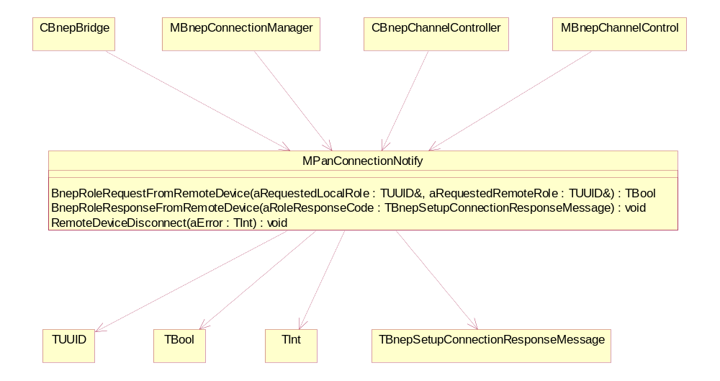

Figure 35: MPanConnectionNotify

MPanDevice
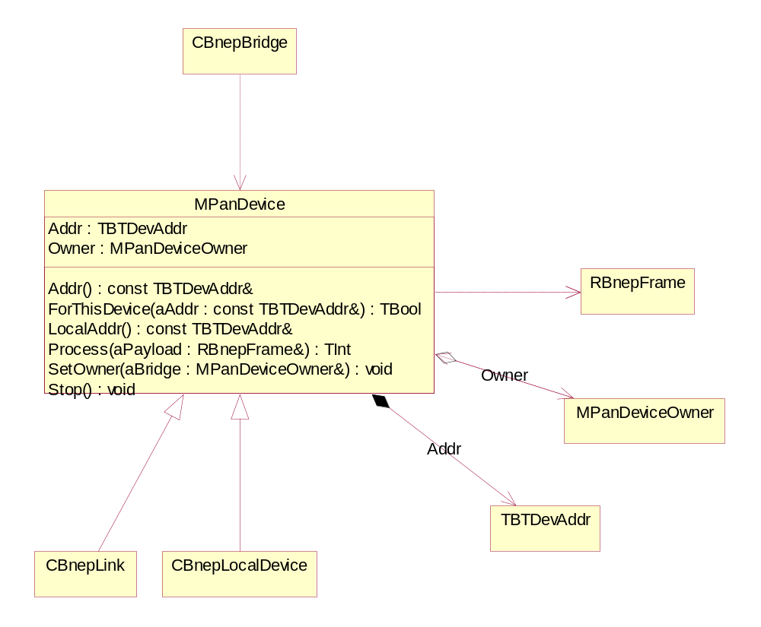

Figure 36: MPanDevice
MPanDevice represents the abstraction of a device that can process BNEP frames as output and be "owned" by any object derived from MPanDeviceOwner. There is a potential analysis error in MPanDevice in that it seems to contain a reference to an object of type MPanDeviceOwner. This logically curious, since objects that are owned do not usually hold references to the objects that own (or contain) them. This has implementation consequences when CBnepLocalDevice is destroyed such that allowance has to be made for the pointer offset. But then, CBnepLocalDevice is attempting to delet the object in which it is contained, which is a piece of logic that probably needs to be re-examined.

MPanDeviceOwner
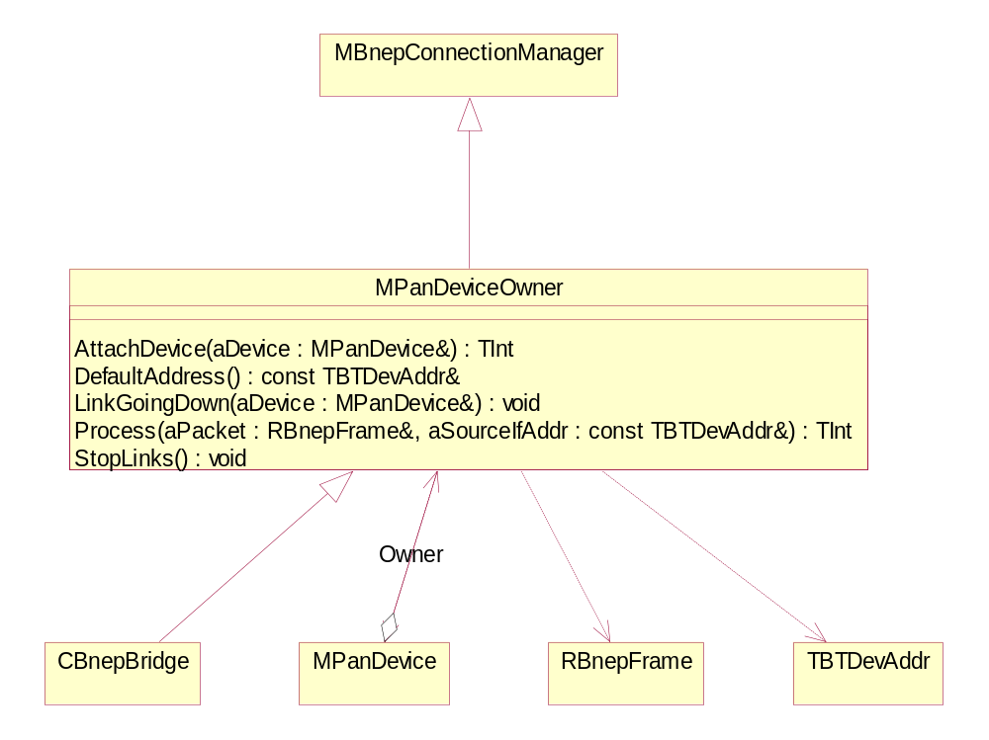

Figure 37: MPanDeviceOwner
MPanDeviceOwner is an interface wrapper for objects which appear to "own" MPanDevice objects. However, in the implementation, it is found that MPanDevices hold a reference to their "owner", which is sometimes used to delete upwards. Similarly, it is also found that CBnepBridge, the MPanDeviceOwner, does not "own" the CBnepLinks (MPanDevices) that it contains, such that it can never delete them.

RBnepControl and derivations
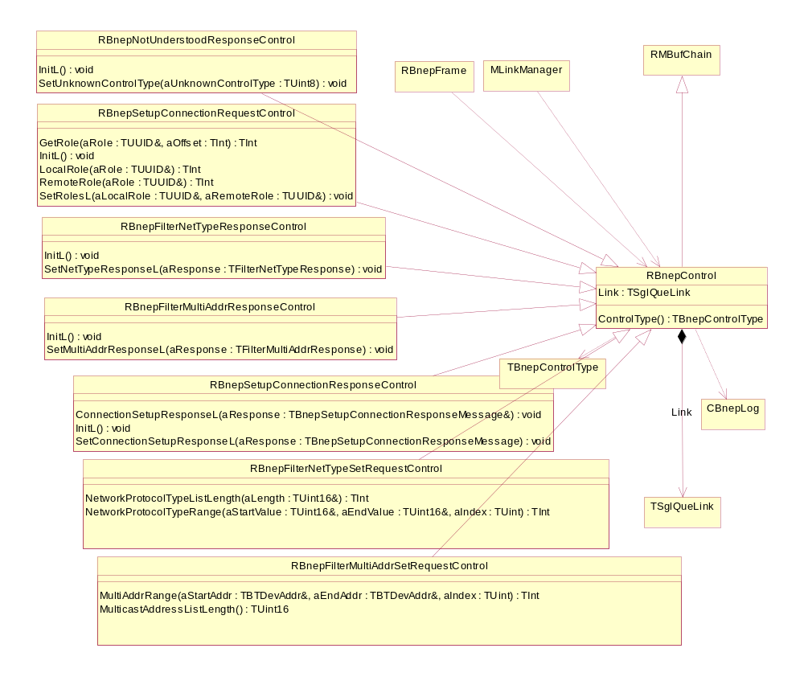

Figure 38: RBnepControl and derivations
RBnepControl is the parent of a set of derived classes representing either BNEP control messages or their responses. Each of these controls is the physical implementation of the message it purports to represent. This means the user must be very careful to make sure that each of these controls have RMBufChain::Free() called at the appropriate times to ensure that MBufManager memory leaks don't occur.
Note also that RBnepControl has a TSglQueLink member, which allows these objects to be held in TSglQues, as they are routinely in RBnepFrame.

Whenever BNEP receives a control that it cannot interpret, a RBnepNotUnderstoodResponseControl is generated. This contains the faulty control code that caused the response to be generated. BNEP currently has no logic to deal with the arrival of this control response from another BNEP.

RBnepSetConnectionRequestControl can be instantiated in two places. The first is on the input side, on receipt of such a request across a Bluetooth connection, and the other is on the output side when BNEP has been instructed to request a connection from the remote end.

RBnepSetupConnectionResponseControls are instantiated on the input side if the BNEP has previously requested a connection be set up on a remote device, or on the output side when responding to a remote request to set up a connection.

RBnepFilterNetTypeSetRequestControl and RBnepFilterMultiAddrSetRequestControl objects should only appear on the input side, as part of the parsing mechanism, when received from a remote link. This version of BNEP does not emit filter requests, as the mechanisms do not exist in the upper layers of the comms stack to enable this functionality to be used. Therefore the current version of BNEP cannot specify filtering on any link. However, it can honour and respond to filtering requests from other BNEP implementations. Currently, therefore, the setting methods on both of these types of objects are not implemented, since they are not required yet.

RBnepFilterNetTypeResponseControl and RBnepFilterMultiAddrResponseControl objects only appear on the output side, as responses to remote filter requests. Again, the limitations on filter requesting, in this version of BNEP, mean that this BNEP should not expect to receive responses to control requests it cannot emit. The accessor methods on these controls are implemented but not used or tested.

RBnepFrame
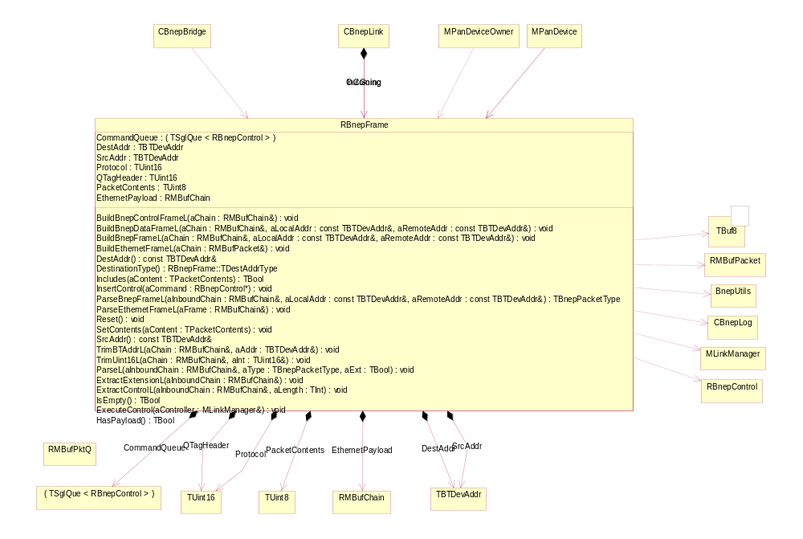

Figure 39: RBnepFrame
RBnepFrame is probably misnamed as it acts more as a BNEP interpretive factory or message processing engine. The nature of RBnepFrame's piecemeal evolution means that it has encapsulated more responsibilities than is usually healthy for any particular object. It is a prime candidate for refactoring, since it's role is too broadly defined and it sits at the centre of BNEP directing the flow of both input and output.
Each CBnepLink contains 2 RBnepFrames - iComing and iGoing. As their names suggest, each has specific role responsibilities with regards to the direction in which information is flowing.
At the heart of RBnepFrame is the command queue; a TSglQue of RBnepControl objects. The parse and extract methods on RBnepFrame will populate the command queue with whatever they find in the BNEP frame in terms of controls and extensions. The results of executing these controls in teh channel controller are likely to be response controls which are similarly collected in the command queue (of a different RBnepFrame instance, in practice). These are then used, in conjunction with any payload, to construct packets for output via the RBnepFrame's build methods.
When BNEP evolves to emit the full set of controls and handle the responses, the command queue mechanism will still be able to serve, in both directions.
It is important to note that all instances of RBnepFrame must be routinely reset when appropriate. Failure to reset at the correct times will cause memory leaks because of the ubiquitous use of RMBufChain as both a parent to RBnepControl and as the specific storage medium for the data payload. It is important to ensure, particularly during leaving methods, that any unused portions of RMBufChains are freed before the leave takes place.

Further Information

References
[1] Bluetooth Network Encapsulation Protocol (BNEP) Specification – Version 1.0 – Feb 14 2003
Bluetooth SIG
[2] “Design Patterns : elements of reusable object-oriented software” Erich Gamma, Richard Helm, Ralph Johnson, John Vlissides – March 1995 – Addison Wesley
[3] Bluetooth Network Encapsulation (BNEP) Test Cases – Version 1.0 – July 23 2002 – Bluetooth SIG

Document History
Date | Version | Comment | Author
1/10/2004 | v0.1 | First draft out for review | Jeremy Pavier
18/10/2004 | V0.2 | Updated after internal review | Jeremy Pavier

