Introduction

Purpose and Scope
The purpose of this document is to detail the design of the Bluetooth Phone Book Access Profile (PBAP) component developed by the short-link team and LPD

Overview

Profile Summary
The Phonebook Access Profile allows a remote device – typically a Bluetooth-enabled carkit – to retrieve individual contacts, lists of contacts, and call histories, from the phone’s memory. The access is read-only.
The profile has both Phonebook Client Equipment (PCE - e.g. the car) and Phonebook Server Equipment (PSE - e.g. the phone) roles –this implementation is only for the server role.
PBAP uses Phone Book Objects, based on the Infrared Mobile Communications specification v1.1 (IrMC), which are transferred using OBEX over a virtual serial port (GOEP over SPP).
The profile is fully detailed in [R1].

Requirement Description
The requirements are derived from the following PREQ
PREQ or EC ref | Title | Description of Requirement | Comments
1215 | Bluetooth Phonebook Access Profile (PBAP) | Symbian OS shall provide an implementation, protocol and API for the Bluetooth Phone Book Access Profile (PBAP). The simple API shall just start and stop the PBAP.  The PBAP shall provide a Bluetooth connected device with read only access to contact information stored on internal phone memory.  All mandatory features of the Phonebook Server Equipment (PSE) role of the PBAP specification version 1.0 will be supported. The version 1.0 specification will be available from the bluetooth SIG at the end of Q4 2005.  Omission: PBAP access to contact information stored on a phone's SIM card will not be provided.

Assumptions
- SIM repository support is not implemented. This feature is optional in the specification, and it is assumed that most users will have copied their SIM contacts to the main phonebook store. However the design is extendable to allow addition of this feature at a later date.
- Only the PSE role is supported.
- Only one PBAP connection is supported at any one time.

Design Overview
The following diagram shows an overview how the implementation of PBAP fits into Symbian OS, and how it interfaces to existing subsystems (Blue represents unchanged Symbian OS components, green represents licensee components and red represents modified Symbian OS components. All other components are shown in rust colour.)

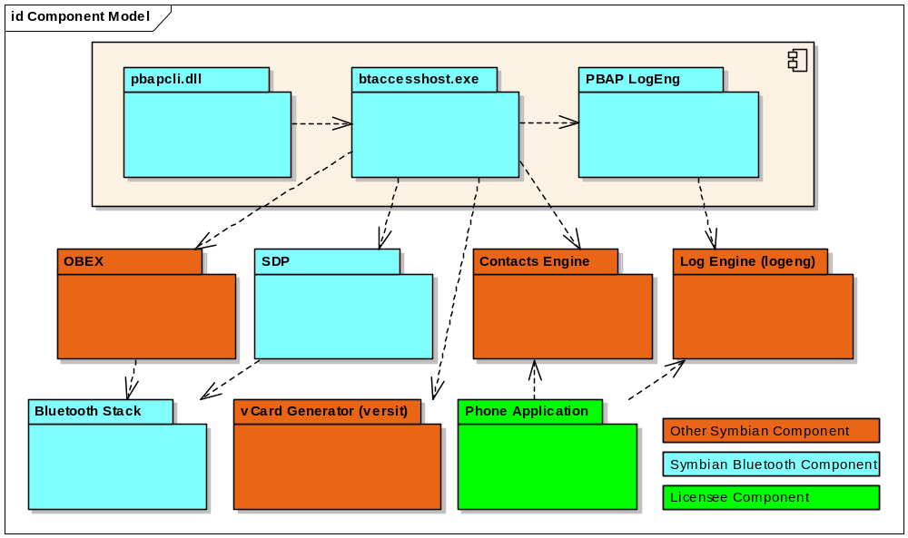

Component Responsibilities
There follows a summary of the key roles of each component:

PBAP Client
- Creating and destroying the PBAP server
- Starting / stopping the profile
- Optionally setting a password required to access the server

PBAP Server
- Listening for incoming Bluetooth PBAP connections
- Registering an SDP service entry
- Parsing and handling the incoming OBEX requests
- Navigating and maintaining the PBAP “virtual folder” structure (in XML) to retrieve the desired information
- Interfacing to contacts to retrieve the phone book (pb) information
- Interfacing to Log Eng to retrieve the call history information (ich, och, mch & cch). Note that this assumes the licensee’s phone application has used the Symbian OS provided logeng interface to list the call history information.
- Implementation of the PBAP-defined XML DTD for folder listing objects.
- Interfacing to versit to export contact items and call log events in vCard 2.1 or 3.0 format.
- Interfacing to filter the exported vCard to only include properties requested by the PCE
- Interfacing allow additional properties (in this case the call history information) to be added to a contact vCard at export time.

PBAP LogEng
- Interfacing to Log Engine to allow localisation of call logging for benefit of different UI variants.
.

Versit
- Encoding of the phone book information into vCard format.

Contacts
- Reading contact items from the database to create the main (pb) phonebook
- Sorting contact items
- Searching the contacts database

Log Engine
- Reading call log events from the log engine store to create call history phonebooks
- Filtering of call log events based on direction (i.e. incoming, outgoing and missed) and read status

Phone Application
- Writing call log events to the log engine store

OBEX
- Provides asynchronous handling of OBEX notifications (requires Symbian OS version 9.2 or greater)
- Allows transfer of PBAP data over a Bluetooth transport

Detailed Component Design

PBAP Client

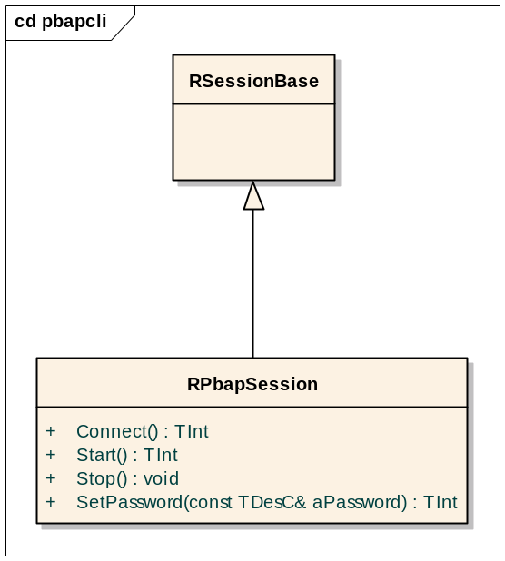

The PBAP client component contains a single class, RPbapSession, which provides the public exported client side API used to access the PBAP server. Its main purpose is to launch the server and start the profile listening for client (PCE) connections.

RPbapSession API Description

IMPORT_C TInt Connect()
Connect the client session to the PBAP server. This must be called before any of the other methods listed in this API description.
The PBAP server is a transient server so the first client to call this method will cause the initiation of the PBAP server within its own process. Also, when all sessions with the server are closed the server will shutdown until this method is called again.
This method returns KErrNone if successful or a system wide error code if not

IMPORT_C TInt Start()
Start the PBAP profile. If this method completes successfully the PBAP server will listen for PCE OBEX connect requests over Bluetooth until RPbapSession::Stop() is called or all sessions with the server have closed (causing the server to shutdown)
This method returns KErrNone if successful or a system wide error code if not

IMPORT_C void Stop()
Stop the PBAP profile. Once this function is called all PCE connect requests will fail until the next successful RPbapSession::Start() call. It will also force a server side disconnect of a PCE connection.

IMPORT_C TInt SetPassword(const TDesC& aPassword)
Set the password required to access the PBAP server. The password is sent in the OBEX challenge header when responding to a PCE connect request. This method maybe called before or after RPbapSession::Start().The password is not persisted so it will only last the lifetime of the PBAP server.

The default policy of the PBAP server is to have OBEX server authentication disabled until this function is called.
This method returns KErrNone if successful or a system wide error code if not.
To disable OBEX server authentication, the PBAP server must be stopped and re-started.

PBAP Server
The following diagram shows the main classes used in the design of the PBAP server. The specific components and individual classes are described in more detail in the subsequent sections.

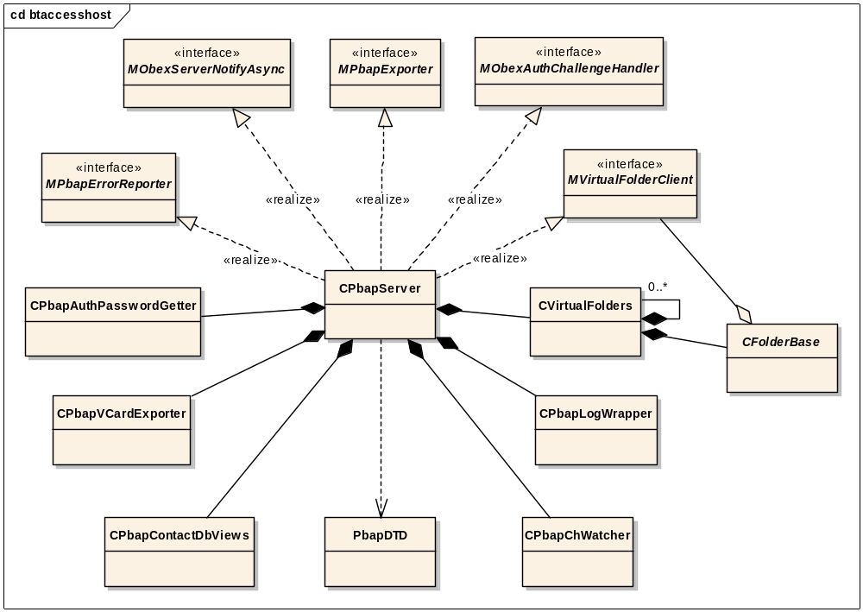

Server start up and shutdown
CPbapServer is a Symbian OS server derived from the CPolicyServer base class.
It is a transient server, created when the first session is created. When the last session is destroyed the CPbapServerShutdown timer is started. If no new sessions are created before this timer expires the server is destroyed.
When CPbapServer is created its second phase constructor performs the following steps:
- Creates the OBEX buffers used to transfer data to the client
- Opens the contacts database
- Creates a CPbapContactDbViews object which will be used to sort and search the contacts database
- Creates a client to access the log engine
- Create a CPbapVCardExporterUtil object to export vCard

OBEX and Bluetooth management
The CPbapServer class also has responsibility for creating a CObexServer object (defined in the Symbian OS Obex component) which is used to listen for OBEX client connections and handle the OBEX request functions detailed in the PBAP specification [R1]
When RPbapSession::Start() is called the server side session handles the request by calling CPbapServer::StartObexL().
CPbapServer::StartObexL() defines the Bluetooth security policy of the PBAP profile using the TBTServiceSecurity class. This is added to a TObexBluetoothProtocolInfo object which also sets the transport type to Bluetooth RFCOMM with RFCOMM channel set to KRfcommPassiveAutoBind. A CObexServer instance is then created using the TObexBluetoothProtocolInfo object and CObexServer::Start() is called to start listening for client connections.
If a server password has been set then CObexServer::SetChallengeL() is called to enable OBEX server authentication.
When CObexServer is created the Bluetooth RFCOMM channel is set to the first free channel. CPbapServer::RegisterWithSdpL() is called with this RFCOMM channel to register a Bluetooth SDP record using the RSdpDatabase API. This allows Bluetooth devices to discover that the profile supports the PBAP PSE role, find out which RFCOMM channel to connect to, and see which features are supported by the profile implementation. This is the only direct access the PBAP profile has with the Symbian OS Bluetooth components, since connection management etc… is handled by the OBEX component.

When RPbapSession::Stop() is called the server side session handles the request by calling CPbapServer::StopObex(). This deletes the CObexServer object and releases the SDP record by calling CPbapServer::ReleaseSdpRegistration().
The CObexServer is deleted rather than just calling CObexServer::Stop() to make sure that a free RFCOMM channel is assigned the next time a client issues a request to start the profile.

OBEX notifications
CPbapServer implements the MObexServerNotifyAsync interface class provided by the OBEX component which allows it to respond to requests from an OBEX client.
The MObexServerNotifyAsync call back functions provide most of the PBAP profile functionality so the following sections contain descriptions of each of these functions.

ObexConnectIndication
This function is called when an OBEX client has successfully connected to the server to access the PBAP profile.
The virtual folder tree is created in this function so that phone book handles etc… can be refreshed between PBAP sessions.

SetPathIndication
This is used to provide the SetPhoneBook PBAP function. SetPath can be used to navigate folders in three ways:
- Move to Root folder
- Move to a specific Child folder of the current folder (note this can only be one level at a time)
- Move to the current folder’s Parent folder.

This function determines whether navigation to the requested folder is possible from the current folder. If it is then a pointer to the current CVirtualFolders object is updated. If not then a “Not Found” OBEX error is reported to the client.

GetRequestIndication
This is used to provide the PullPhoneBook, PullvCardListing, and PullvCardEntry PBAP functions.
The appParams attribute provided by the CObexBaseObject parameter value is passed to a CPbapAppHeader object which parses the attribute to determine the PBAP function type and associated parameter values.
The CObexBaseObject parameter value also provides the name attribute which determines the folder path and phone book object the PBAP function will operate on (Note, the folder path maybe absolute or relative depending on the type of operation)
CPbapServer::ResolvePath() is then called to navigate to the requested folder. If the requested phone book object is a file representation of a phone book then an attempt is made to navigate to the corresponding phone book folder.
CFolderBase::Get() is then called on the requested folder object to process and complete the PBAP function

AbortIndication
This is called when the transfer of data resulting from a get request is aborted. The function is implemented to reset the OBEX buffers.

TransportDownIndication, ErrorIndication and ObexDisconnectIndication
These functions are all called in response to a termination of the current OBEX connection. They are implemented to cancel any outstanding get requests, reset OBEX buffers and destroy the virtual folder tree.

PutRequestIndication
The PBAP PSE service is read only so this function is implemented to always return a “Bad request” error

OBEX authentication
CPbapServer implements the MObexAuthChallengeHandler interface provided by the OBEX component this allows handling of OBEX client authentication challenges.
If a client sends a challenge header in a connect request the OBEX framework calls the function MObexAuthChallengeHandler::GetUserPasswordL(). CPbapServer implements this function by creating a CPbapAuthPasswordGetter active object which starts an extended notifier and waits for a response. The notifier allows users to input the password to be used in the challenge response header.
The notifier is identified by the UID KPbapAuthNotifierUid, it is passed a packaged TPbapAuthNotifierParams object containing the challenge headers realm field and the clients Bluetooth device address (which can be used to look up its device name). It expects a packaged TPbapAuthNotifierResponse object containing the password descriptor in its response.
The implementation of the notifier plug-in is the responsibility of UI vendors; however a text shell implementation is supplied for testing purposes.
When the asynchronous notifier request completes CObexServer::UserPasswordL() is called to respond to the client challenge.

Virtual Folders

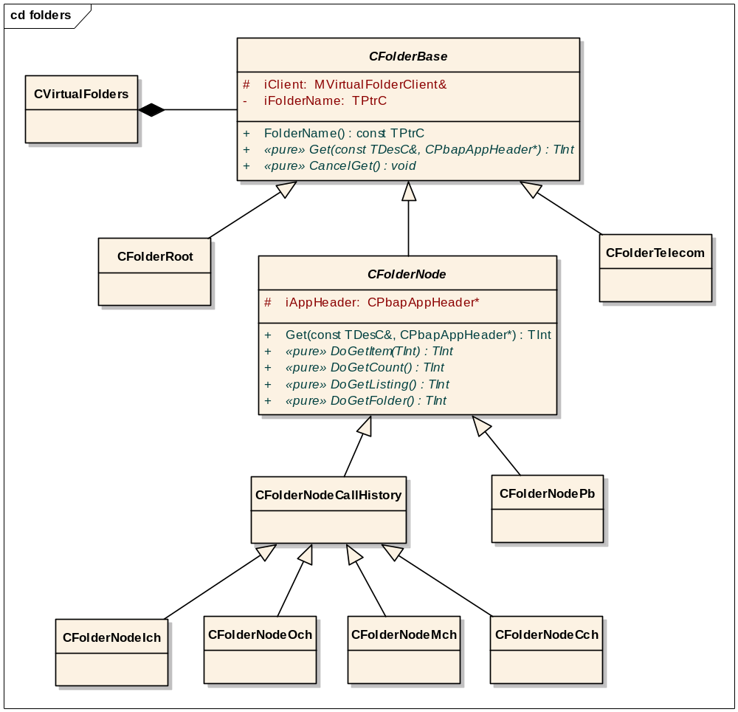

This virtual folder structure described in section 3.1.5 of the PBAP specification [R1] is implemented as a tree of CVirtualFolders classes, each one containing a list of sub-folders and references its parent folder. Each CVirtualFolders class encapsulates a CFolderBase-derived class, which provides access to the data within that folder.
The CFolderBase defines three pure virtual functions which are overridden by the derived concrete Folder classes:

const TPtrC FolderName() const
Return the name of the virtual folder (e.g. “telecom”, “pb”, etc…).This is required for navigation of the folder tree.

TInt Get(const TDesC& aObjectName, CPbapAppHeader* aGetData)
Handle an OBEX Get request. The concrete implementation will depend on whether this folder contains phone book information and if so which type of phone book. Implementations should return KErrNone if the request was handled successfully otherwise return a system wide error code.

void CancelGet()
Handle notification that the current OBEX Get request has been cancelled. This allows any asynchronous processing being performed on a phone book to be cancelled.

CFolderRoot and CFolderTelecom are concrete classes derived directly from CFolderBase. They both implement the Get() function to return an error.

CFolderNode is an abstract class derived from CFolderBase. Concrete classes representing phone book folders are derived from this class rather than CFolderBase. This class implements the Get() function to call one of the following pure virtual functions depending on the type of OBEX Get operation requested.

TInt DoGetItem(TInt aHandle)
Handle a TPbapOperation::EPullVCard request. aHandle is the requested phone book handle. Implementations should return KErrNone if the request was handled successfully otherwise return a system wide error code

TInt DoGetListing()
Handle a TPbapOperation:: EPullVCardListing request. Implementations should return KErrNone if the request was handled successfully otherwise return a system wide error code

TInt DoGetCount()
Handle a TPbapOperation:: ERequestPhoneBookSizerequest. Implementations should return KErrNone if the request was handled successfully otherwise return a system wide error code

TInt DoGetFolder()
Handle a TPbapOperation:: EPullPhoneBook request. Implementations should return KErrNone if the request was handled successfully otherwise return a system wide error code

CFolderNodePb is a concrete class derived from CFolderNode. It handles requests to the Pb phone book.
CFolderNodeCallHistory is an abstract class derived from CFolderNode it contains common functionality used by all the call history phone books.
CFolderNodeIch, CFolderNodeOch, CFolderNodeMch and CFolderNodeCch are concrete implementations of CFolderNodeCallHistory. They handle requests to the ich, och, mch and cch call history phonebooks respectively.
A SIM1 folder tree is represented by a similar class hierarchy derived from the base class CFolderSIM1Base (which in turn is derived from CFolderBase). Although defined in the code, this is not currently used or supported.

The pb folder

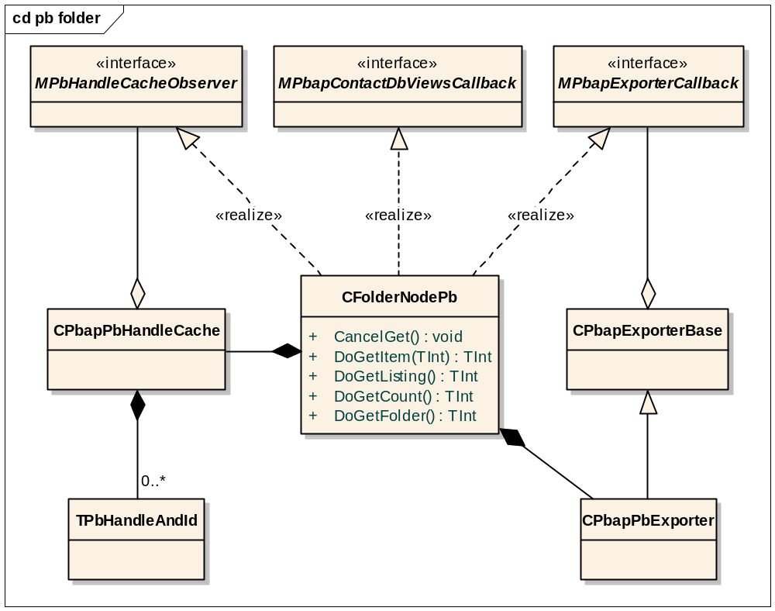

CFolderNodePb is the concrete implementation of CFolderNode and is used to access the main phonebook (pb).
Items within a phonebook are identified by a unique 32-bit integer handle. Since the pb phonebook items correspond to items stored in the contacts database the class CPbapPbHandleCache is created which provides an array of mappings from Pb handles to contacts ids (each items mapping is represented by the class TPbHandleAndId). When CPbapPbHandleCache is constructed the handles are generated in a ascending contiguous range starting from 1. The special owner card handle 0 is also created, and mapped to the id of the current owner card contact item in the database. If no owner card exists then handle 0 is mapped to the contact id KNullContactId.

CPbapPbHandleCache exists throughout the lifetime of CFolderNodePb observing changes to the contacts database. If a change occurs the mapping array is updated and CFolderNodePb is notified of a change to the phonebook via the interface MPbHandleCacheObserver. All calls to CFolderNodePb::DoGetItem() will then result in a “Precondition failed” error being reported to the client until a new listing request is successfully completed (this behaviour is required to satisfy section 3.1.5.1 of the PBAP specification [R1])

The functions handling get requests from the client (i.e. DoGetItem(), DoGetListing(), DoGetCount() and DoGetFolder()) create a CPbapPbExporter derived object which asynchronously writes the requested data to an OBEX buffer stream. When complete CFolderNodePb is notified via the interface MPbapPbExporterCallback and either the data is sent to the client or an error code is reported. If the handle parameter value passed to DoGetItem() does not exist in the phonebook a “Not Found” error is reported immediately.

DoGetListing() also provides functionality to sort and search the Pb phonebook before writing the listing data to the OBEX buffer stream. This is implemented by calling the asynchronous function CPbapContactDbViews::GetContactIdsMatchingCriteriaL() (MVirtualFolderClient provides a reference to the class CPbapContactDbViews) when this request completes CFolderNodePb is notified via the interface MPbapContactDbViewsCallback. Writing the listing data to the OBEX buffer stream then proceeds as described above.

The pb exporter

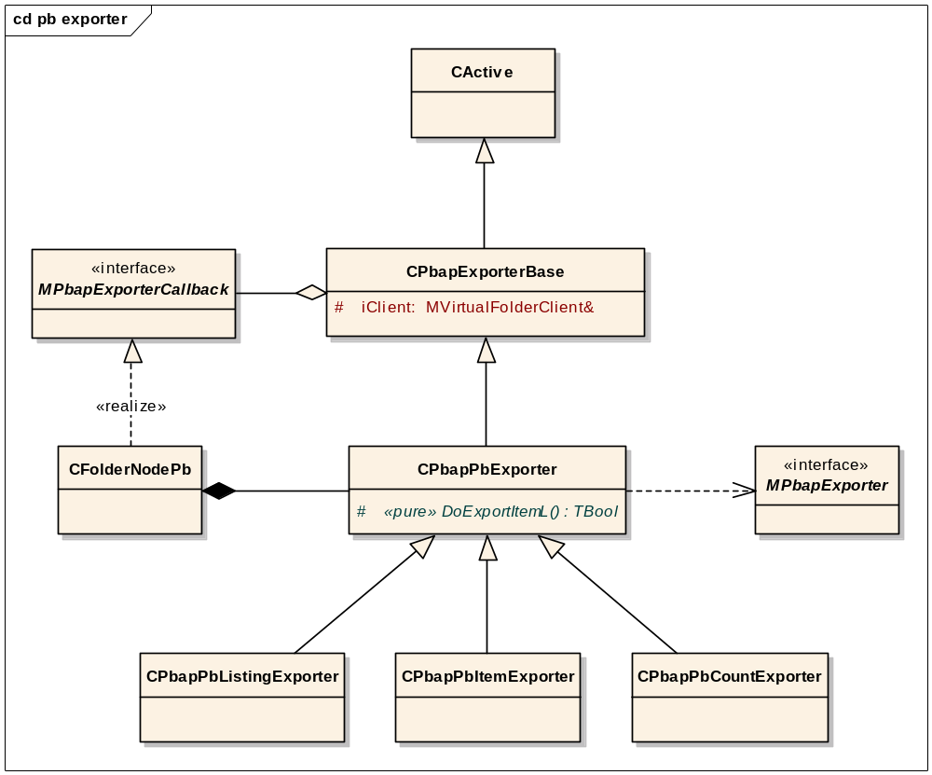

Handling an OBEX Get request from a client may potentially require a lot of time consuming processing (e.g. converting large numbers of contacts to vCards). To avoid lengthy synchronous blocking of the PBAP server process the CActive derived base class CPbapPbExporter is provided to facilitate breaking up of these long running tasks into smaller steps.
CPbapPbExporter opens the OBEX buffer stream for writing in its constructor by calling MPbapExporter::StartExport(), it then completes itself by calling User::RequestComplete(). Its RunL() function is implemented to call the pure virtual function DoExportItemL(). If this function returns ETrue more processing is required and another User::RequestComplete() is issued. If EFalse is returned then processing of the get request is complete and MPbapPbExporterCallback::HandleExportComplete() is called and MPbapExporter::FinaliseExportL() is called to close the OBEX buffer stream for writing.

The concrete CPbapPbExporter subclass implementation of DoExportItemL() varies depending on the type of OBEX Get request received.
CPbapPbListingExporter is created by CFolderNodePb::DoGetListing(). DoExportItemL() is implemented to call MPbapExporter::ExportListingBeginL() the first time it is called. This writes the XML listing DTD header to the OBEX stream. Subsequent calls write XML listing data for each of the requested phone book handles by calling MPbapExporter::ExportListingEntryL(). The final call also writes the XML listing footer by calling MPbapExporter::ExportListingEndL()

CPbapPbItemExporter is created by CFolderNodePb::DoGetItem() and CFolderNodePb::DoGetFolder(). Its DoExportItemL() function is implemented to write a vCard representation of a phone book item to the OBEX buffer stream by calling MPbapExporter::ExportContactL(). This is repeated for each of the requested phone book handles.
CPbapPbCountExporter is created by CFolderNodePb::DoGetCount(). Its DoExportItemL() function is implemented to write the current handle count of the Pb phone book to the OBEX object header by calling MPbapExporter::ExportPhonebookSizeL()

The call history folders
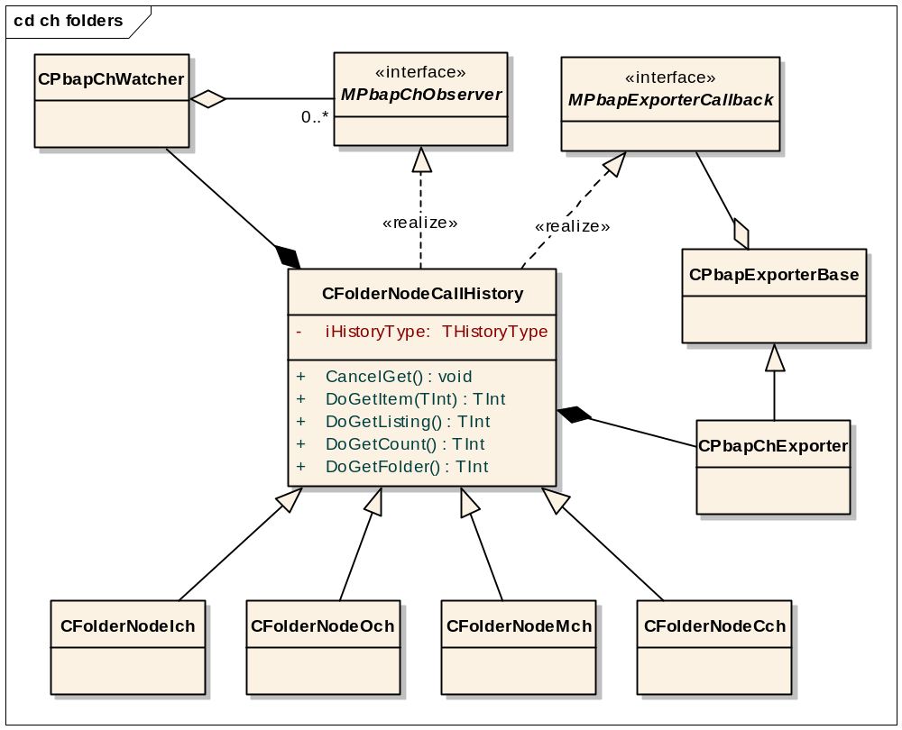

CFolderNodeCallHistory provides implementations of the get request functions defined in the CFolderNode base class (i.e. . DoGetItem(), DoGetListing(), DoGetCount() and DoGetFolder()) .These functions create a CPbapChExporter derived object which asynchronously writes the requested data to an OBEX buffer stream. When complete CFolderNodeCallHistory is notified via the interface MPbapChExporterCallback and either the data is sent to the client or an error code is reported.

Call history exporter
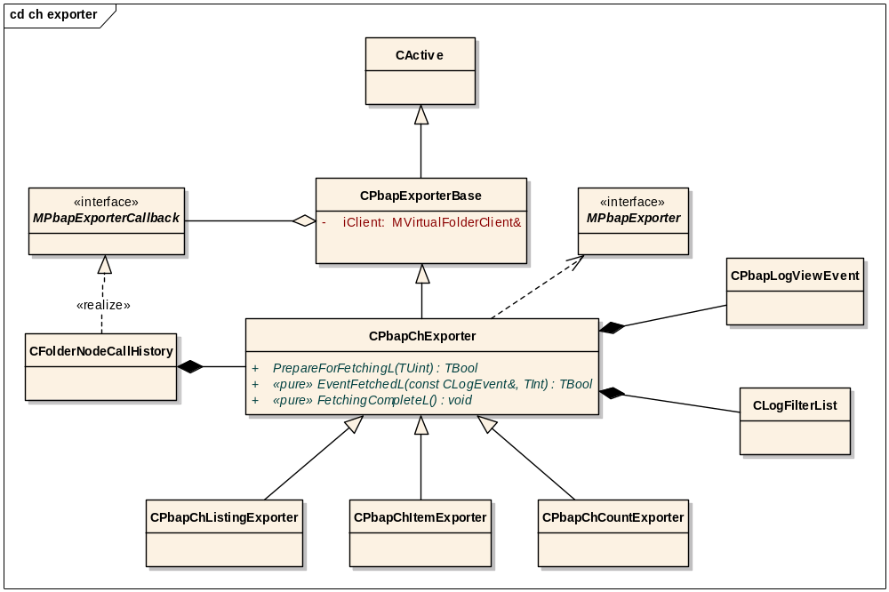

CPbapChExporter is used to implement asynchronous processing of an OBEX Get request on a call history phone book in a similar way to the CPbapPbExporter class although the implementation is more complicated.
Unlike the pb phone book the call history items associated with particular handles may be modified at any time, this is because the PBAP specification states that handles must always be sorted in chronological order with the most recent call being assigned to lowest handle value (i.e. 1). So if a new call is added to the call log during a PBAP session all the items associated with the current handles will change.
For simplicity instead of creating a cache of handle ids to call log ids, and monitoring the state of the call log, handles are allocated dynamically by CPbapChExporter when an OBEX Get request is being processed.
The second phase constructor of CPbapChExporter makes an asynchronous request to create a log engine view (CLogViewEvent) using a filter (CLogFilter) based on call direction (R_LOG_DIR_IN, R_LOG_DIR_OUT, R_LOG_DIR_MISSED or all of them) which maps to the different phone book types and event type which is always set to KLogCallEventTypeUid. The resulting view contains all the log events for a particular call history phone book sorted in chronological order.
After the view is created MPbapExporter::StartExport() is called to open the OBEX buffer stream for writing. Then the pure virtual function CPbapChExporter::PrepareForFetchingL() is called passing in the number of items contained in the view. Concrete classes which implementation this function can return EFalse to abort further writing to the OBEX buffer stream at this point.
If CPbapChExporter::PrepareForFetchingL() returns ETrue CLogEvent objects are then read from the view asynchronously by calling CLogViewEvent::Next(). Each time this request completes successfully the pure virtual function CPbapChExporter::EventFetchedL() is called with a reference to the CLogEvent and the current count of events fetched (this will correspond to the item handle). A concrete class implementing this function can return EFalse to indicate that no more events should be read from the view.
When the final CLogEvent in the view has been read the pure virtual function CPbapChExporter::FetchingCompleteL() is called followed by MPbapExporter::FinaliseExportL() to close the OBEX buffer stream for writing.
The concrete CPbapChExporter subclass implementation of PrepareForFetchingL(), EventFetchedL() and FetchingCompleteL() varies depending on the type of OBEX Get request received.

CPbapChListingExporter is created by CFolderNodeCallHistory::DoGetListing(). PrepareForFetchingL() is implemented to call MPbapExporter::ExportListingBeginL(). This writes the XML listing DTD header to the OBEX stream. EventFetchedL() is implemented to write XML listing data for each of the requested call history handles by calling MPbapExporter::ExportListingEntryL(). The listing handle value is set to the current number of events read from the view. The listing name value is either read from the associated contact item or set to the CLogEvent phone number if no associated contact exists. FetchingCompleteL() is implemented to write the XML listing footer by calling MPbapExporter::ExportListingEndL()
CPbapChItemExporter is created by CFolderNodeCallHistory::DoGetFolder(). Its EventFetchedL() function is implemented to write a vCard representation of the passed in CLogEvent to the OBEX buffer stream by calling MPbapExporter::ExportCallHistoryL().
CPbapChSingleItemExporter is created by CFolderNodeCallHistory::DoGetItem(). Its EventFetchedL() function is implemented to do nothing until the handle of the current event matches the requested handle then MPbapExporter::ExportCallHistoryL() is called to write a vCard representation of the passed in CLogEvent to the OBEX buffer stream.

CPbapChCountExporter is created by CFolderNodeCallHistory::DoGetCount(). Its PrepareForFetchingL() function is implemented to write the number of items in the call history phone book to the OBEX object header by calling MPbapExporter::ExportPhonebookSizeL(). The function returns EFalse to indicate no further writing is required.

If either CPbapChCountExporter, CPbapChItemExporter or CPbapChListingExporter objects are created with the parameter value THistoryType::EMissed then an extra log event view is created filtered on the flag value KLogEventRead. The number of items in this view is used to calculate the new missed calls count which is added to the OBEX object header by calling MPbapExporter::ExportNewMissedCallsL()

Further Information

People
Role | Person / People
Reviewers | Lee Luchford, Tim Howes, Ashvin Lad
Contributors | Thomas Lovell, Lee Luchford
Distribution | List of people the document is to be distributed to or database/location where the document is to be stored.

References
No. | Document Reference | Version | Description
[R1] | Phonebook Access Profile specification | 1.0 | SIG PBAP specification (www.bluetooth.org)
[R2]
[R3]
[R4]

Open Issues

Glossary
Term | Definition

Document History
Date | Version | Status | Author | Description
dd-mm-yyyy | 1.0 | Issued | <Name>
25-09-2006 | 0.6 | Draft | Lee Luchford | Updates following review by Thomas Lovell
21-09-2006 | 0.5 | Draft | Lee Luchford | Minor updates
18-09-2006 | 0.4 | Draft | Lee Luchford | Updates to reflect final implementation
27-03-2006 | 0.3 | Draft | Thomas Lovell | Updates to Handles section following review with Tim Howes and Lee Luchford
22-03-2006 | 0.2 | Draft | Thomas Lovell | Updates to Handles section following comments from Lee Luchford.
13-03-2006 | 0.1 | Draft | Thomas Lovell | First draft based on SGL.PPS001.500 Lightweight Document Template Rev 8.5
12-03-2007 | 1.0 | Issued | Guanyun Zhang | Updates to reflect shortlink implementation

