WAP Messaging API Test Specification

Security Classification: | Internal
Status: | Issued
Version: | 1.0
Last Revised Date: | 12/12/2003
Team/Department : | Core / Networking
Author(s): | Kamran Nobari
Owner(s): | Networking TA

Approver(s): |  | Distribution:

Contents
1 Introduction 3
1.1 Purpose and Scope 3
2 Test Environment 3
2.1 Overview 3
2.2 Hardware 3
2.3 Software 3
2.4 Network 3
3 Test strategy 3
4 Test Configuration/settings 5
5 Test Cases 6
5.1 Description of test steps 7
6 Further Information 14
6.1 People 14
6.2 References 14
6.3 Glossary 14
6.4 Document History 14
6.5 Document Review Date 14
Appendix A - Class diagram of WapStackSuite 15

Introduction

Purpose and Scope
This document describes the Wap Messaging API tests in Symbian OS v8.0 and the hardware/software requirements for each test. It consists of four main sections:
The first section contains the test environment description. It describes hardware and software requirement for running the tests. The second section describes test strategy. It covers the purpose of these tests and what the tests cover. The third section describes any settings and configurations required for running the tests. The final section describes the test steps.

Test Environment

Overview
All the tests can be run under emulator or development board environment. The tests use “test execute” framework. The class diagram for tests is shown in appendix A. The required settings are described in configuration section.

Hardware
For running the tests on the development boards, the Lubbok board is required. Also, if the tester does not want to use SIM TSY, then the tests require a mobile handset. The mobile phone should have the following capabilities:
- Should be able to do both 7 and 8 bit encoding (e.g. Nokia 9210 or any other decent phone)
- Should be able to do loop back for SMS messages.
- Serial connection is preferred although not necessary

Software
Currently there are no specific software requirements.

Network
No network configuration needed.

Test strategy
The tests should cover the unit testing for WAP Messaging API plug-in interface and should test the main functionality of WAP Messaging API layer, which provides an interface abstraction of certain WAP stack message API implementation. The following scenarios are covered in these tests:
- Data handling (i.e. loss, corruption)
- Low memory handling
- Programmatic error
- Invalid parameters for API
- Working under normal conditions
The tests cover the following API:
- Class CWapBoundCLPushService
- NewL
- NewL(KInterfaceUid)
- Connect
- AwaitPush
- GetLocalPort
- GetLocalAddress
- GetBearer
- GetServerAddress
- CancelAwaitPush
- Class CWapBoundDatagramService
- NewL
- NewL(KInterfaceUid)
- Connect
- SendTo
- AwaitRecvDataSize
- RecvFrom
- GetLocalPort
- GetLocalAddress
- GetBearer
- GetDatagramSizes
- CancelRecv
- Class CWapBoundCLWSPService
- NewL
- NewL(KInterfaceUid)
- Connect
- MethodInvoke
- MethodResult
- GetLocalPort
- GetLocalAddress
- GetBearer
- GetServerAddress
- CancelReq
- Class CWapFullySpecCLPushService
- NewL
- NewL(KInterfaceUid)
- Connect
- AwaitPush
- GetLocalPort
- GetLocalAddress
- CancelAwaitPush
- Class CWapFullySpecDatagramService
- NewL
- NewL(KInterfaceUid)
- Connect
- Send
- AwaitRecvDataSize
- Recv
- GetLocalPort
- GetLocalAddress
- GetDatagramSizes
- CancelRecv
- Class CWapFullySpecCLWSPService
- NewL
- NewL(KInterfaceUid)
- Connect
- MethodInvoke
- MethodResult
- GetLocalPort
- GetLocalAddress
- CancelReq

Test Configuration/settings
Currently the tests use SIM TSY by default for automated testing. It is possible to use MM TSY for manual testing (i.e. using a mobile handset), although this doesn’t apply to Push tests. In order to use MM TSY, the parameter “SimTsy” in “z:\testdata\WapStackSuite.ini” file should be set to false. In addition, the file “z:\testdata\WapStackSuite\MM.cfg” should be renamed to “WapStackSuite.cfg”, which contains the settings in commdb for use of MM TSY. Also, in “z:\testdata\WapStackSuite\WapStackSuite.ini” file the “Remote_Host” and “Local_Host” parameters should be set to the phone number used.
Note that if the tests are run under development board, these changes should be made prior to building the ROM. Also, the configuration file of SIM TSY (Config.txt) is located in C drive and doesn't require any modification unless new test steps are added. For more information on SIM TSY refer to “//EPOC/release/7.0s/generic/telephony/simtsy/documentation” in Perforce.
All the information for setting up a development board can be found on Development board group web page http://web.intra/Dev/Developmentboard/top.html.

Also, Note that for WSP manual testing, it is required to use WSP script file and .ini file and configure the emulator to use wintunnel to connect to a test machine with the WAP gateway running on it.

Test Cases
Table 5.1 summarises the test scenarios implemented. The tests, which have been marked with “√” in the table have been implemented, whilst the ones marked with “–“ are not relevant for that particular bearer. In the table, the row for test step 4 also includes the test step specific number relevant to each interface, the details of which can be found in section 5.1. The other cases, which are not implemented, were not relevant cases for the interface. Note that the difference between Bound and Fully Specified API is that in Fully Specified the address and the port of remote host is specified in connection phase, which is not the case for Bound and these values are specified after the connect phase.
Bearer | WDP |  | Push |  | WSP
Test Case | Bound | Fully Specified | Bound | Fully Specified | Bound | Fully Specified
1 | √ | √ | √ | √ | √ | √
2 | √ | √ | √ | √ | √ | √
3 | √ | √ | √ | √ | √ | √
4 | √  4.1.X | √  4.2.X | √  4.3.X | √  4.4.X | √  Manual | √  Manual
5 | – | – | – | – | √ | √
6 | √ | √ | – | – | – | –
7 | √ | √ | √ | √ | √ | √
Note: Push over UDP is tested re-using test step 4 and test step 9, which sends Push messages over UDP using loopback. For further details see UDP Push table in the next section.

Description of test steps
Test No.: | Test Name: | Function Statement ID: | Priority:
1.X | Loading the interface test step | WAP-STACK/WAPMESSAGE/SWS/3 | 1
Actions: | Loads the interface using the NewL with no arguments and then unloads the interface and loads the interface again with the interface ID:  0x101FBB39 Bound Push  0x101FBB37 Bound WDP  0x101FBB3C Bound WSP  0x101FBB3A FullySpec Push  0x101FBB38 FullySpec WDP  0x101FBB3E FullySpec WSP  then unloads it again.
Expected Result: | KErrNone

Test No.: | Test Name: | Function Statement ID: | Priority:
2.X | Connect test step | WAP-STACK/WAPMESSAGE/SWS/3 | 1
Actions: | 1 to 6: Loads the interface, connects to:  - ESMS7 bearer  - ESMS bearer  - EWAPSMS7 bearer  - EWAPSMS bearer  - EIP bearer  - EAll bearer  and finally unloads the interface.  7: Loads the interface, connects to an invalid bearer value (i.e. –1) and finally unloads the interface.  8: Loads the interface, tries to connect to ESMS bearer with secure option set and finally unloads the interface.  10: Loads the interface, connects to ESMS bearer and then tries to reconnect to the same bearer. Finally unloads the interface.  1 and 1.1: Two tests running concurrently. Both load the interface and both try to connect to ESMS7 bearer through same port (i.e. port 226). Finally both unload the interface.  1.2 and 1.3: Two tests running concurrently. Both load the interface and both try to connect to ESMS7 bearer through different ports (i.e. ports 5501 and 5502). Finally both unload the interface.
Expected Result: | 1 to 6: KErrNone  7: KBearerError  8: KErrNotSupported  10: KErrInUse  1 and 1.1: First test KErrNone, second test EportAlreadyBound  1.2 and 1.3: : KErrNone

Test No.: | Test Name: | Function Statement ID: | Priority:
3.X | Calling all API without being connected test step | WAP-STACK/WAPMESSAGE/SWS/3 | 1
Actions: | Loads the interface and tries to call different methods without being connected to any bearer. Finally unloads the interface.
Expected Result: | KErrNotReady

Test No.: | Test Name: | Function Statement ID: | Priority:
4.X | Normal conditions test step | WAP-STACK/WAPMESSAGE/SWS/3 | 1
Actions: | 1.1: Loads the interface. Connects to ESMS bearer through local port 226. Sends a VCard and then waits to receive the size of incoming data, which essentially is the same data sent which is looped back (via SIM tsy or MM tsy on a test phone). Gets the data in one read and compares the sent message is identical to incoming message. Also, checks the local port, bearer and address. Finally unloads the interface.  1.2: Loads the interface. Connects to ESMS bearer through local port 226. Sends a VCard and then waits to receive the size of incoming data, which essentially is the same data sent which is looped back (via SIM tsy or MM tsy on a test phone). Gets the data in multiple reads (as the size of allocated is small) and compares the sent message is identical to incoming message. Also, checks the local port, bearer and address. Finally unloads the interface.  1.3: Loads the interface. Connects to ESMS7 bearer through local port 228. Sends a VCalendar and then waits to receive the size of incoming data, which essentially is the same data sent which is looped back (via SIM tsy or MM tsy on a test phone). Gets the data in one read and compares the sent message is identical to incoming message. Also, checks the local port, bearer and address. Finally unloads the interface.  1.4: Loads the interface. Connects to ESMS7 bearer through local port 228. Sends a VCalendar and then waits to receive the size of incoming data, which essentially is the same data sent which is looped back (via SIM tsy or MM tsy on a test phone). Gets the data in multiple reads (as the size of allocated is small) and compares the sent message is identical to incoming message. Also, checks the local port, bearer and address. Finally unloads the interface.  1.5: Loads the interface. Connects to ESMS7 bearer through local port 226. Sends a VCard and then waits to receive the size of incoming data, which essentially is the same data sent which is looped back (via SIM tsy or MM tsy on a test phone). Gets the data in one read and compares the sent message is identical to incoming message. Also, checks the local port, bearer and address. Finally unloads the interface.  1.5.1: Loads the interface. Connects to ESMS bearer through local port 5505. Sends a Ring tone and then waits to receive the size of incoming data, which essentially is the same data sent which is looped back (via SIM tsy or MM tsy on a test phone). Gets the data in one read and compares the sent message is identical to incoming message. Also, checks the local port, bearer and address. Finally unloads the interface.  1.5.2: Loads the interface. Connects to ESMS bearer through local port 5512. Sends an Email Notification message and then waits to receive the size of incoming data, which essentially is the same data sent which is looped back (via SIM tsy or MM tsy on a test phone). Gets the data in one read and compares the sent message is identical to incoming message. Also, checks the local port, bearer and address. Finally unloads the interface.  1.5.3: Loads the interface. Connects to ESMS bearer through local port 5503. Sends an Internet Access Configuration message and then waits to receive the size of incoming data, which essentially is the same data sent which is looped back (via SIM tsy or MM tsy on a test phone). Gets the data in one read and compares the sent message is identical to incoming message. Also, checks the local port, bearer and address. Finally unloads the interface.
1.5.4: Loads the interface. Connects to ESMS bearer through local port 5506. Sends a Logo and then waits to receive the size of incoming data, which essentially is the same data sent which is looped back (via SIM tsy or MM tsy on a test phone). Gets the data in one read and compares the sent message is identical to incoming message. Also, checks the local port, bearer and address. Finally unloads the interface.
1.6: Loads the interface. Connects to ESMS bearer through local port 226. Sends a VCard and then waits to receive the size of incoming data. Then Cancels the AwaitDataSize and unloads the interface.
1.7: Loads the interface, connects to ESMS bearer through port 226 and sends a VCard. Then calls AwaitRecvDataSize (waits for the message size). Since the size of allocated buffer for incoming message is not big enough it needs to receive the message in two reads. However, after the first read the AwaitRecvDataSize request is get cancelled and finally it unloads the interface.
1.8: Loads the interface, connects to ESMS bearer through port 226 and sends a VCard. Then calls AwaitRecvDataSize (waits for the message size). Since the size of allocated buffer for incoming message is not big enough it needs to receive the message in two reads. However, after the first read the AwaitRecvDataSize request is get cancelled and finally it unloads the interface.
1.9: Loads the interface, connects to ESMS bearer through port 226 and sends a VCard. Then calls AwaitRecvDataSize twice (waits for the message size). Finally unloads the interface.
2.1: Loads the interface. Connects to ESMS bearer through local port 1. Sends a Vcard and then waits to receive the size of incoming data, which essentially is the same data sent which is looped back (via SIM tsy or MM tsy on a test phone). Gets the data in one read and compares the sent message is identical to incoming message. Also, checks the local port, bearer and address. Finally unloads the interface.
2.2: Loads the interface. Connects to ESMS bearer through local port 1. Sends a Vcard and then waits to receive the size of incoming data, which essentially is the same data sent which is looped back (via SIM tsy or MM tsy on a test phone). Gets the data in multiple reads (as the size of allocated is small) and compares the sent message is identical to incoming message. Also, checks the local port, bearer and address. Finally unloads the interface.
2.3: Loads the interface. Connects to ESMS7 bearer through local port 1. Sends a Vcalendar and then waits to receive the size of incoming data, which essentially is the same data sent which is looped back (via SIM tsy or MM tsy on a test phone). Gets the data in one read and compares the sent message is identical to incoming message. Also, checks the local port, bearer and address. Finally unloads the interface.
2.4: Loads the interface. Connects to ESMS7 bearer through local port 1. Sends a Vcalendar and then waits to receive the size of incoming data, which essentially is the same data sent which is looped back (via SIM tsy or MM tsy on a test phone). Gets the data in multiple reads (as the size of allocated is small) and compares the sent message is identical to incoming message. Also, checks the local port, bearer and address. Finally unloads the interface.
2.5: Loads the interface. Connects to ESMS bearer through local port 1. Sends a Vcalendar and then waits to receive the size of incoming data, which essentially is the same data sent which is looped back (via SIM tsy or MM tsy on a test phone). Gets the data in multiple reads (as the size of allocated is small) and compares the sent message is identical to incoming message. Also, checks the local port, bearer and address. Finally unloads the interface.
2.6: Loads the interface. Connects to ESMS bearer through local port 1. Sends a Vcalendar and then waits to receive the size of incoming data. Then Cancels the AwaitDataSize and unloads the interface.
2.7: Loads the interface, connects to ESMS bearer through port 1 and sends a VCalendar. Then calls AwaitRecvDataSize (waits for the message size). Since the size of allocated buffer for incoming message is not big enough it needs to receive the message in two reads. However, after the first read the AwaitRecvDataSize request is get cancelled and finally it unloads the interface.
2.8: Loads the interface, connects to ESMS bearer through port 1 and sends a VCalendar. Then calls AwaitRecvDataSize (waits for the message size). Since the size of allocated buffer for incoming message is not big enough it needs to receive the message in two reads. However, after the first read the AwaitRecvDataSize request is get cancelled and finally it unloads the interface.
3.1: Loads the interface, connects to ESMS bearer through port 2948. Then calls AwaitPush (waits for Push messages). Receives a Push message in multiple reads as the size of allocated buffer is 50 bytes and not enough for the incoming push message (68 bytes). Then checks the server address, local port, bearer and local address. Finally unloads the interface.
3.2: Loads the interface, connects to ESMS bearer through port 2948. Then calls AwaitPush (waits for Push messages). Receives a Push message in one read, as the size of allocated buffer is big enough for the incoming push message (68 bytes). Then checks the server address, local port, bearer and local address. Finally unloads the interface.
3.3: Loads the interface, connects to ESMS bearer through port 2948. Then calls AwaitPush (waits for Push messages) and then cancels the request. Finally unloads the interface.
3.4: Loads the interface, connects to ESMS bearer through port 2948. Then calls AwaitPush (waits for Push messages). Since the size of allocated buffer for incoming message is not big enough it needs to receive the Push message in two reads. However, after the first read the AwaitPush request is get cancelled and finally it unloads the interface.
4.1: Loads the interface and connects to ESMS bearer through port 1. Then calls AwaitPush (waits for Push messages). Receives a Push message in multiple reads as the size of allocated buffer is 50 bytes and not enough for the incoming push message (68 bytes). Then checks the server address, local port, bearer and local address. Finally unloads the interface.
4.2: Loads the interface and connects to ESMS bearer through port 1. Then calls AwaitPush (waits for Push messages). Receives a Push message in one read, as the size of allocated buffer is big enough for the incoming push message (68 bytes). Then checks the server address, local port, bearer and local address. Finally unloads the interface.
4.3: Loads the interface, connects to ESMS bearer through port 1. Then calls AwaitPush (waits for Push messages) and then cancels the request. Finally unloads the interface.
4.4: Loads the interface, connects to ESMS bearer through port 1. Then calls AwaitPush (waits for Push messages). Since the size of allocated buffer for incoming message is not big enough it needs to receive the Push message in two reads. However, after the first read the AwaitPush request is get cancelled and finally it unloads the interface.
Note: Test steps 3.1, 3.2, 3.4, 4.1,4.2 and 4.4 will fail for manual testing as it is expecting to receive a push message, which in automated testing is generated by SIM tsy.
Expected Result: | Test steps 3.3, 3.4, 1.6, 1.7, 1.8, 4.3, 4.4, 2.6, 2.7, 2.8 : KErrCancel  Test step 1.9: KErrInUse  All other test steps: KErrNone

Test No.: | Test Name: | Function Statement ID: | Priority:
6.X | Timout testing for WSP | WAP-STACK/WAPMESSAGE/SWS/3 | 1
Actions: | Loads the interface. Connects to ESMS bearer through port 2948. Issues MethodResult with a timeout and then unloads the interface.
Expected Result: | KErrTimedOut

Test No.: | Test Name: | Function Statement ID: | Priority:
7.X | Testing the wrong sequence of API | WAP-STACK/WAPMESSAGE/SWS/3 | 1
Actions: | Tests wrong sequence of API:  Bound and Fully Spec Push:  Connect-AwaitPush-AwaitPush  Bound and Fully Spec WDP:  Connect- RecvFrom-AwaitDataSize-AwaitDataSize  Bound and FullySpec WSP:  Connect-UnitResult-UnitResult
Expected Result: | KErrInUse

Test No.: | Test Name: | Function Statement ID: | Priority:
UDP Push | Testing Bound Push over UDP | WAP-STACK/WAPMESSAGE/SWS/3 | 1
Actions: | Two concurrent tests 4 and 9 running. Test 4 waits for push message whilst test 9 sends a push message over UDP using loopback.
Expected Result: | KErrNone

Test No.: | Test Name: | Function Statement ID: | Priority:
WSP Manual Test | Testing MethodInvoke/MethodResult | WAP-STACK/WAPMESSAGE/SWS/3 | 1
Actions: | Sending MethodInvoke requests to WAP Gateway and using MethodResponse to get the result. Note that unfortunately the WAP Gateway is incapable of supporting Eput requests.
Expected Result: | KErrNone

Further Information

People
Role | Person / People
Contributor(s) | Kamran Nobari
Reviewer(s) | Iain Campbell, Tianzhou Shi, Patrik Bannura

References
No. | Document Reference | Version | Description
[1] | SGL.GT0167.251 Rev 0.2 WAP_stack_Design.doc | 0.2 | Wap messaging API design document
[2]

Glossary
The following technical terms and abbreviations are used within this document.
Term | Definition

Document History
Date | Version | Status | Author | Description
11-06-2003 | 0.1 | Draft | Kamran Nobari
30-07-2003 | 0.2 | Draft | Kamran Nobari | Updated the test steps and the document
9-08-2003 | 0.3 | Draft | Kamran Nobari | Updated the spec in accordance to Tianzhou’s comments
13-08-2003 | 0.4 | Draft | Kamran Nobari | Update after code review
10-12-2003 | 0.5 | Draft | Kamran Nobari | Update the test steps for CR
12-12-2003 | 1.0 | Issued | Kamran Nobari

Document Review Date
12/8/2003 (formal) and 12-12-2003 (informal)
- Class diagram of WapStackSuite
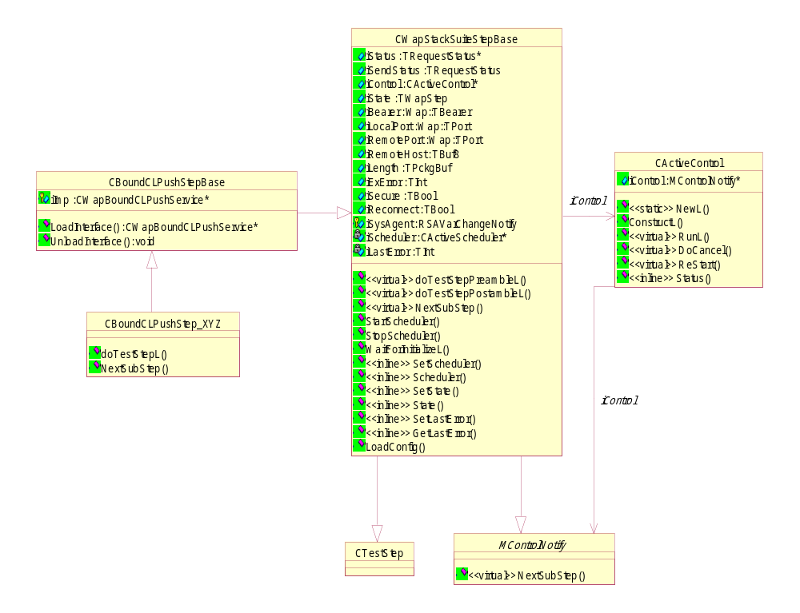
The shorten WAP stack (SWS) will be loaded and running in each test step (each step starts a thread), which tests the WAP message APIs. Since the SWS employs the derived class of CActive to implement the asynchronous requests to ESock, the test thread must instanciate and start the active scheduler. Also the User::WaitForRequest() can not be used to test the asynchronous WAP message APIs. To test the asynchronous WAP message APIs, CActiveControl, a derived class of CActive, is added in WapStacksuite test step.

For further information refer to “//EPOC/master/common/generic/tools/testexecute/documentation” in Perforce

