WAP Stack 8.0 Design Document

Security Classification: | <Internal>
Document Reference: | <SGL.GT0167.251>
Status: | <Issued>
Version: | <1.0>
Team/Department : | <Core/Networking>
Author(s): | <Vitaly Rodionov, Gongjun Cai, Kamran Nobari >
Owner(s): | Networking TA

Approver(s): |  | Distribution:

1 Introduction 3
1.1 Purpose and Scope 3
2 Overview 3
3 Design 3
3.1 Current WAP stack design overview 3
3.2 New WAP stack design overview 4
3.3 WAP Message API 4
3.3.1 WAP Message API Classes (INTERFACE) 4
3.3.2 WAP Message API Classes (IMPLEMENTATION) 5
3.4 Class Diagrams 6
3.5 Sequence diagrams 8
3.6 Connectionless WSP Protocol 12
3.6.1 Overview 12
3.6.2 Connectionless WSP PDU Type 12
3.6.3 Variable Length Unsigned Integers 12
3.6.4 WSP Header Encoding and Decoding 12
3.6.5 Connectionless WSP Protocol Instance 13
3.6.6 Class Definition 13
3.7 API 14
3.7.1 Bound WDP 14
3.7.2 Fully-Specified WDP 17
3.7.3 Bound Connectionless Push 19
3.7.4 Fully-Specified Connectionless Push 20
3.7.5 Bound Connectionless WSP 22
3.7.6 Fully-Specified Connectionless WSP 24
4 Further Information 25
4.1 People 25
4.2 References 25
4.3 Glossary 26
4.4 Document History 26
4.5 Document Review Date 26

Introduction

Purpose and Scope
The purpose of this document is to show the design for the WAP stack component in the Symbian OS 8.0 release.

Overview
The WAP stack in Symbian OS 7.0 is very expensive to maintain and keep up to date whilst browsing technologies have no use for WAP technologies at all. Licensees currently replace the modules when they require a full WAP stack. By providing a replacement "shortened" WAP stack, Symbian improves maintainability and provides better architecture and better support for connectionless WSP, Push and WDP. New WAP message API plug-in will remain BC with existing API and provide some extra functionality for connectionless WSP.

Design

Current WAP stack design overview
The following diagram shows the various levels of dependencies on the WAP Stack and the intermediate interfaces.
TRANSPORT FRAMEWORK
WSP Transport Handler
EAPI
WAP STACK
Wireless Datagram Protocol (WDP)
Wireless Session Protocol (WSP)
Wireless Transaction Protocol (WTP)
Wireless Transport Layer Security (WTLS)
ESOCK
HTTP Transport Handler
WAP Message API
ECOM PLUG-IN
WDP
PUSH
Client/Server
Client/Server
WAP PROT
SMS PROT

New WAP stack design overview
The following diagram shows architecture of new “shortened” WAP stack.
ESOCK
Client/Server
WAP Message API
ECOM PLUG-IN
WAP PROT
SMS PROT
WDP
PUSH
WSP
TRANSPORT FRAMEWORK
HTTP Transport Handler

WAP Message API
The WAP Message API is an ECOM Interface. (See [3] for more information on API) The WAP message API provides an abstraction of certain implementation of the WAP Stack. It supports interfaces for WDP and for Connectionless Push and WSP.

WAP Message API Classes (INTERFACE)

CwapBoundDatagramService
WAP Datagram API (Bound) interface.

CWapFullySpecDatagramService
WAP Datagram API (Fully specified) interface.

CWapBoundCLPushService
WAP Bound Connection-less Push API interface.

CWapFullySpecCLPushService
WAP Fully specified Connection-less Push API interface.

CWapBoundCLWSPService
WAP Bound Connection-less WSP API; API for S-Unit-MethodInvoke and S-Unit-MethodResult primitives; new interface and new implementation required

CWapFullySpecCLWSPService
WAP Fully specified connectionless WSP API; API for S-Unit-MethodInvoke and S-Unit-MethodResult primitives; new interface and new implementation required

WAP Message API Classes (IMPLEMENTATION)
The new interface implementation will provide all required services for WDP, connectionless WSP including Push.

CSWSWapBoundDatagramService
WAP Datagram API (Bound) implementation; existing interface with new implementation; implementation CWapBoundWDPService

CSWSWapFullySpecDatagramService
WAP Datagram API (Fully specified) implementation; existing interface with new implementation; interface CWapFullySpecWDPService

CSWSWapBoundPushService
WAP Bound Connection-less Push API implementation; existing interface with new implementation using WSP module; interface CWapBoundCLPushService

CSWSWapFullySpecPushService
WAP Fully specified Connection-less Push API; existing interface with new implementation using WSP module; implementation CWapFullySpecCLPushService

CSWSWapBoundWSPService
WAP Bound Connection-less WSP API; API for S-Unit-MethodInvoke and S-Unit-MethodResult primitives.

CSWSWapFullySpecWSPService
WAP Fully specified Connection-less WSP API implementation; API for S-Unit-MethodInvoke and S-Unit-MethodResult primitives.

Class Diagrams

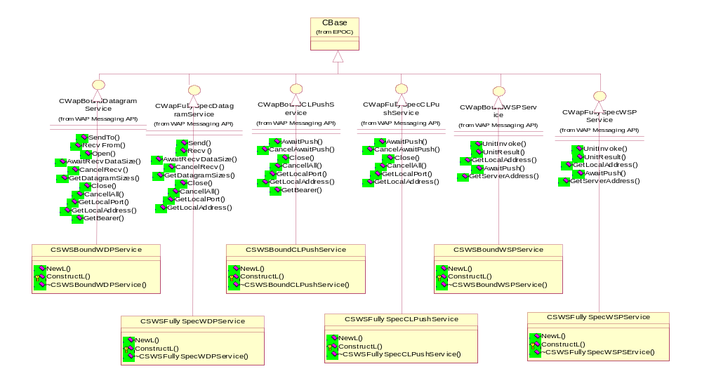

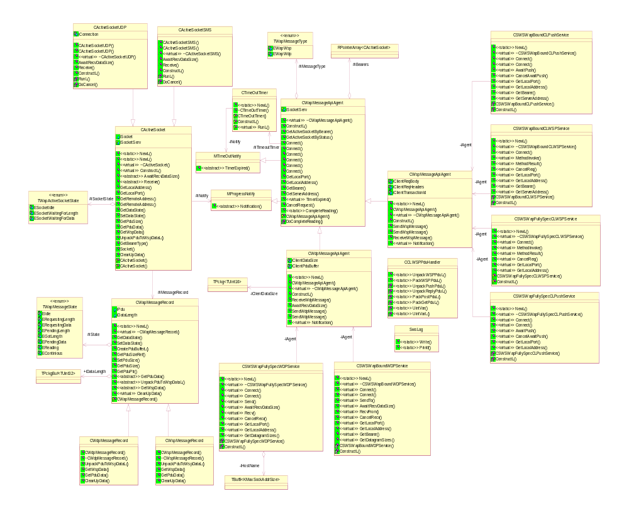

Sequence diagrams
MethodInvoke over SMS bearer: The following sequence diagram demonstrates the situation where a client calls MethodInvoke over SMS bearer using WSP service. The AwaitPush sequence diagram is almost identical to this diagram with minor differences.
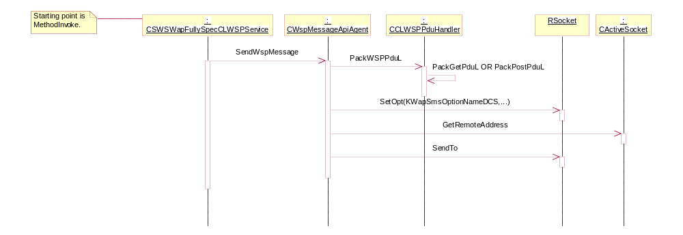

MethodInvoke over UDP bearer: The following sequence diagram demonstrates the situation where a client calls MethodInvoke over UDP bearer using WSP service. The AwaitPush sequence diagram is almost identical to this diagram with minor differences.

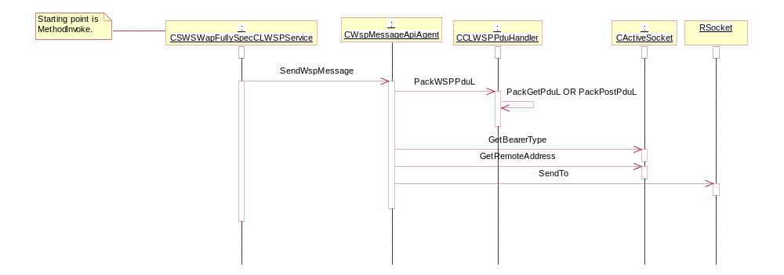

MethodResult over SMS bearer: The scenario where the client issues MethodResult after issuing MethodInvoke over SMS bearer using WSP service is demonstrated in the following sequence diagram. In this diagram it is assumed that the response of the MethodInvoke had been received from the server. Note that the Request status is completed at the end of the sequence diagram with the relevant error.
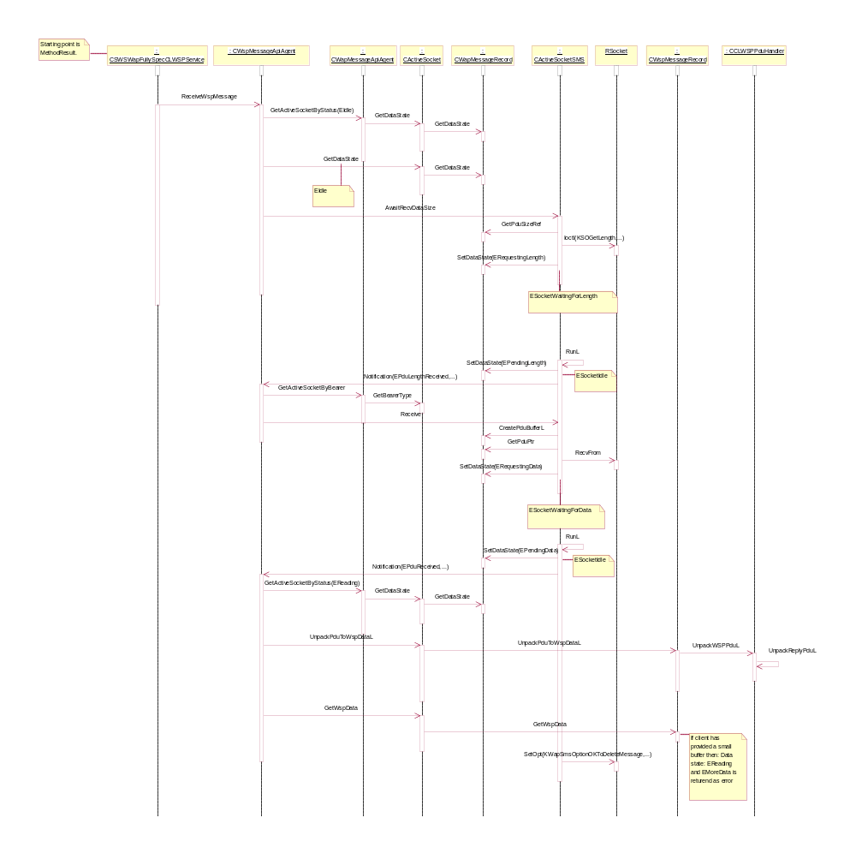

MethodResult over UDP bearer: The scenario where the client issues MethodResult after issuing MethodInvoke over UDP bearer using WSP service is demonstrated in the following sequence diagram. In this diagram it is assumed that the response of the MethodInvoke had been received from the server and the size of allocated buffer is enough to get the entire PDU from ESock. Note that the Request status is completed at the end of the sequence diagram with the relevant error.
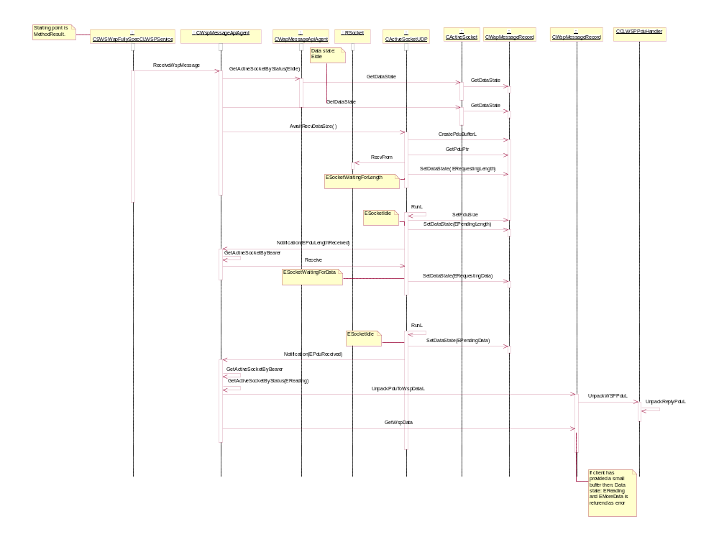

MethodResult over UDP bearer with more data in ESock: The scenario where the client issues MethodResult after issuing MethodInvoke over UDP bearer using WSP service is demonstrated in the following sequence diagram. In this diagram it is assumed that the response of the MethodInvoke had been received from the server and the size of allocated buffer is not enough to get the entire PDU from ESock and thus the buffer needs to be reallocated and a further read from ESock is required. Note that the Request status is completed at the end of the sequence diagram with the relevant error.
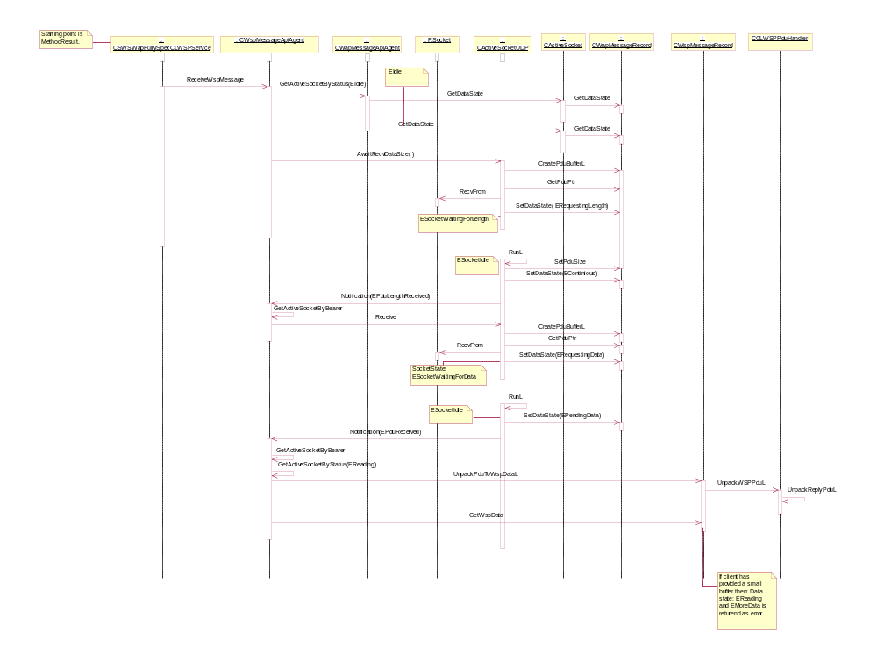

Second read by the client for getting more data: When the client’s buffer is not big enough to get the entire message, WAP Message API will return EMoreData(-5500) to indicate that there is more data. This can happen both over UDP or SMS bearer. Client can issue another MethodeResult to get the rest of the data. This situation is shown in the following sequence diagram.

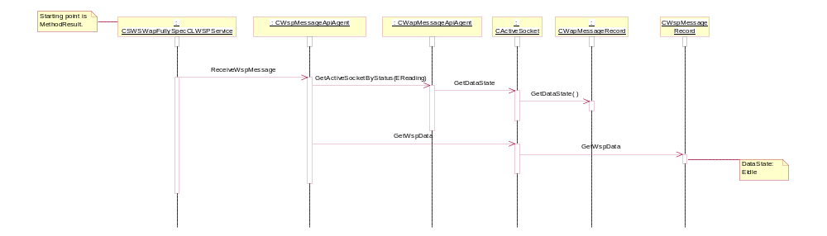

Connectionless WSP Protocol
This section describes the connectionless WSP protocol design in the new WAP stack. It includes the definition of the WSP PDU packing and unpacking interfaces to the WAP message APIs, and the manipulation of the WSP PDU.

Overview
The connectionless WSP protocol module locates between the WSP related WAP message APIs and Esock. It will pack the information data structures provided by connectionless WSP client into WSP PDU, and unpack the WSP PDU into the data structure expected by connectionless WSP client. The connectionless WSP protocol module only has interfaces to the WAP message APIs.

Connectionless WSP PDU Type
- Get PDU: Used for GET, OPTIONS, HEAD, DELETE and TRACE methods.
- Post PDU: Used for POST and PUT methods.
- Reply PDU: Generic response PDU to return information from the server in response to a request.
- Push PDU: Used for sending unsolicited information from the server to the client

Variable Length Unsigned Integers
Connectionless WSP protocol will translate the Uint32 to variable length Unsigned Integer when packing the WSP PDU, and translate the variable length Unsigned Integer to the Uint32 when unpacking the WSP PDU.

WSP Header Encoding and Decoding
WSP Header encoding and decoding are implemented by WSP client components, so no need to implement them in the WSP protocol.

Connectionless WSP Protocol Instance
WAP messaging APIs instances corresponds to the WSP clients, and communicate with the Esock server via WDP or UDP sockets. Connectionless WSP Protocol is a set of static functions to handle the WSP PDU.

Class Definition
Class CCLWSPPduHandler
{
public:
typedef TUint8 TWSPStatus;
Enum TWSPPduType
{
Ereply =0x04,
Epush =0x06,
Eget =0x40,
EgetOptions =0x41,
EgetHead =0x42,
Edelete =0x43,
Etrace =0x44,
Epost =0x60,
EpostPut =0x61
};
- The WSP PDU types need to be used in the connectionless WSP protocol.

static TInt UnpackWSPPdu(HBufC8* aWSPPdu, TWSPPduType& aType, HbufC8*& aWSPHeader, HbufC8*& aBody, TInt& aId, TWSPStatus& aStatus);

- The WAP message API instance call this function to unpack the WSP PDU, which might be push PDU or reply PDU.

Type | Name | Description
HbufC8* | AWSPPdu | (IN)the buffer contains the received WSP PDU.
TWSPPduType& | aType | (OUT)the WSP PDU Type.
HbufC8*& | AWSPHeader | (OUT)the buffer to contain the WSP header after unpacking.
HbufC8*& | Abody | (OUT)the buffer to contain the WSP data after unpacking.
TInt& | Aid | (OUT)the push id or transaction id
TWSPStatus& | Astatus | (OUT)the result code of reply PDU, not in use for push.
Return: TInt KErrNone on successful completion or one of the system errors codes on failure.

static TInt PackWSPPdu(HBufC8*& aWSPPdu, TWSPPduType aType, const TDesC& aURI, const TDesC8& aWSPHeader, const TDesC8& aBody, const TInt aId);

- The WAP message API instance calls this function to pack the WSP client input information into WSP PDU.

Type | Name | Description
HbufC8*& | AWSPPdu | (OUT)the buffer contains the WSP PDU to be sent.
TWSPPduType | Atype | (IN)the method that needs to be invoked in the server.
Const TDesC& | AURI | (IN)the buffer contains the URI.
Const TDesC8& | AWSPHeader | (IN) the buffer contains the WSP header.
Const TDesC8& | Abody | (IN) the buffer contains the WSP body.
Const TInt& | Aid | (IN) the transaction id.
Return: TInt KErrNone on successful completion or one of the system errors codes on failure.

Private:
Static TInt UnpackPushPdu(HBufC8* aWSPPdu, HBufC8*& aWSPHeader, HBufC8*& aBody, TInt& aId);
- The private method to unpack the WSP PUSH PDU.

Static TInt UnpackReplyPdu(HBufC8* aWSPPdu, HBufC8*& aWSPHeader, HBufC8*& aBody, TInt& aId, TWSPStatus& aStatus);
- The private method to unpack the WSP REPLY PDU.

Static TInt PackPostPdu(HBufC8*& aWSPPdu, const TDesC& aURI, const TDesC8& aBody, const TDesC8& aHeaders, const TInt aId);
- The private method to pack the WSP POST PDU.

Static TInt PackGetPdu(HBufC8*& aWSPPdu, const TDesC& aURI, const TDesC8& aHeaders, const TInt aId);
- The private method to pack the WSP GET PDU.
};

API

Bound WDP
class CwapBoundDatagramService
{
IMPORT_C static CWapBoundDatagramService* NewL();
IMPORT_C virtual ~CWapBoundDatagramService();

virtual TInt Connect(Wap::TBearer aBearer, Wap::TPort aPort,TInetAddr aInetAddr);
- Connect to the wapstack, opening an endpoint that can be used to listen for subsequent incoming datagrams. All WapBoundDatagramService implementations must automatically close this endpoint upon destruction. This overload of the Connect method allows an IP address associated with a network interface to be specified. In multihomed systems this can be used to specify which network interface the endpoint should be bound to.

Type | Name | Description
Wap::Tbearer | ABearer | (IN)The bearer to listen on (use EAll for all bearers)
Wap::Tport | APort | (IN) the port to listen on. If set to 0, a local port will be chosen for the client's first SendTo
TinetAddr | AInetAddr | (IN) the ip address of the network interface that should be used in a multihomed system.
Return: TInt KErrNone on successful completion or one of the system errors codes on failure.

virtual TInt Connect(Wap::TBearer aBearer, Wap::TPort aPort);
- Connect to the wapstack, opening an endpoint that can be used to listen for subsequent incoming datagrams. All WapBoundDatagramService implementations must automatically close this endpoint upon destruction.
Type | Name | Description
Wap::Tbearer | aBearer | (IN) The bearer to listen on (use Eall for all bearers)
Wap::Tport | aPort | (IN) the port to listen on. If set to 0, a local port will be chosen for the client's first SendTo
Return: TInt KErrNone on successful completion, or one of the system error codes on failure.

virtual TInt SendTo(const TDesC8& aRemoteHost, Wap::TPort aRemotePort, const TDesC8& aBuffer, Wap::TBearer aBearer);
- Send data to a remote endpoint.
Type | Name | Description
const TDesC8& | aRemoteHost | (IN) the bearer-dependent address of the remote host to which the data will be sent
Wap::TPort | aRemotePort | (IN) the port on the remote host to which the data will be sent
const TDesC8& | aBuffer | (IN) the data buffer to be written over the connection
Wap::TBearer | aBearer | (IN) the bearer to be used, if the bound connection was opened with 'all'
Return: TInt KErrNone on successful completion or one of the system errors codes on failure.

virtual TInt AwaitRecvDataSize(TPckg<TUint16>& aDataSizePckg, TRequestStatus& aReqStatus);
- Wait for a datagram to be received, and discover how large a buffer is required to retrieve it. This asynchronous method waits for a datagram to be received and will then completed allowing the client to discover how large a buffer is needed to retrieve the entire datagram that has been received. A subsequent call to RecvFrom with a buffer of sufficient size will then allow the client to retrieve the datagram fully.

Type | Name | Description
TPckg<TUint16>& | aDataSizePckg | (OUT) the size of data subsequently received, in bytes
TRequestStatus& | aReqStatus | (INOUT) used to signal when a data size is known
Return: TInt KErrNone on successful completion or one of the system errors codes on failure.

virtual TInt RecvFrom(TDes8& aRemoteHost, Wap::TPort& aRemotePort, TDes8& aBuffer, TBool& aTruncated, TRequestStatus& aReqStatus, TUint32 aTimeout);
- Receive data on a bound port. An asynchronous notification is sent to the client when data arrives.

Type | Name | Description
TDes8& | aRemoteHost | (OUT) the bearer-dependent address of the remote host from which the data was received
Wap::TPort& | aRemotePort | (OUT) the port on the remote host from which the data was received
TDes8& | aBuffer | (OUT) a client-allocated data buffer to be filled with data received. Data that overflows the buffer is discarded.
TBool& | aTruncated | (OUT) indicates whether the received datagram was truncated to fit in the client's supplied buffer
TRequestStatus& | aReqStatus | (INOUT) used to notify the client that a datagram was received
TUint32 | aTimeout | (IN) an optional millisecond time-out which allows a timed read to be made. If no data is received within the timeout period the request completes with KErrTimedOut. If a value of 0 is supplied the timeout is infinite.
Return: TInt KErrNone on successful completion or one of the system errors codes on failure.

virtual void CancelRecv();
- Cancel a previously requested asynchronous RecvFrom or AwaitRecvDataSize notification. If a datagram arrives at the local host, it will be discarded.

virtual TInt GetLocalPort(Wap::TPort& aPort);
- Get the local port of this endpoint. Useful if one was chosen automatically.

Type | Name | Description
Wap::TPort& | aPort | (OUT) the port number
Return: TInt KErrNone on successful completion or one of the system errors codes on failure.

virtual TInt GetLocalAddress(HBufC8*& aLocalHost);
- Get the local address of this endpoint.

Type | Name | Description
HBufC8*& | aLocalHost | (INOUT) the address of the local host. A reference to a HBufC8 pointer should be passed in. This pointer MUST be null! A HBufC8 will be allocated to hold the address, ownership of this buffer will be passed over to the client.
Return: TInt KErrNone on successful completion or one of the system errors codes on failure.

virtual TInt GetBearer(Wap::TBearer& aBearer);
- Get the bearer on which a received datagram arrived. Useful when EAll was specified in Connect()

Type | Name | Description
Wap::TBearer& | aBearer | (OUT) the bearer
Return: TInt KErrNone on successful completion or one of the system errors codes on failure.

virtual TInt GetDatagramSizes(TUint16& aMaxSize, TUint16& aNominalSize);
- Query the WDP bearer for its maximum datagram size and its nominal datagram size.

Type | Name | Description
TUint16& | aMaxSize | (OUT) the maximum datagram size
TUint16& | aNominalSize | (OUT) the nominal datagram size (nominal = size within which a datagram won't have to be split into smaller individual messages and then re-assembled at the other end). This will fail for a stream connection
Return: TInt KErrNone on successful completion or one of the system errors codes on failure.
}

Fully-Specified WDP
class CWapFullySpecDatagramService
{
IMPORT_C static CWapFullySpecDatagramService* NewL();
IMPORT_C virtual ~CWapFullySpecDatagramService();

virtual TInt Connect(const TDesC8& aRemoteHost, Wap::TPort aRemotePort, Wap::TBearer aBearer, TInetAddr aInetAddr);
- Connect to the wapstack, opening an endpoint which is to be used only with a single, named remote host. All WapBoundDatagramService implementations must automatically close this endpoint upon destruction. This overload of the Connect method allows an IP address associated with a network interface to be specified. In multihomed systems this can be used to specify which network interface the endpoint should be bound to.

Type | Name | Description
const TDesC8& | aRemoteHost | (IN) the bearer-dependent address of the remote host with which the data will be exchanged
Wap::TPort | aRemotePort | (IN) the port on the remote host to which data will be sent
Wap::TBearer | aBearer | (IN) the bearer to use (not EAll)
TInetAddr | aInetAddr | (in) the ip address of the network interface that should be used in a multihomed system
Return: TInt KErrNone on successful completion or one of the system errors codes on failure.

virtual TInt Connect(const TDesC8& aRemoteHost, Wap::TPort aRemotePort, Wap::TBearer aBearer);
- Connect to the wapstack, opening an endpoint which is to be used only with a single, named remote host. All WapBoundDatagramService implementations must automatically close this endpoint upon destruction. This overload of the Connect method allows an IP address associated with a network interface to be specified. In multihomed systems this can be used to specify which network interface the endpoint should be bound to.

Type | Name | Description
const TDesC8& | aRemoteHost | (IN) the bearer-dependent address of the remote host with which the data will be exchanged
Wap::TPort | aRemotePort | (IN) the port on the remote host to which data will be sent
Wap::TBearer | aBearer | (IN) the bearer to use (not EAll)
Return: TInt KErrNone on successful completion or one of the system errors codes on failure.

virtual TInt Send(const TDesC8& aBuffer);
- Send data on a fully specified connection.

Type | Name | Description
const TDesC8& | aBuffer | (IN) the data buffer to be written over the connection
Return: TInt KErrNone on successful completion or one of the system errors codes on failure.

virtual TInt AwaitRecvDataSize(TPckg<TUint16>& aDataSizePckg, TRequestStatus& aReqStatus);
- Wait for a datagram to be received, and discover how large a buffer is required to retrieve it. This asynchronous method waits for a datagram to be received and will then complete allowing the client to discover how large a buffer is needed to retrieve the entire datagram that has been received. A subsequent call to RecvFrom with a buffer of sufficient size will then allow the client to retrieve the datagram fully.

Type | Name | Description
TPckg<TUint16>& | aDataSizePckg | (OUT) the size of data subsequent ly received, in bytes
TrequestStatus& | aReqStatus | (INOUT) used to signal when a data size is known
Return: TInt KErrNone on successful completion, or one of the system error codes on failure.

virtual TInt Recv(TDes8& aBuffer, TBool& aTruncated, TRequestStatus& aReqStatus, TUint32 aTimeout);
- Receive data on a bound port. An asynchronous notification is sent to the client when data arrives.

Type | Name | Description
TDes8& | aBuffer | (OUT) a client-allocated data buffer to be filled with data received. Data that overflows the buffer is discarded.
TBool& | aTruncated | (OUT) indicates whether the received datagram was truncated to fit in the client's supplied buffer
TrequestStatus& | aReqStatus | (INOUT) used to notify the client that a datagram was received
TUint32 | aTimeout | (IN) an optional millisecond time-out which allows a timed read to be made. If no data is received within the timeout period the request completes with KErrTimedOut. If a value of 0 is supplied the timeout is infinite.
Return: TInt KErrNone on successful completion, or one of the system error codes on failure.

virtual void CancelRecv();
- Cancel a previously requested asynchronous Recv or AwaitRecvDataSize notification. If a datagram arrives at the local host, it will be discarded.

virtual TInt GetLocalPort(Wap::TPort& aPort);
- Get the local port of this endpoint. Useful if one was chosen automatically.

Type | Name | Description
Wap::TPort& | aPort | (OUT) the port number
Return: TInt KErrNone on successful completion or one of the system errors codes on failure.

virtual TInt GetLocalAddress(HBufC8*& aLocalHost);
- Get the local address of this endpoint.

Type | Name | Description
HBufC8*& | aLocalHost | (INOUT) the address of the local host. A reference to a HBufC8 pointer should be passed in. This pointer MUST be null. A HBufC8 will be allocated to hold the address ownership of this buffer will be passed over to the client
Return: TInt KErrNone on successful completion, or one of the system error codes on failure.

virtual TInt GetDatagramSizes(TUint16& aMaxSize, TUint16& aNominalSize)=0;
- Query the WDP bearer for its maximum datagram size and its nominal datagram size.

Type | Name | Description
TUint16& | aMaxSize | (OUT) the maximum datagram size
TUint16& | aNominalSize | (OUT) the nominal datagram size (nominal = size within which a datagram won't have to be split into smaller individual messages and then re-assembled at the other end). This will fail for a stream connection
Return: TInt KErrNone on successful completion or one of the system errors codes on failure.
}

Bound Connectionless Push
class CWapBoundCLPushService
{
IMPORT_C static CWapBoundCLPushService* NewL();
IMPORT_C virtual ~CWapBoundCLPushService();

virtual TInt Connect(Wap::TBearer aBearer, Wap::TPort aPort, TBool aSecure, TInetAddr aInetAddr);
- Opens a socket, which is to be used to listen for subsequent incoming Push messages from any sender; i.e. it has only been 'bound' to the local address. This overload of the Connect method allows an IP address associated with a network interface to be specified. In multihomed systems this can be used to specify which network interface the endpoint should be bound to.

Type | Name | Description
Wap::TBearer | aBearer | (IN) the bearer to listen on (use EAll for all bearers)
Wap::TPort | aPort | (IN) the port to listen on. If set to 0, a local port will be chosen for the client's first SendTo
TBool | aSecure | (IN) security flag indicates whether WTLS will be used or not
TInetAddr | aInetAddr | (IN) the address of the adapter to use
Return: TInt KErrNone on successful completion or one of the system errors codes on failure.

virtual TInt Connect(Wap::TBearer aBearer, Wap::TPort aPort, TBool aSecure);
- Opens a socket which is to be used to listen for subsequent incoming Push messages from any sender; i.e. it has only been 'bound' to the local address

Type | Name | Description
Wap::TBearer | aBearer | (in) the bearer to listen on (use EAll for all bearers)
Wap::TPort | aPort | (IN) the port to listen on. If set to 0, a local port will be chosen for the client's first SendTo
TBool | aSecure | (IN) security flag indicates whether WTLS will be used or not
Return: TInt KErrNone on successful completion or one of the system errors codes on failure.

virtual TInt AwaitPush(TDes8& aPushHeaders, TDes8& aPushBody, PckgBuf<TUint8>& aPushIdPckg, TRequestStatus& aReqStatus);
- Request an asynchronous notification upon arrival of the next push messages on the listening connection. The request completes upon receipt of the message, filling the buffers with as much received data as possible. A return code will indicate whether further data remains. The call must be re-issued for subsequent messages or to receive remaining data from a previous push message.

Type | Name | Description
TDes8& | aPushHeaders | (OUT) (client-allocated) - when a push message arrives the header data is written here
TDes8& | aPushBody | (OUT) (client-allocated) - when a push message arrives the body data is written here
PckgBuf<TUint8>& | aPushIdPckg | (OUT) when a push message arrives an integer ID that uniquely specifies the message is written here
TRequestStatus& | aReqStatus | (INOUT) used by the service provider to notify the client when a push has arrived. EmoreData is returned if more pushed data is available
Return: TInt KErrNone on successful completion or one of the system errors codes on failure.

virtual void CancelAwaitPush();
- Cancel a previously requested push message notification. If a push message arrives the client will not be notified.

virtual TInt GetLocalPort(Wap::TPort& aPort);
- Get the local port of this endpoint. Useful if one was chosen automatically.

Type | Name | Description
Wap::TPort& | aPort | (OUT) the port number
Return: TInt KErrNone on successful completion or one of the system errors codes on failure.

virtual TInt GetLocalAddress(HBufC8*& aLocalHost);
- Get the local address of this endpoint.

Type | Name | Description
HBufC8*& | aLocalHost | (INOUT) the address of the local host. A reference to a HBufC8 pointer should be passed in. This pointer MUST be null! A HBufC8 will be allocated to hold the address, ownership of this buffer will be passed over to the client
Return: TInt KErrNone on successful completion or one of the system errors codes on failure.

virtual TInt GetBearer(Wap::TBearer& aBearer);
- Get the bearer on which the push message arrived. Useful when EAll was specified in Connect()

Type | Name | Description
Wap::TBearer& | aBearer | (OUT) the bearer
Return: TInt KErrNone on successful completion or one of the system errors codes on failure.
}

Fully-Specified Connectionless Push
class CWapFullySpecCLPushService
{
IMPORT_C static CWapFullySpecCLPushService* NewL();
IMPORT_C virtual ~CWapFullySpecCLPushService();

virtual TInt Connect(const TDesC8& aRemoteHost, Wap::TPort aRemotePort, Wap::TBearer aBearer, TBool aSecure, TInetAddr aInetAddr);
- Opens a socket, which is to be used only with a single, named remote host. This overload of the Connect method allows an IP address associated with a network interface to be specified. In multihomed systems this can be used to specify which network interface the endpoint should be bound to.

Type | Name | Description
const TDesC8& | aRemoteHost | (IN) the bearer-dependent address of the remote host with which the data will be exchanged
Wap::TPort | aRemotePort | (IN) the port on the remote host to which data will be sent
Wap::TBearer | aBearer | (IN) the bearer to use (not EAll)
TBool | aSecure | (IN) security flag indicates whether WTLS will be used or not
TInetAddr | aInetAddr | (IN) the address of the adapter to use
Return: TInt KErrNone on successful completion or one of the system errors codes on failure.

virtual TInt Connect(const TDesC8& aRemoteHost, Wap::TPort aRemotePort, Wap::TBearer aBearer, TBool aSecure);
- Opens a socket which is to be used only with a single, named remote host.

Type | Name | Description
const TDesC8& | aRemoteHost | (IN) the bearer-dependent address of the remote host with which the data will be exchanged
Wap::TPort | aRemotePort | (IN) the port on the remote host to which data will be sent
Wap::TBearer | aBearer | (IN) the bearer to use (not EAll)
TBool | aSecure | (IN) security flag indicates whether WTLS will be used or not
Return: TInt KErrNone on successful completion or one of the system errors codes on failure.

virtual TInt AwaitPush(TDes8& aPushHeaders, TDes8& aPushBody, TPckgBuf<TUint8>& aPushIdPckg, TRequestStatus& aReqStatus);
- Request an asynchronous notification upon arrival of the next push messages on the listening connection. The request completes upon receipt of the message, filling the buffers with as much received data as possible. A return code will indicate whether further data remains. The call must be re-issued for subsequent messages or to receive remaining data from a previous push message.

Type | Name | Description
TDes8& | aPushHeaders | (OUT) (client-allocated) - when a push message arrives the header data is written here
TDes8& | aPushBody | (OUT) (client-allocated) - when a push message arrives the body data is written here
TPckgBuf<TUint8>& | aPushIdPckg | (OUT) when a push message arrives an integer ID that uniquely specifies the message is written here
TRequestStatus& | aReqStatus | (INOUT) used by the service provider to notify the client when a push has arrived
Return: TInt KErrNone on successful completion or one of the system errors codes on failure.

virtual void CancelAwaitPush();
- Cancel a previously requested push message notification. If a push message arrives the client will not be notified.

virtual TInt GetLocalPort(Wap::TPort& aPort);
- Get the local port of this endpoint. Useful if one was chosen automatically.

Type | Name | Description
Wap::TPort& | aPort | (OUT) the port number
Return: TInt KErrNone on successful completion or one of the system errors codes on failure

virtual TInt GetLocalAddress(HBufC8*& aLocalHost);
- Get the local address of this endpoint.

Type | Name | Description
HBufC8*& | aLocalHost | (INOUT) the address of the local host. A reference to a HBufC8 pointer should be passed in. This pointer MUST be null! A HbufC8 will be allocated to hold the address, ownership of this buffer will be passed over to the client.
Return: TInt KErrNone on successful completion or one of the system errors codes on failure.
}

Bound Connectionless WSP
class CWapBoundCLWSPService
{
IMPORT_C static CWapBoundCLWSPService* NewL();
IMPORT_C virtual ~CWapBoundCLWSPService();

virtual TInt Connect(Wap::TBearer aBearer, Wap::TPort aPort, TBool aSecure, TInetAddr aInetAddr);
- Opens a socket, which is to be used for S-Unit-MethodInvoke and S-Unit-MethodResult primitives; i.e. it has only been 'bound' to the local address. This overload of the Connect method allows an IP address associated with a network interface to be specified. In multihomed systems this can be used to specify which network interface the endpoint should be bound to.

Type | Name | Description
Wap::TBearer | aBearer | (IN) the bearer to listen on (use EAll for all bearers)
Wap::TPort | aPort | (IN) the port to listen on. If set to 0, a local port will be chosen for the client's first SendTo
TBool | aSecure | (IN) security flag indicates whether WTLS will be used or not
TInetAddr | aInetAddr | (IN) the address of the adapter to use
Return: TInt KErrNone on successful completion or one of the system errors codes on failure.

virtual TInt Connect(Wap::TBearer aBearer, Wap::TPort aPort, TBool aSecure);
- Opens a socket which is to be used to listen for subsequent incoming Push messages from any sender; i.e. it has only been 'bound' to the local address

Type | Name | Description
Wap::TBearer | aBearer | (in) the bearer to listen on (use EAll for all bearers)
Wap::TPort | aPort | (IN) the port to listen on. If set to 0, a local port will be chosen for the client's first SendTo
TBool | aSecure | (IN) security flag indicates whether WTLS will be used or not
Return: TInt KErrNone on successful completion or one of the system errors codes on failure.

virtual TInt MethodInvokeReq(TUint8 aMethod, const TDesC8& aURI, TDes8& aReqHeaders, TdesC8& aReqBody, TRequestStatus& aReqStatus);
- Request an asynchronous S-Unit-MethodInvoke primitive. A return code will indicate whether further data remains. The call must be re-issued for subsequent messages or to receive remaining data from a previous message.

Type | Name | Description
TUint8 | aMethod | (IN) method
const TdesC8& | aURI | (IN) resource
TDes8& | aReqHeaders | (OUT) (client-allocated) - when a push message arrives the header data is written here
TDes8& | aReqBody | (OUT) (client-allocated) - when a push message arrives the body data is written here
TRequestStatus& | aReqStatus | (INOUT) used by the service provider to notify the client when a push has arrived. EmoreData is returned if more pushed data is available
Return: TInt KErrNone on successful completion or one of the system errors codes on failure.

virtual TInt MethodResultRes(const TDes8& aAckHeaders, TRequestStatus& aReqStatus);
- Request an asynchronous S-Unit-MethodResult primitive.
Type | Name | Description
const TdesC8& | aAckHeaders | (IN) a buffer that contains the optional set of headers.
TRequestStatus& | aReqStatus | (INOUT) used by the service provider to notify the client when a push has arrived. EmoreData is returned if more pushed data is available
Return: TInt KErrNone on successful completion or one of the system errors codes on failure.

virtual TInt GetLocalPort(Wap::TPort& aPort);
- Get the local port of this endpoint. Useful if one was chosen automatically.

Type | Name | Description
Wap::TPort& | aPort | (OUT) the port number
Return: TInt KErrNone on successful completion or one of the system errors codes on failure.

virtual TInt GetLocalAddress(HBufC8*& aLocalHost);
- Get the local address of this endpoint.

Type | Name | Description
HBufC8*& | aLocalHost | (INOUT) the address of the local host. A reference to a HBufC8 pointer should be passed in. This pointer MUST be null! A HBufC8 will be allocated to hold the address, ownership of this buffer will be passed over to the client
Return: TInt KErrNone on successful completion or one of the system errors codes on failure.

virtual TInt GetBearer(Wap::TBearer& aBearer);
- Get the bearer on which the push message arrived. Useful when EAll was specified in Connect()

Type | Name | Description
Wap::TBearer& | aBearer | (OUT) the bearer
Return: TInt KErrNone on successful completion or one of the system errors codes on failure.
}

Fully-Specified Connectionless WSP
class CWapFullySpecCLWSPService
{
IMPORT_C static CWapFullySpecCLWSPService* NewL();
IMPORT_C virtual ~CWapFullySpecCLWSPService();

virtual TInt Connect(const TDesC8& aRemoteHost, Wap::TPort aRemotePort, Wap::TBearer aBearer, TBool aSecure, TInetAddr aInetAddr);
- Opens a socket, which is to be used only with a single, named remote host. This overload of the Connect method allows an IP address associated with a network interface to be specified. In multihomed systems this can be used to specify which network interface the endpoint should be bound to.
Type | Name | Description
const TDesC8& | aRemoteHost | (IN) the bearer-dependent address of the remote host with which the data will be exchanged
Wap::TPort | aRemotePort | (IN) the port on the remote host to which data will be sent
Wap::TBearer | aBearer | (IN) the bearer to use (not EAll)
TBool | aSecure | (IN) security flag indicates whether WTLS will be used or not
TInetAddr | aInetAddr | (IN) the address of the adapter to use
Return: TInt KErrNone on successful completion or one of the system errors codes on failure.

virtual TInt Connect(const TDesC8& aRemoteHost, Wap::TPort aRemotePort, Wap::TBearer aBearer, TBool aSecure);
- Opens a socket which is to be used only with a single, named remote host.

Type | Name | Description
const TDesC8& | aRemoteHost | (IN) the bearer-dependent address of the remote host with which the data will be exchanged
Wap::TPort | aRemotePort | (IN) the port on the remote host to which data will be sent
Wap::TBearer | aBearer | (IN) the bearer to use (not EAll)
TBool | aSecure | (IN) security flag indicates whether WTLS will be used or not
Return: TInt KErrNone on successful completion or one of the system errors codes on failure.

virtual TInt MethodInvokeReq(TUint8 aMethod, const TDesC8& aURI, TDes8& aReqHeaders, TdesC8& aReqBody, TRequestStatus& aReqStatus);
- Request an asynchronous S-Unit-MethodInvoke primitive. A return code will indicate whether further data remains. The call must be re-issued for subsequent messages or to receive remaining data from a previous message.

Type | Name | Description
TUint8 | aMethod | (IN) method
const TdesC8& | aURI | (IN) resource
TDes8& | aReqHeaders | (OUT) (client-allocated) - when a push message arrives the header data is written here
TDes8& | aReqBody | (OUT) (client-allocated) - when a push message arrives the body data is written here
TRequestStatus& | aReqStatus | (INOUT) used by the service provider to notify the client when a push has arrived. EmoreData is returned if more pushed data is available
Return: TInt KErrNone on successful completion or one of the system errors codes on failure.
virtual TInt MethodResultRes(const TDes8& aAckHeaders, TRequestStatus& aReqStatus);
- Request an asynchronous S-Unit-MethodResult primitive.

Type | Name | Description
const TdesC8& | aAckHeaders | (IN) a buffer that contains the optional set of headers.
TRequestStatus& | aReqStatus | (INOUT) used by the service provider to notify the client when a push has arrived. EmoreData is returned if more pushed data is available
Return: TInt KErrNone on successful completion or one of the system errors codes on failure.

virtual TInt GetLocalPort(Wap::TPort& aPort);
- Get the local port of this endpoint. Useful if one was chosen automatically.

Type | Name | Description
Wap::TPort& | aPort | (OUT) the port number
Return: TInt KErrNone on successful completion or one of the system errors codes on failure

virtual TInt GetLocalAddress(HBufC8*& aLocalHost);
- Get the local address of this endpoint.

Type | Name | Description
HBufC8*& | aLocalHost | (INOUT) the address of the local host. A reference to a HBufC8 pointer should be passed in. This pointer MUST be null! A HbufC8 will be allocated to hold the address, ownership of this buffer will be passed over to the client.
Return: TInt KErrNone on successful completion or one of the system errors codes on failure.
}

Further Information

People
Role | Person / People
Contributor(s) | Vitaly Rodionov, Gongjun Cai, Kamran Nobari
Reviewer(s) | Aleksander Antonic, Iain Campbell, Patrik Bannura

References
No. | Document reference | Version | Description
 | WAP-259-WDP-20010614-a | Version 14-Jun-2001 | WAP 2.0 - Wireless Datagram Protocol
 | WAP-230-WSP-20010705-a | Approved Version 5 July 2001 | WAP 2.0 – Wireless Session Protocol
 | WAP Messaging API  SGL.GT128.025 | 1.01 | \\londata04\psisoft\Dev\GT\GT Projects in Maintenance\GT 0128 Hurricane WAP\HTTP and WAP documents\SGL.GT0128.025 Rev1.01 Hurricane WAP Message API.doc
 | WAP Message API |  | \\londata04\psisoft\Dev\GT\GT Projects in Maintenance\GT 0128 Hurricane WAP\HTTP and WAP documents\Design Documents\WAP_Messaging_API.mdl

Glossary
The following technical terms and abbreviations are used within this document.
Term | Definition
WDP | Wireless Datagram Protocol
WPS | Wireless Protocol Stack
WCMP | Wireless Control Message Protocol
SAR | Segmentation and Re-Assembly
MTU | Maximum Transfer Unit
GSM | Global System for Mobile Communication
SMS | Short Message Service
GHOST | GSM Hosted SMS Teleservice
USSD | Unstructured Supplementary Service Data
GUTS | General UDP Transport Service
R-Data | Relay Data
CDMA | Code Division Multiple Access
Tetra | Terrestrial Trunked Radio
SDS | Short Data Service

Document History
Date | Version | Status | Description
02/05/2003 | 0.1 | Draft | First draft
10/12/2003 | 0.3 | Draft | Addition of class and sequence diagrams
12/12/2003 | 1.0 | Issued

Document Review Date
Friday 6/6/2003 (Formal)
Friday 12/12/2003 (Informal)

