1 Introduction 3
1.1 Purpose and Scope 3
1.2 Terminology 3
2 FAQ 3
2.1 Building Blocks (Elements) 3
2.1.1 What kind of plans, if any, does Symbian have to develop very simple method-based APIs for being able to hook customisations to the mesh machine? This type of APIs would greatly benefit the Symbian licensees, because the mesh machine functionality is hard to understand and more or less out of scope of the Symbian’s licensee’s business. 3
2.1.2 What kind of restrictions, if any, there are for replacing parts of /networking and /comms-infras when it comes to building and running the code. 4
2.1.3 What is Mesh Machine 5
2.1.4 What is an Activity 7
2.1.5 What is an Activity Map 10
2.1.6 How does the Mesh Machine represent node relationships – RNodeInterface 11
2.1.7 What is Activity Object – CCFNodeActivityBase. 12
2.1.8 What is Activity Context 13
2.1.9 Error handling in Mesh Machine 13
2.1.10 Custom tuple elements 13
2.2 Concrete Implementations (Specific Nodes, Specific Activities) 13
2.2.1 Can an MCpr monitor the connection setup? 13
2.2.2 Application joins, leaves, starts or stops a connection. Does the meta plane (e.g.: MCpr) know about it? 14
2.2.3 If access point goes down, Network MCpr gets TProviderStatusChange, right? 14
2.2.4 If only IPProto MCpr is informed when the IPProto AP (IAP) goes down, then how Network MCpr gets the information of the IAP going down? 14
2.3 Building the code 14
2.4 Configuration (Stack Selection) 14
2.4.1 What is the exact purpose of BearerTypeTable in CommsDat? 14
2.4.2 Is it possible to convert a legacy IAP to an Access Point and vice versa? 14
2.5 Running the code 15
2.6 Documentation 15
2.7 Bearer Availability and Mobility 15
2.7.1 After application has completed its 4-way Mobility API handshake, TCfMessage::TMigrationAccepted is received by Network MCpr. How Network MCpr can determine a) what is the IAP that was started, b) what is the application UID of the client? 15
2.8 Performance 15
2.8.1 Setting up a simple connection involves lots of operations such as more than 100 messages to be passed. Are there any studies available on performance? 15
2.8.2 How much a single message passing transaction takes CPU time? 16
2.8.3 How efficient memory allocation scheme is used? 16
2.8.4 Will the control path (e.g., starting of a connection, be faster or slower than with the legacy architecture? 16
2.8.5 What is approximate time for RConnection::Start()? 16
3 Further Information 17
3.1 People 17
3.2 References 17
3.3 Document History 17

Introduction

Purpose and Scope
This document presents answers to the frequently asked questions captured against the Symbian’s Comms Architecture from release 9.5. This document is a companion to [R1] and [R2].

Terminology

Access Point
An Access Point is a layer in the comms stack that gives access to a remote service.

Bearer
Bearer is a general term for a data traffic carrier
Typically it describes a data carrying service and its associated technology at level 2 of the ISO/OSI network reference model that enables a network terminal/node to exchange data with another terminal/node. Example layer 2 bearers are:
- UMTS packet switched data carrier service as provided by an UMTS operator;
- Ethernet link;
- WiFi link;
In the Comms Framework, bearer is also used as a general term for ‘the layer below this Access Point’ meaning more generally ‘the carrier for the service represented by this Access Point’. When used in this way, bearer does not necessarily refer to a layer 2 protocol.

FAQ

Building Blocks (Elements)

What kind of plans, if any, does Symbian have to develop very simple method-based APIs for being able to hook customisations to the mesh machine? This type of APIs would greatly benefit the Symbian licensees, because the mesh machine functionality is hard to understand and more or less out of scope of the Symbian’s licensee’s business.
We don’t have any plans for any different APIs.
Communication between nodes must be asynchronous to avoid deadlock between threads. This is why the architecture uses message passing. The API of any node is a simple function that receives messages (ReceiveL). A node will receive a certain series of messages in a certain order and this forms the full API of the node within the stack. In addition, an implicit responsibility for any node is that it must respond to any messages received in a standard way in order to keep the overall state machine in the stack running properly.
So the important interface for any node is the ordered message exchange between peer nodes, not really the mesh state machine itself. It would be quite possible for licensees to write their own MCpr without using the mesh machine, as long as the implementation obeyed the general rules of the overall state machine in the stack and exchanged messages with its peers in an orderly fashion.
However, since the mesh machine offers a ready-made state machine implementation and the boiler plate code in each node already implements standard routines in the stack such as start up, shutdown and error handling, we propose that it would be more efficient and would save development time to use the mesh machine and the standard code as much as possible, writing new activities to customise a node and extending existing activities to perform extra functions where necessary.
We are aware from in-house users (WiFi and multimedia protocol engineers in other teams) that there is a significant learning curve for understanding the boiler plate code on the control side of the stack. However, as the operation of the stack is extremely logical and methodical and very repetitive, we have observed that engineers can work well with the code once they have got over this initial learning curve.
We realise how very important it is for engineers to be able to modify and extend the stack with ease, but we think that good organisation of mesh machine activities and good documentation will allow this to happen.
Documentation and in-code is not yet complete and this is currently a barrier for new developers
We will continue to discuss with all users in Symbian and licensees to check that documentation is good once it has been provided and to see if core node activities can be reorganised in any useful ways.

What kind of restrictions, if any, there are for replacing parts of /networking and /comms-infras when it comes to building and running the code.
Various files will clash between releases. e.g. a single .cmi file pre-PREQ399 has been replaced by multiple .cmi files (with different names) post-PREQ399. If all these files coexist there will be problems.
So performing a abld reallyclean on your existing pre-PREQ399 versions of /networking and /comms-infras components will ensure that when you build the new source the networking environment will be clean.
Also it will be necessary to replace the /ser-comms folder (and /bluetooth if you need it) as the PREQ-399 project has touched this

Further things to be aware of: before you build the new code, ensure your \epoc32\include\variant\Symbian_OS_vxxx.hrh file contains the line:
#define SYMBIAN_NON_SEAMLESS_NETWORK_BEARER_MOBILITY
This switches on the PREQ399 functionality.

Also, if your test environment requires shutdown of the comms process (for, say, leak testing), you will need to ensure the line “Testmode=1” is present in your
EPOC32\RELEASE\WINSCW\UDEB\z\private\101f7988\c32start.ini file.
This and other things to look out for are in the Esock HowTo document.

What is Mesh Machine
The name “Mesh Machine” originated from the observation that Comms Framework providers cooperating on different planes (data/control/management) and layers (stacked on each other) form a “mesh of nodes”.
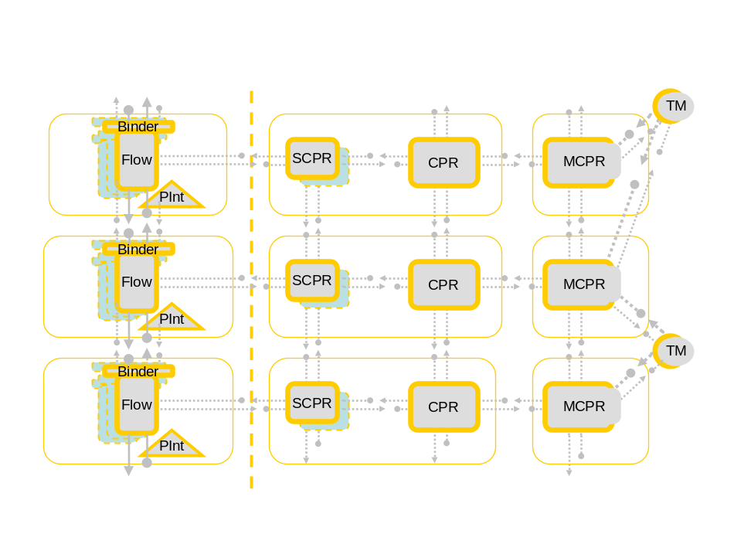
Figure 1 - mesh of nodes
It should be fairly obvious that a node wishing to run in this setup needs to be aware of its role, of its peers and of their roles. The nodes, especially ones on the management and control planes have (quite empirically) proven very complex. For example they would have nontrivial interactions with several other nodes at the same time. To support this multiple-state handling using procedural programming (e.g.: switch statements) rendered unreadable and un-maintainable code. It has then made it obvious that the complexity needs some form of formalization and higher level logic.
This is how the Mesh Machine was born. Concepts and ideas behind it are described in its own documents (“Mesh Machine Fundamentals”).
Mesh Machine facilitates simple implementations of complex interactions between nodes. It separated all of the common functionality related to processing events and responding to requests into a separated library so that only the very specific code needs to be provided by the node.
This specific code provided by nodes include definitions of so called activities (which are themselves state machines) and their building blocks – states, transitions and state forks.
The Mesh Machine, on the other hand, knows how to make all of that run in the context of the node.
The following class diagram illustrates the Comms Framework entities related to the MeshMachine. The sections following describe the entities depicted.
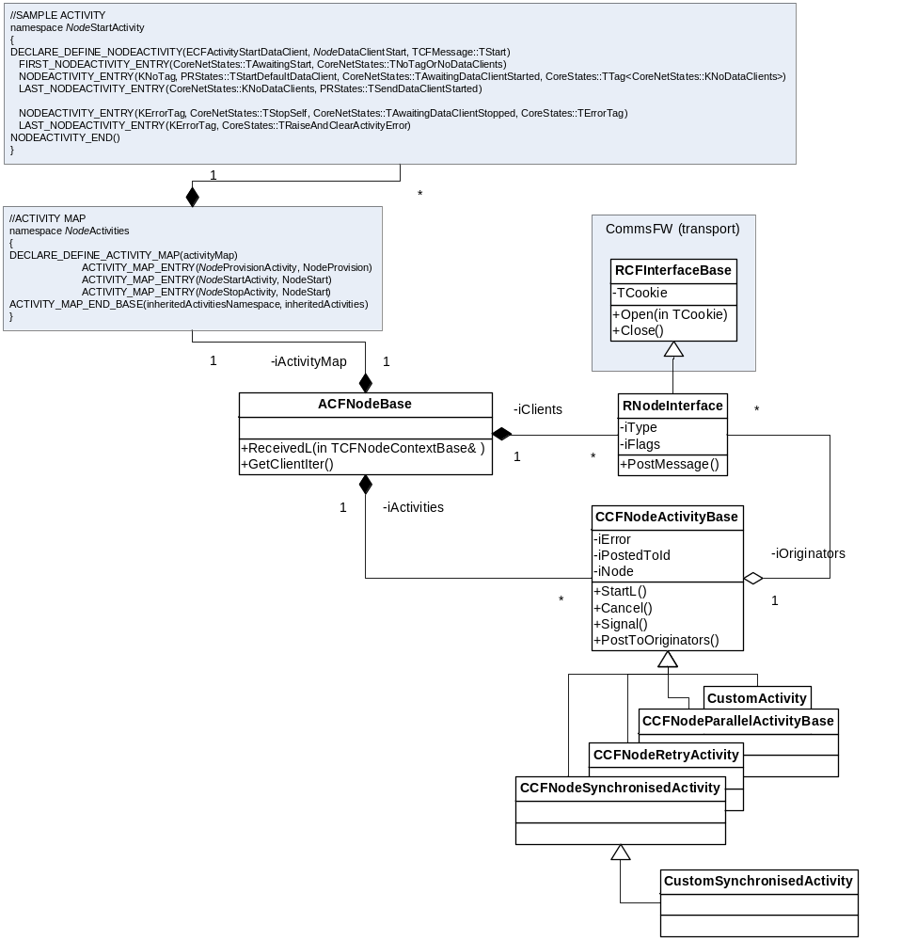
Figure 2 - MeshMachine - class diagram

What is an Activity
An activity is a MeshMachine concept representing the action that (mandated by the protocol) should follow the reception of a Comms Framework message [Error: Reference source not found]. Each Mesh Machine node has an activity map (ACFNodeBase::iActivityMap) listing all the activities the node is capable of executing. At any time a Mesh Machine node can have a number of activities in execution (ACFNodeBase::iActivities). On message reception the Mesh Machine scans the map [2.1.5], locates the activity matching the message and instantiates it (the instance represents the activity ‘in execution’).
For example: a “DataClientStartActivity” responds to TDataClientStart and is responsible for starting the layer (whatever the recipient thinks ‘start’ stands for at its level). As TDataClientStart is conceptually equivalent to a (C++) method name, “DataClientStartActivity” is conceptually equivalent to the method body. An activity is a state machine and can always be represented as one using a one of the standard state diagrams notation, for instance:
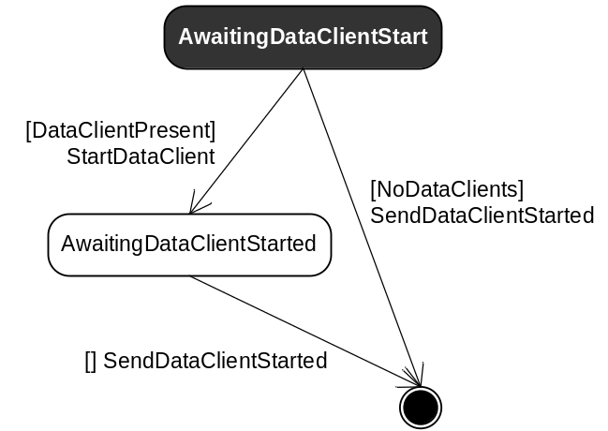
Figure 3 - TDataClientStart state machine
Being typically executed in the following circumstances:
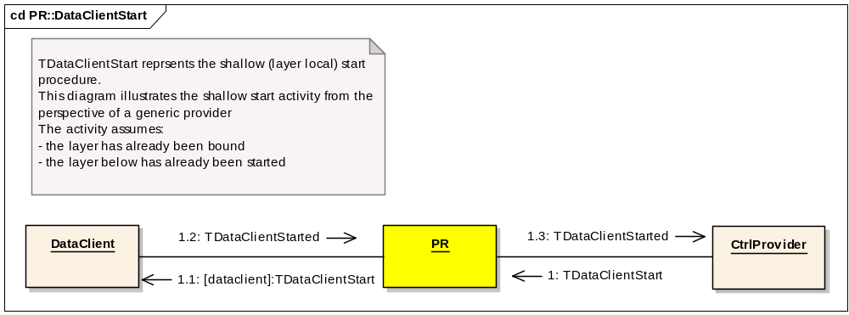
Figure 4 - TDataClientStart collaboration diagram
Can be put as the following code construct:
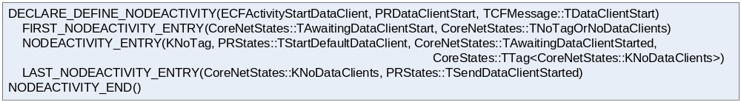
Figure 5 - TDataClientStart activity implementation
Which in prose means: the activity is triggered by TDataClientStart. If the node (running the activity) has a dataclient, the activity sends TDataClientStart to it. Subsequently, or if there are no dataclients, the activity responds TDataClientStared to the requestor.

Activity building blocks
Syntactically an activity definition is thought to reflect a state machine responding to a Comms Framework messages (messages trigger state change). This definition is an ordered list of activity tuples, each embodying a subset of:
- tag – an integer identifying the tuple.
- transition – the action associated with the tuple.
- state – state change trigger awaiting an event (i.e.: a Comms Framework message).
- fork – next tuple choice (calculates the next state).
From the implementation perspective, the tuple elements are respectively represented by:
class MStateTransition
{
protected:
virtual void DoL() = 0;
virtual void Error( TInt aError ) = 0;
};

class MState
{
protected:
virtual TBool Accept() = 0;
virtual void Cancel() = 0;
};

class MStateFork
{
protected:
virtual TInt TransitionTag() = 0;
};

Every activity at any time (in-execution or not) has a conceptual execution pointer pointing at a state in one of its tuples (it’s always the first tuple for activities not in-execution). We say that the activity is in the state of awaiting a specific message.
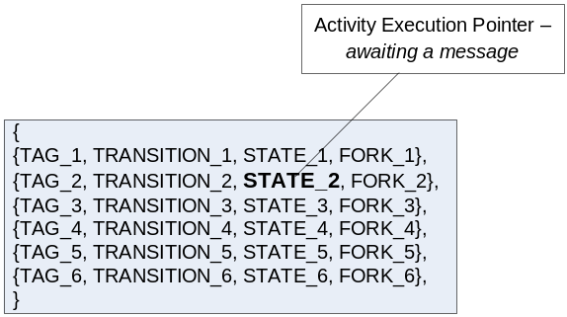

Upon message reception the Mesh Machine consults each activity (those in execution first) on whether it wants to accept the message (calling MState::Accept() at its respective execution pointer). The first activity accepting the message consumes the message. Following the acceptance the Mesh Machine asks the activity to calculate the next tuple calling MStateFork::TransitionTag().It then traverses the tuple list to find the first tag matching the product of MStateFork::TransitionTag():
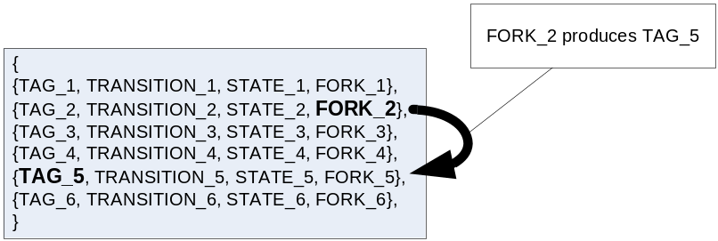
The mesh machine then changes the execution pointer to the found tuple, performs the transition (calling MStateTransition::DoL()) and starts to await the next Comms Framework message:
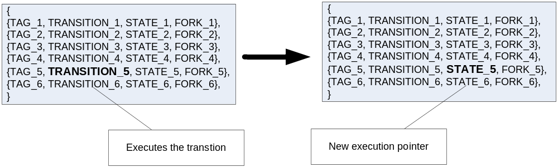
There are essentially four types of tuples:
- first tuple – always the first tuple in an activity and the one that decides whether to put the activity into execution. The first state tuple has no tag (identity) nor transition. It has no tag, because one cannot traverse back to the first state. It has no transition for the same reason, that is, if one cannot enter the first state, one cannot execute the transition associated with that state.
- last tuple – the exiting tuple, i.e.: the tuple termininating the activity. The last activity tuple has no state nor fork. It has no state, because there’s nothing the activty will await for after executing the transition. It has no fork, as there is no further state it will transition to. Note that there can be many last activity tuples (many exit points).
- state tuple – a tuple featuring all the activity elements.
- through tuple – a tuple that has no state. As a matter of convention (code reusability) we implement tarnsitions as atomic actions. It’s easy to imagine that an activity needs to respond to a message executing complex (non-atomic) functionalty. Using through activity tuples allows to easily and visibly aggregate (atomic) transitions. I.e.: after executing the transition associated with a through tuple, the mesh machine doesn’t wait for a message (no state), instead, it immediatelly (same call stack) executes the fork and traverses to the next tuple.
Following notation is probably more representative of a typical activity:

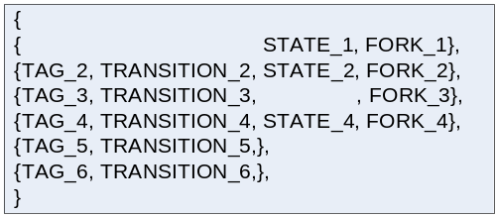
From the implementation perspective, an activity is an array of structures (tuples) holding pointers to MStateTransition, MState and MStateForks constructors.

Formal (BNF) description of the activity syntax.
This section presents the formal description of the MeshMachine activity syntax.
<activity>::=<activity declaration>
<activity body>
<activity closing tag>

<activity declaration>::=
DECLARE_DEFINE_NODEACTIVITY(id, debugtag, kickoff) |
DECLARE_DEFINE_CUSTOM_NODEACTIVITY( id, debugtag, kickoff, activity_ctor ) |
DEFINE_EXPORT_NODEACTIVITY(id, debugtag, kickoff) |
DEFINE_EXPORT_CUSTOM_NODEACTIVITY(id, debugtag, kickoff, activity_ctor) |
DEFINE_NODEACTIVITY(id, debugtag, kickoff)

<activity closing tag>::=NODEACTIVITY_END()

<activity body>::=<single_shot_activity_body>|<full_activity_body>
<single_shot_activity_body>::=<state_tuple>
<full_activity_body>::=<first_tuple>{<body_tuple>}<last_tuple>
<body_tuple>::=<state_tuple>|<through_tuple>

<first_tuple>::=
FIRST_NODEACTIVITY_ENTRY(state, fork)
<last_tuple>::=
LAST_NODEACTIVITY_ENTRY(tag, transition)
<state_tuple>::=
NODEACTIVITY_ENTRY(tag, transition, state, fork)
<through_tuple>::=
THROUGH_NODEACTIVITY_ENTRY(tag, transition, fork)

Finite elements:
- state – as defined in [2.1.4.1].
- fork – as defined in [2.1.4.1].
- transition – as defined in [2.1.4.1].
- tag – as defined in [2.1.4.1].
- id – activity id, integer identifying the activity type (for instance start activity responding to TStart message).
- debugtag – the tag logged by CommsDebugUtility marking the activity execution in runtime.
- kickoff – the kick-off message. The message this activity responds to (is triggered by). Note that indeed the concept of the kickoff message appears redundant with the concept of the first activity tuple, whose state has to accept the kick-off message.
- activity_ctor – the pointer to the NewL method returning a CCFNodeActivityBase [2.1.7] (typically its custom subclass) object. The activity declarations missing this item use the default, i.e.: CCFNodeActivityBase::NewL.

What is an Activity Map
Each mesh-machine based node holds an activity map, which in turn contains the list of activities [2.1.4] the node is capable of executing. The list is ordered and the order is meaningful, i.e.: On message reception the Mesh Machine scans the activity map top-down and the first activity accepting the message, consumes it.
And interesting and practical property of an activity map is that it can inherit an external activity map: ACTIVITY_MAP_END_BASE(inheritedActivityNamespace, inheritedActivityName)

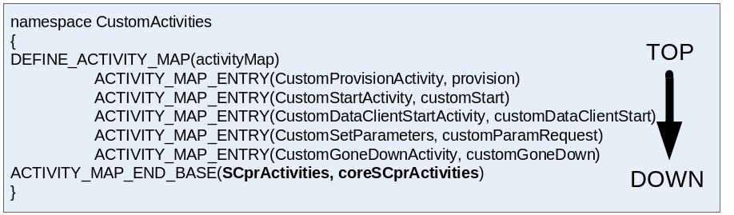
Figure 6 – An example activity map and the scan order.
These two properties of an activity map (order and inheritance) enables OO-like polymorphism, as one can override activities inherited from elsewhere.

How does the Mesh Machine represent node relationships – RNodeInterface
The Mesh Machine defines a node in the mesh as ACFNodeBase. It also ensures that the node knows its immediate peers representing references to them as RNodeInterfaces objects and storing them as iClients.
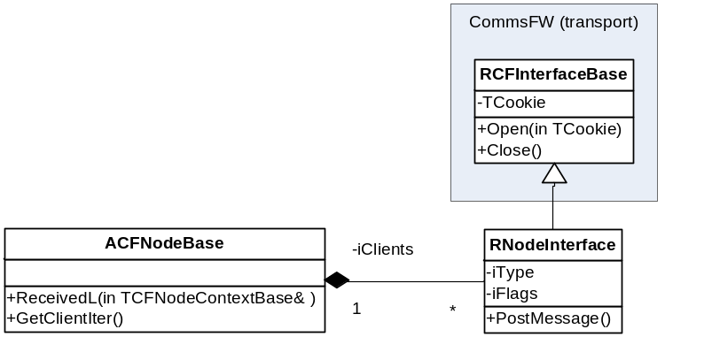
Figure 7 – Inter-node relationships
RNodeInterface object stores the reference to a peer, its role (the conceptual interface it implements) [Error: Reference source not found] and its state. Comms Framework defines the following states for the nodes:
- EActivating - Given away at least one handle to this client and awaiting TBindToComplete to clear.
- EActive – Received TDataClientActive from the client, meaning it’s not idle and can’t be destroy until this flag is cleared by TDataClientIdle.
- EStarting - The peer has been issued with TStart or TDataClientStart – cleared by the response.
- EStarted - The client has responded with TStarted or TDataClientStarted (cleared by TStopped or TDataClientStopped).
- ELeaving - Awaiting for the client to leave (usually after sending TDestroy). This flag never clears.
- EJoining - The client has been prepared to be added and awaiting TApply to be formally joined.
It’s easy to notice that the state information stored against peers is tightly related to the roles [Error: Reference source not found] these peers play.
There are two ways nodes learn about each other:
- TDataClientJoined – the dataclient requested by the node has been created and says hello.
- TDataClientJoinRequest, TCtrlClientJoinRequest: one node asks another node to accept it as a peer. The sender advertises the role it wishes to play with the message type.

Equally, there are two ways nodes forget about each other:
- TClientLeaving – the client responds to TDestroy.
- TClientLeavingRequest: a node requests no to be a client anymore.
Naturally a Mesh-Machine node can iterate through its clients, inspect and change their states.
Please note that the state information stored in an RNodeInterface object is what the owner knows about the referred node solely by inspecting the message exchange. This knowledge doesn’t necessarily reflect the peer’s objective state.
RNodeInterface can be freely overridden to store custom state information if needs to. For instance the IP transport overrides it to store the IP address information against each of its flows.

What is Activity Object – CCFNodeActivityBase.
CCFNodeActivityBase is the default implementation of the Comms Framework Activity class, i.e.: the class instantiated each time an activity [2.1.4] accepts its first message (going into execution) and destroyed when the activity terminates. An activity object represents and stores the state of an activity in execution.
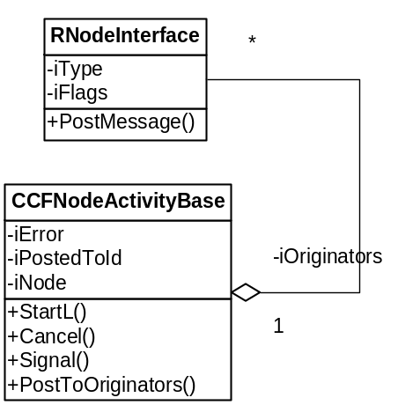
The most important concepts implemented by this default activity class are:

Originators
An originator is the sender of the message (request) that has triggered the activity. It’s also the node awaiting a response. Originators are represented as references to the node’s peers (i.e.: an originator has to be peer) [2.1.6].
In general an activity can have multiple originators, i.e.: multiple requestors of the same functionality. For instance, although there can be multiple nodes simultaneously requesting a provider to perform TStart [Error: Reference source not found] the provider should perform TStart only once and acknowledge the result to each requestor (originator). Clearly there are activities that need to repeat the action per each originator and those should use CCFNodeParallelActivityBase.
In special case an activity can have no originator at all. This is only allowed during implicit cancel [2.1.7.5].

Mode of operation
Mode of operation in this context translates into activities running normal or error/cleanup mode. One switches the activity into error mode by calling ::SetError(). More details in error handling [2.1.9].

Last request buffer
For the cancel –abilty [2.1.7.5] and message filtering purposes each activity monitors requests sent from it. It does that by storing the address (TCommsId) of the node the request has been sent to. On message reception the Mesh Machine will forward the message (call ::Accept) only to the activities whose id and last request address matches those carried by the message. When working with activities, notably when sending requests from them, it is very important to use CCFNodeActivityBase::PostRequestTo() or to manually clear the last request buffer, otherwise the response may go astray.

Synchronisation with other activities
Some activities are mutually exclusive (e.g.: a node cannot conceivably service TStart and TStop both at the same time). The typical way of handling this is to wait for the conflicting activity to terminate. An activity can be parked on a (custom) mutex condition and wait for that condition to clear. Each time an activity terminates, Mesh Machine will ::Signal all activities in execution so they can revaluate their mutexes and perhaps decide to resume. Only CCFNodeSynchronisedActivity can be parked.

Cancel –ability
Some activities can be cancelled, some can’t. For instance, once an e-mail has been sent, it can’t be unsent. Activities that cannot be cancelled should be implemented to panic each time somebody attempts to cancel them. The Mesh Machine will assume every activity is cancellable and hence every activity will be subject to the handling described in this section.
An activity can be cancelled in one of the two ways:
- Explicitly – when one of the originators sends TCancel addressed to this activity (activity id carried by TCancel matches the activity id carried by the request being cancelled).
- Implicitly – one of the originators leaves without waiting for the activity to finish.
If there is at least one more originator except the one requesting cancellation, the activity will only give the impression of being cancelled (to the originator expecting it) and will proceed as normal.
In the explicit scenario, the generic cancelling behaviour only kicks in after all the activities (in execution) have refused to accept TCancel. Consequently, if an activity wishes to implement custom handling of TCancel, it should accept it. After this the implicit and explicit cancellation paths are the same, i.e.: the Mesh Machine finds the activity being cancelled and calls ::Cancel on it. CCFNodeActivityBase implements ::Cancel by:
- Sending TCancel to the node stored in the last request buffer [2.1.7.3] so that any potential request this activity is awaiting for will be automatically cancelled.
- Switching into the error/cleanup mode [2.1.7.2]. From here on the activity is simply a subject to error handling [2.1.9]. From this point onwards it is irrelevant whether the activity has encountered an error or whether it’s been cancelled.

What is Activity Context

Error handling in Mesh Machine

Custom tuple elements

Concrete Implementations (Specific Nodes, Specific Activities)

Can an MCpr monitor the connection setup?
Yes. The MCpr manages its layer. It receives progress notifications and errors related to connection setup.
It will also act on error recovery requests coming from the Cpr and subsequently order the Cpr to retry or propagate the error. This feature can be extended with custom decision making algorithms by licensees.

Application joins, leaves, starts or stops a connection. Does the meta plane (e.g.: MCpr) know about it?
Yes, the MCpr does know. The MCpr is the only point of contact for any node to ask about an existing or non-existent Cpr. The MCpr also receives all the necessary progress notification to determine the state of the Cpr at any point in time.

If access point goes down, Network MCpr gets TProviderStatusChange, right?
Yes. When the connection goes down, the Cpr sends TGoneDown to its Control Clients and TProviderStatusChange to the Control Provider (MCpr).

If only IPProto MCpr is informed when the IPProto AP (IAP) goes down, then how Network MCpr gets the information of the IAP going down?
Before any access point can go down, on any layer of the stack, it requests error recovery from the MCpr representing it. Only after the MCpr responds (with EPropagate == no recovery) the connection can go down. The Network MCpr will be asked for error recovery by the Network Cpr as soon as the currently active IPProto AP goes down.
(The Network MCpr can recover its connection when there are other IPProto APs which it can use to provide the service, in which case the Network layer access point will stay up and running)

Building the code

Configuration (Stack Selection)

What is the exact purpose of BearerTypeTable in CommsDat?
The only purpose of the BearerTypeTable is to provide mapping of IAPs (used for example in legacy CED config files) into Access Points. The BearerTypeTable contains identifiers for libraries to use for any particular bearer or service type along with information about the next layer (which will always be the bearer layer).
The BearerTypeTable should not need provisioning over the air or public access, so it is published partner (NB beta version of 399 does not yet specify this). The table must be fully populated in the default comms database installed at ROM build time.

Is it possible to convert a legacy IAP to an Access Point and vice versa?
Yes.
IAPs are traditionally referred to by their RecordId, which will be an integer less than 254. Legacy applications may continue to us IAP Record Ids when interacting with the Comms Server. It may be necessary to convert this information into a corresponding AP for some activities within the stack or within licensee code.
CommsDat creates an Access Point for every IAP that is entered. This AP represents the single non-mobile layer in the stack that uses just that IAP and cannot use any other service or bearer. There will be a one to one mapping between an IAP and its corresponding non-mobile AP.
When a CommsDat client stores a new IAP, CommsDat generates a corresponding non-mobile AP for it automatically. To do this, CommsDat uses the data in the BearerTypeTable to construct an AP that will load libraries suitable for the IAP’s bearer and service type.
When an IAP is deleted, this corresponding AP is also deleted automatically by CommsDat.

Converting between an IAP and its corresponding AP
To ‘convert’ from an IAP Record Id to an AP Record Id you need to perform a CommsDat FindL on an AP record container to find the non-mobile AP that refers to that IAP record id in its iTag field.
The iTag field in a non-mobile AP will be an integer of this form <TABLEID>|<RECORDID> So the AP with iTagField value equal to 0x03000200 would correspond with IAP record number 2.
To ‘convert’ from an AP record Id to the corresponding IAP record Id, lookup the value in the AP iTag field and extract the record id from this value using CommsDat helper functions.

Running the code

Documentation
<TBA>

Bearer Availability and Mobility

After application has completed its 4-way Mobility API handshake, TCfMessage::TMigrationAccepted is received by Network MCpr. How Network MCpr can determine a) what is the IAP that was started, b) what is the application UID of the client?
The MCpr should know all that before it proposes the migration and the handshake with the mobility client commences.
a) The MCpr learns all that necessary information about the lower APs during selection (TSelectComplete carries the AP id).
b) The mobility on MCpr needs to be started (indirectly by the mobility client) so the TStartMobility could carry all of this necessary info.

Performance

Setting up a simple connection involves lots of operations such as more than 100 messages to be passed. Are there any studies available on performance?
From our initial tests we have no particular concerns over start up time. However, please note that we haven’t yet done performance analysis or any optimisation of any stack routines as we are waiting until functional testing is further advanced
Messages are small (they should be considered events). No large amounts of data are copied between nodes, just events and pointers. Messages are typically created on the stack.
Data-side protocols now no longer need to request configuration parameters one by one. This is all provided in advance.
Since much of the stack message passing and state machine mechanisms are repetitive, small optimisations in frequently used routines may give good performance gains. This is something we will explore after functional testing is complete.
Start up was complex in the old architecture too. The most time consuming start up activity has always been reading the comms database. This remains true after the architectural change. There may be an opportunity to speed up comms database access, though this would come at the cost of greater RAM usage. We will investigate this along with other optimisation ideas.
Current Benchmarks:
Here are some initial figures to give an indication of performance on connection start up. Please note that these figures come from very cursory tests and, as explained above, there has not yet been any attempt to optimise any stack routines.
Connection start-up using dummy.nif under 399: 1064000 microseconds.
Connection start-up using dummy.nif 9.4 (not using 399): 897754 microseconds

How much a single message passing transaction takes CPU time?
We’ll comeback with the figure soon, as we don’t have benchmarking results for this yet.

How efficient memory allocation scheme is used?
Memory allocation for configuration is now more efficient as configuration parameters are not copied between nodes, but written once in one place and read when necessary.
The Mesh Machine elements (with a few obvious exceptions) mostly live on the stack (small, in-place constructed objects).

Will the control path (e.g., starting of a connection, be faster or slower than with the legacy architecture?
No, see 2.5.1.
There are no plans to alter performance of any control-side activities to any significant degree on introduction of the new architecture. However we will optimise the new stack as far as we can.

What is approximate time for RConnection::Start()?
This is an initial indication only.
Connection start-up using dummy.nif under 399: 1064000 microseconds.
Please note that this figure comes from very cursory performance tests and there has not yet been any attempt to optimise any stack routines. See previous sections for further information.

Further Information

People
Role | Person / People
Reviewers | 399 engineers, Comms TAs
Contributors | 399 engineers, Comms TAs
Distribution | Symbian and Licensees

References
No. | Document Reference | Version | Description
[R1] | MeshMachineFundamentals.doc |  | Mesh Machine (the Symbian’s Comms state machine abstraction) concepts.
[R2] | Design for Flexible Comms Stack.doc |  | ESOCK design document.

Document History
Date | Version | Status | Author | Description
15-03-2007 | 0.1 | Draft | Remek Zajac | First draft
28-03-2007 | 0.2 | Draft | Viki Turner | draft
20-04-2007 | 0.3 | Draft | Networking Person | Answers for Mesh Machine, Nodes, Activity Maps, Activities, States, Transitions, StateForks, etc

