1 Introduction 2
1.1 Purpose and Scope 2
2 Message Interceptor 2
3 Pattern Matching 7
3.1 Design 7
3.1.1 General 7
3.1.2 Composition 7
3.1.3 Control interface - MControl 9
3.1.4 Run time interface – MnodeIntercept 9
3.1.5 Concurrent access considerations 9
3.1.6 Performance considerations 9
4 Using the MessageInterceptRegister (MIR) 9
4.1.1 At build time 9
4.1.2 At test or debug time 10
5 Fallible messages 2
5.1 Background 2
5.2 Design 2
5.2.1 Example Walkthrough 3
5.3 Coding 5
6 Further Information 12
6.1 People 12
6.2 References 12
6.3 Open Issues 12
6.4 Glossary 12
6.5 Document History 12

Introduction

Purpose and Scope
This document describes the design of the productised Message Interceptor (MI). This is a test component to enable error testing of the asynchronous environment. It is useful for any engineers who need to write error tests for a system based on the asynchronous environment.

Message Interceptor
The Message Interceptor is a generic debugging component that enables the run time errors to be introduced in to the Productised MeshMachine message traffic. This will allow for targeted and exploratory negative test cases to be written for OOM scenarios outside the scope of OOM loop testing itself.
This tool is based on the ESock Message Interceptor Register (MIR) [1]. The message interceptor register (MIR) has been designed as a process wide singleton in the Actors process space configured and controlled by the worker thread.
The MI can be used in one of two different modes namely fallible message testing and pattern matching. These modes are described in sections 3 and 4 respectively.

Fallible messages

Background
Thorough testing of fallible messages within the system of communicating nodes is a big effort if each test has to be hand written. To maintain these tests is also a significant overhead as any new messages introduced will involve writing new test cases. If these test cases can be generated automatically then that would relieve a big test code development and maintenance effort.
The MI is being kept as it is to allow testing of specific fallible messages possibly during a very specific situation. Whereas the new tool’s purpose is to iterate the protocol sequence and fail each of the fallible messages in turn. Therefore it was decided to keep them separate.

Design
The full list of fallible messages is initially stored within the configuration file FallibleMessages.ini. Initially this will be hard-coded, at a later stage they will be parsed from the header file/s that declares the messages based on the value given to the [Fallible] field in the standard comment block that is above the message declaration. This is to allow the list of fallible messages to be kept up to date automatically and substantially reduce maintenance overhead. Note: In order for the parsing to work, it is essential that the comment block is accurate w.r.t. the [Fallible] field.
An example FallibleMessages.ini configuration file is given here:

[SectionOne]
number_of_fallible=2

fallible_list=
FallibleMsg1
FallibleMsg2

The test code calls RmsgIntercept::Enable(TInt aMsgCount) this method sets a counter to the value of aMsgCount and resets the flag iErrInjected to Efalse.

The test code will then drive the specific protocols within the system of nodes. In each node’s RecievedL method there is a single line macro that invokes the RmsgIntercept::QueryInterceptL method. This method checks that the message is not part of error propagation of the injected fail. It uses a counter to ensure that the same fallible message is failed on each iteration. As can be seen from the diagrams below it is possible for the same fallible message to be failed twice in a row, however on the third iteration it is skipped. A future optimisation would be to modify the algorithm to optimise these scenarios and not do the second fail of the same message as the previous iteration.

Example Walkthrough
An example is given below for the purpose of illustrating some of the steps in the process. The code is given in section 3.3. In the example there are three nodes (NodeA, NodeB and NodeC) and the client (RMMClient). The simple protocol used in this case is that the client sends a non-fallible message to NodeA, while NodeA sends a fallible message to NodeB and NodeB sends a fallible message to NodeC.
The first iteration is shown in Figure 3-1. Here RmsgIntercept::Enable is called with argument 1 and thus iCount is initialised to 1. The first message to be sent is NonFallibleMsg from RMMClient to NodeA (this is the initiating message that triggers the protocol off). In the RecievedL of NodeA it calls RmsgIntercept::QueryInterceptL. The value of iCount is decremented and as it is now 0 the message is checked by searching iFallibleMessages for a match with the message ID. This is not found so RmsgIntercept::QueryInterceptL simply returns. Next the message FallibleMsg1 is sent from NodeA to NodeB. The RecievedL method of NodeB calls RmsgIntercept::QueryInterceptL. As iCount is 0 it is not decremented and iFallibleMessages is searched for a match with the message ID. This time there is a match and therefore the MessageInterceptor leaves with the error value specified in iError. This results in Terror being sent from NodeB to NodeA and TError(errMsg.iError) being sent from NodeA to RMMClient.

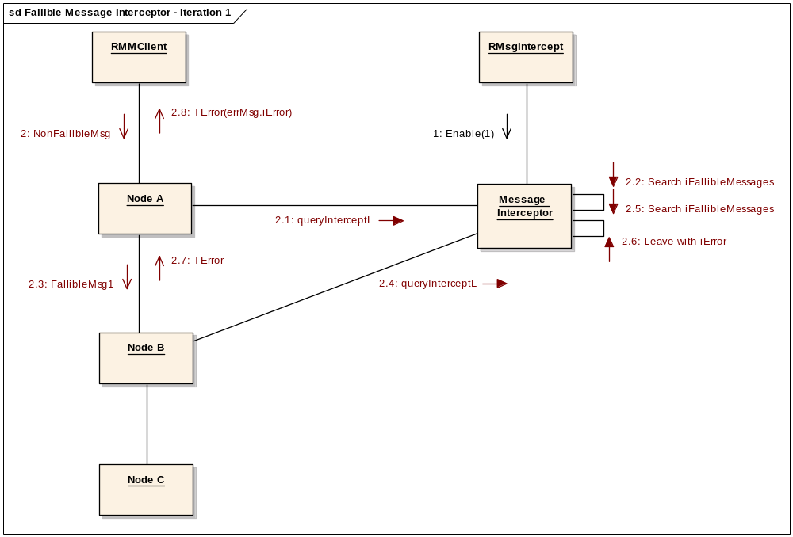
Figure 3-1 – First Iteration
The second iteration follows a similar process as the first, only this time the message NonFalliableMsg sent from RMMClient to NodeA is not searched for in iFallibleMessages as iCount is initially 2.

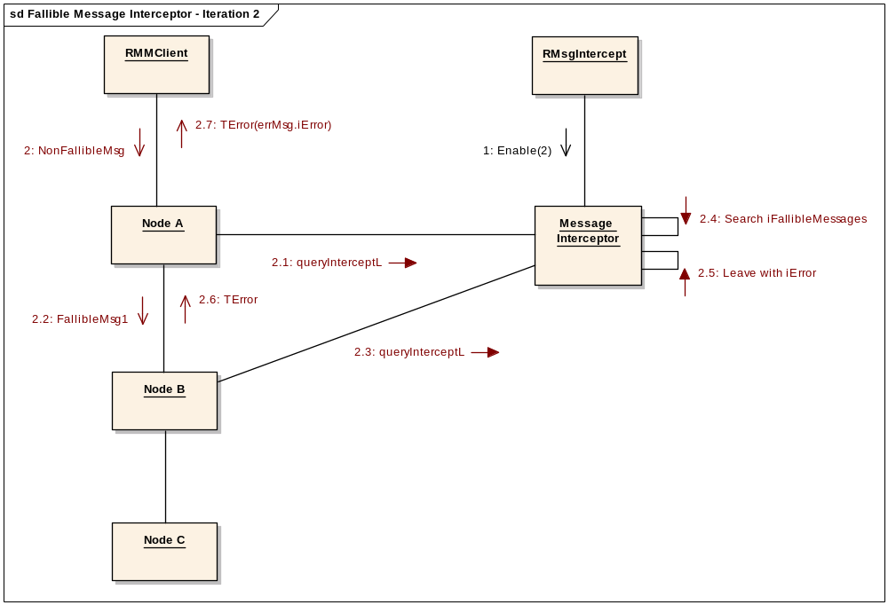
Figure 3-2 – Second Iteration

In the third iteration the first 2 messages – NonFallibleMsg and FallibleMsg1, are ignored and only the third message FallibleMsg2 results in a search of iFallibleMessages. As a match is found this results in a leave.
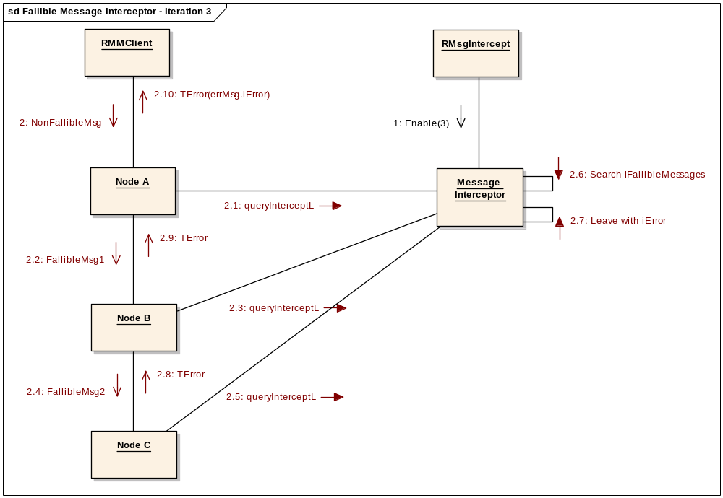
Figure 3-3 – Third Iteration

The method RmsgIntercept::Check is called by the test code to determine whether to carry on with further iterations or if all of the fallible tests have in fact been failed and therefore the overall test has completed. It works by the fact that if there are no further fallible messages to be failed then the counter will remain greater than 0.

Coding

On the client side i.e. the actual test code:

Tverdict CallFallibleTests::doTestStepL()
{
RmsgInterceptor intercept;
?RMMClient? mm;

intercept.ConfigureFromIni();
TInt messageCounter = 1;
do {
intercept.Enable(messageCounter++); // Increment counter ready for
// next iteration.

TInt err = mm.Run(); // This is the ‘kick off’ from the client to
// initiate the messages.
If (iExpectedError != err)
{
return Efail;
}
else
{
// Log partial success
INFO_PRINTF2(_L(“Passed step: %d”, messageCounter));
}
} while (!intercept.Check());

return Epass; // All fallible messages encountered have returned
// expected error.
}

Server side implementation:

void RmsgIntercept::Enable(TInt aMsgCount)
{
iCount = aMsgCount;
iErrInjected = Efalse;
}

void RmsgIntercept::QueryInterceptL(TCFNodeSignalBase aMsg)
{
if (iErrInjected)
{
return; // Ignore error propagation messages
}

// Ignore messages already tested
if (iCount > 0)
{
--iCount;
}

if (iCount == 0)
{
if (iFallibleMessages.find(aMsg) != KerrNotFound)
{
iErrInjected = Etrue;
User::Leave(iError);
}
}
return;
}
Ebool RmsgIntercept::Check()
{
return (iCount > 0);
}

Pattern Matching
Note: This part of the MI has been ported but not yet tested and therefore should not be assumed to be fully functional.

The MIR is configured (with expected patterns of message activity to be traced) and controlled though a client side debug interface of an RSockServ instance. When then enabled it inspects each incoming message reception event via a single line macro (see “Node use macros” section) placed within node ReceivedL method call and compares them against the next expected event expression in the register.
The register of expressions is advanced upon a match and at the termination of a pattern (a sequence of event expressions) an associated action is executed. When the complete sequence of patterns has been witnessed the register is marked complete. In this way it can be queried for completeness by the overseeing test script so that having witnessed all events prescribed can be made a requirement in order to verify that the error action prescribed must have at least been executed.

Design

General
The message interceptor register has been designed with the following basic requirements:
- It be restartable and reusable during the lifetime of the server so that it can be reused within a single test case for multiple examinations of and intrusions on message traffic.
- Must be thread safe as it will be interrogated from multiple threads within the subsystem
- Register nodes upon instantiation so that properties being match against need only be passed to the register once. Thereafter lookup is done each time the nodes participating in an event are passed to the MIR.

Composition
The message intercept is represented by a single instance of the class CMessageInterceptRegister which maintains a list of nodes (RRegisteredNodeList) that have registered with the message intercept upon their construction. The TCookie and UID details of the node are maintained and later matched against nodes involved in message transactions that are passed to the MIR during normal operation of Actors.
CMessageInterceptRegister also maintains a single list of patterns (CPattern objects) each in turn composed of a strict sequence of 1..n watch expressions (TEventExpression) that represent the properties of a message event to be matched against. This list of patterns is provisioned by a controlling test case or other debug code via the MControl interface before enabling the MIR to watch incoming events.

Expression
Action

Expression
Expression
Expression
Action

Expression
Expression
Expression
Expression
Action

Expression
Pattern 0
Pattern 1
Pattern N

Each pattern is terminated with an action (TAction) to be executed on completion of the pattern’s list of expressions. That is, on witnessing each and every expression in the sequence prescribed.
Each expression (TEventExpression) must match against the sender, receiver and message type of an incoming event. It consists of two TNodeExpression elements for the sender and receiver and a TMsgExpression for the message type itself. Message data is not accounted for in any way.
TEventExpression
Sender
TNodeExpression
“CPR1”
UID: IpProtoCPR
Match
Apply tag
ECFCommsBinderRequest
TMsgExpression
Message
Receiver
TNodeExpression
UID: AgentCPR
Match
Apply tag
Expression
Each TNodeExpression can match against one of the following attributes of a node:
- TUid – Of the node itself (as specified at node registration time and expected to be related to the factory responsible for creating the node)
- TProviderInfo – Access point and Tier Id attributes of a provider based node
- TNodeTag – A user defined (at test time) descriptor that matches against nodes tagged earlier in the piece (by means of the node register) having been matched at the time by either of the alternative means. This is primarily to provide a form of instance based matching.
Each TMsgExpression simply represents the message type of the incoming message to match against. Both type and realm.

Control interface - MControl
The message intercept is configured and controlled by an interface MControl upon the singleton CMessageInterceptRegister itself. This interface is intended to be used by Actors main thread only, thereby rendering it the only manager of the register itself. All other users - that is nodes, that may be in other worker threads - are passive users that either query or register with the MIR and do so through the independent MNodeIntercept interface.

Run time interface – MnodeIntercept

Node register
The MIR makes use of an internal node register that records the construction of nodes within the framework (again through the calling of a macro, on the part of each node, for this purpose). This register enables the matching of events against not only the type but instance of either a sending or receiving node as tagged earlier in the running sequence by a short descriptor.

Query message
TBC

Concurrent access considerations
Elements process wide singleton
Locks for concurrent access by the many threads in Elements

Performance considerations
Configured at startup
Low impact considerations
No dynamic memory consumption during execution

Using the MessageInterceptRegister (MIR)

At build time
The MIR is nominally configured for use as is and should not require much developer intervention unless it is to be extended for use in nodes within Elements not already accounted for or indeed for nodes yet to be created. It is also supported by test steps added to the ESockTestSteps framework and so is ready for use with minor configuration.

Compiling in
The MIR is a test and debug only feature with non-zero impact on the performance and memory footprint of Elements and so should be compiled in only as a test and debug aid.
Selective compilation of the MIR is managed by a .mmh file (messageintercept.mmh). This mmp include file manages the inclusion of the MIR with two defines namely __MESSAGE_INTERCEPT_UREL and __MESSAGE_INTERCEPT_UDEB that drive the inclusion or exclusion of the MIR binaries and source code and macro footprints in Elements and associated providers. It is required within the mmp file of each component that makes use of the MIR. It is included with each of the necessary Elements mmp files and other provider based components that will need to query the MIR as a part of operation within the comms-framework.
__MESSAGE_INTERCEPT_UDEB is enabled by default and so the MIR is compiled in to all Elements debug builds. __MESSAGE_INTERCEPT_UREL provides for enabling the MIR in release builds when required for debugging purposes and should remain disabled by default.

Top level compile macro
The binary macro __ELEMENTS_MESSAGE_INTERCEPT_ACTIVE is the top level code side macro that will be evident within various sections of Elements source code and used to compile in and out the MIR. It is intended to be driven solely from the mmh file discussed above and should not be handled manually. They are mentioned purely as a matter of familiarity for the developer who comes across them in the code. They are defined within the scope of the common MIR header files.

Node use macros
The following macros are intended to keep compile time use of the MIR within ESock visually subtle and to keep runtime interaction with it by its passive users universal.
- ELEMENTS_DEBUG_MESSAGE_INTERCEPT(SENDER, MESSAGE, RECEIVER)
Used on reception of message within a ReceivedL() method of a node to call upon the MIR to perform inspection of the received message and its participants, the receiving and sending nodes. SENDER and RECEIVER both of type TCookie
MESSAGE of type TCFSignalBase
- ELEMENTS_DEBUG_REGISTER_GENERAL_NODE(UID, NODE)
Used to register a newly constructed node with the MIR. In this case generally a non-provider based node for which the provider info elements are not significant. This macro should be placed within the node’s constructor or the factory routine that calls it. It makes no claim on the nature of its calling context but a UID representing the node type (either the factory’s UID or a user generated one) and the cookie representing the node need to be available.

At test or debug time
Use of the MIR will typically be from testexecute and via the ESockTestSteps framework.

Control from TEF via ESockTestSteps
Support for the MIR is included in the testexecute based framework ESockTestSteps. The following test steps provide for passing event expressions to the MIR to build up a message sequence scenario and for otherwise resetting, enabling, disabling and querying the register.
Refer to TE_MultimediaTestSteps_Test Specification [3] for details on how to configure each step.
- AppendMessageInterceptPattern
Appends a whole pattern (1 or more event expressions and a single subsequent action) to the MIR.
- EnableMessageInterceptRegister
Enables the MIR
- DisableMessageInterceptRegister
Disables the MIR
- ResetMessageInterceptRegister
Performs a soft reset of the MIR. Sequence of pattern activity and status are fully reset. The node register is not cleared allowing for subsequent use of the MIR within the given test case that depends upon knowledge of previously established nodes.
- QueryMsgInterceptComplete
Queries the completion status of the MIR in order to guarantee the verdict of the test.

Support for MIR outside of ESockTestSteps
The MIR is intended to be controlled outside of Esock via a newly introduced set of self-dispatching control messages. These messages can be passed to Esock via an RsocketServ instance via a single common method call.
TInt RsocketServ::__DbgControl(const EsockDebug::TcontrolMsg& aRequestMsg);
The following TcontrolMsg types are used to control the MIR and are documented in <TODO_reference to >. Each message makes use of the Mcontrol interface to act upon the MIR and so their use should continue to limited to Esock main thread as is required for Mcontrol:
- TsoftResetMsg
To reset the MIR to its startup state. The list of registered nodes is not maintained.
- TenableMsg
Enables operation of the MIR with respect to its passive users through the MnodeInterface interface. That is it can now be registered with by nodes within Esock and queried for matches against incoming message events. Prior to this it can only be controlled through the Mcontrol interface.
- TdisableMsg
Stops operation of the MIR. New events and node registrations will be ignored. Its internal status is maintained and later queried.
- TappendExpressionMsg
Appends a single TeventExpression to the Cpattern currently being provisioned within the MIR.
- TappendActionMsg
Terminates the Cpattern being provisioned and adds it and the preceding list of Texpression objects to the list of patterns within the MIR. Any subsequent TappendExpressionMsg will form the beginning of a new Cpattern.
- TqueryCompleteMsg
Queries the completion status of the MIR which indicates whether the complete list of patterns has been witnessed.

Further Information

People
Role | Person / People
Reviewers | Michal Zurowski, Yun-Yaw Chu, Aleksandar Antonic
Contributors | Rafeeq Hasan
Distribution

References
No. | Document Reference | Version | Description
[R1] | //EPOC/DV3/team/2006/convergedcomms/projects/productisation/common/comms-infras/Elements/Actors/MessageInterceptRegister/documentation/MessageInterceptRegister – Design document.doc | 1.0 | Esock Message Interceptor Register
[R2] | //EPOC/DV3/team/2006/convergedcomms/projects/productisation/common/comms-infras/Elements/MeshMachine/Documentation/MeshMachineFundamentals.doc | Latest | Mesh Machine Fundamentals
[R3] | //EPOC/DV3/team/2008/multimedia/projects/foundation/common/mm-infras/mmhost/test/TE_MultimediaTestSteps/Documentation/TE_MultimediaTestSteps_Test Specification.doc | Latest | Multimedia Test Specification

Open Issues

Glossary
Term | Definition

Document History
Date | Version | Status | Author | Description
dd-mm-yyyy | 1.0 | Issued | <Name>
05-03-2008 | 0.1 | Draft | Rafeeq Hasan | First draft based on SGL.PPS001.500 Lightweight Document Template Rev 8.7

