Message Sequence Viewer Tool

A tool for displaying Comms Framework message sequences using SVG

Creator: | Nadeem Wahid
Approver:
Function: | Device & Internet Connectivity / Comms Framework

Change History

Version | Status | Date | Handled by | Comments
0.1 | Draft | 2009-09-25 | Nadeem Wahid | Copied original document to Nokia template and applied updates

This material, including documentation and any related computer programs, is protected by copyright controlled by Nokia. All rights are reserved. Copying, including reproducing, storing, adapting or translating, any or all of this material requires the prior written consent of Nokia. This material also contains confidential information, which may not be disclosed to others without the prior written consent of Nokia.
Contents:
1. Introduction 3
2. User Guide 3
2.1 Overview 3
2.2 Running the Tool 3
2.3 Description of the Message Sequence Display 4
2.3.1 Nodes and Lifelines 4
2.3.2 Messages between Nodes 6
2.3.2.1 Activity Ids 6
2.3.2.2 Message Arguments 7
2.3.3 Activities and State Transitions 7
2.3.4 Executable Lifelines and ESock Sessions 8
2.3.5 Multiple Pages in the Display 9
2.4 Symbols Window 9
2.5 Relationship Window 9
2.5.1 Node Groups in the Relationship Diagram 9
2.5.2 Generating un-cluttered Relationship Diagrams 11
2.5.3 Use of Labels in Relationship Diagram 11
2.5.4 Animation in Relationship Diagram 11
2.6 Map Window 12
2.7 Interactive Features in Display Output 14
2.7.1 Message Sequence Diagram 14
2.7.2 Relationship Diagram 14
2.7.3 Limitations of Interactive Features 15
2.8 Excluding information from the display 15
2.8.1 Focusing on specific Nodes and Activities 20
2.9 Customising the parseit.bat file 20
2.10 parselog.pl command line arguments 21
2.11 parseseq.pl command line arguments 21
2.12 References 22
2.13 Possible Future Enhancements 23

Introduction
The Comms Framework (CF) subsystem included with TB9.2 onwards (a.k.a 3 Plane Comms) is composed of internal nodes arranged in a grid-like fashion that exchange messages between themselves. In order to facilitate debugging of the Comms Framework, a tool was written to display these message exchanges in a graphical sequence diagram style, by making use of Scalable Vector Graphics (SVG). This document describes the use of this tool for displaying messages sequences.

User Guide

Overview
CF logging contains all the information about message exchanges between internal nodes using the framework. This information is output using the standard UTrace mechanism, and results in a UTrace binary log file on the device filesystem (for the Emulator and ex-Symbian ARM development platforms, e.g. H4). For other phone development platforms, the logging can also appear as a FastTrace binary log file that can be converted into a UTrace binary log file.
The UTrace binary log is converted into a message sequence display via two steps:

- convert the UTrace binary log into a textual log, via the utracedecoder.exe tool
- convert the textual log into HTML/SVG output files for display on suitable (SVG-enabled) browsers (e.g. Internet Explorer (IE) with Adobe SVG Viewer plug-in, Firefox).

Please see [R1] for a link to a Wiki page that describes how to generate the log file for a variety of platforms.

The appearance of the display can be configured in a number of ways:

- via command line options to the Perl scripts
- via mouse clicks on various elements of the display
- via a configuration file
These are described in the sections that follow.

Running the Tool
Once the UTrace log file has been generated, a ulogger.log file should be the result. To generate the message sequence diagram, perform the following steps.

Firstly, copy the files parse.ini and relationships.txt from the \epoc32\tools\commsfw\ directory to the present directory (this is only required once).

Secondly, convert the binary log file to a textual log with the following command line:
\epoc32\tools\commsfw\utracedecoder --message-def
\epoc32\tools\commsfw\ipmessages.definition.txt ulogger.log > ulogger.txt

Thirdly, convert the textual log (ulogger.txt) to SVG output:

\epoc32\tools\commsfw\parseit.bat

Finally, view the file log.html in your browser. Note that for IE you will need to install the Adobe SVG Viewer (version 3.03 at time of writing). Also note that the parseit.bat script produces a number of HTML and SVG files in the present directory as well as in a html/ sub-directory beneath the current directory.

Description of the Message Sequence Display
Figure 1 shows an example of the display output. Each of the elements of the display will be described in the sections below.

Nodes and Lifelines
Each node in the display occupies its own column and includes a vertical lifeline with the name of the node displayed at the top of its lifeline. The node names are also repeated at vertical intervals down the display, to allow them to always be visible whilst scrolling vertically. There are two types of object that are displayed; Executables and CF nodes. Referring to Figure 1, the first two objects are called “TE_RConnectionSuite” and “dnd” and are executables. Executables are displayed at the left-hand side of the display, and are distinguished by their known name. The remaining objects to the right are Nodes (e.g. “TranFlowShim2”). Note that some lifelines in the example also appear to have parallel blue lines very close the lifeline – these are “Activities” and are described later on the document.

Executables never exchange messages. The main purpose in having them on the display is to show the IPC messages that they issue towards ESock. For example, referring again to the figure, TE_RConnectionSuite can be seen to issue an ESoBind IPC. The Nodes to the right of dnd can be seen to exchange messages (described later). Additionally, thread creation and destruction is indicated against executable lifelines via text of the form “(Thread “<name>” Created)” or “(Thread “<name>” Destroyed)” (not shown in Figure 1).

The lifeline of a Node is coloured to show the lifetime of the node. It is light grey until the node is created, at which point is becomes black for the lifetime of the node. When the node is destroyed, it becomes light grey again. For example, in Figure 1 the node FlowRequest2 is destroyed near the top of the sequence. For visual convenience, only one node is shown in each column. Once a node is destroyed, that column will not be used again to show another node and will remain light grey to the end of the page.

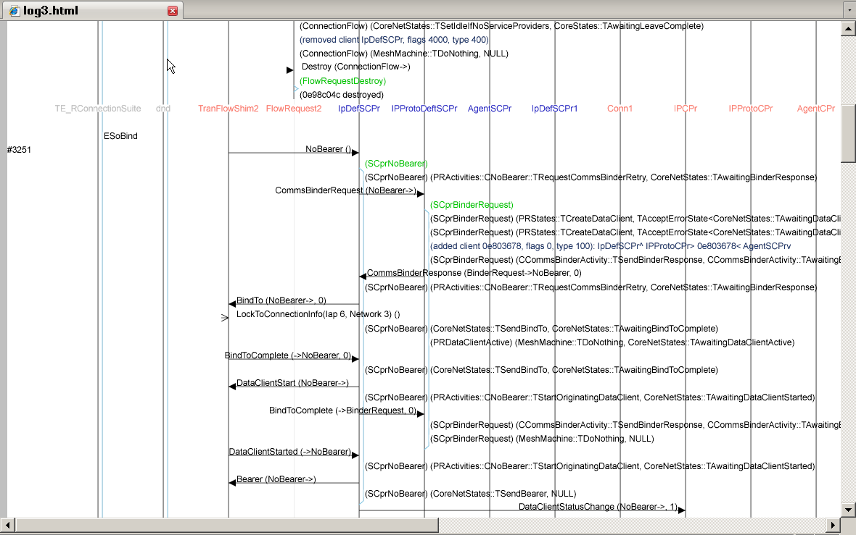
Figure 1 – Example SVG Output
The names of Nodes appear in different colours as a way of grouping together nodes of different types. In the example, the node names of IPDefSCPr through to IPDefSCPr1 are blue, as they are “subconnection” node types, and Conn1 through to AgentCPr are red, as they are all “connection” node types. The Node names alternate between red and blue in this manner across the display. Executable names are all displayed in black (when they appear at the top of the display) or grey (when they appear in the middle of the display).

Messages between Nodes
Messages are represented by arrows between Nodes. There are two types of messages that can be represented on the display – “posted” and “received”. Posted messages are those that have been queued towards a destination node, but have not yet been received by the node. Received messages are previously posted messages that have been received by a destination node. A time delay typically exists between posting and receiving a message, hence a display can appear to show the same messages going twice between two nodes. Posted messages are differentiated by being coloured green and having un-filled arrow heads, whereas received messages are coloured black with filled arrow heads. In this example, only received messages are shown. This is both for clarity and also because this is typically the main usage scenario of the tool. The user can control whether posted messages are displayed or not by the arguments specified to the Perl scripts in the parseit.bat file (see “-p” option in section 2.9 below). Displaying posted messages will substantially increase the size of the message sequence, so it is recommended that they are only displayed when required.

Activity Ids
The message arrows have a label just above the arrow line which shows the name of the message. After this, in parentheses, are source and destination “activity id” of the message and, optionally, a comma-separated list of the most important message arguments. The source and destination activity ids refer to the activity that originated the message and the activity to which the message is directed respectively (please see “Mesh Machine Fundamentals” [R2] for a description of activities). For example, see the following message (sent to IPProto from IpDefSCPr – the 5th and 6th nodes along respectively, look near the centre of the figure):

CommsBinderResponse (BinderRequest->NoBearer, 0)

This shows a CommsBinderResponse message which has a source activity id of BinderRequest and a destination activity id of NoBearer. If present, the activity ids are always shown immediately after the opening parenthesis, with the “->” character sequence used to indicate the source and destination activity ids. The “0” is a message argument (these are described later). In general terms, messages are displayed as follows:

<message name> “(” [ [<source activity id>] “->” [<destination activity id>] ]
[“,” <message argument> ]* “)”

(where “[…]” represents optional arguments and “*” represents zero or more occurrences). Note that it is valid for the source and/or destination activity ids to not be present in a message. For example, Figure 1 also shows the following messages:

CommsBinderRequest (NoBearer->) (IpDefSCPr → IPProtoDeftSCPr)
DataClientStarted (->NoBearer) (TranFlowShim2 → IpDefSCPr)
NoBearer () (TranFlowShim2 → IpDefSCPr)

The alignment of the message name text also represents whether a message is posted or received. For received messages, the text is aligned such that it is closest to the arrow head, and for posted messages the text is aligned such that it is closest to the arrow tail. In this example (as explained previously), all messages are of the “received” type, and the text is aligned against arrow head.
Messages can also be sent from a node to itself (“self posted”). These appear as just an arrow head against the node’s lifeline, with no arrow body. For example, node FlowRequest2 has a Destroy message posted to itself (4th node along, near the top of the display).

Message Arguments
For specific messages, some of the message’s arguments are also displayed after the activity ids. For example:

BindTo (NoBearer->, 0)
DataClientStatusChange (NoBearer->, 1)
CommsBinderResponse (BinderRequest->BinderRequest, IPCPr2)

Where “0”, “1” and “IPCPr2” being message arguments specific to each of the respective messages. Note that, in some cases, the message argument may be a pointer to a node. In this case the name of the node is shown rather than the (less useful) hex value of the pointer (for example, “IPCPr2” above). Not all message arguments are displayed – only those that are considered the most relevant to the message concerned. This is to avoid cluttering up the display. The arguments that are displayed for each message have been pre-specified in the “[MessageArguments]” section of the parse.ini file.

Activities and State Transitions
Each Node may have one or more “activities” running simultaneously. Each activity is created, passes through one or more state transitions, and is destroyed. This information is also represented on the display. When a Node creates a new activity, this is displayed on the node lifeline as text showing the name of the new activity in parentheses and coloured in green. For example, IPDefSCPr can be seen to create a new activity “(SCprNoBearer)”, and IPProtoDeftSCPr can be seen to create activity “(SCprBinderRequest)”. This highlights an important point - text lines associated with a particular node lifeline are always displayed such that they are left justified against the associated node lifeline (i.e. the text starts immediately to the right of the associated node lifeline).

Activities also have lifelines that are shown on the display. These appear as blue lines that “fork” from their owning node’s lifeline, run closely parallel to them whilst the activity is active, and then re-join the node’s lifeline when they end. In the above example, IPDefSCPr has the SCprNoBearer activity and corresponding activity lifeline. Activities typically start and end as a result of incoming messages (although this is not always the case). In this example, the SCprNoBearer activity is started upon receipt of a NoBearer message, and ends just after it has received a DataClientStarted message, upon which it sends a Bearer message and terminates. There can be more than one activity active on a node at the same time, so more than activity lifeline may be displayed running alongside the node lifeline. Activity lifelines may span multiple pages of the display – clicking on an activity lifeline displays the name of the activity in a small popup box, which is convenient if the activity was created (and hence its name first displayed) on an earlier page.

Activity lifelines are normally displayed on-screen in blue (as shown in the figure). If they appear in red, this indicates that the precise end of the activity could not be determined. In this case, the activity will appear to end when the node terminates, but it may have terminated earlier. This may happen if there is a deficiency in the logging output. Red activity lines are typically seen at the end of the display if the test run terminated abnormally (such as a panic).

Activity states and transitions are also shown on the node lifeline as text within parentheses. In this case, the text contains two comma-separated fields indicating the transition and state. For example, just after the SCprNoBearer activity is created by IPDefSCPr, the following line of text appears on the node lifeline:

(SCprNoBearer) (PRActivities::CNoBearer::TRequestCommsBinderRetry,
CoreNetStates::TAwaitingBinderResponse)

This indicates that the SCprNoBearer activity has executed the TRequestCommsBinderRetry transition and has moved to the TAwaitingBinderResponse state.

Executable Lifelines and ESock Sessions
Section above described how activities are represented by one or more blue lines running parallel to the node lifeline. For Executables, which do not have activities, the same representation of a blue line running alongside executable lifelines is used to represent the presence of ESock server sessions instead. For example, Figure 1 shows that both TE_RConnectionSuite and dnd have a single ESock server session. Rather like activities, the blue line indicates the lifetime of the ESock server session.

Multiple Pages in the Display
Long display outputs are split into several approximately equal sized pages, where one of these pages is displayed at a time. This value is typically larger than the height of a browser window, so a vertical scroll bar is usually present to scroll through the page. The main reason for splitting the display into reasonable pages in this way is to limit the simultaneous virtual memory usage of the tool. Each page has an underlying bitmap which, if made too large, can result in heavy paging activity on the machine. The original version of the tool did not perform this splitting and ran into memory problems when viewing very long sequences. Also, the vertical scrollbar ended up being of minimal size, which resulted in difficulty in smoothly scrolling small amounts.

The pages of the sequence can be navigated via a set of navigable page number anchors on the top and bottom line of the display (e.g. “0 1 2 3 …” etc) . The current page number is indicated by being non-navigable and bold. By default, the last page is displayed when the output is first viewed via log.html.

Symbols Window
At the bottom of the display, there is a button labeled “Symbols”. This will bring up a window containing the hex addresses of all the nodes being displayed (across all pages). This is a simple text box with two columns: the node name (e.g. “IPCPr”) and the hex address of the node (specifically, the ANode derived class instance of the node).

Relationship Window
The “Relations” button at the bottom of the display will bring up a “relationship” diagram (see Figure 2). Depending on your browser and its settings, either a new window will appear, or a new tab will appear. This diagram shows how the nodes in the message sequence diagram are related in terms of the notional vertical and horizontal layers that they occupy within the Comms Framework. The positioning is defined in terms of the messages that nodes are seen to exchange, and the defined compass direction that the message takes. For example, a BindTo message is assumed to travel “west” and so two nodes exchanging this message will be positioned such that the recipient nodes is west of the sender node.

Node Groups in the Relationship Diagram
The nodes in the relationship diagram are displayed in one or more groups, with each group showing nodes either connected directly to one another, or indirectly via intermediate nodes. Each node group has its own rectangular light grey background to further differentiate it visually. For example, in Figure 2 there are three node groups shown. There is no particular relevance to the individual node groups. The tool simply analyses the messages passed between nodes over the entire message sequence and shows all node groups that are found. These node groups do not necessarily have any relationship to one another. On the other hand, it is also possible that two apparently separate node groups are related by a node that is excluded from the display (via the parse.ini file facility). Typically, a group represents nodes that are created at around the same time for the same purpose. For example, in the particular case of the Comms subsystem, each group displayed can represent an individual connection that has been started. When running Comms integration tests, for example, there can be several such groups resulting from several individual tests with their own connection starts and stops.

Within each group, the nodes are arranged in alternately coloured columns to highlight nodes of the same type. Referring to the second group in Figure 2, for example, the columns from left to right show Flows, Sub-Connection Providers, Connection Providers and Meta-Connection Providers. Each of these is shown in alternating colours. In the same group in Figure 2, horizontally from top to bottom can be seen the layers for IP Transport, IPProto and Agent.

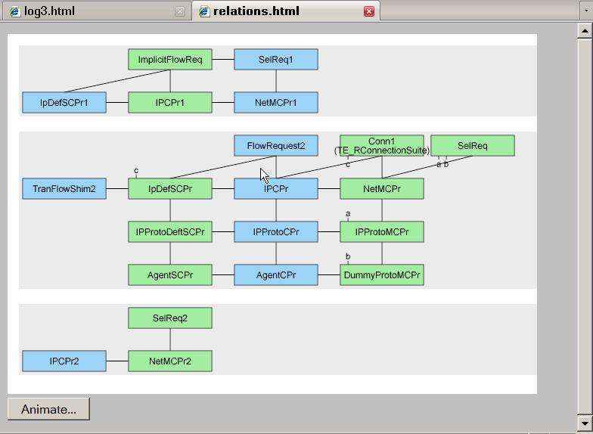
Figure 2 - Relationship diagram

There is also no implied chronological ordering among different node groups in the relationship diagram. Later node groups have not necessarily been created later in the message sequence. In fact, given two node groups, it is possible that within one of the node groups, some nodes could have been created earlier and others created later than nodes in the other group. Consequently, the notion of a chronological order to node groups can actually be meaningless. In this sense, the relationship diagram is like a “fossil record”, displaying all nodes that exist in the message sequence, regardless of when. So, the relationship diagram stays the same regardless of which page of the message sequence diagram is being displayed when the relationship diagram is invoked. The diagram displays both nodes that are in the current message sequence diagram page as well as nodes that may only appear on other pages, either earlier or later in the sequence.

Generating un-cluttered Relationship Diagrams
The parse.ini file provides a mechanism of excluding nodes that are not of interest from the display (described in section below). This can be used to generate easier-to-read relationship (and message sequence) diagrams.

To this end, the following types of (Comms Framework) node classes can be excluded if not of interest:

CTierManagerFactoryContainer
CConnectionFactoryContainer
CSubConnectionFactoryContainer
CSubConnectionFlowFactoryContainer
CMetaExtensionContainer

CIpTierManager
CIPProtoTierManager
CAgentTierManager

CSelectionRequest
CFlowRequest
CImplicitFlowRequest

In particular, the presence of nodes with a 1-to-n relationship with other nodes (i.e. Containers and Tier Managers) will tend to clutter up the display most. The tool will attempt to display these relationships such that lines do not cross, and this leads to very large terse displays with much white space and multiple lines connecting many nodes. Container and Tier type nodes can also produce an artificial relationship between otherwise orthogonal groups. They do this by creating a relationship between nodes in several groups merely because the Tier Managers are of the same type. The result is to display one large group rather than several smaller ones; possibly losing the more useful differentiation that the smaller, less related groups may show.

Use of Labels in Relationship Diagram
Where the relationship lines drawn between nodes would possibly have to be drawn through intervening nodes, thus cluttering up the display, labels are used instead. A label consists of a very short line emerging from a node with an alphabetic letter on the end. In Figure 2, the SelReq node has two labels – “a” and “b” – indicating its relationship to nodes IPProtoMCPr and DummyProtoMCPr. Also, the relationship between Conn1 and IpDefSCPr is shown via label “c”.

Animation in Relationship Diagram
The Relationship diagram can be animated to show the chronological sequence in which nodes and the associations between them are created and destroyed. Node creation is represented by a node appearing on the display, with node destruction represented by a node disappearing. Similarly, associations being created and destroyed between nodes are represented by the line between nodes appearing and disappearing. At any point in time in the animation, the nodes and relationships in existence at the time are displayed. Messages are not included in the animation - just nodes and associations.
At the bottom of the Relationship diagram is an “Animate…” button. Clicking on this button pops up a dialog box with a number of buttons used to control the animation (see Figure 3). Depending on the browser used, and its configuration, this may appear as a new dialog box or as a new tab.
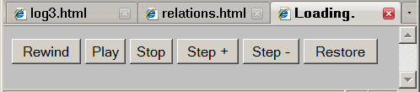
Figure 3 - Animation control panel

The following table describes the function of each button:

Button | Action
Play | Start or continue the animation. When pressed for the first time, clears the Relationship diagram window and starts the animation.
Stop | Pauses the animation. Press “Play” to resume the animation.
Step+ | Displays the next single event in the animation and then pauses. Each press steps forward by one event through the animation manually. Press “Play” to resume the animation.
Step- | Displays the previous single event in the animation and then pauses. Each press steps backwards by one event through the animation manually. Press “Play” to resume the animation (forwards).
Rewind | Rewinds the animation back to the beginning and pauses (clears the display). Press “Play” to start the animation or “Step +” to step forward through the animation.
Restore | Once the animation is no longer required, restores the Relationship diagram.

Map Window
At the bottom of the Message Sequence display is a “Map” button. Clicking on this will bring up a window which is intended to help navigate to a particular message sequence page of interest. The Map window is composed of two parts. The first part (see Figure 4) is composed of a table with one row for each message sequence page. The columns in this table are described below:

Column Name | Description
Page | Page number in the Message Sequence display.
Lines | Two columns which display the beginning and ending ulogger.txt line numbers that were used to construct the message sequence page in question. If you navigate to the page, you will see the log line numbers on the left-hand side of the display. The first and last log line numbers on the page are the ones displayed here.  If the user wishes to see message sequence events occurring around particular log lines, then the correct page can easily be found by scanning these columns.
Times | Two columns which display the beginning and ending timestamps corresponding to the page in question. If you navigate to the page, you will see the timestamps on the left-hand side of the display. The first and last timestamps on the page are the ones displayed here.  If the user wishes to see message sequence events occurring at a particular time, then the correct page can easily be found by scanning these columns.
Objects Created | A list of nodes, processes and threads that were created on the page in question. Nodes are represented in normal text, processes in bold text and threads in bold italic text. If you navigate to the page, you will see the lifelines beginning for these nodes, showing them coming into existence.  If the user is interested in seeing message sequence events around the point where a node is created, the corresponding page can be easily found.
Objects Destroyed | A list of nodes, processes and threads that were destroyed on the page in question. Nodes are represented in normal text, processes in bold text and threads in bold italic text. If you navigate to the page, you will see the lifelines ending for these nodes, showing them being destroyed.  If the user is interested in seeing message sequence events around the point where a node is destroyed, the corresponding page can be easily found.

The second part of the Map window (Figure 5) is composed of a table with one row for each object (executable or node) in the message sequence display. The columns in this table are described below:

Column Name | Description
Object | Name of node or executable. Nodes are shown in normal text, executables in bold and threads in bold italic.
Start/End | The starting page where the object is created, and the ending page where it is destroyed.
Lifetime | The pages where the object is in existence. This is the same information as the “Start/End” column but instead represented in a graphical form. Composed of a single row grid with a square representing each page in the message sequence view. Squares with a blue background indicate pages where the object is in existence. The blue squares are navigable – clicking on them brings up the page they represent.

Interactive Features in Display Output
The previous sections described mostly the static features of the display (apart from the Relationship diagram animation). There are also a number of interactive features that are activated by clicking on certain graphic elements of the message sequence diagram and the relationship diagram. If both the message sequence diagram and relationship diagram are both up, then some of the features can cause changes in the displays of both diagrams simultaneously. These are described in the next few sections.

Message Sequence Diagram
In the message sequence diagram, the following interactive features exist:

 | Action | Result
1 | Mouse click on message arrow line or message label. | Log line number. Pop up a small dialog box displaying the line number of the logging line in the original ulogger.txt file. Clicking on the dialog box will dismiss it.
2 | Mouse click on activity timeline. | Activity name. Pop up a small dialog displaying the name of the activity. Useful if an activity line spans many pages so that the activity name displayed at the beginning of the line is not visible on the current page. Clicking on the dialog box will dismiss it.
3 | Mouse click on node name. | Highlight node and related nodes. Highlight the selected node and all nodes that it exchanges messages with. The highlighting takes the form of displaying in an alternate colour the corresponding node names, timelines and message arrows and labels.  If the relationship diagram window is up, then the selected node is also highlighted in that window in a different colour.
4 | Shift + Mouse click on message arrow line or message label. | Highlight two related nodes. Highlight the two nodes that are exchanging the message and all messages that they exchange.  If the relationship diagram window is up, then the two nodes are also highlighted in that window in a different colour.

Relationship Diagram
In the relationship diagram, the following interactive features exist:

 | Action | Result
5 | Mouse click on node | Highlight node and related nodes (same as action 3 above). On the message sequence diagram, highlight the selected node and all nodes that it exchanges messages with.  On the relationship diagram, highlight the related nodes.
6 | Mouse click on line between two nodes. | Highlight two related nodes (same action 4 above). On the message sequence diagram, highlight the two nodes and all messages that they exchange.  On the relationship diagram, highlight the two nodes.

Limitations of Interactive Features
If both the message sequence diagram and relationship diagram windows are both up, then the interactive features that cause both displays to update simultaneously will be lost if a different message sequence page is selected. The relation diagram window will still be present, but it will become “detached” from the message sequence diagram, and will not be updated by it or vice versa. The full interaction between the windows can be restored by dismissing the relationship window and using the “Relations” button to re-invoke it (i.e. in the context of the new message sequence page).

Excluding information from the display
The message sequence and relationship diagrams can be configured to hide certain nodes and/or messages from the display. This is mainly used to remove unnecessary “clutter” from the display – i.e. information exchanged between nodes that are of no importance to a particular user and can be ignored. This reduces the size of the diagrams and makes it easier for the user to concentrate on a particular aspect of the Comms subsystem.

The configuration describing what to hide from the display is contained in an ini file (default: parse.ini). The path to this file must be specified via the “-x” command line argument to the parselog.pl and parseseq.pl Perl scripts. The file can have any arbitrary name, and the user can manage as many of these files as they wish. The file contains several sections, each beginning with a line containing the text “[<section name>]” followed by a number of lines describing what to exclude. The sections are described in the table below:
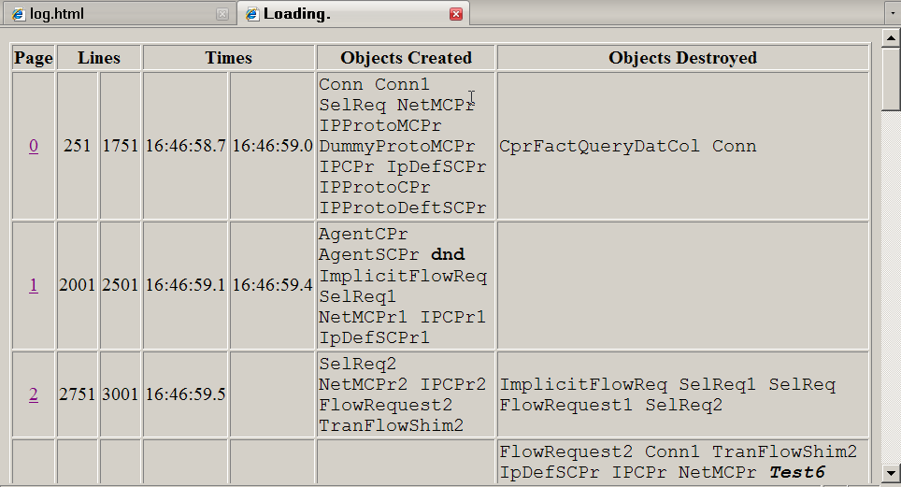
Figure 4 - Map Window (first part)
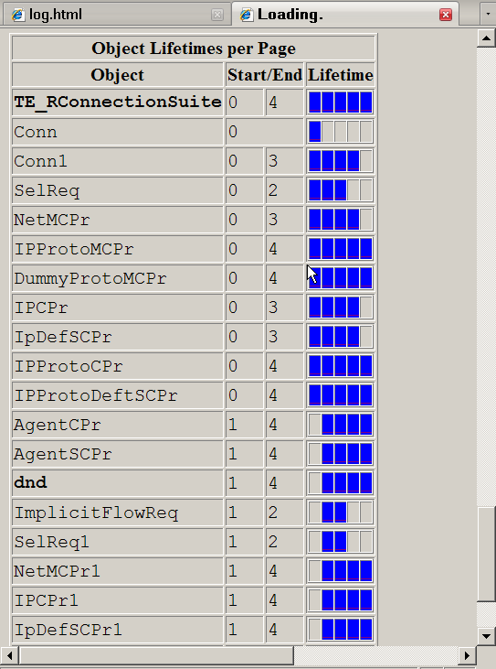
Figure 5 - Map Window (second part

Section Name | Description
[ExcludeClass] | Describes a list of nodes to exclude from the message sequence and relationship diagrams. Following the section name is a list of C++ class names, each on its own line. Any node that is composed of one of these class names specified will not be displayed. For example, specifying “CIPConnectionProvider” will exclude all IP Connection Provider nodes from the display. Remember that the node names displayed in the diagrams are specially shortened versions of the original class names that are more suitable for display purposes. In this particular example, any nodes ordinarily displayed as “IPCPr<n>” will be excluded.
[ExcludeMessage] | Describes a list of messages to exclude from the display. Following the section name is the list of messages, one per line. Excludes particular messages from the message sequence diagram. For example, “ClientLeaving” would exclude all such message exchanges from the display.
[ExcludeIpc] | Describes a list of IPC messages to exclude from the lifelines of executables (i.e. non Comms Framework nodes). For example, specifying “ESoGetOpt” and “ESoSetOpt” can be used to prevent “dnd“ from cluttering up the display with these frequently issued IPCs. The IPC messages cannot be specified for a particular executable.
[ExcludeShortName] | Describes a list of “short” node names to be excluded. The “short” name of a node refers to the name exactly as displayed in the diagrams. As described earlier, it is a shortened version of the original C++ class name. For example, specifying “SelReq2” would exclude a node of that name from the display. Note that wildcards cannot be specified in short names.  This section differs from the “[ExcludeClass]” section as the latter excludes all instances of nodes of a particular C++ class. This section excludes individual instances of nodes as they appear on the display. On the other hand, the node represented by, say, “SelReq2” could be a different node instance between two different message sequence diagram runs. Consequently, this feature is most useful in excluding either nodes that only have a single instance on the display (hence have a name without an instance number), or fine tuning a particular message sequence diagram run by adding particular node names to the exclude file and re-generating the diagrams with the chosen nodes removed.
[DontHideShortName] | Describes a list of short node names that should not be hidden if they do not exchange any messages. Normally, nodes that do not exchange any messages are automatically excluded from the display. This section provides an opportunity to force display of such nodes. Note that the name specified is a “stem” that matches any node with the same stem. For example, “Conn” will match “Conn”, “Conn1” etc.  This section was originally created to force display of nodes at the “edge” of the Comms Framework Mesh Machine that interacted with Comms Framework nodes via mechanisms other than messages. These nodes were normally hidden, yet displaying their lifeline was still useful. This section may be removed in future if found to be redundant.
[ExcludeSingleTuple] | Describes a list of “single triple” activity names to exclude from the display. Activities that are defined as a single triple are often simple “housekeeping” activities that can be removed to reduce clutter in the display. Specifying “*” removes all single triple activities.

An example fragment a parse.ini file is shown below. Note the use of ‘#’ to comment out certain entries:

[ExcludeClass]

# Excluding Tier manager and Container classes makes the relationship diagram much clearer.
# Excluding the SelectionRequest and FlowRequest classes also makes it clearer - include them
# (by commenting them out) as required.

#CSockSessionProxy
CTierManagerFactoryContainer
CConnectionFactoryContainer
CSubConnectionFlowFactoryContainer
CSubConnectionFactoryContainer
#CNetworkMetaConnectionProvider
#CAgentTierManager
#CIpTierManager
#CIPProtoTierManager
#CSelectionRequest
#CFlowRequest
#CImplicitFlowRequest
CMetaExtensionContainer
CRefCountOwnerBase

[ExcludeMessage]
#ClientLeaving
#CtrlClientJoined

[ExcludeIpc]
# DND generates alot of these IPCs, hence they are removed by default
ESoGetOpt
ESoSetOpt

[ExcludeShortName]
# Excluding Tier Managers makes the relationship diagram much clearer
IpTierMgr
IPProtoTierMgr
AgentTierMgr
#SelReq
#SelReq1
#SelReq2
#SelReq3
#FlowRequest
#FlowRequest1
#FlowRequest2
#FlowRequest3
Socket
TranFlowShim
Socket1
TranFlowShim1
MetaExtContArray
CFFactContBrokr3
Socket2
DummyNifFlow
ImplicitFlowReq1
IpDefSCPr2
IPShimFlow

[DontHideShortName]
Conn

[ExcludeSingleTuple]
#*

Focusing on specific Nodes and Activities
Another way of excluding information from the display involves use of the “-A” and “-N” options to parseseq.pl. These options will allow the user to generate a display just showing a particular activity (“-A”) or node (“-N”). See section below for a more detailed description.

Customising the parseit.bat file
The parseit.bat file supplied as standard is a generic version that can be customised. It invokes the three Perl scripts which do the main job of generating the HTML/SVG output files:

perl -S parselog.pl %ARGS% -x parse.ini -s63 %LOGFILE% > log.seq
perl -S parseseq.pl %ARGS% -x parse.ini -p -V log.seq
perl -S relations.pl -x relationships.txt log.seq > relateit.out 2>&1

The parselog.pl script takes the ulogger.txt file and generates an intermediate file called log.seq. This contains a generic description of the message sequence to display. The parseseq.pl script takes the log.seq file and generates the HTML/SVG files displaying the message sequence. The relations.pl script takes the log.seq file and generates an object “relationship” diagram, showing the way in which the objects relate to each other in terms of those that exchange messages with each other.

The customization takes the form of changing the command line arguments supplied to the parselog.pl and parseseq.pl scripts. The following sections describe the arguments to the scripts.

In general, the main customization that takes place is the addition of the “-p” option to parselog.pl in order to display posted as well as dispatched messages. A number of different parseit.bat files could be maintained by the user, each with differing arguments supplied to the two Perl scripts.

parselog.pl command line arguments
This script takes as input a textual version of the UTrace binary log file and generates an intermediate output file (log.seq). The command line arguments are described below:

Synopsis: parselog.pl -x <ini file> [ -p ] <log file>

Flag | Description
<log file> | Name of the log file.
-x <ini file> | Specify the ini file. The content of this file is used to tailor the appearance of the display, and is described in section 2.8 above.
-p | Include “posted” messages in the output as well as “received” messages. Posted messages are those that have been issued to a node but have not been received by that note. Received messages are messages that have been received by a node as a result of a previous posted message. When this option is enabled, a message normally appears twice in the display – when posted and later on when received.

parseseq.pl command line arguments
This script takes the intermediate log.seq file and generates the SVG/HTML output. The command line arguments are as follows:

Synopsis: parseseq.pl -x <ini file> [ -r <begin>,<end> ] [ -A ] [ -H ]
[ -M] [ -N ] [ -R <rows per page> ] [ -v ] –p <log.seq file>

Flag | Description
-x <ini file> | Specify the ini file. The contents of this file are described in section 2.8 above.
-r <begin>,<end> | Only display rows in the range specified. Without this option, the final output contains all messages in the log file, with each message on a separate row. This option allows for the “trimming” of the final output to a subset of these rows. Row numbers start from zero and are inclusive. Negative row numbers count backwards from the last row. <begin> and/or <end> may be omitted, in which case the beginning and ending rows respectively are assumed. For example, “-r -1000,” means display the last 1000 rows to the end, and “-r 100,500” means display rows 100 to 500.
-A | Used to display message sequences specific to a particular activity. A list of activities is presented, allowing the user to make a choice as to the activity of interest.
-H | Don’t Hide objects. On displays that have been "trimmed" via the “-r” option, un-hide objects that don't have any messages within the area specified in the “-r” option (but do have messages outside of the trimmed area, which is not being displayed). These objects are normally not displayed, as otherwise they clutter up the display with empty object timelines with no messages or useful information.
-M | Exclude all messages from the display, leaving just node and activity creation. Useful to get an overview of what is happening.
-N | Used to display message sequences specific to a particular node. A list of nodes is presented, allowing the user to make a choice as to the node of interest.
-R <rows per page> | Maximum number of rows in each page. The overall sequence is generated as a number of individual pages, each showing part of the overall sequence. This option indicates the maximum number of rows per page. Note that because the output is split into equal sized pages, the actual size of each page can vary from half the value of this parameter to its full value. This parameter only limits the maximum size of each page.
-V | Print on standard output some informational messages indicating progress of script. This flag is useful with very large log files that can take a long time.
-v | Print on standard output a list of objects which have not been displayed because they exchanged no messages or were outside of the displayed area specified in a “-r” option (see “-H” option).

References
Reference | Description
[R1] | TWiki page on gathering UTrace Logs: http://wikis.in.nokia.com/CommunicationsFramework/CommsLogging
[R2] | “Mesh Machine Fundamentals” document:  os/commsfw/commsfwsupport/commselements/meshmachine/ documentation/MeshMachineFundamentals.doc

Possible Future Enhancements
This is a list of possible future changes to enhance the usability of the tool:
- If a ulogger.txt file contains several different test runs (i.e. between ESOCKSVR reboots), a command line option to parselog.pl could be used to just display the last test run. This could be implemented by parselog.pl detecting the change in runs in ulogger.txt and simply deleting the log.seq output file. At the end of processing, the log.seq would contain just the last run.
- The Relationship diagram could be enhanced such that nodes that are not visible in the current message sequence page are greyed out on the relationship diagram. The user can then easily disregard nodes that are not relevant to the message sequence page being displayed.
- A “zoom” facility can be included, which can be used to alter the size of the display (by use of the SVG viewBox attribute).
- Ensure that all HTML/SVG files (apart from log.html) are in the html/ sub-directory. Presently, some of the files are placed in the current directory.

This is intended to be a visual convenience so that the executable names are de-emphasised, though still visible, in the middle of the message sequence display
A description of CF Node activities can be found in “Mesh Machine Fundamentals” document.
Earlier versions of the SVG tool displayed text lines centred against the associated node lifeline, but it was sometimes visually difficult to determine which node particularly long text lines were identified with.
The number of rows per page can be configured via the “-R” command line option to the parseseq script, although this rarely, if ever, needs to be changed.
i.e. without an underline, in most common browsers
The relationships.txt file defines the full set of messages and compass directions that are used to build up the relationship diagram
There is presently a bug whereby clicking on the arrow head itself only works for the pixel at the very end of the point
There is currently no way of un-highlighting (!) – selecting a different node will turn off the currently highlighted nodes but display a new highlighting based on the newly selected node. The present workaround is to click on the node name of any executable (e.g. dnd).
an unfortunate consequence of losing the parent/child relationship between the windows
actually, this works inadvertently. ‘#’ is not explicitly recognised as a comment specifier – this feature only works because adding ‘#’ “corrupts” the name, preventing a proper match against the corresponding real name.
Obsolete command line arguments are not described
Obsolete command line arguments are not described

