Contents
1 Introduction 3
1.1 Purpose and Scope 3
1.2 Design Overview 3
2 Cpr Design 5
3 MCpr Design 7
3.1 Mobility Policy 7
3.2 Blacklisting 7
3.3 Interaction between MCpr and Cpr 10
Testing 13
4 Future Development 13
5 Glossary 14
5.1 People 16
5.2 References 16
5.3 Open Issues 17
5.4 Document History 17

Introduction

Purpose and Scope
This document describes the design of a reference implementation of bearer mobility on Symbian OS.

Design Overview
The design features changes to both Management and Connection plane providers though these are in the provision of new functionality rather than modifications to architecture.
This implementation follows the API handshake principles set out in [R1] in that a handshake will be completed, either successfully or by an appropriate error code, before another request may be issued for that connection. In practice this means that should a client be notified of a preferred AP and while performing the migration to a new, more preferred AP becomes available, the migration to the previously notified AP must complete before any further mobility can be performed.
This implementation provides no mechanism for recovery from incomplete handshakes. Such features if desired can be added to a specific mobility implementation.
This implementation also only caters for the scenario where there is a 1-to-1 relationship between a Cpr and its control client (mobility client).

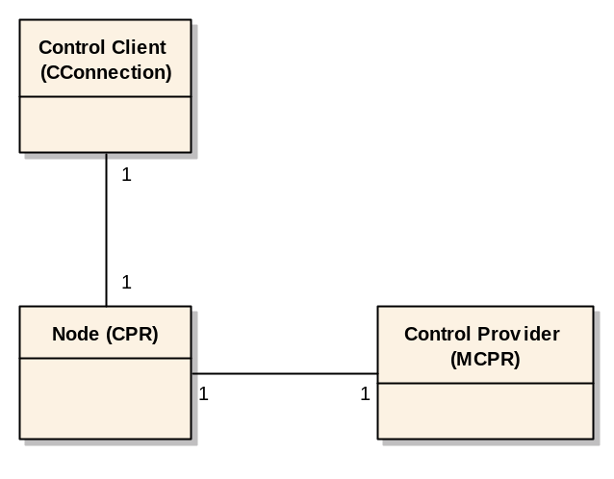
Figure 1: Cardinality of objects involved in the PREQ1060 reference mobility scenario

The reference MCpr will only ever create one Cpr when asked to do so by its control client.
To support multiple mobility clients scenarios the licensee’s specific MCprs will need to create a new Cpr for each requesting client. This will produce the 1:N cardinality required for these scenarios.
The specific MCpr will need to implement policies of dealing with contradictory responses from multiple clients, timeouts, and make other decisions to support non-seamless bearer mobility for multiple clients.
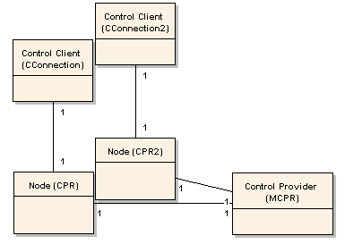

Figure 2: Cardinality of objects involved in the licensee specific mobility scenario

Blacklisting
This mobility implementation provides no mechanism for blacklisting of rejected carriers (APs). This means that a previously rejected carrier will be offered again as soon as it becomes available and/or preferred again, even if it has been rejected just moments before.
Reference blacklisting mechanism will probably be delivered at a later time and must be currently provided by licensees.

Layered architecture
PREQ1060 does not deliver fully stackable mobility implementations on the Connection Plane (the reference mobility implementation on the MCpr is fully stackable).
Currently only one layer of the connection stack can be mobile because there is no Cpr-to-Cpr mobility handshaking (where one Cpr becomes a mobility client for a lower Cpr – not necessarily immediately below).
All of the necessary framework mechanisms for fully stackable mobile Cprs are provided by that PREQ so that a fully stackable mobility implementation should become available soon.
Please see the Future Development section for more details.

Cpr
The Cpr is responsible for:
- Starting and Stopping the mobility activity on the MCPR.
- Receiving notification from the MCPR about new available migrations.
- Informing the mobility client of carrier availability via the mobility extension API.
- Receiving the mobility client’s instructions to migrate to new carrier.
- Requesting the MCpr to perform the migration.
- Starting the new lower connection stack.
- Informing the mobility client that the new lower connection stack is active.
- Receiving the mobility client’s acceptance of the new stack (carrier).

MCpr
The MCpr is responsible for:
- Establishing policies for assessing AP preference.
- Registering with lower MCPRs for availability notification via the mechanism provided by PREQ399.
- Receiving availability notification and assessing preference of notified AP.
- Signalling to the CPR that it should migrate to the new preferred lower AP.

The frequency with which a bearer may change is entirely determined by the mobility implementation (policy) within the MCpr.
This reference implementation will instruct the Cpr to negotiate a new bearer whenever a more preferred becomes available.
The CPR should synchronise this request if a handshake is already in progress (from a lower layer? – see “layered architecture” above).
If there is no mobility client waiting (no mobility extension API has been opened) and we have a non-seamless bearer mobility scenario the MCpr may be returned an error, since no successful negotiation could have been performed. Similarly if some other error occurs.

Cpr Design
Receiving Client Requests
Any mobility client should be serviced in exactly the same way. It may be a Cpr above (see Future Development) or it may be the ESock client (an application). For both the sequences will be identical. The only difference being that the Esock client communicates with the stack using an IPC mechanism, while an internal client sends CF messages.
All mobile CPrs must implement the AMobilityProtocolReq. The mobility API extension will convert IPC calls into self dispatching CF messages. These messages call the AMobilityProtocolReq APIs directly.
The ESock client receives responses by means of a callback class implementing CCommsMobilitySrvResp. This callback object is passed to the AMobilityProtocolReq interface via SubscribeForMessage by the self dispatching mobility messages.
CCommsMobilitySrvResp is a one-shot callback. Once it is used to send a response, a new one must be created and passed to SubscribeForMessage for future responses. This is done with RegisterForMobilityNotification on the client side.
The reference implementation the AMobilityProtocolReq class is aggregated into CMobilityConnectionProvider, along with CCoreConnectionProvider. Mobile Cpr(s) can either directly inherit from this class for simplicity or use another form of inheritance or aggregation to implement AMobilityProtocolReq.

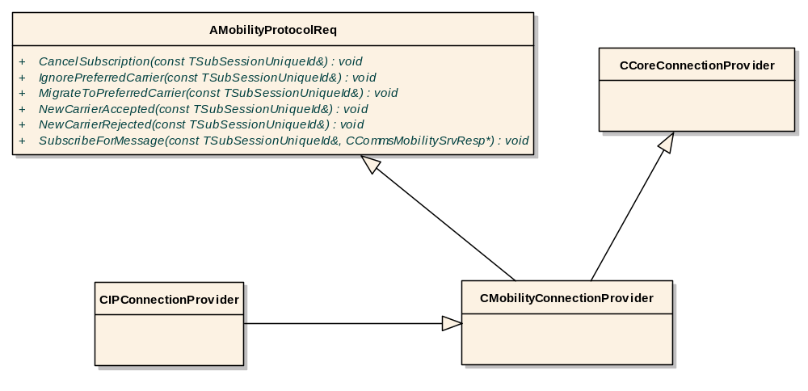
Figure 2: Simple mobility request handling on IpCpr.

Client Notification
Provided the mobility client is ready to receive any notifications (it has registered), the following sequence describes the Cpr’s behaviour:
When a mobile Cpr receives a “migration available” notification from its control provider (the MCpr) instructing it to negotiate a new migration with the mobility client, it will complete the mobility client’s request for subscription to mobility messages with a ‘preferred carrier available’ message.
The mobility client may then respond by signalling the acceptance or otherwise of the new carrier by sending either a ‘new carrier accepted’ or ‘new carrier rejected’ message.
The mobility client can also wait with migration for as long as it is necessary.
If, after a prolonged period of time the newly proposed carrier ceased to be available, the handshake will be errored on the nearest opportunity (once the mobility client decides to migrate to this carrier and registers to receive further notifications).

MCpr Design

Mobility Policy
The MCpr needs to know when to react to or when to ignore the bearer availability notifications. Our reference implementation of the MCpr uses simple prioritised list of APs as a base for the mobility decisions. The list is simply the order of lower MCpr’s (Service Providers) in which they were selected by the reference selection framework.

Blacklisting
As mentioned above there is no blacklisting mechanism offered as part of the PREQ1060 delivery.
Even if rejected, the same carrier (AP) will be offered again each time provided that it is the preferred one.

Mobility Availability Monitoring
The MCpr mobility activity will be started from the connection plane when the mobility client opens the first mobility implementation.
The TStartMobility message will start the mobility activity which in turn will originate availability activity on the mobile MCpr to continuously monitor lower APs for availability.
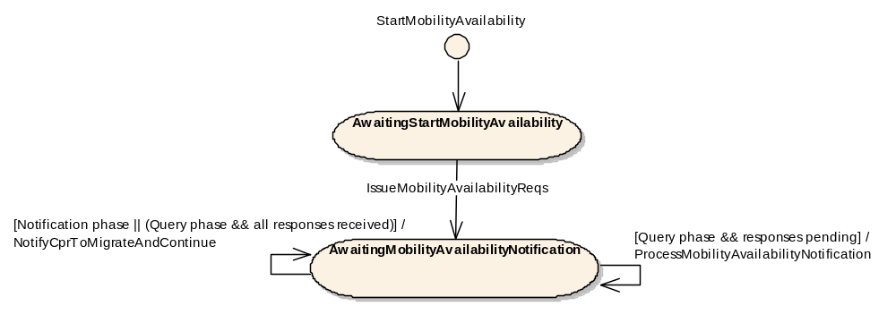
Figure 3: State machine for registering for and responding to lower MCPR availability.
The availability activity is used by the mobility activity to build the request structure (registering for availability notifications with all lower layer MCprs) and it has two phases: a query phase and a notification phase.
The query phase takes place when the mobility implementation is opened and the availability activity is started. The activity issues availability notification requests and waits for all lower MCprs to respond.
Once all responses have been received, the MCpr evaluates the preferability of each of the available APs according with its mobility policy and if there is a more preferred one, instructs the Cpr to handshake a new migration with its mobility client.
The availability activity then moves into the notification phase in which it waits for notifications from any one of the lower MCprs that an AP has become available/unavailable.
When the MCpr receives a notification, the availability activity updates the current availability status of the lower APs.
When the mobility activity is ready (for example it has completed a handshake) it evaluates the availability information accumulated on the node by the availability activity in accordance with its mobility policy.
The mobility activity then makes a decision if to initiate another migration.
The reference mobility activity definition:
namespace MobilityMCprMobilityActivity
{
//This activity monitors availability status on this node
//NOTE: This activity assumes there is only one data client (Cpr) of this MCpr!
//NOTE: This activity can only be executed in the context of CMobilityMetaConnectionProvider (or derived)
//NOTE: TError may come from the availability activity only. It is handled by the ECFActivityError.
DECLARE_DEFINE_CUSTOM_NODEACTIVITY(ECFActivityMCprMobility, MCprMobility, TCFMessage::TStartMobility, MobilityMCprActivities::CMobilityActivity::NewL)
//The activity only makes sense after the startup sequence completed on this layer
FIRST_NODEACTIVITY_ENTRY(MobilityMCprStates::TAwaitingStartMobility, CoreStates::TNoTag)
//Report to the client that we have successfully started
THROUGH_NODEACTIVITY_ENTRY(KNoTag, MobilityMCprStates::TReplyMobilityStarted, CoreStates::TNoTag)
//Issue availability request
THROUGH_NODEACTIVITY_ENTRY(KNoTag, MobilityMCprStates::TSendAvailabilityRequest, CoreStates::TNoTag)
//Set handshake status - this will only be set after a handshake conmpleted (skipped the first time)
//Also, TInformMigrationAvailable will set the status to EActive (immediatelly if the new mobility preference is available)
THROUGH_NODEACTIVITY_ENTRY(MobilityMCprStates::KStartMobilityHandshake, CMobilityActivity::TClearHandshakingFlag, CoreStates::TNoTag)
//Start mobility handshake provided there is a better carrier available
NODEACTIVITY_ENTRY(KNoTag, CMobilityActivity::TInformMigrationAvailableAndSetHandshakingFlagBlockedByConnectionRecoveryOrNoMobilityPreferenceOrError, MobilityMCprStates::TAwaitingMigrationRequestedOrRejected, CMobilityActivity::TNoTagOrErrorTagOrStartMobilityHandshakeBackwards)
// Migrate to the new access point
// For the moment it is sufficient to use the re-connect activity, in the future we may want to
// customise the behavior, for example start the new layer before rebinding it, etc.
NODEACTIVITY_ENTRY(KNoTag, CMobilityActivity::TRequestReConnect, MCprStates::TAwaitingReConnectCompleteOrError, CoreStates::TNoTagOrErrorTag)
//Inform the Cpr:
//If the migration was acepted we loop again waiting for a new, preferred one
//If the migration was rejected we start another one (we can not just reconnect back without the client's consent - please note that
//without a proper blacklisting mechanism in place rejection will result in the same rejected carrier being offered again!)
NODEACTIVITY_ENTRY(KNoTag, CMobilityActivity::TInformMigrationCompleted, MobilityMCprStates::TAwaitingMigrationAcceptedOrRejected, MobilityMCprStates::TStartMobilityHandshakeBackwards)
//On error, we do not terminate the activity.
//We need to inform the client and propose a new handshake should the client wish to continue
THROUGH_NODEACTIVITY_ENTRY(KErrorTag, CoreStates::TRaiseAndClearActivityError, MobilityMCprStates::TStartMobilityHandshakeBackwards)
NODEACTIVITY_END()
}

Interaction between MCpr and Cpr

Below are described main MCpr – Cpr interactions:

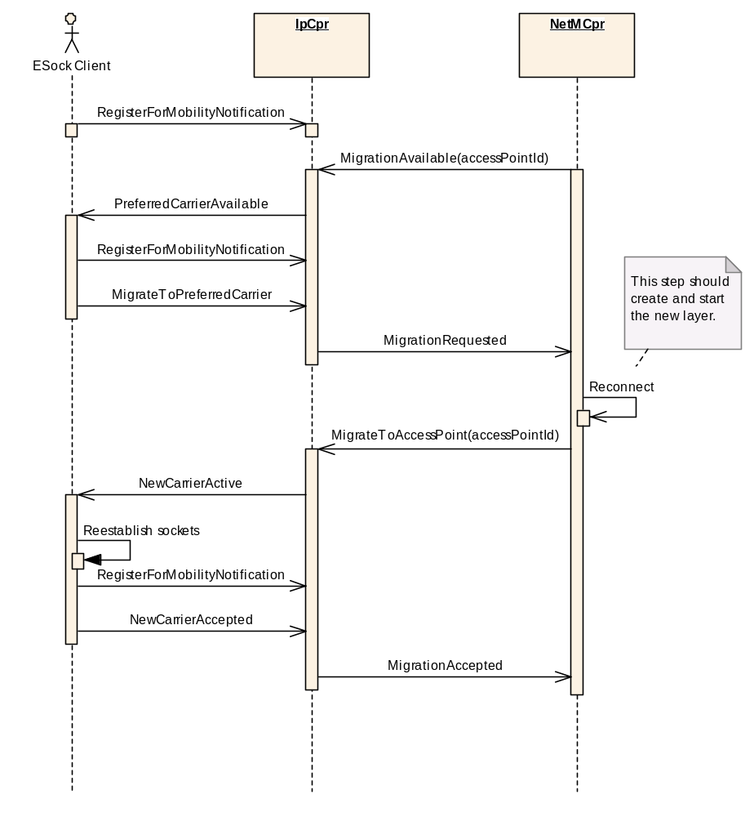

Figure 4: Message sequence for successful migration
Figure 4 shows the sequence of messages between the mobility client (for example ESock client), the Cpr, and MCpr for the case when migration to a new access point is successfully completed.
If interaction with a mobility client is not possible i.e. no client has subscribed for mobility notifications, the migration attempt by the MCpr is rejected. This can be seen in figure 5, below.

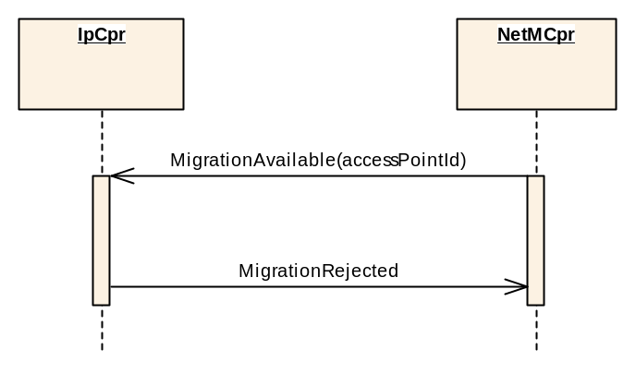
Figure 5: Message sequence for migration attempt with no mobility client

It is possible for the mobility client to reject the migration to a new, more preferred access point.
Figures 6 and 7 below show the two alternative scenarios in which this can happen.

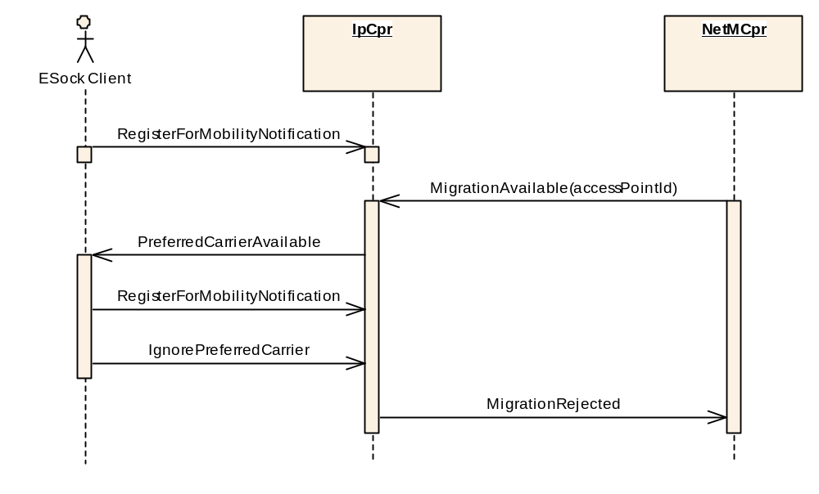
Figure 6: Message sequence where mobility client ignores preferred carrier
Figure 6 illustrates the scenario where the ESock client decides that it does not wish to migrate to the newly notified carrier (AP) without trying it at all. The new carrier is never started in this case and the connection continues on the old access point.

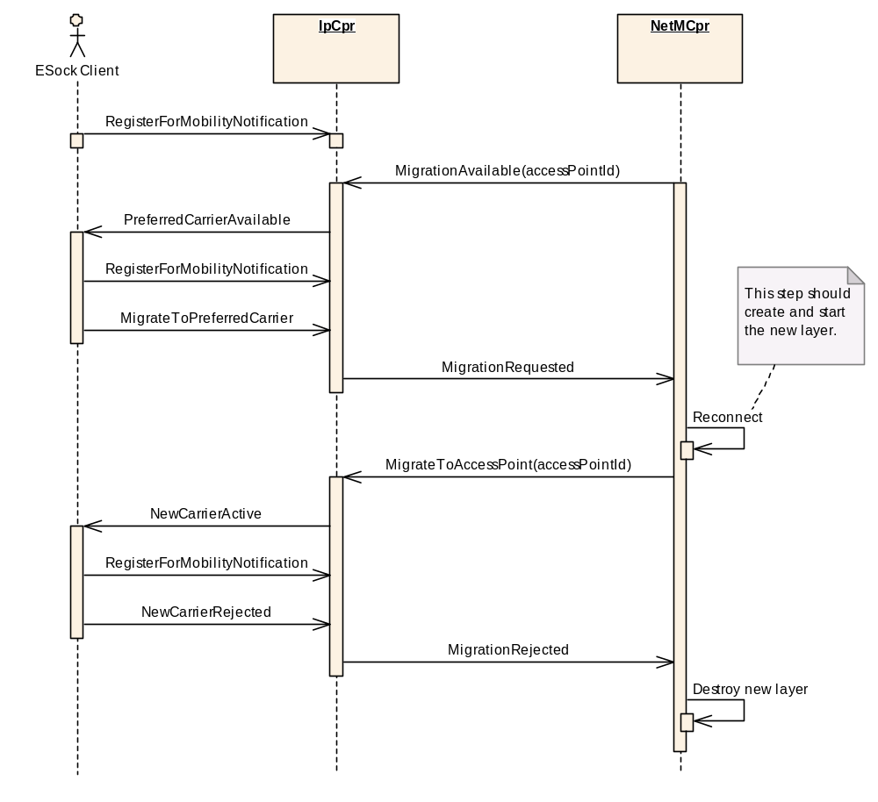

Figure 7: Message sequence where the mobility client rejects a preferred carrier after accepting the migration
Figure 7 illustrates the scenario where an ESock client, having previously accepted a notified preferred carrier, then rejects the carrier for some reason, for example after learning that sockets do not work on the new connection).
Since we do not provide a blacklisting mechanism, the same rejected carrier may be offered by the nearest opportunity.

Testing
Functional testing of PREQ1060 will be performed using the te_BearerMobility test harness described in [R2].

Future Development
As mentioned above, PREQ1060 does not deliver fully stackable mobility implementation because a Cpr can not be at present a mobility client to another Cpr. As mentioned, the reference mobility implementation on MCprs is fully stackable. PREQ1060 delivers all necessary framework mechanisms to make the Cpr mobility implementation stackable and such implementation should become available soon.

The best way to do facilitate a Cpr-to-Cpr communication would be to create self dispatching CF messages which would call the AMobilityProtocolReq APIs. A specialised responder would also need to be used, implementing CCommsMobilitySrvResp, to post responses back to the mobility client node.

The following section describes the basic principles of a stackable mobility implementation in layered architecture:
Mobility may happen at each layer of the connection stack. At each layer, the layer directly above the migrating layer is the mobility client.
A mobility client communicates with the migrating layer below on the connection plane, as only there the mobility is meaningful.
Mobility clients communicate with the migrating layers using Mobility API extension (via asynchronous message posting within the commsfw). In case of the very top layer the esock client is the mobility client. Esock forwards mobility messages to and from the esock client using IPC message mechanism extending the API extension mechanism (and Mobility API extension).
For non seamless bearer mobility, a mobility client must always make a conscious decision about any migration.
This means that migration at the very top layer must always be agreed with the esock client.
Migration at any of the lower layers must be agreed with a layer directly above which in turn may (but does not have to) agree it with its own mobility client above, etc.
This means that a migration deep within the stack does not always have to be agreed with the very top (esock) client, but only when the relevant mobility client refuses to make the decision itself and forwards it up to be made by its own mobility client (and so forth up to the top of the stack).
Should a simultaneous migration take place for two or more layers within the same connection, it should not matter for as long as the relevant mobility clients make their decisions independently. If they require upper layers’ attention (so that both of the mobility handshakes would end up on the same layer) then the second migration should be postponed until the first handshake finishes. In practice, any layer should synchronise negotiating it’s lower layer’s migration with its own layer’s migration notifications/requests on the connection plane.

Glossary

Access Point (AP) = Service access point. A point at which any layer of the connection stack (but the bottom) can obtain services from the next, lower layer. The next layer is a bearer for this layer (see Bearer). The picture below shows the AP philosophy. The physical layer however is at the moment somewhat merged with link layer. (see IAP).

Network layer
Link layer
IP
Physical layer
GPRS
WiFi
CSD
MCP
AP
AP
AP
AP
AP
Figure 6-1: Definition of an access point. At each layer of the connection stack, each bearer provides its access point(s) through which an upper layer can obtain its services

Bearer = Provider of a particular connection (e.g. WiFi, LAN, IP,…). A bearer advertises access points as an access to services (see Access Point).
Carrier = An Access Point that belongs to a layer where the Mobility (bearer switch) takes place as seen by the Mobility client.
Connection Provider = An object (instance) representing an access point.
Default SNAP = A default AP (on the network layer).
IAP = Internet Access Point. It is a specialisation of AP for a link layer. IAPs identify a service to access via a very concrete link layer bearer. It at the moment comprises Link bearer type, service type and physical bearer type. Please note that mobility API refers to AP instead of IAP. IAP is effectively link tier AP. To keep BC with application referring to IAP rather than link tier AP commsDat must make sure that for every IAP there is one link tier AP having the same physical value.
Legend:
generalization
Access Point (AP)
Internet Access Point (IAP)
Service Network Access Point (SNAP)
Figure 6-2 “Hierarchy” of Access Points

Mobility Client = A client application that uses a Mobility Extension API.
Mobility Implementation = A server side implementation that provides Mobility functionality enabled by the Mobility Extension APIs. Usually implemented as part of a Connection (or a Meta Connection) Provider.
Next layer = layer immediately below.
Plugin = (ECom plugin) = An implementation that can be instantiated in the client’s process by the ECom component via especially provided dlls.
Policy plugin = An implementation of a policy logic (pluggable logic, algorithm).
Preferred Carrier = A Carrier that the Mobility client prefers to the one currently used.
Previous layer = layer immediately above.
Service Network = Destination Network plus required service (e.g. IMAP on Symbian network).
SNAP = Service Network Access Point. It is a specialisation of AP for a network layer. A concept developed especially for bearer mobility to identify a Service Network with a service to be accessed on this network. It decouples this information from any particular bearer (see AP).
While the old concept of IAPs (Internet Access Points – and in fact a link layer access points) works fine for connections (even with Multihoming – where the device can connect to multiple networks at the same time) in a non-bearer mobility environment, it is inadequate for bearer mobility environments. An IAP is always tied up to (represents) a particular link layer bearer and as such cannot be used to specify bearer independent selection preferences.
Service Network Access Point (SNAP = network layer access point) has been introduced to address the needs of applications to specify access points on service networks for particular services without the need to care about any particular link layer bearers.
For the purpose of this document it is also possible to think of a SNAP as a collection of IAPs that specify the same network and the same service on that network. This document describes the simplest SNAP selection policy forming such a collection of IAPs (one or more IAP ordered by their desirability to access the particular service).
Internet – provides services X & Y.
Symbian
Vodafone
1. WiLan
2. Ethernet
3. GPRS
4. WiLan
A firewall which blocks service X, but allows service Y
SNAPX: 4,3.
SNAPY: 1,2,4,3.
App
MS
Figure 6-3 An application X may want to use service X while another application Y may want to use service Y (in this example on the same service network). In this example access via Symbian’s network is preferred as well as WiLan is preferred over GPRS. Somewhere in between Symbian and Internet there is a firewall blocking all traffic of type X. Of course each application could simply be trying each IAP one by one but it could also specify a SNAP it wants to use. Since then all the work of the bearer selection and mobility will be done for the application.

People

Role | Person / People
Reviewers | Petr Smrz
Contributors | Ivan Kelly, Michal Zurowski, Simon Turvey
Distribution | Anyone using or maintaining the Mobility APIs.

References
No. | Document Reference | Version | Description
R1 | NonSeamlessBearerMobility_ClientSideAPIs.doc | Newest | Mobility APIs - client side
R2 | Non-Seamless Bearer Mobility Test Spec | Newest | Test spec
R3 | NonSeamlessBearerMobility_ServerSideAPIs.doc | Newest | Mobility APIs - server side

Open Issues
- More scenarios will be added to complete the use cases for the API

Document History
Date | Version | Status | Author | Description
15-01-2007 | 0.1 | Draft | Simon Turvey | New Document
06-02-2007 | 0.2 | Draft | MichaZurowski | Initial revision
01-05-2006 | 0.3 | Draft | Ivan Kelly | Updated description of the Connection Plane
08-05-2006 | 0.4 | Draft | Michal Zurowski | Updated description of the Management Plane

