Network Controller Design Document

Security Classification: | INTERNAL
Document Reference: | SGL.GT0117.278
Status: | ISSUED
Version: | 1.2
Team/Department : | Core Development/Software Engineering
Author(s): | Steve Larkin
Owner(s): | Networking Technology Team

Approver(s): | Nathalie Doyelle | Distribution: | Symbian and Licensees

Contents
1 Introduction 3
1.1 Purpose and Scope 3
2 Design Overview 3
3 Detailed Design 4
3.1 CNetworkController 4
3.1.1 Overview 4
3.1.2 UML Diagram 5
3.1.3 Design Unit Behaviour 6
3.2 CNetConRequestBase 7
3.2.1 Overview 7
3.2.2 UML Diagram 7
3.2.3 Design Unit Behaviour 8
3.3 CSelectionRequest 8
3.3.1 Overview 8
3.3.2 UML Diagram 9
3.3.3 Design Unit Behaviour 10
3.4 CReconnectRequest 10
3.4.1 Overview 10
3.4.2 UML Diagram 11
3.4.3 Design Unit Behaviour 12
3.5 CTelBearer 13
3.5.1 Overview 13
3.5.2 UML Diagram 14
3.5.3 Design Unit Behaviour 15
4 Scenarios for connection retries 16
4.1 Connection fails during IAP selection 16
4.2 Connection fails during agent connection 17
4.3 Connection fails during NIF negotiation 18
5 Further Information 19
5.1 People 19
5.2 References 19
5.3 Open Issues 19
5.4 Glossary 19
5.5 Document History 19
5.6 Document Review Date 20

Introduction

Purpose and Scope
This document contains the design of the Network Controller component (NETCON) in Symbian OS. The intended audience is the Networking Team at Symbian and any licensees working in the networking area.
The NETCON component in the 7.0s release of Symbian OS replaces the existing GENCONN component in previous releases [R2]. The NETCON component satisfies parts of the Multihoming and Multiple PDP Contexts requirements in 7.0s [R3].

Design Overview
NETCON is a replaceable polymorphic DLL module that plugs into the Network Interface Manager (NIFMAN). NIFMAN provides the framework that all Network Controllers must fit into as a series of base classes. More details of this framework can be found in the NIFMAN design document [R4].
The primary purpose of NETCON is to select an Internet Access Point (IAP) to which the Networking subsystem should establish a new connection. This scenario will from now on be referred to as “Selection”. To perform the Selection scenario NETCON interacts with NIFMAN, the Comms Database (COMMDB), the Telephony Server (ETEL) and the User via the Agent Dialog Server (AGENTDIALOG). Figure 2-1 below shows a high level view of how these components interact.
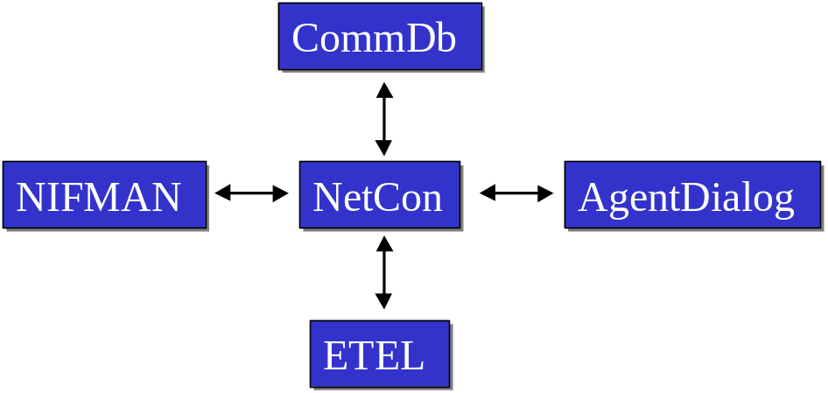
Figure 2-1
NETCON is also responsible in dealing with the case where a previously established connection is dropped. In this case NETCON interacts with the components shown in Figure 2-1 to decide whether to re-establish the connection. From now on this scenario will be referred to as “Reconnection”. Since multiple requests for Selection and Reconnection may be made simultaneously NETCON must queue these requests and process them one by one. During both the Selection and Reconnection cases NETCON may query ETEL to see whether the selected physical bearer is available. If the bearer is not available then an appropriate error code is returned. The class diagram in Figure 2-2 shows how the Selection and Reconnection Requests are modelled along with the other main elements of NETCON. The classes contained within NETCON are CNetworkController, CNetConRequestBase, CSelectionRequest, CReconnectRequest and CTelBearer. The design of each of these classes is discussed in section 3.
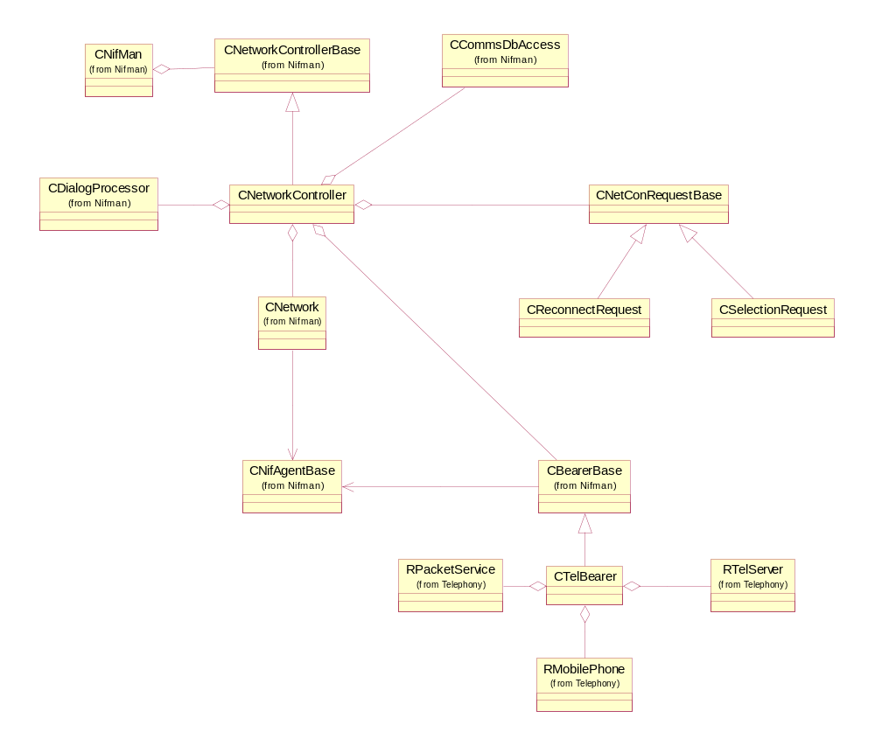
Figure 2-2

Detailed Design
As described in section above NETCON consists of 5 classes: CNetworkController, CNetConRequestBase, CSelectionRequest, CReconnectRequest and CTelBearer. The CNetworkController class acts as the interface to and from NIFMAN and holds all resources shared by the other classes in NETCON such as the Comms Database and the Agent Dialog Server. The CNetworkController class queues requests for Selection and Reconnection – these queued requests are modelled as the CSelectionRequest and CReconnectRequest classes (with common functionality contained in the CNetConRequestBase class). The CTelBearer class is responsible for the interaction with ETEL necessary to assess the availability of the telephony bearers (i.e. GSM, WCDMA, CDMA-95 and CDMA-2000) and services (e.g. GPRS and CDMA packet data). Each of the NETCON classes is discussed in further detail in the following sections.

CNetworkController

Overview
CNetworkController is responsible for the overall co-ordination of NETCON. It queues Selection and Reconnection requests received from NIFMAN in a FIFO queue of CNetConRequestBase objects. When a new request is received CNetworkController adds it to the end of the queue and, if one is not already being processed, the first request is removed from the queue and starts to be processed. When a request completes CNetworkController reports the result of processing the request back to NIFMAN and then starts to process the next request in the queue (if there is one). The CNetworkController class also owns the resources shared by the rest of NETCON such as the communication paths towards the AGENTDIALOG and COMMDB.

UML Diagram
The API between NIFMAN and any Network Controller module is defined by the abstract base class CNetworkControllerBase. The reverse API – from a Network Controller towards NIFMAN – is defined by the MNetworkControllerObserver class. The class definitions of these two APIs that define the asynchronous interface between NIFMAN and NetCon are shown in Figure 3-3 and Figure 3-4 below.
Figure 3-3
class CNetworkControllerBase : public CBase, public MBearerObserver
{
public:
IMPORT_C virtual ~CNetworkControllerBase();

// pure virtual interface required for use by Nifman
virtual void SelectAgent(MNetworkControllerObserver* aObserver, TConnStartType aDirection,
TInt aConnectionAttempt, TInt aLastConnectionError) = 0;
virtual void SelectAgent(MNetworkControllerObserver* aObserver, TConnStartType aDirection,
TInt aConnectionAttempt, TInt aLastConnectionError, const TConnPref& aPref) = 0;
virtual void Reconnect(MNetworkControllerObserver* aObserver, CNifAgentBase* aAgent) = 0;
virtual void Reconnect(MNetworkControllerObserver* aObserver, CNifAgentBase* aAgent,
CStoreableOverrideSettings* aOverrides) = 0;
virtual TInt CancelRequest(MNetworkControllerObserver* aObserver) = 0;
virtual void AgentConnectionFailure(CNifAgentBase* aAgent, TInt aError) = 0;

IMPORT_C TInt FindNetworkById(TUint32 aNetworkId, CNetwork*& aNetwork) const;
IMPORT_C void AddNetworkL(CNetwork* aNetwork);
IMPORT_C void AddBearerL(CBearerBase* aBearer);

protected:
IMPORT_C CNetworkControllerBase();

protected:
RPointerArray<CBearerBase> iBearers;
RPointerArray<CNetwork> iNetworks;
};

Figure 3-4
class MNetworkControllerObserver
{
public:
virtual void SelectComplete(const TDesC& aName) = 0;
virtual void SelectComplete(TInt aError) = 0;
virtual void ReconnectComplete(TInt aError) = 0;
};

All functions in the CNetworkControllerBase API take as a parameter an MNetworkControllerObserver pointer. When one of these functions completes a corresponding function in the MNetworkControllerObserver class is called. For example when the function CNetworkControllerBase ::SelectAgent() completes the relevant SelectComplete() function from MNetworkControllerObserver is called. The class and sequence diagrams below (Figure 3-6 and Figure 3-6) show this relationship.
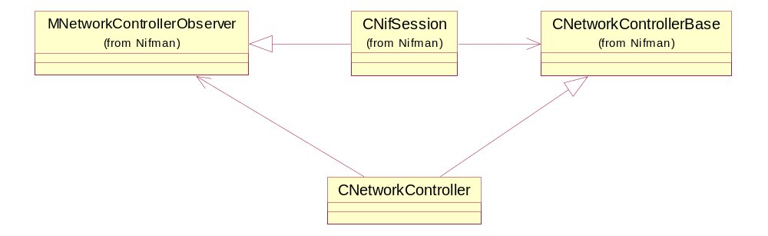
Figure 3-5
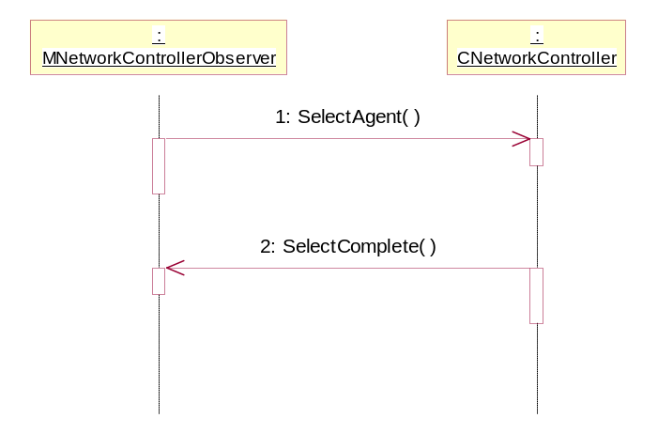
Figure 3-6
The following internal APIs are defined between the classes in NetCon: MNetConDbAccess, MNetConDialogProcAccess and MNetConEnv. The CNetworkControllerBase class implements these 3 APIs which CNetConRequestBase and CTelBearer objects use. A summary of the APIs is given in Table 3-1 below. These APIs are intended to provide increased modularity and to allow test harnesses to stub-out certain classes.
API | Description | Used By
MNetConDbAccess | Provides access to COMMDB | CSelectionRequest, CReconnectRequest and CTelBearer
MNetConDialogProcAccess | Provides access to AGENTDIALOG | CSelectionRequest and CReconnectRequest
MNetConEnv | Used to inform the CNetworkController of state changes such as a request or a bearer availability check completing. | CSelectionRequest, CReconnectRequest and CTelBearer
Table 3-1

Design Unit Behaviour
Figure 3-7 shows the sequence of events following a call to the CNetworkControllerBase API function SelectAgent(). First of all the CNetworkController class creates a new CSelectionRequest from the parameters given in the call to SelectAgent(). This request is added to the queue and an asynchronous callback is triggered to start the processing of the request. When the callback completes the ProcessRequestCb() function is called (step 3 in the diagram). This function removes the first request from the queue – in this case the CSelectionRequest added in step 2 – and calls the StartRequest() function which instructs the request to start its processing. Later on, when the request has completed its processing it calls back to the CNetworkController class using the RequestComplete() function. The CNetworkController class then returns the result of the request to the appropriate observer (in this case the CNifSession).
The sequence of events described here is independent of the actual type of request. For instance if step 1 in the diagram was actually a call to the Reconnect() function of the CNetworkController API the only difference in the events would be that a CReconnectRequest would be created.

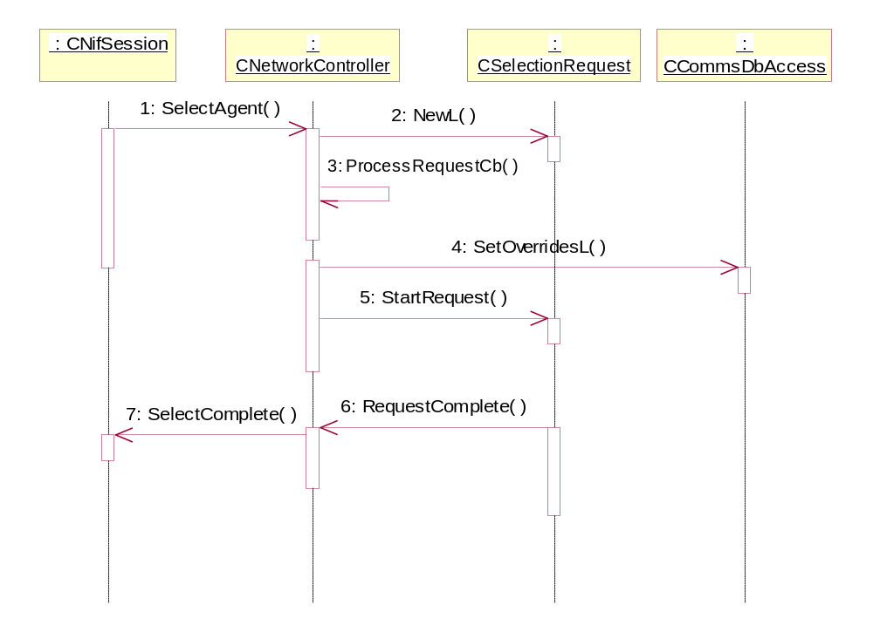
Figure 3-7

CNetConRequestBase

Overview
The CNetConRequestBase class provides the functionality common to both selection and reconnection requests.

UML Diagram
Figure 2-2 shows how CSelectionRequest and CReconnectRequest classes inherit from the CNetConRequestBase class. Figure 3-8 shows the class definition for the CNetConRequestBase class.
Figure 3-8
class CNetConRequestBase : public CBase, public MDialogProcessorObserver
{
public:
virtual ~CNetConRequestBase();

// Start processing this request
virtual void StartRequest() = 0;

// force premature completion of a request with a given error
virtual void RequestComplete(TInt aError) = 0;

virtual void CancelRequest() = 0;

// Bearer availability
virtual void SetAvailableBearers(TUint32 aBearerSet) = 0;

// accessors
CStoreableOverrideSettings* Overrides() const;
MNetworkControllerObserver* Observer() const;

protected:
CNetConRequestBase(MNetConDbAccess* aDatabase, MNetConDialogProcAccess*
aDialogPrc, MNetConEnv* aController,
MNetworkControllerObserver* aObserver,
CStoreableOverrideSettings* aOverrides);

TBool SelectedServiceAvailable(TUint32 aAvailableBearerSet) const;

protected:
MNetConDbAccess* const iDatabase;
MNetConDialogProcAccess* const iDialogPrc;
MNetConEnv* const iController;
MNetworkControllerObserver* const iObserver;
CStoreableOverrideSettings* iOverrides;
TConnectionSettings iSettings;

public:
// link to next element in the queue
TSglQueLink iLink;
};

Design Unit Behaviour
The CNetworkController class maintains a FIFO queue of CNetConRequestBase objects. The only concrete behaviour implemented inside the CNetConRequestBase class is the function SelectedServiceAvailable(). This function takes the available bearer set and calculates whether the service (i.e. CSD, GPRS, CDMA or LAN) selected by the user is available.

CSelectionRequest

Overview
The CSelectionRequest class is responsible for the selection of an IAP to which to make a network connection. This selection is based on the settings contained within COMMDB and may involve interaction with the User via AGENTDIALOG. Once an IAP has been selected the CSelectionRequest class must request NIFMAN to load the appropriate agent module. The UML sequence diagram (Figure 3-9) in the following section shows the sequence of events that commonly occur during the processing of a CSelectionRequest.

UML Diagram
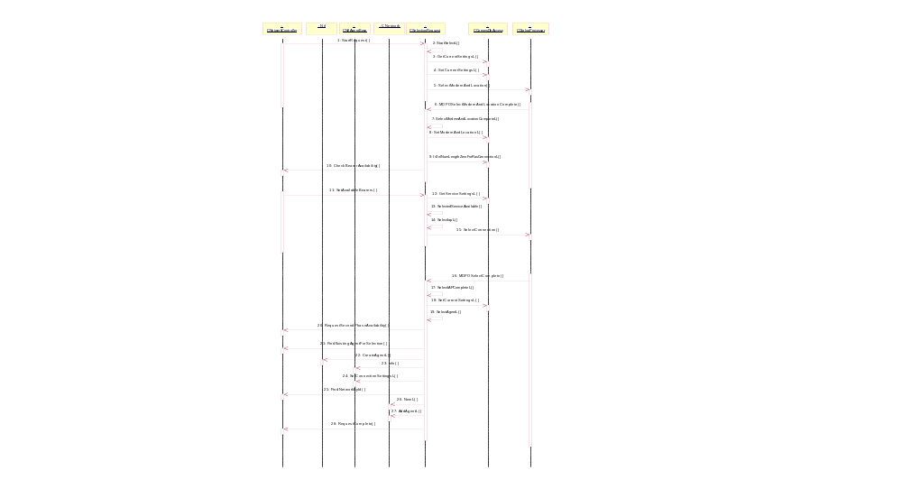
Figure 3-9

Design Unit Behaviour
The sequence of events shown in Figure 3-9 can be broken down into five main areas. First the CSelectionRequest reads the current connection preferences from COMMDB. Second it requests that the CNetworkController initiate a bearer availability check. Third, when the bearer availability check completes, the CSelectionRequest instructs AGENTDIALOG to display a list of IAPs filtered on the available bearers. Fourth, when the dialog box completes the CSelectionRequest instructs NIFMAN to load the appropriate agent module for the selected IAP. Fifth and finally the CSelectionRequest notifies the CNetworkController that it has completed its request.
It should be noted that this description covers only one scenario. Depending on the connection preferences AGENTDIALOG may be asked to display a dialog box warning the user that the device is about to connect to the IAP and asking them whether they would like to continue or cancel the connection. As an alternative, the connection preferences may dictate that the connection should be established without user interaction – in this case no dialog box will be displayed. Another alternative scenario is that the connection preference’s dialog setting is “warn” or “do not prompt” and the service setting indicates either LAN or NTRAS. In this scenario the bearer availability check can be skipped as the radio network will not actually be used.

CReconnectRequest

Overview
The CReconnectRequest class is responsible for deciding whether or not to re-establish a failed connection. In order to do this the CReconnectRequest class interacts with the User via AGENTDIALOG.
The CReconnectRequest class is responsible for deciding whether to re-establish connections that fail after having previously progressed beyond the KLinkLayerOpen stage. When a connection of this type fails NIFMAN calls the agent module’s Reconnect() function to decide whether to go ahead with the reconnection – the sequence diagram in Figure 3-10 shows this. The sequence diagram in Figure 3-11 shows how CAgentBase-derived classes ask NETCON to decide whether to reconnect or not.

UML Diagram
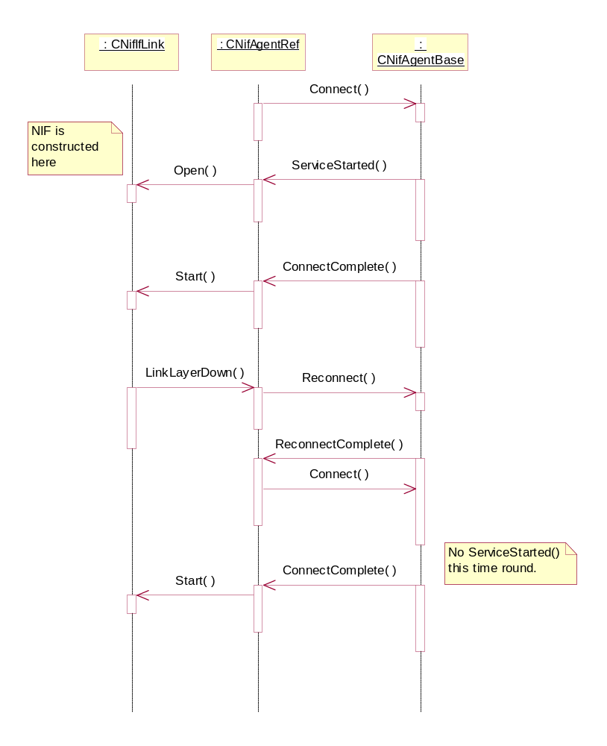
Figure 3-10
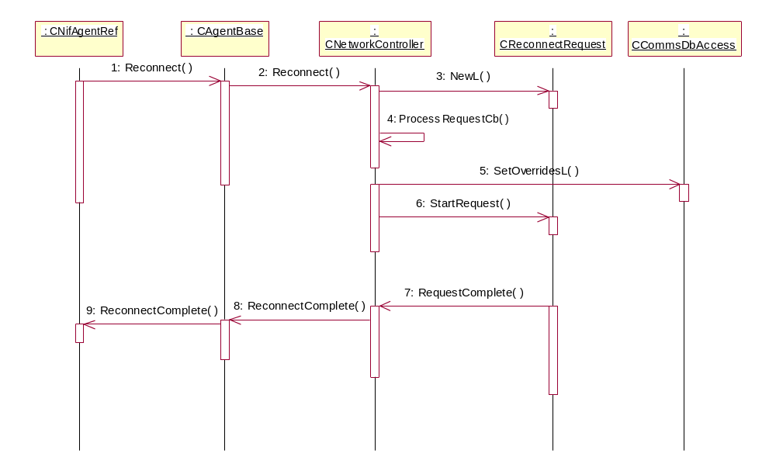
Figure 3-11
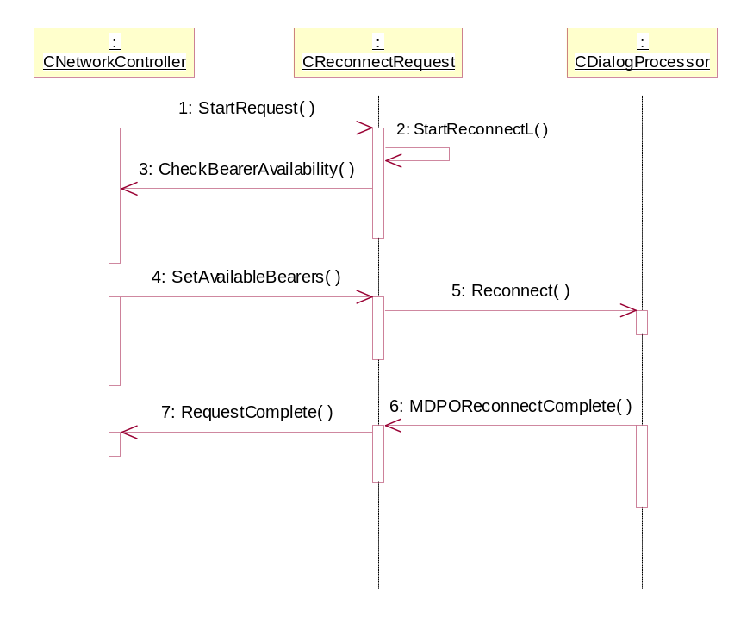
Figure 3-12

Design Unit Behaviour
Figure 3-12 shows how the CReconnectRequest class first checks to see if the underlying physical bearer is still available and then instructs AGENTDIALOG to prompt the User whether or not to reconnect. If, at stage 4, the bearer is no-longer available then the request will complete with KErrCancel to inform NIFMAN not to continue with the reconnection.

CTelBearer

Overview
The CTelBearer class is responsible for all of the interaction with ETEL necessary to work out whether the mobile radio network is available.

UML Diagram
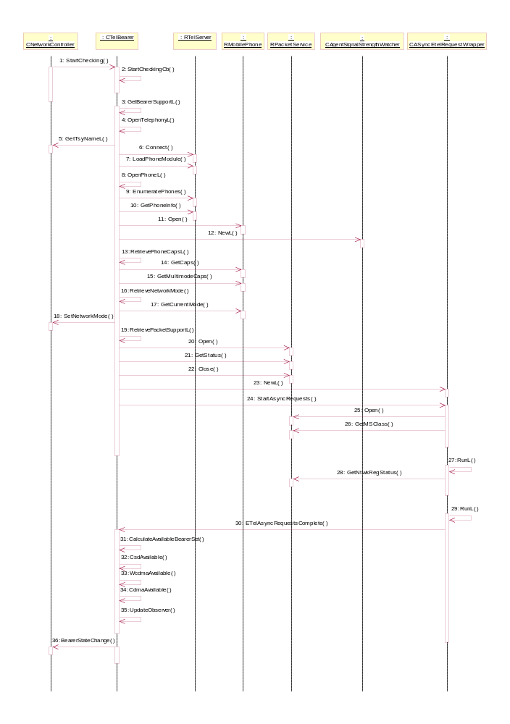
Figure 3-13

Design Unit Behaviour
The sequence diagram in Figure 3-13 shows the details of how telephony bearer availability checking is carried out by the CTelBearer class. This procedure can be split into two stages.
First CTelBearer collects the following information from ETEL:
- The phone capabilities (both basic and multimode)
- The network mode (GSM, WCDMA, cdma95 or cdma2000)
- Whether packet data is supported
Secondly CTelBearer calculates which of the telephony services (CSD, WCDMA or CDMA) are available using the following algorithm.
CSD (either on GSM or CDMA networks) is available if the information gathered in item (a) above indicates that the phone is capable of making data-calls.
WCDMA (used here as a generic term for packet data in GSM/GPRS/WCDMA networks) is available if the following three criteria are met:
- the information gathered in item (a) above indicates that the phone is capable of doing GPRS or WCDMA packet data
- the phone’s MS-class supports packet data
- the phone is attached and registered on the mobile radio network.
CDMA (used here as a generic term for packet data in cdma95 and cdma2000 networks) is available if the following three criteria are met:
- the information gathered in item (a) above indicates that the phone is capable of doing cdma95 or cdma2000 packet data
- the phone’s MS-class supports packet data
- the phone is attached and registered on the mobile radio network.

Scenarios for connection retries

Connection fails during IAP selection
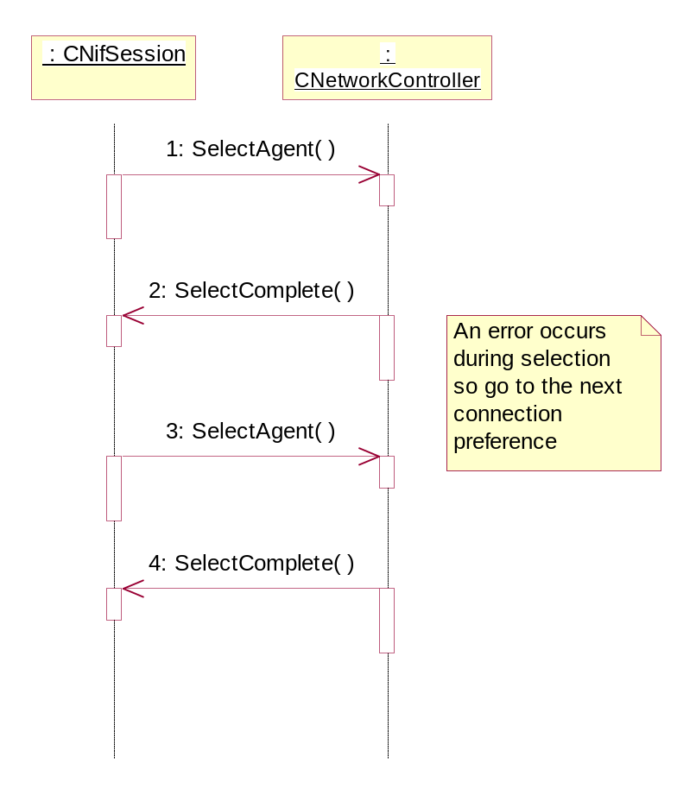
Figure 4-14

Connection fails during agent connection
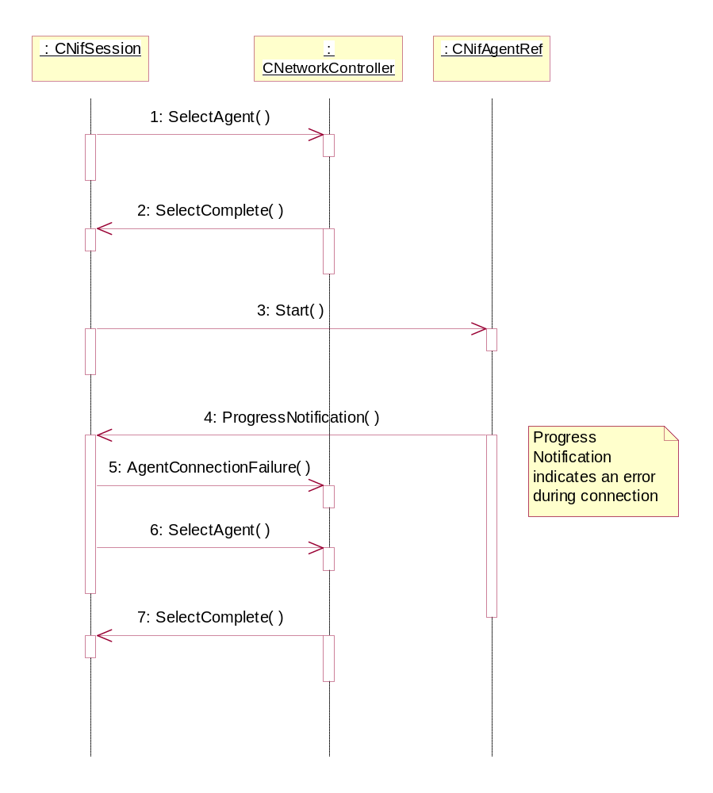
Figure 4-15

Connection fails during NIF negotiation
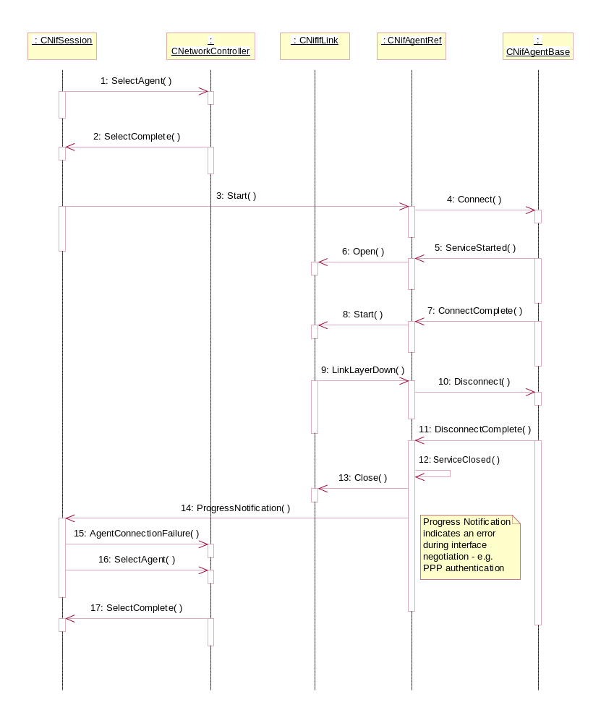
Figure 4-16

Further Information

People
Role | Person / People
Contributor(s)
Reviewer(s) | Richard Collin & Nadeem Wahid

References
No. | Document Reference | Version | Description
[R1] | “UML Explained” |  | by Kendall Scott  (http://www.amazon.co.uk/exec/obidos/tg/stores/detail/-/books/0201721821/toc/202-4456432-1159001)
[R2] | SGL.GT0116.041 | 1.0 | GENCONN design for Hurricane
[R3] | SGL.PGM012.200 | 1.3 | Typhoon High Level Requirements Specification
[R4] | SGL.GT0117.298 | 1.0 | Nifman Design Document

Open Issues
None.

Glossary
The following technical terms and abbreviations are used within this document.
Term | Definition
AGENTDIALOG | The Symbian OS Agent Dialog Server. Displays different types of dialog boxes to the user.
CDMA-95 | Second generation North American air interface standard defined by the 3GPP2 organisation.
CDMA-2000 | Third generation North American air interface standard defined by the 3GPP2 organisation.
COMMDB | The Symbian OS Comms Database – stores information used by the Comms components such as IAP details.
ETEL | The Symbian OS Telephony Server.
GPRS | Standard defined by ETSI/3GPP for the transmission of packet data over the GSM and WCDMA air interfaces.
GSM | Second generation European air interface standard defined by the ETSI standards body.
IAP | An Internet Access Point. Defines the settings used when making a connection.
NIFMAN | The Symbian OS Network Interface Manager.
WCDMA | Third generation European and Asian air interface standard defined by the 3GPP organisation.

Document History
Date | Version | Status | Description
26-11-2002 | 1.2 | Issued | Minor modification to replace reference to the multihoming design/architecture document with the Nifman design document.  Changed distribution to “Symbian and Licensees”
25-11-2002 | 1.1 | Issued | Updated after review
19-11-2002 | 1.0 | Issued | Issued for review
23-08-2002 | 0.1 | Draft | First draft based on SGL.PPS001.457 Component Design Document Template Rev 2.0

Document Review Date
Version 1.0 of this document was reviewed on 20th November 2002. See the review logging form for more details.

