Network Controller Unit Test Specification
Security Classification: | INTERNAL | Team/Department: | Core Development / Software Engineering
Document Reference: | SGL.GT0117.308 | Author(s): | Steve Larkin
Status: | Issued | Owner(s): | Steve Larkin
Version: | 1.8 | Approver(s) | Nathalie Doyelle
Last Revised Date: | 11-12-2002 |  | Nathalie Doyelle

Introduction

Purpose and Scope
This document specifies a series of unit test cases for the Network Controller component. Unit test cases are defined for each class in the Network Controller component as recommended by the SSG Unit Test Standard [1]. The test cases will run in the automated integration test environment [2].
Each unit test table consists of four columns, as detailed below:
Column Heading | Description
Test Case | Unique index used to reference a specific test
Description | The purpose of the test.
Procedure | Programmatic steps to follow to execute the test case
Parameters & results | Expected return code
Expected behaviour & Comments | The test is deemed to have passed if the class exhibits the expected behaviour.

How to run the tests

In the Emulator
1. Build the NetCon test code: ts_queue.dll, ts_netcon.dll and ts_netconoom.dll
2. In the emulated file system create the directory: c:\logs\testresults
3. Lauch scheduletest specifying either the top level script (netcon.script) or the individual NetCon test script file:
- Ts_netcon.script
- Ts_queue.script
- Ts_netconoom.script
e.g. \epoc32\release\wins\udeb\scheduletest.exe z:\testdata\scripts\ts_netcon.script
4. The test results are contained in: c:\logs\testresults\<scriptname>.htm

On Target
1. Build a ROM image including the NetCon test iby file: tnetcon.iby.
2. Boot the ROM on the target platform and create the directory: c:\logs\testresults
3. From ESHELL run scheduletest specifying the NetCon test script file: netcon.script.
i.e. the command line: z:\scheduletest.exe z:\netcon.script
4. The test results are contained in: c:\logs\testresults\netcon.htm

CNetworkController class

Class description
The CNetworkController class is responsible for interaction with NIFMAN. The class holds a queue of requests received from NIFMAN and controls processing of these requests in a FIFO manner. The CNetworkController class is responsible for ownership of the global resources shared by the requests (i.e. access to the Comms database, the dialog server and the bearers).

Unit Test Harness Design – TS_QUEUE
In order to test the CNetworkController class it is necessary to stub-out some of the classes around it.
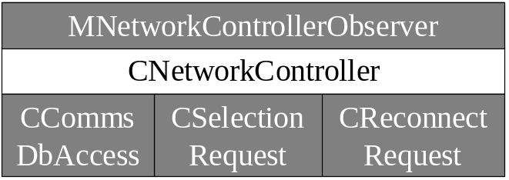
It is not necessary to implement all of the functions of each stubbed-out class. For instance the CNetworkController class uses the single function SetOverrides() from the CCommsDbAccess class. The sequence diagrams in the Network Controller design [3] give more details of the functions used by each class.

Unit Test Cases
The code can be found in “networking\netcon\ts_queue\QueueTests.cpp”
Test Case | Description | Procedure | Parameters & results | Expected behaviour & Comments
NC-1-1 | Test a single request to select an Agent | From the MNetworkControllerObserver derived class call CNetworkController::SelectAgent(). | KErrNone with the name of the agent. | The name of the agent returned in MNetworkControllerObserver::SelectComplete() should be the one returned to the network controller by the stubbed-out CSelectionRequest class.
NC-1-2 | Test a single request to select an Agent – failure case. | From the MNetworkControllerObserver derived class call CNetworkController::SelectAgent(). | Anything other than KErrNone. | The error code returned by MNetworkControllerObserver::SelectComplete() should be that returned to the network controller by the CSelectionRequest.
NC-1-3 | Test adding a single reconnect request | From the MNetworkControllerObserver derived class call CNetworkController::Reconnect(). | KErrNone. | MNetworkControllerObserver::ReconnectComplete() should be called with KErrNone.
NC-1-4 | Test adding a single reconnect request – failure case | From the MNetworkControllerObserver derived class call CNetworkController::Reconnect(). | Anything other than KErrNone. | MNetworkControllerObserver::ReconnectComplete() should be called with the error code returned to the Network Controller by the stubbed-out CReconnectRequest.
NC-1-5 | Test cancelling a queued selection request. | From the MNetworkControllerObserver derived class call CNetworkController::SelectAgent() followed by CNetworkController::CancelSelect(). | None. | The CSelectionRequest should be added to the queue and then removed from the queue without being processed.
NC-1-6 | Test cancelling a selection request that is currently being processed. | From the MNetworkControllerObserver derived class call CNetworkController::SelectAgent(). Issue a callback in order to yield and let the network controller start to process the request. After the callback call CNetworkController::CancelSelect(). | None | The current request should be stopped and cancelled.
NC-1-7 | Test cancelling a queued reconnect request. | From the MNetworkControllerObserver derived class call CNetworkController::Reconnect() followed by CNetworkController::CancelReconnect(). | None. | The CReconnectRequest should be added to the queue and then removed from the queue without being processed.
NC-1-8 | Test cancelling a reconnect request that is currently being processed. | From the MNetworkControllerObserver derived class call CNetworkController::Reconnect(). Issue a callback in order to yield and let the network controller start to process the request. After the callback call CNetworkController::CancelReconnect(). | None | The current request should be stopped and cancelled.
NC-1-9 | Test adding multiple requests | From the MNetworkControllerObserver derived class call CNetworkController::SelectAgent() and CNetworkController::Reconnect() multiple times in a pseudo-random order. | None. | The SelectComplete() and ReconnectComplete() functions of MNetworkControllerObserver should be called in the same order in which the corresponding SelectAgent() and Reconnect() calls were made.
NC-1-10 | Test adding multiple requests and cancelling some of them | From the MNetworkControllerObserver derived class call CNetworkController::SelectAgent(), CNetworkController::CancelSelect(), CNetworkController::Reconnect() and CNetworkController::CancelReconnect() multiple times in a pseudo-random order. | None | The SelectComplete() and ReconnectComplete() functions of MNetworkControllerObserver should be called in the same order in which the corresponding SelectAgent() and Reconnect() calls were made. Any requests that were cancelled by the user should not cause SelectComplete() or ReconnectComplete() to be called.
NC-1-11 | Test addition of an agent to a new network | Instantiate a new agent and call CNetworkController::AddAgentToNetwork() | Parameter – the network id to add the agent to. | The agent should be added to the network. On test completion there should not be any memory leak. This demonstrates that the networks are de-allocated correctly.
NC-1-12 | Test addition of an agent to an existing network | Instantiate a new agent and call CNetworkController::AddAgentToNetwork(). Instantiate another new agent and call CNetworkController::AddAgentToNetwork() again specifying the same network id as before. | Parameter – the network id to add the agent to | The two agents should be added to the single network. On test completion there should not be any memory leak. This demonstrates that the networks are de-allocated correctly.
NC-1-13 | Test double addition of an agent to a network | Instantiate a new agent and call CNetworkController::AddAgentToNetwork(). Then call CNetworkController::AddAgentToNetwork() with the same agent. | Parameter – the network id to add the agent to | It should not be possible to add an existing agent to the network.

CSelectionRequest class

Class description
The CSelectionRequest class is responsible for controlling the selection of connection settings such as Modem, Location and IAP. The class is responsible for filtering the list of IAPs based upon which bearers are available. Based on the selected settings the CSelectionRequest class must request NIFMAN to load a suitable Agent. To achieve these goals the class must read settings from the Comms database and interact with the user via the dialog server.

Unit Test Harness Design – TS_NETCON
The following stubbed classes are required for the CSelectionRequest unit tests.
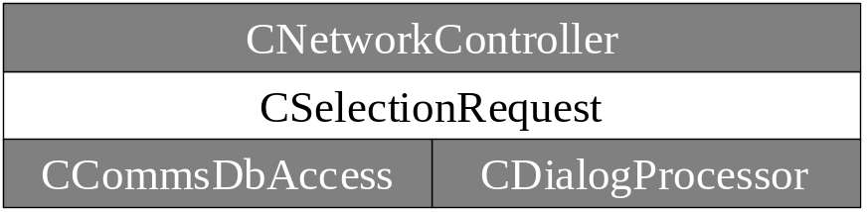
Note that not all member functions of the classes will need to be implemented.

Unit Test Cases
The code can be found in “D:\epoc\CELL\networking\netcon\ts_netcon\ SelectionTests.cpp”
Test Case | Description | Procedure | Parameters & results | Expected behaviour & Comments
NC-2-1 | Test selection when connection attempts is below the maximum | Instantiate a new CSelectionRequest with connection attempt 1 and call StartRequest(). | RequestComplete() should be called with KErrNone | When the GetConnectionAttempts() method is called the stubbed out CNetworkController should return 2.
NC-2-2 | Test selection when connection attempts is above the maximum | Instantiate a new CSelectionRequest with connection attempt 3 and call StartRequest(). | RequestComplete() should be called with an error | When the GetConnectionAttempts() method is called the stubbed out CNetworkController should return 2.
NC-2-3 | Test selection of agent for implicit outgoing connection | Instantiate a new CSelectionRequest with connection direction EAgentStartOutgoingImplicit and call StartRequest(). | RequestComplete() should be called with the same agent name returned by ImplicitConnectionAgentName() | When the ImplicitConnectionAgentName() method is called the stubbed out CNetworkController should return an Agent name.
NC-2-4 | Test selection of agent for explicit outgoing connection | Instantiate a new CSelectionRequest with connection direction EAgentStartOutgoingExplicit and call StartRequest(). | RequestComplete() should be called with the name of an agent. | An agent for an outgoing connection should be created successfully.
NC-2-5 | Test selection of agent for incoming connection | Instantiate a new CSelectionRequest with connection direction EAgentStartIncomingExplicit and call StartRequest(). | RequestComplete() should be called with the name of an agent. | An agent for an incoming connection should be created successfully.
NC-2-6 | Test bearer for selected service available | Instantiate a new CSelectionRequest and call StartRequest() | RequestComplete() should be called with the name of an agent. | On GetCurrentSettingsL() the stubbed CNetworkController class should return a set of connection preferences containing the dialog prompt preference set to DoNotPrompt. After a call to CheckBearerAvailability() the stubbed-out CNetworkController class should call SetAvailableBearers() with all bearers available.
NC-2-8 | Test dialog prompt set to Prompt | Instantiate a new CSelectionRequest and call StartRequest() | SelectConnection() should be called | On GetCurrentSettingsL() the stubbed CNetworkController class should return a set of connection preferences containing the dialog prompt preference set to Prompt.
NC-2-9 | Test dialog prompt set to Warn – user selects “OK” | Instantiate a new CSelectionRequest and call StartRequest() | WarnNewConnection () should be called | On GetCurrentSettingsL() the stubbed CNetworkController class should return a set of connection preferences containing the dialog prompt preference set to Warn.  The stubbed CNetworkController() should call MDPOWarnComplete() with aResponse = ETrue.
NC-2-10 | Test dialog prompt set to Warn – user selects “Cancel” | Instantiate a new CSelectionRequest and call StartRequest() | WarnNewConnection () should be called | On GetCurrentSettingsL() the stubbed CNetworkController class should return a set of connection preferences containing the dialog prompt preference set to Warn.  The stubbed CNetworkController() should call MDPOWarnComplete() with aResponse = EFalse.
NC-2-11 | Test PromptIfWrongMode when network mode is CDMA and service specified by connection preference is GPRS. | Instantiate a new CSelectionRequest and call StartRequest() | A CDMA IAP is selected. | When the CSelectionRequest calls GetCurrentSettings() the connection preferences should indicate that GPRS is requested and the dialog preference is PropmptIfWrongMode. The data network mode returned from GetNetworkMode() should be CDMA. If this is the case the user should be prompted to select a CDMA IAP and SelectConnection() should be called.
NC-2-12 | Test PromptIfWrongMode when network mode is GPRS and service specified by connection preference is CDMA. | Instantiate a new CSelectionRequest and call StartRequest() | A GPRS IAP is selected. | When the CSelectionRequest calls GetCurrentSettings() the connection preferences should indicate that CDMA is requested and the dialog preference is PropmptIfWrongMode. The data network mode returned from GetNetworkMode() should be GRPS. If this is the case the user should be prompted to select a GPRS IAP and SelectConnection() should be called.
NC-2-13 | Test PromptIfWrongMode when the service specified by connection preference is CDMA or GPRS but only CSD is available. | Instantiate a new CSelectionRequest and call StartRequest() | A CSD IAP is selected. | When the CSelectionRequest calls GetCurrentSettings() the connection preferences should indicate that a PSD service is requested and the dialog preference is PropmptIfWrongMode. SetAvailableBearers() should be called with a bearer set indicating that CSD is the only available bearer. If this is the case the user should be prompted to select a CSD IAP and SelectConnection() should be called.
NC-2-14 | Test dialog prompt set to DoNotPrompt | Instantiate a new CSelectionRequest and call StartRequest() | KErrNone | On GetCurrentSettingsL() the stubbed CNetworkController class should return a set of connection preferences containing the dialog prompt preference set to Do Not Prompt.
NC-2-15 | Test selection of a previously selected IAP | Instantiate a new CSelectionRequest and call StartRequest() | KErrNone | On FindExistingAgentForSelection() the stubbed CNetworkController class should return an existing agent.  SelectComplete() should be called with the name of the agent returned above.
NC-2-16 | Test selection of a previously unselected IAP | Instantiate a new CSelectionRequest and call StartRequest() | KErrNone | On FindExistingAgentForSelection() the stubbed CNetworkController class should return KErrNotFound. The CSelectionRequest should call Nif::CreateAgentL().  SelectComplete() should be called with the name of the agent returned from Nif::CreateAgentL().
NC-2-17 | Test successful creation of an agent | Instantiate a new CSelectionRequest and call StartRequest() | KErrNone | The CSelectionRequest should call Nif::CreateAgentL() with a correct agent name. CreateAgentL() shold return a new agent instance. SelectComplete() should be called with the name of the agent created by Nif::CreateAgentL().
NC-2-18 | Test unsuccessful creation of an agent | Instantiate a new CSelectionRequest and call StartRequest() | KErrNotFound | The CSelectionRequest should call Nif::CreateAgentL() with the wrong agent name. CreateAgentL() should leave with KErrNotFound because the agent name was wrong. SelectComplete() should be called with KErrNotFound.
NC-2-19 | Test use of connection preferences (aka overrides) when given a full set of preferences. | Instantiate a new CSelectionRequest passing a TCommDbConnPref containing full details of the connection settings. | KErrNone | The connection settings specified should be obeyed. e.g. no dialog box prompt, IAP 5, etc.
NC-2-20 | Test use of connection preferences (aka overrides) when given a partial set of preferences. | Instantiate a new CSelectionRequest passing a TCommDbConnPref containing partial details of the connection settings. | KErrNone | The connection settings specified should be obeyed. e.g. dialog box set to Warn.
NC-2-21 | Test unpacking of the correct TCommDbConnPref from a TCommDbMultiConnPref container. | Call SelectAgent() specifying multiple connection preferences stored in a TCommDbMultiConnPref container. The connection preferences should be specified so that the first preference has IapId 111 and the second 222. | The name of the agent to load. | The stubbed CSelectionRequest should return KErrNone if the IapId in the 1st connection preference is 111 or the IapId of the second connection preference is 222. Any other value should cause a the request to be completed with KErrArgument.
NC-2-22 | Test unpacking of the correct TCommDbConnPref from a TCommDbMultiConnPref container – failure case. | Call SelectAgent() specifying multiple connection preferences stored in a TCommDbMultiConnPref container. The connection preferences should be specified so that the first preference has IapId 222 and the second 111. | KErrArgument. | The stubbed CSelectionRequest should return KErrNone if the IapId in the 1st connection preference is 111 or the IapId of the second connection preference is 222. Any other value should cause a the request to be completed with KErrArgument.
NC-2-23 | Test selection using a TCommDbConnPref that specifies a different number of connection attempts to the default. | Call SelectAgent() specifying multiple connection preferences stored in a TCommDbMultiConnPref container. The number of connection attempts should be set to 1. | KErrOverflow | After the first request completes call SelectAgent() with the aConnectionAttempt argument set to 2. Since the preferences set the number of connection attempts to 1 the CNetworkController should complete the request with KErrOverflow.
NC-2-24 | Test cancelling of the test selection dialog. | Instantiate a new CselectionRequest call StartRequest. The selection is then cancelled. | KErrCancel | DialogCbComplete is called which will eventaully calls RequestComplete with KErrCancel.

CReconnectRequest class

Class description
The CReconnectRequest class is responsible for determining whether a connection can be re-established after it has been dropped. In order to achieve this the CReconnectRequest class must check whether the underlying bearer is still available and interact with the user via the dialog server.

Unit Test Harness Design – TS_NETCON
The following stubbed classes are required for the CReconnectRequest unit tests.
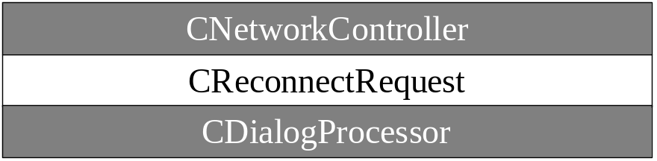
Note that not all member functions of the classes will need to be implemented.

Unit Test Cases
The code can be found in “D:\epoc\CELL\networking\netcon\ts_netcon\ReconnectTests.cpp”

Test Case | Description | Procedure | Parameters & results | Expected behaviour & Comments
NC-3-1 | Test reconnect when bearer is available | Call StartRequest() | Reconnect() should be called | After a call to CheckBearerAvailability() the stubbed CNetworkController should call SetAvailableBearers() with all bearers available.
NC-3-2 | Test reconnect when bearer is not available | Call StartRequest() | RequestComplete() should be called with KErrCancel | After a call to CheckBearerAvailability() the stubbed CNetworkController class should call SetAvailableBearers() with no bearers available.
NC-3-3 | Test reconnect when user agrees to reconnection. | Call StartRequest() | RequestComplete() should be called with KErrNone | The stubbed CNetworkController class should call MDPOReconnectComplete() with KErrNone.
NC-3-4 | Test reconnect when user cancels reconnection. | Call StartRequest() | RequestComplete() should be called with KErrCancel | The stubbed CNetworkController class should call MDPOReconnectComplete() with KErrCancel.

CTelBearer class

Class description
The CTelBearer class is responsible for checking the availability of the telephony bearers (i.e. CSD and PSD (either GPRS or CDMA)). The CTelBearer class must interact with ETEL to assess the capabilities of the handset and network and to check that the received signal strength is above a pre-defined level.

Unit Test Harness Design – TS_NETCON
The following stubbed classes are required for the CTelBearer unit tests.
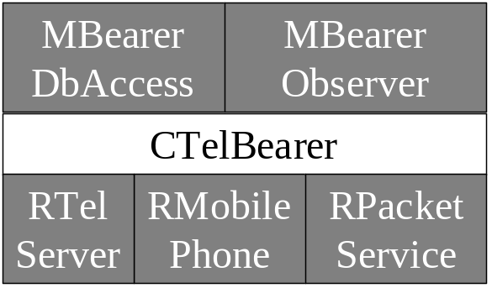
Note that not all member functions of the classes will need to be implemented.

Unit Test Cases
The code can be found in “D:\epoc\CELL\networking\netcon\ts_netcon\ BearerTests.cpp”
Test Case | Description | Procedure | Parameters & results | Expected behaviour & Comments
NC-4-1 | Test starting to check for bearer availability and then stopping straight away | Call StartChecking() followed immediately by StopChecking() | None | BearerStateChange() should not be called.
NC-4-2 | Test stopping availability checking before it has ever been started | Call StopChecking() | None | BearerStateChange() should not be called.
NC-4-3 | Test requesting second phase availability before starting to check for availability | Call SecondPhaseAvailability() | KErrNone | SecondPhaseAvailability() should return KErrNone.
NC-4-4 | Test starting to check for availability and then requesting second phase availability straight away. | Call StartChecking() followed immediately by SecondPhaseAvailability() | KErrNone | SecondPhaseAvailability() should return KErrNone.
NC-4-5 | Test requesting second phase availability after stopping availability checking | Call StartChecking(), StopChecking() and SecondPhasAvailability() | KErrNone | SecondPhaseAvailability() should return KErrNone.
NC-4-6 | Test connecting to ETEL Server | Call StartChecking() | KErrNone | The stubbed RTelServer class should return KErrNone on Connect().
NC-4-9 | Test loading phone module – failure case | Call StartChecking() | Anything but KErrNone | The stubbed RTelServer class should return an error on LoadPhoneModule ().
NC-4-11 | Test opening phone – failure case | Call StartChecking() | Anything but KErrNone | The stubbed RMobilePhone class should return an error on Open ().
NC-4-13 | Test retrieving phone capabilities – failure case | Call StartChecking() | Anything but KErrNone | The stubbed RMobilePhone class should return an error on GetCaps ().
NC-4-15 | Test opening a packet service – failure case | Call StartChecking() | Anything but KErrNone | The stubbed RPacketService class should return an error on Open()
NC-4-17 | Test retrieving packet support – failure case | Call StartChecking() | Anything but KErrNone | The stubbed RPacketService class should return an error on GetStatus()
NC-4-18 | Test retrieving signal strength | Call StartChecking(), wait for the BearerStateChange() and call SecondPhaseAvailability() | KErrNone | The stubbed RMobilePhone class should return a value for signal strength above the minimum
NC-4-19 | Test retrieving signal strength – failure case | Call StartChecking(), wait for the BearerStateChange() and call SecondPhaseAvailability() | Anything but KErrNone | The stubbed RMobilePhone class should return a value for signal strength below the minimum
NC-4-20 | Test checking bearer availability when the TSY is set to “Attach When Needed” | Call StartChecking() | KErrNone | The stubbed RPacketService class should return an RPacketService::EAttachWhenNeeded on GetAttachMode()

OOM Tests

Unit Test Harness Design – TS_NETCONOOM
The following classes need to be stubbed out for the OOM tests.
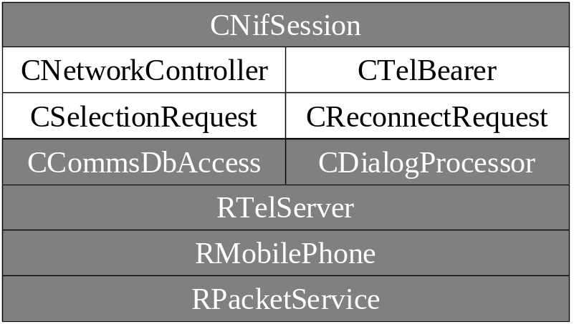
Note that not all member functions of the classes will need to be implemented.

OOM Test Cases
The code can be found in “D:\epoc\CELL\networking\netcon\ts_netconoom\ OomTests.cpp”
Test Case | Description | Procedure | Parameters & results | Expected behaviour & Comments
NC-5-1 | Test selection under low memory conditions. | The test should be run in a loop where the nth heap allocation fails. Call SelectAgent() repetitively until KErrNone is returned. | KErrNone for the last iteration of the loop and KErrNoMemory for each previous iteration. | When a memory allocation fails SelectComplete(KErrNoMemory) should be called.
NC-5-2 | Test reconnect under low memory conditions. | The test should be run in a loop where the nth heap allocation fails. Call Reconnect () repetitively until KErrNone is returned. | KErrNone for the last iteration of the loop and KErrNoMemory for each previous iteration. | When a memory allocation fails ReconnectComplete(KErrNoMemory) should be called.

Further Information

People
Role | Person / People
Contributors
Reviewers | Nadeem Wahid, Thomas Goodfellow, Gordon Sullivan, Emlyn Bolton-Maggs
Distribution

References
No. | Document Reference | Version | Description
[1] | SGL.PPS001.572 | 1.0 | SSG Unit Test Standard
[2] | SGL.GT0116.210 | 1.4 | Integration Test System Design
[3] | SGL.GT0117.278 | 2.0 | NetCon Design
[4] | SGL.GT0117.319 | 1.0 | NetCon Unit Test Specification Review Feedback

Open Issues
None.

Glossary
The following technical terms and abbreviations are used within this document.
Term | Definition
CDMA | Used here as a general term for PSD services on top of the US cdma95 and cdma2000 air interface standards based upon Code Division Multiple Access (CDMA) technology
CSD | Circuit-switched Data
ETEL | Symbian OS Telephony Server
GPRS | General Packet Radio Service. The generic name for the European PSD service on top of either GSM or WCDMA radio interfaces
GSM | European 2G air interface standard (Global System for Mobile Communications)
IAP | Internet Access Point
NIFMAN | Symbian OS Network Interface Manager
PSD | Packet-switched Data
WCDMA | European & Japanese 3G air interface standard based upon (Wideband Code Division Multiple Access)

Document History
Date | Version | Status | Description
10-10-2006 | 1.9 | Issued | Remove test 2.7 as no real check is done on the bearer to see if its available – see DEF081412 and INC079970
11-12-2002 | 1.8 | Issued | Updated after the test harnesses were modified to run in the scheduletest framework on all platforms. Added a section on “How to run the tests”.
02-12-2002 | 1.7 | Issued | Updated test case 2-7 in line with changes made to fix defect DEF10315. Now the bearer availability check is skipped if the dialog box prompt is set to “DoNotPrompt” or “Warn”. Changed test case 2-7 to use dialog box preference “Prompt” rather than “DoNotPrompt”.
19-11-2002 | 1.6 | Issued | Updated descriptions of the test harnesses.
12-08-2002 | 1.5 | Issued | Updated after addition of NC-4-20.
16-07-2002 | 1.4 | Issued | Updated after addition of methods for setting/getting the number of connection preferences to TCommDbMultiConnPref.
09-07-2002 | 1.3 | Issued | Updated after addition of new multiple override container – TCommDbMultiConnPref.
26-06-2002 | 1.2 | Issued | Updated after changes to overrides – TCommDbConnPref.
28-05-2002 | 1.1 | Issued | Updated after review comments.
17-05-2002 | 1.0 | Issued | Sent out for review
17-05-2002 | 0.3 | Draft | Updated after test harness implementation
09-05-2002 | 0.2 | Draft | Modifications after initial test harness implementation
29-04-2002 | 0.1 | Draft | First draft based on SGL.PPS001.500 Lightweight Document Template Rev 7.0

Document Review Date
Version 1.0 of this document was reviewed on 21-05-2002 – see the review feedback document [4] for more details.

