<Dialog> Design

Security Classification: | <Security Classification>
Document Reference: | <SGL.GT0117.405>
Status: | <Issued>
Version: | <1.1>
Team/Department : | <Networking/Core>
Author(s): | <Clive Nutter>
Owner(s): | <Nathalie Doyelle>

Approver(s): | <Nathalie Doyelle> | Distribution: | <Networking>

Contents
1 Introduction 3
1.1 Purpose and Scope 3
2 Design Overview 3
2.1 UML Diagram 4
2.2 Client Side 4
2.3 Server Side 4
2.3.1 CIAPSelection - Connection Dialog Requests 4
2.3.2 CModemAndLocationSelection – Modem & Location Selection Dialog 5
2.3.3 CIAPWarning - Warning Dialog Request 5
2.3.4 CLogin, CAuthenticate - Login and Authentication Dialog Requests 6
2.3.5 CReconnect - Reconnection Dialog Request 6
2.3.6 CPct - Post Connection Terminal Requests 6
2.3.7 CQoSWarning - QoS Warning Dialog Request 7
3 Further Information 8
3.1 People 8
3.2 References 8
3.3 Open Issues 8
3.4 Glossary 8
3.5 Document History 8
3.6 Document Review Date 8

Introduction

Purpose and Scope
This document details the design of the Agent Dialog Server component. The design briefly describes the architecture of the component, as supplied with Symbian OS.

Design Overview
The purpose of the generic connection agent dialog server is to allow user interaction where appropriate when setting up a connection to the Internet using the generic connection agent and its extensions. The basic functionality that the dialog server provides is as follows:
- Connection dialog - to allow the user to chose the service (e.g. ISP for CSD calls), modem, location and chargecard to be used at connection time.
- Warn of new connection dialog - to warn the user that a previous connection failed and that a following connection is to be attempted.
- Login and authentication dialogs - to allow the user to enter username and password for script login and PPP authentication at connection time.
- Post connection terminal (PCT) - to allow the user to see the login script running, see what is sent and received and allow the user to type responses.
- Reconnection dialog - inform the user of a lost connection (during data transfer) and ask them whether or not they wish to reconnect.
- QoS Warning dialog – to inform the user that the connection has dropped below the minimum acceptable quality and ask them whether they wish to disconnect or not.
In theory it is not necessary for any dialogs to be shown to make a connection to the Internet; whether they are or not used is determined by the settings in CommDb. Usually these are set by the user themselves via the control panel, although these settings may also be hardcoded for specific products if appropriate.
If the user has a choice on when to use the dialogs and when not, it is expected that a more experienced user will not want so much interaction at connection time as an inexperienced user, who would find it comforting to have dialogs to confirm connection choices. The option to enter usernames and passwords at connect time rather than store them in CommDb is likely to be used by all users for security reasons.
The Agent Dialog Server has a simple design, being little more than a collection of shared dialogs. Standard client-server architecture is employed, where the client application can invoke a method, which ultimately is delegated to a server side dialog class.
Note: the system software does not include a shippable implementation of the Agent Dialog Server itself, although the interface is included. The implementation is left to the specific product to implement as deemed appropriate. The system software implements only a version of the dialog server for testing purposes. The design detailed here is that of the test version. Product developers are free to develop this functionality in whatever manner they see fit.

UML Diagram
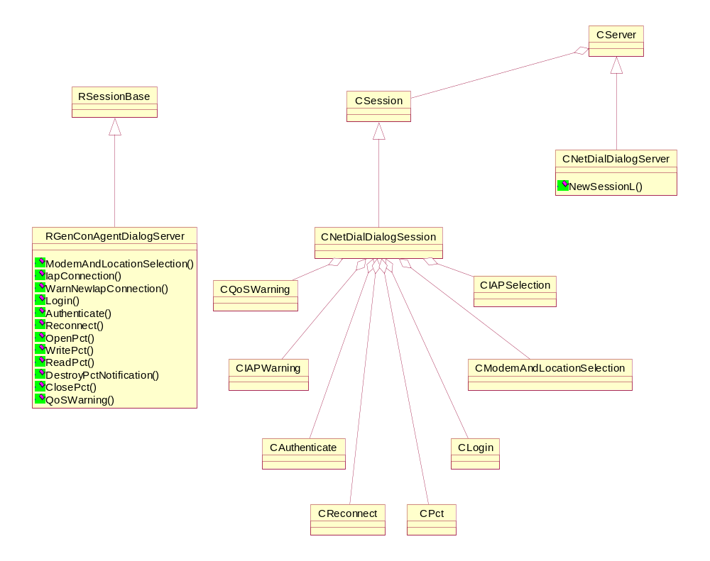

Client Side
The client side of the server consists of one major class, RGenConAgentDialogServer. This class simply provides access methods to operations provided by the server.
In addition, methods (not shown) are supplied to enable dialogs to be dismissed without user interaction.

Server Side
The class, CNetDialDialogServer, co-ordinates access to supported functionality, creating server session objects, CNetDialDialogSession, when new connections to the server are made.
The server is a Comms Provider Module (CPM) and is loaded via the rootserver API. It is loaded on demand, so there exists no .CMI file for it.
All requests for dialogs can be can cancelled without waiting for user interaction, maybe due to a timeout or a change in circumstances that required the dialog in the first place.
The session class delegates all requests made of it to one of the dedicated service classes.

CIAPSelection - Connection Dialog Requests
This dialog request requires extra information to be provided:
- IAP id (returned)
- Connection preference rank
- Direction
- Bearer set
These arguments are the appropriate values from CommDb, or from CommDb overrides, and should be passed with the request. Indicating which rank the connection preference has is achieved by setting rank the value of CONNECT_PREF_RANKING, and similarly indicating the desired direction of the connection and bearer set by setting the direction and bearer set to the values of CONNECTION_PREF_DIRECTION and CONNECT_PREF_BEARER_SET respectively. The value for rank need not be used by the dialog server, however some dialog server writers may wish to use a different dialog depending on whether it is the first or second connection attempt, therefore this information is provided. In addition if a second attempt is made, the error code of the first attempt may be made available for display, in retry dialogs. The other two settings are provided to the dialog server and should be used to determine the subset of service choices that the dialog server should present to the user. This is explained fully in the CommDb design document [2], however a few examples follow here to make this clearer.
- If Direction = Outgoing, Bearer Set = CSD then all IAP records of the type DIAL_OUT_ISP should be displayed to the user for selection.
- If Direction = Incoming, Bearer Set = CSD then all IAP records of the type DIAL_IN_ISP should be displayed to the user for selection.
- If Direction = Outgoing, Bearer Set =GPRS then all IAP records of the type GPRS should be displayed to the user for selection.
- If Direction = Incoming, Bearer Set =GPRS then all IAP records of the type GPRS should be displayed to the user for selection.
- If Direction = Outgoing, Bearer Set =CDMA then all IAP records of the type CDMA2000 should be displayed to the user for selection.
- If Direction = Outgoing, Bearer Set =GPRS and CDMA and CSD then all IAP records of the type GPRS, CDMA2000 and DIAL_OUT_ISP should be displayed to the user for selection.
On receiving this request the server should display a dialog allowing the user to choose an IAP from the IAPs which are in the bearer set and direction, as described above. The dialog server should write back the ID of the chosen ID and the server should also return any relevant error code or KErrNone if there is no error.

CModemAndLocationSelection – Modem & Location Selection Dialog
This request enables you choose the modem and location that you are going to use for data transactions. The selected ids are returned.
The modem and location entered (or confirmed) by the user should be returned by the server to the client. The server should also return any relevant error code or KErrNone if there is no error.

CIAPWarning - Warning Dialog Request
Optional extra information may be supplied as part of this request:
- Connection preference rank
- Direction
- Bearer set
In this case all this information is provided for optional use for the dialog server. Depending on the values supplied, the dialog server may wish to show slightly different dialogs with appropriate wording, in particular whether this is the first or second connection (i.e. the value of rank) is likely to be relevant. The client also provides more information to the server that may or may not be displayed to the user, namely,
- the error with which the previous connection (if any) failed,
- the name (as given in the database) of the IAP to be used for the next connection,
On receiving this request the server should display a dialog warning the user, that the previous attempt to connect failed and that a new connection is to be attempted. The information supplied by the client (as described above) may be used in this dialog as well. The dialog server may also optionally present the user with a choice as to whether to proceed with this connection or to stop. If this is done, then the user’s choice should be indicated to the client, returning TRUE to proceed, or FALSE to cancel. If the user is not prompted to make this choice, the response should always be set to TRUE to allow the agent to continue the next attempted connection. The server should return any relevant error code or KErrNone if there is no error.

CLogin, CAuthenticate - Login and Authentication Dialog Requests
These requests display a dialog to allow the user to input username and password.
The login version of the dialog is requested when login information for use with a script is required by the Genconn agent extension, and the authenticate version is used when the agent requests PPP authentication information. In reality, it is most likely that only one of these two dialogs would be used during each connection attempt. Therefore dialogs may appear identical to the user on the screen, if the dialog server wishes, so that the user is not conscious of which kind of authentication is taking place.
When the server receives either request it should display to the user a dialog to allow the user to enter the username and password for the account in use. The agent (client) passes the username and password from the appropriate record in CommDb (or the override settings). If these are not zero length, it is suggested that the dialog server displays the username in the dialog, leaving the user only to fill in the password, although the dialog server may choose not to do this, or indeed to show both the username and password for confirmation only. The username and password entered (or confirmed) by the user should be returned by the server to the client. The ‘reconnect’ option indicates to the dialog server whether or not this is a reconnection attempt. The reasoning behind providing this information is that the dialog server implementation may choose to suppress the dialog if this is a reconnection and just silently return the values entered by the user at the first connection attempt. The server should also return any relevant error code or KErrNone if there is no error.

CReconnect - Reconnection Dialog Request
The following request is provided to request a dialog is displayed to ask the user whether he/she wishes to reconnect after a connection has been broken during data transfer,
The user should be prompted with a dialog that allows them to confirm they wish reconnection to be attempted or to cancel the reconnection attempt. The user’s response should be returned by the server to the client, TRUE indicating that reconnection should be attempted and FALSE indicating that it should not. The server should return any relevant error code or KErrNone if there is no error.

CPct - Post Connection Terminal Requests
The post connection terminal is for use in place of the login dialog to allow the user to see the running of the login script and to type responses to the ISP’s requests as appropriate. This dialog is activated by the login script for the ISP stored in CommDb containing READ commands (points at which the user is requested to type a response) or by the ISP_DISPLAY_PCT setting in the dial out ISP record being set to TRUE.
The post connection terminal is a more complicated, but lesser used dialog than the others provided by the dialog server. It has several operations associated with its use. These are described in this section.
Firstly, OpenPct is the initial call made by the agent when the settings in the database indicate it should use the PCT. This is a synchronous call and on reception of the request, the dialog server should construct appropriate dialog and display it ready for use.
Following an open, a WritePct, ReadPct or CancelReadPct may be called by the agent to write incoming data into the PCT window and request user input from the PCT (or cancel this request) respectively. When using the PCT, the agent passes all data received, removing unreadable characters, to the PCT during a WritePct request. On receiving such a request, the dialog server should display the data in the PCT window. This call is synchronous and any error the dialog server has (or KErrNone is there is no error) while completing this request should be returned.
When the script indicates that the user needs to enter some information (a READ command is used for this), the agent makes a ReadPct request. The dialog server should then return all characters entered by the user. The server should return any relevant error code or KErrNone if there is no error. The agent keeps posting this request on the dialog server until it has received all the input in requires (usually until a carriage return is entered). The agent then sends all the data input by the user to the ISP.
When the agent has finished using the PCT, it issues a ClosePct request, to inform the dialog server that it should close the PCT. At this point the dialog server should close and destruct the PCT dialog.
The PCT dialog displayed by the dialog server should have a cancel button, or other appropriate way for the user to cancel the dialog. Therefore the request, DestroyPctNotification, is used by the agent to ensure that if the user cancels the dialog, then the dialog server gives notification of this. The request should only be completed by the dialog server if this cancel occurs. The agent can cancel the request for this notification by issuing a CancelDestroyPctNotification.
This should not affect the PCT itself, but just cancels the notification request.

CQoSWarning - QoS Warning Dialog Request
The following request is provided to request a dialog is displayed to inform the user that the connection quality has fallen below the minimum specified in CommDb or the overrides, and to ask whether they wish to disconnect or not.
The user response should be returned by the server to the client, TRUE indicating that the connection should be dropped and FALSE indicating that it should not. The server should return any relevant error code or KErrNone if there is no error.

Further Information

People
Role | Person / People
Contributor(s) | Clive Nutter
Reviewer(s) | Nathalie Doyelle, Mark Van Dijk

References
No. | Document Reference | Version | Description
[R1] | “UML Explained” |  | by Kendall Scott  (http://www.amazon.co.uk/exec/obidos/tg/stores/detail/-/books/0201721821/toc/202-4456432-1159001)
[R2] |  |  | CommDb Design Document
If you select the document description, then Ctrl+k you can input the URL or file location of the reference document, thus making it easier for the reader to locate the document.

Open Issues
The following issues need to be resolved before this document is completed;

Glossary
The following technical terms and abbreviations are used within this document.
Term | Definition
PCT | Post Connection Terminal

Document History
Date | Version | Status | Description
21-11-2002 | 0.1 | Draft | First draft based on SGL.PPS001.457 Component Design Document Template Rev 2.0
27-11-2002 | 1.0 | Issued | Updated after review and issued

Document Review Date
This section should contain the date after which the document should either be reviewed or is out-of-date.

