S60 5.x
Accessory Monitoring API
Design Document

SP SWD SSW Core Services | Timo Pääkkönen

Change history:

Version | Date | Status | Comments
1.0 | 18.01.2007 | Approved

Table of contents:

1. Document control 5
1.1 References 5
1.2 Documentation conventions 5
1.3 Abbreviations 5
1.4 Definitions 5
2. General 6
2.1 Introduction 6
2.2 Component environment 6
2.3 Use cases 7
2.3.1 Get connected accessories 7
2.3.2 Get Accessory Capabilities 8
2.3.3 Get Accessory Capability Value 8
2.3.4 Start listening accessory connections/disconnections 8
2.3.5 Start listening for connections/disconnections from a specific accessory 9
2.3.6 Start listening accessory type connections/disconnections 9
2.3.7 Notify accessory connected/disconnected to a client 9
2.4 Services required 10
2.4.1 From the Symbian OS subsystems 10
2.4.2 From the Domestic OS subsystems 10
2.4.3 From HW 10
2.5 Services provided 10
2.5.1 UI 10
2.5.2 SW IF 10
3. UI control hierarchy 11
4. Design 12
4.1 Class diagrams 12
4.2 Class descriptions 12
4.2.1 Structs, type definitions and enumerations 13
4.2.1.1 AccMonitorInfo.h Structs/Definitions/Enumerations 13
4.3 Operations 14
4.3.1 Getting connected accessories 14
4.3.2 Getting Accessory Capabilities 15
4.3.3 Getting Accessory Capability Value 16
4.3.4 Listening to accessory connections/disconnections 17
4.3.5 Notifying accessory connected/disconnected 17
4.4 Backup and Restore 18
5. Variation 19
6. System resource usage 20
6.1 Files 20
6.2 Other data 20
6.2.1 Databases 20
6.2.2 Central Repository 20
6.2.3 Publish and Subscribe 20
6.3 Memory consumption 20
6.4 Task allocation 20
7. Security 21
7.1 Capabilities of this component 21
7.2 Input and output validation 21
7.3 Environmental assumptions 21
7.4 Additional enforcements 21
8. Exception handling 22
9. Usage 23
9.1 Building 23
9.2 User's guide 23

Document control

References

- S60 Accessory Monitoring API Specification Document
- S60 Accessory API Specification Document

Documentation conventions
Code is shown with the Courier New font.

Abbreviations

AccFW | Accessory Framework
API | Application Programming Interface
SDK | Software Development Kit

Definitions

Accessory | An external device that is attachable to the phone, for instance headset.
Accessory capability | A feature or a characteristic of an accessory.
Accessory Services | The architecture subsystem for accessory related components.
Accessory types | Accessories can be defined with different capabilities, for example a headset with mono audio capability.
Capability value | A value for accessory capability.

General
Accessory Monitoring API is a wrapper component for a domain API called Accessory API. The Accessory Monitoring API is a public SDK API and it presents accessory information to S60 SDK clients. The Accessory Monitoring API does not offer the same information as Accessory API, but a slightly reduced set of accessory features. Mainly Accessory Monitoring API is an API, from which it is easy to get information about connected accessories or accessory connection/disconnection notifications.

Introduction
Accessory Monitoring API presents accessory capability information in an instance of the class CAccMonitorInfo. The CAccMonitorInfo class provides get methods to access the accessory capability information. The API also offers methods for listening accessory connection/disconnection notifications. For the client it is possible to define which accessory connections/disconnections it wants to listen to. If an accessory capability has a value, it is also possible to ask for the value of the capability through this API. Through this API sufficient accessory information is presented to SDK clients.

Component environment
The component environment of the Accessory Monitoring API shows that Accessory Monitor component gets the accessory information through the Accessory API (see reference document [2]). As the capabilities defined by Accessory Monitoring API must be mapped to capabilities defined by Accessory Server, this component has also a dependency to Accessory Policy.
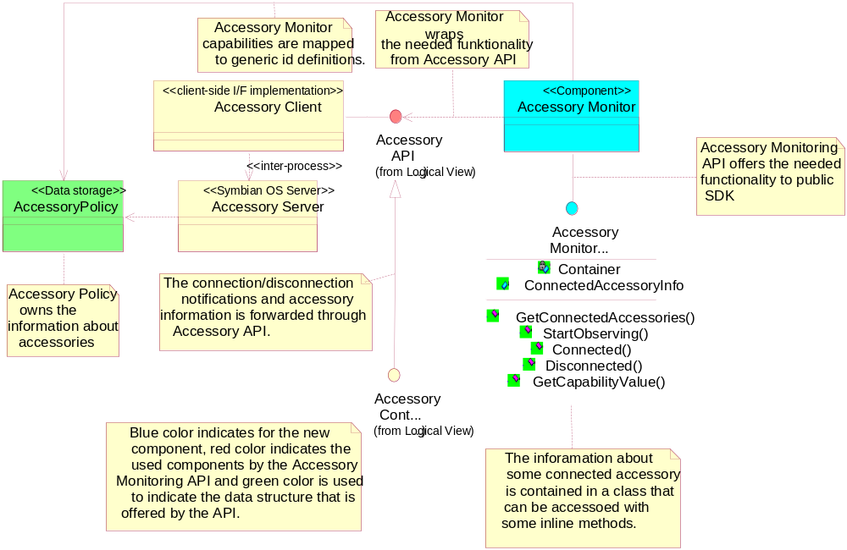
Figure 2.1 Accessory Monitoring API component environment

Use cases
Accessory Monitoring API use cases are described in the next chapter.
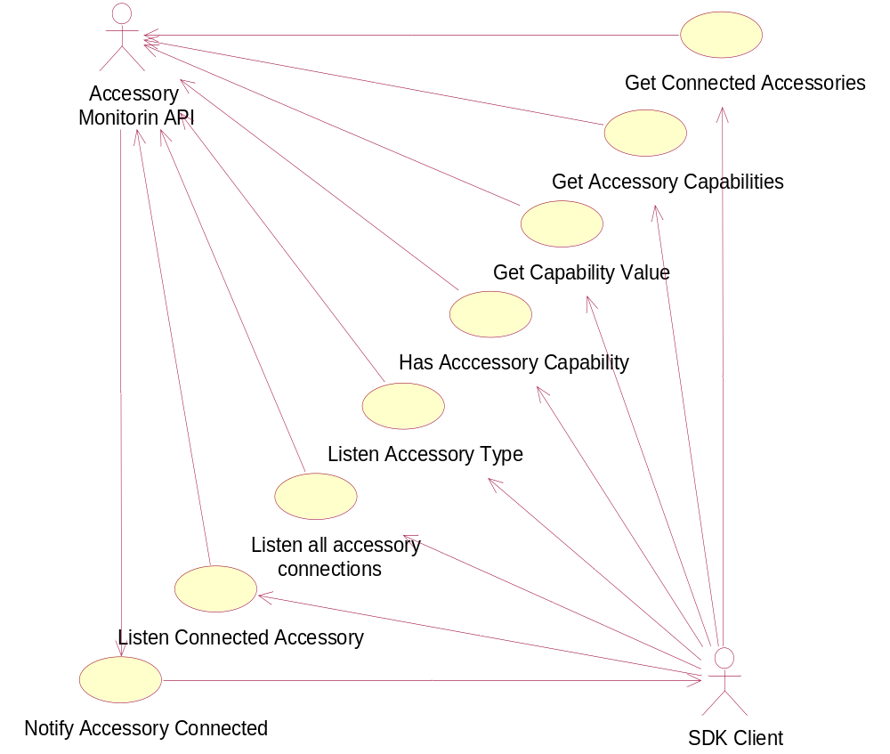
Figure 2.2 Accessory Monitoring API use cases

Get connected accessories

Summary | The client requests the connected accessories via Accessory Monitoring API.
Actor(s) | SDK client, Accessory Monitoring API.
Frequency | Low
Preconditions | Accessory Server is running and an instance is created of the CAccMonitor class.
Description | The client asks information about all the connected accessories. The Accessory Monitoring API provides this information in an array [Exception 1].
Exceptions | [1] Accessory server is not running. Function leaves with error code KErrNotReady.
Postconditions | Accessory information is returned to the client.
Illustrations | Figure 4.4

Get Accessory Capabilities

Summary | The client requests the connected accessories via Accessory Monitoring API.
Actor(s) | SDK client, Accessory Monitoring API.
Frequency | Low
Preconditions | The client has information about the connected accessories.
Description | The client asks capability information about a connected accessory. The Accessory Monitoring API provides this information as capability definitions [Exception 1].
Exceptions | [1] Accessory server is not running. Function leaves with error code KErrNotReady.
Postconditions | The accessory capability information is returned to client.
Illustrations | Figure 4.4

Get Accessory Capability Value

Summary | The client asks for the value of a capability.
Actor(s) | SDK client, Accessory Monitoring API.
Frequency | Low
Preconditions | The client has information about the connected accessories and that the accessory has this capability.
Description | The client asks for a value of a capability. The Accessory Monitoring API provides this information in a capability value [Exceptions 1, 2, 3].
Exceptions | [1] Accessory server is not running. Function leaves with error code KErrNotReady.  [2] No accessories are connected. Function leaves with error code KErrArgument.  [3] The capability has no value. Function leaves with error code KErrNotFound.
Postconditions | The capability value is returned.
Illustrations | Figure 4.5

Start listening accessory connections/disconnections

Summary | The client starts to listen to accessory connections/disconnections.
Actor(s) | SDK client, Accessory Monitoring API.
Frequency | Low
Preconditions | The client has created an instance of the CAccMonitor class and it isn’t listening accessory connections/disconnections already.
Description | The client requests that it wants to listen all accessory connection/disconnection notifications. Accessory Monitoring API requests accessory connection/disconnection notifications from Accessory Server [Exception 4].
Exceptions | [4] The client is listening to this API already.
Postconditions | The client starts to listen to accessory connection notifications.
Illustrations | Figure 4.6

Start listening for connections/disconnections from a specific accessory

Summary | The client starts to listen for connections/disconnections from a specific accessory.
Actor(s) | SDK client, Accessory Monitoring API.
Frequency | Low
Preconditions | The client has created an instance of the CAccMonitor class and it isn’t listening accessory connections/disconnections previously. The client also needs an instance of the accessory that needs to be listened.
Description | The client requests that it wants to listen specific accessory connection/disconnection notifications. Accessory Monitoring API requests accessory connection/disconnection notifications from Accessory Server [Exception 4].
Exceptions | [4] The client is listening accessory connections already.
Postconditions | The client starts to listen to accessory connection notifications.
Illustrations | Figure 4.6

Start listening accessory type connections/disconnections

Summary | The client starts to listen to a certain types of accessory type’s connections/disconnections.
Actor(s) | SDK client, Accessory Monitoring API.
Frequency | Low
Preconditions | The client has created an instance of the CAccMonitor class and it isn’t listening accessory connections/disconnections previously.
Description | The client requests that it wants to listen all accessory connection/disconnection notifications. Accessory Monitoring API requests accessory connection/disconnection notifications from Accessory Server [Exception 4].
Exceptions | [4] The client is listening to accessory connections already.
Postconditions | The client starts to listen to accessory connection notifications.
Illustrations | Figure 4.6

Notify accessory connected/disconnected to a client

Summary | The client is notified about a connection/disconnection.
Actor(s) | SDK client, Accessory Monitoring API.
Frequency | Low
Preconditions | The client has created an instance of the CAccMonitor class and it is listening accessory connections/disconnections.
Description | Accessory Monitoring API receives notification from Accessory API about accessory connection or disconnection. Accessory Monitoring API determines if this is an event that the client is listening. If it is an event the client is listening, the notification is sent to the client [Exception 5].
Exceptions | [5] An exception in the active object. Function AccMonitorObserverError that client has to implement is called in this situation.
Postconditions | The notification is sent to the client and the client continues to listen for accessory connections/disconnections.
Illustrations | Figure 4.6

Services required

From the Symbian OS subsystems

API | Description
Accessory API | Provides information about connected accessories and accessory connection/disconnection notifications.
Accessory Policy API | Defines accessory capabilities to S60 domain API. This information is mapped to Accessory Monitoring API capabilities.

From the Domestic OS subsystems
This component does not have any direct interfaces to the Domestic OS side subsystems.

From HW
This component has no direct HW interfaces.

Services provided

UI
This component does not provide any UI.

SW IF

Provided Service | Description | Protected
Accessory Monitoring API | Provides information about connected accessories and accessory connection/disconnection notifications. | No

UI control hierarchy
The component does not contain any UI or UI controls.

Design

Class diagrams
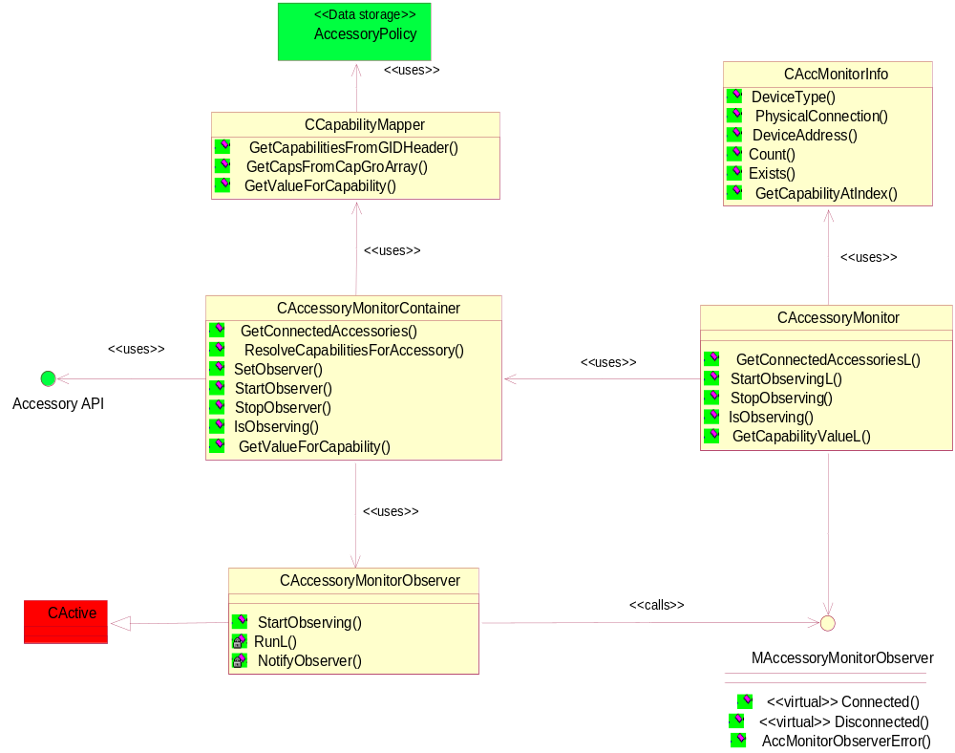
Figure 4.3 Class diagram for Accessory Monitoring API
The class diagram for Accessory Monitoring API is described in Figure 4.3. The component consists of the classes CAccessoryMonitor, CAccessoryMonitorObserver, CAccessoryMonitorContainer and CCapabilityMapper.

Class descriptions

Class | Description | Header file
CAccessoryMonitor | Consists of constructors for this API. | AccMonitor.h
CAccMonitor  Container | The main functionality of this component is placed in this class. | AccMonitorContainer.h
CAccMonitor  Observer | The CAccMonitorObserver class functions as observer for accessory connect/disconnection notifications. | AccMonitorObserver.h
CAccMonitorCap  Mapper | This class maps the Accessory Monitoring API capabilities to Accessory Policy capabilities. | AccMonitorCapMapper.h
MAccMonitor  Observer | An interface class that the client inherits. The functions in this class are used as callback functions for CAccMonitorObserver | AccessoryMonitor.h
CAccMonitorInfo | This class contains the information about a connected accessory. It also contains methods for accessing the accessory information. | AccMonitorInfo.h

Structs, type definitions and enumerations

AccMonitorInfo.h Structs/Definitions/Enumerations

Definition name | Description
Typedef RConnectedAccessories | An array that holds the information about connected accessories. This array contains instances of CAccMonitorInfo.
Typedef RAccessoryCapabilities | A type definition of RArray that contains accessory capabilities.
Typedef TAccMonCapability | A type definition for an accessory capability definition.
const TAccMonCapability KAccMonNoDevice | Constant definition for no device.
const TAccMonCapability KAccMonHeadset | Constant definition for device type headset.
const TAccMonCapability KAccMonCarKit | Constant definition for device type car kit.
const TAccMonCapability KAccMonOffice | Constant definition for device type office, e.g. Music Stand.
const TAccMonCapability KAccMonLoopset | Constant definition for device type Loopset.
const TAccMonCapability KAccMonTTY | Constant definition for device type TTY.
const TAccMonCapability KAccMonAVDevice | Constant definition for device type audio/video device. For example a video cable is an A/V device.
const TAccMonCapability KAccMonWired | Constant definition for physical connection Wired connector. If capability is defined accessory has a wired a connector as a physical connection.
const TAccMonCapability KAccMonBluetooth | Constant definition for physical connection Bluetooth connector. If capability is defined accessory has Bluetooth for its physical connection.
const TAccMonCapability KAccMonStereoAudio | Constant definition for stereo audio. If capability is defined this accessory supports stereo audio output
const TAccMonCapability KAccMonMonoAudio | Constant definition for mono audio. If capability is defined this accessory supports mono audio output.
const TAccMonCapability KAccMonSpeakerAudioOutput | Constant for accessory speaker feature. If capability is defined the accessory has a speaker integrated to this accessory.
const TAccMonCapability KAccMonMicAudioInput | Constant for accessory microphone feature. If capability is defined the accessory has a microphone integrated to this accessory.
const TAccMonCapability KAccMonAudioOut | Constant definition for audio out. Audio out capability is defined if the accessory is capable for outputting audio to another device. Values are defined with enumerations. If value is defined to 0, audio out is defined as standard lineout.
const TAccMonCapability KAccMonBTHSP | Constant definition for Bluetooth profile HS (Headset profile). Accessory supports HS profile.
const TAccMonCapability KAccMonBTHFP | Constant definition for Bluetooth profile HF (Hands Free profile). Accessory supports HF profile.
const TAccMonCapability KAccMonBTAVRCP | Constant definition for Bluetooth profile AVRC (Audio/Video Remote Control profile). Accessory supports AVRC profile.
const TAccMonCapability KAccMonBTA2DP | Constant definition for Bluetooth profile A2D (Advanced Audio Distribution profile). Accessory supports A2D profile.
const TAccMonCapability KAccMonVideoOut | Constant for video capability video out. If capability is defined the accessory has a video out possibility. Values are defined with enumerations. If value is defined to 0 video format is C-Video.

Enumeration's name | Description
enum EAccMonAudioOut | Enumerator for the capability KAccMonAudioOut.
enum EAccMonVideoOut | Enumerator for the capability KAccMonVideoOut.

Operations

Getting connected accessories

Operation | Getting Connected Accessories
Preconditions | An instance of the accessory monitoring API is created.
Description | The SDK client uses GetConnectedAccessoriesL function to get the connected accessories. The Accessory Monitoring API returns the connected accessories in an array RConnectedAccessories.
Inputs | A reference of an empty array is handed to Accessory Monitoring API
Modifies | The array is filled with instances of the connected accessories.
Outputs | Accessory information is outputted from the API.
Postconditions | If the accessories that are connected are successfully inserted to the array KErrNone is returned. If no accessories are connected KErrNotFound is returned. In error situations standard Symbian error code is returned,
Related To | Section 2.3.1.
Related Event | Figure 4.4
Exceptions | KErrNotFound, if no accessories are connected.

Getting Accessory Capabilities

Operation | Getting accessory capabilities
Preconditions | The client has fetched the connected accessories information.
Description | After the client has gotten the connected accessories information it can start to examine an accessory that is connected. The information about the accessory is examined by getting information with functions from the CAccMonitorInfo class.
Inputs | An instance of the accessory.
Modifies | N/A
Outputs | Accessory capabilities are shown to the client.
Postconditions | None
Related To | Section 2.3.2.
Related Event | Figure 4.4
Exceptions | None

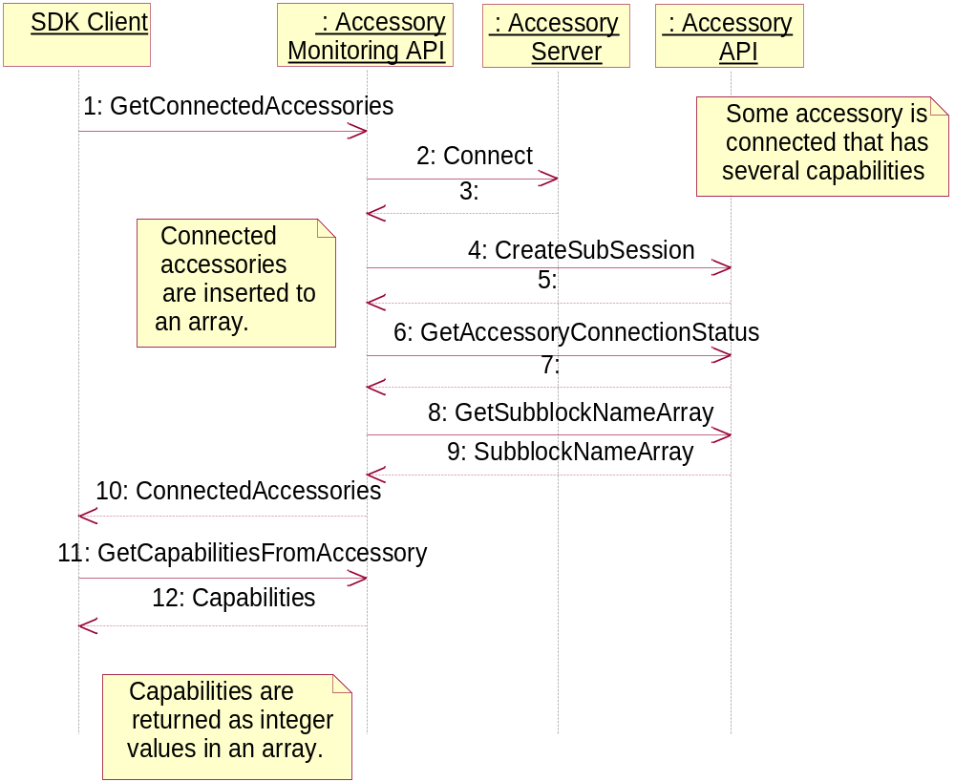
Figure 4.4 Sequence diagram about getting accessory information through Accessory Monitoring API

Getting Accessory Capability Value

Operation | Getting accessory capability value.
Preconditions | The client has information about a connected accessory and about its capabilities.
Description | The client asks from the Accessory Monitoring API what value some accessory capability has. The API returns the value to the client.
Inputs | The accessory capability and the accessory instance that the value needs to be get for. Also a reference to the value is given as input.
Modifies | The value of the capability is set to the input variable of the value.
Outputs | Number of connected accessories.
Postconditions | None
Related To | Section 2.3.3.
Related Event | Figure 4.5
Exceptions | KErrNotFound if this capability is not defined for this accessory, KErrArgument if this accessory is not connected.

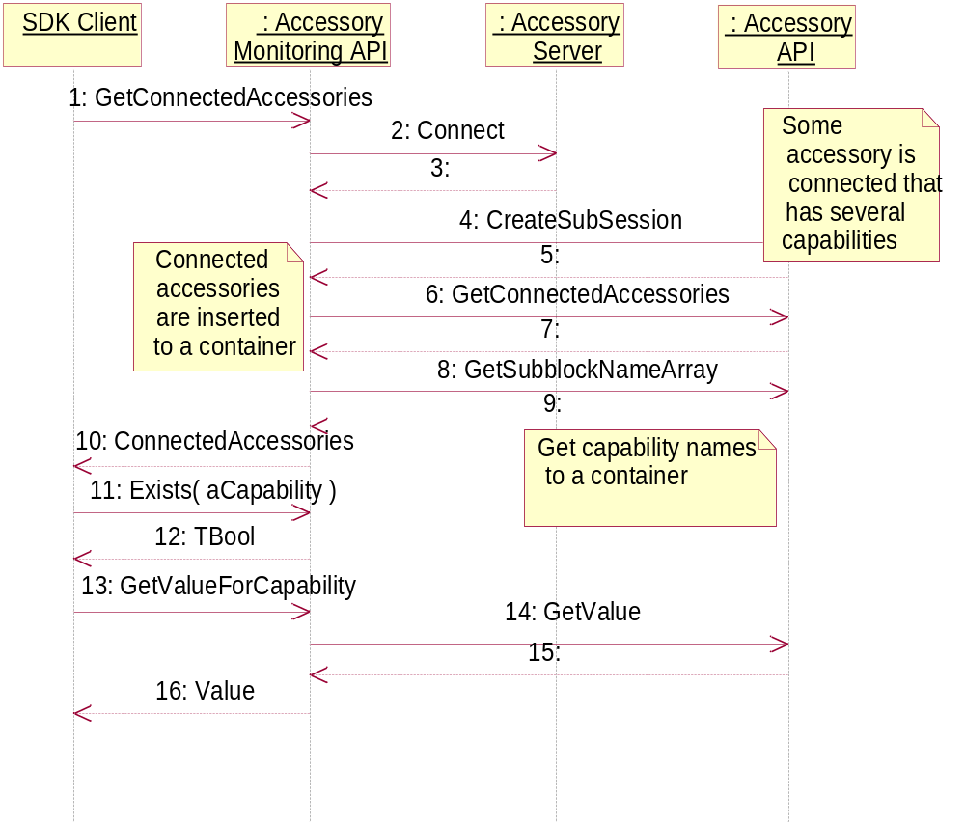
Figure 4.5 Getting a value for an accessory capability

Listening to accessory connections/disconnections

Operation | Listening to accessory connections.
Preconditions | The client has created an instance of the CAccMonitor class.
Description | The client starts to listen to accessory connections/disconnections.
Inputs | The callback to the client’s class is given as input.
Modifies | Nothing
Outputs | Notifies client about connected accessories.
Postconditions | None
Related To | Section 2.3.4.
Related Event | Figure 4.6
Exceptions | KErrAlreadyExists if the API is already observed by this client.

Notifying accessory connected/disconnected

Operation | Notifying accessory connected/disconnected.
Preconditions | The client has been listening accessory connections/disconnections.
Description | The Accessory Monitoring API notifies the client when the accessory that the client listened has been connected/disconnect.
Inputs | Accessory Monitoring API notifies to the client which accessory was connected/disconnected.
Modifies | Nothing
Outputs | Nothing
Postconditions | Accessory Monitoring API continues to listen to the same thing it was listening before.
Related To | Section 2.3.7.
Related Event | Figure 4.6
Exceptions | Exception in active object causes that AccMonitorObserverError function is called.

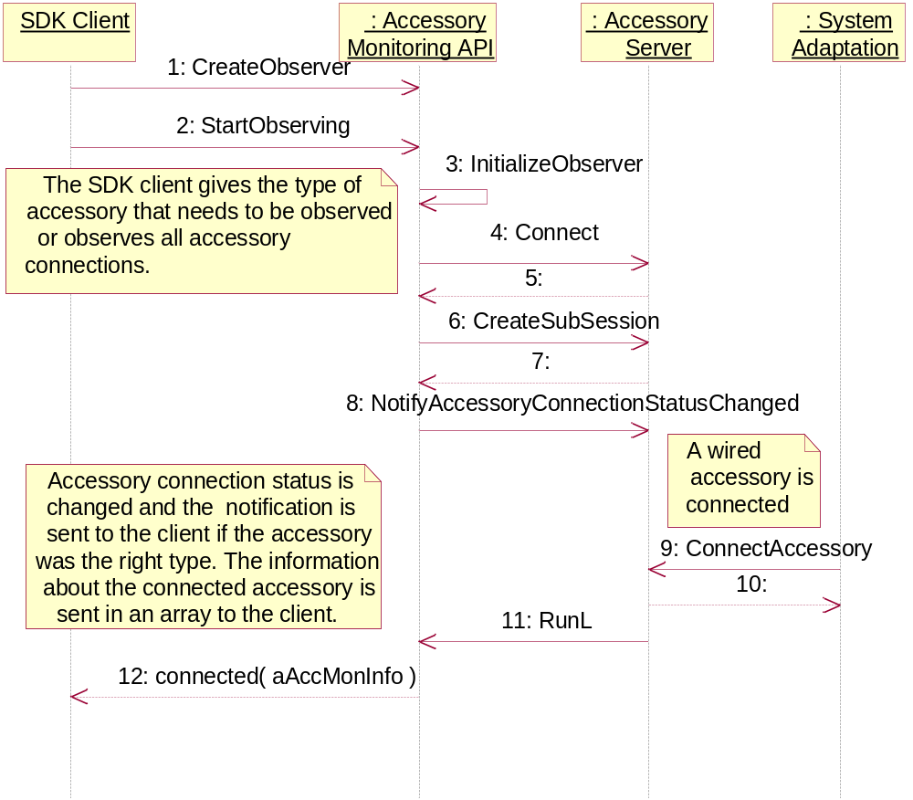
Figure 4.6 Notifying accessory connections

Backup and Restore
This component does not participate in backup and restore.

Variation
Accessory Monitoring API is an SDK API and does not support any other variation mechanism than application wide image creation time variation, i.e. the application can be included in or excluded from a ROM image.

System resource usage

Files
This component does not use any files.

Other data

Databases
This component does not use any databases.

Central Repository
This component does not use Central Repository.

Publish and Subscribe
This component does not use Publish and Subscribe.

Memory consumption

Memory/Build | Consumption
User data area
WINS UDeb | 331 124 bytes
ARMI URel | 4 024 bytes

Task allocation
Component runs in Accessory Servers client process.

Security

Capabilities of this component
No capabilities needed since this is an SDK API.

Input and output validation
Given a malicious parameter for Accessory Monitoring API, leads to a leave situation with an error code.

Environmental assumptions
This component does not make any assumptions about its environment.

Additional enforcements
This component does not have any additional security enforcements.

Exception handling

Exception | Description
Error in active object. | A client is listening to accessory connection notifications. A leave occurs in active object and causes that the error function from MAccMonitor class is called. The client can implement error handling mechanism to function AccMonitorObserverError.

Usage

Building
Bldmake bldfiles
Abld reallyclean
Abld build

User's guide
See reference document [1].

