S60 3.1
Remote Control Plug-ins
Design Document

Team name | Author
Series60/CorePlatform/BaseServices/SystemSW/SIF | Laura Rissanen

Change history:

Version | Date | Status | Comments
4.0 | 07.03.2006 | Approved | Tracked changes accepted, document template updated.
3.0 | 27.02.2006 | Approved | Call handling features added.
2.0 | 15.07.2005 | Approved | Security Threats appendix removed.
1.0 | 14.06.2005 | Approved

Table of contents:

1. Document control 5
1.1 References 5
1.2 Documentation conventions 5
1.3 Abbreviations 5
1.4 Definitions 5
2. General 7
2.1 Introduction 7
2.2 Component environment 7
2.3 Use cases 8
2.3.1 Sending a command from a remote target to a S60 client 8
2.3.2 Sending a command from a S60 client to a remote target 8
2.4 Services required 9
2.4.1 From the Symbian OS subsystems 9
2.4.2 From the Domestic OS subsystems 9
2.4.3 From HW 9
2.5 Services provided 9
2.5.1 UI 9
2.5.2 SW IF 10
3. UI control hierarchy 11
4. Design 12
4.1 Remote Control Extension API 12
4.1.1 Class descriptions 13
4.1.2 Structs, type definitions and enumerations 13
4.1.2.1 RemConExtensionApi.h Enumerations 13
4.1.3 Operations 13
4.1.3.1 Starting to listen to commands from a remote target 14
4.1.3.2 Receiving a command from a remote target 14
4.1.3.3 Sending a response to a remote target 15
4.2 Remote Control TSP Controller 15
4.2.1 Class descriptions 16
4.2.2 Operations 17
4.2.2.1 Delivering a command from a S60 client to remote targets 17
4.2.2.2 Delivering a command from a remote target to S60 clients 17
4.2.2.3 Deciding whether a S60 client can send a command to the specified remote target 18
4.3 Accessory Key Event Handling API 19
4.3.1 Class descriptions 20
4.3.2 Structs, type definitions and enumerations 20
4.3.2.1 RemConKeyEventData.h 20
4.3.3 Operations 21
4.3.3.1 Initialization of Accessory Key Event Handling API 21
4.3.3.2 Key Event Conversion 22
4.4 Backup and Restore 23
5. Variation 24
6. System resource usage 25
6.1 Files 25
6.2 Other data 25
6.2.1 Databases 25
6.2.2 Central Repository 25
6.2.3 Publish and Subscribe 25
6.3 Memory consumption 25
6.4 Task allocation 25
6.5 Performance 25
6.6 Timers 25
7. Security 26
7.1 Capabilities of this component 26
8. Exception handling 27
9. Usage 28
9.1 Building 28
9.2 User's guide 28

Document control

References
- Remote Control Design Document | http://www.symbian.com/
- Series 60 Remote Control Extension API Specification Document
- Series 60 Accessory Key Event Handling API Specification Document
- Symbian SDK | http://www.symbian.com/

Documentation conventions
Code is shown with the Courier New font.

Abbreviations
DLL | Dynamic Link Library
ECOM | A Symbian OS framework by which abstract interfaces can be defined and their implementations identified, loaded and managed.
PoC | Push to talk over Cellular service. The PoC service is a half-duplex form of communications that allows users to engage in immediate communication with one or more receivers, similar to a Walkie Talkie type operation, simply by pushing a button on their handsets.
RemCon | Remote Control framework that is a part of Symbian OS.
TSP | Target Selector Plug-in. Remote Control framework’s name for one of its plug-ins that selects the receiver for a command.

Definitions
Accessory Framework | A Client-Server based solution that is for example responsible for connecting and disconnecting accessories. Accessories such as headsets are typical remote targets from Remote Control’s viewpoint.
Adaptation | A general name for software component(s) that provide means for Remote Control framework to communicate with remote targets. Bearer can be considered as a first part of adaptation from the Remote Control framework’s viewpoint.
Bearer | Remote Control framework’s name for one of its plug-ins that is closest to the remote target. Bearer implements an interface specified by Remote Control framework, making Remote Control framework independent from the remote target specific implementation such as transport protocol. Bearer’s main task is to take care that commands are converted to Remote Control format when they are coming from a remote target and that commands are converted to remote target format when they are coming from S60 clients.
Connectionless Mode | A term used for the connection type when a S60 client acting as Controller connects to Remote Control without specifying the bearer to which the commands should be sent.
Connection-oriented Mode | A term used for the connection type when a S60 client acting as Controller connects to Remote Control by specifying the bearer to which the commands should be sent.
Controller | A S60 client that sends commands to the remote target and receives responses from it through Remote Control. Controller could be for example S60 Music Player that sends a Play command to an accessory when the user selects the Play command in the Music Player application.
Converter | Remote Control framework’s name for one of its plug-ins that converts commands between the remote target and S60 clients. When a command is sent from the remote target, Converter converts it to one of the Remote Control API formats. When a command is sent from a S60 client, Converter converts it to the remote target format. Converter is used by Bearer.
Message | A message that is delivered from a S60 client to the remote target or from the remote target to a S60 client through Remote Control. The message can be a command or a response to a command.
Plug-in | A DLL that implements an abstract interface and can be loaded by a program (e.g. Remote Control Server) to extend its functionality.
Remote Control API | A definition used in this document to describe all APIs that S60 clients can use to receive commands and to send commands through Remote Control. Remote Control Core API and Remote Control Extension API are examples of Remote Control APIs.
Remote target | An object that communicates with S60 software through Remote Control framework. The object can be external to a phone, e.g. a headset or car kit, or it can also be integrated to a phone, e.g. a side volume key.
Target | A S60 client that receives commands from the remote target and sends responses to it through Remote Control. Target could be for example the PoC application that has to react when the user presses the PoC button.

General
Remote Control plug-ins is a part of Remote Control (see reference document [1]). Remote Control provides means for S60 clients to communicate with remote targets in a terminal and remote targets outside a terminal. Remote Control can be used for example to deliver commands from a headset to some S60 application.

Introduction
Remote Control plug-ins consist of Remote Control Extension API, Remote Control TSP Controller and Accessory Key Event Handling API.
Remote Control plug-ins implemented interfaces are specified by Remote Control. Thus, they can only be used together with the framework.

Component environment
Remote Control Extension API provides a way for S60 clients to receive commands from remote targets and to sends responses to commands from remote targets.
Remote Control TSP Controller’s main task is to choose the target(s) to which commands are further delivered from the original sender. If the command comes from a S60 client, Remote Control TSP Controller chooses the remote target(s). If the command comes from the remote target, Remote Control TSP Controller chooses the S60 client(s). Thus, Remote Control TSP Controller acts as a kind of router that selects the receiver for commands sent in the Remote Control context.
Accessory Key Event Handling API is an interpreter between the Bearer plug-in and Remote Control API (e.g. Remote Control Extension API).
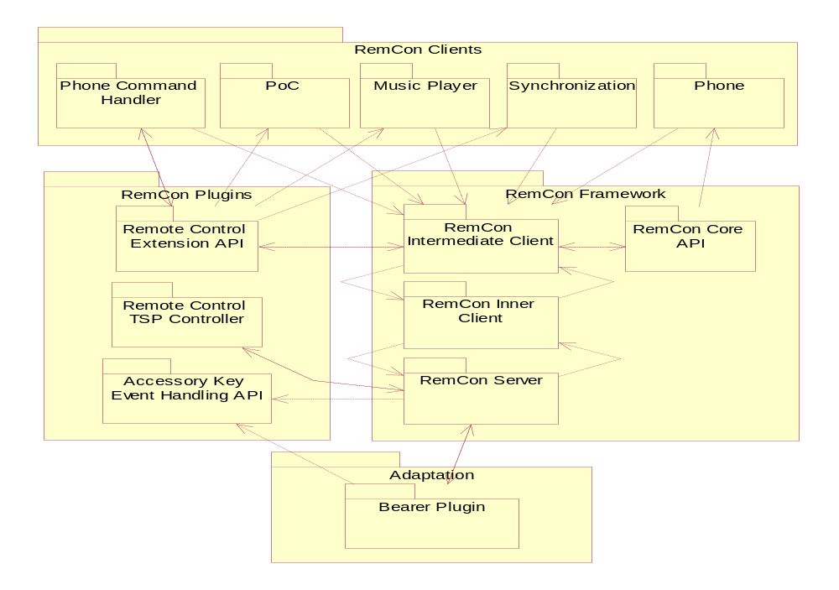
Figure 2.1 Remote Control Plug-ins environment. (Figure doesn’t include all the clients.)

Use cases
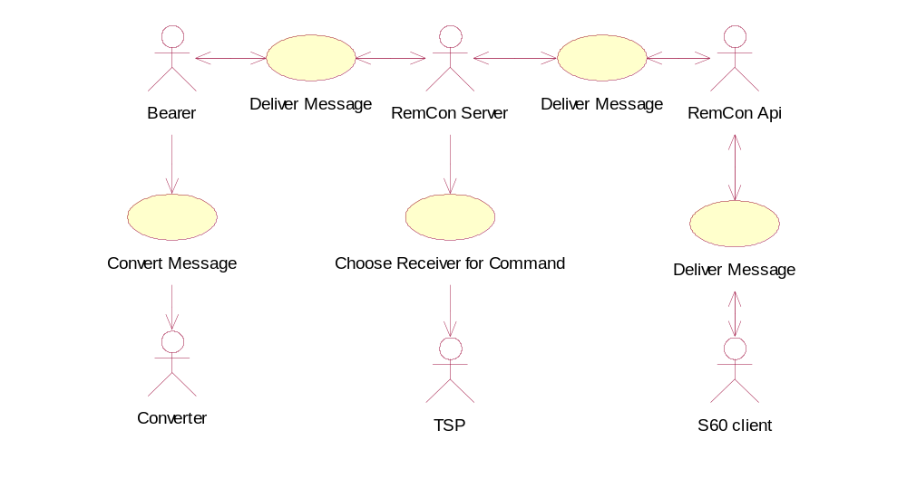
Figure 2.2 Remote Control Plug-ins use cases

Sending a command from a remote target to a S60 client
Summary | Sending a command from a remote target to a S60 client.
Actor(s) | Bearer, Converter, Remote Control Server, TSP (Remote Control TSP Controller), Remote Control API (Remote Control Extension API) and a S60 client (e.g. the Music Player application)
Frequency | The exact frequency depends on the command type. A typical frequency is low. For example, a PoC related command is delivered only when the user makes a PoC call.
Preconditions | - A remote target that is not integrated to the phone has to be connected with the phone.  - Remote Control Server has been started.  - A S60 client has registered to listen commands (e.g. the Music Player application).
Description | Bearer receives a command (e.g. a headset volume up key press) from the remote target. It asks Converter to convert the command to a format that is understood by Remote Control. Bearer notifies Remote Control Server that a new command has been sent. Remote Control Server fetches the command from Bearer. Remote Control Server asks TSP to choose the S60 client(s) to whom the command should be sent. Remote Control Server sends the command to the proper Remote Control API(s). Remote Control API informs the S60 client about the command sent from the remote target.
Exceptions | In case of an error in the S60 client when it handles the command, the S60 client may send an error message to the remote target in the response.
Postconditions | The exact result depends on the command. For example, a synchronization command could start synchronization between the phone and a computer. For some commands, S60 clients can also send a response.
Illustrations

Sending a command from a S60 client to a remote target
Summary | Sending a command from a S60 client to a remote target.
Actor(s) | Bearer, Converter, Remote Control Server, TSP (Remote Control TSP Controller), Remote Control API and a S60 client (e.g. the Music Player application).
Frequency | The exact frequency depends on the command type. A typical frequency is low. For example, a Volume Up command is delivered when the user increases the volume in the Music Player application.
Preconditions | - A remote target that is not integrated to the phone has to be connected with the phone.  - Remote Control Server has been started.  - A S60 client has connected to Remote Control as Controller.
Description | The S60 client calls a method that sends a command in one of the Remote Control APIs. Remote Control Server receives the command. It delivers the command to TSP that either:  - Chooses from 0 to one or more remote targets to which the command should be sent in the connectionless mode, or  - b) Tells whether the command should be sent at all to the remote target in the connection-oriented mode.  Remote Control Server sends the command to 0 or more bearers according to TSP’s instructions. Each bearer will ask Converter to convert the command to a format that is understood by the corresponding remote target. After the conversion, the bearer sends the command to the remote target.
Exceptions
Postconditions | The exact result depends on the command. For example, a Volume Up command can increase the volume in the headset playing a song from the Music Player application. For some commands, remote targets can also send a response.
Illustrations

Services required

From the Symbian OS subsystems
API | Description
ECOM Plug-In Architecture | Standard Symbian plug-in framework.
Telephony ETEL | ETel is Symbian OS Telephony Server.
Remote Control Framework | Provides a server and interfaces to send commands between any S60 client and a remote target.

From the Domestic OS subsystems
This component does not have any direct interfaces to the Domestic OS side subsystems.

From HW
This component has no direct HW interfaces.

Services provided

UI
This component does not provide any UI.

SW IF
Provided Service | Description | Protected
Remote Control Extension API | Provides transfer of some S60 required commands between S60 clients and remote targets that are not supported by Remote Control Core API. For more detailed information, see reference document [2]. | No
Accessory Key Event Handling API | This API implements a converter that converts key presses from some specific accessories to Remote Control Core API and Remote Control Extension API formats. For more detailed information, see reference document [3]. | No

UI control hierarchy
Remote Control plug-ins does not contain any UI or UI controls.

Design
Remote Control plug-ins consists of three components: Remote Control Extension API, Remote Control TSP Controller and Accessory Key Event Handling API. Each component is presented in its own section in this chapter.
Remote Control plug-ins is a part of Remote Control. For information on how Remote Control plug-ins interacts with Remote Control, see reference document [1].

Remote Control Extension API
Remote Control Extension API is a static DLL that is used to send commands between S60 clients and remote targets through Remote Control. Remote Control Extension API is an extension to Remote Control Core API providing some new services not existing in Remote Control Core API (see reference document [1]).
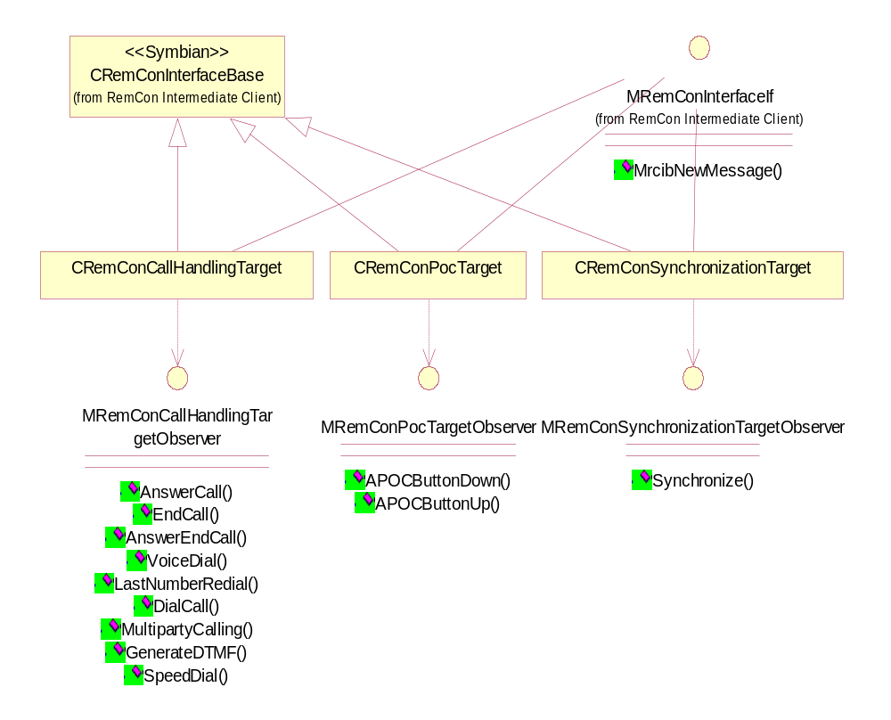
Figure 4.3 Remote Control Extension API
The classes inherited from CRemConInterfaceBase(e.g. CRemConPoCTarget) define the features provided by Remote Control Extension API.
Target classes provide two services for S60 clients. First, S60 clients can listen to feature-related commands from remote targets by implementing the corresponding observer interface. For example, by implementing MRemConPocTargetObserver, the S60 client will be informed when the PoC button is pressed down and released. Second, after handling a feature-related command, the S60 client has to send a response to the remote target by methods provided in the target classes (e.g. CRemConCallHandlingTarget).
The other classes in Figure 4.3 have been defined by Remote Control (see reference document [1]).
The Symbian class CRemConInterfaceBase provides some basic services for target and controller API classes (e.g. canceling of asynchronous requests). The Symbian class MRemConInterfaceIf defines an interface method that is called by the intermediate client when a new message is delivered to an API class.

Class descriptions
Class | Description | Header file
CRemConCallHandlingTarget | Provides a way for a S60 client to receive call handling related commands from a remote target and to send responses to commands. | RemConCallHandlingTarget.H
MRemConCallHandlingTargetObserver | Defines methods corresponding to call handling commands. A S60 client has to implement the methods. Remote Control Extension API calls them when a remote target has sent the corresponding command. | RemConCallHandlingTargetObserver.H
CRemConPocTarget | Provides a way for a S60 client to receive PoC related commands from a remote target and to send responses to commands. | RemConPocTarget.H
MRemConPocTargetObserver | Defines methods corresponding to PoC related commands. A S60 client has to implement the methods. Remote Control Extension API calls them when a remote target has sent the corresponding command. | RemConPocTargetObserver.H
CRemConSynchronization  Target | Provides a way for a S60 client to receive synchronization related commands from a remote target and to send responses to commands. | RemConSynchronizationTarget.H
MRemConSynchronization  TargetObserver | Defines methods corresponding to synchronization related commands. A S60 client has to implement the methods. Remote Control Extension API calls them when a remote target has sent the corresponding command. | RemConSynchronizationTargetObserver.H

Structs, type definitions and enumerations

RemConExtensionApi.h Enumerations
Enumeration's name | Description
TRemConExtPocApiOperationId | Defines PoC related commands.
TRemConExtSynchronizationApiOperationId | Defines synchronization related commands.
TRemConExtCallHandlingApiOperationId | Defines call handling related commands.

Operations
The way to start to listen to commands from remote targets, receive commands and send responses to commands is the same for all Remote Control Extension API features.

Starting to listen to commands from a remote target
Operation | Starting to listen to commands from a remote target.
Preconditions | The S60 client process has not yet connected to Remote Control Server as target.
Description | Before the remote target can send commands through Remote Control, the S60 Platform client has to connect to Remote Control Server.
Inputs | - CRemConInterfaceSelector& aInterfaceSelector: An instance of the interface selector.  - An instance of the appropriate observer interface (e.g. MRemConPocTargetObserver& aObserver)
Modifies
Outputs | An instance of the feature related object (e.g. CRemConPocTarget).
Postconditions | Remote Control Server is started if it is not yet running. Remote Control sends the command to the S60 client as soon as it receives it from the remote target.
Related To
Related Event | One or more of commands specified in the observer interface.
Exceptions | Remote Control Intermediate Client raises a panic in the client thread if OpenTargetL() is called more than once in the client process.

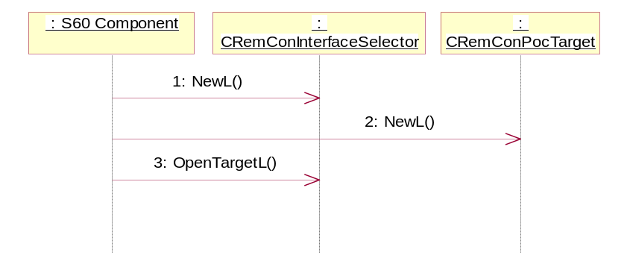
Figure 4.4 Starting to listen to commands from a remote target

Receiving a command from a remote target
Operation | Receiving a command from a remote target.
Preconditions | The S60 client has successfully connected to Remote Control Server as target.
Description | The remote target initializes a command (e.g. the PoC button is pressed down).
Inputs | Some observer commands may have parameter(s).
Modifies
Outputs
Postconditions | The S60 client’s observer method is called with the appropriate parameters.
Related To
Related Event | The client may send a response to the remote target after it has handled the command.
Exceptions | The observer commands are not expected to leave or return an error code. If an error happens in the client when it handles the command, it may send an error message in the response method related to the command.

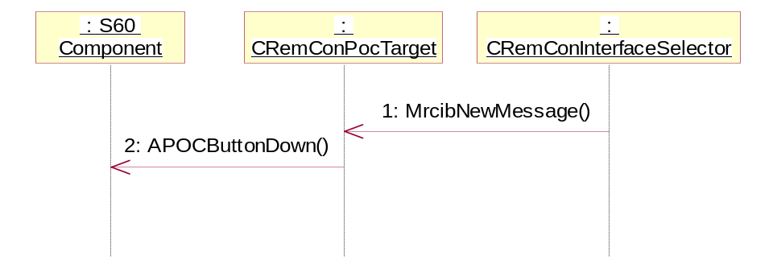
Figure 4.5 Receiving a command from a remote target

Sending a response to a remote target
Operation | Sending a response to a remote target.
Preconditions | The S60 client has received a command from a remote target and it has handled the command.
Description | The S60 client has to send a response to the remote target command. If the S60 client sends a response without receiving the remote target’s command first, Remote Control Server will raise a panic on the S60 client’s thread.
Inputs | - TRequestStatus& aStatus: Indicates the completion status of the response request made to the remote target.  - TInt aError: Indicates whether command was executed successfully or not.
Modifies
Outputs
Postconditions | The remote target receives the response and can do any required further processing based on the response value.
Related To | A command sent from a remote target.
Related Event
Exceptions

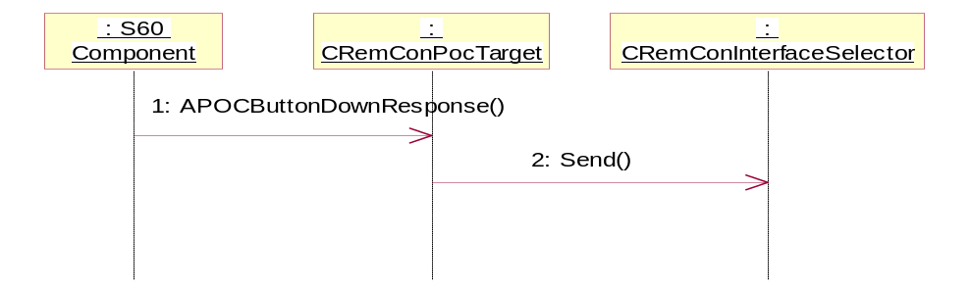
Figure 4.6 Sending a response to a remote target

Remote Control TSP Controller
Remote Control TSP Controller is an ECOM plug-in used by Remote Control Server. Remote Control has defined the following three tasks for TSP that Remote Control TSP Controller implements:
- TSP delivers each command coming from remote targets to 0 or more S60 clients.
- TSP delivers each command coming from S60 clients in the connectionless mode to 0 or more remote targets.
- TSP decides whether S60 clients in the connection-oriented mode are allowed to send commands to the specified remote targets.

Remote Control does not route responses to commands through TSP. It delivers them straight to the correct recipients.
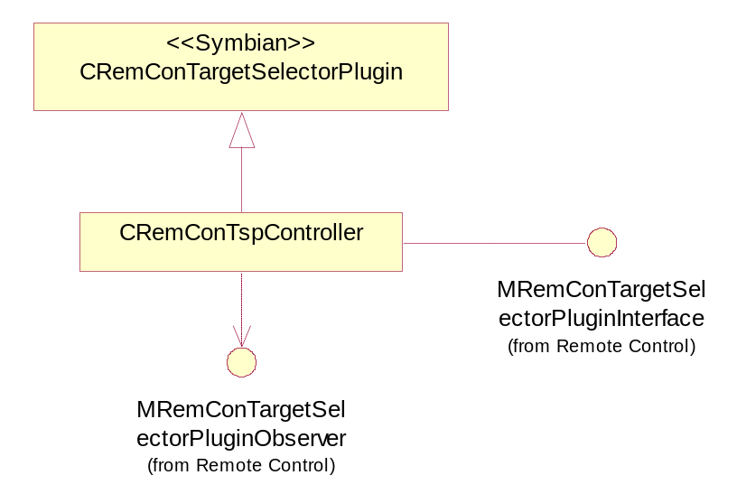
Figure 4.7 Remote Control TSP Controller
The class CRemConTspController has the main implementation for Remote Control TSP Controller. Remote Control TSP has the following functionality:
- By default it delivers each command coming from remote targets to all S60 clients proposed by Remote Control.
- It delivers each command coming from S60 clients to all remote targets proposed by Remote Control.
- It allows S60 clients in the connection-oriented mode to send commands to the specified remote targets.

Remote Control TSP Controller routes commands synchronously. It does not do any capability checks for the command originator.
The other classes in Figure 4.7 have been defined by Remote Control (see reference document [1]).
The Symbian class CRemConTargetSelectorPlugin has the basic functionality for Remote Control to load and delete Remote Control TSP Controller. The Symbian class MRemConTargetSelectorPluginInterface defines services for Remote Control TSP Controller that will be requested by Remote Control. Remote Control TSP Controller uses MremConTargetSelectorPluginObserver to inform Remote Control about completed services.

Class descriptions
Class | Description | Header file
CRemConTpsController | Implementation of TSP. | RemConTspController.H

Operations

Delivering a command from a S60 client to remote targets
Operation | AddressOutgoingCommand()
Preconditions | Remote Control Server is running. A S60 client has connected successfully to Remote Control as controller in the connectionless mode. The S60 client has sent a command to Remote Control, e.g. Music Player has sent a Volume Up command through Remote Control Core API.
Description | Remote Control asks TSP to choose the remote targets to which the command should be sent.
Inputs | - TUid aInterfaceUid: Identifies the client interface (e.g. defines Remote Control Core API).  - TUint aOperationId: Identifies the command.  - const TClientInfo& aSender: Information about the client that has sent the command.  - TSglQue<TRemConAddress>& aConnections: The queue for remote targets.  - TSglQue<TBearerSecurity>& aBearerSecurity: The queue for information related to all bearers.
Modifies | TSglQue<TRemConAddress>& aConnections
Outputs | TSglQue<TRemConAddress>& aConnections stores a list of the remote targets to which the command should be sent.
Postconditions | Remote Control Server sends the command to all the remote targets chosen by TSP.
Related To | AddressIncomingCommand(),PermitOutgoingCommand()
Related Event
Exceptions | If there is not enough memory to create the TRemConAddress object that stores information about the remote targets to which the command should be sent, TSP stops routing and returns KErrNoMemory.

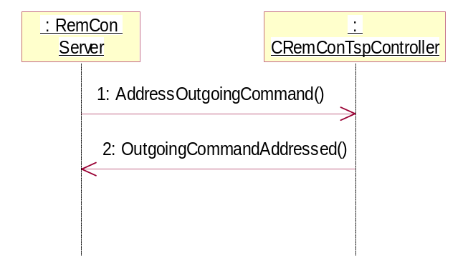
Figure 4.8 Delivering a command from a S60 client to remote targets

Delivering a command from a remote target to S60 clients
Operation | AddressIncomingCommand()
Preconditions | Remote Control Server is running. A S60 client has connected successfully to Remote Control as target. A remote target has sent a command to Remote Control, e.g. the user has pressed the PoC button down.
Description | Remote Control asks TSP to choose the S60 clients to which the command should be sent.
Inputs | - TUid aInterfaceUid: Identifies the client interface (e.g. defines Remote Control Extension API).  - TUint aOperationId: Identifies the command.  - TSglQue<TClientInfo>& aClients: A collection of the existing S60 clients.
Modifies | TSglQue<TClientInfo>& aClients
Outputs | TSglQue<TClientInfo>& aClients stores a list of the S60 clients to which the command should be sent.
Postconditions | Remote Control Server sends the command to all the S60 clients chosen by TSP.
Related To | AddressOutgoingCommand(),PermitOutgoingCommand()
Related Event
Exceptions

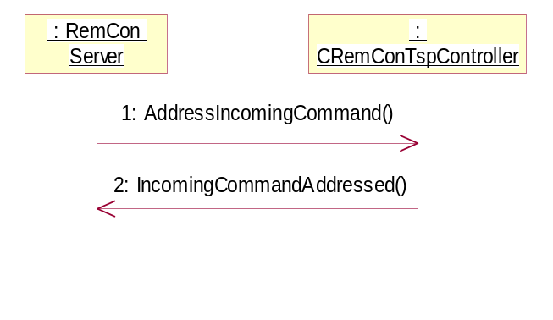
Figure 4.9 Delivering a command from a remote target to S60 clients

Deciding whether a S60 client can send a command to the specified remote target
Operation | PermitOutgoingCommand()
Preconditions | Remote Control Server is running. A S60 client has connected successfully to Remote Control as controller in the connection-oriented mode. The S60 client has sent a command to Remote Control, e.g. the Music Player application has sent a Volume Up command through Remote Control Core API.
Description | Remote Control asks TSP whether to send the command to the remote target specified by the S60 client.
Inputs | - TUid aInterfaceUid: Identifies the client interface.  - TUint aOperationId: Identifies the command.  - TClientInfo& aSender: Information about the S60 client.  - const TRemConAddress& aConnection: Identifies the remote target to which the command will be sent if TSP gives permission.
Modifies
Outputs | TSP calls the observer method to indicate that it has decided whether an outgoing command is permitted or not.
Postconditions | Remote Control Server sends the command to the remote target specified by the S60 client if it receives permission from TSP.
Related To | AddressOutgoingCommand(), AddressIncomingCommand()
Related Event
Exceptions

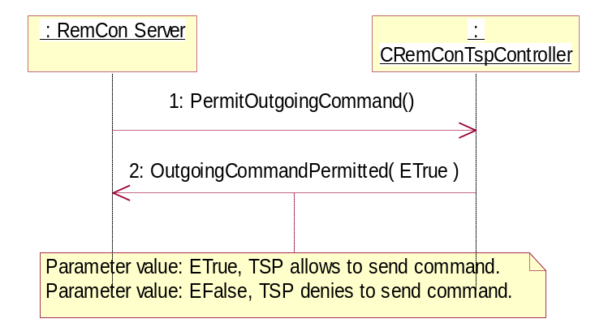
Figure 4.10 Deciding whether a S60 client can send a command to the specified remote target

Accessory Key Event Handling API
Accessory Key Event Handling API is an ECOM plug-in used by the Bearer plug-in and Remote Control Server.
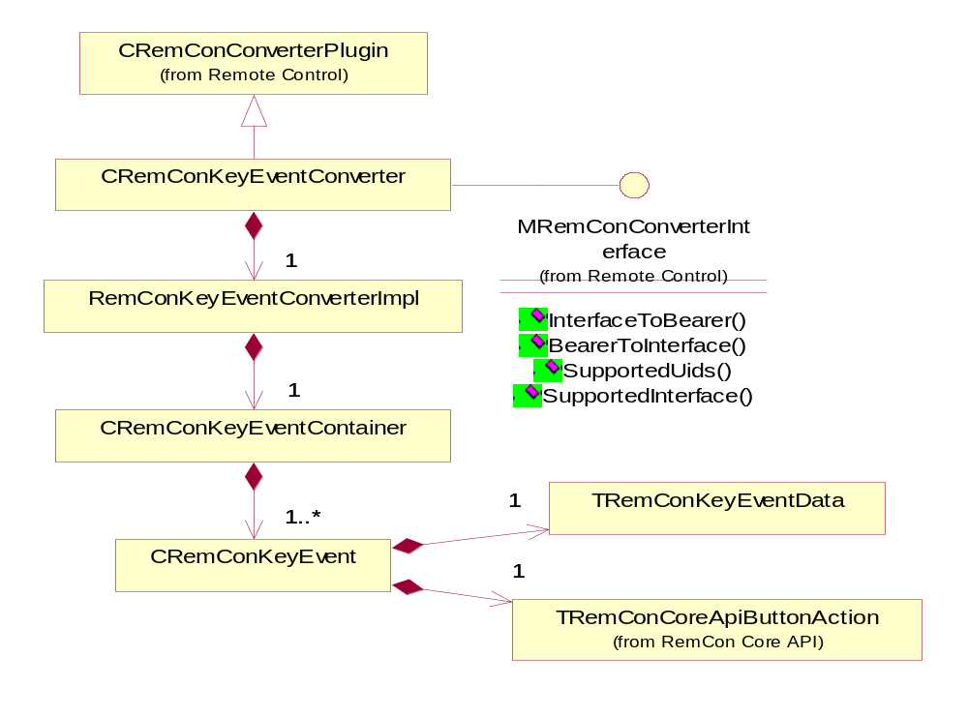
Figure 4.11 Accessory Key Event Handling API

Class descriptions
Class | Description | Header file
CRemConKeyEventConverter | The interface class for Key Event Converter. Derives from the CRemConConverterPlugin base class defined in Symbian Remote Control. | RemConKeyEventConverter.H
CRemConKeyEventConverterImpl | The implementation class for Key Event Converter. Has a friend relationship to the CRemConKeyEventConverter interface class and owns CRemConKeyEventContainer and CRemConKeyEventEnvironment instances. | RemConKeyEventConverterImpl.H
CRemConKeyEventContainer | A container and accessor class for all defined key event instances (CRemConKeyEvent). | RemConKeyEventContainer.H
CRemConKeyEvent | The key event definition class. Used to map key event data (for example, button actions, interface UIDs and operation IDs) to event specific key event prerequisites. | RemConKeyEvent.H
CRemConKeyEvent  Environment | An environment class that is used to evaluate the different states of environment for key event prerequisites (e.g. the voice call status). | RemConKeyEventEnvironment.H

Structs, type definitions and enumerations

RemConKeyEventData.h
TRemConKeyEventData | This structure defines the key event data. It consists of key code, key modifier, key state and event type definitions.
TRemConKeyCode | The key code of the event.
TRemConKeyModifier | The key modifier of the event.
TRemConKeyState | The key state of the event.
TRemConKeyEventType | The event type of the event.

TRemConKeyCode | The key code definition. Defines the actual key that triggered the event.
ERemConKeyCodeSendEnd | Send/End key.
ERemConKeyCodeVolumeUp | Volume up adjustment.
ERemConKeyCodeVolumeDown | Volume down adjustment.
ERemConKeyCodePlayPause | Play/pause playback.
ERemConKeyCodeStop | Stop playback.
ERemConKeyCodeBack | Previous track, rewind, previous radio station, etc. See the header file for a full definition.
ERemConKeyCodeForward | Next track, fast forward, next radio station, etc. See the header file for a full definition.
ERemConKeyCodePOC | PoC (Push to talk).
ERemConKeyCodeSync | Synchronize key (synchronize contacts, calendar, etc. between the terminal and some other device).
ERemConKeyCode1 | Customizable key code 1.
ERemConKeyCode2 | Customizable key code 2.
ERemConKeyCode3 | Customizable key code 3.
ERemConKeyCode4 | Customizable key code 4.

TRemConKeyModifier | The key modifier code. For future usage (Shift-, Alt- key modifiers, etc.).
ERemConKeyModifierNone | No modifier.

TRemConKeyState | The physical state of the key.
ERemConKeyStateUp | The key is up, not pressed.
ERemConKeyStateDown | The key is down, pressed.

TRemConKeyEventType | The event type of the key.
ERemConKeyEventNone | No event type specified.
EremConKeyEventShortPress | A short key press event.
ERemConKeyEventLongPress | A long key press event.
EremConKeyEventRepeat | A repeating key event (key stays down longer than in a long press event).

Operations
Accessory Key Event Handling API can be thought to have two different operations: first being the initialization of the converter by Remote Control Server and second being the key event conversion requested from the Bearer plug-in through Remote Control Server.

Initialization of Accessory Key Event Handling API
Operation | Initialization of Accessory Key Event Handling API.
Preconditions | Remote Control Server is starting up (being a transient server, this means that the first Remote Control Server client is also starting up) and is looking for converter plug-ins from the environment. The Key Event Converter binary needs to be in the environment.
Description | Key Event Converter is being created and initialized and a reference to it is added to the list of converters in Remote Control Server.
Inputs | Remote Control server looks for converter implementations via the ECOM FW by calling every converter’s implementation proxy.
Modifies | A converter instance is created and its internal state is initialized. Namely, CRemConKeyEventConverter, CRemConKeyEventConverterImpl, CRemConKeyEventContainer together with all the defined CRemConKeyEvent instances are created.
Outputs | Remote Control Server has a reference to an instance of Key Event Converter (of the type CRemConKeyEventConverter).
Postconditions | Key Event Converter is initialized and a CRemConKeyEventConverter instance is accessible by the Bearer plug-ins via Remote Control Server.
Related To | CRemConKeyEventConverter, CRemConKeyEventConverterImpl, CRemConKeyEventContainer, CRemConKeyEvent.
Related Event | Remote Control server startup.
Exceptions | If Remote Control Server fails to load the converter, it is not accessible by the Bearer plug-ins either.

Key Event Conversion
Operation | Key event conversion.
Preconditions | Key Event Converter has been created and initialized by Remote Control Server. The Bearer plug-in has been initialized by Remote Control Server. See reference document [4] for more details on how Remote Control Server implements the sequence.
Description | After the Key Event Converter has been detected and created by Remote Control Server, it is accessible by the Bearer plug-ins. The Bearer plug-ins can use Key Event Converter to convert key events between the bearer specific and the Remote Control Server formats by calling indirectly the BearerToInterface()method in CRemConKeyEventConverter. ..
Inputs | References to the Bearer data (a TRemConKeyEventData instance), interface UID, operation ID, TRemConMessageType and TDes8 for the data associated with the operation.
Modifies | Successful conversion (meaning that the Bearer given key event data is mapped to a key event instance defined in Key Event Converter) modifies the given reference parameters as follows:  - Interface UID holds the interface UID of the event.  - Operation ID holds the operation ID of the event.  - Message type is not used.  - Operation data holds the key action.  (All key actions are defined by Remote Control in RemConCoreApi.H).
Outputs | If the operation was successful, the reference parameters given from Bearer are modified.
Postconditions | Bearer has the event information needed to be able to call Remote Control Server.
Related To | CRemConKeyEventConverter, CRemConKeyEventConverterImpl, CRemConKeyEventContainer, CRemConKeyEvent.
Related Event | Bearer has received a key event and wants to convert it to a format suitable for Remote Control Server.
Exceptions | If Key Event Converter does not recognize the key event data from Bearer and cannot map it to any existing key events, the call returns KErrNotSupported.  In other error cases Key Event Converter returns KErrGeneral.

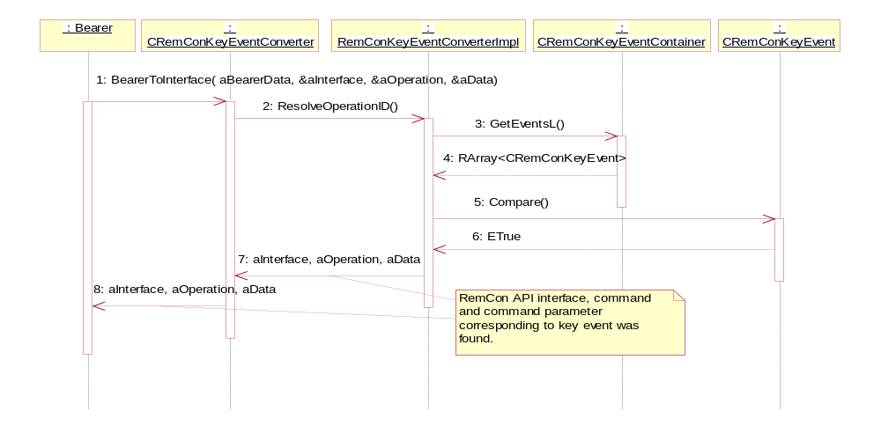
Figure 4.12 Key event conversion

Backup and Restore
This component does not participate in backup and restore.

Variation
Remote Control Plug-ins does not support variation.

System resource usage

Files
Remote Control plug-ins does not use any files.

Other data

Databases
Remote Control plug-ins does not use any databases.

Central Repository
Remote Control plug-ins does not use Central Repository.

Publish and Subscribe
Remote Control plug-ins does not use Publish and Subscribe.

Memory consumption
Memory/Build | Consumption
Remote Control Extension API, WINSCW UDeb | 286212 bytes
Remote Control Extension API, ARMV5 URel | 1645 bytes
Remote Control TSP Controller, WINSCW UDeb | 224776 bytes
Remote Control TSP Controller, ARMV5 URel | 1269 bytes
Key Event Handling API, WINSCW UDeb | 268388 bytes
Key Event Handling API, ARMV5 URel | 2422 bytes

Task allocation
Remote Control Extension API runs in the same process as the S60 client that loads it.
Remote Control TSP Controller runs in the same process as Remote Control Server.
Accessory Key Event Handling API runs in the same process as Remote Control Server.

Performance
No time consuming tasks have been identified in Remote Control plug-ins.

Timers
Remote Control plug-ins does not use any timers.

Security

Capabilities of this component

Component | Capability | Justification
Remote Control Extension API | ALL -TCB | Defined by S60 for general purpose DLLs.
Remote Control TSP Controller | ProtServ LocalServices NetworkServices NetworkControl CommDD | The capabilities have been specified by Remote Control for components running in Remote Control Server’s process.
Accessory Key Event Handling API | ProtServ LocalServices NetworkServices NetworkControl CommDD | The capabilities have been specified by Remote Control for components running in Remote Control Server’s process.

Exception handling
The leave mechanism of the Symbian OS environment is used to handle memory exhaustion.

Usage

Building
When the Symbian OS services listed in Section 2.4.1 are present, Remote Control plug-ins can be built successfully from the folder accessoryremotecontrol\group by using the following commands:
bldmake bldfiles
abld build armv5 (for hardware)
or
abld build winscw (for emulator)

User's guide
For information on how to use Remote Control Extension API, see reference document [2].
For information on how to use Accessory Key Event Handling API, see reference document [3].
To put traces on while debugging any of Remote Control plug-ins, the following thing has to be done: Build an udeb version of the component.

