S60 3.1
Accessory Framework
Design Document

Team name | Author
Core BS System | Mikael Häkkilä

Change history:

Version | Date | Status | Comments
2.0 | 17.08.2006 | Approved | Added Accessory Framework UI Notifier design reference
1.0 | 26.04.2006 | Approved

Table of contents:

1. Document control 5
1.1 References 5
1.2 Documentation conventions 5
1.3 Abbreviations 5
1.4 Definitions 6
2. General 7
2.1 Introduction 7
2.2 Component environment 8
2.3 Use cases 9
2.3.1 Accessory Server is started 12
2.3.2 Accessory Server client starts listening for the new accessory connection 13
2.3.3 Accessory is connected 14
2.3.4 Wired accessory is detected but not connected 15
2.3.5 Accessory Server client reads the Generic ID 16
2.3.6 Accessory Server client requests Accessory Capabilities 16
2.3.7 Accessory Server client requests a value for the specified Accessory Capability 17
2.3.8 Accessory Server requests the value for a specific Accessory Capability from ASY 17
2.3.9 ASY notifies Accessory Server about the change in accessories’ internal state 18
2.3.10 Audio client requests BT audio accessory to open a mono audio link 19
2.3.11 Accessory mode is changed 20
2.3.12 Accessory is disconnected 20
2.4 Services required 21
2.4.1 From the Symbian OS subsystems 21
2.4.2 From Domestic OS subsystems 21
2.4.3 From HW 21
2.5 Services provided 21
2.5.1 UI 21
2.5.2 SW IF 21
3. UI control hierarchy 23
4. Design 24
4.1 Framework 24
4.2 Components 24
4.2.1 Accessory Server 24
4.2.1.1 Accessory Server Class diagrams 24
4.2.1.2 Accessory Server class descriptions 26
4.2.1.3 Accessory Server structs, type definitions and enumerations 27
4.2.1.4 Accessory Server API definitions 28
4.2.1.5 Accessory Server state diagrams 28
4.2.2 Accessory Server client APIs 30
4.2.2.1 Accessory Server client API class diagrams 30
4.2.2.2 Accessory Server client API class descriptions 31
4.2.2.3 Accessory Server client API definitions 32
4.2.3 ASY Proxy 33
4.2.3.1 ASY Proxy class diagrams 33
4.2.3.2 ASY Proxy class descriptions 35
4.2.3.3 ASY Proxy structs, type definitions and enumerations 36
4.2.3.4 ASY Proxy API definitions 36
4.2.4 ASY reference implementation 37
4.2.4.1 ASY reference implementation class diagrams 37
4.2.4.2 ASY reference implementation class descriptions 37
4.2.5 Accessory Server utilities 37
4.2.5.1 Accessory Server utilities class diagrams 37
4.2.5.2 Accessory Server utilities class descriptions 38
4.2.6 ASY Comms 39
4.2.6.1 ASY Comms class diagrams 39
4.2.6.2 ASY Comms class descriptions 39
4.2.6.3 ASY Comms API definitions 40
4.2.7 Accessory Policy 40
4.2.7.1 Accessory Policy class diagrams 40
4.2.7.2 Accessory Policy class descriptions 41
4.2.7.3 Accessory Policy structs, type definitions and enumerations 42
4.2.8 Accessory Policy API definitions 42
4.2.9 Accessory Policy database 42
4.2.9.1 Accessory Policy database class diagrams 43
4.2.9.2 Accessory Policy database class descriptions 43
4.3 Operations 43
4.3.1 Accessory Server construction 43
4.3.2 ASY loading 44
4.3.3 Initialize connection status 45
4.3.4 Notify New Accessory Connected Request 47
4.4 Process command 49
4.4.1 Create transaction 52
4.4.2 Delete the transaction 53
4.4.3 Disable vibra 54
4.5 Flag definitions 55
4.6 Backup and Restore 55
5. Variation 56
5.1 Accessory control/Bluetooth 56
5.2 Accessory Server/Bluetooth 56
6. System resource usage 57
6.1 Files 57
6.2 Other data 58
6.2.1 Databases 58
6.2.2 Central Repository 58
6.2.3 Publish and subscribe 58
6.3 Memory consumption 58
6.4 Task allocation 59
6.5 Timers 59
7. Exception handling 60
8. Usage 61
8.1 Building 61
8.2 User's guide 61

Document control

References
- HW Resources and Enhancements SWAD for Series 60 3.1
- S60 Accessory Client Server Design Document
- S60 Accessory Key Event Converter Design Document
- S60 Accessory Key Event Converter API Document
- S60 Accessory Policy Design Document
- S60 Accessory API Specification Document
- S60 Accessory Plug-In API Specification Document
- S60 Accessory framework integration guideline
- S60 PC GID tool User guide
- S60 PC GID tool design document
- S60 Phone Command Handler Design
- S60 RemCon Extension API Specification Document
- S60 Accessory Policy Common capability generic ID definitions
- User Guide for GID
- S60 Accessory Framework UI Notifier Design Document

Documentation conventions
Code is shown with the Courier New font.

Abbreviations
ACC | Accessory
ACC FW | Accessory Framework
ASY | Accessory Handler Provider Module
BT | Bluetooth
BT_DEV_ADDR | BT Device Address.
BTAAC | Bluetooth Audio Accessory Controller
CAP | Capability
Caps | Capabilities
CR | Central Repository
GID | Generic ID
HFP | Handsfree Profile
HSP | Headset Profile
HW | Hardware
ID | Identification
OS | Operating System
P&S | Publish & Subscribe
SCO | Synchronous Connection Oriented
SWAD | SW Architecture Description
TTY | Text Device
UI | User Interface

Definitions
ACC CAP name-value record | Each ACC CAP has name, e.g. unique constant identifying a specific capability. Many ACC CAPs also have the value that is associated to the specific name. ACC CAP names and values constitute ACC CAP name-value records: e.g. ACC CAP 1 = (Name 1, Value 1). See Section4.2.7.
ACC CAP Capability group | Structures containing accessory capabilities for the connected accessory.
Accessory capability (ACC CAP) | Accessory capability (ACC CAP), i.e. accessory feature or property (see Section 4.2.7).
Accessory connection status | Combined connection status for all the currently connected accessories. All the connected accessories need to have existing signaling or control connection.
Accessory Mode | Super state for connection status and audio accessory modes.
Combined connection status | All currently connected accessories.
Control connection | Control or signaling connection has been established between the accessory in question and the terminal. When control connection has been established it means that accessory is now ready to process user actions (e.g. button presses) as well as ready to receive requests from the terminal (e.g. open audio link). Pre-conditions:  - Physical connection with accessory has been established.  - If accessory requires authentication, it has been executed.  - If accessory connection requires any initialization (e.g. HFP Service Level Connection), it has been executed.
Device Type | Each Device Type may have multiple associated capability groups.
Generic ID | ACC FW Generic ID (GID). Concept, which enables the clients to identify the connected accessory, based on features, rather than hard coded constants or provider specific HW IDs (see Section 4.2.7).
Generic ID class | ACC FW class, which realizes the Generic ID concept for the ACC FW clients (see Section 4.2.7).
GID header | Fixed length part of the Generic ID that contains the invariable ACC CAPs (features), e.g. the features that are defined for all types of accessory (see Section 4.2.7).
HW Device ID | Accessory device ID (see Section 4.2.7).
HW Model ID | Accessory model or type ID. Provided by accessory manufacturer; usually has correspondent sales name (see Section 4.2.7).
Physical connection | Physical Connection is established at the moment the accessory is detected.  When physical connection is established, it usually follows that control connection will be created. There are, however, some pre-conditions, that may prevent the control connection from being created. For example: accessory is not properly powered or authentication fails.
Single accessory connection status | Connection status of one, specific (specified with GID) accessory.

General

Introduction
The Accessory Services subsystem abstracts accessory services for platform and SDK clients, and provides accessory related APIs for adaptation and provider specific modules. Accessory Server accessory related APIs create the basis for the accessory framework (ACC FW).
This document is a high-level design document for showing the high-level design of Accessory Framework. The document represents the division of Accessory Framework to smaller components and their high-level design. The design for individual Accessory Framework components is documented separately in the component specific design documents.
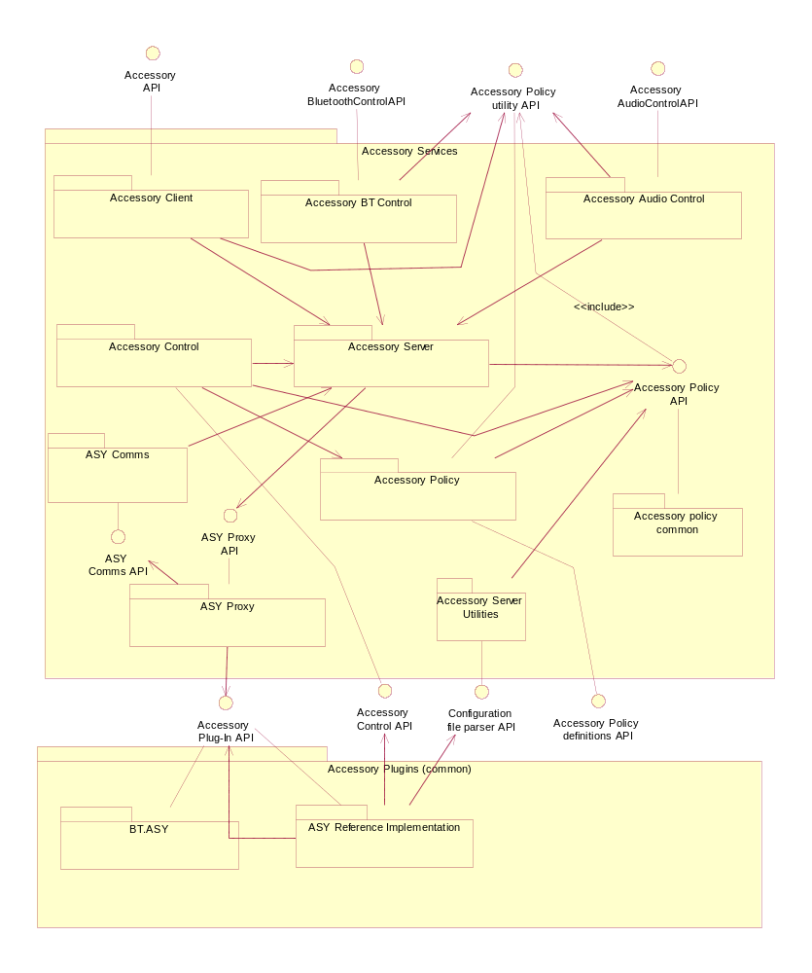
Figure 2.1 Accessory Framework: Accessory Services components

Component environment
The following figure shows the key relationships between Accessory Framework and the components in its environment.
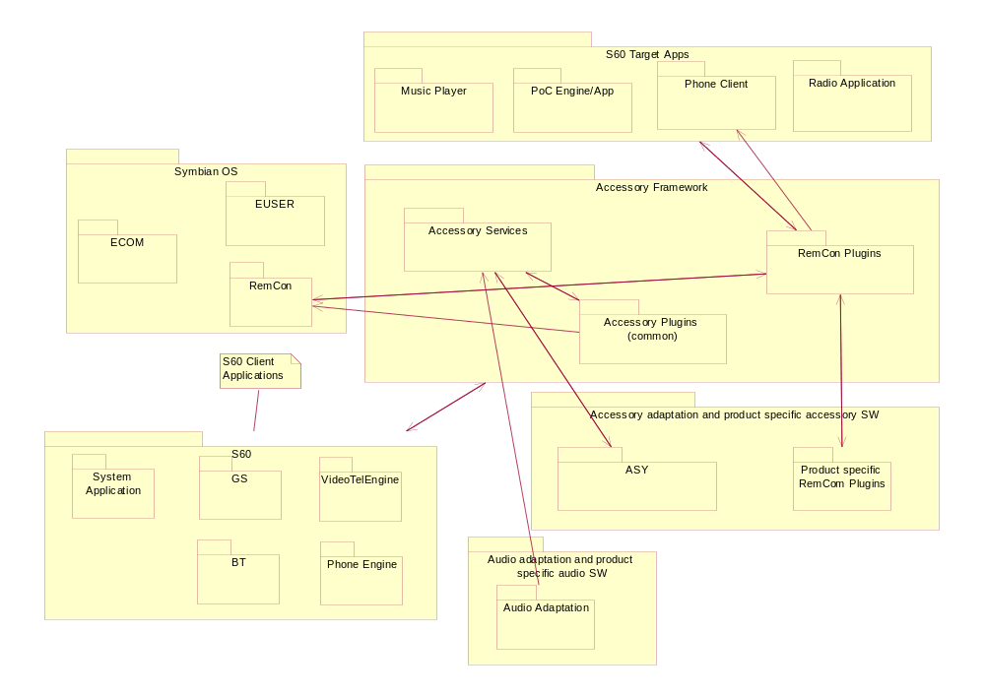
Figure 2.2 Accessory Framework environment

Use cases
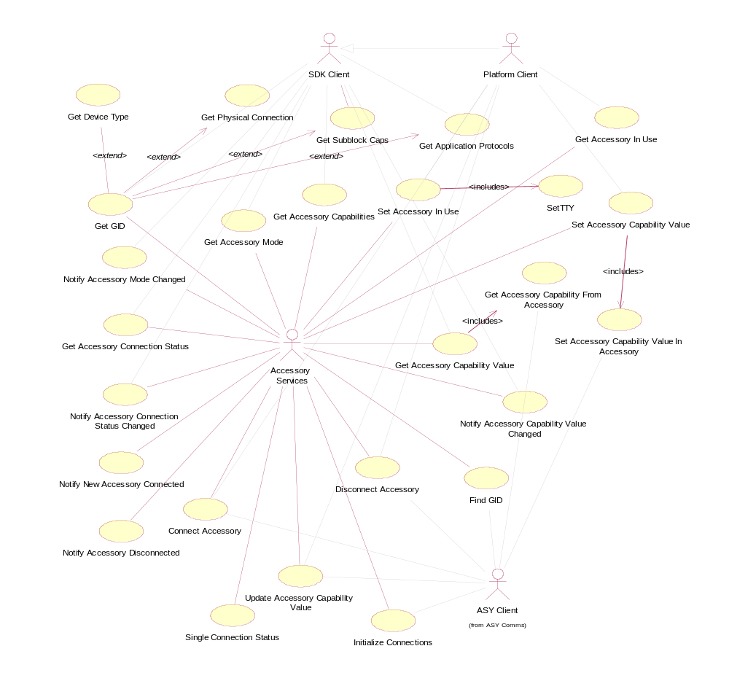
Figure 2.3 Accessory Services use cases
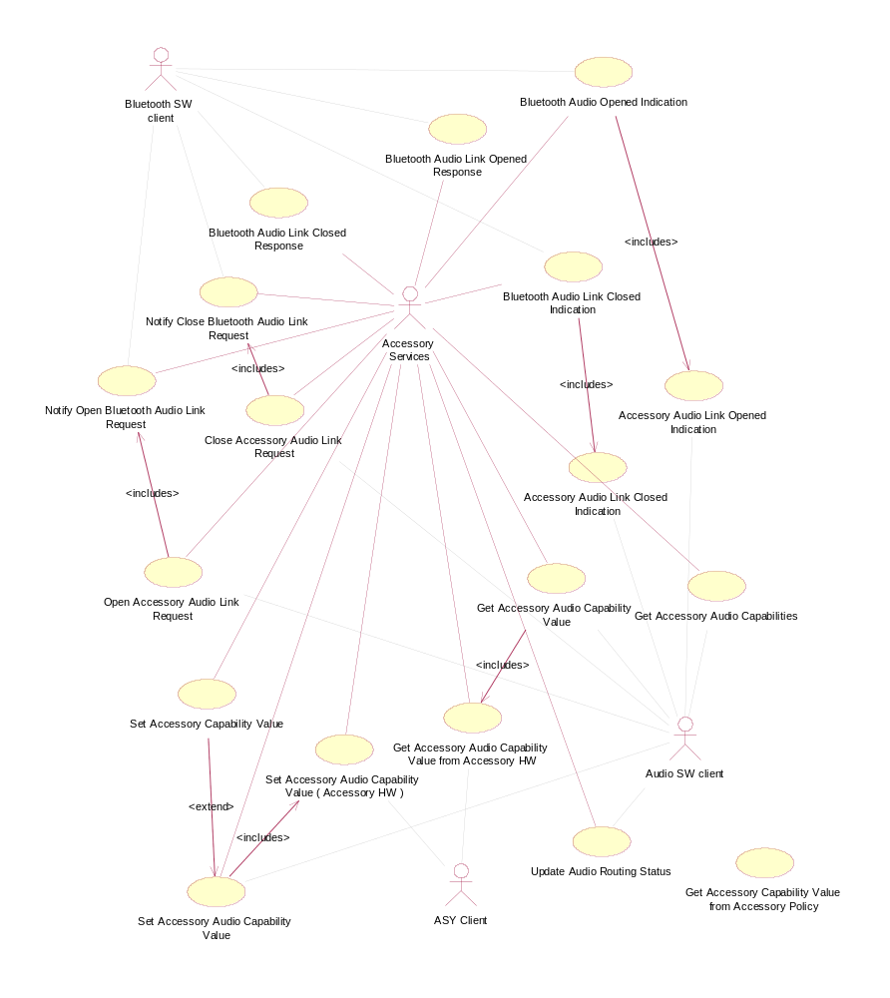
Figure 2.4 Accessory Services use cases – Bluetooth and Audio
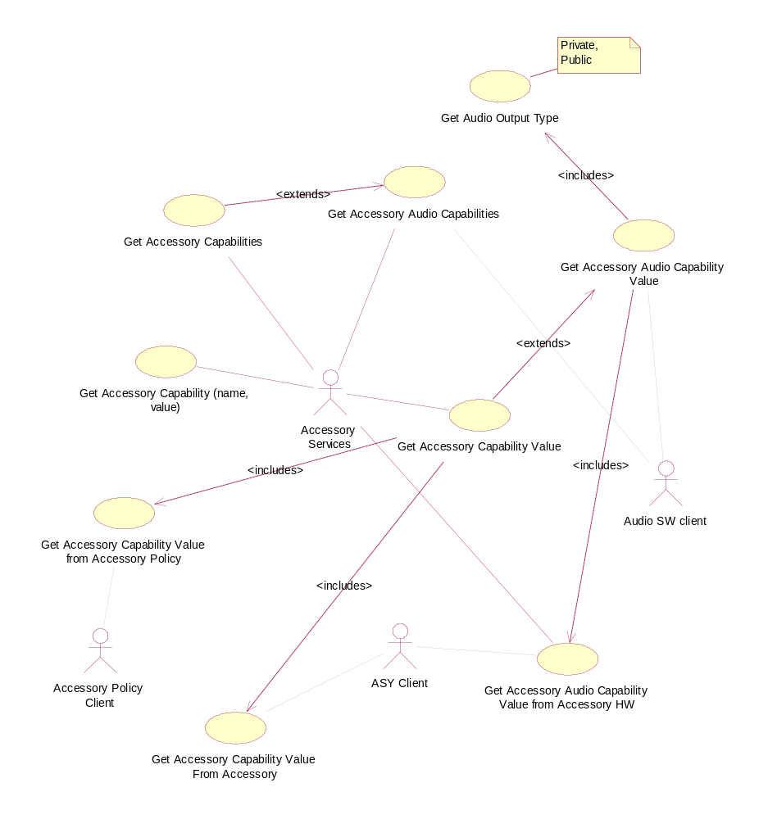
Figure 2.5 Accessory Services use cases – Accessory Capabilities

Accessory Server is started

Summary | Accessory Server is started when terminal is started.
Actor(s) | Starter, Accessory Server, ASY Proxy, ASY(s).
Frequency | The use case is executed once every time when terminal is booted up.  Low.
Preconditions
Description | When terminal starts up, the S60 Starter module creates a new process and requests Accessory Server to start up. Accessory Server construction is a two phase construction:  - In the first phase, Accessory Server executable is constructed and the server’s active scheduler is started. Accessory Server’s connection status and accessory mode flags are set to the ‘Init wait’ status to indicate that the server is initializing. In the first phase, Accessory Server also creates ASY Proxy, which starts loading the ASYs.  - ASY loading is phase two of Accessory Server construction. It is an asynchronous operation and continues in the background when the Accessory Server executable construction is already complete, and startup request has been returned to the Starter module (phase 1). When ASY loading is complete, ASY Proxy notifies Accessory Server. After notification, Accessory Server starts initializing the connection status and accessory modes by sending ‘initialize connections’ (ProcessCommand with init parameter) command to ASY. When the processing of the command is complete, connection status and accessory mode have been initialized, and Accessory Server turns the connection status and accessory mode flags to the ‘Ready’ position to indicate that the server is ready for client requests. This ends phase 2.
Exceptions | - There are no ASYs: Accessory Server is started up with limited functionality.  - Creating new thread for at least one of the found ASYs fails. ASY Proxy makes one attempt to re-establish the thread for the ASY.  - If the thread is killed and there is only one ASY, ASY Proxy terminates the load ASYs operation with an error. Accessory Server is started up with limited functionality.  - If the thread is killed and there is more than one ASY, ASY Proxy continues with trying to establish the thread for other ASYs.  - There are no ASYs and the ‘initialize connections’ command cannot be executed the connection status is initialized to zero (no connections), the accessory mode is initialized to ‘Handportable mode’. The connection status and accessory mode flags are set to the ‘Ready’ position. However, the ASY recognized flag remains in the FALSE position to indicate that there are no ASYs and thus no commands to ASYs may be executed.  - Processing of ‘initialize connections’ fails. If ASY loading fails, ASY Proxy signals Accessory Server with LoadingTimedOutL(). Applying timers is common for the loading process of all ASYs, not including an individual timer check of each ASY
Postconditions | Accessory Server is up and running. Accessory connection status and the accessory mode have been initialized.
Illustrations

Accessory Server client starts listening for the new accessory connection

Summary | Accessory Server client starts listening for the new accessory connection.
Actor(s) | Accessory Server client, Accessory Server.
Frequency | The use case is executed once during component initialization, and after that, every time after the previous accessory connection has been handled by the client; e.g. every time when the new accessory is connected.  Low
Preconditions | Accessory Server is running. The client thread has established Accessory Server connection. The client has created Single Accessory Connection sub session or Accessory Connection sub session for listening or controlling the changes in accessory connection.
Description | The client issues the Notify New Accessory Connect request. Accessory server handles the message. Request is handled by the corresponding server side sub session  When new accessory is connected, asynchronous request is completed.
Exceptions | Notify New Accessory Connected request is already outstanding: kErrAlreadyExists
Postconditions | Notify New Accessory Connected request has been handled by the Accessory Server. Accessory Server has added the request to the notification queue and the request is outstanding. Client thread has an active object (active) waiting for the completion of the request.  Notification for the new connected accessory.  Generic ID of the new connected accessory is returned to the client responsible for the connection request.  New accessory is connected and client has been notified about the new connection.
Illustrations

Accessory is connected

Summary | New accessory is detected. ASY or Bluetooth Controller requests Accessory Server to connect the accessory. Accessory Server handles the request and notifies all the clients that have registered for listening with the new accessory connection notification.
Actor(s) | Accessory Server client, Accessory Server, Accessory Policy, ASY or BT Controller.
Frequency | The use case is executed once every time a new accessory is connected.  Low
Preconditions | Accessory Server is running. ASY or BT Controller has established Accessory Server session and correspondent sub session for accessory control.
Description | New accessory is connected. ASY or BT Controller requests the accessory to be connected. Accessory server starts handling the request. Accessory Server checks the validity of the new connection from the Accessory Policy. In the case the new connection is approved, accessory server updates the connection status. After the connection status is updated, New Accessory Connection indication is sent to the registered clients, i.e. all the Notify New Accessory Connection client requests are completed. When the indication is sent, Accessory Server creates a task for updating the combined accessory connection status. When the task is created, Accessory Server completes the original connection request.  After the new single accessory connection has been established, Accessory Server starts executing the task for updating the combined connection status. First it checks the validity of the new combined connection status from Accessory Policy. If approved, Accessory Server updates the combined accessory connection status. After the combined connection status is updated, all the Notify Accessory Connection Status Changed client requests are completed. Finally, Accessory Server creates a task for updating the Accessory Mode (see Section 2.3.11).
Exceptions | - Accessory Server is busy with processing a previous Connect request: in this case the client needs to re-issue the request after a short time period.  - The new accessory connection is rejected: Accessory Policy may reject the new connection as a whole or it can allow only the physical connection to be established (see Section 2.3.4). In both cases the connection status stays the same.  - Accessory policy informs the new combined accessory connection is not allowed: Accessory server will reject new control connection.
Postconditions | Accessory Server has connected the detected accessory. Connection status has been updated, and all the clients have been notified about it. Combined accessory connection status has been updated and the clients have been notified about it. Accessory Server has created task for updating the Accessory Mode.
Illustrations

Wired accessory is detected but not connected

Summary | Accessory Policy rejects the new accessory connection with a message indicating that only physical connection is allowed. Accessory server establishes the physical connection but not the control connection.
Actor(s) | Accessory Server, Accessory Policy, ASY or BT Controller.
Frequency | The use case is executed only in the case the new wired accessory is connected and the connection has conditions that are not fulfilled.  Low
Preconditions | A new wired accessory has been detected and ASY has requested Accessory Server to connect the accessory. Accessory Server has started handling the request and it has made a query to Accessory Policy to check if the new accessory connection is allowed. Accessory Server has made a query concerning the validity of the new accessory connection. Accessory Policy has read its database for the specified Generic ID in order to find out if there are conditions for the connection. Accessory Policy has found some conditions and also has checked if the conditions are fulfilled. The result has been false.
Description | Accessory Policy reply to the query is that there are conditions for the connection that are not fulfilled; only physical connection is allowed. As a consequence, Accessory Server updates its register for the new physical accessory connection, but it does not update the control connection. Changes in physical connection are not informed to the Accessory Server clients and thus no indications are sent.
Exceptions
Postconditions | Accessory Server has established new physical connection but the accessory is not connected. When any of the conditions for the connection changes, Accessory Server checks the connection status automatically.
Illustrations

Accessory Server client reads the Generic ID

Summary | Accessory Server client reads the Generic ID in order to conclude how the new accessory connection indication should be handled.
Actor(s) | Accessory Server client.
Frequency | Accessory Server clients can read generic ID every now and then to check accessory states and connected accessories.  Medium.
Preconditions | Accessory Server client has received New Accessory Connected Notification or Accessory Connection Status Changed Indication in which Generic ID has been returned as a parameter.
Description | Generic ID can be read in various ways. Basically reading means examining the significant Generic ID bits. If the significant bit is TRUE, it means that accessory supports the capability defined by the specific bit.  Significant bits are different for different clients, i.e. in order to read the Generic ID, the client first needs to consider, what information it needs to know about the connected accessory.  Significant bits can be read from Generic ID by using predefined bit masks, which are then compared to the Generic ID data using standard logical operations.
Exceptions
Postconditions | Accessory Server client knows the connected accessories general capabilities, e.g. the capabilities that are common for all type of accessories: the device type, the physical connection, the application protocols, the sub blocks and HW Model ID.
Illustrations

Accessory Server client requests Accessory Capabilities

Summary | Accessory Server client reads the Accessory Capability Names, which are associated with the Generic ID.
Actor(s) | Accessory Server client, Accessory Services.
Frequency | The use case is executed, if the client’s general capabilities are not enough and it needs to study the accessory capabilities stored in the GID sub blocks.
Preconditions | Accessory Server client has read the general capabilities from the Generic ID, but the client needs to have additional, e.g. audio related capability information, to conclude how the new accessory connection indication should be handled.
Description | The client creates an array for requesting the capability names and passes it to the server when requesting accessory (capability groups) capabilities. Accessory Server and Accessory Policy return all the capabilities associated to the specific Generic ID or alternatively only the capabilities associated to specific sub block. The client reads the returned list through to verify, if the accessory capabilities, that client is interested about, are supported by the accessory.
Exceptions
Postconditions | The client knows all the relevant capabilities for the connected accessory.
Illustrations

Accessory Server client requests a value for the specified Accessory Capability

Summary | Accessory Server client requests Accessory Capability Value, which is associated to the specific Generic ID and the specific Accessory Capability Name.
Actor(s) | Accessory Server client, Accessory Services.
Frequency | The value is usually requested when new accessory is connected or when client connects to the accessory server and accessory is already being connected. The frequency depends on the client.  Low.
Preconditions | Accessory is connected. The Accessory Capability Name (provided by the client) is supported by the accessory (identified by GID).
Description | Accessory Server client provides the Accessory Capability Name and the Generic ID as parameters and requests the value related to the parameters. Accessory Server requests the data value from Accessory Policy.
Exceptions | - The provided accessory capability name is not valid: returns an error to the client  - The provided GID is not valid: returns an error to the client  - Service Discovery Database request fails: returns an error to the client
Postconditions | The client has received the data value it requested.
Illustrations

Accessory Server requests the value for a specific Accessory Capability from ASY

Summary | Accessory Server requests a specified ACC CAP value from ASY.
Actor(s) | Accessory Server, ASY Proxy, ASY, Accessory (device).
Frequency | Critical values are queried during connection process. Other values are queried when they are needed for the first time.  Medium.
Preconditions | Accessory is connected and identified with GID. Accessory supports the specified ACC CAP name and the name has associated data value.
Description | Accessory Server sends process command notification to ASY Proxy and starts a timer to follow-up the completion of the transaction with ASY. When an observer object in ASY Proxy receives the notification, ASY Proxy first creates new notification request to Accessory Server. After this ASY Proxy creates ASY command handling object and makes the actual request to ASY. When ASY has processed the request and the request has been returned, ASY Proxy sends the response to Accessory Server and destroys the command handling ASY object. Accessory Server deletes the timer and does further handling for the data, e.g. stores the retrieved data to Accessory Registry.
Exceptions | - If the same command for the same capability exists: a new command is not sent, but the existing transaction is used to get the needed information.  - The request does not return from ASY: a time out occurs, an error will be returned to the client.
Postconditions | Accessory Server has received the data value it requested.
Illustrations

ASY notifies Accessory Server about the change in accessories’ internal state

Summary | ASY notifies Accessory Server about the change in accessories’ internal state, i.e. updates the value associated to specific Accessory Capability (ACC CAP).
Actor(s) | Accessory Server, ASY Proxy, ASY, Accessory (device).
Frequency | The value is updated when the change occurs in accessories’ internal state.  Low.
Preconditions | Accessory is connected.
Description | ASY notifies Accessory Server about the change in specific ACC CAP value for the specific Generic ID. Accessory Server checks if the ACC CAP in question is valid for the specified Generic ID. Accessory Server checks if the accessory with the specified GID is connected. Accessory Server checks if the new value is different from the one that Accessory Server has in its register. Accessory Server checks if the new value is within the accepted range. Accessory Server updates the new value into the Accessory register. Accessory Server checks if any Notify Accessory Value Changed type of client requests exist for the ACC CAP in question. All the requests in the question are completed. Accessory Server checks If there exists physical accessory connections for which the specific ACC CAP is a condition. If such a connection(s) exists, the connection status for the accessories in question is re-evaluated.
Exceptions | - The ACC CAP is not supported by the Generic ID: returns an error to the client.  - Generic ID is not valid: returns KErrArgument to the client.  - The new value is the same that Accessory Server has in its register: ASY request is completed with kErrNone.  - The new value is not within the accepted range: returns an error to the client.  - There are no client requests for the ACC CAP in question: no need for notifications.  - There are no physical accessory connections for which the ACC CAP in question is a condition: no need for evaluation.
Postconditions | Accessory Registry has been updated. Clients with outstanding requests have received the updated data values. ASY request has been completed with kErrNone.
Illustrations

Audio client requests BT audio accessory to open a mono audio link

Summary | Audio client requests BT audio accessory to open a mono audio link, i.e. SCO link.
Actor(s) | Audio client, e.g. Audio Policy, Accessory Server, BTAAC.
Frequency | The use case is executed when the audio client (any audio component responsible for routing the audio) has decided to route the current mono audio to the connected BT audio accessory.  Low.
Preconditions | BT audio accessory is connected, i.e. service level connection is established.
Description | Audio client makes a request to open audio link to the connected BT accessory. Accessory server handles the request. If connection for the provided GID exists, Accessory Server verifies the GID belongs to the BT device. Accessory Server resolves BT_DEV_ADDR for the GID. Accessory Server checks if any Notify open audio link request type of BT client requests exist for the BT_DEV_ADDR in question. Accessory Server completes the client requests in question with BT_DEV_ADDR as a parameter. BTAAC opens the SCO link to the BT device. BTAAC sends Audio Link Opened Indication to Accessory Server. BTAAC sends Open Audio Link Response to the Accessory Server. If the status of the response is KErrNone, Accessory Server first completes the BTAAC request and then the original Audio client Open Audio Link request with kErrNone.
Exceptions | - Connection for the provided GID does not exist: returns an error to the client  - GID does not belong to the BT device: returns an error to the client  - No outstanding Notify Open Audio Link type of client requests exist with the specific BT_DEV_ADDR: returns an error to the client  - BTAAC does not send Audio Link Opened Indication: Accessory Server does not have timers to control this.
Postconditions | Audio link has been opened to the connected BT audio accessory.
Illustrations

Accessory mode is changed

Summary | Combined accessory connection status has changed. Accessory Server evaluates if Accessory mode needs to be updated.
Actor(s) | Accessory Server, Accessory Server client.
Frequency | Every time the combined accessory connection status has changed, e.g. when accessory has been connected or disconnected.  Low
Preconditions | Combined accessory connection status has changed. Task for re-evaluating the Accessory mode has been created.
Description | Task for re-evaluating the Accessory mode is executed after the active scheduler has first finished executing the same priority tasks in the queue. When the task is started, Accessory Server first checks if Audio client has notified Accessory Server about the audio routing status and if the accessory audio routing status is clear. If accessory audio routing status is clear, Accessory server queries new Accessory mode from Accessory Policy. Accessory Policy resolves the Accessory mode based on connection status and audio routing status. Accessory Policy returns the resolved Accessory mode. If Accessory mode has changed, Accessory Server first updates the current Accessory mode in Accessory Registry. After this Accessory Server checks if there are any outstanding notify Accessory mode type of client requests. If such requests exist, Accessory Server completes all the requests in the question.
Exceptions
Postconditions | Accessory mode has been re-evaluated. If Accessory mode has changed, the clients have been notified about it.
Illustrations

Accessory is disconnected

Summary | ASY or BT Controller has detected accessory disconnection and requests the Accessory Server to disconnect the accessory. Accessory Server handles the request immediately and notifies all the clients that have registered for listening accessory disconnection notification. After this task for updating the combined accessory connection status is created.
Actor(s) | Accessory Server client, Accessory Server, Accessory Policy, ASY or BT Controller.
Frequency | The use case is executed once every time when new accessory is disconnected.  Low.
Preconditions | Accessory to be disconnected is connected earlier.
Description | Accessory is disconnected. Accessory Server handles the request by notifying all the clients that have registered for listening the disconnection notification. After this Accessory Server creates task for updating combined accessory connection status. Combined accessory connection status is updated. After this Accessory Server creates task for updating the Accessory mode. Accessory mode is updated.
Exceptions
Postconditions | Accessory connection status and Accessory mode have been updated. Clients that have registered for listening the notifications of accessory disconnection or clients that have registered for listening notifications of changes in combined connection status are informed.
Illustrations

Services required

From the Symbian OS subsystems

API | Description
ECom Plug-In Architecture | Standard Symbian plug-in framework.
Threads and Processes | Provides access to processes, threads, and thread-local storage.
Remote Control Framework | Provides framework for remote control handling

From Domestic OS subsystems
This component does not have any direct interfaces to the Domestic OS subsystems.

From HW
This component has no direct HW interfaces.

Services provided

UI
This component provides Accessory Framework UI Notifier (see reference document [15]) to show information according to connected accessory. UI is used via Symbian Notifier framework.

SW IF
Accessory Framework provides framework of APIs providing accessory related services for various kind of clients.
- The Accessory API (see reference document [6]) allows clients to be notified when a remote device is connected, or to request information of the connected device.
- The Accessory Control API (see reference document [6]) provides means to control accessory related functions in accessory HW and SW. The API is based on the Accessory API. The Accessory Control API adds appropriate methods, types and constants to Accessory API, that enable notifying changes in accessory connection status and accessory internal status as well as accessing accessory resources.
- The Accessory Bluetooth Control API (see reference document [6]) is a Bluetooth specific extension to Accessory Control API. The Accessory Bluetooth Control API adds appropriate methods, types and constants to Accessory Client-Side API, that enable controlling the changes in Bluetooth accessory connection status and audio link status.
- The Accessory Audio Control API (see reference document [6]) is audio specific extension to Accessory API. The Accessory Audio Control API adds appropriate methods, types and constants to Accessory Control API, that enable controlling the audio related accessory features.
- The Configuration File Parser API (see reference document [6]) is a utility API for Accessory Server plug-ins to parse configuration. It is used to map detected accessory HW Device IDs to Generic IDs and parse Generic ID from Accessory Capabilities.
- The Accessory Policy API (see reference document [5]) encapsulates accessory policy private functionality.
- The Accessory Policy definitions API (see reference document [6]) contains common Generic ID declarations. Accessory Policy Definitions Extension API can be used to declare proprietary Accessory capabilities. Extension mechanism is described in reference document [5].
- The Accessory Policy utility API (see reference document [6]) contains utility functions and classes for GenericID handling.
- The Accessory settings API (see reference document [6]) is a Central Repository interface to accessory specific settings.
- The Accessory Plug-In API (see reference document [7]) is a ECom Plug-In API for Accessory Server plug-ins, i.e. ASYs. The abstract API consists of two base classes, from which the ASY classes are inherited. The API also provides the types, constants and utilities needed in ASY – Accessory Server communication.
- The Key Event Handling API (see reference document [4]) is ACC FW API that provides method for handling accessory key events. Reference document [3] describes the data format for wired key event related bearer data.
- The RemCon Extension API (see reference document [12]) defines a set of commands that can be delivered through the Remote Control framework between S60 components and remote targets (e.g. headsets).

UI control hierarchy
The component does not contain any UI or UI controls.

Design

Framework
This Chapter provides static object model for the Accessory Framework components using meta model definitions.
- Class diagrams for the Accessory Framework components can be found in referenced Accessory Framework design documents.
- Section 4.2.1.2 provides names and purposes for the stereotype classes instead of real classes.

Diagrams that describe the dynamic behavior of classes use stereotype classes instead of real classes.

Components

Accessory Server

Accessory Server Class diagrams
Accessory server is a standalone server, which is launched at startup. It is the main thread in Accessory Server process and has responsibility to manage the Accessory Server plug-ins, i.e. ASYs, which all need to be executed in their own threads. From the previous requirement it follows, that Accessory Server needs to manage all the threads in the Accessory Server process.
In Accessory Server, ASY loading, ASY communication and the thread handling has been encapsulated in the polymorphic DLL called ASY Proxy. Accessory Server provides polymorphic interface for the ASY Proxy and loads it during the construction in startup.
Accessory Server manages also the accessory connection status, accessory related data and accessory related settings. For Accessory Server clients, it provides notification services and enables access to accessory resources.
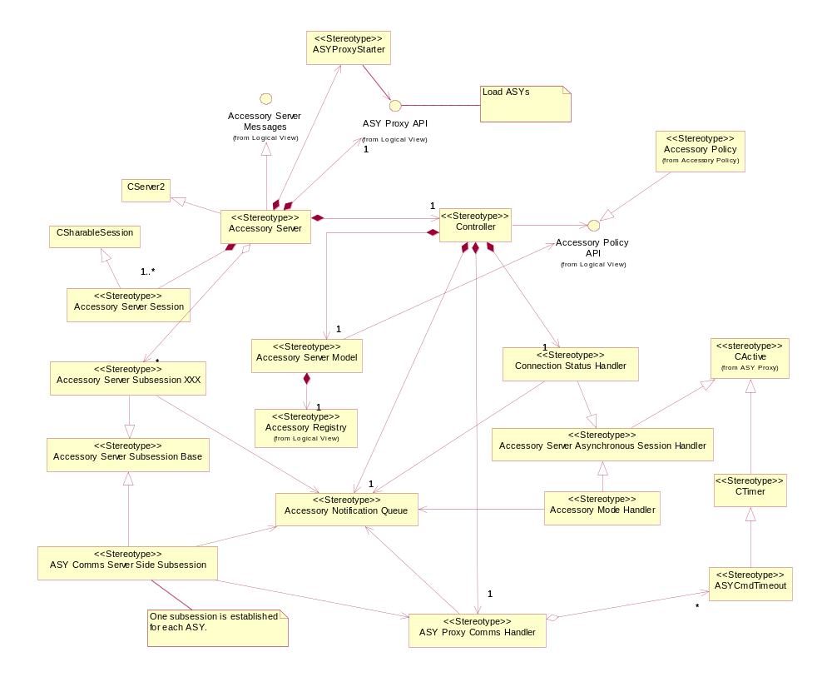
Figure 4.6 Accessory Server metamodel definition
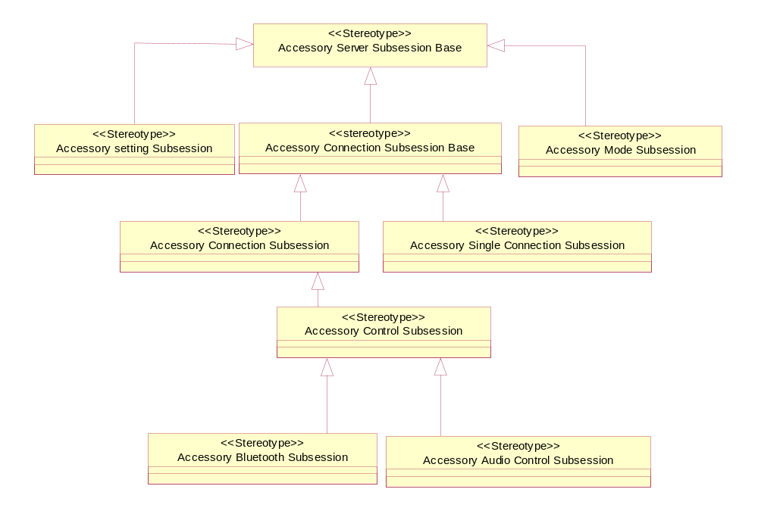
Figure 4.7 Accessory Server sub sessions (Accessory Server sub session XXX). Note: ASY Comms as well as settings sub sessions are excluded from the diagram
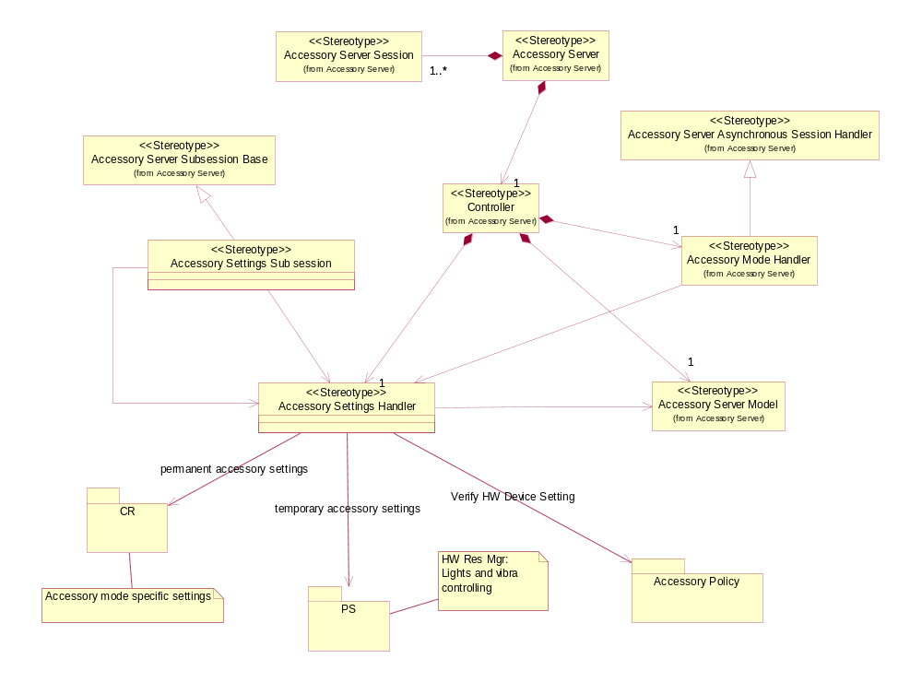
Figure 4.8 Accessory Server settings (metamodel definition)

Accessory Server class descriptions
Class | Description | Header file
Accessory Server | A server class.
Accessory notification queue | Accessory notification queue maintains a list of outstanding notification type of requests.
Accessory Server session | Accessory Server session represents a session for a client thread on the server side. One instance of the class is created for each client thread.
Accessory Server Sub session base | Accessory Server sub session base class. All Accessory server sub session classes are inherited from this class.
Accessory Server Sub session example | Accessory Server sub session class. Sub session represents an independent channel of communication within the current Accessory Server session.  Sub session classes are responsible for handling the client requests to the completion. However, in the case of notify type of requests sub session does not complete the request in its own, but instead places itself into the notification queue.
ASY Comms Sub Session | Special type of server side sub session class. Each ASY Comms sub session instance represents communication channel to the specific Accessory Handler, i.e. ASY.
Accessory Server controller | Controller class that is responsible for maintaining and updating accessory connection status. Singleton.
Accessory server model | Accessory Server model encapsulates Accessory Server data and provides operations for requesting and maintaining the data.
Accessory Server asynchronous handler base | Accessory Server asynchronous handler base is an active object and a base class for Accessory Server asynchronous handlers.  Asynchronous Handlers enable creating a task and executing the tasks asynchronously after the original task has already been completed.
Accessory connection status handler | Asynchronous Handler. Handles accessory connection status change asynchronously.
Accessory mode handler | Asynchronous Handler. Handles Accessory mode change asynchronously.
ASY Comms Handler | Asynchronous Handler. Handles ASY commands asynchronously.
ASY Proxy Starter | Responsible for starting and observing ASY loading.
Accessory Settings Sub session | Server side sub session for Accessory Settings API. Responsible for handling accessory settings related client requests.
Accessory Settings Handler | The class is responsible for storing, restoring and updating accessory settings. Permanent accessory settings are stored in Central Repository. Temporary settings are stored in Publish and Subscribe.

Detailed class descriptions and dynamic behavior for Accessory Server components and classes is provided in reference document [2].

Accessory Server structs, type definitions and enumerations
Most common ACC FW structures, type definitions, and enumerations are provided by Accessory Policy and are listed in Section 4.2.7. Note: ‘common’ refers to data types that are common for various ACC FW components.
Common structures, type definitions and enumerations, provided by Accessory Server are listed below:

Struct/Definition/Enumeration’s name | Description
ASY command type | Enumeration
Accessory client – server message | Enumeration

Accessory Server API definitions
ASY Proxy API is private polymorphic interface. API specification for ASY Proxy API can be found in reference document [2].

Accessory Server state diagrams

Accessory Server connection states
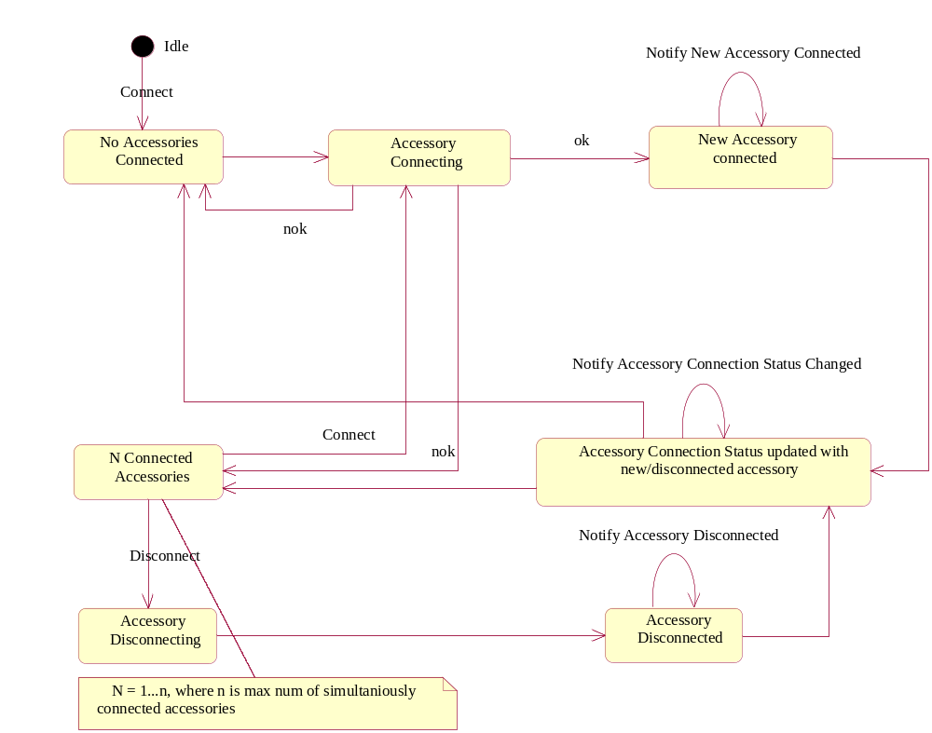
Figure 4.9 Accessory Server connection states, triggers, and related notifications

Accessory Modes (headsets and car kits)
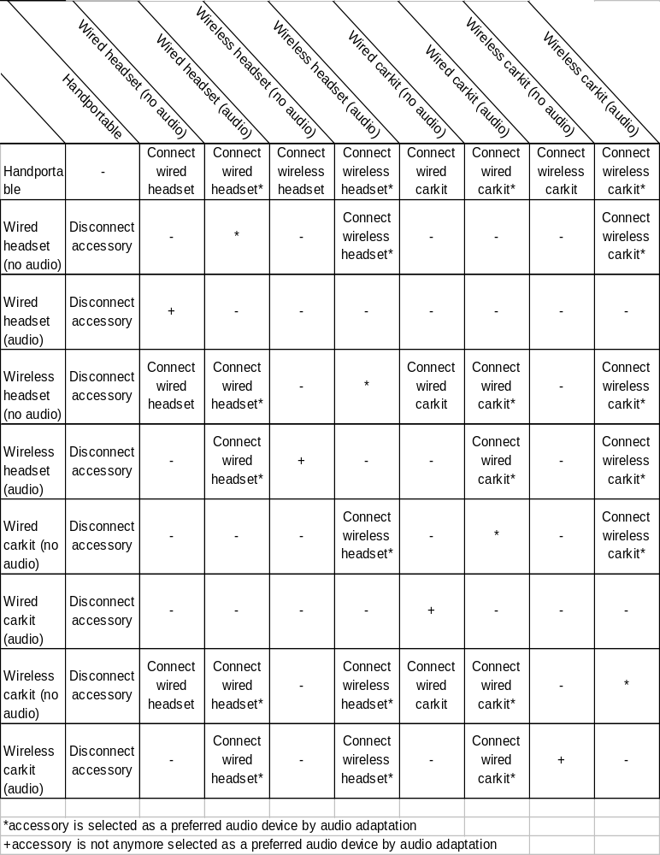
Figure 4.10 Accessory Mode state matrix for headsets and car kits (default). Music stand, TTY and loopset accessories and related accessory modes behaves just like wired headset. Note: state transitions are configured in Accessory Policy.

Accessory Server client APIs

Accessory Server client API class diagrams
Accessory Server client side implementation is split into multiple binaries. In AccPollicy.lib, AccClient.lib, AccControl.lib, AccAudioControl.lib and AccBTControl.lib libraries
- The public operations are separated from the protected or private operations.
- Accessory control services (write device data) are separated from accessory information Services (read device data).
- Information services are provided in AccClient.lib that also provides the base classes from which it is easy to inherit new Accessory Server client side classes. AccClient.lib is thus a core API from which all the other Accessory Client APIs are extended.
- Bluetooth operations are encapsulated in BT specific client API, AccBTControl.lib. In products, where the BT is not supported, the binary is left out from the image. The BT Control binary also encapsulates static, compile time dependencies to other BT components, e.g. BT Engine. Having the separate binary enables having BC and SC breaks in Bluetooth Control API (protected), but not in Accessory API (public).
- Audio operations are encapsulated in Audio Control API, which by having its own binary enables flexibility in product variation. This is useful with audio SW that is mostly product specific.

Accessory Server client side implementation consists of single Accessory Server session and multiple Accessory Server sub session classes.
Accessory Server Session class is needed to establish the communication channel between the client and the Accessory Server. Client thread only needs to establish the Accessory Server connection once; in fact only one Accessory Server session is allowed to the specific client thread.
Within one established Accessory Server session a client may create as many sub sessions as needed: each sub session represents independent communication channel between the client and the Server.
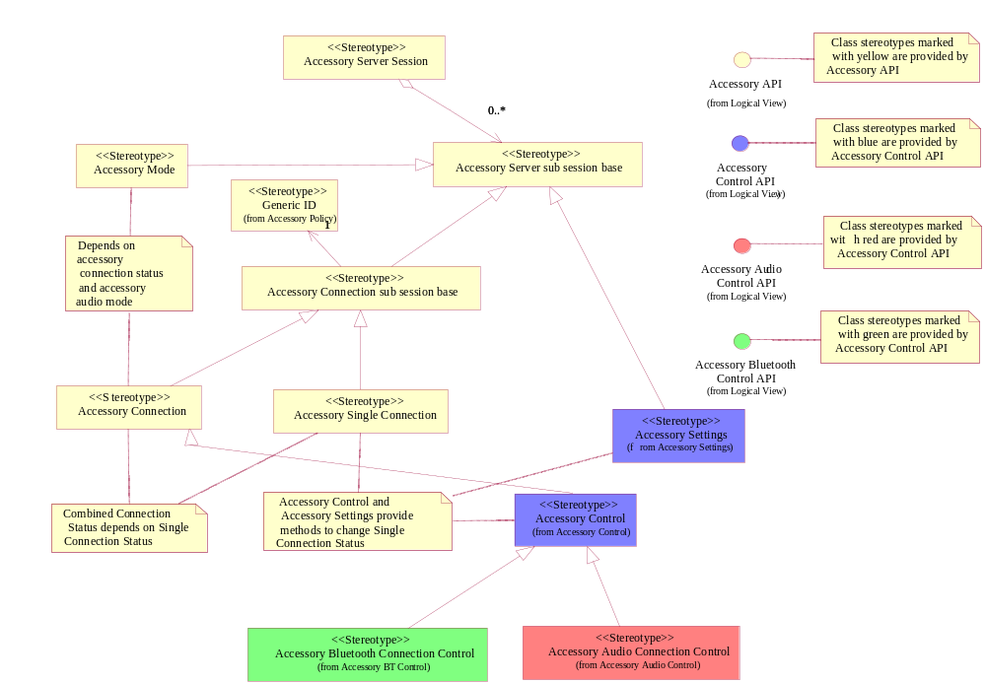
Figure 4.11 Accessory Server client side (metamodel definition)

Accessory Server client API class descriptions

Accessory API

Class | Description | Header file
Accessory Server | Accessory API class for establishing a session with Accessory Server. Note: each client thread may have only one session with Accessory Server.
Accessory Sub session base | Base class for Accessory Server client side sub session classes.
Accessory Connection Sub session base | Base class for connection and single connection sub sessions.
Accessory Single Connection Sub session | Accessory API sub session class that represents a specific accessory connection. The sub session class provides notifications for the accessory connection and disconnection and methods for requesting and observing the connection status.  Sub session has two states: idle, when accessory is not connected and connected, when accessory connection has been established. In connected state, the sub session is locked to observe the changes in one, specific accessory connection.
Accessory Connection Sub session | Accessory API sub session class that represents a combined accessory connection. The sub session class provides notification for observing the changes in the combined accessory connection. Combined accessory connection is updated every time any accessory is connected or any accessory is disconnected.
Accessory Mode Sub session | Accessory API sub session class that represents accessory mode. The sub session class provides notification for observing the changes in the accessory mode. Accessory mode may change when combined connection status changes or when audio routing status changes.

Detailed class descriptions for Accessory Server client component and classes are provided in reference document [2].

Accessory Control API

Class | Description | Header file
Accessory Control Sub session | Accessory Control API Sub session class that represents accessory control connection. The sub session class provides methods for connecting and disconnecting an accessory as well as method for notifying Accessory Server about the changes in accessories internal status.
Accessory Settings Sub Session | Accessory API sub session that represents interface for accessory user settings.

Detailed class descriptions for Accessory Control components and classes are provided in Accessory Server Design Document [2].

Accessory Bluetooth and Audio Control APIs

Class | Description | Header file
Accessory BT control sub session | Accessory BT Control API sub session class that represents accessory BT control connection. The sub session class provides methods for connecting and disconnecting a BT accessory as well as methods for audio link control. The API clients are BT components that are responsible for controlling the connection to the BT device, e.g. BT Accessory Server.
Accessory audio control sub session | Accessory Audio Control API sub session class that represents accessory audio control connection. The sub session class provides methods for requesting audio link opening and closing as well as method for notifying the accessory audio routing status. The API clients are audio components that are responsible for controlling the audio routing and managing the audio resources, e.g. Audio Policy Server, Audio Server or equivalent components.

Detailed class descriptions for Accessory BT Control components and classes and Accessory Audio Control components and classes are provided in reference document [3].

Accessory Server client API definitions
API definitions for Accessory API can be found in reference document [6].

ASY Proxy

ASY Proxy class diagrams
ASY Proxy encapsulates the communications with the Accessory Server plug-in modules i.e. ASYs and provides definition for the Accessory Server Plug-In API. ASY proxy is responsible for loading ASY modules as well as for creating new ASY services when needed at run-time. In the case the device has multiple ASYs installed, ASY proxy is responsible for resolving the correct ASY implementation(s) to be used.
ASY Proxy is singleton, i.e. it is instantiated and used only by Accessory server. ASY Proxy implements the ASY Proxy API by implementing the concrete class derived from the abstract base class. ASY Proxy DLL also exports a single function whose only purpose is to construct an object of the derived type.
ASY Proxy creates ASYs into their own threads. This is why most of the run-time communication between Accessory Server and ASY Proxy, takes place over the thread boundary. Since Accessory Server is executable, which runs in its own process, the natural interface for the communication with the server over the thread boundary is the server’s client side implementation. Accessory Server’s client side implementation has extension named ASY Comms API, through which run-time commands and responses to the commands are changed between the proxy and the server. Advantages of this solution are that there is no need to implement synchronization between the threads to enable communication between Accessory Server and ASYs.
In Plug-In API interface, ASY proxy exports synchronous functions only. This is to ensure that responsibility on completion of any asynchronous request originated from the client side, resides on Accessory Server and ASY Proxy - not accessory plug-in modules (ASYs).
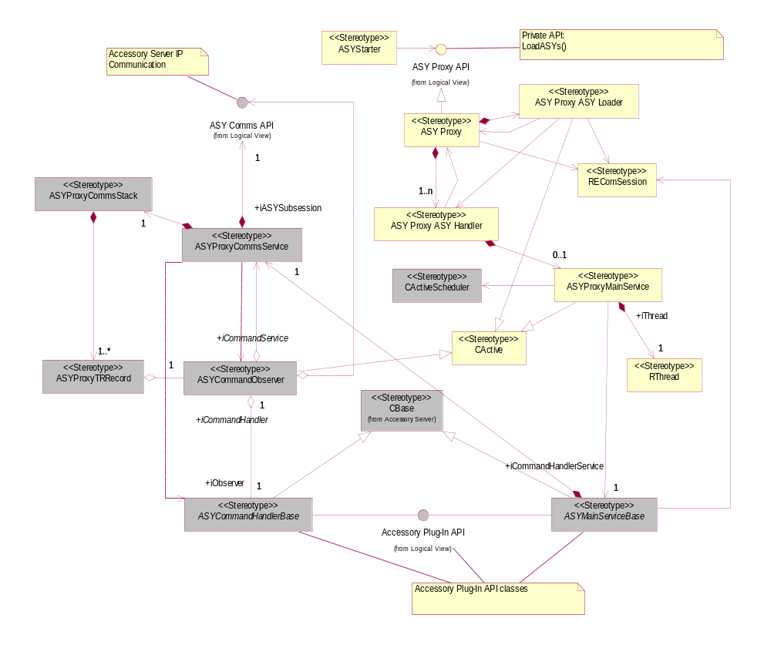
Figure 4.12 Accessory Handler Proxy (metamodel definition). Note: components with gray background run in ASY sub thread, components with yellow background run in Accessory Server main thread.

ASY Proxy class descriptions
Class | Description | Header file
Accessory proxy | ASY proxy main class. The concrete class inherited from the abstract class defined by ASY Proxy API.
ASY Handler | The class represents ASY module in Accessory Server and ASY Proxy. One instance of the class will be created for each loaded ASY module.
ASY proxy Main service | Active object and service class that is responsible for creation and the usage of the RThread class as well as ASY construction.  The class provides asynchronous operation for creating a new thread and the thread entry point function, which kernel must call when starting execution of the new thread. Prior to active object activation, a asynchronous Logon() request to the Kernel is made. RunL of the active object is called in the case Logon request is completed. Kernel completes the Logon request only in the case the sub thread is exited.  When Thread Entry Point is called, ASY Proxy Main Service automatically installs active scheduler as well as creates cleanup stack for the new thread.  ASY proxy main service also supervises ASY threads and is acting as a dead watcher.
ASY proxy Comms service | Service class that is responsible for establishing and maintaining the communication channel between Accessory Server and ASY.  Each ASY Proxy Comms Service instance has it’s own session within Accessory server. When session is established ASY Proxy Comms Service requests Accessory Server to send notification if the command needs to be processed. Every ASY Proxy Comms Service instance has always one outstanding Notify Process Command Request active. Active request indicates that ASY is ready to receive and process ASY commands.
ASY Command observer | Observer class responsible for handling ‘Notify Process command completion, i.e., RunL() of the active object is called when Accessory Server indicates that ASY needs to process a command.
ASY Main Service Base | First of Accessory Server Plug-In API base classes and the base class for ASY Main Service.
ASY Command Handler Base | Second Accessory Server Plug-In API base class and the base class for ASY Command Service.
ASY Proxy Comms Stack | Stack for storing valid Transaction Records and observers and or command handlers related to specific transaction.
ASY Proxy Transaction Record | Each transaction starts when a command from Accessory Server to ASY is executed. ASY Proxy has always a Command Observer listening for the new transactions to start. When the command is executed and the transaction is started, ASY main Service creates a Command Handler to carry out the processing of the command in the ASY. When the Command Handler calls Handle Response and the response is delivered to Accessory Server, the transaction is completed.  Transaction record is a class storing all the information related to the specific transaction as well as a reference to the related observer object.

Detailed class descriptions for ASY Proxy components and classes are provided in reference document [1].

ASY Proxy structs, type definitions and enumerations
Structs, type definitions and enumerations provided by ASY Proxy, are listed below.

Struct/Definition/Enumeration’s name | Description
Accessory Plug-in API UID KACCESSORYPLUGINAPIUID | Accessory Plug-In API universal identification. ECom uses the UID to resolve the correct implementations for the API.
Accessory Plug-in API Main Service  KACCESSORYPLUGINAPIMAINSERVICE | Type definition used to identify ASY’s main service class.
Accessory Plug-in API Command Handler Service  KACCESSORYPLUGINAPIHANDLER | Type definition used to identify ASY’s command hander service class.

ASY Proxy API definitions
API definitions for Accessory Plug-In API can be found in reference document [7].

ASY reference implementation

ASY reference implementation class diagrams
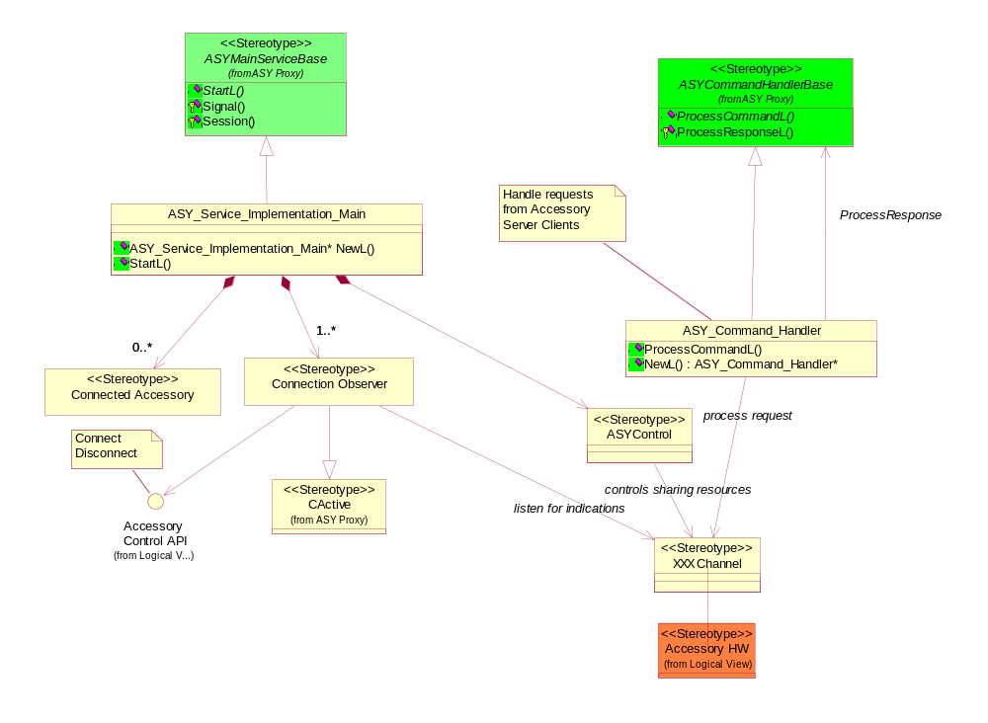
Figure 4.13 Accessory Handler reference Implementation (metamodel definition)

ASY reference implementation class descriptions

ASY Service Implementation Main | Reference implementation of the ASY service main.
ASY Service Implementation Command Handler | Reference implementation of the ASY service command handler.

Accessory Server utilities

Accessory Server utilities class diagrams
Accessory Server utilities provides utility type classes and functionality for Accessory Framework components and ASYs. For example: HW ID Configuration file parser.
Configuration file parser is a utility that is documented as a part of Accessory Control API (see reference document [6]). The parser is used by ASYs to map the detected accessory HW IDs to Generic IDs defined by ACC FW. Mapping is done prior to connecting to Accessory Server. Used configuration files are part of manufacturer specific Accessory Policy. In order to use the parser ASY needs to link against the static library AccSrvUtil.lib.
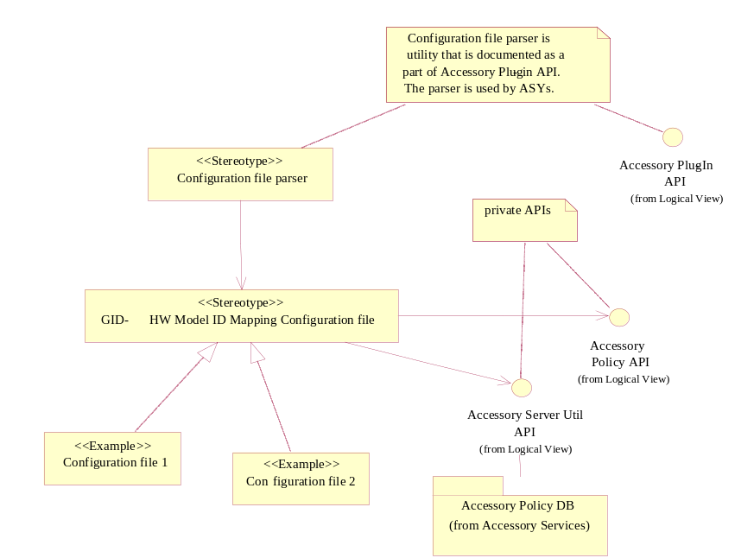
Figure 4.14 Accessory Server utilities: configuration file parser

Accessory Server utilities class descriptions

Configuration file parser | Used to map detected HW IDs to Generic IDs. Provides the FindL operation for the purpose.

ASY Comms

ASY Comms class diagrams
ASY Comms enables inter-thread communication between Accessory server main thread and ASY sub threads. ASY client-side sub session is created in ASY thread by ASY Proxy when the ASY is loaded. ASY Comms API is a private API and is encapsulated by ASY Proxy.
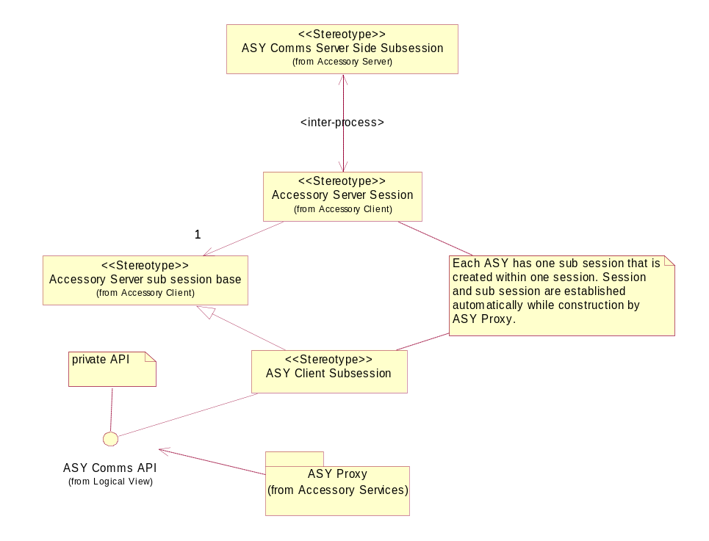
Figure 4.15 ASY Comms

ASY Comms class descriptions

Class | Description | Header file
ASY Comms client side sub session | Accessory Server client side sub session class that enables inter-process and thread communication between Accessory Server thread and ASY sub threads. Single instance of the class is created for each loaded ASY.

Detailed class descriptions for ASY Comms components and classes are provided in reference document [2].

ASY Comms API definitions
ASY Comms API is a private API and there exists no separate API specification document for it. API specification for the API can be found in reference document [2].

Accessory Policy

Accessory Policy class diagrams
Accessory Policy provides common information structures, constants, enumerations, and accessory related data used by ACC FW. The common information structures are listed in table 4.2.7.
Accessory Policy also provides operations for resolving Generic ID and Generic ID related data, such as sub blocks and name-value records, and for resolving valid accessory connection status and the accessory mode.
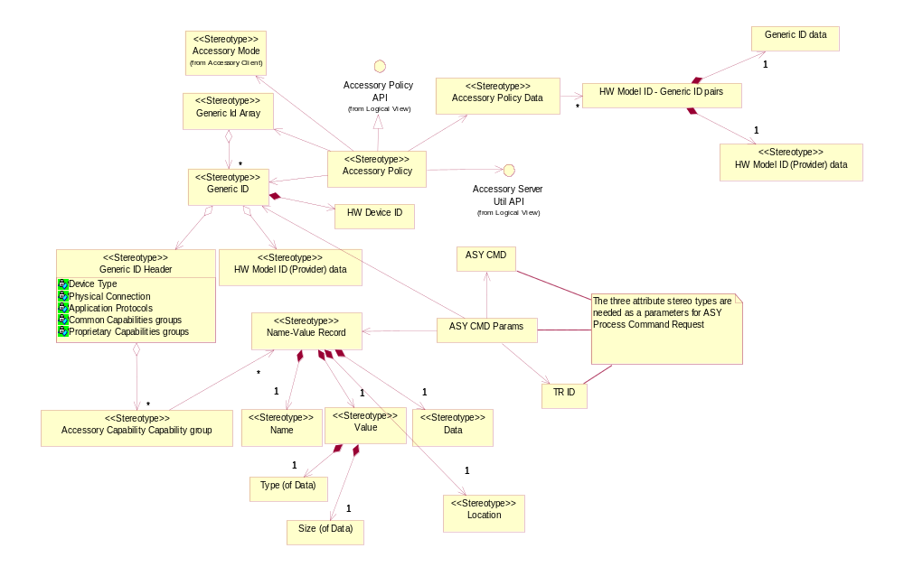
Figure 4.16 Accessory Policy (metamodel definition)

Accessory Policy class descriptions
Class | Description | Header file
Generic ID class | In practice, Generic ID is a large structure, in which each feature or capability is represented by one bit.  Generic ID class is ACC FW class, which acts as a user interface to the structure. The class consists of following internal structures: GID header, ACC CAPs sub blocks, HW model ID and HW device ID.
GID Integer | Generic ID header and associated sub blocks (names) packed up as a series of integers.
Generic ID Array | An array of Generic ID classes.
Accessory Capability | Accessory capability (ACC CAP), i.e. accessory feature or property. Accessory Policy defines variety of accessory capabilities, which accessories support or not.  Some capabilities/features are invariable: they can be defined for any kind of -accessories, e.g. Device Type, Physical Connection, HW Model ID.  Some capabilities are varying: they can be only defined for specified device types. In Generic ID, these capabilities are defined in variable length Generic ID sub blocks.
Accessory capabilities (ACC CAPs) groups | Capability group describe the varying accessory capabilities.  In practice, list of accessory capability name value records. | -
Accessory capability name value record | Capabilities may be static, i.e. the property does not change while accessory is connected. Most capabilities are such. Capabilities may also be dynamic: capability has associated data type and value may change while accessory is connected.  Accessory capability name value record consists of:  - The capability name (constant)  - The type of the associated value (enum)  - The size of the associated value (int)  - The static/dynamic value (bool)  - The location value (bool).  Common, e.g. S60 defined ACC CAP Name-Value records are defined in AccPolCommonNameValuePairs.h. | -
Accessory Policy data | Contains list of supported accessories in the accessory framework.
Name Record | Contains name of the capability
Value Record | Contains value of the capability
Name-Value Record | Contains both Name record and Value record
Detailed class descriptions for Accessory Policy components and classes are provided in reference document [6].

Accessory Policy structs, type definitions and enumerations
Structs, type definitions and enumerations provided by Accessory Policy, are listed below.

Struct/Definition/Enumeration’s name | Description
Generic ID Header | Fixed length part of the Generic ID that contains the invariable ACC CAPs (features), e.g. the features which are defined for all types of accessories. Invariable capabilities:  - Device Type  - Physical Connection  - Protocols  - Sub blocks
GID Sub Block | Supported sub blocks in the generic ID. Bitmap that contains information which sub blocks are supported in the generic ID.
HW model ID | Accessory model or type ID. Provided by accessory manufacturer; usually has correspondent sales name.  E.g. When the HW Model ID exists, it is used to resolve the set of features / capabilities that accessory supports.  If HW Model ID does not exist (some BT accessories), the set of features / capabilities is resolved based on SDP queries. In such case some of the ‘standard’ HW Model IDs is used (HW Model ID is resolved based on known features).
HW device ID | Accessory device ID: unique ID for the HW device. E.g. BT_ADDR HW device IDs for the BT accessories are granted by SIG for all the accessory manufacturers.
Accessory mode | Defines accessory mode enumeration.
GID Device Caps | Bitmasks for each device type.
GID Physical Connection Caps | Bitmasks for each physical connection type.
GID Application Protocol Caps | Bitmasks for each application protocol type.
GID Sub Block Caps | Names for capabilities used in sub blocks.

Accessory Policy API definitions
Accessory Policy API is a private API. API definitions for Accessory Policy API can be found in reference document [5] and in the case of common classes, structures and enumerations, reference document [6].

Accessory Policy database
Accessory policy database is storage for the accessory policy data.

Accessory Policy database class diagrams
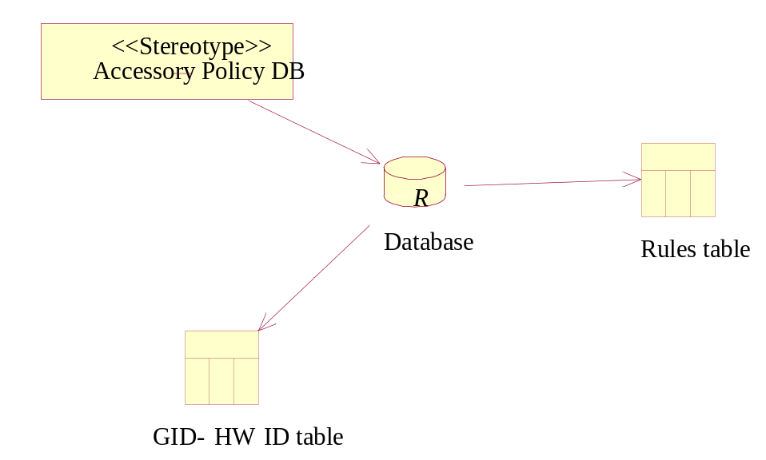
Figure 4.17 Accessory Policy database (metamodel definition)

Accessory Policy database class descriptions

Class | Description
Database | DBMS database which is storage for the data.
GID – HW ID table | Database table which contains GID – HW ID mappings.
Rules table | Contains specific rules for connections (critical capabilities).

Operations

Accessory Server construction

Operation | Accessory Server construction.
Preconditions | Accessory Server class instance has been created. ConstructL has been called.
Description | Describes Accessory Server construction in startup. ASY loading is initiated in the scope of ConstructL, but completed in the background.
Inputs
Modifies
Outputs
Postconditions | Accessory Server has been constructed. ASY loading has been started.
Related To | ASY Proxy::Load ASYs().
Related Event
Exceptions

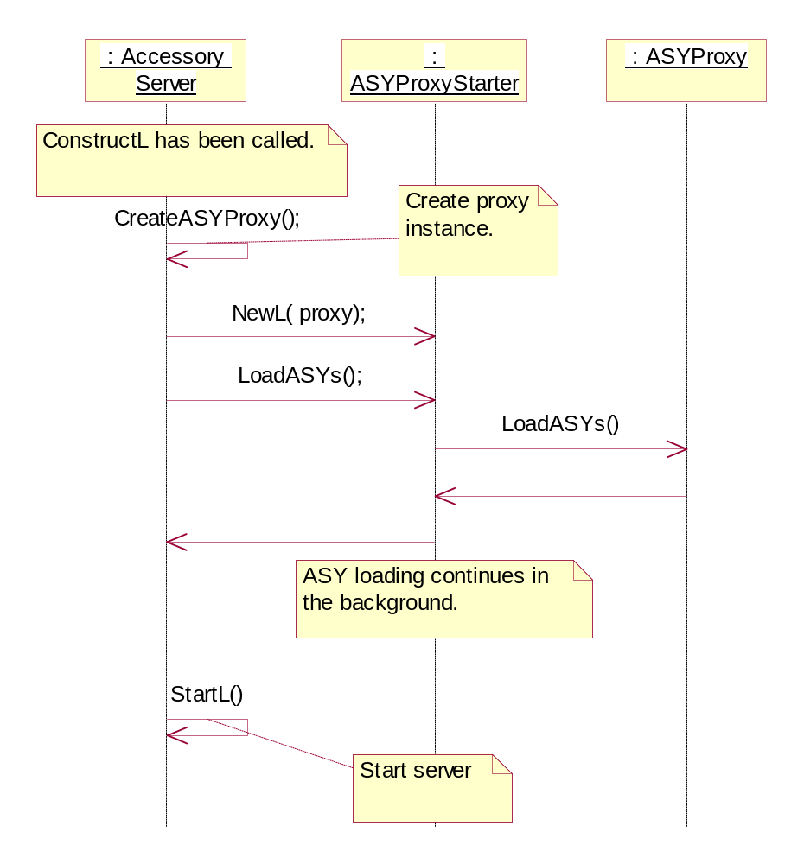
Figure 4.18 Accessory Server construction

ASY loading

Operation | ASY Proxy: Load ASYs.
Preconditions | Accessory Server ConstructL() has been called
Description | Load ASYs in the background after the accessory server is started. ASY Proxy tries to find ASY implementations via ECom interfaces. After ASY implementations are found, ASY Proxy loads ASYs and creates a thread for each ASY and starts them.
Inputs
Modifies
Outputs
Postconditions | ASY Proxy has loaded ASYs. Identified ASY implementations have been created into the sub thread for the each identified ASY.
Related To | Creating ASY sub thread.
Related Event | 4.3.1.
Exceptions | No ASYs found. Accessory Server starts normally, but without any ASY.

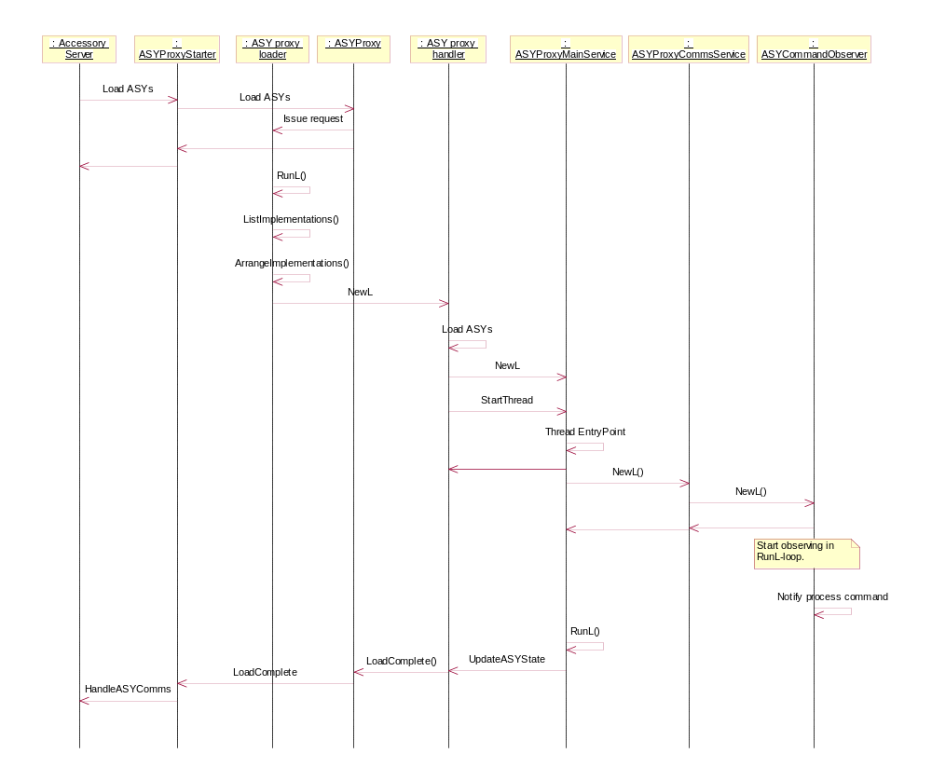
Figure 4.19 Load ASYs

Initialize connection status
Operation | Accessory Server (Accessory Control) initializes connection status.
Preconditions | ASY Proxy has completed the LoadASYs operation. Connection Status is initialized to InitWait.
Description | Accessory Control creates a InitConnections ASY command. Transaction ID is generated. Timer is set. The command is sent to ASY.  ASY makes a connection. ASY completes the command by sending Process Response.
Inputs
Modifies | - ASY  - ASYCommandHandler  - iConnectionStatus
Outputs | In successful case: kErrNone.
Postconditions | Connection Status is initialized to 0 (no accessories connected), or iConnections is initialized with array of GIDs.
Related To | Proxy: LoadASYs.
Related Event
Exceptions

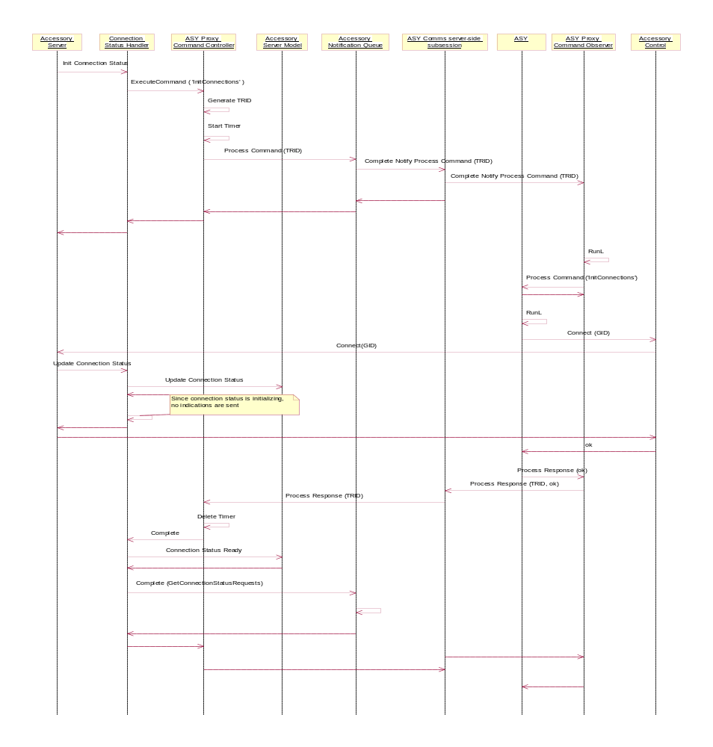
Figure 4.20 Initializing connection

Notify New Accessory Connected Request

Operation | Notify New Accessory Connected Request.
Preconditions | Accessory Server is running. The client has established Accessory Server session and Single Accessory Connection sub session.
Description | The client issues the Notify New Accessory Connect request. Accessory server handles the message. Request is handled by the corresponding server side sub session.
Inputs | Generic ID.
Modifies | Accessory Server: notification queue.
Outputs | Notification for the connected accessory.  Generic ID of the connected accessory is returned to the client responsible for the ConnectAccessory() request.
Postconditions | Notify New Accessory Connected request, has been handled by Accessory Server. Accessory Server has added the request to the notification queue and the request is outstanding. The client thread has an active object (active) waiting for the completion of the request.
Related To | - Accessory Control: ConnectAccessory  - Accessory Server: ConnectAccessory  - Accessory Client: NotifyNewAccessoryConnected  - Accessory Client: NotifyAccessoryModeChanged()  - Accessory Client: NotifyAccessoryConnectionStatusChanged
Related Event | Accessory Server: connect.
Exceptions | Notify New Accessory Connected request is already outstanding: returns with KErrAllreadyExist.

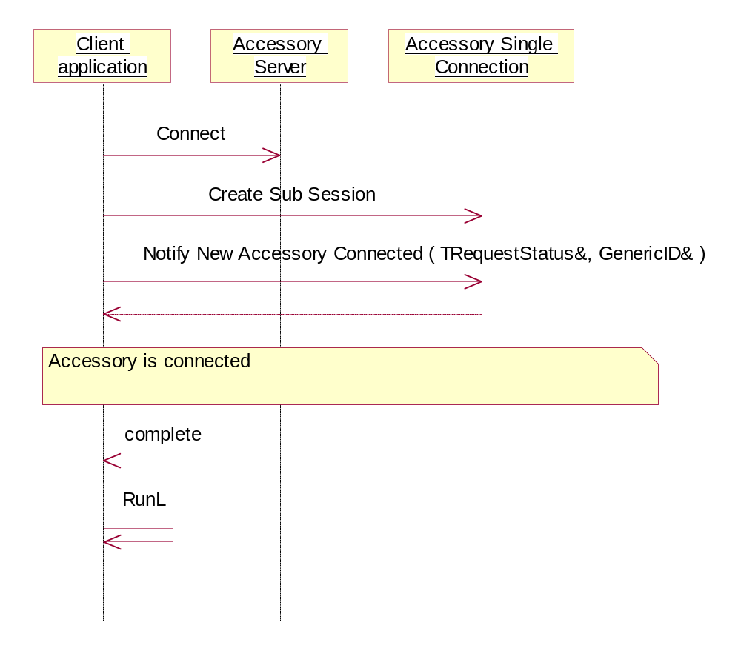
Figure 4.21 Listening for accessory connection

Process command

Operation | ASY Proxy processes the received ASY command.
Preconditions | Accessory Server has completed ASY Proxy’s NotifyProcessCommand request.
Description | ASY Proxy Command Observer is activated when NotifyProcessCommandRequest is completed. Command Observer notifies ASY Proxy Comms Service object about the new process command request and updates the ASY Comms Stack Transaction Record with new transaction id (TRID) and a command id (AsyCmdParams). ASY Proxy Comms Service creates a new transaction, i.e., it creates a Command Observer object to listen the new commands from the Accessory Server and adds the new Transaction Record to the ASY Comms Stack. Meanwhile the first (initial) observer continues with processing the received command. The initial Command Observer requests ASY Comms Service object to create a new ASY Command Handler. When the handler is created, the command observer requests ASY Command Handler to process the received command.  In the case ASY Command handler is active object or has an active object for processing the command, ‘Process Command’ function call returns immediately and the processing of the command is continued on the background. The Command observer checks the iResponse flag status.  In case ASY Command handler is not active object, ‘Process Command’ function call returns immediately and the processing of the command is handled synchronious.
Inputs | <integer> a Command ID, <integer> a Transaction ID, <descriptor> command parameters.
Modifies | - ASY Comms Stack  - Transaction Record  - ASY
Outputs
Postconditions | Processing of the command has been started by ASY. Accessory Server has started timer for following up the timeout while processing the command.
Related To | NotifyAccessoryModeChanged().
Related Event | - ASYComms:: NotifyProcessCommand  - ASYComms::HandleResponse  - ASYComms::ProcessingNotify  - ASY Proxy::HandleResponse
Exceptions
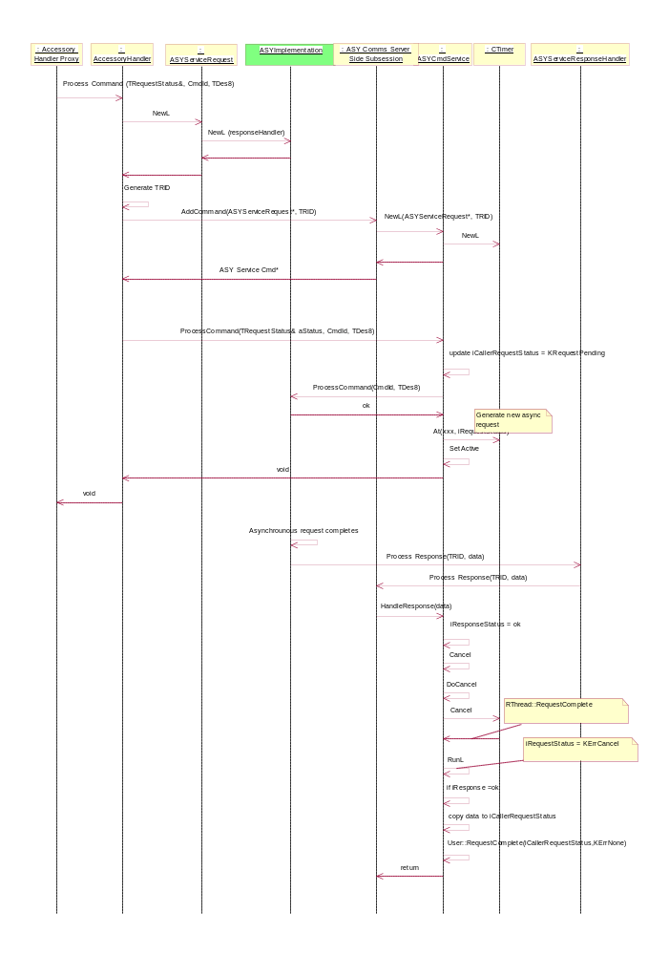
Figure 4.22 Process command
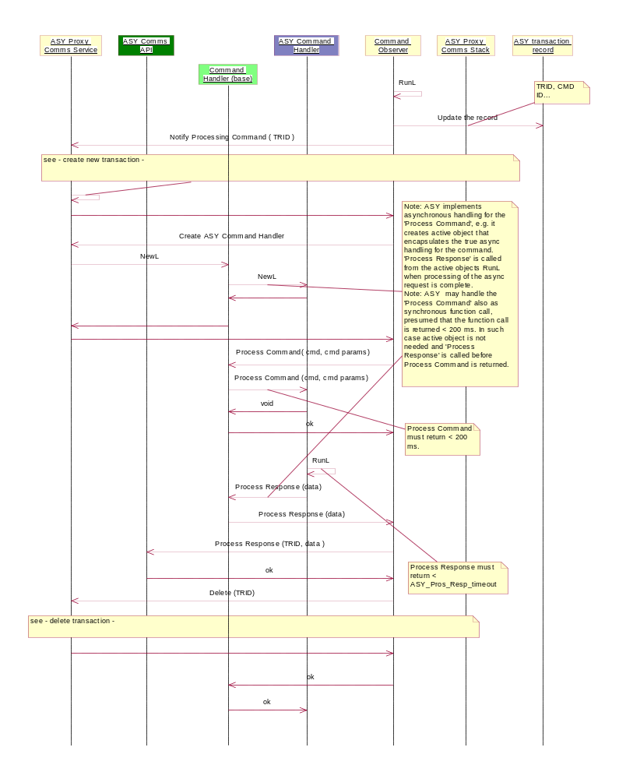
Figure 4.23 Process Command and handle response

Create transaction
Operation | ASY Proxy (Comms Service) creates a new transaction record and a Command Observer to listen a new ASY command from Accessory Server.
Preconditions | ASY Comms Stack has no record with transaction ID (TRID) of 0, i.e., there is no outstanding Notify Process Command request nor command observer object responsible for listening the completion of the request. This situation occurs 1) in ASY Proxy Comms Service construction (ASY Loading) and 2) when previous Notify Process Command request has been completed.
Description | Call to update ASY Comms Stack is caused in two different situation:  Situation occurrence I): During ASY Proxy Comms Service construction, i.e. CASYProxyCommsService::ConstructL() causes to call updating ASY Comms Stack  Or  Situation occurrence II): When previous Notify Process Command request has been completed, i.e. completion of TRequestStatus of pending Command Observer launches CASYProxyCommandObserver::RunL(), which causes to call updating ASY Comms Stack.  Updating ASY Comms Stack has following actions:  - Creates a new CASYProxyCommandObserver object  - Adds it to ASYProxyCommsStack  - Goes through the Transaction Record array of ASYProxyCommsStack and if any CASYProxyTRRecord with TRID equals to -1(KResetRecord) is founded (Which is obvious with Situation occurrence II):  - CASYProxyCommandObserver attached to that Transaction Record and Transaction Record itself is deleted and removed from Transaction Record array.  4) Creates a new CASYProxyTRRecord object, initializes its TRID to 0, and adds it to Transaction Record array. CASYProxyTRRecord is owner of the CASYProxyCommandObserver object created in point 1. TRID will be later changed to some positive, non zero value by AccFW during Notify Process Command and finally to -1 (KResetRecord) when ASY Proxy has received the Process Response related to that Notify Process Command.  5) Calls IssueRequest() of the created CASYProxyCommandObserver object, which launches the new Notify Process Command with TRequestStatus of CASYProxyCommandObserver object.
Inputs
Modifies | - ASY Proxy Command Observer  - ASY Proxy Comms Stack  - ASY Proxy TR Record  - Accessory Server
Outputs | A new Notify Process Command has been launched.
Postconditions | ASYProxyCommandObserver exists for pending completion of NotifyProcessCommand.  ASYCommsStack has an TransactionRecord with TRID of 0.  ASYCommsStack has not a TransactionRecord with TRID of -1 (KResetRecord).
Related To
Related Event | Creation of ASYProxyCommsService, CASYProxyCommsService::ConstructL()  Completion of NotifyProcessCommand, ASYProxyCommandObserver::RunL()
Exceptions

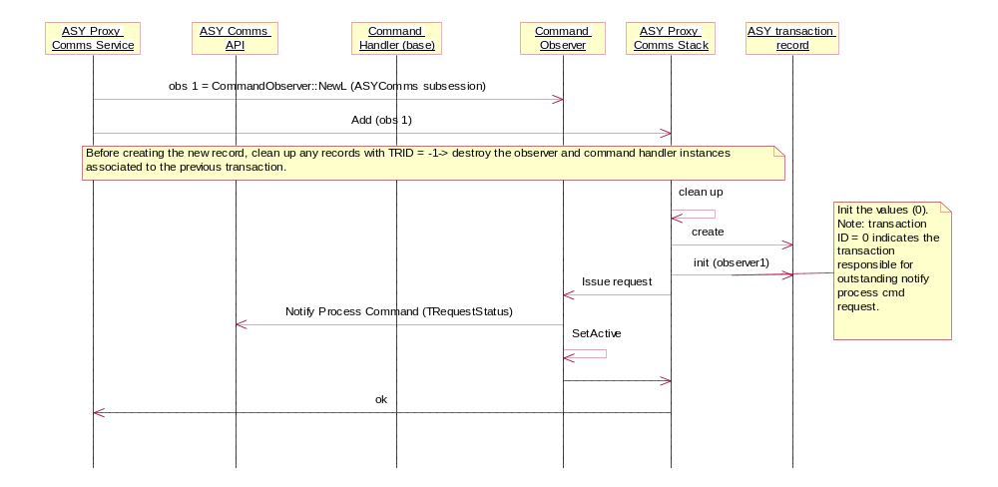
Figure 4.24 Create transaction

Delete the transaction

Operation | ASY Proxy Command Observer requests ASY Proxy (Comms Service) to delete the transaction record.
Preconditions | ASY Proxy Command Handler has completed processing the command.
Description | ASY Proxy Command Handler has completed processing the command. ASY Proxy Command Observer’s task has been accomplished and it requests ASY Proxy Comms Service to start the cleanup: the related transaction and the command handler instance as well as the Command Observer instance itself can be destroyed. ASY Comms Service processes the request by setting the transaction ID to negative range. From negative transaction ID value, ASY Proxy Comms stack knows that the memory is ready to be de-allocated when the cleanup method is called for the next time.
Inputs
Modifies | - ASY Comms Stack  - ASY
Outputs
Postconditions | Transaction ID has been set to negative value.
Related To | 4.4.1.
Related Event | ASY Comms Service: cleanup.
Exceptions

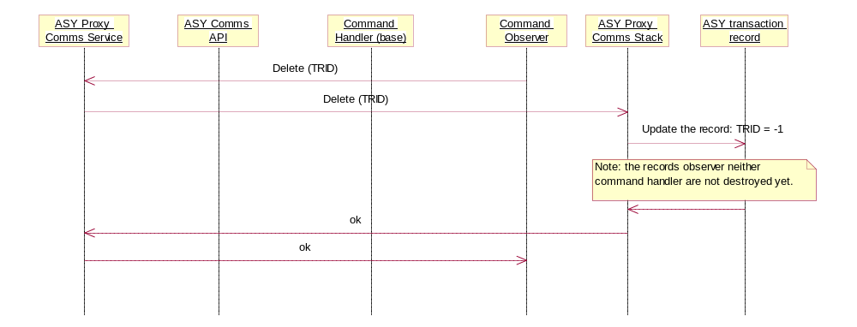
Figure 4.25 Destroy transaction

Disable vibra

Operation | Vibra is disabled when wired advanced car kit is connected.
Preconditions | Advanced wired car kit is detected. ASY has made Connect Request.
Description | When ASY makes the Connect request, the connection status is handled. After the connection status has been updated, Accessory Mode is updated. After the new Accessory Mode has been updated to the Accessory Server Model, Accessory Mode Handler requests Accessory Settings handler to update the Accessory Mode related settings. Accessory Settings handler requests the updated accessory mode from the model and in the case the Mode is Wired Car Kit mode, disables the vibra using the vibra blocked Publish and Subscribe key defined in HW resource manager.
Inputs | Generic ID.
Modifies | - Accessory Model: connection status  - Accessory Model: current Accessory mode  - HW resource manager: HWRM Accessory vibra blocked Publish and Subscribe key
Outputs
Postconditions | Accessory mode is updated. Vibra is disabled.
Related To
Related Event | Connect
Exceptions

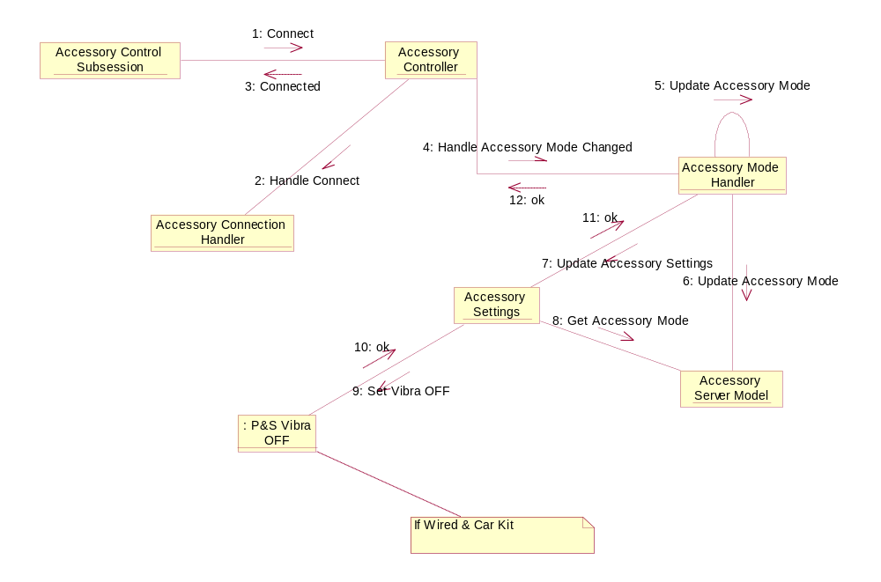
Figure 4.26 Vibra accessory setting is disabled when wired car kit is connected

Flag definitions
Used flags are defined in reference document [2]. Variation flags are defined in Chapter 5.

Flag | Description
_DEBUG | Debugging macro

Backup and Restore
This component does not participate in backup and restore.

Variation
Accessory Framework needs to support the Bluetooth type of accessories only in case the product has the Bluetooth chip. The product supports Bluetooth if it has the pre-processor flag __BT defined.
Accessory Framework uses two variation techniques to fulfill the requirement.

Accessory control/Bluetooth
AccBTControl.dll is included in the ROM image if the __BT flag is defined in AccessoryServices.iby (image creation time variation).

Accessory Server/Bluetooth
Accessory server supports Bluetooth accessories if the __BT flag is defined in AccessoryServer.mmp (compile time variation).

System resource usage
This Chapter provides an overview to Accessory Framework’s resource usage.

Files
Accessory Framework’s Accessory Policy uses multiple different configuration files. Configuration files are used to read:
- Header file definitions for Accessory capability groups, i.e.,
- Constants for common capability groups (ACCPOLGENERICIDDEFINITIONS.h)
- Constants for proprietary capability groups (ACCPOLPROPGENERICID.h)

- Header file definitions for Accessory Capabilities (constants, related value types and locations), i.e.,
- Constants for common accessory capabilities defined in GID Header (CACCGENERICID.h)
- Name literals for common Accessory Capabilities (ACCPOLCOMMONNAMEVALUEPAIRS.h)
- Name literals for proprietary Accessory Capabilities (ACCPOLPROPRIETARYNAMEVALUEPAIRS.h)
- Value types and locations for common Accessory Capabilities (ACCPOLCOMMONNAMEVALUEPAIRS.h)
- Value types and locations for proprietary Accessory Capabilities (ACCPOLPROPRIETARYNAMEVALUEPAIRS.h)

- Header file definitions for the defined Accessory Modes (ACCPOLACCESSORYMODE.h)

In addition Accessory Policy has manufacturer specific data configuration file, i.e. Accessory Policy Data. Accessory Policy Data contains manufacturer specific GID integer forms as well as the default values for accessory capability names. Accessory Policy Data (ACCPolicyDB.db) is generated using a PC GID tool (see reference document [9]), manufacturer specific HW Model ID configuration files (*.DAT) and import file tool ACCDBImport.exe.
- HW Model ID mapping to Generic ID Integer form:
- AccPolGIDInt.dat
- Template file for generating GID integer forms and the import file tool for generating Accessory Policy data:
- GID PC Tool
- ACCDBImport.exe

File | Accessory Policy Database (ACCPolicyDB.db).
Type | Private.
Location | ROM.
Format | Symbian OS DBMS data file.
Sharing | No.
Size estimate | Depends on the numbers of stored GIDs, the defined Accessory Capability Name-Value pairs and the related values.
Clean up
Description | Accessory Policy Database .DAT file.

Other data

Databases
ACC FW uses custom Symbian OS DBMS file, ACCPolicyDB.db (see Section 6.1).

Central Repository
The Accessory Framework uses Central Repository to save accessory settings data. See reference document [1].

Publish and subscribe
The accessory framework uses Publish and Subscribe to control vibra. See reference document [1].

Memory consumption
Refer to detailed design documents:

Component | Document
Accpolicy.dll  AccPolCom.dll | See reference document [5].
AccClient.dll  AccServer.exe  AsyComms.dll  AsyProxy.dll  AccControl.dll  AccBTControl.dll  AccAudioControl.dll  ASYReferencePlugin.dll  AccSrvUtil.dll | See reference document [2].
RemConKeyEventConverter.dll  RemConTspController.dll  RemConExtensionAPI.dll  PhoneCmdHandler.dll | See reference document [3].

Task allocation
Accessory Server runs in its own process. Accessory Server is started-up by Starter module in the system start-up which also creates the new process. Once Accessory Server is up and running and the main thread has been established, Accessory Server starts loading the ASYs. In Accessory Server process, each ASY is loaded into its own sub thread.
Accessory Server client side implementation runs always in the client thread. In most cases the client thread belongs to the client process. Special kind of exception for this rule occurs when ASY takes Accessory Server client role: in such case Accessory Server client side implementation runs in ASY (sub) thread that belongs to Accessory Server process.
Basically accessory server doesn’t contain any performance critical tasks and execution is relatively straightforward. However depending on complexity of the General IDs and size of the accessory policy database size of the data to be handled can be quite big. This may cause some slowness so it is important to keep data amounts relatively small.

Timers
Accessory Server (see reference document [2]) uses timer(s) to control the maximum time that is needed for processing the ASY command(s). In case the time needed to process the command exceeds the ASY_CMD_MAX_TIME, the timer triggers and the ASY command is cancelled. In case the ASY command was originated from Accessory API client request, the client request is completed with the response kErrTimeout.
ASY Proxy (see reference document [2]) uses timer(s) to watch that ASY loading is completed in ASY_LOAD_MAX_TIME.

Exception handling
Accessory Framework handles exceptions in two mechanisms:
If the exception is about programming error such as bad parameters, or environment’s resources that are running out, e.g., low memory, the exception handling is forwarded to the user:
In URel builds, the leave mechanism of Symbian OS environment is used in most such situations.
In UDeb builds, the exceptions are handled by leave mechanism (exceptions from the environment) or by panics (programming errors).
In case the exception is about timeout or other errors in ASYs, Accessory Server handles the exceptions internally. Also every Accessory Server client request is guaranteed to complete in fixed time. In the case the Accessory Server client request completes within the maximum time limit with the response kErrTimeout, the exception handling is forwarded to the client and the client needs to renew the request. Also in the case Accessory Server is busy while processing another client request, the exception is handled with KerrBusy and the client needs to renew the request.

Exception | Description
Bad parameters | Forwarded to the user.
Low memory / Out of memory | Forwarded to the user.
The Server is busy | Forwarded to the user.
The client request is timed out | The accessory framework handles exception internally.

Usage
The Integration guide (reference document [8]) contains detailed information about the integration of the accessory framework. Reference document [2] contains detailed information about building Accessory Server.

Building
The __ACCESSORY_FW feature flag must be defined before building. The following accessory framework components must be built:
- Accessory server and related components (accessoryserver/group)
- Accessory server UI notifier (accfwuinotifier/group)
- Accessory policy reference (ReferenceAccessoryPolicy/Group)

Also, all S60 platform clients must be built (clean build).

User's guide
- Accessory framework integration guideline (reference document [8])
- Generic ID PC tool user guide (reference document [9])
- GID user guide (reference document [14])

