S60 3.1
Accessory Policy
Design Document

Team name | Author
RTC/PoC | Juha Niemi

Change history:

Version | Date | Status | Comments
1.0 | 19.06.06 | Approved

Table of contents:
1. Document control 5
1.1 References 5
1.2 Documentation conventions 5
1.3 Abbreviations 5
1.4 Definitions 5
2. General 7
2.1 Introduction 7
2.2 Component environment 8
2.3 Use cases 10
2.3.1 Add a new Generic ID to the Accessory Policy DB 10
2.3.2 Add a new critical capability to the Accessory Policy DB 11
2.3.3 Request accessory data from Accessory Policy DB 11
2.3.4 Extend Accessory Policy definitions 12
2.3.5 Resolve critical capabilities 12
2.3.6 Get critical capabilities 13
2.3.7 Create Generic ID content 13
2.3.8 Check accessory connection 13
2.3.9 Resolve accessory mode 14
2.4 Services required 14
2.4.1 From the Symbian OS subsystems 14
2.4.2 From the Domestic OS subsystems 14
2.4.3 From HW 14
2.5 Services provided 14
2.5.1 UI 14
2.5.2 SW IF 14
2.5.3 Internal APIs 14
2.5.4 External APIs 15
3. Design 16
3.1 Class diagrams 16
3.1.1 Accessory Policy 16
3.2 Class descriptions 16
3.2.1 API definitions 17
3.2.1.1 Accessory Policy Utility API 17
3.2.1.2 Accessory Policy API (private API) 18
3.2.1.3 Accessory Policy DB API (private API) 18
3.2.1.4 Accessory Policy Definitions API 18
3.2.1.5 Accessory Policy Extension API 18
3.2.1.6 Configuration File Parser API 18
3.2.2 Struts, type definitions and enumerations 18
3.2.2.1 AccPolAccessoryMode.h 18
3.2.2.2 AccPolValueRecord.h 18
3.2.2.3 AccPolicyDBNames.h 19
3.2.2.4 AccPolGIDHeader.h 19
3.2.2.5 AccPolGenericIdDefinitions.h and AccPolCommonNameValuePairs.h 19
3.2.3 Flag definitions 19
3.3 Operations 20
3.3.1 Extend Accessory Policy definitions 20
3.3.1.1 Common capability definition example 20
3.3.1.2 Proprietary capability definition example 21
3.4 Backup and Restore 22
4. System resource usage 23
4.1 Files 23
4.2 Other data 23
4.2.1 Databases 23
4.2.2 Central Repository 23
4.2.3 Publish and Subscribe 23
4.3 Memory consumption 23
4.4 Task allocation 23
4.5 Timers 23
5. Exception handling 24
6. Usage 25
6.1 Building 25
6.2 User's guide 25

Document control

References

- S60 Accessory Framework Design Document
- S60 3.1 HW Resources and Enhancements Subsystem Architecture Description
- S60 Accessory API Specification Document
- S60 GID PC Tool User's Guide
- S60 Accessory Policy Common Generic ID Definitions Specification
- Accessory Framework Integration Guideline

Documentation conventions
Code is shown with the Courier New font.

Abbreviations

AccFW | Accessory Framework
Accessory Policy DB | Accessory Policy database
DB | Database
GID | Generic ID

Definitions

Accessory | An external device that is attachable to the phone, for instance a headset.
Accessory Connection State | Accessory Connection State can be interpreted as Deny, Detect or Connect. For further information, see reference document [1].  - Detect: Physical connection is established.  - Connect: Control connection is established.  - Deny: Accessory connection is not allowed.
Accessory Mode | A superstate for the connection status and audio accessory modes [1].
Accessory Policy Folder | Data directory in Proprietary Accessory Policy.
ASY | Accessory adaptation is implemented in Accessory Handlers (ASYs).
Audio Output Status | Indicates the audio routing state (Audio is routed to accessory/Audio is not routed to accessory).
Capability Groups | Tells which capability groups are defined in Generic ID, e.g.  - KSBAudioSubblock  - KSBCarKitSubblock.
Capability Rules Table | DBMS table. Includes user-defined Critical Capabilities.
Critical Capability | A physical connection is established at the moment the accessory is detected. When the physical connection is established, it usually follows that a control connection will be created. There are, however, some pre-conditions, that may prevent the control connection from being created, e.g. Critical Capability.  Example:  Critical Capability Audio Out Connector [5] is configured to Accessory Policy DB.  - Value 0, means that a headphone is not connected to sound adapter.  - Value 1, means that a headphone is connected to sound adapter.  A headphone is not connected to the sound adapter, which means that the accessory is not detected as a control connection (the headset icon is not shown on the phone display).  Audio Out Connector capability value is updated by ASY when the headphone is connected to the sound adapter, which means that the accessory connection is updated as a control connection.
Generic ID | Data type that is used to identify an accessory based on its features instead of some accessory specific ID.
GID Integer | Generic ID displayed in a character string of integers.
HW Device ID | Accessory device ID.
HW Model ID | Accessory model or type ID. Provided by the accessory manufacturer. Usually has a corresponding sales name.
Multiple Connection Rules table | A hard-coded table to prioritize a multiple accessory connections:  - Wired is given priority over wireless accessory.  - Wired stereo is given priority over wired mono accessory.  - Wireless stereo given priority over wireless mono accessory.
Proprietary Accessory Policy | A licensee extension to Accessory Policy.
Proprietary Constants | Proprietary capabilities defined by the licensee.
Value Location | The location of a capability value:  - Accessory. The capability value is located in the accessory.  - Policy. The capability value is located in the accessory policy.

General
Accessory Policy is part of Accessory Framework. Its main purpose is to function as a repository for the information needed to identify a certain accessory, its features and modes, and to offer an API for accessing this information. Accessory Policy uses a CCapabilityStorage structure to store its data at runtime.
It also provides the Generic ID data type that is used for identifying an accessory on the basis of its features, instead of some accessory-specific ID. The Generic ID can also be used as a container for accessory device information and service type of information. The Generic ID provides an efficient way to pass information about the currently connected accessories between the different software modules, meaning S60 clients as well as adaptation-specific implementations.
Proprietary Accessory Policy consists of proprietary definitions and the Accessory Policy DB (see Section 2.1). It is mandatory for the licensee to implement proprietary accessory policy, and the minimum requirements are the following:
- Generic IDs are defined for accessory models which the licensee wants to support. For further information, see reference document [4].
- Generic IDs are generated to Accessory Policy DB, which is stored under Proprietary Policy.

Introduction
Accessory Policy is a part of Accessory Framework for the S60 platform. For further information, see reference document [1].
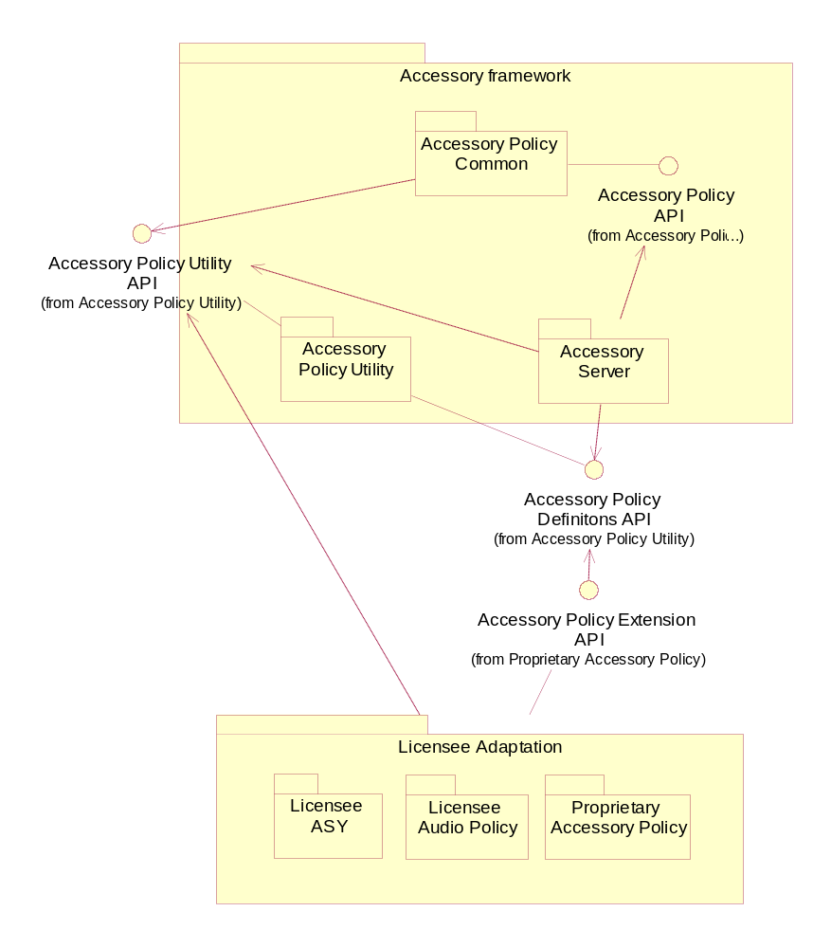
Figure 2.1 Accessory Policy APIs

Component environment
Accessory Server is the main component in Accessory Services. Accessory Server uses accessory Policy via Accessory Policy API. Accessory Policy API is a private API used by Accessory Server of Accessory Framework to get information about the connected accessories. A connected accessory is identified using an assigned Generic ID, which is a data structure that describes the relevant physical and logical features of the accessory. Accessory Policy DB and ASY are part of the adaptation, and the rest of the components are part of the S60 platform.
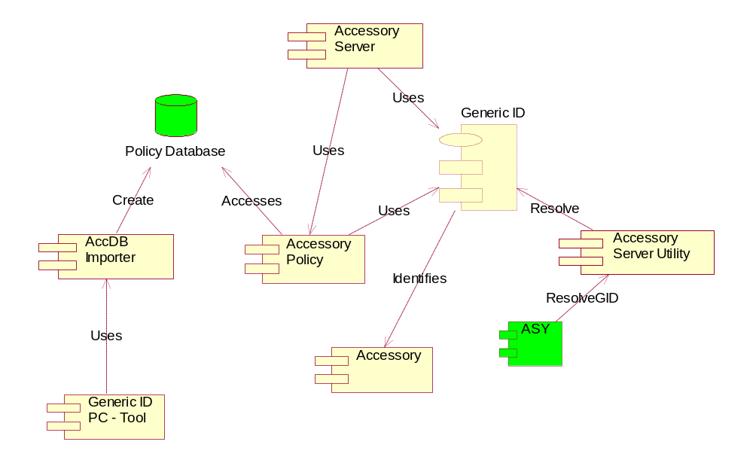
Figure 2.2 Component environment

Use cases
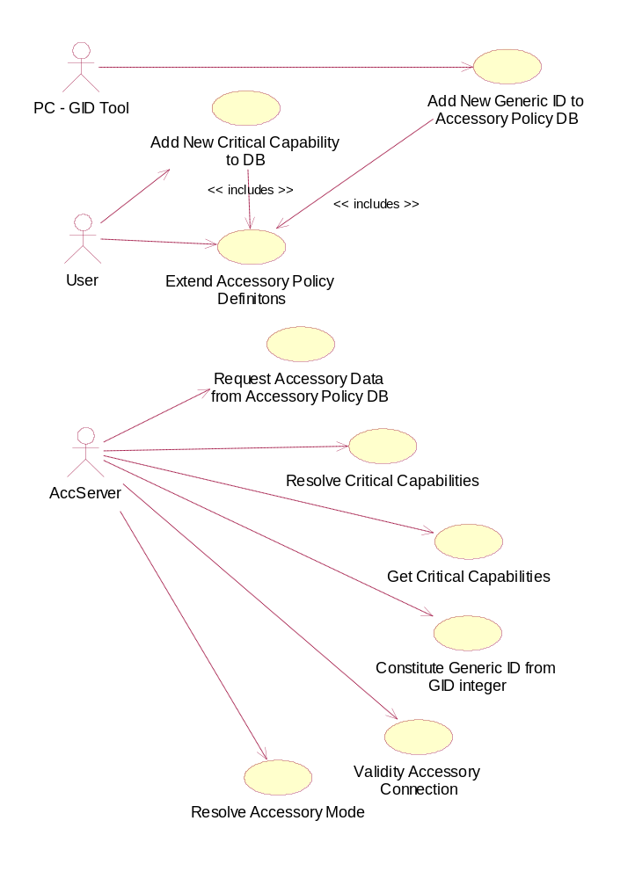
Figure 2.3 Accessory Policy use cases

Add a new Generic ID to the Accessory Policy DB

Summary | This use case defines how a new Generic ID is imported to the Accessory Policy DB. This use case is not executed in the terminal.
Actor(s) | Generic ID PC Tool
Frequency | This use case sequence has to be executed every time when a new Generic ID definition needs to be imported to the Accessory Policy domain.
Preconditions
Description | The user defines the Generic ID content for the Accessory model by using Generic ID PC Tool (see reference document [4]). After this, the Generic ID is packed to the GID integer format and stored into the Accessory Policy DB.
Exceptions
Post conditions | A new Accessory Policy DB file containing the new Generic ID definitions has been created and stored under proprietary Accessory Policy Folder.
Illustrations

Add a new critical capability to the Accessory Policy DB

Summary | This use case defines how a new critical capability is created in to the Accessory Policy DB. This use case is not executed in the terminal. This is an optional feature.
Actor(s) | Generic ID PC Tool
Frequency | This use case sequence has to be executed every time a new critical capability definition needs to be imported to the Accessory Policy DB.
Preconditions | Accessory Policy DB exists.
Description | A Generic ID consist a set of capabilities. The user can optionally define a critical capability which will observe when accessory is connected. A critical capability and its value can be set as critical by adding the capability to the AccPolCriticalCaps.ini file. After this, Generic IDs are regenerated and critical capabilities are stored into the Accessory Policy DB.
Exceptions
Post conditions | A new Accessory Policy DB files containing the new Critical Capability.
Illustrations

Request accessory data from Accessory Policy DB

Summary | Accessory data is requested from Accessory Policy DB and the requested data is returned.
Actor(s) | - Accessory Server  - Accessory Server Utils
Frequency | When the accessory is connecting/connected: moderate.
Preconditions | The user has connected an accessory.
Description | Accessory Server or Accessory Policy Utils has received an API call, which requires Accessory Policy data to be resolved. Accessory Server or Accessory Policy Utils requests data from Accessory Policy. At first the Accessory Policy uses the AccPolicyDB DLL’s API to open a DBMS session to the database, accesses the data and at the end closes the session. It is AccPolicyDB that calls the Symbian OS DBMS API and this is not in any way visible to the Accessory Policy.
Exceptions | Accessory Policy fails to provide the required data.
Post conditions | Accessory Policy returns the queried data.
Illustrations

Extend Accessory Policy definitions
Accessory Policy Definitions API consists of two header files: AccPolGenericIdDefinitions.h and AccPolCommonNameValuePairs.h. The first header file includes Generic ID header part definitions (see reference document [5]) and the second one the common name value pair definitions (see reference document [5]). Accessory Policy Definitions API can be extended by the licensee writing a Proprietary Accessory Policy. Accessory Policy Extension API is defined by the two header files, AccPolPropGenericID.h and AccPolProprietaryNameValuePairs.h, where the new proprietary definitions and values can be added. The proprietary values which are defined to the header file have to be mapped to the Accessory Policy DB by using Generic ID PC Tool (see reference document [4]).

Summary | The user extends Accessory Policy definitions. This use case is not executed in the terminal.
Actor(s) | The user.
Frequency | This use case is valid during the product creation time.
Preconditions | The user has added a proprietary Generic ID definition using Generic ID PC Tool (see reference document [4]) and regenerated the Accessory Policy DB.
Description | The user adds a new proprietary Generic ID definition to the licensee Accessory Policy Definition API. (AccPolPropGenericID.h, AccPolProprietaryNameValuePairs.h)  See the definition example in the Accessorypolicyreference component:  - KSBProprietaryCapabilityGroup in AccPolPropGenericID.h  - KAccProprietaryCapability in AccPolProprietaryNameValuePairs.h
Exceptions
Post conditions | Accessory Policy Extension API is updated.
Illustrations

Resolve critical capabilities

Summary | Critical capabilities are requested from Accessory Policy DB and the requested data is returned.
Actor(s) | Accessory Server
Frequency | When an accessory is connecting/connected: moderate.
Preconditions | The user has connected an accessory.
Description | The critical capabilities are fetched from the Accessory Policy DB and returned to Accessory Server via Accessory Policy API. The capabilities are filtered according to the source data (Generic ID and a set of capabilities).
Exceptions | Accessory Policy fails to provide the required data.
Post conditions | A set of critical capabilities is returned to Accessory Server.
Illustrations

Get critical capabilities

Summary | All critical capabilities are requested from the Accessory Policy DB and the requested data is returned.
Actor(s) | Accessory Server
Frequency | When an accessory is connecting/connected: moderate.
Preconditions | The user has connected an accessory.
Description | The critical capabilities are fetched from the Accessory Policy DB and returned to Accessory Server via Accessory Policy API.
Exceptions | Accessory Policy fails to provide the required data.
Post conditions | All critical capabilities are returned to Accessory Server.
Illustrations

Create Generic ID content

Summary | This use case defines how Generic ID class content is created from a GID integer.
Actor(s) | Accessory Policy
Frequency | When a new accessory is connected.
Preconditions | The user has connected an accessory. Accessory data is requested from the Accessory Policy DB (see Section 2.3.3) and the returned data is GID integer.
Description | Accessory Policy created a Generic ID from the data received from the Accessory Policy DB. The format is GID integer.
Exceptions | Accessory Policy fails to create Generic ID from the data given by the Accessory Policy DB.
Post conditions | The created Generic ID is returned to Accessory Server.
Illustrations

Check accessory connection

Summary | Accessory Server resolves the accessory connection status.
Actor(s) | Accessory Server
Frequency | When an accessory is connecting/connected: moderate.
Preconditions | The user has connected an accessory.
Description | An indication of the Accessory connection is received from Accessory Server. The allowed connection is based on the accessory capability values, which can be defined as critical capabilities (see reference document [4]). The Accessory Connection state can be interpreted as Detect, Connect or Deny depending on the Accessory Policy configuration. The Accessory Connection state is returned to Accessory Server.
Exceptions
Post conditions | The connection state is returned to Accessory Server.
Illustrations

Resolve accessory mode

Summary | Accessory Server resolves the accessory mode.
Actor(s) | Accessory Server
Frequency | - When accessory is connecting/disconnecting: moderate.  - Connection state is changed: moderate.  - Accessory audio routing status is changed: moderate.
Preconditions | The user has connected an accessory.
Description | The Accessory Mode is resolved. The resolved Accessory Mode depends on the number of connected accessories, the Audio Output status and the Multiple Connection Rules table.
Exceptions
Post conditions | Accessory mode is successfully resolved.
Illustrations

Services required

From the Symbian OS subsystems

API | Description
RDb | Symbian DBMS API
RDbNamedDatabase | Symbian DBMS API
RDbView | Symbian DBMS API
RFs | Symbian File Server API

From the Domestic OS subsystems
This component does not have any direct interfaces to the Domestic OS side subsystems.

From HW
This component has no direct HW interfaces.

Services provided

UI
This component does not provide any UI.

SW IF
This component does not provide services for other subsystems.

Internal APIs
Accessory Policy API encapsulates the accessory policy private functionality. It provides methods to resolve e.g. the accessory connection state and mode. The services provided by Accessory Policy API are listed in following table:
Table 2.1 Accessory Policy API
Provided service | Description | Protected
Check accessory connection | Validates that a certain accessory is allowed to connect to the terminal. | No
Resolve accessory mode | Resolves an accessory mode, which is based on the currently connected accessories. | No
Resolve critical capabilities | Fetches critical capabilities from the Accessory Policy DB. Capabilities are filtered according to the source data (Generic ID and a set of capabilities). | No
Gets all critical capabilities | Fetches all critical capabilities from the Accessory Policy DB. | No
Constitute Generic ID content | Constitutes Generic ID. The data is fetched from the Accessory Policy DB. | No

Accessory Policy DB API provides the means to get data/information from the Accessory Policy DB. Services provided by Accessory Policy DB API are listed in the following table:
Table 2.2 Accessory Policy DB API
Provided service | Description | Protected
Open database | Opens the Accessory Policy DB. | No
Close database | Closes the Accessory Policy DB. | No
Find GID integer | Searches if the device ID has a mapped GID integer defined in the Accessory Policy DB. | No
Compares capability value | Compares the capability value given as a parameter to the value defined in the Accessory Policy DB. | No
Gets all critical capabilities | Search all the critical capabilities from the Accessory Policy DB. | No

External APIs
Accessory Policy definitions API (see Section 3.2.1.2) contains common Generic ID and name value pair declarations.
Accessory Policy utility API (see Section 3.2.1.1) contains public utility functions and classes for Generic ID handling.
Accessory Policy Extension API (see Section 3.2.1.5) can be used to declare proprietary accessory capabilities. This API is an extension for Accessory Policy Definitions API and has to be defined by the licensee.

Design

Class diagrams

Accessory Policy
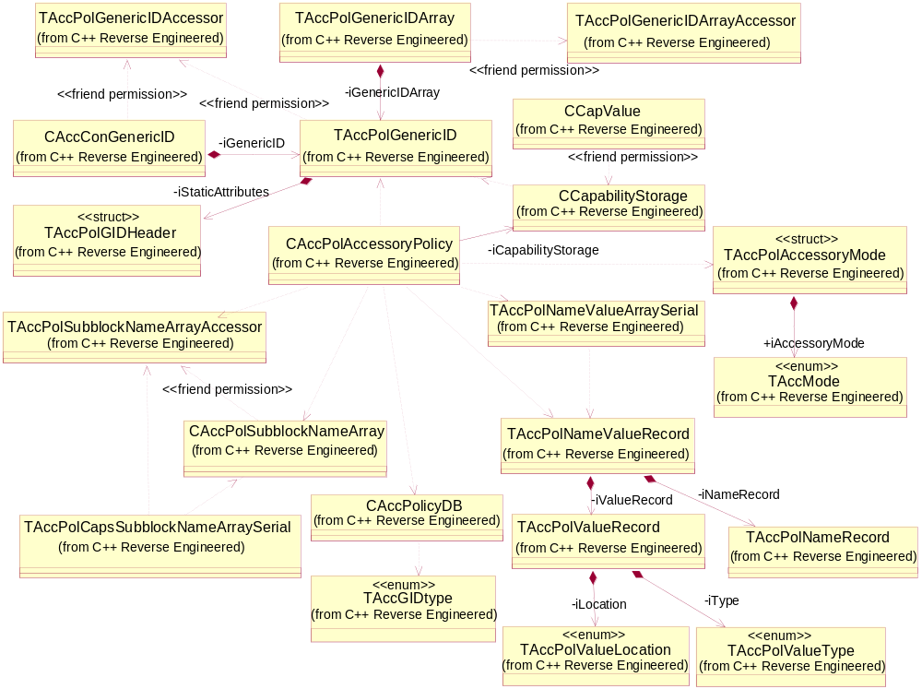
Figure 3.4 Accessory Policy class diagram

Class descriptions

Class | Description | Header file
CAccPolAccessory  Policy | This is the main Accessory Policy API class, and the Accessory Server uses it. It provides all kinds of accessory functions for the server, and most operations can be mapped straight to the ones defined in Accessory Server Client API. | AccPolAccessoryPolicy.h
CAccPolicyDB | This class defines the Accessory Policy DB interface. It is used by the Accessory Policy to access the database. | AccPolicyDB.h
CAccPolSubblock  NameArray | This is a public API class that defines the Capability Name Array class. It is used as a container for a set of capability name definitions. | AccPolSubblockNameArray.h
TAccPolCaps  SubblockNameArraySerial | This class defines static operations that are used in the serialization of a variable length capability name array into/from a stream. This way it can be passed between process boundaries. Accessory Server and Accessory Policy use the operations. | AccPolCapsSubblockName  ArraySerial.h
TAccPolGenericID | A public API class of the Generic ID, which provides means for describing, detecting, connecting and controlling an enhancement. | AccPolGenericID.h
TAccPolGenericID  Accessor | A private accessory API for Accessory Policy internal use. This API is used for modifying the Generic ID header part values. | AccPolGenericIDAccessor.h
TAccPolGenericID  Array | This is a public API class that defines the Generic ID Array class. It is used as a container for a set of Generic ID instances. | AccPolGenricIDArray.h
TAccPolGenericID  ArrayAccessor | A private accessory API for the Generic ID Array. Accessory Server and Accessory Policy use it internally. | AccPolGenericIDArray  Accessor.h
TAccPolGIDHeader | This is the header part of the Generic ID class. Every Generic ID has values defined for these basic attributes. | AccPolGIDHeader.h
TAccPolNameRecord | The name record definition that is part of the Name/Value record concept. In addition to Accessory Server and Accessory Policy, this class is used in the Accessory Plug-in interface. | AccPolNameRecord.h
TAccPolNameValue  Record | A structure definition that realizes the Name/Value record concept. An accessory can have a variable amount of Name/Value records that define some specific features for that accessory. | AccPolNameValueRecord.h
TAccPolSubblock  NameArrayAccessor | A private accessory API for the Capability Name Array. For Accessory Server and Accessory Policy internal use only. | AccPolSubblockNameArray.h
TAccPolValue  Record | A value record definition that is part of the name/value record concept. | AccPolValueRecord.h
TAccPolNameValue  ArraySerial | A private accessory API for Accessory Server internal use. This API is used to externalize name/value array instance. | AccPolNameValueArray  Serial.h
CCapValue | The data structure for an individual capability. For Accessory Server internal use. | AccCapabilityStorage.h
CCapability  Storage | A capability storage for Accessory Server internal use. | AccCapabilityStorage.h
CAccConGenericID | Heap-allocated Generic ID class definition to be used in accessory connection. | AccConGenericID.h
CAccConfigFile  Parser | Used for mapping the detected accessory HW Device IDs to Generic IDs. | AccConfigFileParser.h

API definitions

Accessory Policy Utility API
See reference document [3] for Accessory Policy Utility API definitions.

Accessory Policy API (private API)
Accessory Policy Common API is declared in the following headers:
- AccPolAccessoryPolicy.h
- AccPolCapabilityStorage.h
- AccPolCapsSubblockNameArraySerial.h
- AccPolGenericIDAccessor.h
- AccPolGenericIDArrayAccessor.h
- AccPolNameValueArraySerial.h
- AccPolSubblockNameArrayAccessor.h

See the header files for detailed API definitions.

Accessory Policy DB API (private API)
Accessory Policy DB API is declared in AccPolicyDB.h. See the header file for detailed API definitions.

Accessory Policy Definitions API
Accessory Policy Definitions API is declared in the AccPolGenericIdDefinitions.h and AccPolCommonNameValuePairs.h header files. For more information, see reference document [5].

Accessory Policy Extension API
Accessory Policy Definitions Extension API is declared in AccPolPropGenericID.h and AccPolProprietaryNameValuePairs.h. The extension mechanism is described in Section 2.3.4.

Configuration File Parser API
See reference document [3] for Configuration File Parser API.

Struts, type definitions and enumerations

AccPolAccessoryMode.h
See the Accessory Mode type definitions in reference document [3].

AccPolValueRecord.h

TAccPolValueLocation | Description
EAPVNotDefined | Location not defined.
EAPVAccessory | The value is requested from/stored in the accessory HW.
EAPVPolicy | The value is defined in the Accessory Policy.

TAccPolValueType | Description
EAPVNone | No type defined.
EAPVBool | Boolean
EAPVInt | Integer
EAPVUInt | Unsigned integer
EAPVDes8 | 8-bit descriptor

AccPolicyDBNames.h
AccPolicyDBNames.h contains private Accessory Policy DB definitions. These definitions are used by Accessory Policy DB and Accessory Policy DB importer.
TAccGIDtype defines the type of a row in the Accessory Policy DB.

TAccGIDtype | Description
EAccNormal | This row is a normal Generic ID in the GID integer table.

Accessory Policy DB table definitions:

GID Integer table | Description
_LIT( KACCDBGIDIntTable, "gIntTbl" ) | The GID Integer table.
_LIT( KACCDBGIDIntDeviceIDCol, "gIntDEVCol" ) | The device ID column of the GID integer table.
_LIT( KACCDBGIDIntGIDCol, "gIntGIDCol" ) | The GID Integer column of the GID integer table.
_LIT( KACCDBGIDIntKeyIDCol, "gIntKEYCol" ) | The type column of the GID integer.

Capability rules table | Description
_LIT( KACCDBCapRulesTable, "capRulesTbl" | The capability rules table.
_LIT( KACCDBCapRulesName, "capRulesNameCol" ) | The name column of the capability rules table.
_LIT( KACCDBCapRulesValue, "capRulesValueCol" ) | The value column of the capability rules table.

AccPolGIDHeader.h
AccPolGIDHeader.h defines the following constants:

Constant | Description
const TInt KHWModelIDMaxLength( 12 ) | The maximum length of the HW model ID definition.
const TInt KHWDeviceIDMaxLength( 12 ); | The maximum length of the HW device ID definition.
const TInt KGIDIntMaxLength( 1024 ); | The maximum length of the GID integer.

AccPolGenericIdDefinitions.h and AccPolCommonNameValuePairs.h
See reference document [5].

Flag definitions

Flag | Description
API_TRACE_FLAG | When this flag is defined, components output trace whenever public API method is entered and exited.
COMPONENT_TRACE_FLAG | When this flag is defined, components output miscellaneous trace. If neither of these trace flags is defined, no trace is produced by Accessory Client-Server.

Operations

Extend Accessory Policy definitions
In the generic identification, common properties of accessories are defined in a static part called GID header (AccPolGenericIdDefinitions.h). These static parts are device type, physical connection, application protocols and capability groups. The capability groups define what capability groups are defined for this accessory. The capability groups consist of more detailed capabilities and define the other major part of the generic identification: the dynamic part of the generic identification (AccPolCommonNameValuePairs.h).

Common capability definition example
The capability group is defined as TUint64 type and the first 32 bits are specified as a common part. The rest of the bits are allocated for the licensee (proprietary) usage.
The capability group addresses the space definition (AccPolGIDHeader.h):
Hex format:
// Common part : 0x0000000000000001-0x00000000FFFFFFFF
// Proprietary part : 0x0000000100000000-0xFFFFFFFFFFFFFFFF
TUint64 iCapabilitiesSubblocks;

KSBAudioSubblock is allocated from the capability group to address space:
// Const definition for capability Group
const TUint64 KSBAudioSubblock = 0x1;

The first capability defined for Audio Capability Group (KSBAudioSubblock):
// Const definition for capability
Hex format: Binary format:
const TUint32 KAccAcousticEchoControl = 0x0000; --> 000000 00000 00000

KAccAcousticEchoControl in binary format:
// 0b 000000 00000 00000
// | | |
// | | | 5 bits for capability. Tells which bit is one (*).
// | | 5 bits for namespace (0 -3 are supported),
// | 6 bits for capability group. Tells which bit is one (*) e.g. audio capability group.
// in this example first 6 bits (000000) means that bit number 0 is on, i.e. value is
// 0b0001=0x1.
// Capability group 0x1 = KSBAudioSubblock.
// (*):
// 0b00 -> bit number 0 is one -> value is 0b0001=1
// 0b01 -> bit number 1 is one -> value is 0b0010=2
// 0b10 -> bit number 2 is one -> value is 0b0100=4
// 0b11 -> bit number 3 is one -> value is 0b1000=8

In other words, the KAccAcousticEchoControl capability belongs to the KSBAudioSubblock capability group, which is allocated from the common address space of Capabilities Groups.
KAccAcousticEchoControl consists of the capability group 000000 (value is 0b0001=1), name space 00000 (value is 0) and capability 00000 (value s 0b0001=1).
Common capabilities can be added to accessory models. For further information, see reference document [4].

Proprietary capability definition example
The proprietary capability group is allocated from the proprietary address space, which is defined in Capabilities Groups as follows:
Proprietary part: 0x0000000100000000-0xFFFFFFFFFFFFFFFF

An example allocation of a proprietary capability group (first address in proprietary space):
const TUint64 KSBProprietaryCapabilityGroup = 0x100000000;

An example definition of a proprietary capability:
Hex format: Binary format:
const TUint32 KAccProprietaryCapability = 0x8000; -->100000 00000 00000

KAccProprietaryCapability in binary format:
// 0b 100000 00000 00000
// | | |
// | | | 5 bits for capability. Tells which bit is one (*).
// | | 5 bits for namespace (0 -3 are supported),
// | 6 bits for capability group. Tells which bit is one (*) e.g. audio capability group.
// in this example first 6 bits (32) means that bit number 6 is on, i.e. value is
// 0b100000=0x8000.
// Capability group 0x1 = KAccProprietaryCapability.
// (*):
// 0b00 -> bit number 0 is one -> value is 0b0001=1
// 0b01 -> bit number 1 is one -> value is 0b0010=2
// 0b10 -> bit number 2 is one -> value is 0b0100=4
// 0b11 -> bit number 3 is one -> value is 0b1000=8

In other words, the KAccProprietaryCapability capability belongs to the KSBProprietaryCapabilityGroup capability group which is allocated from the proprietary address space of Capabilities Groups.
KAccProprietaryCapability consists of the capability group 100000 (value is 0b100000=32), name space 00000 (value is 0) and capability 00000 (value s 0b0001=1).
See the example definition in adaptation\stubs\accessorypolicyreference.
- AccPolPropGenericID.h includes Generic ID header part proprietary definitions.
- AccPolProprietaryNameValuePairs.h includes detailed proprietary accessory information capabilities.
The defined proprietary capability must be added to the Accessory Policy DB, which is done by using Generic ID PC Tool (see reference document [4]).

Backup and Restore
This component does not participate in backup and restore.

System resource usage

Files
- HW Model ID mapping to Generic ID Integer form:
- *.DAT
- Critical capability definitions:
- AccPolCapRules.ini

Other data

Databases
DBS_10205030_accpolicydb.db is generated from configuration files which are listed in Section 4.1.

Central Repository
This component does not use Central Repository.

Publish and Subscribe
This component does not use Publish and Subscribe.

Memory consumption
Accessory Policy consists of three binaries: AccPolCom.dll, AccPolicy.dll, AccPolicyDB.dll and one Accessory Policy DB file DBS_10205030_accpolicydb.db. The size of the Accessory Policy DB depends on the amount of configuration data. The combined memory consumption of the binaries is given in table below:

Memory/Build | Consumption
[WINSCW UDeb] | ~ 904 KB
[ARMV5 URel] | ~ 11 KB

Task allocation
AccPolicy.dll runs in the same thread as its client does.
AccPolicyDB.dll runs in Accessory Server and the same thread as its client does.
AccPolCom.dll runs in Accessory Server and the same thread as its client does.

Timers
No timers are used.

Exception handling
Accessory Policy exception handling mechanisms:
If the exception is about a programming error, such as bad parameters, or environment resources that are running out, e.g. low memory, the exception handling is forwarded to the user:
In UDeb and URel builds, the leave mechanism of Symbian OS environment is used in most such situations.

Exception | Description
Bad parameters | Forwarded to the user.
Low memory / Out of memory | Forwarded to the user.

Usage

Building
See reference document [1].

User's guide
See reference documents [4], [5] and [6].

