S60 5.1
Accessory Client-Server
Design Document

Team name | Author
D RD S60 CSU OS System and Product SW FI | Toni Maaninka

Change history:

Version | Date | Status | Comments
1.0 | 13.01.2009 | Approved

Table of contents:

1. Document control 5
1.1 References 5
1.2 Documentation conventions 5
1.3 Abbreviations 5
1.4 Definitions 5
2. General 7
2.1 Introduction 7
2.2 Component environment 7
2.3 Use cases 8
2.4 Services required 8
2.4.1 From the Symbian OS subsystems 8
2.4.2 From the Domestic OS subsystems 8
2.4.3 From HW 8
2.5 Services provided 8
2.5.1 UI 8
2.5.2 SW IF 8
3. UI control hierarchy 9
4. Design 10
4.1 Accessory Server class diagram 10
4.2 Accessory Client class diagram 11
4.3 ASY Proxy class diagram 12
4.4 Reference ASY class diagram 13
4.5 Charging Context class diagram 14
4.6 Component 15
4.7 Class descriptions 16
4.7.1 Accessory Server class descriptions 16
4.7.2 Accessory Client class descriptions 18
4.7.3 ASYProxy class descriptions 18
4.8 Structs, type definitions and enumerations 19
4.8.1 AccSrvServerModel.h 19
4.8.2 AccSrvConnectionHandler.h 19
4.8.3 AccSrvASYProxyHandler.h 19
4.8.4 AccSrvSubASYComms.h 19
4.8.5 AccSrvSettingsHandler.h 19
4.8.6 ASYCmdTypes.h 19
4.8.7 AccessoryTypes.h 20
4.8.8 ASYProxyMainService.h 21
4.8.9 ASYMainServiceBase.h 21
4.8.10 AccSrvNotificationQueue.h 21
4.8.11 AccModeSetting.h 21
4.8.12 AccSrvProxy.h 21
4.8.13 AccClientServerMessages.h 21
4.8.14 AccessoryAsyComms.h 22
4.8.15 AccessoryBTControl.h 22
4.8.16 accessoryservicesinternalpskeys.h 22
4.8.17 ChargingContextFSMBody.h 22
4.9 Flag definitions 22
4.10 State diagrams 23
4.10.1 Charging Context 23
4.11 Operations 23
4.11.1 Starting Accessory Server 23
4.11.2 Create SubSession 29
4.11.3 Close SubSession 30
4.11.4 Connect accessory 31
4.11.5 Disconnect accessory 33
4.11.6 Synchronous getters 35
4.11.7 Asynchronous getters 36
4.11.8 Notifications 37
4.11.9 Get capability values 39
4.11.10 Set capability values 40
4.11.11 GetSupportedHWDevices 42
4.11.12 GetHWDeviceSettings 43
4.11.13 SetHWDeviceSettings 43
4.11.14 ProcessResponse 44
4.11.15 AccessoryValueChangedNotifications 45
4.11.16 SetAccessoryModeSetting 47
4.11.17 GetAccessoryModeSetting 48
4.11.18 BT: NotifyAccessoryAudioLinkOpened 50
4.11.19 BT: NotifyBluetoothAudioLinkOpenReq 50
4.11.20 BT: AccessoryAudioLinkOpen 51
4.11.21 BT: BluetoothAudioLinkOpenedNotify 52
4.11.22 BT: BluetoothAudioLinkOpenResp 53
4.11.23 Base case operations 54
4.11.23.1 Complete ASYCmdL 55
4.11.23.2 CreateCAccSrvModelAndConnectionControl 55
4.11.23.3 InitializeCriticalCapsL 57
4.11.23.4 MessageHandlingToSubSession 58
4.11.23.5 ProxyUpdateAsyCommsStackL 59
4.11.24 Charging Context 60
4.11.24.1 Creation of Charging Context 60
4.11.24.2 “Wait for Charger” state 61
4.11.24.3 “Charging” state 61
4.11.24.4 “Maintain Activity” state 62
4.12 Backup and Restore 62
5. Variation 63
5.1 Variable component/feature 63
6. System resource usage 64
6.1 Files 64
6.2 Other data 64
6.2.1 Databases 64
6.2.2 Central Repository 65
6.2.3 Publish and Subscribe 65
6.3 Memory consumption 65
6.4 Task allocation 65
6.5 Performance 65
6.6 Timers 65
7. Security 66
7.1 Capabilities of this component 66
7.2 Input and output validation 66
7.3 Environmental assumptions 66
8. Exception handling 67
9. Usage 68
9.1 Building 68
9.2 User's guide 68

Document control

References

- S60 Accessory Framework Design Document
- S60 Accessory Plug-In API Specification
- S60 3.0 HW Resources and Enhancements Subsystem Architecture Description Document
- S60 Accessory API Specification
- S60 Accessory Policy Design Document
- S60 GID PC Tool User’s Guide

Documentation conventions
Code is shown with the Courier New font.

Abbreviations

ASY | Accessory Handler Provider Module
ACC | Accessory
ACC FW | Accessory Framework
AO | Active Object
BT | Bluetooth
FSM | Finite State Machine
GID | Generic ID
IHF | Integrated hands free
P&S | Publish & Subscribe
USB | Universal Serial Bus

Definitions

Accessory connection status | Combined connection status for all the currently connected accessories. All the connected accessories need to have existing signaling or control connection.
Accessory Mode | Super state for connection status and audio accessory modes.
Generic ID | ACC FW Generic ID (GID). Concept, which enables the clients to identify the connected accessory based on features.
Central Repository | Symbian provided service for storing data centrally.
Physical connection | Physical Connection is established at the moment the accessory is detected.  When physical connection is established, it usually follows that control connection is created. There are, however, some pre-conditions, that may prevent the control connection from being created. For example: accessory is not properly powered or authentication fails.
Publish & Subscribe | Symbian provided service for publishing data runtime.
Single accessory connection status | Connection status of one, specific (specified with GID) accessory.

General
Accessory Client-Server is part of Accessory Framework. This document describes the detailed design of Accessory Client-Server. Note: This document does not offer design for all Accessory Framework components. For Accessory Framework design overview, please see reference document [1].

Introduction
Design of Accessory Server follows Symbian Client-Server Framework. Accessory Server client side implementation consists of a single Accessory Server session and multiple Accessory Server sub session classes. Using just a single Accessory Server session spares significant system resources.
Within one established Accessory Server session, a client may create as many sub sessions as needed. Each sub session represents independent communication channel between the client and the server.

Component environment
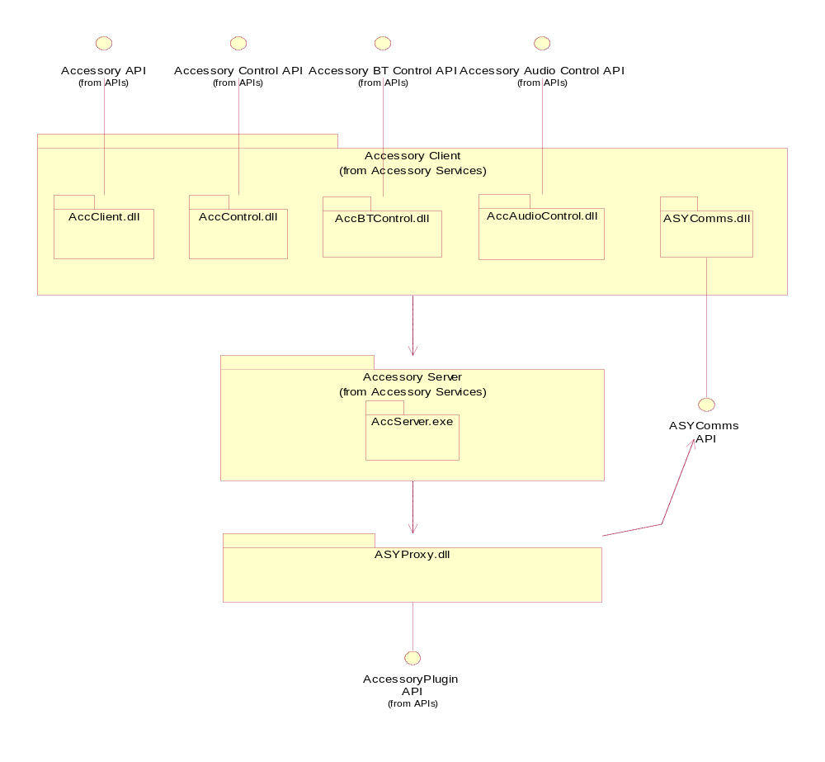
Figure 2.1 Accessory Client-Server components

Use cases
Please see reference document [1] for more information on use cases.

Services required

From the Symbian OS subsystems
The following table describes the required services.

API | Description
Client-server framework | Standard Client-server Framework.
ECOM Plug-In Architecture | Standard Symbian plug-in Framework.
Threads and Processes | Provides access to processes, threads, and thread-local storage.
Streams | For Inter process communication.
CenRep | Central Repository.
DBMS | Accessory Policy SQL database.
RNotifier | UI note showing.
RTimer | Controlling time outs.

From the Domestic OS subsystems
This component does not have any direct interfaces to the Domestic OS side subsystems.

From HW
This component has no direct HW interfaces.

Services provided

UI
Accessory Client-Server uses AccFWUiNotifier via RNotifier to show dialogs and notes.

SW IF
Accessory Client-Server provides API for clients and Plug-In API for plug-In modules. Please see reference document [4] for more information on client APIs, and reference document [2] for the API of plug-in modules.

UI control hierarchy
Accessory Client-Server uses AccFwUiNotifier to show an unsupported note in case there was an unsupported accessory connected to the phone.

Design

Accessory Server class diagram
The Accessory Server class diagram represents the server-side classes.
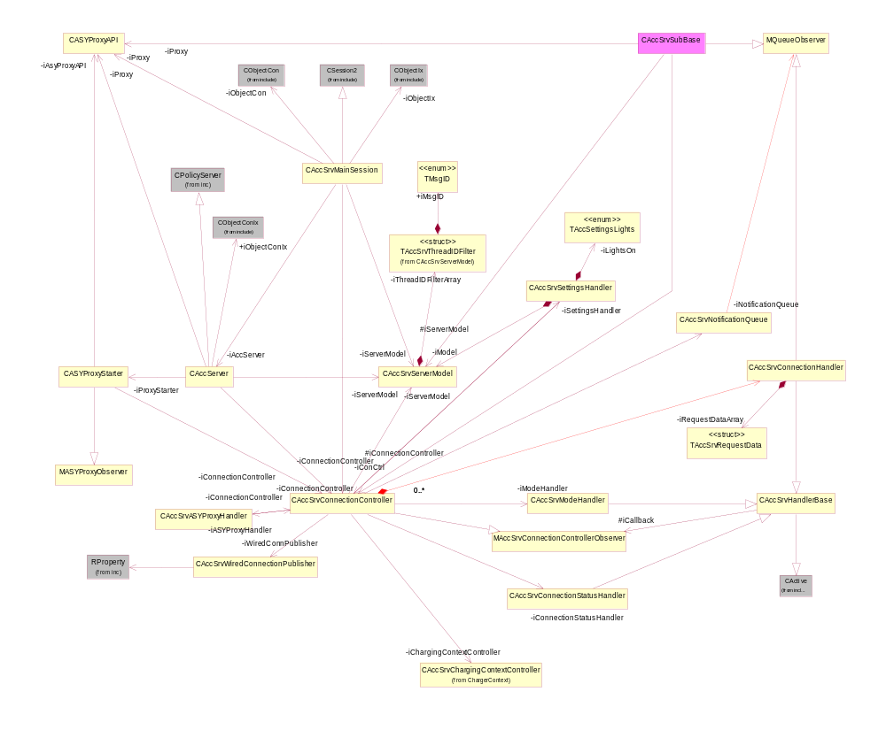
Figure 4.2 Accessory Server class diagram
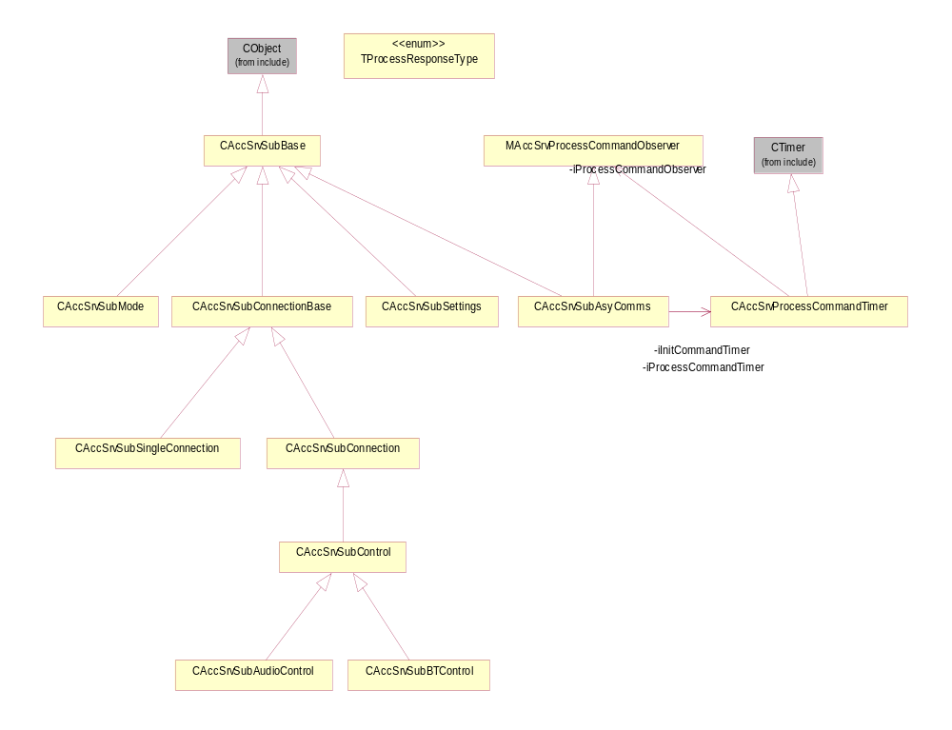
Figure 4.3 Accessory Server class diagram, sub classes

Accessory Client class diagram
The Accessory Client class diagram represents the client-side diagram.
- Accessory API consists of API classes: RAccessorySingleConnection, RAccessoryConnection and RaccessoryMode.
- Accessory Control API consists of API classes: RAccessoryControl and RAccessorySettings.
- Accessory BT Control API consists of API classes: RAccessoryBTControl.
- Accessory Audio Control API consists of API classes: RAccessoryAudioControl.
- Accessory ASY Comms API consists of API classes: RAccessoryASYComms. Accessory ASY Comms API is private API of Accessory Client-Server.

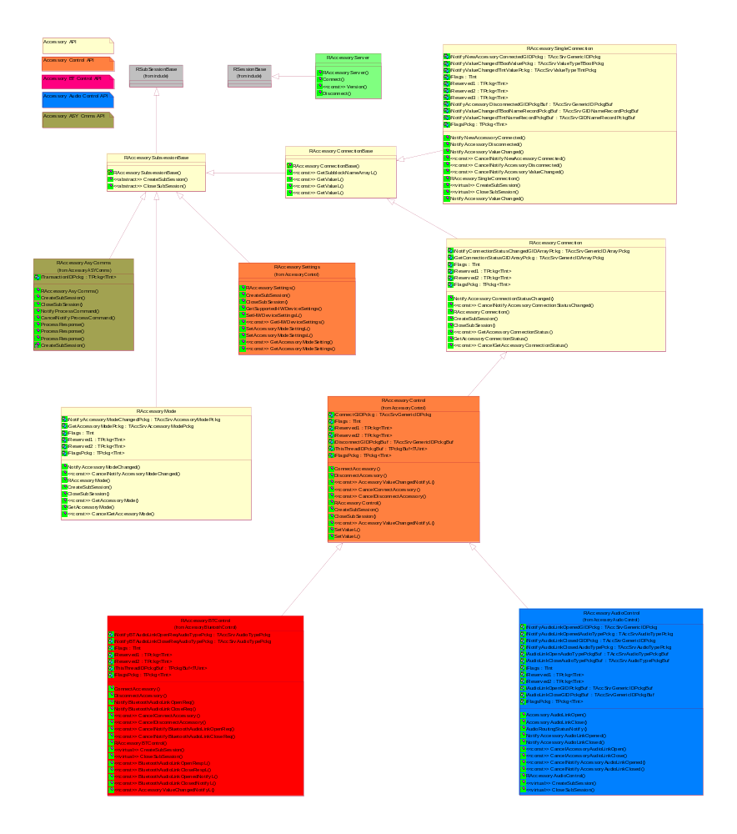
Figure 4.4 Accessory Client class diagram

ASY Proxy class diagram
The ASY Proxy class diagram represents the classes of the ASY Proxy.
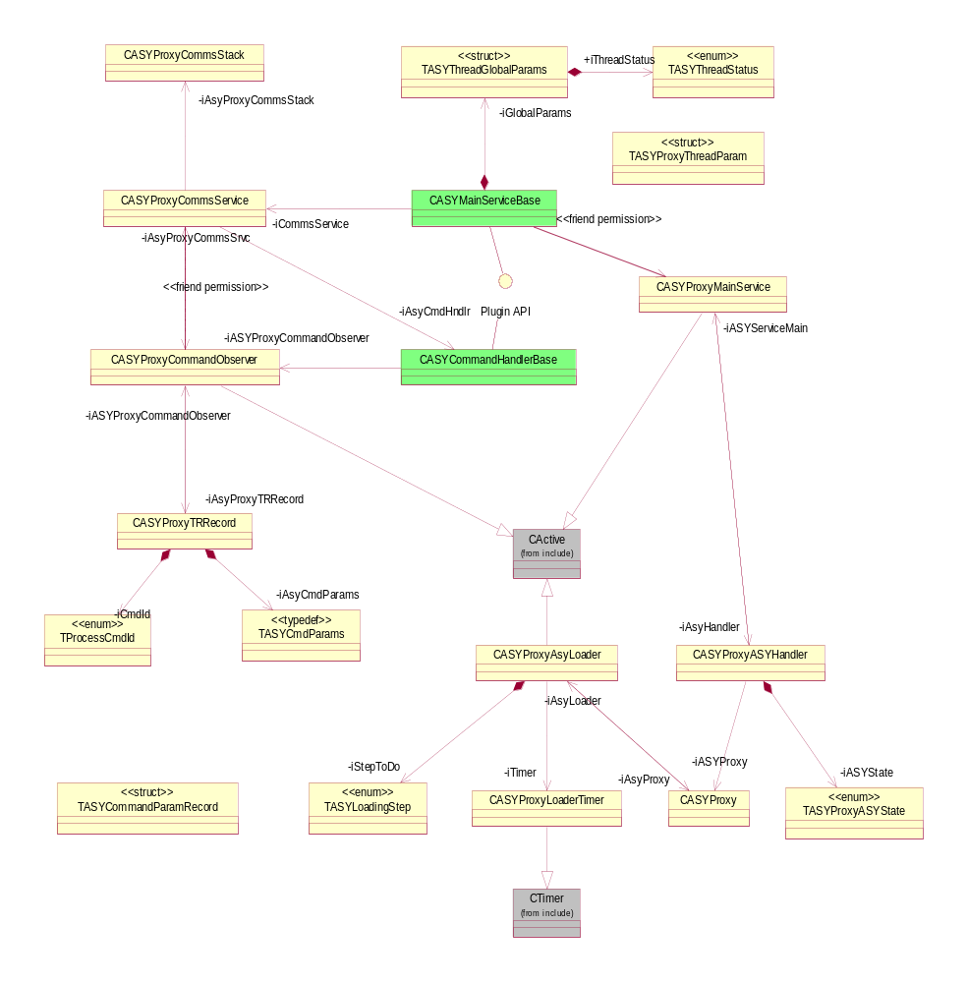
Figure 4.5 ASY Proxy class diagram

Reference ASY class diagram
Reference ASY exists as a reference implementation for ASYs. Please see reference document [2] for more information.
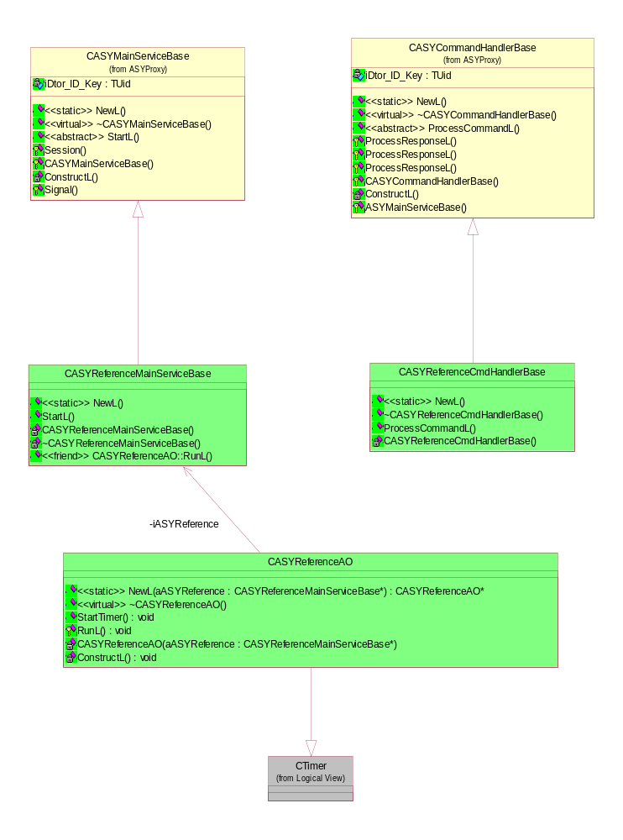
Figure 4.6 Reference ASY class diagram

Charging Context class diagram
In order to enhance usability of mobile device it shall be possible while battery charge is on and device orientation is “display up”:
- For a user to see phone display content just by looking at the display.
- That phone is in a state where user has to give minimal number of commands (key presses) to control phone.
Affected functionalities:
    - Backlight: Light on all the time while display up and battery charge is on
      - User is able to set light of just by activating key lock
    - Keylock: Must not lock, while display up and battery charge is on
    - Device lock: Must not lock, while display up and battery charge is on
      - Yet, entering the state ”charge on & display up” must not automatically unlock device lock, instead let the user unlocking of her/his own free will
    - Screen Saver must not set on, while display up and battery charge is on
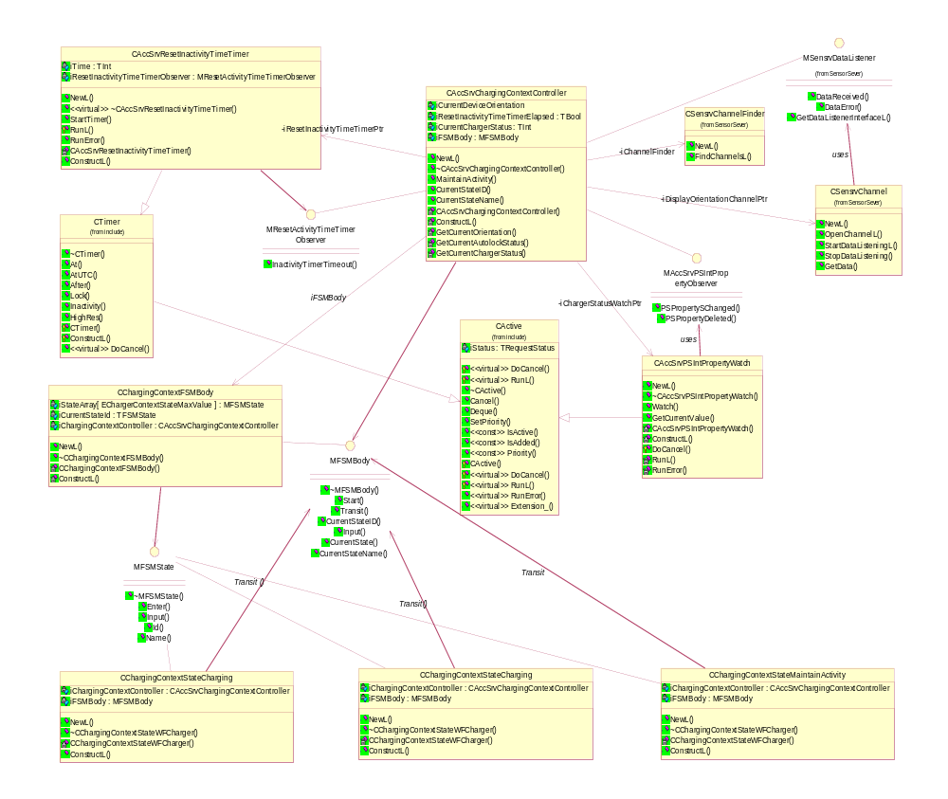
Figure 4.7 Charging context class diagram

Component
See more detailed information on S60 Accessory Framework Design Document in reference document [1].

Class descriptions

Accessory Server class descriptions

Class | Description | Header file
CAccServer | A server-side server class. | AccServer.h
CAccSrvASYProxyHandler | Handles ASY transaction related tasks. | AccSrvASYProxyHandler.h
CAccSrvConnection  Controller | Handles accessory connection and disconnection related tasks as well as accessory mode and connection status updates. | AccSrvConnectionController.h
CAccSrvConnection  Handler | A handler for AccSrvConnectionController. Makes needed ASY queries asynchronously:  - Resolves critical capabilities  - Supported BT profile query | AccSrvConnectionHandler.h
CAccSrvConnection  StatusHandler | Starts asynchronous accessory connection status update. | AccSrvConnectionStatus  Handler.h
CAccSrvHandlerBase | Pure virtual base class for asynchronous handlers. | AccSrvHandlerBase.h
CAccSrvMainSession | A server-side session class. | AccSrvMainSession.h
CAccSrvModeHandler | Starts asynchronous accessory mode update. | AccSrvModeHandler.h
CAccSrvNotification  Queue | A queue class for observers to register and complete messages. | AccSrvNotificationQueue.h
CAccSrvProcessCommand  Timer | A timer class for time out of ProcessCommands. | AccSrvProcessCommand  Timer.h
CAccSrvServerModel | Data repository of Accessory Server. | AccSrvServerModel.h
CAccSrvSettingsHandler | A controller for accessory settings functionality. | AccSrvSettingsHandler.h
CAccSrvSubAsyComms | A subconnection class for a session of ASYComms subsession. | AccSrvSubAsyComms.h
CAccSrvSubAudioControl | An accessory audio control server-side sub-session implementation. | AccSrvSubAudioControl.h
CAccSrvSubBase | A base class implementation for all server side sub-session. | AccSrvSubBase.h
CAccSrvSubBTControl | An accessory BT control server-side sub-session implementation. | AccSrvSubBTControl.h
CAccSrvSubConnection | An accessory connection server-side sub-session implementation. | AccSrvSubConnection.h
CAccSrvSubConnection  Base | An accessory connection base server-side sub-session implementation. | AccSrvSubConnectionBase.h
CAccSrvSubControl | An accessory control server-side sub-session implementation | AccSrvSubControl.h
CAccSrvSubMode | An accessory mode server-side sub-session implementation. | AccSrvSubMode.h
CAccSrvSubSettings | A sub session class for Accessory Settings. | AccSrvSubSettings.h
CAccSrvSubSingle  Connection | An accessory single connection server-side sub-session implementation. | AccSrvSubSingleConnection.h
MAccSrvConnection  ControllerObserver | An interface class to be used from an instance of CAccSrvConnectionStatusHandler to Connection Controller for call-backs. | AccSrvConnectionController.h
MAccSrvProcessCommand  Observer | An observer class for call back functions to handle time out of process commands. | AccSrvProcessCommand  Observer.h
MQueueObserver | An interface class to be used for Notification Queue callbacks. | AccSrvQueueObserver.h
CASYProxyStarter | A startup class for loading ASYs and handling changes in ASYs statuses. | ASYProxyStarter.h
CAccSrvWiredConnectionPublisher | Updates the P&S key holding the status of wired accessory (other than USB) connections regardless of the actual accessory modes. | AccSrvWiredConnection  Publisher.h
MAccSrvCentralRepositoryObserver | Callback interface for observer of CAccSvrCentralRepositoryObserver object. | AccSrvCentralRepository  Observer.h
CAccSrvCentralRepositoryWatch | Class to watch key value changes in Central Repository. | AccSrvCentralRepository  Watch.h
CAccSrvChargingContextController | Charging Context Controller for checking desired conditions and acting according them in order to ease usability of device during charging. | AccSrvChargingContext  Controller.h
MAccSrvPSIntPropertyObserver | Callback interface of Publish and Subscribe integer property observer. | AccSrvPSIntPropertyObserver.h
CAccSrvPSIntProperty  Watch | Watcher class for PS' integer property value changes. | AccSrvPSIntPropertyWatch.h
CAccSrvResetInactivityTimeTimer | Timer class for calling User::ResetInactivityTime() frequently. | AccSrvResetInactivityTime  Timer.h
CChargingContextFSM  Body | Finite State Machine class for Charging Context Controller. | ChargingContextFSMBody.h
CChargingContextState  Charging | "Charging" state implementation for Charging Context Controller. | ChargingContextState  Charging.h
CChargingContextState  MaintainActivity | "Maintain activity" state implementation for Charging Context Controller. | ChargingContextStateMaintainActivity.h
CChargingContextState  WFCharger | "Wait For Charger" state implementation for Charging Context Controller. | ChargingContextStateWF  Charger.h
MFSMBody | Body interface of Finite State Machine. | FiniteStateMachine.h
MFSMState | State interface of Finite State Machine. | FiniteStateMachine.h
MResetActivityTime  TimerObserver | Callback interface for observer of CAccSrvResetInactivityTimeTimer object. | ResetInactivityTimeTimer  Observer.h

Accessory Client class descriptions

Class | Description | Header file
RAccessoryAsyComms | AsyComms sub-session represents AsyComms connection. | AccessoryAsyComms.h
RAccessoryAudioControl | Accessory Audio Control sub-session. | AccessoryAudioControl.h
RAccessoryBTControl | Accessory Bluetooth Control sub-session. | AccessoryBTControl.h
RAccessoryConnection | Accessory Connection sub-session. | AccessoryConnection.h
RAccessoryConnection  Base | Base class for Accessory Server RAccesoryConnection and RAccesorySingleConnection sub-sessions. | AccessoryConnectionBase.h
RAccessoryControl | Accessory Control sub-session. | AccessoryControl.h
RAccessoryMode | Accessory Mode sub-session. | AccessoryMode.h
RAccessory Server | Session class for the Accessory Server. | Accessory Server.h
RAccessorySettings | Accessory Settings sub-session. | AccessorySettings.h
RAccessorySingle  Connection | Accessory Single Connection sub-session represents single accessory connection. | AccessorySingleConnection.h
RAccessorySubsession  Base | Base class for Accessory Server sub-sessions. | AccessorySubsessionBase.h
TAccModeSetting | Parameter definitions for RAccessorysettings. | AccModeSetting.h
TAccModeSettingArray | Parameter definitions for RAccessorysettings. | AccModeSettingArray.h

ASYProxy class descriptions

Class | Description | Header file
CASYCommandHandlerBase | Pure virtual base class for ASYs, from where ASYs are meant to be inherited. | ASYCommandHandlerBase.h
CASYMainServiceBase | Pure virtual base class for ASYs, from where ASYs are meant to be inherited. | ASYMainServiceBase.h
CASYProxy | Provides polymorphic interface to Accessory Server for the module construction. | ASYProxy.h
CASYProxyAPI | ASY Proxy API definition. | ASYProxyAPI.h
CASYProxyASYHandler | Handler for instance of ASY. | ASYProxyASYHandler.h
CASYProxyAsyLoader | Loader class for ASYs. | ASYProxyAsyLoader.h
CASYProxyCommand  Observer | Observer class for processing current response. | ASYProxyCommandObserver.h
CASYProxyCommsService | Creates communication channel to Accessory server. | ASYProxyCommsService.h
CASYProxyCommsStack | Class for handling concurrent transactions. | ASYProxyCommsStack.h
CASYProxyLoaderTimer | Timer class for time out checking during loading ASYs. | ASYProxyLoaderTimer.h
CASYProxyMainService | Creates an ASY to its own thread | ASYProxyMainService.h
CASYProxyTRRecord | Container of transaction command data. | ASYProxyTRRecord.h
MASYProxyObserver | Observer class for call back functions from ASY to Server. | ASYProxyObserver.h

Structs, type definitions and enumerations

AccSrvServerModel.h

Struct/Definition/Name of Enumeration | Description
struct TAccSrvThreadIDFilter | Storage for thread ID/message filter.

AccSrvConnectionHandler.h

Struct/Definition/Name of Enumeration | Description
struct TAccSrvRequestData | Storage to join the name and corresponding transaction ID for each ASY request.

AccSrvASYProxyHandler.h

Struct/Definition/Name of Enumeration | Description
struct TAccSrvTrIDMatchingRecord | Storage for ongoing transactions towards ASY to use existing transaction ID for filtered ASY commands.

AccSrvSubASYComms.h

Struct/Definition/Name of Enumeration | Description
enum TProcessResponseType | Helps to recognize the ProcessResponse type in ASYComms internal data handling.

AccSrvSettingsHandler.h

Struct/Definition/Name of Enumeration | Description
enum TAccSettingsLights | Light set statuses in Accessory Server.

ASYCmdTypes.h

Struct/Definition/Name of Enumeration | Description
struct TASYBTAccInfo | Bluetooth accessory information. Used while querying supported Bluetooth profiles from BT-ASY.
struct TASYCommandParamRecord | Storage for parameter of ProcessCommand.
enum TProcessCmdId | Enumerates ProcessCommand types.
typedef TPckgBuf<TASYCommandParamRecord> TASYCmdParams | Package buffer type definition for ASYCmd parameter.
typedef TPckgC<TASYBTAccInfo> TASYBTAccInfoPckgC | Package type definition for TASYBTAccInfo.

AccessoryTypes.h

Struct/Definition/Name of Enumeration | Description
struct TAccSrvGIDNameRecord | Storage for generic ID and NameRecord.
struct TAccValueTypeTInt | Storage for TInt type data.
struct TaccValueTypeTBool | Storage for Boolean type data.
enum TAccAudioType | Enumerates different audio types.
typedef TPckg <TAccPolGenericID> TAccSrvGenericIDPckg | Package type definition for TAccPolGenericID.
typedef TPckgC <TAccPolGenericID> TAccSrvGenericIDPckgC | Package type definition for TAccPolGenericID.
typedef TPckgBuf <TAccPolGenericID> TAccSrvGenericIDPckgBuf | Package buffer type definition for TAccPolGenericID.
typedef TPckg <TAccPolGenericIDArray> TAccSrvGenericIDArrayPckg | Package type definition for TAccPolGenericIDArray.
typedef TPckgC <TAccPolGenericIDArray> TAccSrvGenericIDArrayPckgC | Package type definition for TAccPolGenericIDArray.
typedef TPckgC <TAccAudioType> TaccSrvAudioTypePckgC | Package type definition for TAccAudioType.
typedef TPckg <TAccAudioType> TaccSrvAudioTypePckg | Package type definition for TAccAudioType.
typedef TPckgBuf <TAccAudioType> TaccSrvAudioTypePckgBuf | Package buffer type definition for TAccAudioType.
typedef TPckg <TAccPolAccessoryMode> TaccSrvAccessoryModePckg | Package type definition for TAccPolAccessoryMode.
typedef TPckgC <TAccPolNameRecord> TaccSrvNameRecordPckgC | Package type definition for TAccPolNameRecord.
typedef TPckg <TAccPolNameRecord> TaccSrvNameRecordPckg | Package type definition for TAccPolNameRecord.
typedef TPckgBuf <TAccPolNameRecord> TaccSrvNameRecordPckgBuf | Package buffer type definition for TAccPolNameRecord.
typedef TPckg <TAccValueTypeTBool> TaccSrvValueTypeTBoolPckg | Package type definition for TAccValueTypeTBool.
typedef TPckgBuf <TAccValueTypeTBool> TaccSrvValueTypeTBoolPckgBuf | Package buffer type definition for TAccValueTypeTBool.
typedef TPckg <TAccValueTypeTInt> TaccSrvValueTypeTIntPckg | Package type definition for TAccValueTypeTInt.
typedef TPckgBuf <TAccValueTypeTInt> TaccSrvValueTypeTIntPckgBuf | Package buffer type definition for TAccValueTypeTInt.
typedef TPckgBuf <TAccSrvGIDNameRecord> TAccSrvGIDNameRecordPckgBuf | Package buffer type definition for TAccSrvGIDNameRecord.
typedef TPckg <TAccSrvGIDNameRecord> TAccSrvGIDNameRecordPckg | Package type definition for TAccSrvGIDNameRecord.

ASYProxyMainService.h

Struct/Definition/Name of Enumeration | Description
struct TASYProxyThreadParam | Data storage for passing parameter from thread of proxy to created thread of ASY.

ASYMainServiceBase.h

Struct/Definition/Name of Enumeration | Description
struct TASYThreadGlobalParams | Storage for handling starting/signaling status data in the internal operations of ASY and passing information about progress status of creating of ASY to Accessory Server.

AccSrvNotificationQueue.h

Struct/Definition/Name of Enumeration | Description
enum TMsgID | Enumerates different message IDs for handling queued messages.

AccModeSetting.h

Struct/Definition/Name of Enumeration | Description
enum TAccModeSettingType | Enumerates possible accessory mode setting types.

AccSrvProxy.h

Struct/Definition/Name of Enumeration | Description
enum TASYProxyASYState | Enumerates the states of ASY.

AccClientServerMessages.h

Struct/Definition/Name of Enumeration | Description
enum TaccPolValueLocation | Enumerates location of capability value.
enum TaccPolValueType | Enumerates type of capability.
enum TaccSrvMsgs | Enumerates messages between Accessory Server and Client.
enum TaccServerError | Enumerates some panic codes of Accessory Server.
enum TAccSrvConnection | Enumerates result of connection validation.

AccessoryAsyComms.h

Struct/Definition/Name of Enumeration | Description
typedef TPckg<TProcessCmdId> TAccSrvProcessCmdIdPckg | Package type definition for TProcessCmdId.

AccessoryBTControl.h

Struct/Definition/Name of Enumeration | Description
typedef TPckg<TBTDevAddr> TAccSrvBTDevAddrPckg | Package type definition for TBTDevAddr.
typedef TPckgC<TBTDevAddr> TAccSrvBTDevAddrPckgC | Package type definition for TBTDevAddr.
typedef TPckgBuf<TBTDevAddr> TAccSrvBTDevAddrPckgBuf | Package buffer type definition for TBTDevAddr.

accessoryservicesinternalpskeys.h

Struct/Definition/Name of Enumeration | Description
enum TAccSrvcsWiredConnection | Enumerates wired connection.

ChargingContextFSMBody.h

Struct/Definition/Name of Enumeration | Description
enum TChargerContextState | Enumerates states of Charging Context FSM.

Flag definitions

Flag | Description
API_TRACE_FLAG | When this flag is defined, components output trace whenever public API method is entered and exited.
COMPONENT_TRACE_FLAG | When this flag is defined, components output miscellaneous trace. If neither of these trace flags is defined, no trace is produced by Accessory Client-Server.

State diagrams

Charging Context
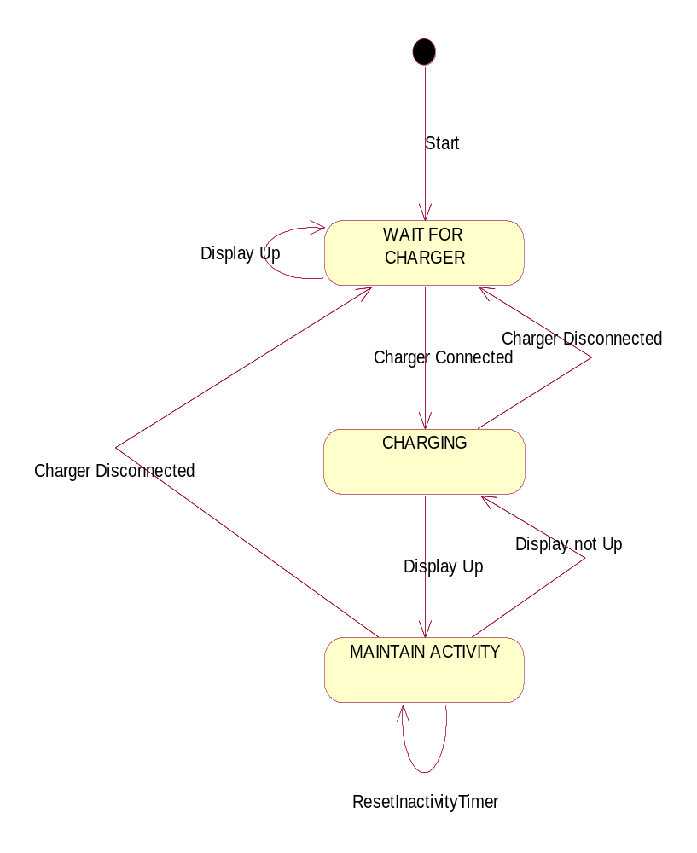
Figure 4.8 Charging context state chart

Operations
The following conventions have been used in this Section:
- Modifies: only most important modifications are shown.
- Related To: only most important classes are listed.

Starting Accessory Server

Operation | Start Accessory Server.
Preconditions | Accessory Server is not yet running.
Description | Starts Accessory Server.
Inputs
Modifies | Starts the server in own process and begins loading of ASYs.
Outputs
Postconditions | Accessory Server has been started and initialized  ASYComms subsession has been created  ASYs has been loaded.
Related To | CAccServer, CASYProxy, CAccSrvServerModel, CAccSrvConnectionController.
Related Event | Phone boot, Accessory Server is started during phone boot.
Exceptions

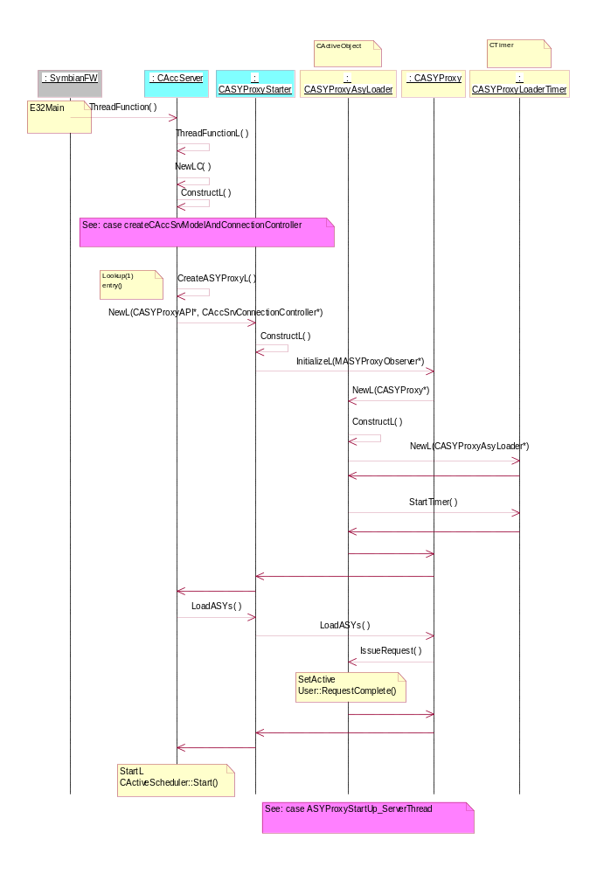
Figure 4.9 Accessory Server startup
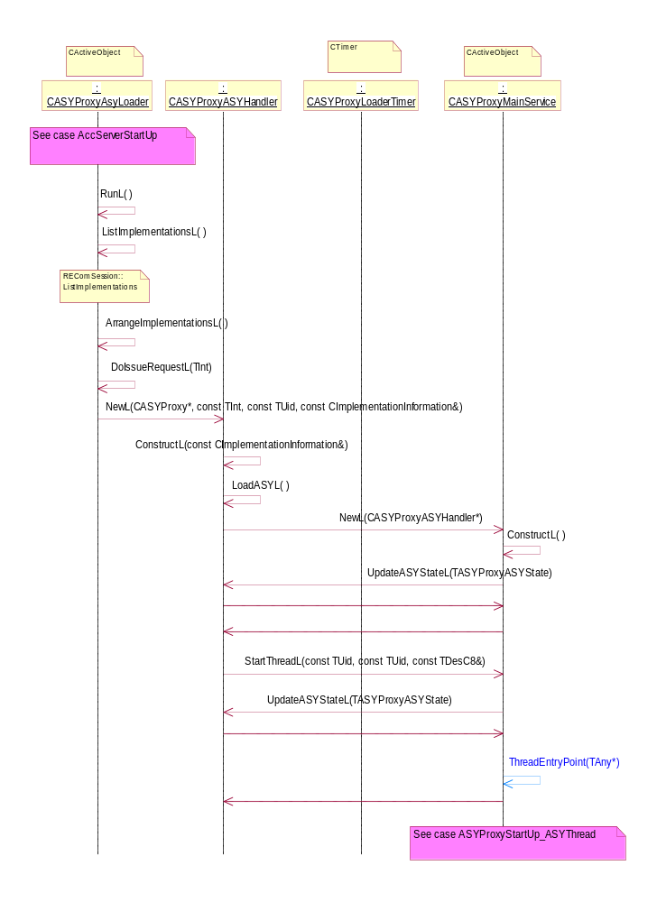
Figure 4.10 ASY Proxy startup in Server thread
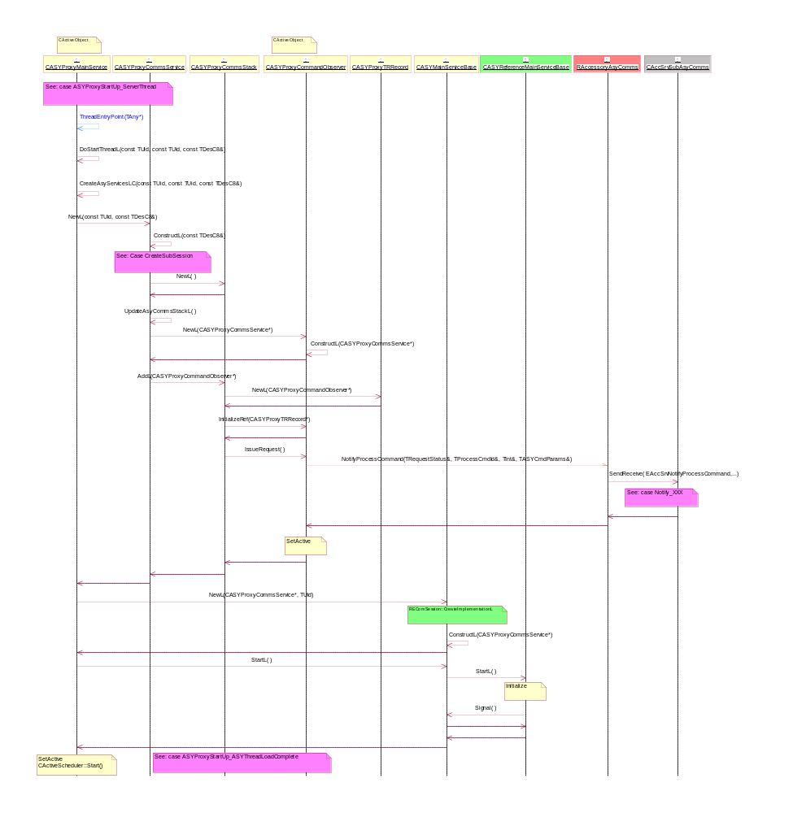
Figure 4.11 ASY Proxy startup in ASY thread
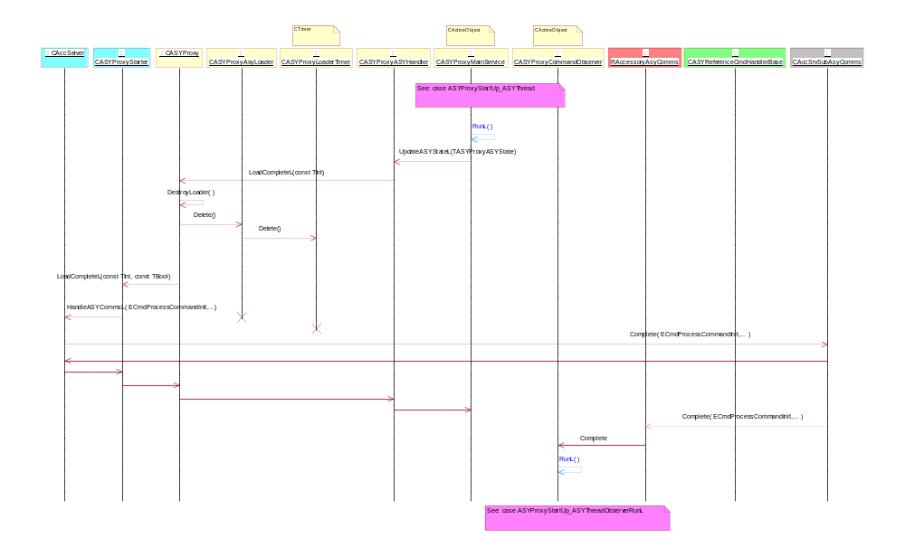
Figure 4.12 ASY Proxy startup in ASY thread, load complete
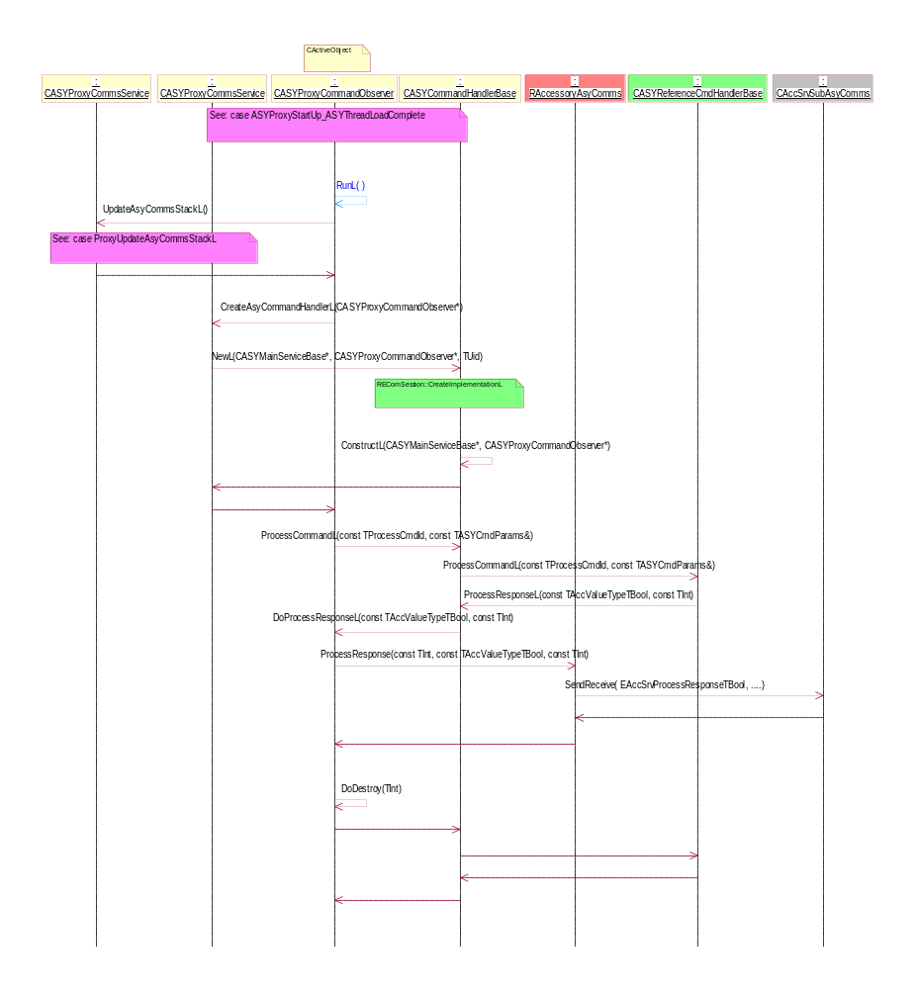
Figure 4.13 ASY Proxy startup in ASY thread, load complete – observer RunL

Create SubSession

Operation | EAccSrvCreateSubSessionAccessoryMode, EAccSrvCreateSubSessionAccessorySettings, EAccSrvCreateSubSessionAccessoryConnection, EAccSrvCreateSubSessionAccessoryControl, EAccSrvCreateSubSessionAccessorySingleConnection, EAccSrvCreateSubSessionAccessoryBTControl, EAccSrvCreateSubSessionAccessoryAudioControl, EAccSrvCreateSubSessionAccessoryAsyComms.
Preconditions | Accessory Server has been started. Connection to Accessory Server has been made.
Description | Creates a subsession to Accessory Server.
Inputs | RAccessory Server.
Modifies | CObjectIx, CObjectCon.
Outputs
Postconditions | Subsession to Accessory Server has been created.
Related To | Appropriate subsession inherited from CAccSrvSubBase.
Related Event | CreateSubSession of appropriate client.
Exceptions

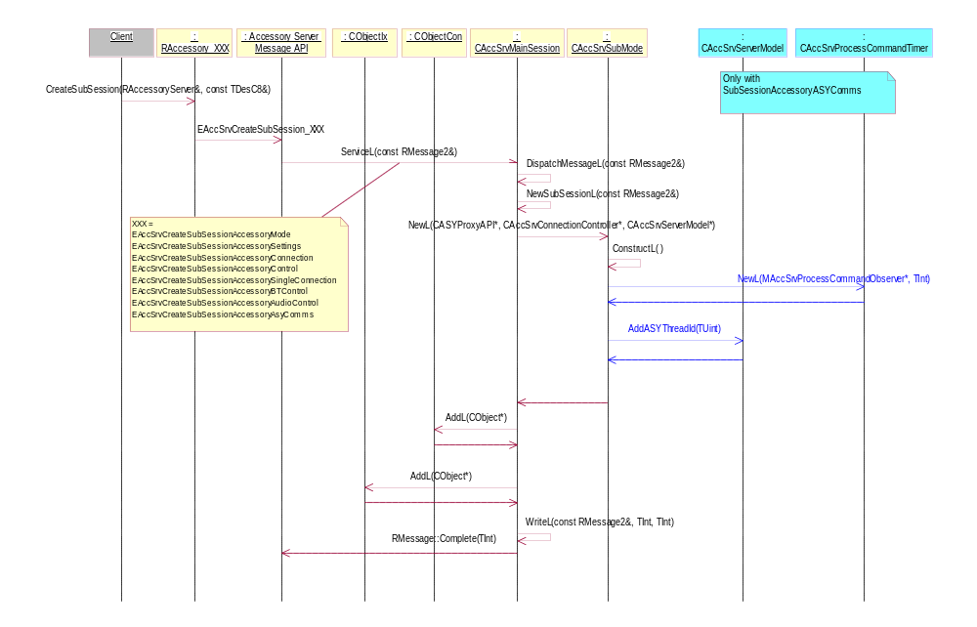
Figure 4.14 Create SubSession

Close SubSession

Operation | EAccSrvCloseSubSessionAccessoryMode, EAccSrvCloseSubSessionAccessorySettings, EAccSrvCloseSubSessionAccessoryConnection, EAccSrvCloseSubSessionAccessoryControl, EAccSrvCloseSubSessionAccessorySingleConnection, EAccSrvCloseSubSessionAccessoryBTControl, EAccSrvCloseSubSessionAccessoryAudioControl, EAccSrvCloseSubSessionAccessoryAsyComms.
Preconditions | SubSession has been created.
Description | Closes a subsession to Accessory Server.
Inputs
Modifies | CObjectIx, CObjectCon.
Outputs
Postconditions | Subsession to Accessory Server has been closed.
Related To | Appropriate subsession inherited from CAccSrvSubBase.
Related Event | CloseSubSession of appropriate client.
Exceptions

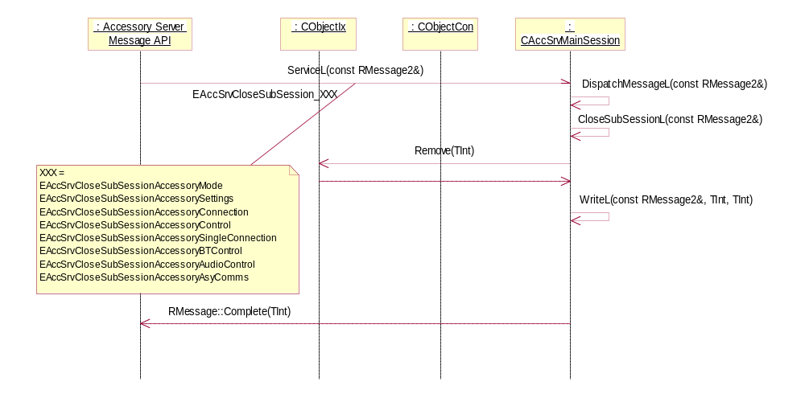
Figure 4.15 Close SubSession

Connect accessory

Operation | EAccSrvConnectAccessory.
Preconditions | RAccessoryControlSubSession has been created.
Description | Connects Accessory to Accessory Server.
Inputs | TAccPolGenericID.
Modifies | CAccSrvServerModel.
Outputs | - Query critical values from ASY (ProcessCommandL)  - New Accessory connected notification (NotifyNewAccessoryConnected)  - Connection status changed notification (NotifyAccessoryConnectionStatusChanged)  - Accessory mode changed notification (NotifyAccessoryModeChanged).
Postconditions | Accessory has been connected to Accessory Server.
Related To | CAccSrvConnectionHandler.
Related Event | RAccessoryControl::ConnectAccessory.
Exceptions | If an unidentified accessory is connected, “Unsupported Accessory Connected” -notification is shown.

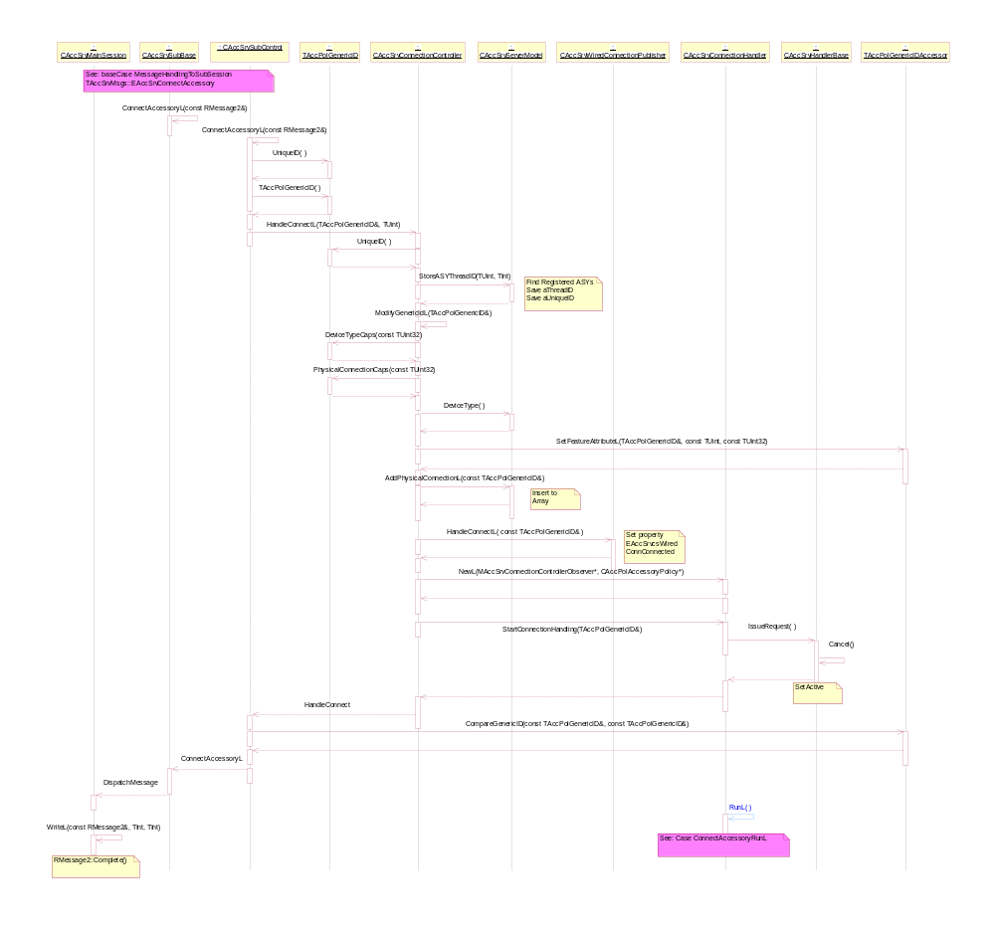
Figure 4.16 Connect accessory
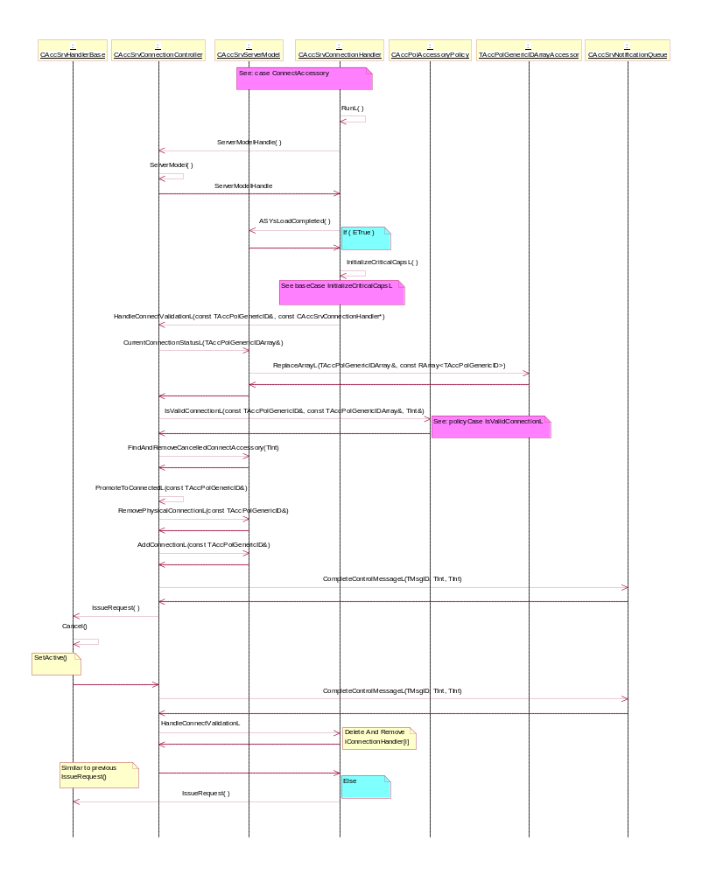
Figure 4.17 Connect accessory – RunL: Update connection status and Accessorymode asynchronously

Disconnect accessory

Operation | EAccSrvDisconnectAccessory.
Preconditions | Accessory has been connected to Accessory Server.
Description | Disconnects Accessory from Accessory Server.
Inputs | TAccPolGenericID.
Modifies | CAccSrvServerModel.
Outputs | - Accessory disconnected notification (NotifyAccessoryDisconnected)  - Connection status changed notification (NotifyAccessoryConnectionStatusChanged)  - Accessory mode changed notification (NotifyAccessoryModeChanged).
Postconditions | Accessory has been disconnected from Accessory Server.
Related To | CAccSrvConnectionHandler.
Related Event | RAccessoryControl::DisconnectAccessory.
Exceptions

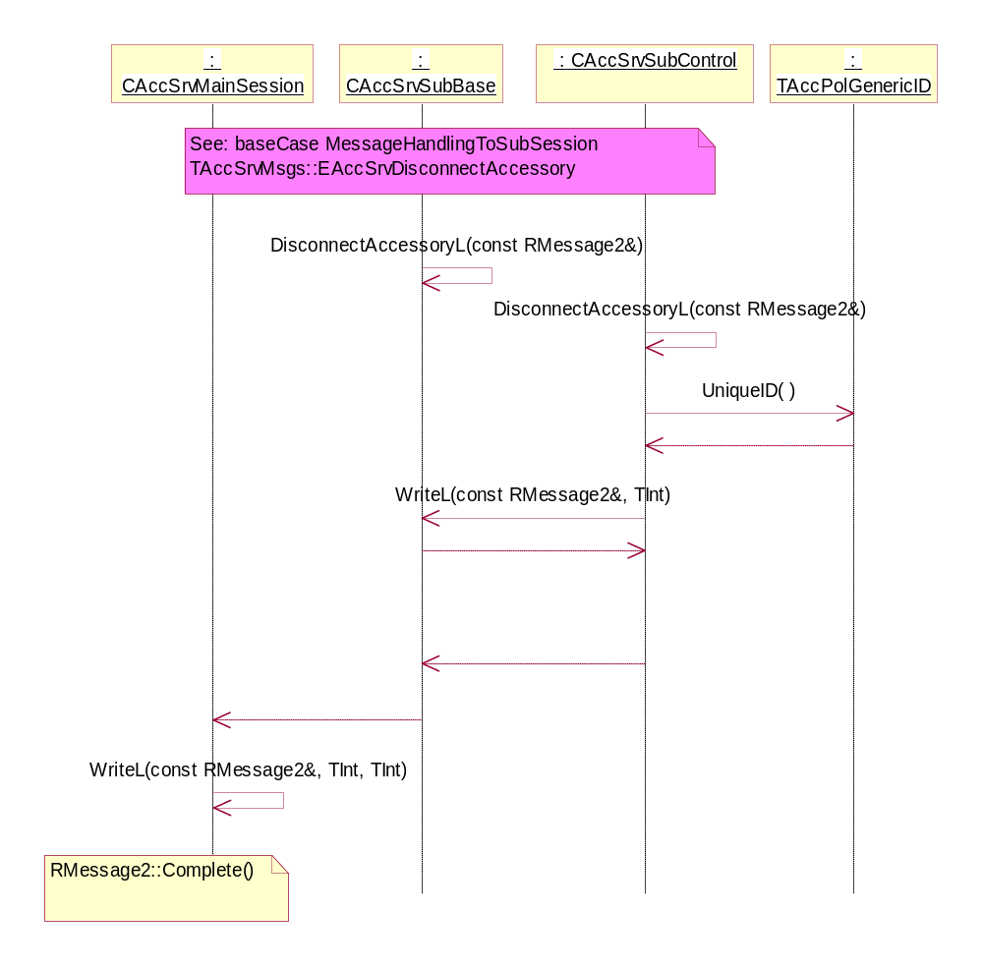
Figure 4.18 Disconnect accessory

Synchronous getters

Operation | EAccSrvGetAccessoryMode, EAccSrvGetAccessoryModeSetting, EaccSrvGetAccessoryModeSettings, EaccSrvGetAccessoryConnectionStatus.
Preconditions | Appropriate subsession has been created.
Description | Request accessory information synchronously.
Inputs | TAccMode, TAccModeSetting, TAccModeSettingArray, TAccPolGenericIDArray.
Modifies | CAccSrvServerModel.
Outputs | Returns accessory information requested.
Postconditions
Related To
Related Event | RAccessoryMode::GetAccessoryMode, RAccessorySettings::GetAccessoryModeSetting, RAccessorySettings::GetAccessoryModeSettings, RAccessoryConnection::GetAccessoryConnectionStatus.
Exceptions | Returns an error code if the accessory specified query was for an accessory that is not connected.

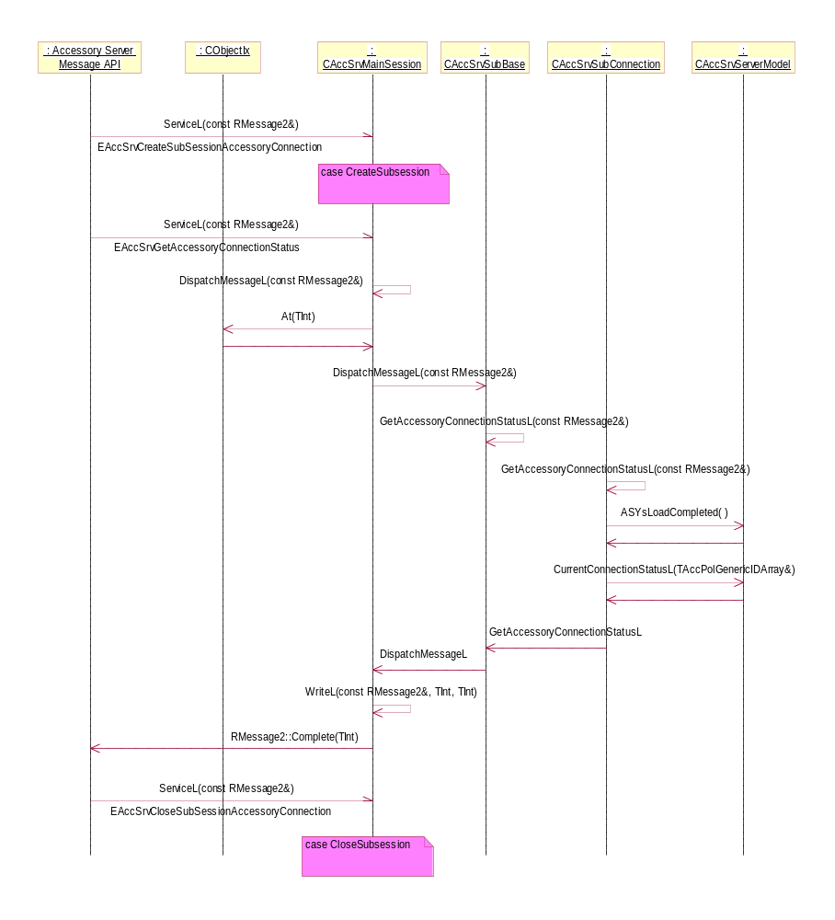
Figure 4.19 GetAccessoryConnectionStatus

Asynchronous getters

Operation | EAccSrvGetAccessoryModeAsync, EaccSrvGetAccessoryConnectionStatusAsync.
Preconditions | Appropriate subsession has been created.
Description | Request accessory information asynchronously.
Inputs | TAccMode, TAccPolGenericIDArray.
Modifies | CAccSrvServerModel.
Outputs | Returns accessory information requested.
Postconditions
Related To
Related Event | RAccessoryMode::GetAccessoryMode, RAccessoryConnection::GetAccessoryConnectionStatus.
Exceptions | Asynchronous request completes synchronously if ASYs has been already loaded.

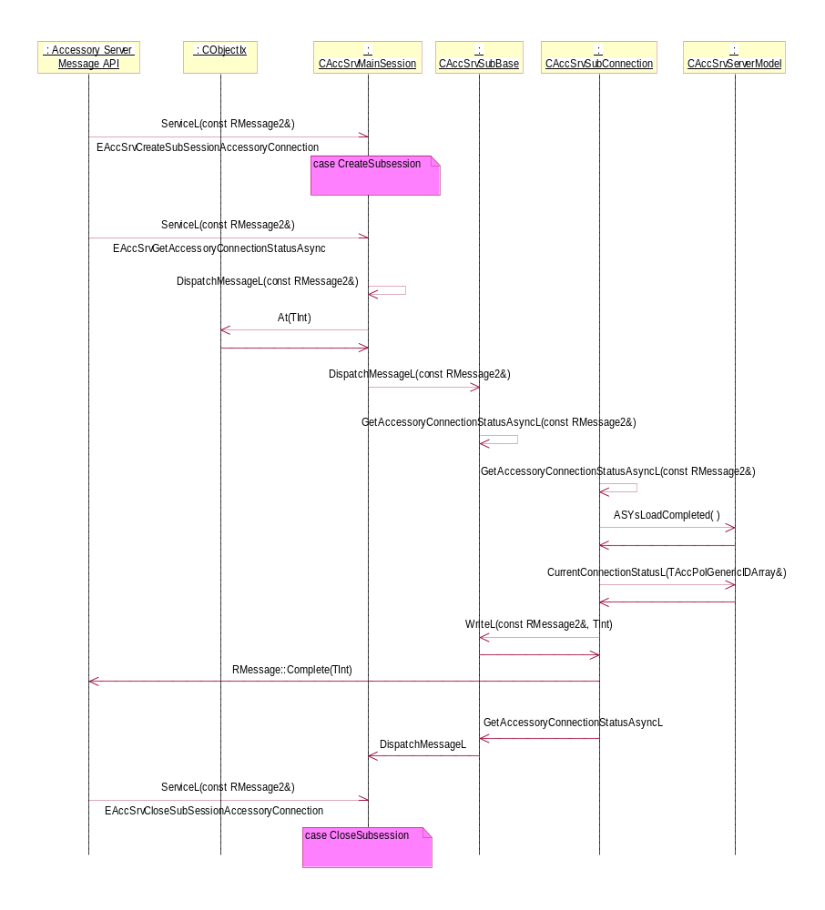
Figure 4.20 GetAccessoryModeAsync

Notifications

Operation | EAccSrvNotifyNewAccessoryConnected, EAccSrvNotifyAccessoryDisconnected, EAccSrvNotifyAccessoryValueChangedTBool, EAccSrvNotifyAccessoryValueChangedTInt, EAccSrvNotifyAccessoryConnectionStatusChanged, EAccSrvNotifyAccessoryModeChanged, EAccSrvNotifyProcessCommand.
Preconditions | Appropriate subsession exists.  EAccSrvNotifyAccessoryDisconnected: Accessory must be connected.  EaccSrvNotifyAccessoryValueChangedTInt, EaccSrvNotifyAccessoryValueChangedTBool: Accessory must be connected.  Accessory must have a capability whose value change notification is ordered.
Description | Notifications are asynchronous requests which are completed when appropriate event occurs.
Inputs | TAccPolGenericID, TAccPolNameRecord, TAccPolGenericIDArray, TAccPolAccessoryMode, TProcessCmdId, Tint, TASYCmdParams.
Modifies | CAccSrvNotificationQueue.
Outputs | TAccPolGenericID, TAccPolGenericIDArray, TAccPolAccessoryMode, TProcessCmdId, Tint, TASYCmdParams.  Accessory value changed notification (NotifyAccessoryValueChanged).
Postconditions | Current notification request has been completed. If further notification is required, the notification request must be renewed.
Related To
Related Event | RAccessorySingleConnection::NotifyNewAccessoryConnected, RAccessorySingleConnection::NotifyAccessoryDisconnected, RAccessorySingleConnection::NotifyAccessoryValueChanged, EAccSrvNotifyAccessoryConnectionStatusChanged, RAccessoryMode::NotifyAccessoryModeChanged, RAccessoryAsyComms::NotifyProcessCommand.
Exceptions | Returns an error code if the accessory specified query was for accessory that is not connected.

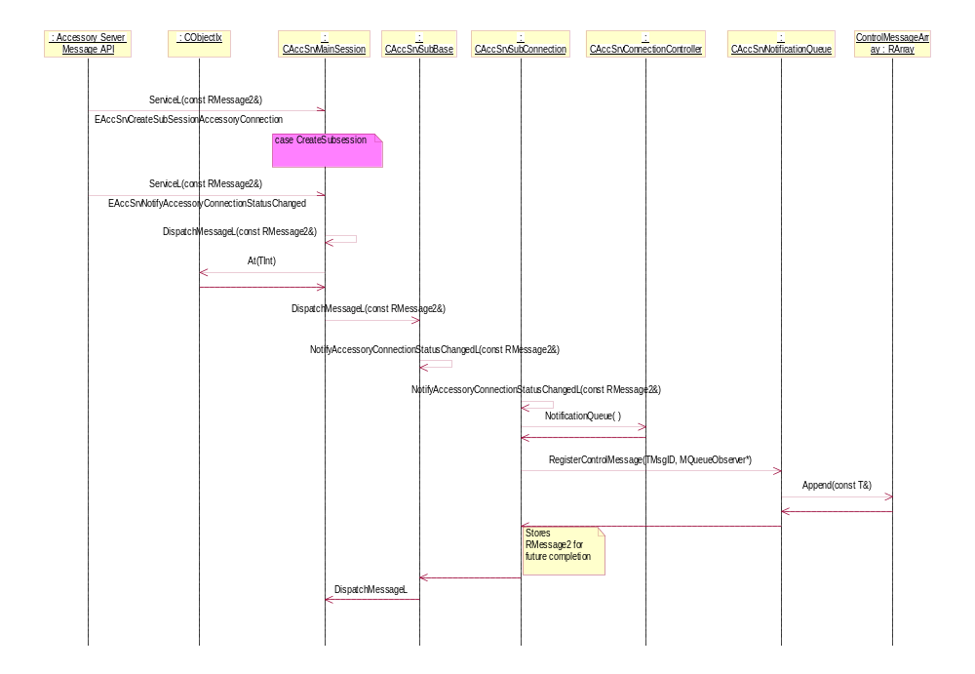
Figure 4.21 NotifyAccessoryConnectionStatusChanged

Get capability values

Operation | EAccSrvGetValueTBool, EAccSrvGetValueTInt, EAccSrvGetValueTDes8.
Preconditions | Appropriate subsession exists  Accessory must be connected.  Accessory must have a capability whose value is requested.
Description | Query a capability value of accessory.
Inputs | TAccPolGenericID, TAccPolNameRecord.
Modifies | TAccValueTypeTBool, TAccValueTypeTInt, TDes8.
Outputs | Capability value of accessory.
Postconditions | If the value of capability is KErrUnknown (-19) and the location of the value is accessory (EAPVAccessory) then the value is queried from ASY. Otherwise value is retrieved from AccessoryPolicy.
Related To
Related Event | RAccessoryConnectionBase::GetValueL.
Exceptions | Returns an error code if the accessory specified query was for accessory that is not connected.

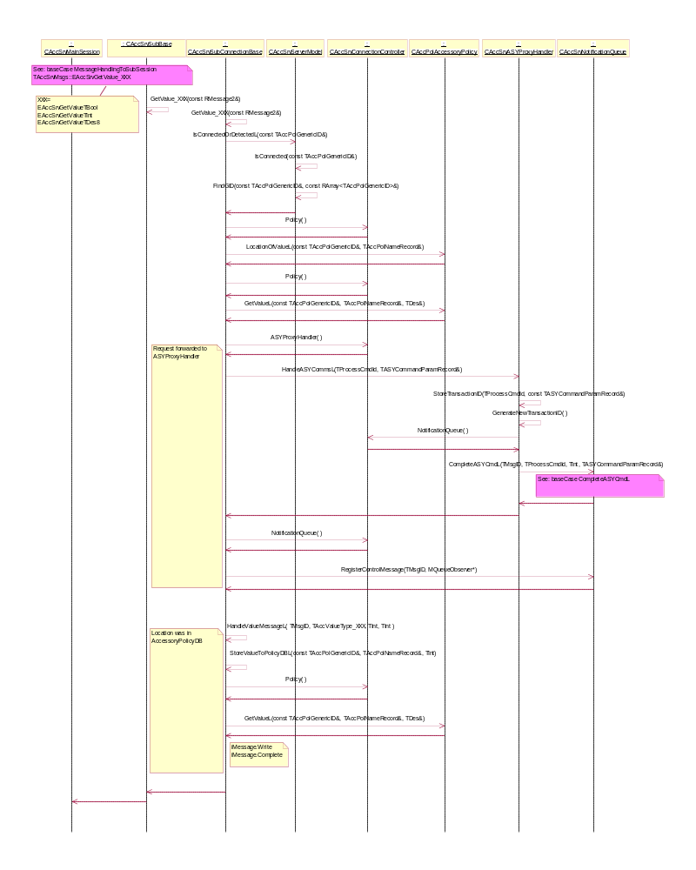
Figure 4.22 Get capability value XXX

Set capability values

Operation | EAccSrvSetValueTBool, EAccSrvSetValueTInt.
Preconditions | Appropriate subsession exists  Accessory must be connected.  Accessory must have a capability whose value is to be set.
Description | Sets the capability value of accessory.
Inputs | TAccPolGenericID, TAccPolNameRecord, TAccValueTypeTBool, TAccValueTypeTInt.
Modifies | TAccValueTypeTBool, TAccValueTypeTInt.
Outputs
Postconditions | If the location of capability is accessory, then the setter request is forwarded to ASY, otherwise setter request is forwarded to AccessoryPolicy.
Related To
Related Event | RAccessoryControl::SetValueL.
Exceptions | Returns an error code if the accessory specified query was for an accessory that is not connected.

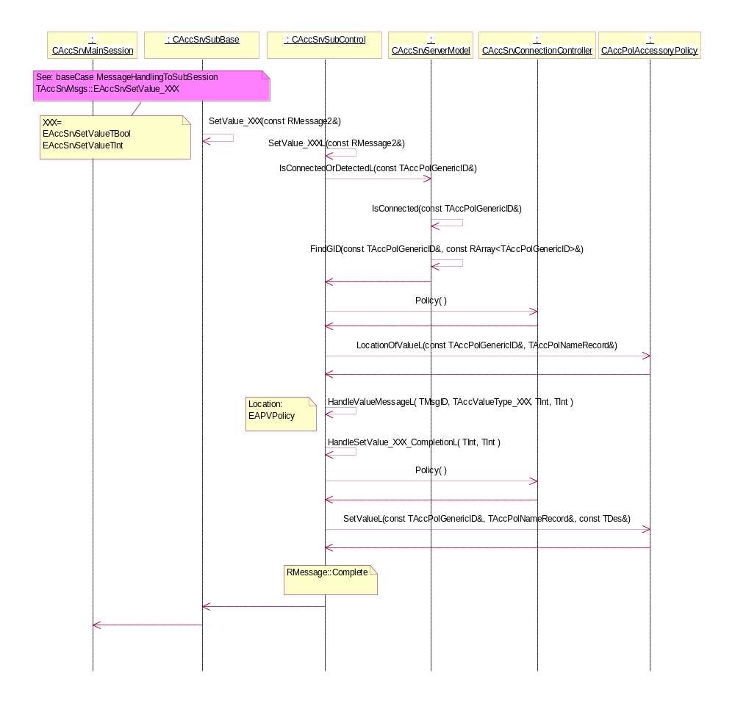
Figure 4.23 Set capability value XXX

GetSupportedHWDevices

Operation | EAccSrvGetSupportedHWDevices.
Preconditions | Appropriate subsession exists.  Supported devices are configured to connection rules of AccessoryPolicy.  The following feature flags are used: TTY (KFeatureIdPhoneTty) and TvOut (KFeatureIdTvOut).
Description | Returns HW devices that cannot be properly identified when they are connected to phone without additional information.
Inputs
Modifies | CAccSrvServerModel.
Outputs | List of supported devices.
Postconditions
Related To
Related Event | RAccessorySettings::GetSupportedHWDeviceSettings.
Exceptions

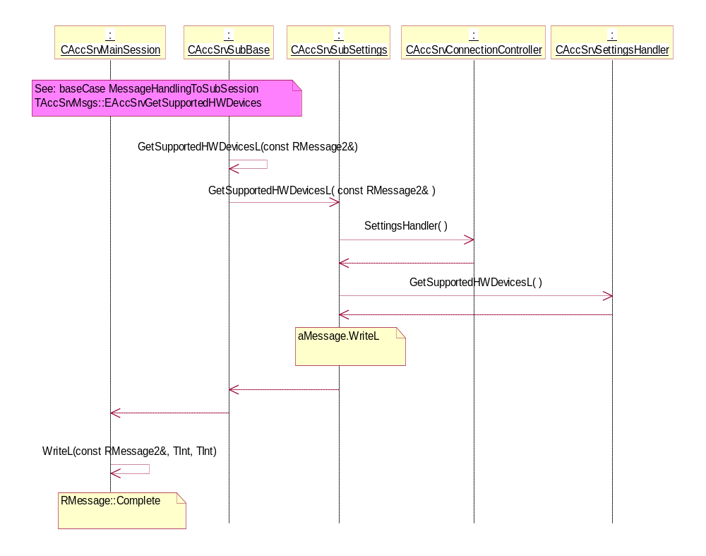
Figure 4.24 GetSupportedHWDevices

GetHWDeviceSettings

Operation | EAccSrvGetHWDeviceSettings.
Preconditions | Appropriate subsession exists.
Description | Returns current HW devices.
Inputs | TUint32.
Modifies
Outputs | Current HW device setting.
Postconditions
Related To
Related Event | RAccessorySettings::GetHWDeviceSettings.
Exceptions

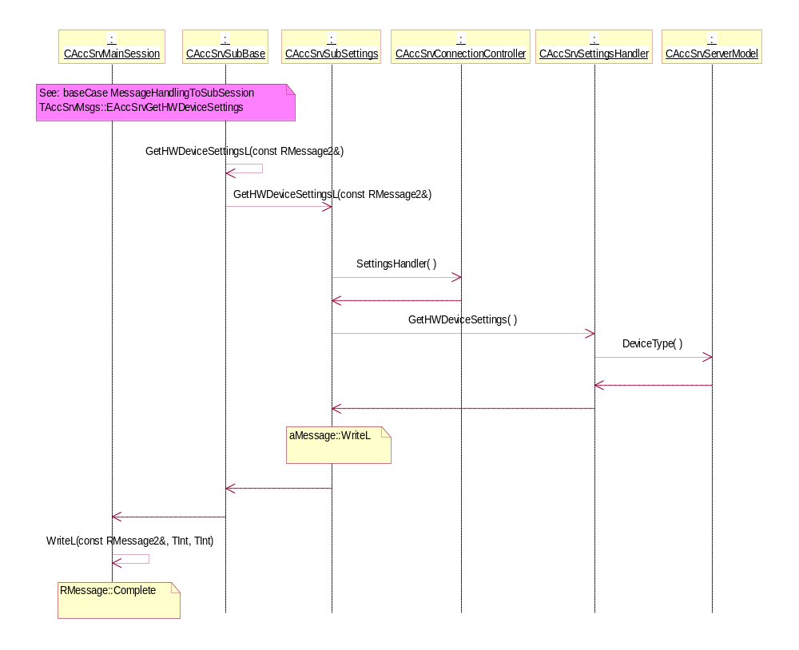
Figure 4.25 GetHWDeviceSettings

SetHWDeviceSettings

Operation | EAccSrvSetHWDeviceSettings.
Preconditions | Appropriate subsession exists.
Description | Sets current HW devices.
Inputs | HW Device to be set.
Modifies | KAccServerHWDevices is updated.
Outputs
Postconditions | KAccServerHWDevices has been updated.
Related To
Related Event | RAccessorySettings::SetHWDeviceSettingsL.
Exceptions

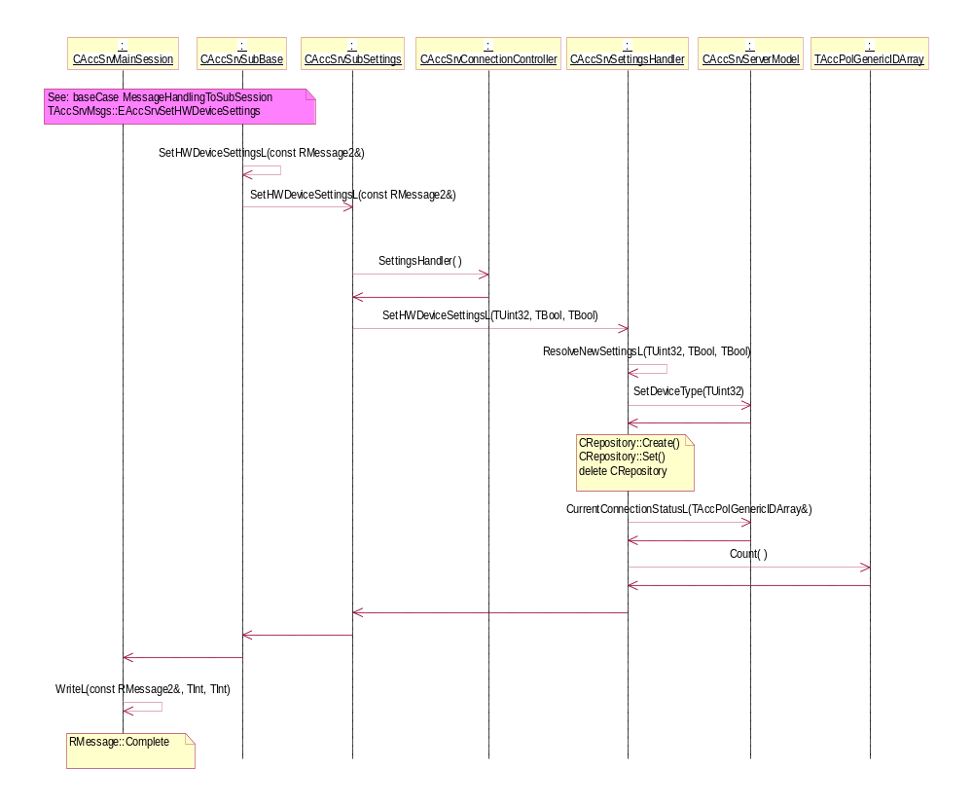
Figure 4.26 SetHWDeviceSettings

ProcessResponse

Operation | EAccSrvProcessResponseTBool, EAccSrvProcessResponseTInt, EAccSrvProcessResponseTDes.
Preconditions | Appropriate subsession exists  ProcessCommandRequest has been made.
Description | Response for NotifyProcessCommand made before.
Inputs | Tint, TAccValueTypeTBool, TAccValueTypeTInt, TASYBTAccInfo.
Modifies
Outputs | Server continues processing the original process command.
Postconditions
Related To | CAccSrvConnectionController, CAccSrvNotificationQueue.
Related Event | RAccessoryAsyComms::ProcessResponse.
Exceptions | Possible error code is given as a parameter.

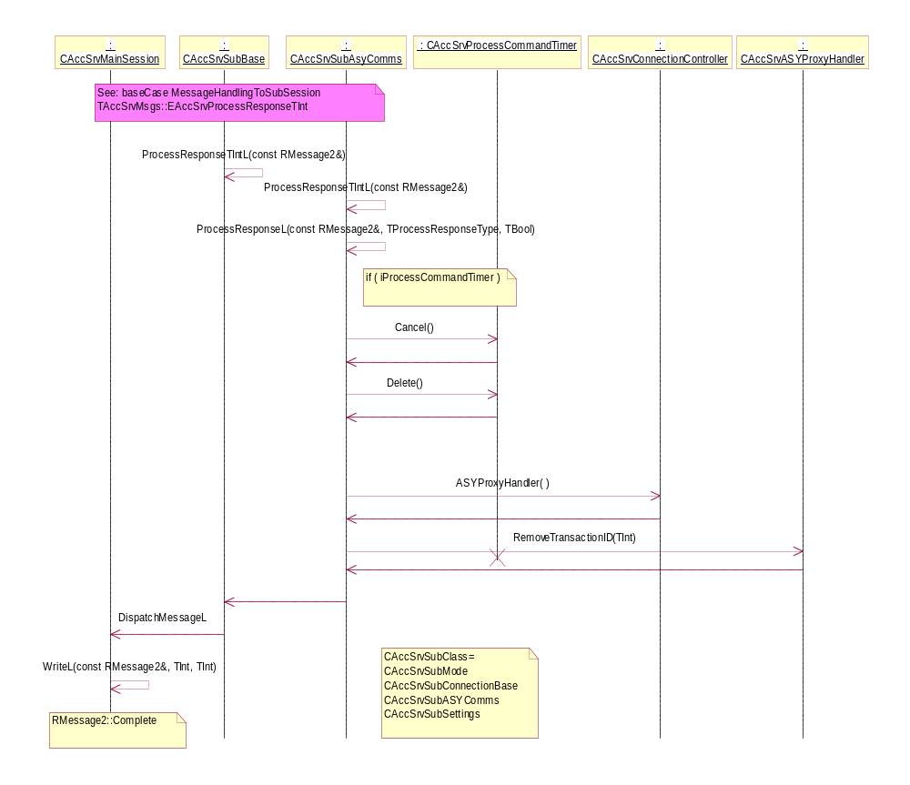
Figure 4.27 ProcessResponse

AccessoryValueChangedNotifications

Operation | EAccSrvAccessoryValueChangedTBoolNotify, EAccSrvAccessoryValueChangedTIntNotify.
Preconditions | Appropriate subsession exists. Accessory must be connected.
Description | Notification of some capability value changes.
Inputs | TAccPolGenericID, TAccPolNameRecord, TAccValueTypeTBool / TAccValueTypeTInt.
Modifies | CAccSrvNotificationQueue.
Outputs | RAccessorySingleConnection::NotifyAccessoryValueChanged.
Postconditions
Related To | CAccSrvServerModel.
Related Event | RAccessoryControl::AccessoryValueChangedNotifyL.
Exceptions | Returns error code if the accessory specified is not connected.

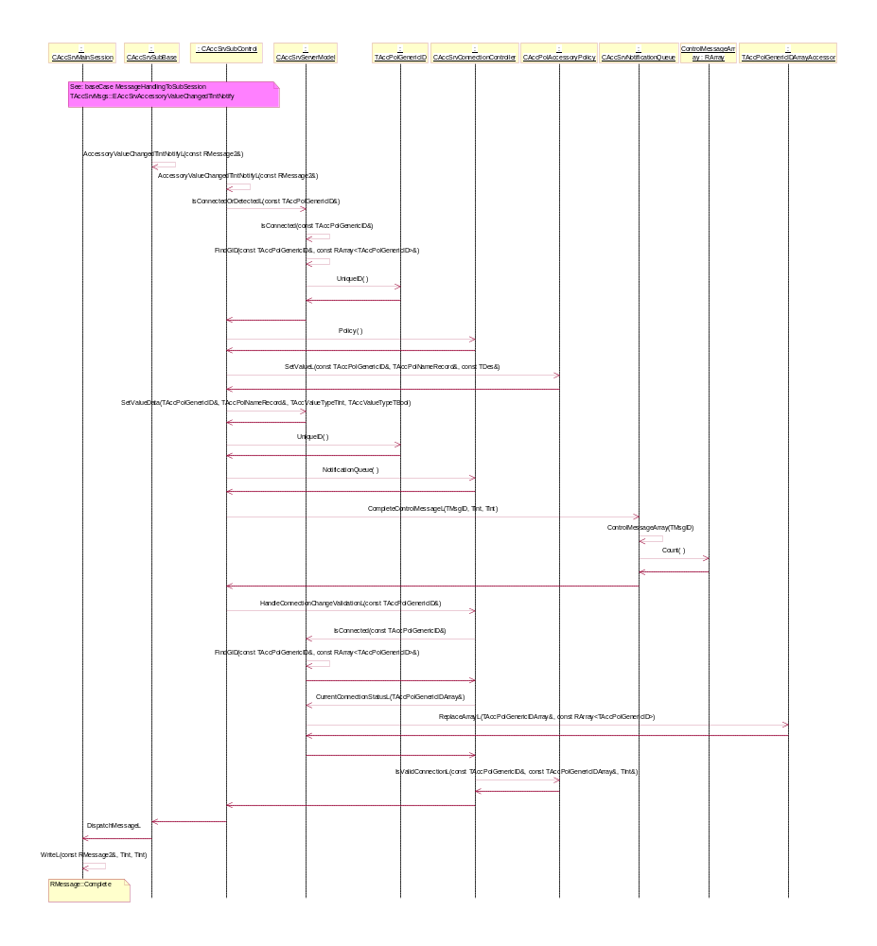
Figure 4.28 AccessoryValueChangedNotification

SetAccessoryModeSetting

Operation | EAccSrvSetAccessoryModeSetting, EAccSrvSetAccessoryModeSettings.
Preconditions | Appropriate subsession exists.
Description | Set accessory mode specific setting.
Inputs | TAccMode, TAccModeSetting, TAccModeSettingArray.
Modifies | KAccServerWiredHSLights, KAccServerWirelessHSLights, KAccServerWiredCarKitLights, KAccServerWirelessCarKitLights, KAccServerTextDeviceLights, KAccServerLoopsetLights, KAccServerMusicStandLights, KAccServerSyncStandLights, or a user defined setting.
Outputs
Postconditions | Setting is stored to Central Repository.
Related To
Related Event | RAccessorySettings::SetAccessoryModeSettingL, RAccessorySettings::SetAccessoryModeSettingsL.
Exceptions

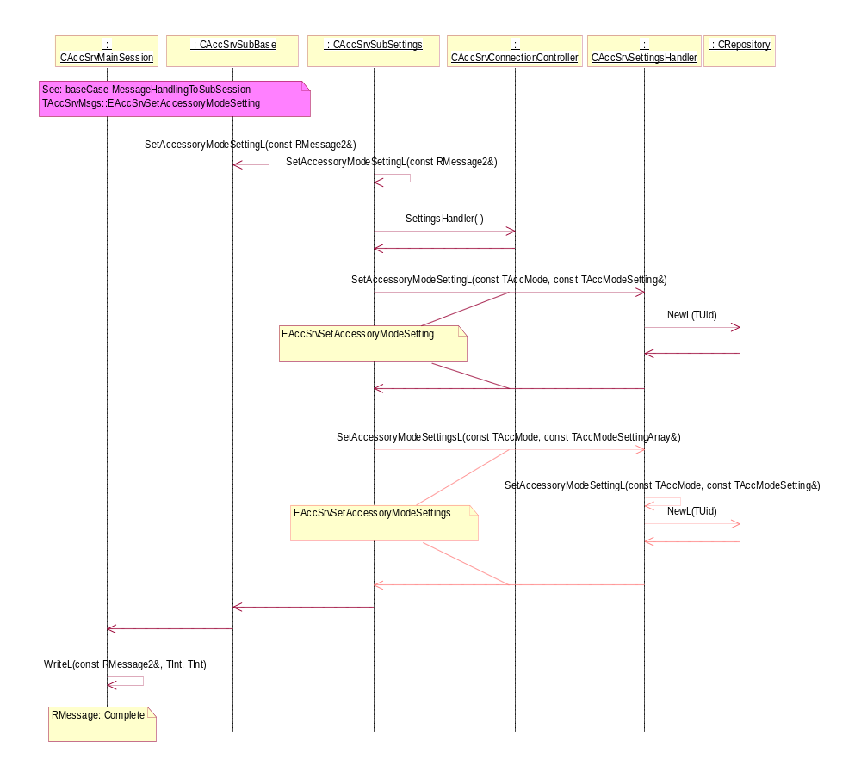
Figure 4.29 SetAccessoryModeSetting

GetAccessoryModeSetting

Operation | EAccSrvGetAccessoryModeSetting, EAccSrvGetAccessoryModeSettings.
Preconditions | Appropriate subsession exists.
Description | Get accessory mode specific setting.
Inputs | TAccMode, TAccModeSetting, TAccModeSettingArray.
Modifies | TAccModeSetting, TAccModeSettingArray.
Outputs | Return setting value for the specified AccessoryMode.
Postconditions
Related To
Related Event | RAccessorySettings::GetAccessoryModeSetting, RAccessorySettings::GetAccessoryModeSettings.
Exceptions

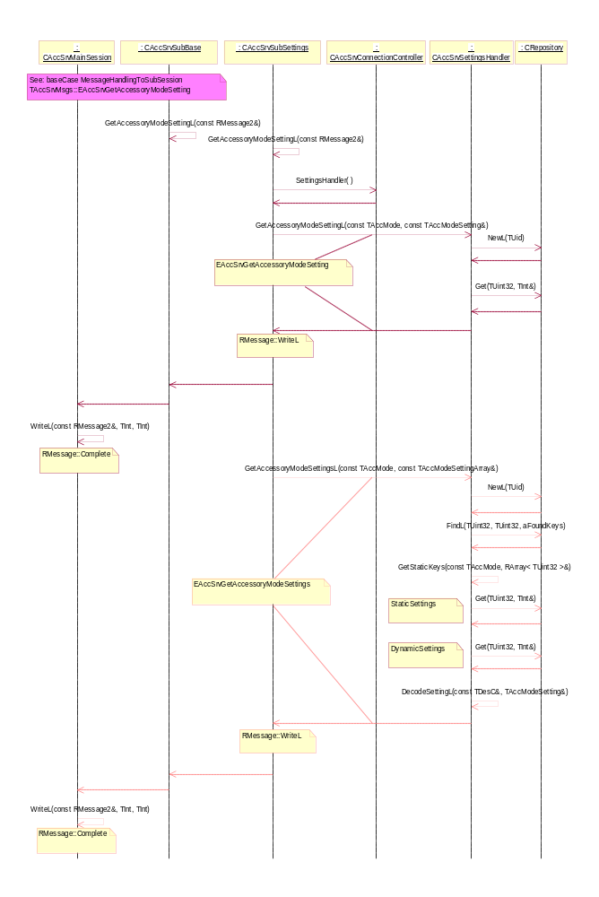
Figure 4.30 GetAccessoryModeSetting

BT: NotifyAccessoryAudioLinkOpened

Operation | EAccSrvNotifyAccessoryAudioLinkOpened.
Preconditions | Accessory must be connected.
Description | Orders the notification of audio link opened, for example, audio transfer from IHF to BT accessory.
Inputs | TAccPolGenericID, TAccAudioType.
Modifies | CAccSrvServerModel, CAccSrvNotificationQueue.
Outputs
Postconditions | Notification order is stored to notification queue.
Related To | AccessoryAudioLinkOpen.
Related Event | RAccessoryAudioControl::NotifyAccessoryAudioLinkOpened.
Exceptions | NotifyAccessoryAudioLinkOpened is not completed to the thread that has received the audio link open request.

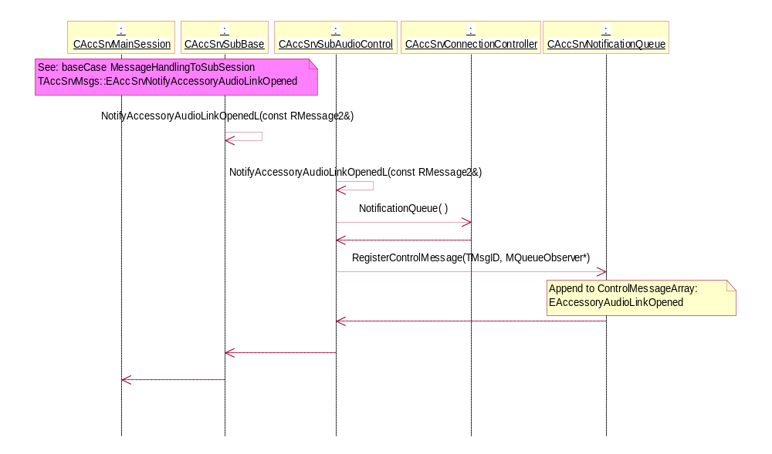
Figure 4.31 NotifyAccessoryAudioLinkOpened

BT: NotifyBluetoothAudioLinkOpenReq

Operation | EAccSrvNotifyBluetoothAudioLinkOpenReq.
Preconditions | Accessory must be connected.
Description | Order notification of Bluetooth audio link open request.
Inputs | TBTDevAddr, TAccAudioType.
Modifies | CAccSrvServerModel, CAccSrvNotificationQueue.
Outputs
Postconditions | Notification order is stored to notification queue.
Related To | AccessoryAudioLinkOpen.
Related Event | RAccessoryBTControl::NotifyBluetoothAudioLinkOpenReq.
Exceptions

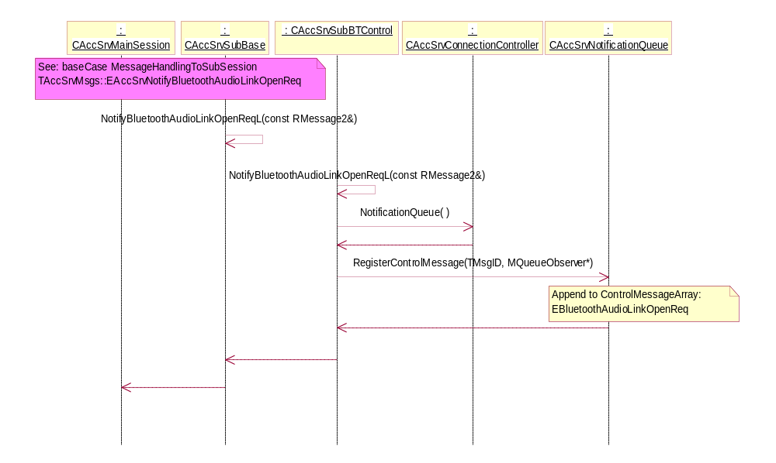
Figure 4.32 NotifyBluetoothAudioLinkOpenReq

BT: AccessoryAudioLinkOpen

Operation | EAccSrvAccessoryAudioLinkOpen.
Preconditions | Accessory must be connected.
Description | Opens the accessory audio link.
Inputs | TAccPolGenericID, TAccAudioType.
Modifies | CAccSrvServerModel, CAccSrvNotificationQueue.
Outputs | Type of audio link and remote BT accessory is in question.
Postconditions | NotifyBluetoothAudioLinkOpenReq has been completed.
Related To
Related Event | RAccessoryAudioControl::AccessoryAudioLinkOpen.
Exceptions | Returns an error code if the accessory specified is not connected.

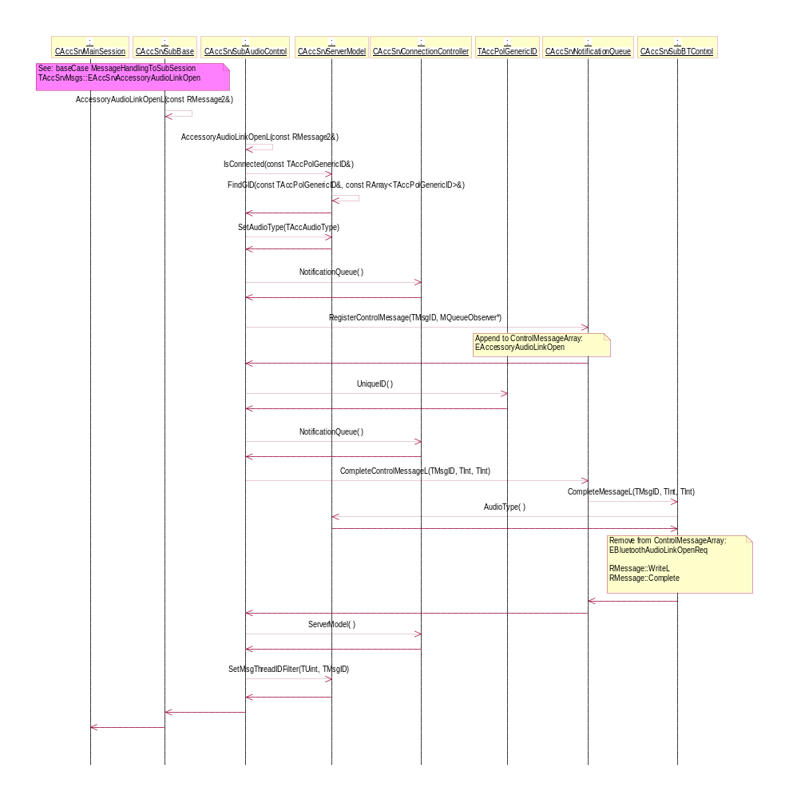
Figure 4.33 AccessoryAudioLinkOpen

BT: BluetoothAudioLinkOpenedNotify

Operation | EAccSrvBluetoothAudioLinkOpenedNotify.
Preconditions | Accessory must be connected.
Description | Response for AudioLinkOpenRequest or audio link open request from remote BT accessory i.e. Audio transfer from IHF to remote BT accessory.
Inputs | TBTDevAddr, TAccAudioType.
Modifies | CAccSrvServerModel, CAccSrvNotificationQueue.
Outputs | Type of audio link and remote BT accessory is in question.
Postconditions | NotifyAccessoryAudiLinkOpened notification is completed in audio transfer case.
Related To | AccessoryAudioLinkOpen.
Related Event | RAccessoryBTControl::BluetoothAudioLinkOpenedNotifyL.
Exceptions | Returns error code if the accessory specified is not connected.

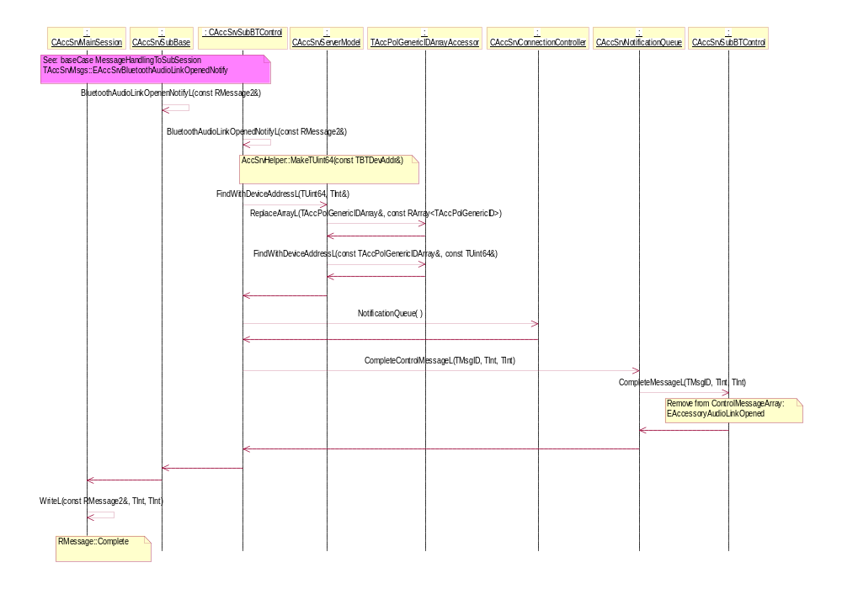
Figure 4.34 BluetoothAudioLinkOpenedNotify

BT: BluetoothAudioLinkOpenResp

Operation | EAccSrvBluetoothAudioLinkOpenResp.
Preconditions | Accessory must be connected.
Description | Response to AudioLLinkOpenRequest.
Inputs | TBTDevAddr.
Modifies | CAccSrvServerModel, CAccSrvNotificationQueue.
Outputs | Remote BT accessory.
Postconditions | AccessoryAudioLinkOpen request is completed.
Related To | AccessoryAudioLinkOpen.
Related Event | RAccessoryBTControl::BluetoothAudioLinkOpenRespL.
Exceptions | Returns error code if the accessory specified is not connected.

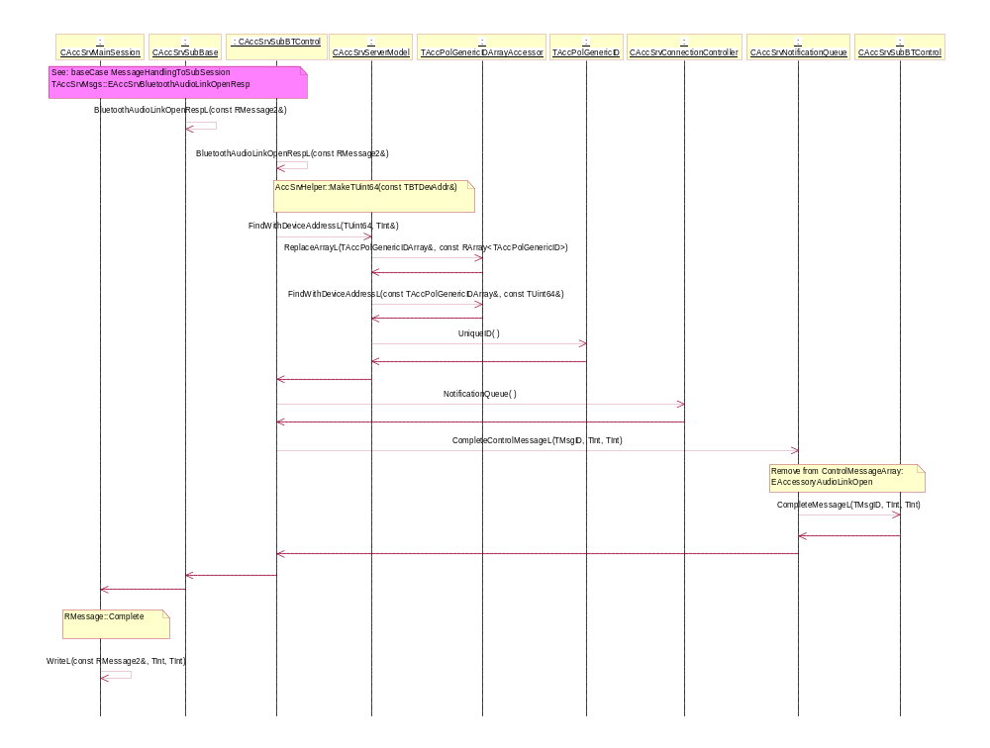
Figure 4.35 BluetoothAudioLinkOpenResp

Base case operations
Some repetitive sequences has been separated to own sequences, called base cases. Thus, some long main case sequences has been split to a shorter form, where the base case(s) is/are called inside the main cases. This is just a documentation technical practice.

Complete ASYCmdL
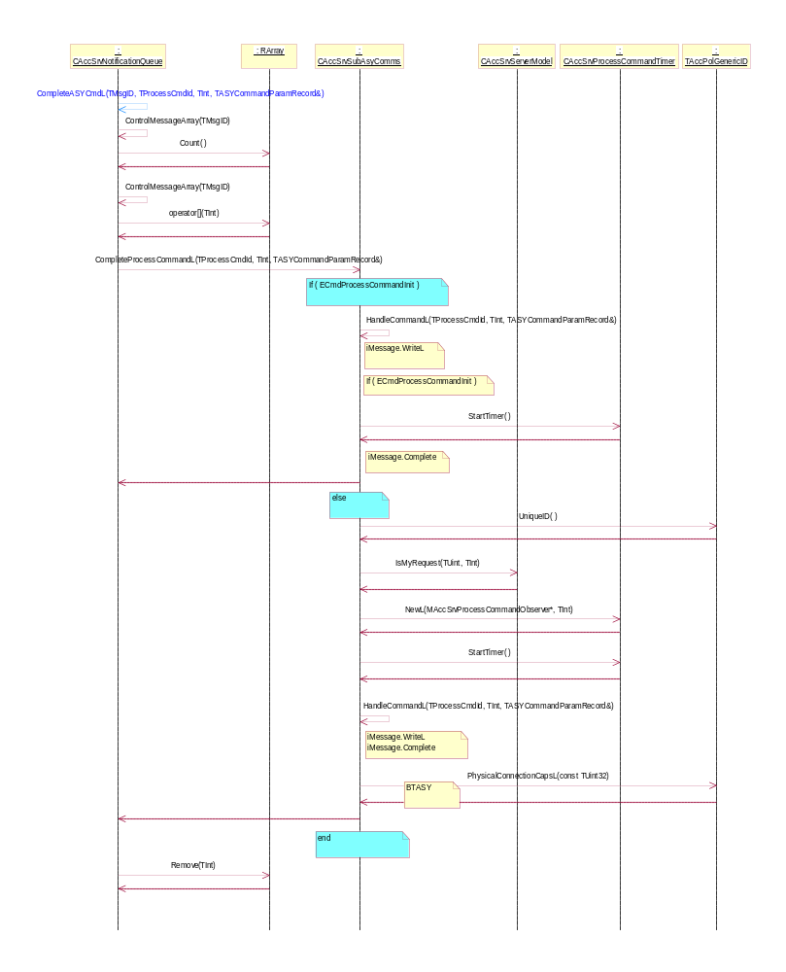
Figure 4.36 CompleteASYCmdL

CreateCAccSrvModelAndConnectionControl

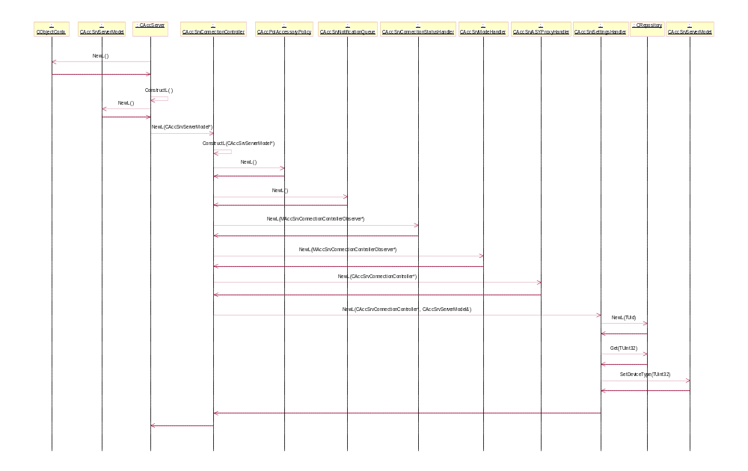
Figure 4.37 CreateCAccSrvModelAndConnectionControl

InitializeCriticalCapsL
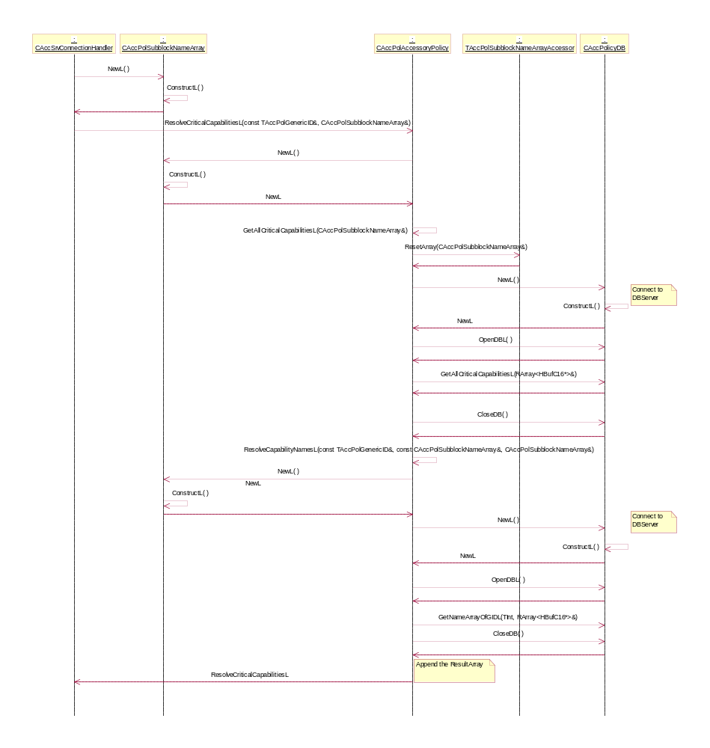
Figure 4.38 InitializeCriticalCapsL

MessageHandlingToSubSession
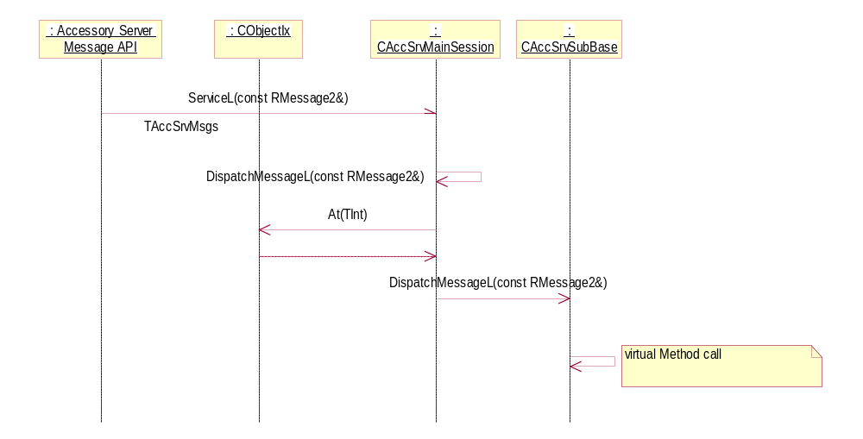
Figure 4.39 MessageHandlingToSubSession

ProxyUpdateAsyCommsStackL
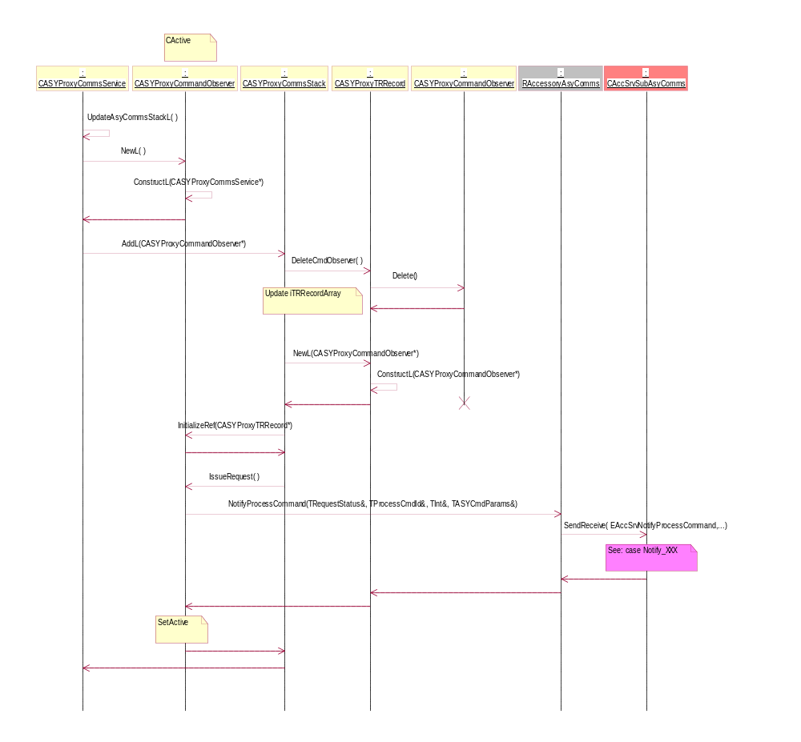
Figure 4.40 ProxyUpdateAsyCommsStackL

Charging Context

Creation of Charging Context
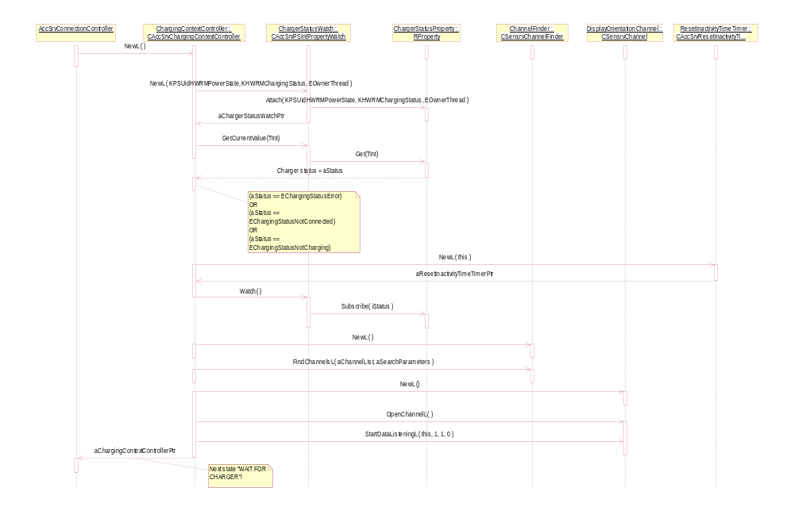 Figure 4.41 Creation of Charging Context

“Wait for Charger” state
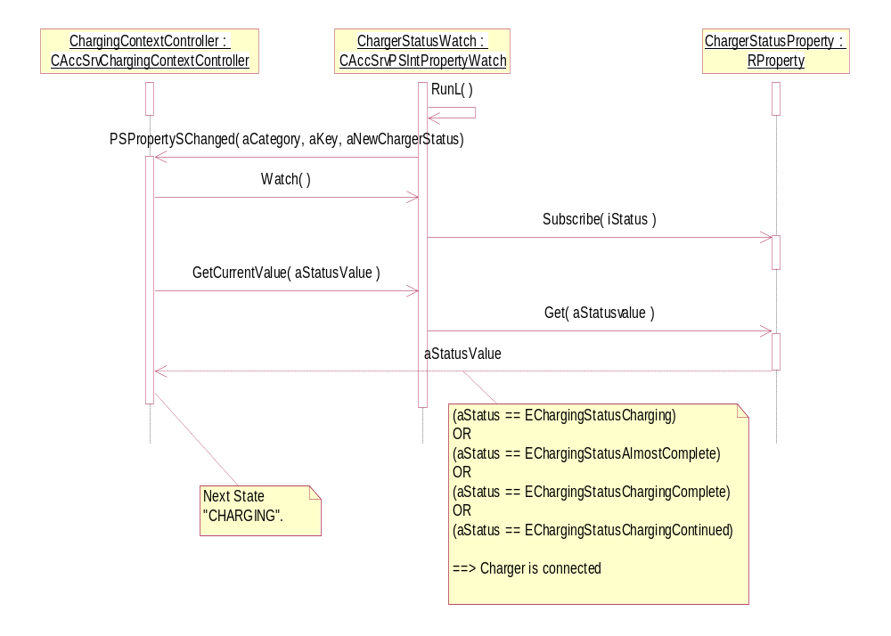
Figure 4.42 State “Wait for charger”.

“Charging” state
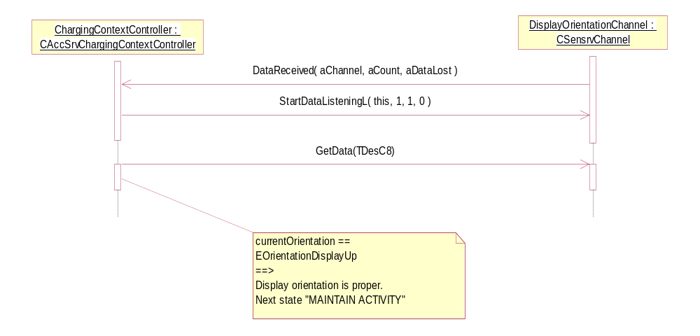
Figure 4.43 State “Charging”

“Maintain Activity” state
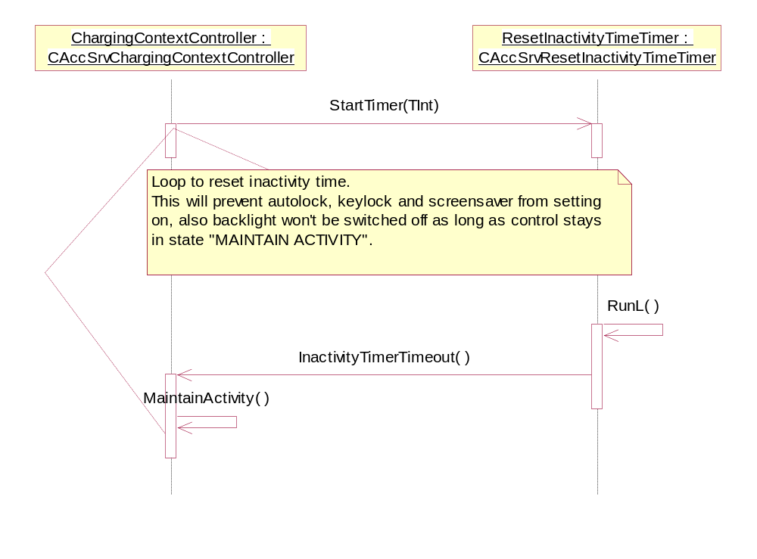
Figure 4.44 State “Maintain Activity”

Backup and Restore
This component does not participate in backup and restore.

Variation

Variable component/feature

__ACCESSORY_FW | When this flag is defined, components of Accessory Framework are included to compiling.

System resource usage

Files

File | hwdevices.ini
Type | Private read only
Location | ROM
Format | ASCII
Sharing | Not shared
Encryption | No
Size estimate | 1 byte
Clean up | Permanent
Description | Defines (with bitmask) accessories that require user setting before they can be identified.

File | 10205030.spd
Type | public read only
Location | ROM
Format | Binary
Sharing | Yes. For DBMS server.
Encryption | No
Size estimate | 41 bytes
Clean up
Description | Defines run-time security policy for Accessory DB.

File | 10205030.txt
Type | Private
Location | N/A
Format | ASCII
Sharing | N/A
Encryption | No
Size estimate | N/A
Clean up | N/A
Description | 10205030.spd file is generated based on this file (defines Accessory DB security policy).

Other data

Databases
Accessory Policy Database is used via AccessoryPolicy. Please see reference document [5] for more information.

Central Repository
This component uses Central Repository. See reference document [3] for details.

Publish and Subscribe
This component uses Publish and Subscribe. See reference document [3] for details.

Memory consumption
Accessory Client-Server consists of seven binaries: AccServer.exe, AccClient.dll, ASYProxy.dll, ASYComms.dll, AccControl.dll, AccAudioControl.dll and AccBTControl.dll. Their combined memory consumption is given in table below.

Memory/Build | Consumption
[User data area] | ~ 12 KB for files specified in Section 6.1
[WINSCW UDeb] | ~ 2650 KB
[ARMV5 URel] | ~ 40 KB

Task allocation
Accessory Server runs in its own process, which is started by the Starter component. Accessory Server creates n pcs ASYMainService threads, one thread for each founded ASY.

Performance
Startup during phone boot of Accessory Server is time critical process. Therefore loading of ASYs has made by using AO framework to allow continuous startup process for Accessory Server.

Timers

Timer | Purpose | Interval | Lifetime
ASY loading timer | Launch ASYLoad timeout for AccServer. | Const variable:  5000 milliseconds | Startup
Init ProcessCommand timer | Complete ProcessCommand init. | Const variable:  5000 milliseconds | Startup
ProcessCommand timer | Complete ProcessCommand. | Const variable:  2500 milliseconds | ProcessCommand / ProcessResponse
Timer for reset inactivity timer. | Launch User::ResetInactivityTime() | Const variable: 4800000 milliseconds | Whenever charger connected and orientation of display is “up”.

Security

Capabilities of this component
Accessory Server exe of this component have capability set of CAP_SERVER, CommDD, PowerMgmt, MultimediaDD, TrustedUI, DiskAdmin, NetworkControl, AllFiles.
AccessoryClient DLLs of this component have capability set of CAP_CLIENT_DLL.
ASYProxy DLL of this component have capability set of CAP_CLIENT_DLL.

Capability | Justification
CAP_SERVER | Default server capabilities are needed.
CAP_CLIENT_DLL | Default client capabilities are needed.
CommDD | ASYs can have a dependencies to communication device drivers.
PowerMgmt | Accessory server internal usage.
MultimediaDD | ASYs can have a dependencies to communication device drivers.
TrustedUI | Accessory server internal usage.
DiskAdmin | Accessory server internal usage.
NetworkControl | Accessory server internal usage.
AllFiles | Accessory server internal usage.

Input and output validation
Given malicious parameter for a Client API leads to a leave situation in client side or asynchronous message completion with error code.
GenericID is validated in Server side to check that the accessory of target operation is really connected.

Environmental assumptions
Accessory Server does not have environmental assumptions.

Exception handling
All exceptions related to misuse of Client API are propagated to clients to handle, if they occur during a client call. Also operations timeouts are propagated to clients.
If Accessory Server process panics or exits for any reason, system reboots. Accessory Server only panics when it encounters an unrecoverable error condition.
If any ASY thread managed by Accessory Server panics, thread itself kills or exits for any reason, Accessory Server is signaled about that.

Usage

Building
The following feature flag must be defined: __ACCESSORY_FW

#define __ACCESSORY_FW

- ReferenceAccessoryPolicy\Group
- bldmake bldfiles
- abld export

Note: In licensee product ReferenceAccessoryPolicy may need to be replaced with licensee specific policy. Please see reference document [5] for more information.

- Accessory Server\Group
- bldmake bldfiles
- abld build

Updating DB, please see reference document [6].

User's guide
Please see reference document [4] for detailed information.

