S60 3.x
Accessory Framework
Integration Guideline

Team name | Author
 | Juha Niemi

Change history:

Version | Date | Status | Comments
1.0 | 04.12.2006 | Approved

Table of contents:

1. Document control 4
1.1 References 4
1.2 Documentation conventions 4
1.3 Abbreviations 5
2. Accessory Framework overview 6
3. Integrating Accessory Framework: what is needed? 8
3.1 S60 platform 8
3.2 S60 Domestic OS server and Companion Modules 8
3.3 S60 Accessory Services subsystem 8
3.4 S60 Remote Control FW plug-ins subsystem (since S60 3.0) 8
3.5 S60 Bluetooth related subsystems 9
3.6 S60 Audio related subsystems 9
4. S60 Accessory Services subsystem overview 10
4.1 Accessory Server 10
4.2 Accessory Plug-ins 10
4.3 Generic ID PC tool 10
4.4 Accessory DB 10
4.5 S60 Remote Control FW Plug-ins subsystem 12
4.6 Related S60 subsystems in brief 13
4.6.1 S60 Local Connectivity subsystem 13
4.6.1.1 S60 PAN Applications subsystem in brief 13
4.6.1.2 S60 PAN Engines subsystem in brief 13
4.6.2 S60 Multimedia subsystem 14
4.6.2.1 S60 MMF subsystem in brief 14
4.6.2.2 S60 Audio Enhancement subsystem in brief 15
4.6.2.3 S60 DevSound Extensions subsystem in brief 15
Appendix: S60 Domestic OS server and Companion Modules overview 16

Document control

References
- S60 3.1 PAN Engines Subsystem Architecture Description
- S60 3.1 PAN Applications Subsystem Architecture Description
- S60 3.1 Audio Enhancements Subsystem Architecture Description
- S60 3.1 MMF Subsystem Architecture Description
- S60 3.1 DevSound Extensions Subsystem Architecture Description
- S60 Accessory Plug-in API Specification Document
- S60 GID PC Tool User’s Guide
- S60 Accessory Framework Design Document
- S60 Accessory API Specification Document
- S60 Accessory Key Event Handling API Specification Document
- S60 BT Audio Adaptation API Specification Document
- S60 3.0 Telephony Audio Routing Adaptation Guide
- S60 3.0 Audio Enhancements Adaptation Guide
- S60 DOS Server Plug-in Event API Specification Document
- S60 DOS Server Plugin API Specification
- S60 Common DSY Plug-in API Specification
- S60 DOS Server Client API Specification Document
- S60 MMF DevSound Server Design Document
- S60 Licensee DSY Implementation Guide
- S60 Accessory Policy Design Document
- Remote Control Design Document | A Symbian document.

Documentation conventions
Code is shown with the Courier New font.

Abbreviations
A2DP | Advanced Audio Distribution file
ACC FW | Accessory Framework
API | Application Programming Interface
BT | Bluetooth
HCI | Host Controller Interface
HFP | Hands free profile
HSP | Headset profile
OBEX | Object Exchange session protocol
SC/BC | Source code and binary compatibility
SCO | Synchronous connection oriented

Accessory Framework overview
This document is valid from S60 release 3.1 onwards.
Accessory Framework (ACC FW) provides APIs for platform clients to get information on accessory connection status as well as on the accessory device and service type. The APIs also provide accessory connection and disconnection handling in the Symbian OS side SW.
Adaptation APIs are provided for the addition of new Accessory Framework plug-in components, such as Accessory plug-ins (ASYs) for accessory related connection/disconnection handling as well as communication between a terminal and an accessory. New ACC FW plug-in components include Remote Control bearer plug-ins for wired and wireless key event handling.
The concept of Accessory Policy is introduced to identify a certain accessory based on its features instead of some accessory hardware ID.
The Generic ID PC tool is used for Accessory Policy configuration.
Mono SCO and stereo audio link control between the audio clients and BT audio accessories.
Accessory Framework provides means for audio routing in cases when an accessory is connected to a terminal.
The __ACCESSORY_FW feature flag enables Accessory Framework in S60 platforms.
Figure 2.1 shows the S60 Accessory Framework environment.
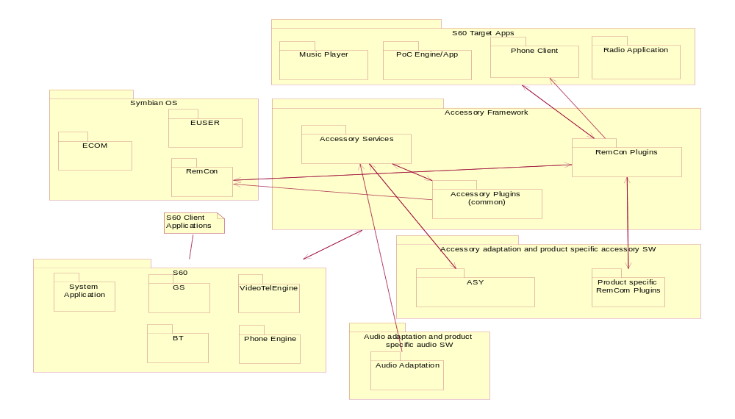
Figure 2.1 S60 Accessory Framework environment
- The Accessory Services subsystem provides Accessory Server which is the core Accessory Framework.
- The Remote Control FW Plug-ins subsystem provides plug-ins for Symbian's Remote Control Framework to support key event handling from accessories.

Figure 2.2 shows the subsystem related to Accessory Framework.
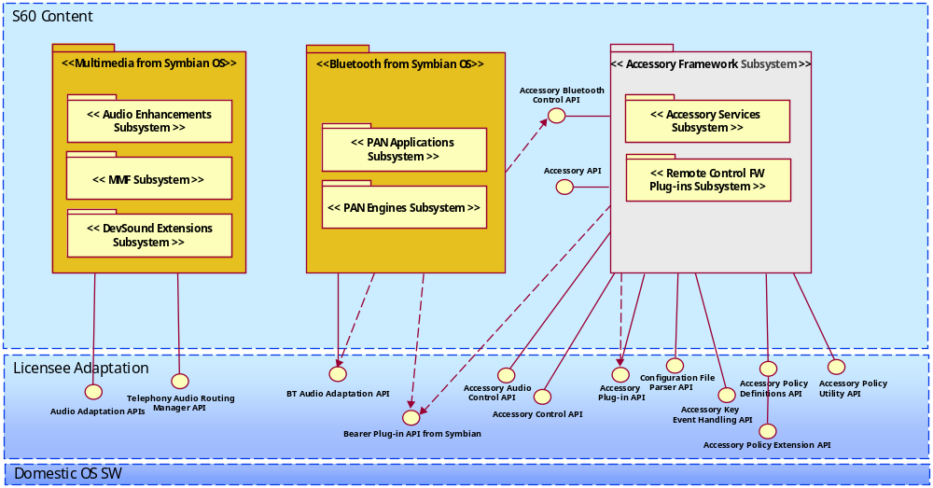
Figure 2.2 S60 Accessory Framework related subsystems
Accessory Framework interacts with Local Connectivity and Multimedia subsystems.
Accessory Framework assumes that the Local Connectivity related subsystem manages the communication between the S60 platform and Symbian’s Bluetooth stack.
Accessory Framework also assumes that the Local Connectivity related subsystem controls the Bluetooth stereo audio streams through the PAN Applications (see Section 4.6.1.1) and PAN Engines subsystems (see Section 4.6.1.2). For more details on PAN Applications and PAN Engines see reference documents [1] and [2].
Accessory Framework assumes that the Multimedia related subsystems control both telephony and non- telephony audio routing through MMF (see Section 4.6.2.1), Audio Enhancement (see Section 4.6.2.2) and DevSound Extensions subsystems (see Section 4.6.2.3). For more details on MMF, Audio Enhancement and DevSound Extensions see reference documents [3], [4] and [5].

Integrating Accessory Framework: what is needed?

S60 platform
Accessory Framework creates SC/BC breaks in multiple S60 internal APIs as well. S60 clean build is needed.

S60 Domestic OS server and Companion Modules
Accessory Framework causes SC and BC break in the following adaptation APIs:
- DOS Plug- in API.
- DOS Plug-in Event API.
- Common DSY Plug-in API.

The following services will be removed from the Dosserver and CommonDSYcomponents when the __ACCESSORY_FW flag is enable to S60 platform.
- Telephony audio related services.
- Accessory related services.
- Bluetooth Audio related services.
- Registering for listening and receiving Accessory, Audio and BT related DOS events.

For more details on Domestic OS server and Companion Modules, see Appendix.

S60 Accessory Services subsystem
- Implement the adaptation Accessory Plug-in module.
- See reference document [6].
- See reference implementation available in S60 3.1 release package in \Adaptation\stubs\ASYReference.

- Implement Extended Accessory Policy.
- See reference document [20].
- See reference implementation available in S60 3.1 release package in \adaptation\stubs\AccessoryPolicyReference.
- See reference document [7].

- Accessory Audio Control API to control audio links.
- See reference documents [8] and [9].

S60 Remote Control FW plug-ins subsystem (since S60 3.0)
- Implement Bearer plug-in to Remote Control which uses Accessory Key Event Handling API.
- New Key Events supported, e.g. Send/End key functionality.
- See reference documents [10] and [21].

S60 Bluetooth related subsystems
BT stereo can be enabled only when Accessory Framework is enabled. The __BT_STEREO_AUDIO feature flag enables BT stereo in the S60 platform.
Implement BT audio adaptation for BT stereo feature. For more information see reference document [11].

S60 Audio related subsystems
- Start using the telephony audio routing API.
- Telephony Audio Routing Manager API provides an interface for the Adaptation system to communicate audio output changes to Telephony Audio Routing Server.
- See reference document [12].

- Audio Adaptation APIs.
- See reference documents [18] and [13].

S60 Accessory Services subsystem overview
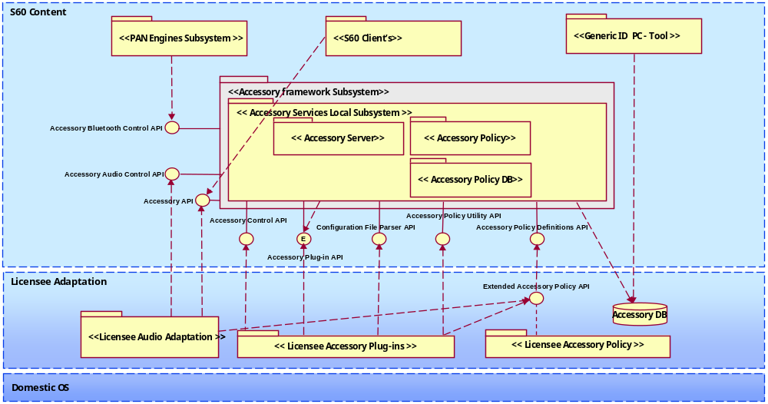
Figure 4.3 S60 Accessory Services subsystem overview

Accessory Server
Accessory Server is a standalone server, which is launched at startup. Accessory adaptation is implemented in Accessory Plug-ins. Accessory Server manages also the accessory connection status, accessory related data and accessory related settings. For Accessory Server clients, it provides notification services and enables access to accessory resources.
Accessory Server offers Accessory Audio Control API to control SCO links between audio client and BT audio accessory.

Accessory Plug-ins
Accessory Plug-In API is an adaptation API for Accessory Server. The abstract API is realized by Accessory Plug-ins, which are adaptation modules between Domestic OS and S60. The API definition is based on standard ECom Plug-in architecture applied to the needs of Accessory Framework. Accessory Server hosts multiple Accessory Plug-ins.

Generic ID PC tool
The Generic ID PC tool is used in configuring Accessory Frameworks Accessory Policy. Accessory Policy contains information about accessories’ capabilities (properties).

Accessory DB
Accessory database is a configurable for information needed in the accessory detection / identification process. Accessory database is a major part of the Accessory Policy concept.
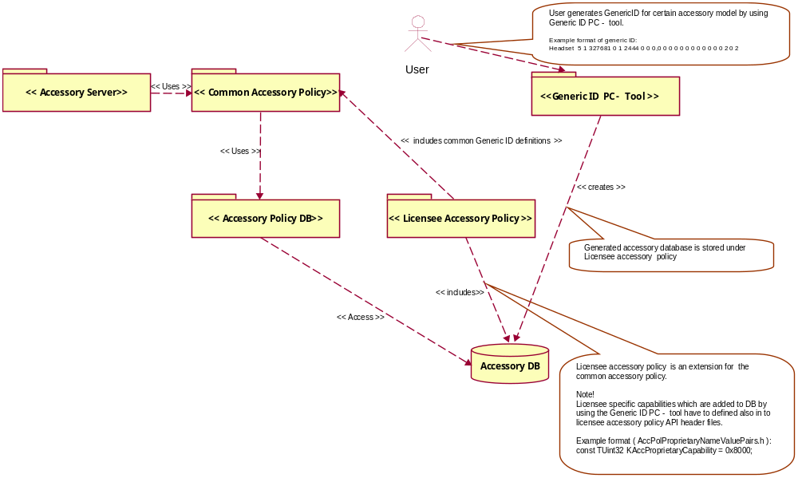
Figure 4.4 S60 Accessory Services Subsystem Accessory Policy (static view)
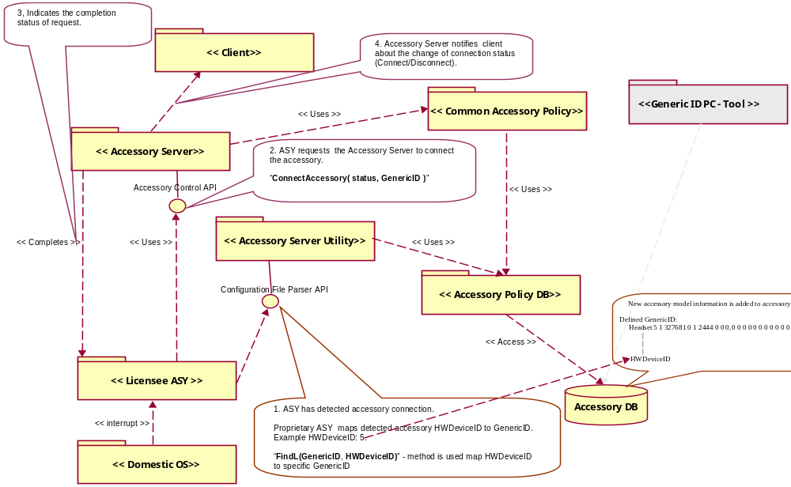
Figure 4.5 Accessory Service subsystem (dynamic view), example: Connecting Accessory

S60 Remote Control FW Plug-ins subsystem
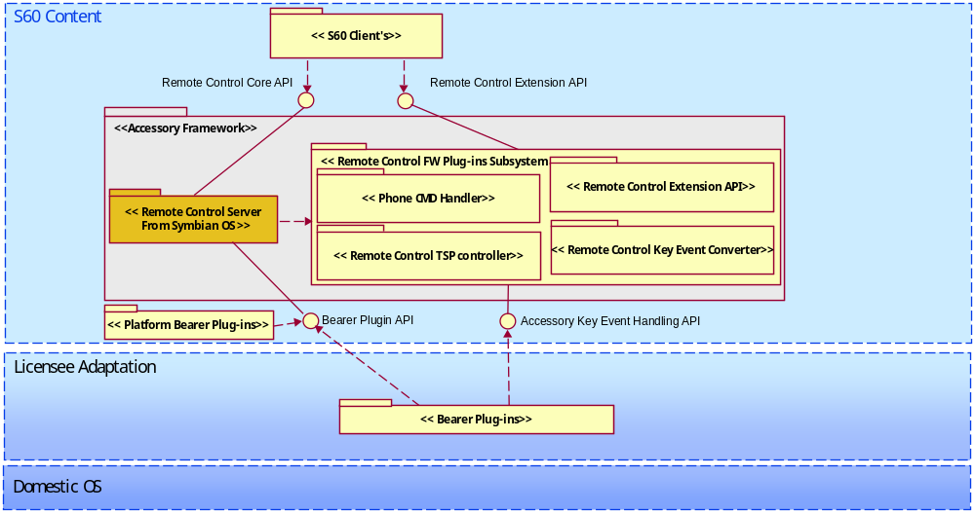
Figure 4.6 S60 Remote Control FW Plug-ins subsystem overview
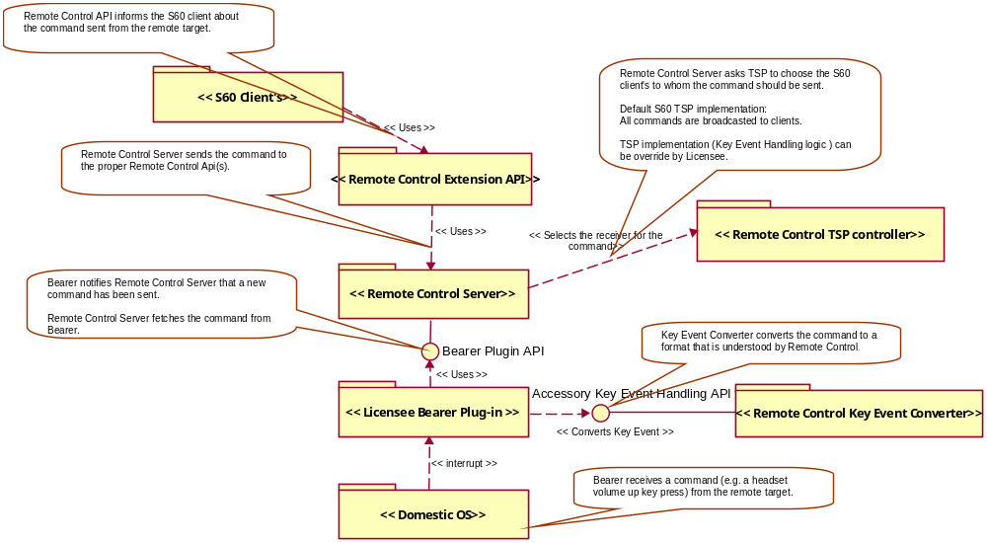
Figure 4.7 Remote Control FW Plug-ins subsystem dynamic view example: Sending a command from a remote target to a S60 client

Related S60 subsystems in brief

S60 Local Connectivity subsystem
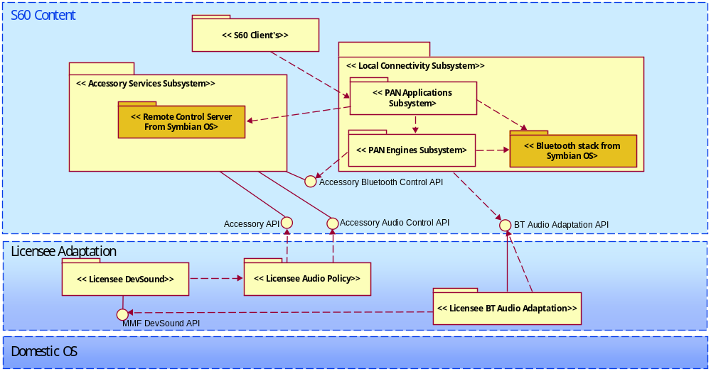
Figure 4.8 S60 Local Connectivity subsystem overview

S60 PAN Applications subsystem in brief
The PAN Applications subsystem provides support for BT audio, which means that the user is able to use, e.g. a BT headset or a BT car kit with the phone. More precisely, in this case BT audio support means that the phone implements the Application Gateway role specified in the HFP/HSP/A2DP specifications.
Bluetooth Mono Audio especially means SCO (synchronous connection oriented) type of audio. The specialty of the Bluetooth SCO channels is that they provide a kind of circuit switched channel that is routed in the HCI bus layer below the Symbian BT stack (e.g. from the BT module to the DSP).
Bluetooth Stereo Audio extends the BT audio capabilities from the mono phone calls to a stereo audio. The phone-side functionality supports Bluetooth streaming. It is implemented using packet based traffic through the BT stack.
Bluetooth SIM Access allows another device such as a car phone to access the SIM of the phone. The SIM Access connection is created over an encrypted (128-bit encryption) Bluetooth connection. The local use of the SIM is disabled while the SIM is in remote use. The phone only provides the SIM server role and the other device needs to be the client.
For more information on the PAN Applications subsystem, see reference document [2].

S60 PAN Engines subsystem in brief
The present PAN Engines consist of two main subsystems: Short-Range Connectivity services and Bluetooth Base Services.
The Short Range Connectivity subsystem provides a generic ECom interface to start service controllers using OBEX over different local connectivity media. The main use cases are with PC connectivity related services.
Bluetooth Base Services cover BT Engine and BT Server. BT Engine is a kind of higher layer API for applications to:
- Setup a connection and Bluetooth profiles over the Symbian BT APIs.
- Controlling the Bluetooth power state and the other hardware related Bluetooth settings.
- Setup Bluetooth profiles.

For more information on the PAN Engines subsystem, see reference document [1].

S60 Multimedia subsystem
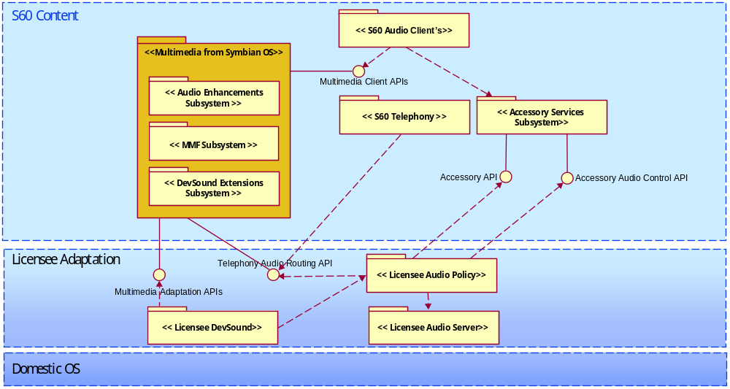
Figure 4.9 S60 Multimedia subsystem overview

S60 MMF subsystem in brief
The MMF subsystem provides clients with access to audio, video, and MIDI on the device.
These capabilities are realized by writing MMF plug-ins for the desired multimedia format. Any number of such plug-ins may be written, by Symbian or other parties, effectively providing unlimited extensibility from a multimedia perspective.
Common audio and speech functions used by MMF clients include the following:
- Playing audio from a file
- Recording voice memos
- Recording MMS notes
- Playing ringing tones

For more information on the MMF subsystem, see reference document [4].

S60 Audio Enhancement subsystem in brief
The Audio Enhancement subsystem is a collection of utilities and APIs that extend the audio features beyond those offered by the Symbian MMF APIs. The currently supported enhancements are the following:
- Audio playback enhancement using effects and visualization.
- Ability to read metadata embedded within audio content.
- Ability to route or control audio input for recording and audio output for playback.
- Allow third party applications without the DRM capability to play DRM-encrypted audio without jeopardizing security issues.
- Provide auto pause and resume functionality with Audio Resource Utility.
- Ability to route audio output for playback required by advanced telephony applications.
- Provide a framework to facilitate the usage of custom commands and custom interfaces provided by the MMF subsystem.

For more information on the Audio Enhancement subsystem, see reference document [3].

S60 DevSound Extensions subsystem in brief
The DevSound Extensions subsystem provides an interface to:
- Playing audio,
- Recording audio,
- Playing tones to other subsystems and it is the main interface to the audio services in Symbian OS.

DevSound Adaptation API defined by the DevSound Extensions subsystem is realized by the adaptation.
The DevSound Extensions subsystem provides a process boundary between MMF DevSound API and DevSound Adaptation API and it is responsible for copying control messages and data buffers from/to MMF DevSound API to/from DevSound Adaptation API.
The DevSound Extensions subsystem provides a generic framework for S60 or licensee’s components to pass IPC messages between the client side component and the server side component.
MMF DevSound API has a generic interface to configure the codec that is rendering/capturing audio.
For more information on the DevSound Extensions subsystem, see reference document [5].

Appendix: S60 Domestic OS server and Companion Modules overview
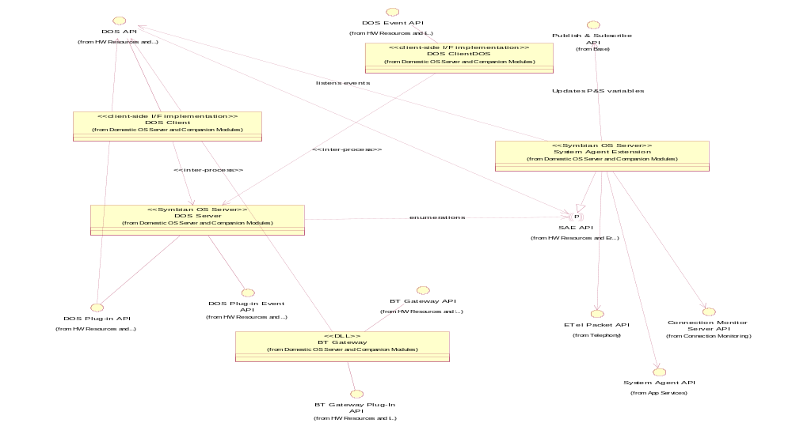
Figure 1 S60 Domestic OS server and Companion Modules overview
S60 Domestic OS server and Companion Modules Changes
Adaptation API changes:
- DOS Plug-in Event API
- The following methods are removed from the class CDosEventManager:
IMPORT_C TInt AudioLinkOpenReq();
IMPORT_C TInt AudioLinkCloseReq(THCIConnHandle aConnectionHandle);
IMPORT_C TInt ActivateVoiceRecognitionReq();
IMPORT_C TInt AbortVoiceRecognitionReq();
IMPORT_C TInt VoiceRecognitionStatusReq();
IMPORT_C TInt QuerySpeedDialNumberReq(TInt aIndex);
IMPORT_C TInt QueryLastDialledVoiceNumberReq();
IMPORT_C TInt AccessoryModeChangedInd(TBTAccessoryMode aAccMode);
IMPORT_C TInt BTAccessoryModeChangedInd(TBTDeviceType aDeviceType);
IMPORT_C TInt AccessorySpeakerVolumeSetInd(TUint aVolume);
IMPORT_C TInt ServiceLevelConnEstablishedInd(TBTServiceLevelConnParams aParam);
IMPORT_C TInt HeadsetButtonChanged(EPSButtonState aState);
IMPORT_C TInt HandsfreeModeChanged(EPSHandsFreeMode aMode);
IMPORT_C TInt OutputVolumeLevelChanged(TInt aLevel);
IMPORT_C TInt AccessoryModeChangedL(TDosAccessoryMode aAccessoryState);
- For more details on DOS Plug-in Event API, see reference document [14].

- DOS Plug-in API
- The following methods are removed from the class MDosFactoryBaseDSY:

/**
* The implementation should create a licensee specific BTAudio Service.
* @return A pointer to the newly created object.
*/
virtual CDosBTAudioBase* NewBTAudioServiceL()=0;

/**
* The implementation should create a licensee specific Accessory Service.
* @return A pointer to the newly created object.
*/
virtual CDosAccessoryBase* NewAccessoryServiceL()=0;

/**
* The implementation should create a licensee specific Audio Service.
* @return A pointer to the newly created object.
*/
virtual CDosAudioBase* NewAudioServiceL()=0;

- The following classes are removed:
- MDosAudioBaseDSY
- MDosBTAudioBaseDSY
- MDosAccessoryBaseDSY

- For more details on DOS Plug-in API, see reference document [15].

- CommonDSY Plug-in API
- The following methods are not supported by the commonDSY implementation:

/**
* The function returns an object derived from CDosBTAudioBase,
* which implements the pure virtual functions defined in MDosBTAudioBaseDSY to DOS Server.
* @return CDosBTAudioBase* Pointer to the plug-in.
*/
CDosBTAudioBase* NewBTAudioServiceL();

/**
* The function returns an object derived from CDosAccessoryBase,
* which implements the pure virtual functions defined in MDosAccessoryBaseDSY to DOS Server.
* @return CDosAccessoryBase* Pointer to the plug-in.
*/
CDosAccessoryBase* NewAccessoryServiceL();

/**
* The function returns an object derived from CDosAudioBase,
* which implements the pure virtual functions defined in MDosAudioBaseDSY to DOS Server.
* @return CDosAudioBase* Pointer to the plug-in.
*/
CDosAudioBase* NewAudioServiceL();

- For more details on Common DSY Plug-in API, see reference documents [16] and [19].

Client API changes:
- DOS Client API
- The following classes are removed:
- class RDosAudio
- class RDosAccessory
- class RDosBTAudio

- The following methods are removed from CDosEventListenerBase:
IMPORT_C virtual void HeadsetButtonChangedL(EPSButtonState aState);
IMPORT_C virtual void OutputVolumeLevelChangedL(TInt aLevel);
IMPORT_C virtual void AudioLinkOpenReq();
IMPORT_C virtual void AudioLinkCloseReq( THCIConnHandle aConnectionHandle );
IMPORT_C virtual void ActivateVoiceRecognitionReq();
IMPORT_C virtual void AbortVoiceRecognitionReq();
IMPORT_C virtual void VoiceRecognitionStatusReq();
IMPORT_C virtual void QuerySpeedDialNumberReq( TInt aIndex );
IMPORT_C virtual void QueryLastDialledVoiceNumberReq();
IMPORT_C virtual void AccessoryModeChangedInd( TBTAccessoryMode aAccMode );
IMPORT_C virtual void BTAccessoryModeChangedInd( TBTDeviceType aDeviceType );
IMPORT_C virtual void AccessorySpeakerVolumeSetInd( TUint aVolume );
IMPORT_C virtual void ServiceLevelConnEstablishedInd( TBTServiceLevelConnParams aServiceLevelConnParams );
IMPORT_C virtual void HandsfreeModeChanged(EPSHandsFreeMode aMode);
IMPORT_C virtual void AccessoryModeChangedL(TDosAccessoryMode aAccessoryState);

- For more details on DOS Client API, see reference document [17].

- DOS Event API
- The following classes are removed from the class CDosEventSender:
IMPORT_C void AudioLinkOpenReq();
IMPORT_C void AudioLinkCloseReq( THCIConnHandle aConnectionHandle );
IMPORT_C void ActivateVoiceRecognitionReq();
IMPORT_C void AbortVoiceRecognitionReq();
IMPORT_C void VoiceRecognitionStatusReq();
IMPORT_C void QuerySpeedDialNumberReq( TInt aIndex );
IMPORT_C void QueryLastDialledVoiceNumberReq();
IMPORT_C void AccessoryModeChangedInd( TBTAccessoryMode aAccMode );
IMPORT_C void BTAccessoryModeChangedInd( TBTDeviceType aDeviceType );
IMPORT_C void AccessorySpeakerVolumeSetInd( TUint aVolume );
IMPORT_C void ServiceLevelConnEstablishedInd( TBTServiceLevelConnParams aServiceLevelConnParams )

- For more details on DOS Event API, see reference document [17].

- SAE API
- The following enumerations have been removed:

enum EPSAccLpsMode
{
EPSAccLpsModeUninitialized = KEnumerationFirstValue,
EPSAccLpsOff,
EPSAccLpsOn,
EPSAccTty = 0x04
};

enum EPSHandsFreeMode
{
EPSHandsFreeModeUninitialized = KEnumerationFirstValue,
EPSIhfOff,
EPSIhfOn
};

