S60 3.x
Accessory Policy Common Generic ID Definitions
Specification Document

Team name | Author
SystemSW | Timo Pääkkönen

Change history:

Version | Date | Status | Comments
1.0 | 01.02.2006 | Approved

Table of contents:

1. Document control 4
1.1 References 4
1.2 Abbreviations 4
1.3 Definitions 4
2. General 5
2.1 Introduction 5
2.2 About the capability information 6
2.2.1 Defining more exact capability information 7
3. GID Header capabilities 8
4. Detailed accessory information capabilities 11
5. Usage 18

Document control

References
- S60 GID PC Tool User’s Guide
- S60 GID Tool Design Document

Abbreviations
GID | Generic Identification

Definitions
Capability | A feature that an accessory has
Location | The location/source of the value; When the state is updated it has a direction, defined as input (updated from accessory) or output (updated from terminal). For example if the location of value is accessory it means the value can be asked from accessory.
Type | Type of the value
Value | Value of the capability

General

Introduction
This document describes the capabilities that accessories can have. Capabilities for a certain accessory are collected to an information package and this is presented as a generic identification for an accessory. How the generic identification is created is described in reference document [1].
Accessories are described with certain major characteristics that categorize the accessories. For example a wired headset has a wired connection as a physical connection and its device type is headset. To categorize the accessories there are capabilities that define the basic features of the accessories. In the generic identification these basic properties of accessories are defined in a static part called GID header. For every accessory there is a definition for these static parts. These static parts are device type, physical connection, application protocols and capability groups. Generic identification structure is described in Figure 2.1.
One and only one device type should be defined for every accessory. The device type describes the type of accessory (for example a car kit or a headset). In the physical connection part there are capabilities that define how the accessory is connected to the terminal. One accessory can have multiple physical connection possibilities. For example a car kit can have a wired connection and a Bluetooth connection. The application protocols describe a protocol for transferring data between the accessory and the terminal. The application protocol is an optional capability. The last part of the GID header is capability groups. The capability groups part defines what capability groups are defined for this accessory. The capability groups consist of more detailed capabilities and it defines the other major part of the generic identification; the dynamic part of the generic identification.
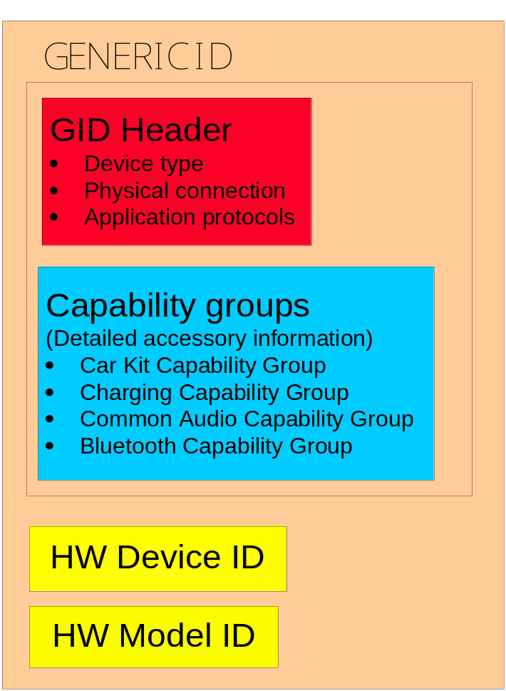
Figure 2.1 Generic identification structure
So to define the accessories in a more specific way we need the dynamic part to access the exact properties of accessories in the generic identification. These capabilities are categorized in capability groups. This orientation of capabilities can be presented as detailed accessory information. In this type of capability information we can sort out for example accessory audio features. For the capabilities in this group you can also set values for the capabilities that are defined.
The generic identification consists also of accessory identifier information: HW device ID and HW model ID. HW model ID is the commercial name for the accessory and HW device ID is a numerical identifier that is used to identify accessories.

About the capability information
Table 2.1 and Table 2.2 present the information fields for a single GID header capability and for a detailed accessory information capability.
Table 2.1 Capability information table for GID header capabilities
Group of capability | This field defines the capability group name.
Capability | This field defines the group in which the capability belongs.
Defined in header file | This section shows the header where the capability is defined.
Description | Here is a short description of the capability.

Table 2.2 Capability information table for the more detailed accessory information capabilities
Group of capability | This field defines the capability name.
Capability | This field defines the group in which the capability belongs.
Defined in header file | This section shows the header where the capability is defined.
Description | Here is a short description of the capability.
IO type | The direction of the information that is updated. For example: From accessory to terminal, input.
Dynamic Type | Here is defined if the information is dynamic or static.

The capabilities in this document are divided into two sections based on the orientation of the capabilities; GID header (see Chapter 3) and detailed accessory information capabilities (see Chapter 4).

Defining more exact capability information
User defined values that can vary between accessories can be set for more detailed capabilities. Also a type and a location must be defined for every value. Type means the enumeration of the type (TBool, Tint, etc.) in code level. Values can exist as dynamic (updated runtime) in the database, which also means that the value must be updated with a certain direction (from accessory/terminal). Directions (location) are defined as input and output; input means that the state of the value is updated by the accessory and output means that the state of the value is updated by the terminal. Type and direction can have only numerical values. The value itself can also have string values, but if the value is dynamic it is set to -19 (Symbian OS standard error code KErrUnknown). If the capability values are defined as static, values should not be set by the user.

GID Header capabilities
Group of capability | Device Type
Capability | Headset
Defined in header file | AccPolGenericid.h
Description | Headsets (Device type bit mask definitions).

Group of capability | Device Type
Capability | CarKit
Defined in header file | AccPolGenericid.h
Description | Carkits (Device type bit mask definitions).

Group of capability | Device Type
Capability | Office
Defined in header file | AccPolGenericid.h
Description | Stands, placed on the table (Device type bit mask definitions).

Group of capability | Device Type
Capability | Messaging
Defined in header file | AccPolGenericid.h
Description | Digital pen & Keyboards (Device type bit mask definitions).

Group of capability | Device Type
Capability | Imaging
Defined in header file | AccPolGenericid.h
Description | Imaging devices (Device type bit mask definitions).

Group of capability | Device Type
Capability | Loopset
Defined in header file | AccPolGenericid.h
Description | Loopsets are accessories used with hearing aids, (Device type bit mask definitions).

Group of capability | Device Type
Capability | Data Cable
Defined in header file | AccPolGenericid.h
Description | Datacables (Device type bit mask definitions).

Group of capability | Device Type
Capability | Charger
Defined in header file | AccPolGenericid.h
Description | Phone chargers (Device type bit mask definitions).

Group of capability | Device Type
Capability | TTY
Defined in header file | AccPolGenericid.h
Description | Text device (Device type bit mask definitions).

Group of capability | Physical Connection
Capability | Wired
Defined in header file | AccPolGenericid.h
Description | Wired connection.

Group of capability | Physical Connection
Capability | Bluetooth
Defined in header file | AccPolGenericid.h
Description | Bluetooth connection.

Group of capability | Physical Connection
Capability | InfraRed
Defined in header file | AccPolGenericid.h
Description | Infrared connection.

Group of capability | Physical Connection
Capability | USB
Defined in header file | AccPolGenericid.h
Description | USB connection.

Group of capability | Application protocol
Capability | AT
Defined in header file | AccPolGenericid.h
Description | AT Application protocol.

Group of capability | Application protocol
Capability | OBEX
Defined in header file | AccPolGenericid.h
Description | OBEX Application protocol.

Group of capability | Capability group
Capability | AudioSubblock
Defined in header file | AccPolGenericid.h
Description | Audio capability group.

Group of capability | Capability group
Capability | CarKitSubblock
Defined in header file | AccPolGenericid.h
Description | Car Kit capability group.

Group of capability | Capability group
Capability | ChargingSubblock
Defined in header file | AccPolGenericid.h
Description | Charging capability group.

Group of capability | Capability group
Capability | BluetoothSubblock
Defined in header file | AccPolGenericid.h
Description | Bluetooth capability group.

Detailed accessory information capabilities

Group of capability | Audio capability group
Capability | Acoustic Echo Control
Defined in header file | AccPolCommonNameValuePairs.h
Description | Accessory supports acoustic echo control. If value is true the terminal must disable its own echo control. To indicate if the accessory has internal acoustic echo control.
IO type | From Accessory to Terminal, INPUT
Dynamic Type | Dynamic
Value Type | TBool

Group of capability | Audio capability group
Capability | Noise Reduction
Defined in header file | AccPolCommonNameValuePairs.h
Description | To indicate if the accessory has internal noise reduction. If the value is true the terminal must disable its own noise reduction.
IO type | From accessory to terminal, input.
Dynamic Type | Dynamic
Value Type | TBool

Group of capability | Audio capability group
Capability | Stereo Audio Output
Defined in header file | AccPolCommonNameValuePairs.h
Description | To indicate if the accessory has stereo audio output.
IO type
Dynamic Type | Static
Value Type

Group of capability | Audio capability group
Capability | Mono Audio Output
Defined in header file | AccPolCommonNameValuePairs.h
Description | To indicate if the accessory has mono audio output.
IO type
Dynamic Type | Static
Value Type

Group of capability | Audio capability group
Capability | External Audio In Activation
Defined in header file | AccPolCommonNameValuePairs.h
Description | If the capability exists it indicates that the accessory supports activating (ETrue) / deactivating (EFalse) the external audio input. External audio in activation capability requires that accessory has audio in connector capability.
IO type | From terminal to accessory, output.
Dynamic Type | Dynamic
Value Type | TBool

Group of capability | Audio capability group
Capability | External Audio out Connector
Defined in header file | AccPolCommonNameValuePairs.h
Description | The audio out connector capability indicates that the accessory has a connector enabling audio output to the external audio device. The value indicates if the external audio device is removed (EFalse) or connected (ETrue).
IO type | From accessory to terminal, input.
Dynamic Type | Dynamic
Value Type | TBool

Group of capability | Audio capability group
Capability | External Audio out Activation
Defined in header file | AccPolCommonNameValuePairs.h
Description | External Audio OUT Activation capability indicates that accessory supports activating (ETrue) / deactivating (EFalse) the external audio output. External audio in activation capability requires that accessory has audio in connector capability.
IO type | From terminal to accessory, output.
Dynamic Type | Dynamic
Value Type | TBool

Group of capability | Audio capability group
Capability | Audio amplifier
Defined in header file | AccPolCommonNameValuePairs.h
Description | The audio amplifier capability indicates that the accessory has an audio amplifier.
IO type
Dynamic Type | Static
Value Type

Group of capability | Audio capability group
Capability | Volume Level Sync
Defined in header file | AccPolCommonNameValuePairs.h
Description | If the name is defined, the connected accessory has volume control keys and it uses logical volume levels to communicate the accessory initiated volume level changes to the terminal. If the name is undefined but the accessory has volume keys, it indicates that the accessory uses volume up and down events to communicate the accessory initiated volume level changes to the terminal.
IO type | From accessory to terminal, input.
Dynamic Type | Dynamic
Value Type | TBool

Group of capability | Audio capability group
Capability | Volume Level Set
Defined in header file | AccPolCommonNameValuePairs.h
Description | Indicates that the accessory supports an interface for setting the volume level from terminal.
IO type | From accessory to terminal, input.
Dynamic Type | Dynamic
Value Type | TInt

Group of capability | Audio capability group
Capability | Audio Output Type
Defined in header file | AccPolCommonNameValuePairs.h
Description | The audio output type definition corresponds to the audio output type definition in MMF. It is used to decide how audio is routed.
IO type
Dynamic Type | Static
Value Type | TInt

Group of capability | Audio capability group
Capability | DRM output
Defined in header file | AccPolCommonNameValuePairs.h
Description | DRM capability indicates that the accessory is allowed to handle DRM protected audio output.
IO type
Dynamic Type | Static
Value Type | TBool

Group of capability | Audio capability group
Capability | Mute All Audio
Defined in header file | AccPolCommonNameValuePairs.h
Description | The mute capability indicates that the accessory supports muting all audio outputs (e.g. any speakers). The value indicates that any accessory audio outputs need to be muted (ETrue) / unmuted (EFalse).
IO type | From accessory to terminal, input.
Dynamic Type | Dynamic
Value Type | TBool

Group of capability | Car Kit capability group
Capability | Audio To Privacy Handset
Defined in header file | AccPolCommonNameValuePairs.h
Description | The audio to privacy handset capability indicates that the car kit supports an interface for routing the audio from default audio output to privacy handset. The name is also used to route audio back to the default audio output. Control handset audio in Car Handfree peripherals. Audio is routed to the handset when call is active and handset is removed from its holder. The audio needs to be activated (ETrue) / deactivated (EFalse).
IO type | From terminal to accessory, output.
Dynamic Type | Dynamic
Value Type | TBool

Group of capability | Car Kit capability group
Capability | Privacy Handset
Defined in header file | AccPolCommonNameValuePairs.h
Description | Indicates if the handset is in the holder (ETrue) or not (EFalse)
IO type | From accessory to terminal, input.
Dynamic Type | Dynamic
Value Type | TBool

Group of capability | Car Kit capability group
Capability | Car Radio Mute
Defined in header file | AccPolCommonNameValuePairs.h
Description | Car Radio Mute, indicates that accessory supports an interface for muting the peripheral car radio. The value (dynamic) indicates that Car Radio needs to be muted (ETrue)/ unmated (EFalse).
IO type | From terminal to accessory, output.
Dynamic Type | Dynamic
Value Type | TBool

Group of capability | Charging capability group
Capability | External Power Supply
Defined in header file | AccPolCommonNameValuePairs.h
Description | When connected, the power supply of the enhancement is active and enhancement can work properly. When disconnected, the enhancement doesn’t have power supply and the enhancement is detected, but not indicated to the user and is not activated. E.g. required audios are not routed to enhancement The value (dynamic) indicates that external power supply is connected (ETrue) / disconnected (EFalse).
IO type | From accessory to terminal, input.
Dynamic Type | Dynamic
Value Type | TBool

Group of capability | Bluetooth capability group
Capability | HSP
Defined in header file | AccPolCommonNameValuePairs.h
Description | Headset Profile (HS), Bluetooth device supports HFP.
IO type
Dynamic Type
Value Type

Group of capability | Bluetooth capability group
Capability | OPP
Defined in header file | AccPolCommonNameValuePairs.h
Description | Object Push Profile (OPP), the device supports Object Push Profile.
IO type
Dynamic Type
Value Type

Group of capability | Bluetooth capability group
Capability | GOEP
Defined in header file | AccPolCommonNameValuePairs.h
Description | Generic Object Exchange Profile (GOEP), the device supports Generic Object.
IO type
Dynamic Type
Value Type

Group of capability | Bluetooth capability group
Capability | FTP
Defined in header file | AccPolCommonNameValuePairs.h
Description | File Transfer Profile (FTP), the name indicates that the device supports File Transfer Profile.
IO type
Dynamic Type
Value Type

Group of capability | Bluetooth capability group
Capability | GAP
Defined in header file | AccPolCommonNameValuePairs.h
Description | Generic Access Profile (GAP), the name indicates that the device supports Generic Access Profile.
IO type
Dynamic Type
Value Type

Group of capability | Bluetooth capability group
Capability | SPP
Defined in header file | AccPolCommonNameValuePairs.h
Description | Serial Port Profile (SPP), the name indicates that device supports Serial Port Profile.
IO type
Dynamic Type
Value Type

Group of capability | Bluetooth capability group
Capability | HFP
Defined in header file | AccPolCommonNameValuePairs.h
Description | Handsfree Profile (HFP), Bluetooth device supports HFP.
IO type
Dynamic Type
Value Type

Group of capability | Bluetooth capability group
Capability | AVRCP
Defined in header file | AccPolCommonNameValuePairs.h
Description | Audio Video Remote Control Profile (AVRCP), the device supports AVRCP.
IO type
Dynamic Type
Value Type

Group of capability | Bluetooth capability group
Capability | GAVDP
Defined in header file | AccPolCommonNameValuePairs.h
Description | Generic Audio Video Distribution Profile (GAVDP), the device supports AVRCP.
IO type
Dynamic Type
Value Type

Group of capability | Bluetooth capability group
Capability | A2DP
Defined in header file | AccPolCommonNameValuePairs.h
Description | Advanced Audio Distribution Profile (A2DP), the name indicates that device supports Advanced Audio Distribution Profile.
IO type
Dynamic Type
Value Type

Group of capability | Bluetooth capability group
Capability | HID
Defined in header file | AccPolCommonNameValuePairs.h
Description | Human Interface Device Profile (HID), the device supports Human Interface Device Profile.
IO type
Dynamic Type
Value Type

Group of capability | Bluetooth capability group
Capability | PAN
Defined in header file | AccPolCommonNameValuePairs.h
Description | Personal Area Networking Profile (PAN), the device supports Personal Area Networking Profile.
IO type
Dynamic Type
Value Type

Group of capability | Bluetooth capability group
Capability | SAP
Defined in header file | AccPolCommonNameValuePairs.h
Description | SIM Access Profile (SAP), the device supports SIM Access Profile.
IO type
Dynamic Type
Value Type

Group of capability | Bluetooth capability group
Capability | BIP
Defined in header file | AccPolCommonNameValuePairs.h
Description | Basic Imaging Profile (BIP), the device supports this Profile.
IO type
Dynamic Type
Value Type

Group of capability | Bluetooth capability group
Capability | BPP
Defined in header file | AccPolCommonNameValuePairs.h
Description | Basic Printing Profile (BPP), the device supports this Profile.
IO type
Dynamic Type
Value Type

Usage
Generic identifications are created with GID PC Tool. For more information, see reference document [1].

