S60 3.x
GID PC Tool
User’s Guide

Team name | Author
Core BS | Timo Pääkkönen

Change history:

Version | Date | Status | Comments
2.0 | 10.05.2006 | Approved | Added the rules chapters (3.3.31 and 4.3).
1.0 | 28.03.2006 | Approved

Table of contents:

1. Document control 4
1.1 References 4
1.2 Abbreviations and Definitions 4
2. Introduction 5
2.1 General 5
2.2 Generic identification structure 5
2.3 About the coding 7
3. Using the GID PC tool 8
3.1 Installation 8
3.2 Configuration settings 10
3.3 Main use cases 10
3.3.1 Create user 10
3.3.2 Redefining user information 11
3.3.3 Create GID 12
3.3.4 Modify GID 13
3.3.5 Destroy GID 14
3.3.6 View GID 15
3.3.7 Add new capability 16
3.3.8 Destroy a capability 16
3.3.9 Modify a capability 16
3.3.10 View capabilities 17
3.3.11 Updating the accessory database 18
3.3.12 Update XML capability information files 18
3.3.13 Creating a rule for the Accessory Policy 19
4. Examples 23
4.1 Creating a capability to a new capability group 23
4.2 Creating a generic identification with a new capability 25
4.3 Creating a rule and mapping it to selections in the Accessory Selection dialog 27

Document control

References

- Accessory Common Capability Definitions
- Accessory Framework Design Document
- Accessory Policy Design Document
- Accessory Framework UI notifier design document

Abbreviations and Definitions

Accessory Capability | Some feature of an accessory.
Accessory Rules | Rules how to act with accessories that can not be identified.
Generic Identification | Structure that holds information about an accessory.
GID | Generic Identification.
GID Integer | Numeric part of the GID structure.
HW ID | Hardware identification is an identification code that is mapped to some information that is received from the domestic OS side.
Model ID | Model identification is the commercial name of the accessory.
Rule index | An integer value that is used in labeling the rules.
Selection dialog | A dialog component that is showed when an accessory can not be identified.

Introduction

General
The GID PC Tool is used in configuring Accessory Frameworks Accessory Policy. Accessory Policy contains information about accessories’ capabilities (properties). The accessories are configured through varying accessory capability definitions. These capabilities are packaged to a data structure called GID integer. The GID integer is mapped to the accessory’s identification information (see Section 2.2). The GID integer and the identification information form the concept of generic identification.
GID PC Tool can also be used in creating new capabilities and modifying, destroying and viewing existing capabilities. The capabilities are mapped to a numeric space. This numeric space is divided to common and proprietary part. The common space is reserved to be used by S60 platform. The capabilities from common space are capabilities that accessories usually have. The capabilities in the proprietary space are capabilities that can be freely used in describing accessories capabilities. The capabilities and the numeric space are described more deeply in the common capability definitions document (reference document [1]). The capabilities are stored in capability information XML files that are divided in two parts, common and proprietary capability information files. The common XML files are stored in Accessory Server and these are defined by S60 platform. The proprietary XML files are stored in Accessory Policy and can be freely used.
The GID PC Tool has also Accessory Policy control features (updating XML files to/from Accessory Policy, updating common XML files from Accessory Server, updating database) and it can be used in creating accessory rules tables. The accessory rules table is used in configuring which accessory modes are shown in the accessory selection dialog (see reference document [2]).

Generic identification structure
The generic identification is used in identifying the properties that certain accessory type has. The form of the Generic Identification that is presented in the .dat files (the accessory database is constructed of the .dat files, will be explained later) is:

HS-X | 010001 | 1 | 327681 | 0 | 1 | 2400 | 0 | 0 | 0 | , | 0 | 0 | 0 | 0 | 0 | 0 | 0 | 0 | 0 | 2 | 0 | 2

Figure 2.1 Example of Generic Identification
Generic ID consists of accessory identification information and of a string of binary coded numerals, GID Integer. The accessory’s identification information is divided in to HW Model ID and to HW Device ID. The GID integer is a packaged form of accessory’s capability definitions. Each capability definition is marked with one bit to a capability group. Each capability can hold 32 capability definitions, except Capability Groups (the fourth part of GID header) capability group can hold 63 capabilities. The defined bits are packed to an integer form (see Section 2.3).

 | HW Model ID | HW Device ID
 | HS-5 | 01001
Type | ASCII | Hex
Figure 2.2 Accessory’s identification information
GID header:
The first four numbers, separated with a spacebar in the string, form the GID header part. The GID header values are mandatory for every generic id. The first part of GID header defines the device type for the accessory. Second part defines physical connection, and third application protocols. The Capability Groups are the last part of GID header. The capability definitions in the Capability Groups define what other capability groups (in addition to the GID header capability groups) are defined for the accessory.
Device type | Physical connection | Application protocol | Capability groups
1 | 327681 | 0 | 1
Integer | Integer | Integer | Integer
Figure 2.3 GID header parts
More exact information capabilities (additional capability groups):
The next parts of the generic ID are the capabilities in the additional capability groups. One capability group definition consists of four subgroups that are the size of 32 bits. In other words the size of one capability group is 4*32 name definitions. The first 32 bits are reserved for common parts (used by S60) and the 31 next bits are for proprietary use.

Audio capability group (1/4) | Audio capability group (2/4) | Audio capability group (3/4) | Audio capability group (4/4)
2400 | 0 | 0 | 0
Integer | Integer | Integer | Integer
Figure 2.4 Example of Audio capability group
Additional information can be set for every capability that is defined in these capability groups (in additional capability groups). A location has to be defined for this additional information (where the state of this additional information is updated) type of the information (TBool, TInt, TDesC), and of course the value itself. If a capability in these capability groups does not have any information it is set to zero. For more exact definitions to these values look to the common capability definitions document (reference document [2]).
Marker | Location | Value | Type | Location | Value | Type | Location | Value | Type | Location | Value | Type
, | 0 | 0 | 0 | 0 | 0 | 0 | 0 | 0 | 0 | 2 | 0 | 2
ASCII | Integer | ASCII | Integer | Integer | ASCII | Integer | Integer | ASCII | Integer | Integer | ASCII | Integer
Figure 2.5 Values for the capabilities
Example:
The generic identification that is presented in figure 1, the accessory device type (name) is HS-5 and the HWID is 010001. The first actual number of the GID is 1 and it defines the capabilities inside the device type capability group. The next number is 327681. It shows the physical connection type of the accessory. Next number 0 is Application Protocols, means that no application protocols are defined for this accessory, and 1 is Capability Groups, meaning that audio capability group is defined. In the Audio Capability Groups first sub group there is the number 2400, which means that the accessory has mono audio, integrated audio output (integrated speaker), integrated audio input (microphone) and audio output type capabilities. For the first three capabilities the additional information is defined to zero. For the audio output type is set a location 2 value 0 and a type 2 (see reference document [2]).
The main purpose of this tool is to create generic identifications. The next Chapter describes how the coding is done.

About the coding
The capabilities inside the capability groups are coded to binary numerals so that one figure (describing a capability group) can contain up to 32 capabilities, and their variations. Basically coding is sorted so that if one capability is defined, a byte is set to one. And if a capability is not defined, it is set to zero. Then the bits are converted to binary coded numerals so that no information is lost and the information is in a very suitable form. Decoding is done in a reverse order so that the figure is changed to a binary string and then the bytes can be read. An example is presented in Figure 2.6.

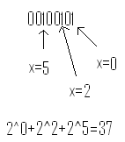
Figure 2.6 How the binary coded numerals are constructed

Using the GID PC tool

Installation
As a prerequisite for the GID PC Tool java runtime environment (jre1.4.2 or newer) must be installed. GID PC Tool is installed to your computer through an installer program. This program is started by running the setup.exe. When the installer program is run, the user should follow the steps as shown in Figure 3.7, Figure 3.8, Figure 3.9, Figure 3.10 and Figure 3.11. The installation path (shown in Figure 3.9) must be set to a substed drive where the S60 release is installed.
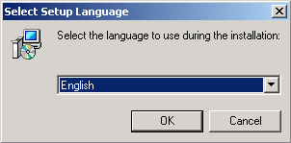
Figure 3.7 Setting up the installation language
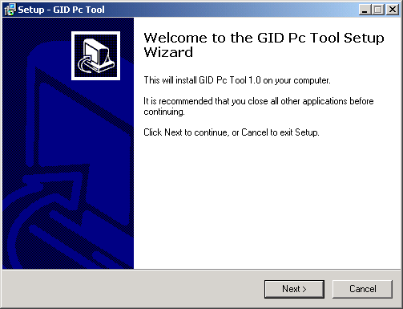
Figure 3.8 Starting the GID PC Tool setup
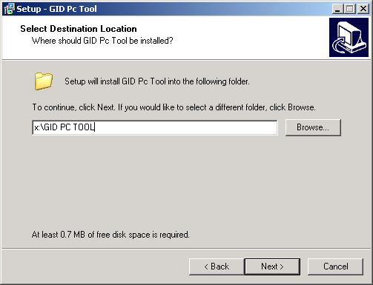
Figure 3.9 Setting the path for GID PC Tool. Note that it should be in the root of the substed drive
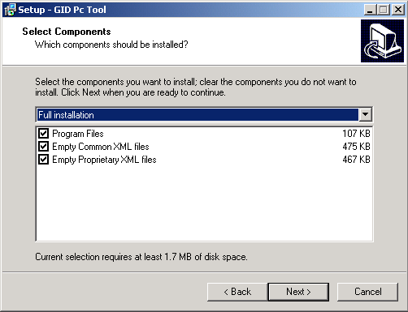
Figure 3.10 Defining which parts should be installed for GID PC Tool
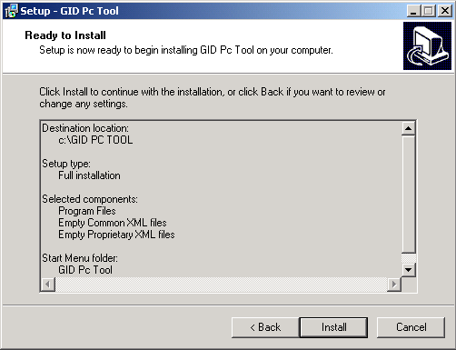
Figure 3.11 The overview of the parts that are going to be installed

Configuration settings
GID PC Tool is meant to be used with the Accessory Policy component. Accessory Policy can be constructed from Accessory Policy Reference and should be constructed before GID PC Tool is taken into use (see reference document [3]). The GID tool is set to use the accessory policy in use case 3.3.1. The EPOCROOT environment variable has to be set to the root of the drive.

Main use cases

Create user
When GID PC Tool is started the user information window opens up. By selecting ‘New User’ from the existing radio buttons and then pressing ‘OK’ button a new user can be created (see Figure 3.13). After the user name is given, the path to the Accessory Policy that is used has to be defined. This is done by typing the path to the Accessory Policy component (for example adaptation\stubs\accessorypolicyreference). After the path is set, the name of the accessory database file has to be set. This file can be set to anything (for example team_name). The program adds the type to the file, which is .dat, so the user must not set it. After the user information is configured, the information is saved to the program, so that the user information can be later used. The S60 Administrator user definition is meant to be used only by S60 personnel.
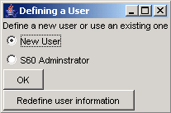
Figure 3.12 User Information, new user
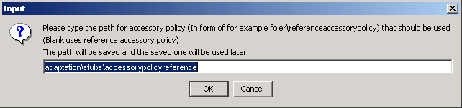
Figure 3.13 Path to Accessory Policy
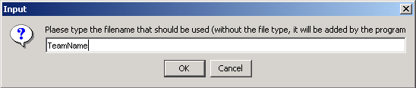
Figure 3.14 Database file name

Redefining user information
User information can be redefined in the user information window. Simply by selecting the user name that needs to be redefined from the radio buttons and pressing redefine user information button (shown in Figure 3.13), the user information can be redefined. Like in the create user use case the path to the accessory policy and the name of the database file has to be set.
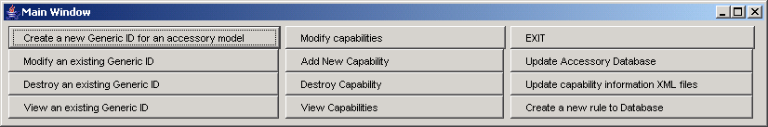
Figure 3.15 GID PC Tool main window

Create GID
The main function of the GID PC Tool is the create GID. The create GID function can be run be clicking the Create a new Generic ID for an accessory model button. This opens a window as shown in Figure 3.16.
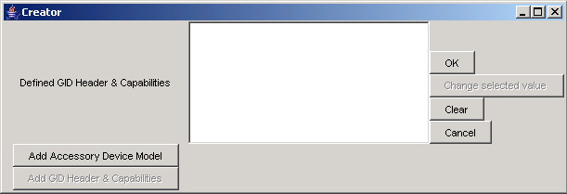
Figure 3.16 Create GID window
The create GID process is started by giving the Accessory model ID and the HW ID. This is done by clicking the Add Accessory Device Model. Two generic identifications can not have the same name or the same HWID. After adding the name the Add GID Header & Capabilities button becomes active. The capabilities can be fed through this button. When the button is pressed, it opens up a window with check buttons. The capabilities are set on by checking a check button as shown in Figure 3.19.
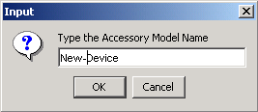
Figure 3.17 Naming the accessory model ID
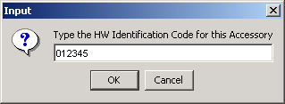
Figure 3.18 Naming the HW Identification
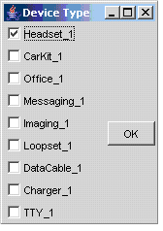
Figure 3.19 Defining capabilities for device type
In the first window, the Device Type is defined. The other windows that pop up are physical connection, application protocol and capability groups. These parts form the GID Header. In the last part of GID Header (capability groups) you define the additional capability groups. If a capability group is defined a new window opens up and there you can define some other capabilities for the generic identification. After all the capabilities are defined, the existing capabilities are shown in the Defined Capabilities list. By clicking OK the GID is saved to the .dat file that was defined in the user information window. If some capability was defined wrong, you can change the capabilities by selecting some capability from the defined capabilities list and by clicking the change selected value button. This opens up the capability group that you selected from the list with the defined capabilities. If you want to change the capability groups that you defined, you have to define ALL the capabilities to the additional capability groups again!

Modify GID
The modify GID uses the create GID operation so using modify GID is very similar to using the create GID. The modify GID is opened by clicking the ‘modify an existing GID’ button in the main window. A window opens up with a list of accessories (if accessories exist in this .dat file). Now you can select a generic identification for an accessory from the list to be modified. This opens up the create GID window with the initial values of the accessory that was selected. Modifying the capabilities is done as in the create GID part.
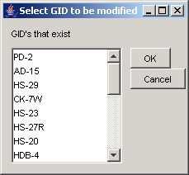
Figure 3.20 Modifying an existing accessory

Destroy GID
If you need to destroy an existing generic identification from the .dat file that is used, this is done through the destroy GID operation. The destroy GID window is opened by clicking the destroy an existing generic ID button. In this window there is a list of all the accessories generic identifications that the .dat file contains. If you want to destroy one or more GIDs, select them from the list and click the ‘>>>’ button, which moves the GIDs to the list on the right side of the window. The list on the right side is the list for the GIDs to be destroyed. By clicking OK the GIDs are destroyed. With cancel, no changes are made.
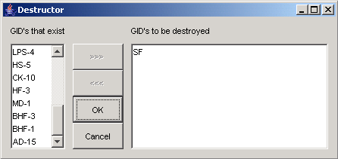
Figure 3.21 Destroy GID

View GID
You can view the capabilities that an existing generic identification contains with the view GID operation. This is opened from the main window with the View an existing GID button. This opens a window that contains a tree model that has all the existing GIDs for accessories in the .dat file. If you want to print some accessory’s information to a file, you have to select the accessory and select the print to a file command from the menu bar. This saves the information to a file named CapabilitiesInDB.html.
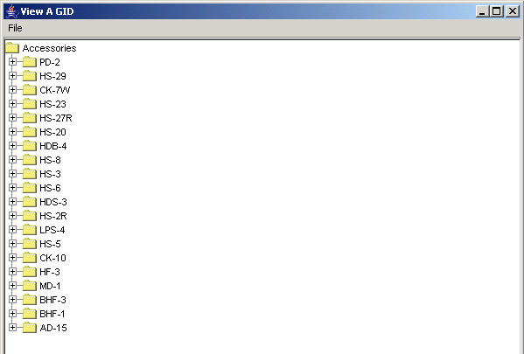
Figure 3.22 View a GID

Add new capability
Add new capability operation is started by clicking the ‘Add a New Capability’ button from the main window. When the window opens up (it takes a while to load all the XML files) with the tree model, you have to open up the capability group where you want to add the new capability. The new capability is added by clicking the empty spot where the capability is supposed to be added (to the same position as in the AccPolProprietaryNameValuePairs.h). The name of the capability and the name that is defined in the header file (AccPolProprietaryNameValuePairs.h) has to be typed to the dialogs that open up. If the capability can have additional information, press ‘Yes’ button when the dialog requires it, if it can’t have any press ‘No’ button. If the capability was added to a new capability group (or to a new subgroup) you have to name the new group also. When a new capability group needs to be taken in to use, it must also be defined in the Capability Groups (the capability must be defined that points to the capability group). In the GID PC Tool every subgroup must be named with its own name (this has only an effect to the GID PC Tool), even though the four subgroups form one capability group. The names of the capability groups should be related to the same as was defined in the Capability Groups capability group. See the example of adding a new capability group in section 4.2.
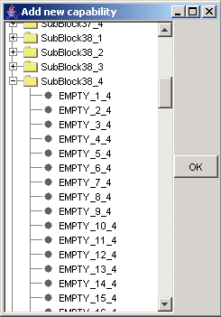
Figure 3.23

Destroy a capability
Destroying a Capability is opened by clicking the ‘destroy a capability’ button in the main window. When the window opens up with the tree model, it shows all the capabilities that are defined to the XML database. If you want to destroy some capability just click the capability and confirm ‘OK’ in the dialog that appears. This can still be undone by pressing the ‘cancel’ button.

Modify a capability
The ‘modifying a capability’ window is opened by clicking the ‘modify a capability’ button in the main window. When the window opens up with the tree model, it shows all the capabilities that are defined to the XML database. If you want to modify some capability, just click the capability and give the new name and name defined in the header file to the dialogs that appear. If the capability has additional information, click the ‘OK’ button. All the changes can still be undone by pressing the cancel button.

View capabilities
If you want to look at capabilities explanations, open up the view capability window. You can browse the capabilities and their information by clicking the capabilities and looking at the information window that opens up. New definitions can also be added to the list. The capability definitions can also printed to a file named AccessoryCapabilities.doc (this is printed to the root of the GID PC Tool).
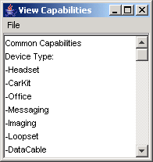
Figure 3.24 Viewing capabilities
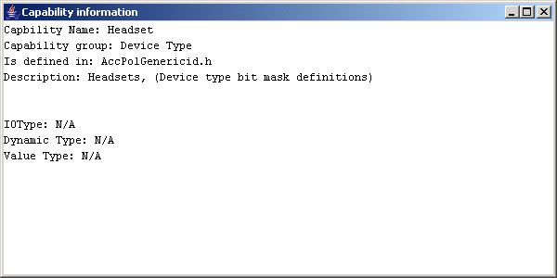
Figure 3.25 Viewing capabilities

Updating the accessory database
The updating of the accessory database is done from the GID PC Tool main window. By pressing the ‘Update Accessory Database’ button the database in the S60 environment can be updated. What happens when the accessory database is updated is described in Figure 3.26. Basically, the work is done by the createDB.cmd file. It copies the .dat file to the correct location and runs the DBImporter.exe. After DBImporter.exe is run, the logs of which capabilities for which accessories were imported are printed to the EPOCWND.out file. All the user has to do is to press the update button.
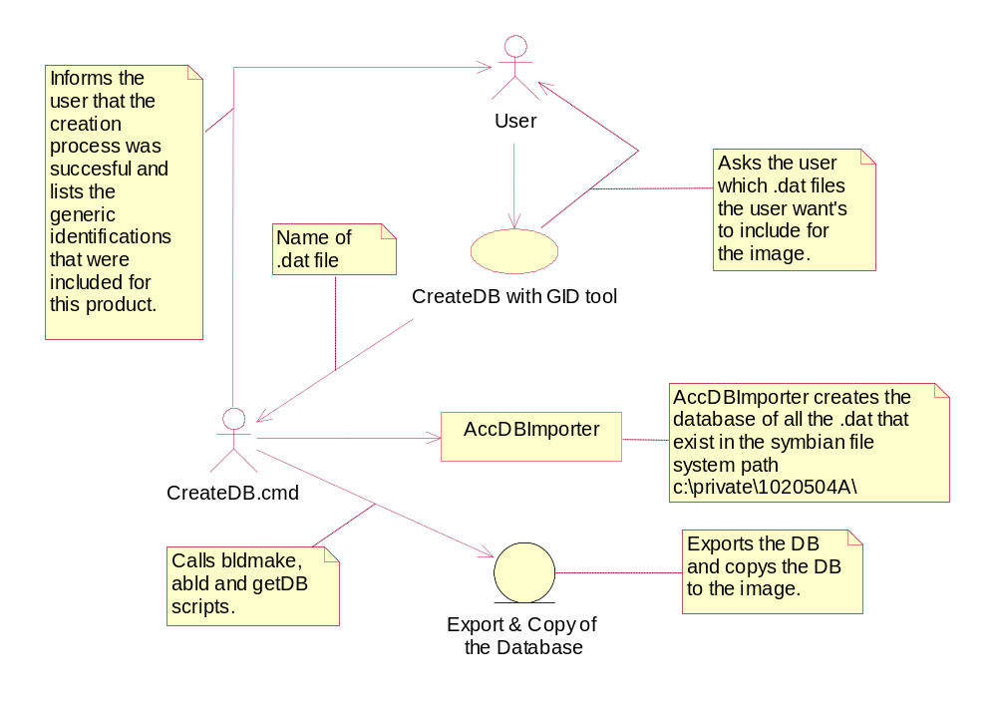
Figure 3.26 Updating database with GID tool

Update XML capability information files
The updating of the capability information files is done from the GID PC Tool main window. When the ‘Update Capability Information XML files’ button is pressed the dialog in Figure 3.27 opens up. In this dialog the direction of the update has to be set by selecting the correct radio button. The update process starts when the ‘OK’ button is pressed. The first selection copies the proprietary XML files to the accessory policy’s data\XML folder. The second choice copies the proprietary XML files from Accessory Policy to GID PC Tool XML_FILES\PROP folder. The third choice copies the common XML files from Accessory Servers Data\XML folder to GID PC Tool XML_FILES\COM folder. This should be done each time the S60 release is updated (so the newest capabilities would be used).
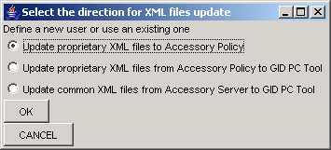
Figure 3.27 Updating XML files
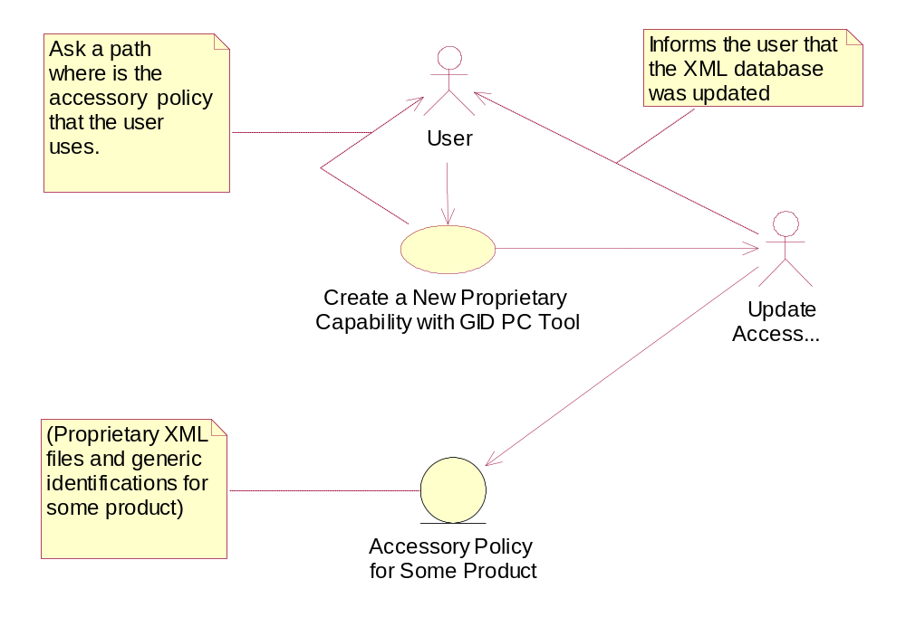
Figure 3.28 Updating proprietary XML files with GID tool to Accessory Policy

Creating a rule for the Accessory Policy

Accessory rules are used to control accessory selection dialog, so that every rule index is associated with a certain amount of selections. These selections appear to the phone UI when some accessory, that is unidentified, is connected to the phone. The actual rules are defined as capabilities from the GID header and these capabilities are compared with information received from the domestic OS side.
Creating a rule is started by pressing the create a rule button from the GID PC Tool main window (Figure Figure 3.15 GID PC Tool main window). The create a rule window is now opened up (Figure 3.29). The rule creation is started by giving the rule index by pressing the ‘Set rule index, HW model ID and HW device ID’ button. For every rule index can be set rules by defining capabilities or HW identification information (see examples chapter 4.3.). For every rule index can be defined more than one rules. When accessory server checks which capabilities match to which rule index, the capabilities inside one rule are matched with AND bit operation and capabilities in different rules but same index are matched with OR bit operation. How the rules are linked to information received from the domestic OS layer is explained in Accessory Policy design document [3].

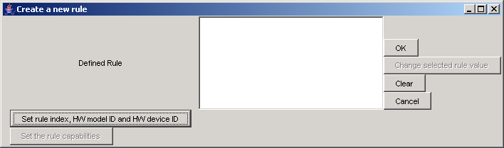
Figure 3.29 The defining a rule window
The rule index must be defined to an integer value (Figure 3.30). After the rule index has been defined and ‘OK’ button has been pressed the accessory model ID window pops up (Figure 3.31).
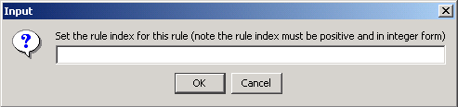
Figure 3.30 Setting the rule index
If the accessory model ID is set, it is used as a rule. After this window the set HW device ID window pops up (Figure 3.32). If the HW device ID is set it is set as a rule as HW model ID. Both of these information chunks can be matched to domestic OS side information as with capabilities.
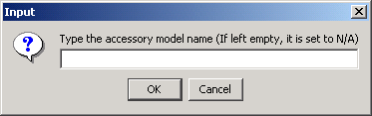
Figure 3.31 Setting the accessory model for a rule
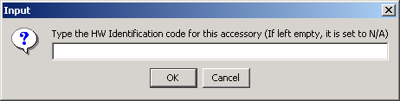
Figure 3.32 Setting the HW device ID for a rule
Capabilities from GID header can be set as rules by pressing the ‘set the rule Capabilities’ button. The windows pop up in order for setting Figure 3.33, Figure 3.34, Figure 3.35 and Figure 3.36 capabilities as rules. After the rules have been defined, the window for setting the selections to this rule index pops up. Selections can be defined as shown in Figure 3.37. After this the defined rules and selection can be seen on the screen as shown in Figure 3.38.
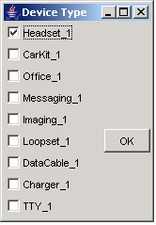
Figure 3.33 Setting the device type for a rule
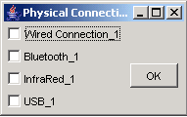
Figure 3.34 Setting the physical connection for a rule
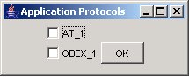
Figure 3.35 Setting the application protocols for a rule
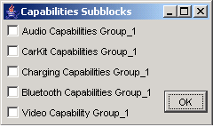
Figure 3.36 Setting the capability groups for a rule
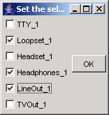
Figure 3.37 Setting the selections for this rule.
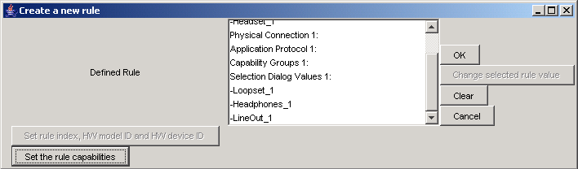
Figure 3.38 Defined rules for these for an index

Examples

Creating a capability to a new capability group
After the capability and the new capability group is defined to the header file (AccPolGenericIdDefinitions.h), it must be set to the GID PC Tool. In GID PC Tool should the ‘add new capability’ window be opened (Figure 3.23).
- First the new capability group (=new capability) is added to the Capability Groups (Figure 4.39 and Figure 4.40). Capability Groups is the fourth part of the GID header.

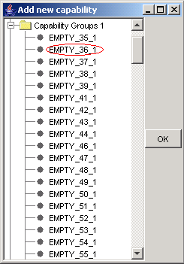
Figure 4.39 Adding a new capability group
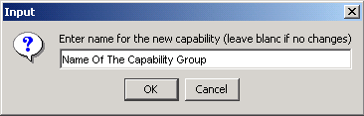
Figure 4.40 Naming a new capability group
- After this is done, the same capability group that was added to Capability Groups is opened (Figure 4.41). The capability is added to this capability groups first sub group (the capabilities should be used in order from the groups).
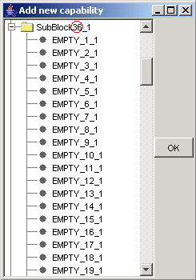
Figure 4.41 Adding a capability to a capability group
- First, the name of the new capability is asked (Figure 4.42). After this, the name that is in the header file for this capability is asked (Figure 4.43).
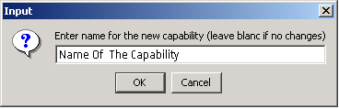
Figure 4.42 Naming the new capability
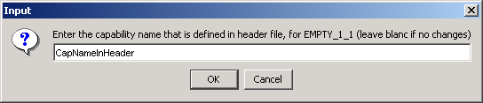
Figure 4.43 Naming the capability’s header file name
- After the name of the capability is given, the program asks for the name of the new capability group (Figure 4.44). The name can be set to anything, and it isn’t bound to Capability Groups capability definition, but it is advised that the same name is given to this group as the capability’s name in Capability Groups. After this the capability is ready to be used in a generic identification. The next example shows how this capability is used in a GID.
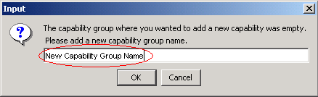
Figure 4.44 Figure 34

Creating a generic identification with a new capability
As the new capability is created to the capability information XML files, we’ll make a generic identification that uses it. The create GID window is opened from the main window.
- First HW model and device IDs are given to the accessory (Figure 4.45).
Figure 4.45 Naming the accessory model ID
Figure 4.46 Naming the HW Identification
- Next the ‘Add GID Header & Capabilities’ button is pressed (Figure 3.16). Next the GID header part capabilities have to be given (fig. Figure 4.47, Figure 4.48 and Figure 4.49), and in the fourth part, Capability Groups, the new capability group is defined (Figure 4.50).
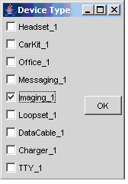
Figure 4.47 Device type
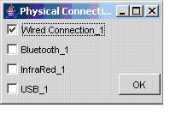
Figure 4.48 Physical connection
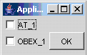
Figure 4.49 Application protocols
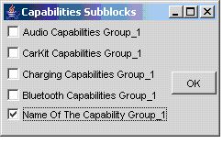
Figure 4.50 Capability groups
- Now that the new capability group was defined, after pressing ‘OK’ button the new capability group window opens up. From that window the new capability is defined (Figure 4.51).
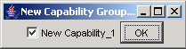
Figure 4.51 The new capability in the new capability group
- After this the generic identification is shown in the defined capabilities window. By pressing ‘OK’ button the generic identification is created to the .dat file. This GID can be exported to the database as in 3.3.12.

Creating a rule and mapping it to selections in the Accessory Selection dialog

Let’s look at a situation where a rule must be created that is linked to information. We’ll look at an example where some information should result two selections to accessory selection dialog. If we assume a situation where we receive from domestic OS side either the information
- headset and audio capability group capabilities
or
- HW device ID 012345 and audio capability group capability
, must the headset and loopset selections appear to the dialog.
To get the OR operation (in other words that the rule is matched with the first two capabilities OR to the HW device ID and the audio capability group capability) to this rule we have to create two rules for one rule index. Let’s look at the first side of the OR.
- As the create rule window is opened, the ‘Set rule index, HW model ID and HW device ID’ button is pressed to set the rule index. This opens up a window where the rule index is inserted as in Figure 4.52.
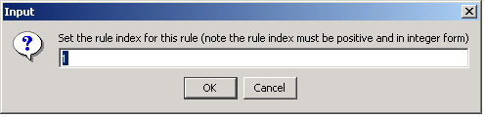
Figure 4.52 Setting the rule index for a rule
2. The accessory model name and HW device ID fields must be left empty so that they are not used as a rule (Figure 4.53 and Figure 4.54). The application sets these fields as N/A when they are left empty. As the first fields are filled the Create a new rule window should be updated as in Figure 4.55.
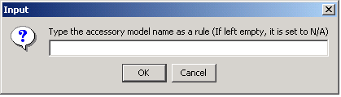
Figure 4.53 Setting the HW model ID for a rule
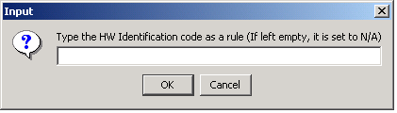
Figure 4.54 Setting a HW device ID for rule
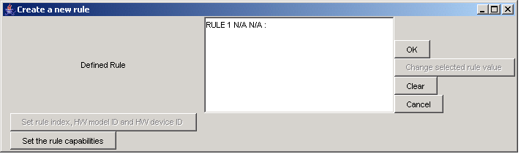
Figure 4.55 The create a new rule window with rule main information
3. To set the capabilities as rules for this rule index the ‘Set the rule capabilities’ button must be pressed. This opens windows for setting the capabilities to this rule index. As we wanted to set the headset capability as a rule, we must now check the headset button as shown in Figure 4.56. And since we didn’t want to use capabilities from physical connection or application protocols capabilities as a rule, we leave those empty.
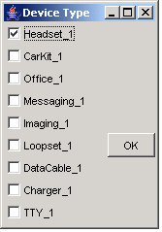
Figure 4.56 Defining headset capability as rule
4. The other capability in this rule that was meant to be matched with the AND bit operation to this rule was Audio Capability Group. To add the Audio Capability Group to this rule the capability is marked as in Figure 4.57.
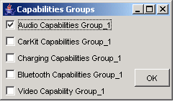
Figure 4.57 Defining Audio Capability Group as rule
5. As the rules have been set it is time to set the right selections for this rule. These are selected in the next window that opens after the capability groups. As shown in Figure 4.58 the loopset and headset capabilities are selected. After ‘OK’ button is pressed Create a new rule window is updated as in Figure 4.59 (showing the rules and selections made).
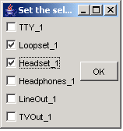
Figure 4.58 Defining selections for accessory selection dialog
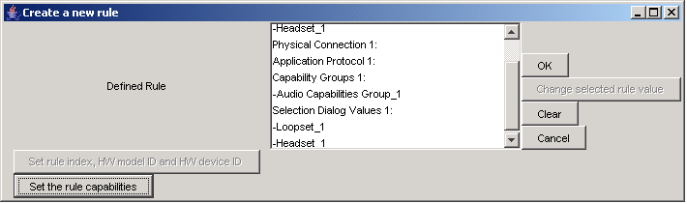
Figure 4.59 The defined rules and selections for a rule index
6. Now as the first part of this rule’s AND operation is made it is time to make the other part. It is started by opening up again the create a new rule window. As in the first time the ‘set rule index, HW model ID and HW device ID’ button is pressed. To rule index is set to the same number as with the first time as in Figure 4.52 and the HW model ID is left empty as in the first time. HW device ID has to be set as we wanted it to be in this rule the ‘012345’. This is done by writing the number to the HW device ID to the ‘set HW Device ID as a rule’ window as shown in Figure 4.60. After pressing ‘OK’ button the create a new rule window should look like Figure 4.61.
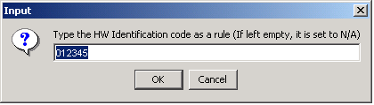
Figure 4.60 Defining a HW device ID for a rule
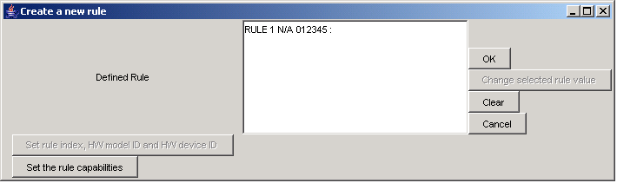
Figure 4.61 Rule main information shown in the Create a new rule window
7. After this we must add the capability Audio Capability Group to this rule. This is done by pressing the button ‘Set the rule capabilities’. The first three capability groups (device type, physical connection and application protocols) must be left empty, and in the fourth group (Capability Groups) must the Audio Capability Group capability selected as a rule (Figure 4.57 Defining Audio Capability Group as rule). After this the selections must be made as with the previous rule (Figure 4.58 Defining selections for accessory selection dialog). Now the rule is ready and showed in the Create a new rule window.
These two rules for the rule index 1 form the whole rule. The rules are saved in the rules.dat file in the used Accessory Policy. The generic identifications for selections are located also in the rules.dat file. The generic identifications for these selections can be modified just like a normal generic identification (3.3.4).

