S60 5.2
Plugged Display ASY
Design Document

Team name | Author
D RD SD SYMBA MYMEX Oulu Videos SWA FI | Jouni Vallo

Change history:

Version | Date | Status | Comments
1.0 | 14.8.2009 | Approved

Table of contents:

1. Document control 5
1.1 References 5
1.2 Documentation conventions 5
1.3 Abbreviations 5
1.4 Definitions 5
2. General 6
2.1 Introduction 6
2.2 Component environment 6
2.3 Services required 7
2.3.1 From the Symbian OS subsystems 7
2.3.2 From the Domestic OS subsystems 7
2.3.3 From HW 7
2.4 Services provided 7
2.4.1 UI 7
2.4.2 SW IF 7
3. UI control hierarchy 8
4. Design 9
4.1 Class diagrams 9
4.1.1 Framework 9
4.1.2 Component 11
4.1.3 HDMI Cable Status FSM 12
4.1.4 CTvOutConfigForHDMI 13
4.1.5 CEdidHandler 14
4.1.6 CAccessoryControlIf 15
4.1.7 CHDMICableStateIdle 16
4.1.8 CHDMICableStateRejected 17
4.1.9 CHDMICableStateConnected 18
4.1.10 CCompositeCableStatusFSM 19
4.1.11 CTvOutConfigForComposite 20
4.1.12 CCompositeCableStateIdle 21
4.1.13 CCompositeCableStateConnected 22
4.1.14 CCentralRepositoryWatch 23
4.2 Class descriptions 24
4.2.1 Structs, type definitions and enumerations 26
4.2.1.1 Definitions of ediddatatypes.h 26
4.2.1.2 Enumerations of ediddatatypes.h 26
4.2.1.3 Structs of ediddatatypes.h 26
4.2.1.4 Definitions of multifinitestatemachine.h 27
4.2.1.5 Enumerations of pdeconstants.h 27
4.2.1.6 Structs of tvoutconfigforhdmi.h 27
4.2.2 Flag definitions 27
4.2.3 State diagrams 28
4.2.3.1 Composite Cable Status FSM’s main states 28
4.2.3.2 Composite Cable Connected state’s substates 29
4.2.3.3 HDMI Cable Status FSM’s main states 30
4.2.3.4 HDMI Cable Connetected state’s substates 31
4.3 Operations 31
4.3.1 Creating Plugged Display Engine 31
4.3.2 Creating Composite Cable Status FSM 32
4.3.3 Creating the (Composite FSM) Connected state 33
4.3.4 Connected state’s actions (Composite FSM) 34
4.3.5 Idle state’s actions (Composite FSM) 35
4.3.6 Creating HDMI Cable Status FSM 36
4.3.7 Creating the (HDMI FSM) Connected state 37
4.3.8 Connected state, basic and disconnect actions (HDMI FSM) 38
4.3.9 Connected state, setting change (HDMI FSM) 39
4.3.10 Connected state, copy protection status change (HDMI FSM) 40
4.3.11 Connected state, set on/off and get copy protection status (HDMI FSM) 41
4.3.12 Connected state, get objects (HDMI FSM) 42
4.3.13 Idle state, cable connection (HDMI FSM) 43
4.3.14 Rejected state, cable disconnection (HDMI FSM) 44
4.3.15 Connected state, EDID data handling (HDMI FSM) 45
4.3.16 Idle state, EDID data handling (HDMI FSM) 46
4.4 Backup and Restore 47
5. Variation 48
6. System resource usage 49
6.1 Files 49
6.2 Other data 49
6.2.1 Databases 49
6.2.2 Central Repository 49
6.2.3 Publish and Subscribe 49
6.3 Memory consumption 49
6.4 Task allocation 49
6.5 Performance 50
6.6 Timers 50
7. Security 51
7.1 Capabilities of this component 51
7.2 Input and output validation 51
7.3 Environmental assumptions 51
7.4 Additional enforcements 51
8. Exception handling 52
9. Usage 53
9.1 Building 53
9.2 User's guide 53

Document control

References
- S60 Accessory Framework Design Document
- CEA-861-E: A DTV Profile for Uncompressed High Digital Interfaces | Consumer Electronics Association (CEA) document. http://www.ce.org/

Documentation conventions
Code is shown with the Courier New font.

Abbreviations
FSM | Finite State Machine

Definitions
Composite FSM | Composite Cable Status FSM
HDMI FSM | HDMI Cable Status FSM
MFSM | Multi FSM. An object that includes several FSM implementations.

General

Introduction
Plugged Display ASY’s main responsibility is to observe the HDMI and composite cable connection status.
The Plugged Display ASY responsibilities are:
- Listening to HDMI cable connections
- Resolving video parameters from the HDMI device and providing the supported video formats to Display Adaptation and Driver
- Resolving audio parameters from the HDMI device and providing the supported audio parameters to Audio Adaptation
- Listening to composite cable connections
- Resolving user configured TV out settings and providing the configured settings to Display Adaptation and Driver
- Connecting the HDMI or composite TV as a new accessory via the Accessory Framework

Component environment
The key relationships between Plugged Display ASY and the components in its environment are shown in reference document Error: Reference source not found.
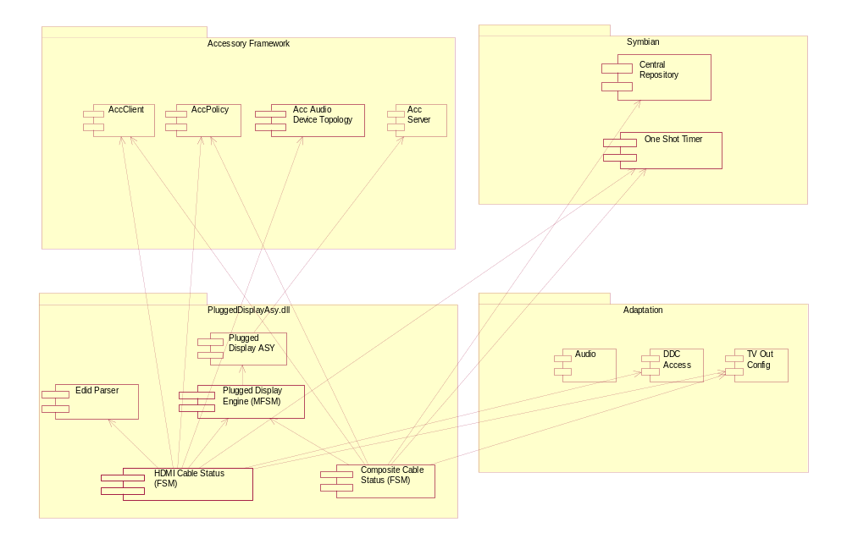
Figure 2.1 Plugged Display ASY environment

Services required

From the Symbian OS subsystems
API | Description
CRepository | Provides access to repository. Composite Cable Status FSM subscribes for following key value changes under the category KCRUidTvoutSettings:  - KSettingsTvAspectRatio  - KSettingsTvoutFlickerFilter  - KSettingsTvSystemInfo
CActive | The core class of the active object abstraction.
Math | A collection of mathematical functions.
CAsyncOneShot | An active object that performs processing that is only performed once.
TParse | Parses filenames.
TFileName | A buffer that can contain the name of a file.
CFbsBitmap | A bitmap managed by the font and bitmap server.
TBitmapUtil | Provides fast read/write access to the image data of a bitmap.
CTvOutConfig | An adaptation component that hides hw-drivers from the users.
CDdcAccess | An adaptation component that hides hw-drivers from the users.

From the Domestic OS subsystems
This component does not have any direct interfaces to the Domestic OS side subsystems.

From HW
This component has no direct HW interfaces.

Services provided

UI
This component does not provide any UI.

SW IF
Plugged Display ASY (together with Plugged Display Engine) implements an ASY Plug-in. Only HDMI Cable connection parameters can be accessed and/or manipulated through CPDAsyCmdHandler. Composite Cable connection parameters cannot be accessed through CPDAsyCmdHandler.

Provided Service | Description | Protected
CPDASyMainService | Implements the ASY Plug-in API’s main service. | Yes
CPDAsyCmdHandler | Responsible for handling commands sent by the Accessory Framework. | Yes

UI control hierarchy
The component does not contain any UI or UI controls.

Design

Class diagrams

Framework
Plugged Display Engine follows the MFSM framework. In this framework there is an MFSM object that implements an MFSMBody interface. MFSM object owns one to n FSM objects that are independent state machines. FSM objects’ life span can be the same as MFSM’s lifespan or shorter. FSM object implements the interfaces MFSMForBody and MFSMForState so there are two views available; one for viewing from “above” and other for viewing from “below”. Each FSM object can have 0 to n FSMState objects representing different states of a given FSM. FSMState object implements an MFSMState interface. At a given moment of time an FSM can have only one FSMState object active representing the current state. FSMState can have substates.
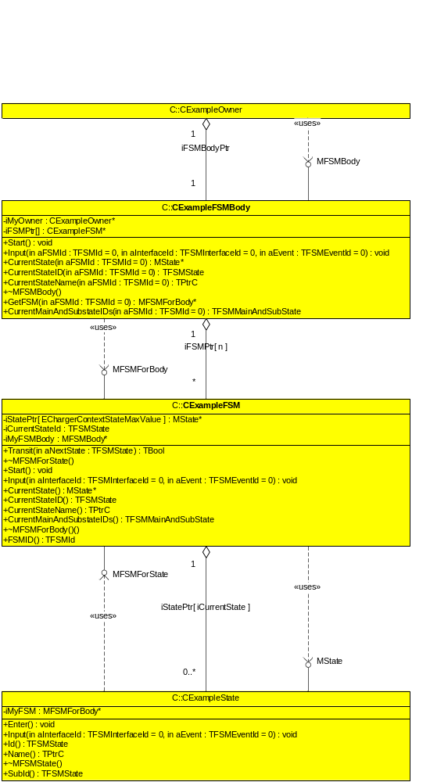
Figure 4.2 MFSM framework

Component
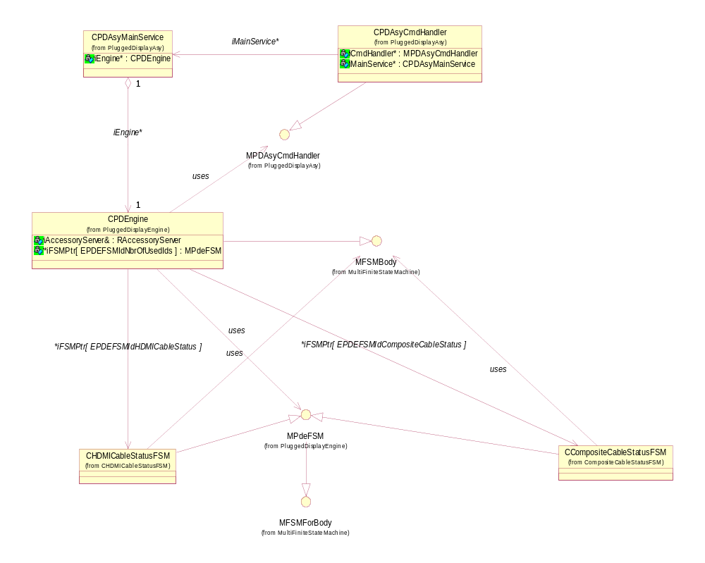
Figure 4.3 Plugged Display ASY
Figure 4.3 illustrates the parts of Plugged Display Engine. CPDEngine is an MFSM object that has two FSM objects: CHDMICableStatusFSM and CCompositeCableStatusFSM. CPDAsyMainService creates CPDEngine to be used for example by CPDAsyCmdHandler.

HDMI Cable Status FSM
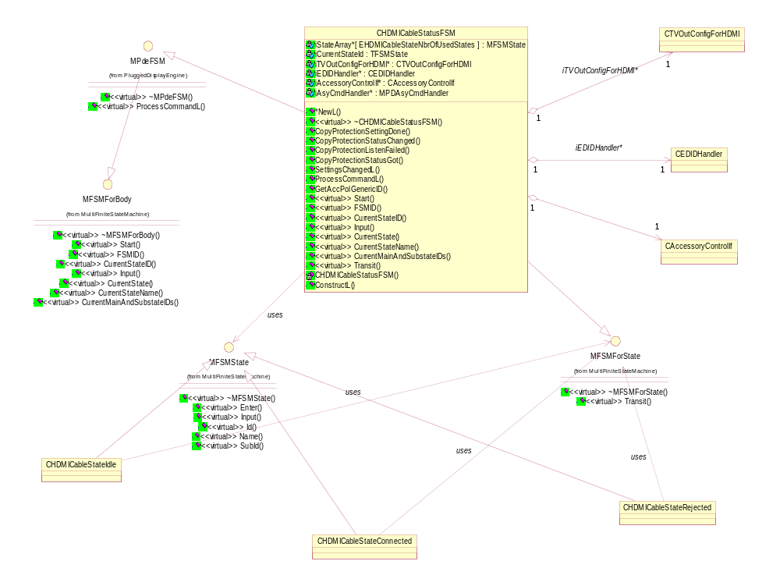
Figure 4.4 HDMI Cable Status FSM
Figure 4.4 shows that HDMI Cable Status FSM has three main states: Idle, Connected and Rejected.

CTvOutConfigForHDMI
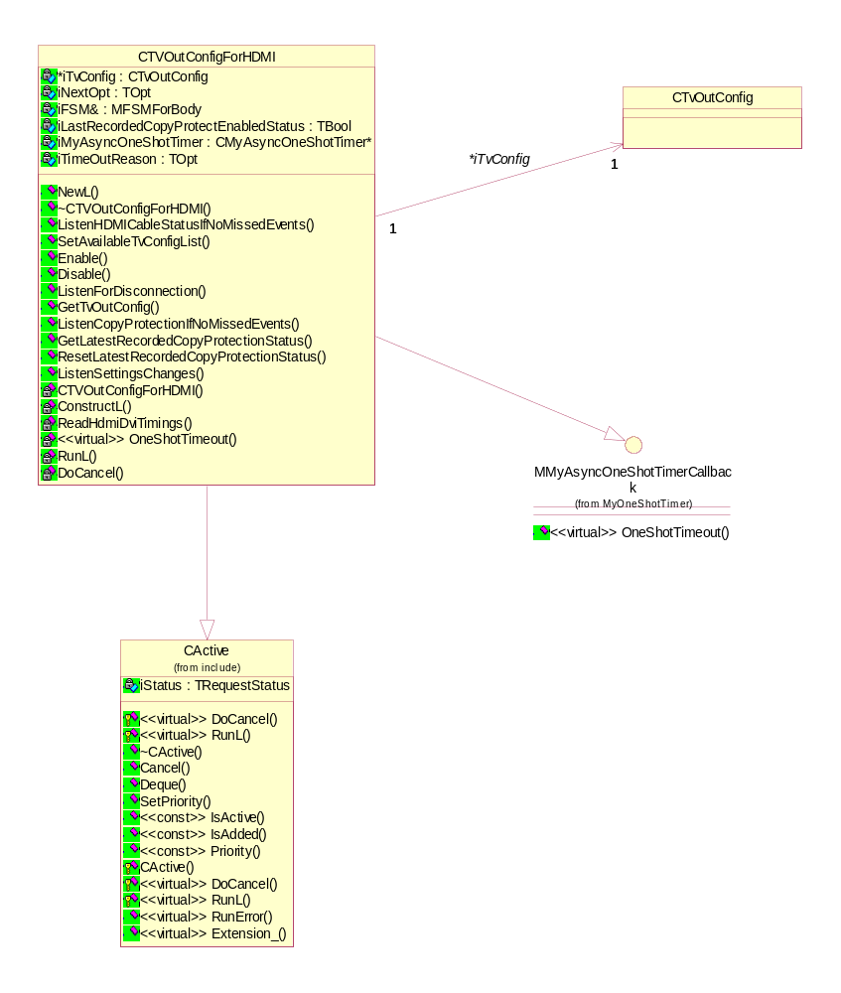
Figure 4.5 CTvOutConfigForHDMI

CEdidHandler
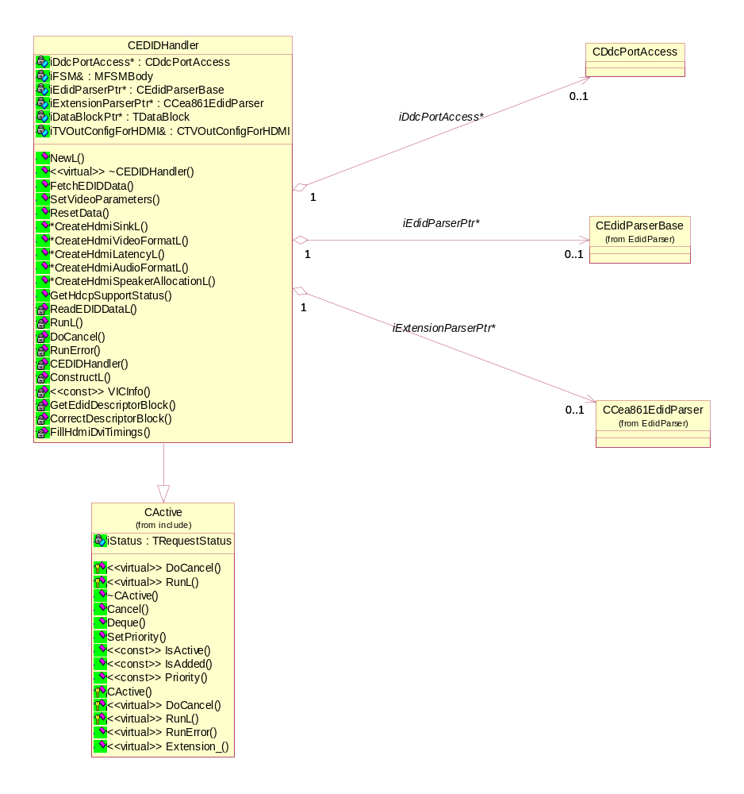
Figure 4.6 CEdidHandler

CAccessoryControlIf
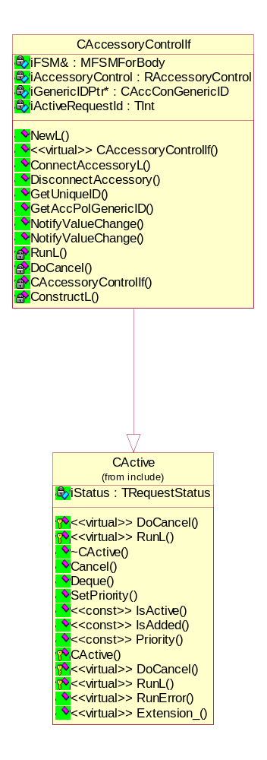
Figure 4.7 CAccessoryControlIf

CHDMICableStateIdle
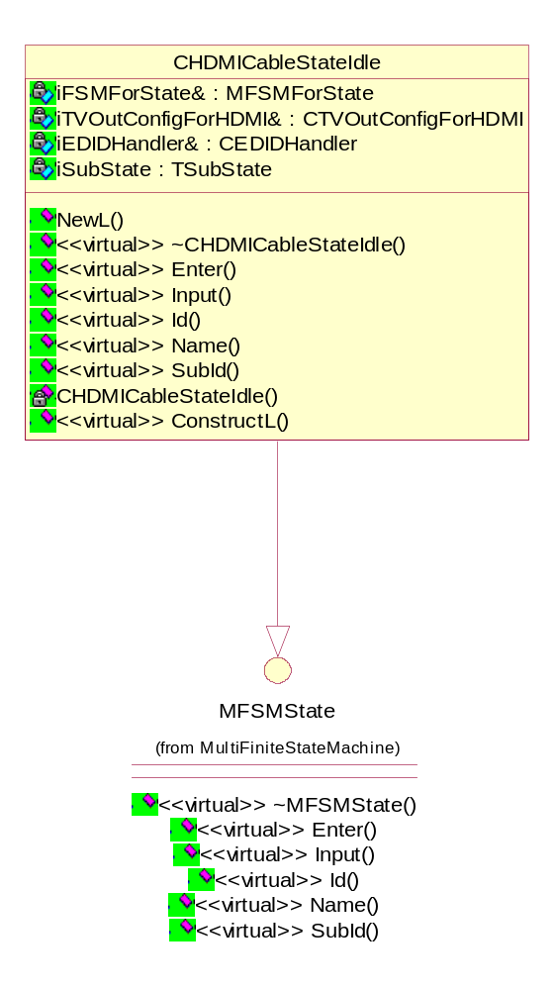
Figure 4.8 CHDMICableStateIdle

CHDMICableStateRejected
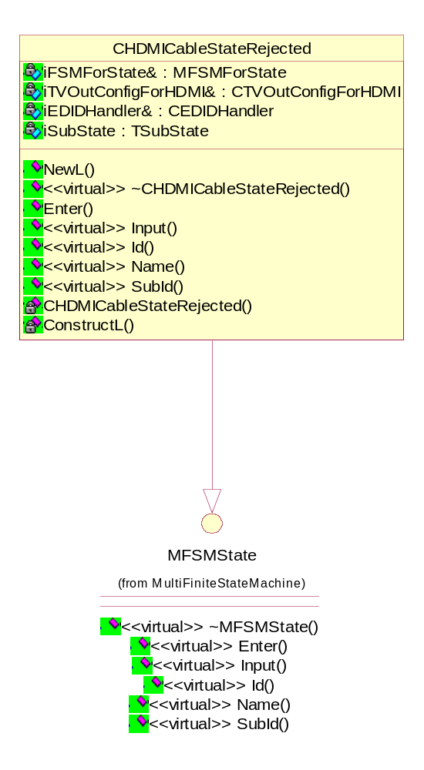
Figure 4.9 CHDMICableStateRejected

CHDMICableStateConnected
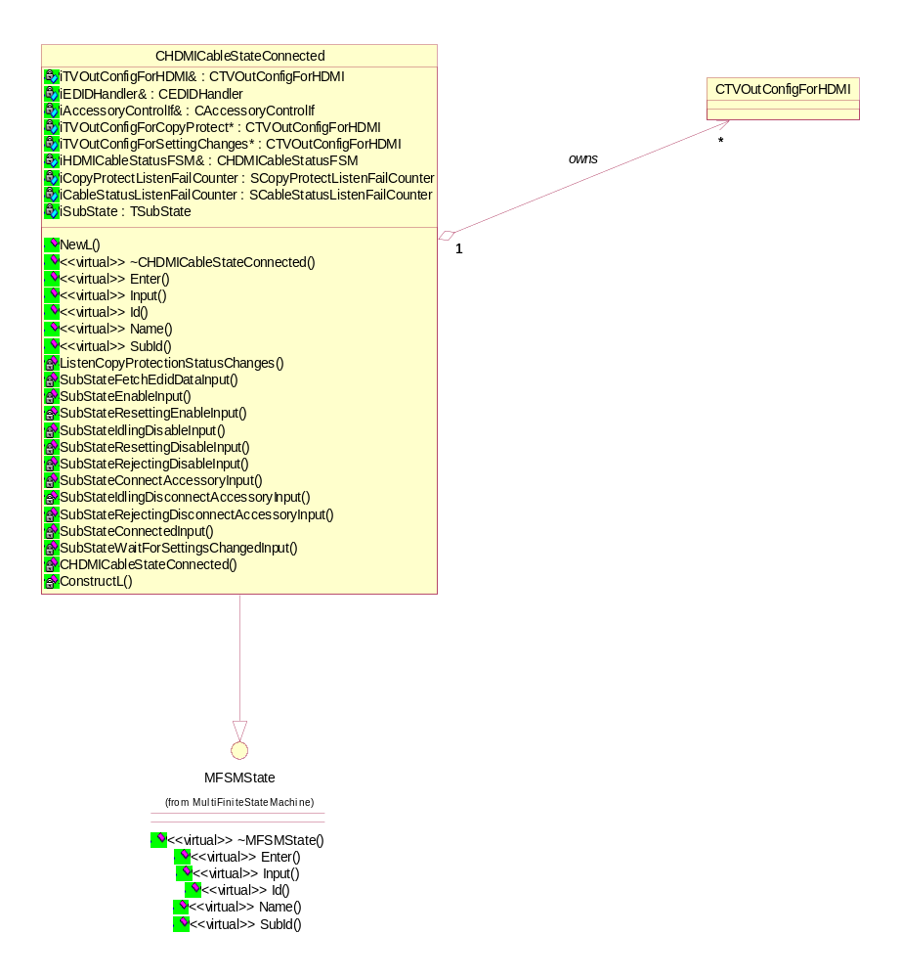
Figure 4.10 CHDMICableStateConnected

CCompositeCableStatusFSM
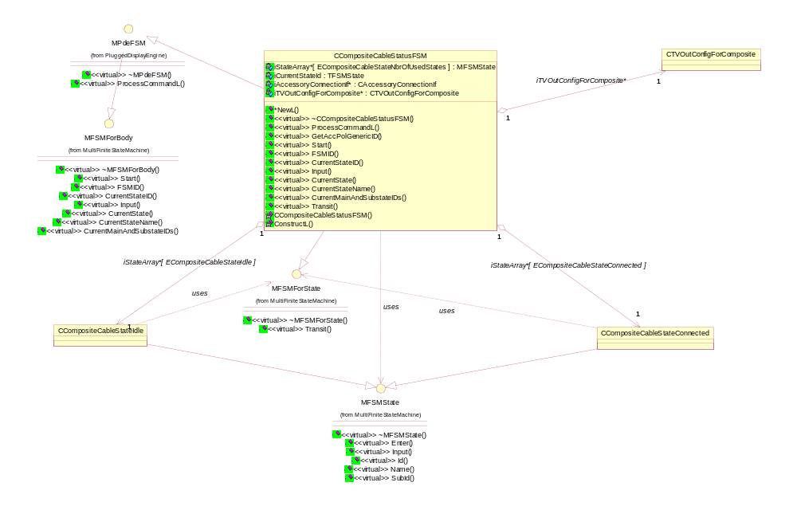
Figure 4.11 CCompositeCableStatusFSM
Figure 4.11 shows that Composite Cable Status FSM has two main states: Idle and Connected.

CTvOutConfigForComposite
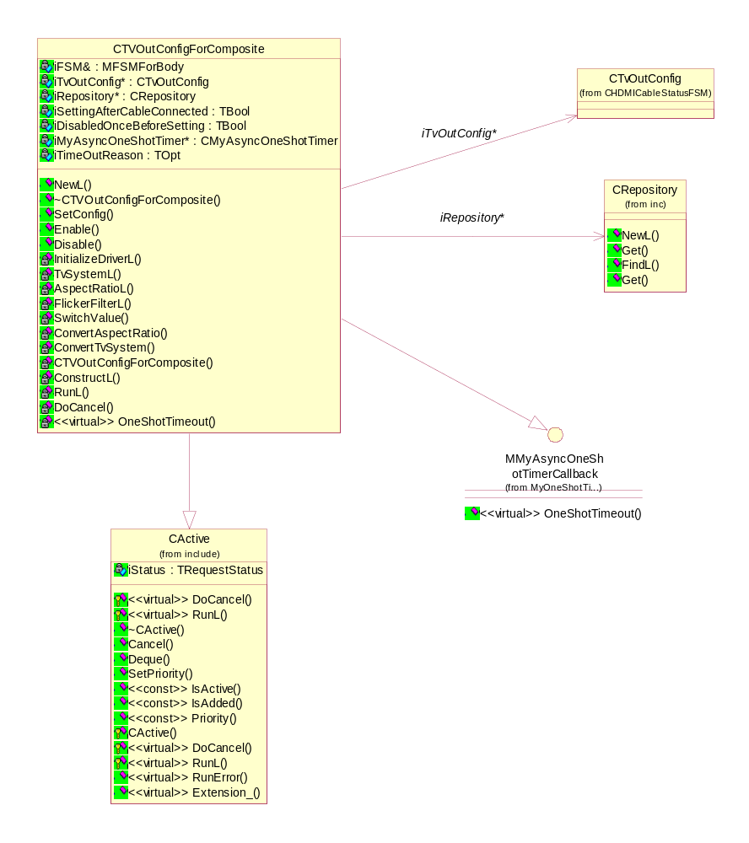
Figure 4.12 CTvOutConfigForComposite

CCompositeCableStateIdle
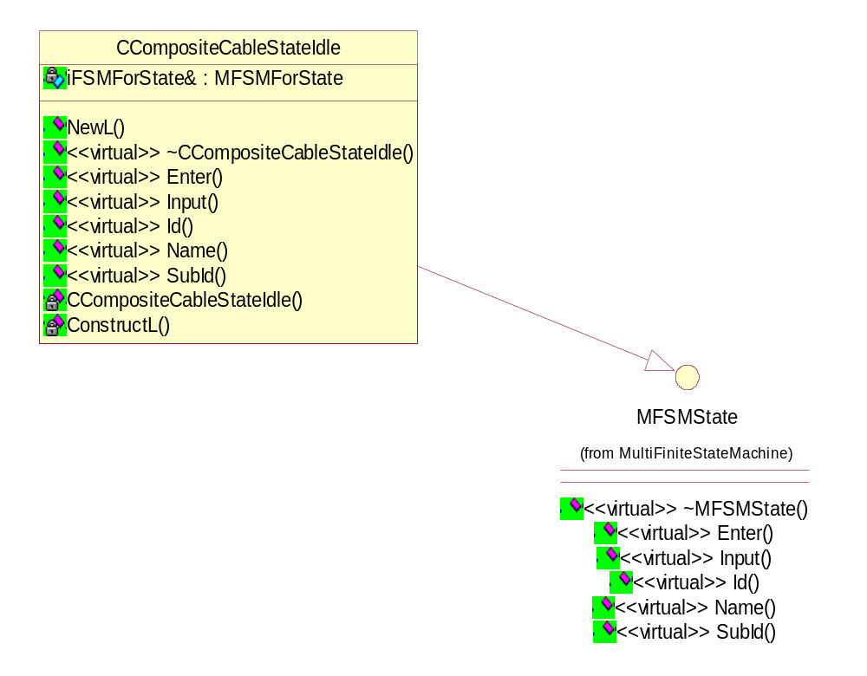
Figure 4.13 CCompositeCableStateIdle

CCompositeCableStateConnected
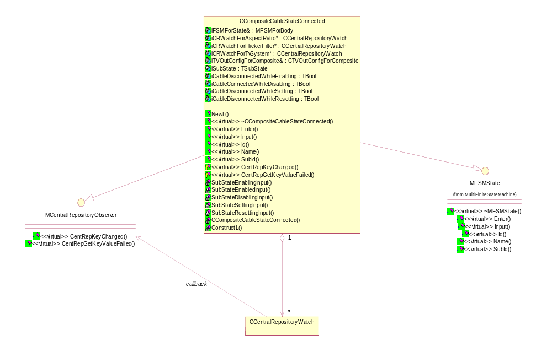
Figure 4.14 CCompositeCableStateConnected

CCentralRepositoryWatch
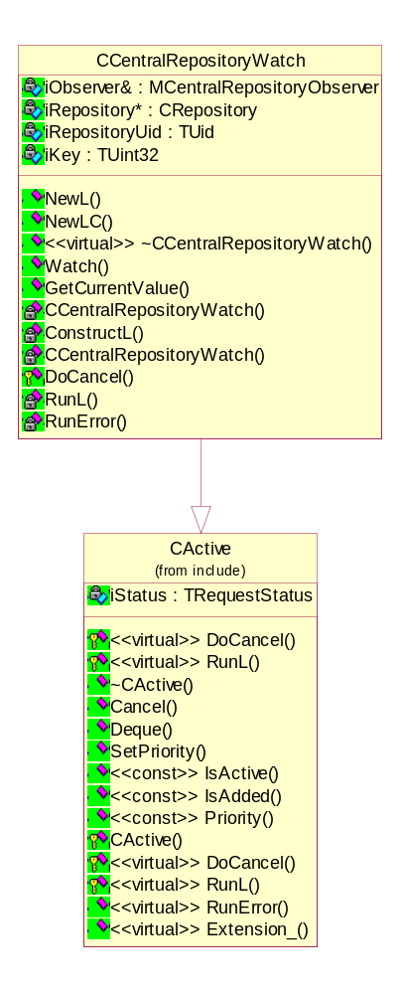
Figure 4.15 CCentralRepositoryWatch

Class descriptions
Class | Description | Header file
CEdidParserBase | The base class for parsing EDID data. | edidparserbase.h
CCea861EdidParser | The base class for parsing CEA 861 EDID extension data. | cea861edidparser.h
TCEA861VideoData  Block | Video data block. See reference document [2] | cea861ediddatatypes.h
TCEA861AudioData  Block | Audio data block. There can be up to ten short audio descriptors in the audio data block. Each audio descriptor consists of three bytes. See reference document [2]. | cea861ediddatatypes.h
TCEA861Speaker  AllocationData | Speaker Allocation Data block. See reference document [2]. | cea861ediddatatypes.h
TCEA861Vendor  SpecificDataBlockPayload | Vendor Specific Data Block payload. | cea861ediddatatypes.h
TCEA861Vendor  SpecificDataBlock | Vendor Specific Data block. See reference document [2]. | cea861ediddatatypes.h
TCEA861TEdid  DescriptorBlockList | A linked list that holds all descriptor blocks. | cea861ediddatatypes.h
TCEA861Video  CapabilityDataBlock | Video Capability Data block. | cea861ediddatatypes.h
CCea861ExtEdid  Information | CEA 861 Extended EDID information. | cea861ediddatatypes.h
MPDAsyCmdHandler | Provides the needed services through which Plugged Display Engine can process command responses. | pdasycmdhandlerinterface.h
CPDAsyMainService | Implements the ASY Plug-in API main service. | pdasymainservice.h
CPDAsyCmdHandler | Is responsible for handling commands sent by the Accessory Framework. | pdasycmdhandler.h
CAccessory  ConnectionIf | Accessory Connection interface. | accessoryconnectionif.h
CAccessory  ControlIf | Accessory Control interface. | accessorycontrolif.h
MCentral  RepositoryObserver | A callback interface for the observer of the CCentralRepositoryWatch object. This callback interface has to be implemented by the observer class. | centralrepositoryobserver.h
CCentral  RepositoryWatch | A class to watch the key value changes in Central Repository. | centralrepositorywatch.h
CCompositeCable  StateConnected | Connected state implementation for Composite Cable Status FSM. Composite Cable is connected in this state. | compositecablestateconnected.h
CCompositeCable  StateIdle | Idle state implementation for Composite Cable Status FSM. Composite Cable is not connected in this state. | compositecablestateidle.h
CCompositeCable  StatusFSM | A Finite State Machine class for HDMI Cable Status. | compositecablestatusfsm.h
CEDIDHandler | A class to handle EDID data. | edidhandler.h
CHDMICableState  Connected | Connected state implementation for HDMI Cable Status FSM. HDMI Cable is connected in this state. | hdmicablestateconnected.h
CHDMICableState  Idle | Idle state implementation for HDMI Cable Status FSM. HDMI Cable is not connected in this state. | hdmicablestateidle.h
CHDMICableState  Rejected | Rejected state implementation for HDMI Cable Status FSM. HDMI Cable connection has been failed for reason or another and user action to disconnect the cable is expected in this state. | hdmicablestaterejected.h
CHDMICableStatus  FSM | Finite State Machine class for HDMI Cable Status. | hdmicablestatusfsm.h
TFSMMainAndSub  State | Data type for FSM's main- and substate. Each implemented FSM has an enumeration for main- and substate identifiers, and the enumeration values are assigned to a variable of this type so that the FSM framework can handle the values transparently. | multifinitestatemachine.h
MFSMBody | Finite State Machine's body interface for its owner. Body can include one to n state machines. This callback interface has to be implemented by the FSM body implementation class. | multifinitestatemachine.h
MFSMForBody | FSM's interface for its (owning) Body. This callback interface has to be implemented by the FSM implementation class. | multifinitestatemachine.h
MFSMForState | FSM's interface for its State. This callback interface has to be implemented by the FSM state’s implementation class. | multifinitestatemachine.h
CMyAsyncOneShot  Timer | Asynchronous one shot timer implementation. | myasynconeshottimer.h
MMyAsyncOneShot  TimerCallback | A callback interface for CAsyncOneShotTimer derived class. | myasynconeshottimercallback.h
MPdeFSM | Finite State Machine's body interface for Plugged Display Engine. This callback interface has to be implemented by the FSM body implementation class. | pdefsm.h
CPDEngine | The CPDEngine class provides the main functionality in the plugged display. | pdengine.h
CTVOutConfigFor  Composite | TV Out Configurer for Composite Cable Status FSM. | tvoutconfigforcomposite.h
CTVOutConfigFor  HDMI | TV Out Configurer for HDMI Cable Status FSM. | tvoutconfigforhdmi.h
CTvStandbyFigure | A helper class for handling the stand by figure. Loads a bitmap from the MBM file, writes a string over it and converts the result bitmap to 16-bit RGB565 format. | tvstandbyfigure.h

Structs, type definitions and enumerations

Definitions of ediddatatypes.h
Definition's name | Description
KEdidParserSizeOfEdidBlock | Every EDID-block is 128 bytes long (padded to 128 bytes if shorter).
KEdidParserSizeOfEdidHeader | EDID header size.
KBaseEdidHeader[KEdidParserSizeOfEdidHeader] | Valid base EDID header.
KEdidBaseYear | Year of manufacture stored in EDID data is "Year of Manufacture - 1990".
KEdidPaddingByte | Padding byte’s initialization value.
KEdidParserSizeOfSegment | DDC segment size.
KEdidParserManufacturerCodeLength | Length of manufacturer code.
TEdidVendorCode | EDID manufacturer code.

Enumerations of ediddatatypes.h
Enumeration's name | Description
TEdidStereoViewingSupport | Stereo Viewing Support status constants.
TEdidSyncSignalDefinitions | Sync Signal Definitions.
TEdidDescriptorBlockType | EDID descriptor block type.
TEdidExtensionTagCode | EDID extension types.
TEdidEstablishedTimings1 | Established timings 1.
TEdidEstablishedTimings2 | Established timings 2.

Structs of ediddatatypes.h
Struct's name | Description
TDataBlock[KEdidParserSizeOfSegment] | EDID data block including extension.
TExtDataBlock[KEdidParserSizeOfEdidBlock] | One extension data block array (block size is 128 bytes).
TEdidAspectRatio | Aspect Ratio.
TEdidScreenSize | Screen Size (Horizontal and vertical in centimeters).
TEdidVendorProductInfo | Product vendor information.
TEdidBaseBlock | EDID block structure.
TEdidDescriptorBlock | EDID descriptor block type.

Definitions of multifinitestatemachine.h
Definition's name | Description
TFSMState | Data type for FSM's states. Each implemented FSM has an enumeration for state identifiers, and the enumeration value is assigned to a variable of this type so that the FSM framework can handle the value transparently.
TFSMId | Data type for FSM's identifications. Each implemented FSM body has an enumeration for included FSMs, and the enumeration value is assigned to a variable of this type so that the FSM framework can handle the value transparently.
TFSMInterfaceId | Data type for Interface identifications. Every interface used by an FSM Body has to have a unique identifier, i.e. an enumeration constant, of which the value is assigned to a variable of this type so that the FSM framework can handle the value transparently.
TFSMEventId | Data type for Interface's event identifications. Every interface has to have unique identifiers for its events, i.e. enumeration constants, of which the values are assigned to a variable of this type so that the FSM framework can handle the values transparently.

Enumerations of pdeconstants.h
Enumeration's name | Description
TPDEFSMId | Plugged Display Engine's FSM identifications.
TPDEInterface | Constants for used external interfaces/APIs.
THDMICableState | Constants for the states of HDMI Cable Status FSM.
TCompositeCableState | Constants for the states of Composite Cable Status FSM.

Structs of tvoutconfigforhdmi.h
Struct's name | Description
TCopyProtctListenRetValues | Returned struct for function CTVOutConfigForHDMI::ListenCopyProtectionIfNoMissedEvents().

Flag definitions
Flag | Description
traceconfiguration.hrh’s #undef/define FUNC_TRACE | This is normally undefined, but has to be defined if function tracing is to be done.

State diagrams

Composite Cable Status FSM’s main states
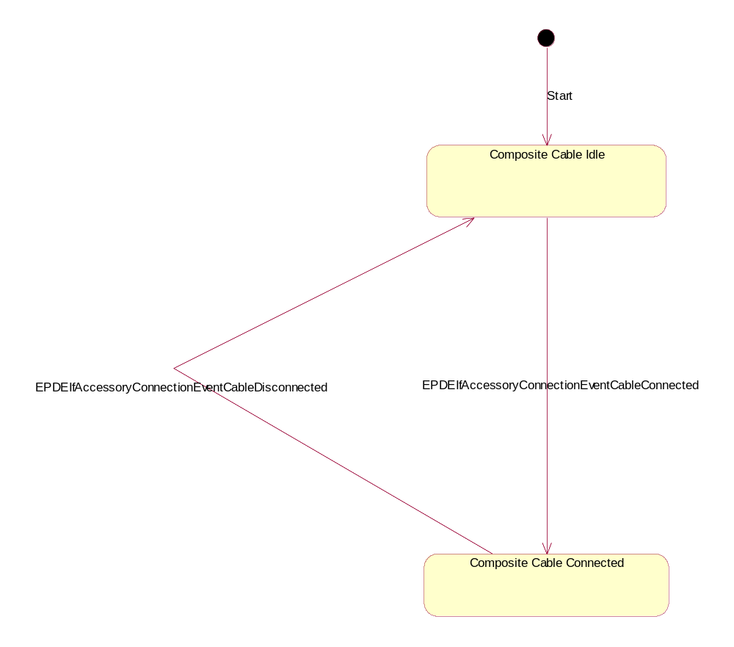
Figure 4.16 Composite Cable Status FSM’s main states

Composite Cable Connected state’s substates
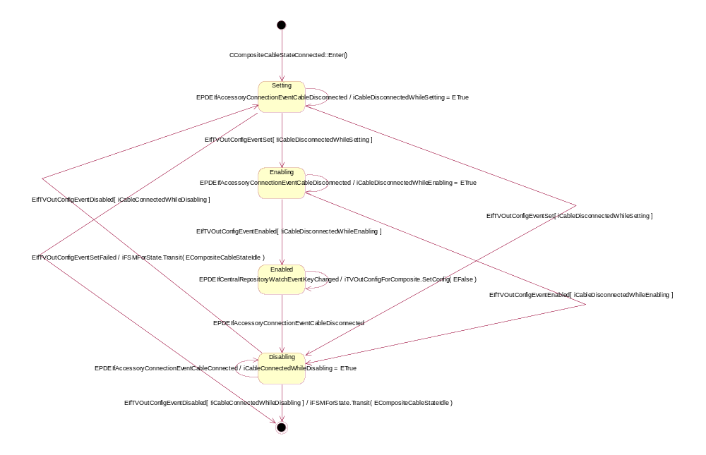
Figure 4.17 Composite Cable Connected state’s substates

HDMI Cable Status FSM’s main states
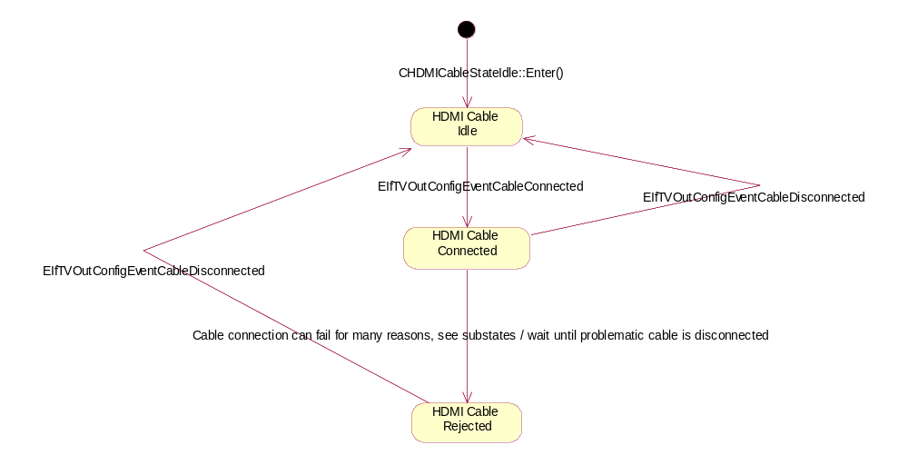
Figure 4.18 HDMI Cable Status FSM’s main states

HDMI Cable Connetected state’s substates
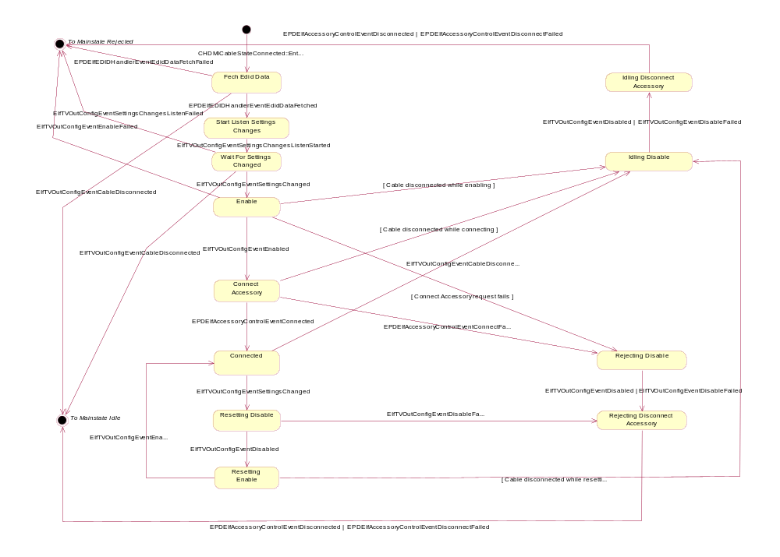
Figure 4.19 HDMI Cable Connected state’s substates

Operations

Creating Plugged Display Engine
Operation | Creating Plugged Display Engine.
Preconditions | The Accessory FW has started the creation of Plugged Display ASY.
Description | CPDAsyMainService creates Plugged Display Engine.
Inputs | Reference to the RAccessoryServer object.
Modifies | Creates an instance of CPDEngine.
Outputs
Postconditions | Plugged Display Engine (MFSM) is created and started.
Related To
Related Event
Exceptions
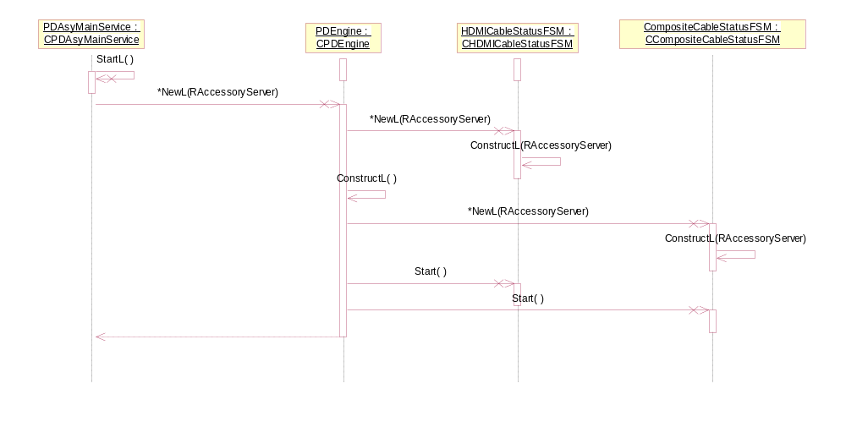
Figure 4.20 Creating Plugged Display Engine

Creating Composite Cable Status FSM
Operation | Creating Composite Cable Status FSM.
Preconditions | Plugged Display ASY has started the creation of Plugged Display Engine.
Description | CPDEngine creates Composite Cable Status FSM.
Inputs | Reference to the RAccessoryServer object.
Modifies | Creates an instance of CCompositeCableStatusFSM.
Outputs
Postconditions | FSM is created and started, and it enters the Idle state.
Related To
Related Event
Exceptions

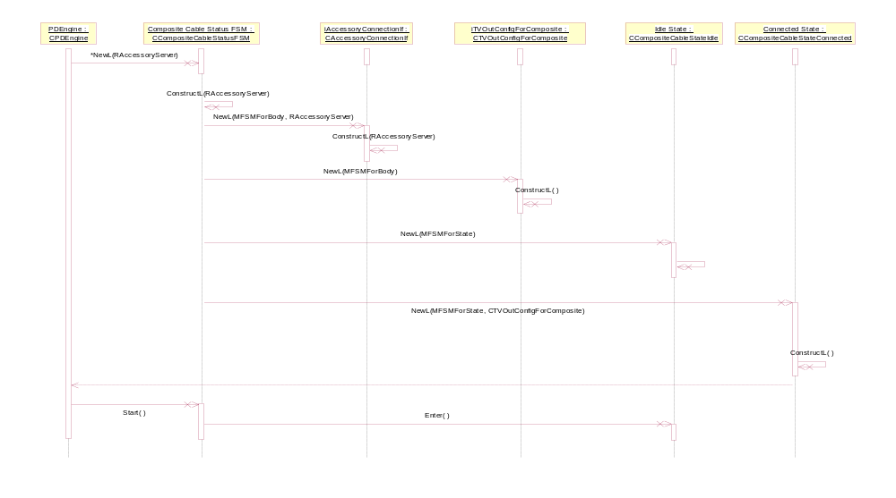
Figure 4.21 Creating Composite Cable Status FSM

Creating the (Composite FSM) Connected state
Operation | Creating the (Composite Cable Status FSM) Connected state.
Preconditions | Composite Cable Status FSM has started the creation of CCompositeCableStateConnected.
Description | Composite Cable Status FSM creates its Connected state.
Inputs | Reference to the RAccessoryServer object.
Modifies | Creates an instance of CCompositeCableStateConnected.
Outputs
Postconditions | The Connected state object is created.
Related To
Related Event
Exceptions

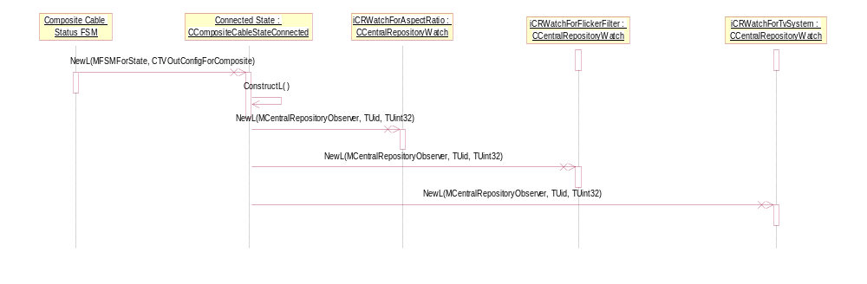
Figure 4.22 Creating the Connected state of Composite Cable Status FSM

Connected state’s actions (Composite FSM)
Operation | Connected state, connect and setting change, and disconnect.
Preconditions | A Composite cable has been connected.
Description | Few actions have to be done before the substate Enabled is reached. Settings can change on the run while the cable is connected. A normal disconnection is also presented here.
Inputs | Several inputs can be seen in Figure 4.23. See the parameters of CCompositeCableStateConnected::Input().
Modifies | Changes the setting and the status (enabled/disabled) of TV Out Config through the CTvOutConfigForComposite object.
Outputs
Postconditions | FSM changes to the Idle state.
Related To
Related Event
Exceptions

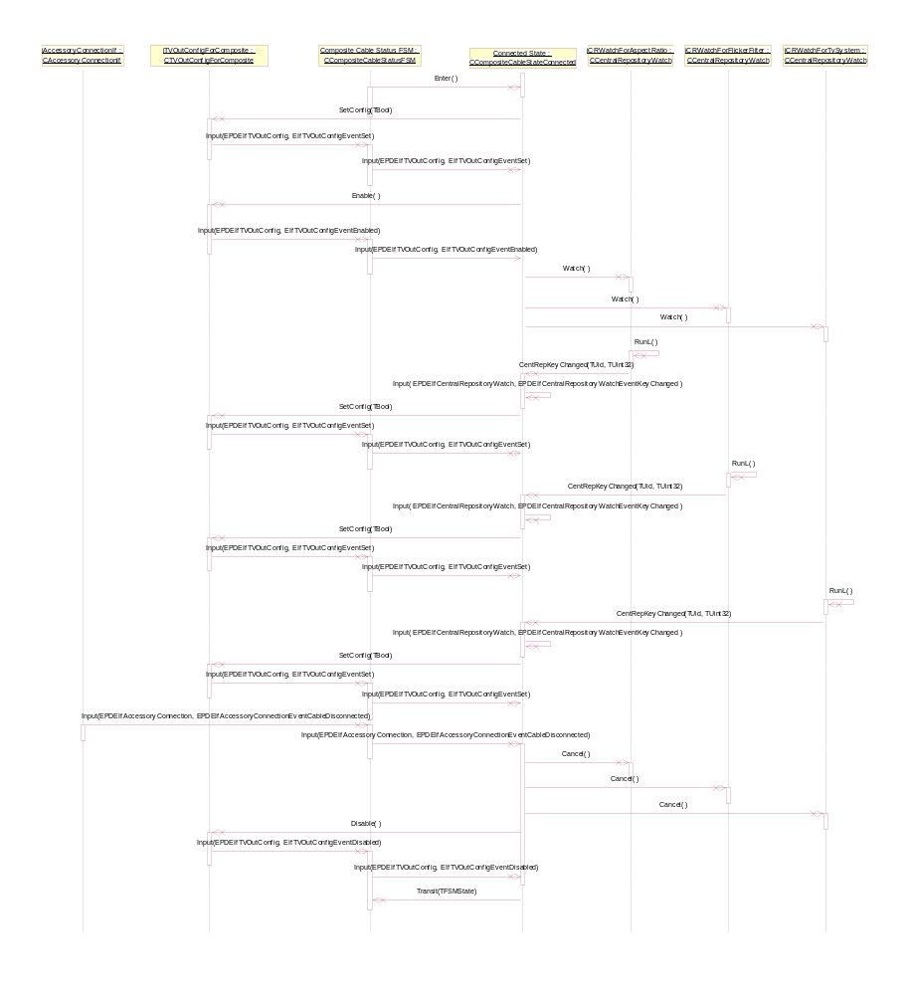
Figure 4.23 Connected state’s actions in Composite Cable Status FSM

Idle state’s actions (Composite FSM)
Operation | Idle state, connect.
Preconditions | A composite cable has been disconnected.
Description | Accessory Connection API notifies that the composite cable has been connected and Composite Cable Status FSM transfers to Connected state.
Inputs | Input events can bee seen as the parameters of function CCompositeCableStateIdle::Input().
Modifies | The state of Composite Cable Status FSM changes to Connected.
Outputs
Postconditions | FSM enters the Connected state.
Related To
Related Event
Exceptions

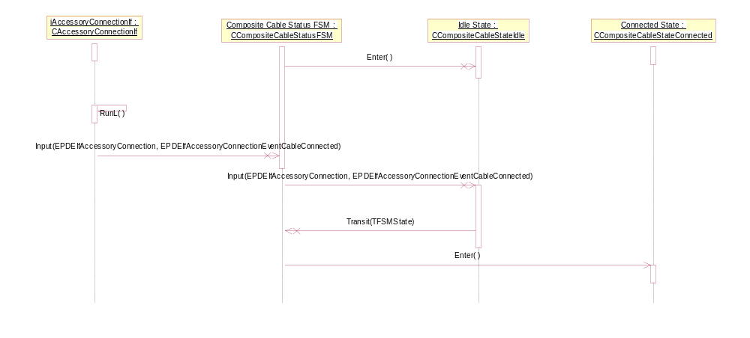
Figure 4.24 Idle state’s actions (Composite FSM)

Creating HDMI Cable Status FSM
Operation | Creating HDMI Cable Status FSM.
Preconditions | Plugged Display ASY has started the creation of Plugged Display Engine.
Description | CPDEngine creates HDMI Cable Status FSM.
Inputs | Reference to the RAccessoryServer object.
Modifies | Creates an instance of CHDMICableStatusFSM.
Outputs
Postconditions | FSM is created and started, and it enters the Idle state.
Related To
Related Event
Exceptions

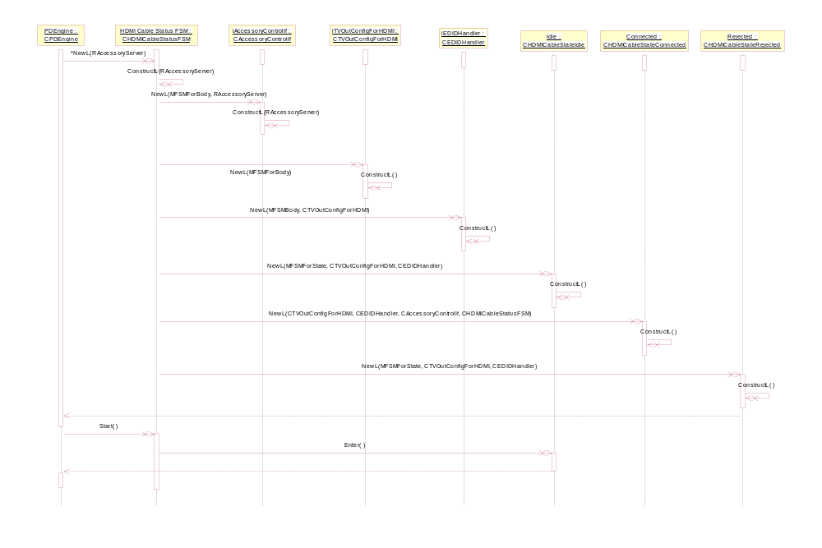
Figure 4.25 Creating HDMI Cable Status FSM

Creating the (HDMI FSM) Connected state
Operation | Creating the (HDMI Cable Status FSM) Connected state.
Preconditions | HDMI Cable Status FSM has started the creation of CHDMICableStateConnected.
Description | HDMI Cable Status FSM creates its Connected state.
Inputs | Reference to the RAccessoryServer object.
Modifies | Creates an instance of CHDMICableStateConnected.
Outputs
Postconditions | The Connected state object is created.
Related To
Related Event
Exceptions

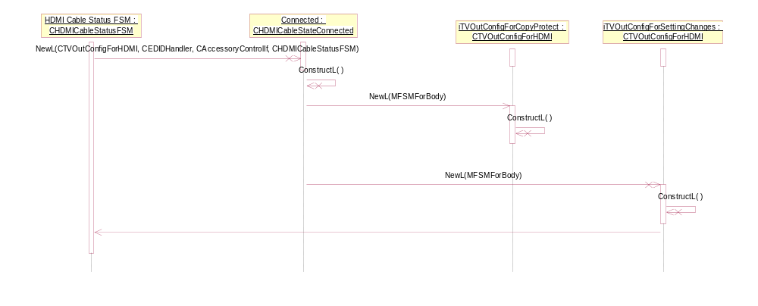
Figure 4.26 Creating (HDMI FSM) Connected state

Connected state, basic and disconnect actions (HDMI FSM)
Operation | Connected state, basic and disconnect actions.
Preconditions | An HDMI cable has been connected.
Description | Few actions have to be done before the substate Connected is reached.
Inputs | Several input events can be seen in Figure 4.27. See the parameters of CHDMICableStateConnected::Input().
Modifies | Changes the setting and the status (enabled/disabled) of TV Out Config through the CTvOutConfigForHDMI object.
Outputs
Postconditions | FSM enters first the state Connected and then also the substate Connected. At the end of the disconnection procedures FSM changes back to the Idle state.
Related To
Related Event
Exceptions

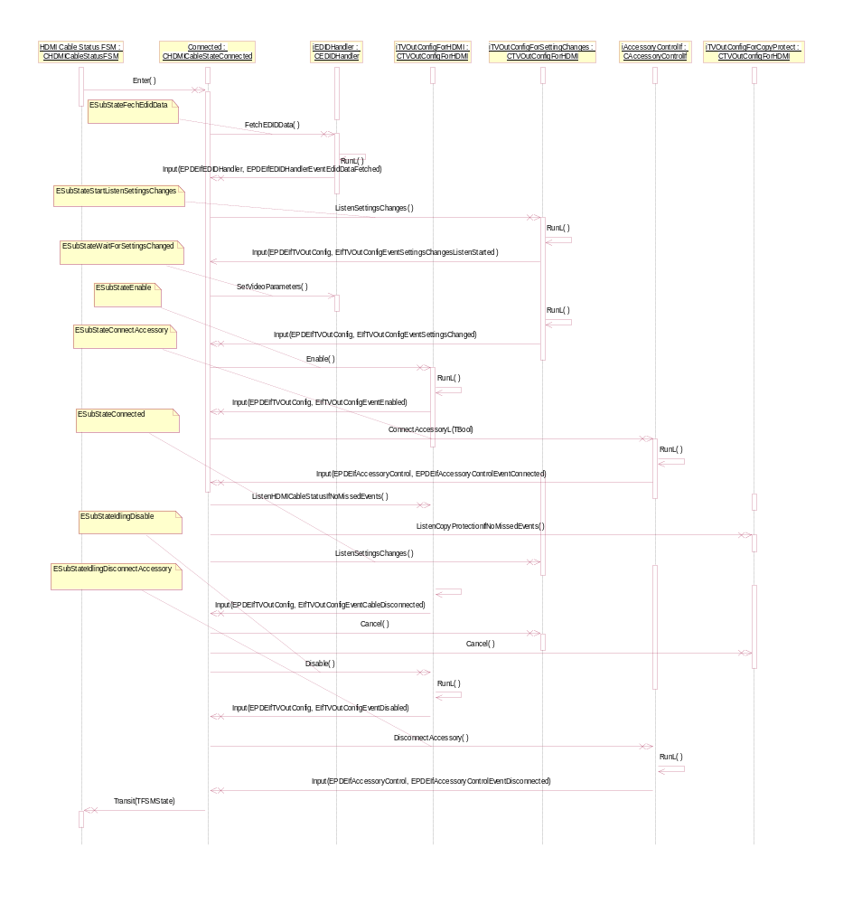
Figure 4.27 Connected state (HDMI FSM) basic and disconnect actions

Connected state, setting change (HDMI FSM)
Operation | Connected state, setting change
Preconditions | An HDMI cable has been connected and the substate Connected is reached.
Description | Settings can change on the run while the cable is connected.
Inputs | Several input events can be seen in Figure 4.28. See the parameters of CHDMICableStateConnected::Input().
Modifies | Changes the setting and the status (enabled/disabled) of TV Out Config through the CTvOutConfigForHDMI object. Accessory Control API is used to notify of the setting change.
Outputs
Postconditions | FSM is in the Connected state all the time, but the substate changes as follows: Connected -> ResettingDisable -> ResettingEnable -> Connected.
Related To
Related Event
Exceptions

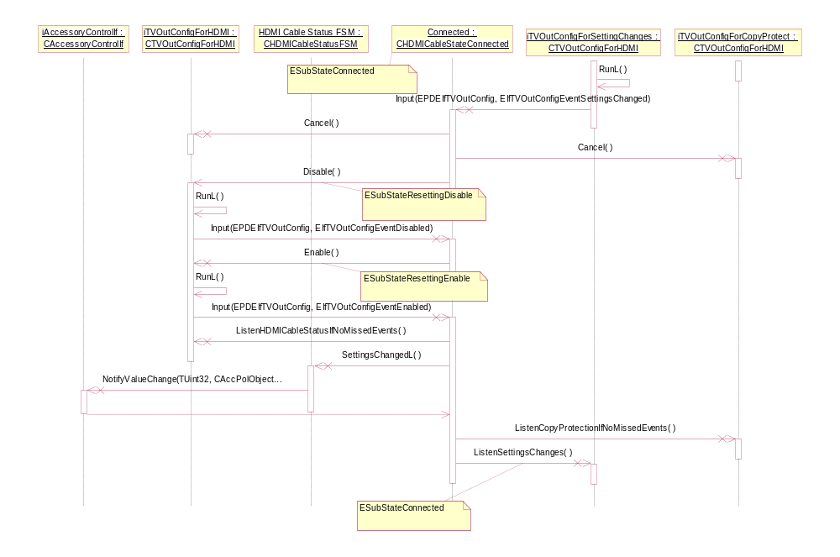
Figure 4.28 Connected state, setting change (HDMI FSM)

Connected state, copy protection status change (HDMI FSM)
Operation | Connected state, copy protection status change.
Preconditions | An HDMI cable has been connected and the substate Connected is reached.
Description | Copy protection status can change on the run while the cable is connected.
Inputs | Several input events can be seen in Figure 4.29. See the parameters of CHDMICableStateConnected::Input().
Modifies | Changes the setting and the status (enabled/disabled) of TV Out Config through the CTvOutConfigForHDMI object. Accessory Control API is used to notify of the status change.
Outputs
Postconditions | The main state and the substate of FSM are both Connected.
Related To
Related Event
Exceptions

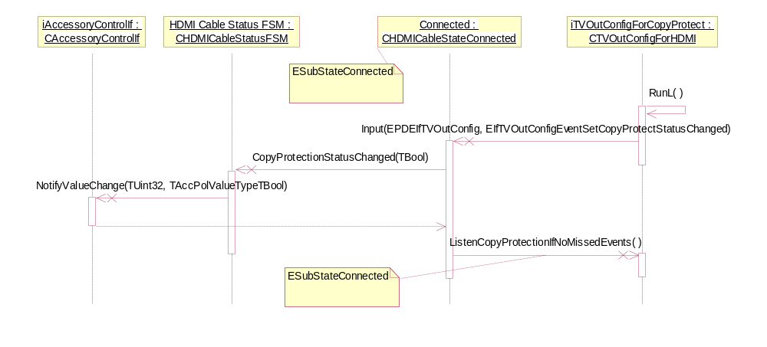
Figure 4.29 Connect state (HDMI FSM), copy protection status change

Connected state, set on/off and get copy protection status (HDMI FSM)
Operation | Connected state, set on/off and get copy protection status.
Preconditions | An HDMI cable has been connected and the substate Connected is reached.
Description | Copy protection status can be set, reset and accessed through the ASY command interface while the cable is connected.
Inputs | Several input events can be seen in Figure 4.30. See the parameters of CHDMICableStateConnected::Input().
Modifies | Changes the copy protection status value of TV Out Config through the CTvOutConfigForHDMI object.
Outputs
Postconditions | The main state and the substate of FSM are both Connected.
Related To
Related Event
Exceptions

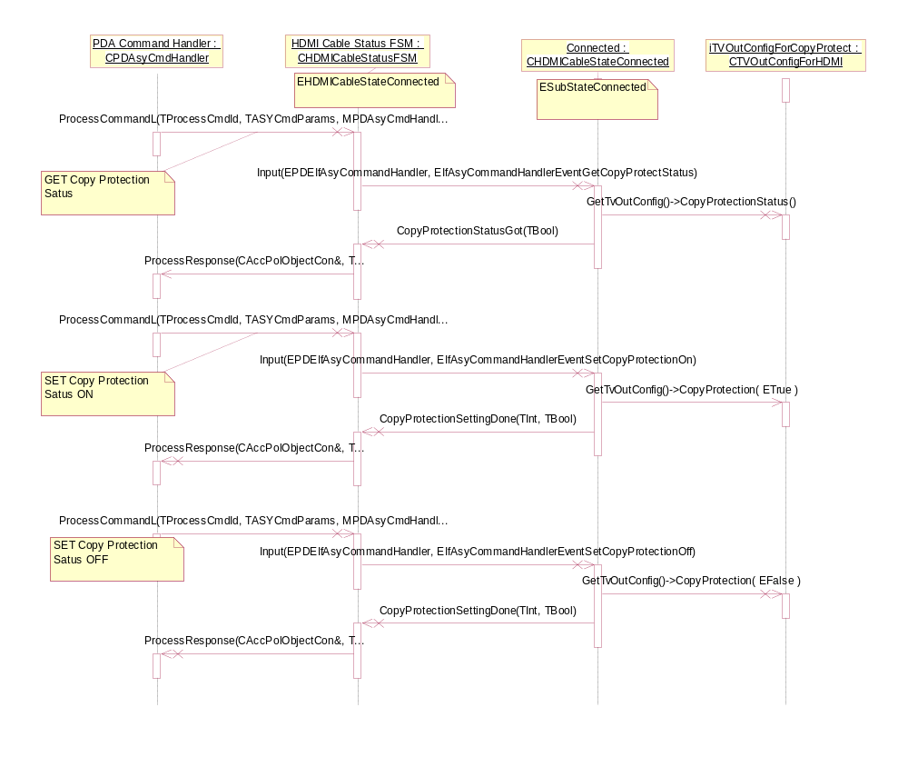
Figure 4.30 Connected state, set on/off and get copy protection status (HDMI FSM)

Connected state, get objects (HDMI FSM)
Operation | Connected state, get objects.
Preconditions | An HDMI cable has been connected and the substate Connected is reached.
Description | The HDMI video attributes and/or video format can be asked through the ASY command interface while FSM is in the main- and substate Connected.
Inputs | Command from the ASY command interface.
Modifies
Outputs | Requested objects are delivered through the ASY command interface.
Postconditions | The main state and the substate of FSM are both Connected.
Related To
Related Event
Exceptions

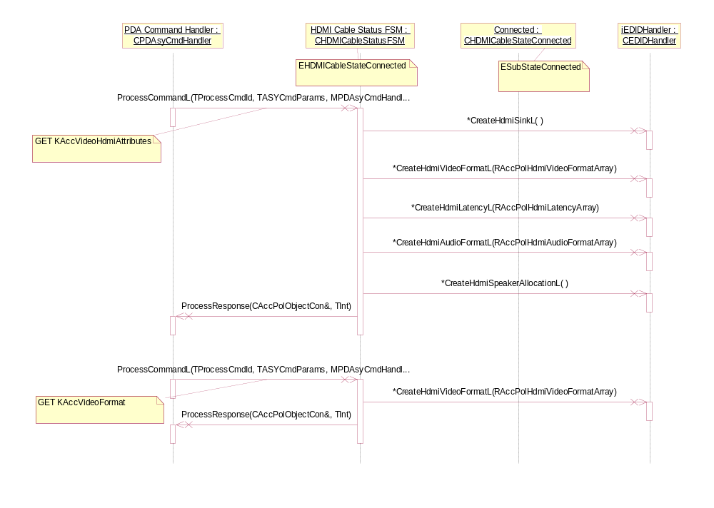
Figure 4.31 Connected state, get objects (HDMI FSM)

Idle state, cable connection (HDMI FSM)
Operation | Idle state, entering the state and cable connection.
Preconditions | An HDMI cable has been disconnected and the main state Idle is reached.
Description | The end user connects the HDMI cable.
Inputs | See the parameters of CHDMICableStateIdle::Input().
Modifies
Outputs
Postconditions | FSM enters its main state Connected.
Related To
Related Event
Exceptions

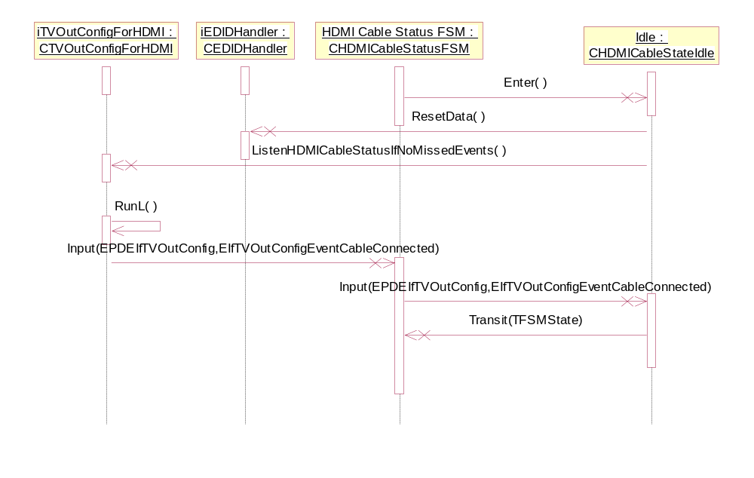
Figure 4.32 Idle state, entering the state and connect cable (HDMI FSM)

Rejected state, cable disconnection (HDMI FSM)
Operation | Rejected state, entering the state and cable disconnection.
Preconditions | An HDMI cable has been connected, but something has gone wrong during the connection procedure and the main state Rejected is reached.
Description | The end user disconnects the HDMI cable after the connection has failed.
Inputs | See the parameters of CHDMICableStateRejected::Input().
Modifies
Outputs
Postconditions | FSM enters its main state Idle.
Related To
Related Event
Exceptions

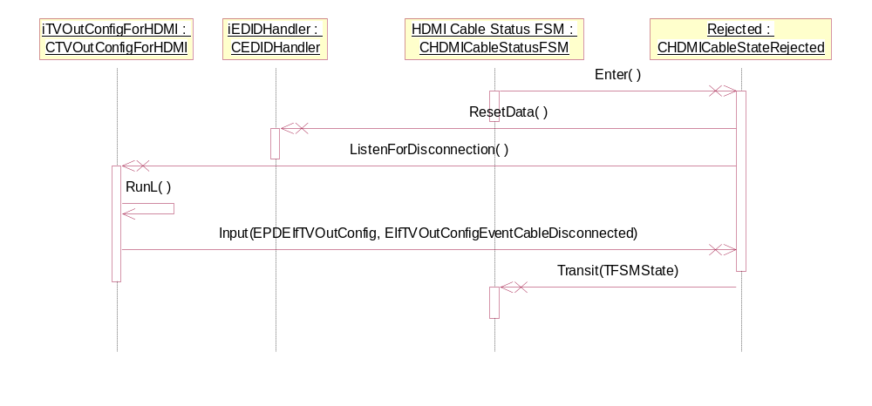
Figure 4.33 Rejected State, entering state & cable disconnection (HDMI FSM)

Connected state, EDID data handling (HDMI FSM)
Operation | Connected state, EDID data handling.
Preconditions | An HDMI cable has been connected.
Description | EDID data is read and interpreted during the cable connection procedure.
Inputs | See the parameters of CHDMICableStateConnected::Input().
Modifies | Changes the settings of TV Out Config through the CTvOutConfigForHDMI object.
Outputs
Postconditions | FSM enters its main state Connected and the substate WaitForSettingsChanged.
Related To
Related Event
Exceptions

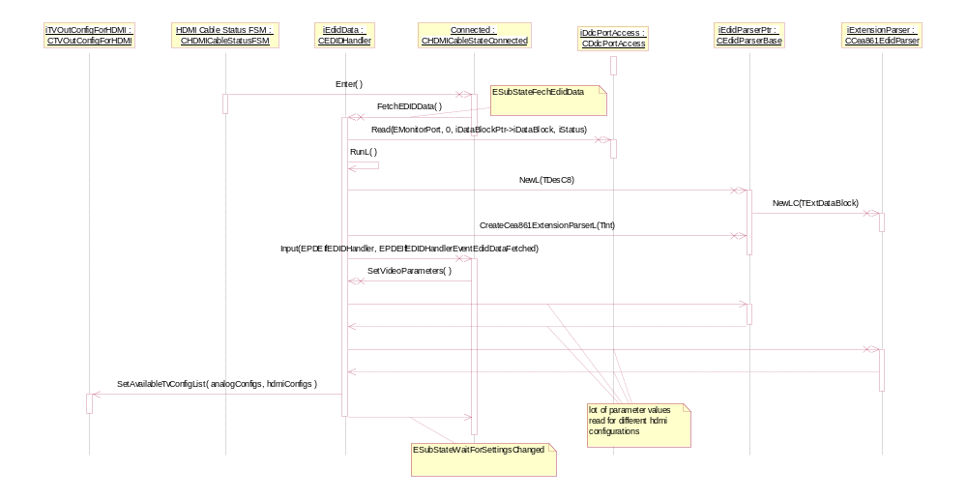
Figure 4.34 Connected state, EDID data handling (HDMI FSM)

Idle state, EDID data handling (HDMI FSM)
Operation | Idle state, EDID data handling.
Preconditions | An HDMI cable has been disconnected.
Description | Previous EDID data is removed during the cable disconnection procedure.
Inputs | See the parameters of CHDMICableStateIdle::Input().
Modifies | Internal EDID data is deleted and memory released.
Outputs
Postconditions | FSM enters its main state Idle.
Related To
Related Event
Exceptions

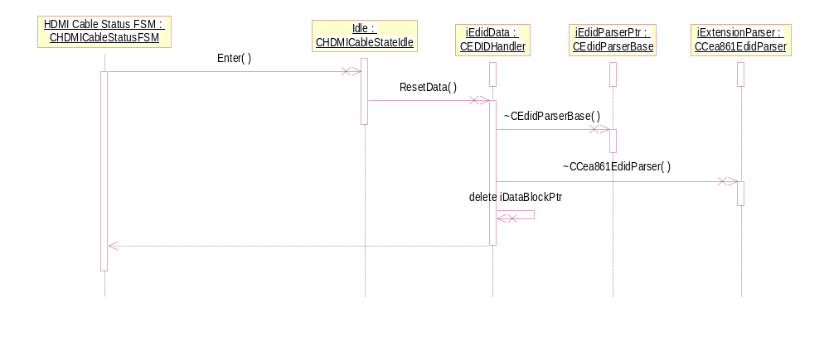
Figure 4.35 Idle state, EDID data handling (HDMI FSM)

Backup and Restore
This component does not participate in backup and restore.

Variation
Plugged Display ASY does not support any variation mechanism.

System resource usage

Files
This component does not use any files.

Other data

Databases
This component does not use any databases.

Central Repository
This component does not publish Central Repository keys.

Publish and Subscribe
This component does only subscribe for Publish and Subscribe key changes.

Memory consumption
Memory/Build | Consumption
Edidparser.dll WINSCW UDeb | 284 460 B
Edidparser.dll WINSCW URel | 69 632 B
Edidparser.dll ARMV5 UDeb | 8 662 B
Edidparser.dll ARMV5 URel | 4 212 B
Pluggeddisplayasy.dll WINSCW UDeb | 189 204 B
Pluggeddisplayasy.dll WINSCW URel | 65 536 B
Pluggeddisplayasy.dll ARMV5 UDeb | 2 020 B
Pluggeddisplayasy.dll ARMV5 URel | 1 524 B
Pluggeddisplayengine.dll WINSCW UDeb | 553 272 B
Pluggeddisplayengine.dll WINSCW URel | 98 304 B
Pluggeddisplayengine.dll ARMV5 UDeb | 22 937 B
Pluggeddisplayengine.dll ARMV5 URel | 13 467 B

Task allocation
Accessory Server creates a dedicated thread for Plugged Display ASY.

Performance
Only filling the available configuration list for TV Out Config API is a heavy task from the point of view of performance. There can be a lot of configuration alternatives per display device.

Timers
Timer | Purpose | Interval | Lifetime
CTVOutConfigForComposite::iMyAsyncOneShotTimer.  Of type CMyAsyncOneShotTimer that derives from CAsyncOneShot. | Used whenever Tv Out Server has denied service with the KErrServerBusy status. | Timer elapses immediately during the first check by OS. The exact duration between the setting and the timeout cannot be predicted. | See the previous column.
CTVOutConfigForComposite::iMyAsyncOneShotTimer.  Of type CMyAsyncOneShotTimer that derives from CAsyncOneShot. | Used whenever Tv Out Server has denied service with the KErrServerBusy status. | Timer elapses immediately during the first check by OS. The exact duration between the setting and the timeout cannot be predicted. | See the previous column.

Security

Capabilities of this component
Capability | Justification
CAP_ECOM_PLUGIN | Plugged Display ASY (pluggeddisplayasy.dll) implements ASY Plug-in API.
CAP_GENERAL_DLL | For edisparser.dll and pluggeddisplayengine.dll.

Input and output validation
EDID Parser validates EDID Data information read from the display device.

Environmental assumptions
This component does not make any assumptions about its environment.

Additional enforcements
This component does not have any additional security enforcements.

Exception handling
Exception | Description
An HDMI cable is rejected during the connection procedure, which can happen for many different reasons. | HDMI Cable Status FSM enters the Rejected main state and remains there until the end user disconnects the rejected cable.

Usage

Building
cd \sf\os\devicesrv\accessoryservices\pluggeddisplay\group
bldmake bldfiles
abld build

User's guide
This component is used only by the Accessory Framework and through the ASY Plug-in API.

