S60 3.1
Accessory API Specification
Document

Team name | Author
Core BS System | Kari K. Karvonen

Change history:

Version | Date | Status | Comments
2.0 | 07.04.2006 | Approved
1.0 | 01.02.2006 | Approved

Table of contents:

1. Document control 6
1.1 References 6
1.2 Documentation conventions 6
1.3 Abbreviations 6
1.4 Definitions 6
2. Purpose 7
2.1 List of required interfaces 8
3. Technical specification 9
3.1 Type of interface 9
3.2 Interface class structure 9
3.3 Usage 12
3.3.1 Protocol 12
3.3.1.1 Synchronous method call 12
3.3.1.2 Asynchronous method call 13
3.3.1.3 Accessory Audio and Bluetooth control 13
3.3.2 Error handling 13
3.4 Example 14
3.5 Detailed description 17
3.5.1 CAccConfigFileParser 17
3.5.1.1 FindL() 17
3.5.1.2 NewL() 18
3.5.2 CAccConGenericID 18
3.5.2.1 GenericID() 18
3.5.2.2 NewL() 18
3.5.3 CAccPolSubblockNameArray 18
3.5.3.1 HasName() 19
3.5.3.2 NewL() 19
3.5.4 RAccessoryAudioControl 20
3.5.4.1 AccessoryAudioLinkClose() 20
3.5.4.2 AccessoryAudioLinkOpen() 20
3.5.4.3 AudioRoutingStatusNotify() 21
3.5.4.4 CancelAccessoryAudioLinkClose() 21
3.5.4.5 CancelAccessoryAudioLinkOpen() 21
3.5.4.6 CancelNotifyAccessoryAudioLinkClosed() 22
3.5.4.7 CancelNotifyAccessoryAudioLinkOpened() 22
3.5.4.8 CloseSubSession() 22
3.5.4.9 CreateSubSession() 23
3.5.4.10 NotifyAccessoryAudioLinkClosed() 23
3.5.4.11 NotifyAccessoryAudioLinkOpened() 24
3.5.5 RAccessoryBTControl 24
3.5.5.1 AccessoryValueChangedNotifyL() 24
3.5.5.2 BluetoothAudioLinkClosedNotifyL() 25
3.5.5.3 BluetoothAudioLinkCloseRespL() 25
3.5.5.4 BluetoothAudioLinkOpenedNotifyL() 26
3.5.5.5 BluetoothAudioLinkOpenRespL() 26
3.5.5.6 CancelConnectAccessory() 27
3.5.5.7 CancelDisconnectAccessory() 27
3.5.5.8 CancelNotifyBluetoothAudioLinkCloseReq() 27
3.5.5.9 CancelNotifyBluetoothAudioLinkOpenReq() 28
3.5.5.10 CloseSubSession() 28
3.5.5.11 ConnectAccessory() 29
3.5.5.12 CreateSubSession() 29
3.5.5.13 DisconnectAccessory() 30
3.5.5.14 NotifyBluetoothAudioLinkCloseReq() 30
3.5.5.15 NotifyBluetoothAudioLinkOpenReq() 31
3.5.6 RAccessoryConnection 31
3.5.6.1 CancelGetAccessoryConnectionStatus() 31
3.5.6.2 CancelNotifyAccessoryConnectionStatusChanged() 31
3.5.6.3 CloseSubSession() 32
3.5.6.4 CreateSubSession() 32
3.5.6.5 GetAccessoryConnectionStatus() 32
3.5.6.6 GetAccessoryConnectionStatus() 33
3.5.6.7 NotifyAccessoryConnectionStatusChanged() 33
3.5.7 RAccessoryConnectionBase 34
3.5.7.1 GetSubblockNameArrayL() 34
3.5.7.2 GetValueL() 34
3.5.7.3 GetValueL() 35
3.5.7.4 GetValueL() 36
3.5.8 RAccessoryControl 37
3.5.8.1 AccessoryValueChangedNotifyL() 37
3.5.8.2 AccessoryValueChangedNotifyL() 37
3.5.8.3 CancelConnectAccessory() 38
3.5.8.4 CancelDisconnectAccessory() 38
3.5.8.5 CloseSubSession() 39
3.5.8.6 ConnectAccessory() 39
3.5.8.7 DisconnectAccessory() 40
3.5.8.8 SetValueL() 40
3.5.8.9 SetValueL() 41
3.5.9 RAccessoryMode 41
3.5.9.1 CancelGetAccessoryMode() 41
3.5.9.2 CancelNotifyAccessoryModeChanged() 42
3.5.9.3 CloseSubSession() 42
3.5.9.4 CreateSubSession() 42
3.5.9.5 GetAccessoryMode() 42
3.5.9.6 GetAccessoryMode() 43
3.5.9.7 NotifyAccessoryModeChanged() 43
3.5.10 RAccessoryServer 44
3.5.10.1 Connect() 44
3.5.10.2 Disconnect() 44
3.5.10.3 Version() 44
3.5.11 RAccessorySettings 45
3.5.11.1 CloseSubSession() 45
3.5.11.2 CreateSubSession() 45
3.5.11.3 GetAccessoryModeSetting() 45
3.5.11.4 GetAccessoryModeSettings() 46
3.5.11.5 GetHWDeviceSettings() 46
3.5.11.6 GetSupportedHWDeviceSettings() 47
3.5.11.7 SetAccessoryModeSettingL() 47
3.5.11.8 SetAccessoryModeSettingsL() 48
3.5.11.9 SetHWDeviceSettingsL() 48
3.5.12 RAccessorySingleConnection 49
3.5.12.1 CancelNotifyAccessoryDisconnected() 49
3.5.12.2 CancelNotifyAccessoryValueChanged() 49
3.5.12.3 CancelNotifyNewAccessoryConnected() 50
3.5.12.4 CloseSubSession() 50
3.5.12.5 CreateSubSession() 50
3.5.12.6 NotifyAccessoryDisconnected() 50
3.5.12.7 NotifyAccessoryValueChanged() 51
3.5.12.8 NotifyAccessoryValueChanged() 52
3.5.12.9 NotifyNewAccessoryConnected() 52
3.5.13 TAccModeSetting 53
3.5.13.1 GetTBool() 53
3.5.13.2 GetTDes() 53
3.5.13.3 GetTInt() 54
3.5.13.4 Id() 54
3.5.13.5 SetId() 54
3.5.13.6 SetTBool() 55
3.5.13.7 SetTDes() 55
3.5.13.8 SetTInt() 55
3.5.13.9 Type() 56
3.5.14 TAccModeSettingArray 56
3.5.14.1 AddSetting() 56
3.5.14.2 GetArraySize() 56
3.5.14.3 GetMaxArraySize() 57
3.5.14.4 GetSetting() 57
3.5.14.5 Reset() 57
3.5.15 TAccPolGenericID 58
3.5.15.1 ApplicationProtocolCaps() 58
3.5.15.2 ApplicationProtocolCaps() 58
3.5.15.3 DeviceAddress() 58
3.5.15.4 DeviceTypeCaps() 59
3.5.15.5 DeviceTypeCaps() 59
3.5.15.6 HWDeviceID() 59
3.5.15.7 HWModelID() 59
3.5.15.8 PhysicalConnectionCaps() 60
3.5.15.9 PhysicalConnectionCaps() 60
3.5.15.10 SubblockCaps() 60
3.5.15.11 SubblockCaps() 61
3.5.15.12 UniqueID() 61
3.5.16 TAccPolGenericIDArray 61
3.5.16.1 Count() 61
3.5.16.2 GetGenericIDL() 62
3.5.17 TAccPolNameRecord 62
3.5.17.1 GetName() 62
3.5.17.2 SetNameL() 62
3.5.18 Code architecture 63
4. Index 64
4.1 List of constants and enums 64
4.2 Alphabetical list of classes and methods 65

Document control

References

- S60 Accessory Client Server Design Document
- S60 Accessory FW Main Design Document
- S60 Accessory Policy Design Document
- S60 Accessory Plug-In API Specification Document
- S60 Accessory Policy Common Generic ID Definitions Specification Document

Documentation conventions
Code is shown with the Courier New font.

Abbreviations

API | Application Programming Interface
ASY | Accessory Handler Provider Module
BT | Bluetooth
OS | Operating System
TTY | Text Device
UI | User Interface

Definitions

Accessory capability | A feature that an accessory has.
Accessory connection | When connection has been established it means that accessory is now ready to process user actions (e.g. button presses) as well as ready to receive requests from the terminal (e.g. open audio link).
Accessory mode | Super state for connection status and audio accessory modes.
Accessory service type information | Information about services supported by accessory.
Capability | A feature that an accessory has.
Combined accessory connection status | All currently connected accessories.
Notification type of asynchronous request | Asynchronous request which is completed when actual event happens.
System event | Information about the state of the specific system state e.g. accessory mode.

Purpose
This document describes following APIs:
- Accessory API
- Accessory Control API
- Accessory Audio Control API
- Accessory Bluetooth Control API
- Accessory Policy Utility API
- Accessory Policy Definitions API
- Configuration File Parser API

The Accessory API provides accessory related functions for UI applications and application engines. The API allows a client to request information of the connected device. Provided services include accessory mode and connection status, as well as accessory device and service type of information. The API allows a client to be notified when:
- a remote device is connected or disconnected
- combined accessory connection status is changed
- accessory mode is changed
- internal state of a remote device is changed

Accessory Control API provides means to control accessory related functions in accessory HW and SW. The API enables notifying changes in accessory internal status, as well as the control for accessories. The API is based on the Accessory API.
Accessory Audio Control API is Accessory API extension for audio subsystem clients. It provides methods for controlling Bluetooth audio link status, and enables notifying changes of the current audio routing state.
Accessory Bluetooth Control API is a Bluetooth specific Accessory API extension for Bluetooth subsystem clients. The API enables controlling the changes in Bluetooth accessory connection status and audio link status, as well as the control for accessories.
Accessory Policy Utility API contains utility functions and classes for GenericID handling.
Accessory Policy Definitions API contains common GenericID declarations. Accessory Policy Definitions Extension API can be used to declare proprietary Accessory capabilities. Extension mechanism is described in reference document [3].
Configuration File Parser API is a utility API for Accessory Server plug-ins to parse configuration. It is used to map detected accessory HW Device IDs to Generic IDs, and parse Generic ID from Accessory Capabilities.
Generic ID is a concept that enables the clients to identify the connected accessories, based on features. These Accessory Capabilities are described in reference document [5]. Common Generic ID declarations belong to Accessory Policy Definitions API.

List of required interfaces
The Accessory API utilises interfaces as illustrated in Figure 1.
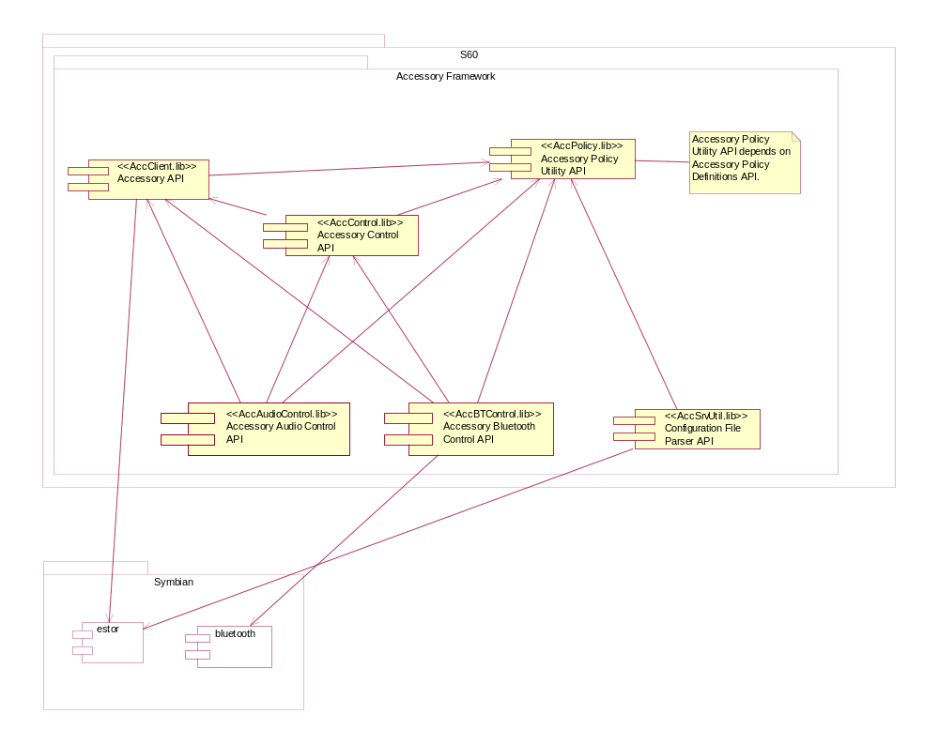
Figure 1 Required interfaces for Accessory API

Technical specification

Type of interface
Accessory API is a client-server API.

Interface class structure
The RAccessoryServer class offers an interface for the client to connect to Accessory server.
Accessory API services are provided through RSubSessionBase derived classes (Figure 2).
Accessory API is realized by the classes:
- RAccessoryConnectionBase
- RAccessoryConnection
- RAccessorySingleConnection
- RAccessoryMode
Accessory Control API is realized by the classes:
- RAccessorySettings
- RAccessoryControl
The Accessory Audio Control API is realized by the class:
- RAccessoryAudioControl
The Accessory Bluetooth Control API is realized by the class:
- RAccessoryBTControl
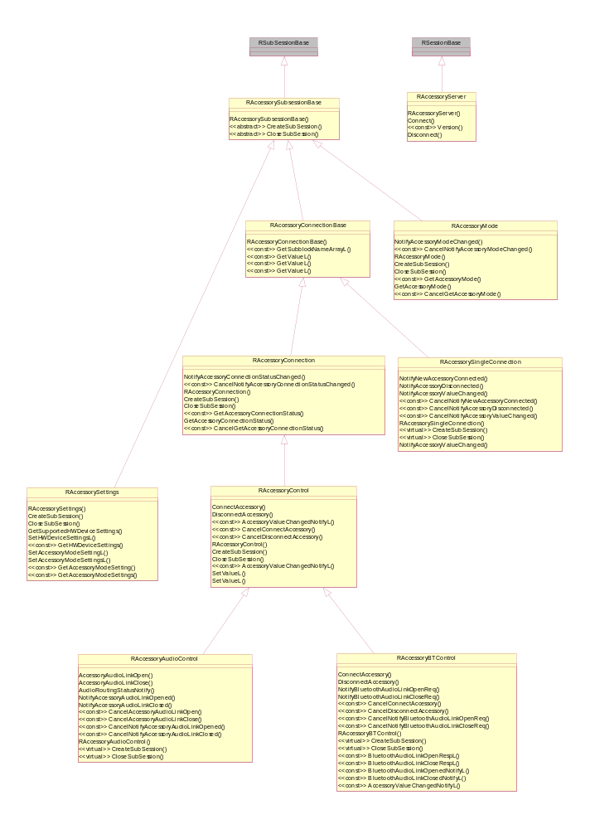
Figure 2 Accessory API class hierarchy
Accessory Policy Utility API is realized by the classes:
- TAccPolGenericID
- TAccPolGenericIDArray
- CAccPolSubblockNameArray
- TAccPolNameRecord
- CAccConGenericID
The Accessory Policy Definitions API is realized by the files:
- AccPolGenericIdDefinitions.h
- AccPolCommonNameValuePairs.h
- AccPolPropGenericID.h
- AccPolProprietaryNameValuePairs.h
The Configuration File Parser API is realized by the class:
- CAccConfigFileParser

To access Configuration File Parser API, the client creates an instance of CAccConfigFileParser using the standard Symbian C-class NewL-pattern.

Usage

Protocol
The Accessory API uses the client-server framework model on Symbian OS. In order to use Accessory API, the client has to create a session with a server, and a sub-session within an existing session.

Synchronous method call
After a sub-session within an existing session is created, synchronous methods can be called as illustrated in Figure 3.
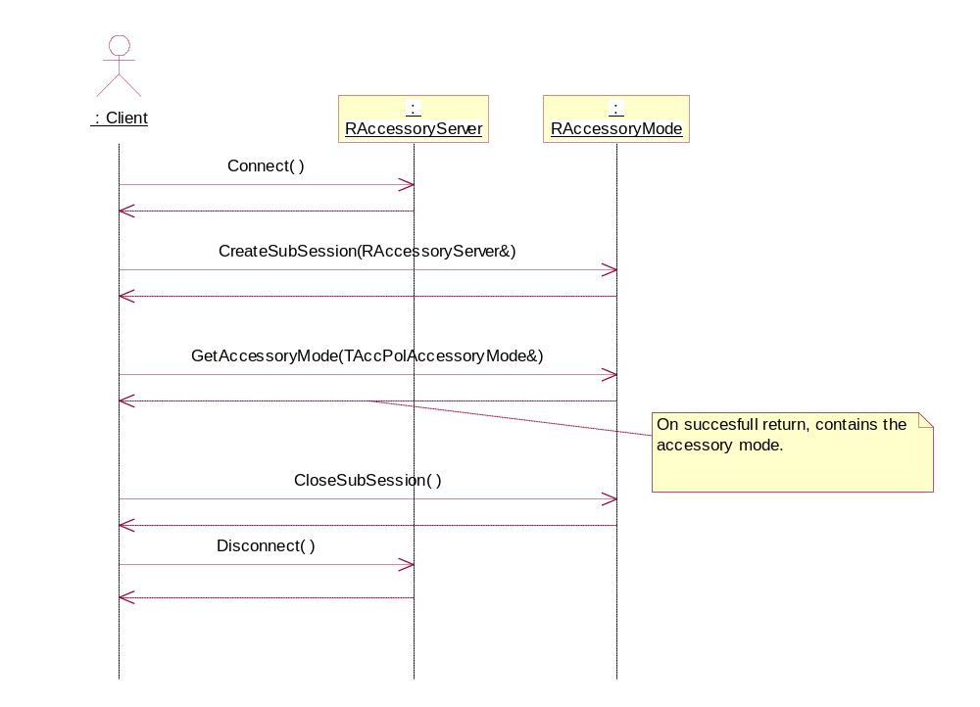
Figure 3 Calling a synchronous method

Asynchronous method call
After a sub-session within an existing session is created, asynchronous methods can be called as illustrated in Figure 4. In this example the client uses Active Objects model on Symbian OS to handle asynchronous request completion. The notification type of asynchronous request must be renewed if further notifications of system events are needed.
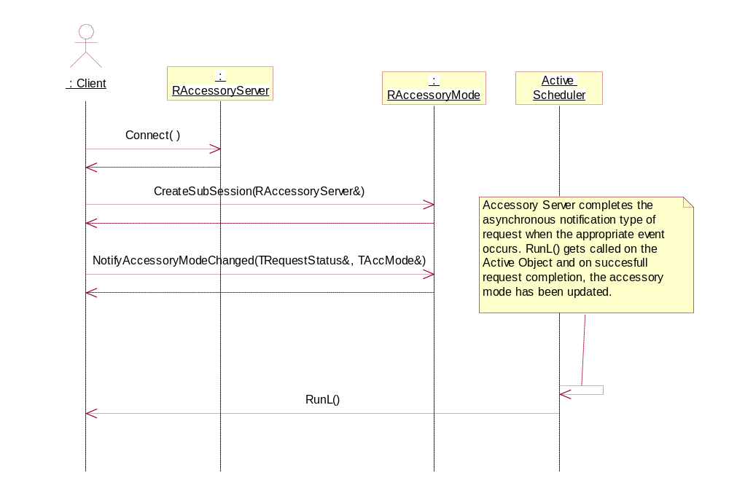
Figure 4 Calling an asynchronous method

Accessory Audio and Bluetooth control
Bluetooth audio link opening and closing, as well as audio transfer sequences, are described in reference document [2].

Error handling
Accessory Server may return Symbian OS generic error codes.

Example
Synchronous example
Calling a synchronous method:

#include <AccessoryServer.h>
#include <AccessoryConnection.h>
. . .
TInt error( KErrNone );
RAccessoryServer server;
RAccessoryConnection connection;
TAccPolGenericIDArray genericIDarray;
. . .
// Creates a session with a server.
error = server.Connect();

// Creates a new sub-session within an existing session.
error = connection.CreateSubSession( server );

// Get combined accessory connection status, i.e. all currently
// connected accessories.
connection.GetAccessoryConnectionStatus( genericIDarray );

// Close the RAccessoryConnection sub-session.
connection.CloseSubSession();

// Closes a session with a server.
server.Disconnect();

Asynchronous example
In this example, the client uses Active Objects model on Symbian OS to handle asynchronous request completion (for clarity, this example does not show all methods needed for active object implementation). An active object class must derive from CActive, for example:

CTest : public CActive
{
public:
virtual ~CTest();

protected:
/**
* From CActive
* Handles an active object's request completion event.
*/
virtual void RunL()=0;

CTest();

private:
RAccessoryServer iServer;
RAccessoryConnection iConnection;
TAccPolGenericIDArray iGenericIDarray;
};

A sub-session within an existing session is created, like in the synchronous example. A notification type of asynchronous request call:

// Get combined accessory connection status asynchronously,
// i.e. get all currently connected accessories.
iConnection.GetAccessoryConnectionStatus( iStatus, iGenericIDarray );

When asynchronous request is completed, the active object RunL() gets called:

void CTest::RunL()
{
if( KErrNone == iStatus )
{
// iGenericIDarray contains currently connected accessories.
}
}

Using Control API
Set accessory detection so that wired headset is detected as TTY. The setting is stored permanently.

TUint32 supportedDevices
. . .
// Read all accessories which can't be properly identified.
GetSupportedHWDeviceSettings( supportedDevices );
. . .
// If TTY is not detected properly by phone, following method has to be called
// so that TTY is identified.
SetHWDeviceSettingsL( KASTTY );

//Remove above set TTY setting
SetHWDeviceSettingsL( KASTTY, EFalse );

Force phone lights on when a wired car kit is connected to the phone. The setting is stored permanently.

TAccMode accessoryMode;
TAccModeSetting accessorySetting;
. . .
// Setting is made for wired headset
accessoryMode = EAccModeWiredCarKit;

// Display lights setting for wired carkit
accessorySetting.SetId( KAccServerWiredCarKitLights );

// Lights on
SetTInt( 1 );
. . .
// Phone lights are set on when wired car kit is connected
SetAccessoryModeSettingL( accessoryMode, accessorySetting );

Query accessory information
This example shows how to get an accessory’s External Audio out Connector capability and its value. The External Audio out Connector capability is declared in AccPolCommonNameValuePairs.h. This declaration defines a constant literal and a type of value. For External Audio out Connector capability, the constant literal is KAccAudioOutConnector and the value type is TBool.

// Name: External Audio out Connector
// Value: TBool
// I/O: From accessory to terminal, input
// Dynamic Type: Dynamic
// Description: Audio out connector capability indicates that accessory has a
// connector enabling audio output to external audio device. Value
// indicates if the external audio device is removed (EFalse) or
// connected (ETrue).
// Bitmask: 00000000000000000000000001000000
_LIT( KAccAudioOutConnector, "1#1#64" );

A sub-session within an existing session is created, like in the synchronous example. HasName() checks if the array contains the specified capability. GetValueL() Gets the value for the capability.

TAccValueTypeTBool boolValue = { EFalse };
TAccPolNameRecord nameRecord;
CAccPolSubblockNameArray* nameArray = CAccPolSubblockNameArray::NewL();
CleanupStack::PushL( nameArray );
. . .
//Get all supported capabilities for the connected accessory.
connection.GetSubblockNameArrayL( iGenericID, *nameArray );

if( nameArray->HasName( KAccAudioOutConnector ) )
{
//The accessory has "External Audio out Connector" capability

//Set the capability name which value is queried
nameRecord.SetNameL( KAccAudioOutConnector );

//Get the value
connection.GetValueL( iGenericID, nameRecord, boolValue );

if( boolValue.iValue )
{
//external audio device is connected
}
else
{
//external audio device is not connected
}
}
else
{
//The accessory doesn't have "Audio in Connector" capability
}

CleanupStack::PopAndDestroy( nameArray );

Configuration File Parser API usage
The following example shows how to find Generic ID from Accessory Policy Database, according to a device identifier (0x1 as an example). Model identifier is set to KNullDesC, thus Model identifier from Accessory Policy Database is used.

. . .
CAccConfigFileParser* configFileParser = CAccConfigFileParser::NewL( KNullDesC );
CleanupStack::PushL( configFileParser );

TUint64 HWDeviceID( 0x1 );
configFileParser->FindL( iGenericID, HWDeviceID, KNullDesC );

CleanupStack::PopAndDestroy( configFileParser );

//iGenericID is created and ready to be used for accessory connection.

Detailed description
In this Section, the classes and methods of Accessory API are described in alphabetical order.

CAccConfigFileParser
Configuration file parser interface.

FindL()
Find a matching Generic ID for Device ID. Returned Generic ID is unique among all the Generic IDs. Matching Generic ID is retrieved from Accessory Policy Database.
Operation:

void FindL( CAccConGenericID* const aGenericID, TUint64 aHWDeviceID, const TDesC& aHWModelID );

Parameters:

Parameter | Description
CAccConGenericID* const aGenericID | On successful return, contains the Generic ID.
TUint64 aHWDeviceID | Device ID.
const TDesC& aHWModelID | Manufacturer specific model for the hardware type (optional). Max size is KHWModelIDMaxLength, define in AccPolGIDHeader.h (e.g. TBuf<KHWModelIDMaxLength>).

Return value:
Void

NewL()
A two-phased constructor.
Operation:

static CAccConfigFileParser* NewL( const TDesC& aConfFileName );

Parameters:

Parameter | Description
const TDesC& aConfFileName | The name of the configuration file to be used. If KNullDesC, default configuration file is used. Only KNullDesC is supported.

Return value:
Void

CAccConGenericID
A heap-allocated Generic ID class definition to be used in accessory connects and update.

GenericID()
Get TAccPolGenericID (Generic ID header).
Operation:

TAccPolGenericID GenericID() const

Return value:
Generic ID header.

NewL()
A two-phased constructor.
Operation:

static CAccConGenericID* NewL()

Return value:
CAccConGenericID*

CAccPolSubblockNameArray
Used as a container for a set of sub block name definitions.

HasName()
Checks if the array contains the specified accessory capability name. Accessory capability name constants are defined in AccPolCommonNameValuePairs.h and AccPolProprietaryNameValuePairs.h.
Operation:

TBool HasName( const TUint32& aName ) const

Parameters:

Parameter | Description
const TUint32& aName | A name definition searched from the array.

Return value:
ETrue if the array contains the name, otherwise EFalse.

NewL()
A two-phased constructor.
Operation:

static CAccPolSubblockNameArray* NewL()

Return value:
Instance of CAccPolSubblockNameArray.

RAccessoryAudioControl
Accessory Audio Control sub-session. This class is not intended for user derivation.

AccessoryAudioLinkClose()
Request to close accessory audio connection.
Operation:

void AccessoryAudioLinkClose( TRequestStatus& aStatus, const TAccPolGenericID& aGenericId, TAccAudioType aAudioType )

Parameters:

Parameter | Description
TRequestStatus& aStatus | Indicates the completion status of a request. KErrNone if successful, system-wide error code if failed. Specifically: KErrAlreadyExists, if request already exists, KErrCancel if request is cancelled.
const TAccPolGenericID& aGenericId | Generic ID of the accessory.
aAudioType | Type of the audio connection.

Return value:
void

AccessoryAudioLinkOpen()
Request to open accessory audio connection.
Operation:

void AccessoryAudioLinkOpen( TRequestStatus& aStatus, const TAccPolGenericID& aGenericId, TAccAudioType aAudioType )

Parameters:

Parameter | Description
TRequestStatus& aStatus | Indicates the completion status of a request. KErrNone if successful, system-wide error code if failed. Specifically: KErrAlreadyExists, if request already exists, KErrCancel if request is cancelled.
const TAccPolGenericID& aGenericId | Generic ID of the accessory.
aAudioType | Type of the audio connection.

Return value:
void

AudioRoutingStatusNotify()
Notifies change of audio routing. Audio subsystem uses this method to notify to which accessory audio will be routed, or audio routing is stopped.
Operation:

AudioRoutingStatusNotify( TBool aActiveAudio, const TAccPolGenericID& aGenericId )

Parameters:

Parameter | Description
TBool aActiveAudio | ETrue = Audio is routed according to the aGenericId parameter. EFalse = No audio, aGenericId parameter is the ignored
const TAccPolGenericID& aGenericId | Generic ID of the accessory. Empty Generic ID means that audio is routed to the phone.

Return value:
void

CancelAccessoryAudioLinkClose()
Cancel AccessoryAudioLinkClose(). This does not leave the accessory audio connection open, it must be opened with AccessoryAudioLinkOpen().
Operation:

void CancelAccessoryAudioLinkClose() const

Return value:
void
See also:
3.5.4.1

CancelAccessoryAudioLinkOpen()
Cancel AccessoryAudioLinkOpen(). This does not close the accessory audio connection, it must be closed with AccessoryAudioLinkClose().
Operation:

void CancelAccessoryAudioLinkOpen() const

Return value:
void
See also:
3.5.4.2

CancelNotifyAccessoryAudioLinkClosed()
Cancel NotifyAccessoryAudioLinkClosed().
Operation:

void CancelNotifyAccessoryAudioLinkClosed() const

Return value:
void
See also:
3.5.4.10

CancelNotifyAccessoryAudioLinkOpened()
Cancel NotifyAccessoryAudioLinkOpened().
Operation:

void CancelNotifyAccessoryAudioLinkOpened() const

Return value:
void
See also:
3.5.4.11

CloseSubSession()
Closes the RAccessoryAudioControl sub-session.
Operation:

virtual TInt CloseSubSession()

Return value:
KErrNone if successful, system-wide error code if failed.
See also:
3.5.4.9

CreateSubSession()
Creates a new sub-session within an existing session.
Operation:

virtual TInt CreateSubSession(RAccessoryServer& aSession)

Parameters:

Parameter | Description
RAccessoryServer& aSession | Session to which this sub-session will belong to.
Return value:
KErrNone if successful, system-wide error code if failed.

NotifyAccessoryAudioLinkClosed()
Issues a request for audio link closed notification. Request must be renewed after completion if further notifications are needed.
The notification is not sent to the thread where AccessoryAudioLinkClose() is called. The thread is defined when a sub-session is created.
Operation:

void NotifyAccessoryAudioLinkClosed( TRequestStatus& aStatus, TAccPolGenericID& aGenericId, TAccAudioType& aAudioType );

Parameters:

Parameter | Description
TRequestStatus& aStatus | Indicates the completion status of a request. KErrNone if successful, system-wide error code if failed. Specifically: KErrAlreadyExists, if request already exists, KErrCancel if request is cancelled.
TAccPolGenericID& aGenericId | On successful request completion, contains the updated Generic ID of the accessory.
TAccAudioType& aAudioType | On successful request completion, contains the type of audio connection.

Return value:
void

NotifyAccessoryAudioLinkOpened()
Issues a request for audio link opened notification. Request must be renewed after completion if further notifications are needed.
The notification is not sent to the thread where AccessoryAudioLinkOpen() is called. The thread is defined when a sub-session is created.
Operation:

void NotifyAccessoryAudioLinkOpened( TRequestStatus& aStatus, TAccPolGenericID& aGenericId, TAccAudioType& aAudioType )

Parameters:

Parameter | Description
TRequestStatus& aStatus | Indicates the completion status of a request. KErrNone if successful, system-wide error code if failed. Specifically: KErrAlreadyExists, if request already exists, KErrCancel if request is cancelled.
TAccPolGenericID& aGenericId | On successful request completion, contains the updated Generic ID of the accessory.
TAccAudioType& aAudioType | On successful request completion, contains the type of audio connection.

Return value:
Void

RAccessoryBTControl
Accessory Bluetooth Control sub-session. This class is not intended for user derivation.

AccessoryValueChangedNotifyL()
Notifies value change of specific accessory capability.
Accessory capability name constants and value types are defined in AccPolCommonNameValuePairs.h and AccPolProprietaryNameValuePairs.h.
Operation:

void AccessoryValueChangedNotifyL( const TBTDevAddr& aBTDevAddr, const TAccPolNameRecord& aNameRecord, const TAccValueTypeTBool aValue ) const

Parameters:

Parameter | Description
const TBTDevAddr& aBTDevAddr | Bluetooth device address.
const TAccPolNameRecord& aNameRecord | Accessory capability name.
const TAccValueTypeTBool aValue | Value for the specific accessory capability.

Return value:
void
Exceptions:
System-wide error code if failed. Specifically: KErrArgument if an argument is out of range.

BluetoothAudioLinkClosedNotifyL()
Audio link is closed. Bluetooth subsystem uses this method to notify that audio link is closed towards remote accessory.
Operation:

void BluetoothAudioLinkClosedNotifyL( const TBTDevAddr& aBTDevAddr, TAccAudioType aAudioType ) const

Parameters:

Parameter | Description
const TBTDevAddr& aBTDevAddr | Bluetooth device address.
TAccAudioType aAudioType | Type of the audio connection

Return value:
void
See also:
3.5.5.14
Exceptions:
System-wide error code if failed. Specifically: KErrArgument if an argument is out of range

BluetoothAudioLinkCloseRespL()
This method is used to send response for previously received close audio link request.
Operation:

void BluetoothAudioLinkCloseRespL( const TBTDevAddr& aBTDevAddr, TInt& aResponse ) const

Parameters:

Parameter | Description
const TBTDevAddr& aBTDevAddr | Bluetooth device address.
TInt& aResponse | Indicates the status of a request. KErrNone if successful, or a Symbian OS standard error code

Return value:
void
Exceptions:
System-wide error code if failed. Specifically: KErrArgument if an argument is out of range
See also:
3.5.5.14

BluetoothAudioLinkOpenedNotifyL()
Audio link is open. Bluetooth subsystem uses this method to notify that audio link is opened towards remote accessory.
Operation:

BluetoothAudioLinkOpenedNotifyL( const TBTDevAddr& aBTDevAddr, TAccAudioType aAudioType ) const

Parameters:

Parameter | Description
const TBTDevAddr& aBTDevAddr | Bluetooth device address.
TAccAudioType aAudioType | Type of the audio connection

Return value:
void
See also:
3.5.5.15
Exceptions:
System-wide error code if failed. Specifically: KErrArgument if an argument is out of range

BluetoothAudioLinkOpenRespL()
This method is used to send response to a previously received open audio link request.
Operation:

void BluetoothAudioLinkOpenRespL( const TBTDevAddr& aBTDevAddr, TInt& aResponse ) const

Parameters:

Parameter | Description
const TBTDevAddr& aBTDevAddr | Bluetooth device address.
TInt& aResponse | Indicates the status of a request. KErrNone if successful, or a Symbian OS standard error code

Return value:
void
Exceptions:
System-wide error code if failed. Specifically: KErrArgument if an argument is out of range
See also:
3.5.5.15

CancelConnectAccessory()
Cancel ConnectAccessory().
Operation:

void CancelConnectAccessory() const

Return value:
void
See also:
3.5.5.11

CancelDisconnectAccessory()
Cancel DisconnectAccessory().
Operation:

void CancelDisconnectAccessory() const

Return value:
void
See also:
3.5.5.13

CancelNotifyBluetoothAudioLinkCloseReq()
Cancel NotifyBluetoothAudioLinkCloseReq().
Operation:

void CancelNotifyBluetoothAudioLinkCloseReq() const

Return value:
void
See also:
3.5.5.14

CancelNotifyBluetoothAudioLinkOpenReq()
Cancel NotifyBluetoothAudioLinkOpenReq().
Operation:

void CancelNotifyBluetoothAudioLinkOpenReq() const

Return value:
void
See also:
3.5.5.15

CloseSubSession()
Closes the RAccessoryBTControl sub-session.
Operation:

virtual TInt CloseSubSession()

Return value:
KErrNone if successful, system-wide error code if failed.
See also:
3.5.4.9

ConnectAccessory()
Bluetooth subsystem has detected an accessory connection and requests the Accessory server to connect the accessory.
Operation:

void ConnectAccessory( TRequestStatus& aStatus, const TBTDevAddr& aBTDevAddr )

Parameters:

Parameter | Description
TRequestStatus& aStatus | Indicates the completion status of a request. KErrNone if successful, system-wide error code if failed. Specifically: KErrAlreadyExists if request already exists, KErrCancel if request is cancelled.
const TBTDevAddr& aBTDevAddr | Bluetooth device address of connected BT accessory.

Return value:
KErrNone if successful, system-wide error code if failed.
See also:
3.5.5.13

CreateSubSession()
Creates a new sub-session within an existing session.
Operation:

virtual TInt CreateSubSession( RAccessoryServer& aSession )

Parameters:

Parameter | Description
RAccessoryServer& aSession | The session to which this sub-session will belong to.

Return value:
KErrNone if successful, system-wide error code if failed.

DisconnectAccessory()
Bluetooth subsystem has detected accessory disconnection and requests the Accessory Server to disconnect the accessory.
Operation:

void DisconnectAccessory( TRequestStatus& aStatus, const TBTDevAddr& aBTDevAddr )

Parameters:

Parameter | Description
TRequestStatus& aStatus | Indicates the completion status of a request. KErrNone if successful, system-wide error code if failed. Specifically: KErrAlreadyExists if request already exists, KErrCancel if request is cancelled. KErrNotFound, if accessory is not found.
const TBTDevAddr& aBTDevAddr | Bluetooth device address of disconnected BT accessory.

Return value:
void
See also:
3.5.5.11

NotifyBluetoothAudioLinkCloseReq()
This method is used to order notification of Bluetooth audio link close request.
Operation:

void NotifyBluetoothAudioLinkCloseReq( TRequestStatus& aStatus, TBTDevAddr& aBTDevAddr, TAccAudioType& aAudioType )

Parameters:

Parameter | Description
TRequestStatus& aStatus | Indicates the completion status of a request. KErrNone if successful, system-wide error code if failed. Specifically: KErrAlreadyExists if request already exists, KErrCancel if request is cancelled.
TBTDevAddr& aBTDevAddr | On successful request completion, contains the updated Bluetooth device address.
TAccAudioType& aAudioType | On successful request completion, contains the type of audio connection.
Return value:
void
See also:
3.5.5.3

NotifyBluetoothAudioLinkOpenReq()
This method is used to order notification of Bluetooth audio link open request.
Operation:

void NotifyBluetoothAudioLinkOpenReq( TRequestStatus& aStatus, TBTDevAddr& aBTDevAddr, TAccAudioType& aAudioType )

Parameters:

Parameter | Description
TRequestStatus& aStatus | Indicates the completion status of a request. KErrNone if successful, system-wide error code if failed. Specifically: KErrAlreadyExists if request already exists, KErrCancel if request is cancelled.
TBTDevAddr& aBTDevAddr | On successful request completion, contains the updated Bluetooth device address.
TAccAudioType& aAudioType | On successful request completion, contains the type of audio connection.

Return value:
void
See also:
3.5.5.5

RAccessoryConnection
Accessory Connection sub-session. This class is not intended for user derivation.

CancelGetAccessoryConnectionStatus()
Cancel GetAccessoryConnectionStatus().
Operation:

void CancelGetAccessoryConnectionStatus() const

Return value:
void

CancelNotifyAccessoryConnectionStatusChanged()
Cancel NotifyAccessoryConnectionStatusChanged().
Operation:

void CancelNotifyAccessoryConnectionStatusChanged() const

Return value:
void

CloseSubSession()
Closes the RAccessoryConnection sub-session.
Operation:

TInt CloseSubSession()

Return value:
KErrNone if successful, system-wide error code if failed.
See also:
3.5.4.9

CreateSubSession()
Creates a new sub-session within an existing session.
Operation:

TInt CreateSubSession( RAccessoryServer& aSession )

Parameters:

Parameter | Description
RAccessoryServer& aSession | The session to which this sub-session will belong to.

Return value:
KErrNone if successful, system-wide error code if failed.

GetAccessoryConnectionStatus()
Get combined accessory connection status, i.e. all currently connected accessories.
Operation:

void GetAccessoryConnectionStatus( TRequestStatus& aStatus, TAccPolGenericIDArray& aGenericIdArray )
Parameters:
Parameter | Description
TRequestStatus& aStatus | Indicates the completion status of a request. KErrNone if successful, system-wide error code if failed. Specifically: KErrAlreadyExists if request already exists, KErrCancel if request is cancelled.
TAccPolGenericIDArray& aGenericIdArray | On successful request completion, contains the array of currently connected accessories. Accessories are in connection order, last connected accessory in index 0.

Return value:
void

GetAccessoryConnectionStatus()
Get combined accessory connection status, i.e. all currently connected accessories.
Operation:

TInt GetAccessoryConnectionStatus( TAccPolGenericIDArray& aGenericIdArray ) const

Parameters:

Parameter | Description
TAccPolGenericIDArray& aGenericIdArray | On return, contains the array of currently connected accessories. Accessories are in connection order, last connected accessory in index 0.

Return value:
KErrNone if successful. KErrNotReady if a device is not ready to start operation

NotifyAccessoryConnectionStatusChanged()
Issues a request for accessory connection status change notification. Request must be renewed after completion if further notifications are needed.
Operation:

void NotifyAccessoryConnectionStatusChanged( TRequestStatus& aStatus, TAccPolGenericIDArray& aGenericIdArray )

Parameters:

Parameter | Description
TRequestStatus& aStatus | Indicates the completion status of a request. KErrNone if successful, system-wide error code if failed. Specifically: KErrAlreadyExists if request already exists, KErrCancel if request is cancelled.
TAccPolGenericIDArray& aGenericIdArray | On successful request completion, contains the array of currently connected accessories. Accessories are in connection order, last connected accessory in index 0.

Return value:
Void

RAccessoryConnectionBase
Base class for Accessory Server RAccessoryConnection and RAccessorySingleConnection sub-sessions. This class is not intended for user derivation.

GetSubblockNameArrayL()
Get supported capabilities for the connected accessory.
Operation:

void GetSubblockNameArrayL( const TAccPolGenericID& aGenericID, CAccPolSubblockNameArray& aNameArray ) const

Parameters:

Parameter | Description
const TAccPolGenericID& aGenericID | Generic ID of the connected accessory.
CAccPolSubblockNameArray& aNameArray | On return, contains array of supported capabilities.

Return value:
void
Exceptions:
System-wide error code if failed. Specifically: KErrArgument if an argument is out of range.
See also:
- 3.5.7.2
- AccPolCommonNameValuePairs.h
- AccPolProprietaryNameValuePairs.h

GetValueL()
Get the value for the specific accessory capability.
Accessory capability name constants and value types are defined in AccPolCommonNameValuePairs.h and AccPolProprietaryNameValuePairs.h.
Operation:

TInt GetValueL( const TAccPolGenericID& aGenericID, const TAccPolNameRecord& aNameRecord, TDes8& aValue ) const

Parameters:

Parameter | Description
const TAccPolGenericID& aGenericID | Generic ID of the connected accessory.
const TAccPolNameRecord& aNameRecord | Accessory capability.
TDes8& aValue | On return, contains the current value for the specific accessory capability.

Return value:
KErrNone if successful. KErrTimedOut if an operation has timed out.
Exceptions:
System-wide error code if failed. Specifically: KErrArgument if an argument is out of range.
See also:
- 3.5.7.1
- AccPolCommonNameValuePairs.h
- AccPolProprietaryNameValuePairs.h
- AccPolGenericid.h

GetValueL()
Get the value for the specific accessory capability.
Accessory capability name constants and value types are defined in AccPolCommonNameValuePairs.h and AccPolProprietaryNameValuePairs.h.
Operation:

TInt GetValueL( const TAccPolGenericID& aGenericID, const TAccPolNameRecord& aNameRecord, TAccValueTypeTInt& aValue ) const

Parameters:

Parameter | Description
const TAccPolGenericID& aGenericID | Generic ID of the connected accessory.
const TAccPolNameRecord& aNameRecord | Accessory capability.
TAccValueTypeTInt& aValue | On return, contains the current value for the specific accessory capability.

Return value:
KErrNone if successful. KErrTimedOut if an operation has timed out.
Exceptions:
System-wide error code if failed. Specifically: KErrArgument if an argument is out of range.
See also:
- 3.5.7.1
- AccPolCommonNameValuePairs.h
- AccPolProprietaryNameValuePairs.h
- AccPolGenericid.h

GetValueL()
Get the value for the specific accessory capability.
Accessory capability name constants and value types are defined in AccPolCommonNameValuePairs.h and AccPolProprietaryNameValuePairs.h.
Operation:

TInt GetValueL( const TAccPolGenericID& aGenericID, const TAccPolNameRecord& aNameRecord, TAccValueTypeTBool& aValue ) const

Parameters:

Parameter | Description
const TAccPolGenericID& aGenericID | Generic ID of the connected accessory.
const TAccPolNameRecord& aNameRecord | Accessory capability.
TAccValueTypeTBool& aValue | On return, contains the current value for the specific accessory capability.

Return value:
KErrNone if successful. KErrTimedOut if an operation has timed out.
Exceptions:
System-wide error code if failed. Specifically: KErrArgument if an argument is out of range.
See also:
- 3.5.7.1
- AccPolCommonNameValuePairs.h
- AccPolProprietaryNameValuePairs.h
- AccPolGenericid.h

RAccessoryControl
Accessory Control sub-session. This class is not intended for user derivation.

AccessoryValueChangedNotifyL()
Notifies value change of a specific accessory capability.
Accessory capability name constants and value types are defined in AccPolCommonNameValuePairs.h and AccPolProprietaryNameValuePairs.h.
Operation:

void AccessoryValueChangedNotifyL( const TAccPolGenericID& aGenericId, const TAccPolNameRecord& aNameRecord, const TAccValueTypeTBool aValue ) const

Parameters:

Parameter | Description
const TAccPolGenericID& aGenericId | Generic ID of the connected accessory.
const TAccPolNameRecord& aNameRecord | Accessory capability.
const TAccValueTypeTBool aValue | Value for the specific accessory capability.

Return value:
void
Exceptions:
System-wide error code if failed. Specifically: KErrArgument if an argument is out of range.

AccessoryValueChangedNotifyL()
Notifies value change of a specific accessory capability.
Accessory capability name constants and value types are defined in AccPolCommonNameValuePairs.h and AccPolProprietaryNameValuePairs.h.
Operation:

void AccessoryValueChangedNotifyL( const TAccPolGenericID& aGenericId, const TAccPolNameRecord& aNameRecord, const TAccValueTypeTInt aValue ) const

Parameters:

Parameter | Description
const TAccPolGenericID& aGenericId | Generic ID of the connected accessory.
const TAccPolNameRecord& aNameRecord | Accessory capability.
const TAccValueTypeTInt aValue | Value for the specific accessory capability.

Return value:
void
Exceptions:
System-wide error code if failed. Specifically: KErrArgument if an argument is out of range.

CancelConnectAccessory()
Cancel ConnectAccessory().
Operation:
void CancelConnectAccessory() const
Return value:
void
See also:
3.5.5.11

CancelDisconnectAccessory()
Cancel DisconnectAccessory().
Operation:

void CancelDisconnectAccessory() const

Return value:
void
See also:
3.5.5.13

CloseSubSession()
Closes the RAccessoryControl sub-session.
Operation:

TInt CloseSubSession()

Return value:
KErrNone if successful, system-wide error code if failed.
See also:
3.5.4.9

ConnectAccessory()
ASY has detected accessory connection and requests the Accessory Server to connect the accessory.
If this method is called for an already connected accessory, it is interpreted as a update for existing connection.
Operation:

void ConnectAccessory( TRequestStatus& aStatus, CAccConGenericID* const aGenericID, TBool aEvaluateConnectionRules )

Parameters:

Parameter | Description
TRequestStatus& aStatus | Indicates the completion status of a request. KErrNone if successful, system-wide error code if failed. Specifically: KErrAlreadyExists if request already exists, KErrCancel if request is cancelled.
CAccConGenericID* const aGenericID | On successful request completion, contains the updated Generic ID of the connected accessory.
TBool aEvaluateConnectionRules | Indicates that accessory server evaluates connection rules for this connection.

Return value:
void
See also:
3.5.5.13

DisconnectAccessory()
ASY has detected accessory disconnection and requests the Accessory Server to disconnect the accessory.
Operation:

void DisconnectAccessory( TRequestStatus& aStatus, const TAccPolGenericID& aGenericId )

Parameters:

Parameter | Description
TRequestStatus& aStatus | Indicates the completion status of a request. KErrNone if successful, system-wide error code if failed. Specifically: KErrAlreadyExists if request already exists, KErrCancel if request is cancelled.
const TAccPolGenericID& aGenericId | Generic ID of the accessory to be disconnected.

Return value:
void
See also:
3.5.5.11

SetValueL()
Set the value for the specific accessory capability.
Accessory capability name constants and value types are defined in AccPolCommonNameValuePairs.h and AccPolProprietaryNameValuePairs.h.
Operation:

TInt SetValueL( const TAccPolGenericID& aGenericId, const TAccPolNameRecord& aNameRecord, const TAccValueTypeTInt aValue )

Parameters:

Parameter | Description
const TAccPolGenericID& aGenericId | Generic ID of the connected accessory.
const TAccPolNameRecord& aNameRecord | Accessory capability.
const TAccValueTypeTInt aValue | Value for the specific accessory capability.

Return value:
KErrNone if successful. KErrTimedOut if an operation has timed out. KErrServerBusy if the server is busy handling another request.
Exceptions:
System-wide error code if failed. Specifically: KErrArgument if an argument is out of range.

SetValueL()
Set the value for the specific accessory capability.
Accessory capability name constants and value types are defined in AccPolCommonNameValuePairs.h and AccPolProprietaryNameValuePairs.h.
Operation:

TInt SetValueL( const TAccPolGenericID& aGenericId, const TAccPolNameRecord& aNameRecord, const TAccValueTypeTBool aValue )

Parameters:

Parameter | Description
const TAccPolGenericID& aGenericId | Generic ID of the connected accessory.
const TAccPolNameRecord& aNameRecord | Accessory capability.
const TAccValueTypeTBool aValue | Value for the specific accessory capability.

Return value:
KErrNone if successful. KErrTimedOut if an operation has timed out. KErrServerBusy if the server is busy handling another request.
Exceptions:
System-wide error code if failed. Specifically: KErrArgument if an argument is out of range.

RAccessoryMode
Accessory Mode sub-session. This class is not intended for user derivation.

CancelGetAccessoryMode()
Cancel GetAccessoryMode().
Operation:

void CancelGetAccessoryMode() const

Return value:
void

CancelNotifyAccessoryModeChanged()
Cancel NotifyAccessoryModeChanged().
Operation:

void CancelNotifyAccessoryModeChanged() const

Return value:
void

CloseSubSession()
Closes the RAccessoryMode sub-session.
Operation:

TInt CloseSubSession()

Return value:
KErrNone if successful, system-wide error code if failed.
See also:
3.5.4.9

CreateSubSession()
Creates a new sub-session within an existing session.
Operation:

TInt CreateSubSession( RAccessoryServer& aSession )

Parameters:

Parameter | Description
RAccessoryServer& aSession | Session to which this sub-session will belong.

Return value:
KErrNone if successful, system-wide error code if failed.

GetAccessoryMode()
Returns the current accessory mode.
Operation:

Void GetAccessoryMode( TRequestStatus& aStatus, TAccPolAccessoryMode& aAccessoryMode )

Parameters:

Parameter | Description
TRequestStatus& aStatus | aStatus indicates the completion status of a request. KErrNone if successful, system-wide error code if failed. Specifically: KErrAlreadyExists if request already exists, KErrCancel if request is cancelled.
TAccPolAccessoryMode& aAccessoryMode | On successful request completion, contains the Accessory mode. TAccPolAccessoryMode is declared in AccPolAccessoryMode.h.

Return value:
void

GetAccessoryMode()
Returns the current accessory mode.
Operation:

TInt GetAccessoryMode( TAccPolAccessoryMode& aAccessoryMode ) const

Parameters:

Parameter | Description
TAccPolAccessoryMode& aAccessoryMode | On return, contains the Accessory mode. TAccPolAccessoryMode is declared in AccPolAccessoryMode.h.

Return value:
KErrNone if successful. KErrNotReady if a device is not ready to start operation

NotifyAccessoryModeChanged()
Issues a request for accessory mode changed notification. Request must be renewed after completion if further notifications are needed.
Operation:

void NotifyAccessoryModeChanged( TRequestStatus& aStatus, TAccPolAccessoryMode& aAccessoryMode )

Parameters:

Parameter | Description
TRequestStatus& aStatus | Indicates the completion status of a request. KErrNone if successful, system-wide error code if failed. Specifically: KErrAlreadyExists if request already exists, KErrCancel if request is cancelled.
TAccPolAccessoryMode& aAccessoryMode | On successful request completion, contains the updated Accessory Mode. TAccPolAccessoryMode is declared in AccPolAccessoryMode.h.

Return value:
Void

RAccessoryServer
RAccessoryServer is a session class for Accessory erver. This class is not intended for user derivation.

Connect()
Creates a session with a server. RAccessoryServer does not allow more than one connection to the Accessory server per client thread.
Operation:

TInt Connect()

Return value:
KErrNone if successful, system-wide error code if failed. Specifically: KErrNotFound, if Server is not running KErrAlreadyExists, if connection already exist

Disconnect()
Closes a session with a server. All the related sub-sessions must be closed before closing the session.
Operation:

void Disconnect()

Return value:
void

Version()
Get version information about the server.
Operation:
TVersion Version() const
Return value:
Version information about the server

RAccessorySettings
Accessory Settings sub-session. Accessory Settings provides methods for changing and checking status of accessory related settings.
This class is not intended for user derivation.

CloseSubSession()
Closes the RAccessorySettings sub-session.
Operation:

TInt CloseSubSession()

Return value:
KErrNone if successful, system-wide error code if failed.
See also:
3.5.4.9

CreateSubSession()
Creates a new sub-session within an existing session.
Operation:

TInt CreateSubSession(RAccessoryServer& aSession)

Parameters:

Parameter | Description
RAccessoryServer& aSession | The session to which this sub-session will belong.

Return value:
KErrNone if successful, system-wide error code if failed.

GetAccessoryModeSetting()
Returns one setting for the specified accessory mode.
Operation:

TInt GetAccessoryModeSetting( const TAccMode aAccMode, TAccModeSetting& aSetting ) const

Parameters:
Parameter | Description
const TAccMode aAccMode | Defines an accessory mode. Parameter has to be set before calling this method.
TAccModeSetting& aSetting | Defines setting and its value. Identification of setting has to be set to aSetting before calling this method.

Return value:
KErrNone if successful, system-wide error code if failed.

GetAccessoryModeSettings()
Returns all settings for the specified accessory mode.
Operation:

TInt GetAccessoryModeSettings( const TAccMode aAccMode, TAccModeSettingArray& aArray ) const

Parameters:
Parameter | Description
const TAccMode aAccMode | Defines accessory mode. Parameter has to be set before calling this method.
TAccModeSettingArray& aArray | On return contains all existing settings for accessory mode.

Return value:
KErrNone if successful, system-wide error code if failed.

GetHWDeviceSettings()
Returns current HW devices.
Operation:

TInt GetHWDeviceSettings( TUint32& aSettings ) const

Parameters:

Parameter | Description
TUint32& aSettings | Bit mask storing one or several HW devices. At the moment only one setting is supported. See AccessoryTypes.h for HW device bit mask definitions.

Return value:
KErrNone if successful, system-wide error code if failed.

GetSupportedHWDeviceSettings()
Returns HW devices that cannot be properly identified, when they are connected to the phone, without additional information.
Operation:

TInt GetSupportedHWDeviceSettings( TUint32& aSettings )

Parameters:

Parameter | Description
TUint32& aSettings | Bit mask storing one or several HW devices. See AccessoryTypes.h for HW device bit mask definitions.

Return value:
KErrNone if successful, system-wide error code if failed.

SetAccessoryModeSettingL()
Sets one setting for the specified accessory mode.
For example: When accessory mode is EAccModeWiredCarKit and settings ID is KAccServerWiredCarKitLights, the setting value type must be enum TAccLightSettings.
Operation:

TInt SetAccessoryModeSettingL( const TAccMode aAccMode, TAccModeSetting& aSetting )

Parameters:

Parameter | Description
const TAccMode aAccMode | Defines an accessory mode. Parameter has to be set before calling this method.
TAccModeSetting& aSetting | Defines setting and its value. Fill in identification number and TInt, TBool or TDes type setting before calling this method. For details on how to fill in TAccModeSetting object, see AccModeSetting.h.

Return value:
KErrNone if successful, KErrArgument if an argument was invalid.
Exceptions:
System-wide error code if failed.

SetAccessoryModeSettingsL()
Sets several settings for specified accessory mode.
Operation:

TInt SetAccessoryModeSettingsL( const TAccMode aAccMode, TAccModeSettingArray& aArray )
Parameters:

Parameter | Description
const TAccMode aAccMode | Defines an accessory mode. Parameter has to be set before calling this method.
TAccModeSettingArray& aArray | Defines an array of several setting and value pairs. See AccModeSettingArray.h on how to add TAccModeSetting objects to array. For each TAccModeSetting object, fill in identification number and TInt, TBool or TDes type setting. For details on how to fill in TAccModeSetting object, see AccModeSetting.h.
Return value:
KErrNone if successful, KErrArgument if an argument was invalid.
Exceptions:
System-wide error code if failed.

SetHWDeviceSettingsL()
Sets or removes HW devices. Used to identify HW device properly when it is connected to the phone.
Operation:
TInt SetHWDeviceSettingsL( TUint32 aSettings, TBool aEnable = ETrue, TBool aForce = EFalse )

Parameters:
Parameter | Description
TUint32 aSettings | Bit mask storing one or several HW devices. At the moment only one setting is supported. New setting overrides possible current setting. See AccessoryTypes.h for HW device bit mask definitions.
TBool aEnable = ETrue | ETrue: sets HW device. EFalse: removes HW device.
TBool aForce = EFalse | Reserved for future use.

Return value:
KErrNone if successful, KErrArgument if an argument was invalid.
Exceptions:
System-wide error code if failed.

RAccessorySingleConnection
Accessory Single Connection sub-session represents a single accessory connection. The class provides methods for detecting a new accessory connection and disconnection, as well as observing changes in internal status of the accessory connection.
Example:
- New single accessory connection is created when a wired car kit is connected to the mobile terminal.
- Internal status of accessory connection will change when wired car kit privacy handset status changes (on-hook / off-hook).

This class is not intended for user derivation.

CancelNotifyAccessoryDisconnected()
Cancel NotifyAccessoryDisconnected().
Operation:

void CancelNotifyAccessoryDisconnected() const

Return value:
void

CancelNotifyAccessoryValueChanged()
Cancel NotifyAccessoryValueChanged().
Operation:

void CancelNotifyAccessoryValueChanged( const TAccPolNameRecord& aNameRecord ) const

Parameters:

Parameter | Description
const TAccPolNameRecord& aNameRecord | Accessory capability that identifies the notification to be cancelled. If empty, all pending NotifyAccessoryValueChanged() requests are cancelled.

Return value:
void

CancelNotifyNewAccessoryConnected()
Cancel NotifyNewAccessoryConnected().
Operation:

void CancelNotifyNewAccessoryConnected() const

Return value:
void

CloseSubSession()
Closes the RAccessorySingleConnection sub-session.
Operation:

virtual TInt CloseSubSession()

Return value:
KErrNone if successful, system-wide error code if failed.
See also:
3.5.4.9

CreateSubSession()
Creates a new sub-session within an existing session.
Operation:

virtual TInt CreateSubSession( RAccessoryServer& aSession )

Parameters:

Parameter | Description
RAccessoryServer& aSession | The session to which this sub-session will belong.

Return value:
KErrNone if successful, system-wide error code if failed.

NotifyAccessoryDisconnected()
Issues a request for accessory disconnected notification. Request must be renewed after completion if further notifications are needed.
Note: If the client needs to listen to the disconnection for more than one existing accessory, separate sub-session(s) need to be created for each connected accessory.
Operation:

void NotifyAccessoryDisconnected( TRequestStatus& aStatus, const TAccPolGenericID& aGenericId )
Parameters:

Parameter | Description
TRequestStatus& aStatus | Indicates the completion status of a request. KErrNone if successful, system-wide error code if failed. Specifically: KErrAlreadyExists if request already exists, KErrCancel if request is cancelled.
const TAccPolGenericID& aGenericId | Generic ID of the target accessory.

Return value:
void

NotifyAccessoryValueChanged()
Issues a request for the specific accessory capability value changed notification. Request must be renewed after completion if further notifications are needed.
Note: If the client needs to listen to the internal changes of an accessory connection status for more than one existing accessory, separate sub-session(s) need to be created for each connected accessory.
Operation:

void NotifyAccessoryValueChanged( TRequestStatus& aStatus, const TAccPolGenericID& aGenericId, const TAccPolNameRecord& aNameRecord, TAccValueTypeTInt& aValue );

Parameters:

Parameter | Description
TRequestStatus& aStatus | Indicates the completion status of a request. KErrNone if successful, system-wide error code if failed. Specifically: KErrAlreadyExists if request for another Generic ID already exists, KErrCancel if request is cancelled (this happens e.g. when target accessory is disconnected) KErrNotFound if target accessory is not connected, KErrNotSupported if accessory capability is not supported.
const TAccPolGenericID& aGenericId | Generic ID of the target accessory.
const TAccPolNameRecord& aNameRecord | Accessory capability.
TAccValueTypeTInt& aValue | On return, contains the current value for the specific accessory capability.

Return value:
void

NotifyAccessoryValueChanged()
Issues a request for the specific accessory capability value changed notification. Request must be renewed after completion if further notifications are needed.
Note: If the client needs to listen to internal changes of an accessory connection status for more than one existing accessory, separate sub-session(s) need to be created for each connected accessory.
Operation:

void NotifyAccessoryValueChanged( TRequestStatus& aStatus, const TAccPolGenericID& aGenericId, const TAccPolNameRecord& aNameRecord, TAccValueTypeTBool& aValue )

Parameters:

Parameter | Description
TRequestStatus& aStatus | Indicates the completion status of a request. KErrNone if successful, system-wide error code if failed. Specifically: KErrAlreadyExists if request for another Generic ID already exists, KErrCancel if request is cancelled (this happens e.g. when target accessory is disconnected) KErrNotFound if target accessory is not connected, KErrNotSupported if accessory capability is not supported.
const TAccPolGenericID& aGenericId | Generic ID of the target accessory.
const TAccPolNameRecord& aNameRecord | Accessory capability.
TAccValueTypeTBool& aValue | On return, contains the current value for the specific accessory capability.

Return value:
void

NotifyNewAccessoryConnected()
Issues a request for new accessory connected notification. Request must be renewed after completion if further notifications are needed.
Operation:

void NotifyNewAccessoryConnected( TRequestStatus& aStatus, TAccPolGenericID& aGenericId )

Parameters:

Parameter | Description
TRequestStatus& aStatus | Indicates the completion status of a request. KErrNone if successful, system-wide error code if failed. Specifically: KErrAlreadyExists if request already exists, KErrCancel if request is cancelled.
TAccPolGenericID& aGenericId | On successful request completion, contains the updated Generic ID of the connected accessory.

Return value:
void

TAccModeSetting
Used to deliver parameters in some of the RAccessorySettings class methods.

GetTBool()
Returns value of setting that has TBool as a type.
Operation:

TInt GetTBool( TBool& aValue ) const

Parameters:

Parameter | Description
TBool& aValue | Stores setting when the method has been successfully called.

Return value:
KErrNotFound if setting's type is not TBool.

GetTDes()
Returns value of setting that has descriptor as a type.
Operation:

TInt GetTDes( TDes& aDes ) const

Parameters:

Parameter | Description
TDes& aDes | Stores setting when the method has been successfully called.

Return value:
KErrNotFound if setting's type is not descriptor

GetTInt()
Returns value of setting that has TInt as a type.
All settings listed in AccSettingsDomainCRKeys.h are of type TInt.
Operation:

TInt GetTInt( TInt& aValue ) const

Parameters:

Parameter | Description
TInt& aValue | Stores setting when the method has been successfully called.

Return value:
KErrNotFound if setting's type is not Tint.

Id()
Returns identification number for setting.
Operation:

TUint32 Id() const

Return value:
Identification number.

SetId()
Sets the identification number for a setting.
If any of the settings listed in AccSettingsDomainCRKeys.h are stored to Accessory Server, the following two things have to be taken into account:
- Identification number is equal to constant value in AccSettingsDomainCRKeys.h. E.g. if lights are set for wired headset mode, then aId = KAccServerWiredHSLights.
- Value of the setting has to be of type TInt. This means that the value has to be set with the method TAccModeSetting::SetTInt(const TInt aValue)

If the setting is read from Accessory Server, the following has to be taken into account before reading:
- Set identification number of the setting so that Accessory Server knows what setting is wanted to be read.
Operation:

void SetId( const TUint32 aId )

Parameters:

Parameter | Description
const TUint32 aId | Identifies setting.

Return value:
void

SetTBool()
Sets value for setting that has TBool as a type.
Operation:

void SetTBool( const TBool aValue )

Parameters:

Parameter | Description
const TBool aValue | Setting's value.

Return value:
void

SetTDes()
Sets value for setting that has descriptor as a type.
Operation:

TInt SetTDes( const TDesC& aValue )

Parameters:

Parameter | Description
const TDesC& aValue | Setting's value.

Return value:
KErrArgument if the length of aValue is longer than maximum descriptor length (KMaxAccModeSetting).

SetTInt()
Sets value for setting that has TInt as a type.
All settings listed in AccSettingsDomainCRKeys.h are of type TInt.
Operation:

void SetTInt( const TInt aValue )
Parameters:

Parameter | Description
const TInt aValue | Setting's value.

Return value:
void

Type()
Returns type of setting.
Operation:

TAccModeSettingType Type() const

Return value:
See definition of AccModeSettingType for possible values.

TAccModeSettingArray
Stores number of TAccModeSetting objects.

AddSetting()
Adds setting onto the end of the array.
Operation:

TInt AddSetting( const TAccModeSetting& aSetting )

Parameters:

Parameter | Description
const TAccModeSetting& aSetting | Setting.

Return value:
KErrAlreadyExists if setting with same id has already been stored. KErrNotSupported if array is full.

GetArraySize()
Returns the size of an array.
Operation:
TInt GetArraySize() const

Return value:
Size of an array.

GetMaxArraySize()
Returns maximum size of an array.
Operation:

TInt GetMaxArraySize() const

Return value:
Maximum size of an array.

GetSetting()
Returns setting from array at the specified position.
Operation:

TInt GetSetting( const TInt aIndex, TAccModeSetting& aSetting ) const

Parameters:

Parameter | Description
const TInt aIndex | Specifies position (= an index of array).
TAccModeSetting& aSetting | Setting.

Return value:
KErrNotSupported if aIndex is out of the array's range.

Reset()
Removes all items from array.
Operation:

void Reset()

Return value:
void

TAccPolGenericID
Generic ID class definition. The Generic ID provides means to describe, detect, connect and control an enhancement without need to use HW and/or provider specific definitions.

ApplicationProtocolCaps()
Returns the application protocol type(s) of the accessory in question.
Operation:

TUint32 ApplicationProtocolCaps() const

Return value:
Application protocol type(s) of the accessory in question Application Protocol bitmasks are defined in AccPolGenericID.h.

ApplicationProtocolCaps()
Tells whether the application protocol type(s) given as parameter are supported by the accessory in question.
Operation:

TBool ApplicationProtocolCaps( const TUint32 aApplicationProtocolBitMask ) const

Parameters:

Parameter | Description
const TUint32 aApplicationProtocolBitMask | Application Protocol bitmask definition. Can contain one or more definitions if the given parameter is a result of OR -bit operation. For instance, TUint32 KParamBitMask = KAPAT | KAPOBEX. Application Protocol bitmasks are defined in AccPolGenericID.h.

Return value:
TBool indicating whether accessory supports the application protocol type(s) (ETrue) or not (EFalse).

DeviceAddress()
Returns the device address for this accessory. Value can be 0, if accessory does not have a device address.
Operation:

TUint64 DeviceAddress() const

Return value:
Device address.

DeviceTypeCaps()
Returns the device type(s) of the accessory in question.
Operation:

TUint32 DeviceTypeCaps() const

Return value:
Device type(s) of the accessory in question. Device type bitmasks are defined in AccPolGenericID.h.

DeviceTypeCaps()
Tells whether the device type(s) given as parameter are supported by the accessory in question.
Operation:

TBool DeviceTypeCaps( const TUint32 aDeviceTypeBitMask ) const

Parameters:

Parameter | Description
const TUint32 aDeviceTypeBitMask | aDeviceTypeBitMask device type bitmask definition. Can contain one or more definitions if the given parameter is a result of OR -bit operation. For instance, TUint32 KParamBitMask = KDTHeadset | KDTCarKit. Device type bitmasks are defined in AccPolGenericID.h.

Return value:
TBool indicating whether accessory supports the device type(s) (ETrue) or not (EFalse).

HWDeviceID()
Returns the hardware device specific identifier for this accessory. The form of identifier, and if it exists, depends on the accessory itself.
Operation:

TUint64 HWDeviceID() const

Return value:
Hardware device identifier.

HWModelID()
Returns the model identifier for this accessory. The form of identifier, and if it exists, depends on the accessory itself.
Operation:

TPtrC HWModelID() const

Return value:
Pointer to HW Model ID. Max size is KHWModelIDMaxLength.

PhysicalConnectionCaps()
Returns the physical connection type(s) of the accessory in question.
Operation:

TUint32 PhysicalConnectionCaps() const

Return value:
Physical connection type(s) of the accessory in question. Physical connection bitmasks are defined in AccPolGenericID.h.

PhysicalConnectionCaps()
Tells whether the physical connection type(s) given as parameter are supported by the accessory in question.
Operation:

TBool PhysicalConnectionCaps( const TUint32 aPhysicalConnectionBitMask ) const

Parameters:

Parameter | Description
const TUint32 aPhysicalConnectionBitMask | Physical connection bitmask definition. Can contain one or more definitions if the given parameter is a result of OR -bit operation. For instance, TUint32 KParamBitMask = KPCWired | KPCBluetooth. Physical connection bitmasks are defined in AccPolGenericID.h.

Return value:
TBool indicating whether accessory supports the physical connection type(s) (ETrue) or not (EFalse).

SubblockCaps()
Returns all the supported capability groups of the accessory in question.
Operation:

TUint64 SubblockCaps() const

Return value:
Supported capability groups of the accessory in question. Capability group bitmasks are defined in AccPolGenericID.h.

SubblockCaps()
Tells whether the capability group(s) given as parameter are supported by the accessory in question.
Operation:

TBool SubblockCaps( const TUint64 aCapabilityGroupBitMask ) const

Parameters:

Parameter | Description
const TUint64 aCapabilityGroupBitMask | Capability group bitmask definition. Can contain one or more definitions if the given parameter is a result of OR -bit operation. For instance, TUint32 KParamBitMask = KSBAudioSubblock | KSBVideoSubblock. Capability group bitmasks are defined in AccPolGenericID.h.

Return value:
TBool indicating whether accessory supports the capability group(s) (ETrue) or not (EFalse).

UniqueID()
Returns the unique identifier of this Generic ID.
Operation:

TInt UniqueID() const

Return value:
Accessory unique identifier.

TAccPolGenericIDArray
This class is used as a container for a set of Generic ID instances.

Count()
Gets the number of objects in the array.
Operation:

TInt Count() const

Return value:
The number of objects in the array.

GetGenericIDL()
Get Generic ID from a defined index.
Operation:

const TAccPolGenericID GetGenericIDL( const TInt aIndex ) const

Parameters:

Parameter | Description
const TInt aIndex | Index of the returned Generic ID instance.

Return value:
TAccPolGenericID the Generic ID instance at the defined index, leaves with KErrGeneral if index is out of array size range.

TAccPolNameRecord
TAccPolNameRecord is a class representation that holds an Accessory Capability.

GetName()
Returns the name of Accessory Capability.
Accessory Capability name constants and value types are defined in AccPolCommonNameValuePairs.h and AccPolProprietaryNameValuePairs.h.
Operation:

void GetName( TUint32& aName ) const

Parameters:

Parameter | Description
TUint32& aName | On successfull return, contains the capability name.

Return value:
void

SetNameL()
Sets the name of Accessory Capability.
Accessory Capability name constants and value types are defined in AccPolCommonNameValuePairs.h and AccPolProprietaryNameValuePairs.h.
Operation:

void SetNameL( const TUint32& aName )

Parameters:

Parameter | Description
const TUint32& aName | Accessory Capability name which is set.

Return value:
void

Code architecture
The Accessory API is declared in AccessoryServer.h, AccessoryConnectionBase.h, AccessoryConnection.h, AccessoryMode.h, AccessorySingleConnection.h, AccessoryControl.h, AccessorySettings.h, AccessoryAudioControl.h and AccessoryBTControl.h.
The Configuration File Parser API is declared in AccConfigFileParser.h.

Index

List of constants and enums
Accessory mode enumerations are defined in AccPolAccessoryMode.h.

TAccMode | Enumeration for different Accessory Mode states
EAccModeHandPortable | Phone is in hand portable mode, i.e. no accessories connected.
EAccModeWiredHeadset | A wired headset accessory is connected. A headset is a device that can be used to make a call via the terminal and is portable. An example of a headset is a light hands free device with an integrated earpiece and a microphone.
EAccModeWirelessHeadset | A wireless headset accessory is connected. A headset is a device that can be used to make a call via the terminal and is portable. An example of a headset is a light hands free device with an integrated earpiece and a microphone.
EAccModeWiredCarKit | A wired carkit accessory is connected. Carkit is a category for accessories meant to be used especially in cars or other transport vehicles. The accessory is integrated to the car and it is not that portable as a headset is.
EAccModeWirelessCarKit | A wireless carkit accessory is connected. Carkit is a category for accessories meant to be used especially in cars or other transport vehicles. The accessory is integrated to the car and it is not that portable as a headset is.
EAccModeTextDevice | A text device accessory is connected. Text device is an accessory which can be used to input text.
EAccModeLoopset | A loopset accessory is connected. Loopset accessory is a hearing aid device.
EAccModeMusicStand | A music stand accessory is connected. Music stand is a device with a loudspeaker. It is used to playback audio to all listeners in the same space.

/**
* Accessory Mode structure, with active audio information.
*/
struct TAccPolAccessoryMode
{
// Accessory mode
TAccMode iAccessoryMode;
// ETrue accessory has active audio output,
// EFalse accessory is silent (no audio).
// Audio client updates this value with the
// RAccessoryAudioControl::AudioRoutingStatusNotify() -method.
TBool iAudioOutputStatus;
};

AccessoryTypes.h defines following types used in Accessory API:

// HW device types used in Accessory Control API's settings part
const TUint32 KASNoDevice = 0; // 00000000000000000000
const TUint32 KASTTY = 1; // 00000000000000000001
const TUint32 KASLoopset = 2; // 00000000000000000010

struct TAccValueTypeTBool
{
TBool iValue;
};

struct TAccValueTypeTInt
{
TInt iValue;
};

enum TAccAudioType
{
EAccMonoAudio,
EAccStereoAudio
};

Accessory Settings specific constants and enums are defined in AccModeSetting.h and AccSettingsDomainCRKeys.h.
Common Name-Value pairs are defined in AccPolCommonNameValuePairs.h, proprietary Name-Value pairs are defined in AccPolProprietaryNameValuePairs.h.
Common Generic ID bit masks and constant definitions are defined in AccPolGenericID.h, proprietary bit mask and constant definitions are defined AccPolPropGenericID.h.

Alphabetical list of classes and methods
See Section 3.5 - each class reference has its own list of methods.

