S60 3.1
Accessory Plug-In API
Specification Document

Team name | Author
Core BS System SW | Ilkka Karvonen

Change history:

Version | Date | Status | Comments
1.0 | 12.12.2005 | Approved
2.0 | 09.08.2006 | Approved | Content updated

Table of contents:

1. Document control 4
1.1 References 4
1.2 Documentation conventions 4
1.3 Abbreviations 4
2. Purpose 5
2.1 ASY Reference 5
2.2 List of the required interfaces 5
2.3 Constraints 5
3. Technical specification 6
3.1 Type of the interface 6
3.2 Interface class structure 6
3.3 Usage 7
3.3.1 Protocol 7
3.3.2 Error handling 8
3.3.3 Memory overhead 8
3.3.4 Extensions to the API 8
3.4 Example (optional) 8
3.5 Detailed description 12
3.5.1 CASYMainServiceBase 12
3.5.1.1 NewL() 12
3.5.1.2 virtual ~CASYMainServiceBase() 12
3.5.1.3 StartL() 12
3.5.1.4 Signal() 12
3.5.1.5 Session() 13
3.5.1.6 CASYMainServiceBase() 13
3.5.2 CASYCommandHandlerBase 13
3.5.2.1 NewL() 13
3.5.2.2 virtual ~CASYCommandHandlerBase() 14
3.5.2.3 ProcessCommandL() 14
3.5.2.4 ProcessResponseL() 14
3.5.2.5 ProcessResponseL() 14
3.5.2.6 ProcessResponseL() 15
3.5.2.7 CASYCommandHandlerBase() 15
3.5.3 Code architecture 15
4. Index 16
4.1 List of constants and enumerations 16
4.2 Alphabetical list of classes and methods 16

Document control

References
- S60 Accessory Framework Design Document
- S60 Accessory API Specification Document
- S60 Accessory Control API Specification Document

Documentation conventions
Code is shown with the Courier New font.

Abbreviations
ACC FW | Accessory Framework
API | Application Programming Interface
ASY | Accessory Handler Provider Module
ECOM | EPOC Common Object Model
OS | Operating System
UI | User Interface

Purpose
Accessory Plug-In API is an adaptation API for Accessory Server. The abstract API is realized by Accessory Handlers (ASYs), which are adaptation modules between Domestic OS and S60. The API definition is based on standard ECom Plug-In architecture applied to the needs of Accessory Framework.

ASY Reference
ASY Reference is used as an example implementation of a real ASY. It shows the basic idea of how the ASY implementation must be done. Pay attention especially to the following things:
- The use of the API
The API classes CASYMainServiceBase and CASYCommandHandlerBase described in this document are meant to be the base classes for ASYs, i.e. an ASY must inherit them. ASY Reference does so.
- Because ASYs are ECom plug-in modules, the ASY’s implementation must be done considering the demands set by the ECom Plug-In framework. ASY Reference does so.
- There are also some other conventions to take care of. For example, an ASY must call the Signal() method of the base class after it’s own loading process has been totally completed.

List of the required interfaces
- AccPolNameRecord.h: AccPolicy.lib
The class TAccPolNameRecord is used in ASYProxy, referred from ASY Reference’s AsyCmdTypes.h.
- AccPolGenericid.h: AccPolicy.lib
The class TAccPolGenericID is used in ASYProxy, referred from ASY Reference’s AsyCmdTypes.h.
- ASYServiceUids.h
Defines UIDs and constants needed by ASY
- AsyProxyAPI.h
Defines pure virtual base class for CASYProxy.
- Euser.lib
Is needed to use Symbian specific libraries.
- Ecom.h: ECom.lib is needed to use the ECom framework.
- AccessoryAsyComms.h: ASYComms.lib
Client API of ASYComms.
- AccessoryServer.h: AccClient.lib
RAccessoryServer –class is used.

Constraints
Accessory Plug-In API is a part of Accessory Framework. Thus, it is supported only when Accessory Framework is supported and enabled, starting from S60 release 3.1.

Technical specification

Type of the interface
This is an ECom plug-in module with both a public method call API and a realized public API.

Interface class structure
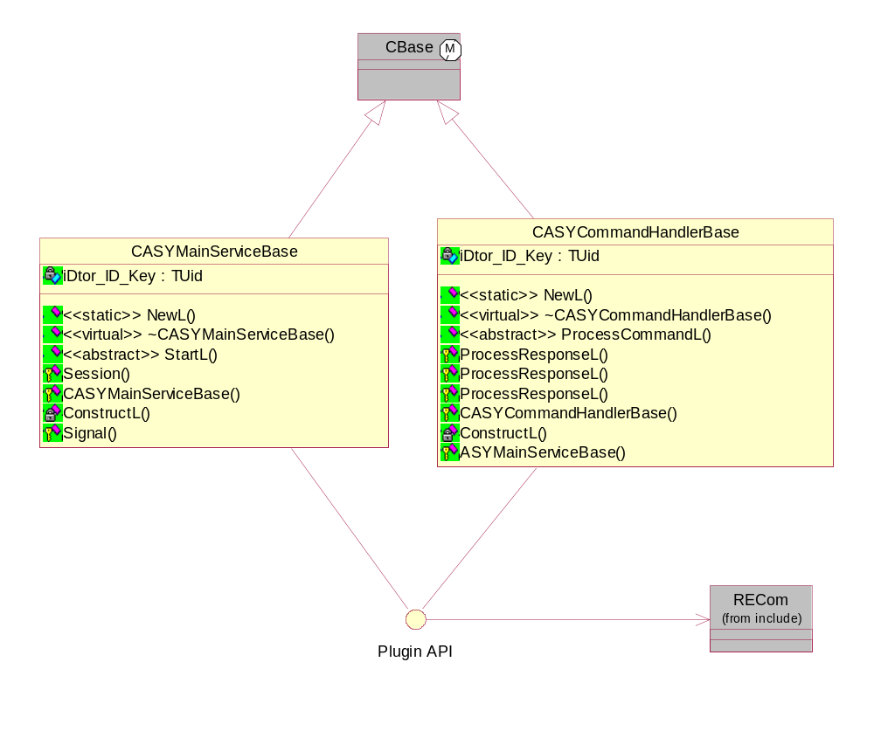
Figure 3.1 Accessory Plug-In API interface classes
The minimum implementation of an ASY consists of one concrete class that is inherited from the Accessory API base class CASYMainServiceBase. The complete implementation of an ASY must, however, implement another class, CASYCommandHandlerBase as well.
The CASYMainServiceBase and CASYCommandHandlerBase classes are delivered in ASYProxy.dll, which is a part of the Accessory Server module.
From this point onwards, the CASYMainServiceBase-derived ASY is called MainServiceASY and CASYCommandHandlerBase-derived ASY is called HandlerASY.
ASYThread is a thread created by ASYProxy for each ASY. It means that each ASY runs in its own threads.
ASYProxy is a singleton module instantiated by Accessory Server. It is a communication channel between Accessory Server and its plug-in modules, ASYs. ASYProxy is responsible for loading the ASY modules (MainServiceASY) as well as creating new ASY services (HandlerASY) when needed at run time.
Because an ASY consists of MainServiceASY and HandlerASY, those two instances are always in the same ASY thread. In fact, there can be more than one HandlerASY instances in ASYThread, depending on the run time needs for process handling. However, also just one MainServiceASY instance per ASYThread is acceptable.
MainServiceASY has the following responsibilities:
- Communicating to ASYProxy the progress of loading an ASY.
- Controlling the ASYThread existence after startup.

HandlerASY has the following responsibilities:
- Handling process commands from ASYProxy.
- Calling the process response functions after handling.

Usage

Protocol
During the phone’s startup, Accessory Server is started. The responsibility for loading the ASYs has been set to ASYProxy, which communicates with Accessory Server on when to start loading the ASYs. When that process has been processed so far to create instances of the ASYs, ASYProxy handles each founded ASYs as follows:
- ASYProxy creates an own thread for the ASY. “ASYThread – [xxxxxxxx]” is the name to be assigned to this thread. The name’s part “[xxxxxxxx]” is a unique implementation_uid of MainServiceASY. For example, implementation_uid = 0x1000B000 (exists in a resource file, for this example named 101f5500.rss ) means that the assigned thread’s name is “ASYThread – [1000b000]”.
- Within this new thread ASYProxy connects to AccessoryServer and creates a subsession to ASYComms. After connecting it makes an asynchronous NotifyProcessCommand() to AccessoryServer using the ASYComms client.
- CASYMainServiceBase::NewL() is called. Note that this function is a part of the ASYProxy implementation.
- REComSession::CreateImplementationL() is called. Note the parameter aImplementationUidAsyService which is the implementation UID of MainServiceASY.
- A proxy table is used to map the interface implementation to implementation factory functions.
- CASYReferenceMainServiceBase::NewL() is then called by the ECom framework.
- CASYReferenceMainServiceBase::StartL() is called. Now it is time for the ASY to proceed its initializing.
- After completing its initializing, the ASY must call CASYMainServiceBase::Signal() to signal ASYProxy for completion of it’s initializing.
- ASYProxy forwards signalling to AccessoryServer by using ASYProxyAPI and calling LoadComplete()with appropriate parameter values.
- AccessoryServer completes itself in step 2 made NotifyProcessCommand()with EcmdProcessCommandInit parameter – not by some third client, like all later made NotifyProcessCommand()are expected to be completed.

ASYProxy prepares to proceed completion handling. The main steps for that operation are the following:

- ASYProxy makes a new NotifyProcessCommand()for waiting next completion by some third client – not from AccessoryServer any more.
- CASYCommandHandlerBase::NewL() is called. Note that this function is a part of the ASYProxy implementation.
- REComSession::CreateImplementationL() is called. Note the parameter aImplementationUidAsyHandler, which is the implementation UID of HandlerASY.
- A proxy table is used to map the interface implementation to implementation factory functions.
- CASYReferenceCmdHandlerBase::NewL() is then called by the ECom framework.
- CASYReferenceCmdHandlerBase::ProcessCommandL() is called by ASYProxy.
- After completing the ProcessCommandL() handling, the ASY must call the ProcessResponseL() function and ASY Reference needs to continues its proceeding.
- When proceeding is completed in the ASYProxy side, ASYProxy deletes the just used instance of ASYHandler. That is why CASYReferenceCmdHandlerBase:: ~CASYReferenceCmdHandlerBase() is called.
- ASYProxy was ready to serve next completion because of in (latter) step 1 was NotifyProcessCommand() made again. After completion it by some third client, (latter) step 1 is reached again.

Error handling
On error cases, Symbian leave codes are used.

Memory overhead
The memory overhead of Accessory Plug-in API varies by the definition of ASYs.

Extensions to the API
This API cannot be extended.

Example (optional)
ASY Reference exists as a reference and is an example implementation of an ASY. ASYs are ECom plug-ins from ASYProxy’s view of point, so their implementation must fit the demands of the ECom framework. The used ECom plug-in components are the following:
- Interface definition
- Interface implementation
- Proxy, i.e. an association table
- Resource file
- (Resolver is not used)

An ASY’s interface definition is defined and implemented at the ASYProxy’s side. This is possible, because ASY Reference is derived from the following ASYProxy’s plug-in side API classes:
- class CASYReferenceMainServiceBase : private CASYMainServiceBase
- class CASYReferenceCmdHandlerBase : public CASYCommandHandlerBase

The NewL() functions of those base classes, CASYMainServiceBase::NewL() and CASYCommandHandlerBase::NewL() are called first by the ECom framework and after that the derived functions CASYReferenceMainServiceBase::NewL() and CASYReferenceCmdHandlerBase::NewL() are called by the named base classes.
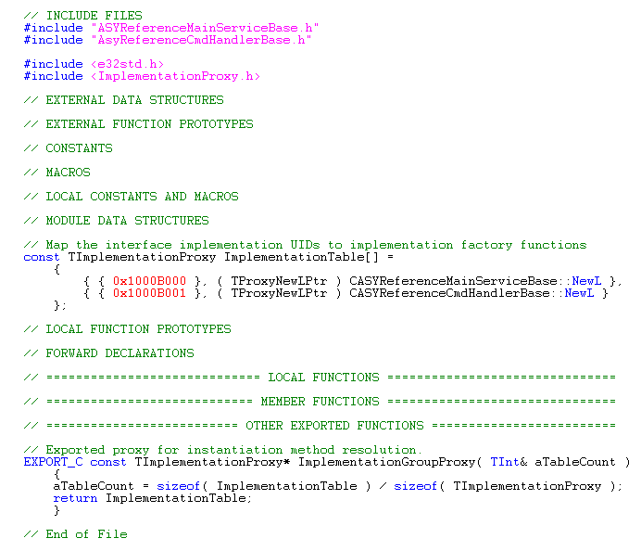
Figure 3.2 ASYReferencePluginProxy.cpp: Proxy file of ASY Reference

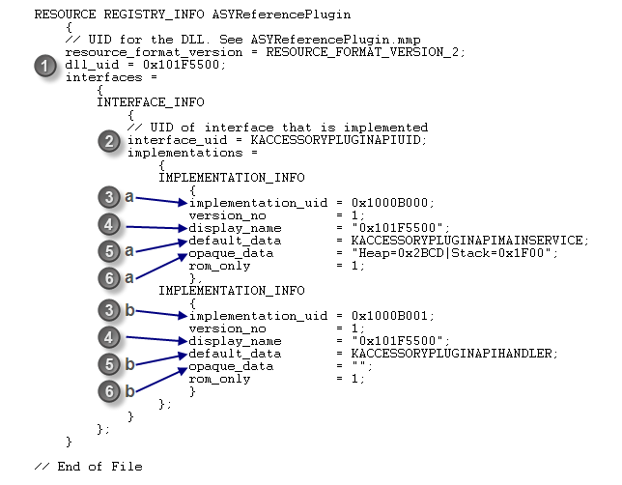
Figure 3.3 Plug-in side resource file
The resource file lists all the plug-in properties, including information about each concrete class implementing an ECom interface. The resource file must be named using a hexadecimal value of the third UID of the plug-in DLL (e.g. in this case: 101f5500.rss).
A single REGISTRY_INFO structure is used to declare all the implementations of ECom interfaces (identified by interface_uid ) available in the plug-in DLL (identified by dll_uid).
- dll_uid must be the same as the third UID (SID) of the plug-in DLL.
- interface_uid must be set to KAccessoryPluginAPIUid, which is defined in ASYServiceUids.h.
- implementation_uid is the unique implementation UID of ASY Reference implementations:
- implementation_uid of MainServiceASY.
- implementation_uid of HandlerASY.
- display_name must be set the same as dll_uid.
- default_data indicates the issue type of the ASY:
- For the MainServiceASY implementation, set default_data to be KAccessoryPluginAPIMainService.
- For the HandlerASY implementation, set default_data to be KAccessoryPluginAPIHandler.
- opaque_data can be used as memory consumption definition for ASY thread. Use of this feature is optional. Format of definition is:
opaque_data = "Heap=<heapvalue as hexadecimal number>|Stack=<stackvalue as hexadecimal number>";
Both heap and stack size can be defined (no matter with order) , only one of them or neither. Missing or unvalid values are replaced with default values by Accessory Server. Default values has been shown in section 4.1, List of constants and enumerations. Examples of right definitions, how memory sizes can be defined:
opaque_data = "Heap=0x2ABC|Stack=0x100E";
opaque_data = "Heap=0x2ABC";
opaque_data = "Stack=0x100E|Heap=0x2ABC";
opaque_data = "Stack=0x100E";
opaque_data = "";
Note, that:
- Memory value size must always be defined with 4 hexadecimal number.
- No spaces are allowed inside double quatation ( "" ) marks.
- Heap- and Stack keywords must have capital letter as initial letter.
- MainServiceASY implementation can use opaque_data -field.
- HandlerASY implementation must not use opaque_data -field.
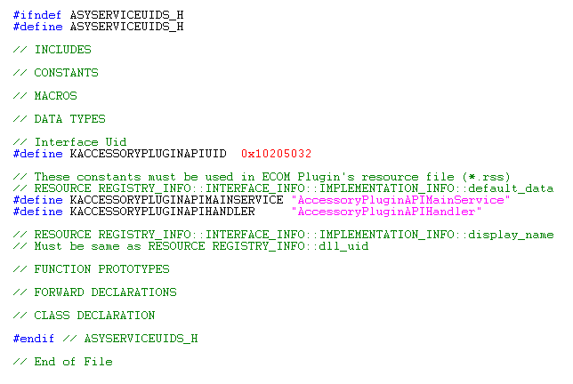
Figure 3.4 UIDs and constants needed by the ASY are defined in ASYServiceUids.h

Detailed description

CASYMainServiceBase
This class creates the ASY main service. It is a pure virtual base class for ASYs, from where the ASY is meant to be inherited. ASYProxy creates the instances.

NewL()
This method is a two-phased constructor. This method creates an instance of ASYs when Accessory Server is started. The ASY starts to monitor accessory indications by default.
Operation:
static CASYMainServiceBase* NewL( CASYProxyCommsService* aCommsService, TUid iImplementationUidAsyService )

Parameters:
Type | Name | Description
CASYProxyCommsService* | aCommsService | The communication channel to Accessory Server.
TUid | iImplementationUidAsyService | The implementation UID of ASYMainService.

Return value:
KErrNone if the operation was successful, or a Symbian OS standard error code.

virtual ~CASYMainServiceBase()
This is a destructor.

StartL()
The ASY's startup function is called after creating the ASY.
Operation:
virtual TInt StartL() = 0

Parameters:
None.
Return value:
The error code of the startup.
KErrNone if the operation was successful, or a Symbian OS standard error code.

Signal()
This method signals Accessory Server that the ASY implementation is ready to receive commands.
Operation:
void Signal()

Parameters:
None.
Return value:
KErrNone if the operation was successful, or a Symbian OS standard error code.

Session()
Returns a reference to Accessory Server created by this thread.
Operation:
RAccessoryServer& Session()

Parameters:
None.
Returns:
A reference to Accessory Server.

CASYMainServiceBase()
This method is the C++ default constructor.

CASYCommandHandlerBase
This class processes request commands from Accessory Server. It is a pure virtual base class for ASYs, from where the ASY is meant to be inherited. ASYProxy creates the instances.

NewL()
This method is a two-phased constructor. It calls the ECom ASY implementation.
Operation:
static CASYCommandHandlerBase* NewL( CASYMainServiceBase* aAsyMainServiceBase, CASYProxyCommandObserver* aASYProxyCommandObserver, TUid iImplementationUidAsyHandler )

Parameters:
Type | Name | Description
CASYMainServiceBase* | aAsyMainServiceBase | A pointer to an CASYMainServiceBase instance.
CASYProxyCommand  Observer* | aASYProxyCommandObserver | A pointer to an observer. It processes responses to the client.
TUid | iImplementationUidAsyHandler | The implementation UID of ASYHandler.

Return value:
KErrNone if the operation was successful, or a Symbian OS standard error code.

virtual ~CASYCommandHandlerBase()
This is method is a destructor.

ProcessCommandL()
This method processes request commands from Accessory Server. This method is triggered when the client has made a request to Accessory Server. Accessory Server delivers some of the requests to the ASYs.
Operation:
virtual void ProcessCommandL( const TProcessCmdId aCommand, const TASYCmdParams& aCmdParams ) = 0

Parameters:
Type | Name | Description
const TProcessCmdId | aCommand | The command to process.
const TASYCmdParams& | aCmdParams | The parameters of the command to process.

Returns:
void

ProcessResponseL()
This method is called by the ASY after handling a process command.
Operation:
void ProcessResponseL( const TAccValueTypeTBool aCmdResponse, const TInt aErrCode = KErrNone )

Parameters:
Type | Name | Description
Const TAccValueTypeTBool | aCmdResponse | The response value.
const TInt | aErrCode | The error code of the response. The default value is KErrNone.

Returns:
void

ProcessResponseL()
This method is called by the ASY after handling a process command.
Operation:
void ProcessResponseL( const TAccValueTypeTInt aCmdResponse, const TInt aErrCode = KErrNone

Parameters:
Type | Name | Description
Const TAccValueTypeTInt | aCmdResponse | The response value.
const TInt | aErrCode | The error code of the response. The default value is KErrNone.

Returns:
void

ProcessResponseL()
This method is called by the ASY after handling a process command.
Operation:
void ProcessResponseL( const TDesC8& aCmdResponse, const TInt aErrCode = KErrNone )

Parameters:
Type | Name | Description
const TDesC8& | aCmdResponse | The response value.
const TInt | aErrCode | The error code of the response. The default value is KErrNone.

Returns:
void

CASYCommandHandlerBase()
This method is the C++ default constructor.

Code architecture
The functionality of Accessory Plug-in API is defined in ASYMainServiceBase.h ASYCommandHandlerBase.h and ASYServiceUids.h

Index

List of constants and enumerations
#define KAccessoryPluginAPIUid 0x10205032
#define KAccessoryPluginAPIMainService "AccessoryPluginAPIMainService"
#define KAccessoryPluginAPIHandler "AccessoryPluginAPIHandler"

const TInt KMinASYHeapSize = 0x2000;
const TInt KDefaultASYHeapSize = 0x4000;
const TInt KMaxASYHeapSize = 0x8000;

const TInt KMinASYStackSize = 0x1000;
const TInt KDefaultASYStackSize = 0x2000;
const TInt KMaxASYStackSize = 0x4000;

typedef TPckgBuf<TASYCommandParamRecord> TASYCmdParams;

enum TASYThreadStatus
{
TASYThreadSyncLoadOkSignalOk,
TASYThreadSyncLoadOkSignalNOk
};

enum TProcessCmdId
{
ECmdSetValueBool,
ECmdSetValueTInt,
ECmdGetValueBool,
ECmdGetValueTInt,
ECmdGetValueTDes8,
ECmdProcessCommandInit,
ECmdGetSupportedBTProfiles,
ECmdBadFunction = 0xffff // Error tracking
};

Alphabetical list of classes and methods
CASYCommandHandlerBase
CASYCommandHandlerBase()
static CASYCommandHandlerBase* NewL(
CASYMainServiceBase* aAsyMainServiceBase,
CASYProxyCommandObserver* aASYProxyCommandObserver,
TUid iImplementationUidAsyHandler )
virtual ~CASYCommandHandlerBase()
virtual void ProcessCommandL(
const TProcessCmdId aCommand,
const TASYCmdParams& aCmdParams ) = 0
void ProcessResponseL(
const TAccValueTypeTBool aCmdResponse,
const TInt aErrCode = KErrNone )
void ProcessResponseL(
const TAccValueTypeTInt aCmdResponse,
const TInt aErrCode = KErrNone
void ProcessResponseL(
const TDesC8& aCmdResponse,
const TInt aErrCode = KErrNone )

CASYMainServiceBase
CASYMainServiceBase()
RAccessoryServer& Session()
static CASYMainServiceBase* NewL(
CASYProxyCommsService* aCommsService,
TUid iImplementationUidAsyService )
virtual ~CASYMainServiceBase()
virtual TInt StartL() = 0
void Signal()

