S60 3.2
Common DSY Plug-in API Specification
Document

Team name | Author

Change history:

Version | Date | Status | Comments
5.0 | 15.08.2006 | Approved | Release validity updated.
4.0 | 14.08.2006 | Approved | Chapter 2.0 updated: Interface flag note added.
3.0 | 03.03.2006 | Approved | Template corrected.
2.0 | 08.02.2006 | Approved | Release validity updated.  Section 4.1 updated.
1.0 | 09.09.2004 | Approved
Table of contents:

1. Document control 4
1.1 References 4
1.2 Documentation conventions 4
1.3 Abbreviations 4
1.4 Definitions 4
2. Purpose 6
2.1 List of required interfaces 6
2.2 Constraints 6
3. Technical specification 7
3.1 Type of interface 7
3.2 Interface Class Structure 7
3.3 Usage 7
3.3.1 Protocol 7
3.3.2 Error handling 10
3.3.3 Memory overhead 10
3.3.4 Extensions to the API 10
3.4 Example 10
3.4.1 Construction of DSY Modules 10
3.4.2 Processing a Request from DOS Client API 11
3.4.3 Processing an Event from the Domestic OS 12
3.5 Detailed description 12
3.5.1 CCDSYController 12
3.5.2 TCDSYMessage 15
3.5.3 MCDSYServiceLogic 17
3.5.4 MCDSYServiceLogicFactory 17
3.5.5 Code architecture 18
4. Index 19
4.1 List of constants and enumerations 19
4.2 Alphabetical list of classes and methods 26
4.2.1 Class CCDSYController 27
4.2.2 Class TCDSYMessage 27
4.2.3 Interface MCDSYServiceLogicFactory 27
4.2.4 Interface MCDSYServiceLogic 28

Document control

References

- S60 Common DSY Design Document
- S60 Licensee DSY Implementation Guide
- S60 DOS Server Plug-in API Specification
- S60 DOS Server Plug-in Event API Specification

Documentation conventions
Code is shown with Courier New font.

Abbreviations

API | Application Programming Interface
CDSY | Common DSY
DLL | Dynamic Link Library
DOS | Domestic Operating System
LDSY | Licensee DSY
HW | Hardware
IF | Interface
OS | Operating System
SAE | System Agent Extension
SW | Software
UI | User Interface

Definitions

Common DSY | Common DSY module that implements DOS Plug-in API and offers this API to be implemented by Licensee DSY.
Core Services | Subsystem containing DOS server and other platform components.
Domestic OS | Licensee specific protocol SW (e.g. cellular modem SW).
DSY | DOS Server Plug-in module that adapts Domestic OS behaviour. This includes bot Common DSY and Licensee DSY.
DSY Message | A data structure that contains several parameters and is typically passed between Common DSY and Licensee DSY as well as service logic and message mapper modules inside Licensee DSY.
Domestic OS Provider Modules | Licensee DSY subsystem.
DOS Server | S60 server that offers an API for Symbian OS side applications to use services offered by Domestic OS.
Licensee DSY | Licensee specific DSY module that contains e.g. service logics and message mappers.
Licensing DSY | Common DSY subsystem.
Message Mapper | Message mapper is a part of Licensee DSY that maps function calls to Domestic OS messages, AT commands etc.
Service Logic | Service logic is a part of Licensee DSY that adapts the logic of Domestic OS behavior.

Purpose
Note!
Part of API has been flagged with __ACCESSORY_FW and RD_STARTUP_CHANGE -flags.
This document describes the application programming interface and services offered by the Common DSY to Symbian OS software (basically this means Licensee DSY) in S60.

List of required interfaces
Common DSY implements DOS Plug-in API and DOS Plug-in Event API specified in reference documents [3] and [4] and provides Common DSY Plug-in API that is to be implemented by Licensee DSY module.
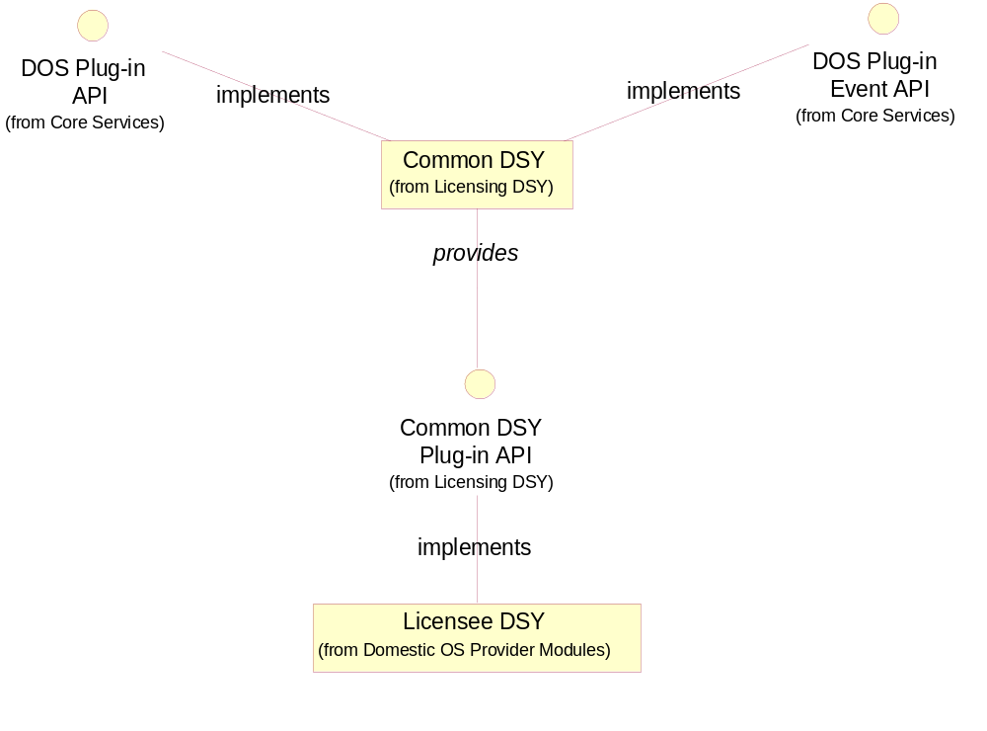
Figure 2.1 List of required interfaces

Constraints
The API specified in this document is usable only for S60 3.1.

Technical specification

Type of interface
The interface uses local objects, method calls and callback functions.

Interface Class Structure
Figure 3.2 describes Common DSY Plug-in API interface classes. Two different interface classes are provided. MCDSYServiceLogicFactory must be implemented by Licensee DSY factory that is accessed through the DLL entry point. This object is only responsible for constructing all necessary MCDSYServiceLogic implementations. MCDSYServiceLogic is an interface to be implemented by all service logics and message mappers (in this document it is assumed that logic and message mapping is implemented into separate classes).
It is intended that everything related to state mapping, logic etc. are implemented to so called service logic modules whereas message mapping between Domestic OS and DSY should be implemented into its own message mapper modules. This is recommended but not required. These modules communicate via the CCDSYController by using TCDSYMessages.
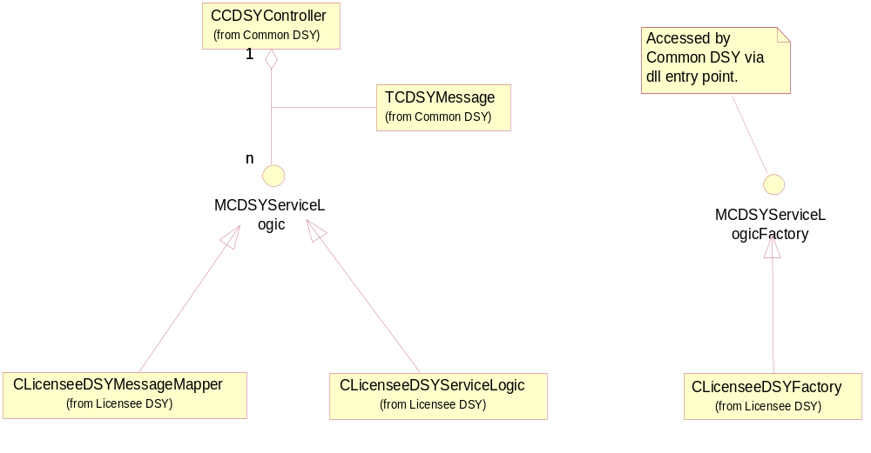
Figure 3.2 DSY Service API interface classes

Usage

Protocol
This section provides an overview on how this API works and how it should be used. Consult reference document [2] for more detailed information.

Construction of DSY Modules
This section describes the construction of both DSY Modules.
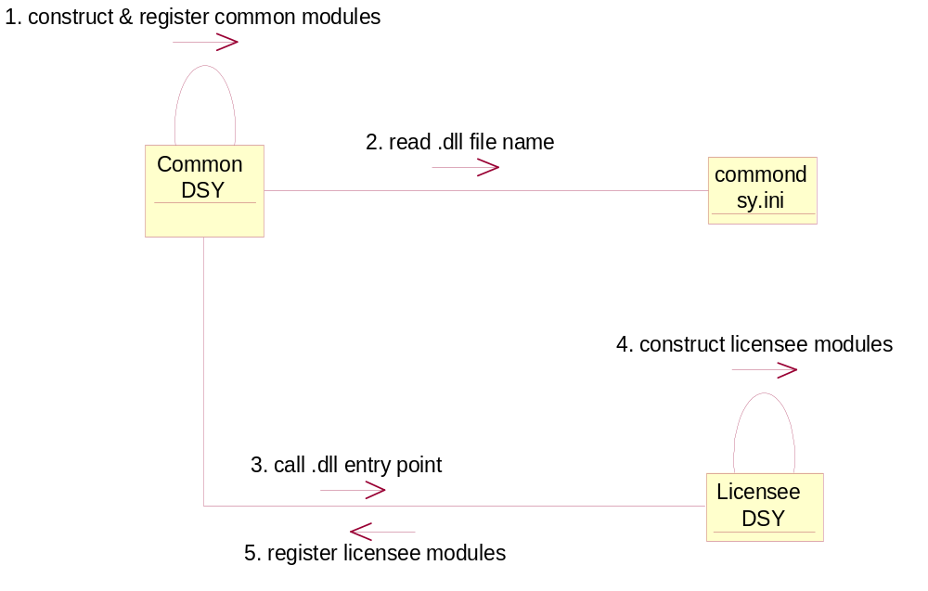
Figure 3.3 Construction of DSY Modules
- Construct & register common modules.
Common DSY is a polymorphic DLL that implements DOS Plug-in API and is factorized when the DOS Server calls the entry point of the DLL for the first time (typically when the first client connects to the DOS Server). When Common DSY is factorized, it constructs all common modules that contain service logic (currently there is not any) and registers them to listen for specific messages. It also constructs Common DSY event manager that is responsible for passing events to upper layers, controller and message mapper between DOS Server and Common DSY.
- Read DLL file name.
When the Common DSY has been factorized, it reads Licensee DSY DLL file name from the commondsy.INI.
- Call dll entry point.
Common DSY factorizes Licensee DSY by calling its DLL entry point.
- Construct licensee modules.
As a part of Common DSY factorization, all licensee specific logic modules, licensee specific message mapper modules and possible gateway components between DSY and Domestic OS are constructed. Consult reference document [2] for more information.
- Register licensee modules.
When all licensee specific modules have been constructed they are registered to the controller one by one to listen for specified messages.

Processing a Request from DOS Client API
This section describes how DSY processes requests from the DOS Client API.
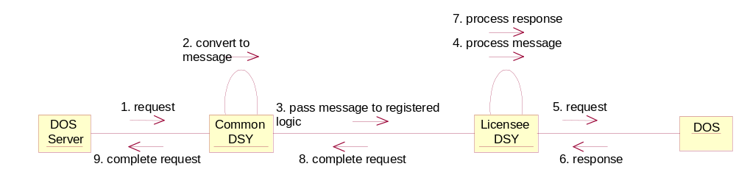
Figure 3.4 Processing a Request from the DOS Client API
- Request.
Asynchronous or synchronous request from DOS Client API through DOS Plug-in API.
- Convert to message.
Request (function call) is converted to a common message, which is then passed to the controller.
- Pass message to registered logic.
The controller finds a logic module that is registered to a specific common message and passes the message to the module. The controller calls the ProcessMessageL() function of the registered logic and passes the common message as a parameter.
- Process message.
Logic module processes the message. This operation might include some state mapping or just a direct mapping to one or more licensee messages. Consult reference document [2] for more information.
- Request.
The logic module sends a licensee message to the Domestic OS for processing.
- Response.
The response is received from the Domestic OS. The response is converted to a licensee message by the Licensee DSY and passed to the controller by calling the ProcessMessageL() function and passing the message as a parameter. Consult reference document [2] for more information.
- Process response.
Logic module processes the request and creates a new common message that contains all the requested parameters. Consult reference document [2] for more information.
- Complete request.
A common message is sent to the controller by calling the ProcessMessageL() function and passing the message as a parameter. The response message has the same transaction id as the command message.
- Complete request.
This signals the completion of the request to the DOS Server client by using standard Symbian OS client-server framework.

Processing an Event from the Domestic OS
This section describes how DSY processes events received from the Domestic OS.
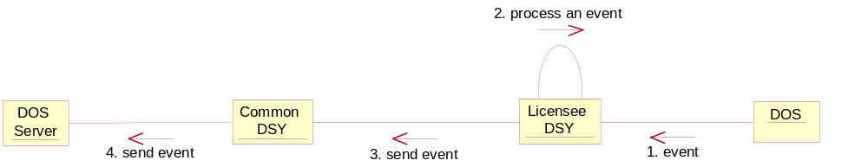
Figure 3.5 Processing an Event from the Domestic OS
- Event.
Indication is received from the Domestic OS. The indication is converted to a licensee message by Licensee DSY and passed to the controller by calling the ProcessMessageL() function and passing the message as a parameter. Consult reference document [2] for more information.
- Process an event.
The controller passes the licensee message to the registered logic module, which processes the event and creates a new common message. The message containing all parameters for the DOS Server event is sent to the controller by calling the ProcessMessageL() function and passing the message as a parameter.
- Send event.
The controller passes the common message to the Common DSY event manager.
- Send event.
The event manager fires a DOS Server Event according to the parameters received via the common message.

Error handling
Errors are usually handled by using the Symbian OS leave mechanism. Only standard Symbian OS error codes are used. Check reference documents [2] and [3] for more information about error codes.
If an error occurs when the licensee module is processing a message from the Common DSY, there are two alternatives; leaving or returning a message with an error code. If the error occurs when the licensee module is processing a message from the Domestic OS, a message with an error code must be returned to the Common DSY. If an error occurs and a message is not returned to the Common DSY, the request performs a time out.

Memory overhead
DSY Service API is an abstract interface and the memory usage depends on its implementation. Common DSY does not have any hard coded buffer sizes.

Extensions to the API
This API can be extended by defining more common messages described in Section 4.1.

Example
This section provides code examples for Figure 3.3, Figure 3.4 and Figure 3.5. All communication between the Domestic OS and the DSY are out of scope of this document and therefore not described here.

Construction of DSY Modules
The commondsy.INI file containing the Licensee DSY file name must be copied to \System\Data. The content of the file might be for example licenseedsy.DLL.
Licensee DSY DLL must be created with LibEntryL() as a first exported function. The factory class (here CLicenseeDSYFactory) must implement the MCDSYServiceLogicFactory interface.

EXPORT_C CLicenseeDSYFactory* LibEntryL()
{
CLicenseeDSYFactory* factory = CLicenseeDSYFactory::NewL();
return factory;
}

Initialization mechanism is implemented by implementing the InitializeL() function e.g:

void CLicenseeDSYFactory::InitializeL( CCDSYControler* aController )
{
// Instantiate all classes required to communicate with Domestic OS.
iGateway = CLicenseeDSYGateway::NewL( aController );

// Instantiate all service logic and message mapper classes. These classes
// always implement MCDSYServiceLogic interface.
iServiceLogic = CLicenseeDSYServiceLogic::NewL( aController );
iMessageMapper = CLicenseeDSYMessageMapper::NewL( aController, iGateway );
}

Every class that implements the MCDSYServiceLogic interface (e.g. CLicenseeDSYServiceLogic and CLicenseeDSYMessageMapper) must also register itself to the controller during construction. This can be implemented into a two-part construction.

void CLicenseeDSYServiceLogic::NewL( CCDSYController* aCtrl )
{
CLicenseeDSYServiceLogic* l = new (ELeave) CLicenseeDSYServiceLogic(aCtrl);
CleanupStack::PushL(l);
l->ConstructL();
CleanupStack::Pop(l);

return l;
}

void CLicenseeDSYServiceLogic::CLicenseeDSYServiceLogic( CCDSYController* aCtrl )
{
iController = aCtrl;
}

void CLicenseeDSYServiceLogic::ConstructL()
{
iController->RegisterServiceLogicL( KExampleGroup, KExampleID, this );
}

Every class has to be registered to listen for specific messages one by one. One message ID can have only one registered client. Typically the class has to register itself to listen for commands (i.e. DOS Client API requests) and returns (i.e. responses from the Domestic OS):

// Register for DOS Client API requests (common messages).
iController->RegisterServiceLogicL( KCDSYMessageGroup, KExampleCommand, this );

// Register for Domestic OS responses (licensee messages).
iController->RegisterServiceLogicL( KLDSYMessageGroup, KSpecificReturn, this );

Processing a Request from DOS Client API
Preconditions: DSY modules have been constructed and logic modules and message mappers have been registered to listen for certain messages. The first thing that involves the Licensee DSY is when the common message has been passed to a service logic module. When the service logic module sends the message, it must use the transaction ID from a previous message. The implementation of the ProcessMessageL() function could be as follows:

void CLicenseeDSYServiceLogic::ProcessMessageL( TCDSYMessage* aMsg )
{
switch ( aMsg->ID() )
{
case KExampleCommand: // Command from DOS Client API.
// All service logic such as state flags must be included here.

// Create a new message and pass it to message mapper.
TCDSYMessage msg( KLDSYMessageGroup, // mapper listens this
KSpecificCommand, // mapper listens this
NULL, // data not needed
aMsg->TransactionID() ); // id from prev message
iController->ProcessMessageL( msg );
.
.
.
}
}

Then the message is passed to message mapper that could be implemented just like the service logic example above. When the return arrives from the Domestic OS, it is first passed to the message mapper that creates and sends a new message to the service logic module, which converts the mapper response to the Common DSY response message e.g:

void CLicenseeDSYServiceLogic::ProcessMessageL( TCDSYMessage* aMsg )
{
switch ( aMsg->ID() )
{
case KSpecificReturn: // Return from Domestic OS.
// All service logic such as state flags must be included here.

// Create a new message and pass it to common DSY.
TCDSYMessage msg( KCDSYMessageGroup, // common waits for this
KExampleReturn, // common waits for this
NULL, // data not needed
aMsg->TransactionID() ); // id from prev message
iController->ProcessMessageL( msg );
.
.
.
}
}

Processing an Event from the Domestic OS
Events are processed almost the same way that requests are from the DOS Client API. The only difference is that the transaction id is not used.

Detailed description

CCDSYController
The CCDSYController routes the DSY messages to registered listeners. Message(s) are routed to the object that has registered itself to the message’s group and id (transaction id is optional). When the message is routed to an object the ProcessMessageL() function is called.

static CCDSYController* NewL( )
Creates a new instance of CDSYController.
Leave values: KErrNoMemory
Return value: CCDSYController*

~CCDSYController( )
Destructor.
Leave values: This function will not leave.
Return value: N/A

IMPORT_C void RegisterServiceLogicL(
const TUint32 aMessageGroup,
const TUint32 aMessageID,
MCDSYServiceLogic* aCDSYServiceLogic )
Registers service logic for a specific message group and ID. The function is exported.

Parameters:
Type | Name | Description
const TUint32 | aMessageGroup | Message group to which the service logic is registered.
const TUint32 | aMessageID | Message ID to which the service logic is registered.
MCDSYServiceLogic* | aCDSYServiceLogic | Pointer to service logic which is registered.

Leave values: Symbian OS standard error code.
Return value: void

IMPORT_C void RegisterServiceLogicL(
const TUint32 aMessageGroup,
const TUint32 aMessageID,
const TUint32 aTransactionID,
MCDSYServiceLogic* aCDSYServiceLogic )
Registers service logic for a specific message group, message ID and transaction ID. The function is exported.

Parameters:
Type | Name | Description
const TUint32 | aMessageGroup | Message group to which the service logic is registered.
const TUint32 | aMessageID | Message ID to which the service logic is registered.
const TUint32 | aTransactionID | Message's transaction ID to which the service logic is registered.
MCDSYServiceLogic* | aCDSYServiceLogic | Pointer to service logic, which is registered.

Leave values: Symbian OS standard error code.
Return value: void

IMPORT_C void UnregisterServiceLogic(
const TUint32 aMessageGroup,
const TUint32 aMessageID,
MCDSYServiceLogic* aCDSYServiceLogic )
Unregisters service logic for a specific message group and ID. The function is exported.

Parameters:
Type | Name | Description
const TUint32 | aMessageGroup | Message group from which the service logic is unregistered.
const TUint32 | aMessageID | Message ID from which the service logic is unregistered.
MCDSYServiceLogic* | aCDSYServiceLogic | Pointer to service logic that is unregistered.

Leave values: The function does not leave.
Return value: void

IMPORT_C void UnregisterServiceLogic(
const TUint32 aMessageGroup,
const TUint32 aMessageID,
const TUint32 aTransactionID,
MCDSYServiceLogic* aCDSYServiceLogic )
Unregisters service logic for a specific message group, message ID and transaction ID. The function is exported.

Parameters:
Type | Name | Description
const TUint32 | aMessageGroup | Message group from which the service logic is unregistered.
const TUint32 | aMessageID | Message ID from which the service logic is unregistered.
const TUint32 | aTransactionID | Message's transaction ID to which the service logic is registered.
MCDSYServiceLogic* | aCDSYServiceLogic | Pointer to service logic that is unregistered.

Leave values: The function does not leave.
Return value: void

IMPORT_C void ProcessMessageL(
TCDSYMessage& aCDSYMessage )
Processes DSY message. The function routes the message to the service logics registered to the message. The function is exported.

Parameters:
Type | Name | Description
TCDSYMessage& | aCDSYMessage | Message that is routed.

Leave values: Any error code specified at ProcessMessageL() function on MCDSYServiceLogic implementation.
Return value: void

IMPORT_C void ExpireMessageL(
TCDSYMessage& aCDSYMessage )
Expires the message. Called if a response is not received to a Common DSY command message within specified time interval. The function is exported. It can also be called by a service logic to cancel/expire a command message sent to another service logic. The function is exported.

Parameters:
Type | Name | Description
TCDSYMessage& | aCDSYMessage | Message to be expired

Leave values: Any error code specified at ExpireMessageL() function on MCDSYServiceLogic implementation.
Return value: void

IMPORT_C TUint8 GetNewTransactionID( )
Returns new transaction ID (0-255). The function is exported.
Leave values: The function does not leave.
Return value: KErrNone or KErrNotFound

TCDSYMessage
TCDSYMessage is a generic message class. The class can be derived by the Licensee DSY if needed.

IMPORT_C TCDSYMessage(
const TUint32 aGroup,
const TUint32 aID,
const TDesC8* aData,
const TUint32 aTransactionID )
The function constructs a TCDSYMessage object and sets its transaction ID to 0.

Type | Name | Description
const TUint32 | aGroup | Message group.
const TUint32 | aID | Message ID.
const TDesC8* | aData | Pointer to data
const TUint32 | aTransactionID | Transaction ID.

Leave values: The function does not leave.
Return value: N/A

IMPORT_C TCDSYMessage(
const TUint32 aGroup,
const TUint32 aID,
const TDesC8* aData )
The function constructs a TCDSYMessage object.

Type | Name | Description
const TUint32 | aGroup | Message group.
const TUint32 | aID | Message ID.
const TDesC8* | aData | Pointer to data

Leave values: The function does not leave.
Return value: N/A

IMPORT_C virtual ~TCDSYMessage()
Destructor.
Leave values: This function does not leave.
Return value: N/A

inline TUint32 Group() const
Returns message group. The function does not take any parameters.
Leave values: The function does not leave.
Return value: Message group.

inline TUint32 ID() const
Returns message ID. The function does not take any parameters.
Leave values: The function does not leave.
Return value: Message ID.

inline TUint32 TransactionID() const
Returns messages transaction ID. The function does not take any parameters.
Leave values: The function does not leave.
Return value: Transaction ID.

inline const TDesC8* Data() const
Returns a pointer to the messages data is copied to a member variable in the message. The function does not take any parameters.
Leave values: The function does not leave.
Return value: Messages data.

inline const TDesC8* ReturnData() const
Returns a pointer to the messages return data. The function does not take any parameters.
Leave values: The function does not leave.
Return value: Return data.

IMPORT_C void SetReturnDataL( const TDesC8* aReturnData )
Sets the messages return data. The function is exported.
Parameters:

Type | Name | Description
const TDesC8* | aReturnData | Return data.

Leave values: Symbian OS standard error code.
Return value: void

inline void SetTransactionID( TUint32 aTransactionID )
Sets the transaction ID.

Parameters:
Type | Name | Description
TUint32 | aTransactionID | Transaction ID.

Leave values: The function does not leave.
Return value: void

MCDSYServiceLogic
MCDSYServiceLogic is the interface class for all classes that registers themselves to the controller (e.g. logic modules and message mappers).

virtual void ProcessMessageL(
TCDSYMessage* aCDSYMessage ) = 0
Processes the message.

Parameters:
Type | Name | Description
TCDSYMessage* | aCDSYMessage | Pointer to TCDSYMessage.

Leave values: All possible error codes (depends on the implementation).
Return value: void

virtual void ExpireMessageL(
TCDSYMessage* aCDSYMessage ) = 0
Expires the message.

Parameters:
Type | Name | Description
TCDSYMessage* | aCDSYMessage | Pointer to TCDSYMessage.

Leave values: All possible error codes (depends on the implementation).
Return value: void

MCDSYServiceLogicFactory
MCDSYServiceLogicFactory is the interface class for Licensee DSY factory class.

virtual ~ MCDSYServiceLogicFactory ( )
Destructor.
Leave values: This function does not leave.
Return value: N/A

virtual void InitializeL(
CCDSYController *aCDSYController ) = 0
Initializes the factory.

Parameters:
Type | Name | Description
CCDSYController* | aCDSYController | Pointer to CCDSYController.

Leave values: All possible leave values.
Return value: void

virtual void DeInitialize( ) = 0
Deinitializes the factory. The function does not take any parameters.
Leave values: The function does not leave.
Return value: void

Code architecture
The following header files are experted to the \epoc32\include\oem\ folder:
cdsycontroller.H; cdsyenums.H; cdsymessage.H; cdsymessagestructures.H; cdsyservicelogic.H; cdsyservicelogicfactory.H; cdsymessageids.H
The libraries provided are commondsy.LIB and commondsy.DLL.

Index

List of constants and enumerations
The following lists specify every message ID and structure including parameters that are to be used on Common DSY. See reference document [2] for more information on usage and descriptions. Message IDs are defined at cdsymessageids.H and message structures are defined at cdsymessagestructures.H.
The following syntax is used for listing all command-return pairs.

Message ID | Message structure
<command> | <struct>
<parameters for command’s struct>
<return> | <struct>
<1st parameter for return’s struct>
<2nd parameter for return’s struct>

Message ID (Accessory) | Message structure
KCDSYMsgSelectEnhancementLoopsetCommand | NULL
No parameters.
KCDSYMsgSelectEnhancementLoopsetReturn | TCDSYMsgDataReturn
Error code or KErrNone.
KCDSYMsgSelectEnhancementTTYCommand | NULL
No parameters.
KCDSYMsgSelectEnhancementTTYReturn | TCDSYMsgDataReturn
Error code or KErrNone.
KCDSYMsgSelectEnhancementHeadsetCommand | NULL
No parameters.
KCDSYMsgSelectEnhancementHeadsetReturn | TCDSYMsgDataReturn
Error code or KErrNone.
KCDSYMsgGetActiveEnhancementCommand | NULL
No parameters.
KCDSYMsgGetActiveEnhancementReturn | TCDSYMsgDataReturnValue
enum EPSAccLpsMode; defined at psvariables.h
Error code or KErrNone.
KCDSYMsgGetAccessoryTypeCommand | NULL
No parameters.
KCDSYMsgGetAccessoryTypeReturn | TCDSYMsgDataReturnValue
enum TDosAccessoryMode; defined at dossrvservices.h
Error code or KErrNone.
KCDSYEventAccessoryType | TCDSYMsgDataEvent
enum TDosAccessoryMode; defined at dossrvservices.h
KCDSYEventHeadsetButtonStatus | TCDSYMsgDataEvent
enum EPSButtonState; defined at psvariables.h
KCDSYMsgGenerateGripEventCommand | NULL
No parameters.
KCDSYMsgGenerateGripEventReturn | TCDSYMsgDataReturn
Error code or KErrNone.

Message ID (Audio) | Message structure
KCDSYMsgGetOutputVolumeLevelCommand | NULL
No parameters.
KCDSYMsgGetOutputVolumeLevelReturn | TCDSYMsgDataReturnValue
Volume level; 0-9
Error code or KErrNone.
KCDSYMsgSetOutputVolumeLevelCommand | TCDSYMsgDataValue
Volume level; 0-9
KCDSYMsgSetOutputVolumeLevelReturn | TCDSYMsgDataReturn
Error code or KErrNone.
KCDSYEventOutputVolumeLevel | TCDSYMsgDataEvent
Volume level; 0-9
KCDSYMsgActivateIntegratedHandsfreeCommand | NULL
No parameters.
KCDSYMsgActivateIntegratedHandsfreeReturn | TCDSYMsgDataReturn
Error code or KErrNone.
KCDSYMsgDeactivateIntegratedHandsfreeCommand | NULL
No parameters.
KCDSYMsgDeactivateIntegratedHandsfreeReturn | TCDSYMsgDataReturn
Error code or KErrNone.
KCDSYMsgGetIntegratedHandsfreeStatusCommand | NULL
No parameters.
KCDSYMsgGetIntegratedHandsfreeStatusReturn | TCDSYMsgDataReturnValue
enum EPSHandsFreeMode; defined at psvariables.h
Error code or KErrNone.
KCDSYEventHandsfreeStatus | TCDSYMsgDataEvent
enum EPSHandsFreeMode; defined at psvariables.h

Message ID (Bluetooth audio) | Message structure
KCDSYMsgBTAudioAccessoryAttachCommand | TCDsyBTAudioAttachReqData
TBTDevAddr
enum TBTDeviceType defined at dossrvservices.h
Supported features according to BT HFP
KCDSYMsgBTAudioAccessoryAttachReturn | TCDSYMsgDataReturn
Error code or KErrNone.
KCDSYMsgCancelBTAudioAccessoryAttachCommand | NULL
No parameters.
KCDSYMsgCancelBTAudioAccessoryAttachReturn | NULL
No parameters.
KCDSYMsgBTAudioAccessoryDetachCommand | TCDsyBTAudioDetachReqData
TBTDevAddr
enum TBTDeviceType defined at dossrvservices.h
KCDSYMsgBTAudioAccessoryDetachReturn | TCDSYMsgDataReturn
Error code or KErrNone.
KCDSYMsgCancelBTAudioAccessoryDetachCommand | NULL
No parameters.
KCDSYMsgCancelBTAudioAccessoryDetachReturn | NULL
No parameters.
KCDSYEventBTAudioAccessoryAttach | TCDSYMsgDataEvent
enum TBTAccessoryMode; defined at dossrvservices.h
KCDSYMsgBTAudioLinkOpenRespCommand | TCDsyBTAudioLinkOpenRespData
Status
THCIConnHandle
KCDSYMsgBTAudioLinkOpenRespReturn | TCDSYMsgDataReturn
Error code or KErrNone.
KCDSYMsgBTAudioLinkOpenIndCommand | TCDsyBTAudioLinkOpenIndData
TBTDevAddr
THCIConnHandle
KCDSYMsgBTAudioLinkOpenIndReturn | TCDSYMsgDataReturn
Error code or KErrNone.
KCDSYEventBTAudioLinkOpenReq | NULL
No parameters.
KCDSYMsgBTAudioLinkCloseRespCommand | TCDSYMsgDataValue
Status
KCDSYMsgBTAudioLinkCloseRespReturn | TCDSYMsgDataReturn
Error code or KErrNone.
KCDSYMsgBTAudioLinkCloseIndCommand | TCDsyBTAudioLinkCloseIndData
TBTDevAddr
THCIConnHandle
KCDSYMsgBTAudioLinkCloseIndReturn | TCDSYMsgDataReturn
Error code or KErrNone.
KCDSYEventBTAudioLinkCloseReq | TCDSYMsgDataEvent
THCIConnHandle
KCDSYEventBTAudioDeviceType | TCDSYMsgDataEvent
enum TBTDeviceType defined at dossrvservices.h
KCDSYEventBTAudioConnectionEstablished | TCDSYMsgDataServiceLevelConnEstablishedIndEventData
struct TBTServiceLevelConnParams defined at dossrvservices.h

Message ID (Bluetooth audio speed dialing) | Message structure
KCDSYMsgBTQuerySpeedDialNumberRespCommand | TCDsyBTAudioQuerySpeedDialNumRespData
Status
Phone number
KCDSYMsgBTQuerySpeedDialNumberRespReturn | TCDSYMsgDataReturn
Error code or KErrNone.
KCDSYEventBTQuerySpeedDialNumberReq | TCDSYMsgDataEvent
Index
KCDSYMsgBTQueryLastDialledVoiceNumberRespCommand | TCDsyBTAudioQueryLastDialledVoiceNumberRespData
Status
Phone number
KCDSYMsgBTQueryLastDialledVoiceNumberRespReturn | TCDSYMsgDataReturn
Error code or KErrNone.
KCDSYEventBTQueryLastVoiceNumberReq | NULL
No parameters.

Message ID (Bluetooth audio voice recognition) | Message structure
KCDSYMsgBTActivateVoiceRecognitionRespCommand | TCDSYMsgDataValue
Status
KCDSYMsgBTActivateVoiceRecognitionRespReturn | TCDSYMsgDataReturn
Error code or KErrNone.
KCDSYEventBTActivateVoiceRecognitionReq | NULL
No parameters.
KCDSYMsgBTAbortVoiceRecognitionRespCommand | NULL
No parameters.
KCDSYMsgBTAbortVoiceRecognitionRespReturn | TCDSYMsgDataReturn
Error code or KErrNone.
KCDSYEventBTAbortVoiceRecognitionReq | NULL
No parameters.
KCDSYMsgBTVoiceRecognitionStatusIndCommand | TCDSYMsgDataValue
enum TBTVoiceRecognitionState; defined at dossrvservices.h
KCDSYMsgBTVoiceRecognitionStatusIndReturn | TCDSYMsgDataReturn
Error code or KErrNone.
KCDSYMsgBTVoiceRecognitionStatusRespCommand | TCDSYMsgDataValue
enum TBTVoiceRecognitionState; defined at dossrvservices.h
KCDSYMsgBTVoiceRecognitionStatusRespReturn | TCDSYMsgDataReturn
Error code or KErrNone.
KCDSYEventBTVoiceRecognitionStatusReq | NULL
No parameters.

Message ID (Extension) | Message structure
KCDSYMsgInitializeExtensionCommand | NULL
No parameters.
KCDSYMsgInitializeExtensionReturn | TCDSYMsgDataExtensionInitialization
Pointer to the initialized class.
KCDSYEventGeneral | TCDSYMsgDataGeneralEvent
Parameters are defined by the implementation.

Message ID (Network) | Message structure
KCDSYEventNetworkSignalLevel | TCDSYMsgDataEvent
Signal bars; 0-7

Message ID (Real-time clock) | Message structure
KCDSYMsgCheckTimeValidityCommand | NULL
No parameters.
KCDSYMsgCheckTimeValidityReturn | TCDSYMsgDataReturnValue
Boolean
Error code or KErrNone.
KCDSYMsgSetWakeupAlarmCommand | TCDSYMsgDataDateTime
TTime
KCDSYMsgSetWakeupAlarmReturn | TCDSYMsgDataReturn
Error code or KErrNone.
KCDSYMsgCancelWakeupAlarmCommand | NULL
No parameters.
KCDSYMsgCancelWakeupAlarmReturn | TCDSYMsgDataReturn
Error code or KErrNone.

Message ID (Restore factory settings) | Message structure
KCDSYMsgExecuteDeepRfsCommand | NULL
No parameters.
KCDSYMsgExecuteDeepRfsReturn | TCDSYMsgDataReturn
Error code or KErrNone.
KCDSYMsgExecuteNormalRfsCommand | NULL
No parameters.
KCDSYMsgExecuteNormalRfsReturn | TCDSYMsgDataReturn
Error code or KErrNone.

Message ID (Selftests) | Message structure
KCDSYMsgExecuteSelfTestCommand | NULL
No parameters.
KCDSYMsgExecuteSelfTestReturn | TCDSYMsgDataReturn
Error code or KErrNone.
KCDSYEventSelfTestFinished | TCDSYMsgDataEvent
enum TStartupSTResult; defined at dsyenums.h

Message ID (SIM & security) | Message structure
KCDSYMsgGetPreferredLanguageCommand | NULL
No parameters.
KCDSYMsgGetPreferredLanguageReturn | TCDSYMsgDataReturnValue
Language code.
KCDSYEventSIMReady | TCDSYMsgDataEvent
enum EPSSimReadyStatus; defined at psvariables.h
KCDSYEventSIMChanged | TCDSYMsgDataEvent
enum EPSSimChanged; defined at psvariables.h
KCDSYEventSIMLockStatus | TCDSYMsgDataEvent
enum EPSSimLockStatus; defined at psvariables.h
KCDSYEventSIMStatus | TCDSYMsgDataEvent
enum EPSSimCStatus; defined at psvariables.h
KCDSYEventSIMKnownStatus | TCDSYMsgDataEvent
enum EPSCurrentSimOwnedSimStatus; defined at psvariables.h
KCDSYEventSecurityCodeStatus | TCDSYMsgDataEvent
enum EPSSecurityCodeStatus; defined at psvariables.h
KCDSYEventCallDivertStatus | TCDSYMsgDataEvent
enum EPSCallsForwardingStatus; defined at psvariables.h
KCDSYEventVoiceMailStatus | TCDSYMsgDataEvent
enum EPSVoiceMailStatus; defined at psvariables.h
KCDSYEventFaxMessageStatus | TCDSYMsgDataEvent
Boolean
KCDSYEventDataMessageStatus | TCDSYMsgDataEvent
Boolean

Message ID (SMS) | Message structure
KCDSYEventSmsStorageStatus | TCDSYMsgDataEvent
enum TDosSmsStorageStatus; defined at dossrvservices.h

Message ID (Startup, shutdown & reset) | Message structure
KCDSYMsgGetSoftwareResetStatusCommand | NULL
No parameters.
KCDSYMsgGetSoftwareResetStatusReturn | TCDSYMsgDataReturn
Boolean
KCDSYMsgExecuteSoftwareResetCommand | NULL
No parameters.
KCDSYMsgExecuteSoftwareResetReturn | TCDSYMsgDataReturn
Error code or KErrNone.
KCDSYMsgGetSoftwareResetReasonCommand | NULL
No parameters.
KCDSYMsgGetSoftwareResetReasonReturn | TCDSYMsgDataReturnValue
enum TSWStartupReason; defined at sysstartup.h
KCDSYMsgSetSoftwareResetReasonCommand | TCDSYMsgDataValue
enum TSWStartupReason; defined at sysstartup.h
KCDSYMsgSetSoftwareResetReasonReturn | TCDSYMsgDataReturn
Error code or KErrNone.
KCDSYMsgSwitchOffPowerCommand | NULL
No parameters.
KCDSYMsgSwitchOffPowerReturn | TCDSYMsgDataReturn
Error code or KErrNone.
KCDSYMsgSendShutdownSyncCommand | NULL
No parameters.
KCDSYMsgSendShutdownSyncReturn | TCDSYMsgDataReturn
Error code or KErrNone.
KCDSYEventDomesticOSInitiatedShutdown | NULL
No parameters.
KCDSYMsgIndicatePowerOnCommand | NULL
No parameters.
KCDSYMsgIndicatePowerOnReturn | TCDSYMsgDataReturn
Error code or KErrNone.
KCDSYMsgSendStartupSyncCommand | NULL
No parameters.
KCDSYMsgSendStartupSyncReturn | TCDSYMsgDataReturn
Error code or KErrNone.
KCDSYMsgInitiateDSYStartupCommand | NULL
No parameters.
KCDSYMsgInitiateDSYStartupReturn | TCDSYMsgDataReturn
Error code or KErrNone.
KCDSYMsgGetStartupReasonCommand | NULL
No parameters.
KCDSYMsgGetStartupReasonReturn | TCDSYMsgDataReturnValue
enum TWD2StartupReason; defined at startupreasons.h
KCDSYMsgSetDomesticOSStatusCommand | TCDSYMsgDataValue
enum TCDSYMTCState; defined at cdsyenums.h
KCDSYMsgSetDomesticOSStatusReturn | TCDSYMsgDataReturn
Error code or KErrNone.
KCDSYEventPhonePowerOn | NULL
No parameters.
KCDSYMsgSetOfflineStatusCommand | TCDSYMsgDataValue
enum TDosStateFlag; defined at dossrvservices.h
KCDSYMsgSetOfflineStatusReturn | TCDSYMsgDataReturn
Error code or KErrNone.
KCDSYMsgGetOfflineStatusCommand | NULL
No parameters.
KCDSYMsgGetOfflineStatusReturn | TCDSYMsgDataReturnValue
enum TDosStateFlag; defined at dossrvservices.h
Error code or KErrNone.

The following enumerations are defined at cdsyenums.H:

enum TCDSYRfsType
{
ECDSYRfsNormal = 0,
ECDSYRfsDeep = 1
};

enum TCDSYMTCState
{
ECDSYMtcChargingState,
ECDSYMtcAlarmState,
ECDSYMtcPowerOffState,
ECDSYMtcNormalState,
ECDSYMtcRfInactiveState,
ECDSYMtcBTSAP
};

Alphabetical list of classes and methods
The following table shortly describes the purpose of the classes.

Class | Description | Header file
CCDSYController | Common DSY Controller, which routes the messages and keeps the state information. | CDSYController.H
TCDSYMessage | Generic CDSY message class. | CDSYMessage.H
MCDSYServiceLogic | Interface class for all classes that registers themselves to the controller. | CDSYServiceLogic.H
MCDSYServiceLogicFactory | Factory class to be implemented by Licensee DSY. | CDSYServiceLogicFactory.H

Class CCDSYController

Method | Description
~CCDSYController | Destructor.
NewL | Creates a new instance of CDSYController.
RegisterServiceLogicL | Registers service logic for a specific message.
UnregisterServiceLogicL | Unregisters service logic for a specific message.
ProcessMessageL | Processes the incoming TCDSYMessage. The function routes the message to the service logics registered to the message.
ExpireMessageL | Expires the message.
GetNewTransactionID | Returns new transaction ID.

Class TCDSYMessage

Method | Description
TCDSYMessage | Constructor.
~TCDSYMessage | Destructor.
Group | Returns message group.
ID | Returns message ID.
TransactionID | Returns messages transaction ID.
Data | Returns messages data.
ReturnData | Return messages return data.
SetReturnDataL | Sets the messages return data.
SetTransactionID | Sets the transaction ID.

Interface MCDSYServiceLogicFactory

Method | Description
~MCDSYServiceLogicFactory | Destructor.
DeInitialize | Deinitializes the factory.
InitializeL | Initializes the factory.

Interface MCDSYServiceLogic

Method | Description
ProcessMessageL | Processes message.
ExpireMessageL | Expires message.

