S60 3.2

DOS Server Client

API Specification Document

Team name | Author
System Info | Laura Rissanen

Change history:

Version | Date | Status | Comments
12.0 | 15.08.2006 | Approved | Release validity updated.
11.0 | 14.08.2006 | Approved | Chapter 2.0 updated: Interface flag note added.
10.0 | 17.03.2006 | Approved | Layout fix.
9.0 | 03.03.2006 | Approved | Template corrected.
8.0 | 08.02.2006 | Approved | Release validity updated.  Chapters 4.3.2, 4.3.3, 4.4.2, 4.4.3, 4.12.15, 4.12.16, 4.12.21, 4.12.25, 4.12.27, 4.12.28, 4.12.30 and 4.12.38 updated.  Chapters 4.3.4, 4.3.5, 4.4.4, 4.12.35 and 4.12.40 removed.  “Syevdef.h” replaced with “psvariables.h” everywhere.  Appendix A updated.  Appendix B updated.
7.0 | 30.08.2005 | Approved | Chapter 2 updated.  Chapter 4.4.4, 4.4.5, 4.4.6 and 4.4.7 removed.  Chapter 4.9 removed.  Chapters 4.13.15, 4.13.16, 4.13.17 and 4.13.19 removed.  Appendix A updated.  Appendix B updated.
6.0 | 02.08.2004 | Approved | Chapter 4.12 modified (new CallFunction() overloads added, old asynchronous CallFunction() removed)  Defects found in review corrected;  - Old synchronous CallFunction() set as deprecated 4.11.2  - 4.12 – some “iParLength” words had “i” with different font than the rest of the word  - 4.12.5 “EFlase” and TExtension with small “e”  Added more content to chapter 4.12 (iParLength has to be >= 0)
5.0 | 02.06.2004 | Approved | Figure 3.3 updated  Chapters 4.1, 4.2, 4.3, 4.5, 4.5.3, 4.6.5, 4.6.7, 4.9.2 and 4.10.2 updated  Added feature flag information to chapters 4.4.2 and 4.4.3  Added “corresponding methods” to description in following sections:  4.4.2, 4.4.3, 4.6.2, 4.6.3, 4.6.4, 4.6.5, 4.7.2, 4.7.3, 4.7.5, 4.7.7, 4.7.8, 4.9.2, 4.9.3, 4.9.4, 4.9.5, 4.9.6, 4.11.2.1, 4.11.2.2, 4.11.2.3, 4.11.2.4, 4.13.8, 4.13.12, 4.13.13, 4.13.14, 4.13.21, 4.13.35  Section 4.4.2 and 4.4.3 corrected last paragraph “this feature is not supported…”
4.0 | 18.05.2004 | Approved | Following deprecated methods removed:  - TInt SetVolumeMuteState(const TSAVolMuteState aState) const  - TInt GetVolumeMuteState(TSAVolMuteState& aState) const  - TInt SetAccessoryMode(const TSAAudioAccMode aMode) const  - void SetAccessoryMode( TRequestStatus& aStatus, const TSAAudioAccMode aMode)  - void CancelSetAccessoryMode()  - void SetMicMuteState(TRequestStatus& aStatus, const TSAMicMuteState aState)  - void CancelSetMicMuteState()  - void SetVolumeMuteState(TRequestStatus& aStatus, const TSAVolMuteState aState)  - void CancelSetVolumeMuteState()  - void GetMicMuteState(TRequestStatus& aStatus, TSAMicMuteState& aState)  - void CancelGetMicMuteState()  - void GetVolumeMuteState(TRequestStatus& aStatus, TSAVolMuteState& aState)  - void CancelGetVolumeMuteState()  - void GetOutputVolume(TRequestStatus& aStatus, TInt& aVolume)  - void CancelGetOutputVolume()  - void SetOutputVolume(TRequestStatus& aStatus, const TInt aVolume)  - void CancelSetOutputVolume()  - TInt EnumerateAudioVolumeLevels(const TInt aLevels) const  - void EnumerateAudioVolumeLevels( TRequestStatus& aStatus, const TInt aLevels)  - void CancelEnumerateAudioVolumeLevels()  - TInt GetAccessoryMode(TSAAudioAccMode & aMode ) const  - void GetAccessoryMode( TRequestStatus& aStatus, TSAAudioAccMode& aMode )  - void CancelGetAccessoryMode()  - Virtual void HeadsetStatusL (TSAHeadsetStatus aMode)  - Virtual void AudioAccessoryModeChangedL (TSAAudioAccMode aMode)  - Virtual void LoopsetStatusL(TSALoopsetStatus aStatus)  Added:GetAccessoryMode() 4.4.9 and AccessoryModeChangedL() 4.13.10  Appendix A: List of constants and enumerations and Appendix B: Alphabetical list of classes and methods updated accordingly  Chapter 4 technical details revised.  Added chapter 4.4.7. Deprecated chapters 4.4.4, 4.4.5 and 4.4.6
3.0 | 19.02.2004 | Approved | Technical details revised. Added deprecation information to chapter 4.
2.0 | 21.10.2003 | Approved | All technical details revised.
1.0 | 28.04.2003 | Approved

Table of contents:
1. Document control 7
1.1 References 7
1.2 Abbreviations 7
1.3 Definitions 8
2. Purpose 9
2.1 List of required interfaces 10
2.2 Product Platform and/or Symbian OS version constraints 10
3. Technical specification 11
3.1 Type of the interface 11
3.2 Interface class structure 11
3.2.1 DOS Server Client API structure 11
3.2.2 DOS Event API structure 12
3.3 Usage 12
3.3.1 Protocol 12
3.3.1.1 Usage of DOS Server sub-session 12
3.3.1.2 Usage of DOS Events 13
3.3.2 Error handling 14
3.3.3 Extensions: RDosExtension usage 15
3.4 Examples of usage 15
3.4.1 Example: using DOS Server sub-session 15
3.4.2 Example: listening events 15
3.4.3 Example: using RDosExtension 17
3.4.3.1 Service functions 17
3.4.3.2 DOS Server extension Events 18
4. Detailed description 19
4.1 RDosServer 19
4.1.1 StartServer() 19
4.1.2 Connect() 19
4.1.3 Close() 19
4.1.4 ServerShutdown() 19
4.2 RDosSubSession 20
4.2.1 Close() 20
4.3 RDosAudio 20
4.3.1 Open() 20
4.3.2 SetHandsfreeMode() 21
4.3.3 GetHandsfreeMode() 21
4.3.4 GetOutputVolume() 21
4.3.5 SetOutputVolume() 22
4.4 RDosAccessory 22
4.4.1 Open() 22
4.4.2 SetLoopSetModeState() 23
4.4.3 GetLoopSetModeState() 23
4.4.4 GetAccessoryMode() 24
4.5 RDosSysUtils 24
4.5.1 Open() 24
4.5.2 GetSimLanguage() 25
4.5.3 PerformDosRfs() 25
4.5.4 SetDosAlarm() 26
4.6 RDosHelper 26
4.6.1 Open() 26
4.6.2 GetStartupReason() 26
4.6.3 GetSWStartupReason() 27
4.6.4 SetSWStartupReason() 28
4.6.5 HiddenReset() 29
4.6.6 GetRTCStatus() 29
4.6.7 GenerateGripEvent() 29
4.7 RDosMtc 30
4.7.1 Open() 30
4.7.2 PowerOn() 30
4.7.3 PowerOff() 30
4.7.4 DosSync() 31
4.7.5 ResetGenerate() 31
4.7.6 SetState() 31
4.7.7 SetStateFlag() 32
4.7.8 GetStateFlag() 32
4.7.9 DosShutdownSync() 32
4.8 RDosSelfTest 33
4.8.1 Open() 33
4.8.2 PerformSelfTest() 33
4.9 RDosSae 33
4.9.1 Open() 34
4.9.2 StartSae() 34
4.10 RDosBTAudio 34
4.10.1 Open() 34
4.10.2 Requests 35
4.10.2.1 AttachAudioAccessoryReq() 35
4.10.2.2 CancelAttachReq() 35
4.10.2.3 DetachAudioAccessoryReq() 36
4.10.2.4 CancelDetachReq() 36
4.10.3 Responses 36
4.10.3.1 AudioLinkOpenResp() 36
4.10.3.2 AudioLinkCloseResp() 37
4.10.3.3 ActivateVoiceRecognitionResp() 37
4.10.3.4 AbortVoiceRecognitionResp() 37
4.10.3.5 VoiceRecognitionStatusResp() 38
4.10.3.6 QuerySpeedDialNumberResp() 38
4.10.3.7 QueryLastDialledVoiceNumberResp() 38
4.10.4 Indications 39
4.10.4.1 AudioLinkOpenInd() 39
4.10.4.2 AudioLinkCloseInd() 39
4.10.4.3 VoiceRecognitionStatusInd() 39
4.11 RDosExtension 40
4.11.1 Open() 40
4.11.2 CallFunction() 40
4.11.3 CallFunction() 41
4.11.4 CallFunction() 42
4.11.5 CallFunction() 43
4.12 CDosEventListenerBase 43
4.12.1 CDosEventListenerBase() 44
4.12.2 CDosEventListenerBase() 44
4.12.3 StartListeningL() 44
4.12.4 StartListeningL() 44
4.12.5 Stop() 45
4.12.6 OnError() 45
4.12.7 DosServer() 45
4.12.8 AbortVoiceRecognitionReq() 45
4.12.9 AccessoryModeChangedInd() 46
4.12.10 AccessoryModeChangedL() 46
4.12.11 AccessorySpeakerVolumeSetInd() 46
4.12.12 AudioLinkOpenReq() 47
4.12.13 AudioLinkCloseReq() 47
4.12.14 ActivateVoiceRecognitionReq() 47
4.12.15 CallsForwardingStatusL() 48
4.12.16 CurrentSimOwnedStatusL() 48
4.12.17 DoMtcInitiatedShutdownL() 48
4.12.18 EmailMessageL() 49
4.12.19 FaxMessageL() 49
4.12.20 GeneralEventL() 49
4.12.21 HeadsetButtonChangedL() 49
4.12.22 NetworkBarsL() 50
4.12.23 NotifySelfTestStatusL() 50
4.12.24 PhonePowerOnL() 51
4.12.25 SecurityCodeL() 51
4.12.26 SimChangedL() 51
4.12.27 SimLockStatusL() 51
4.12.28 SimReadyL() 52
4.12.29 SimStateL() 52
4.12.30 VoiceMailStatusL() 53
4.12.31 VoiceRecognitionStatusReq() 53
4.12.32 QuerySpeedDialNumberReq() 53
4.12.33 QueryLastDialledVoiceNumberReq() 54
4.12.34 BTAccessoryModeChangedInd() 54
4.12.35 OutputVolumeLevelChangedL() 54
4.12.36 ServiceLevelConnEstablishedInd() 55
4.12.37 SmsStorageStatusChangedL() 55
4.12.38 HandsfreeModeChanged() 56
4.13 Code architecture 56
Appendix A: List of constants and enumerations 57
Appendix B: Alphabetical list of classes and methods 62

Document control

References
- Series 60 Restore Factory Settings Design Document
- Series 60 System Agent Extension Design Document
- Series 60 Startup Application Design Document
- Series 60 System Application Design Document
- Series 60 General Settings Application Design Document
- Series 60 Bluetooth Audio Accessory Controller Design Document
- Hands-Free Profile v0.96 | http://www.bluetoothsig.org/
- S60 DOS Server Plug-in API Specification Document
- S60 DOS Server Plug-in Event API Specification Document

Abbreviations
AVKON | UIKON extended GUI
DLL | Dynamic Link Library
DOS | Domestic Operating System
DSY | Domestic Operating System Module
HAL | Hardware Abstraction Layer
HW | Hardware
IF | Interface
IHF | Integrated Hands Free
IMSI | International Mobile Subscriber Identity
MDA | Media Server
MS | Mobile Station
MTC | Mobile Terminal Controller
OEM | Original Equipment Manufacturer
OS | Operating System
RFS | Restore Factory Settings (functionality)
RTC | Real Time Clock
S60 | S60 Platform
SAE | System Agent Extension
SIM | Subscriber Identification Module
SW | Software
TSY | Telephony Module

Definitions
Deprecated | A deprecated method (or some other entity) is one that usage is not recommended.
Domestic (DOS) event | In this context DOS events mean indication type of events that originate from Domestic OS.

Purpose
Note!
Part of API has been flagged with __ACCESSORY_FW and RD_STARTUP_CHANGE -flags.
This document describes the application programming interface and services offered by DOS Server to Symbian OS based software in S60 Platform.
DOS Server was developed to completely isolate S60 Platform from Domestic OS. It handles all the requirements that S60 Platform has regarding Domestic OS that are not handled by Symbian OS standard interfaces (Telephony Server, Communication Server, or Media Server). See Figure 2.1.
Calls to DOS Server are initialized from certain S60 Platform modules (see reference documents [1], [2], [3], [4], and [5]). They concern, for example, power management and SIM. The services offered by DOS Server can be accessed through the DOS Server Client API from any software developed for S60 Platform.

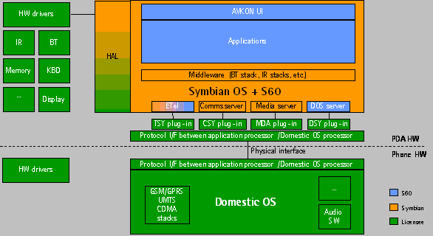
Figure 2.1 S60 Platform architecture

Services offered by DOS Server Client API:
- Telephony audio related services
- Accessory related services
- SysUtils (for SysUtil internal use)
- Startup and reset related services
- Startup and shutdown related services
- Self test services
- SAE (for SAE internal use)
- Bluetooth Audio related services
- Extension to extend DOS Server Client API functionality
- Registering for listening and receiving DOS events

DOS Event API is used for testing purposes. It can be used to simulate DOS events triggering from Domestic OS.
DOS Server also provides adaptation API (DOS Plug-in API) [8] and [9] that each OEM needs to use in order to implement their own way of communication with Domestic OS. This adaptation module is generally called DSY and it contains the functionality to resolve the requests, whereas the server has the functionality to collect the requests.
Interfaces defined by DOS Server are illustrated in Figure 2.2.
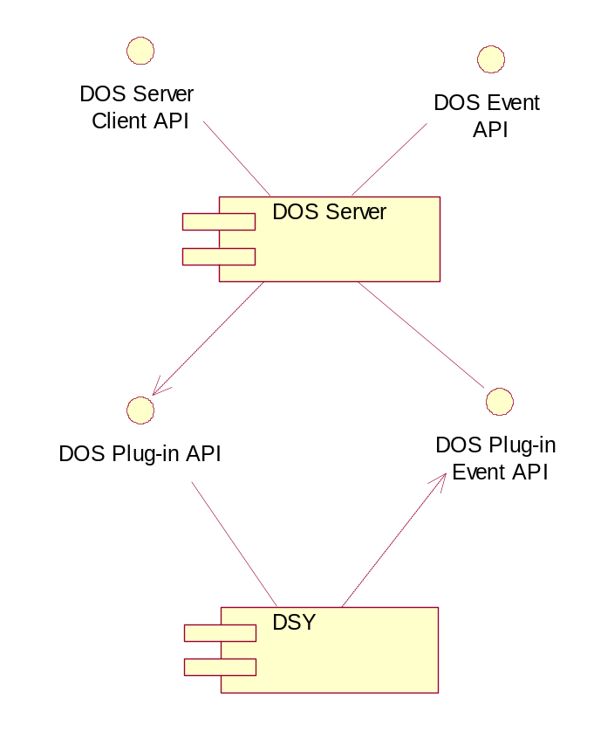
Figure 2.2 Interfaces defined by DOS Server

List of required interfaces
DOS Plug-in API must be realized by plug-in module to provide domestic operating system access for DOS Server (see Figure 2.2). DOS Server Client API uses constants and enumerations from Bluetooth Socket API and SAE API.

Product Platform and/or Symbian OS version constraints
API described here is valid for the S60 version 3.1 onwards.

Technical specification

Type of the interface
The service offered by DOS Server is accessed through the DOS Server Client API. Interface contains synchronous and asynchronous services and events that are call back functions. These events can also be sent thru DOS Event API.

Interface class structure

DOS Server Client API structure
Most services are provided thru RSubSessionBase derived classes. CDosEventListenerBase class provides with services to listen for events. Detailed description of these service classes is in chapter 4.
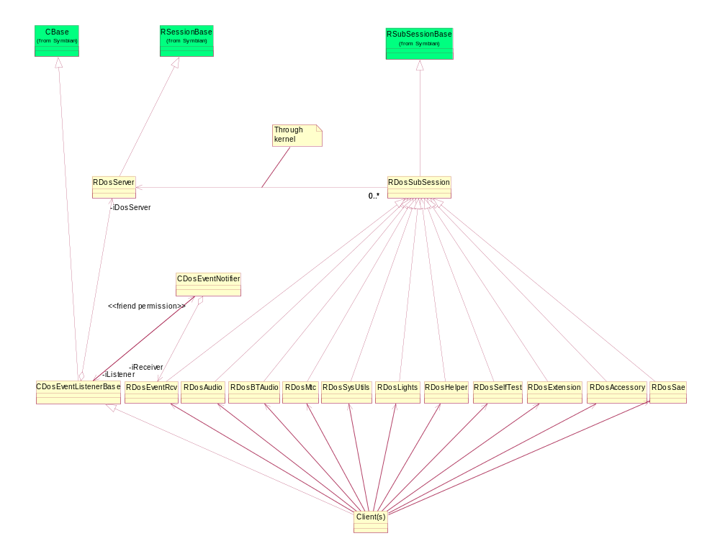
Figure 3.3 DOS Server Client API class structure.

DOS Event API structure
DOS Event API services are provided thru CDosEventSender class.
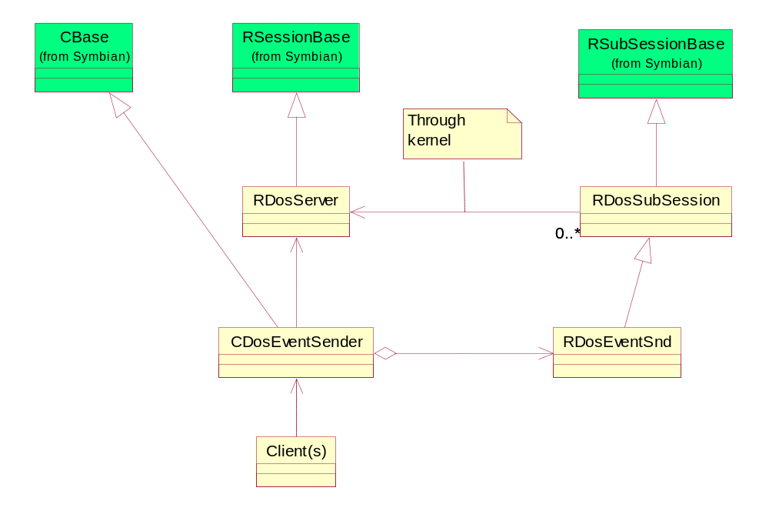
Figure 3.4 DOS Event API class structure.

Usage

Protocol
The DOS Server Client API follows the Symbian OS client/server archritecture. The DOS Server Client API, represented as the library DSClient.DLL and a header file that can be found in the file \epoc32\include\oem\DosSvrServices.H defines all the services offered by DOS Server.
The channel of communication between a client and a server is known as a session. DOS Server Client API is offered through the RSessionBase derived class RDosServer and several RSubSessionBase derived classes offering optimized subsets of the full API to make resource usage more efficient.

Usage of DOS Server sub-session
Before sending requests for DOS Server services, a connection, i.e. a session from a client application to DOS Server, must first be established. Having created a connection between the client and DOS Server, the client is then free to issue requests for services.
When the application has completed using DOS Server, the connection should be closed to free the server side resources that have been reserved for that session.
In Figure 3.5 DosService represents one of the RSubSessionBase derived classes.
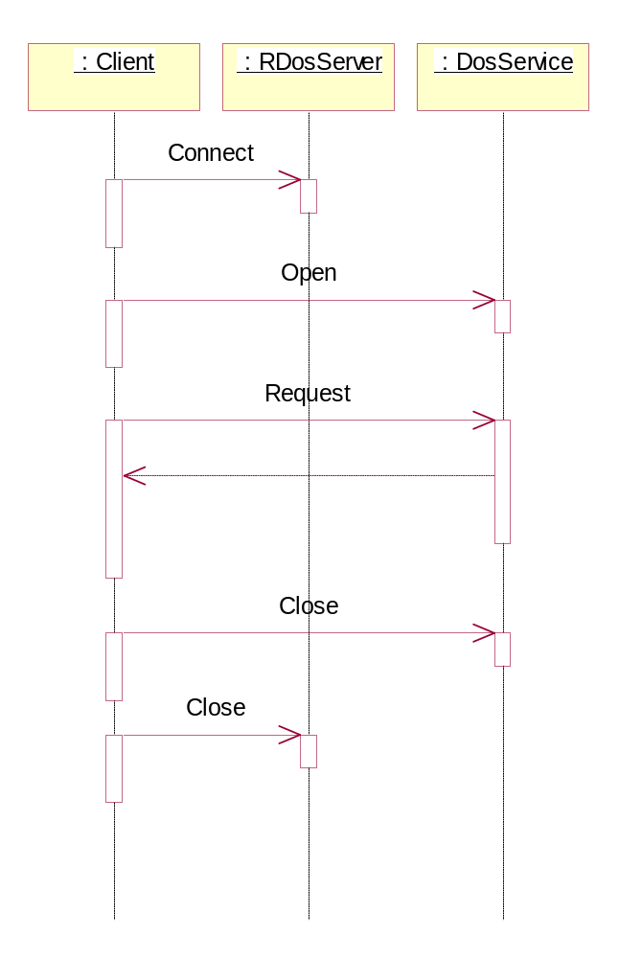
Figure 3.5 DOS Server sub-session usage.

DOS Server Client interface contains synchronous and asynchronous methods. Request status object is used to carry the completion status of an asynchronous request. The status can be handled in a standard Symbian way.

Usage of DOS Events
Client(s) inheriting from CDosEventListenerBase can start listening DOS Server Client Events by calling StartListeningL method from base class as illustrated in Figure 3.6. See detailed example from chapter 3.4.2. Events are received from Domestic operating system thru DSY and DOS Server will call overridden callback method for registered events. To stop event listening, client must call Stop method from base class. All supported DOS Server Client Events are listed in chapter 4.12.
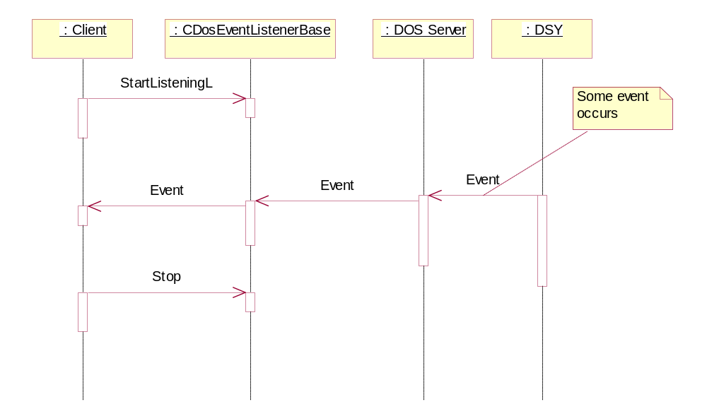
Figure 3.6 Starting to listen events
Launching a DOS event outside the DOS Server thread can be made with help of CDosEventSender class. All clients that are registered to listen launched event receive it.
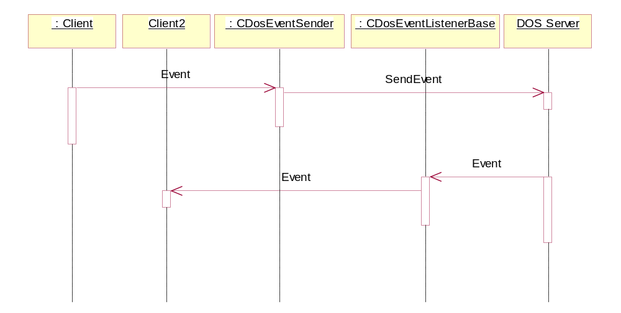
Figure 3.7 Launching a DOS event.

Error handling
Error handling for each operation in the interface is described in Chapter 4.

Extensions: RDosExtension usage
The RDosExtension class is meant for extending DOS Server with additional functionality. Using of RDosExtension is product specific decision.
The parameters set here are passed untouched to the plug-in side object derived from CDosExtensionBase where they have to be parsed and processed.
The best way to do this from the client side is to create a new DLL that contains the extensions and derive all the new DLL classes from the RDosExtension class. The function ID and the parameters have to be understood by the plug-in side object so this should be considered when creating the extension DLL.
See Section 3.4.3 for more information.

Examples of usage

Example: using DOS Server sub-session
The main steps when using a DOS Server sub-session are:
- Open a session.
- Connect the sub-session to the session.
- Use the sub-session.
- Close the sub-session.
- Close the session.

The following example code demonstrates this:

RDosServer session;
RDosSysUtils subsession;

session.Connect(); //Open the session
subsession.Open(server); //Connect the sub session to the session

err = subsession.GetSimLanguage(lang); //Use the subsession.

subsession.Close();
session.Close();

The session and sub-sessions use the Symbian client/server framework.

Example: listening events
Events provided by Event listener are listed in chapter 4.12.
Example: client needs to listen two events:
- BatteryBars,
- SimReady,

Following steps:
Step 1: Writing the CDosEventListenerBase derived class
The following example code shows the definition of the derived class:

class CExampleDosObserver : public CDosEventListenerBase
{
public:

CExampleDosObserver(RDosServer& aServer);

/**
* This method is provided to applications/application engine
* to activate event listening.
*/
void StartL();

/**
* This method is provided to applications/application engine
* to stop event listening.
*/
void Stop();

private:

/**
* Callback functions
*/
void BatteryBarsL(TInt aValue); //From CDosEventListenerBase
void SimReadyL(); //From CDosEventListenerBase
};

Step 2: Implementing the constructor
The constructor can be implement in two ways: by calling the CDosEventListenerBase constructor with a reference to a DOS Server session or without. In the first case, the object uses the passed reference and in the second case, the object creates and destroys its own session object. See from chapter 3.4.1 how to connect a session to DOS Server.
The following is the example’s constructor function:

CExampleDosObserver::CExampleDosObserver(RDosServer& aServer)
: CDosEventListenerBase(aServer)
{
// Construction
}

Step 3: Implementing the StartL function
This function is the one that the application using this object calls to register for events and start listening.

void CExampleDosObserver::StartL()
{
//Event Name Parameter Size Event Queue
TRegisterEvent eventList[] = {
{KBatteryBars, sizeof(TInt), EOnlyLast},
{KSimReady, 0, EQueue}};

// Starts listening for events listed above
StartListeningL(eventList,2);
}

Step 4: Implementing callback functions
void CExampleDosObserver::BatteryBarsL(TInt aValue)
{
// BatteryBarsL event is received
};

void CExampleDosObserver:: SimReadyL()
{
// SimReadyL event is received
};

Step 5: Stop listening events
To stop listening events, Stop() method must be called.
void CExampleDosObserver::Stop()
{
Stop();
};

Example: using RDosExtension

Service functions
To communicate with the CDosExtensionBase derived object, use the corresponding CallFunction function (4.11.3, 4.11.5). There are two versions of CallFunction: synchronous and asynchronous (also the old synchronous overloaded function taking TAny* still exists but it is not recommended to use it since it internally just wraps the data to a temporary descriptor and calls the overloaded CallFunction(TExtensionParPckg& aParamInfo, TDes8& aParameter)).
This is an example of a class definition using RDosExtension.
enum TFunctionID
{
EFunc1,
Efunc2
};

class RExampleSubsession : public RDosExtension
{
public:
TInt ExampleService1(TInt aPar); //Synchronous
TInt ExampleService2(TRequestStatus &aStatus, TInt& aPar); //Asynchronous
};

The implementation of these two functions could be:
TInt RExampleSubsession::ExampleService1(TInt aPar)
{
TExtensionParPckg parInfo;
parInfo().iFunc = Efunc2;
parInfo().iParLength = sizeof(TInt);
parInfo().iAutoComplete = ETrue; // DosServer completes request

TPtr8 ptr((TUint8*)&aPar, sizeof(TInt), sizeof(TInt));

return CallFunction(parInfo, ptr));
}

TInt RExampleSubsession::ExampleService2(TrequestStatus &aStatus, TInt& aPar);
{
TExtensionParPckg parInfo;
parInfo().iFunc = Efunc2;
parInfo().iParLength = sizeof(TInt);
parInfo().iAutoComplete = ETrue; // DosServer completes request

TPtr8 ptr((TUint8*)&aPar, sizeof(TInt), sizeof(TInt));

CallFunction(aStatus, parInfo, ptr);

User::WaitForRequest(aStatus); // Or implement a RunL() -method
return aStatus.Int();
}

EFunc1 and Efunc2 are identifiers among the extended functions identifying the function being called. Corresponding CallFunction methods to the identifiers are required in DSY side. DOS Server completes CallFunction –call automatically if auto complete flag is set to ETrue and DSY must complete it in case the flag is set to EFalse.

DOS Server extension Events
CDosEventListenerBase can be extended by using the raw event GeneralEventL and processing it in a CDosEventListenerBase::GeneralEventL() derived function.
When adding new event IDs to DOS Server, reserved event ID’s must not be used (Appendix A: List of constants and enumerations).

Detailed description

RDosServer
The RDosServer class represents a session with DOS Server and provides services to start, connect, close and shutdown the DOS Server.
The RDosServer class is derived from RSessionBase.

StartServer()
TInt StartServer() starts DOS Server. This is also called automatically when a client connects to DOS Server without starting it before.
Operation:
TInt StartServer() const
Parameters:
None.
Return value:
KErrNone if successful, or a Symbian OS standard error code.

Connect()
TInt Connect() connects and registers a session to DOS Server. If DOS Server has not been started before, a call to this function will start it.
Operation:
TInt Connect()
Parameters:
None.
Return value:
KErrNone if successful, or a Symbian OS standard error code.

Close()
void Close() closes the session and frees the server resources attached to it. It is advisable to close the corresponding sub-session before calling this method.
Operation:
void Close()
Parameters:
None.
Return value:
void

ServerShutdown()
void ServerShutdown() shuts down the server. This method shuts down the whole DOS Server so it is unnecessary to individual clients to use this method.
Operation:
void ServerShutdown() const
Parameters:
None.
Return value:
void

RDosSubSession
The RDosSubSession class represents a base class for all the DOS Server sub-sessions. The RDosSubSession class is derived from RSubSessionBase and all sub-sessions of the DOS Server API derive from it.

Close()
Closes the session and frees the server resources attached to it.
Operation:
void Close()
Parameters:
None.
Return value:
Void

RDosAudio
RDosAudio offers telephony audio related services such as changing/retrieving
- Handsfree mode
- Microphone mute state
- Output volume level

The RDosAudio class is derived from RDosSubSession.

Open()
This method opens the sub-session.
Operation:
TInt Open(RDosServer& aServer)
Parameters:
Parameter | Description
RDosServer& aServer | A connected session with DOS Server.

Return value:
KErrNone if successful, or a Symbian OS standard error code.

SetHandsfreeMode()
This method sets the mode of the integrated hands free. The parameter aMode contains the integrated hands free mode to be set. See the corresponding getter method from chapter 4.3.3. The method is meant for Phone Engine usage only.
Operation:
TInt SetHandsfreeMode(const EPSHandsFreeMode aMode) const
Parameters:
Parameter | Description
const EPSHandsFreeMode aMode | Declared in psvariables.h.
- EPSIhfOff | Disable IHF.
- EPSIhfOn | Enable IHF.

These values are recommended and the ones S60 Platform provides. Adding or removing values might mean modifying the component that uses this function.
Return value:
- KErrNone if successful, or a Symbian OS standard error code.
- KErrNotSupported if the feature is not supported.

GetHandsfreeMode()
IHF mode means audio routing state in which audio is routed to earpiece (IHF is disabled) or accessory (IHF is enabled). Accessory may be integrated (loudspeaker) or wireless/ wired accessory. The mode is stored to aMode reference parameter. See the corresponding setter method from chapter 4.3.2. The method is meant for Phone Engine usage only.
Operation:
TInt GetHandsfreeMode(EPSHandsFreeMode& aMode) const
Parameters:
Parameter | Description
EPSHandsFreeMode& aMode | Declared in psvariables.h.
- EPSIhfOff | IHF is disabled.
- EPSIhfOn | IHF is enabled.

These values are recommended and the ones S60 Platform provides. Adding or removing values might mean modifying the component that uses this function.
Return value:
- KErrNone if successful, or a Symbian OS standard error code.
- KErrNotSupported if the feature is not supported.

GetOutputVolume()
The method synchronously returns the audio output volume level of the currently selected audio channel. The result is passed though the parameter aVolume. See the corresponding setter method from chapter 4.3.5.
Operation:
TInt GetOutputVolume(TInt& aVolume) const
Parameters:
Parameter | Description
TInt& aVolume | Valid values depend on selected audio channel. For IHF loudspeaker and earpiece valid values are 0-9.

Return value:
- KErrNone if successful, or a Symbian OS standard error code.
- KErrNotSupported if the feature is not supported.

SetOutputVolume()
The method synchronously sets up the audio output volume level of the currently selected audio channel. The level is defined by the parameter aVolume. See the corresponding getter method from chapter 4.3.4. The method is meant for Phone Engine usage only.
Operation:
TInt SetOutputVolume(const TInt aVolume) const
Parameters:
Parameter | Description
const TInt aVolume | Valid values depend on selected audio channel. For IHF loudspeaker and earpiece valid values are 0-9.

Return value:
- KErrNone if successful, or a Symbian OS standard error code.
- KErrNotSupported if the feature is not supported.

RDosAccessory
The RDosAccessory module offers an API for setting:
- Loop set mode.

The RDosAccessory class is derived from RDosSubSession.

Open()
This method opens a sub-session.
Operation:
TInt Open(RDosServer& aServer)
Parameters:
Parameter | Description
RDosServer& aServer | A connected session with DOS Server.

Return value:
KErrNone if successful, or a Symbian OS standard error code.

SetLoopSetModeState()
This method sets the current loop set mode. The parameter aMode contains the loop set mode to be set.
This feature can be used to force the Domestic OS side accessory control to go in to/out of the wireless induction loop set mode or the TTY device mode. This feature is needed because headsets, loop sets and TTY devices are galvanically similar.
The parameter EPSAccLpsOn as aMode activates the wireless loop set mode and the parameter EPSAccTty activates the TTY device mode. After that, a headset connected to the phone will be detected as loop set or TTY accordingly. The parameter EPSAccLpsOff deactivates the loop set or TTY mode. After that, a loop set or TTY connected to the phone will now be detected as headset.
This feature is not supported if feature flag __AUTO_ACCESSORY_IDENTIFICATION is defined.
See the corresponding get method from chapter 4.4.3.
Operation:
TInt SetLoopSetModeState(const EPSAccLpsMode aMode) const
Parameters:
Parameter | Possible values
const EPSAccLpsMode aMode | Declared in psvariables.h.
- EPSAccLpsOff | Used to force the device to go out of the wireless loop set or TTY device mode.
- EPSAccLpsOn | Used to force the device to go in to the wireless loop set mode.
- EPSAccTty | Used to force the device to go in to the TTY device mode.

These values are recommended and the ones S60 Platform provides. Adding or removing values might mean modifying the component that uses this function.
Return value:
- KErrNone if successful, or a Symbian OS standard error code.
- KErrNotSupported if the feature is not supported.

GetLoopSetModeState()
This method gets the current loop set mode.
This feature is not supported if feature flag __AUTO_ACCESSORY_IDENTIFICATION is defined.
See the corresponding set method from chapter 4.4.2.
Operation:
TInt GetLoopSetModeState(EPSAccLpsMode& aMode) const
Parameters:
Parameter | Possible values
EPSAccLpsMode& aMode | Declared in psvariables.h.
- EPSAccLpsOff | The device is not in the wireless loop set or TTY device mode.
- EPSAccLpsOn | The device is in the wireless loop set mode.
- EPSAccTty | The device is in the TTY device mode.

These values are recommended and the ones S60 Platform provides. Adding or removing values might mean modifying the component that uses this function.
Return value:
- KErrNone if successful, or a Symbian OS standard error code.
- KErrNotSupported if the feature is not supported.

GetAccessoryMode()
Gets current audio accessory mode.
Operation:
TInt GetAccessoryMode( TDosAccessoryMode& aAccessoryState ) const
Parameters:
Parameter | Description
TDosAccessoryMode& aAccessoryState | Declared in DosSvrServices.h
- EDosAccNotConnected | No accessory connected
- EDosAccUnsupportedConnected | Unsupported accessory connected
- EDosAccModeHeadset | Wired headset connected
- EDosAccModeLoopset | Loopset connected
- EDosAccModeTty | TTY device connected
- EDosAccModeCarKit | Wired car kit connected
- EDosAccModeBtHeadset | BT headset connected
- EDosAccModeBtCarKit | BT car kit connected

Return value:
- KErrNone if successful.
- KErrNotSupported if the feature is not supported.
- KErrGeneral in other cases.

RDosSysUtils
The RDosSysUtils module offers an API for:
- Getting the default language value stored in the SIM card.
- Performing Domestic OS side restore factory settings.
- Setting or disabling the RTC alarm time for the Domestic OS.

The RDosSysUtils class is derived from RDosSubSession.

Open()
This method opens a sub-session.
Operation:
TInt Open(RDosServer &aServer)
Parameters:
Parameter | Description
RDosServer &aServer | A connected session with DOS Server.

Return value:
KErrNone if successful, or a Symbian OS standard error code.

GetSimLanguage()
Status:
Platform | Status
S60 2.1 | Deprecated
S60 2.5 | Deprecated
S60 2.6 | Deprecated

This method gets the default language code stored in the SIM card. The language code of the SIM card is stored to aSimLanguage if the operation is successful. A Symbian OS standard error code is returned whether the operation was successful or not.
Operation:
TInt GetSimLanguage(TInt& aSimLanguage) const
Parameters:
Type | Name | Possible values
TInt& | aSimLanguage | 0−255

Return value:
- KErrNone if successful, or a Symbian OS standard error code.
- KErrNotSupported if the feature is not supported.

PerformDosRfs()
This method executes a restore factory settings operation in the Domestic OS side asynchronously. Restoring factory settings has two different levels. The normal level is intended for end-users and the deep level is for after sales purposes. This operation is asynchronous and the return value is returned with the aStatus parameter when the operation is completed. For more detailed information see Series 60 Restore Factory Settings Design Document [1].
Operation:
void PerformDosRfs(TUint aReason,TRequestStatus& aStatus) const
Parameters:
Parameter | Description
TUint aReason | Must be an enum of type TRfsType declared by rfs component (rfsHandler.h).
- ERfsNormal | Normal
- ERfsDeep | Deep
TRequestStatus& aStatus | A status variable to control the completion of the task.

Return value:
- KErrNone if successful, or a Symbian OS standard error code.
- KErrNotSupported if the feature is not supported.

SetDosAlarm()
This method sets the Domestic OS RTC alarm time so that the phone can be woken up by an alarm if it is turned off. The method sets or clears the next alarm time in the Domestic OS.
Operation:
TInt SetDosAlarm(TTime* aAlarmTime) const
Parameters:
Parameter | Description
TTime* aAlarmTime | The alarm time. NULL if switching off the Domestic OS alarm is desired.

Return value:
- KErrNone if successful, or a Symbian OS standard error code.
- KErrNotSupported if the feature is not supported.

Used by:
SysUtil

RDosHelper
The RDosHelper class is derived from RDosSubSession.

Open()
This method opens a sub-session.
Operation:
TInt Open(RDosServer& aServer)
Parameters:
Parameter | Description
RDosServer& aServer | A connected session with DOS Server.

Return value:
KErrNone if successful, or a Symbian OS standard error code.

GetStartupReason()
This method gets the startup reason from the Domestic OS side. Domestic OS startup reasons are mapped to Symbian OS startup reasons by adaptation and the result is stored to the aReason variable. A standard Symbian OS error code is returned indicating the success of this operation.
See also Symbian OS startup related methods, 4.6.3 and 4.6.4.
Operation:
TInt GetStartupReason(TInt& aReason) const
Parameters:
Parameter | Description | Status
TInt& aReason | Must be an enum of type TWD2StartupReason declared by Starter component (startupreasons.h). | Supported
- ENormal | Normal start-up | Supported
- EAlarm | RTC alarm | Supported
- EMidnightAlarm |  | Not used by S60
- EHiddenReset |  | Not used by S60
- ECharger | The device is off and a charger is connected | Supported
- ETest | Test mode | Supported
- ELocal |  | Not used by S60
- ESelftestFail | Self test failed | Not used by S60
- ENotReadFromHardware |  | Not used by S60
- ENotKnown | Not known | Supported

These values are recommended and the ones S60 Platform provides. Adding or removing values might mean modifying the component that uses this function.
Default value:
ENormal
Return value:
- KErrNone if successful, or a Symbian OS standard error code.
- KErrNotSupported if the feature is not supported.

GetSWStartupReason()
This method queries the software startup reason set by the Symbian OS with SetSWStartupReason() method (4.6.4). Value is stored to aReason. In error situations, the value stored in aReason is ESWNone.
See also Domestic OS startup related method 4.6.2.
Operation:
TInt GetSWStartupReason(TInt16& aReason) const
Parameters:
Parameter | Description
TInt16& aReason | Must be an enum of type TSWStartupReason declared by Sysutil component (sysstartup.h).
ESWNone = 100 | Nothing set the (default value).
ESWRestoreFactorySet = 101 | Restore Factory Settings (Normal).
ESWLangSwitch = 102 | Language Switched.
ESWWarrantyTransfer = 103 | Warranty transfer.
ESWChargerConnected = 104 | Power off and charger connected.
ESWRestoreFactorySetDeep =105 | Restore Factory Settings (Deep).

These values are recommended and the ones S60 Platform provides. Adding or removing values might mean modifying the component that uses this function.
Default value:
ESWNone
Return value:
- KErrNone, if successful, or a Symbian OS standard error code.
- KErrNotSupported, if the feature is not supported.
Used By:
- System Application and Starter (thru SysUtil API)

SetSWStartupReason()
This method stores permanently the software-reset reason to the Domestic OS. The reset reason is used as a Symbian OS specific startup reason in the next restart of the device. Starter clears the value after reason has been handled properly. List of possible values is based on SysUtil definitions (sysstartup.h). See the corresponding getter method from chapter 4.6.3.
See also Domestic OS startup related method 4.6.2.
Operation:
TInt SetSWStartupReason(TInt16 aReason) const
Parameters:
Parameter | Description
TInt16 aReason | Must be an enum of type TSWStartupReason declared by Sysutil component (sysstartup.h).
ESWNone = 100 | Nothing set the (default value).
ESWRestoreFactorySet = 101 | Restore Factory Settings (Normal).
ESWLangSwitch = 102 | Language Switched.
ESWWarrantyTransfer = 103 | Warranty transfer.
ESWChargerConnected = 104 | Power off and charger connected.
ESWRestoreFactorySetDeep =105 | Restore Factory Settings (Deep).

These values are recommended and the ones S60 Platform provides. Adding or removing values might mean modifying the component that uses this function.
Return value:
- KErrNone if successful, or a Symbian OS standard error code.
- KErrNotSupported if the feature is not supported.

Used By:
- System Application to save the startup reason for the next startup (thru SysUtil API)
- Starter to clear the value after the value has been used (thru SysUtil API)

HiddenReset()
This method checks if there is a hidden reset situation. After hidden reset when phone boots up security codes are not asked from user.
See also 4.7.5 ResetGenerate() which generates a HiddenReset.
Operation:
TBool HiddenReset() const
Parameters:
None.
Return value:
TBool, ETrue if there is a hidden reset, otherwise EFalse.
Default value:
EFalse.
Used By:
- Startup Application and Starter (thru SysUtil API)

GetRTCStatus()
This method checks the RTC (Real Time Clock) time validity from the Domestic OS and stores the result to the aStatus variable.
Operation:
TInt GetRTCStatus(TBool& aStatus) const
Parameters:
Parameter | Description
TBool& aStatus
ETrue | The time is valid.
EFalse | RTC is corrupted or not valid.

These values are recommended and the ones S60 Platform provides. Adding or removing values might mean modifying the component that uses this function.
Default value:
ETrue.
Return value:
- KErrNone if successful, or a Symbian OS standard error code.
- KErrNotSupported if the feature is not supported.

GenerateGripEvent()
The implementation is expected to generate a grip event with the current grip state. Function call causes a keyevent to be generated that tells the current grip state.
Operation:
TInt GenerateGripEvent() const
Parameters:
None.
Return value:
- KErrNone if successful, or a Symbian OS standard error code.
- KErrNotSupported if the feature is not supported.

RDosMtc
Class contains methods for requesting Domestic OS Mobile Terminal Control states changes and informing Symbian OS state changes to Domestic OS.

Open()
This method opens a sub-session.
Operation:
TInt Open(RDosServer& aServer)
Parameters:
Parameter | Possible values
RDosServer& aServer | A connected session with DOS Server.

Return value:
KErrNone if successful, or a Symbian OS standard error code.

PowerOn()
This method informs the Domestic OS side that the Symbian OS side’s power is on.
See also PowerOff method 4.7.3.
Operation:
TInt PowerOn() const
Parameters:
None.
Return value:
- KErrNone if successful, or a Symbian OS standard error code.
- KErrNotSupported if the feature is not supported.

PowerOff()
This method informs the Domestic OS that the Symbian OS side is being powered off.
See also PowerOn method 4.7.2, and 4.7.9 DosShutdownSync() which must be called to allow the Domestic OS to continue the shutdown.
Operation:
TInt PowerOff() const
Parameters:
None.
Return value:
- KErrNone if successful, or a Symbian OS standard error code.
- KErrNotSupported if the feature is not supported.

DosSync()
This method synchronizes the Domestic OS and Symbian OS startup and shutdown. It sends a S60 synchronization message to the Domestic OS when called, which can be used in the Domestic OS side for synchronization.
Operation:
TInt DosSync() const
Parameters:
None.
Return value:
- KErrNone if successful, or a Symbian OS standard error code.
- KErrNotSupported if the feature is not supported.

ResetGenerate()
This method generates a hidden reset.
See also 4.6.5 HiddenReset() which checks if there has been a HiddenReset event.
Operation:
TInt ResetGenerate() const
Parameters:
None.
Return value:
- KErrNone if successful, or a Symbian OS standard error code.
- KErrNotSupported if the feature is not supported.

SetState()
This method sets the Domestic OS state.
Operation:
TInt SetState(const TInt aStateType) const
Parameters:
Parameter | Description
const TInt aStateType | Must be an enum of type TSysApMtcStateType declared by SysAp component (SysAp.hrh).
- ESysApMtcNormalState
- ESysApMtcAlarmState
- ESysApMtcChargingState
- ESysApMtcPowerOffState
- ESysApMtcRfInactiveState
- ESysApMtcBtSapState

These values are recommended and the ones S60 Platform provides. Adding or removing values might mean modifying the component that uses this function.
Return value:
- KErrNone if successful, or a Symbian OS standard error code.
- KErrNotSupported if the feature is not supported.

SetStateFlag()
This method changes the state of offline flag that reside in Domestic OS.
See corresponding get method 4.7.8.
Operation:
TInt SetStateFlag(const TDosStateFlag aFlag) const
Parameters:
Parameter | Description
const TDosStateFlag aFlag
- EDosOfflineStateFlagFalse | Sets offline state flag in Domestic OS to false.
- EDosOfflineStateFlagTrue | Sets offline state flag in Domestic OS to true.

These values are recommended and the ones S60 Platform provides. Adding or removing values might mean modifying the component that uses this function.
Return value:
- KErrNone if successful, or a Symbian OS standard error code.
- KErrNotSupported if the feature is not supported.

GetStateFlag()
This method gets the state of offline flag that reside in Domestic OS.
See corresponding set method 4.7.7
Operation:
TInt GetStateFlag(TDosStateFlag& aFlag)
Parameters:
Parameter | Description
TDosStateFlag& aFlag
- EDosOfflineStateFlagFalse | The offline state flag in Domestic OS is false.
- EDosOfflineStateFlagTrue | The offline state flag in Domestic OS is true.

These values are recommended and the ones S60 Platform provides. Adding or removing values might mean modifying the component that uses this function.
Return value:
- KErrNone if successful, or a Symbian OS standard error code.
- KErrNotSupported if the feature is not supported.

DosShutdownSync()
The method synchronises Symbian OS with Domestic OS on shutdown. Shutdown can be initiated from Domestic OS side via indication (4.12.17) or Symbian OS side via RDosMtc::PowerOff() (4.7.3). This method must be called when Symbian OS is ready to let Domestic OS continue shutdown.
Operation:
TInt DosShutdownSync() const
Parameters:
None.
Return value:
- KErrNone if successful, or a Symbian OS standard error code.
- KErrNotSupported if the feature is not supported.

Used by:
SysApp

RDosSelfTest
RDosSelfTest handles self-test related tasks. The RDosSelfTest class is derived from RDosSubSession.

Open()
This method opens a sub-session.
Operation:
TInt Open(RDosServer& aServer)
Parameters:
Parameter | Description
RDosServer& aServer | A connected session with DOS Server.

Return value:
KErrNone if successful, or a Symbian OS standard error code.

PerformSelfTest()
This method initiates a Domestic OS self-test. When the test is completed, a NotifySelfTestStatus event is received from the Domestic OS.
Operation:
TInt PerformSelfTest() const
Parameters:
None.
Return value:
- KErrNone if successful, or a Symbian OS standard error code.
- KErrNotSupported if the feature is not supported.

RDosSae
The RDosSae class contains functions needed by System Agent Extension.
The System Agent Extension subsystem of S60 Platform is responsible for monitoring S60 Platform specific system state variables and notifying the changes to the core System Agent, which is responsible for passing the events to registered clients (see reference document [2].
The RDosSae class is derived from RDosSubSession.

Open()
This method opens a sub-session.
Operation:
TInt Open(RDosServer& aServer)
Parameters:
Parameter | Description
RDosServer& aServer | A connected session with DOS Server.

Return value:
KErrNone if successful, or a Symbian OS standard error code.

StartSae()
This method indicates that SAE is ready to receive events from Domestic OS side. SAE calls this method at the end of its construction.
Operation:
TInt StartSae() const
Parameters:
None.
Return value:
- KErrNone if successful, or a Symbian OS standard error code.
- KErrNotSupported if the feature is not supported.
Used by:
SAE

RDosBTAudio
The RDosBTAudio class contains services needed by Bluetooth Audio Accessory Controller (see reference document [6]). The services of RDosBTAudio are divided into three categories: issuing requests, sending responses, and sending indications. The receiving of requests and indications is done via CDosEventListenerBase.
The Bluetooth Audio Accessory Controller subsystem of S60 Platform is responsible for controlling Bluetooth audio accessories, for example, taking a Bluetooth headset into use. The class RDosBTAudio is derived from RDosSubSession.

Open()
This method opens a sub-session.
Operation:
TInt Open( RDosServer& aServer )
Parameters:
Parameter | Description
RDosServer& aServer | A connected session with DOS Server.

Return value:
KErrNone if successful, or a Symbian OS standard error code.

Requests
Requests are issued from Symbian OS to Domestic OS.

AttachAudioAccessoryReq()
This method makes an asynchronous accessory attach request to take a Bluetooth audio accessory into use.
To cancel this asynchronous call use 4.10.2.2 CancelAttachReq().
See also corresponding detach method 4.10.2.3 DetachAudioAccessoryReq().
Operation:
void AttachAudioAccessoryReq( TRequestStatus& aStatus, const TBTDevAddr& aBDAddress, TBTDeviceType aDeviceType, TUint32 aSupportedFeatures )
Parameters:
Parameter | Description
TRequestStatus& aStatus | A Symbian OS error code.
const TBTDevAddr& aBDAddress | The accessory device's Bluetooth Device Address.
TBTDeviceType aDeviceType
- EBTNoDevice | No device
- EBTUnknownDevice | Unknown device
- EBTHeadset | Headset
- EBTCarkit | Car kit
- EBTHeadsetPropietary | Proprietary headset
- EBTCarkitPropietary | Proprietary car kit
TUint32 aSupportedFeatures | The supported features of the accessory device.

Return value:
None.

CancelAttachReq()
This method cancels the currently active asynchronous accessory attach request.
See 4.10.2.1 AttachAudioAccessoryReq().
Operation:
void CancelAttachReq()
Parameters:
None.
Return value:
None.

DetachAudioAccessoryReq()
This method makes an asynchronous accessory detach request to take a Bluetooth audio accessory out of use.
To cancel this asynchronous call use 4.10.2.4 CancelDetachReq().
See also corresponding attach method 4.10.2.1 AttachAudioAccessoryReq().
Operation:
void DetachAudioAccessoryReq( TRequestStatus& aStatus, const TBTDevAddr& aBDAddress, TBTDeviceType aDeviceType )
Parameters:
Parameter | Description
TRequestStatus& aStatus | A Symbian OS error code.
const TBTDevAddr& aBDAddress | The accessory device's Bluetooth Device Address.
TBTDeviceType aDeviceType
- EBTNoDevice | No device
- EBTUnknownDevice | Unknown device
- EBTHeadset | Headset
- EBTCarkit | Car kit
- EBTHeadsetPropietary | Proprietary headset
- EBTCarkitPropietary | Proprietary car kit

Return value:
None.

CancelDetachReq()
This method cancels the currently active asynchronous accessory detach request.
See 4.10.2.3 DetachAudioAccessoryReq().
Operation:
void CancelDetachReq()
Parameters:
None.
Return value:
None.

Responses
Responses are issued from Symbian OS to Domestic OS.

AudioLinkOpenResp()
This method responds to an audio link open request event AudioLinkOpenReq() 4.12.12.

Operation:
TInt AudioLinkOpenResp( TInt aStatus, THCIConnHandle aConnectionHandle ) const
Parameters:
Parameter | Description
TInt aStatus | The status of the request, a Symbian OS error code.
THCIConnHandle aConnectionHandle | Declared in bttypes.h
- TUint16 | Identifier of the opened audio link.

Return value:
A Symbian OS error code or KErrNotSupported if the feature is not supported.

AudioLinkCloseResp()
This method responds to an audio link close request event AudioLinkCloseReq() 4.12.13.
Operation:
TInt AudioLinkCloseResp( TInt aStatus ) const
Parameters:
Parameter | Description
TInt aStatus | A Symbian OS error code.

Return value:
A Symbian OS error code or KErrNotSupported if the feature is not supported.

ActivateVoiceRecognitionResp()
This method responds to an activate voice recognition request event ActivateVoiceRecognitionReq() 4.12.14.
Operation:
TInt ActivateVoiceRecognitionResp( TInt aStatus ) const
Parameters:
Parameter | Description
TInt aStatus | A Symbian OS error code.

Return value:
A Symbian OS error code or KErrNotSupported if the feature is not supported.

AbortVoiceRecognitionResp()
This method responds to an abort voice recognition request event AbortVoiceRecognitionReq() 4.12.8.
Operation:
TInt AbortVoiceRecognitionResp() const
Parameters:
None.
Return value:
A Symbian OS error code or KErrNotSupported if the feature is not supported.

VoiceRecognitionStatusResp()
This method responds to a voice recognition status request event VoiceRecognitionStatusReq() 4.12.31.
Operation:
TInt VoiceRecognitionStatusResp( TBTVoiceRecognitionState aState ) const
Parameters:
Type | Description
TBTVoiceRecognitionState aState | Declared in DosSvrServices.h
- EBtVoiceReadyState | Voice server ready to be used after start-up
- EBtVoiceIdleState | Voice server in idle state
- EBtVoiceTrainingState | Voice server performing training
- EBtVoiceRecognitionState | Voice server performing recognition
- EBtVoiceRecordingState | Voice server performing recording
- EBtVoicePlaybackState | Voice server performing playback
- EBtVoiceSystemAbortState | Some one other than application has aborted voice server, performing abort.
- EBtVoiceApplicationAbortState | Application has aborted voice server, performing abort.
- EBtVoiceSystemCableAbortState | Data cable just connected, performing abort.
- EBtVoiceSystemAccAbortState | Accessory mode has changed to illegal and Voice server is aborting the current service.
Return value:
A Symbian OS error code or KErrNotSupported if the feature is not supported.

QuerySpeedDialNumberResp()
This method responds to a query Speed Dial number request event QuerySpeedDialNumberReq() 4.12.32.
Operation:
TInt QuerySpeedDialNumberResp( TInt aStatus, const TDesC& aNumber )
Parameters:
Parameter | Description
TInt aStatus | The status of the request, a Symbian OS error code.
const TDesC& aNumber | The result phone number.

Return value:
A Symbian OS error code or KErrNotSupported if the feature is not supported.

QueryLastDialledVoiceNumberResp()
This method responds to a query last dialed voice number request event QueryLastDialledVoiceNumberReq() 4.12.33.
Operation:
TInt QueryLastDialledVoiceNumberResp(TInt aStatus, const TDesC& aNumber)
Parameters:
Parameter | Description
TInt aStatus | The status of the request, a Symbian OS error code.
const TDesC& aNumber | The result phone number.

Return value:
A Symbian OS error code or KErrNotSupported if the feature is not supported.

Indications
Indications are sent from Symbian OS to Domestic OS.

AudioLinkOpenInd()
This method sends an audio link open indication.
Operation:
TInt AudioLinkOpenInd(const TBTDevAddr& aBDAddress, THCIConnHandle aConnectionHandle)
Parameters:
Parameter | Description
const TBTDevAddr& aBDAddress | The accessory device's Bluetooth Device Address.
THCIConnHandle aConnectionHandle | A handle to the audio connection.

Return value:
A Symbian OS error code or KErrNotSupported if the feature is not supported.

AudioLinkCloseInd()
This method sends an audio link close indication.
Operation:
TInt AudioLinkCloseInd(const TBTDevAddr& aBDAddress, THCIConnHandle aConnectionHandle)
Parameters:
Parameter | Description
const TBTDevAddr& aBDAddress | The accessory device's Bluetooth Device Address.
THCIConnHandle aConnectionHandle | A handle to the audio connection.

Return value:
A Symbian OS error code or KErrNotSupported if the feature is not supported.

VoiceRecognitionStatusInd()
This method sends a voice recognition status indication.
Operation:
TInt VoiceRecognitionStatusInd( TBTVoiceRecognitionState aState ) const
Parameters:
Parameter | Description
TBTVoiceRecognitionState aState | Declared in DosSvrServices.h
- EBtVoiceReadyState | Voice server ready to be used after start-up
- EBtVoiceIdleState | Voice server in idle state
- EBtVoiceTrainingState | Voice server performing training
- EBtVoiceRecognitionState | Voice server performing recognition
- EBtVoiceRecordingState | Voice server performing recording
- EBtVoicePlaybackState | Voice server performing playback
- EBtVoiceSystemAbortState | Some one other than application has aborted voice server, performing abort.
- EBtVoiceApplicationAbortState | Application has aborted voice server, performing abort.
- EBtVoiceSystemCableAbortState | Data cable just connected, performing abort.
- EBtVoiceSystemAccAbortState | Accessory mode has changed to illegal and Voice server is aborting the current service.

Return value:
A Symbian OS error code or KErrNotSupported if the feature is not supported.

RDosExtension
RDosExtension provides means to extend DOS Server Client API without breaking the architecture.
The RDosExtension class is derived from RDosSubSession.

Open()
This method opens a sub-session.
Operation:
TInt Open(RDosServer& aServer)
Parameters:
Parameter | Description
RDosServer& aServer | A connected session with DOS Server.

Return value:
KErrNone if successful, or a Symbian OS standard error code.

CallFunction()
Deprecated, please use the overloaded function taking descriptors (4.11.3);
TInt CallFunction(const TExtensionParPckg& aParamInfo, TDes8& aParameter)
This method executes a synchronous raw function call that has to be implement in the DSY plug-in. It is expected to execute the corresponding function to aFunc. It is also responsible for getting the parameters from aParameter before the execution. aParLength can not be a negative value, otherwise call will result to KErrGeneral.
Due to IPC v2 security requirements that forbid direct references to client side memory this function now indirectly calls its overloaded synchronous counterpart function taking descriptors as parameters.
Operation:
TInt CallFunction(TInt aFunc, TAny* aParameter=NULL, TInt aParLength=0,TBool aAutoComplete=ETrue)
Parameters:
Parameter | Description
TInt aFunc | A unique integer among the extended functions identifying the called function.
TAny *aParameter | A pointer to the parameter.
TInt aParLength | The parameter length.
TBool aAutoComplete
- ETrue | The server completes the function.
- EFalse | The function is going to be completed in the plug-in.

Return value:
- KErrNone if successful, or a Symbian OS standard error code.
- KErrNotSupported if the feature is not supported.

Used by:
N/A

CallFunction()
This method executes a synchronous function call that has to be implement in the DSY plug-in. As opposed to its synchronous overloaded function taking TAny* this method takes descriptors as parameters. This change is due to IPC v2 security requirements that forbid direct references to client side memory. The client parameter data has to be passed via the TDes8& aParameter. The other parameter takes TExtensionParPckg& aParamInfo – package buffer holding inside an instance of TExtensionPar –struct. The struct has following members;
struct TExtensionPar
{
TInt iFunc;
TInt iParLength;
TBool iAutoComplete;
};
iFunc is the unique integer among the extended functions identifying the called function. iParLength tells the length of the data passed in the aParameter. It can not be a negative value, otherwise call will result to KErrGeneral. iAutoComplete tells if the function is to be completed in the plugin (ETrue) or not (EFalse).
See example about client side usage in 3.4.3.1.
Operation:
TInt CallFunction(const TExtensionParPckg& aParamInfo, TDes8& aParameter)
Parameters:
Parameter | Description
const TExtensionParPckg& aParamInfo  - iFunc  - iParLength  - iAutoComplete | A package buffer holding inside an instance of TExtensionPar –struct;  iFunc is the unique integer among the extended functions identifying the called function.  iParLength tells the length of the data passed in the aParameter. It can not be a negative value, otherwise call will result to KErrGeneral.  iAutoComplete tells if the function is to be completed in the plugin (ETrue) or not (EFalse).
TDes8& aParameter | A descriptor holding the parameter data.

Return value:
- KErrNone if successful.
- KErrNotSupported if the feature is not supported.
- KErrGeneral in any other error situation.

Used by:
N/A

CallFunction()
Note that this method is removed from S60 Platform 2.6 on due to IPC v2 requirements.
This method executes an asynchronous raw function call that has to be implement in the DSY plug-in. It is expected to execute the correspondent functions to aFunc. It is also responsible for getting the parameters from aParameter before the execution.
Operation:
void CallFunction(TRequestStatus& aStatus, TInt aFunc, TAny* aParameter=NULL, TInt aParLength=0, TBool aAutoComplete=EFalse)
Parameters:
Parameter | Description
TRequestStatus& aStatus | A status variable to control the completion of the asynchronous request.
TInt aFunc | A unique integer among the extended functions identifying the function being called.
TAny* aParameter | A pointer to the parameter.
TInt aParLength | Parameter length.
TBool aAutoComplete
- ETrue | The server completes the function.
- EFalse | The function is going to be completed in the plug-in.

Return value:
void
The return value is received when an asynchronous method calls aStatus.Complete() and signals the event scheduler of the calling active object.
Used by:
N/A

CallFunction()
This method executes an asynchronous function call that has to be implement in the DSY plug-in. It is expected to execute the corresponding functionality identified with TExtensionParPckg().iFunc parameter.
The client parameter data has to be passed via the TDes8& aParameter. Note that if server modifies the data passed as parameter it is the client’s responsibility to take care that the passed instance is alive during server execution.
Second parameter needs to be TExtensionParPckg& aParamInfo – package buffer holding inside an instance of TExtensionPar –struct. The struct has following members;
struct TExtensionPar
{
TInt iFunc;
TInt iParLength;
TBool iAutoComplete;
};
iFunc is the unique integer among the extended functions identifying the called function. iParLength tells the length of the data passed in the aParameter. It can not be a negative value, otherwise call will result to KErrGeneral. iAutoComplete tells if the function is to be completed in the plugin (EFalse) or in the DosServer (ETrue).
See example about client side usage in 3.4.3.1.

Operation:
void CallFunction(TRequestStatus& aStatus, const TExtensionParPckg& aParamInfo, TDes8& aParameter)
Parameters:
Parameter | Description
TRequestStatus& aStatus | A status variable to control the completion of the asynchronous request.
const TExtensionParPckg& aParamInfo  - iFunc  - iParLength  - iAutoComplete | A package buffer holding inside an instance of TExtensionPar –struct;  iFunc is the unique integer among the extended functions identifying the called function.  iParLength tells the length of the data passed in the aParameter. It can not be a negative value, otherwise call will result to KErrGeneral.  iAutoComplete tells if the function is to be completed in the plugin (EFalse) or in the DosServer (ETrue).
TDes8& aParameter | A descriptor holding the parameter data.

Return value:
void
Used by:
N/A

CDosEventListenerBase
Dosserver.EXE also contains a listener interface, which receives events from the Domestic OS and routes them to the S60 services that have registered to listen to them. The CDosEventListenerBase class enables services to listen for events.
The CDosEventListenerBase class is intended for derivation. The derived class should override and implement all the virtual event methods that its objects are going to register to listen to. DOS Server calls these event methods when a corresponding event occurs in the Domestic OS. Before that can happen, the event listener implementation must register to listen those events. Since DOS Server is the only party calling the event methods, the methods do not have to return anything. If an error occurs while processing an event in an event listener, DOS Server simply ignores it.
If an overridden event function leaves an error, it is TRAPped by the OnError function that can also be overridden to handle the error.

CDosEventListenerBase()
CDosEventListenerBase() is a constructor that creates a session to DOS Server.
Operation:
CDosEventListenerBase()

CDosEventListenerBase()
CDosEventListenerBase(RDosServer& aServer) is a constructor that uses an already connected session to DOS Server.
Operation:
CDosEventListenerBase(RDosServer& aServer)
Parameters:
Parameter | Description
RDosServer& aServer | A connected session to DOS Server.

StartListeningL()
This method registers the object to all the events contained in aEventArray.
Operation:
void StartListeningL(TRegisterEvent* aEventArray, TInt aEventCount)
Parameters:
Parameter | Description
TRegisterEvent* aEventArray | An array of an event for registration.
TInt aEventCount | The number of events in the array.

Return value:
void

StartListeningL()
This method registers the object to only one event.
Operation:
void StartListeningL(TUint aEvent,TInt aParamSize=0, TQueueType aQueue=EQueue)
Parameters:
Type | Possible values
TUint aEvent | The unique ID of the event.
TInt aParamSize | The size of the parameter that the event carries.
TQueueType aQueue | The type of queue wished for the event.

Return value:
void

Stop()
Stops the listening of the events sent by DOS Server.
Operation:
void Stop()
Return value:
void

OnError()
This function gets called whenever an error occurs in event handling. A derived class can override it.
Operation:
virtual void OnError(TInt aError, TBool& aStopListening)
Parameters:
Parameter | Description | Status
TInt aError | A Symbian OS error code. | Supported
TBool& |  | Supported
- ETrue | Client should stop listening events | Not used
- EFalse | Client can continue event listening | Supported
Return value:
void

DosServer()
This method returns a reference to the session with DOS Server.
Operation:
inline const RDosServer& DosServer() const
Parameters:
void
Return value:
RDosServer& instance

AbortVoiceRecognitionReq()
This event notifies of an abort voice recognition request.
See also corresponding response 4.10.3.4 AbortVoiceRecognitionResp().
Operation:
virtual void AbortVoiceRecognitionReq()
Parameters:
None.
Return value:
void

AccessoryModeChangedInd()
This event is sent when the accessory mode has been changed as a result of a BT accessory being connected.
Operation:
virtual void AccessoryModeChangedInd( TBTAccessoryMode aAccMode )
Parameters:
Parameter | Description | Status
TBTAccessoryMode aAccMode | Declared in DosSvrServices.h API | Supported
- EBTAudioAccessoryAttached | BT audio accessory has been attached to device | Supported
- EBTOtherMode |  | Supported

Return value:
Void

AccessoryModeChangedL()
This event is sent when the audio accessory mode has been changed.
Operation:
virtual void AccessoryModeChangedL(TDosAccessoryMode aAccessoryState)
Parameters:
Parameter | Description | Status
TDosAccessoryMode aAccessoryState | Declared in DosSvrServices.h API | Supported
- EDosAccNotConnected | No accessory connected | Supported
- EDosAccUnsupportedConnected | Unsupported accessory connected | Supported
- EDosAccModeHeadset | Wired headset connected | Supported
- EDosAccModeLoopset | Loopset connected | Supported
- EDosAccModeTty | TTY device connected | Supported
- EDosAccModeCarKit | Wired car kit connected | Supported
- EDosAccModeBtHeadset | BT headset connected | Supported
- EDosAccModeBtCarKit | BT car kit connected | Supported

Return value:
Void

AccessorySpeakerVolumeSetInd()
This event notifies of an accessory speaker volume set indication.
Operation:
virtual void AccessorySpeakerVolumeSetInd( TUint aVolume )
Parameters:
Parameter | Possible values
TUint aVolume | Any unsigned integer.

Return value:
Void
Used by:
Currently not used by any S60 components.

AudioLinkOpenReq()
This event notifies of an audio link open request.
See also corresponding response 4.10.3.1 AudioLinkOpenResp().
Operation:
virtual void AudioLinkOpenReq()
Parameters:
None.
Return value:
void

AudioLinkCloseReq()
This event is sent when requesting to close an audio link (i.e. audio path) to BT Audio accessory.
See also corresponding response 4.10.3.2 AudioLinkCloseResp().
Operation:
virtual void AudioLinkCloseReq( THCIConnHandle aConnectionHandle )
Parameters:
Parameter | Description | Status
THCIConnHandle aConnectionHandle | Declared in bttypes.h | Supported
- TUint16 | Identifier of the audio link to be closed. | Supported

Return value:
void

ActivateVoiceRecognitionReq()
This event notifies of an activate voice recognition request.
See also corresponding response 4.10.3.3 ActivateVoiceRecognitionResp().
Operation:
virtual void ActivateVoiceRecognitionReq()
Parameters:
None.
Return value:
void

CallsForwardingStatusL()
This event is received to indicate a calls forwarding status change. It notifies about a change in the status of the calls forwarding settings. The aStatus parameter has the new status.
Operation:
virtual void CallsForwardingStatusL(EPSCallsForwardingStatus aStatus)
Parameters:
Parameter | Description | Status
EPSCallsForwardingStatus aStatus | Declared in psvariables.h from SAE component | Supported
- EPSForwardedOnLine1 | Calls are forwarded on line 1 (primary) only | Supported
- EPSForwardedOnLine2 | Calls are forwarded on line 2 (alternate) only | Supported
- EPSForwardedOnBothLines | Calls are forwarded on both lines | Supported
- EPSNoCallsForwarded | No calls are forwarded | Supported
These values are recommended and the ones S60 Platform provides. Adding or removing values might mean modifying the component that uses this function.
Return value:
void

CurrentSimOwnedStatusL()
This event is received when handling a security event indication. It notifies about a change in the status of the current SIM. The aStatus parameter has the new status.
Operation:
virtual void CurrentSimOwnedStatusL(EPSCurrentSimOwnedSimStatus aStatus)
Parameters:
Parameter | Description | Status
EPSCurrentSimOwnedSimStatus aStatus | Declared in psvariables.h from SAE component | Supported
- EPSCurrentSimOwned |  | Supported
- EPSCurrentSimNotOwned |  | Supported
These values are recommended and the ones S60 Platform provides. Adding or removing values might mean modifying the component that uses this function.
Return value:
void

DoMtcInitiatedShutdownL()
This event is received when the Domestic OS side has initiated a shutdown.
See also 4.7.9 DosShutdownSync() which must be called to allow the Domestic OS to continue the shutdown.
Operation:
virtual void DoMtcInitiatedShutdownL()
Parameters:
None.
Return value:
void

EmailMessageL()
This event is received to indicate if an email message is waiting or not. It notifies about the existence of an e-mail message in voice mail.
Operation:
virtual void EmailMessageL(TBool aValue)
Parameters:
Parameter | Description | Status
TBool aValue | ETrue if Email is waiting, EFalse otherwise | Supported

Return value:
void

FaxMessageL()
This event is received to indicate if a fax message is waiting or not. It notifies about the existence of a fax message in voice mail.
Operation:
virtual void FaxMessageL(TBool aValue)
Parameters:
Parameter | Description | Status
TBool aValue | ETrue if fax is waiting, EFalse otherwise | Supported
Return value:
void

GeneralEventL()
This method is for expanding the functionality of the listener interface. It delivers a raw event that has to be interpreted by the receiver.
Operation:
virtual void GeneralEventL(const TRegisterEvent& aEvent,TAny* aParameter)
Parameters:
Parameter | Description
const TRegisterEvent& aEvent | The number of the event.
TAny* aParameter | A pointer to the parameter for the event.

Return value:
void

HeadsetButtonChangedL()
This event is received when the headset button is pressed or released.
Operation:
virtual void HeadsetButtonChangedL(EPSAButtonState aState)
Parameters:
Parameter | Description | Status
EPSButtonState aState | Declared in psvariables.h from SAE component | Supported
- EPSButtonUp | Button has been released | Supported
- EPSButtonDown | Button has been pressed down | Supported
- EPSButtonDownLongPress | Button has been held down | Supported
These values are recommended and the ones S60 Platform provides. Adding or removing values might mean modifying the component that uses this function.
Return value:
void

NetworkBarsL()
This event is received when the network resource indication has changed. It notifies about a change in the network bars. The aValue parameter has the value of network bars.
Operation:
virtual void NetworkBarsL(TInt aValue)
Parameters:
Parameter | Description | Status
TInt aValue | Possible values of 0 to 7, 0 being representing no network coverage | Supported
These values are recommended and the ones S60 Platform provides. Adding or removing values might mean modifying the component that uses this function.
Return value:
void

NotifySelfTestStatusL()
This event is received when a self-test has been finished. It notifies that a Domestic OS self-test has completed. The aSelfTestResult parameter has the result of the self-test. The possible values are phone dependant.
Operation:
virtual void NotifySelfTestStatusL(const TInt aSelfTestResult)
Parameters:
Parameter | Description | Status
const TInt aSelfTestResult
- EStartupSTNotStarted = 0 | Initial value of selftest before Phonet server | Supported
- EStartupSTNotReady = 1 |  | Supported
- EStartupSTFail = 2 | Device startup self test failed | Supported
- EStartupSTOk = 3 | Device selftest ok | Supported
Return value:
void

PhonePowerOnL()
An event is received notifying that the power is on in the Domestic OS side after the Domestic OS has been started up.
Operation:
virtual void PhonePowerOnL()
Parameters:
None.
Return value:
void

SecurityCodeL()
This event is received when a security event indication has occurred. It notifies about a change in the status of the security code. The aStatus parameter has the new security code status.
Operation:
virtual void SecurityCodeL(EPSSecurityCodeStatus aStatus)
Parameters:
Parameter | Description | Status
EPSSecurityCodeStatus aStatus | Declared in psvariables.h from SAE component | Supported
- EPSSecurityCodeNotRequired | Security code is not required by domestic OS | Supported
- EPSSecurityCodeRequired | Security code is required by domestic OS | Supported
- EPSSecurityCodeInitWait | Security server is being initialised | Supported
These values are recommended and the ones S60 Platform provides. Adding or removing values might mean modifying the component that uses this function.
Return value:
void

SimChangedL()
This event is received when the SIM card indication changes and indicates if the IMSI on the card has changed or not.
Operation:
virtual void SimChangedL(TBool aValue)
Parameters:
Parameter | Description | Status
TBool aValue | ETrue if SIM has been changed otherwise EFalse | Supported
Return value:
void

SimLockStatusL()
This event is received when the SIM card lock status changes. It notifies about a change in the status of SimLock. The aStatus parameter has the new SIM lock status.
Operation:
virtual void SimLockStatusL(EPSSimLockStatus aStatus)
Parameters:
Parameter | Description | Status
EPSSimLockStatus aStatus | Declared in psvariables.h from SAE component | Supported
- EPSSimLockActive | Lock is active | Supported
- EPSSimLockRestrictionOn | Restriction on and SIM is locked | Supported
- EPSSimLockRestrictionPending | Restriction pending, on startup code query is shown | Supported
These values are recommended and the ones S60 Platform provides. Adding or removing values might mean modifying the component that uses this function.
Return value:
void

SimReadyL()
This event is received when the SIM card is ready to be fully used. It notifies that the SIM card is ready for reading e.g. contact information.
Operation:
virtual void SimReadyL(EPSSimReadyStatus aStatus)
Parameters:
Parameter | Description | Status
EPSSimReadyStatus aStatus | Declared in psvariables.h from SAE component | Supported
- EPSSimNotReady | SIM card is not ready to send contacts information | Supported
- EPSSimReady | SIM card is ready to send contacts information | Supported
These values are recommended and the ones S60 Platform provides. Adding or removing values might mean modifying the component that uses this function.
Return value:
void

SimStateL()
This event is received when the SIM card state changes. The aState parameter has the new SIM state.
Operation:
virtual void SimStateL(TDosSimState aState)
Parameters:
Parameter | Description | Status
TDosSimState aState | Declared in DosSvrServices.h | Supported
- ESimStateInitWait | SIM server is being initialized | Supported
- ESimStateLockOperative |  | Supported
- ESimStatePinVerifyRequired | PIN or UPIN required | Supported
- ESimStatePermanentlyBlocked | SIM card is permanently blocked | Supported
- ESimStateRemoved | SIM is not connected | Supported
- ESimStateRejected | SIM card is rejected | Supported
- ESimStateBlocked | UPUK code required | Supported
- ESimStateOk | SIM is OK | Supported
These values are recommended and the ones S60 Platform provides. Adding or removing values might mean modifying the component that uses this function.
Return value:
void

VoiceMailStatusL()
This event is received when a SIM voice message response is received. It notifies about a change in the status of the voice mail settings.
Operation:
virtual void VoiceMailStatusL(EPSVoiceMailStatus aStatus)
Parameters:
Parameter | Description | Status
EPSVoiceMailStatus aStatus | Declared in SAE API psvariables.h | Supported
- EPSNoVoiceMails | No voice mails waiting | Supported
- EPSWaiting | If ALS is not supported – voice mail waiting. | Supported
- EPSWaitingOnLine1 | Voice mail waiting on line 1 | Supported
- EPSWaitingOnLine2 | Voice mail waiting on line 2 | Supported
- EPSWaitingOnBothLines | Voice mail waiting on both lines | Supported
These values are recommended and the ones S60 Platform provides. Adding or removing values might mean modifying the component that uses this function.
Return value:
void

VoiceRecognitionStatusReq()
This event notifies of a voice recognition status request.
See also corresponding response 4.10.3.5 VoiceRecognitionStatusResp().
Operation:
virtual void VoiceRecognitionStatusReq()
Parameters:
None.
Return value:
void

QuerySpeedDialNumberReq()
This event notifies of a query Speed Dial number request. See the corresponding response QuerySpeedDialNumberResp() 4.10.3.6.
Operation:
virtual void QuerySpeedDialNumberReq( TInt aIndex )
Parameters:
Parameter | Description | Status
TInt aIndex | Specifies the Speed Dial index. The Phone number attached to that index is requested. | Supported

Return value:
void

QueryLastDialledVoiceNumberReq()
This event notifies of a query last dialed voice number request. See the corresponding response QueryLastDialledVoiceNumberResp() 4.10.3.7
Operation:
virtual void QueryLastDialledVoiceNumberReq()
Parameters:
None.
Return value:
void

BTAccessoryModeChangedInd()
This event notifies of a Bluetooth accessory mode changed indication.
Operation:
virtual void BTAccessoryModeChangedInd( TBTDeviceType aDeviceType )
Parameters:
Parameter | Description | Status
TBTDeviceType aDeviceType | Declared in DOS API | Supported
- EBTNoDevice | The currently connected BT Audio accessory is disconnected from the phone. | Supported
- EBTUnknownDevice | Unknown device. | Supported
- EBTHeadset | Headset | Supported
- EBTCarkit | Car kit | Supported
- EBTHeadsetPropietary | Proprietary headset | Supported
- EBTCarkitPropietary | Proprietary car kit | Supported

Return value:
Void

OutputVolumeLevelChangedL()
The event is raised when the level of the audio channel volume is changed. The parameter aLevel specifies the new volume level.
Operation:
virtual void OutputVolumeLevelChangedL(TInt aLevel)
Parameters:
Parameter | Description | Status
TInt aLevel | A vlaid integer representing level | Supported
Return value:
void

ServiceLevelConnEstablishedInd()
The event notifies that a service level connection has been established. More detailed use cases are depicted in reference document [6].
Operation:
virtual void ServiceLevelConnEstablishedInd( TBTServiceLevelConnParams aServiceLevelConnParams )
Parameters:
Parameter | Description | Status
TBTServiceLevelConnParams aServiceLevelConnParams | Declared in DOS API | Supported
- TBool aServiceLevelConnParams.iSupportedFeaturesKnown | ETrue if BT Audio Accessory device has reported its capabilities.  EFalse if BT Audio Accessory device capabilities are not known. | Supported
- TUint32 aServiceLevelConnParams.iSupportedFeatures | Supported features as described in [7]. | Supported

Return value:
void

SmsStorageStatusChangedL()
This event notifies of a changes in the SMS storage status. The parameter aStatus contains the status value.
Operation:
virtual void SmsStorageStatusChangedL( TDosSmsStorageStatus aStatus )
Parameters:
Parameter | Description | Status
TDosSmsStorageStatus aStatus | Declared in DosSvrServices.h | Supported
- ESmsStorageFull | Inbox storage is getting full or is already full | Supported
- ESmsStorageAvailable | Inbox storage space has been freed | Supported
- ESmsSimStorageFull | SIM storage is getting full or is already full | Supported
- ESmsSimStorageAvailable | SIM storage space has been freed | Supported
Return value:
Void

HandsfreeModeChanged()
This event notifies of a change in the handsfree mode. The parameter aMode contains the new handsfree mode.
Operation:
virtual void HandsfreeModeChanged(EPSHandsFreeMode aMode)
Parameters:
Parameter | Description | Status
EPSHandsFreeMode aMode | Declared in psvariables.h from SAE component | Supported
- EPSIhfOff | IHF is not active | Supported
- EPSIhfOn | IHF is active | Supported
Return value:
Void

Code architecture
DOS Server Client API, which is represented as the library DSClient.DLL and the header file \epoc32\include\oem\DosSvrServices.H defines all the services offered by DOS Server. DosEventSender.h defines the class CDosEventSender that is used to raise events using Dos Server from a different process than the one running the server. Some of the event enumerations are located in System Agent Extension’s (SAE) header file psvariables.h.

Appendix A: List of constants and enumerations
This appenddix contains a list of the most important enumerations and constants needed when using DOS Server.
Event names:
const TUint KNotifySelfTestStatus= 0x00000001;
const TUint KDoMtcInitiatedShutdown= 0x00000002;
const TUint KPhonePowerOn= 0x00000003;
const TUint KSimReady= 0x00000008;
const TUint KSimChanged= 0x00000009;
const TUint KSimLockStatus= 0x00000010;
const TUint KSimState= 0x00000011;
const TUint KCallsForwardingStatus= 0x00000012;
const TUint KVoiceMailStatus= 0x00000013;
const TUint KFaxMessage= 0x00000014;
const TUint KEmailMessage= 0x00000015;
const TUint KNetworkBars= 0x00000016;
const TUint KSecurityCode= 0x00000017;
const TUint KCurrentSimOwnedStatus= 0x00000019;
const TUint KAudioLinkOpenReq= 0x00000020;
const TUint KAudioLinkCloseReq= 0x00000021;
const TUint KActivateVoiceRecognitionReq= 0x00000022;
const TUint KAbortVoiceRecognitionReq= 0x00000023;
const TUint KVoiceRecognitionStatusReq= 0x00000024;
const TUint KQuerySpeedDialNumberReq= 0x00000025;
const TUint KQueryLastDialledVoiceNumberReq=0x00000026;
const TUint KAccessoryModeChangedInd= 0x00000027;
const TUint KBTAccessoryModeChangedInd= 0x00000028;
const TUint KAccessorySpeakerVolumeSetInd= 0x00000029;
const TUint KServiceLevelConnEstablishedInd=0x00000030;
const TUint KHeadsetButtonChanged= 0x00000032;
const TUint KHandsfreeModeChanged= 0x00000033;
const TUint KOutputVolumeLevelChanged= 0x00000035;
const TUint KSmsStorageStatusChanged= 0x00000036;
const TUint KAccessoryModeChanged= 0x00000039;
Enumerations used in events:

Defined in dossvrservices.h:
enum TDosSimState
{
ESimStateInitWait,
ESimStateLockOperative,
ESimStatePinVerifyRequired,
ESimStatePermanentlyBlocked,
ESimStateRemoved,
ESimStateRejected,
ESimStateBlocked,
ESimStateOk
};
enum TDosSmsStorageStatus
{
ESmsStorageFull,
ESmsStorageAvailable,
ESmsSimStorageFull,
ESmsSimStorageAvailable
};
enum TQueueType
{
ENoQueue,
EQueue,
EOnlyLast
};
enum TBTAccessoryMode
{
EBTAudioAccessoryAttached,
EBTOtherMode
};
enum TBTDeviceType
{
EBTNoDevice,
EBTUnknownDevice,
EBTHeadset,
EBTCarkit,
EBTHeadsetPropietary,
EBTCarkitPropietary,
};
struct TBTServiceLevelConnParams
{
TBool iSupportedFeaturesKnown;
TUint32 iSupportedFeatures;
};
enum TDosAccessoryMode
{
EDosAccNotConnected,
EDosAccUnsupportedConnected,
EDosAccModeHeadset, //Headset
EDosAccModeLoopset, //Loopset
EDosAccModeTty, //TTY/TDD
EDosAccModeCarKit, //Car kit
EDosAccModeBtHeadset, //BT Headset
EDosAccModeBtCarKit //BT Car kit
};
struct TExtensionPar
{
// Function flag used to identify between different RDosExtension
// function calls (multiple extensions are supported at the same time).
TInt iFunc;

// Length or size of the parameter data.
// Server needs to know the size to be able to allocate memory from heap.
TInt iParLength;

// Auto complete flag.
// ETrue if the function is completed by the server,
// EFalse if it's gonna be completed by the DSY.
TBool iAutoComplete;
};

// Convenience type definitions to wrap package buffers:
typedef TPckgBuf<TExtensionPar> TExtensionParPckg;

Defined in psvariables.h
enum EPSButtonState
{
EPSButtonStateUninitialized = KEnumerationFirstValue,
EPSButtonUp,
EPSButtonDown,
EPSButtonDownLongPress
};
enum EPSHandsFreeMode
{
EPSHandsFreeModeUninitialized = KEnumerationFirstValue,
EPSIhfOff,
EPSIhfOn
};
enum EPSSecurityCodeStatus
{
EPSSecurityCodeStatusUninitialized = KEnumerationFirstValue,
EPSSecurityCodeNotRequired,
EPSSecurityCodeRequired,
EPSSecurityCodeInitWait
};
enum EPSSimLockStatus
{
EPSSimLockStatusUninitialized = KEnumerationFirstValue,
EPSSimLockActive,
EPSSimLockRestrictionPending,
EPSSimLockRestrictionOn
};
enum EPSSimReadyStatus
{
EPSSimReadyStatusUninitialized = KEnumerationFirstValue,
EPSSimNotReady,
EPSSimReady
};
enum EPSCallsForwardingStatus
{
EPSCallsForwardingStatusUninitialized = KEnumerationFirstValue,
EPSNoCallsForwarded,
EPSAllForwarded, // In this case, ALS is not supported
EPSForwardedOnLine1,
EPSForwardedOnLine2,
EPSForwardedOnBothLines,
EPSCallsForwardedToVoiceMailbox,
};
enum EPSVoiceMailStatus
{
EPSVoiceMailStatusStatusUninitialized = KEnumerationFirstValue,
EPSNoVoiceMails,
EPSWaiting, // If ALS is not supported
EPSWaitingOnLine1,
EPSWaitingOnLine2,
EPSWaitingOnBothLines,
};
enum EPSCurrentSimOwnedSimStatus
{
EPSCurrentSimOwnedSimStatusUninitialized = KEnumerationFirstValue,
EPSCurrentSimNotOwned,
EPSCurrentSimOwned
};

Defined in bttypes.h
typedef TUint16 THCIConnHandle;

Enumerations used in methods:

Defined in dossvrservices.h:
enum TDosAccessoryMode
{
EDosAccNotConnected,
EDosAccUnsupportedConnected,
EDosAccModeHeadset, //Headset
EDosAccModeLoopset, //Loopset
EDosAccModeTty, //TTY/TDD
EDosAccModeCarKit, //Car kit
EDosAccModeBtHeadset, //BT Headset
EDosAccModeBtCarKit //BT Car kit
};
enum TDosStateFlag
{
EDosOfflineStateFlagFalse,
EDosOfflineStateFlagTrue
};

Bluetooth specific enumerations:
enum TBTDeviceType
{
EBTNoDevice,
EBTUnknownDevice,
EBTHeadset,
EBTCarkit,
EBTHeadsetPropietary,
EBTCarkitPropietary,
};
enum TBTVoiceRecognitionState
{
EBtVoiceReadyState = 1,
EBtVoiceIdleState,
EBtVoiceTrainingState,
EBtVoiceRecognitionState,
EBtVoiceRecordingState,
EBtVoicePlaybackState,
EBtVoiceSystemAbortState,
EBtVoiceApplicationAbortState,
EBtVoiceSystemCableAbortState,
EBtVoiceSystemAccAbortState
};
enum TBTVoiceRecognitionState
{
EBtVoiceReadyState = 1,
EBtVoiceIdleState,
EBtVoiceTrainingState,
EBtVoiceRecognitionState,
EBtVoiceRecordingState,
EBtVoicePlaybackState,
EBtVoiceSystemAbortState,
EBtVoiceApplicationAbortState,
EBtVoiceSystemCableAbortState,
EBtVoiceSystemAccAbortState
};
enum TBTDeviceType
{
EBTNoDevice,
EBTUnknownDevice,
EBTHeadset,
EBTCarkit,
EBTHeadsetPropietary,
EBTCarkitPropietary,
};

Defined in psvariables.h
enum EPSAccLpsMode
{
EPSAccLpsModeUninitialized = KEnumerationFirstValue,
EPSAccLpsOff,
EPSAccLpsOn,
EPSAccTty = 0x04
};
enum EPSHandsFreeMode
{
EPSHandsFreeModeUninitialized = KEnumerationFirstValue,
EPSIhfOff,
EPSIhfOn
};

Defined in bttypes.h
class TBTDevAddr
typedef TUint16 THCIConnHandle;

Appendix B: Alphabetical list of classes and methods
class RDosServer
IMPORT_C TInt StartServer() const;
IMPORT_C TInt Connect();
IMPORT_C void Close();
IMPORT_C void ServerShutdown() const;

class RDosSubSession
IMPORT_C void Close();

class RDosAudio
IMPORT_C TInt Open(RDosServer& aServer);
IMPORT_C TInt SetHandsfreeMode(const EPSHandsFreeMode aMode) const;
IMPORT_C TInt GetHandsfreeMode(EPSHandsFreeMode& aMode) const;
IMPORT_C TInt GetOutputVolume(TInt& aVolume) const;
IMPORT_C TInt SetOutputVolume(const TInt aVolume) const;

class RDosAccessory
IMPORT_C TInt Open(RDosServer& aServer);
IMPORT_C TInt SetLoopSetModeState(const EPSAccLpsMode aMode) const;
IMPORT_C TInt GetLoopSetModeState(EPSAccLpsMode& aMode) const;
IMPORT_C TInt GetAccessoryMode( TDosAccessoryMode& aAccessoryState ) const;

class RDosSysUtils
IMPORT_C TInt Open(RDosServer &aServer);
IMPORT_C TInt GetSimLanguage(TInt& aSimLanguage) const;
IMPORT_C void PerformDosRfs(TUint aReason,TRequestStatus& aStatus) const;
IMPORT_C TInt SetDosAlarm(TTime* aAlarmTime) const;

class RDosHelper
IMPORT_C TInt Open(RDosServer& aServer);
IMPORT_C TInt GetStartupReason(TInt& aReason) const;
IMPORT_C TInt GetSWStartupReason(TInt16& aReason) const;
IMPORT_C TInt SetSWStartupReason(TInt16 aReason) const;
IMPORT_C TBool HiddenReset() const;
IMPORT_C TInt GetRTCStatus(TBool& aStatus) const;
IMPORT_C TInt GenerateGripEvent() const;

class RDosMtc
IMPORT_C TInt Open(RDosServer& aServer);
IMPORT_C TInt PowerOn() const;
IMPORT_C TInt PowerOff() const;
IMPORT_C TInt DosSync() const;
IMPORT_C TInt ResetGenerate() const;
IMPORT_C TInt SetState(const TInt aStateType) const;
IMPORT_C TInt SetStateFlag(const TDosStateFlag aFlag) const;
IMPORT_C TInt GetStateFlag(TDosStateFlag& aFlag);
IMPORT_C TInt DosShutdownSync() const;

class RDosSelfTest
IMPORT_C TInt Open(RDosServer& aServer);
IMPORT_C TInt PerformSelfTest() const;

class RDosSae
IMPORT_C TInt Open(RDosServer& aServer);
IMPORT_C TInt StartSae() const;

class RDosBTAudio
IMPORT_C TInt Open( RDosServer& aServer );
IMPORT_C void AttachAudioAccessoryReq( TRequestStatus& aStatus,
const TBTDevAddr& aBDAddress,
TBTDeviceType aDeviceType,
TUint32 aSupportedFeatures );
IMPORT_C void CancelAttachReq();
IMPORT_C void DetachAudioAccessoryReq( TRequestStatus& aStatus,
const TBTDevAddr& aBDAddress,
TBTDeviceType aDeviceType );
IMPORT_C void CancelDetachReq();
IMPORT_C TInt AudioLinkOpenResp( TInt aStatus,
THCIConnHandle aConnectionHandle ) const;
IMPORT_C TInt AudioLinkCloseResp( TInt aStatus ) const;
IMPORT_C TInt ActivateVoiceRecognitionResp( TInt aStatus ) const;
IMPORT_C TInt AbortVoiceRecognitionResp() const;
IMPORT_C TInt VoiceRecognitionStatusResp( TBTVoiceRecognitionState aState ) const;
IMPORT_C TInt QuerySpeedDialNumberResp( TInt aStatus,
const TDesC& aNumber );
IMPORT_C TInt QueryLastDialledVoiceNumberResp( TInt aStatus,
const TDesC& aNumber );
IMPORT_C TInt AudioLinkOpenInd( const TBTDevAddr& aBDAddress,
THCIConnHandle aConnectionHandle );
IMPORT_C TInt AudioLinkCloseInd( const TBTDevAddr& aBDAddress,
THCIConnHandle aConnectionHandle );
IMPORT_C TInt VoiceRecognitionStatusInd( TBTVoiceRecognitionState aState ) const;

class RDosExtension
IMPORT_C TInt Open(RDosServer& aServer);

class CDosEventListenerBase
IMPORT_C CDosEventListenerBase(RDosServer& aServer);
IMPORT_C CDosEventListenerBase();
IMPORT_C ~CDosEventListenerBase();
IMPORT_C void StartListeningL(TRegisterEvent* aEventArray, TInt aEventCount);
IMPORT_C void StartListeningL(TUint aEvent,TInt aParamSize=0, TQueueType aQueue=EQueue);
IMPORT_C void Stop();
IMPORT_C virtual void OnError(TInt aError, TBool& aStopListening);
protected:
IMPORT_C virtual void NotifySelfTestStatusL(const TInt aSelfTestResult);
IMPORT_C virtual void DoMtcInitiatedShutdownL();
IMPORT_C virtual void PhonePowerOnL();
IMPORT_C virtual void SimReadyL(EPSSimReadyStatus aStatus);
IMPORT_C virtual void SimChangedL(TBool aValue);
IMPORT_C virtual void SimLockStatusL(EPSSimLockStatus aStatus);
IMPORT_C virtual void SimStateL(TDosSimState aState);
IMPORT_C virtual void CallsForwardingStatusL(EPSCallsForwardingStatus aStatus);
IMPORT_C virtual void VoiceMailStatusL(EPSVoiceMailStatus aStatus);
IMPORT_C virtual void FaxMessageL(TBool aValue);
IMPORT_C virtual void EmailMessageL(TBool aValue);
IMPORT_C virtual void NetworkBarsL(TInt aValue);
IMPORT_C virtual void SecurityCodeL(EPSSecurityCodeStatus aStatus);
IMPORT_C virtual void CurrentSimOwnedStatusL(EPSCurrentSimOwnedSimStatus aStatus);
IMPORT_C virtual void HeadsetButtonChangedL(EPSButtonState aState);
IMPORT_C virtual void OutputVolumeLevelChangedL(TInt aLevel);
IMPORT_C virtual void AudioLinkOpenReq();
IMPORT_C virtual void AudioLinkCloseReq( THCIConnHandle aConnectionHandle );
IMPORT_C virtual void ActivateVoiceRecognitionReq();
IMPORT_C virtual void AbortVoiceRecognitionReq();
IMPORT_C virtual void VoiceRecognitionStatusReq();
IMPORT_C virtual void QuerySpeedDialNumberReq( TInt aIndex );
IMPORT_C virtual void QueryLastDialledVoiceNumberReq();
IMPORT_C virtual void AccessoryModeChangedInd( TBTAccessoryMode aAccMode );
IMPORT_C virtual void BTAccessoryModeChangedInd( TBTDeviceType aDeviceType );
IMPORT_C virtual void AccessorySpeakerVolumeSetInd( TUint aVolume );
IMPORT_C virtual void ServiceLevelConnEstablishedInd( TBTServiceLevelConnParams aServiceLevelConnParams );
IMPORT_C virtual void SmsStorageStatusChangedL( TDosSmsStorageStatus aStatus );
IMPORT_C virtual void GeneralEventL(const TRegisterEvent& aEvent,TAny* aParameter);
IMPORT_C virtual void HandsfreeModeChanged(EPSHandsFreeMode aMode);
IMPORT_C virtual void AccessoryModeChangedL(TDosAccessoryMode aAccessoryState);

