S60 3.2

DOS Server Plug-in API

Specification Document

Team name | Author
AP/SP/SPD/SIF | Laura Rissanen

Change history:

Version | Date | Status | Comments
16.0 | 15.08.2006 | Approved | Release validity updated.
15.0 | 14.08.2006 | Approved | Chapter 2.0 updated: Interface flag note added.
14.0 | 03.03.2006 | Approved | Template corrected.
13.0 | 08.02.2006 | Approved | Release validity updated.  Chapters 3.5.9.3, 3.5.10.3 and 3.5.10.4 removed.  Chapters 3.5.9.1, 3.5.9.2, 3.5.10.1 and 3.5.10.2 updated.  Appendix A updated.
12.0 | 30.08.2005 | Approved | Chapter 2 updated.  Chapter 3.5.1.5 removed.  Chapter 3.5.6 removed.  Chapters 3.5.10.3, 3.5.10.4, 3.5.10.5 and 3.5.10.6 removed.  Appendix A updated.
11.0 | 20.10.2004 | Approved | Chapter 3.5.6.1 updated: new enum TDOSPlgLightsMode is added to replace TSysApLightsMode.
10.0 | 16.09.2004 | Approved | Chapter 3.5.6.1 updated: new lights target (keypad) added to method SwitchLightsL().
9.0 | 31.08.2004 | Approved | BT SAP related enumeration added to chapter 3.5.4.5  Chapters 3.5.2.3 and 3.5.5.1 updated.
8.0 | 02.08.2004 | Approved | IPC v2 related changes;  Parameter definitions in following chapters were modified (RMessagePtr was changed to RMessagePtr2):  3.5.2.2, 3.5.8.1.1, 3.5.8.1.3 and 3.5.10.4  All “RMessage”s replaced with “RMessage2”.
7.0 | 02.06.2004 | Approved | Chapters 3.5.2, 3.5.2.2, 3.5.3.4, 3.5.3.6, 3.5.6.1 and 3.5.9 updated
6.0 | 18.05.2004 | Approved | Following deprecated methods removed:  - TInt SetVolumeMuteStateL( const TInt aState )  - TInt GetVolumeMuteStateL( TInt& aState )  - TInt SetAccessoryModeL( const TInt aMode )  - void SetAccessoryModeL(const RMessagePtr aMessage, const TInt aMode)  - void CancelSetAccessoryModeL()  - void SetMicMuteStateL(const RMessagePtr aMessage, const TInt aState)  - void CancelSetMicMuteStateL()  - void SetVolumeMuteStateL(const RMessagePtr aMessage, const TInt aState)  - void CancelSetVolumeMuteStateL()  - void GetMicMuteStateL(const RMessagePtr aMessage)  - void CancelGetMicMuteStateL()  - void GetVolumeMuteStateL(const RMessagePtr aMessage)  - void CancelGetVolumeMuteStateL()  - void GetOutputVolumeL(const RMessagePtr aMessage)  - void CancelGetOutputVolumeL()  - void SetOutputVolumeL(const RMessagePtr aMessage, const TInt aVolume)  - void CancelSetOutputVolumeL()  - TInt EnumerateAudioVolumeLevelsL(const TInt aLevels)  - void EnumerateAudioVolumeLevelsL(const RMessagePtr aMessage, const TInt aLevels)  - void CancelEnumerateAudioVolumeLevelsL()  - TInt GetAccessoryModeL(TInt& aMode)  - void GetAccessoryModeL(const RMessagePtr aMessage)  - void CancelGetAccessoryModeL()  Added:  - GetAccessoryModeL() 3.5.9.3  Appendix A. Alphabetical list of classes and methods updated accordingly.  Events are separated to own document [7]  Chapter 3.5 technical details revised.  Added chapter 3.5.10.6  Deprecated chapters 3.5.10.3, 3.5.10.4 and 3.5.10.5
5.0 | 15.03.2004 | Approved | Document name corrected in header.
4.0 | 15.03.2004 | Approved | Technical details revised in chapter 1.1.1.
3.0 | 24.02.2004 | Approved | Technical details revised. Added deprecation information to chapter 3.5. Added chapters 1.1, 1.1.1, 3.5.4.8, 3.5.10.7, 3.5.4.6 and 3.5.4.7.
2.0 | 17.10.2003 | Approved | All technical details revised.
1.0 | 19.06.2003 | Approved

Table of contents:

1. Document control 7
1.1 Document name 7
1.2 References 7
1.3 Documentation conventions 7
1.4 Abbreviations 7
1.5 Definitions 8
2. Purpose 9
2.1 List of the required interfaces 10
2.2 Product Platform and/or Symbian OS version constraints 10
3. Technical specification 11
3.1 Type of the interface 11
3.2 Interface class structure 11
3.3 Usage 11
3.3.1 Protocol 11
3.3.2 Error handling 12
3.3.3 Memory overhead 12
3.3.4 Extensions to the API 12
3.4 Example 12
3.5 Detailed description 12
3.5.1 MDosFactoryBaseDSY 12
3.5.1.1 CDosSysUtilsBase* NewSysUtilsServiceL() 13
3.5.1.2 CDosHelperBase* NewHelperServiceL() 13
3.5.1.3 CDosMtcBase* NewMTCServiceL() 13
3.5.1.4 CDosSelfTestBase* NewSelfTestServiceL() 13
3.5.1.5 CDosSaeBase* NewSaeServiceL() 13
3.5.1.6 CDosBTAudioBase* NewBTAudioServiceL() 13
3.5.1.7 CDosExtensionBase* NewExtensionServiceL() 13
3.5.1.8 CDosAccessoryBase* NewAccessoryServiceL() 13
3.5.1.9 CDosAudioBase* NewAudioServiceL() 13
3.5.2 MDosSysUtilsBaseDSY 13
3.5.2.1 GetSimLanguageL() 14
3.5.2.2 PerformDosRfsL() 14
3.5.2.3 SetDosAlarmL() 15
3.5.3 MDosHelperBaseDSY 15
3.5.3.1 GetStartupReasonL() 15
3.5.3.2 GetSWStartupReasonL() 16
3.5.3.3 SetSWStartupReasonL() 16
3.5.3.4 HiddenResetL() 17
3.5.3.5 GetRTCStatusL() 17
3.5.3.6 GenerateGripEventL() 18
3.5.4 MDosMtcBaseDSY 18
3.5.4.1 PowerOnL() 18
3.5.4.2 PowerOffL() 18
3.5.4.3 DosSyncL() 19
3.5.4.4 ResetGenerateL() 19
3.5.4.5 SetStateL() 19
3.5.4.6 SetStateFlagL() 20
3.5.4.7 GetStateFlagL() 20
3.5.4.8 DosShutdownSyncL() 20
3.5.5 MDosSelfTestBaseDSY 21
3.5.5.1 PerformSelfTestL() 21
3.5.6 MDosSaeBaseDSY 21
3.5.6.1 StartSaeL() 21
3.5.7 MDosBTAudioBaseDSY 21
3.5.7.1 Requests 21
3.5.7.1.1 AttachAudioAccessoryReq() 21
3.5.7.1.2 CancelAttachReq() 22
3.5.7.1.3 DetachAudioAccessoryReq() 22
3.5.7.1.4 CancelDetachReq() 23
3.5.7.2 Responses 23
3.5.7.2.1 AudioLinkOpenResp() 23
3.5.7.2.2 AudioLinkCloseResp( ) 23
3.5.7.2.3 ActivateVoiceRecognitionResp () 24
3.5.7.2.4 AbortVoiceRecognitionResp () 24
3.5.7.2.5 VoiceRecognitionStatusResp () 24
3.5.7.2.6 QuerySpeedDialNumberResp () 25
3.5.7.2.7 QueryLastDialledVoiceNumberResp () 25
3.5.7.3 Indications 25
3.5.7.3.1 AudioLinkOpenInd() 25
3.5.7.3.2 AudioLinkCloseInd() 26
3.5.7.3.3 VoiceRecognitionStatusInd () 26
3.5.8 MDosExtensionBaseDSY 27
3.5.8.1 CallFunctionL() 27
3.5.8.2 CallFunctionAndCompleteL() 27
3.5.9 MDosAccessoryBaseDSY 28
3.5.9.1 SetLoopSetModeStateL() 28
3.5.9.2 GetLoopSetModeStateL() 28
3.5.9.3 GetAccessoryModeL() 29
3.5.10 MDosAudioBaseDSY 29
3.5.10.1 SetHandsfreeModeL() 29
3.5.10.2 GetHandsfreeModeL() 30
3.5.10.3 GetOutputVolumeL() 30
3.5.10.4 SetOutputVolumeL() 31
3.5.11 Code architecture 31
Appendix A. Alphabetical list of classes and methods 32

Document control

Document name
This Document was renamed to DOS Server Plug-in API Specification (previously known as DSY Plug-in API Specification).

References
- Series 60 Bluetooth Audio Accessory Controller Design Document
- Series 60 General Settings Application Design Document
- Series 60 Restore Factory Settings Design Document
- Series 60 Startup Application Design Document
- Series 60 System Agent Extension Design Document
- Series 60 System Application Design Document
- S60 DOS Server Plug-in Event API Specification Document

Documentation conventions
Code is written in the Courier New font.

Abbreviations
API | Application Programming Interface
BT | Bluetooth
CDMA | Code Division Multiple Access
CSY | Communications Server provider module
DLL | Dynamically Linked Library
DOS | Domestic Operating System
DSY | Domestic Operating System Module
ETel | Symbian OS Telephony Server
GPRS | General Packet Radio Service
GSM | Global System for Mobile communication
HW | Hardware
IR | Infrared
MDA | Media Server
MTC | Mobile Terminal Control
OS | Operating System
PDA | Personal Digital Assistant
RTC | Real Time Clock
SAE | System Agent Extension
SIM | Subscriber Identity Module
TSY | Telephony Module
UI | User Interface
UML | Unified Modelling Language; Standard SW Notation
UMTS | Universal Mobile Telephone Service

Definitions
Deprecated | A deprecated method (or some other entity) is one that usage is not recommended.

Purpose
Note!
Part of API has been flagged with __ACCESSORY_FW and RD_STARTUP_CHANGE -flags.
This document describes the requirements for the S60 DOS Server plug-in interface between S60 Platform and the Domestic OS.
DOS Server Plug-in API is adaptation API that each OEM needs to use in order to implement their own way of communication with Domestic OS. This adaptation module is generally called DSY and it contains the functionality to resolve the requests, whereas the server has the functionality to collect the requests. Calls to the Domestic OS side are initialized from Symbian/S60 modules (e.g. documents [2], [3], [4], [5] and [6]).
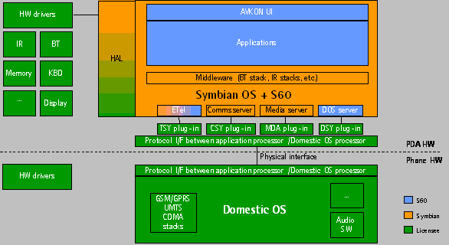
Figure 2.1 S60 Platform architecture

Services defined by DOS Server Plug-in API:
- Telephony audio related services
- Accessory related services
- SysUtils (for SysUtil internal use)
- Startup and reset related services
- Startup and shutdown related services
- Self test services
- SAE (for SAE internal use)
- Bluetooth Audio related services
- Extension to extend DOS Server Client API functionality

List of the required interfaces
DSY implementation must use DOS Plug-in API and DOS Plug-in Event API [7] in order to provide communication with Domestic OS. The DOS Plug-in API is defined in the dosdsy.h file and class structure is explained in chapter 3.2. DOS Plug-in Event API is used to route events from the Domestic OS to the S60.
In Domestic OS side DSY needs to use OEM specific Domestic OS interface and device drivers.
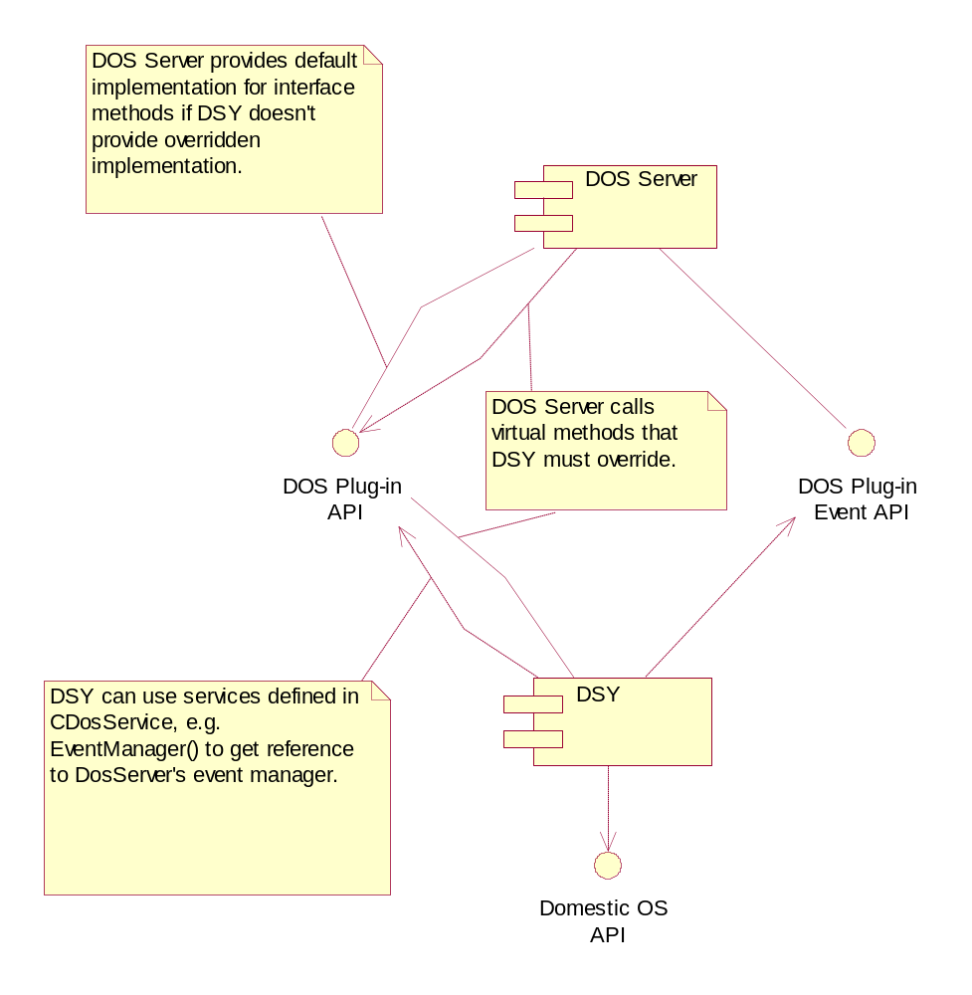
Figure 2.2 Required interfaces.

Product Platform and/or Symbian OS version constraints
API described here is valid for the S60 version 3.1 onwards.

Technical specification

Type of the interface
DOS Plug-in API contains base classes that have virtual methods to be overridden in DSY implementation.

Interface class structure
The class hierarchy for the service classes is illustrated in Figure 3.3. The derived class that DSY must implement is named as CDosSERVICEMyClass. That class derives from MDosSERVICEBaseDSY class, which defines abstract methods to be implement. CDosService class provides e.g EventManager() method that returns reference to the DosServer event manager. This reference is used to launch DOS Plug-in Events.
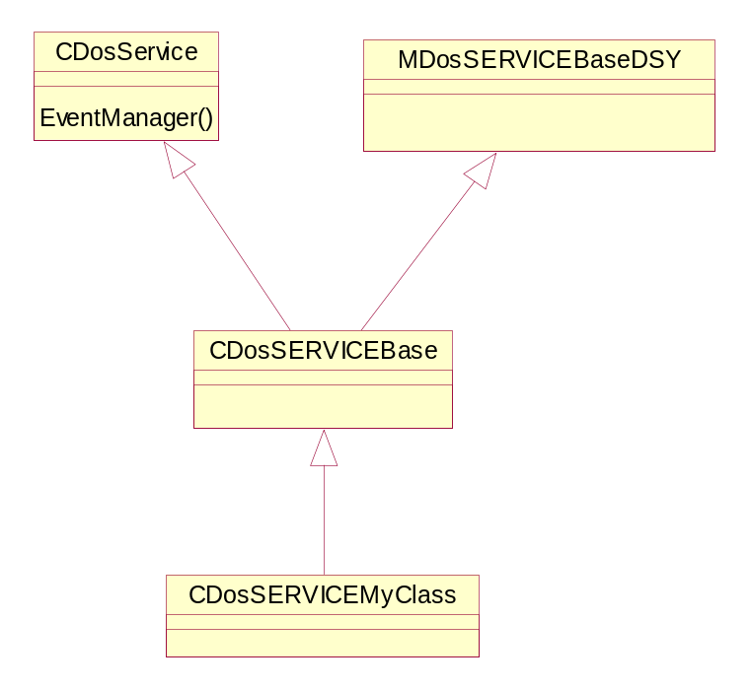
Figure 3.3 DOS Plug-in API Class hierarchy for the service classes

Usage

Protocol
DOS Plug-in API contains two types of functions to be implemented:
- Synchronous: DOS Server completes the operation when the function returns.
- Asynchronous: These function calls receive a reference to the Rmessage2 object that originated the request and the operation is completed by using the Complete() method of Rmessage2, which can be done after the function itself returns.

If certain functionality is not overwritten, the default implementation in base classes is called.
DSY implementation must launch certain events when they occur in Domestic OS side to notify S60 about these events. The events that are supported by S60 are listed in [7].

Error handling
The exception handling is done by using the Symbian OS leave mechanism.
All request functions return an error either with a function return value (synchronous requests) or with the status variable (asynchronous requests). All error codes are passed thru DOS Server as such. Error handling for each operation in the interface is described in Section 3.5.

Memory overhead
The DOS plug-in interface is abstract and the memory consumption depends on DSY implementation.

Extensions to the API
The DOS plug-in API can be extended by using the MDosExtensionBaseDSY class; see Section 3.5.8 for further information.

Example
Following example shows how to define a DSY class.
#include "DosSaeBase.h"

class CDosSaeExample : public CDosSaeBase
{
public:
/**
* NewL function that creates the object.
* @return the newly created object.
*/
static CDosSaeExample* NewL();

TInt StartSaeL(); // From CDosSaeBase

private:
/**
* Symbian two-phased constructor.
*/
void ConstructL();
};

Empty implementation for StartSaeL:
TInt CDosSaeExample::StartSaeL()
{
//Do StartSaeL related functionality here.

return KErrNone;
}

Detailed description
This section presents the classes of the interface and the public methods of the classes.

MDosFactoryBaseDSY
MDosFactoryBase is the interface class for the plug-in factory. Its responsibility is to create the objects that satisfy the requests on the demand of DOS Server. DOS Server creates only one instance of this class when it is started and it uses it to create service objects. When a call is received to for example the SAE service, the factory creates a new object to fulfill the request, if the appropriate object does not already exist.
The NewService functions always return a pointer to the base class but they have to create an object of the derived class. The L indicates that the functions may leave and DOS Server handles the error.

CDosSysUtilsBase* NewSysUtilsServiceL()
The function returns an object derived from CDosSysUtilBase, which implements the pure virtual functions defined in MDosSysBaseDSY to DOS Server.

CDosHelperBase* NewHelperServiceL()
The function returns an object derived from CDosHelperBase, which implements the pure virtual functions defined in MDosHelperBaseDSY to DOS Server.

CDosMtcBase* NewMTCServiceL()
The function returns an object derived from CDosMTCBase, which implements the pure virtual functions defined in MDosMTCBaseDSY to DOS Server.

CDosSelfTestBase* NewSelfTestServiceL()
The function returns an object derived from CDosSelfTestBase, which implements the pure virtual functions defined in MDosSelfTestBaseDSY to DOS Server.

CDosSaeBase* NewSaeServiceL()
The function returns an object derived from CDosSaeBase, which implements the pure virtual functions defined in MDosSaeBaseDSY to DOS Server.

CDosBTAudioBase* NewBTAudioServiceL()
The function returns an object derived from CDosBTAudioBase, which implements the pure virtual functions defined in MDosBTAudioBaseDSY to DOS Server.

CDosExtensionBase* NewExtensionServiceL()
The function returns an object derived from CDosExtensionBase, which implements the pure virtual functions defined in MDosExtensionBaseDSY to DOS Server.

CDosAccessoryBase* NewAccessoryServiceL()
The function returns an object derived from CDosAccessoryBase, which implements the pure virtual functions defined in MDosAccessoryBaseDSY to DOS Server.

CDosAudioBase* NewAudioServiceL()
The function returns an object derived from CDosAudioBase, which implements the pure virtual functions defined in MDosAudioBaseDSY to DOS Server.

MDosSysUtilsBaseDSY
The MDosSysUtilsBaseDSY module offers an API for:
- Getting the default language value stored on the SIM card.
- Performing the Domestic OS side restore factory settings.
- Setting or disabling the RTC alarm time for the Domestic OS.

GetSimLanguageL()
Status of this method:
Platform | Status
S60 2.1 | Deprecated
S60 2.5 | Deprecated
S60 2.6 | Deprecated

The implementation retrieves the default language code stored on the SIM card.
The language code of the SIM card is stored to aSimLanguage. A Symbian OS standard error code is returned indicating whether the operation was successful or not.
Operation:
virtual TInt GetSimLanguageL(TInt& aSimLanguage)=0
Parameters:
Parameter | Description
TInt& aSimLanguage | 0−255

Return value:
KErrNone if successful, KErrNotSupported if not supported by the DSY, or a Symbian OS standard error code.

PerformDosRfsL()
The implementation initiates the restore factory settings operation in the Domestic OS side.
Restoring the factory settings has two different levels. The normal level is intended for the end-users and the deep level is for after sales purposes.
This operation is asynchronous and the return value is returned when calling the aMessage active object’s Complete() method.
For more detailed information see Series 60 Restore Factory Settings Design Document [3].
Operation:
virtual void PerformDosRfsL(TUint aReason, const RMessagePtr2 aMessage)=0
Parameters:
Parameter | Description
TUint aReason | Must be an enum of type TRfsType declared by rfs component (rfsHandler.h).
- ERfsNormal | Normal
- ERfsDeep | Deep
const RMessagePtr2 aMessage | The message to be completed. Has to be completed by the implementation of the function.

Return value:
The value is set when calling aMessage.Complete(). The value is KErrNone if successful, KErrNotSupported if not supported by the DSY, or a Symbian OS standard error code.

SetDosAlarmL()
The implementation sets the Domestic OS RTC (Real Time Clock) alarm time so that the phone is powered up by an alarm if it is off. The method must set or clear the next alarm time in the Domestic OS.
S60 supports only one active alarm. This function supports 0-1 similar wakeup alarms. If parameter is NULL, alarm is deleted (even it does not exist). If parameter is something else than NULL, old alarm is deleted (even it does not exist) and after that new alarm time is set.
The format of TTime is system time.
Operation:
virtual TInt SetDosAlarmL(TTime* aAlarmTime)=0
Parameters:
Parameter | Description
TTime* aAlarmTime | The alarm time. NULL if switching off the Domestic OS alarm is desired.

Return value:
KErrNone if successful, KErrNotSupported if not supported by the DSY, or a Symbian OS standard error code.

MDosHelperBaseDSY
The MDosHelperBaseDSY module offers an API for:
- Getting and setting the SW startup reason.
- Getting startup reason
- Checking the hidden reset situation.
- Checking the RTC (Real Time Clock) time validity.
- Generate a grip event with the current grip state.

GetStartupReasonL()
This method gets the startup reason from the Domestic OS side. Domestic OS startup reasons are mapped to Symbian OS startup reasons by adaptation and the result is stored to the aReason variable. A standard Symbian OS error code is returned indicating the success of this operation.
Operation:
virtual TInt GetStartupReasonL(TInt& aReason)=0
Parameters:
Parameter | Description | Status
TInt& aReason | Must be an enum of type TWD2StartupReason declared by Starter component (startupreasons.h). | Supported
- ENormal | Normal start-up | Supported
- EAlarm | RTC alarm | Supported
- EMidnightAlarm |  | Not used by S60
- EHiddenReset |  | Not used by S60
- ECharger | The device is off and a charger is connected | Supported
- ETest | Test mode | Supported
- ELocal |  | Not used by S60
- ESelftestFail | Self test failed | Not used by S60
- ENotReadFromHardware |  | Not used by S60
- ENotKnown | Not known | Supported

These values are recommended and the ones S60 Platform provides. Adding or removing values might mean modifying the component that uses this function.
Default value:
ENormal.
Return value:
KErrNone if successful, KErrNotSupported if not supported by the DSY, or a Symbian OS standard error code.

GetSWStartupReasonL()
This method queries the software startup reason set by the Symbian OS with SetSWStartupReasonL() method (3.5.3.3). Value is stored to aReason. In error situations, the value stored in aReason is ESWNone.
Operation:
virtual TInt GetSWStartupReasonL(TInt16& aReason)=0
Parameters:
Parameter | Description
TInt16& aReason | Must be an enum of type TSWStartupReason declared by Sysutil component (sysstartup.h).
ESWNone = 100 | Nothing set the (default value).
ESWRestoreFactorySet = 101 | Restore Factory Settings (Normal).
ESWLangSwitch = 102 | Language Switched.
ESWWarrantyTransfer = 103 | Warranty transfer.
ESWChargerConnected = 104 | Power off and charger connected.
ESWRestoreFactorySetDeep =105 | Restore Factory Settings (Deep).

These values are recommended and the ones S60 Platform provides. Adding or removing values might mean modifying the component that uses this function.
Default value:
ESWNone.
Return value:
KErrNone if successful, KErrNotSupported if not supported by the DSY, or a Symbian OS standard error code.

SetSWStartupReasonL()
This method stores permanently the software-reset reason to the Domestic OS. The reset reason is used as a Symbian OS specific startup reason in the next restart of the device. Starter clears the value after reason has been handled properly. List of possible values is based on SysUtil definitions (sysstartup.h). See the corresponding getter method from chapter 3.5.3.2.
Operation:
virtual TInt SetSWStartupReasonL(TInt16 aReason)=0
Parameters:
Parameter | Description
TInt16 aReason | Must be an enum of type TSWStartupReason declared by Sysutil component (sysstartup.h).
ESWNone = 100 | Nothing set the (default value).
ESWRestoreFactorySet = 101 | Restore Factory Settings (Normal).
ESWLangSwitch = 102 | Language Switched.
ESWWarrantyTransfer = 103 | Warranty transfer.
ESWChargerConnected = 104 | Power off and charger connected.
ESWRestoreFactorySetDeep =105 | Restore Factory Settings (Deep).

These values are recommended and the ones S60 Platform provides. Adding or removing values might mean modifying the component that uses this function.
Return value:
KErrNone if successful, KErrNotSupported if not supported by the DSY, or a Symbian OS standard error code

HiddenResetL()
The implementation checks if a hidden reset situation is on. After hidden reset when phone boots up security codes are not asked from user.
Operation:
virtual TBool HiddenResetL()=0
Parameters:
None.
Return value:
TBool, ETrue if a hidden reset is on; otherwise EFalse.
Default value:
EFalse.

GetRTCStatusL()
Checks the RTC (Real Time Clock) time validity from the Domestic OS and stores the result in the aStatus variable.
Operation:
virtual TInt GetRTCStatusL(TBool& aStatus)=0
Parameters:
Parameter | Description
TBool& aStatus
- ETrue | The time is valid.
- EFalse | RTC is corrupted or not valid.

These values are recommended and the ones S60 Platform provides. Adding or removing values might mean modifying the component that uses this function.
Default value:
ETrue.
Return value:
KErrNone if successful, KErrNotSupported if not supported by the DSY, or a Symbian OS standard error code.

GenerateGripEventL()
Generates a grip event. Function call causes a keyevent to be generated that tells the current grip state.
Operation:
virtual TInt GenerateGripEventL()=0
Parameters:
None.
Return value:
KErrNone if successful, KErrNotSupported if not supported by the DSY, or a Symbian OS standard error code.

MDosMtcBaseDSY
The MDosMtcBaseDSY plug-in handles the Domestic OS functions related to MTC (Mobile Terminal Controller). These functions are similar to the events from the Symbian OS to the Domestic OS and thus have no return values or parameters.

PowerOnL()
The implementation informs the Domestic OS side that the Symbian OS side’s power is on.
Operation:
virtual TInt PowerOnL()=0
Parameters:
None.
Return value:
KErrNone if successful, KErrNotSupported if not supported by the DSY, or a Symbian OS standard error code.

PowerOffL()
The implementation informs the Domestic OS that the Symbian OS side is being powered off.
Operation:
virtual TInt PowerOffL()=0
Parameters:
None.
Return value:
KErrNone if successful, KErrNotSupported if not supported by the DSY, or a Symbian OS standard error code

DosSyncL()
The implementation synchronizes the Domestic OS and Symbian OS startup and shutdown. It sends a S60 synchronization message to the Domestic OS when called.
Operation:
virtual TInt DosSyncL()=0
Parameters:
None.
Return value:
KErrNone if successful, KErrNotSupported if not supported by the DSY, or a Symbian OS standard error code

ResetGenerateL()
The implementation generates a hidden reset.
Operation:
virtual TInt ResetGenerateL()=0
Parameters:
None.
Return value:
KErrNone if successful, KErrNotSupported if not supported by the DSY, or a Symbian OS standard error code

SetStateL()
Sets the Domestic OS state.
Operation:
virtual TInt SetStateL(const TInt aStateType)=0
Parameters:
Parameter | Description
const TInt aStateType | Must be an enum of type TSysApMtcStateType declared by SysAp component (SysAp.hrh).
- ESysApMtcNormalState
- ESysApMtcAlarmState
- ESysApMtcChargingState
- ESysApMtcPowerOffState
- ESysApMtcRfInactiveState
- ESysApMtcBtSapState

These values are recommended and the ones S60 Platform provides. Adding or removing values might mean modifying the component that uses this function.
Return value:
KErrNone if successful, KErrNotSupported if not supported by the DSY, or a Symbian OS standard error code

SetStateFlagL()
This method changes the states of flags that reside in Domestic OS.
Operation:
virtual TInt SetStateFlagL(const TDosStateFlag aFlag)=0
Parameters:
Parameter | Description
const TDosStateFlag aFlag
- EDosOfflineStateFlagFalse | Sets offline state flag in Domestic OS to false.
- EDosOfflineStateFlagTrue | Sets offline state flag in Domestic OS to true.

These values are recommended and the ones S60 Platform provides. Adding or removing values might mean modifying the component that uses this function.
Return value:
KErrNone if successful, KErrNotSupported if not supported by the DSY, or a Symbian OS standard error code

GetStateFlagL()
This method gets the states of flags that reside in Domestic OS.
Operation:
virtual TInt GetStateFlagL(TDosStateFlag& aFlag)=0
Parameters:
Parameter | Description
TDosStateFlag& aFlag
- EDosOfflineStateFlagFalse | The offline state flag in Domestic OS is false.
- EDosOfflineStateFlagTrue | The offline state flag in Domestic OS is true.

These values are recommended and the ones S60 Platform provides. Adding or removing values might mean modifying the component that uses this function.
Return value:
KErrNone if successful, KErrNotSupported if not supported by the DSY, or a Symbian OS standard error code

DosShutdownSyncL()
The method synchronises Symbian OS with Domestic OS on shutdown. Call from DOS Server to this method means that Domestic OS can continue shutdown and therefore DSY implementation must inform Domestic OS to complete shutdown.
Operation:
virtual TInt DosShutdownSyncL()=0
Parameters:
None.
Return value:
KErrNone if successful, KErrNotSupported if not supported by the DSY, or a Symbian OS standard error code

MDosSelfTestBaseDSY
The MDosSelfTestBaseDSY plug-in handles self-test related tasks in the Domestic OS.

PerformSelfTestL()
The implementation initiates a Domestic OS self-test.
This is a background operation, and when the test is completed, the NotifySelfTestStatus event is launched.
Operation:
virtual TInt PerformSelfTestL()=0
Parameters:
None.
Return value:
KErrNone if successful, KErrNotSupported if not supported by the DSY, or a Symbian OS standard error code.

MDosSaeBaseDSY
The MDosSaeBaseDSY class contains the functions needed by System Agent Extension.
The System Agent Extension of S60 Platform is responsible for monitoring the S60 specific system state variables and notifying the changes to the core System Agent, which is responsible for passing the events to registered clients. See reference document [5] for further information.

StartSaeL()
The implementation starts the event listener in the DSY plug-in so that events can be retrieved and delivered to DOS Server to be transferred to registered clients (i.e. SAE).
Operation:
virtual TInt StartSaeL()=0
Parameters:
None.
Return value:
KErrNone if successful, KErrNotSupported if not supported by the DSY, or a Symbian OS standard error code

MDosBTAudioBaseDSY
The MDosBTAudioBaseDSY class contains the services needed by Bluetooth Audio Accessory Controller; see reference document [1] for further information. The services are divided into three categories: issuing requests, sending responses and sending indications.

Requests
Requests are issued from Symbian OS to Domestic OS.

AttachAudioAccessoryReq()
The implementation makes an asynchronous accessory attach request to take Bluetooth Audio Accessory into use.
Operation:
virtual void AttachAudioAccessoryReq( const RMessagePtr2 aMessage, const TBTDevAddr& aBDAddress, TBTDeviceType aDeviceType, TUint32 aSupportedFeatures )=0
Parameters:
Parameter | Description
const RMessagePtr2 aMessage | The message to be completed. Has to be completed by the implementation of the function.
const TBTDevAddr& aBDAddress | The accessory device's Bluetooth Device Address.
TBTDeviceType aDeviceType
- EBTNoDevice | No device
- EBTUnknownDevice | Unknown device
- EBTHeadset | Headset
- EBTCarkit | Car kit
- EBTHeadsetPropietary | Proprietary headset
- EBTCarkitPropietary | Proprietary car kit
TUint32 aSupportedFeatures | The supported features of the accessory device.

Return value:
None.

CancelAttachReq()
The implementation cancels an accessory attach request. See Section 3.5.7.1.1.
Operation:
virtual void CancelAttachReq()=0
Parameters:
None.
Return value:
None.

DetachAudioAccessoryReq()
The implementation makes an asynchronous accessory detach request to take Bluetooth Audio Accessory out of use.
Operation:
virtual void DetachAudioAccessoryReq( const RMessagePtr2 aMessage, const TBTDevAddr& aBDAddress, TBTDeviceType aDeviceType )=0
Parameters:
Parameter | Description
const RMessagePtr2 aMessage | The message to be completed. Has to be completed by the implementation of the function.
const TBTDevAddr& aBDAddress | The accessory device's Bluetooth Device Address.
TBTDeviceType aDeviceType
- EBTNoDevice | No device
- EBTUnknownDevice | Unknown device
- EBTHeadset | Headset
- EBTCarkit | Car kit
- EBTHeadsetPropietary | Proprietary headset
- EBTCarkitPropietary | Proprietary car kit

Return value:
None.

CancelDetachReq()
The implementation cancels an accessory detach request. See Section 3.5.7.1.3.
Operation:
virtual void CancelDetachReq()=0
Parameters:
None.
Return value:
None.

Responses
Responses are issued from Symbian OS to Domestic OS.

AudioLinkOpenResp()
The implementation responds to an audio link open request event AudioLinkOpenReq() [7].
Operation:
virtual TInt AudioLinkOpenResp( TInt aStatus, THCIConnHandle aConnectionHandle )=0
Parameters:
Parameter | Description
TInt aStatus | The status of the request, a Symbian OS error code.
THCIConnHandle aConnectionHandle | Declared in bttypes.h
- TUint16 | Identifier of the opened audio link.

Return value:
KErrNone if successful, KErrNotSupported if not supported by the DSY, or a Symbian OS standard error code.

AudioLinkCloseResp( )
The implementation responds to an audio link close request event AudioLinkCloseReq() [7].
Operation:
virtual TInt AudioLinkCloseResp( TInt aStatus )=0
Parameters:
Parameter | Description
TInt aStatus | The status of the request, a Symbian OS error code.

Return value:
KErrNone if successful, KErrNotSupported if not supported by the DSY, or a Symbian OS standard error code.

ActivateVoiceRecognitionResp ()
The implementation responds to an activate voice recognition request event ActivateVoiceRecognitionReq() [7].
Operation:
virtual TInt ActivateVoiceRecognitionResp( TInt aStatus )=0
Parameters:
Parameter | Description
TInt aStatus | The status of the request, a Symbian OS error code.

Return value:
KErrNone if successful, KErrNotSupported if not supported by the DSY, or a Symbian OS standard error code.

AbortVoiceRecognitionResp ()
The implementation responds to an abort voice recognition request event AbortVoiceRecognitionReq() [7].
Operation:
virtual TInt AbortVoiceRecognitionResp()=0
Parameters:
None.
Return value:
KErrNone if successful, KErrNotSupported if not supported by the DSY, or a Symbian OS standard error code.

VoiceRecognitionStatusResp ()
The implementation responds to a voice recognition status request event VoiceRecognitionStatusReq() [7].
Operation:
virtual TInt VoiceRecognitionStatusResp( TBTVoiceRecognitionState aState )=0
Parameters:
Type | Description
TBTVoiceRecognitionState aState | Declared in DosSvrServices.h
- EBtVoiceReadyState
- EBtVoiceIdleState
- EBtVoiceTrainingState
- EBtVoiceRecognitionState
- EBtVoiceRecordingState
- EBtVoicePlaybackState
- EBtVoiceSystemAbortState
- EBtVoiceApplicationAbortState
- EBtVoiceSystemCableAbortState
- EBtVoiceSystemAccAbortState
Return value:
KErrNone if successful, KErrNotSupported if not supported by the DSY, or a Symbian OS standard error code.

QuerySpeedDialNumberResp ()
The implementation responds to a query Speed Dial number request event QuerySpeedDialNumberReq() [7].
Operation:
virtual TInt QuerySpeedDialNumberResp( TInt aStatus, const TDesC& aNumber )=0
Parameters:
Parameter | Description
TInt aStatus | The status of the request, a Symbian OS error code.
const TDesC& aNumber | The result phone number.

Return value:
KErrNone if successful, KErrNotSupported if not supported by the DSY, or a Symbian OS standard error code.

QueryLastDialledVoiceNumberResp ()
The implementation responds to a query last dialed voice number request event QueryLastDialledVoiceNumberReq() [7].
Operation:
virtual TInt QueryLastDialledVoiceNumberResp( TInt aStatus, const TDesC& aNumber )=0
Parameters:
Parameter | Description
TInt aStatus | The status of the request, a Symbian OS error code.
const TDesC& aNumber | The result phone number.

Return value:
KErrNone if successful, KErrNotSupported if not supported by the DSY, or a Symbian OS standard error code.

Indications

AudioLinkOpenInd()
The implementation sends an audio link open indication telling that an audio link between the phone and Bluetooth Audio Accessory has been established.
Operation:
virtual TInt AudioLinkOpenInd( const TBTDevAddr& aBDAddress, THCIConnHandle aConnectionHandle )=0
Parameters:
Parameter | Description
const TBTDevAddr& aBDAddress | The accessory device's Bluetooth Device Address.
THCIConnHandle aConnectionHandle | A handle to the audio connection.

Return value:
KErrNone if successful, KErrNotSupported if not supported by the DSY, or a Symbian OS standard error code.

AudioLinkCloseInd()
The implementation sends an audio link close indication telling that the audio link between the phone and Bluetooth Audio Accessory has been released.
Operation:
virtual TInt AudioLinkCloseInd( const TBTDevAddr& aBDAddress, THCIConnHandle aConnectionHandle )=0
Parameters:
Parameter | Description
const TBTDevAddr& aBDAddress | The accessory device's Bluetooth Device Address.
THCIConnHandle aConnectionHandle | A handle to the audio connection.

Return value:
KErrNone if successful, KErrNotSupported if not supported by the DSY, or a Symbian OS standard error code.

VoiceRecognitionStatusInd ()
The implementation sends a voice recognition status indication telling the status of voice recognition.
Operation:
virtual TInt VoiceRecognitionStatusInd( TBTVoiceRecognitionState aState )=0
Parameters:
Parameter | Description
TBTVoiceRecognitionState aState | Declared in DosSvrServices.h
- EBtVoiceReadyState
- EBtVoiceIdleState
- EBtVoiceTrainingState
- EBtVoiceRecognitionState
- EBtVoiceRecordingState
- EBtVoicePlaybackState
- EBtVoiceSystemAbortState
- EBtVoiceApplicationAbortState
- EBtVoiceSystemCableAbortState
- EBtVoiceSystemAccAbortState

Return value:
KErrNone if successful, KErrNotSupported if not supported by the DSY, or a Symbian OS standard error code.

MDosExtensionBaseDSY
RDosExtension provides means to extend DOS Server Client API without breaking the architecture.

CallFunctionL()
Implements a raw function call. The implementation interprets the parameters and satisfies the requests.
Executes the corresponding functions to aFunc. It is also responsible for getting the parameters from aParameter before the execution.
Operation:
virtual TInt CallFunctionL(TInt aFunc , TAny *aParameter , TInt aParLength, TBool& aParameterModified)=0
Parameters:
Parameter | Description
TInt aFunc | A unique integer among the extended functions identifying the called function.
TAny *aParameter | A pointer to the parameter.
TInt aParLength | The parameter length.
TBool& aParameterModified
- ETrue | The contents of aParameter have changed.
- EFalse | Otherwise

Return value:
KErrNone if successful, KErrNotSupported if not supported by the DSY, or a Symbian OS standard error code.

CallFunctionAndCompleteL()
This is the asynchronous version of CallFunction.
Executes the correspondent functions to aFunc. It is also responsible for getting the parameters from aParameter before the execution.
Operation:
virtual void CallFunctionAndCompleteL(TInt aFunc , TAny *aParameter , TInt aParLength, const Rmessage2& aMessage)=0
Parameters:
Parameter | Description
TInt aFunc | A unique integer among the extended functions identifying the called function.
TAny *aParameter | A pointer to the parameter.
TInt aParLength | The parameter length.
const Rmessage2& aMessage | The message to be completed. Has to be completed by the implementation of the function.

Return value:
The return value is received when the asynchronous method calls aMessage.Complete() and signals the event scheduler of the calling active object.

MDosAccessoryBaseDSY
The MDosAccessoryBaseDSY module offers an API for:
- Getting the audio accessory mode.
- Getting and setting the loop set mode state.

SetLoopSetModeStateL()
Sets the loop set mode state.
This feature is supported if feature flag __AUTO_ACCESSORY_IDENTIFICATION is defined.
Operation:
virtual TInt SetLoopSetModeStateL(const TInt aMode) = 0
Parameters:
Parameter | Description
const TInt aMode | Must be an enum of type EPSAccLpsMode declared by SAE component (psvariables.h).
- EPSAccLpsOff | Used to force the device to go out of the wireless loop set or TTY device mode.
- EPSAccLpsOn | Used to force the device to go in to the wireless loop set mode.
- EPSAccTty | Used to force the device to go in to the TTY device mode.

Return value:
KErrNone if successful, KErrNotSupported if not supported by the DSY, or a Symbian OS standard error code.

GetLoopSetModeStateL()
Gets the loop set mode state.
This feature is supported if feature flag __AUTO_ACCESSORY_IDENTIFICATION is defined.
Operation:
virtual TInt GetLoopSetModeStateL(TInt& aMode) = 0
Parameters:
Parameter | Description
TInt& aMode | Must be an enum of type EPSAccLpsMode declared by SAE component (psvariables.h).
- EPSAccLpsOff | The device is not in the wireless loop set or TTY device mode.
- EPSAccLpsOn | The device is in the wireless loop set mode.
- ESAAccTty | The device is in the TTY device mode.

Return value:
KErrNone if successful, KErrNotSupported if not supported by the DSY, or a Symbian OS standard error code.

GetAccessoryModeL()
Gets current audio accessory mode.
Operation:
virtual TInt GetAccessoryModeL(TDosAccessoryMode& aAccessoryState) = 0
Parameters:
Parameter | Description
TDosAccessoryMode& aAccessoryState | Declared in DosSvrServices.h
- EDosAccNotConnected | No accessory connected
- EDosAccUnsupportedConnected | Unsupported accessory connected
- EDosAccModeHeadset | Wired headset connected
- EDosAccModeLoopset | Loopset connected
- EDosAccModeTty | TTY device connected
- EDosAccModeCarKit | Wired car kit connected
- EDosAccModeBtHeadset | BT headset connected
- EDosAccModeBtCarKit | BT car kit connected

Return value:
- KErrNone if successful.
- KErrNotSupported if the feature is not supported.
- KErrGeneral in other cases.

MDosAudioBaseDSY
The MDosAudioBaseDSY module offers an API for:
- Changing the audio mute state.
- Getting and setting the current handsfree mode.
- Getting and setting the microphone mute state.
- Getting and setting the output volume level.
- Enumerating the audio volume levels.

SetHandsfreeModeL()
Implementation should set the current integrated hands free mode according to the parameter given i.e. activate or deactivate it. After the activation, a phone with IHF functionality is able to do hands free operation without any accessories. See the corresponding getter method from chapter 3.5.10.2.
Operation:
virtual TInt SetHandsfreeModeL(const TInt aMode) = 0
Parameters:
Parameter | Description
const TInt aMode | Must be an enum of type EPSHandsFreeMode declared by SAE component (psvariables.h).
- EPSIhfOff | IHF is disabled.
- EPSIhfOn | IHF is enabled.

Return value:
KErrNone if successful, KErrNotSupported if not supported by the DSY, or a Symbian OS standard error code.

GetHandsfreeModeL()
Implementation should find out the current integrated hands free mode. IHF mode means audio routing state in which audio is routed to earpiece (IHF is disabled) or accessory (IHF is enabled). Accessory may be integrated (loudspeaker) or wireless/ wired accessory. The mode is stored to aMode reference parameter. See the corresponding setter method from chapter 3.5.10.1.
Operation:
virtual TInt GetHandsfreeModeL(TInt& aMode) = 0
Parameters:
Parameter | Description
TInt& aMode | Must be an enum of type EPSHandsFreeMode declared by SAE component (psvariables.h).
- EPSIhfOff | IHF is disabled.
- EPSIhfOn | IHF is enabled.

Return value:
KErrNone if successful, KErrNotSupported if not supported by the DSY, or a Symbian OS standard error code.

GetOutputVolumeL()
Implementation should return synchronously the audio output volume level of the currently selected audio channel. The result is passed though the parameter aLevel. See the corresponding setter method from chapter 3.5.10.4.
Operation:
virtual TInt GetOutputVolumeL(TInt& aLevel) = 0
Parameters:
Parameter | Description
TInt& aLevel | Logical volume level, valid values 0-9.

Return value:
KErrNone if successful, KErrNotSupported if not supported by the DSY, or a Symbian OS standard error code.

SetOutputVolumeL()
Implementation should set the audio output volume level of the currently selected audio channel according to the given parameter. See the corresponding getter method from chapter 3.5.10.3.
Operation:
virtual TInt SetOutputVolumeL(const TInt aVolume) = 0
Parameters:
Parameter | Description
const TInt aVolume | Valid values depend on selected audio channel. For IHF loudspeaker and earpiece valid values are 0-9

Return value:
KErrNone if successful, KErrNotSupported if not supported by the DSY, or a Symbian OS standard error code.

Code architecture
The DSY plug-in abstract interface is defined in the dosdsy.H file. The DSY plug-in can be named freely and the chosen name must be defined in the dosserver.INI file.
The DSY plug-in is used by DSClient.DLL.

Appendix A. Alphabetical list of classes and methods
class MDosFactoryBaseDSY
virtual CDosSysUtilsBase* NewSysUtilsServiceL()=0;
virtual CDosHelperBase* NewHelperServiceL()=0;
virtual CDosMtcBase* NewMtcServiceL()=0;
virtual CDosSelfTestBase* NewSelfTestServiceL()=0;
virtual CDosSaeBase* NewSaeServiceL()=0;
virtual CDosBTAudioBase* NewBTAudioServiceL()=0;
virtual CDosExtensionBase* NewExtensionServiceL()=0;
virtual CDosAccessoryBase* NewAccessoryServiceL()=0;
virtual CDosAudioBase* NewAudioServiceL()=0;

class MDosSysUtilsBaseDSY
virtual TInt GetSimLanguageL(TInt& aSimLanguage)=0;
virtual void PerformDosRfsL(TUint aReason, const RmessagePtr2 aMessage)=0;
virtual TInt SetDosAlarmL(TTime* aAlarmTime)=0;

class MDosHelperBaseDSY
virtual TInt GetStartupReasonL(TInt& aReason)=0;
virtual TInt GetSWStartupReasonL(TInt16& aReason)=0;
virtual TInt SetSWStartupReasonL(TInt16 aReason)=0;
virtual TBool HiddenResetL()=0;
virtual TInt GetRTCStatusL(TBool& aStatus)=0;
virtual TInt GenerateGripEventL()=0;

class MDosMtcBaseDSY
virtual TInt PowerOnL()=0;
virtual TInt PowerOffL()=0;
virtual TInt DosSyncL()=0;
virtual TInt ResetGenerateL()=0;
virtual TInt SetStateL(const TInt aStateType)=0;
virtual TInt SetStateFlagL(const TDosStateFlag aFlag)=0;
virtual TInt GetStateFlagL(TDosStateFlag& aFlag)=0;
virtual TInt DosShutdownSyncL()=0;

class MDosSelfTestBaseDSY
virtual TInt PerformSelfTestL()=0;

class MDosSaeBaseDSY
virtual TInt StartSaeL()=0;

class MDosBTAudioBaseDSY
virtual void AttachAudioAccessoryReq( const RmessagePtr2 aMessage,
const TBTDevAddr& aBDAddress,
TBTDeviceType aDeviceType,
TUint32 aSupportedFeatures )=0;
virtual void CancelAttachReq()=0;
virtual void DetachAudioAccessoryReq( const RmessagePtr2 aMessage,
const TBTDevAddr& aBDAddress,
TBTDeviceType aDeviceType )=0;
virtual void CancelDetachReq()=0;
virtual TInt AudioLinkOpenResp( TInt aStatus,
THCIConnHandle aConnectionHandle )=0;
virtual TInt AudioLinkCloseResp( TInt aStatus )=0;
virtual TInt ActivateVoiceRecognitionResp( TInt aStatus )=0;
virtual TInt AbortVoiceRecognitionResp()=0;
virtual TInt VoiceRecognitionStatusResp( TBTVoiceRecognitionState aState )=0;
virtual TInt QuerySpeedDialNumberResp( TInt aStatus, const TDesC& aNumber )=0;
virtual TInt QueryLastDialledVoiceNumberResp( TInt aStatus, const TDesC& aNumber )=0;
virtual TInt AudioLinkOpenInd( const TBTDevAddr& aBDAddress,
THCIConnHandle aConnectionHandle )=0;
virtual TInt AudioLinkCloseInd( const TBTDevAddr& aBDAddress,
THCIConnHandle aConnectionHandle )=0;
virtual TInt VoiceRecognitionStatusInd( TBTVoiceRecognitionState aState )=0;

class MDosExtensionBaseDSY
virtual TInt CallFunctionL(TInt aFunc , TAny *aParameter , TInt aParLength, TBool& aParameterModified)=0;
virtual void CallFunctionAndCompleteL(TInt aFunc , TAny *aParameter , TInt aParLength, const Rmessage2& aMessage)=0;

class MDosAccessoryBaseDSY
virtual TInt SetLoopSetModeStateL(const TInt aMode) = 0;
virtual TInt GetLoopSetModeStateL(TInt& aMode) = 0;
virtual TInt GetAccessoryModeL(TDosAccessoryMode& aAccessoryState) = 0;

class MDosAudioBaseDSY
virtual TInt SetHandsfreeModeL(const TInt aMode) = 0;
virtual TInt GetHandsfreeModeL(TInt& aMode) = 0;
virtual TInt GetOutputVolumeL(TInt& aLevel) = 0;
virtual TInt SetOutputVolumeL(const TInt aVolume) = 0;

