S60 3.2
DOS Server Plug-in Event API
Specification Document

Team name | Author
TP/AP/SP/SPD/SIF | Laura Rissanen

Change history:

Version | Date | Status | Comments
6.0 | 15.08.2006 | Approved | Release validity updated.
5.0 | 14.08.2006 | Approved | Chapter 2.0 updated: Interface flag note added.
4.0 | 03.03.2006 | Approved | Template corrected.
3.0 | 08.02.2006 | Approved | Release validity updated.  Chapters 3.5.1.2.3 and 3.5.1.2.6 removed.  Chapters 3.5.1.2.2, 3.5.1.2.3, 3.5.1.2.4, 3.5.1.2.9, 3.5.1.3.1, 3.5.1.3.2, 3.5.1.3.4 and 3.5.1.3.5 updated.
2.0 | 30.08.2005 | Approved | Chapters 3.5.1.2.2, 3.5.1.2.3, 3.5.1.2.4 and 3.5.1.2.7 removed.  Chapter 4.1 updated.
1.0 | 31.05.2004 | Approved

Table of contents:

1. Document control 5
1.1 References 5
1.2 Documentation conventions 5
1.3 Abbreviations 5
1.4 Definitions 5
2. Purpose 7
2.1 List of required interfaces 7
2.2 Product platform and/or Symbian OS version constraints 7
3. Technical specification 8
3.1 Type of interface 8
3.2 Interface class structure 8
3.3 Usage 9
3.3.1 Error handling 9
3.3.2 Extensions to API 9
3.4 Example 10
3.4.1 Calling an event 10
3.4.2 Registering for an event 11
3.5 Detailed description 11
3.5.1 Events from the Domestic OS 11
3.5.1.1 Bluetooth related events 11
3.5.1.1.1 TInt AbortVoiceRecognitionReq() 11
3.5.1.1.2 TInt AccessoryModeChangedInd( TBTAccessoryMode aAccMode ) 12
3.5.1.1.3 TInt AccessorySpeakerVolumeSetInd( TUint aVolume ) 13
3.5.1.1.4 TInt ActivateVoiceRecognitionReq() 13
3.5.1.1.5 TInt AudioLinkCloseReq( THCIConnHandle aConnectionHandle ) 14
3.5.1.1.6 TInt AudioLinkOpenReq() 15
3.5.1.1.7 TInt BTAccessoryModeChangedInd( TBTDeviceType aDeviceType ) 15
3.5.1.1.8 TInt QueryLastDialledVoiceNumberReq() 16
3.5.1.1.9 TInt QuerySpeedDialNumberReq( TInt aIndex ) 17
3.5.1.1.10 TInt ServiceLevelConnEstablishedInd( TBTServiceLevelConnParams aParam ) 18
3.5.1.1.11 TInt VoiceRecognitionStatusReq() 18
3.5.1.2 Common events 19
3.5.1.2.1 TInt AccessoryModeChangedL( TDosAccessoryMode aAccessoryState ) 20
3.5.1.2.2 TInt CallsForwardingStatus( EPSCallsForwardingStatus aStatus ) 20
3.5.1.2.3 TInt HandsfreeModeChanged( EPSHandsFreeMode aMode ) 21
3.5.1.2.4 TInt HeadsetButtonChanged( EPSButtonState aState ) 22
3.5.1.2.5 TInt NetworkBars( TInt aValue ) 23
3.5.1.2.6 TInt OutputVolumeLevelChanged(TInt aLevel) 23
3.5.1.2.7 TInt PhonePowerOn() 24
3.5.1.2.8 TInt SmsStorageStatusChanged( TDosSmsStorageStatus aStatus ) 24
3.5.1.2.9 TInt VoiceMailStatus( EPSVoiceMailStatus aStatus ) 26
3.5.1.3 SIM Security events 27
3.5.1.3.1 TInt CurrentSimOwnedStatus( EPSCurrentSimOwnedSimStatus aStatus ) 27
3.5.1.3.2 TInt SecurityCode( EPSSecurityCodeStatus aStatus ) 27
3.5.1.3.3 TInt SimChanged( TBool aValue ) 28
3.5.1.3.4 TInt SimLockStatus( EPSSimLockStatus aStatus ) 29
3.5.1.3.5 TInt SimReady( EPSSimReadyStatus aStatus ) 30
3.5.1.3.6 TInt SimState( TDosSimState aState ) 30
3.5.1.4 Specialized events 31
3.5.1.4.1 TInt DoMtcInitiatedShutdown() 31
3.5.1.4.2 TInt EmailMessage( TBool aValue ) 32
3.5.1.4.3 TInt FaxMessage( TBool aValue ) 32
3.5.1.4.4 TInt GeneralEvent( TInt32 aEvent,TAny* aParameter,TInt aParSize ) 33
3.5.1.4.5 TInt NotifySelfTestStatus( TInt aSelfTestResult ) 34
4. Index 35
4.1 Alphabetical list of events 35

Document control

References

- S60 DOS Server Plug-in API Specification Document
- Series 60 Bluetooth Audio Accessory Controller Design Document
- Hands-Free Profile v.1.0 | http://www.bluetooth.org/

Documentation conventions
Code is written in the courier new font.

Abbreviations

API | Application Programming Interface
ALS | Alternate Line Service
BT | Bluetooth
DLL | Dynamic Link Library
DOS | Domestic OS
IHF | Integrated Hands Free
IMSI | International Mobile Subscriber Identity
OS | Operating System
PIN | Personal Identification Number
PUK | Personal Unblocking Key
SA | System Agent
SAE | System Agent Extension component
SIM | Subscriber Identity Module
SMS | Short Message Service
TTY | Tele-Type accessory
UPIN | Universal PIN
UPUK | Universal PUK

Definitions

Bluetooth accessory | Any accessory connected to the device via bluetooth.
DSY | Used to describe the DOS plug-in module.
Handsfree accessory | An audio accessory allowing hands free use of the device.
Integrated hands free | Hands free consisting of a loudspeaker and microphone built into the device.
Wired accessory | Accessory connected to the device via cable.

Purpose
Note!
Part of API has been flagged with __ACCESSORY_FW and RD_STARTUP_CHANGE -flags.
This document describes DOS server plug-in event API. The DOS server event API is used by a DOS server plug-in to send events to the S60 platform. The API is one of several provided by the DOS server, others are Plug-in API and client API.
Clients use the event API described here to report an event that has occurred in the Domestic OS. Following an event that is being sent, all services that have registered to listen to that particular event are notified by the DOS server and may then take appropriate action.

List of required interfaces
The external interfaces required by the plug-in event API are as follows:
- Bluetooth socket API: used by the BT events and is provided in the bttypes.H header file.
- SAE API: used by many common events. These require the SAE interface header file, psvariables.h.

Product platform and/or Symbian OS version constraints
The API described here is valid from the S60 release 3.1 onwards.

Technical specification

Type of interface
This interface is called via the methods in the DOS server’s CDosEventManager class.
Clients may call this object via the instance returned from the CDosService::EventManager() method which is defined in the derived clients’ service classes (for example CDosSaeBase), see Section 3.2.

Interface class structure
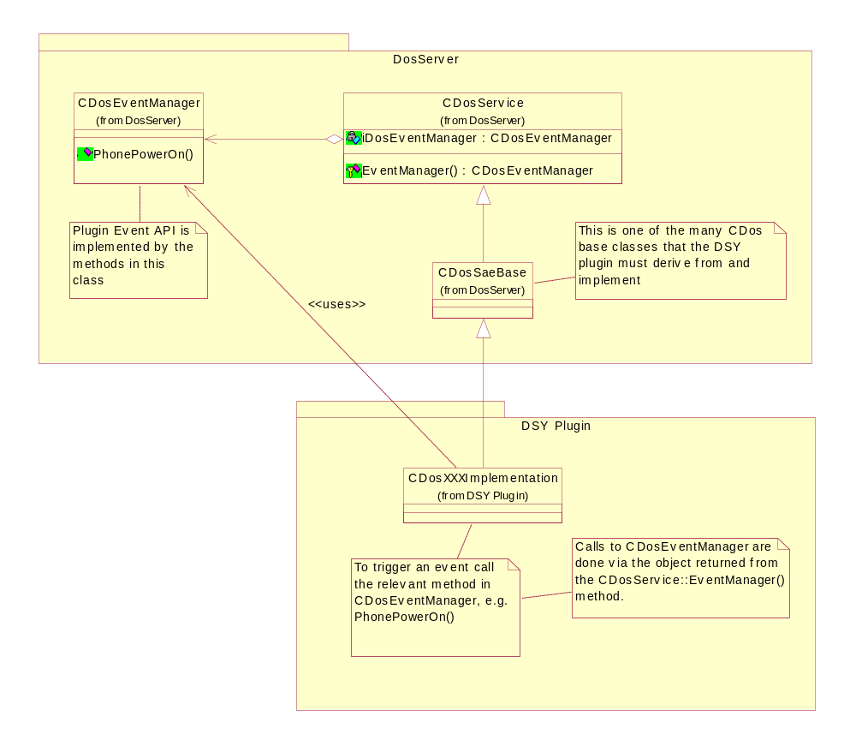
Figure 3.1 Plug-in event API class diagram
An example of how the event API is called is shown in Figure 3.1.
DSY plug-in implements the CDos base class (CDosXXXImplementation. XXX in this case may be SAE as the class is derived from CDosSaeBase), and may call the event API via the CDosEventManager contained by the parent CDosService class.

Usage
Use of this interface is simply a synchronous method call via the CdosEventManager. The following code fragment demonstrates a typical example of how to use this interface from a client’s service class:
Header File (DosXXXImplementation.H):

#include <DosSaeBase.h>
…

class CDosXXXImplementation : public CDosSaeBase
{
…
private:
CDosEventManager* iDosEventManager;
};

C++ Source File (DosXXXImplementation.CPP):

#include “DosXXXImplementation.h”
…

CDosXXXImplementation::CDosXXXImplementation( … )
{
// call method in parent class CDosService
iDosEventManager = EventManager()
…
}

CDosXXXImplementation::GeneratePowerOnEvent( … )
{
…
iDosEventManager->PhonePowerOn();
…
}

Error handling
The following error codes may be returned when attempting to raise an event from the Domestic OS:
- KerrNotFound, if no clients have registered for the event.
- KerrNoMemory, or other leave code from HBufC8::NewL() (from the method CDosWaitingEvent::SetParameterL).

Extensions to API
User events may be added to the plug-in event API through the GeneralEvent (see Section 3.5.1.4.4 for further details).
To use a general event, a unique ID must first be defined. This must be an ID that is not already defined in the DosSvrServices.H header file.

Example

Calling an event
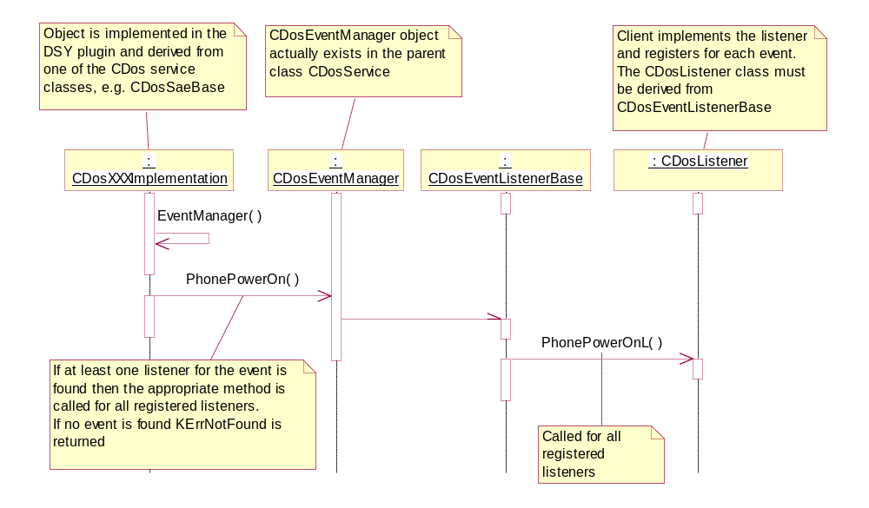
Figure 3.2 Sequence diagram for calling a plug-in event

Registering for an event
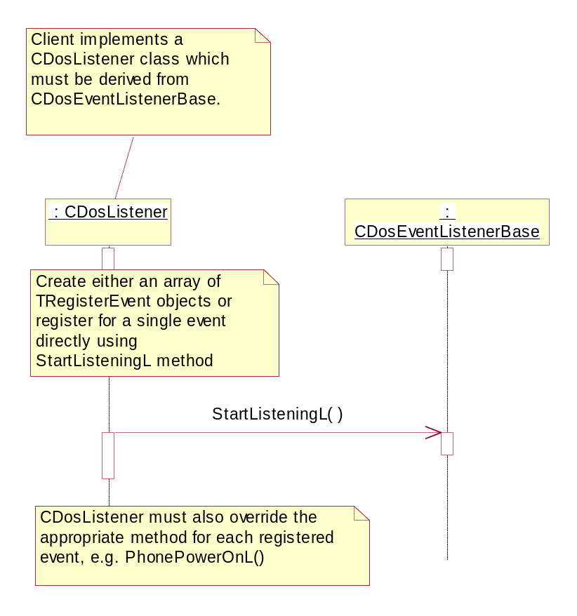
Figure 3.3 Sequence diagram for registering for an event

Detailed description

Events from the Domestic OS
Every service class (see class CDosXXXImplementation in Figure 3.1) derived from CDosService has a reference to the DOS Server’s event manager (the CDosEventManager class) and can be used to notify S60 Platform about events that occur in the Domestic OS side.
The customer needs to implement the code that calls the event manager methods when events occur in the Domestic OS side. The events that are supported by S60 Platform have been listed in this section.

Bluetooth related events
Bluetooth events in this section may only be used by bluetooth services.

TInt AbortVoiceRecognitionReq()
Description:
This event is sent when requesting to abort the currently ongoing voice recognition process in the phone.
Preconditions:
- Voice recognition is activated (see Section 3.5.1.1.11).
Post conditions:
The Symbian OS side client calls AbortVoiceRecognitionResp()(see reference document [1]) method through the DOS Server to send response to the request.
Example diagram(s):
- Same as in Section 3.5.1.1.11 (only method names are different).
Related event(s):
- TInt ActivateVoiceRecognitionReq()
Parameters:
- None.
Return values:

Value | Description
KErrNone | If successful.
KErrNotFound | No listeners for this event.
Other Symbian OS error code

TInt AccessoryModeChangedInd( TBTAccessoryMode aAccMode )
Description:
This event is sent when the accessory mode has been changed as a result of a BT accessory being connected.
Preconditions:
- BT accessory has been connected.
Post conditions:
- None.
Example diagram(s):
- None.
Related event(s):
- None.
Parameters:

Parameter | Description | Status
TBTAccessoryMode aAccMode | Declared in DosSvrServices.H API. | Supported
- EBTAudioAccessoryAttached | BT audio accessory has been attached to the device. | Supported
- EBTOtherMode |  | Supported
Return values:

Value | Description
KErrNone | If successful.
KErrNotFound | No listeners for this event.
Other Symbian OS error code

TInt AccessorySpeakerVolumeSetInd( TUint aVolume )
Description:
This event is sent when the accessory speaker volume has been set.
Preconditions:
- Volume has been modified.
Post conditions:
- None.
Example diagram(s):
- None.
Related event(s):
- None.
Parameters:

Parameter | Description | Status
TUInt aVolume | Any unsigned integer used to represent volume level. | Supported

Return values:

Value | Description
KErrNone | If successful.
KErrNotFound | No listeners for this event.
Other Symbian OS error code

TInt ActivateVoiceRecognitionReq()
Description:
This event is sent when requesting to activate voice recognition. The request to activate voice recognition is initiated by the Domestic OS side entity.
Preconditions:
- The Bluetooth Audio Accessory Controller subsystem is initialised. See reference document [2].
Post conditions:
- Symbian OS side client calls ActivateVoiceRecognitionResp()(see reference document [1]) method through DOS Server to send response of the request.
Example diagram(s):
- Same as in Section 3.5.1.1.11 (only method names are different).
Related event(s):
- TInt AbortVoiceRecognitionReq().
Parameters:
- None.
Return values:

Value | Description
KErrNone | If successful.
KErrNotFound | No listeners for this event.
Other Symbian OS error code

TInt AudioLinkCloseReq( THCIConnHandle aConnectionHandle )
Description:
This event is sent when requesting to close an audio link (that is, audio path) to BT Audio accessory.
Preconditions:
- An audio link to the BT Audio accessory exists. See reference document [2].
Post conditions:
- The Symbian OS side client calls AudioLinkCloseResp() (see reference document [1]) method through the DOS Server to send response of the request.
Example diagram(s):
- Same as in Section 3.5.1.1.11 (only method names are different).
Related event(s):
- TInt AudioLinkOpenReq()
Parameters:

Parameter | Description | Status
THCIConnHandle aConnectionHandle | Declared in bttypes.H. | Supported
- TUint16 | Identifier of the audio link to be closed. | Supported

Return values:

Value | Description
KErrNone | If successful.
KErrNotFound | No listeners for this event.
Other Symbian OS error code

TInt AudioLinkOpenReq()
Description:
This event is sent when requesting to open an audio link (that is, audio path) to BT Audio accessory. Link is needed, for example, when a call is created from the phone while BT HF is active and connected with the phone.
Preconditions:
- BT HF is active and connected with the phone.
Post conditions:
- The Symbian OS side client calls AudioLinkOpenResp() (see reference document [1]) method through the DOS Server to send response of the request.
Example diagram(s):
- Same as in Section 3.5.1.1.11 (only method names are different).
Related event(s):
- TInt AudioLinkCloseReq( THCIConnHandle aConnectionHandle )
Parameters:
- None.
Return values:

Value | Description
KErrNone | If successful.
KErrNotFound | No listeners for this event.
Other Symbian OS error code

TInt BTAccessoryModeChangedInd( TBTDeviceType aDeviceType )
Description:
This event is sent when the BT Audio accessory mode has been changed.
Preconditions:
- The Bluetooth Audio Accessory Controller subsystem is initialised (see reference document [2]).
Post conditions:
- None.
Example diagram(s):
- Almost the same as in Section 3.5.1.1.11 (only method names are different and there is no response).
Related event(s):
- None.
Parameters:

Parameter | Description | Status
TBTDeviceType aDeviceType | Declared in DOS API. | Supported
- EBTNoDevice | The currently connected BT Audio accessory is disconnected from the phone. (this is because the Domestic OS side entity has taken the BT Audio accessory out of use.) | Supported
- EBTUnknownDevice | Unknown device. | Supported
- EBTHeadset | Headset. | Supported
- EBTCarkit | Car kit. | Supported
- EBTHeadsetPropietary | Proprietary headset. | Supported
- EBTCarkitPropietary | Proprietary car kit. | Supported

Return values:

Value | Description
KErrNone | If successful.
KErrNotFound | No listeners for this event.
Other Symbian OS error code

TInt QueryLastDialledVoiceNumberReq()
Description:
This event is sent when the Domestic OS side entity requests the last dialled voice call number.
Preconditions:
- The user wants to initiate a call to the last dialled voice call number from the BT Audio accessory.
Post conditions:
- The Symbian OS side client calls QueryLastDialledVoiceNumberResp() (see reference document [1]) method through the DOS Server to send response to the request.
Example diagram(s):
- Same as in Section 3.5.1.1.11 (only method names are different).
Related event(s):
- None.
Parameters:
- None.
Return values:

Value | Description
KErrNone | If successful.
KErrNotFound | No listeners for this event.
Other Symbian OS error code

TInt QuerySpeedDialNumberReq( TInt aIndex )
Description:
This event is sent when the Domestic OS side entity requests the phone number attached to a specified Speed Dial index.
Preconditions:
- None.
Post conditions:
- The Symbian OS side client calls QuerySpeedDialNumberResp() (see reference document [1]) method through DOS Server to send response of the request.
Example diagram(s):
- Same as in Section 3.5.1.1.11 (only method names are different).
Related event(s):
- None.
Parameters:

Parameter | Description | Status
TInt aIndex | Specifies the Speed Dial index. The Phone number attached to that index is requested. | Supported

Return values:

Value | Description
KErrNone | If successful.
KErrNotFound | No listeners for this event.
Other Symbian OS error code

TInt ServiceLevelConnEstablishedInd( TBTServiceLevelConnParams aParam )
Description:
This event is sent to indicate about a change in BT connection status, that is, a service level connection is established.
Preconditions:
- A control connection between the phone and a BT audio accessory has been established.
Post conditions:
- If BT Audio Accessory device capabilities are not received, an Accessory Attach request (AttachAudioAccessoryReq() (see reference document [1]) is made using that information.
Example diagram(s):
- Same as in Section 3.5.1.1.11 (only method names are different).
Related event(s):
- None.
Parameters:

Parameter | Description | Status
TBTServiceLevelConnParams aParam | Declared in DOS API. | Supported
- TBool aParam.iSupportedFeaturesKnown | ETrue if BT Audio Accessory device has reported its capabilities.  EFalse if BT Audio Accessory device capabilities are not known. | Supported
- TUint32 aParam.iSupportedFeatures | Supported features as described in reference document [3]. | Supported

Return values:

Value | Description
KErrNone | If successful.
KErrNotFound | No listeners for this event.
Other Symbian OS error code

TInt VoiceRecognitionStatusReq()
Description:
The Domestic OS side entity requests information about the current voice recognition state of the phone from Symbian OS side entity.
Preconditions:
- The Bluetooth Audio Accessory Controller subsystem is initialised (see reference document [2]).
Post conditions:
- The Symbian OS side client calls VoiceRecognitionStatusResp() (see reference document [2]) method through DOS Server to send response of the request.
Example diagram(s):
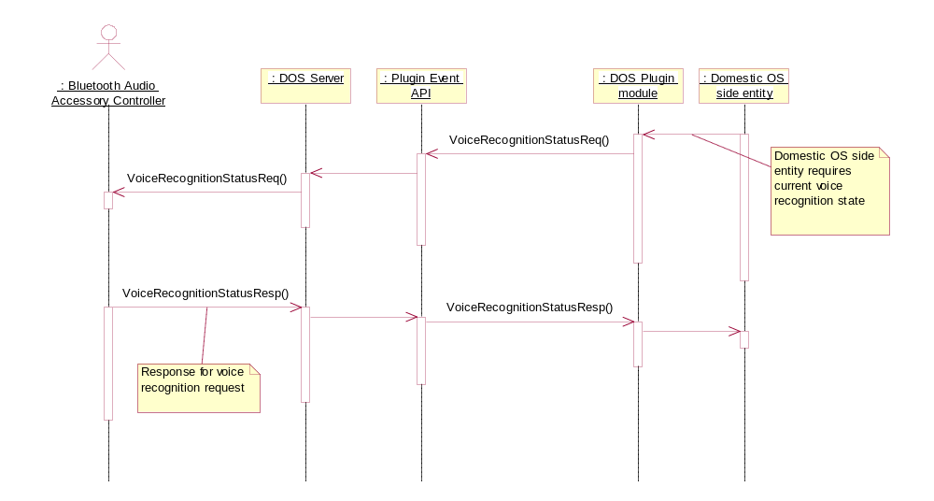
Related event(s):
- None.
Parameters:
- None.
Return values:

Value | Description
KErrNone | If successful.
KErrNotFound | No listeners for this event.
Other Symbian OS error code

Common events
Common events may be used by any service.

TInt AccessoryModeChangedL( TDosAccessoryMode aAccessoryState )
Description:
This event is sent when the audio accessory mode has been changed, that is, an audio accessory has been connected to the device.
Preconditions:
- Audio accessory has been attached to the device.
Post conditions:
- None.
Example diagram(s):
- Same as in Section 3.4.1 (only event method name differs).
Related event(s):
- None.
Parameters:

Parameter | Description | Status
TDosAccessoryMode aAccessoryState | Declared in DosSvrServices.h API. | Supported
- EDosAccNotConnected | No accessory connected. | Supported
- EDosAccUnsupportedConnected | Unsupported accessory connected. | Supported
- EDosAccModeHeadset | Wired headset connected. | Supported
- EDosAccModeLoopset | Loopset connected. | Supported
- EDosAccModeTty | TTY device connected. | Supported
- EDosAccModeCarKit | Wired car kit connected. | Supported
- EDosAccModeBtHeadset | BT headset connected. | Supported
- EDosAccModeBtCarKit | BT car kit connected. | Supported

Return values:

Value | Description
KErrNone | If successful.
KErrNotFound | No listeners for this event.
Other Symbian OS error code

TInt CallsForwardingStatus( EPSCallsForwardingStatus aStatus )
Description:
This event is sent to indicate a call forwarding status change.
Preconditions:
- System agent must be initialised.
- SIM server has sent call forwarding message from the Domestic OS.
Post conditions:
- System agent variable KUidCallsForwardingStatus is updated.
Example diagram(s):
- Same as in Section 3.4.1 (only event method name differs).
Related event(s):
- None.
Parameters:

Parameter | Description | Status
EPSCallsForwardingStatus aStatus | Declared in psvariables.h from SAE component. | Supported
- EPSForwardedOnLine1 | Calls are forwarded on line 1 (primary) only. | Supported
- EPSForwardedOnLine2 | Calls are forwarded on line 2 (alternate) only. | Supported
- EPSForwardedOnBothLines | Calls are forwarded on both lines. | Supported
- EPSNoCallsForwarded | No calls are forwarded. | Supported

Return values:

Value | Description
KErrNone | If successful.
KErrNotFound | No listeners for this event.
Other Symbian OS error code

TInt HandsfreeModeChanged( EPSHandsFreeMode aMode )
Description:
This event is sent to indicate about a change in the status of the handsfree mode.
Preconditions:
- The device’s IHF mode has been changed.
- Audio server has sent an event.
Post conditions:
- Audio is routed accordingly.
Example diagram(s):
- Same as in Section 3.4.1 (only event method name differs).
Related event(s):
- None.
Parameters:

Parameter | Description | Status
EPSHandsFreeMode aMode | Declared in psvariables.h from SAE component. | Supported
- EPSIhfOff | IHF is not active. | Supported
- EPSIhfOn | IHF is active. | Supported

Return values:

Value | Description
KErrNone | If successful.
KErrNotFound | No listeners for this event.
Other Symbian OS error code

TInt HeadsetButtonChanged( EPSButtonState aState )
Description:
This event is sent to indicate about a headset button state change.
Preconditions:
- Accessory server has sent headset button event.
Post conditions:
- None.
Example diagram(s):
- Same as in Section 3.4.1 (only event method name differs).
Related event(s):
- None.
Parameters:

Parameter | Description | Status
EPSButtonState aState | Declared in psvariables.h from SAE component. | Supported
- EPSButtonUp | Button has been released. | Supported
- EPSButtonDown | Button has been pressed down. | Supported
- EPSButtonDownLongPress | Button has been held down. | Supported

Return values:

Value | Description
KErrNone | If successful.
KErrNotFound | No listeners for this event.
Other Symbian OS error code

TInt NetworkBars( TInt aValue )
Description:
This event is sent when the network resource indication has changed. It notifies about a change in the network bars.
Preconditions:
- System agent must be initialised.
- Network server has sent an event.
Post conditions:
- System agent variables KUidNetworkBars, KUidNetworkStatus and KUidNetworkStrength are updated.
Example diagram(s):
- Same as in Section 3.4.1 (only event method name differs).
Related event(s):
- None.
Parameters:

Parameter | Description | Status
TInt aValue | Possible values of 0 to 7, 0 being representing no network coverage. | Supported

Return values:

Value | Description
KErrNone | If successful.
KErrNotFound | No listeners for this event.
Other Symbian OS error code

TInt OutputVolumeLevelChanged(TInt aLevel)
Description:
This event is sent to indicate about an output volume level change.
Preconditions:
- Audio server has sent an event.
Post conditions:
- None.
Example diagram(s):
- Same as in Section 3.4.1 (only event method name differs).
Related event(s):
- None.
Parameters:

Parameter | Description | Status
TInt aLevel | A valid integer representing volume level. | Supported

Return values:

Value | Description
KErrNone | If successful.
KErrNotFound | No listeners for this event.
Other Symbian OS error code

TInt PhonePowerOn()
Description:
The event is sent to notify that the power is on in the Domestic OS side after the Domestic OS has been started up.
Preconditions:
- System agent is being initialised.
Post conditions:
- System agent variable KUidPhonePwr is updated.
Example diagram(s):
- Same as in Section 3.4.1 (only event method name differs).
Related event(s):
- None.
Parameters:
- None.
Return values:

Value | Description
KErrNone | If successful.
KErrNotFound | No listeners for this event.
Other Symbian OS error code

TInt SmsStorageStatusChanged( TDosSmsStorageStatus aStatus )
Description:
This event is sent to indicate about a changed SMS storage status.
Preconditions:
- SMS server has sent an event, or SMS storage status has been requested.
Post conditions:
- None.
Example diagram(s):
- Same as in Section 3.4.1 (only event method name differs).
Related event(s):
- None.
Parameters:

Parameter | Description | Status
TDosSmsStorageStatus aStatus | Declared in DosSvrServices.h. | Supported
- ESmsStorageFull | Inbox storage is getting full or is already full. | Supported
- ESmsStorageAvailable | Inbox storage space has been freed. | Supported
- ESmsSimStorageFull | SIM storage is getting full or is already full. | Supported
- ESmsSimStorageAvailable | SIM storage space has been freed. | Supported

Return values:

Value | Description
KErrNone | If successful.
KErrNotFound | No listeners for this event.
Other Symbian OS error code

TInt VoiceMailStatus( EPSVoiceMailStatus aStatus )
Description:
This event is sent to indicate SIM voice message status at startup.
Preconditions:
- System Agent must be initialised.
- Voice mail status data has been set to SIM card.
- Indication is sent from the Domestic OS during startup when the Domestic OS SIM control is initialized.
Post conditions:
- System agent variable KUidVoiceMailStatus is updated.
Example diagram(s):
- Same as in Section 3.4.1 (only event method name differs).
Related event(s):
- None.
Parameters:

Parameter | Description | Status
EPSVoiceMailStatus aStatus | Declared in SAE API psvariables.h. | Supported
- EPSNoVoiceMails | No voice mails waiting. | Supported
- EPSWaiting | If ALS is not supported – voice mail waiting. | Supported
- EPSWaitingOnLine1 | Voice mail waiting on line 1. | Supported
- EPSWaitingOnLine2 | Voice mail waiting on line 2. | Supported
- EPSWaitingOnBothLines | Voice mail waiting on both lines. | Supported

Return values:

Value | Description
KErrNone | If successful.
KErrNotFound | No listeners for this event.
Other Symbian OS error code

SIM Security events
Events used by the SIM Security server.

TInt CurrentSimOwnedStatus( EPSCurrentSimOwnedSimStatus aStatus )
Description:
This event is sent when handling a security event indication. It notifies about a change in the status of the current SIM.
Preconditions:
- System agent must be initialised.
- Security server state is being checked.
Post conditions:
- System agent variable KUidCurrentSimOwnedSimStatus is updated.
Example diagram(s):
- Same as in Section 3.4.1 (only event method name differs).
Related event(s):
- TInt SimChanged( TBool aValue )
Parameters:

Parameter | Description | Status
EPSCurrentSimOwnedSimStatus aStatus | Declared in psvariables.h from SAE component. | Supported
- EPSCurrentSimOwned |  | Supported
- EPSCurrentSimNotOwned |  | Supported

Return values:

Value | Description
KErrNone | If successful.
KErrNotFound | No listeners for this event.
Other Symbian OS error code

TInt SecurityCode( EPSSecurityCodeStatus aStatus )
Description:
This event is sent when a security event indication has occurred. It notifies about a change in the status of the security code.
Preconditions:
- System agent must be initialised.
- SIM Security server is being initialized or has sent an event.
Post conditions:
- System agent variable KUidSecurityCodeStatus is updated.
Example diagram(s):
- Same as in Section 3.4.1 (only event method name differs).
Related event(s):
- None.
Parameters:

Parameter | Description | Status
EPSSecurityCodeStatus aStatus | Declared in psvariables.h from SAE component. | Supported
- EPSSecurityCodeNotRequired | Security code is not required by the Domestic OS. | Supported
- EPSSecurityCodeRequired | Security code is required by the Domestic OS. | Supported
- EPSSecurityCodeInitWait | Security server is being initialised. | Supported

Return values:

Value | Description
KErrNone | If successful.
KErrNotFound | No listeners for this event.
Other Symbian OS error code

TInt SimChanged( TBool aValue )
Description:
This event is sent when the SIM card indication changes and indicates if the IMSI on the card has changed or not.
Preconditions:
- System agent must be initialised.
- SIM Security server has sent an event.
Post conditions:
- System agent variable KUidSimChanged is updated.
Example diagram(s):
- Same as in Section 3.4.1 (only event method name differs).
Related event(s):
- TInt CurrentSimOwnedStatus( EPSCurrentSimOwnedSimStatus aStatus )
Parameters:

Parameter | Description | Status
TBool aValue | ETrue if SIM has been changed otherwise Efalse. | Supported

Return values:

Value | Description
KErrNone | If successful.
KErrNotFound | No listeners for this event.
Other Symbian OS error code

TInt SimLockStatus( EPSSimLockStatus aStatus )
Description:
This event is sent when the SIM card lock status changes.
Preconditions:
- System agent must be initialised.
- SIM Security server has sent a SIM lock message.
Post conditions:
- System agent variable KUidSimLockStatus is updated.
Example diagram(s):
- Same as in Section 3.4.1 (only event method name differs).
Related event(s):
- None.
Parameters:

Parameter | Description | Status
EPSSimLockStatus aStatus | Declared in psvariables.h from SAE component | Supported
- EPSSimLockActive | Lock is active. | Supported
- EPSSimLockRestrictionOn | Restriction on and SIM is locked. | Supported
- EPSSimLockRestrictionPending | Restriction pending, on startup, code query is shown. | Supported

Return values:

Value | Description
KErrNone | If successful.
KErrNotFound | No listeners for this event.
Other Symbian OS error code

TInt SimReady( EPSSimReadyStatus aStatus )
Description:
This event is sent when the SIM card is ready to be fully used. It notifies that the SIM card is ready for, for example, reading contacts information.
Preconditions:
- System agent must be initialised.
Post conditions:
- System agent variable KUidSimReadyStatus is updated.
Example diagram(s):
- Same as in Section 3.4.1 (only event method name differs).
Related event(s):
- None.
Parameters:

Parameter | Description | Status
EPSSimReadyStatus aStatus | Declared in psvariables.h from SAE component. | Supported
- EPSSimNotReady | SIM card is not ready to send contacts information. | Supported
- EPSSimReady | SIM card is ready to send contacts information. | Supported

Return values:

Value | Description
KErrNone | If successful.
KErrNotFound | No listeners for this event.
Other Symbian OS error code

TInt SimState( TDosSimState aState )
Description:
This event is sent when the SIM card state changes.
Preconditions:
- System agent must be initialised.
Post conditions:
- System agent variable KUidSimCStatus is updated and in some cases also KUidSIMStatus.
Example diagram(s):
- Same as in Section 3.4.1 (only event method name differs).
Related event(s):
- None.
Parameters:

Parameter | Description | Status
TDosSimState aState | Declared in DosSvrServices.H | Supported
- ESimStateInitWait | SIM server is being initialised. | Supported
- ESimStateLockOperative | All SIM locks are locked, phone cannot be used with this SIM (not allowed). | Supported
- ESimStatePinVerifyRequired | PIN or UPIN required. | Supported
- ESimStatePermanentlyBlocked | SIM card is permanently blocked. | Supported
- ESimStateRemoved | SIM is not connected. | Supported
- ESimStateRejected | SIM card is rejected. | Supported
- ESimStateBlocked | UPUK code required. | Supported
- ESimStateOk | SIM is OK. | Supported

Return values:

Value | Description
KErrNone | If successful.
KErrNotFound | No listeners for this event.
Other Symbian OS error code

Specialized events
These events are to be used only in specialized cases and should not be used by most services.

TInt DoMtcInitiatedShutdown()
Description:
This event is sent when the Domestic OS side has initiated a shutdown.
Preconditions:
- Device shutdown has been initiated.
Post conditions:
- All applications closed by system application.
- All resources freed by system application.
Example diagram(s):
- Same as in Section 3.4.1 (only event method name differs).
Related event(s):
- None.
Parameters:
- None.
Return values:

Value | Description
KErrNone | If successful.
KErrNotFound | No listeners for this event.
Other Symbian OS error code

TInt EmailMessage( TBool aValue )
Description:
This event is sent to indicate if an email message is waiting or not.
Preconditions:
- System agent must be initialised.
- SIM server has sent an email waiting event.
Post conditions:
- System agent variable KUidEmailMessageStatus is updated.
Example diagram(s):
- Same as in Section 3.4.1 (only event method name differs).
Related event(s):
- TInt FaxMessage( TBool aValue )
Parameters:

Parameter | Description | Status
TBool aValue | ETrue if email is waiting, EFalse otherwise. | Supported

Return values:

Value | Description
KErrNone | If successful.
KErrNotFound | No listeners for this event.
Other Symbian OS error code

TInt FaxMessage( TBool aValue )
Description:
This event is sent to indicate if a fax message is waiting or not.
Preconditions:
- System agent must be initialised.
- SIM server has sent a fax message waiting event.
Post conditions:
- System agent variable KUidFaxMessageStatus is updated.
Example diagram(s):
- Same as in Section 3.4.1 (only event method name differs).
Related event(s):
- TInt EmailMessage( TBool aValue )
Parameters:

Parameter | Description | Status
TBool aValue | ETrue if fax is waiting, EFalse otherwise. | Supported

Return values:

Value | Description
KErrNone | If successful.
KErrNotFound | No listeners for this event.
Other Symbian OS error code

TInt GeneralEvent( TInt32 aEvent,TAny* aParameter,TInt aParSize )
Description:
This method is for expanding the functionality of the listener interface where any new event ID can be provided.
Preconditions:
- Event ID must be unique. For other event IDs, see DosSvrServices.H definition of event names.
- Other conditions are event dependent.
Post conditions:
- Event dependent.
Example diagram(s):
- Same as in Section 3.4.1 (only event method name differs).
Related event(s):
- None.
Parameters:

Parameter | Description | Status
TInt32 aEvent | Unique event ID. | Supported
TAny* aParameter | Pointer to the parameters of the event. | Supported
TInt aParSize | Size of the parameters. | Supported
Return values:

Value | Description
KErrNone | If successful.
KErrNotFound | No listeners for this event.
Other Symbian OS error code

TInt NotifySelfTestStatus( TInt aSelfTestResult )
Description:
This event is sent when the Domestic OS self-test has been finished, usually as part of startup.
Preconditions:
- Self test has been carried out in the Domestic OS.
Post conditions:
- None.
Example diagram(s):
- Same as in Section 3.4.1 (only event method name differs).
Related event(s):
- None.
Parameters:

Parameter | Description | Status
TInt aSelfTestResult | Any self test result. | Supported

Return values:

Value | Description
KErrNone | If successful.
KErrNotFound | No listeners for this event.
Other Symbian OS error code

Index

Alphabetical list of events

AbortVoiceRecognitionReq 11, 14
AccessoryModeChangedInd 12
AccessoryModeChangedL 20
AccessorySpeakerVolumeSetInd 13
ActivateVoiceRecognitionReq 12, 13
AudioLinkCloseReq 14, 15
AudioLinkOpenReq 14, 15
BTAccessoryModeChangedInd 15
CallsForwardingStatus 20
CurrentSimOwnedStatus 27, 28
DoMtcInitiatedShutdown 31
EmailMessage 32, 33
FaxMessage 32
GeneralEvent 33
HandsfreeModeChanged 21
HeadsetButtonChanged 22
NetworkBars 23
NotifySelfTestStatus 34
OutputVolumeLevelChanged 23
PhonePowerOn 24
QueryLastDialledVoiceNumberReq 16
QuerySpeedDialNumberReq 17
SecurityCode 27
ServiceLevelConnEstablishedInd 18
SimChanged 27, 28
SimLockStatus 29
SimReady 30
SimState 30
SmsStorageStatusChanged 24
VoiceMailStatus 26
VoiceRecognitionStatusReq 18

