S60 5.0
Sensor Server Plug-in API
Specification Document

Team name | Author
TP SP SWD SSW Core Services FI | Kari Karvonen

Change history:

Version | Date | Status | Comments
3.0 | 19.12.2008 | Approved | Updated example resource and the list constants and enumerations.
2.0 | 27.08.2008 | Approved
1.0 | 20.03.2007 | Approved

Table of contents:

1. Document control 5
1.1 References 5
1.2 Documentation conventions 5
1.3 Abbreviations 5
1.4 Definitions 5
2. Purpose 7
2.1 List of the required interfaces 7
2.2 Constraints 7
3. Technical specification 8
3.1 Type of interface 8
3.2 Interface Class Structure 8
3.3 Usage 8
3.3.1 Protocol 8
3.3.1.1 Loading SSY 9
3.3.1.2 Opening a channel 9
3.3.1.3 Start and stop data listening 10
3.3.1.4 Closing a channel 11
3.3.1.5 Getting a property 12
3.3.1.6 Setting a property 12
3.3.1.7 Changing channel registration 13
3.3.1.8 Condition evaluation 13
3.3.2 Error handling 14
3.3.3 Memory overhead 14
3.3.4 Extensions to the API 15
3.4 Example 15
3.4.1 SSY plug-in 15
3.4.2 Event plug-in 15
3.4.3 Filter plug-in 15
3.5 Detailed description 15
3.5.1 CSensrvConditionEvaluator 15
3.5.1.1 EvaluateCondition() 15
3.5.1.2 CheckConditionValidity() 16
3.5.1.3 NewL() 16
3.5.2 CSsyControl 17
3.5.2.1 CloseChannelL() 17
3.5.2.2 NewL() 17
3.5.2.3 OpenChannelL() 18
3.5.3 MSsyCallback 18
3.5.3.1 BufferFilled() 18
3.5.3.2 ChannelClosed() 19
3.5.3.3 ChannelOpened() 19
3.5.3.4 PropertyChanged() 20
3.5.3.5 RegisterChannelsL() 20
3.5.4 MSsyChannelDataProvider 21
3.5.4.1 StartChannelDataL() 21
3.5.4.2 StopChannelDataL() 21
3.5.4.3 ForceBufferFilledL() 22
3.5.4.4 GetChannelDataProviderInterfaceL() 22
3.5.5 MSsyPropertyProvider 22
3.5.5.1 CheckPropertyDependenciesL() 22
3.5.5.2 GetAllPropertiesL() 23
3.5.5.3 GetPropertyL() 23
3.5.5.4 SetPropertyL() 24
3.5.5.5 GetChannelPropertyProviderInterfaceL() 25
3.5.6 Code architecture 25
4. Index 26
4.1 List of constants and enumerations 26
4.2 Alphabetical list of classes and methods 29
4.3 Data format of SSY ECom resource 29

Document control

References

- S60 Sensor Channel API Specification Document
- S60 Sensor Server Design Document
- S60 SSY Reference Design Document
- S60 Orientation Event Plug-in Design Document

Documentation conventions
Code is shown with the Courier New font.

Abbreviations

API | Application Programming Interface
DLL | Dynamic linking library
ECom | Epoc Component Object Model – Symbian provided mechanism for loading plug-in DLLs.
HW | Hardware
SSY | Sensor System plug-in module that provides data channels.

Definitions

Channel | An abstraction of a sensor. The data from one physical sensor may be mapped to several channels. For example, Sensor System handling an acceleration sensor may provide raw acceleration data on one channel and preprocessed tap events on another.
Channel condition | A value-operator pair targeting a single value inside a data item, indicated by an index. A condition is met when the channel data value comparison with the condition value using condition operator is true. The conditions are gathered in condition sets.  There are two condition types: single limit conditions and range conditions. Range conditions are actually made up from two separate conditions representing lower and upper limits of the range.
Channel condition set | A set of channel conditions. There are two types of condition sets, AND sets and OR sets. An AND set is only met by a data value if it meets all conditions in the set. For OR sets, meeting only one condition in the set is sufficient.
Condition Evaluator | Same as the filter plug-in.
Channel ID | Sensor Server assigns a channel ID to all channel information objects in the channel registration phase. SSY must use the channel IDs assigned by Sensor Server.
Data item | A discrete data package that contains sensor data or an event parsed from the sensor data and possibly some related values, such as timestamp. Each channel provides single type of data items only. A data item is typically a T-class.
Data item index | Data item index is an index pointing to an attribute inside a data item.
Data loss | The sensor data items that are lost while transferring them from the sensor hardware to the client software. Data loss at the SSY or the sensor driver level is not detected, but data loss at the Sensor Server level is. Data loss at the server level occurs when the clients do not handle data fast enough and the server buffer overflows.
Dynamic channel | A dynamic channel is a channel, availability of which is bound to a dynamic resource. A dynamic resource is a resource which may not always be available. Dynamic channel is not available, if the required resource is not available, even if the corresponding SSY is loaded.
Event plug-in | An event plug-in is a special case of the SSY plug-in, where the channels provided by it are based on the data received from another channel provided by some other SSY plug-in. For example some event plug-in may parse the raw data channel of the acceleration sensor and provide tapping events on its own channel. The event plug-ins uses the normal Sensor Client to get the channel data.
Filter plug-in | An ECom plug-in DLL loaded by Sensor Server and used to perform condition comparison with data items. A single plug-in can support multiple channel types.
Property | Properties are settable or just read-only configuration values of the sensors and channels. Changing a property affects all clients listening to the affected channel(s). There are three different types of properties:  - Sensor properties. These affect all channels which draw data from one physical sensor.  - Channel properties. These affect a single channel.  - Channel item properties. These affect a single value inside a channel data item. I.e. an attribute inside a data item. The data item index is used to specify which attribute is in question.
Sensor | A physical sensor. A single sensor can provide multiple channels, such as raw data channel and event channels, or multiple sensor readings can be incorporated into a single channel.
Sensor Services | An S60 service for handling client access to data channels provided by various SSY plug-ins.

Purpose
Sensor Server Plug-In API is an adaptation API defined by the Sensor services subsystem. The abstract API is realized by SSY (Sensor Subsystem plug-in module), which implements the adaptation layer between the HW driver and Sensor Server. The API definition is based on the standard ECom plug-in architecture applied to the needs of Sensor Subsystem. The event and filter plug-ins are special types of the Sensor Subsystem plug-ins. They are used to process data before it is sent to the client.

List of the required interfaces
SSY implements control and provider interfaces and uses the callback interface as a communication channel towards Sensor Server. The most relevant APIs and interfaces required from SSY:
- Sensor Channel Definitions API (sensrvutil.lib) to get data type definitions used in Sensor Server Plug-in API
- Sensor Channel API (sensrvclient.lib) for the event plug-in to be able to provide a new channel based on the data received from another channel.
- ssycontrol.h, the main control interface for the SSY plug-ins.
- ssycallback.h, the SSY plug-ins callback interface.
- ssychanneldataprovider.h, the channel data provider interface for the SSY plug-ins.
- ssypropertyprovider.h, the property provider interface for the SSY plug-ins.
- sensrvconditionevaluator.h, the control interface for the Condition Evaluator plug-ins.
- ECom (ecom.lib) is needed to use the ECom framework.

Constraints
Sensor Server Plug-in API is valid from S60 release 5.0 onwards.

Technical specification

Type of interface
Sensor Server Plug-in API is an ECom plug-in interface.

Interface Class Structure
The Sensor Server Plug-in API class structure is illustrated in Figure 3.1.
The SSY plug-in module implements the CSsyControl class which is a base class for the SSY plug-ins and implements the ECom interface. It is instantiated by Sensor Server to a thread dedicated to a SSY plug-in, i.e. each SSY plug-in runs in its own thread. The SSY plug-in module must also implement MSsyChannelDataProvider for channel data handling and MSsyPropertyProvider for property handling.
The filter plug-in module implements both the CSensrvConditionEvaluator class for the filter plug-ins and the ECom interface. It is instantiated by Sensor Server to the Sensor Server’s main thread i.e. all filter plug-ins run in same thread.
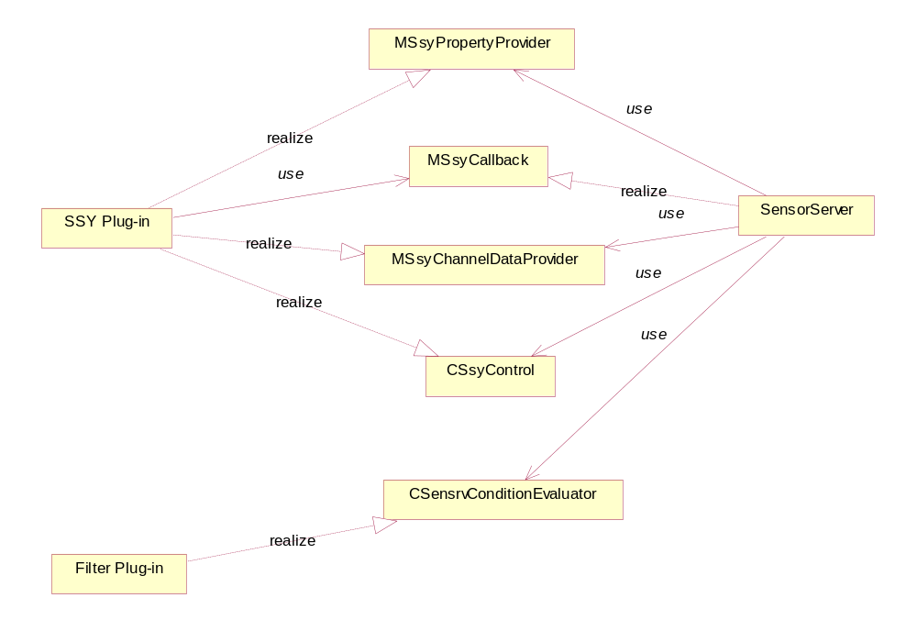
Figure 3.1 Sensor Server Plug-in API class structure

Usage

Protocol
SSY’s are loaded by Sensor Server during the Sensor Server construction. If there are no open channels for SSY it is unloaded eventually.

Loading SSY
SSY loading is illustrated in Figure 3.2. SSY must register all channels it provides with the RegisterChannelsL() methods during its construction. All channel information objects of the channels SSY provides must be added to the channel information list which is delivered to Sensor Server. Sensor Server assigns the channel ID to all channel information objects in the list. If a channel is an exact match to a previously registered channel, it is assigned the same channel ID as previously. After SSY is loaded it must be ready to process open channel request.
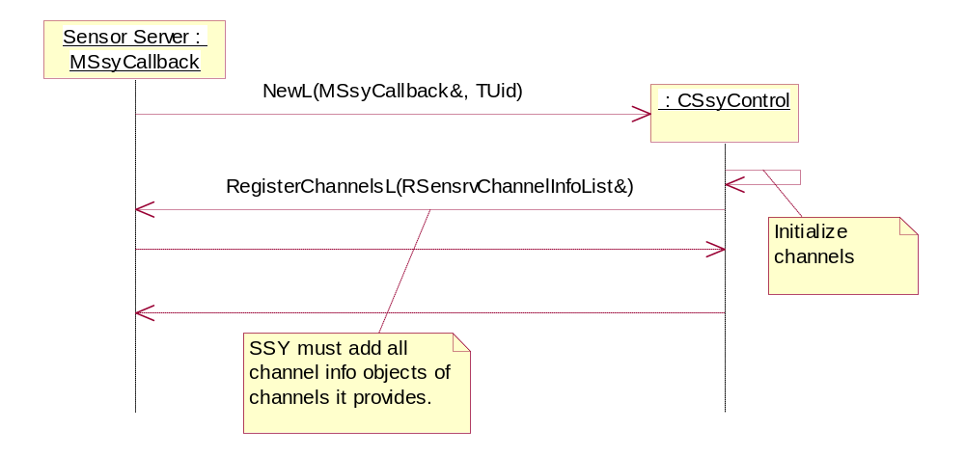
Figure 3.2 Loading SSY

Opening a channel
The channel opening sequence is illustrated in Figure 3.3.SSY must handle an open channel request asynchronously. ChannelOpened() is a response to the channel open request after SSY has done required initializations. A pointer to the channel data provider and channel property provider is passed to Sensor Server as a parameter. These providers must be created before the ChannelOpened()response is called.
After the channel opened response is sent to Sensor Server it requests the channel’s maximum data rate which in practice means that the value of the KSensrvPropIdDataRate property is got. After this the channel is opened and ready to process all channel related requests.
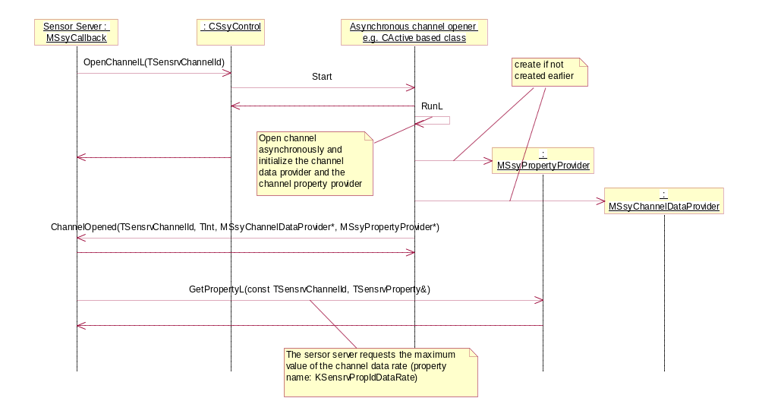
Figure 3.3 Channel opening sequence

Start and stop data listening
The data listening starting and stopping sequence is illustrated in Figure 3.4. Sensor Server starts data listening with the StartChannelDataL() method. Data listening must be started asynchronously. Sensor Server provides the required data item count and a pointer to the data buffer where channels data items must be written to one by one in the receiving order. Whenever the requested data amount is written to the data buffer, Sensor Server must be notified with the BufferFilled() method. A new data buffer pointer and data item count is delivered when the BufferFilled() method returns.
Sensor Server can request new data to be immediately notified by the ForceBufferFilledL() method. In that case, all data items currently in the SSY buffer must be written with the BufferFilled()method and data listening continues normally after that. The BufferFilled()method can also be called synchronously during the ForceBufferFilledL() operation.
When Sensor Server is no longer interested in the channel data, the data listening is stopped with the StopChannelDataL() method. After the data listening is stopped, no more BufferFilled()calls are allowed or the SSY thread panics.
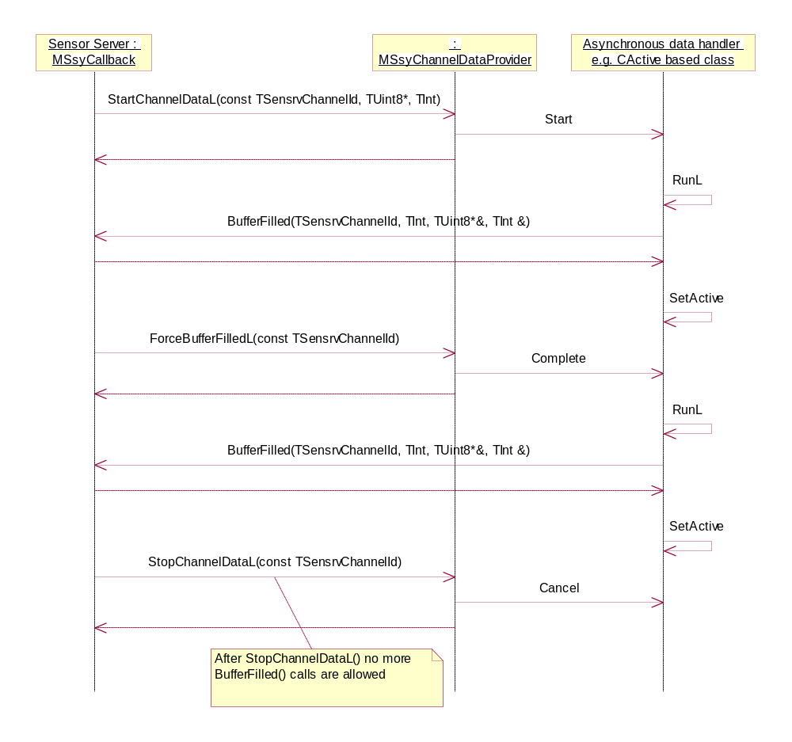
Figure 3.4 Starting and stopping data listening

Closing a channel
The channel closing sequence is illustrated in Figure 3.5.The CloseChannelL() request must be handled asynchronously and the response to it is sent with the ChannelClosed() method.
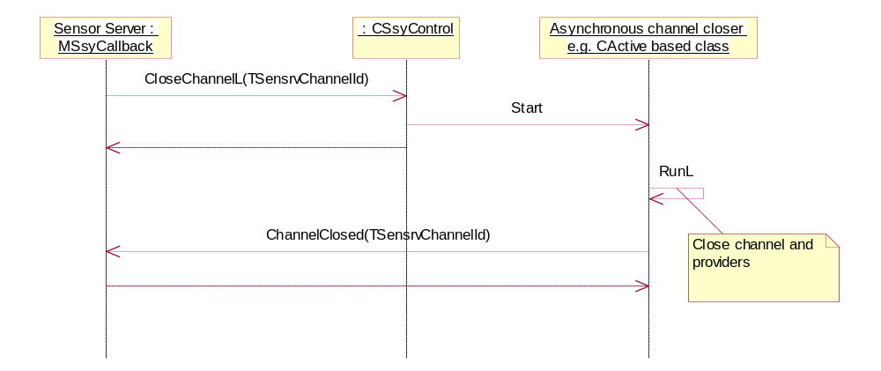
Figure 3.5 Closing a channel

Getting a property
Getting a property sequence is illustrated in Figure 3.6. Sensor Server can query the value of any property at any time after the channel has been opened. The properties are queried from the property provider that was provided when the channel opened response was called by SSY.
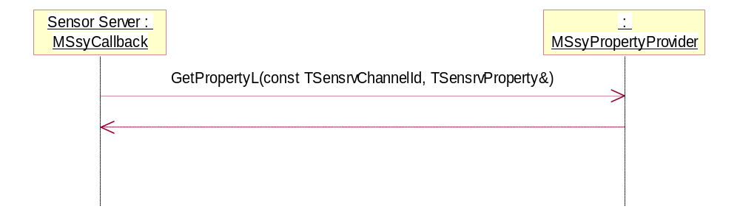
Figure 3.6 Getting a property

Setting a property
The setting a property sequence is illustrated in Figure 3.7. First Sensor Server checks if the property value to be set affects other sensor channels already open from this SSY. If the new property value is legal but affects somehow other channels properties, SSY must return the list of the affected channels so that Sensor Server can check if the client is allowed to set this property. Setting the property value is allowed for the client if there are no higher priority clients using the same channel. Client priorities are configured to Central Repository. If Sensor Server allows the property value to be changed it calls the SetPropertyL() method. SSY is responsible for checking that the property setting is legal, including property’s security check. SSY must handle the property setting asynchronously.
SSY notifies that a sensor property value has changed with the PropertyChanged() method and it has an effect to specific channels which are listed in the parameter. The channel ID linked to the property changes message is excluded from the affected channels list.
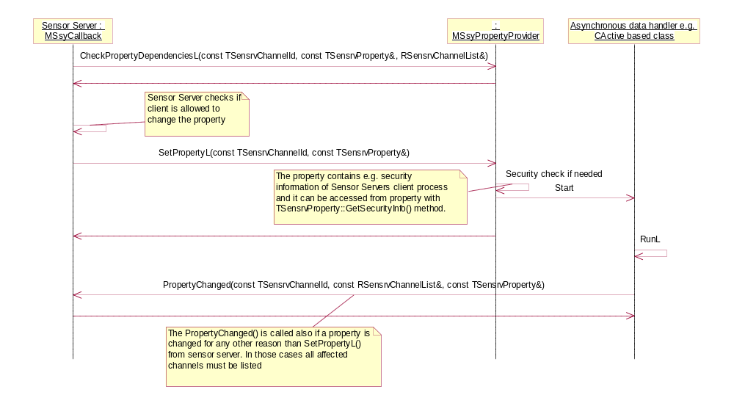
Figure 3.7 Setting a property

Changing channel registration
After the SSY construction channel registration information can be changed with the RegisterChannelsL() method, see Figure 3.8. All currently provided channels must be listed at each re-registration.
To be able to change channel registration there must be an open channel to SSY to prevent SSY unloading. In practice, this means that at least one channel from this SSY must have a client to keep the channel open and SSY loaded. If the SSY is unloaded while new channels become available it can not notify Sensor Server about new channels until some existing channel opening causes it to be reloaded.
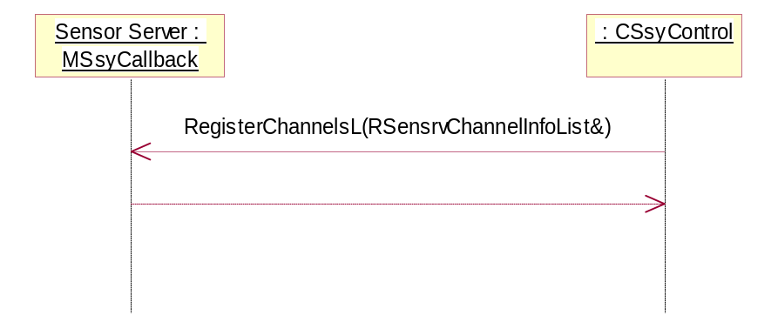
Figure 3.8 Changing channel registration

Condition evaluation
The filter plug-in is responsible for condition evaluation and it implements only the CSensrvConditionEvaluator abstract interface, see Figure 3.1. The filter plug-in uses a resource file to declare which channels it can evaluate. The resource file is a standard ECom resource file where the set of implementations and interfaces plug-in implements are listed. The channels that the filter plug-in can evaluate are listed in the default_data field. An example default_data field content is listed below.
// This plug-in handles the following channels:
// KSensrvChannelTypeIdAccelerometerXYZAxisData 0x1020507e
// KSensrvChannelTypeIdAccelerometerWakeupData 0x1020507f
// KSensrvChannelTypeIdAccelerometerDoubleTappingData 0x10205081
default_data = "0x1020507e||0x1020507f||0x10205081";
The condition evaluation sequence is illustrated in Figure 3.9. When a new condition is added to the channel by a client, the condition is validated using the CheckConditionValidity() method. Each data item from a channel that the filter plug-in is evaluating is passed to the filter plug-in with the EvaluateCondition() method. The filter plug-in is responsible to check the given condition against the given data item.
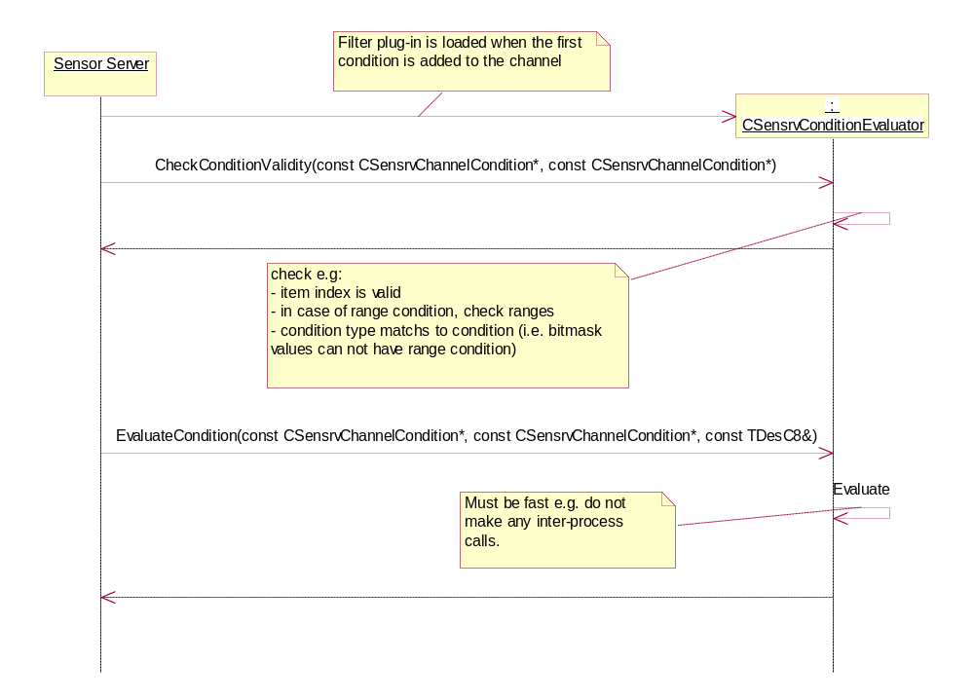
Figure 3.9 Condition evaluation

Error handling
If SSY panics during property, condition or data listening it is reloaded immediately. Otherwise SSY is reloaded when the channel is opened or listening is started.

Memory overhead
Memory consumption in the Sensor Server main thread depends on the sensor channel’s data item size and the maximum data rate of the provided channel. By default, the amount of the maximum buffered channel data items is the maximum data rate per second of the channel multiplied by the buffer size multiplier. The buffer size multiplier is Sensor Server’s configuration value, and by default it is six.

Extensions to the API
SSY can define new sensor channels and data types they provide. Also SSY can define new properties to present channel configuration in an appropriate way. To be able to use new channels SSY must provide the following information to the Sensor Server clients:
- The channel type ID (the channel type IDs defined by the S60 platform are declared in sensrvsensorchannels.h). The value of the channel type ID must be unique among the all channels. To guarantee uniqueness, the UID value can be used for channel ID. The UID values are assigned to the developers centrally by Symbian.
- The channel data type (the data types defined by the S60 platform are declared in sensrvchanneldatatypes.h). The value of the channel data type ID must be unique as well, and therefore Symbian UIDs can be used.
- Possible new properties (general properties defined by the S60 platform are declared in sensrvgeneralproperties.h and accelerometer specific properties are declared in sensrvaccelerometerproperties.h)

Example

SSY plug-in
For an example of an SSY plug-in, see reference document [3].

Event plug-in
For an example of an event plug-in, see reference document [4].

Filter plug-in
For an example of a filter plug-in, see sensrvcondeval.dll.

Detailed description
In this section, the classes and methods of Sensor Plug-in API are described in alphabetical order.

CSensrvConditionEvaluator
The Condition Evaluator class for the filter plug-ins. It provides mandatory ECom interface specific things in addition to condition evaluation services. Note that the Condition Evaluator plug-ins run in the Sensor Server main thread, so all method calls return promptly.

EvaluateCondition()
Checking the condition against the given data item. This is called possibly many times for each data item, so any processing done in this method must be kept at minimum. Note: Any conditions given in the parameters aCondition1 and aCondition2 are checked with the CheckConditionValidity() method before this method is called for the first time for those conditions, therefore no duplicate validity checking is necessary.
Operation:

virtual TBool EvaluateCondition(const CSensrvChannelCondition* aCondition1, const CSensrvChannelCondition* aCondition2, const TDesC8& aData) = 0;

Parameters:

Parameter | Description
const CSensrvChannelCondition* aCondition1 | The first condition to check the data item against. If the condition is a two-part condition, this contains the first part and the other part is given in aCondition2. This parameter is never NULL.
const CSensrvChannelCondition* aCondition2 | The second condition to check the data item against. Only used with two-part conditions, otherwise NULL.
const TDesC8& aData | The data item to be evaluated.

Return value:
If a match is found, ETrue is returned. Otherwise, EFalse is returned.

CheckConditionValidity()
Checks that the condition values and indexes are valid for a single or two-part condition. Both conditions have the same index.
Operation:

virtual TBool CheckConditionValidity( const CSensrvChannelCondition* aCondition1, const CSensrvChannelCondition* aCondition2 ) = 0;

Parameters:

Parameter | Description
const CSensrvChannelCondition* aCondition1 | The first condition to check. If the condition is a two-part condition, this contains the first part and the other part is given in aCondition2. This parameter is never NULL.
const CSensrvChannelCondition* aCondition2 | The second condition to check. Only used with two-part conditions, otherwise NULL.

Return value:
If the given condition is valid, ETrue is returned.

NewL()
Two-phase constructor.
Operation:

inline static CSensrvConditionEvaluator* NewL( TSensrvChannelInfo& aChannelInfo );

Parameters:

Parameter | Description
TSensrvChannelInfo& aChannelInfo | Determines the channel information of the channel that the loaded plug-in is needed for. The correct Condition Evaluator plug-in for each channel is found by matching for the channel type UID (full 0x00000000 format) in the default data field of the implementation information of the plug-in.

Return value:
A pointer to the created CSensrvConditionEvaluator object.

CSsyControl
The main control class for SSY. Controls the sensor basic functionality and provides the mandatory ECOM interface specific things.

CloseChannelL()
Requests to close a sensor channel asynchronously. The response to the request is delivered through MSsyCallback::ChannelClosed(). Multiple CloseChannel()requests can be active for different channels at the same time.
Operation:

virtual void CloseChannelL( TSensrvChannelId aChannelId ) = 0;

Parameters:

Parameter | Description
TSensrvChannelId aChannelId | The channel that is requested to be closed.

Return value:
Void.

NewL()
A two-phase constructor.
Operation:

inline static CSsyControl* NewL( MSsyCallback& aSsyCallback, TUid aImplementationUid );

Parameters:

Parameter | Description
MSsyCallback& aSsyCallback | A reference to the SSY callback instance.
TUid aImplementationUid | UID of the implementation to create.

Return value:
A pointer to the created CSsyControl object.

OpenChannelL()
Requests for SSY to open a sensor channel asynchronously. The response to the request is delivered through MSsyCallback::ChannelOpened(). Initializes SSY (and the sensor) to be ready for other control commands via data and property providers. Multiple OpenChannel() requests can be active for different channels at the same time.
Operation:

virtual void OpenChannelL( TSensrvChannelId aChannelId ) = 0;

Parameters:

Parameter | Description
TSensrvChannelId aChannelId | The channel that is requested to be opened.

Return value:
Void.

MSsyCallback
The base class for a callback instance. SSY communicates with Sensor Server through this interface.

BufferFilled()
SSY notifies Sensor Server that a write buffer is filled. SSY receives a new buffer and its size as a reference parameter.
Operation:
virtual void BufferFilled( TSensrvChannelId aChannelId, TInt aWriteCount, TUint8*& aNewBuffer, TInt &aNewCount ) = 0;
Parameters:

Parameter | Description
TSensrvChannelId aChannelId | Identifies the channel this notification is related to.
TInt aWriteCount | The number of objects written to the buffer. A negative number indicates a Symbian OS error code. If there is an error the channel is closed by Sensor Server, and the contents of the aNewBuffer and aNewCount return parameters are undefined.
TUint8*& aNewBuffer | A pointer to a new data buffer.
TInt &aNewCount | Indicates a new data buffer size as a count of the data objects.

Return value:
Void.

ChannelClosed()
A response to the channel closing request. SSY calls this function when the channel is closed after the channel closing request.
Operation:

virtual void ChannelClosed( TSensrvChannelId aChannelId ) = 0;

Parameters:

Parameter | Description
TSensrvChannelId aChannelId | The channel ID of the channel for which this response is delivered.

Return value:
Void.

ChannelOpened()
A response to the channel opening request. SSY calls this function when the SSY initiation is done after the channel opening request.
Operation:

virtual void ChannelOpened( TSensrvChannelId aChannelId, TInt aErrorCode, MSsyChannelDataProvider* aChannelDataProvider, MSsyPropertyProvider* aSensorPropertyProvider ) = 0;

Parameters:

Parameter | Description
TSensrvChannelId aChannelId | The channel ID of the channel for which this response is delivered.
TInt aErrorCode | A Symbian OS error code for the operation.
MSsyChannelDataProvider* aChannelDataProvider | A pointer to the channel data provider instance. Must be a non-NULL, unless there was an error.
MSsyPropertyProvider* aSensorPropertyProvider | A pointer to the sensor property provider instance. Must be non-NULL, unless there was an error.

Return value:
Void.

PropertyChanged()
SSY notifies that a sensor property value has changed and it has an effect on specific channels which are listed in the parameter.
Operation:

virtual void PropertyChanged( const TSensrvChannelId aChannelId, const RSensrvChannelList& aAffectedChannels, const TSensrvProperty& aProperty ) = 0;

Parameters:

Parameter | Description
const TSensrvChannelId aChannelId | The channel ID to be linked to this property changes message.
const RSensrvChannelList& aAffectedChannels | The channel IDs of the channels that are linked to the changed property. If the property change was initiated by Sensor Server using MSsyPropertyProvider::SetPropertyL, the channel linked to that property provider must not be added to this list. If this omission leaves the aAffectedChannels list empty, there is no need to call PropertyChanged at all.
const TSensrvProperty& aProperty | New values of the all changed properties.

Return value:
Void.

RegisterChannelsL()
Registers all channels implemented by SSY. Must initially be called during the CSsyControl construction or it cannot be ensured that the first clients find the channels provided by SSY.
This method must also be called after the CSsyControl construction, if the set of channels provided by SSY changes. All currently provided channels must be listed at each re-registration.
The registered channel info must match to the info given in the Ecom resource of SSY. If registered channel info is invalid, the method panics in debug build (SensorServer 23). In release build, the method leaves with KErrArgument and SSY is marked as bad and unloaded. See section 4.3 for ECom resource definitions.
Note: If this method is called multiple times in rapid succession, it is not guaranteed that the clients get notifications about all intermediate changes. However, it is guaranteed that the clients know the final registered set.
Operation:

virtual void RegisterChannelsL( RSensrvChannelInfoList& aChannelInfoList ) = 0;

Parameters:

Parameter | Description
RSensrvChannelInfoList& aChannelInfoList | A channel information list where SSY must add all channel information objects of the channels it provides. Sensor Server assigns the channel ID to all channel information objects in the list. If a channel is an exact match to a previously registered channel, it is assigned the same channel ID as previously. If the list is empty, this method leaves with KErrArgument, as SSY with no channels is not usable.

Return value:
Void.

MSsyChannelDataProvider
The channel data provider callback interface.

StartChannelDataL()
Starts the asynchronous data listening. Multiple StartChannelDataL() requests can be active for different channels at the same time.
Operation:

virtual void StartChannelDataL( const TSensrvChannelId aChannelId, TUint8* aBuffer, TInt aCount ) = 0;

Parameters:

Parameter | Description
const TSensrvChannelId aChannelId | The channel ID to be linked to this start channel data message.
TUint8* aBuffer | A pointer to a data buffer.
TInt aCount | Indicates the data buffer size as a count of the data objects.

Return value:
Void.

StopChannelDataL()
Stops the asynchronous data listening. The data buffer is not valid after call of this function.
Operation:

virtual void StopChannelDataL( const TSensrvChannelId aChannelId ) = 0;

Parameters:

Parameter | Description
const TSensrvChannelId aChannelId | The channel ID to be linked to this stop channel data message.

Return value:
Void.

ForceBufferFilledL()
Forces SSY to call BufferFilled() regardless of how many data items have been written to the buffer. Even if no data items have yet been written, BufferFilled() must be called.
Operation:

virtual void ForceBufferFilledL( const TSensrvChannelId aChannelId ) = 0;

Parameters:

Parameter | Description
const TSensrvChannelId aChannelId | The channel ID to be linked to this force buffer filled message.

Return value:
Void.

GetChannelDataProviderInterfaceL()
Gets extended channel data provider interface by identifier. This method allows the interface to be extended in the future without a break.
Operation:

virtual void GetChannelDataProviderInterfaceL( TUid aInterfaceUid, TAny*& aInterface ) = 0;

Parameters:

Parameter | Description
TUid aInterfaceUid | Identifier of the extended interface from the caller.
TAny*& aInterface | Pointer of the extended interface for the caller. Must be set to NULL if the requested extended interface is not supported.

Return value:
Void.

MSsyPropertyProvider
The channel property provider callback interface.

CheckPropertyDependenciesL()
Checks if the property value affects other sensor channels already open. If the new property value is legal but affects somehow other channels' properties, SSY must return a list of the affected channels so that Sensor Server can check if the client is allowed to set this property. If the SSY value is not legal SSY must leave with the KErrArgument value.
Operation:

virtual void CheckPropertyDependenciesL( const TSensrvChannelId aChannelId, const TSensrvProperty& aProperty, RSensrvChannelList& aAffectedChannels ) = 0;

Parameters:

Parameter | Description
const TSensrvChannelId aChannelId | The channel ID to be linked to this operation.
const TSensrvProperty& aProperty | The property to be checked.
RSensrvChannelList& aAffectedChannels | Returns a list of the channels which are affected if the property value is set.

Return value:
Void.

GetAllPropertiesL()
Get all channel properties. Returns all properties which are related to this channel.
Operation:

virtual void GetAllPropertiesL( const TSensrvChannelId aChannelId, RSensrvPropertyList& aChannelPropertyList ) = 0;

Parameters:

Parameter | Description
const TSensrvChannelId aChannelId | The channel ID to be linked to this get all properties operation.
RSensrvPropertyList& aChannelPropertyList | List of the all properties of the channel.

Return value:
Void.

GetPropertyL()
Gets the channel property value. The property parameter contains the channel ID and the item index. SSY fills values and attributes to the property object.
Operation:

virtual void GetPropertyL( const TSensrvChannelId aChannelId, TSensrvProperty& aProperty ) = 0;

Parameters:

Parameter | Description
const TSensrvChannelId aChannelId | The channel ID to be linked to the get property operation.
TSensrvProperty& aProperty | A reference to the property object to be filled with property values and attributes.

Return value:
Void.

SetPropertyL()
Sets a property for the channel. SSY is responsible for checking that the property setting is legal.
Operation:

virtual void SetPropertyL( const TSensrvChannelId aChannelId, const TSensrvProperty& aProperty ) = 0;

Parameters:

Parameter | Description
const TSensrvChannelId aChannelId | The channel ID to be linked to this set property operation.
const TSensrvProperty& aProperty | A reference to the property object to be set. iSecurityInfo of the property contains the client capabilities.

Return value:
Void.

GetChannelPropertyProviderInterfaceL()
Gets extended channel property provider interface by identifier. This method allows the interface to be extended in the future without a break.
Operation:

virtual void GetPropertyProviderInterfaceL ( TUid aInterfaceUid, TAny*& aInterface ) = 0;

Parameters:

Parameter | Description
TUid aInterfaceUid | Identifier of the extended interface from the caller.
TAny*& aInterface | Pointer of the extended interface for the caller. Must be set to NULL if the requested extended interface is not supported.

Return value:
Void.

Code architecture
SSY is an ECom plug-in module. It is loaded to the own thread created by Sensor Server. A filter plug-in is an ECom plug-in module as well and it is loaded to Sensor Server’s main thread. Both of these plug-ins can be installed to ROM during the image creation time or with the SIS package.

Index

List of constants and enumerations

//Types from sensrvresource.hrh
const TUid KSsyControlInterfaceUid = { 0x10205080 };
const TUid KSensrvConditionEvaluatorInterfaceUid = { 0x10205081 };

//General properties defined in sensrvgeneralproperties.h
const TSensrvPropertyId KSensrvPropIdDataRate = 0x00000002;
const TSensrvPropertyId KSensrvPropIdDataType = 0x00000003;
const TSensrvPropertyId KSensrvPropIdAvailability = 0x00000004;
const TSensrvPropertyId KSensrvPropIdMeasureRange = 0x00000005;
const TSensrvPropertyId KSensrvPropIdChannelDataFormat = 0x000000006;
const TSensrvPropertyId KSensrvPropIdScaledRange = 0x000000007;
const TSensrvPropertyId KSensrvPropIdChannelAccuracy = 0x000000008;
const TSensrvPropertyId KSensrvPropIdChannelScale = 0x000000009;
const TSensrvPropertyId KSensrvPropIdChannelUnit = 0x0000000010;
const TSensrvPropertyId KSensrvSensorModel = 0x0000000011;
const TSensrvPropertyId KSensrvSensorConnectionType = 0x0000000012;
const TSensrvPropertyId KSensrvSensorDescription = 0x0000000013;

//Types defined in sensrvtypes.h
const TSensrvChannelTypeId KSensrvChannelTypeIdUndefined = 0x00000000;

/**
* The quantity of channel values. Defines the quantity the channel is measuring.
*
* Possible values:
* - ESensrvQuantityNotUsed, Channel doesn't provide this information.
* - ESensrvQuantityNotdefined quantity is not defined.
* - ESensrvQuantityAcceleration Channel measures acceleration
* - ESensrvQueantityTapping Channel measures tapping events
* - ESensrvQuantityOrientation Channel measures phone orientation
* - ESensrvQuantityRotation Channel measures phone rotation
* - ESensrvQuantityMagnetic
* - ESensrvQuantityAngle
* - ESensrvQuantityLicenseeBase, start of licensee quantity range.
* - ESensrvQuantityLicenseeEnd, end of licensee quantity range.
*
*/
enum TSensrvQuantity
{
ESensrvQuantityNotUsed = -1,
ESensrvQuantityNotdefined = 0,
ESensrvQuantityAcceleration = 10,
ESensrvQuantityTapping = 11,
ESensrvQuantityOrientation = 12,
ESensrvQuantityRotation = 13,
ESensrvQuantityMagnetic = 14,
ESensrvQuantityAngle = 15,
ESensrvQuantityProximity = 16,
ESensrvQuantityLicenseeBase = 8192,
ESensrvQuantityLicenseeEnd = 12287
};

/**
* The context type of sensor.
*
* Possible values:
* - ESensrvContextTypeNotUsed, Channel doesn't provide this information.
* - ESensrvContextTypeNotdefined, Context type is not defined
* - ESensrvContextTypeAmbient for category contains sensors measuring some generic,
* common features of the environment such as pressure or temperature of the air,
* sound intensity, or state of the weather.
* - ESensrvContextTypeDevice for sensors, which are producing information of the device itself.
* - ESensrvContextTypeUser for sensors which are measuring user initiated stimulus (gesture),
* or characteristics/properties of the user (body temperature, mass, heart rate).
* - ESensrvContextTypeLicenseeBase, start of licensee context type range.
* - ESensrvContextTypeLicenseeEnd, end of licensee context type range.
*
*/
enum TSensrvContextType
{
ESensrvContextTypeNotUsed = -1,
ESensrvContextTypeNotDefined = 0,
ESensrvContextTypeAmbient = 1,
ESensrvContextTypeDevice = 2,
ESensrvContextTypeUser = 3,
ESensrvContextTypeLicenseeBase = 8192,
ESensrvContextTypeLicenseeEnd = 12287
};

/**
* The connection type of sensor.
*
* Possible values:
* - ESensrvConnectionTypeNotDefined, Connection type is not defined
* - ESensrvConnectionTypeEmbedded, Sensor is embedded in Handset
* - ESensrvConnectionTypeRemote for sensors in remote location
* - ESensrvConnectionTypeWired for sensors which are attached to handset with wire
* - ESensrvConnectionTypeWireless for sensors which are attached to handset wireless
* - ESensrvConnectionTypeLicenseeBase, start of licensee connection type range.
* - ESensrvConnectionTypeLicenseeEnd, end of licensee connection type range.
*
*/
enum TSensrvConnectionType
{
ESensrvConnectionTypeNotDefined = 0,
ESensrvConnectionTypeEmbedded,
ESensrvConnectionTypeRemote,
ESensrvConnectionTypeWired,
ESensrvConnectionTypeWireless,
ESensrvConnectionTypeLicenseeBase = 8192,
ESensrvConnectionTypeLicenseeEnd = 12287
};

/**
* The TSensrvChannelUnit represents the unit of the measured data values.
*
* Possible values:
* - ESensrvChannelUnitNotDefined, Unit is not defined
* - ESensevChannelUnitAcceleration, Acceleration, meter per square second (m/s^2)
* - ESensrvChannelUnitGravityConstant, Acceleration, gravitational constant (G)
* - ESensrvChannelUnitLicenseeBase, start of licensee channel unit range.
* - ESensrvChannelUnitLicenseeEnd, end of licensee channel unit range.
*
*/
enum TSensrvChannelUnit
{
ESensrvChannelUnitNotDefined = 0,
ESensevChannelUnitAcceleration = 10,
ESensrvChannelUnitGravityConstant = 11,
ESensrvChannelUnitLicenseeBase = 8192,
ESensrvChannelUnitLicenseeEnd = 12287
};

/**
The format of the data measured by the sensor channel
Licensee defined values must be between ESensrvChannelDataFormatLicenseeBase and
ESensrvChannelDataFormatLicenseeEnd

@code
Scaled format example:
Measure range for the accelerometer, KSensrvPropIdMeasureRange: -2g to 2g.
KSensrvPropIdScaledRange defines following values:
Range: Min: -127 Max: 127

Example values for the data item and their absolute values:
Data item: -64 = > -64/127 * 2g = -1.01g
Data item: 32 = > 32/127 * 2g = 0.51g
Data item: 127 = > 127/127 * 2g = 2g
@endcode

@see KSensrvPropIdChannelDataFormat
*/
enum TSensrvChannelDataFormat
{
ESensrvChannelDataFormatNotDefined = 0,
ESensrvChannelDataFormatAbsolute,
ESensrvChannelDataFormatScaled,
ESensrvChannelDataFormatLicenseeBase = 8192,
ESensrvChannelDataFormatLicenseeEnd = 12287
};

/**
* The TSensrvErrorSeverity represents sensor server error code which can occur in
* sensor listeners.
*
* Possible values:
* - ESensrvErrorCodeMinor, some async request(s) failed. If this is not followed
* by ESensrvFatal, it means listening has been successfully continued.
* - ESensrvErrorCodeFatal, fatal error, server internal state regarding this channel might
* be corrupted. The channel was closed and sensor server session terminated.
*/

enum TSensrvErrorSeverity
{
ESensrvErrorSeverityNotDefined = 0,
ESensrvErrorCodeMinor,
ESensrvErrorSeverityFatal
};

/**
* The type of channel change detected.
*
* Possible values:
* - ESensrvChannelChangeTypeNotDefined, a channel not defined
* - ESensrvChannelChangeTypeRemoved, a channel was removed
* - ESensrvChannelChangeTypeAdded, a new channel was added enum
*/
TSensrvChannelChangeType
{
ESensrvChannelChangeTypeNotDefined = 0,
ESensrvChannelChangeTypeRemoved,
ESensrvChannelChangeTypeAdded
};

//Types defined in sensrvresourcechannelinfo.h

/**
* Channel group.
*/
enum TSensrvChannelGroup
{
ESensrvChannelGroupNotSolved = -1, ///< Channel group is not solved yet
ESensrvChannelGroupNotDefined, ///< Channel does not belong to any group
ESensrvChannelGroupData, ///< Channel belongs to group of data channels
ESensrvChannelGroupEvent, ///< Channel belongs to group of event channels
ESensrvChannelGroupState ///< Channel belongs to group of state channels
};

Alphabetical list of classes and methods
Section 3.5 lists the classes and methods in alphabetical order.

Data format of SSY ECom resource
Following channel info data format is used in ‘default_data’ and ‘opaque_data’ fields of ECom resource. Channel data items are defined in a row if SSY provides multiple channels. The data can be split between ‘default_data’ and ‘opaque_data’ at any point. The maximum size for combined ‘default_data’ and ‘opaque_data’ is 1024 bytes.

Item name | Type | Bytes | Mandatory/Optional
Channel info version | TUint8 | 1 | Mandatory - this being version 1
Channel info length | TUint8 | 1 | Mandatory – includes ‘Channel info version’ and ‘Channel info length’
Flags:  B0 = Dynamic channel,  B1 = Location present,  B2 = Vendor ID present,  B3 = Channel security policy present,  B4-B5 = Channel group,  B6-B7 reserved. | TUint8 | 1 | Mandatory
Channel type | TInt32 | 4 | Mandatory
Context type | TInt32 | 4 | Mandatory
Quantity | TInt32 | 4 | Mandatory
Location | length – TUint8 | 1 | Mandatory for static channels  Optional for dynamic channels. If not provided encode as empty string. If used for dynamic channel, informed by ‘Flags’.
Location | string - max length 16 chars (TUInt8) | 0-16
Vendor ID | length – TUint8 | 1 | Mandatory for static channels  Optional for dynamic channels. If not provided encode as empty string. If used for dynamic channel, informed by ‘Flags’.
Vendor ID | string - max length 16 chars (TUint8) | 0-16
Channel data type ID | TInt32 | 4 | Mandatory
Channel security policy | size of TSecurityPolicy | 8 | Optional – if not provided encode as ETypePass. If used, informed by ‘Flags’.

Example of SSY ECom resource definition:
#include <sensrvresource.hrh>
#include <ecom/registryinfov2.rh>

RESOURCE REGISTRY_INFO theInfo
{
resource_format_version = RESOURCE_FORMAT_VERSION_2;
dll_uid = <DLL uid>;
interfaces =
{
INTERFACE_INFO
{
instantiation_interface_uid = KSsyControlInterfaceUid;
implementations =
{
BINARY_IMPLEMENTATION_INFO
{
implementation_uid = <SSY uid>;
version_no = <SSY version>;
display_name = <SSY display name>;
default_data = {<byte0>, <byte1>, <byte2>...};
opaque_data = {<byte3>, <byte4>, <byte5>...};
rom_only = <bool>;
},
};
},
};
}

Example of channel info definition in ‘default_data’ field:
Channel info version = 0x01
Length of channel info (including this) = 39 bytes
Flags:
Dynamic = false
Location present = true
Vendor ID present = true
Channel security policy present = true
Channel group = ESensrvChannelGroupData
Channel type = 0x1020507F
Context type = ESensrvContextDevice
Quantity = ESensrvQuantityAcceleration
Location = “Ext”
VendorId = “Symbian”
Channel data type id = 0x1020507F
Channel security policy:
type = ETypeS3 (Secure ID and up to 3 capabilities)
cap1 = ECapabilityReadDeviceData
cap2 = ECapabilityWriteDeviceData
cap3 = not set
SID = 0x12345678

default_data =
{
0x01, // Channel info version
0x27, // Channel info length
0x1E, // Flags
0x7F, 0x50, 0x20, 0x10, // Channel type
0x02, 0x00, 0x00, 0x00, // Context type
0x0A, 0x00, 0x00, 0x00, // Quantity
0x03, 0x45, 0x78, 0x74, // Location
0x07, 0x53, 0x79, 0x6D, 0x62, 0x69, 0x61, 0x6E, // Vendor ID
0x7F, 0x50, 0x20, 0x10, // Channel data type ID
0x04, 0x04, 0x05, 0xFF, 0x78, 0x56, 0x34, 0x12 // Channel security policy
};

