S60 3.0
Shared Data
API Specification Document

Team name | Author
S60/CorePlatform/BaseServices/SystemSW/System | Tiia Lahtonen

Change history:

Version | Date | Status | Comments
5.0 | 08.11.2005 | Approved | Editorial changes
4.0 | 18.03.2005 | Approved | Changes:  - Editorial changes  - Release validity updated  - Whole document updated to match release 3.0
3.0 | 18.06.2004 | Approved | Changes:  - Editorial changes  - Front page: Corrected team name  - 1.1: Added references  - 2: Plug-in mentioned  - 2:1: Figure updated  - 3.3.1.3, 3.5.7.5, 3.5.7.22: Plug-in notes added
2.0 | 17.05.2004 | Approved | Editorial changes
1.0 | 05.06.2003 | Approved

Table of contents:

1. Document control 4
1.1 Documentation conventions 4
1.2 Abbreviations 4
2. Purpose 5
2.1 List of required interfaces 5
2.2 Product platform and/or Symbian OS version constraints 5
3. Technical specification 6
3.1 Type of interface 6
3.2 Interface class structure 6
3.3 Usage 6
3.3.1 Protocol 6
3.3.1.1 Connecting to server 6
3.3.1.2 Closing connection 6
3.3.2 Reserve file support 7
3.3.3 Error handling 7
3.3.4 Extensions to the API 7
3.4 Example 7
3.5 Detailed description 8
3.5.1 RSharedDataClient 8
3.5.1.1 RSharedDataClient() 8
3.5.1.2 TInt Connect( TInt aPriority = CActive::EPriorityStandard ) 8
3.5.1.3 Void Close() 8
3.5.1.4 Void RequestFreeDiskSpaceLC( const TInt aAmount ) const 8
3.5.1.5 Void RequestFreeDiskSpace( const TInt aAmount ) const 9
3.5.1.6 Void CancelFreeDiskSpaceRequest() const 9
3.5.2 Code architecture 9
4. Index 10
4.1 List of constants and enums 10
4.2 Alphabetical list of classes and methods 10

Document control

Documentation conventions
Code samples and class names are written in the Courier New font.

Abbreviations
API | Application Programming Interface
OS | Operating System

Purpose
The Shared Data subsystem is part of S60 common components (Common Engine package) and it offers reserve file support functionality. The reason for this functionality is to support transaction-based delete operations to succeed in a full disk situation.

List of required interfaces
This subsystem uses in its implementation the Symbian Client/Server framework, Active Objects and File Access Protocol.
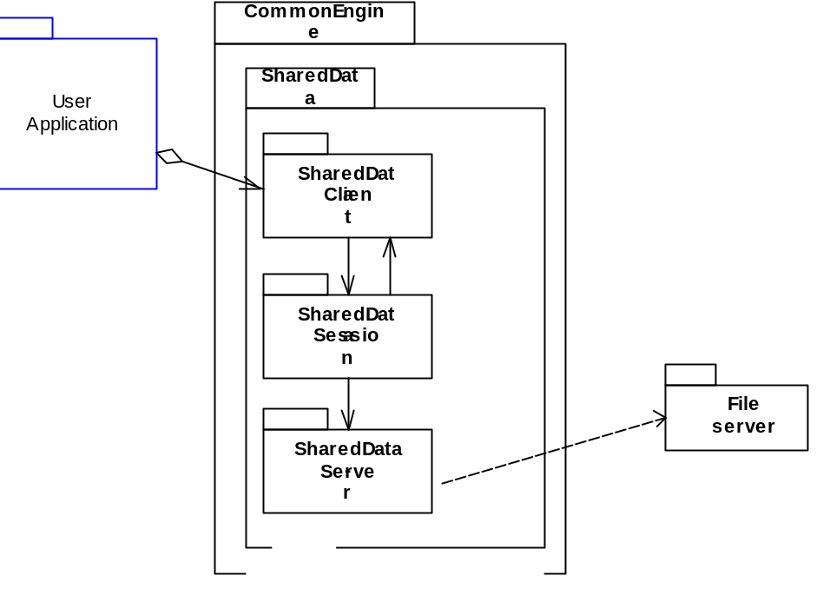
Figure 2.1 Shared Data environment

Product platform and/or Symbian OS version constraints
No known constraints.

Technical specification

Type of interface
- Server Client API.

The service offered by the Shared Data server is accessed through the client API (RSharedDataClient).

Interface class structure
The RSharedDataClient class offers an interface for the client to connect to the Shared Data server and use its services.
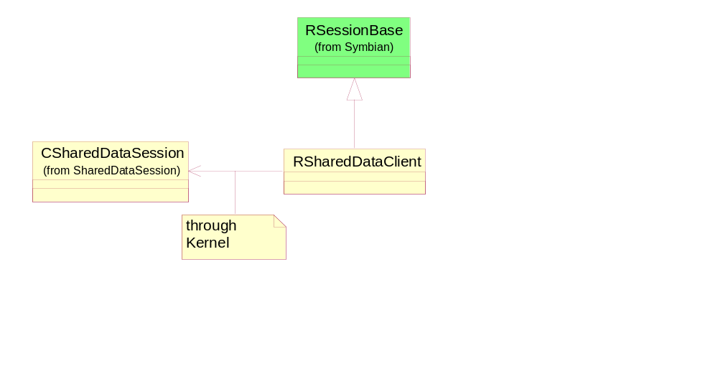
Figure 3.2 Client side class diagram of the SharedData subsystem

Usage

Protocol
In the following it is explained how the Shared Data services are accessed through the RSharedDataClient. More detailed information about the functions of the interface can be found in Section 3.5 and some example code in Section 3.4. Error handling is described in Section 3.3.3.

Connecting to server
A new session to the server is created using the Connect()method.

Closing connection
The connection to a server must be closed using the Close()method.

Reserve file support
The reason for this functionality is to support transaction-based delete operations to succeed in a full disk situation. This is the case for example when deleting data from Symbian OS StreamStores.
The Shared Data server checks if the free disk space is below the given minimum threshold. If it is so, the Shared Data server reduces the size of a reserve file to free up some disk space. No overhead is caused if there is enough free disk space already. Thus, unless the reserve file is somehow exhausted, the free disk space is guaranteed to be above the given parameter after this call. Of course, the parameter is limited to the maximum size of the reserve file that is about 64 kB.
There are two correct usage patterns represented below, one for synchronous delete operations and the other for asynchronous ones.
Note: when the Shared Data connection is closed, the server always assumes that the corresponding client no longer requires the reserve space.
See Section 3.4 for usage patterns for synchronous and asynchronous delete operations.

Error handling
Standard Symbian error codes are used throughout the component. Error handling for each individual operation in the interface is described in Section 3.5.

Extensions to the API
None.

Example
The following presents a code snippet describing an implementation for the simple connect/close sequence explained in sections 3.3.1.1 - 3.3.1.2.
#include <SharedDataClient.h> // link against CommonEngine.lib
const TUid uid = {0x0100ffff};
RSharedDataClient sd;
TBuf<25> buffer;
// Connecting and initialization:
sd.Connect();
// Closing connection:
sd.Close();

Sequence for synchronous delete operation (explained in Section 3.3.2):
// iSharedDataClient is connected to the server here.

iSharedDataClient.RequestFreeDiskSpaceLC( KDiskSpaceNeededForDelete );

// Do the delete operation here, the code may leave.

// Do NOT close the SharedData connection here nor delete the
// RSharedDataClient object.

CleanupStack::PopAndDestroy(); // cancels free disk space request

Sequence for asynchronous delete operation (explained in Section 3.3.2):
// iSharedDataClient is connected to the server here.

iSharedDataClient.RequestFreeDiskSpace( KDiskSpaceNeededForDelete );

// Start the asynchronous delete operation here

// Do NOT close the SharedData connection here nor delete the
// RSharedDataClient object.

// When the asynchronous request has completed:

iSharedDataClient.CancelFreeDiskSpaceRequest();

Detailed description
All public interfaces of the subsystem are described here in more detail.

RSharedDataClient
Applications use the subsystem via the RSharedDataClient class. First, they need to connect to the server by calling the Connect() member function. (The server is launched if this is the first client using it.). When Shared Data connection is not needed anymore, call Close() to end the session.

RSharedDataClient()
Constructor.

TInt Connect( TInt aPriority = CActive::EPriorityStandard )
This starts the server if it is not already running. It creates a new session. It does nothing if the session is already established by the client.
Parameters:
Type | Name | Description
TInt | aPriority | Priority for the active object handling notify events. Note: This has no effect in 3.0.
Return value:
Standard Symbian OS error code.

Void Close()
This closes the session. Remember to call this to a connected session in some point.

Void RequestFreeDiskSpaceLC( const TInt aAmount ) const
This is full disk support for synchronous and transactional delete operations. If needed, it frees up disk space so that it will be above the given minimum threshold.
Use CleanupStack::PopAndDestroy() to cancel the request after delete operation. This method can leave only if CleanupStack::PushL() leaves.
Parameters:
Type | Name | Description
const TInt | aAmount | Requested minimum amount of free disk space in bytes. The maximum size of the reserve file is approximately 64kB so there is no use to request higher amounts.

Void RequestFreeDiskSpace( const TInt aAmount ) const
This is full disk support for asynchronous and transactional delete operations. If needed, it frees up disk space so that it will be above the given minimum threshold.
The user is responsible for calling CancelFreeDiskSpaceRequest() after the asynchronous delete operation has been finished.
Parameters:
Type | Name | Description
const TInt | aAmount | Requested minimum amount of free disk space in bytes. The maximum size of the reserve file will be approximately 64kB so there is no use to request higher amounts.

Void CancelFreeDiskSpaceRequest() const
This cancels the request made by calling RequestFreeDiskSpace(). In case of RequestFreeDiskSpaceLC(), CleanupStack handles calling this function.

Code architecture
The client interface for the Shared Data server can be accessed through RSharedDataClient interface class that is defined in header ShareDataClient.H. The actual component is linked to COMMONENGINE.DLL library.

Index

List of constants and enums
None.

Alphabetical list of classes and methods
- RSharedDataClient
- RSharedDataClient()
- void CancelFreeDiskSpaceRequest() const
- void Close()
- TInt Connect( TInt aPriority = CActive::EPriorityStandard )
- void RequestFreeDiskSpace( const TInt aAmount ) const
- void RequestFreeDiskSpaceLC( const TInt aAmount ) const

