S60 3.1
System Language Util API
Specification Document

Team name | Author
TP/AP/SP/SPD/SIF | Laura Rissanen

Change history:

Version | Date | Status | Comments
3.0 | 15.02.2006 | Approved | Updated for 3.1
2.0 | 08.11.2005 | Approved | Changed to new template
1.0 | 31.08.2004 | Approved
Table of contents:

1. Document control 4
1.1 References 4
1.2 Documentation conventions 4
1.3 Abbreviations 4
2. Purpose 5
2.1 List of required interfaces 5
3. Technical specification 6
3.1 Type of interface 6
3.2 Interface Class Structure 6
3.3 Usage 6
3.3.1 Protocol 6
3.3.2 Error handling 6
3.3.3 Extensions to the API 6
3.4 Example 6
3.5 Detailed description 7
3.5.1 SysLangUtil 7
3.5.1.1 GetAutoLanguageState() 7
3.5.1.2 GetEpocLanguage() 7
3.5.1.3 IsValidLanguage() 8
3.5.1.4 GetDefaultLanguage() 8
3.5.1.5 GetInstalledLanguages() 8
3.5.1.6 RestoreSIMLanguage() 8
3.5.1.7 StoreSIMLanguage() 9
3.5.2 Code architecture 9
4. Index 10
4.1 Alphabetical list of classes and methods 10

Document control

References

- System Utils API Specification Document
- GSM 03.38 Specification | http://www.etsi.org/

Documentation conventions
Code samples and class names are written in Courier New font.

Abbreviations

API | Application Programming Interface
OS | Operating System

Purpose
This document describes the functionality of the System Language Util interface, which is part of the System Utils component (see reference document [1]). SysLangUtil provides the interface for reading and writing language specific information. This API is meant for system applications, which require this type of information.

List of required interfaces
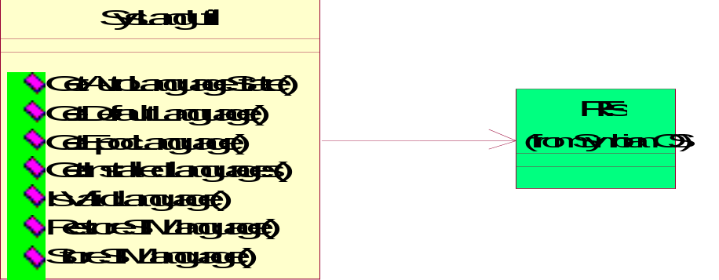
Figure 2.1. SysLangUtil required interfaces.

Technical specification

Type of interface
The service offered by SysLangUtil is accessed through the SysLangUtil API (SysLangUtil.H).

Interface Class Structure
The SysLangUtil class provides the interface for the client to connect to the SysLangUtil and use its services (see Figure 3.2).
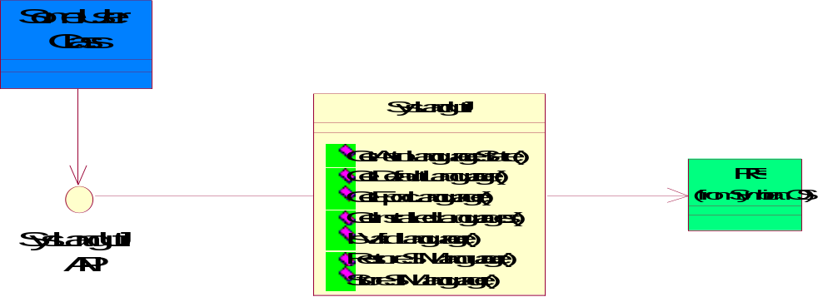
Figure 3.2. SysLangUtil interface class structure.

Usage

Protocol
SysLangUtil contains only static-functions. There is no need to use other methods of any class to be able to use SysLangUtil. All methods are synchronous. None of the requests can be cancelled.
More detailed information about the methods of the interface can be found in section 3.5.

Error handling
Standard Symbian OS error codes are used throughout the interface. Error handling for each operation in the interface is described in section 3.5 in more details.

Extensions to the API
None.

Example
The following simple code shows the example of using SysLangUtils class.

// initialize variables
TInt automaticLanguageState(0);
TInt errorCode(0);

// check automatic language flag status
errorCode = SysLangUtil::GetAutoLanguageState( automaticLanguageState, NULL);

Detailed description

SysLangUtil
SysLangUtil class provides an interface for reading and writing language specific information.

GetAutoLanguageState()
The method is used to determine if the device display language setting is automatic or some specific language.

Parameters:
Type | Name | Possible values
TBool& | aOn | This parameter returns a value if the operation successful:  ETrue, if the display language of the device is set to automatic.  EFalse, if the display language is set to some specific language.  If the operation failed, the value is unspecified.
RFs* | aFileServerSession | Optional file server session handle. If omitted, a new one is created.

Return value:
KErrNone if successful, or a Symbian OS standard error code.

GetEpocLanguage()
Not supported.
Parameters:
Type | Name | Possible values
const TInt | aSIMLanguage
TInt& | aLanguage
RFs* | aFileServerSession

Return value:
- KErrNone if successful.
- KErrNotSupported if unknown language.
- Symbian OS standard error code in case of any other error.

IsValidLanguage()
This method checks if the language given as an argument is valid (i.e. installed language).

Parameters:
Type | Name | Possible values
const TInt& | aLanguage | Returned Symbian OS language code matching SIM one.
RFs* | aFileServerSession | Optional file server session handle. If omitted, a new one is created.

Return value:
ETrue if language is installed, otherwise returns EFalse.

GetDefaultLanguage()
This method checks and returns the default language in a parameter given.

Parameters:
Type | Name | Possible values
TInt& | aLanguage | Symbian OS language as a number.
RFs* | aFileServerSession | Optional file server session handle. If omitted, a new one is created.

Return value:
KErrNone if successful, or a Symbian OS standard error code.

GetInstalledLanguages()
This method checks and returns installed languages in a parameter given.

Parameters:
Type | Name | Possible values
CarrayFixFlat<TInt>*& | aLanguages | Symbian OS languages as a arrayfixflat<int>. Ownership given to the user, so the user must take care of the proper cleanup!
RFs* | aFileServerSession | Optional file server session handle. If omitted, a new one is created.

Return value:
KErrNone, if successful, or a Symbian OS standard error code.

RestoreSIMLanguage()
This method returns SIM preferred languages in to a given parameter.

Parameters:
Type | Name | Possible values
TInt& | aLanguage | Language that was stored in the flash file system.
RFs* | aFileServerSession | Optional file server session handle. If omitted, a new one is created.

Return value:
KErrNone if successful, or a Symbian OS standard error code.

StoreSIMLanguage()
This method stores SIM preferred languages in to a parameter given.

Parameters:
Type | Name | Possible values
TInt | aLanguage | Language that is to be stored into the flash file system.
RFs* | aFileServerSession | Optional file server session handle. If omitted, a new one is created.

Return value:
KErrNone if successful, or a Symbian OS standard error code.

Code architecture
The SysLangUtil interface is defined in header SysLangUtil.H. SysLangUtil interface is linked to the SysLangUtil.DLL library.

Index

Alphabetical list of classes and methods

class SysLangUtil
IMPORT_C static TInt GetAutoLanguageState(TBool &aOn, RFs* aFileServerSession = NULL);
IMPORT_C static TInt GetDefaultLanguage(TInt& aLanguage, RFs* aFileServerSession = NULL);
IMPORT_C static TInt GetEpocLanguage(const TInt aSIMLanguage, TInt &aLanguage, RFs* aFileServerSession = NULL);
IMPORT_C static TInt GetInstalledLanguages(CArrayFixFlat<TInt>*& aLanguages, RFs* aFileServerSession = NULL);
IMPORT_C static TBool IsValidLanguage(const TInt& aLanguage, RFs* aFileServerSession = NULL);
IMPORT_C static TInt RestoreSIMLanguage(TInt &aLanguage, RFs* aFileServerSession = NULL);
IMPORT_C static TInt StoreSIMLanguage(TInt aLanguage, RFs* aFileServerSession = NULL);

