S60 3.2
Common DSY
Design Document

Team name | Author

Change history:

Version | Date | Status | Comments
4.0 | 15.08.2006 | Approved | Release validity updated.
3.0 | 03.03.2006 | Approved | Template corrected.
2.0 | 08.02.2006 | Approved | Release validity updated.
1.0 | 02.07.2004 | Approved
Table of contents:

1. Document control 4
1.1 References 4
1.2 Documentation conventions 4
1.3 Abbreviations 4
1.4 Definitions 4
2. General 5
2.1 Introduction 5
2.2 Subsystem environment 5
2.3 Services required 5
2.3.1 From the Symbian OS subsystems 5
2.3.2 From the Domestic OS subsystems 5
2.3.3 From HW 5
2.4 Services provided 5
2.4.1 UI 5
2.4.2 SW IF 6
3. Design 7
3.1 Class diagrams 7
3.1.1 Framework 7
3.1.2 Subsystem 7
3.2 Class descriptions 10
3.2.1 API definitions 10
3.2.1.1 <CDSYController.H> CCDSYController 10
3.2.1.2 <CDSYDOSServerRequestManager.H> CCDSYDOSServerRequestManager 12
3.2.1.3 <CDSYEventManager.H> CCDSYEventManager 14
3.2.1.4 <CDSYFactory.H> CCDSYFactory 15
3.2.1.5 <CDSYMessage.H> TCDSYMessage 16
3.2.1.6 <CDSYMessageBufferItem.H> CCDSYMessageBufferItem 18
3.2.1.7 <CDSYMessagesServiceLogic.H> CCDSYMessagesServiceLogic 19
3.2.1.8 <CDSYServiceLogic.H> MCDSYServiceLogic 21
3.2.1.9 <CDSYServiceLogicFactory.H> MCDSYServiceLogicFactory 21
3.2.2 Structures, type definitions and enumerations 21
3.2.3 Flag definitions 22
3.2.4 State diagrams 22
3.3 Variation 23
3.4 Operations 23
3.4.1 Construction 23
3.4.2 DOS Plug-in API function call 24
3.4.3 Message processing 25
3.4.4 Process message 26
3.4.5 Raising an event 27
3.4.6 DSY Extension API 28
3.4.7 Destruction 29
4. System resource usage 30
4.1 Files 30
4.2 Databases 30
4.3 Memory consumption 30
4.4 Task allocation 30
4.5 Performance 30
4.6 Timers 30
5. Exception handling 31
6. Usage 32
6.1 Building 32
6.2 User's guide 32

Document control

References

- S60 DOS Server Client API Specification Document
- S60 DOS Server Plug-in API Specification Document
- S60 Common DSY Plug-in API Specification Document
- S60 DOS Server Plug-in Event API Specification
- S60 Licensee DSY Implementation Guide

Documentation conventions
Code is shown with Courier New font.
Common DSY classes use CDSY prefix and Licensee DSY classes use LDSY prefix.

Abbreviations

API | Application Programming Interface
CDSY | Common DSY
DLL | Dynamic Link Library
DOS | Domestic Operating System
LDSY | Licensee DSY
HW | Hardware
IF | Interface
OS | Operating System
SAE | System Agent Extension
SW | Software
UI | User Interface

Definitions

DSY | DOS Server plug-in module. It includes both Common and Licensee DSY.
MMP | Project definition file.
Command message | Command message is a message, which performs an action.
Return message | Return message is a logical response to command message.
Event message | Event message is a message, which raises an event to DOS Server.
Common DSY | A platform provides framework for Licensee DSY.
Licensee DSY | Licensee’s DSY.
Service logic | Service logic receives DSY messages and performs actions based on those.

General
This chapter describes the environment of Common DSY module, which is a part of Common DSY subsystem. Common DSY provides a Common DSY Plug-in API to be implemented in Licensee DSY.

Introduction
Common DSY is a platform component, which provides a common implementation framework for Licensee DSY.
Common DSY is based on messaging architecture. Common DSY routes DSY messages to the service logics registered to the messages. Licensee DSY contains the implementation of licensee specific logic as well as the implementation of message mapping between DSY and Domestic Operating System.

Subsystem environment
Figure 2.1 represents the subsystem environment of Common DSY. Standard DLLs, such as euser and fileserver, have been removed from the picture for clarification purposes. Common DSY implements DOS Server DSY Plug-in interface to DOS Server. Common DSY loads Licensee DSY to implement the DOS Server requests.
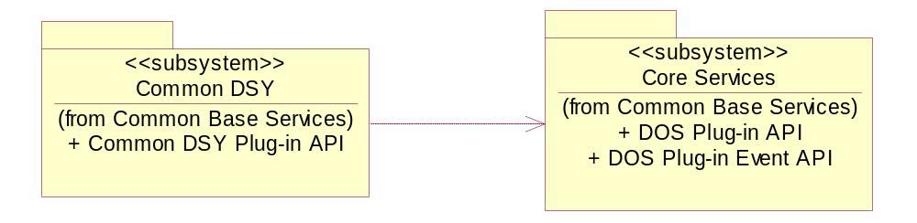
Figure 2.1 Subsystem environment

Services required

From the Symbian OS subsystems
Common DSY uses file server client interface to read configuration files (CommonDSY.INI).

From the Domestic OS subsystems
Communication with the Domestic OS is done in Licensee DSY and is out of the scope of this document.

From HW
This component has no direct HW interfaces.

Services provided

UI
This component does not have any UI.

SW IF
The component implements DOS Server Plug-in API (see reference document [2]), DOS Server Plug-in Event API (see reference document [4]) and provides a Common DSY Plug-in API (see reference document [3]).

Design

Class diagrams
This section describes the static object model of the component.

Framework
DOS Server implements the client-server framework. Common DSY is DOS Server’s plug-in component and is responsible for completing some requests. Common DSY itself offers an implementation framework for implementing Licensee DSY module (see reference documents [3] and [5]).

Subsystem
Figure 3.2 represents the subsystem.
Common DSY is a DLL, which is dynamically loaded by DOS Server on system startup. Licensee DSY is also a DLL, which is dynamically loaded by Common DSY.
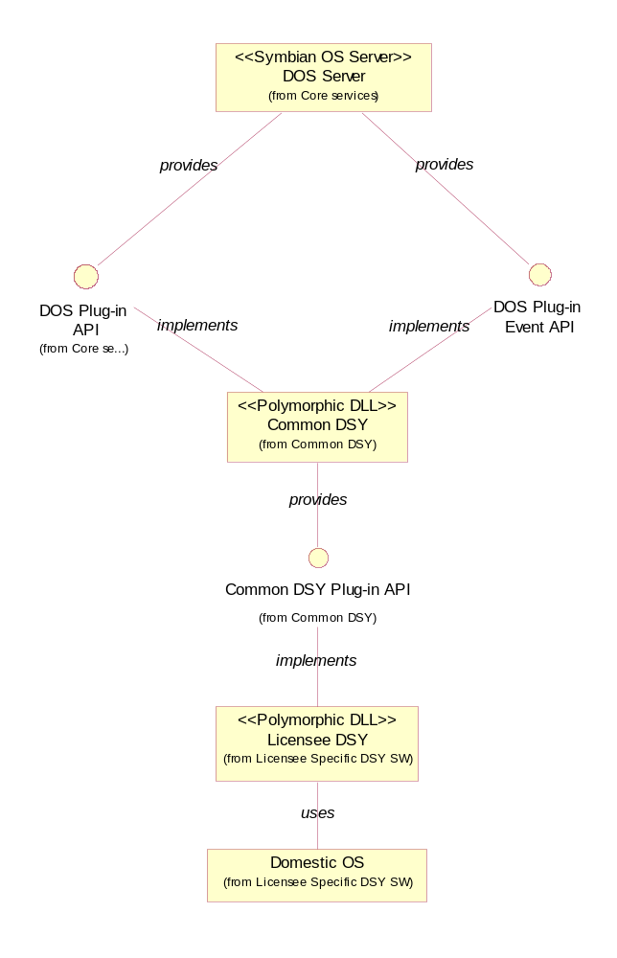
Figure 3.2. Subsystem
Figure 3.3 represents DOS Server plug-in related classes. Common DSY implements DOS Server plug-in interface, which uses CCDSYDOSServerRequestManager class to access DSY. Common DSY is factored by CCDSYFactory, which also initializes Licensee’s DSY.
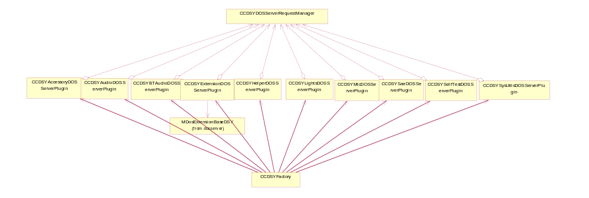
Figure 3.3. DOS Server plug-in interface class diagram
Figure 3.4 represents the static model of Common DSY.
DOS Server plug-in classes use CCDSYDOSServerRequestManager to send TCDSYMessages to CCDSYController. CCDSYController is a message router, which forwards the arriving message to the service logics that have requested the message. The service logics located in Licensee DSY receive messages from CCDSYController and may process the message, for example, by sending another message to controller or by accessing the kernel using some device driver. Licensee DSY service logics respond to the messages by sending a respond message to CCDSYController. CCDSYDOSServerRequestManager is responsible of matching responses to the commands sent.
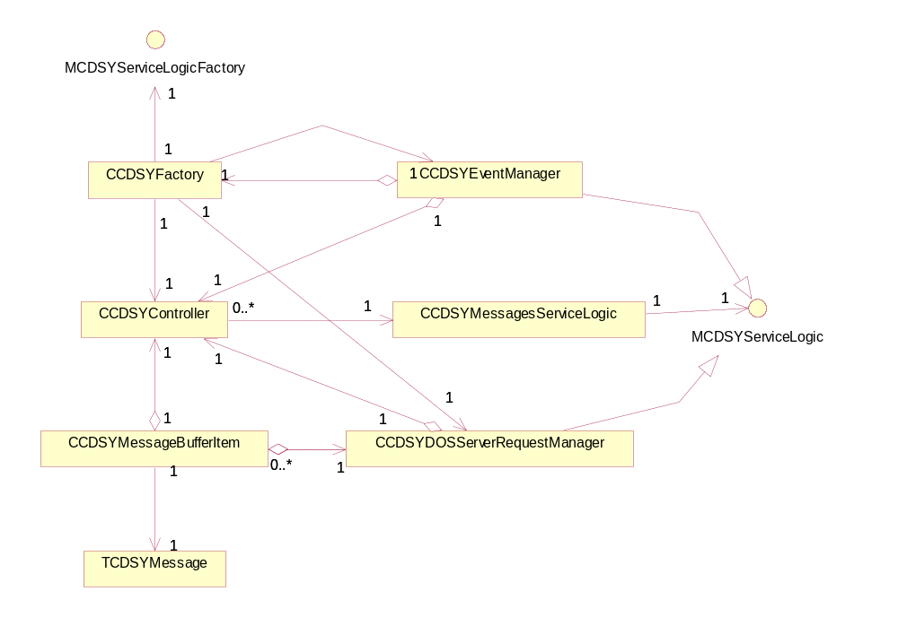
Figure 3.4. Common DSY class diagram
TCDSYMessagesServiceLogic is a helper class for storing a message and the message’s service logic binding.

Class descriptions
The following table briefly describes the purpose of the classes.

Class | Description | Header file
CCDSYController | Common DSY Controller, which routes the messages. | CDSYController.H
CCDSYDOSServerRequestManager | Sends the messages to controller and gets the responses to the messages. | CCDSYDOSServerRequestManager.H
CCDSYEventManager | Raises events to the DOS Server. | CDSYEventManager.H
CCDSYFactory | The interface class for the DOS Server plug-in factory. | CDSYFactory.H
TCDSYMessage | Generic CDSY message class. | CDSYMessage.H
CCDSYMessageBufferItem | Keeps a DSY message in buffer and waits for the response. | CDSYMessageBufferItem.H
CCDSYMessagesServiceLogic | Keeps the message’s service logic registration information. | CDSYMessagesServiceLogic.H
CCDYxxxDOSPlugin | An xxx DOS Server plug-in interface class. | CDSYxxxDOSPlugin.H
CLDSYDosMessageMapper | Maps the messages between DOS and DSY (part of Licensee DSY). | LDSYDosMessageMapper.H
CLDSYServiceLogicFactory | Factory class for service logics (part of Licensee DSY). | CLDSYServiceLogicFactory.H
MCDSYServiceLogic | Interface class for service logics. | CDSYServiceLogic.H
MCDSYServiceLogicFactory | Interface class for LDSY factory class. | CDSYServiceLogicFactory.H

API definitions

<CDSYController.H> CCDSYController
Common DSY Controller, which routes the messages.

~CCDSYController()
Destructor.
Return value: N/A

static CCDSYController* NewL()
Creates a new instance of CCDSYController. The function does not take any parameters.
Return value: Pointer to an instance of CCDSYController.

IMPORT_C void RegisterServiceLogicL(const TUint32 aMessageGroup, const TUint32 aMessageID, MCDSYServiceLogic* aCDSYServiceLogic)
Registers service logic for a specific message. The function is exported.

Parameters:
Type | Name | Description
const TUint32 | aMessageGroup | Message group to which the service logic will be registered.
const TUint32 | aMessageID | Message ID to which the service logic will be registered.
MCDSYServiceLogic* | aCDSYServiceLogic | Pointer to service logic which will be registered.

Return value: Void.

IMPORT_C void RegisterServiceLogicL(const TUint32 aMessageGroup, const TUint32 aMessageID, const TUint32 aTransactionID, MCDSYServiceLogic* aCDSYServiceLogic)
Registers service logic for a specific message with given transaction ID. The function is exported.

Parameters:
Type | Name | Description
const TUint32 | aMessageGroup | Message group to which the service logic will be registered.
const TUint32 | aMessageID | Message ID to which the service logic will be registered.
const TUint32 | aTransactionID | Message's transaction ID to which the service logic will be registered.
MCDSYServiceLogic* | aCDSYServiceLogic | Pointer to service logic which will be registered.

Return value: Void.

IMPORT_C void UnregisterServiceLogicL(const TUint32 aMessageGroup, const TUint32 aMessageID, const MCDSYServiceLogic* aCDSYServiceLogic)
Unregisters service logic for a specific message. The function is exported.

Parameters:
Type | Name | Description
const TUint32 | aMessageGroup | Message group from which the service logic will be unregistered.
const TUint32 | aMessageID | Message ID from which the service logic will be unregistered.
const MCDSYServiceLogic* | aCDSYServiceLogic | Pointer to service logic that will be unregistered.

Return value: Void.

IMPORT_C void UnregisterServiceLogicL(const TUint32 aMessageGroup, const TUint32 aMessageID, const MCDSYServiceLogic* aCDSYServiceLogic)
Unregisters service logic for a specific message and transaction ID. The function is exported.

Parameters:
Type | Name | Description
const TUint32 | aMessageGroup | Message group from which the service logic will be unregistered.
const TUint32 | aMessageID | Message ID from which the service logic will be unregistered.
const TUint32 | aTransactionID | Message's transaction ID from which the service logic will be unregistered.
const MCDSYServiceLogic* | aCDSYServiceLogic | Pointer to service logic that will be unregistered.

Return value: Void.

IMPORT_C void ProcessMessageL(TCDSYMessage& aCDSYMessage)
Processes the incoming TCDSYMessage. The function routes the message to the service logics registered to the message. The function is exported.

Parameters:
Type | Name | Description
TCDSYMessage& | aCDSYMessage | Reference to the message that will be routed.

Return value: Void.

IMPORT_C TUint8 GetNewTransactionID()
Returns new transaction ID. The function does not take any parameters. The function is exported.
Return value: TUint8 transaction ID.

<CDSYDOSServerRequestManager.H> CCDSYDOSServerRequestManager
CCDSYDOSServerRequestManager sends the messages to controller and gets the responses to the messages.

~CCDSYDOSServerRequestManager()
Destructor.
Return value: N/A

static CCDSYDOSServerRequestManager * NewL(CCDSYController& aCDSYController)
Creates a new instance of CCDSYIFAdapter.

Parameters:
Type | Name | Description
CCDSYController& | aCDSYController | Reference to CCDSYController.

Return value: Pointer to an instance of CCDSYIFAdapter.

void SendMessageL(TCDSYMessage& aCDSYMessage)
Sends the message to CCDSYController. Provides waits for the response to the message.

Parameters:
Type | Name | Description
TCDSYMessage& | aCDSYMessage | Reference to the message to be sent.

Return value: Void.

void SendMessageL(TCDSYMessage& aCDSYMessage, RMessagePtr aMessage)
Sends the message to CCDSYController. Returns after the message has been sent.

Parameters:
Type | Name | Description
TCDSYMessage& | aCDSYMessage | Reference to the message to be sent.
RMessagePtr | aMessage | Pointer to DOS Server’s message.

Return value: Void.

void ProcessMessageL(TCDSYMessage& aCDSYMessage)
Processes the response to the message sent.

Parameters:
Type | Name | Description
TCDSYMessage& | aCDSYMessage | Reference to the message received.

Return value: Void.

void ExpireMessageL(TCDSYMessage& aCDSYMessage)
Expires the message. No processing needed.

Parameters:
Type | Name | Description
TCDSYMessage& | aCDSYMessage | Reference to the message to be expired.

Return value: Void.

void Cancel(TUint32 aTransactionID, TInt aReason)
Cancels the async request.

Parameters:
Type | Name | Description
TUint32 | aTransactionID | Transaction ID of the message to be canceled.
TInt | aReason | Cancel reason.

Return value: Void.

<CDSYEventManager.H> CCDSYEventManager
This class implements the CCDSYEventManager, which raises events using CDosEventManager.

~CCDSYEventManager()
Destructor.
Return value: N/A

static CCDSYEventManager* NewL(CCDSYController& aCDSYController, CCDSYFactory& aDosEventManager)
Creates a new instance of CCDSYEventManager.

Parameters:
Type | Name | Description
CCDSYController& | aCDSYController | Reference to CCDSYController.
CCDSYFactory& | aCDSYFactory | Reference to an instance of CCDSYFactory.

Return value: Pointer to an instance of CCDSYEventManager.

void ProcessMessageL(TCDSYMessage& aCDSYMessage)
Processes the incoming TCDSYMessage. The function raises an event to using CDosEventManager.

Parameters:
Type | Name | Description
TCDSYMessage& | aCDSYMessage | Reference to event message.

Return value: Void.

inline void ExpireMessageL( TCDSYMessage& /*aCDSYMessage*/ )
Expires the message. No processing needed.

Parameters:
Type | Name | Description
TCDSYMessage& | aCDSYMessage | Reference to event message to be expired. Not used.

Return value: Void.

<CDSYFactory.H> CCDSYFactory
CCDSYFactory is an interface class for the DOS Server plug-in factory.

~CCDSYFactory()
Destructor.
Return value: N/A

static CCDSYFactory* NewL()
Creates a new instance of CCDSYFactory. The function does not take any parameters.
Return value: Pointer to an instance of CCDSYFactory.

CDosSysUtilsBase* NewSysUtilsServiceL()
The function returns a CCDSYSysUtilsDOSServerPlugin object derived from CDosSysUtilBase, which implements the pure virtual functions defined in MDosSysBaseDSY to DOS Server. The function does not take any parameters.
Return value: Pointer to an instance of plug-in.

CDosHelperBase* NewHelperServiceL()
The function returns a CCDSYHelperDOSServerPlugin object derived from CDosHelperBase, which implements the pure virtual functions defined in MDosHelperBaseDSY to DOS Server. The function does not take any parameters.
Return value: Pointer to an instance of plug-in.

CDosMtcBase* NewMTCServiceL()
The function returns a CCDSYMtcDOSServerPlugin object derived from CDosMTCBase, which implements the pure virtual functions defined in MDosMTCBaseDSY to DOS Server. The function does not take any parameters.
Return value: Pointer to an instance of plug-in.

CDosSelfTestBase* NewSelfTestServiceL()
The function returns a CCDSYSelfTestDOSServerPlugin object derived from CDosSelfTestBase, which implements the pure virtual functions defined in MDosSelfTestBaseDSY to DOS Server. The function does not take any parameters.
Return value: Pointer to an instance of plug-in.

CDosLightsBase* NewLightsServiceL()
The function returns a CCDSYLightsDOSServerPlugin object derived from CDosLightsBase, which implements the pure virtual functions defined in MDosLightsBaseDSY to DOS Server. The function does not take any parameters.
Return value: Pointer to an instance of plug-in.

CDosSaeBase* NewSaeServiceL()
The function returns a CCDSYSaeDOSServerPlugin object derived from CDosSaeBase, which implements the pure virtual functions defined in MDosSaeBaseDSY to DOS Server. The function does not take any parameters.
Return value: Pointer to an instance of plug-in.

CDosBTAudioBase* NewBTAudioServiceL()
The function returns a CCDSYBTAudioDOSServerPlugin object derived from CDosBTAudioBase, which implements the pure virtual functions defined in MDosBTAudioBaseDSY to DOS Server. The function does not take any parameters.
Return value: Pointer to an instance of plug-in.

CDosExtensionBase* NewExtensionServiceL()
The function returns a CCDSYExtensionDOSServerPlugin object derived from CDosExtensionBase, which implements the pure virtual functions defined in MDosExtensionBaseDSY to DOS Server. The function does not take any parameters.
Return value: Pointer to an instance of plug-in.

CDosAccessoryBase* NewAccessoryServiceL()
The function returns a CCDSYAccessoryDOSServerPlugin object derived from CDosAccessoryBase, which implements the pure virtual functions defined in MDosAccessoryBaseDSY to DOS Server. The function does not take any parameters.
Return value: Pointer to an instance of plug-in.

CDosAudioBase* NewAudioServiceL()
The function returns a CCDSYAudioDOSServerPlugin object derived from CDosAudioBase, which implements the pure virtual functions defined in MDosAudioBaseDSY to DOS Server. The function does not take any parameters.
Return value: Pointer to an instance of plug-in.

<CDSYMessage.H> TCDSYMessage
TCDSYMessage is a generic message class.

IMPORT_C virtual ~TCDSYMessage()
Destructor.
Return value: N/A

IMPORT_C TCDSYMessage (const TUint32 aGroup, const TUint32 aID, const TDesC8* aData, const TUint32 aTransactionID)
The function constructs a TCDSYMessage object.

Type | Name | Description
const TUint32 | aGroup | Message group.
const TUint32 | aID | Message ID.
const TDesC8* | aData | Data.
const TUint32 | aReceiver | Message receiver.
const TUint32 | aTransactionID | Transaction ID.

Return value: N/A

IMPORT_C TCDSYMessage (const TUint32 aGroup, const TUint32 aID, const TDesC8* aData)
The function constructs a TCDSYMessage object.

Type | Name | Description
const TUint32 | aGroup | Message group.
const TUint32 | aID | Message ID.
const TDesC8* | aData | Data.
const TUint32 | aReceiver | Message receiver.

Return value: N/A

inline TUint32 Group() const
Returns message group. The function does not take any parameters. The function is inline.
Return value: Message group.

inline_C TUint32 ID() const
Returns message ID. The function does not take any parameters. The function is inline.
Return value: Message group.

inline TUint32 TransactionID() const
Returns message’s transaction ID. The function does not take any parameters. The function is inline.
Return value: Message group.

inline const TDesC8* Data() const
Returns message data. The function does not take any parameters. The function is inline.
Return value: Message data.

inline const TDesC8* ReturnData() const
Returns message return data. The function does not take any parameters. The function is inline.
Return value: Message’s return data.

IMPORT_C void SetReturnDataL(const TDesC8* aReturn)
Sets the message’s return data. The function is exported.

Parameters:
Type | Name | Description
TDesC8* | aReturn | Message’s return data.

Return value: Pointer to message’s data.

inline void SetTransactionID( TUint32 aTransactionID )
Sets the message’s transaction ID.

Parameters:
Type | Name | Description
TUint32 | aTransactionID | Message’s transaction ID.

Return value: Void.

<CDSYMessageBufferItem.H> CCDSYMessageBufferItem
Keeps the DSY message in buffer and waits for the response.

~CCDSYMessageBufferItem()
Destructor.
Return value: N/A

static CCDSYMessageBufferItem* NewL( CCDSYController& aCDSYController, CCDSYDOSServerRequestManager& aCDSYDOSServerRequestManager, TCDSYMessage& aCDSYMessage )
Creates a new instance of CCDSYMessageBufferItem.

Parameters:
Type | Name | Description
CCDSYController& | aCDSYController | Reference to CCDSYController.
CCDSYDOSServerRequestManager& | aCDSYDOSServerRequestManager | Reference to CCDSYDOSServerRequestManager.
TCDSYMessage* | aCDSYMessage | Pointer to the message to be sent.

Return value: Pointer to instance of CCDSYMessageBufferItem.

static CCDSYMessageBufferItem* NewL( CCDSYController& aCDSYController, CCDSYDOSServerRequestManager& aCDSYDOSServerRequestManager, TCDSYMessage& aCDSYMessage, RMessagePtr aMessage )
Creates a new instance of CCDSYMessageBufferItem.

Parameters:
Type | Name | Description
CCDSYController& | aCDSYController | Reference to CCDSYController.
CCDSYDOSServerRequestManager& | aCDSYDOSServerRequestManager | Reference to CCDSYDOSServerRequestManager.
TCDSYMessage* | aCDSYMessage | Pointer to the message to be sent.
RMessagePtr | aMessage | Pointer to client/server message.

Return value: Pointer to instance of CCDSYMessageBufferItem.

void SendMessageL()
Sends the message to the controller and waits for the response. The function does not take any parameters.
Return value: Void.

void ProcessResponseL(const TCDSYMessage& aCDSYMessage)
Processes the response to the message sent.

Parameters:
Type | Name | Description
TCDSYMessage& | aCDSYMessage | Reference to the response message.

Return value: Void.

void CancelAsyncCommand( TInt aReason ) const
Cancels async message.

Parameters:
Type | Name | Description
TInt | aReason | Cancel reason.

Return value: Message related to the MessageBufferItem.

inline TUint32 TransactionID() const
Returns the message’s transaction ID. The function does not take any parameters.
Return value: Message’s transaction ID.

inline TBool IsAsyncMessage()
Returns if the message is async. The function does not take any parameters.
Return value: Async flag.

<CDSYMessagesServiceLogic.H> CCDSYMessagesServiceLogic
Stores the message and service logic binding.

~CCDSYMessagesServiceLogic()
Destructor.
Return value: N/A

static CCDSYMessagesServiceLogic* NewL(const TUint32 aMessageGroup, const TUint32 aMessageID, MCDSYServiceLogic* aCDSYServiceLogic)
Creates a new instance of CCDSYMessagesServiceLogic.

Parameters:
Type | Name | Description
const TUint32 | aMessageGroup | Message group to which the service logic is registered.
const TUint32 | aMessageID | Message ID to which the service logic is registered.
CCDSYServiceLogic* | aCDSYServiceLogic | Pointer to service logic.

Return value: Pointer to an instance of CCDSYMessagesServiceLogic.

static CCDSYMessagesServiceLogic* NewL( const TUint32 aMessageGroup, const TUint32 aMessageID, const TUint32 aMessageTransactionID, MCDSYServiceLogic* aCDSYServiceLogic )
Creates a new instance of CCDSYMessagesServiceLogic.

Parameters:
Type | Name | Description
const TUint32 | aMessageGroup | Message group to which the service logic is registered.
const TUint32 | aMessageID | Message ID to which the service logic is registered.
const TUint32 | aMessageTransactionID | Message's transaction ID to which the service logic is registered.
CCDSYServiceLogic* | aCDSYServiceLogic | Pointer to service logic.

Return value: Pointer to an instance of CCDSYMessagesServiceLogic.

inline TUint32 MessageGroup() const
Returns the message group to which the service logic is registered. The function does not take any parameters.
Return value: Message group to which the service logic is registered.

inline TUint32 MessageID() const
Returns the message ID to which the service logic is registered. The function does not take any parameters.
Return value: Message ID to which the service logic is registered.

inline MCDSYServiceLogic* CDSYServiceLogic()
Returns the service logic related to the message. The function does not take any parameters.
Return value: Pointer to service logic related to the message.

inline TBool DynamicRegistration() const
Returns if the service logic is dynamically registered. The function does not take any parameters.
Return value: Registration status.

inline TBool DynamicRegistration() const
Returns the tranasaction ID to which the service logic is registered. The function does not take any parameters.
Return value: Transaction ID.

<CDSYServiceLogic.H> MCDSYServiceLogic
MCDSYServiceLogic is interface class for service logics.

virtual void ProcessMessageL(TCDSYMessage& aCDSYMessage) = 0
Processes the incoming message.

Type | Name | Description
TCDSYMessage& | aCDSYMessage | Reference to the message to be processed.

Return value: Void.

virtual void ExpireMessageL( TCDSYMessage& aCDSYMessage ) = 0
Expires the incoming message.

Type | Name | Description
TCDSYMessage& | aCDSYMessage | Reference to the message to be expired.

Return value: Void.

<CDSYServiceLogicFactory.H> MCDSYServiceLogicFactory
MCDSYServiceLogicFactory is the interface class for LDSY factory class.

virtual ~MCDSYServiceLogicFactory()
Destructor.
Return value: N/A

virtual void InitializeL(CCDSYController& aCDSYController) = 0
Initializes the factory.

Parameters:
Type | Name | Description
CCDSYController& | aCDSYController | Reference to CCDSYController.

Return value: Void.

virtual void DeInitialize() = 0
Deinitializes the factory. The function does not take any parameters.
Return value: Void.

Structures, type definitions and enumerations
The structures are defined in the headers:
- CDSYEnums.H Common DSY Enumerations.
- CDSYMessageIDs.H Common DSY message's identifiers.
- CDSYMessageStructures.H Common DSY message structures.

The structures, type definitions and enumerations are described in API documentation (see reference document [3]).

Flag definitions
Common DSY uses the following compilation flags:

Flag | Description
COMPONENT_TRACE_FLAG | Component traces are used to track the component’s internal execution. This is implemented by tracing all other than exported functions in a similar way to the API traces, which are described later in this document. The component traces may also include other relevant information about the component, such as:  - The state of the component or relevant components.  - The sizes of buffers etc.  - The compilation date and time of the source.  - The trace outputs the function calls in the following format:  CDSY - Class_name::Function_Name(0x01, 0x00, 0x5f5694550)  Other traces are output in the following format:  CDSY - Class_name::Function_Name – Trace information  The traces are output if the debug version of the component is used and the following macro is defined in the component’s MMP file:  macro COMPONENT_TRACE_FLAG
API_TRACE_FLAG | API traces are used to track the component’s interface. This is implemented by tracing the component’s exported functions and their return values.  The trace outputs the API call in the following format:  CDSY - Class_name::Function_Name(0x01, 0x00, 0x5f5694550)  The trace outputs the return value in the following format:  CDSY - Class_name::Function_Name – return value|void  The traces are output if the debug version of the component is used and the following macro is defined in the component’s MMP file:  macro API_TRACE_FLAG

State diagrams
None.

Variation
This component is not variated.

Operations

Construction

Operation | Construction.
Preconditions | DOS Server started.
Description | DOS Server initializes Common DSY, which in turn initializes Licensee’s DSY. In initialization the service logics are registered to CCDSYController.
Inputs | N/A
Modifies | DSY’s data structures.
Outputs | N/A
Postconditions | DSY’s constructed and service logics registered to CCDSYController.
Related To | All CDSY classes, LDSY classes.
Related Event | DOS Server loads DSY.
Exceptions | Symbian OS leave mechanism is used in the following situations: Unable to load DSY modules, unable to allocate memory for objects, unable to read configuration files.

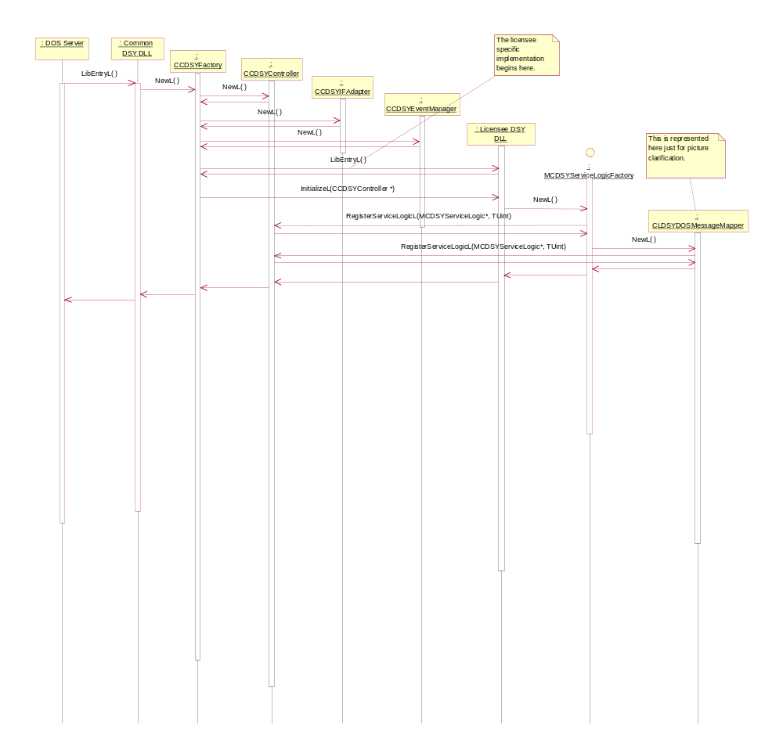
Figure 3.5 Construction

DOS Plug-in API function call

Operation | DOS Plug-in API function call
Preconditions | DSY’s constructed and service logics registered to the CCDSYController. DOS Server requests.
Description | DOS Server calls Plug-in API function. The plug-in constructs a TCDSYMessage and forwards it to CCDSYDOSServerRequestManager. The CCDSYDOSServerRequestManager sends it to CCDSYController, which routes the request to the service logic, which has registered to the message. The service logic sends a return message, which is forwarded to CCDSYDOSServerRequestManager. The CCDSYDOSServerRequestManager returns the message to the plug-in and the function call returns to DOS Server.
Inputs | Function call to Plug-in API.
Modifies | N/A
Outputs | N/A
Postconditions | Message sent and response received.
Related To | All CDSY classes, LDSY classes.
Related Event | N/A
Exceptions | Symbian OS leave mechanism is used in the following situations: Unable to load DSY modules, unable to allocate memory for objects, unable to read configuration files.  If a message is not received in time, leave occurs and error is returned.

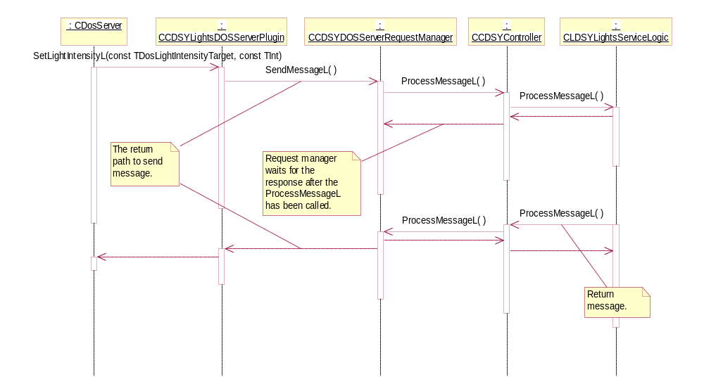
Figure 3.6 DOS Plug-in API function call

Message processing

Operation | Message processing.
Preconditions | DSY’s constructed and service logics registered to CCDSYController. DOS Server request.
Description | DOS Server calls Plug-in API function. The plug-in constructs a TCDSYMessage and forwards it to CCDSYDOSServerRequestManager. The CCDSYDOSServerRequestManager sends it to CCDSYController, which routes the request to the service logic, which has registered to the message. The service logic sends a return message, which is forwarded to CCDSYDOSServerRequestManager. The CCDSYDOSServerRequestManagerreturns the message to the plug-in and the function call returns to DOS Server.
Inputs | Function call to Plug-in API.
Modifies | Service logic may modify the state related to CDSYController.
Outputs | N/A
Postconditions | Message sent and response received.
Related To | All CDSY classes, LDSY classes.
Related Event | N/A
Exceptions | Symbian OS leave mechanism is used in the following situations: Unable to load DSY modules, unable to allocate memory for objects, if a message is not received in time and error is returned.
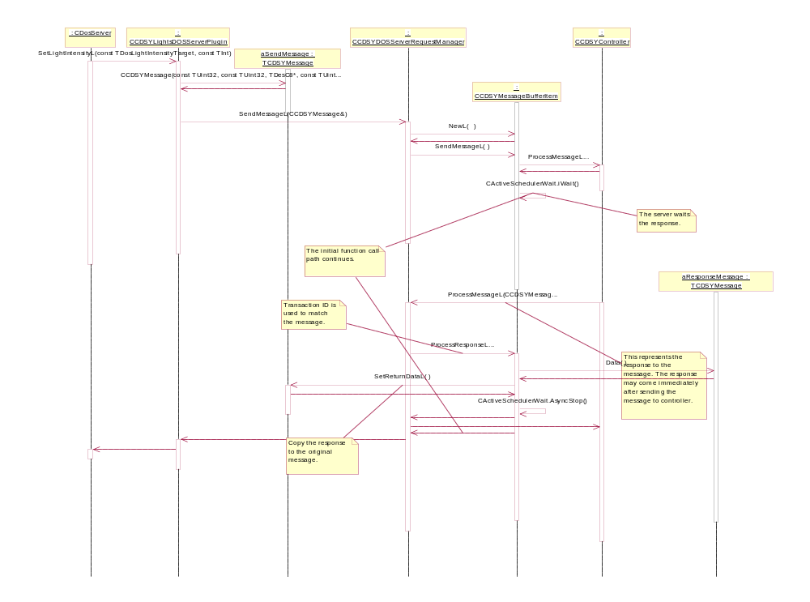
Figure 3.7. Sending a message

Process message

Operation | Process Message
Preconditions | DSY’s constructed and service logics registered to CCDSYController. CDSYMessage is constructed.
Description | The DSY Controller processes the message by sending it to the parties related to the message. The service logics may create additional messages and send them to the controller.
Inputs | Message specific.
Modifies | Service logic may modify the state related to CDSYController.
Outputs | N/A
Postconditions | Message sent and response received.
Related To | CDSY classes, LDSY classes, DOS.
Related Event | N/A
Exceptions | Symbian OS leave mechanism is used in the following situations: Unable to load DSY modules, unable to allocate memory for objects, if a message is not received in time and error is returned.
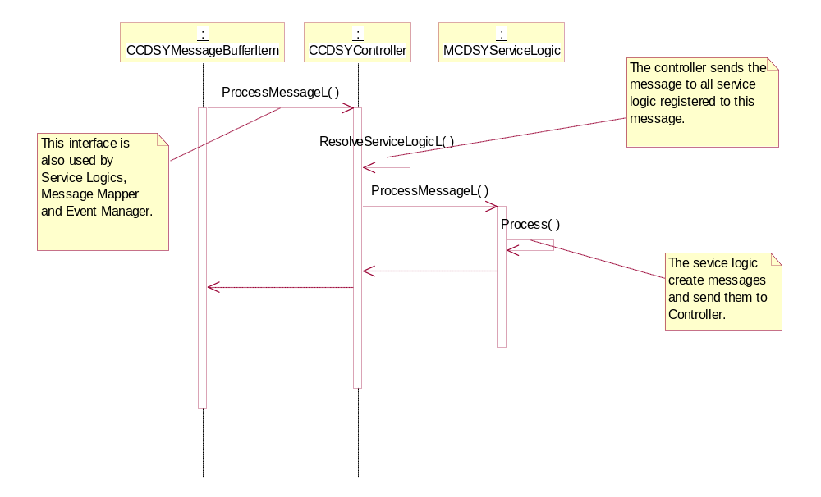
Figure 3.8. Process message

Raising an event

Operation | Sending an event.
Preconditions | DSY’s constructed and service logics registered to the CCDSYController. DOS changes its state.
Description | The DSY controller routes a message to event manager, which calls back the functions related to the event.
Inputs | Message specific.
Modifies | Service logic may modify the state related to CDSYController.
Outputs | N/A
Postconditions | Event sent.
Related To | CCDSYController, CDSYMessage, CCDSYEventManager, DOS Server plug-ins, LDSY classes.
Related Event | N/A
Exceptions | Symbian OS leave mechanism is used in the following situations: Unable to load DSY modules, unable to allocate memory for objects, if a message is not received in time and error is returned.

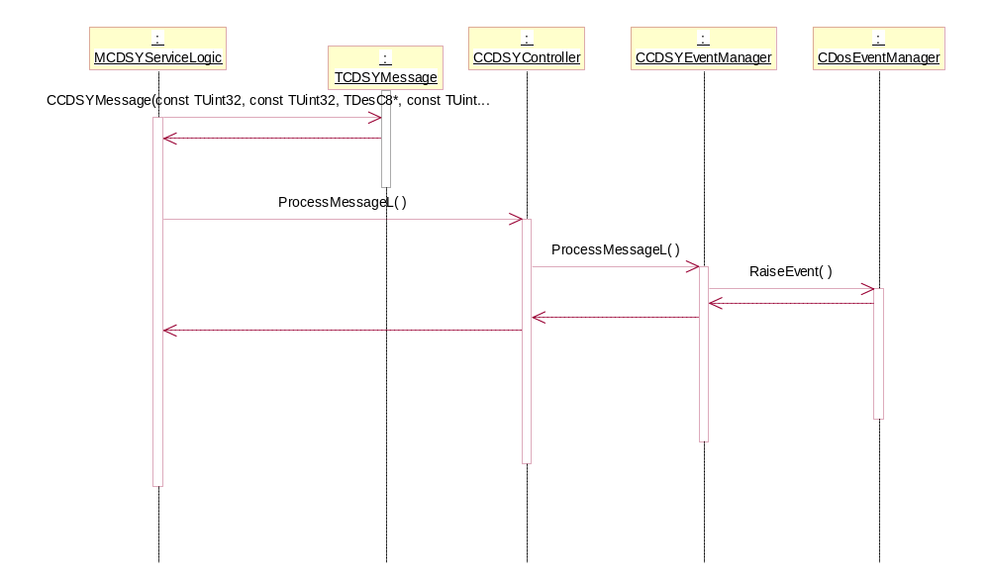
Figure 3.9. Sending an event

DSY Extension API
Figure 3.10 describes the DSY Extension API.
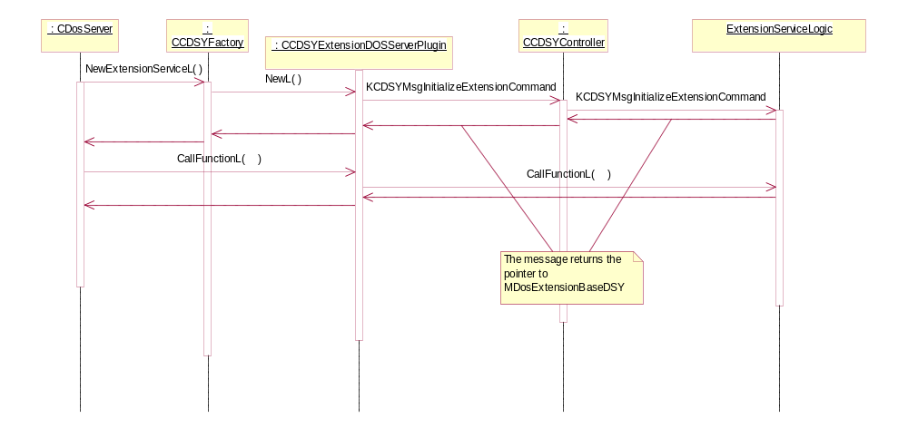
Figure 3.10 Extension API
When DOS Server calls DSY Factory’s NewExtensionServiceL function, the CCDSYExtensionDOSServerPlugin sends KCDSYMsgInitializeExtensionCommand to CCDSYController, which forwards it to the service logic registered to the message. The service logic implemented in LDSY returns pointer to MDosExtensionBaseDSY.

Destruction

Operation | Destruction.
Preconditions | DSY’s constructed and service logics registered to the CCDSYController.
Description | DOS Server calls CCDSYFactory’s destructor. The destructor deinitializes the Licensee’s DSY and calls the destructors of constructed classes. The service logics are unregistered before the service logics are destructed.
Inputs | N/A
Modifies | All CDSY classes, LDSY classes.
Outputs | N/A
Postconditions | DSY uninitialized.
Related To | All CDSY classes, LDSY classes.
Related Event | N/A
Exceptions | Symbian OS leave mechanism is used in the following situations: Unable to load DSY modules, unable to allocate memory for objects, if a message is not received in time and error is returned.

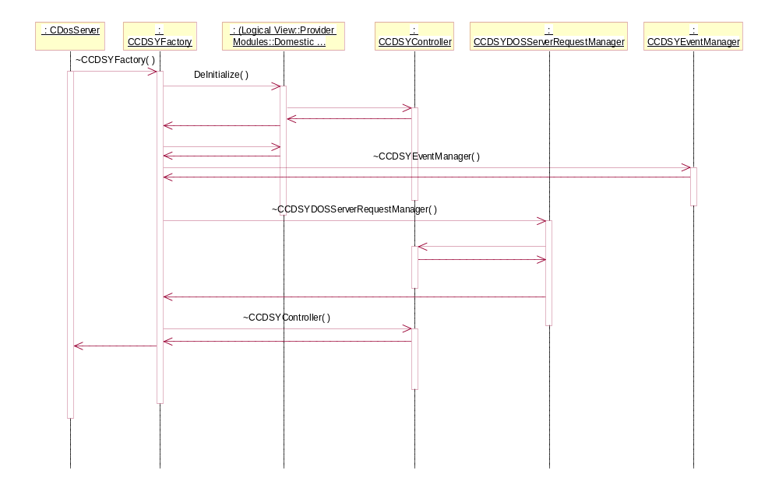
Figure 3.11 Destruction

System resource usage

Files
Common DSY reads the name of Licensee DSY DLL from a file (Z:\system\data\CommonDSY.INI).

Databases
This SW does not use any database.

Memory consumption
Estimated ROM module size 25 kb (UREL).

Task allocation
This software module runs in DOS Server’s thread.

Performance
The overall performance is dependent on Common DSY Plug-in API implementation. Common DSY itself does not have performance critical operations.

Timers
Timers will be used in CCDSYDOSServerRequestManager. A timer is set when a message is sent to CDSYController. The timer fires in 10 seconds (UREL) and 20 seconds (UDEB). If no response has been received, an error is returned to the client.

Exception handling
The exception handling is done using Symbian OS leave mechanism. In the server and plug-in side, Symbian OS client-server framework traps all leave errors and deliver them to the client side.

Usage

Building
Standard Symbian OS building procedure is used. MMP file is located in the group directory that also contains a bld.INF file.

User's guide
Reference documents [3] and [5] contain instructions on how to use the services provided by this component.
The tracing of the component is defined in Section 3.2.3.

