S60 3.2
Licensee DSY Implementation Guide

Team name | Author

Change history:

Version | Date | Status | Comments
4.0 | 15.08.2006 | Approved | Release validity updated.
3.0 | 03.03.2006 | Approved | Template corrected.
2.0 | 08.02.2006 | Approved | Release validity updated.  Section 2.2 updated.
1.0 | 11.10.2004 | Approved

Table of contents:

1. Document control 4
1.1 References 4
1.2 Documentation conventions 4
1.3 Abbreviations 4
1.4 Definitions 4
2. Purpose 6
2.1 Introduction 6
2.2 List of required interfaces 6
2.3 Constraints 7
3. Architecture 8
4. Requirements 10
5. Design 11
5.1 Class diagrams 11
5.1.1 Class CLDSYFactory 11
5.1.2 Class CLSDYMapper 11
5.1.3 Class CLDSYServiceLogic 11
5.2 Sequence diagrams 12
5.2.1 Construction 12
5.2.2 Process message 12
5.2.3 Expire message 14
5.2.4 Destruction 14
5.3 Code examples 15

Document control

References

- S60 Common DSY Design Document
- S60 DOS Server Client API Specification Document
- S60 DOS Server Plug-in API Specification Document
- S60 Common DSY Plug-in API Specification Document
- S60 DOS Server Plug-in Event API Specification Document
- Series 60 Common DSY Subsystem Architecture Description

Documentation conventions
Code is shown in Courier New font.
Common DSY classes use the CDSY prefix and Licensee DSY classes use the LDSY prefix.

Abbreviations

API | Application Programming Interface
CDSY | Common DSY
DLL | Dynamic Link Library
DOS | Domestic Operating System
DOS server | Server that provides S60 applications an interface to Domestic OS.
HW | Hardware
IF | Interface
LDSY | Licensee DSY
OS | Operating System
SAE | System Agent Extension
SW | Software
UI | User Interface

Definitions

DSY | DOS Server plugin module. It includes both Common and Licensee DSY.
MMP | Project definition file.
Command message | Command message is a message that performs an action.
Common DSY | A platform that provides a framework for Licensee DSY.
Event message | Event message is a message that raises an event to a DOS Server.
Licensee DSY | Licensee’s DSY.
Return message | Return message is a logical response to a command message.
Service logic | Service logic receives DSY messages and performs actions based on them.

Purpose

Introduction
This document describes the general implementation guideline and high-level reference design of the Licensee DSY module, implemented by using Common DSY Plug-in API (see reference document [4]).
It is strongly recommended that this document should be read concurrently with reference documents [1], [4] and [6].
The purpose of this document is to aid and speed up the S60 licensees’ implementations of their own Licensee DSY modules.

List of required interfaces
The Licensee DSY context diagram below shows the direct Symbian OS side relationships of the subsystem. The relations described in the diagram are expected dependencies and the actual adaptation may add other dependencies as well. Please note that most of the dependencies are dependencies to header files, not to binaries. See reference document [6] for Common DSY context diagram.
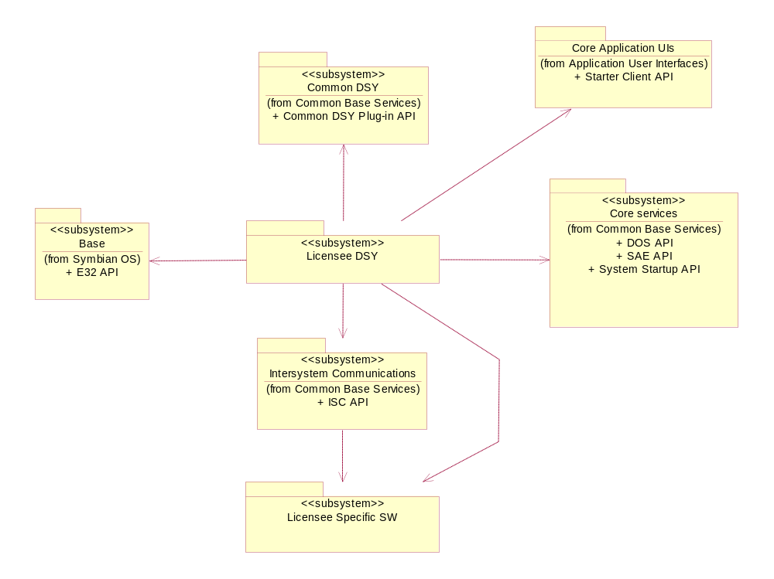
Figure 2.1 Licensee DSY Context Diagram
Symbian OS \ Base: this subsystem is included because of the standard E32 API that is required by the Licensee DSY.
Common Base Services \ Common DSY: this subsystem is included because the Licensee DSY implements the Common DSY Plug-in API.
Common Base Services \ Core Services: this subsystem is included because of the DOS API (aka DOS Client API) and the DOS Plug-in API, as some of the constants needed by the Licensee DSY implementation are defined there. This also applies to the SAE API because of the enumerations and constants defined at psvariables.h. The System Startup API is needed for startup features (this binary is used directly).
Application User Interfaces \ Core Application UIs: this subsystem is included because of the startupreasons.H file that belongs to the Starter Client API.
Common Base Service \ Inter System Communications: this subsystem is needed for accessing the Domestic OS modem.

Constraints
The Common DSY is designed for S60 release 3.0 and therefore this constraint applies to the Licensee DSY as well.

Architecture
This section describes the recommended architectural design of the manufacturer-specific Domestic OS Server adaptation plug-in module implementing the Common DSY Plug-in API.
The following Figure 3.2 shows the recommended architecture. The Licensee DSY should be implemented to a DLL, which uses the services offered by the Domestic OS. The Licensee DSY uses System Startup API, ISC API, SAE API, E32 API and X API, which represents the other API’s needed.
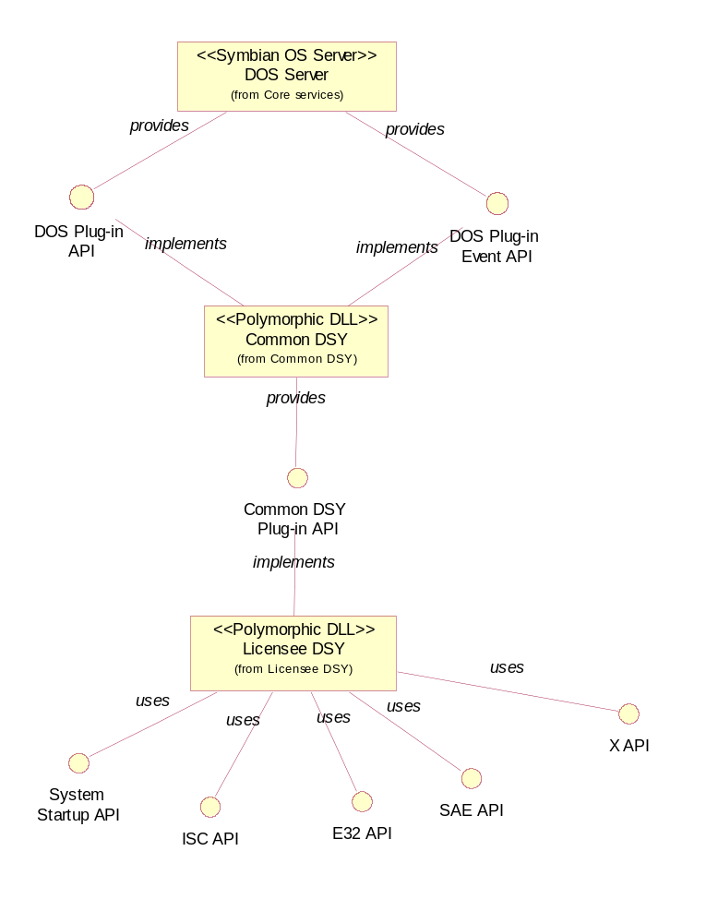
Figure 3.2 Architectural design

The following Figure 3.3 illustrates the recommended packaging of different Service Logics. These packages are grouped according to the features needed of the Domestic OS.
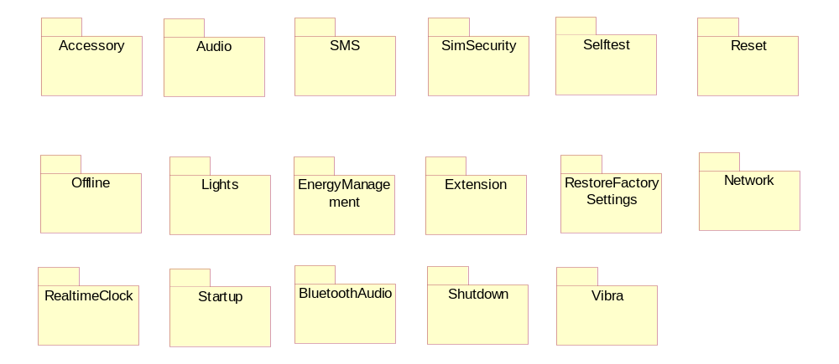
Figure 3.3 Packages
All packages should/may contain Service Logic and the corresponding mapper. Service Logics may use services from other packages, e.g. the startup services may start the initialization functionalities of other services.

Requirements
Requirements are described in reference document [6].

Design
This section describes the recommended design principles of the manufacturer-specific Domestic OS Server adaptation plug-in module implementing the Common DSY Plug-in API.

Class diagrams
The following Figure 5.4 illustrates the generic design pattern for implementing the Licensee DSY. The classes are described in the following sections.
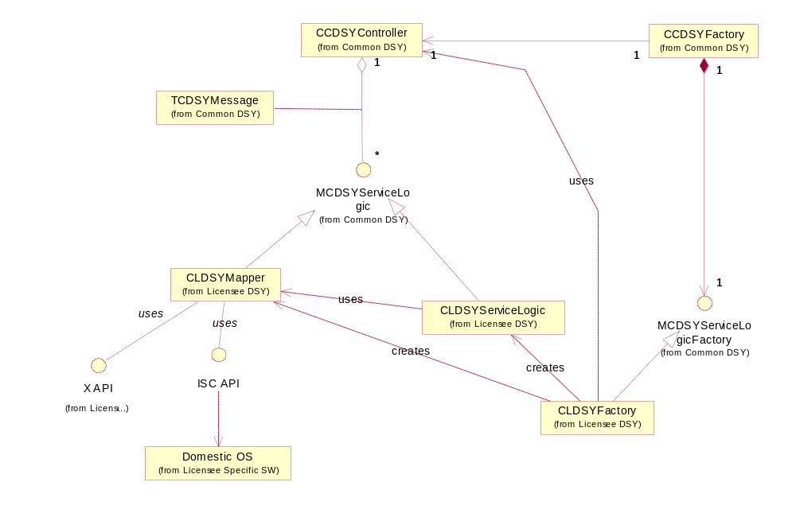
Figure 5.4 Generic class diagram
The following subchapters further explain the generic licensee specific (CLDSYxxx) classes presented in Figure 5.4.

Class CLDSYFactory
The CLDSYFactory creates Service Logics and message mappers and registers them to CCDSYController.

Class CLSDYMapper
The CLSDYMapper provides an interface for receiving and sending ISC/Domestic OS messages. The role of the mapper should be kept simple and only have it providing ISC/Domestic OS message mapping to corresponding DSY messages. All resending and other complicated message handling should be designed/implemented into Service Logics.

Class CLDSYServiceLogic
The CLDSYServiceLogic class should contain all logic needed to implement a certain Service Logic. This Logic may contain e.g. a Domestic OS event, an API event rising or a message resending e.g. when a response from the Domestic OS has not been received in time.

Sequence diagrams

Construction
The following Figure 5.5 illustrates the design pattern of the construction of the Licensee DSY.
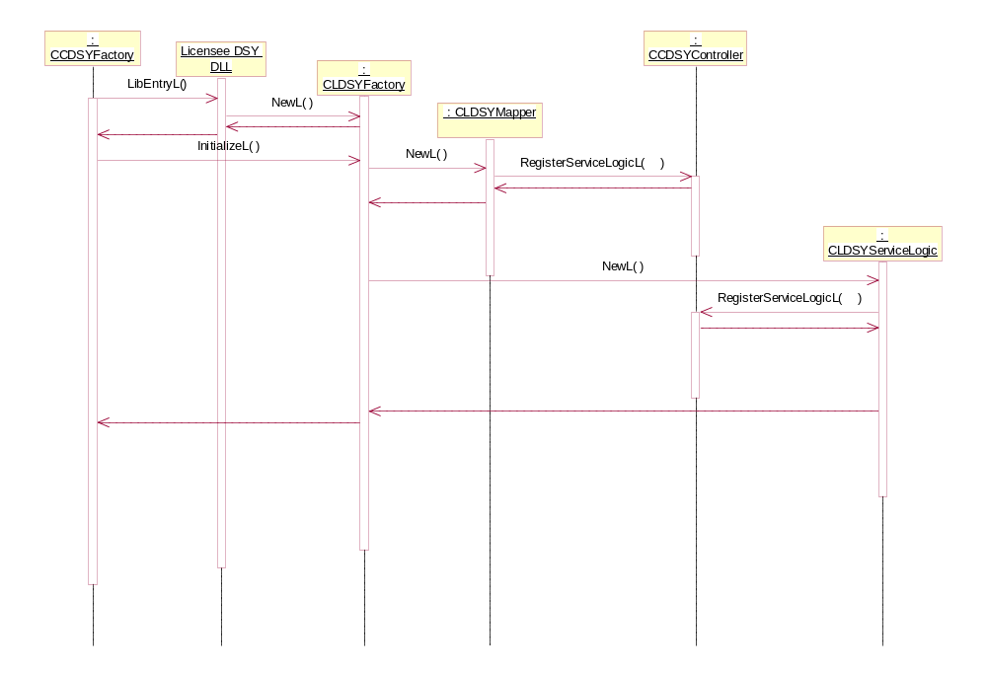
Figure 5.5 Construction

Process message
The following Figure 5.6 describes the design pattern for processing a DSY message.
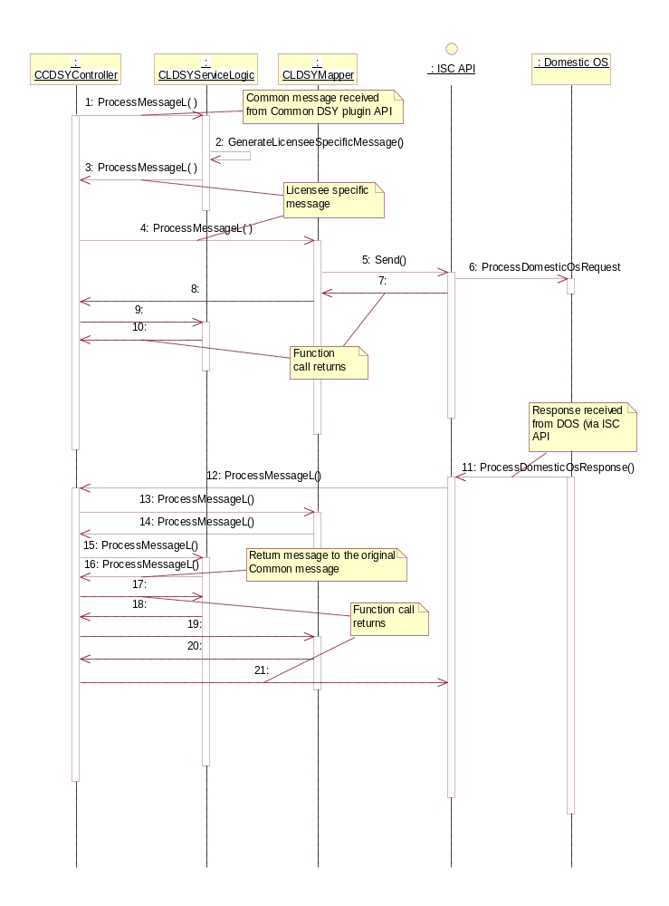
Figure 5.6 Process message

1. | When CCDSYController receives a Common DSY message, it should be handled first in Service Logic. If state information is needed, it should be stored in Service Logic.
2. – 4. | Service Logic should send a LDSY message to the Domestic OS via a corresponding mapper, which does the message mapping between the Domestic OS and the DSY.
5. – 6. | A message is sent to the Domestic OS.
7. – 10. | The function call path returns back to the controller.
11. – 21. | The function path of the return message.

Responses from the Domestic OS should be received by a corresponding mapper, which should create a DSY message to be processed in Service Logic.
For simple services or for stack memory optimization purposes, the implementation of Service Logic and the corresponding mapper could be included into the same class.

Expire message
The following Figure 5.7 describes the Expire message feature.
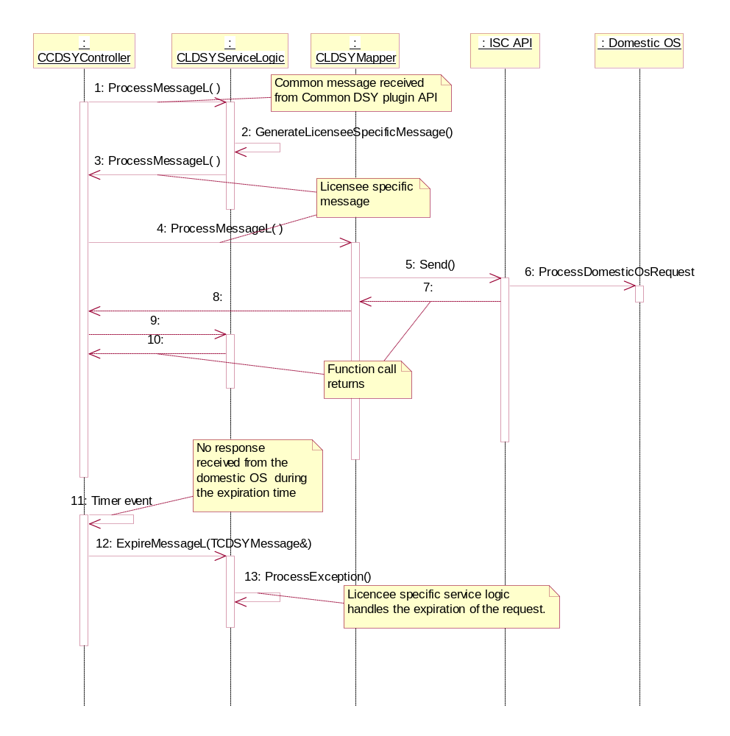
Figure 5.7 ExpireMessageL
The ExpireMessageL method of the corresponding Service Logic is called when the expiration time of the request message has been filled up without a response to that message (arrows 11 & 12). The default implementation also removes the dynamic request from the list of active requests.

Destruction
The following Figure 5.8 describes the destruction of the Licensee DSY.
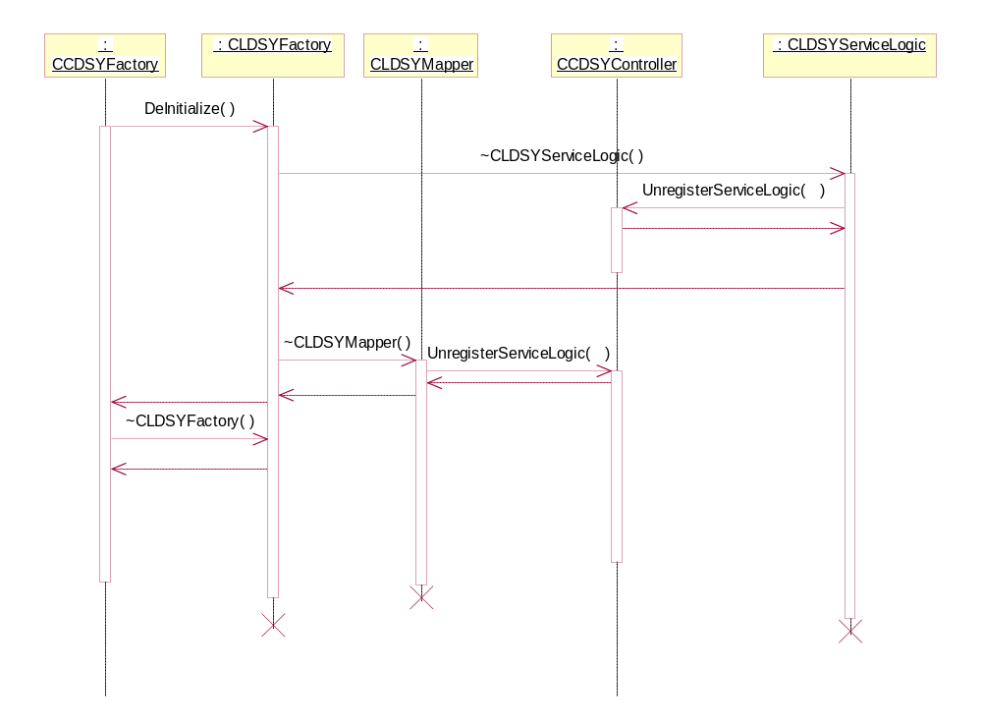
Figure 5.8 Destruction
Upon request, CCDSYFactory starts the destruction process by calling the DeInitialize function in CLDSYFactory. The unregistration to CCDSYController should be made either during the DeInitialize function call or in the destruction phase of CLDSYFactory.
Note: CLDSYServiceLogic should be destroyed before the corresponding mapper if there are any deinitialization messages required by the Domestic OS.

Code examples
Code examples can be found in reference document [4].

