S60 3.2

DOS Server System Agent Extension

Design Document

Team name | Author
TP/S60/Core/Base Services/System Software | Ilkka Karvonen

Change history:

Version | Date | Status | Comments
2.0 | 05.12.2006 | Approved | Document updated
1.0 | 31.08.2006 | Approved

Table of contents:

1. Document control 4
1.1 References 4
1.2 Documentation conventions 4
1.3 Abbreviations 4
2. General 5
2.1 Introduction 5
2.2 Subsystem environment 5
2.3 Services required 6
2.3.1 From the Symbian OS subsystems 6
2.3.2 From HW 6
2.4 Services provided 7
2.4.1 UI 7
2.4.2 SW IF 7
3. Design 8
3.1 Class diagrams 8
3.1.1 Subsystem 8
3.2 Class descriptions 9
3.2.1 CSaeThread 9
3.2.2 CSae 9
3.2.3 CSaePubSubNotifier 10
3.2.4 CSaeEtelObserver 10
3.2.5 CSaeGprsAvailabilityObserver 11
3.2.6 CSaeConnMonObserver 12
3.3 Operations 13
3.3.1 Creating and initializing SAE 13
3.3.2 GPRS registration status information is received from MMETel 13
3.3.3 GPRS status information is received from Connection Monitor 14
4. System resource usage 15
4.1 Files 15
4.2 Databases 15
4.3 Memory consumption 15
4.4 Task allocation 15
5. Exception handling 16
6. Usage 17
6.1 User's guide 17

Document control

References

- Publish and Subscribe | http://www.symbian.com/

Documentation conventions
Code is shown with Courier New font.

Abbreviations

API | Application Programming Interface
DOS | Domestic Operating System
DOS Server | S60 server that offers an API for Symbian OS side applications to use services offered by DOS
HW | Hardware
MMETel | Multimode Telephony API
SAE | System Agent Extension
SW | Software
UI | User Interface

General
Note!
Part of API has been flagged with __ACCESSORY_FW and RD_STARTUP_CHANGE -flags.
Name “SAE – System Agent Extension” originates from old Symbian version, where “SA – System Agent” was used and SAE was implemented as on extension for SA. Nowadays SA API is deprecated and SAE uses Publish and Subscribe as recommended by Symbian.

Introduction
The System Agent Extension (SAE) subsystem of Series 60 Platform Application SW is responsible for monitoring Domestic OS related system state information and publishing the properties. Clients are then responsible to listen property changes by using subscribe (see Figure 2.1).
Kernel

MMETel

-RPhone
-RMobilePhone

Connection Monitor

SAE
Client 1
Client 2
Client n
Subscribe
Publish
Figure 2.1 System Agent Extension environment
SAE is publisher. Clients are subscribers.
Some of S60 Platform’s Publish and Subscribe properties are updated by SAE and some of them are updated by other components.
SAE has no user interface. Publish and Subscribe is specified in reference document [1].
DOS Server launches SAE to it’s own thread at the startup phase of the phone when first client connects to DOS Server. SAE is operational during the power on period.

Subsystem environment
The relationships between System Agent Extension and the modules used are shown in Figure 2.2. SAE is dependent on MMETel and Connection Monitor. SAE fetches information from those interfaces and publish them using Publish and Subscribe.
Some S60 Platform specific variables are defined by SAE but still published by some other modules. Those variables are listed in Table 2.2.
Connection Monitor
(from S60)
MMEtel
(from Symbian)
Publish and Subscribe
(from Kernel)

SAE
(System Agent Extension)
Figure 2.2 System Agent Extension environment
Table 2.1 lists the variables of which SAE is responsible for updating. In cases in which variables can be updated by some other modules as well, the table is restricted to define only the information providers where the information is fetched by SAE. See psvariables.h for all state enumerations.
Table 2.1 Variables of which SAE is responsible for updating
State information SAE is responsible to fetch | Definition | Information provider
GPRS Availability | KPSUidGprsAvailability | MMETel
GPRS Status | KPSUidGprsStatus | Connection Monitor
Wcdma Status | KPSUidWcdmaStatus | Connection Monitor

Table 2.2 lists the variables of which SAE is responsible for updating, but variables itself has been defined by other module than SAE, usually by SysAgent2. In cases in which variables can be updated by some other modules as well, the table is restricted to define only the information providers where the information is fetched by SAE.
Table 2.2 Variables of which SAE is responsible for updating, but not defined by SAE.
State variable/event |  | Responsible module
Network status | KUidNetworkStatus | MMETel
Network strength | KUidNetworkStrength | MMETel

Services required

From the Symbian OS subsystems
DOS Server lauches SAE at startup. The state events are routed to S60 Platform applications through Publish and Subscribe. SAE uses the client interfaces of Connection Monitor and MMETel.

From HW
SAE has no direct HW interfaces.

Services provided

UI
SAE does not provide a UI.

SW IF
SAE monitors the system state variables and uses subscribe of Publish and Subscribe to update property values. Publish and Subsribe is the only subsystem this module gives information to. The properties are changed by using RProperty -class. SAE is a stand-alone server so it does not provide any interfaces.

Design

Class diagrams

Subsystem
Figure 3.3 describes the System Agent Extension subsystem class diagram. Symbian framework classes (grey), MMETel (cyan) and Connection Monitor (green) are used to get and update all the states that SAE is responsible for updating Publish and Subscribe properties.
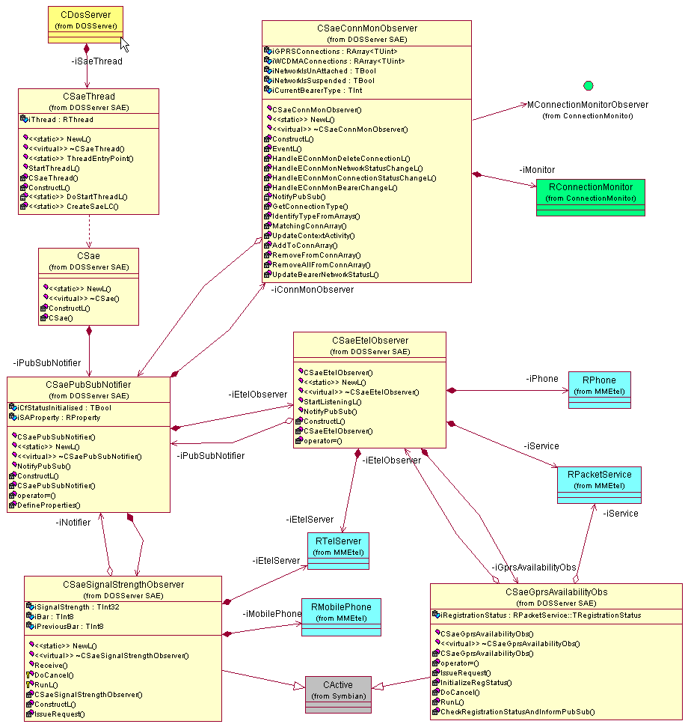
Figure 3.3 System Agent Extension subsystem class diagram

Class descriptions

CSaeThread | Creates SAE to it’s own thread.
CSae | This class creates SAE instance. It is through this class that the SAE subsystem is created.
CSaePubSubNotifier | Defines properties, creates the observers and notifies about state changes to Publish and Subscribe. Changes status information through RProperty -class.
CSaeEtelObserver | Creates a sub-environment to get status information from MMETel. Passes the information to CSaePubSubNotifier.
CSaeGprsAvailabilityObs | An active object that observes GPRS availability.
CSaeConnMonObserver | Implements MConnectionMonitorObserver and listens for GPRS and network states from Connection Monitor.
CSaeSignalStrengthObserver | Observes signal strengths from ETel

CSaeThread

CSaeThread | Creates SAE thread
// construct/destruct/copy
static CSaeThread* NewL() | A two-phase constructor for creating an instance of CSaeThread.
virtual ~CSaeThread() | A destructor.
static TInt ThreadEntryPoint(TAny* aParameter) | Thread's entry point.
void StartThreadL() | Starts the thread creating.
// private
CSaeThread() | The C++ default constructor is hidden.
void ConstructL() | Symbian 2nd phase constructor.
static TInt DoStartThreadL() | Creates CActiveScheduler object and begins SAE creating.
static TInt CreateSaeLC() | Creates SAE.
// data
RThread iThread | A handle to the created thread.

CSae

CSae | Creates and owns the SAE environment
// construct/destruct/copy
static CSae* NewL() | A two-phase constructor for creating an instance of CSae.
virtual ~CSae() | A destructor.
// private
CSae() | The C++ default constructor is hidden.
void ConstructL() | Initializes members and creates an instance of CsaeSysAgentNotifier.
// data
CSaePubSubNotifier* iPubSubNotifier | Publish and Subscribe.

CSaePubSubNotifier

CSaePubSubNotifier | This class defines Publish and Subscribe properties, creates the observers and changes property values
// construct/destruct/copy
CSaePubSubNotifier() | The C++ default constructor.
static CSaePubSubNotifier* NewL() | A two-phased constructor.
virtual ~CSaePubSubNotifier() | A destructor.
ConstructL() | Creates CSaeConnMonObserver and CSaeEtelObserver.
// update
TInt NotifyPubSub(const TUid aVariable, const TInt aState) | Through this method Publish and Subscribe property values are changed.
// private
CSaePubSubNotifier(const CSaePubSubNotifier&) | The copy constructor is private, so using it is prohibited.
CSaePubSubNotifier& operator= (const CSaePubSubNotifier&) | Using the assignment operator is also prohibited.
void DefineProperties() | Define Publish and Subscribe properties.
// data
RProperty iSAProperty | Publish and Subscribe properties.
CSaeSignalStrengthObserver* iSignalObserver | Network signal strength observer.
CSaeConnMonObserver* iConnMonObserver | Connection monitor observer.
CSaeEtelObserver* iEtelObserver | MMETel observer.
TBool iCfStatusInitialised | Indicates whether the calls forwarding information is initialised.

CSaeEtelObserver

CSaeEtelObserver | This class is responsible for creating the MMETel observer
// construct/destruct/copy
CSaeEtelObserver(CSaePubSubNotifier* aPubSubNotifier) | The C++ default constructor.
static CSaeEtelObserver* NewL(CSaePubSubNotifier* aPubSubNotifier) | A two-phased constructor.
virtual ~CSaeEtelObserver() | A destructor.
void ConstructL() | The default Symbian OS constructor.
TInt StartListeningL() | Initialize the Etel observer, creates GPRS session and observers and start listening for events.
// update
void NotifyPubSub( const TUid aVariable, const TInt aState ) | Notifies Publish and Subscribe (delegates it to iPubSubNotifier)
// private
CSaeEtelObserver(const CSaeEtelObserver&) | Using the copy constructor is prohibited.
CSaeEtelObserver& operator= (const CSaeEtelObserver&) | Using the assignment operator is also prohibited.
// data
CSaePubSubNotifier* iPubSubNotifier | A pointer to the Publish and Subscribe. Not owned.
CSaeGprsAvailabilityObs* iGprsAvailabilityObs | Observes the GPRS availability.
RTelServer iEtelServer | An RTelServer session.
RPhone iPhone | An RPhone session.
RPacketService iService | Session with MMETel API. Used to get MS class and network registration status.

CSaeGprsAvailabilityObserver

CSaeGprsAvailabilityObs | This class observes the GPRS availability
// construct/destruct/copy
CSaeGprsAvailabilityObs(CSaeEtelObserver* aEtelObserver, RPacketService* aService) | The C++ default constructor.
virtual ~CSaeGprsAvailabilityObs() | A destructor.
CSaeGprsAvailabilityObs(const CSaeGprsAvailabilityObs&) | By default, prohibits the copy constructor.
CSaeGprsAvailabilityObs& operator= (const CSaeGprsAvailabilityObs&) | Prohibits the assignment operator.
// update
void IssueRequest() | Issues the request.
void DoCancel() | Cancels the request.
void RunL() | Handles the event
void InitializeRegStatus() | Initialize GPRS registration status.
// query
void CheckRegistrationStatusAndInformPubSub() | Checks the current network registration status and informs Publish and Subscribe.
// data
CSaeEtelObserver* iEtelObserver | A pointer to the MMETel observer. Not owned.
RPacketService* iService | Pointer to a Session with MMETel API. Not owned.
RGprs::TRegistrationStatus iRegistrationStatus | A variable for the current GPRS registration status.

CSaeConnMonObserver

CSaeConnMonObserver | Listens for GPRS and network states from Connection Monitor.
// construct/destruct/copy
CSaeConnMonObserver(CSaePubSubNotifier* aPubSubNotifier) | The C++ default constructor.
static CSaeConnMonObserver* NewL(CSaePubSubNotifier* aPubSubNotifier) | A two-phased constructor.
virtual ~CSaeConnMonObserver() | A destructor.
void ConstructL() | Symbian 2nd phase constructor.
// callback
void EventL(const CConnMonEventBase &aConnMonEvent) | Events from Connection Monitor are handled here.
// update
void HandleEConnMonDeleteConnectionL(const CConnMonDeleteConnection& aEvent) | Handles the received CConnMonDeleteConnection events.
void HandleEConnMonNetworkStatusChangeL(const CConnMonDeleteConnection& aEvent) | Handles the received CConnMonNetworkStatusChange events.
void HandleEConnMonConnectionStatusChangeL(const CConnMonDeleteConnection& aEvent) | Handles the received CConnMonConnectionStatusChange events.
void HandleEConnMonBearerChangeL(const CConnMonBearerChange& aEvent) | Handles the received CConnMonBearerChange-events.
void NotifyPubSub() | Notifies Publish and Subscribe (delegates it to iPubSubNotifier)
TSAEConnectionType GetConnectionType( const TUint &aConnId) | Helper function that checks if the connection is of supported connection type.
void IdentifyTypeFromArrays(TUint aConnectionId, TSAEConnectionType& aConnType) | Helper function that checks if the connection ID is allready in some connection type -specific member array.
RArray<TUint>* MatchingConnArray(const TSAEConnectionType& aConnType, TUint aConnId = 0) | Return the connection array specific to connections of passed type.
void UpdateContextActivity(const TSAEConnectionType& aConnType) | Update current context activity to Publish and Subscribe.
void AddToConnArray(const TSAEConnectionType& aConnType, const TUint aConnId) | Adds a new connection to the member array of active connections.
TInt RemoveFromConnArray(const TSAEConnectionType& aConnType, const TUint aConnId) | Removes a connection from the member array of active connections.
void RemoveAllFromConnArray(const TSAEConnectionType& aConnType) | Removes all connections (reset) from the member array of active connections.
void UpdateBearerNetworkStatusL(const TSAEConnectionType& connType) | Checks the state of the network and updates SA state variable accordingly.
// data
CSaePubSubNotifier* iPubSubNotifier | A pointer to the PubSubNotifier instance. Not owned.
RConnectionMonitor iMonitor | Instance of the Connection Monitor interface.
RArray<TUint> iGPRSConnections | An array of active GPRS connections.
RArray<TUint> iWCDMAConnections | An array of active WCDMA connections.
TBool iNetworkIsUnAttached | A flag saying whether the network is unattached or attached.
TBool iNetworkIsSuspended | A flag saying whether the network is suspended or not.
TInt iCurrentBearerType | Keeps state about current bearer type.

Operations
The operation specifications include the creation and initialization of SAE, and one case of handling a state change from each state source (MMETel, Connection Monitor, and DOS Server).

Creating and initializing SAE

Operation | Creating and initializing SAE.
Preconditions | SAE is launched by the DOS Server at startup.
Description | This operation creates and initializes SAE before it is ready to receive indications and updating Publish and Subscribe properties.
Inputs | SAE thread has been created.
Modifies | Creates instances of SAE classes.
Outputs
Postconditions | The subsystem (all classes) is constructed, initialized, and ready to receive indications from MMETel and Connection Monitor.
Related to | All classes of the SAE subsystem.
Related event
Exceptions | The operation is interrupted and all reserved resources freed if the memory is exhausted during the construction of the subsystem.

GPRS registration status information is received from MMETel

Operation | GPRS registration status information is received from MMETel.
Preconditions | The SAE subsystem is running and receiving indications.
Description | SAE is listening for GPRS registration status information from MMETel through the RPacketService interface.
Inputs | SAE receives a notification about the GPRS registration status from MMETel via the active object framework. The notifications get handled in the CSaeGprsAvailabilityObs::RunL() callback operation.
Modifies | The GPRS registration status variable of Publish and Subscribe is modified according to the received event from MMETel.
Outputs | KPSUidGprsAvailability -property of Publish and Subscribe.
Postconditions | KPSUidGprsAvailability has been updated.
Related to | The class CSaeGprsAvailabilityObs.
Related event
Exceptions

GPRS status information is received from Connection Monitor

Operation | GPRS status information is received from Connection Monitor.
Preconditions | The SAE subsystem is running and receiving indications.
Description | SAE is listening for GPRS and WCDMA events from Connection Monitor.
Inputs | Connection Monitor sends events about network and context changes to its clients. SAE (in class CSaeConnMonObs) checks whether the received event is GPRS or WCDMA related and if it should be handled somehow.
Modifies | The GPRS or WCDMS status variable of Publish and Subscribe is modified according to the received event from MMETel.
Outputs | KPSUidGprsStatus or KPSUidWcdmaStatus -property of Publish and Subscribe.
Postconditions | KPSUidGprsStatus or KPSUidWcdmaStatus has been updated.
Related to | The class CSaeConnMonObs.
Related event
Exceptions

System resource usage

Files
System Agent Extension does not use files.

Databases
System Agent Extension does not use any databases.

Memory consumption
N/A

Task allocation
System Agent Extension runs in the thread created by DOS Server.

Exception handling
The leave mechanism of the Symbian OS environment is used.

Usage

User's guide
N/A

