S60 3.1
DSY Test Tool
Design Document

Team name | Author

Change history:

Version | Date | Status | Comments
1.0 | 17.11.2004 | Approved
Table of contents:

1. Document control 5
1.1 References 5
1.2 Documentation conventions 5
1.3 Abbreviations 5
1.4 Definitions 5
2. General 6
2.1 Introduction 6
2.2 Services required 6
2.2.1 From Symbian OS subsystems 6
2.2.2 From the Domestic OS subsystems 6
2.2.3 From HW 6
2.3 Services provided 6
2.3.1 UI 6
2.3.2 SW IF 6
2.4 DSY Test Tool Concepts 7
2.4.1 Test Suite 7
2.4.2 Test Case 7
2.4.3 Plug-in Module 7
2.4.4 Plug-in Specific Test Case 7
2.4.5 Example 7
3. Design 9
3.1 Static Model 9
3.1.1 Component Diagram 9
3.1.2 Component Descriptions 11
3.1.2.1 DSY Test Tool Core 11
3.1.2.2 STIF Adapter 11
3.1.2.3 DosServer Control Plug-in Module 12
3.1.2.4 Domestic OS Plug-in Module 12
3.1.3 Class Diagrams 12
3.1.3.1 DSY Test Tool Base Classes 12
3.1.3.2 Plug-in Module Framework 16
3.1.3.3 Plug-in Module Interface 18
3.1.3.4 Test Server 20
3.1.3.5 Adapter Interface 22
3.1.3.6 STIF Adapter 24
3.1.3.7 DosServer Test Case Plug-in Module 26
3.1.4 Enumerations 30
3.1.5 UIDs 31
3.1.6 Flag definitions 31
3.1.7 State diagrams 33
3.1.7.1 Test Case Wrapper States 33
3.1.7.2 DosServer Plug-in Test Case States 34
3.2 Operations 35
3.2.1 Startup 35
3.2.2 Creating Test Cases 38
3.2.3 Running Test Cases 41
3.2.4 Test Server 44
3.2.5 DosServer Plug-in 47
4. System resource usage 51
4.1 Files 51
4.2 Databases 51
4.3 Memory consumption 51
4.4 Task allocation 51
5. Exception handling 52
6. Usage 53
6.1 Building 53
6.2 Setting up a Memory Card 53
6.3 Running test cases 54
6.4 Interpreting results 54
6.5 Logging 54
7. Test Case Implementation 56
7.1 Helper Macros 56
7.2 Examples 57

Document control

References

- Series 60 2.8 Common DSY Design Document
- Series 60 STIF Test Framework User's Guide

Documentation conventions
Code is shown with Courier New font.

Abbreviations

API | Application Programming Interface
CDSY | Common DSY
DLL | Dynamic Link Library
DOS | Domestic Operating System
HW | Hardware
IF | Interface
LDSY | Licensee DSY
OS | Operating System
SAE | System Agent Extension
STIF | System Testing and Integration Factory
SW | Software
UI | User Interface

Definitions

Common DSY | A platform that provides framework for Licensee DSY.
DosServer | A Series 60 component that provides miscellaneous platform functions for Series 60 applications. DosServer plug-in API is implemented in Common DSY.
DSY | Domestic OS Server plugin module. It includes both Common and Licensee DSY.
ECom | Symbian framework for plug-in implementations.
Licensee DSY | Licensee’s DSY.
MMP | Project definition file.

General
This document describes the testing environment for Licensee DSY module.

Introduction
Common DSY [1] is a platform component, which provides a common implementation framework for Licensee DSY. It implements the DosServer plug-in API and translates the DosServer function calls to Common DSY messages. Common DSY routes DSY messages to the service logics registered to the messages. Licensee DSY contains the implementation of licensee specific logic as well as the implementation of message mapping between DSY and Domestic OS.
DSY Test Tool is a test driver that is used to test the functionality of Licensee DSY. It provides a basic set of test cases that are run using DosServer client API. DSY Test Tool can be extended with stub components for better test coverage. It integrates to STIF TestFramework, which provides the UI for running test cases.

Services required

From Symbian OS subsystems
DSY Test Tool uses ECom framework to load plug-in modules that specify test cases.

From the Domestic OS subsystems
The communication with Domestic OS is done in Licensee DSY and is out of scope of this document.

From HW
This component has no direct HW interfaces.

Services provided

UI
DSY Test Tool does not have an UI.

SW IF
DSY Test Tool provides an ECom plug-in interface that can be used to extend its functionality with plug-in test modules. It also provides a client-server interface that is used by the plug-in modules to communicate with the test tool.

DSY Test Tool Concepts
There are several important concepts in DSY Test Tool that are described here.

Test Suite
A test suite is a collection of test cases that are somehow related to each other. The purpose of a test suite is to specify a group of tests that can be run with the test case repeater. Each test suite may contain sub test suites. DSY Test Tool contains one root test suite and test cases and sub test suites are added to that. Thus the test cases are organized into a directory structure.

Test Case
From the STIF-TF UI point of view, one test case is a single unit of execution. A test case is run by STIF-TF and when it returns, the results from the run are shown in the UI and logged. From DSY Test Tool point of view, a test case can be divided into multiple parts that may execute independently of each other. When all test case parts are complete, the results are passed to the STIF-TF.
A test case contains an ID, which is a 32-bit number. When linking additional functionality to existing test cases, the plug-in module developer needs to know the ID of the test case where to functionality is to be linked and the ID of the stub object that the new functionality represents.

Plug-in Module
A plug-in module is a dynamically loaded library that may provide the following to DSY Test Tool:
- A stub object that identifies the plug-in module.
- New test cases.
- Additional functionality to test cases provided by other plug-in modules.
Just as a test case is identified with an ID, the stub objects provided by the plug-in modules need to have unique IDs. However, a plug-in module does not necessarily need to provide a stub object. It may as well provide new test cases that use the ID of an existing stub object defined in another plug-in module.

Plug-in Specific Test Case
A plug-in specific test case provides functionality to test cases. A test case object itself does not do anything useful, but it needs to be linked to functionality provided by the plug-in modules. A pair of IDs identifies a plug-in specific test case: The test case ID and the stub object ID specified by the plug-in module.

Example
dosservercontrol.DLL plug-in module provides a stub object with ID 1 and adds three test cases:
- Test suite, which has the name “Lights” that contains following test cases:
- Test case with name “Lights On” and ID 5
- Test case with name “Lights Off” and ID 6

domesticosplugin.DLL plug-in module provides a stub object with ID 2 and adds one test case:
- Test suite, which has the name “Accessory Events” and contains following test cases:
- Test case with name “Headset Connected” and ID 10

After all plug-in modules have created the test case objects DSY Test Tool integrates plug-in specific functionality into the test case objects:
Dosservercontrol.DLL plug-in adds:
- DosServer function call to turn lights on to case 5
- DosServer function call to turn lights off to case 6
- DosServer event observer that waits for “Headset Connected” event to case 10

Domesticosplugin.DLL module adds:
- Functionality to verify Lights On message sent by licensee DSY to case 5
- Functionality to verify Lights Off message sent by licensee DSY to case 6
- Functionality to simulate “Headset Connected” message to case 10

This results in following test suites:
- Test suite “Lights”
- Test case “Lights On” with ID 5
- Dosserverplugin part with ID 1 and functionality “Turn Lights On”
- Domesticosplugin part with ID 2 and functionality “Verify Lights On message”
- Test case “Lights Off” with ID 6
- Dosserverplugin part with ID 1 and functionality “Turn Lights Off”
- Domesticosplugin part with ID 2 and functionality “Verify Lights Off message”
- Test suite “Accessory Events”
- Test case “Headset Connected” with ID 10
- Dosserverplugin part with ID 1 and functionality “Wait for AccessoryModeChanged event”
- Domesticosplugin part with ID 2 and functionality “Simulate Headset Connected message”

Design

Static Model
This chapter describes the static object model of the component.

Component Diagram
Figure 3.1 shows the components of DSY Test Tool and their relations to DSY and DosServer.
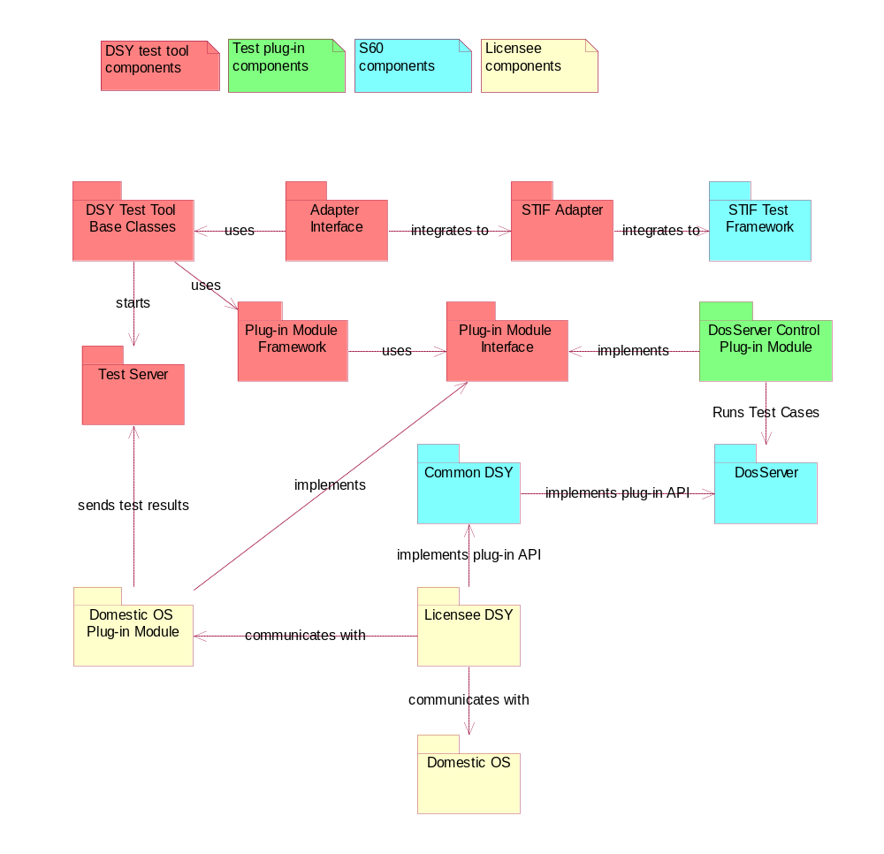
Figure 3.1 DSY Test Tool Components

Component Descriptions

DSY Test Tool Core
DSY Test Tool Core is implemented into dsytfcore.DLL and the implementation is divided into 5 sub-components.

DSY Test Tool Base Classes
The DSY Test Tool base classes component contains the following:
- Entry point to DSY Test Tool library.
- Test suite class.
- Test case base classes that are subclassed when creating test cases.
- Test environment class that contains global variables such as test case logging facilities.
- Helper classes for active object and timer management.
- Test case repeater class that can be used to run the test cases in a test suite repeatedly.

Plug-in Module Framework
The Plug-in module framework contains the following:
- A framework that loads and manages the test modules that are specified in ECom plug-ins. Each plug-in module may specify additional functionality to existing test cases.
- A test case class that extends from the base test case class and is used to manage the plug-in specific test cases.

Plug-in Module Interface
The Plug-in module interface defines the classes that need to be implemented when creating a new plug-in module to DSY Test Tool.

Test Server
DSY Test Tool contains two test servers. One is running in the thread of the test framework and one is running in a thread that is created when DSY Test Tool is started. The purpose of the test servers is to allow communication with the test framework from remote processes or threads. For example a plug-in component that is used for domestic OS message checking needs to use the test server, since DSY runs in DosServer process and DSY Test Framework runs in STIF-TF process.

Adapter Interface
The adapter interface is provided so that DSY Test Tool can be plugged into different test frameworks. The implementation for STIF Test Framework integration has been made.

STIF Adapter
Implements the adapter interface provided by DSY Test Tool to integrate into STIF Test Framework. The implementation is in dsytfstifadapter.DLL. It does not export any functions except LibEntryL, which is called by STIF-TF.

DosServer Control Plug-in Module
DosServer Control module is a plug-in module implementation that provides test cases that are run on top of the DosServer client API. The module is implemented into dosservercontrol.DLL.

Domestic OS Plug-in Module
Domestic OS plug-in module is an optional component that can be used to increase test coverage and to perform test cases that are not possible with DosServer plug-in alone. For example the following functionality could be implemented with the help of a domestic OS plug-in module:
- The simulation of startup, reset and shutdown functions. For example, the ResetGenerate call of DosServer should not be delegated to the domestic OS during tests.
- The generation of events for automated test cases. For example a simulated AccessoryModeChanged event could be generated.
The actual functionality of the Domestic OS plug-in module is out of the scope of this document. This document describes the interfaces that are used when integrating the module into DSY Test Tool.

Class Diagrams

DSY Test Tool Base Classes
Figure 3.2 shows the base classes of DSY Test Tool.
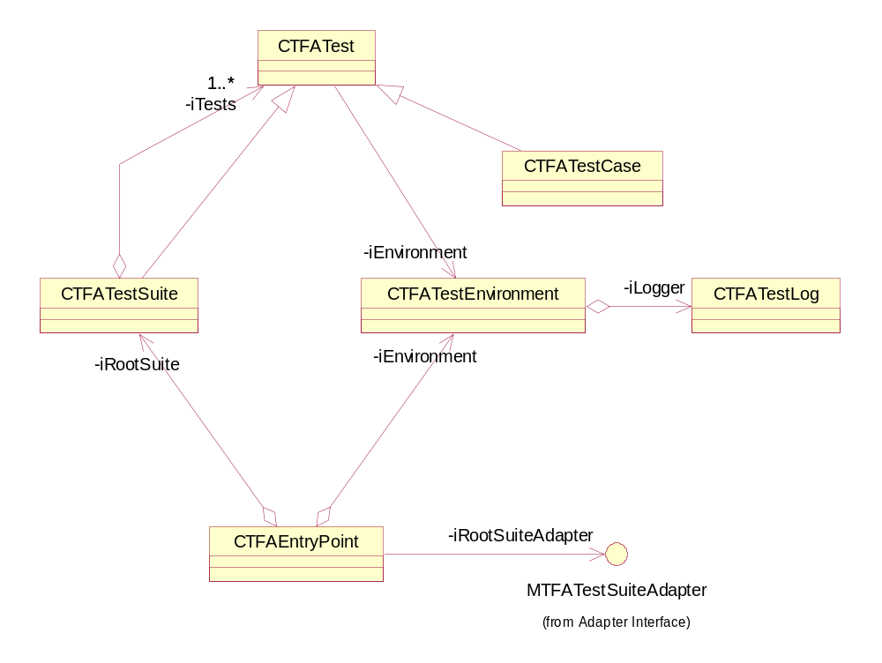
Figure 3.2 DSY Test Tool Core

Class | Description | Header file
CTFATest | A base class for the test suite and test case classes. CTFATest class contains a reference to the test environment and the name of the test case or test suite. | CTFATest.H
CTFATestCase | Defines the interface, which is used to run test cases. CTFATestCase needs to be subclassed and the subclass must provide implementation for the SetupL, RunTestL and Teardown virtual methods. CTFATestCase also exports functions that can be used to set test execution flags and test case timeout | CTFATestCase.H
CTFATestSuite | Test suite is a container for test cases and other test suites. It provides functions to add members and to access them. Once added, a suite member cannot be removed. | CTFATestSuite.H
CTFATestEnvironment | Test environment contains data that is shared among all test cases and test suites via the CTFATest base class. It provides access to test logger and global test execution flags. | CTFATestEnvironment.H
CTFAEntryPoint | The entry point class is intended to be subclassed into the adapter library that integrates DSY Test Tool with the test framework executing tests. It declares virtual functions that are used to created adapter objects for test suite and test case objects. | CTFAEntryPoint.H
CTFATestLog | The adapter library subclasses the test logger object and calls to the logger are delegated to the logger provided by the test framework running tests. | CTFATestLog.H
MTFATestSuiteAdapter | The entry point contains a reference to the root test suite and corresponding root test suite adapter. See Section 3.1.3.5 for more details | MTFATestSuiteAdapter.H

Figure 3.3 shows the utility classes provided by DSY Test Tool core for plug-in modules.
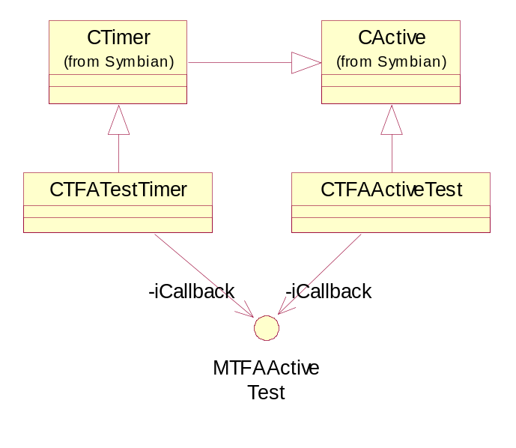
Figure 3.3 DSY Test Tool Core Utility Classes

Class | Description | Header file
CTFATestTimer | An implementation of a timer object that takes an instance of the MTFAActiveTest interface as a constructor parameter and notifies timer events via that interface. | CTFATestTimer.H
CTFAActiveTest | CActive implementation that notifies the completion of the request via the MTFAActiveTest callback interface. | CTFAActiveTest.H
MTFAActiveTest | A callback interface used by the timer and active test objects to notify timer and asynchronous events. | MTFAActiveTest.H
CTimer | A Symbian timer base class. | e32base.H
CActive | A Symbian active object. | e32base.H

Figure 3.4 shows the relations of the test case repeater class.
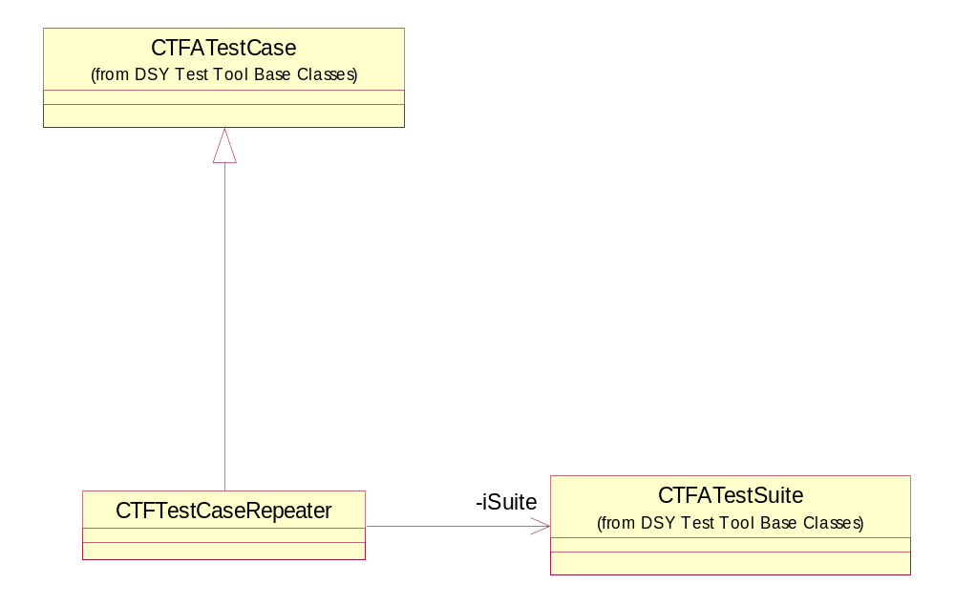
Figure 3.4 DSY Test Tool Core Test Case Repeater

Class | Description | Header file
CTFTestCaseRepeater | Runs the test cases of a test suite sequentially or by random selection | CTFTestCaseRepeater.H
CTFATestCase | See Figure 3.2 DSY Test Tool Core | CTFATestCase.H
CTFATestSuite | See Figure 3.2 DSY Test Tool Core | CTFATestSuite.H

A test case repeater contains a reference to a test suite. The repeater runs the members of the test suite as many times as specified in the repeater parameters. Currently there are following parameters:
Random testing: Selects one of the test cases by random and runs it. Then selects the next case by random and runs it. This is repeated until n test cases have been run or one test case fails.
Sequential testing: Runs the first test n times, then second n times until all tests have been run. After that runs each test once starting from the last test and repeating this loop n times and finally runs each test once starting from the first test and repeats this loop n times. The test case is terminated if any of the tests fail. For example:
Test cases 1, 2 and 3, repeat count 3 would result in following 1,1,1,2,2,2,3,3,3 ; 3,2,1,3,2,1,3,2,1 ; 1,2,3,1,2,3,1,2,3. Note that the amount of time spent running the tests increases very rapidly if the test suite contains lots of tests.

Plug-in Module Framework
Figure 3.5 shows the plug-in framework of DSY Test Tool.
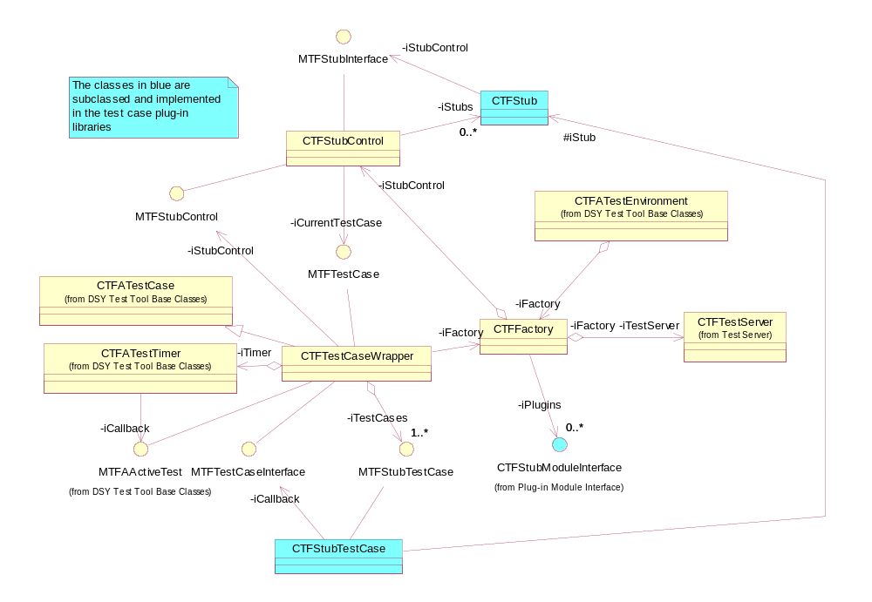
Figure 3.5 Plug-in Module Framework

Class | Description | Header file
CTFFactory | Loads the ECom plug-in modules and loads the test cases from them. Also exports a set of static functions that are used to access the test server. The factory object is stored in thread-local storage so it is accessible from any code within the thread of DSY Test Tool. | CTFFactory.H
CTFStubControl | Maintains a list of stub objects loaded from the plug-in modules and contains a reference to the currently executing test case. The plug-in module specific parts of the test case are available via the stub controller methods. | CTFStubControl.H
CTFStub | The stub class is subclassed by the plug-in modules, and each plug-in module that implements a stub needs to have a unique stub ID. Provides a reference to the currently executing test case to the plug-in modules. | CTFStub.H
CTFStubTestCase | The base class for plug-in specific test case implementation. Provides access to test case logger and defines the callback function that is used to complete the plug-in specific test case. The subclass needs to provide implementation for the SetupL, RunL and Teardown methods. | CTFStubTestCase.H
CTFTestCaseWrapper | An implementation of CTFATestCase that is used to control plug-in specific test cases. See Section 3.1.7.1 for state diagram and 3.2.2 for sequences. | CTFTestCaseWrapper.H
CTFStubModuleInterface | The ECom plug-in interface that needs to be implemented into every plug-in module. See Section 3.2.1 for sequences. | CTFStubModuleInterface.H
CTFATestCase | See Section 3.1.3.1 | CTFATestCase.H
CTFATestTimer | See Section 3.1.3.1 | CTFATestTimer.H
CTFATestEnvironment | See Section 3.1.3.1 | CTFATestEnvironment.H
CTFTestServer | See Section 3.1.3.4 | CTFTestServer.H
MTFStubTestCase | Defines the interface to the plug-in specific test case object. This interface is implemented by the CTFStubTestCase class and should not be used directly. | MTFStubTestCase.H
MTFStubInterface | Defines the public interface between CTFStub and CTFStubControl objects. The stub can access the plug-in specific parts of the currently executing test case via this interface. This interface is provided to the stub object via CTFFactory. | MTFStubInterface.H
MTFStubControl | Defines the public interface between a test case implementation and a CTFStubControl object. CTFFactory provides this interface to the test case object. The test case implementation sets itself as the active test case via this interface when test execution starts. | MTFStubControl.H
MTFTestCase | Defines the public interface between the CTFStubControl and the currently executing test case. The stub controller then has access to the stub-specific parts of the currently executing test case. This interface is provided to the stub controller via the MTFStubControl interface. | MTFTestCase.H
MTFTestCaseInterface | A callback interface between the plug-in specific test case object and the CTFTestCaseWrapper object running the plug-in specific parts. Defines the TestComplete method that is called by the plug-in specific part when it has finished processing. Also provides access to the test case logging facilities to the plug-in test case objects. | MTFTestCaseInterface.H
MTFAActiveTest | See Section 3.1.3.1 | MTFAActiveTest.H

Plug-in Module Interface
Figure 3.6 shows the classes of the plug-in module interface that is implemented by modules that provide test cases for DSY Test Tool.
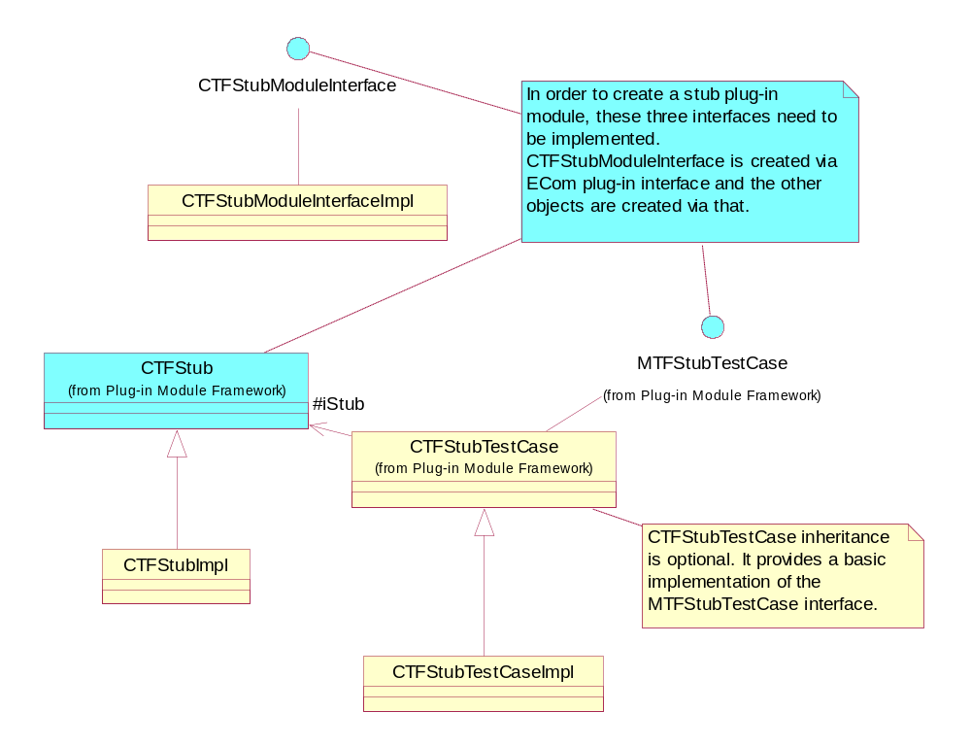
Figure 3.6 Plug-in Module Interface

Class | Description | Header file
CTFStubTestCase | Base class for plug-in specific test case implementation. Provides access to test case logger and defines the callback function that is used to complete the plug-in specific test case. The subclass needs to provide implementation for the SetupL, RunL and Teardown methods. | CTFStubTestCase.H
CTFStubModuleInterface | The ECom plug-in interface that needs to be implemented into every plug-in module. See Section 3.2.1 for sequences. | CTFStubModuleInterface.H
CTFStub | Stub class is subclassed by the plug-in modules and each plug-in module that implements a stub needs to have a unique stub ID. Provides a reference to the currently executing test case to the plug-in modules. | CTFStub.H
MTFStubTestCase | Defines the interface to the plug-in specific test case object. This interface is implemented by the CTFStubTestCase class and should not be used directly. | MTFStubTestCase.H
CTFStubModuleInterfaceImpl | Example implementation of the ECom plugin interface.
CTFStubImpl | Example implementation of a stub.
CTFStubTestCaseImpl | Example test case implementation.

Test Server
Figure 3.7 shows the test server classes.
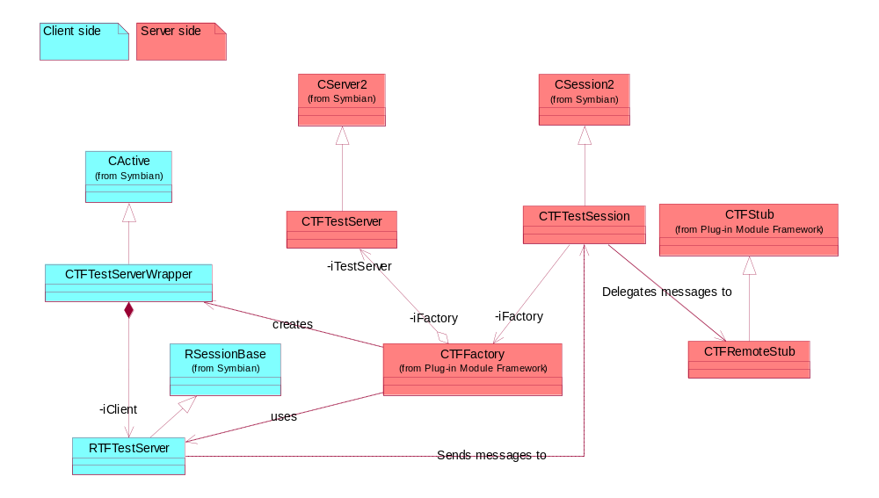
Figure 3.7 Test Server

Class | Description | Header file
CActive | A Symbian active object. | e32base.H
CTFTestServerWrapper | An active object that is used to call the test server client session and to delete itself when processing is complete. | CTFTestServer.H
RSessionBase | A Symbian base class for client sessions. | e32std.H
RTFTestServer | A client interface implementation to access the test server. The functions of RTFTestServer are not exported, but they are used via static functions defined in CTFFactory. | CTFTestServer.H
CServer2 | A Symbian base class for servers. | e32std.H
CSession2 | A Symbian base class for server sessions. | e32std.H
CTFTestServer | Implementation of the test server. Extends CServer2. | CTFTestServer.H
CTFTestSession | Implementation of the test server session. The session object delegates messages to plug-in components via the CTFRemoteStub interface if the stub implements that interface. | CTFTestServer.H
CTFFactory | The factory object starts the test servers. It provides a set of static functions that can be used by the plug-in components to access the test framework from other threads or processes. See Section 3.2.4 for sequences. | CTFFactory.H
CTFStub | See Section 3.1.3.2. | CTFStub.H
CTFRemoteStub | Extension of the CTFStub base class that is implemented by plug-in modules that need to support calls from remote processes or threads. The test server calls the ProcessMessageAndCompleteL method of the stub when a client sends data to the test server. The stub can then write data back to the client via the RMessage2 methods. See Section 3.2.4 for details. | CTFRemoteStub.H

Adapter Interface
Figure 3.8 shows the interface classes that need to be implemented when integrating the DSY Test Tool core into the test driver framework. DSY Test Tool contains an implementation of this interface that integrates with STIF Test Framework.
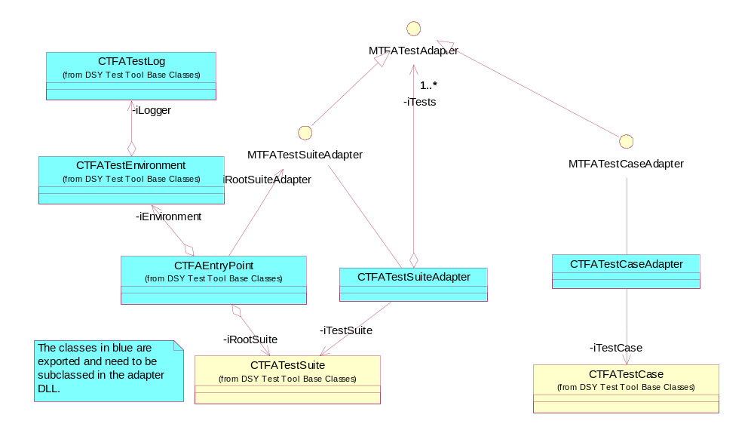
Figure 3.8 Adapter Interface

Class | Description | Header file
CTFATestLog | The adapter library implementation of the logger needs to delegate the logger method calls to the actual logger provided by the test framework. | CTFATestLog.H
CTFATestEnvironment | The adapter library implementation of the test environment needs to initialize the test logger. | CTFATestEnvironment.H
CTFAEntryPoint | The adapter library implementation of the entry point class needs to provide functions that are used to create the test environment, test suite adapters and test case adapters. | CTFAEntryPoint.H
CTFATestSuiteAdapter | The adapter library implementation needs to provide a test suite implementation that delegates test suite methods to the DSY Test Framework. STIF Test Framework does not have the concept of test suites, so the STIF adapter implementation of this does nothing. | CTFATestSuiteAdapter.H
CTFATestCaseAdapter | The adapter library implementation needs to call the SetupL, RunTestL and Teardown methods of the CTFATestCase object wrapped into the adapter. | CTFATestCaseAdapter.H
CTFATestSuite | See Section 3.1.3.1 | CTFATestSuite.H
CTFATestCase | See Section 3.1.3.1 | CTFATestCase.H
MTFATestSuiteAdapter | Public interface for test suite adapter implementations. | MTFATestSuiteAdapter.H
MTFATestAdapter | Public interface for test suite and test case adapter implementations. | MTFATestAdapter.H
MTFATestCaseAdapter | Public interface for test case adapter implementations. | MTFATestCaseAdapter.H

STIF Adapter
Figure 3.9 shows the classes of the STIF Test Framework adapter implementation.
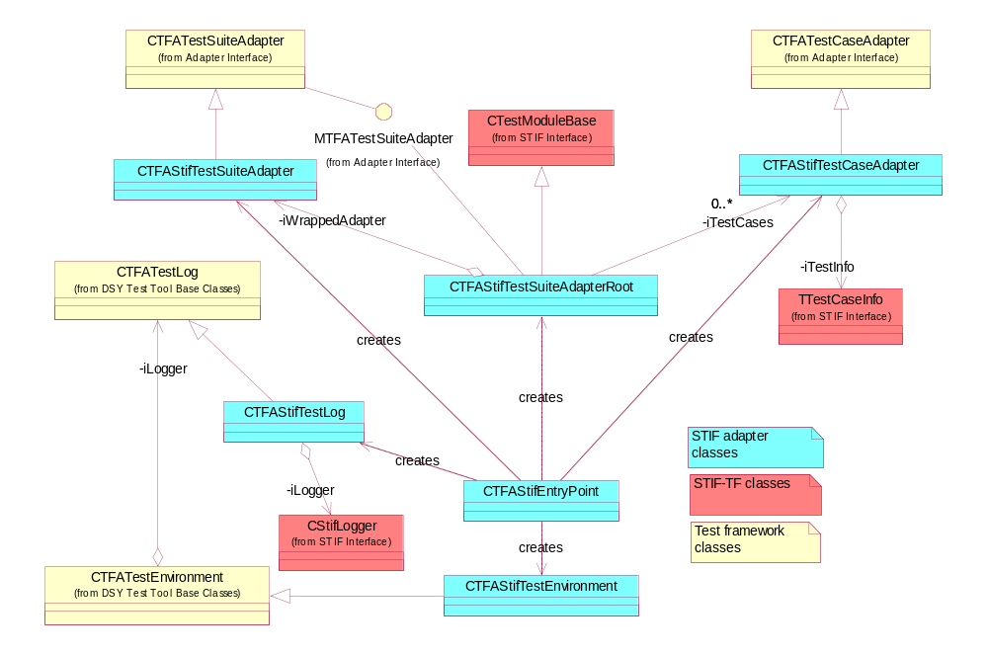
Figure 3.9 STIF Adapter

Class | Description | Header file
CTFATestSuiteAdapter | See Section 3.1.3.5 | CTFATestSuiteAdapter.H
CTFATestLog | See Section 3.1.3.5 | CTFATestLog.H
CTFATestEnvironment | See Section 3.1.3.5 | CTFATestEnvironment.H
CTFATestCaseAdapter | See Section 3.1.3.5 | CTFATestCaseAdapter.H
MTFATestSuiteAdapter | See Section 3.1.3.5 | MTFATestSuiteAdapter.H
CTFAStifTestSuiteAdapterRoot | Implements the CTestModuleBase interface of STIF Test Framework. When STIF-TF queries for test cases, this fetches the TTestCaseInfo objects from the CTFStifTestCaseAdapter objects. When STIF-TF runs a test case, this delegates the calls to the correct test case adapter that then delegates it to the test case object of DSY Test Tool. | CTFAStifTestSuiteAdapterRoot.H
CTFAStifTestSuiteAdapter | Implementation of test suite adapter interface. Since STIF Test Framework does not have functionality to group test cases, this class does nothing. | CTFAStifTestSuiteAdapter.H
CTFAStifTestCaseAdapter | Called by the CTFAStifTestSuiteAdapterRoot object to run a test case. A test case adapter maps the data from a CTFATestCase into TTFTestInfo format understood by STIF-TF. | CTFAStifTestCaseAdapter.H
CTFAStifTestLog | Delegates logger methods to CStifLogger. | CTFAStifTestLog.H
CTFAStifEntryPoint | Implements functionality to create STIF adapter objects for DSY Test Tool suites and test cases. | CTFAStifEntryPoint.H
CTFAStifTestEnvironment | Creates the CTFAStifTestLog object and provides it to DSY Test Tool. | CTFAStifTestEnvironment.H
CTestModuleBase | STIF-TF base class for test modules. | stiftestinterface.H
CStifLogger | Logger class provided by STIF-TF. | stiflogger.H
TTestCaseInfo | STIF-TF test case specification. | stiftestinterface.H

DosServer Test Case Plug-in Module
Figure 3.10 shows the classes of the DosServer Test Case Plug-in Module.
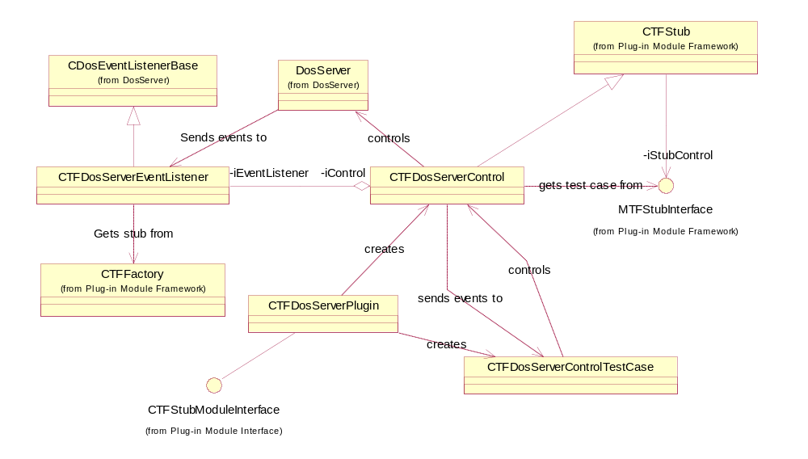
Figure 3.10 DosServer Test Case Plug-in Module

Class | Description | Header file
CDosEventListenerBase | Base class for DosServer event listeners
CTFDosServerEventListener | Implementation of DosServer event listener that delegates event notifications to CTFDosServerControl stub object. | CTFDosEventListener.H
CTFFactory | See Section 3.1.3.2. The event listener gets the factory object from TLS and gets a pointer to the CTFDosServerControl stub object via that. | CTFFactory.H
DosServer | DosServer client API classes.
CTFDosServerControl | Implementation of the CTFStub class. Provides functionality for the test cases to call API DosServer functions. Also provides a function that is called by the DosServer event listener to notify the test cases about DosServer events. | CTFDosServerControl.H
CTFDosServerPlugin | Implementation of CTFStubModuleInterface that is loaded to DSY Test Tool via ECom. Implements the functions to create the stub object and test cases. | CTFDosServerPlugin.H
CTFDosServerControlTestCase | A test case implementation that runs test case via the DosServer client API. See Section 3.1.7.2 for the state diagram and Section 3.2.5 for sequence diagrams. | CTFDosServerControlTestCase.H
CTFStubModuleInterface | ECom plug-in interface. See Section 3.1.3.2. | CTFStubModuleInterface.H
CTFStub | Stub base class. See Section 3.1.3.2. | CTFStub.H
MTFStubInterface | Stub callback interface. See Section 3.1.3.2. | MTFStubInterface.H

Figure 3.11 shows the relations of the stub class from DosServer Plug-in Module.
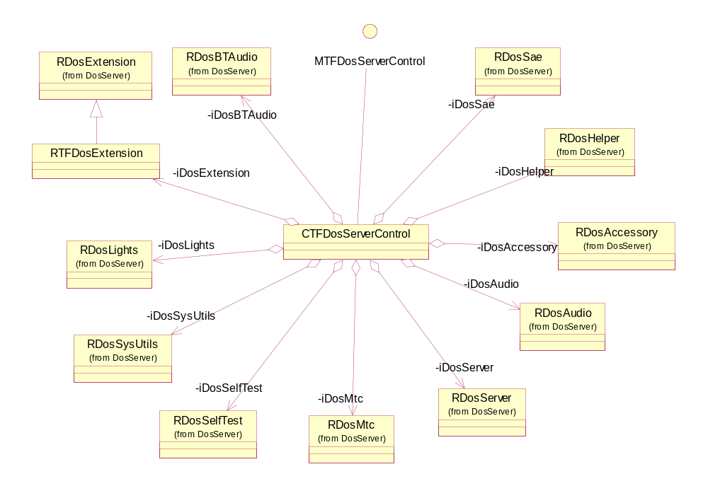
Figure 3.11 DosServer Plug-in Stub

Class | Description | Header file
MTFDosServerControl | Exported interface to public methods of CTFDosServerControl. Allows an external component to generate DosServer events and to call DosServer API functions. | MTFDosServerControl.H
CTFDosServerControl | Implementation of CTFStub class. Provides functionality for the test cases to call API DosServer functions. Also provides a function that is called by DosServer event listener to notify the test cases about DosServer events. | CTFDosServerControl.H
RDos… | DosServer client API classes

Figure 3.12 shows the test case classes from DosServer Plug-in Module.
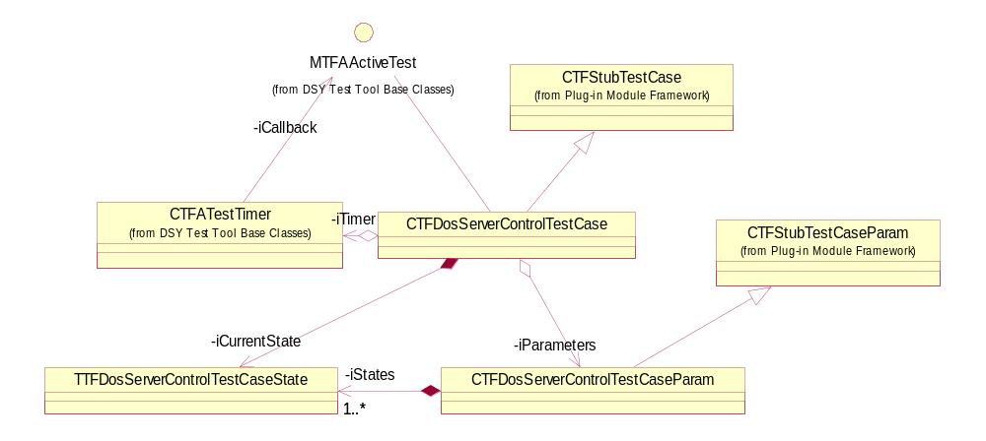
Figure 3.12 DosServer Plug-in Test Case

Class | Description | Header file
CTFStubTestCase | A test case base class. See Section 3.1.3.2 | CTFStubTestCase.H
CTFDosServerControlTestCase | A test case implementation that runs a test case via DosServer client API. See Section 3.1.7.2 for a state diagram and Section 3.2.5 for sequence diagrams. | CTFDosServerControlTestCase.H
CTFATestTimer | A timer utility class. See Section 3.1.3.1 | CTFATestTimer.H
MTFAActiveTest | A timer callback interface. See Section 3.1.3.1 | MTFAActiveTest.H
CTFStubTestCaseParam | A base class for test case parameters. Contains no implementation | CTFStubTestCaseParam.H
CTFDosServerControlTestCaseParam | Contains the parameter of a single test case. | CTFDosServerControlTestCaseParam.H
TTFDosServerControlTestCaseState | Defines one state within a test case. See Section 3.1.7.2 for a state diagram and Section 3.2.5 for sequence diagrams. | tfdosservertypes.H

Enumerations
DSY Test Tool contains the following enumerations:

Enumeration | Description | Header file
TTFATestType | A test case type returned by the Type method of the CTFATest base class. Valid values are:  - ETFATestTypeCase – Test case  - ETFATestTypeSuite – Test suite  - ETFATestTypeStubWrapper – Test case that is an instance of CTFATestCaseWrapper  - ETFATestTypeStubRepeater – Test case repeater. | tftypes.H
TTFPanic | Contains various panic codes for DSY Test Tool | tftypes.H
TTFTestCaseFlags | Test case flags that define additional behavior for test cases. Flags are set to test cases either globally via CTFATestEnvironment::SetTestCaseFlags or case-by-case with CTFATestCase::SetFlags. Valid flags are:  - ETFMayLeakMemory – Test case allocates memory that is not freed during test execution.  - ETFMayLeakRequests – Test case either starts more asynchronous requests than it completes or completes more than it starts.  - ETFMayLeakHandles – Test case opens R-classes that it does not close during test execution. | tftypes.H
TTFDosFunction | DosServer function call types that are set to the DosServer plug-in test case states. | tfdosservertypes.H
TTFDosEvent | DosServer event types that are set to the DosServer plug-in test case states. | ttfdosservertypes.H
TTFDosFlags | Flags for the DosServer plug-in test case states. Flags start with ETFDosFlags_ (for example ETFDosFlags_IgnoreResult):  - None – No flags  - IgnoreParameters – The parameters from a getter function are ignored when checking test results.  - IgnoreEventParameters – The parameters of an event are ignored.  - IgnoreResult – The return value from a function is ignored.  - IgnoreUnexpectedEvents – Ignores all events that arrive during the test case execution.  - StoreParameters – Stores the parameters returned by a getter function.  - UseParameters – Uses the previously stored parameters in a setter function. | ttfdosservertypes.H

UIDs
DSY Test Tool uses the following UIDs:

UID | Description
0x101FB44A | DSY Test Tool core DLL (dsytfcore.DLL) UID.
0x10200c7d | DSY Test Tool ECom interface UID. Needs to be specified in ECom resource files of all plug-in implementations.
0x101FB3E7 | Dsytfstifadapter.DLL uses this UID since STIF Test Framework requires it.
0x10200C6F | DosServer plug-in module DLL (dosservercontrol.DLL) UID.
0x10200c77 | ECom implementation UID for DosServer plug-in module.

Flag definitions
DSY Test Tool uses the following compilation flags:

Flag | Description
COMPONENT_TRACE_FLAG | Component traces are used to track the internal execution of DSY Test Tool. It is useful when debugging DSY Test Tool, but should not be used when running tests. The traces are outputted if a debug version of the component is used and the following macro is defined in the component’s MMP file:  macro COMPONENT_TRACE_FLAG  The component trace flag is available in all three .MMP files of DSY Test Tool (dsytfcore.MMP, dsytfstifadapter.MMP, dosservercontrol.MMP). It is turned off by default.
TEST_CASE_TRACE_FLAG | Test case traces are used to trace the execution flow when running test cases. When a test case consists of multiple calls to DosServer, test case trace shows which part of the test case failed. The traces are outputted if a debug version of dosservercontrol.DLL is used and the following macro is defined in dosservercontrol.MMP:  macro TEST_CASE_TRACE_FLAG  The test case trace flag is turned on by default.
TEST_NAME_TRACE_FLAG | Test name traces are used to trace the name of the test case when the test case execution starts and the test results when the execution ends. The traces are outputted if a debug version of dsytfcore.DLL is used and the following macro is defined in the dsytfcore.MMP:  macro TEST_NAME_TRACE_FLAG  The test name trace flag is turned on by default.

State diagrams

Test Case Wrapper States
Figure 3.13 shows the states of the CTFTestCaseWrapper class when it is running test cases from the plug-in modules.
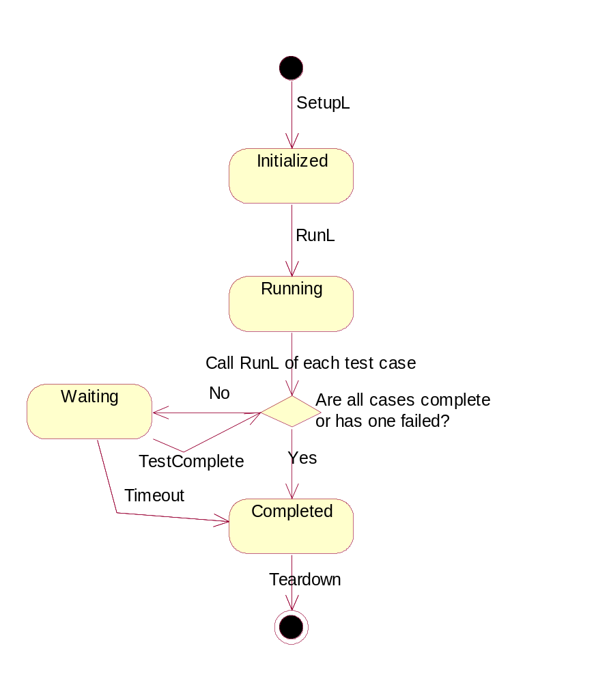
Figure 3.13 Test Case Wrapper States
When the RunTestL method of CTFTestCaseWrapper is called, it calls the RunL method of each test case object from the plug-in modules. After that it calls the TestComplete method of the plug-in test cases. If any of the test cases from the plug-in modules return EFalse to the TestComplete method and none of the plug-in test cases have failed, the test case wrapper starts an active scheduler wait loop. The plug-in test cases do their processing in the active wait loop and when a plug-in specific test case is complete, it calls the TestComplete callback method of the test case wrapper. When the TestComplete callback is called, the test case wrapper again calls the TestComplete method of each plug-in test case and if all are have been completed or one of them has failed, the active scheduler wait loop is stopped and the RunL method of the test case wrapper returns.
Each test case contains a timeout value that is used when entering the Waiting state. If a plug-in does not call TestComplete within time, the test case execution is stopped and test completes with KErrTimedOut.

DosServer Plug-in Test Case States
Figure 3.14 shows the states of the test case object of DosServer plug-in module.
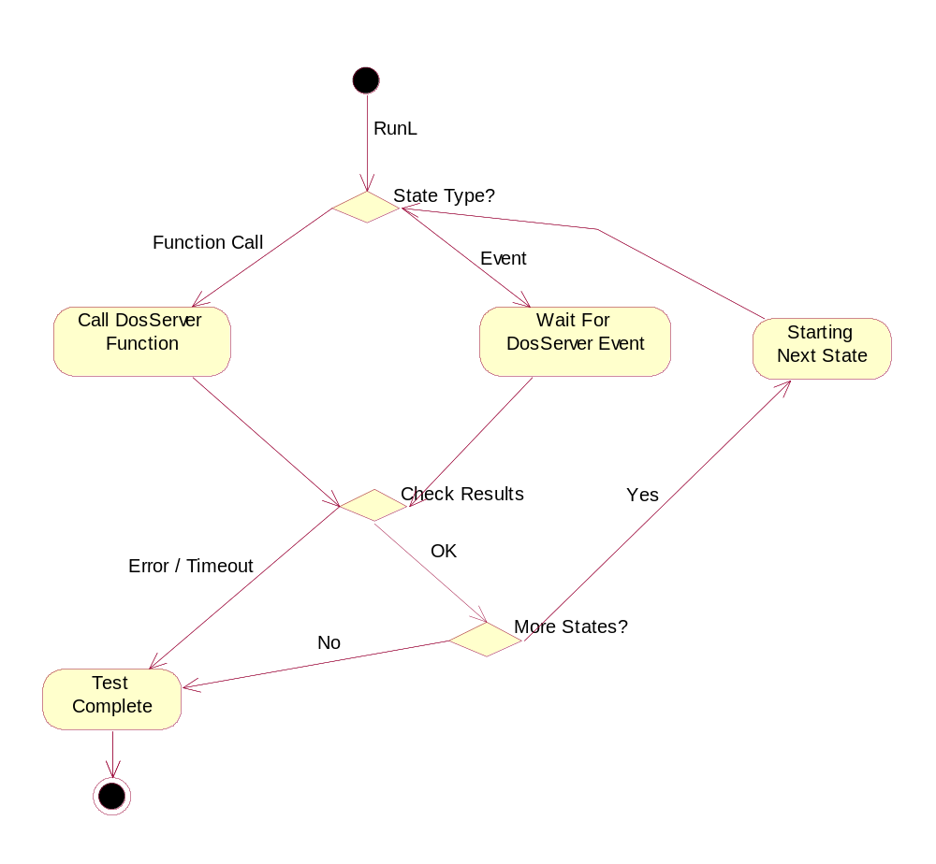
Figure 3.14 DosServer Plug-in Test Case States
Each test case is specified as an array of TTFDosServerControlTestCaseState objects. When running test cases the first call to RunL method of CTFDosServerControlTestCase executes the first state in the state array. If the state specifies a DosServer function call, the function is called and the return value from the function is checked in the CheckResults phase. If results were OK, the next state in the state array is set as the current state and a timer is launched that causes RunL method to be called again. The next call to RunL then processes the next state. If results are not OK, the TestComplete callback of the callback interface to CTFTestCaseWrapper is called and the test case is finished. If a state specifies a DosServer event, the RunL method exits and when the event arrives, the CheckResults phase is entered.

Operations
This chapter describes the dynamic model of DSY Test Tool

Startup
When STIF Test Framework is started it loads the test modules and calls their first exported function. In DSY Test Tool the function is named LibEntryL in dsytfstifadapter.DLL. It causes DSY Test Tool to load all test plug-in modules and to initialize all test cases from those modules. Sequence shown in Figure 3.15 shows the initialization of the test environment objects of DSY Test Tool.
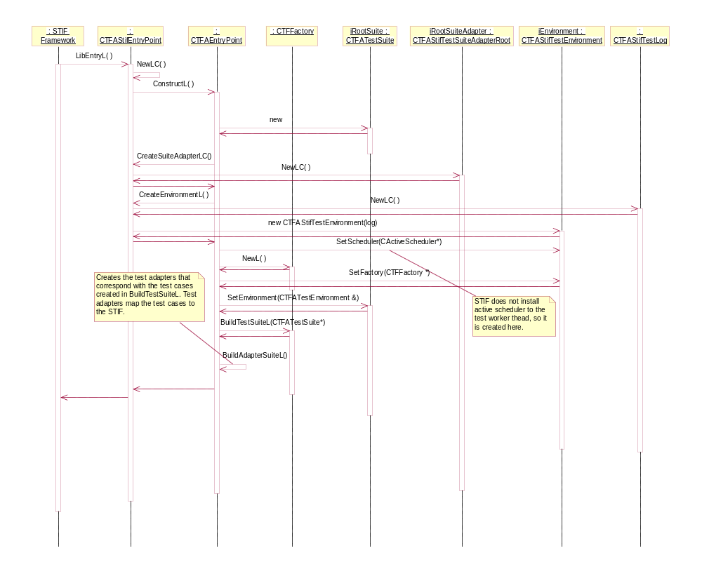
Figure 3.15 Test Environment Initialisation

The STIF adapter library calls the ConstructL method of the CTFAEntryPoint class. ConstructL method does the following:
- Creates the root test suite (CTFATestSuite object)
- Calls the virtual methods to create a root suite adapter (CTFATestSuiteAdapter) and a test environment (CTFATestEnvironment). The adapter library has implemented these methods and will create adapter-specific instances.
- Creates an active scheduler if one has not yet been installed for the current thread. The active scheduler is stored into the test environment object.
- Creates the CTFFactory object, which manages the ECom plug-in modules. The factory object is also stored into the test environment object.
- A reference to the test environment is given to the root test suite. When the plug-in modules create test cases they need to obtain the test environment from the root test suite and forward it to the test case objects.

When the test environment has been initialized, the test case objects are loaded from the plug-in modules. This sequence is shown in Figure 3.16. This sequence expands the BuildTestSuiteL call from Figure 3.15.
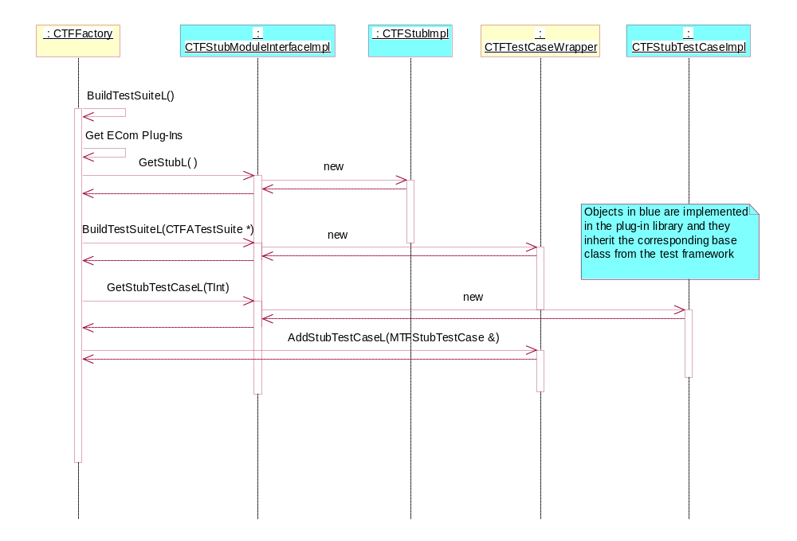
Figure 3.16 Loading Test Cases from Plug-in modules

The ECOM plug-in interface contains three functions:
- GetStubL creates an instance of CTFStub and returns a pointer to it. DSY Test Tool is then responsible for deleting the stub object. Each plug-in may implement one stub that has a unique stub identifier. It is also possible that the plug-in module uses a stub object specified in some other plug-in module, and in that case the GetStubL function may return NULL. The GetStubL function is called once for every ECom plug-in.
- BuildTestSuiteL creates the test case objects. The root test suite created by the test framework is passed to BuildTestSuiteL as a parameter. The sub test suites and cases are added to that. Test framework releases the memory allocated for the test cases. There are four types of test case objects:
- Test suites (instance of CTFATestSuite), which can be used to group tests cases.
- General test cases (instance of a class derived from CTFATestCase), which are fully implemented within one plug-in module.
- Test cases, which contain implementation from multiple plug-in modules, are instances of CTFATestCaseWrapper. An instance of CTFATestCaseWrapper does not actually contain any test code; it is instead implemented within CTFStubTestCase objects. Each plug-in module may link a CTFStubTestCase implementation into a CTFATestCaseWrapper and these are run as one test case. This is needed to separate licensee-specific parts of the test cases from the generic parts that can be released to licensees.
- Repeater test cases (instance of CTFATestCaseRepeater), which contain a reference to a test suite. The test cases within the test suite are run multiple times according to the parameters set to the repeater.
- GetStubTestCaseL creates the CTFStubTestCase implementation that is linked to the test case with the identifier passed as a method parameter. This requires that the plug-in modules have knowledge of the test case identifiers.

The BuildTestSuiteL method of each plug-in module is called first to construct the entire test suite. After that every test case that is an instance of CTFATestCaseWrapper is used with the GetStubTestCaseL method to initialize the stub-specific parts of the test case.
After the test cases have been loaded from the plug-in modules, they are wrapped into adapter objects that integrate into STIF Test Framework. Figure 3.17 expands the BuildAdapterSuiteL call from Figure 3.15.
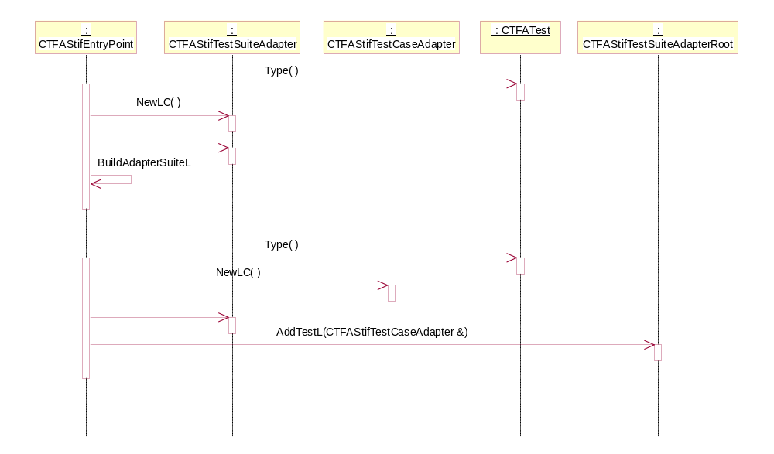
Figure 3.17 Test Case Adapters
The Type method of the test object is used to determine if the test is a suite or a test case. If the CTFATest object is a test suite, a new test suite adapter is created and added to the current adapter. BuildAdapterSuiteL is called recursively to construct the sub adapter suites. If the CTFATest object is a test case, it is added to the current adapter. Since STIF Test Framework does not support test suites, the test cases are stored in an array within the root adapter that implements the STIF test module interface.

Creating Test Cases
Figure 3.16 shows the method calls from DSY Test Tool to the plug-in libraries when starting up. The plug-in libraries need to create the stub and the test case objects within these method calls. Figure 3.18 shows the creation of a CTFStub-derived class.
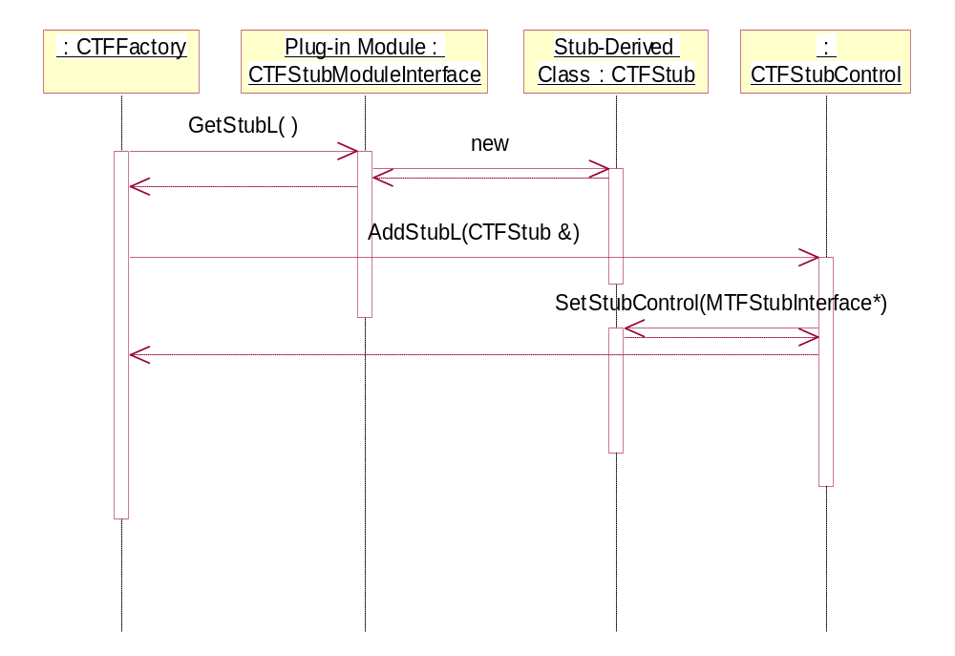
Figure 3.18 Creation of a Stub Object
The plug-in module creates an instance of the CTFStub-derived class and returns it to the factory object. The factory object delegates the stub object to the stub controller, which stores the stub object to an array and gives a callback interface pointer (MTFStubInterface) to the stub object. When tests are run the stub object can access the currently executing test case via the callback interface.
After the stub has been created, the factory tells the plug-in module to initialize all test case objects. This is shown in Figure 3.19.
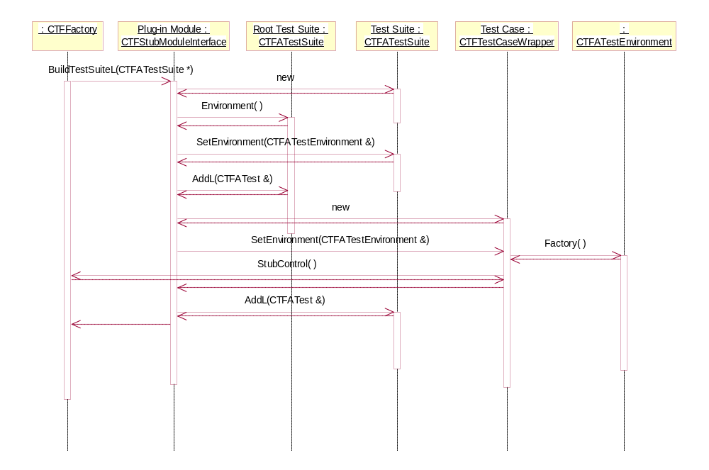
Figure 3.19 Creation of the Test Cases
In Figure 3.19 the plug-in module adds one test suite to the root suite and then adds one test case to the new test suite. The test environment is obtained from the root test suite and needs to be set to the test suite and test case objects created by the plug-in. The test case wrapper object gets a reference to the stub controller via the environment and factory objects. When test cases are run the test case wrapper object calls the stub controller and tells that this test case is now the currently running test case.
After the test case objects have been created the factory calls the plug-in module to link the plug-in specific functionality into the test case objects. This is shown in Figure 3.20.
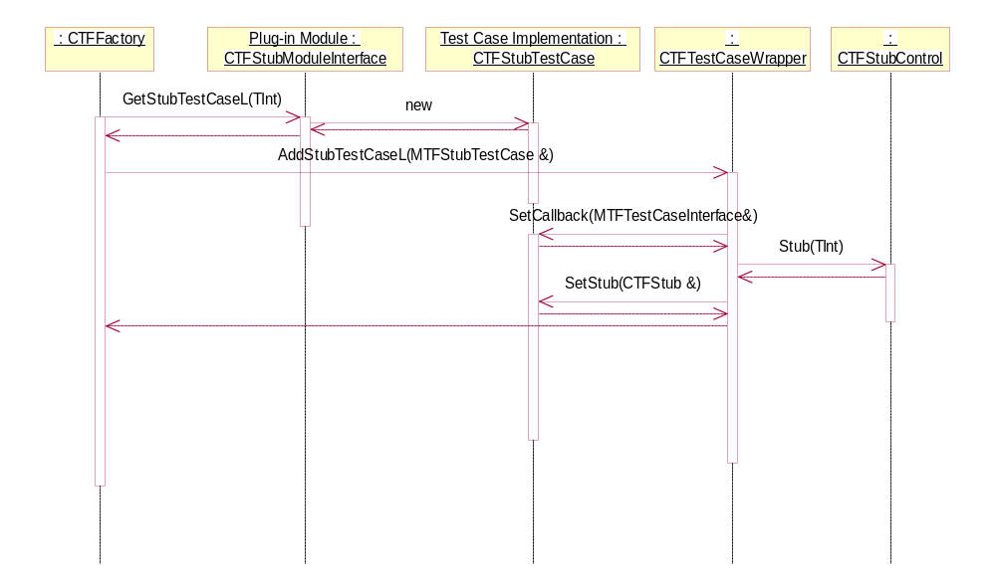
Figure 3.20 Creation of the Plug-in Specific Test Case Parts
The plug-in module returns an instance of MTFStubTestCase interface from the GetStubTestCaseL function. The function takes the test case ID as a parameter and the returned test case object is then linked to the test case wrapper object that has the given ID. The test case wrapper object gets the CTFStub object that has the same ID as the MTFStubTestCase and sets the stub object to the test case. Thus when test cases are run the MTFStubTestCase implementation can access the functionality of the CTFStub object. The test case wrapper also sets itself to the plug-in specific test case via the SetCallback method. The plug-in specific test case uses the callback interface to notify the test case wrapper about completion of a test.
Note that this sequence is valid only if the test case is an instance of CTFTestCaseWrapper. CTFTestCaseWrapper returns ETFTestTypeStubWrapper from its Type method and the factory uses that to determine whether to call GetStubTestCaseL or not. If the plug-in module has added test cases derived directly from CTFATestCase, the plug-in specific parts and the reference to the stub object are not set to the test case.
After all test cases have been created, the LibEntryL function of the STIF-TF adapter library returns and the test cases are shown in the STIF Test Framework UI.

Running Test Cases
After the test suite construction is complete and the LibEntryL function returns, STIF Test Framework fetches the test cases from the test module. The TestInfo method of the adapter maps the test case information into STIF format. This is shown in Figure 3.21.
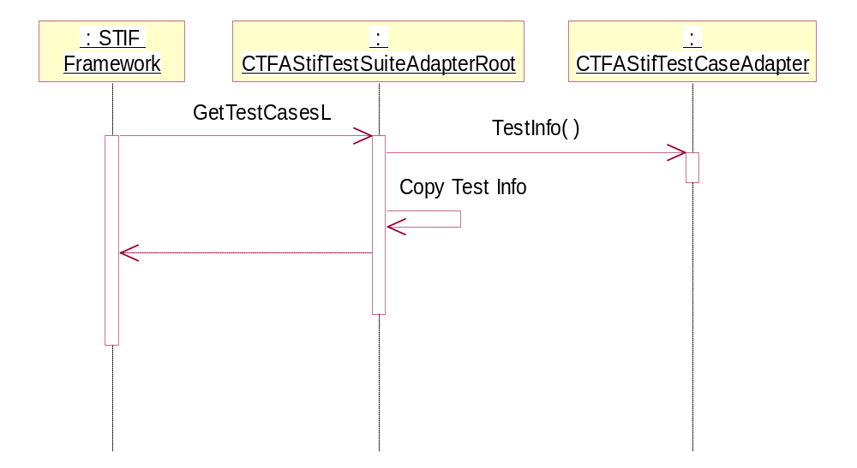
Figure 3.21 Mapping Test Cases to STIF-TF Format
STIF Test Framework takes ownership of the test info objects, so they must be copied before returning. The test info objects contain test case name, ID and STIF-TF-specific data.
When a test case is run, STIF-TF calls RunTestCaseL as shown in Figure 3.22. The adapter maps the call to the SetupL, RunTestL and Teardown functions of the DSY Test Tool test case objects. If SetupL leaves, the leave is delegated to STIF-TF and Teardown is not called. If RunTestL leaves, the error is trapped and set as test result. Teardown is called if RunTestL leaves.
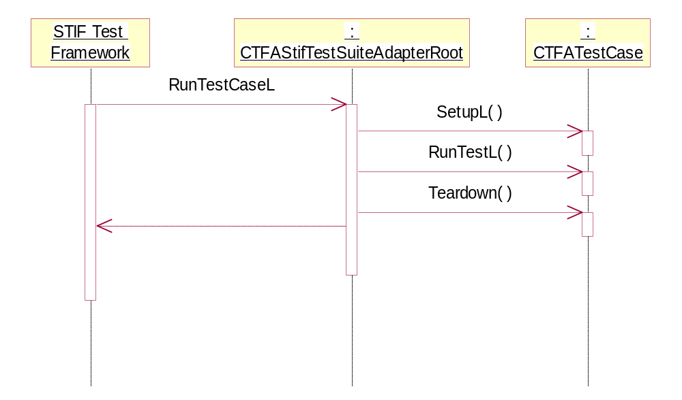
Figure 3.22 Running a Test Case
If the test case object extends from CTFATestCase directly, the test case implementer needs to provide the functionality for the three methods described above. The plug-in module framework is not used in that case.
All test cases defined in dosservercontrol.DLL use the plug-in module framework and the test cases are instances of the CTFATestCaseWrapper class. The run sequence with the test case wrapper is shown in Figure 3.23.
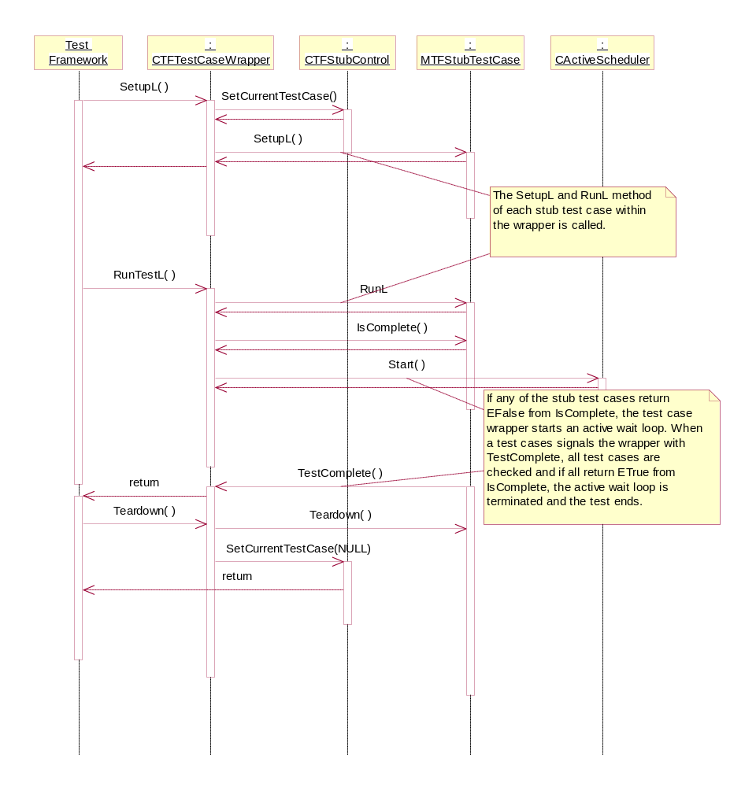
Figure 3.23 Running a Test Case with Parts from Plug-in Modules

In Figure 3.23 each MTFStubTestCase implementation is first set up using the SetupL method. A callback interface is passed with that method. When setup is complete, the RunL method of each is called. If any of the plug-in test case implementations return EFalse from their IsComplete method, the test case wrapper starts an active wait loop that waits for TestComplete callbacks from plug-in modules. When the plug-in module finishes processing, it calls TestComplete and after all plug-in modules are complete, the active wait loop is terminated and RunTestL returns.
If the test case implementation is an instance of CTFATestCaseRepeater the run sequence is shown in Figure 3.24.
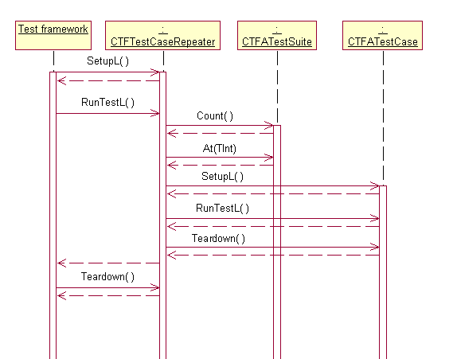
Figure 3.24 Running a Test Case Repeater

Test Server
NOTE: The test server is not used by DSY Test Tool, but is provided for extension purposes. For example a domestic OS plug-in would use the test server to notify DSY Test Tool with events happening at the domestic OS interface of DSY.
The CTFFactory object starts two test servers during its construction and provides static functions to call these servers. The CallLocalStubL function needs to be used if the tested component and the test framework run in the same thread. This is not applicable when using the dosservercontrol.DLL to run test cases via the DosServer client API since DSY runs in the DosServer process and DSY Test Tool runs in the process of STIF Test Framework. However, if DSY is tested directly either via DosServer plug-in API or via CommonDSY plug-in API, CallLocalStubL could be used to generate RMessage2 objects to test methods that require them. Figure 3.25 shows the usage of the test server when called from a DSY Test Tool thread.
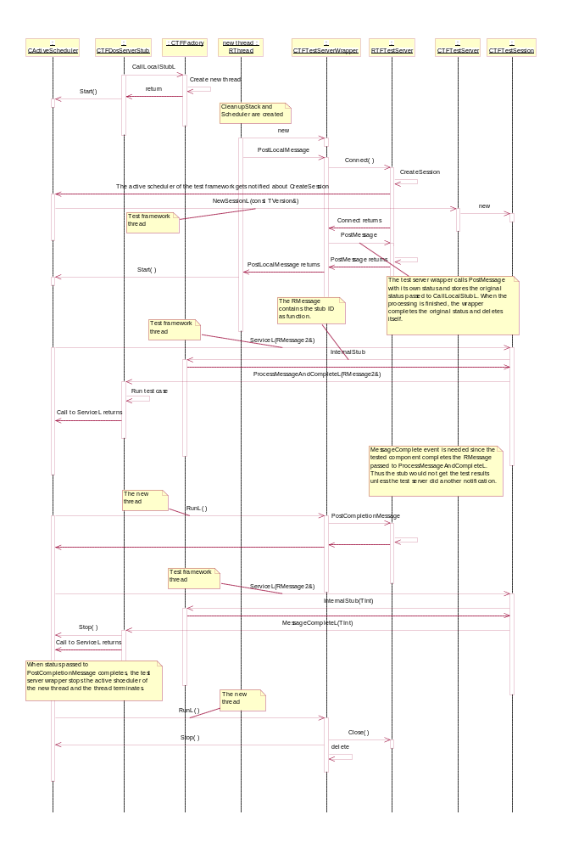
Figure 3.25 Using the CallLocalStubL Function
The problem with CallLocalStubL is that the server is not running in the same thread as DSY Test Tool so the calls to DSY do not arrive with the same thread that created it. This might restrict the usage of R-classes that have been opened during DSY startup and might create synchronization problems if the DSY thread does simultaneous processing.
When DSY runs in the process of DosServer, the CallRemoteStubL method of CTFFactory is used instead. The test server that receives the session made with CallRemoteStubL runs in the thread of DSY Test Tool so the above restrictions do not apply. Figure 3.26 and Figure 3.27 show the sequences associated with CallRemoteStubL.
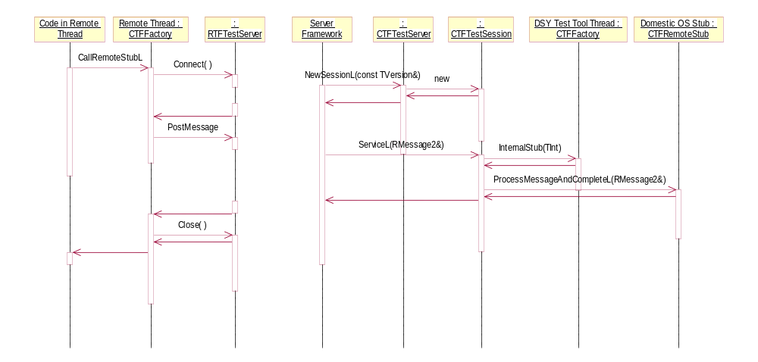
Figure 3.26 Using the Synchronous CallRemoteStubL Function
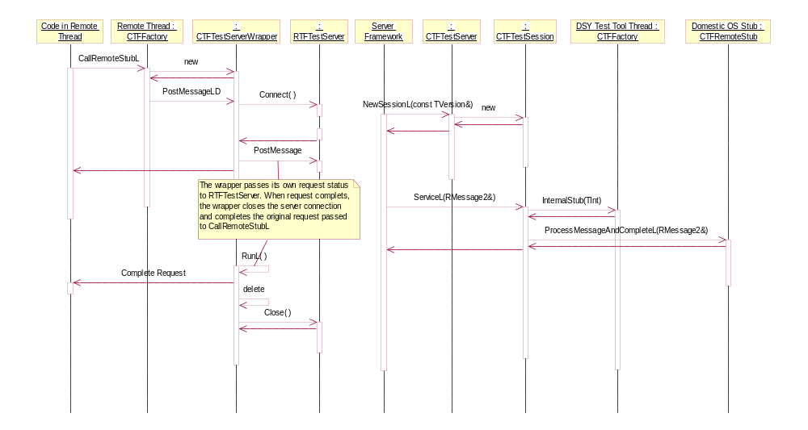
Figure 3.27 Using the Asynchronous CallRemoteStubL Function
The synchronous case opens a connection to the test server and then posts a message to the server. The clients thread blocks until the server responds. The client sets the ID of the CTFStub object into the message so that the server can locate the correct stub object where the message should be delegated. The stub implementation needs to inherit from CTFRemoteStub, which contains the virtual function ProcessMessageAndCompleteL that is used to process the request from the client.
The asynchronous case allocates a temporary active object before sending the request to the server. The request status of the temporary active object is passed to the server and the request status given to CallRemoteStubL is stored into the active object. When the server completes the request RunL method of the active object gets called. The active object then closes the connection to the server and completes the original request provided by client.

DosServer Plug-in
Figure 3.28 shows the test case sequence when calling DosServer functions that do not produce events.
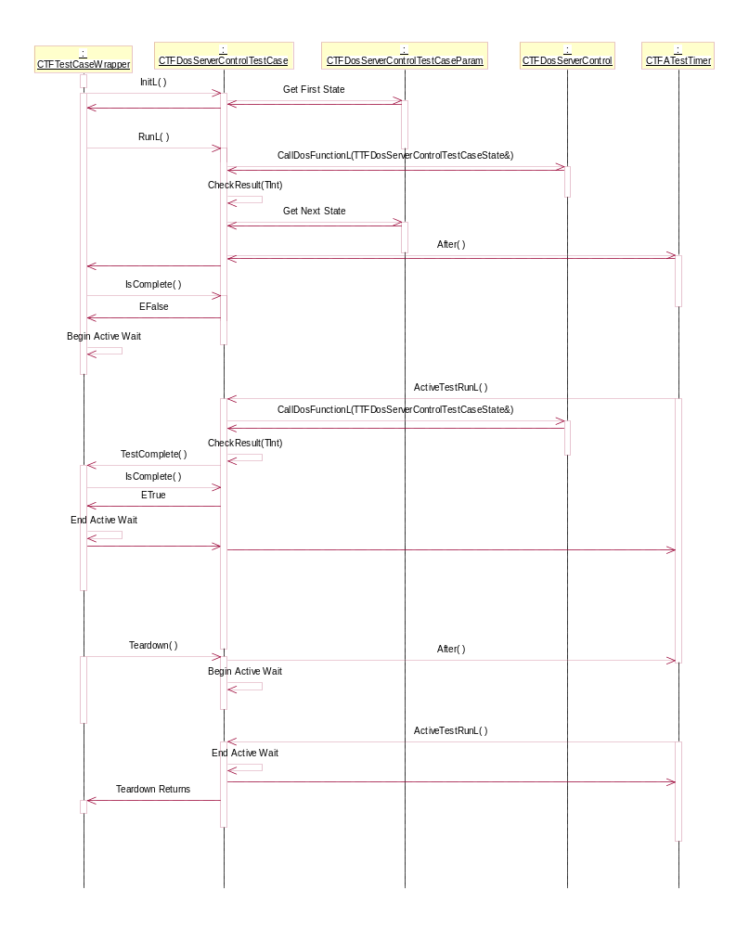
Figure 3.28 Synchronous DosServer Function Call Without Events
There are two test case states in the above sequence. When a test case is initialized, the first state is fetched from the test case parameters. From the RunL method the corresponding DosServer function is called. After the DosServer function returns, the results are checked and if they are OK, the next state is entered with the help of a timer. The RunL function returns after the timer has been set. When RunL returns, the CTFTestCaseWrapper object asks if every plug-in specific test case has completed. Since the DosServer test case contains more states, it returns EFalse to the IsComplete call and the test case wrapper starts an active wait loop.
When the timer fires, it calls the ActiveTestRunL method which then calls the DosServer function from the next state. After the second DosServer call is finished, the test case notices that the second state was the last state. After the results have been checked it calls the TestComplete callback method of the test case wrapper, which again checks if all plug-in specific parts have completed. If they are, the test case wrapper stops the active wait loop and calls Teardown. The DosServer test case starts a cleanup wait loop within teardown to allow pending events to run before the next test case is started.
A DosServer test case state may specify an event instead of a function call. The associated sequence is shown in Figure 3.29.
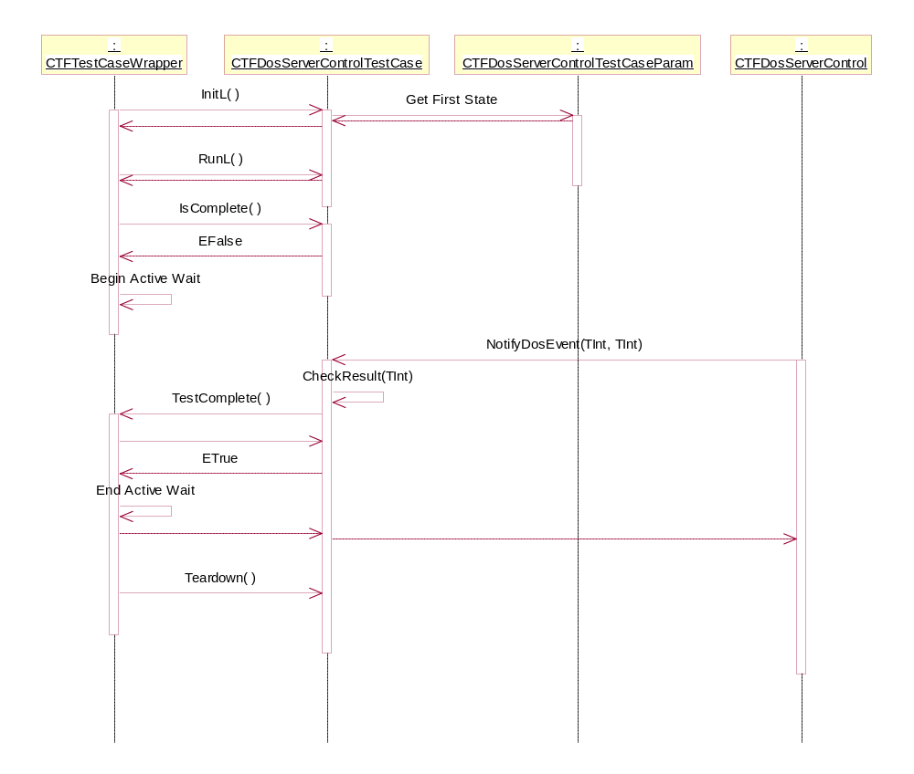
Figure 3.29 DosServer Event
When a state specifies an event, the RunL method of the test case object does nothing. When DosServer fires an event the call is delegated to the CTFDosServerControl object, which then delegates the event to the currently active test case. The test case then compares the data from the event to the currently active state and if the results are OK, the next state is started. In Figure 3.29 there are no more states after the event state, so TestComplete is called after the event has been processed.

System resource usage

Files
DSY Test Tool generates log files to c:\logs\TestFramework directory.

Databases
This SW does not use any database.

Memory consumption
Memory consumption should not be an issue since this is test SW.

Task allocation
This software module runs in threads/processes of STIF-TF and DosServer. Communication between processes is done via DosServer and the Test Server of DSY Test Tool.

Exception handling
There are multiple levels of exception handling in STIF Test Framework and DSY Test Tool:
- If a test case does not return in time, STIF-TF terminates the test module. It then reloads all test cases and continues from the next test case.
- To avoid test module termination. A timer has been added to the CTFTestCaseWrapper class. If a plug-in specific test case does not complete in time, the active wait loop is terminated and the test case completes with KErrTimedOut.
- If a DosServer function leaves, the test case object of the DosServer plug-in module traps the leave and returns the leave code to STIF-TF as test result.
- If a function causes a crash within DosServer, the next DosServer function call should restart it. However, all states that have been initialized in previous test cases are lost so some future test case may fail.

DSY Test Tool defines the following error codes for test cases:

Error code | Value | Description
KTFErrIgnore | -10000 | Tells that an action should be ignored. Not used, but provided for extension plug-in modules.
KTFErrTestNotActive | -10001 | Tells that currently there is no active test case. Not used, but provided for extension plug-in modules.
KTFErrNoTestCase | -10002 | Tells that a test case is missing. Not used, but provided for extension plug-in modules.
KTFErrNoStub | -10003 | Tells that a CTFStub object is missing.
KTFErrDosServiceMissing | -4001 | Returned by CallDosFunctionL if the test case state contains an invalid function ID.
KTFErrDosUnexpectedEvent | -5000 | If an unexpected DosServer event is received by a test case, the test case is completed with this error code and the event ID. For example if event 15 is received unexpectedly, the test case result is –5015.
KTFErrDosUnexpectedEventParameter | -6000 | If a DosServer event contains an unexpected parameter, the test case is completed with this error code and the parameter value. For example if parameter value is 54, the test result is -6054. Note that the error category will no longer be -6000 if the parameter value is more than 1000 or less than –1000.
KTFErrDosUnexpectedArg1 | -7000 | If the value of parameter 1 from a getter function differs from the expected value, the test case result will be this error code and the parameter value.
KTFErrDosUnexpectedArg2 | -8000 | If the value of parameter 2 from a getter function differs from the expected value, the test case result will be this error code and the parameter value.
KTFErrDosUnexpectedResult | -9000 | If the return value from a DosServer function differs from the expected return value, the test case result will be this error code added with the returned value. For example, if result from a DosServer function is KErrGeneral (-2), the test result is -9002.

Usage
This chapter describes how to build and run Console-UI based testing environment in HW. Environment includes a Symbian release, STIF Test Framework and DSY Test Tool.

Building
The Symbian environment with DSY Test Tool and STIF Test Framework needs to be obtained first. See reference [2] for STIF Test Framework instructions. After STIF Test Framework has been built, go to dsytesttool\group directory and type bldmake bldfiles and abld build.

Setting up a Memory Card
To be able to use DSY Test Tool, the required files need to be copied into a memory card. Memory card should have following directory structure:
CONSOLEUI.EXE
\system
\libs
STIFTESTENGINE.DLL
STIFTESTINTERFACE.DLL
STIFTESTSERVER.DLL
STIFTFWIF.DLL
TESTCOMBINER.DLL
TESTSCRIPTER.DLL
DSYTFCORE.DLL
DSYTFSTIFADAPTER.DLL
\plugins
10200C6F.RSC
DOSSERVERCONTROL.DLL
\programs
TESTSERVERSTARTER.EXE
\Testframework
TESTFRAMEWORK.INI

File locations:
CONSOLEUI.EXE, TESTSERVERSTARTER.EXE and all files to be copied under \system\libs-directory are found from epoc32\release\thumb\udeb -directory after successful build process of STIF Test Framework and DSY Test Tool.
10200C6F.RSC and DOSSERVERCONTROL.DLL files are found from epoc32\release\thumb\udeb\z\system\LIBS\Plugins –directory.
TESTFRAMEWORK.INI file is found from \dsytesttool\group-directory.

Running test cases
After proper file structure has been created, use filebrowser to launch ConsoleUi.EXE. Console UI is a menu-based application, which requires that at least two navigation keys are available. One key is used to activate an item from menu, and another key is used to change the selection. Console UI supports also the use of Series 60-type five-way navigation.
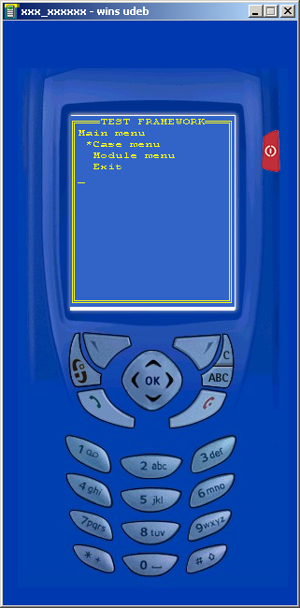
Figure 6.30 STIF-TF Main Menu
Test cases can be viewed and executed one by one by selecting Case menu\Start new case and selecting the case to be executed. Sequential execution can be started by selecting Case menu\Run multiple cases. Note that DSY Test Tool does not support the concurrent execution selection that is shown in the Run multiple cases menu.

Interpreting results
Test results can be viewed in the test tool itself or from logs that are generated while tests are executed.
In the test tool, results of already executed tests can be found from Passed cases, Failed cases or Aborted/Crashed cases menus. If a test case is not yet completed, it is located in Ongoing cases menu. All executed cases can be found from Executed cases menu.

Logging
Logs are created into the directory specified in the TestFramework.INI file. By default the directory is c:\Logs\TestFramework. It can be changed by modifying the following line in TestFramework.INI:
TestReportFilePath= C:\LOGS\TestFramework\
Logs files are in html format and the file name is a timestamp from the point of time the STIF test framework was started. If a test case crashes, a new html log file gets generated. Note that although the log file is generated by the release version of DSY Test Tool, the release version will not write anything into the file. In addition to the html log files, STIF Test Framework generates a TestReport.TXT file that contains the results of each test case that has been run.

Test Case Implementation

Helper Macros
Figure 3.19 shows the sequence of adding a test suite and a test case to DSY Test Tool. A set of macros is defined in tftestmacros.H that help in the creation of test suites and test cases.

Macro | Description
TF_START_TEST_DECLARATION_L | Called at the beginning of the implementation of CTFStubModuleInterface::BuildTestSuiteL. Declares a variable for currently active test suite and an array of test suites that is used by the other macros. Takes the root test suite that is passed to BuildTestSuiteL as a parameter.
TF_END_TEST_DECLARATION | Called at the end of the implementation of CTFStubModuleInterface::BuildTestSuiteL to release the array allocated by TF_START_TEST_DECLARATION_L.
TF_ADD_TEST_SUITE_L | Adds a new child test suite to the currently active test suite and sets the new test suite as active. Test cases that are added with TF_ADD_TEST_CASE_L are added to the new suite created with this macro. Takes the test suite name as parameter.
TF_END_TEST_SUITE | Ends the declaration of the currently active test suite and sets the parent of the current test suite as the active test suite.
TF_ADD_TEST_SUITE_FUNCTION_L | Adds a new child test suite to the currently active test suite. The child test suite is built in a function which has the following declaration:  void SuiteNameL( CTFATestSuite* aSuite );  The macro takes the test suite name and the function to be called as a parameter.
TF_INIT_TEST_SUITE_FUNCTION | Called at the beginning of a function that is used to build a test suite. Initializes the variables that are needed when using the TF_ADD_TEST_CASE_L macro to add test cases.
TF_ADD_TEST_CASE_L | Adds a test case to the currently active test suite and sets the test environment to the test case. The test case that is added is an instance of CTFTestCaseWrapper. The macro takes the test case ID and test case name as parameters.
TF_SET_TEST_TIMEOUT | Sets the timeout of the test case that was previously added with TF_ADD_TEST_CASE_L macro. The timeout parameter is in seconds.
TF_SET_TEST_FLAGS | Sets the test case flags of the test case that was previously added with TF_ADD_TEST_CASE_L macro. See Section 3.1.4 for flag definitions.
TF_ADD_TEST_SUITE_REGRESSION_L | Adds a repeater test case that takes the currently active test suite as parameter. The macro takes the test case ID, name and repeat count as parameters.
TF_ADD_TEST_SUITE_RANDOMIZE_L | Adds a randomizer test case that takes the currently active test suite as a parameter. The macro takes the test case ID, name and repeat count as parameters.

Examples
The example plug-in implementation shows how to use the macros defined in Section 7.1.
The example contains one exported function ExampleFunctionL. The calls to ExampleFunctionL are delegated to the CExampleStub object. If the test tool is running in the same thread as the caller, the function calls are made directly. If the caller and test tool are in different threads, the function calls are made via the test server. The stub object delegates the calls to the currently active test case, which then completes the test case.
The example code contains the following classes:

Class | Description
CExamplePlugin | The implementation of the ECom plug-in interface. It has the following functions:  - GetStubL function returns an instance of CExampleStub.  - BuildTestSuiteL adds two test case objects, which have the IDs 101 and 102.  - GetStubTestCaseL creates CExampleStubTestCase objects that are linked to the test cases.
CExampleStub | The implementation of CTFRemoteStub. The stub contains the implementation of the following functions:  - ProcessMessageAndCompleteL gets called when CTFFactory::CallRemoteStubL is called from the tested code. The call is delegated to ExampleFunction.  - ExampleFunction gets called when tested code calls ExampleFunctionL exported function. The call is delegated to the currently active test case.
CExampleStubTestCase | The implementation of CTFStubTestCase. The stub calls the ExampleFunction method of the active test case from its own ExampleFunction implementation. The test case also contains implementation of the InitL, RunL and Teardown methods. RunL does nothing since the test case processing is done in the ExampleFunction.

