S60 3.1
Mediator
Design Document

Team name | Author
S60/CorePlatform/BaseServices/SystemSW/SystemUtilities | Marko Pekkarinen

Change history:

Version | Date | Status | Comments
3.0 | 26.04.2006 | Approved | Added information on client logging. Variation and capability information updated.
2.0 | 10.04.2006 | Approved
1.0 | 29.11.2005 | Approved

Table of contents:

1. Document control 5
1.1 References 5
1.2 Documentation conventions 5
1.3 Abbreviations 5
1.4 Definitions 5
2. General 7
2.1 Introduction 7
2.2 Component environment 7
2.3 Use cases 8
2.4 Services required 8
2.4.1 From the Symbian OS subsystems 8
2.4.2 From the Domestic OS subsystems 8
2.4.3 From HW 9
2.5 Services provided 9
2.5.1 UI 9
2.5.2 SW IF 9
3. UI control hierarchy 10
4. Design 11
4.1 Class diagrams 11
4.1.1 Mediator client 11
4.1.2 Mediator server 12
4.2 Mediator plug-in base 13
4.3 Class descriptions 14
4.3.1 Structs, type definitions and enumerations 15
4.3.1.1 Mediator specific error definitions 15
4.3.1.2 MediatorServiceDefs.h structs/definitions/enumerations 15
4.3.2 Flag definitions 15
4.4 Operations 16
4.4.1 Mediator server start 17
4.4.2 Instantiate Mediator API class 18
4.4.3 Process resource events 19
4.4.4 Start Mediator plug-ins 20
4.4.5 Register events 20
4.4.6 Unregister events 23
4.4.7 Subscribe events 24
4.4.8 Unsubscribe events 25
4.4.9 Raise event 25
4.4.10 Register commands 28
4.4.11 Unregister commands 29
4.4.12 Issue command 30
4.4.13 Respond to command 31
4.4.14 Command timeout 32
4.4.15 Cancel command 33
4.4.16 Get Mediator registered info 34
4.4.17 Register for notifications 35
4.4.18 Receive notifications 36
4.4.19 Mediator session closing 37
4.5 Backup and Restore 38
5. Variation 39
6. System resource usage 40
6.1 Files 40
6.2 Other data 40
6.2.1 Databases 40
6.2.2 Central Repository 40
6.2.3 Publish and Subscribe 40
6.3 Memory consumption 41
6.4 Task allocation 41
6.5 Timers 41
7. Security 42
7.1 Capabilities of this component 42
7.2 Input and output validation 42
7.3 Environmental assumptions 42
7.4 Additional enforcements 42
8. Exception handling 43
9. Usage 44
9.1 Building 44
9.1.1 Debugging support 44
9.1.2 Client logging 44
9.2 User's guide 45

Document control

References
- S60 Mediator Subsystem Architecture Specification
- S60 Mediator API Specification

Documentation conventions
Code is shown with the Courier New font.

Abbreviations
API | Application Programming Interface
BAFL | Basic Application Framework Library
BC | Binary Compatibility
DLL | Dynamic Linked Library
HW | Hardware
OOM | Out-Of-Memory
OS | Operating System
ROM | Read Only Memory
SID | Secure ID
UI | User Interface

Definitions
ECom | EPOC component object model - Symbian provided mechanism for loading plug-in DLLs.
Domain | Identifies the purpose for which the services of Mediator are used. For example when the Mediator is used to exchange messages between Secondary Display and S60 software components, the domain identifier is “Secondary Display”.
Category | Identifies the functionality area within the domain to which the message belongs to. An example of a category could be a set of commands used for launching services or events and commands related to telephony functionality. Each category represents a collection of services, an API that is versioned and managed.
Event | Identifies a unique message representing the actual service. An example of an event is a change in some system status property.
Command | Identifies a unique message representing the actual service. An example of a command is answering an incoming call.
Command Initiator | Command Initiator is an instance, which requests commands from Mediator. Command initiator has a possibility to issue a new command and cancel ongoing command processing.
Command Responder | Command Responder is an instance, which then fulfills the command request e.g. servers command. Command responder registers those commands it can serve and then according to initiator's requests serves incoming requests. Note that there can be only one responder for each specific command.
Event Provider | Event Provider is an instance, which registers (publishes) certain events and then raises event to Mediator Server when needed.
Event Consumer | Event Consumer is then an instance, which subscribes to listen to specific event(s) and acts according to notifications received from Mediator.

General

Introduction
The Mediator subsystem is part of S60 platform components and offers structural command and event delivery capabilities. The Mediator subsystem itself is a stand-alone Symbian OS server. Clients don't have access to the server itself nor to any RSessionBase -derived classes, but client side API is wrapped behind CBase -derived API. This provides better maintainability for the future. The Mediator subsystem architecture description (reference document [1]) provides a wider perspective to the subsystem and its dependencies.
Semantically, Mediator is a routing instance between its clients. It can deliver commands and events from one client to another.
In command use cases, Command Responder is a client offering services. Command Responder needs to register those commands to Mediator, which it can serve. Command Initiator is then the client requesting the service using command.
In event use cases, Event Provider is a client responsible for registering events and publishing them. Event Consumer is then a client that needs to subscribe to events to get the event notifications when the event is triggered.
Mediator also provides an information receiving interface to find out what the state is concerning registered domains, categories, commands and events. This interface provides asynchronous notifications when events/commands are added/removed to/from Mediator.
More detailed description about the Mediator API can be found in reference document [2].

Component environment
The Mediator subsystem (shown in Figure 2.1) is a stand-alone Symbian OS server. It provides client-side capsulation DLL (MediatorClient), which provides the interfaces for Mediator services.
Mediator is also dependent on ECom to enable plug-in framework for the developers. MediatorPluginBase is the module providing this interface.
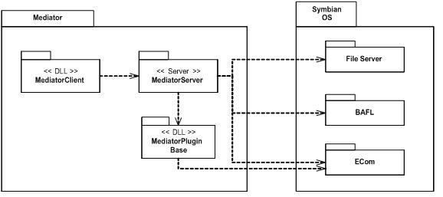
Figure 2.1 Mediator component environment

Use cases
The Mediator subsystem consists of the following use cases, shown in Figure 2.2. Use cases are actually Mediator services, which it provides for other subsystems. Use cases are described more closely in Section 4.4. Reference document [2] contains a description of the services and their usage.
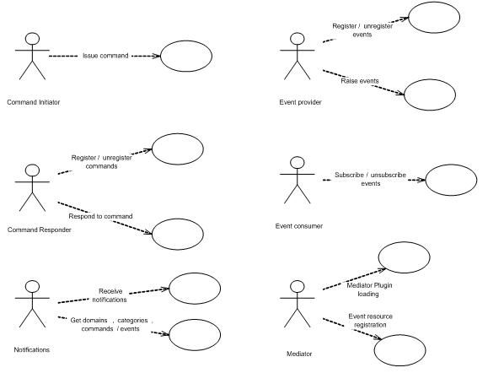
Figure 2.2 Mediator use cases

Services required

From the Symbian OS subsystems
Following table lists the required services of the Symbian OS infrastructure.

API | Description
ECom | For Mediator plug-in framework functionality.
BAFL | For static event registration resource reading.
File Server | For static event registration resource reading.

From the Domestic OS subsystems
This component does not have any direct interfaces to the Domestic OS side subsystems.

From HW
This component has no direct HW interfaces.

Services provided

UI
This component does not provide any UI.

SW IF
This subsystem provides five independent interfaces to be used from other subsystems:
- Mediator Command Initiation interface
- Mediator Command Responding interface
- Mediator Event Providing interface
- Mediator Event Consuming interface
- Mediator Notifications interface

The Mediator subsystem provides also a plug-in framework to add new plug-ins. Plug-ins can be used to wrap legacy functionality without the need to modify the original code.
Static event registration functionality can be considered as a SW interface.
More detailed description of the interfaces provided by this subsystem can be found in reference document [2].

UI control hierarchy
The component does not contain any UI or UI controls.

Design

Class diagrams

Mediator client
Figure 4.3 gives the description about the client side classes. The Mediator interface classes use a facade-pattern type of approach. This means that the actual interface class (e.g. CMediatorNotifications) does not contain logic, but it uses body class (e.g. CMediatorNotificationsBody) directly, which then implements the actual logic behind the service. This way binary compatibility can be maintained more easily as the changes in logic do not affect on the interface BC.
Most of the body classes are CActive derived as they provide asynchronous callbacks via callback classes. CMediatorEventProviderBody is an exception to this as it does not return any callbacks through the Event Provider interface.
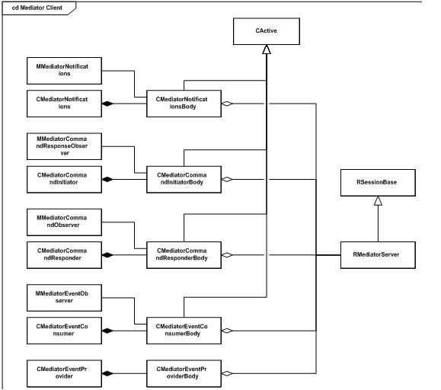
Figure 4.3 Mediator client diagram

Mediator server
Figure 4.4 gives a class description of the Mediator server core. Mediator server is derived from CPolicyServer, which gives a capability-checking framework to handle client-server requests properly.
Incoming requests to register events/commands and to subscribe to events need SwEvent capability. However some clients with specific Secure IDs can access the Mediator services without the SwEvent capability. Those SID values are defined in allowedsids.rsc file within Mediator's private directory in ROM. CPolicyServer::CustomSecurityCheckL method is overwritten to handle the capability/SID checking.
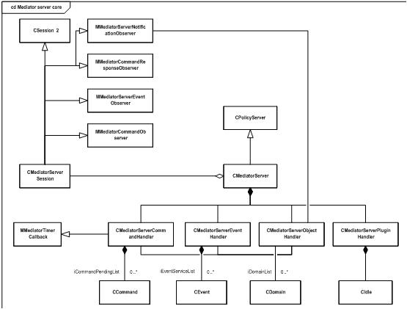
Figure 4.4 Mediator server diagram
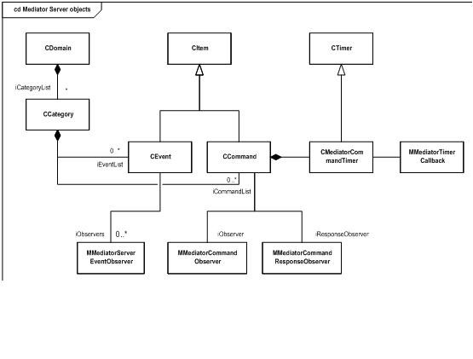
Figure 4.5 Mediator server objects diagram

Mediator plug-in base
CMediatorPluginBase is a base class for Mediator plug-ins. It contains only simple logic to get notification of the idle and start the plug-in after the notification with the StartL method.
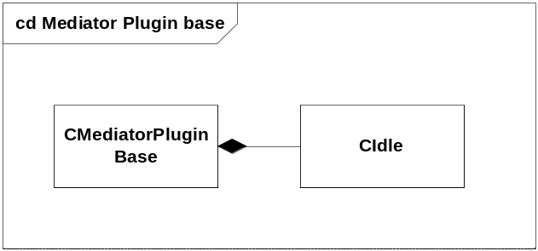
Figure 4.6 Mediator plug-in base diagram.

Class descriptions

Class | Description | Header file
CMediatorEventConsumer | Event Consumer interface class. | MediatorEventConsumer.h
MMediatorEventObserver | Event Consumer callbacks. | MediatorEventConsumer.h
CMediatorEventConsumerBody | Event Consumer interface implementation. | MediatorEventConsumerBody.h
CMediatorEventProvider | Event Provider interface class. | MediatorEventProvider.h
CMediatorEventproviderBody | Event Provider interface implementation. | MediatorEventProviderBody.h
CMediatorCommand  Initiator | Command Initiator interface class. | MediatorCommandInitiator.h
MMediatorCommand  ResponseObserver | Command Initiator callbacks. | MediatorCommandInitiator.h
CMediatorCommand  InitiatorBody | Command Initiator interface implementation. | MediatorCommandInitiator Body.h
CMediatorCommand  Responder | Command Responder interface class. | MediatorCommandResponder.h
MMediatorCommand  Observer | Command Responder callbacks. | MediatorCommandResponder.h
CMediatorCommand  ResponderBody | Command Responder interface implementation. | MediatorCommandResponder Body.h
CMediatorNotifications | Notifications interface class. | MediatorNotifications.h
MMediatorNotifications | Notifications callbacks. | MediatorNotifications.h
CMediatorNotificationsBody | Notifications interface implementation. | MediatorNotificationsBody.h
RMediatorServer | Mediator server client interface implementation. | MediatorServerClient.h
CMediatorServer | Mediator server core. Constructs all handlers in startup and processes static event registration resources. | MediatorServer.h
CMediatorServerSession | Mediator server session class. | MediatorServerSession.h
CMediatorServerObject  Handler | Maintains domain hierarchies. | MediatorServerObjectHandler.h
CMediatorServerCommandHandler | Provides command handling services within server. | MediatorServerCommandHandler.h
CMediatorServerEvent  Handler | Provides event handling services within server. | MediatorServerEventHandler.h
CMediatorServerPlugin  Handler | Resolves Mediator plug-ins and launches each of them to new thread. | MediatorServerPluginHandler.h
CDomain | Domain information class. | MediatorServerObjects.h
CCategory | Category information class. | MediatorServerObjects.h
CItem | Base class for events and commands within Mediator server. | MediatorServerObjects.h
CEvent | Event class derived from CItem. | MediatorServerObjects.h
CCommand | Command class derived from CItem. | MediatorServerObjects.h
CMediatorCommandTimer | Mediator specific timer service used by commands. | MediatorCommandTimer.h
MMediatorTimerCallback | Timer callback class | MediatorCommandTimer.h
CMediatorPluginBase | Base class for Mediator plug-ins. | MediatorPluginBase.h
RMediatorDebug | Server side logging services. | MediatorDebug.h

Structs, type definitions and enumerations

Mediator specific error definitions
The Mediator subsystem has a set of specific error values. These values are explained in reference document [2].

MediatorServiceDefs.h structs/definitions/enumerations

Struct/Definition/Enumeration's name | Description
MediatorService::TEvent | Structure for Mediator event information.
MediatorService::TCommand | Structure for Mediator command information.
MediatorService:: RDomainList | Type definitions for RArray<TUid>. Contains list of domain UIDs.
MediatorService:: RCategoryList | Type definitions for RArray<TUid>. Contains list of category UIDs.
MediatorService:: REventList | Type definitions for RArray<TEvent>. Contains list of events.
MediatorService:: RCommandList | Type definitions for RArray<TCommand>. Contains list of commands.

Flag definitions

Flag | Description
_DEBUG_MEDIATOR | Used in debug.h to turn on logging functionality both at client and server side. The trace prints enabled with this flag are primarily targeted to the developers of the Mediator sub-system itself.
_DEBUG | Enables server side logging of Mediator. This flag is enabled by default for UDeb versions. The trace prints enabled with this flag contain only the most essential information about operations performed by Mediator and is targeted to the developers implementing clients.

Operations
The client-server functionality and sequence is not drawn completely in the sequence diagrams within this chapter to keep diagrams a bit simpler. Client-server -frameworks involvement is not shown and in the most of the diagrams the sequence is drawn so that client side class would call directly Mediator server session class interface. This is not true and normal SendReceive functionality in client side and ServiceL functionality in server side are included.
The style of the arrows depends, whether it is a direct function call, object creation or then "pseudo" -logic/function call.
Direct function call notation:
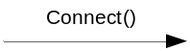

Object creation notation:
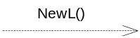

Pseudo-logic notation:
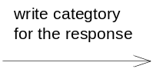

Mediator server start

Operation | Start of the Mediator server.
Preconditions
Description | Mediator server is started as a stand-alone Symbian OS server. In construction phase, it creates CMediatorObjectHandler, CMediatorEventHandler, CMediatorCommandHandler and CMediatorPluginHandler. CMediatorPluginHandler loads the plug-ins when it gets idle notifications. This is described in Section 4.4.4. After handler creation, Mediator server reads static event resource registrations (Section 4.4.2).
Inputs
Modifies
Outputs
Postconditions | Mediator server is started as new process. New thread(s) are created per plug-in.
Related To | CMediatorServer, CMediatorServerObjectHandler, CMediatorServerCommandHandler, CMediatorServerEventHandler, CMediatorServerPluginHandler.
Related Event | Instantiate Mediator API class (see Section 4.4.2).
Exceptions | Out of memory.

Figure 4.7 Start of the Mediator server core

Instantiate Mediator API class

Operation | Instantiate one of the Mediator API classes.
Preconditions
Description | The client creates an instance of the Mediator API class (one of the five). Each API class within the implementation creates the RMediatorServer instance which connects to the server and makes a new session.
Inputs | Depending of the API class they can take callback interface implementer as a pointer.
Modifies | Adds a new session to Mediator server session queue.
Outputs | New client side API class instance.
Postconditions | Client instance is created. New session is established to Mediator server.
Related To | CMediatorCommandInitiator, CMediatorCommandResponder, CMediatorEventProvider, CMediatorEventConsumer, CMediatorNotifications, CMediatorCommandInitiatorBody, CMediatorCommandResponderBody, CMediatorEventProviderBody, CMediatorEventConsumeBody, CMediatorNotificationsBody, RMediatorServer, CMediatorServerSession.
Related Event | Mediator server start (see Section 4.4.1).
Exceptions | If Mediator server is not started already, the session creation will fail with KErrNotFound. At this point, the client starts the server with the StartServer() method.

Figure 4.8 gives the information of the sequence behind the API class instantiation. It uses the CMediatorCommandInitiator class as an example. However, other classes will have similar behavior.
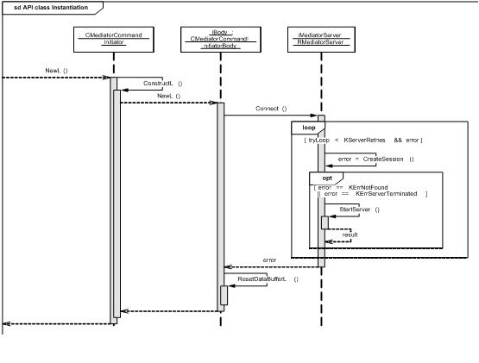
Figure 4.8 Mediator API class instantiation

Process resource events

Operation | Process static event resource registrations.
Preconditions | Server is starting.
Description | Mediator server scans the events subdirectory within its private directory. It processes all the resource files it finds from the directory and creates domain/categories/events structures according to the registrations.
Inputs | Resource files under events subdirectory within Mediator's private directory.
Modifies | Domain/category/event structures within Mediator.
Outputs
Postconditions | Static event registrations are added to Mediator.
Related To | CMediatorServer
Related Event | Mediator server start (see Section 4.4.1).
Exceptions | Error in event registration. In this case error is handled, but other domains/resource files are still processed (so the processing is not stopped).

Figure 4.9 shows the resource events registration sequence. Note that, within the loop, if RegisterEventListL method fails, the processing is continued from the next category.
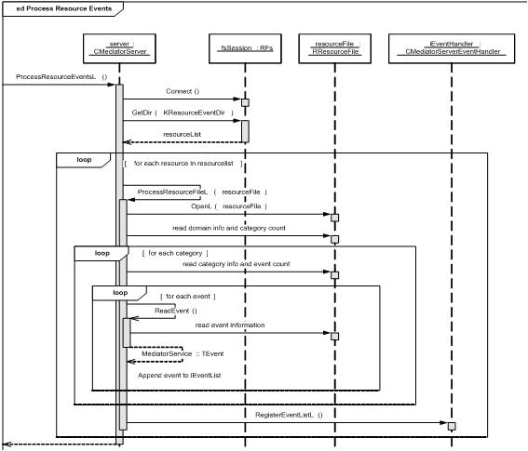
Figure 4.9 Processing of the resource files

Start Mediator plug-ins

Operation | Start Mediator plug-ins.
Preconditions | Server is starting.
Description | When CMediatorPluginHandler gets idle callback, it makes an ECom resolve request to find out the list of plug-ins fulfilling the required plug-in interface. Then it launches a separate thread for each plug-in.
Inputs
Modifies
Outputs
Postconditions | There is a new thread for each loaded plug-in. Plug-ins are running.
Related To | CMediatorPluginHandler, MediatorPluginBase.
Related Event | Mediator server start (see Section 4.4.1).
Exceptions | Out of memory, error in plug-in construction. These errors are considered fatal and will cause leave in server construction.

Figure 4.10 shows the sequence for Mediator plug-in loading. Note that the CMediatorPluginBase class starts the actual plug-in implementation with the StartL() method. Before this method is called, the plug-in should not make Mediator API calls, as this situation might end with a deadlock.
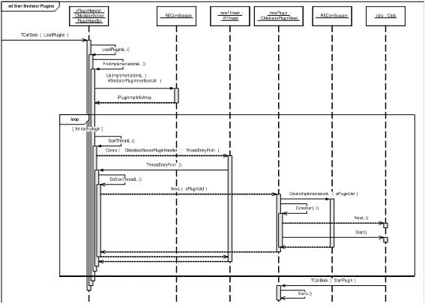
Figure 4.10. Mediator plug-in loading

Register events

Operation | Register events.
Preconditions | Mediator server is up and running.
Description | Client specifies one or more events to be registered. Event information contains event id, required capabilities to subscribe the event and version information. Event list is send to Mediator server, which then handles the request using CMediatorServerEventHandler.
Inputs | Two flavors of the API method:  - domain, category, event ID, capabilities required and event version  - domain, category and list of events
Modifies | Events are added to specified domain/category event list.
Outputs | Status of the success of the operation.
Postconditions | Events are added to specified domain/category event list.
Related To | CMediatorEventProvider, CMediatorEventProviderBody, RMediatorServerClient, CMediatorServerSession, CMediatorServerEventHandler, CMediatorServerObjectHandler, CDomain, CCategory, CEvent.
Related Event
Exceptions | OOM situation. Mediator specific error situation (KErrMediatorDomainNotFound, KErrMediatorCategoryNotFound, KErrMediatorEventAllreadyExists). In case of an error situation, the procedure is rolled back, so that no events are registered if a single event registration fails.

Note that this method requires the SwEvent capability from the client registering the event(s).
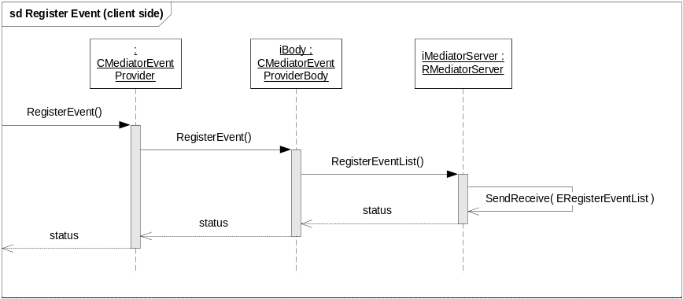
Figure 4.11 Event registration from the client side
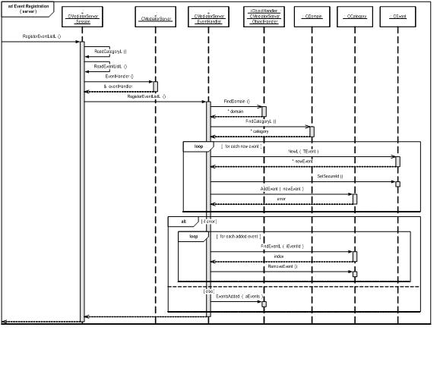
Figure 4.12. Event registration from the server side

Unregister events

Operation | Unregister events.
Preconditions | Mediator server is up and running. There are event(s) registered within Mediator server.
Description | Client specifies one or more events to be unregistered. Event information contains event id in this case. Event list is send to Mediator server, which then handles the request using CMediatorServerEventHandler. Handler checks the Secure ID of the client. Only that client who is registered the event can unregister it.
Inputs | Two flavors of the API method:  - domain, category, event id  - domain, category and list of events
Modifies | Events are removed from specified domain/category event list.
Outputs | Status of the success of the operation.
Postconditions | Events are removed from specified domain/category event list.
Related To | CMediatorEventProvider, CMediatorEventProviderBody, RMediatorServerClient, CMediatorServerSession, CMediatorServerEventHandler, CMediatorServerObjectHandler, clas CDomain, CCategory, CEvent.
Related Event | Register event(s) (see Section 4.4.5).
Exceptions | OOM situation. Mediator specific error situation (KErrMediatorDomainNotFound, KErrMediatorCategoryNotFound, KErrMediatorEventNotFound, KErrMediatorSecureIdMismatch). In case of error situation the procedure is rolled back, so that no events are unregistered if a single event unregistration fails.

Note that this method requires the SwEvent capability from the client unregistering the event(s).

Subscribe events

Operation | Subscribe events.
Preconditions | Mediator server is up and running. There are event(s) registered.
Description | Client specifies one or more events to be subscribed. Event information contains event id and version information in this case. Event list is send to Mediator server, which then handles the request using CMediatorServerEventHandler. Handler checks that client has required capabilities to subscribe to the specified event. Also handler checks that major version number match.
Inputs | Two flavors of the API method:  - domain, category, event id and event version  - domain, category and list of events
Modifies | Observer definition is added for the specified events.
Outputs | Status of the success of the operation.
Postconditions | Observer definition is added for the specified events.
Related To | CMediatorEventProvider, CMediatorEventProviderBody, RMediatorServerClient, CMediatorServerSession, CMediatorServerEventHandler, CMediatorServerObjectHandler, CDomain, CCategory, CEvent.
Related Event | Register event(s) (see Section 4.4.5).
Exceptions | OOM situation. KErrPermissionDenied, if capabilities do not meet. Mediator specific error situation (KErrMediatorDomainNotFound, KErrMediatorCategoryNotFound, KErrMediatorEventNotFound, KErrMediatorVersionMismatch). In case of error situation the procedure is rolled back, so that no events are subscribed if a single event subscription fails.

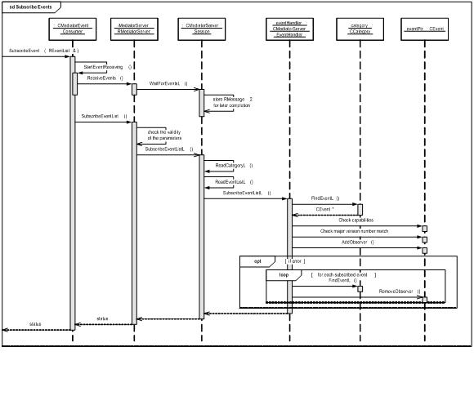
Figure 4.13 Subscribe to events

Unsubscribe events

Operation | Unsubscribe events.
Preconditions | Mediator server is up and running. There are event(s) registered and the client has subscribed those.
Description | Client specifies one or more events to be unsubscribed. Event information contains event id in this case. Event list is send to Mediator server, which then handles the request using CMediatorServerEventHandler.
Inputs | Two flavors of the API method:  - domain, category, event ID  - domain, category and list of events
Modifies | Observer definition is added for the specified events.
Outputs | Status of the success of the operation.
Postconditions | Observer definition is added for the specified events.
Related To | CMediatorEventProvider, CMediatorEventProviderBody, RMediatorServerClient, CMediatorServerSession, CMediatorServerEventHandler, CMediatorServerObjectHandler, CDomain, CCategory, CEvent.
Related Event | Subscribe events (see Section 4.4.7).
Exceptions | OOM situation. Mediator specific error situation (KErrMediatorDomainNotFound, KErrMediatorCategoryNotFound, KErrMediatorEventNotFound, KErrMediatorNoSubscription). In case of error situation the procedure is rolled back, so that no events are unsubscribed if a single event unsubscribing fails.

Raise event

Operation | Raise event.
Preconditions | Mediator server is up and running. Event is registered to it.
Description | Event Provider raises the event. Event information is delivered to CMediatorServerEventHandler, which checks the major version match against registered event info. Then event information with parameter data is propagated to all subscribed sessions via MMediatorServerEventObserver interface. Sessions then complete the pending Event Consumer side requests as shown in Figure 4.15.
Inputs | Domain, category, event ID, event version and event parameter data.
Modifies
Outputs | Status of the success of the operation.
Postconditions | Event is propagated to all the Event Consumers.
Related To | CMediatorEventProvider, CMediatorEventProviderBody, RMediatorServerClient, CMediatorServerSession, CMediatorServerEventHandler, CMediatorServerObjectHandler, CDomain, CCategory, CEvent, CMediatorEventConsumer, CMediatorEventConsumerBody.
Related Event | Register event(s) (see Section 4.4.5) and subscribe events (see Section 4.4.7).
Exceptions | OOM situation. Mediator specific error situation (KErrMediatorDomainNotFound, KErrMediatorCategoryNotFound, KErrMediatorEventNotFound, KErrMediatorVersionMismatch).

Note that this method requires the SwEvent capability from the client raising the event.
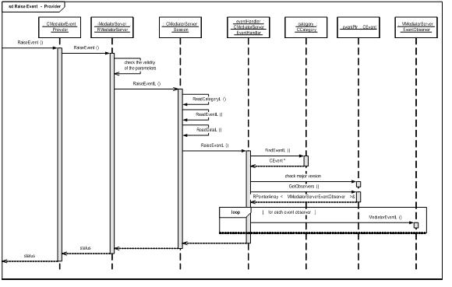
Figure 4.14 Raising event - provider side
Figure 4.15 shows the sequence when an event is propagated to Event Consumers. Note that if there is no active request pending (meaning that the client is busy processing the previous event), then event is buffered by the session.
If event data exceeds the default maximum value client has reserved, no data is written to client and wait request is completed with actual data size. This way, the client can reserve more space for incoming data and fetch the whole parameter data then synchronously from the server.
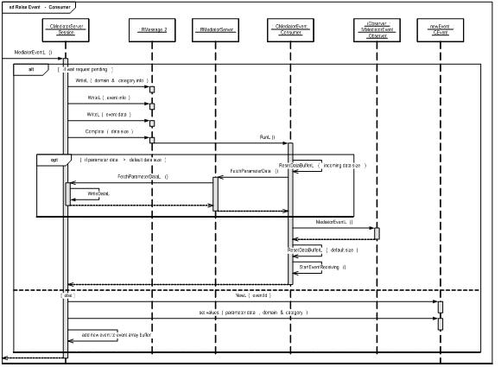
Figure 4.15 Raising event - consumer side

Register commands

Operation | Register commands.
Preconditions | Mediator server is up and running.
Description | Client specifies one or more commands to be registered. Command information contains command id, required capabilities to issue the command, command timeout and version information. Command list is sent to Mediator server, which then handles the request using CMediatorServerCommandHandler.
Inputs | Two flavors of the API method:  - domain, category, command ID, capabilities required, command timeout and command version  - domain, category and list of commands
Modifies | Commands are added to specified domain/category command list.
Outputs | Status of the success of the operation.
Postconditions | Commands are added to specified domain/category command list.
Related To | CMediatorCommandResponder, CMediatorCommandResponderBody, RMediatorServerClient, CMediatorServerSession, CMediatorServerCommandHandler, CMediatorServerObjectHandler, CDomain, CCategory, CCommand.
Related Event | None. (The sequence is similar to Register events sequence in Figure 4.11 and in Figure 4.12).
Exceptions | OOM situation. Mediator specific error situation (KErrMediatorDomainNotFound, KErrMediatorCategoryNotFound, KErrMediatorCommandAllreadyExists). In case of error situation the procedure is rolled back, so that no commands are registered if a single command registration fails.

Note that this method requires the SwEvent capability from the client registering command(s).

Unregister commands

Operation | Unregister commands.
Preconditions | Mediator server is up and running. There are command(s) registered within Mediator server.
Description | Client specifies one or more commands to be unregistered. Command information contains command id in this case. Command list is send to Mediator server, which then handles the request using CMediatorServerCommandHandler. Handler checks the Secure ID of the client. Only that client who is registered the command can unregister it.
Inputs | Two flavors of the API method:  - domain, category, command ID  - domain, category and list of commands
Modifies | Commands are removed from specified domain/category command list.
Outputs | Status of the success of the operation.
Postconditions | Commands are removed from specified domain/category command list.
Related To | CMediatorCommandResponder, CMediatorCommandResponderBody, RMediatorServerClient, CMediatorServerSession, CMediatorServerCommandHandler, CMediatorServerObjectHandler, CDomain, CCategory, CCommand.
Related Event | Register commands(s) (see Section 4.4.10).
Exceptions | OOM situation. Mediator specific error situation (KErrMediatorDomainNotFound, KErrMediatorCategoryNotFound, KErrMediatorCommandNotFound, KErrMediatorSecureIdMismatch). In case of error situation the procedure is rolled back, so that no commands are unregistered if a single command unregistering fails.

Note that this method requires the SwEvent capability from the client unregistering command(s).

Issue command

Operation | Issue command.
Preconditions | Mediator server is up and running. There is a command registered within Mediator server.
Description | Command Initiator specifies command to be issued. Command information contains command ID, version and parameters. Command is send to Mediator server, which then handles the request using CMediatorServerCommandHandler. Handler checks the capabilities of the client and major version number match from the command. CMediatorServerCommandHandler then delivers the command to the correct command responder session.
Inputs | Domain, category, command ID, command version and command parameter data.
Modifies | Command is stored to CMediatorServerCommandHandler's pending commands list to wait for response or timeout.
Outputs | Command is notified to Mediator's command specific command responder, who then should take an action to respond to it.
Postconditions | Command Responder has received a notification of the issued command. Command is stored in Mediator's pending command list.
Related To | CMediatorCommandResponder, CMediatorCommandResponderBody, RMediatorServerClient, CMediatorServerSession, CMediatorServerCommandHandler, CMediatorServerObjectHandler, CDomain, CCategory, CCommand, CMediatorCommandInitiator, CMediatorCommandInitiatorBody.
Related Event | Command response sequence is described in Figure 4.17. If the command is cancelled by Command Initiator, command cancellation procedure is described in Section 4.4.15.
Exceptions | OOM situation. Mediator specific error situation (KErrMediatorDomainNotFound, KErrMediatorCategoryNotFound, KErrMediatorCommandNotFound, KErrMediatorVersionMismatch).  If the command response does not come before command timeout is notified, the command is completed with KErrMediatorTimeout. This sequence is shown in Figure 4.18.

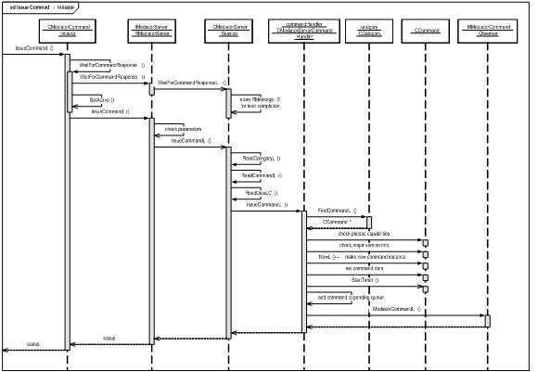
Figure 4.16 Issue command

Respond to command

Operation | Respond to command.
Preconditions | Command has been issued.
Description | Command Responder makes IssueResponse() call with return status information and response parameters. Data is delivered to Mediator Server, which handles it to CMediatorCommandHandler. Command handler then checks the pending list, removes and deletes the pending command and responds to Command Initiator with the status and result parameters.
Inputs | Domain, category, command ID, command response status and command result data.
Modifies | Command is removed from the command pending list in Mediator server.
Outputs | CommandResponseL() callback for the Command Initiator with status and result data.
Postconditions | Command is removed from the command pending list in Mediator server.
Related To | CMediatorCommandResponder, CMediatorCommandResponderBody, RMediatorServerClient, CMediatorServerSession, CMediatorServerCommandHandler, CMediatorServerObjectHandler, CDomain, CCategory, CCommand, CMediatorCommandInitiator, CMediatorCommandInitiatorBody.
Related Event | Issue command (see Section 4.4.12).
Exceptions | OOM situation. Mediator specific error situation (KErrMediatorDomainNotFound, KErrMediatorCategoryNotFound, KErrMediatorCommandNotFound).

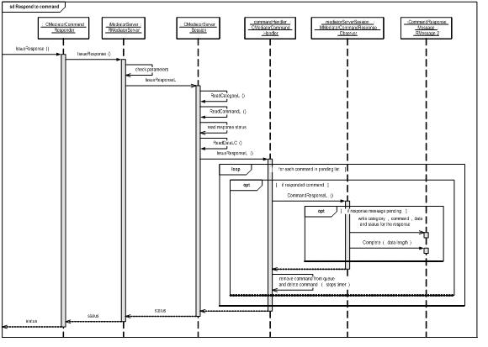
Figure 4.17 Respond to command

Command timeout

Operation | Command timeout (exception case)
Preconditions | Command has been issued, but no response within specified time interval.
Description | CMediatorCommandTimer callback is delivered to CMediatorServerCommandHandler. Handler then checks its pending command list and if the correct command can be found, it makes the response to Command Initiator with KErrMediatorTimeout error code. Also it removes the pending command from Command Responder's session, if it is not delivered to responder yet.
Inputs | Timer expiration callback with expired command information.
Modifies | CMediatorServerCommandHandler's command pending list.
Outputs | Callback to Command Initiator with KErrMediatorTimeout status code.
Postconditions | Command is removed from pending list.
Related To | CMediatorCommandTimer, CMediatorServerCommandHandler, CMediatorServerSession, CCommand, CMediatorCommandInitiatorBody.
Related Event | Issue command (see Section 4.4.12).
Exceptions

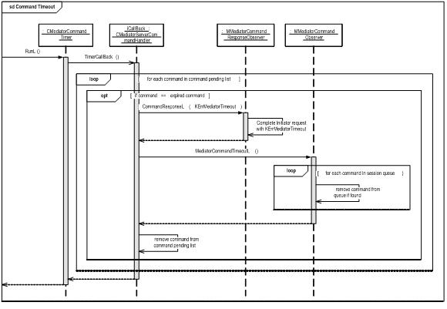
Figure 4.18 Command timeout

Cancel command

Operation | Cancel command.
Preconditions | Mediator server is up and running. There is ongoing command active in Mediator.
Description | Command Initiator cancels ongoing command. Command information contains command id. Command is send to Mediator server, which then handles the request using CMediatorServerCommandHandler. Handler checks the command pending list and when it finds to correct command, it notifies the Command Responder with CancelMediatorCommand callback with the cancelled command information.
Inputs | Domain, category, command ID.
Modifies | Command is removed from CMediatorServerCommandHandler's pending commands list.
Outputs | Command Responder is notified with CancelMediatorCommand callback with the cancelled command information.
Postconditions | Command is removed from the command pending list.
Related To | CMediatorCommandInitiator, CMediatorCommandInitiatorBody, RMediatorServerClient, CMediatorServerSession, CMediatorServerCommandHandler, CMediatorServerObjectHandler, CDomain, CCategory, CCommand, CMediatorCommandResponder, CMediatorCommandResponderBody.
Related Event | Issue command (see Section 4.4.12).
Exceptions | OOM situation. Mediator specific error situation (KErrMediatorDomainNotFound, KErrMediatorCategoryNotFound, KErrMediatorCommandNotFound).

Get Mediator registered info

Operation | Get Mediator domains, categories, events or commands. Events are used as an example, but similar sequence is used for domains, categories and commands.
Preconditions | Mediator server is up and running.
Description | CMediatorNotifications API is used to get registered object information. It sends the request to Mediator Server. CMediatorServerObjectHandler handles the request. If the returned list count exceeds the default maximum value, then more space is reserved in client side and the full list is fetched synchronously from the Mediator server.
Inputs | - GetDomains: reference to empty domain list  - GetCategories: domain ID, reference to empty category list  - GetEvents: domain ID, category ID, reference to empty event list  - GetCommands: domain ID, category ID, reference to empty command list
Modifies
Outputs | Requested objects are updated to list given as a reference parameter.
Postconditions | Requested info is returned to the client.
Related To | CMediatorCommandNotifications, CMediatorCommandNotificationsBody, RMediatorServerClient, CMediatorServerSession, CMediatorServerObjectHandler, CDomain, CCategory, CCommand, CEvent.
Related Event
Exceptions | OOM situation. Mediator specific error situation (KErrMediatorDomainNotFound, KErrMediatorCategoryNotFound).

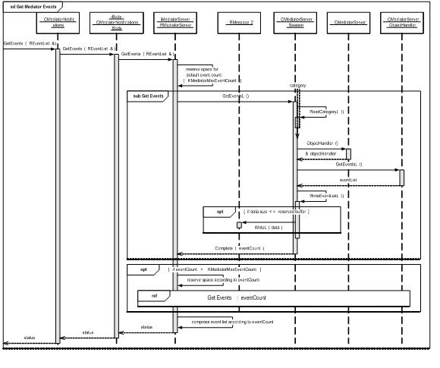
Figure 4.19 Mediator event information fetching

Register for notifications

Operation | Register to receive registration/unregistration notifications from Mediator.
Preconditions | Mediator server is up and running.
Description | The CMediatorNotifications::RegisterNotificationObserver method is used to register observer. Internally this method sends asynchronous request to Mediator server, which is completed when change in Mediator object structure happens.
Inputs
Modifies | New asynchronous request is send to Mediator.
Outputs | Status of the operation.
Postconditions | Asynchronous request is pending in Mediator.
Related To | CMediatorCommandNotifications, CMediatorCommandNotificationsBody, RMediatorServerClient, CMediatorServerSession.
Related Event
Exceptions | OOM situation. Mediator specific error situation (KErrMediatorAlreadySubscribed).

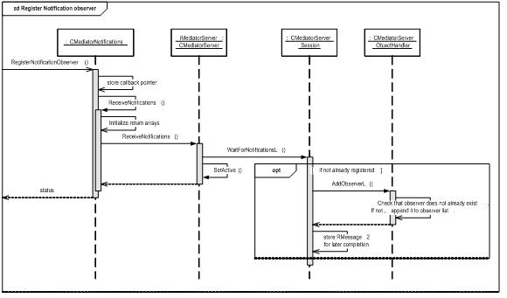
Figure 4.20 Register to receive notifications

Receive notifications

Operation | Receive notifications.
Preconditions | Mediator server is up and running. Client has registered to receive notifications (Section 4.4.17).
Description | CMediatorObjectHandler gets notifications for changes in Mediator object structure. It loops through the list of notification observers and gives a callback for each observer defining the type of the change and the list of the changed objects.
Inputs | List of objects (events/commands/category) added or removed.
Modifies
Outputs | List of objects (events/commands/category) added or removed. Type of the actions.
Postconditions
Related To | CMediatorCommandNotifications, CMediatorCommandNotificationsBody, RMediatorServerClient, CMediatorServerSession, CMediatorServerObjectHandler.
Related Event | Register for notifications (see Section 4.4.17).
Exceptions | OOM situation.

Figure 4.21 Receive notifications

Mediator session closing

Operation | Mediator session closing.
Preconditions | Mediator server is up and running. Client has created a session to it (=instantiated an API class).
Description | CMediatorServerSession destructor is called. Destructor cancels all possible asynchronous requests with error code KErrCancel. After this it requests object handler to remove all event subscriptions and command registrations belonging to this session. Unregistered commands are notified to observer clients.  Note that this is an exception situation. Normally the client should have unregistered those registrations done before closing the session.
Inputs
Modifies
Outputs | Notifications about unregistrations for the clients.
Postconditions | All pending requests are cancelled and all pending registrations are unregistered.
Related To | CMediatorServerSession, CMediatorServerObjectHandler, CEvent, CCategory, MMediatorServerNotificationObserver.
Related Event
Exceptions | OOM situation. Leave is TRAPped and ignored and unregistration procedure continues.

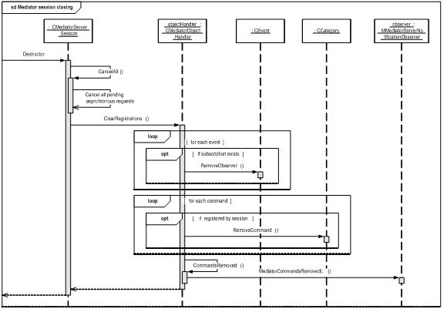
Figure 4.22 Mediator session closing

Backup and Restore
This component does not participate in backup and restore.

Variation
Mediator can be left out from the ROM image if feature flag __MEDIATOR is not defined. In that case, the Mediator client DLL is replaced by a stub implementation which returns KErrNotSupported to all interface function calls. Thus clients are not obligated to variate according to the __MEDIATOR feature flag.
Mediator plug-ins can be variated in image creation time, if required.

System resource usage

Files

File | Static event resource registration file (*.*).
Type | Private read only.
Location | ROM. Subdirectory events under Mediator's private directory.
Format | Resource file.
Size estimate | Small (<1 kB) but depends on the amount of registered events per resource file.
Description | Events can be registered using resource files.

File | allowedsids.rsc
Type | Private read only.
Location | ROM. Stored in Mediator's private directory.
Format | Resource file.
Size estimate | Small (<1 kB) but depends on the amount of SIDs stored in this file.
Description | Clients possessing a Secure Id stored in this file do not need the SwEvent capability for using Mediator’s interface functions.

File | MediatorDebug.rsc
Type | Private read only.
Location | ROM. Stored in z:\resource.
Format | Resource file.
Size estimate | Small (<1 kB) but depends on the amount of configuration data.
Description | Contains configuration data for debug builds.

Other data

Databases
This component does not use any databases.

Central Repository
This component does not use Central Repository.

Publish and Subscribe
This component does not use Publish and Subscribe.

Memory consumption

Memory/Build | Consumption
User data area
WINSCW UDeb | MediatorServer.exe: 395 kB  MediatorClient.dll: 270 kB  MediatorPluginBase: 87 kB
ARMv5 URel | MediatorServer.exe: 13.1 kB  MediatorClient.dll: 6 kB  MediatorPluginBase: 1 kB

Task allocation
Mediator server is a stand-alone server running in its own process. Server starts one new thread for each Mediator plug-in it finds in the startup.

Timers

Timer | Purpose | Interval | Lifetime
CMediator  Command  Timer | Indicate timeout for command processing. | Command specific (= Command Responder defines). | When command is being processed. Is stopped when command is responded by Command Responder. One timer for each active command.

Security

Capabilities of this component
Mediator server capabilities are defined in the following table:

Capability | Justification
CAP_SERVER | Base capability set for Symbian OS server.
NetworkControl | Network control needed for implementing Telephony Services Engine (TSE) plug-in.
MultimediaDD | This capability is needed by Telephony Services Engine plug-in for using client API of Telephony Audio Routing server.

Mediator client and Mediator plug-in base DLL capabilities are defined in the following table:

Capability | Justification
CAP_GENERAL_DLL | Base capability set for DLL.

Input and output validation
Command/event IDs are validated.
Command/event parameter data is not validated because it is just delivered to remote party. Mediator subsystem takes no preference about the syntax of the incoming parameters. Syntax agreement needs to be made between the clients of the subsystem.

Environmental assumptions
This component does not make any assumptions about its environment.

Additional enforcements
The Mediator subsystem makes some enforcement for the clients using it:
- Secure ID is stored for the commands/events registered by the client. Only the same client can unregister commands/events. This is checked in unregistration phase by comparing the client's secure ID for the stored one.
- Client issuing a command or subscribing to events must meet the capability requirements defined for those specific commands/events.

Exception handling
Mediator defines its own set of error codes which are used in Mediator specific error situations. When there are capabilities or other platform security errors, common Symbian error codes are used. Mediator specific errors are listed in this document in Section 4.3.1.1. Also, reference document [2] contains information about the exception handling in Mediator server (e.g. partial recovery is described there).
The leave mechanism of Symbian OS environment is used to handle memory exhaustion.

Usage

Building
cd \s60\Mediator\group
bldmake bldfiles
abld build

Debugging support
By default, the UDeb build of Mediator projects only yields an error trace, meaning that only when an error (e.g. system runs out of memory) occurs trace is printed.
Function level tracing can be enabled by compiling Mediator projects with macro _DEBUG_MEDIATOR defined.

Client logging
The amount of debug information printed by the Mediator can be configured, e.g. debug messages logged can be restricted (filtered) to a certain domain or category. Logging configuration can be altered by making changes to file MediatorDebug.rss and recompiling the Mediator. By default, most of the output is filtered out.
The data fields of the resource file structure are described in the table below.

Structure field | Description
domain_options | Filtering mode for the operations with domain information, which defines how the domains array is interpreted. Possible values are EInclusive (inclusive filtering) and EExclusive (exclusive filtering).  Inclusive filtering means that trace is printed only for domains that are defined in domains array.  Exclusive filtering means that trace is not printed for domains that are defined in domains array.
domains | An array of UIDs of the domains that are filtered. UIDs are given as a comma-separated list in hexadecimal format.
category_options | Filtering mode for the operations with category information, which defines how the categories array is interpreted. Possible values are EInclusive (inclusive filtering) and EExclusive (exclusive filtering).  Inclusive filtering means that trace is printed only for categories that are defined in categories array.  Exclusive filtering means that trace is not printed for categories that are defined in categories array.
categories | An array of UIDs of the categories that are filtered. UIDs are given as a comma-separated list in hexadecimal format.
options | A bit-mask of generic options for client logging.  KLogStatus means that the following information is printed when an registration procedure (e.g. a command) is performed by any client: amount of allocated memory for the server, count of registered commands and events and count of loaded plug-ins.  KLogCommands means that operations having the command identifier information are printed.  KLogEvents means that operations having the event identifier information are printed.  KLogParameterData means that parameter data passed with a command or an event is printed.
outputfile | A file name without path information for storing the logging data. The file is created under C:\Logs\Mediator if it does not exist. If an empty string is given, no file logging is performed.

User's guide
See reference document [2] for detailed information about the usage of the Mediator subsystem.

