S60 3.2
Power Save Mode Server
Design Document

Team name | Author
SystemSW\CoS\Accessories | Pekka Karjalainen

Change history:

Version | Date | Status | Comments
1.0 | 09.10.2007 | Approved

Table of contents:

1. Document control 5
1.1 Documentation conventions 5
1.2 Abbreviations 5
1.3 Definitions 5
2. General 6
2.1 Introduction 6
2.2 Component environment 6
2.3 Use cases 6
2.3.1 Change the Power Save mode 7
2.3.2 Cancel the Power Save mode change 7
2.3.3 Back up and get the settings 8
2.3.4 Get the configurations 8
2.3.5 Back up the configurations 8
2.3.6 Change the passive configurations 9
2.4 Services required 9
2.4.1 From the Symbian OS subsystems 9
2.4.2 From the Domestic OS subsystems 9
2.4.3 From HW 9
2.5 Services provided 9
2.5.1 UI 9
2.5.2 SW IF 9
3. UI control hierarchy 11
4. Design 12
4.1 Class diagrams 12
4.1.1 Framework 12
4.1.2 PSMServer 13
4.1.3 PSMClient 14
4.2 Class descriptions 14
4.2.1 Structs, type definitions and enumerations 15
4.2.1.1 Psmtypes.h classes, definitions and enumerations 15
4.2.2 Flag definitions 16
4.3 Operations 16
4.3.1 Changing the Power Save mode 16
4.3.2 Creating a backup and getting the settings 17
4.4 Backup and Restore 18
5. Variation 19
6. System resource usage 20
6.1 Files 20
6.2 Other data 20
6.2.1 Databases 20
6.2.2 Central Repository 21
6.2.3 Publish and Subscribe 21
6.3 Memory consumption 21
6.4 Task allocation 21
6.5 Performance 21
6.6 Timers 21
7. Security 22
7.1 Capabilities of this component 22
7.2 Input and output validation 22
7.3 Environmental assumptions 22
7.4 Additional enforcements 22
8. Exception handling 23
9. Usage 24
9.1 Building 24
9.2 User's guide 24
9.2.1 Structure of the configuration file 24
9.2.2 Implementing a PSM plug-in 24
9.2.3 Client vs. Plug-in 25

Document control

Documentation conventions
Code is shown with the Courier New font.

Abbreviations

API | Application Progmming Interface
PSM | Power Save Mode
PSMServer | Power Save Mode Server
XML | Extensible Markup Language

Definitions

PSM Services | An S60 service for switching device into power save mode

General

Introduction
The Power Save Mode server (PSMServer) is an S60 subsystem that is responsible for switching the device into the Power Save mode and back.

Component environment
PSM Services consist of PSMServer, PSMClient and possible PSM plug-ins. There can be number of PSM plug-ins, which all have to implement PSM Plugin API. From Symbian OS, PSMServer uses ECom to load PSM Plug-ins, Central Repository is used to change passive settings of the device, and XML Parser is used for handling configuration and backup files. File Server is used to read from and write to files.
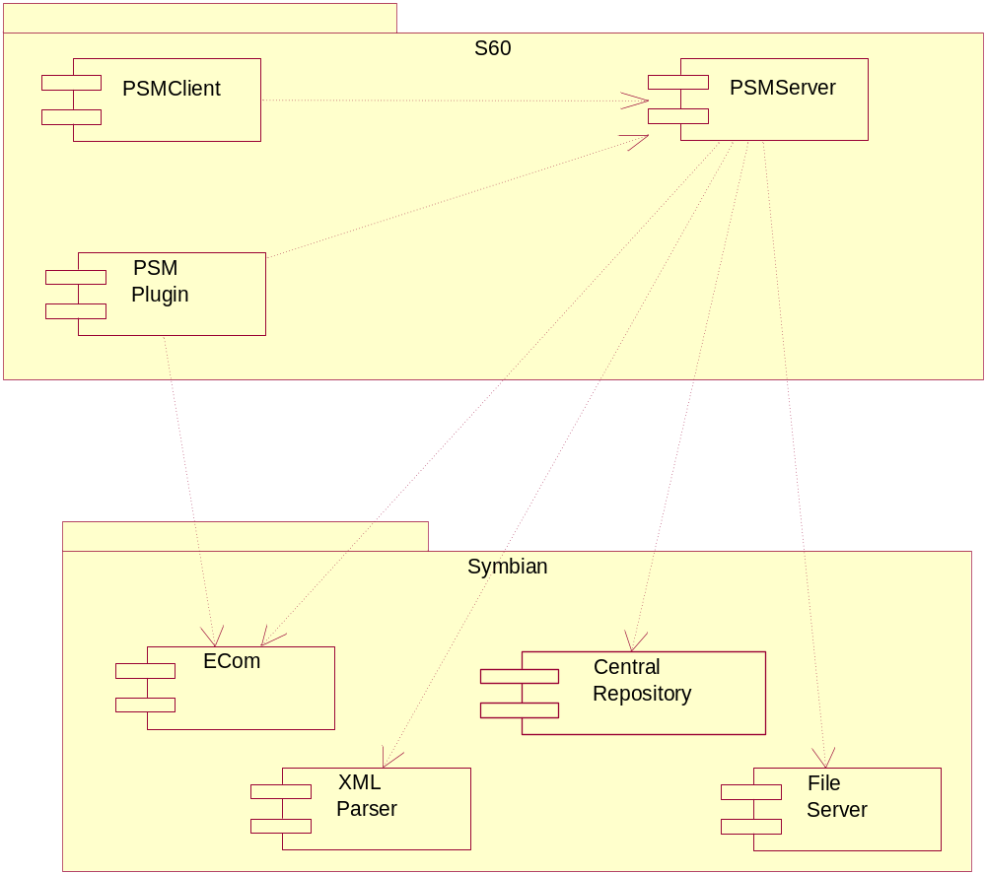
Figure 2.1 PSM Services environment

Use cases
Only the most critical use cases are described in the following subsections.
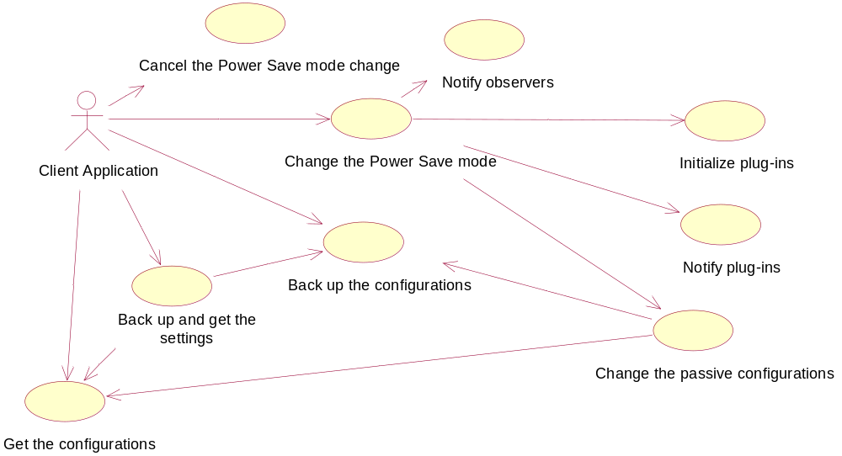
Figure 2.2 PSMServer use cases

Change the Power Save mode

Summary | Change the Power Save mode. Goes through PSM plug-ins and notifies about the mode change, and then notifies the registered observers about the mode change.
Actor(s) | The client application.
Frequency | Low.
Preconditions | The device enters the Power Save mode, either automatically or by user selection. PSMClient is used to inform PSMServer about the mode change.
Description | PSMServer is requested to change the Power Save mode. It loads all PSM Plug-ins, notifies and waits for plug-ins to complete their mode change. It notifies the registered clients about the mode change.
Exceptions | - The requested power save mode is already active.  - Unknown power save mode.  - Failure during power save mode change.
Postconditions | All plug-ins are unloaded. The Power Save mode is changed.
Illustrations | See Section 4.3.1.

Cancel the Power Save mode change

Summary | Cancel the Power Save mode change. Changes the ongoing Power Save mode back to the previous mode. The registered observers are not notified.
Actor(s) | The client application.
Frequency | Low.
Preconditions | There is an ongoing Power Save mode change.
Description | PSMServer is requested to cancel the Power Save mode change. The ongoing Power Save mode change is canceled and the previous mode is restored.
Exceptions
Postconditions | All plug-ins are unloaded. The Power Save mode change is canceled and the previous mode is active.
Illustrations

Back up and get the settings

Summary | Change the setting values with the correct values related to the currently active Power Save mode.
Actor(s) | The client application or PSM Plug-in.
Frequency | Low.
Preconditions | The Power Save mode is ongoing or just completed.
Description | PSMServer creates a backup from the currently active settings, searches new settings for the current Power Save mode and returns new settings values.
Exceptions
Postconditions | Previous settings are stored in the backup storage and the client has received new, updated values.
Illustrations

Get the configurations

Summary | Searches the current set of configurations for the current Power Save mode.
Actor(s) | The client application or PSM Plug-in.
Frequency | Low.
Preconditions | PSMServer is up and running.
Description | Searches the requested configurations for the current Power Save mode and returns those.
Exceptions
Postconditions | The client has requested the configurations for the current Power Save mode.
Illustrations

Back up the configurations

Summary | Stores the requested configurations into the backup storage.
Actor(s) | The client application or PSM Plug-in.
Frequency | Low.
Preconditions | PSMServer is up and running.
Description | Stores the requested configurations to the backup storage. If a backup storage does not exist, it is created.
Exceptions
Postconditions | The requested configurations are stored into the backup storage.
Illustrations

Change the passive configurations

Summary | Searches for passive configurations (configurations with no clients) and changes those after all the PSM plug-ins have done a Power Save mode change.
Actor(s) | The client application.
Frequency | Low.
Preconditions | The Power Save mode change is ongoing.
Description | Lists all the passive configurations for the current Power Save mode and activates new values.
Exceptions
Postconditions | All the passive configurations are activated.
Illustrations

Services required

From the Symbian OS subsystems
PSMServer uses ECom to load and unload PSM Plug-ins. File server is used to access storage files, Central Repository is used for passive configurations and XML Parser is used to parse and compose configuration files.

API | Description
CMDXMLParser | To parse configuration and backup files.
CMDXMLComposer | To compose backup files.
RFs | Needed to access storage files.
REcomSession | For loading and unloading of PSM plug-ins.

From the Domestic OS subsystems
This component does not have any direct interfaces to the Domestic OS side subsystems.

From HW
This component has no direct HW interfaces.

Services provided

UI
This component does not provide any UI.

SW IF

Provided Service | Description | Protected
CPsmPluginBase | A base class for PSM plug-ins. | Yes
MPsmSettingsProvider | A settings API for PSM plug-ins. | Yes
MPsmClientObserver | An observer of the mode change. | Yes
CPsmClient | PSM Client API for the Power Save mode change functionality. | Yes
CPsmSettings | PSM Client API for the configurations functionality. | Yes

UI control hierarchy
PSM Services do not contain any UI or UI controls.

Design
This chapter contains class and sequence diagrams to clarify the functionality of PSM Services.

Class diagrams
This chapter contains class diagrams and a metamodel definition of the PSM Services subsystem.

Framework
A metamodel definition of the PSM Services subsystem is presented in Figure 4.3.
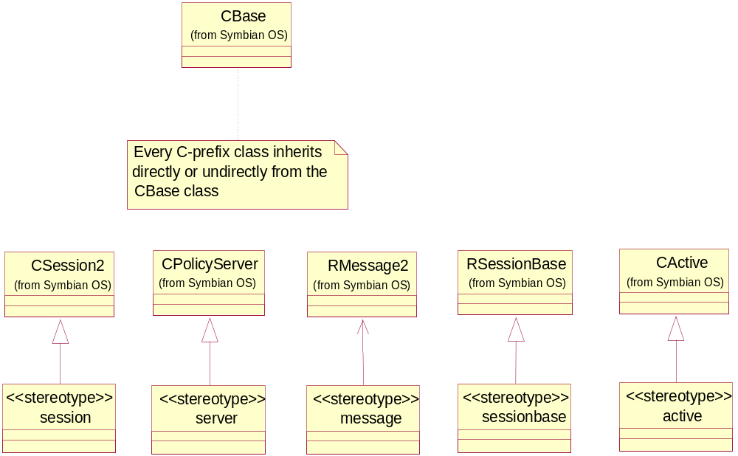
Figure 4.3 Metamodel definition of PSM Services

PSMServer
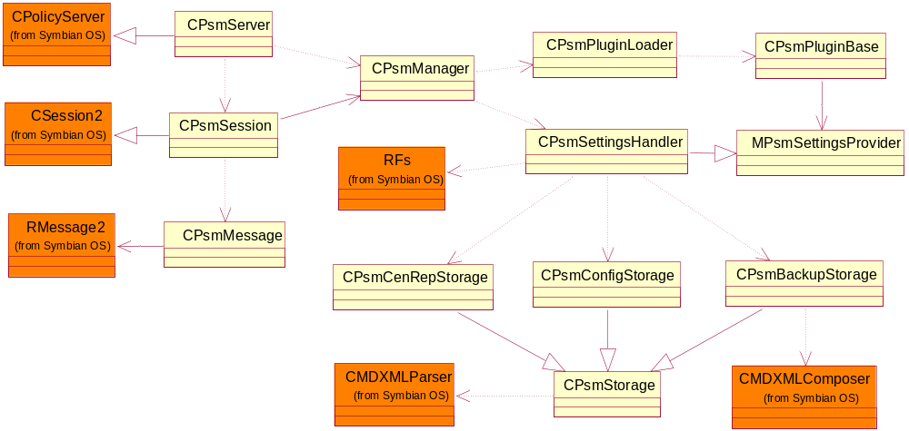
Figure 4.4 Class diagram of PSMServer
Figure 4.4 shows the class diagram of PSMServer. The main class is CPsmManager, which manages all events related to the Power Save mode functionality. PSMServer can be roughly split to the server part and to the engine part, and CPsmManager can be called the divider of these parts, as can be seen from the diagram.
The server part consists of CPsmServer, which realizes CPolicyServer from Symbian OS. CPsmServer is the owner of the CPsmManager class. CPsmSession realizes CSession2 from Symbian OS. It is responsible for using CPsmManager. CPsmMessage is a wrapper for RMessage2 from Symbian OS.
CPsmManager instantiates and creates CPsmPluginLoader and CPsmSettingsHandler. CPsmPluginLoader is responsible for handling all PSM plug-in related events including loading and unloading plug-ins. CPsmSettigsHandler is a gateway to storages. CPsmStorage is the base class of the storages in PSMServer. It has a direct dependency to CMDXMLParser from Symbian OS. It also has some helper functions for handling different events related to storage handling. CPsmConfigStorage is responsible for reading configuration files. CPsmBackupStorage is responsible for backup-related events and CPsmCenRepStorage is responsible for handling passive configurations related events.
Passive configurations are basically configuration files, which are accessed from PSMServer automatically after all plugins have done their mode change. These configurations do not have clients or plug-ins to originate the mode change, but PSMServer takes care of that. Passive configurations are Central Repository settings, where a storage file name represents the category of Central Repository, and it contains all the changeable keys in that category.
Backup is also created from passive configurations.

PSMClient
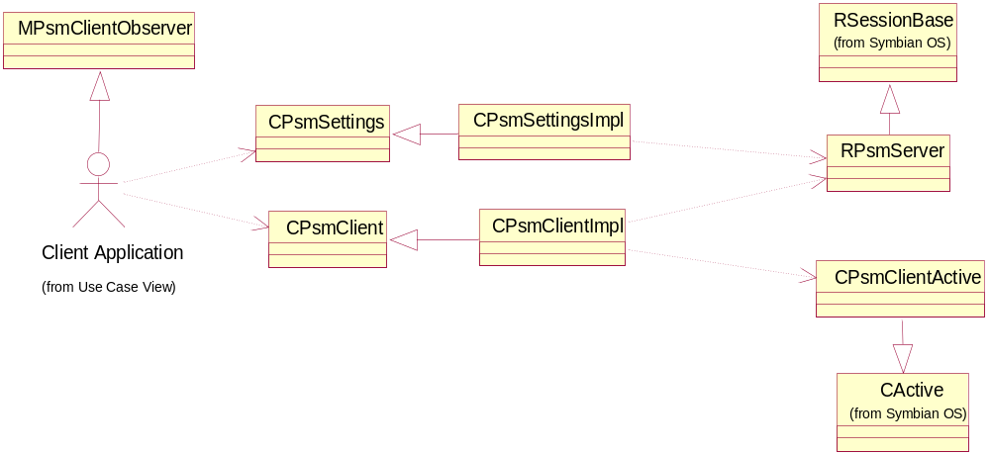
Figure 4.5 PSMClient class diagram
Figure 4.5 shows the class diagram of the PSMClient component. The actor in this diagram is the actual client application using the PSMClient component.
PSM Client API consists of two abstract classes: CPsmClient and CPsmSettings. CPsmClient is used to change the Power Save mode and CPsmSettings is used for different settings functionalities.
The Symbian client side session is hidden from the client application and it is used internally in API implementation classes.
The client application implements MPsmClientObserver in order to get a notification when the Power Save mode change is completed.

Class descriptions
PSMServer classes:

Class | Description | Header file
CPsmBackupStorage | A storage class responsible for backup operations. | psmbackupstorage.h
CPsmCenRepStorage | A storage class responsible for Central Repository changes. | psmcenrepstorage.h
CPsmConfigStorage | A storage class responsible for reading configurations. | psmconfigstorage.h
CPsmManager | Manages the Power Save mode changes. | psmmanager.h
CPsmMessage | A wrapper class for Symbian RMessage2. | psmsrvmessage.h
CPsmPluginBase | A base abstract class for PSM plug-ins. | psmpluginbase.h
CPsmPluginLoader | Handles PSM plug-ins. | psmpluginloader.h
CPsmServer | The main server class. | psmsrvserver.h
CPsmSession | The main session class of PSMServer. | psmsrvsession.h
CPsmSettingsProvider | Responsible for settings related functionality | psmsettingshandler.h
CPsmStorage | Base class for storage classes | psmstorage.h
MPsmSettingsProvider | Interface for CPsmSettingsProvider class | psmsettingsprovider.h

PSMClient classes:

Class | Description | Header file
CPsmClient | An abstact class for PSM Client API. | psmclient.h
CPsmClientActive | An active object used to wait the completion of asynchronous requests to the server. Only for internal use. | psmclientactive.h
CPsmClientImpl | Implements PSM Client API. | psmclientimpl.h
CPsmSettings | An abstract class for PSM Settings API. | psmsettings.h
CPsmSettingsImpl | Implements PSM Settings API. | psmsettingsimpl.h
MPsmClientObserver | An interface for observing PSM changes. | psmclientobserver.h
RPsmServer | A client side session for client-server communications. Only for internal use. | psmsession.h

Structs, type definitions and enumerations
There are no structs defined in the PSM Services subsystem, but there is one class that is used as a struct but not shown in any class diagram.

Psmtypes.h classes, definitions and enumerations

Class TPsmsrvConfigInfo | Represents a single configuration
iConfigId | The identifier number in a configuration file.
iConfigType | Identifies the data type of the configuration; see Configuration data types in the table below.
iBlocked | Indicates if the value is modifiable in the active Power Save mode.
i<type>Value | Contains the value of the configuration.

Enumeration TPsmsrvConfigTypes | Configuration data types
EConfigTypeInt | An integer data type.
EConfigTypeReal | A real data type.
EConfigTypeBuf | A textual data type.

Enumeration TPsmsrvMode | Known power save modes
EPsmsrvModeNormal | Normal, non-PSM mode.
EPsmsrvModePowerSave | Full Power Save mode.
EPsmsrvPartialMode | Partial mode.

Type definitions | Description
RConfigInfoArray | The RArray class containing TPsmsrvConfigInfo.
RPassiveConfigList | The RArray class containing TUint32 data types.
KPsmMaxBufferLength | The maximum buffer length of a textual configuration.

Flag definitions
The trace flags can only be defined in debug builds.

Flag | Description
API_TRACE_FLAG | When this flag is defined, a trace is produced whenever the public API methods are entered and exited.
COMPONENT_TRACE_FLAG | When this flag is defined, miscellaneous traces, such as regular methods enter and exit traces, and various branching traces, are produced. Defining this flag slows down the server because of the sheer amount of trace.
ERROR_TRACE_FLAG | When this flag is defined, a trace about error situations is produced. This flag is defined by default.
MEMORY_TRACE_FLAG | When this flag is defined, a trace about heap memory usage by various threads is produced.

Operations
Only the most complex operations are illustrated here.

Changing the Power Save mode

Operation | Changing the Power Save mode.
Preconditions | PSMServer is started when the first client connects to it.
Description | The client application requests to change the Power Save mode. The request goes asynchronously to PSMServer. The server loads and notifies PSM Plug-ins, changes passive configurations and finally notifies the observer about the change.
Inputs | The desired Power Save mode and an observer to notify about the mode change.
Modifies | Changes the values of the configurations defined by PSM plug-ins.
Outputs | A system-wide error code about the completion of the PSM change.
Postconditions | The mode has been changed.
Related To | Related to use the case in Section 2.3.1.
Related Event | A need to change the Power Save mode, user-originated or automated.
Exceptions | - The requested PSM is already active – PSM is not changed.  - Requested PSM is not known – PSM is not changed.  - Some of the configurations failed to change – PSM is changed, and the observer is notified about some failures during the mode change.

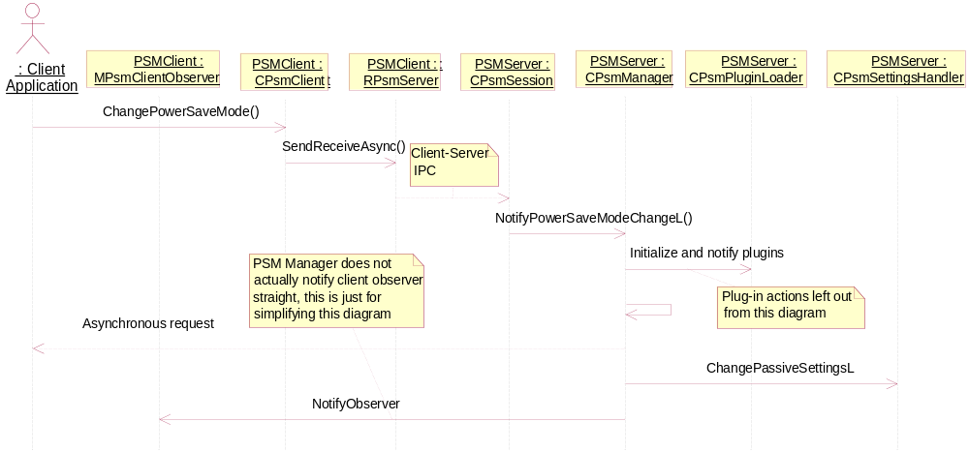
Figure 4.6 Changing the Power Save mode

Creating a backup and getting the settings

Operation | Creating a backup and getting settings.
Preconditions | PSM has been changed or the change is currently ongoing.
Description | Creates a backup from the given settings and replaces those settings with the ones specified for the current PSM.
Inputs | An array of configurations that needs to be stored in the backup and changed for the corresponding values for the current PSM.
Modifies | The backup storage.
Outputs | The same array is returned with the changed settings.
Postconditions | The changed settings are returned and those should be active.
Related To | Related to the use case in Section 2.3.3.
Related Event | The Power Save mode change notification.
Exceptions | - The configuration storage is not found – No changes are made.  - One or more settings are not found from the configuration storage – Those settings remain the same.

Note: Only those settings that are in the array are updated. PSMServer does not add or remove settings to/from the array.
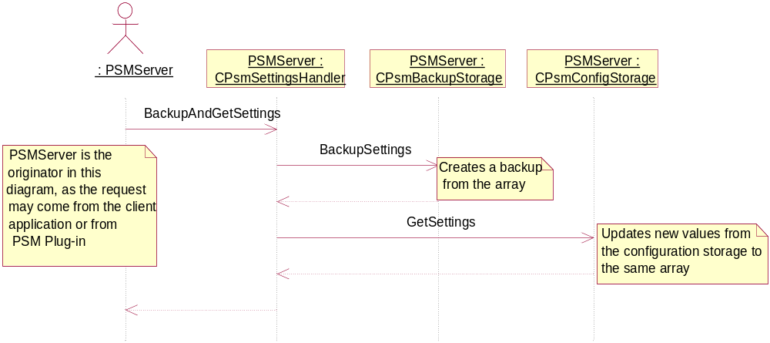
Figure 4.7 Creating a backup and getting the settings

Backup and Restore
This component does not participate in backup and restore. There is backup service in PSMServer, but that is explained elsewhere.

Variation
PSMServer itself does not provide any variations beyond leaving the server executable out of the device altogether. All the device-specific configurations are done in configuration files owned by PSM plug-ins and PSM client applications.

System resource usage

Files
PSMServer reads configurations from configuration files owned by PSM plug-ins and clients. PSMServer does not know whether there are any files or not. Configuration files are named as UID.xml where UID is the secure ID of the owning component or any other unique ID.
PSMServer also creates backup files based on the configuration files, also named in the same manner.
Configuration files:

File | <UID>.xml
Type | Private read only.
Location | ROM, PSMServer’s private folder.
Format | XML format defined by PSMServer.
Sharing | PSM Plug-ins and clients export the configuration files to PSMServer’s private folder. Only PSMServer has direct access to those files.
Encryption | No.
Size estimate | 1 - 5 kB, depends on the number of configurations defined in the file.
Clean up
Description | Contains the configurations of a specific PSM plug-in or a client in different Power Save modes. These configurations are customizable for the needs of different products.

Backup files:

File | <UID>.xml
Type | Private.
Location | RAM, PSMServer’s private folder.
Format | XML format defined by PSMServer.
Sharing | Not shared. Only PSMServer has direct access to these files.
Encryption | No.
Size estimate | 1 - 5 kB, depends on the number of configurations defined in the file.
Clean up
Description | Contains the backup of the original configuration values during the Power Save mode.

Other data

Databases
This component does not use any databases.

Central Repository
This component has one Central Repository key to store the current Power Save mode. It is also used to notify client applications about the Power Save mode change.

Publish and Subscribe
This component does not use Publish and Subscribe.

Memory consumption
PSM Servers memory consumption:

Memory/Build | Consumption
WINS UDeb | 443 588 bytes
ARMI URel | 8 148 bytes

PSM Clients memory consumption:

Memory/Build | Consumption
WINS UDeb | 225 628 bytes
ARMI URel | 2 046 bytes

Task allocation
PSMServer is an executable program and runs in its own process. All PSM Plug-ins run in the same process as PSMServer. PSMClient runs in the client application’s process.

Performance
During the Power Save mode change, PSMServer has access to the file storage several times. Sometimes this may be a time-consuming operation.

Timers
PSMServer has only one timer.

Timer | Purpose | Interval | Lifetime
Shutdown timer | The inactivity time of the server to shutdown after the last client disconnects. | 1 minute | When the last client disconnects, the shutdown timer is started. When the timer expires, PSMServer is shut down. If there are new connections when the timer is active, it is canceled.

Security

Capabilities of this component

Capability | Justification
CAP_SERVER | PSMServer is an S60 protected server, and therefore has the default S60 server capabilities.
CAP_CLIENT_DLL | PSMClient is S60 client DLL, and therefore has the default S60 client DLL capabilities.

Input and output validation
Configuration files have to be in the correct format. Otherwise it may cause misleading results during the Power Save mode change.

Environmental assumptions
PSMServer assumes that System Application is the only component which has the right to inform PSMServer about the need to change the Power Save mode.
Moreover, PSMServer assumes that every client and PSM plug-in that uses either PSM Settings API or the Settings provider for plug-ins have exported their own configuration files to the correct location. They are also responsible for taking configurations into ROM during the compilation time.

Additional enforcements
This component does not have any additional security enforcements.

Exception handling
In any error case, the leave mechanism is used when an error occurs by the PSM plug-in operation. PSM API’s do not have any leaving functions, but those functions will return a corresponding error code in any error situation.

Usage

Building
bldmake bldfiles
abld reallyclean
abld build

User's guide
This chapter explains how to use the PSM Services subsystem and describes the structure of the configuration files.

Structure of the configuration file
Configuration files are based on XML. Each file starts with a root tag definition which is <PowerSaveModeConfig> and ends with an ending of the root tag, </PowerSaveModeConfig>.

<PowerSaveModeConfig>
<Setting mode="1"><!-- PSM mode Full PSM -->
<SetItem key="1" type="0" value="55"></SetItem>
<SetItem key="2" type="0" value="66"></SetItem>
<SetItem key="3" type="0" value="77"></SetItem>
<SetItem key="4" type="0" value="88"></SetItem>
<SetItem key="5" type="0" value="99"></SetItem>
</Setting>
<Setting mode="2"><!-- PSM mode Partial PSM-->
<SetItem key="1" type="0" value="555"></SetItem>
<SetItem key="2" type="0" value="666"></SetItem>
<SetItem key="3" type="0" value="777"></SetItem>
<SetItem key="4" type="0" value="888"></SetItem>
<SetItem key="5" type="0" value="999"></SetItem>
</Setting>
</PowerSaveModeConfig>

Following a root tag, there is a Power Save mode group tag, called <Setting>. It has one attribute, mode, which tells the mode this group belongs to. Each configuration file must have settings groups to all known Power Save modes, excluding EPsmNormalMode.
Every single configuration is defined by a <SetItem> tag. It has three attributes:
- The key attribute is the identifier of the configuration. This is the same as iConfigId in the TPsmsrvConfigInfo class.
- The type attribute tells the data type of the configuration data. This is the same as iConfigType in the TPsmsrvConfigInfo class.
- The value attribute is the actual configureable value. This is the same as i<type>Value in the TPsmsrvConfigInfo class, where <type> is defined by the Type attribute.

Implementing a PSM plug-in
PSM plug-ins are ECom plug-ins used by PSMServer. PSMServer defines an abstract base class for plug-ins, CPsmPluginBase. The base class has only one pure virtual function that the plug-ins have to implement, NotifyModeChange. The base class has also two interfaces for plug-in use:
- MPsmPluginCallback is used by plug-ins to inform PSMServer that they have done their PSM change in case they could not complete it right away.
- MPsmSettingsProvider is an interface for getting configurations and other relevant information about the mode change from PSMServer.

Each PSM plug-in has to create and export a configuration file in case they have any configurable settings. Each configuration file is owned either by a PSM plug-in or some client application using PSM Settings API, and the owner of the configuration file is responsible for taking it to ROM during the compilation time. The owner is also responsible for the maintenance of the configuration file.

Client vs. Plug-in
Basically, PSMServer provides the same services to PSMClient and PSM plug-ins. The difference between a client and a plug-in is that a plug-in runs in the PSMServer’s process. It is created when the Power Save mode is ongoing and deleted when it has done its mode change actions, while clients run in a different process and have to communicate with PSMServer through the PSMClient component.
PSMServer does not have access to UI components, so PSM plug-ins cannot use the UI directly.

