S60 3.0
Vibra Control
Design Document

Team name | Author
S60/CorePlatform/BaseServices/SystemSW/SystemUtilities | Heli Pikkarainen

Change history:

Version | Date | Status | Comments
3.0 | 15.11.2007 | Approved | Editorial changes
2.0 | 12.08.2005 | Approved | Updated to 3.0
1.0 | 19.08.2004 | Approved

Table of contents:

1. Document control 4
1.1 References 4
1.2 Documentation conventions 4
1.3 Abbreviations 4
2. General 5
2.1 Introduction 5
2.2 Subsystem environment 5
2.3 Services required 5
2.3.1 From the Symbian OS subsystems 5
2.3.2 From the Domestic OS subsystems 6
2.3.3 From HW 6
2.4 Services provided 6
2.4.1 UI 6
2.4.2 SW IF 6
3. Design 7
3.1 Class diagrams 7
3.2 Class descriptions 7
3.2.1 API definitions 8
3.2.1.1 <vibractrl.h> CVibraControl 8
3.2.1.2 <vibractrl.h> MVibraControlObserver 8
3.2.1.3 <vibractrl.h> VibraFactory 8
3.2.1.4 <vibractrlwrapperimpl.h> CVibraControlImpl 8
3.2.2 Structures, type definitions and enumerations 9
3.2.2.1 <vibractrl.h> CVibraControl::TVibraModeState 9
3.2.2.2 <vibractrl.h> CVibraControl::TVibraRequestStatus 9
3.2.2.3 <vibractrl.h> CVibraControl::TVibraCtrlPanic 10
3.2.3 Flag definitions 10
3.2.4 State diagrams 10
3.3 Variation 10
3.4 Operations 10
3.4.1 Instantiating a new CVibraControl object 10
3.4.2 Starting the vibra 11
3.4.3 Stopping the vibra 12
3.4.4 Retrieve the current settings of the vibration feature 12
4. System resource usage 13
4.1 Files 13
4.2 Databases 13
4.3 Memory consumption 13
4.4 Task allocation 13
4.5 Performance 13
4.6 Timers 13
5. Exception handling 14
6. Usage 15
6.1 Building 15
6.2 User's guide 15

Document control

References

- S60 Vibra API Specification Document
- S60 Vibra Control API Specification Document

Documentation conventions
Code is shown with the Courier New font.

Abbreviations

API | Application Programming Interface
HW | Hardware
HWRM | Hardware Resource Manager
SW | Software
UI | User Interface

General

Introduction
Vibra Control provides the ability to control the device vibration feature. Vibra Control is deprecated. Use HWRM Vibra API instead in new implementations. For details, see reference document [1].

Subsystem environment
The key relationships between Vibra Control and the components in its environment are shown in Figure 2.1. HWRM Vibra Client provides the interface to access the device vibration feature. CVibraControlImpl is used to redirect the vibra service requests to the HWRM Vibra Client.
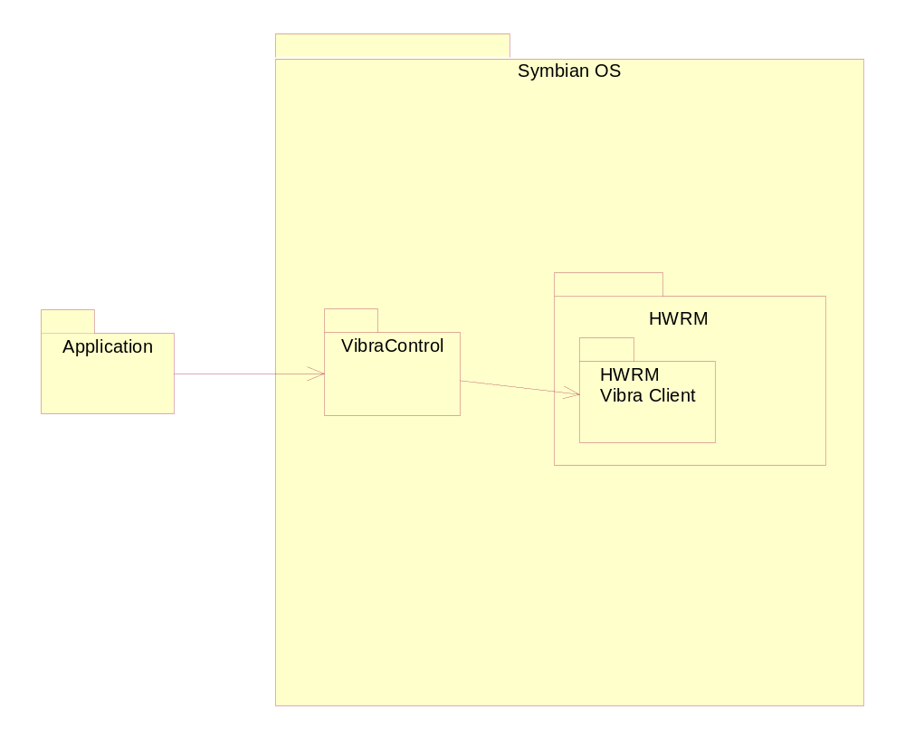
Figure 2.1 Vibra Control subsystem environment

Services required

From the Symbian OS subsystems
Vibra Control uses the following Symbian OS and S60 subsystem services:
- HWRM Vibra API (see reference document [1])

From the Domestic OS subsystems
Vibra Control has no direct interfaces to the Domestic OS side subsystems.

From HW
This component has no direct HW interfaces.

Services provided

UI
The SW does not provide UI.

SW IF
Vibra Control provides services to control the device vibration. Provided services are:
- Start vibra (see Section 3.4.2)
- Stop vibra (see Section 3.4.3)
- Observer interface (see Section 3.4.1)
- Retrieve the user profile setting of the vibration feature (see Section 3.4.4)

Design

Class diagrams
The class diagram of Vibra Control is shown in Figure 3.2.
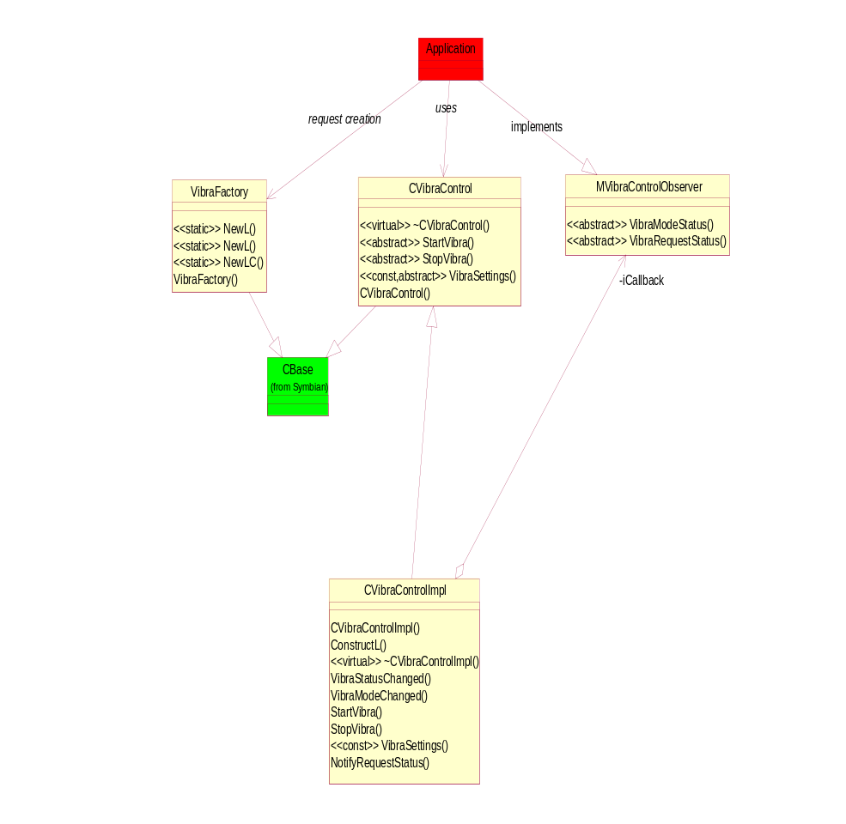
Figure 3.2 Vibra Control class diagram

Class descriptions
The following table gives a list of the classes with a short description of each class.

Class | Description | Header file
CVibraControl | The Vibra Control interface. | vibractrl.h
MVibraControlObserver | The Vibra Control observer class for the clients of Vibra Control. | vibractrl.h
VibraFactory | The Factory class for creating instances of Vibra Control. | vibractrl.h
CVibraControlImpl | An implementation for the pure virtual methods defined in the CVibraControl class. | vibractrlwrapperimpl.h

API definitions

<vibractrl.h> CVibraControl

CVibraControl | Description
virtual ~CVibraControl() | This is the destructor.
CVibraControl() | This is the constructor.
virtual void StartVibraL(TUint16 aDuration) = 0 | Starts the vibra with defined duration (factory-defined intensity is used).
virtual void StartVibraL(TUint16 aDuration, TInt aIntensity) = 0 | Starts the vibra with defined duration and intensity. Note! This is supported in S60 release 2.6 and onwards.
virtual void StopVibraL(void) = 0 | Stops the vibration.
virtual TVibraModeState VibraSettings(void) const = 0 | Retrieves the current settings of the vibration feature in the user profile.

<vibractrl.h> MVibraControlObserver

MVibraControlObserver | Description
virtual void VibraModeStatus(CVibraControl::TVibraModeState aStatus) = 0 | This is called when the vibration setting in the user profile is changed and when the vibra is started or stopped.
virtual void VibraRequestStatus(CVibraControl::TVibraRequestStatus aStatus) = 0 | This is called when the device vibration feature is requested.

<vibractrl.h> VibraFactory

VibraFactory | Description
VibraFactory() | This is the constructor.
IMPORT_C static CVibraControl* NewL() | This creates a CVibraControl object without the notify handling.
IMPORT_C static CVibraControl* NewL(MVibraControlObserver* aCallback) | This create a CVibraControl Object using the notify handling.
IMPORT_C static CVibraControl* NewLC(MVibraControlObserver* aCallback) | This create a CVibraControl Object using the notify handling. The object is left to cleanup stack.

<vibractrlwrapperimpl.h> CVibraControlImpl

CVibraControlImpl | Description
CVibraControlImpl(MVibraControlObserver* aCallback) | This is the constructor.
void ConstructL() | This is the two-phased constructor.
virtual ~CVibraControlImpl() | This is the destructor.
void VibraModeChanged(CHWRMVibra::TVibraModeState aStatus) | From MHWRMVibraObserver.
void VibraStatusChanged(CHWRMVibra::TVibraStatus aStatus) | From MHWRMVibraObserver.
IMPORT_C void StartVibraL(TUint16 aDuration) | From CVibraControl.
IMPORT_C void StartVibraL(TUint16 aDuration, TInt aIntensity) | From CVibraControl.
IMPORT_C void StopVibraL() | From CVibraControl.
IMPORT_C TVibraModeState VibraSettings() const | From CVibraControl.
void NotifyRequestStatus(TVibraRequestStatus aStatus) | The client of Vibra Control is notified about the status of the request.
void StartVibraL(TUint16 aDuration, TInt aIntensity, TBool aUseDefaultIntensity) | This is the actual implementation for starting the vibra. It is called from both of the public StartVibraL() methods.
void HandleErrorL(TInt aError) | Handles error from HWRM Vibra API.

Structures, type definitions and enumerations

<vibractrl.h> CVibraControl::TVibraModeState
Vibration setting in the user profile.

TVibraModeState | Description
EVibraModeON | The vibration setting in the user profile is on.
EVibraModeOFF | The vibration setting in the user profile is off.
EVibraModeUnknown | Used for debugging/development and signalling an error condition.

<vibractrl.h> CVibraControl::TVibraRequestStatus
The status of the vibrating setting request.

TVibraRequestStatus | Description
EVibraRequestOK | The request is OK.
EVibraRequestFail | The request has failed.
EVibraRequestNotAllowed | The vibra is set off in the user profile
EVibraRequestStopped | The vibra is stopped
EVibraRequestUnableToStop | Unable to stop the vibra
EVibraRequestUnknown | For debugging/development and signalling an error condition.

<vibractrl.h> CVibraControl::TVibraCtrlPanic
Internal panic codes.

TVibraCtrlPanic | Description
EPanicUnableToGetVibraSetting | The vibra settings cannot be read from the Shared Data.
EPanicVibraGeneral | Reserved for future use.

Flag definitions
No flags used.

State diagrams
Vibra Control has no state information.

Variation
No variation is used.

Operations

Instantiating a new CVibraControl object

Operation | Instantiating a new CVibraControl object.  CVibraControl* VibraFactory::NewL()  CVibraControl* VibraFactory::NewL(MVibraControlObserver* aCallback)  CVibraControl* VibraFactory::NewLC(MVibraControlObserver* aCallback)
Preconditions | None.
Description | Vibra Factory creates a new instance of the CVibraControl class.
Inputs | A reference to a class implementing the MVibraControlObserver interface if needed.
Modifies | Creates an instance of the CVibraControl derived CVibraControlImpl class which has the real implementation of CVibraControl. Creates the CHWRMVibra object to which CVibraControlImpl directs service requests.
Outputs | A pointer to the created CVibraControl object is returned.
Postconditions | The Vibra Control is ready to accept the Vibra Control requests.
Related to | Class CVibraControlImpl,  class CHWRMVibra.
Related event
Exceptions | The device runs out of memory.

Starting the vibra

Operation | Starting the vibra.  void StartVibraL(TUint16 aDuration)  void StartVibraL(TUint16 aDuration, TInt aIntensity)
Preconditions | The CVibraControl object is successfully created. The Vibra is set ON in the user profile.
Description | Vibra is started.
Inputs | The vibration duration time and possible vibra intensity. If intensity is not present, factory-defined intensity is used.
Modifies | Starts the devise vibration.
Outputs | Notify the client of the request status if constructed with notify handling.
Postconditions | Device is vibrating during the time specified. Vibration occurs by user-defined intensity or by factory defined intensity, depending on which method is used to start the Vibra.
Related to | Class CVibraControlImpl.
Related event | Client wants to turn vibra on.
Exceptions | The Vibra is not set on if the Vibra mode is off in the user profiles.  All clients access Vibra with the same priority i.e. several clients can access to vibra at the same time.  Leave reason codes:  - KErrBadHandle Invalid HWRM client.  - KErrAccessDenied The vibration feature is not supported.  - KErrArgument One of the parameters is out of range.

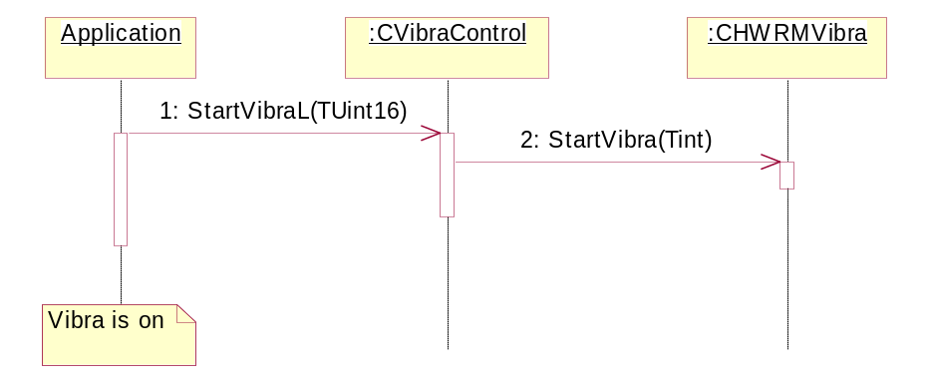
Figure 3.3 Starting the vibra
Starting the vibra
- Client application starts the vibra with the StartVibraL method.
- Vibra Control’s wrapper redirects the client application’s service request to HWRM Vibra API (see Section 3.4.1).

Stopping the vibra

Operation | Stopping the vibra.  void StopVibraL(void)
Preconditions | The CVibraControl object is successfully created.
Description | The vibra is stopped.
Inputs
Modifies | Stops the vibration of the device.
Outputs | Notifies the client of the request status if constructed with notify handling.
Postconditions | Vibration is stopped.
Related to | Class CVibraControlImpl.
Related event | Client wants to turn vibra off.
Exceptions | Leave reason codes:  KErrbadHandle Invalid HWRM client.

Retrieve the current settings of the vibration feature

Operation | Retrieve the current settings of the vibration feature.  TVibraModeState VibraSettings(void) const
Preconditions | The CVibraControl object is successfully created.
Description | Retrieve the user profile setting of the vibration feature.
Inputs
Modifies
Outputs | The current profile setting of the vibration feature.
Postconditions
Related to | Class CVibraControlImpl.
Related event | Client wants to know vibration profile setting state.
Exceptions

System resource usage

Files
This SW does not use any files.

Databases
This SW does not use any databases.

Memory consumption
VibraCtrl.dll takes approximately 3kB of the ROM.

Task allocation
This subsystem runs in one thread, which is the thread of the using application.

Performance
Synchronous methods are used to communicate with HWRM to set vibra state.

Timers
This SW does not use any timers.

Exception handling
The leave mechanism of the Symbian OS environment is used to handle exception situations. Detailed reason codes are listed in Section 3.4.

Usage

Building
Build Vibra Control for all environments (referred as target_env below) by running the following commands in the Group folder in the component root:
bldmake bldfiles
abld build
This results a vibractrl.dll component in your epoc32\release\target_env\udeb (and urel) folder and vibractrl.h in your \epoc32\include folder.

User's guide
Vibra Control is deprecated. Use HWRM Vibra API instead in new implementations. For details, see reference document [1].

