S60 5.x
Orientation SSY
Configuration Document

Team name | Author
D RD S60 CSU OS System and Product SW FI | Timo M. Pääkkönen

Change history:

Version | Date | Status | Comments
1.0 | 15.05.2008 | Approved

Table of contents:

1. Document control 4
1.1 References 4
1.2 Documentation conventions 4
1.3 Abbreviations 4
1.4 Definitions 4
2. General 5
2.1 Introduction 5
2.2 Configuration examples 5

Document control

References
- S60 Sensor API Specification

Documentation conventions
Code is shown with the Courier New font.

Abbreviations
API | Application Programming Interface
OS | Operating System
SSY | Sensor System

Definitions
ECom | A Symbian OS framework for loading plug-ins.
Sensor System | An ECom plug-in component that provides sensor channels to Sensor Server.

General
This document describes the configuration of the Orientation SSY component.

Introduction
The Orientation SSY component is responsible for providing device orientation to the Sensor API. The device orientation is calculated from the Earth’s gravitational vector. Orientation SSY provides six different states for the device orientation. These states are defined in the Sensor definitions API. The states describe in which way the device display is headed in relation to the Earth’s gravitational vector. The states of the device can be described as areas in the spherical polar coordinate system. When the gravitational vector points to a certain area, the device orientation is chosen accordingly. These areas need to be configurable. The configuration is done to Central Repository and can be done with S60 Configuration Tool. The Central Repository key descriptions can be found from the Central Repository definitions.
The configuration can be done from each state to every other state. For example, if the device is in the Display upwards state, the gravitational vector points to the area as described in Figure 2.1 (display upwards). The wideness of the area is bounded by angles to other states. From one state the device can switch to five other states. Four of these states are neighbour states and one is on the opposite side of the sphere. The transactions to other states are defined by the azimuth and zenith angles from the spherical polar coordinate system. These angles bound the areas of the states. The angles that bound the areas can be configured with the Central Repository keys.
As the gravitational vector points to another state’s area that the device is currently in, the orientation SSY starts to evaluate if the new area can be used as a new orientation state for the device. The evaluation is done according to how long the device is staying in the new state. This is done in a certain time window that can be varied by the Central Repository keys. Thus both the angle and the time window can be varied.
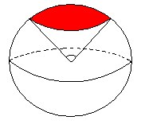
Figure 2.1 Area of the Display upwards state

Configuration examples
In the first example the angles for the device orientation state transaction from display up to display right up are described. The area of the Display up default state area is described in Figure 2.2 a). Next, the angle towards the Display right up state is configured and the angle is set to 30 degrees. As the angle is widened by 30 degrees, the area of the Display up state is widened towards the Display right up state as seen in Figure 2.2 b).
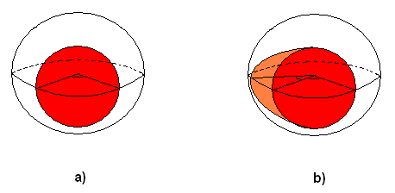
Figure 2.2 a) Default area of Display up. b) Display up area widened with configuration towards Display right up.
If the the transaction to another state needs to be set more sensitive the angle can be configured also smaller. For example, the angle from the Display upwards state to the Display up state is set to -20 degrees. This narrows the area of the Display upwards state from the Display up state. This is presented in Figure 2.3 a) and b).
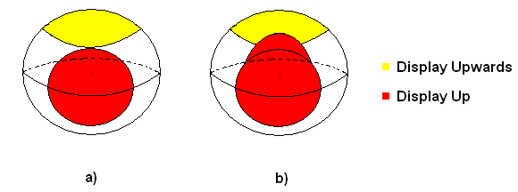
Figure 2.3 Display upwards and Display up states. a) Default. b) Angle configured smaller.
In Orientation SSY, the time window where the orientation is evaluated is also configurable. It means that Orientation SSY evaluates how long the device should remain in one orientation to change the orientation to another state. This can be demonstrated with an example of changing the orientation from the Display up state to the Display right up state. For example, if the timer value is set to 300 ms, Orientation SSY takes accelerometer values for 300 ms which produces acceleration data at 30 Hz frequency. These values are converted to orientation events and then evaluated whether the device has remained in the Display right up state orientation long enough. This is demonstrated in Figure 2.4.
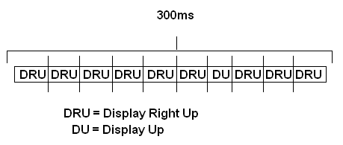
Figure 2.4 Time window for changing state from display up to display right up
In the case of Figure 2.4, there are nine Display right up events and one Display up event. The device has remained in the Display right up state for 90 % of the time window. The limit for changing the state to a new state is that the device has stayed in the new state for at least 75 % of the measured time. In this case, it has stayed long enough in the new state and the state is changed.

