S60 5.1
Sensor Data Compensator
Design Document

Team name | Author
D RD S60 CSU OS System and Product SW FI | Marko Pekkarinen

Change history:

Version | Date | Status | Comments
1.0 | 09.02.2009 | Approved

Table of contents:

1. Document control 5
1.1 References 5
1.2 Documentation conventions 5
1.3 Abbreviations 5
2. General 6
2.1 Introduction 6
2.2 Component environment 6
2.3 Use cases 7
2.3.1 Creating Sensor Data Compensator Object 7
2.3.2 Compensating Sensor Data 8
2.4 Services required 8
2.4.1 From the Symbian OS subsystems 8
2.4.2 From the Domestic OS subsystems 8
2.4.3 From HW 8
2.5 Services provided 8
2.5.1 UI 8
2.5.2 SW IF 8
3. UI control hierarchy 9
4. Design 10
4.1 Class diagrams 10
4.1.1 Framework 10
4.1.2 Component 10
4.2 Class descriptions 11
4.2.1 Structs, type definitions and enumerations 11
4.2.1.1 sensordatacompensatormatrix.h enumerations 11
4.2.2 Flag definitions 12
4.2.3 State diagrams 12
4.3 Operations 13
4.3.1 Creating CSensorDataCompensatorImpl object 13
4.3.2 Updating compensation data 13
4.3.3 Compensating axis channel data 13
4.3.4 Compensating magnetic north channel data 14
4.3.5 Compensating tapping channel data 14
4.4 Backup and Restore 15
5. Variation 16
6. System resource usage 17
6.1 Files 17
6.2 Other data 17
6.2.1 Databases 17
6.2.2 Central Repository 17
6.2.3 Publish and Subscribe 17
6.3 Memory consumption 17
6.4 Task allocation 17
6.5 Performance 17
6.6 Timers 17
7. Security 18
7.1 Capabilities of this component 18
7.2 Input and output validation 18
7.3 Environmental assumptions 18
7.4 Additional enforcements 18
8. Exception handling 19
9. Usage 20
9.1 Building 20
9.2 User's guide 20

Document control

References
- S60 Sensor API Specification Document
- S60 5.1 Sensor Services Subsystem Architecture Description

Documentation conventions
Code is shown with the Courier New font.

Abbreviations
API | Application Programming Interface
DLL | Dynamic Link Library
UI | User Interface

General

Introduction
The coordinate and angle data provided from different sensors with the API set are always bound to the device form factor and hardware configurations, using one coordinate system named as the device base coordinate system (see the reference document [1] for more information about the coordinate system). For example, if the display orientation changes, the accelerometer sensor still provides the axis data by using the device base coordinate system. In order to convert the axis data to match the current display orientation, illustrated in the figure below, the Sensor Data Compensator API is provided for adjusting the coordinate system to match the changed system characteristics. This procedure is called sensor data compensation.
For converting the raw sensor data to the compensated values, the adjustment values (e.g. interchanging x-axis with y-axis) for each device state the compensation is applied to need to be configured and taken as an input for calculations. These values are called compensation data, also referred to as compensation values in this document.
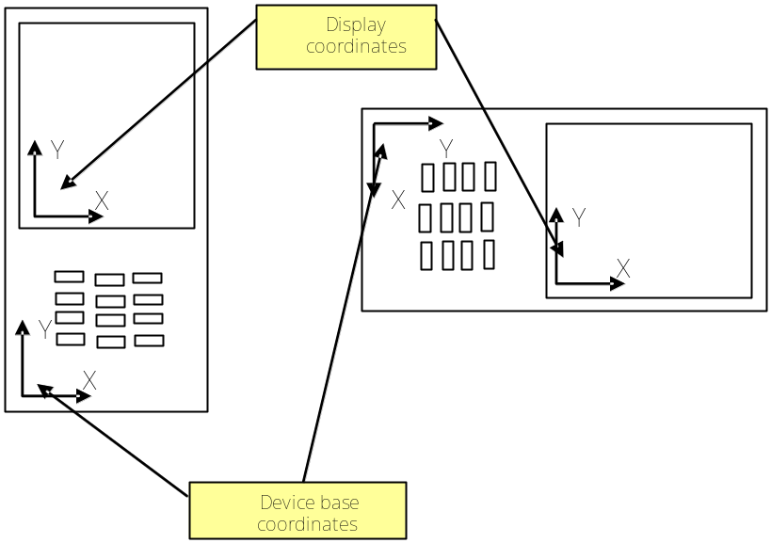
Figure 2.1 Example of adjustment of the coordinate system due to device orientation change
Sensor Data Compensator is a DLL component providing the Sensor Data Compensator API. It defines and uses the Sensor Data Compensator Plug-in API for getting the data needed for compensation calculations. The implementation supports compensating from several sensor channels: axis data (accelerometer or magnetometer), magnetic north data and tapping data.
Sensor Data Compensator is a part of the Sensor Services subsystem described in reference document [2].

Component environment
Figure 2.2 shows the Sensor Data Compensator component environment. Clients using Sensor Data Compensator can be any S60 or third party applications or servers. Sensor Data Compensator relies on the Sensor Data Compensator Plug-in to get correct compensation values based on the current system state.
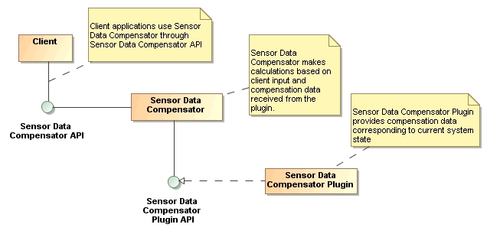
Figure 2.2 Sensor Data Compensator environment

Use cases
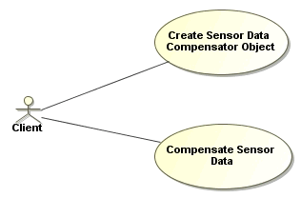
Figure 2.3 Sensor Data Compensator use cases

Creating Sensor Data Compensator Object
Summary | Client application creates a new CSensorDataCompensator object.
Actor(s) | The client application.
Frequency | Low.
Preconditions
Description | The client application creates a new CSensorDataCompensator object.  The new object loads the Sensor Data Compensator Plug-in as it is created.
Exceptions | Sensor Data Compensator Plug-in is not found, it cannot be loaded or compensation for the requested data type is not supported. In production builds the error is silently ignored and in debugging builds it is logged.
Postconditions | Client application has a CSensorDataCompensator object which it can use for data compensation.
Illustrations

Compensating Sensor Data
Summary | Client application uses the Compensate function of the CSensorDataCompensator object.
Actor(s) | The client application.
Frequency | Low.
Preconditions | Client application has successfully created a CSensorDataCompensator object.
Description | Client application calls the Compensate function of the CSensorDataCompensator object.  Sensor Data Compensator calculates the result from the current compensation data and the input parameters and returns the result to the client.
Exceptions | If the Sensor Data Compensator Plug-in has not been loaded or compensation for the requested data type is not supported, Sensor Data Compensator returns the error value KErrNotSupported. The input sensor data is also returned to the client unmodified.  If Sensor Data Compensator is not ready to make compensation, the error code KErrNotReady is returned to the client along with unmodified input sensor data.
Postconditions | Client application has sensor data compensated based on the current device state.
Illustrations

Services required

From the Symbian OS subsystems
API | Description
Sensor Definitions API | Needed for identifying different sensor channels and data types.

From the Domestic OS subsystems
This component does not have any direct interfaces to the Domestic OS side subsystems.

From HW
This component has no direct HW interfaces.

Services provided

UI
This component does not provide any UI.

SW IF
Provided Service | Description | Protected
Sensor Data Compensator API | Provides the functionality for converting the data values received from the Sensor API depending on the current device and UI orientation. | No

UI control hierarchy
The component does not contain any UI or UI controls.

Design

Class diagrams

Framework
Sensor Data Compensator is a very simple component, so it does not have any framework classes.

Component
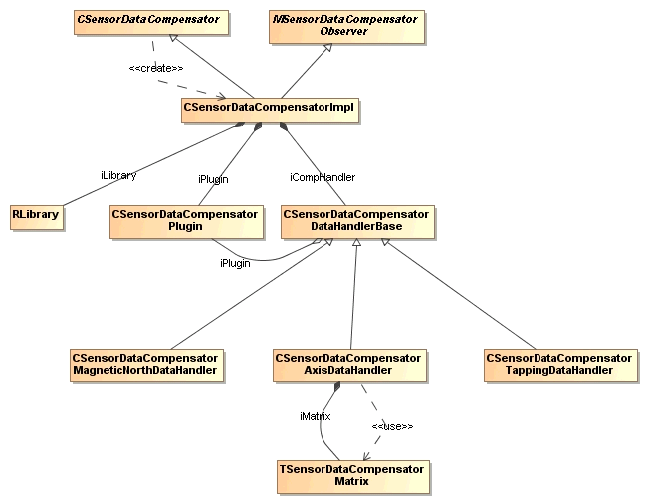
Figure 4.4 Class diagram of the Sensor Data Compensator component
Figure 4.4 shows the class diagram of the Sensor Data Compensator component. CSensorDataCompensatorImpl is derived from the CSensorDataCompensator interface, and it contains the Sensor Data Compensator API implementation. The compensation for the received data is performed by sensor channel-specific compensation handlers derived from the base class CSensorDataCompensatorHandlerBase, which declares the abstract methods to be implemented by the compensation handlers for executing compensation and updating the compensation values. The compensation handlers are CSensorDataCompensatorAxisDataHandler, CSensorDataCompensatorMagneticNorthDataHandler and CSensorDataCompensatorTappingDataHandler. The data channel to be compensated is selected by the API client upon the construction of the API interface object and cannot be changed without destroying and recreating the object. TSensorDataCompensatorMatrix is a utility class providing the matrix calculation operations needed by CSensorDataCompensatorAxisDataHandler.
As the CSensorDataCompensatorImpl object is created, it loads the Sensor Data Compensator Plug-in API implementation using methods contained in RLibrary. The RLibrary is stored as a member variable, so the plug-in object loaded from the library is accessible through the lifetime of the object. The plug-in object itself is an object of type CSensorDataCompensatorPlugin, and it is stored as a member variable as well. Depending on the data type requested to be compensated, CSensorDataCompensatorImpl creates the corresponding data compensation handler and stores it as a member variable. Every time the interface method Compensate is called, the call is propagated to the instantiated compensation handler.
CSensorDataCompensatorImpl requests the compensation handler to update its compensation values, when the interface method Compensate is called for the first time. CSensorDataCompensatorImpl also implements the MSensorDataCompensatorObserver interface, which is defined in the Sensor Data Compensator Plug-in API. Through the MSensorDataCompensatorObserver interface the plug-in can inform CSensorDataCompensatorImpl when compensation data changes. CSensorDataCompensatorImpl then in turn passes the update notification to the currently instantiated data compensation handler. This way, the active data compensation handler can fetch the compensation data from the plug-in only when data is updated (e.g. due to a change in the device orientation).

Class descriptions
Class | Description | Header file
CSensorDataCompensator  Impl | Implementation of the Sensor Data Compensator API. | Sensordatacompensator  impl.h
CSensorDataCompensator  DataHandlerBase | Base class for compensation handlers. | Sensordatacompensator  datahandlerbase.h
CSensorDataCompensator  AxisDataHandler | Handles compensation received from magnetometer and accelerometer channels. | Sensordatacompensator  axisdatahandler.h
CSensorDataCompensator  MagneticNorthDataHandler | Handles compensation for data received from magnetic north channel. | Sensordatacompensator  magneticnorthdatahandler.cpp
CSensorDataCompensator  TappingDataHandler | Handles compensation for data received from tapping channel. | Sensordatacompensator  tappingdatahandler.h
TFixedPoint | Implements a template class providing arithmetic operations for fixed point calculations. | Sensordatacompensator  mathoperations.h
TSensorDataCompensator  Matrix | Implements operations for matrix calculations. | Sensordatacompensator  matrix.h

Structs, type definitions and enumerations

sensordatacompensatormatrix.h enumerations
Enumeration's name | Description
TSensorDataCompensatorMatrixItem | Matrix item definitions as indices to access the items.

Flag definitions
Flag | Description
__SDCOMP_FUNC_TRACE__ | Print traces to RDebug. Trace output is produced about entering/exiting functions.  Has effect only in UDeb build.
__SDCOMP_INFO_TRACE__ | Print some traces to RDebug. Only prints out traces about the most interesting points of execution.  Has effect only in UDeb build.
__SDCOMP_TRACE_INTO_FILE__ | Print timestamp traces to RDebug.  Has effect only in UDeb build.
__SDCOMP_TIMESTAMP_TRACE__ | Print traces to FLogger instead of RDebug.
SDCOMP_USE_FIXED_POINT | When enabled, fixed point arithmetic is used for compensation calculations.

State diagrams
CSensorDataCompensatorImpl is a fairly simple class which only has two possible internal states. The states are shown in Figure 4.5. When the object is created, it fetches the up-to-date compensation data from the plug-in. As long as the compensation data stays up-to-date, compensation calculations can be done directly with that data. When compensation data changes, for instance because UI orientation has changed, the plug-in informs CSensorDataCompensatorImpl through the MSensorDataCompensatorObserver interface and CSensorDataCompensatorImpl enters compensation data out-of-date state. It stays in that state until the client requests a compensation calculation to be done. At that time, CSensorDataCompensatorImpl fetches the latest compensation data from the plug-in and re-enters compensation data up-to-date state.
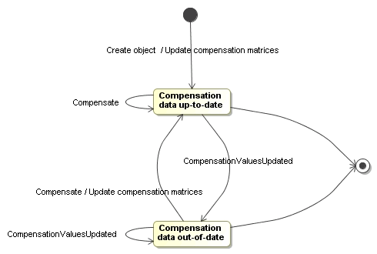
Figure 4.5 Internal states of the CSensorDataCompensatorImpl class

Operations

Creating CSensorDataCompensatorImpl object
Operation | Creating a CSensorDataCompensatorImpl object.
Preconditions
Description | Client application calls CSensorDataCompensator::NewL(). A CSensorDataCompensatorImpl object is created.
Inputs | Identification of the sensor channel to which the compensation is applied and the requested compensation type.
Modifies
Outputs | New object.
Postconditions | A CSensorDataCompensatorImpl object has been constructed. If a Sensor Data Compensator Plug-in is available, it has been loaded and a data compensation handler for the data type to be compensated has been created.
Related To | CSensorDataCompensator::NewL()
Related Event | CSensorDataCompensator::NewL()
Exceptions | If the Sensor Data Compensator Plug-in or the data compensation handler is not available, the error is silently ignored in production builds and logged in debugging builds.

Updating compensation data
Operation | Updating compensation data
Preconditions | A CSensorDataCompensatorImpl object has been created and it has loaded a Sensor Data Compensator Plug-in and instantiated the compensation handler.
Description
Inputs
Modifies | The internal state of the CSensorDataCompensatorImpl object is changed.
Outputs
Postconditions | The internal state of the CSensorDataCompensatorImpl object is compensation data out-of-date. See Section 4.2.3 for details.
Related To | MSensorDataCompensatorObserver::CompensationValuesUpdated()
Related Event | MSensorDataCompensatorObserver::CompensationValuesUpdated()
Exceptions

Compensating axis channel data
Operation | Compensating axis channel data.
Preconditions | The operation described in Section 4.3.1 has been successfully finished with a CSensorDataCompensatorAxisDataHandler object instantiated as the data compensation handler.
Description | Client application calls CSensorDataCompensator::Compensate(), giving the data to be compensated as a parameter. The axis data (x, y, z) received from the sensor channel is mapped to the coordinate system applicable to the current device state.
Inputs | Accelerometer or magnetometer sensor data which needs to be compensated.
Modifies | If the internal state of the CSensorDataCompensatorImpl object is compensation data out-of-date, the new compensation values are fetched from the plug-in by the CSensorDataCompensatorAxisDataHandler object. The internal state of CSensorDataCompensatorImpl is updated accordingly. See Section 4.2.3 for details.
Outputs | The compensated data.
Postconditions | The internal state of the CSensorDataCompensatorImpl object is compensation data up-to-date. See Section 4.2.3 for details.
Related To | CSensorDataCompensator::Compensate()
Related Event | CSensorDataCompensator::Compensate()
Exceptions | If loading of the plug-in has failed when creating the CSensorDataCompensatorImpl object, data compensation is not tried. This also applies if the compensation values have not been given by the plug-in or if an error has occurred while retrieving the values.

Compensating magnetic north channel data
Operation | Compensating magnetic north channel data.
Preconditions | A CSensorDataCompensatorImpl object has been created.
Description | Client application calls CSensorDataCompensator::Compensate(), giving the data to be compensated as a parameter. The angle between the device and the magnetic north, which is received from the sensor, is compensated according to the current device state.
Inputs | Magnetic north channel data which needs to be compensated.
Modifies | If the internal state of the CSensorDataCompensatorImpl object is compensation data out-of-date, the new compensation values are fetched from the plug-in and the internal state is updated accordingly. See Section 4.2.3 for details.
Outputs | The compensated data.
Postconditions | If the internal state of the CSensorDataCompensatorImpl object is compensation data out-of-date, the new compensation values are fetched from the plug-in by the CSensorDataCompensatorMagneticNorthDataHandler object. The internal state of CSensorDataCompensatorImpl is updated accordingly. See Section 4.2.3 for details.
Related To | CSensorDataCompensator::Compensate()
Related Event | CSensorDataCompensator::Compensate()
Exceptions | If loading of the plug-in has failed when creating the CSensorDataCompensatorImpl object, data compensation is not tried. This also applies if the compensation values have not been given by the plug-in or if an error has occurred while retrieving the values.

Compensating tapping channel data
Operation | Compensating tapping channel data.
Preconditions | A CSensorDataCompensatorImpl object has been created.
Description | Client application calls CSensorDataCompensator:: Compensate(), giving the data to be compensated as a parameter. The tapping direction data is compensated according to the current device state.
Inputs | Tapping channel data which needs to be compensated.
Modifies | If the internal state of the CSensorDataCompensatorImpl object is compensation data out-of-date, the new compensation values are fetched from the plug-in and the internal state is updated accordingly. See Section 4.2.3 for details.
Outputs | The compensated data.
Postconditions | If the internal state of the CSensorDataCompensatorImpl object is compensation data out-of-date, the new compensation values are fetched from the plug-in by the CSensorDataCompensatorTappingDataHandler object. The internal state of CSensorDataCompensatorImpl is updated accordingly. See Section 4.2.3 for details.
Related To | CSensorDataCompensator::Compensate()
Related Event | CSensorDataCompensator::Compensate()
Exceptions | If loading of the plug-in has failed when creating the CSensorDataCompensatorImpl object, data compensation is not tried. This also applies if the compensation values have not been given by the plug-in or if an error has occurred while retrieving the values.

Backup and Restore
This component does not participate in backup and restore.

Variation
Sensor Data Compensator component does not support any variation mechanism.

System resource usage

Files
This component does not use any files.

Other data

Databases
This component does not use any databases.

Central Repository
This component does not publish any APIs to Central Repository.

Publish and Subscribe
This component does not publish any APIs to Publish and Subscribe.

Memory consumption
Memory/Build | Consumption
User data area
WINS UDeb | 236 568 bytes
ARMI URel | 3 760 bytes

Task allocation
Sensor Data Compensator component runs in the thread of the client application or server.

Performance
Some performance benefit is gained by using fixed point values instead of floating point values in calculations. This is controlled with the internal flag SDCOMP_USE_FIXED_POINT, which is enabled by default. The downside of using fixed point arithmetic is that the calculation results in compensation are less accurate.
Depending on the Sensor Data Compensator Plug-in implementation, the reading of compensation values can have an impact on the performance.

Timers
This component does not use any timers.

Security

Capabilities of this component
Sensordatacompensator.dll has a capability set of CAP_GENERAL_DLL.

Capability | Justification
CAP_GENERAL_DLL | The DLL does not need more capabilities than the CAP_GENERAL_DLL set contains, and there is no need to restrict the set of capabilities of the DLL to a smaller set.

Input and output validation
The channel data provided by the client for compensation is expected to be organized in memory as declared in the Sensor Definitions API, only the data size is checked by the compensation handler and an error is returned if the size does not match the size of the expected data type. A similar approach is used for validating the updated compensation values which are received via the plug-in interface.

Environmental assumptions
This component does not make any assumptions about its environment.

Additional enforcements
This component does not have any additional security enforcements.

Exception handling
The leave mechanism of Symbian OS environment is used to handle memory exhaustion and other error conditions.

Usage

Building
The following commands can be used to build the Sensor Data Compensator component:
cd \s60\osext\systemswservices\sensorservices\sensordatacompensator\group
bldmake bldfiles
abld build

User's guide
Sensor Data Compensator component can be used only through the Sensor Data Compensator API.
To use the Sensor Data Compensator API, the client has to create a CSensorDataCompensator object which the client uses to call the Compensate method. In order to avoid compensation errors, the client should first ensure from the Sensor Channel API that the data received from the sensor channel is not already compensated.
The example below shows how the Sensor Data Compensator API can be used. The example assumes that the client has implemented the listener interface Sensor Channel API, where the method DataReceived is derived from. It is also assumed that the client has successfully registered as a listener to the accelerometer data channel with the iSensorChannel object, which is an instance of the CSensrvChannel class also belonging to the Sensor Channel API.

#include <sensordatacompensator.h> // link against sensordatacompensator.lib

void CMyClass::ConstructL()
{
// iSensorChannel already instantiated and registered
iCompensator = CSensorDataCompensator::NewL(
TSensrvAccelerometerAxisData::KDataTypeId,
ESensorCompensateDeviceAndUIOrientation );
}

CMyClass::~CMyClass()
{
delete iCompensator;
}

void CMyClass::DataReceived( CSensrvChannel& aChannel,
TInt /*aCount*/,
TInt /*aDataLost*/ )
{

TPckgBuf<TSensrvAccelerometerAxisData> dataBuf;
iSensorChannel->GetData( dataBuf );

if ( !AlreadyCompensated() )
{
if ( iCompensator->Compensate( dataBuf ) == KErrNone )
{
// Now use the compensated data.
}
}

