S60 5.0
Sensor Server
Design Document

TP SP SWD SSW Core Services | Kari Karvonen

Change history:

Version | Date | Status | Comments
2.0 | 21.12.2008 | Approved
1.0 | 26.02.2007 | Approved

Table of contents:

1. Document control 5
1.1 References 5
1.2 Documentation conventions 5
1.3 Abbreviations 5
1.4 Definitions 5
2. General 7
2.1 Introduction 7
2.2 Component environment 7
2.3 Use cases 9
2.3.1 Find channel 9
2.3.2 Open channel 10
2.3.3 Close channel 10
2.3.4 Start listening for channel data 10
2.3.5 Receive channel data 11
2.3.6 Stop listening for channel data 11
2.3.7 Get channel properties 11
2.3.8 Set channel properties 12
2.3.9 Start listening for property change notifications 12
2.3.10 Receive channel property change notifications 13
2.3.11 Stop listening for property change notifications 13
2.3.12 Add channel condition set 13
2.3.13 Remove channel condition set 14
2.3.14 Start listening for channel condition notifications 14
2.3.15 Receive channel condition notification 15
2.3.16 Stop listening for channel condition notifications 15
2.3.17 Start listening for channel change notifications 15
2.3.18 Receive channel change notifications 16
2.3.19 Stop listening for channel change notifications 16
2.4 Services required 16
2.4.1 From the Symbian OS subsystems 16
2.4.2 From the Domestic OS subsystems 17
2.4.3 From HW 17
2.5 Services provided 17
2.5.1 UI 17
2.5.2 SW IF 17
3. UI control hierarchy 18
4. Design 19
4.1 Class diagrams 19
4.1.1 Framework 19
4.1.2 Component 20
4.2 Class descriptions 22
4.2.1 Structs, type definitions and enumerations 26
4.2.2 Flag definitions 26
4.3 Operations 27
4.3.1 Sensor Server startup 27
4.3.2 Proxy initialization 27
4.3.3 Execution flow mediating between threads 28
4.3.4 Loading SSY 30
4.3.5 Proxy cleanup 32
4.3.6 Finding channels 33
4.3.7 Opening a channel 33
4.3.8 Closing a channel 37
4.3.9 Starting data listening 38
4.3.10 Receiving asynchronous data notification 39
4.3.11 Stopping data listening 41
4.3.12 Getting a single property 42
4.3.13 Getting all properties 42
4.3.14 Setting a single property 43
4.3.15 Starting property listening 43
4.3.16 Receiving property change notifications 44
4.3.17 Stopping property listening 45
4.3.18 Adding channel condition set 45
4.3.19 Removing channel condition set 46
4.3.20 Starting condition listening 46
4.3.21 Receiving asynchronous condition met notification 47
4.3.22 Stopping condition listening 48
4.3.23 Starting channel change listening 49
4.3.24 Receiving channel change notifications 49
4.3.25 Stopping channel change listening 50
4.3.26 Transaction timeout 50
4.3.27 Unloading SSY due to inactivity 51
4.3.28 Shutting down Sensor Server 51
4.4 Backup and Restore 52
5. Variation 53
6. System resource usage 54
6.1 Files 54
6.2 Other data 54
6.2.1 Databases 54
6.2.2 Central Repository 54
6.2.3 Publish and Subscribe 54
6.3 Memory consumption 54
6.4 Task allocation 54
6.5 Performance 54
6.6 Timers 55
7. Security 56
7.1 Capabilities of this component 56
7.2 Input and output validation 56
7.3 Environmental assumptions 56
7.4 Additional enforcements 56
8. Exception handling 57
9. Usage 58
9.1 Building 58
9.2 User's guide 58

Document control

References

- S60 5.0 Sensor Services Subsystem Architecture Description
- Sensor channel API specification
- Sensor plug-in API specification

Documentation conventions
Code is shown with the Courier New font.

Abbreviations

Sensrv | Sensor Server
SSY | Sensor System
OOM | Out Of Memory

Definitions

Channel | An abstraction of a sensor. The data from one physical sensor may be mapped to several channels. For example, Sensor System handling an acceleration sensor may provide raw acceleration data on one channel and preprocessed tap events on another.
Channel condition | A value-operator pair targeting a single value inside a data item, indicated by an index. A condition is met when the channel data value comparison with the condition value using condition operator is true. The conditions are gathered in condition sets.  There are two condition types: single limit conditions and range conditions. Range conditions are actually made up from two separate conditions representing lower and upper limits of the range.
Channel condition set | A set of channel conditions. There are two types of condition sets, AND-sets and OR-sets. AND-set is only met by a data value if it meets all conditions in the set. For OR-sets, meeting only one condition in the set is sufficient.
Condition Evaluator | An ECom plug-in DLL loaded by Sensor Server and used to perform condition comparison with data items. A single plug-in can support multiple channel types.
Data Item | A discrete data package that contains sensor data or an event parsed from the sensor data and possibly some related values, such as timestamp. Each channel provides single type of data items only.
Data loss | The sensor data items that are lost while transferring them from the sensor hardware to the client software. Data loss at the SSY or the sensor driver level is not detected, but data loss at the Sensor Server level is. Data loss at the server level occurs when the clients do not handle data fast enough and the server buffer overflows.
Event plug-in | An event plug-in is a special case of the SSY plug-in, where the channels provided by it are based on the data received from another channel provided by some other SSY plug-in. For example some event plug-in might parse the raw data channel of the acceleration sensor and provide tapping events on its own channel. The event plug-ins use the normal Sensor Client to get the channel data.
Mediator transaction | Mediator transaction is a special transaction that is only used internally and one way (i.e. from the SSY thread to the server main thread, or from the server main thread to the SSY thread, as opposed to the normal transactions which typically go both ways and are initiated by an external client request). Mediator transactions are reusable, so the same transaction can be in the same mediator queue several times without any problems.  The primary use for Mediator transactions is to pass SSY initiated notifications to the server main thread, such as the buffer filled or property change notifications.
Property | Properties are settable or just read-only configuration values of the sensors and channels. Changing a property affects all clients listening to the affected channel(s). There are three different types of properties:  - Sensor properties – These affect all channels which draw data from one physical sensor.  - Channel properties – These affect a single channel.  - Channel Item properties – These affect single value inside a channel data item.
Sensor | A physical sensor. A single sensor can provide multiple channels, such as raw data channel and event channels, or multiple sensor readings can be incorporated into a single channel.
Sensor Services | An S60 service for handling client access to data channels provided by various SSY plug-ins.
SSY | A Sensor Services system adaptation module. SSY is an ECom plug-in DLL loaded by Sensor Server. It handles one or more physical sensors and provides one or more channels.
Transaction | A data holder for client initiated or internal operations. Transactions are used when the operation needs to be queued or cannot be completed by a single thread.

General

Introduction
Sensor Services is an S60 subsystem that provides the clients with the access to the data provided by various sensors of the device.

Component environment
Sensor Services consists of the Sensor Server, the Sensor Client and the Sensor Util subcomponents. To provide a useful service, it also requires one or more adaptation plug-ins (called SSYs) and corresponding sensor hardware on the device. Condition listening also requires the Condition Evaluator plug-in to be available for the channel type.
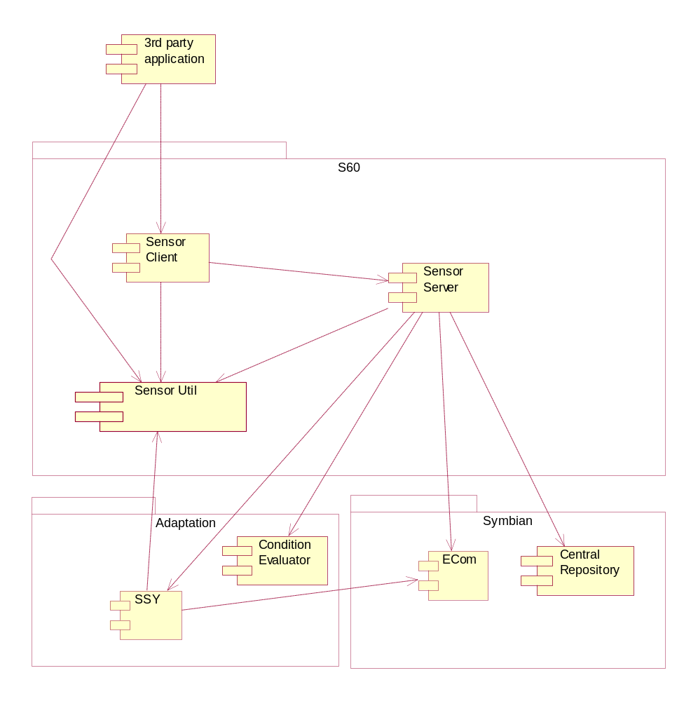
Figure 2.1 Sensor Services environment

Use cases
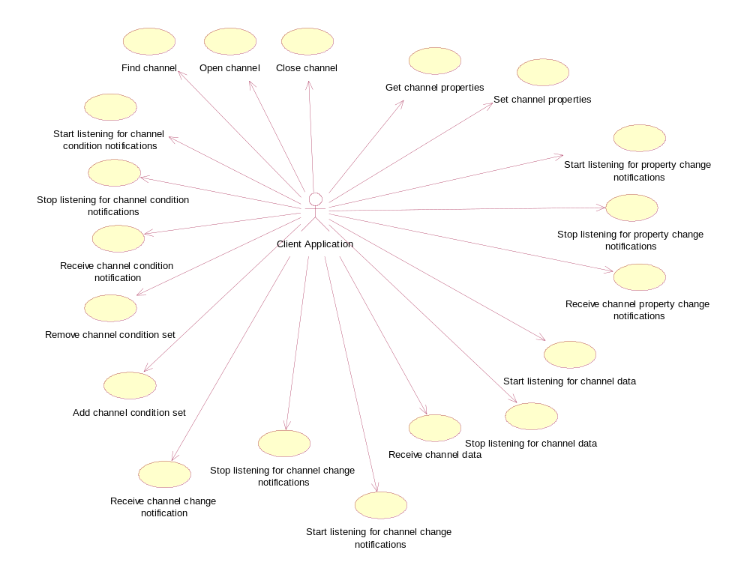
Figure 2.2 Sensor Services use cases

Find channel

Summary | The client application finds channels matching the search parameters.
Actor(s) | The client application.
Frequency | Low.
Preconditions | The client application must be connected to Sensor Services.
Description | The client application specifies the search parameters and queries Sensor Services which responds with a list of channel information matching the search parameters.  If the Find request is done during the SSY initialization, the Find request is queued until all SSYs have been initialized to ensure that an incomplete channel set is not used.
Exceptions | The most likely case to occur is an OOM situation. In this case, a Standard Symbian error code is returned, and the only solution is to try again later.
Postconditions | The client application has a list of channel information which can be used to open channels.
Illustrations

Open channel

Summary | The client application opens a channel.
Actor(s) | The client application.
Frequency | Low.
Preconditions | The client application must be connected to Sensor Services.
Description | The client application specifies the channel identifier and requests Sensor Services to open the channel. If the channel is not yet open to any other client application, Sensor Services requests channel opening from SSY.  If SSY providing the requested channel is currently unloaded, the Open channel request blocks until SSY has been reinitialized.
Exceptions | In case of an invalid channel identifier, an error code is returned. It is not possible to open a channel with an invalid identifier.  If the channel is already open, an error code is returned. Opening a channel twice for the same client is not possible.  The most likely case to occur is an OOM situation. In this case, a Standard Symbian error code is returned, and the only solution is to try again later.
Postconditions | The channel is open and available for use.
Illustrations

Close channel

Summary | The client application closes a channel.
Actor(s) | The client application.
Frequency | Low.
Preconditions | The channel must be open for this client application.
Description | The client application requests Sensor Services to close an open channel. If the channel is not used by any other client application, Sensor Services requests channel closing from SSY.
Exceptions | None. The channel close always closes the server session, even if there is an error.
Postconditions | The channel is closed for this client application.
Illustrations

Start listening for channel data

Summary | The client application requests the activation of channel data listening.
Actor(s) | The client application.
Frequency | Low.
Preconditions | The channel must be open for this client application.
Description | The client application requests data notifications for an open channel from Sensor Services. The client application specifies desired buffering count, maximum buffering count and optional buffering period as parameters.  Sensor Services activates listening for this client application and if there are no other active client applications already, it also requests data notifications from SSY.
Exceptions | If the channel is not open for the client, en error code is returned.  If the client is already listening for the channel, an error code returns. No need to restart. If different buffering parameters or the listener instance need to be specified, listening must first be stopped.  The most likely case to occur is an OOM situation. In this case, a Standard Symbian error code is returned, and the only solution is to try again later.
Postconditions | The server is ready to serve asynchronous data requests for the channel data.
Illustrations

Receive channel data

Summary | The client application requests and receives channel data asynchronously.
Actor(s) | The client application.
Frequency | High. Depends on the sensor, but can be 100 times per second or even more for very fast sensors.
Preconditions | The client application must be listening for the channel data.
Description | While channel listening is active, SSY provides data for Sensor Services and Sensor Services transfers data to each client application listening to the channel. If the client application cannot handle data fast enough, data loss occurs.
Exceptions | If data receiving fails, it is retried. If listening cannot be resumed, the channel is closed.
Postconditions | The client application receives notifications about the new data.
Illustrations

Stop listening for channel data

Summary | The client application requests deactivation of channel data listening.
Actor(s) | The client application.
Frequency | Low.
Preconditions | The client application must be listening for the channel data.
Description | The client application cancels data notifications for an actively listened open channel from Sensor Services. Sensor Services deactivates listening for this client application and if there are no other active clients remaining, data notifications from SSY are cancelled.
Exceptions | None. Stopping always succeeds from the client application point of view.
Postconditions | Notifications about the new data are no longer sent.
Illustrations

Get channel properties

Summary | The client application fetches the channel properties.
Actor(s) | The client application.
Frequency | Low.
Preconditions | The channel must be open for this client application.
Description | The client application specifies the property identifier of a single property or specifies that all properties are desired and requests Sensor Services to provide the property value(s) and other details. Sensor Services requests specified property details from SSY that provides the open channel linked to this session.
Exceptions | Nonexistent property details cannot be provided.  The most likely case to occur is an OOM situation. In this case, a Standard Symbian error code is returned, and the only solution is to try again later.
Postconditions | The client application has the requested property details.
Illustrations

Set channel properties

Summary | The client application sets the channel properties.
Actor(s) | The client application.
Frequency | Low.
Preconditions | The channel must be open for this client application.
Description | The client application specifies the property identifier and a new value of a single property and requests Sensor Services to set the new property value. Sensor Services passes the request to SSY that provides the open channel linked to this session.
Exceptions | Setting a nonexistent property value is not possible.  Setting the properties always requires at least the WriteDeviceData capability from the client application. Individual properties may require other capabilities.  If there is a higher priority client already using the channel, the properties cannot be set.  Setting a read-only property is not possible.  If the new value is outside min/max range of the property, an error code is returned. Try a legal value.  The most likely case to occur is an OOM situation. In this case, a Standard Symbian error code is returned, and the only solution is to try again later.
Postconditions | The requested property has a new value. The other clients of the channels that the property affects are notified of the property change.
Illustrations

Start listening for property change notifications

Summary | The client application requests channel property notifications.
Actor(s) | The client application.
Frequency | Low.
Preconditions | The channel must be open for this client application.
Description | The client application requests property change notifications from Sensor Services. Sensor Services activates the property change listening for this client application.
Exceptions | If the channel is not open for the client, en error code is returned.  If the client application is already listening for property change notifications, an error code returns. No need to restart.  The most likely case to occur is an OOM situation. In this case, a Standard Symbian error code is returned, and the only solution is to try again later.
Postconditions | The client application is listening for notifications about property changes.
Illustrations

Receive channel property change notifications

Summary | The client application receives channel property notifications asynchronously.
Actor(s) | The client application.
Frequency | Low.
Preconditions | This client application must be listening for channel property change notifications.
Description | SSY notifies Sensor Services about changed properties and the channels they affect and Sensor Services in turn notifies all client applications that are interested in property changes of those channels. If the client application is busy handling the previous notification, the new notification is queued at Sensor Services.
Exceptions | If data receiving fails, it is retried. If listening cannot be resumed, the channel is closed.
Postconditions | The client application has the changed property details.
Illustrations

Stop listening for property change notifications

Summary | The client application requests that no more channel property notifications are sent.
Actor(s) | The client application.
Frequency | Low.
Preconditions | This client application must be listening for the channel property change notifications.
Description | The client application requests stopping the property change notifications from the Sensor Services. Sensor Services deactivates the property change listening for this client application.
Exceptions | None. The client application does not receive any more notifications even if Sensor Services somehow fails to cancel them.
Postconditions | The client application no longer receives notifications about property changes.
Illustrations

Add channel condition set

Summary | The client application requests adding a channel condition set.
Actor(s) | The client application.
Frequency | Low.
Preconditions | The channel must be open for the client application.
Description | The client application requests adding a new condition set to an open channel. Sensor Server adds the condition set to an internal list.
Exceptions | If the channel is not open for the client, en error code is returned.  Adding the same condition set object twice is not possible.  The condition set must be complete before it is added. The condition set is considered incomplete when it contains no conditions or unpaired range conditions.  The condition set must not contain conditions that target invalid data item indexes or are otherwise deemed invalid by the Condition Evaluator plug-in.  The most likely case to occur is an OOM situation. In this case, a Standard Symbian error code is returned, and the only solution is to try again later.
Postconditions | The condition set is added to Sensor Server.
Illustrations

Remove channel condition set

Summary | The client application requests removing a channel condition set.
Actor(s) | The client application.
Frequency | Low.
Preconditions | The channel must be open for the client application.
Description | The client application requests removing a previously added condition set from a channel. Sensor Server removes the condition set from an internal list. Attempting to remove a nonexistent condition set completes without error.
Exceptions | If the channel is not open for this client, en error code is returned.  The most likely case to occur is an OOM situation. In this case, a Standard Symbian error code is returned, and the only solution is to try again later.
Postconditions | The condition set is removed from Sensor Server.
Illustrations

Start listening for channel condition notifications

Summary | The client application requests activation of channel condition listening.
Actor(s) | The client application.
Frequency | Low.
Preconditions | The channel must be open for the client application.
Description | The client application requests condition met notifications for an open channel from Sensor Services. The client application specifies the desired buffering count and the optional buffering period as parameters.  Sensor Services activates listening for the client application and if there are no other active client applications already, it also requests data notifications from SSY.
Exceptions | If the channel is not open for this client, en error code is returned.  If the client is already listening for the channel, an error code is returned. No need to restart. If different buffering parameters or listener instance need to be specified, listening must first be stopped.  The most likely case to occur is an OOM situation. In this case, a Standard Symbian error code is returned, and the only solution is to try again later.
Postconditions | The server is ready to serve asynchronous condition met requests for channel.
Illustrations

Receive channel condition notification

Summary | The client application requests and receives channel condition met notifications asynchronously.
Actor(s) | The client application.
Frequency | Low.
Preconditions | This client application must be listening for condition met notifications. There must be at least one added condition set.
Description | While the channel listening is active, SSY provides data for Sensor Server and Sensor Server uses the Condition Evaluator plug-in to determine if the received data meets any of the added condition sets. The sets that meet the conditions are notified to the client application listening to the channel. The met sets are removed from the Sensor Server internal list. It is however possible for the client to re-add the same sets when the notifications for those sets are received.
Exceptions | If the condition met notification receiving fails, it is retried. If listening cannot be resumed, the channel is closed.
Postconditions | The client application receives notifications about the met condition sets.
Illustrations

Stop listening for channel condition notifications

Summary | The client application requests deactivation of the condition met notifications listening.
Actor(s) | The client application.
Frequency | Low.
Preconditions | The client application must be listening for condition met notifications.
Description | The client application cancels the condition met notifications for an actively listened open channel from Sensor Services. Sensor Services deactivates listening for this client application and if there are no other active clients remaining, it cancels the data notifications from SSY. Any unmet conditions are also removed from the internal list.
Exceptions | None. Stopping always succeeds from the client application point of view.
Postconditions | Notifications about the met conditions are no longer sent.
Illustrations

Start listening for channel change notifications

Summary | The client application requests channel change notifications.
Actor(s) | The client application.
Frequency | Low.
Preconditions
Description | The client application requests notifications from Sensor Services when a new channel becomes available or previously available channel is removed. Sensor Services activates the channel change listening for this client application.
Exceptions | If the client application is already listening for channel change notifications, an error code is returned. No need to restart.  The most likely case to occur is an OOM situation. In this case, a Standard Symbian error code is returned, and the only solution is to try again later.
Postconditions | The client application is listening for the notifications about channel changes.
Illustrations

Receive channel change notifications

Summary | The client application receives channel change notifications asynchronously.
Actor(s) | The client application.
Frequency | Low.
Preconditions | This client application must be listening for channel change notifications.
Description | SSY notifies Sensor Services about new and/or removed channels and Sensor Services in turn notifies all client applications that are interested in channel changes. If the client application is busy handling the previous notification, a new notification is queued at Sensor Services. Each new or removed channel is notified separately.
Exceptions | If data receiving fails, it is retried. If listening cannot be resumed, the session is closed.
Postconditions | The client application has the channel information of the new or removed channel.
Illustrations

Stop listening for channel change notifications

Summary | The client application requests that no more channel change notifications are sent.
Actor(s) | The client application.
Frequency | Low.
Preconditions | The client application must be listening for channel change notifications.
Description | The client application requests stopping channel change notifications from Sensor Services. Sensor Services deactivates channel change listening for the client application.
Exceptions | None. The client application does not receive any more notifications even if Sensor Services somehow fails to cancel them.
Postconditions | The client application no longer receives notifications about the channel changes.
Illustrations

Services required

From the Symbian OS subsystems
The following services of Symbian OS infrastructure are required.

API | Description
Central Repository | The Sensor Server settings are stored in Central Repository.
ECom | The SSY plug-ins are loaded using the ECom service.

From the Domestic OS subsystems
This component does not have any direct interfaces to the Domestic OS side subsystems. If some sensors are provided by the Domestic OS subsystems, the SSY plug-ins hide this from Sensor Services.

From HW
This component has no direct HW interfaces; it uses the SSY plug-ins for this purpose.

Services provided

UI
This component does not provide any UI.

SW IF

Provided Service | Description | Protected
Sensor Channel API | Provides methods for finding and listening for the sensor channels and manipulating the channel properties. | Yes
Sensor Utility API | Provides common classes for sensor controlling, such as channel information and property classes. | No
Sensor Plug-in API | Provides an interface for interaction of Sensor Services and the SSY plug-in. | No
Condition Evaluation Plug-in API | Provides an interface for evaluating conditions. | No
Sensor Definitions API | Provides definitions for the default channels, data types and properties. | No
Sensor Server Settings API | Central Repository API for the Sensor Server settings. | No
Sensor Prioritization Settings API | Central Repository API for the client prioritization settings. | No

UI control hierarchy
The component does not contain any UI or UI controls.

Design

Class diagrams

Framework
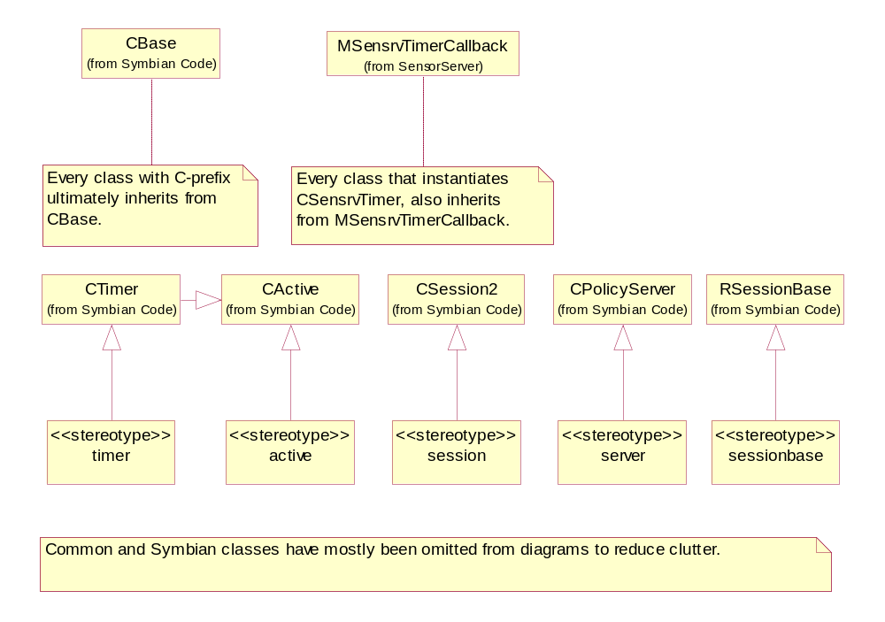
Figure 4.3 Metamodel definition

Component
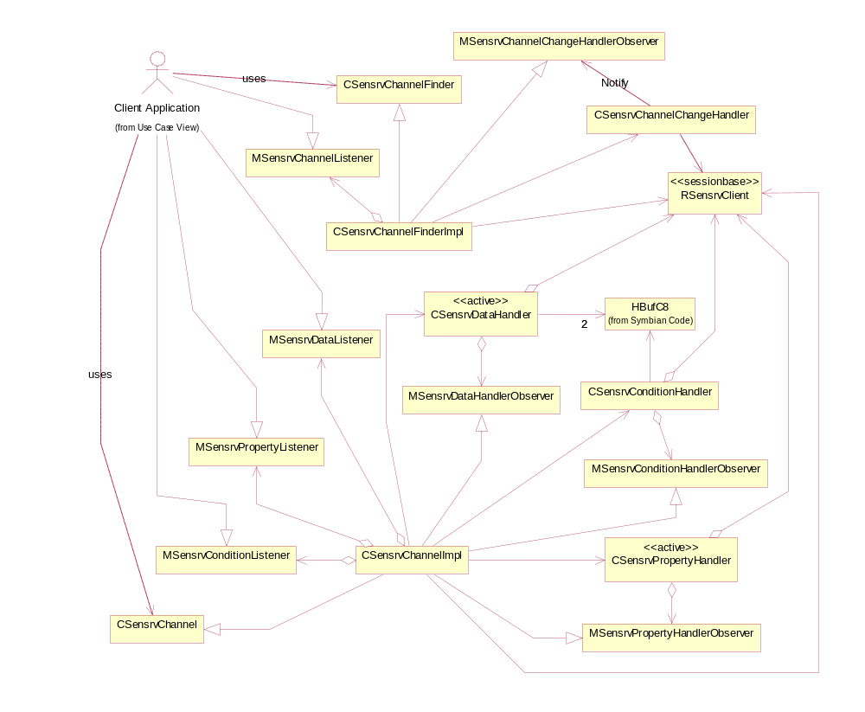
Figure 4.4 Sensor Client
Figure 4.4 shows the Sensor Client subsystem. Sensor Client implements Sensor Channel API.
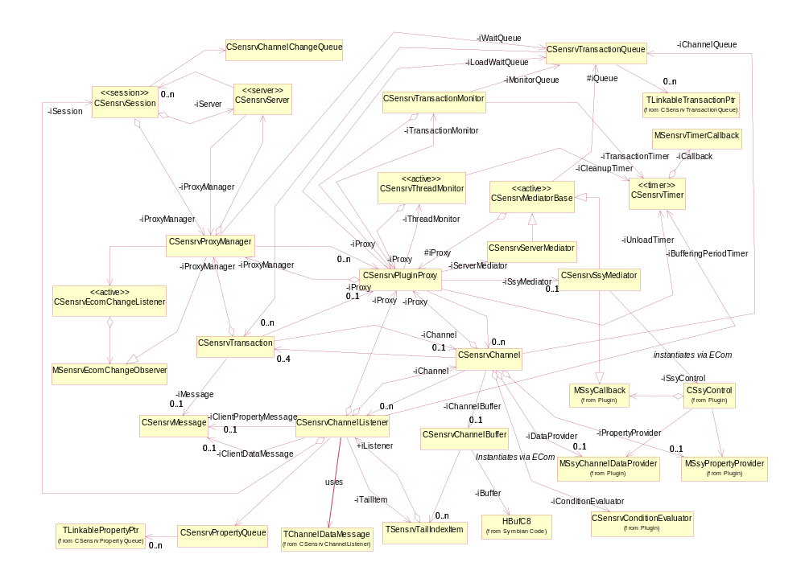
Figure 4.5 Sensor Server
Figure 4.5 shows the Sensor Server subsystem. Sensor Server implements the SSY and channel management logic and handles the client sessions.
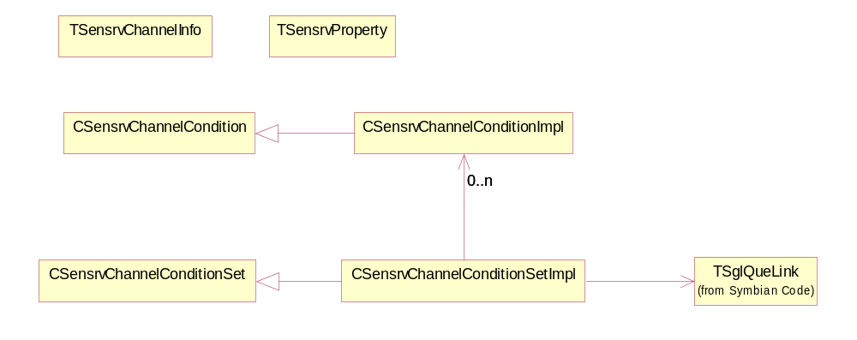
Figure 4.6 Sensor Util
Figure 4.6 shows the Sensor Util subsystem. Sensor Util implements miscellaneous classes that are needed on all levels from the client application to SSY.

Class descriptions
Sensor Client classes:
Class | Description | Header file
CSensrvChannel  Finder | A pure virtual interface for finding channels. | sensrvchannelfinder.h
CSensrvChannel  FinderImpl | An implementation of the channel finder interface. | sensrvchannelfinderimpl.h
CSensrvChannel | A pure virtual interface for controlling channels and their properties. | sensrvchannel.h
CSensrvChannel  Impl | An implementation of the channel interface. | sensrvchannelimpl.h
RSensrvClient | Implements the client side session to Sensor Server. | sensrvclient.h
MSensrvData  Listener | A callback interface for notifying client applications about the new channel data or the data listening errors. | sensrvdatalistener.h
MSensrvProperty  Listener | A callback interface for notifying client applications about the channel property changes or the property listening errors. | sensrvpropertylistener.h
CSensrvData  Handler | Implements the client side data listening. The data is requested from Sensor Server with asynchronous messages. | sensrvdatahandler.h
CSensrvData  HandlerObserver | A callback interface for notifying channel implementation about the new channel data or the data listening errors. The notifications are routed to client applications via the MSensrvDataListener interface. | sensrvdatahandlerobserver.h
CSensrvProperty  Handler | Implements the client side property changes listening. The property change notifications are requested from Sensor Server with asynchronous messages. | sensrvpropertyhandler.h
CSensrvProperty  HandlerObserver | A callback interface for notifying channel implementation about the changed properties or the property listening errors. The notifications are routed to client applications via the MSensrvPropertyListener interface. | sensrvpropertyhandlerobserver.h
CSensrvCondition  Handler | Implements the client side condition listening. The condition met notifications are requested from Sensor Server with asynchronous messages. | sensrvconditionhandler.h
CSensrvCondition  HandlerObserver | A callback interface for notifying channel implementation about the met conditions or the condition listening errors. The notifications are routed to client applications via MSensrvChannelConditionListener. | sensrvconditionhandlerobserver.h
MSensrvChannel  ConditionListener | A callback interface for notifying client applications about the met conditions or the condition listening errors. | sensrvchannelconditionlistener.h
CSensrvChannel  ChangeHandler | Implements the client side channel change notifications listening. The channel change notifications are requested from Sensor Server with asynchronous messages. | sensrvchannelchangehandler.h
CSensrvChannel  ChangeHandler  Observer | A callback interface for notifying channel implementation about the changes to the channels or the channel change listening errors. The notifications are routed to client applications via MSensrvChannelListener. | sensrvchannelchangehandlerobserver.h
MSensrvChannel  Listener | A callback interface for notifying client applications about the changes to the channels or the channel change listening errors. | sensrvchannellistener.h

Sensor Server classes:

Class | Description | Header file
CSensrvServer | A Sensor Server main class. Owns the sessions and the proxy manager. | sensrvserver.h
CSensrvSession | A server side client session. | sensrvsession.h
CSensrvProxy  Manager | Contains the SSY proxies and routes the channel specific client requests to correct proxies. Handles Find channel queries. | sensrvproxymanager.h
CSensrvPlugin  Proxy | Acts as a proxy for the SSY plug-in. The proxies are never deleted after successful initialization. The proxy manages the single SSY plug-in and things related to it, such as the SSY thread management, the plug-in level transactions, and the plug-in loading and unloading depending on the usage. It also routes the channel specific client requests to correct channel objects.  The proxy provides a mutex to ensure the data integrity, as the proxy, the channels and the transactions need to be accessed from different threads. | sensrvpluginproxy.h
CSensrvChannel | Represents a single channel provided by SSY. Manages a list of active listeners (client sessions) and a channel state at SSY. Handles the channel specific client requests and routes the listener specific requests to the listener objects. Also maintains the channel data buffer and determines the correct buffering count for SSY. | sensrvchannel.h
CSensrvChannel  Buffer | Implements the channel data buffer. This buffer acts in a ring buffer fashion, overwriting the old data with the new data when necessary. The buffer maintains one head pointer for writing and multiple tail pointers for reading, one for each client. If the client is too slow in requesting data from the buffer, tail pointers get automatically adjusted if the data they point to is overwritten. This induces data loss, which is reported to the client in the next asynchronous data request response. | sensrvchannelbuffer.h
TSensrvTailIndex  Item | A data object for storing the channel buffer tail pointer, the available new data count, the data loss count and the related listener pointer. | sensorchannelbuffer.h
CSensrvChannel  Listener | Represents a client that has opened the channel. The channel listener handles asynchronous data and property listening messages from the client, as well as the buffering period timer. | sensorchannellistener.h
CSensrvChannel  Listener::  TChannelDataMessage | A data object for temporarily storing the pointers to buffer, the data item count and the data loss, when writing data to the client message. | sensorchannellistener.h
CSensrvProperty  Queue | Implements a simple queue for queuing property change notifications at the channel listener. The SSY mediator adds the changed properties to the queue of the each interested listener. The queued properties are notified to the clients one at a time in the order they were received using the asynchronous property change notification messages.  The properties queued in this queue are always allocated to the server main thread heap, regardless of the thread that does adding. This is done to ensure that the queued properties are always valid, even if the SSY thread panics. | sensrvpropertyqueue.h
CSensrvProperty  Queue::TLinkable  PropertyPtr | A data holder containing a link item for the property queue and the property. These objects are always instantiated in the server main heap. | sensrvpropertyqueue.h
CSensrvMediator  Base | A base class for mediators. The mediators are active objects that are used to transfer the transaction execution flow between the server main thread and the SSY thread. The SSY thread and the server main thread each have one mediator per SSY plug-in. The execution of a transaction is transferred from one thread to another by adding the transaction to the mediator running in the target thread, which also completes the mediator request, causing RunL to be run on that mediator. | sensrvmediatorbase.h
CSensrvServer  Mediator | Implements the server side mediator. | sensrvservermediator.h
CSensrvSsy  Mediator | Implements the SSY side mediator. | sensrvssymediator.h
CSsyControl | A base class for the SSY plug-ins. Implements the ECom interface. It is instantiated by the SSY mediator in the SSY thread. | ssycontrol.h
MSsyCallback | A callback interface for SSY. The notifications about the new data and properties come via this interface, as well as Asynchronous channel open and close confirmations. | ssycallback.h
MSsyChannelData  Provider | Implemented by SSY that passes the pointer to Sensor Server in Asynchronous channel open confirmation. This interface is used by the SSY mediator to control data listening. | ssychanneldataprovider.h
MSsyProperty  Provider | Implemented by SSY that passes the pointer to Sensor Server in Asynchronous channel open confirmation. This interface is used by the SSY mediator to control the properties. | ssypropertyprovider.h
CSensrv  TransactionQueue | Implements a simple queue for queuing transactions. The queue can act in two different modes, decided on the construction: owning and non-owning. In the owning mode, all queued transactions are considered owned by the queue, so when a transaction is removed from the queue, it is deleted. Conversely, in the non-owning mode, the transactions are not deleted when they are removed from the queue.  All queues, the queued TLinkableTransactionPtr items and the transactions themselves are always allocated to the server main heap, so adding transactions is thread safe, as long as it is done within the mutex of the proxy. | sensrvtransactionqueue.h
CSensrv  Transaction  Queue::TLinkable  TransactionPtr | A data holder containing a link item for transaction queue and a transaction pointer. | sensrvtransactionqueue.h
CSensrv  Transaction | Transactions are used to pass the data between threads or just to store client requests temporarily in queues to ensure the correct order of execution for requests. The transactions store all relevant information about the request, such as the client message, the request type and the related channel. | sensrvtransaction.h
CSensrvMessage | A wrapper to the RMessage2 class. | sensrvmessage.h
CSensrvThreadMonitor | Monitors an SSY thread. If the SSY thread dies unexpectedly, the thread monitor initiates a proxy cleanup. It is also used to terminate SSY threads forcefully, if they do not die within the configured time limit, when SSY is unloaded. | sensrvthreadmonitor.h
CSensrv  Transaction  Monitor | Monitors the transaction execution time at SSY. If SSY does not handle the transaction in the configured time limit, it is assumed that SSY is somehow deadlocked, and it is unloaded and the proxy is cleaned up. | sensrvtransactionmonitor.h
CSensrvTimer | A generic timer for the Sensor Server timing needs. | sensrvtimer.h
MSensrvTimer  Callback | A callback interface for timer events. | sensrvtimer.h
CSensrvCondition  Evaluator | A base class for the Condition Evaluator plug-ins. Implements the ECom interface. It is instantiated by the Sensor Server main thread. | sensrvconditionevaluator.h
CSensrvChannel  ChangeQueue | A queue for storing the channel change notifications. | sensrvchannelchangequeue.h
CSensrvEcom  ChangeListener | Listens for the changes in the ECom registration information and notifies the proxy manager via the MSesnrvEcomChangeObserver interface about the changes in the available plug-ins. | sensrvecomchangelistener.h
MSensrvEcomChangeObserver | A callback interface for notifying about the changes in the available plug-ins. | sensrvecomchangeobserver.h

Sensor Util classes:

Class | Description | Header file
TSensrvChannel  Info | A data holder object for channel information. | sensrvchannelinfo.h
TSensrvProperty | A data holder object for the property details. | sensrvproperty.h
CSensrvChannel  Condition | An interface for the channel condition objects. | sensrvchannelcondition.h
CSensrvChannel  ConditionSet | An interface for the channel condition set objects. | sensrvchannelconditionset.h
CSensrvChannel  ConditionImpl | An implementation of the CSensrvChannelCondition interface. | sensrvchannelconditionimpl.h
CSensrvChannel  ConditionSetImpl | An implementation of the CSensrvChannelConditionSet interface. | sensrvchannelconditionsetimpl.h

Structs, type definitions and enumerations
No structs are used, but there are some classes that are used like structs. Some of those are described above in the class definitions, as they are also shown in the class diagram. Rest of the data holder classes, enumerations and type definitions that are used are thoroughly commented in the headers where they are defined.

Flag definitions
The trace flags can only be defined in the UDeb builds.

Flag | Description
API_TRACE_FLAG | When this flag is defined, a trace is produced whenever the public API methods are entered and exited. Sensor Server also traces the client-server messages if this flag is defined.
COMPONENT_TRACE_FLAG | When this flag is defined, miscellaneous traces such as regular methods enter and exit traces, various branching traces, etc. are produced. Defining this flag slows down the server because of the sheer amount of trace. For example, running a full module test set produces hundreds of megabytes of trace.
ERROR_TRACE_FLAG | When this flag is defined, a trace about error situations is produced. This flag is defined by default.
THREAD_TRACE_FLAG | When this flag is defined, the API, COMPONENT, ERROR, and MEMORY traces are preceded with the thread name of the current thread. As the thread name is traced on the separate line, this increases the amount of traces significantly.
BUFFER_TRACE_FLAG | When this flag is defined, a trace about channel buffer status is produced.
MEMORY_TRACE_FLAG | When this flag is defined, a trace about heap memory usage by various threads is produced.
__SENSRV_TEST_ALWAYS_FAIL_SERVER_MEDIATOR_NOTIFY | When this flag is defined, the server mediator notify always fails. This is strictly for testing the server mediator notification failure handling.

Operations
Note: Trivial cases are not provided with sequence diagrams. Also, if the operation is fundamentally similar to some other operation, only differing in minor details, no sequence is provided.

Sensor Server startup

Operation | Starting Sensor Server.  TInt E32Main()  TInt RSensrvClient::Connect()
Preconditions | The client application has created the CSensrvChannel object.
Description | Sensor Server is started by the first client trying to connect to server.
Inputs
Modifies | E32Main()creates a new cleanup stack, a new instance of CSensrvServer and installs a new CActiveScheduler.  At startup CSensrvServer creates an instance of CSensrvProxyManager, which in turn does the following:  - Initializes a server wide mutex used to protect the channel ID and the SSY thread name generation.  - Loads configuration settings from Central Repository.  - Lists all available SSY implementations using ECom and creates and initializes a proxy for each one (see Section 4.3.2).  Sensor Server is never meant to be shut down during normal operation, but it is not set as system critical or system permanent process, as the shutdown must be supported for module tests.
Outputs
Postconditions | Sensor Server is up and running, ready to the server client requests.
Related To | CSensrvServer, CSensrvProxyManager, CSensrvPluginProxy, CSensrvChannel (client side), RSensrvClient  See the use case 2.3.1 (Find Channel usually causes the first connection attempt).
Related Event | The first client application attempts to connect to Sensor Server.
Exceptions | If the Sensor Server initialization fails for any reason, a new attempt to start it is done when a client attempts to connect to it next time.  If the configuration settings cannot be located or loading fails for any reason, the default values are used.

Proxy initialization

Operation | Initializing the SSY plug-in proxy.  CSensrvPluginProxy* CSensrvPluginProxy::NewL( CSensrvProxyManager& aParent, TUid aImplementationUid)  void CSensrvPluginProxy::InitializePluginL()
Preconditions | Sensor Server has acquired implementation information from ECom.
Description | The proxy initialization is done in two phases, first the proxy instance is created and then the plug-in is initialized with a separate call.
Inputs | The callback reference to CSensrvProxyManager and the implementation UID of the plug-in this proxy is for.
Modifies | ConstructL creates the following:  - A mutex for synchronizing access within this proxy and the related channels, transactions, etc.  - A transaction queue for Find channel queries.  - A transaction monitor.  - A thread monitor.  - An unload timer.  InitializePluginL does the following:  - Creates and starts the SSY thread which must be named uniquely.  - Starts monitoring the SSY thread.  - Creates new mediators.  - Queues the load transaction (see Section 4.3.4).
Outputs
Postconditions | The SSY plug-in loading is ongoing.
Related To | CSensrvPluginProxy, CSensrvServerMediator, CSensrvSsyMediator, CSensrvMediatorBase, CSensrvThreadMonitor, CSensrvTransactionMonitor, CSensrvTransaction, CSensrvTimer
Related Event | See the operation in Section 4.3.1.
Exceptions | If any error occurs, the proxy is not stored and the channels provided by the plug-in are not available for clients.

Execution flow mediating between threads

Operation | Notifying another thread to handle a transaction.  TInt CSensrvMediatorBase::Notify(CSensrvTransaction* aTransaction)
Preconditions | One thread has handled a transaction to a point where another thread must continue handling.  For example, an open channel transaction handling is done on the server main thread and SSY has to be notified to actually open the channel.
Description | Each thread (server main thread and SSY threads) has its own active scheduler. For each plug-in, there is one SSY thread with its own heap, one SSY mediator and one server mediator. Both mediators are created to the server main heap, and owned by the plug-in proxy, but the SSY mediator is added to SSY thread’s scheduler whereas the server mediator is added to the server main thread’s scheduler. Execution of the transaction can be passed to another thread by calling the CSensrvMediatorBase::Notify() method.  Since all threads run in the same process, they can access the data in another thread’s heap. The proxy, the mediators and the transactions are examples of objects that are accessed from both threads. In order to avoid race situations and other problems, all access to the proxy and the other shared data is protected by a proxy specific mutex.
Inputs | All necessary data is stored or can be accessed via the transaction object passed as the parameter.
Modifies | The transaction state is modified after the transaction is handled by another thread.  Before passing the transaction to the SSY mediator, the transaction is added to the transaction monitor, which monitors the transactions for timeout. See the effects of the transaction timeout in Section 4.3.18.  Depending on the operation, other changes may also occur.
Outputs
Postconditions | Transaction handling can be continued by another thread once it is running.
Related To | CSensrvMediatorBase, CSensrvTransaction
Related Event | One thread has handled a transaction to a point where another thread must continue handling.
Exceptions | If notifying the SSY mediator fails (probably due to an OOM situation), the transaction is completed with error, or the failure is ignored, depending on the operation.  If notifying server mediator fails, ignoring this is not an option, and the transaction completion needs to be handled in the server thread anyway. In such case the NULL transaction is used in notification, as there is no need to allocate memory in that case, and the original transaction’s state is set to indicate notification failure. On the server thread side the transaction with notification failure state is located by brute force search of all transaction queues and channel owned mediator transactions, and handled normally.

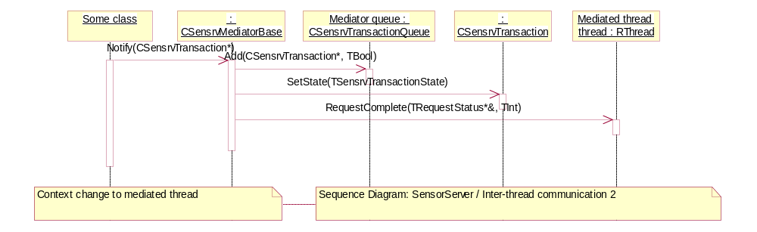
Figure 4.7 Inter-thread communication, notifying other thread
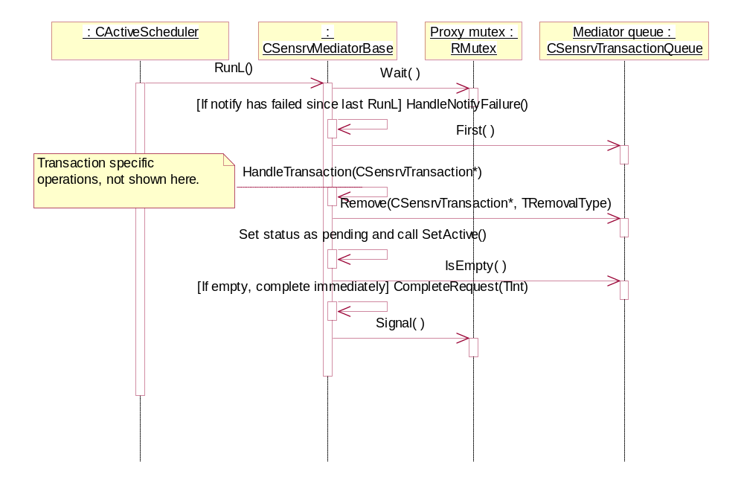
Figure 4.8 Inter-thread communication, handling notification

Loading SSY

Operation | Loading the SSY plug-in.  TSensrvTransactionType::ETransTypeLoadSsy
Preconditions | The proxy and the plug-in thread must be initialized and the load transaction queued.
Description | The SSY plug-in is loaded using the TSensrvTransactionType::ETransTypeLoadSsy transaction.
Inputs | The TSensrvTransactionType::ETransTypeLoadSsy transaction.
Modifies | The SSY mediator constructs a new CSsyControl object. During construction, SSY registers channels it provides using MSsyCallback::RegisterChannelsL(). New channel IDs for registered channels are generated with ProxyManager ::GenerateUniqueId(), or if this is not the first time this SSY has been loaded, IDs are fetched from the previously registered channel information, so that the channel IDs remain the same through multiple SSY loads and unloads.
Outputs
Postconditions | The plug-in has been loaded and is ready to serve.
Related To | CSensrvTransaction, CSensrvSsyMediator, CSsyControl, CSensrvProxyManager
Related Event | Proxy initialization (see Section 4.3.2).
Exceptions | If loading SSY fails, the proxy still exists, but it provides no channels and is therefore useless. Same happens if SSY does not register any channels the first time it is loaded. If the loading fails, the SSY is unloaded and the channels are removed. in debug builds the SSY thread is panicked.

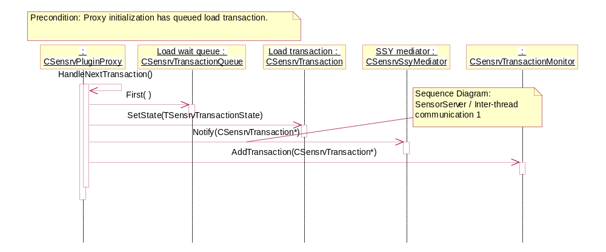
Figure 4.9 Loading SSY plug-in, initial Sensor Server main thread handling
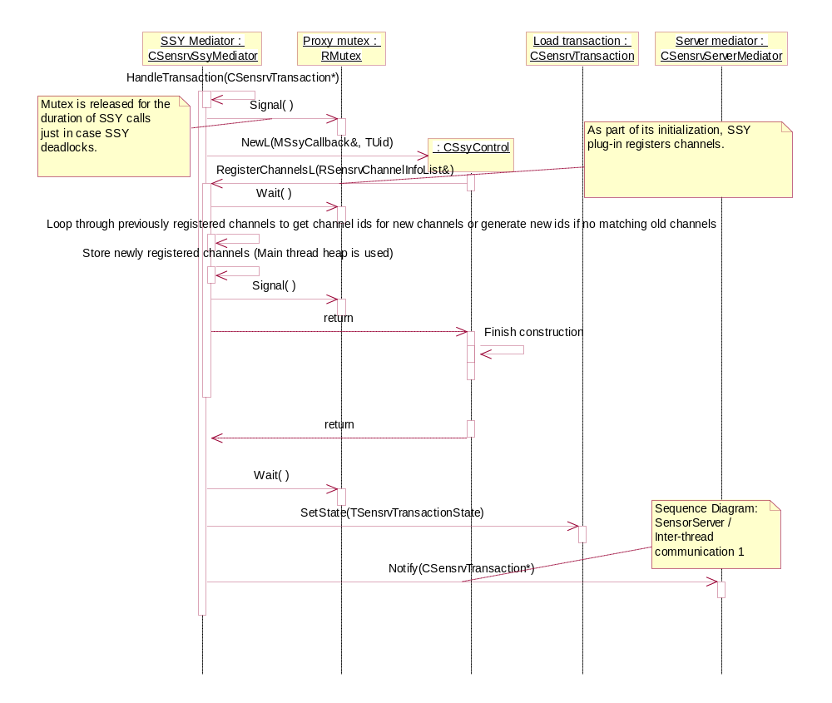
Figure 4.10 Loading SSY plug-in, handling load transaction at SSY thread
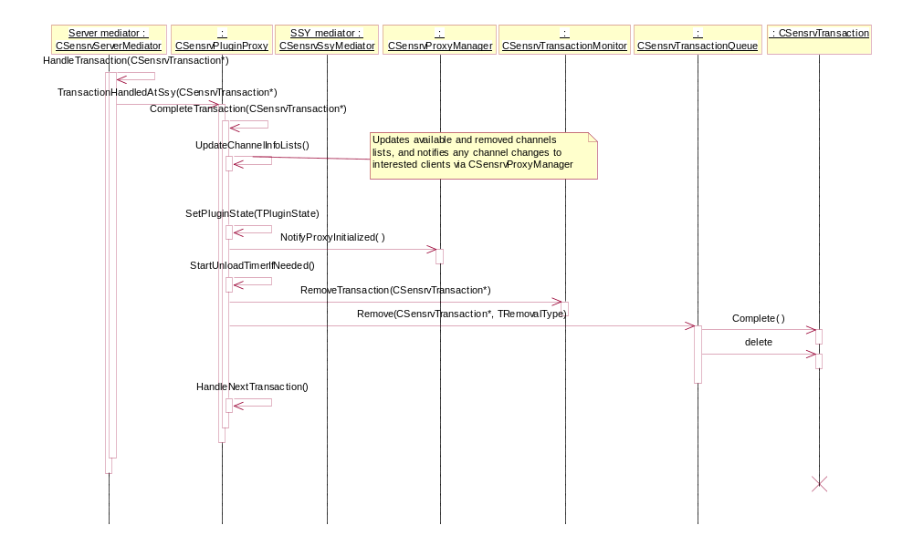
Figure 4.11 Loading SSY plug-in, finishing loading at Sensor Server main thread

Proxy cleanup

Operation | Proxy cleanup.  void CSensrvPluginProxy::CleanupPlugin()  void CSensrvPluginProxy::SsyThreadTerminated()
Preconditions | SSY is loaded.
Description | A cleanup of the SSY thread and plug-in is attempted first. If it does not succeed within the configured time, the SSY thread is killed forcibly. In panic cases the thread is already dead, so SsyThreadTerminated() is executed immediately.  If a new channel open request comes after the cleanup is started but before it is finished, the open and load transactions are queued to proxy’s queue and handled after proxy cleanup is complete.
Inputs
Modifies | All CSensrvChannel objects owned by the proxy are destroyed and all transactions related to those channels are completed with KErrCancel. The mediator transaction queues are emptied. The SSY thread‘s scheduler is stopped and the CSsyControl object is destroyed.
Outputs | ProxyManager is notified about thread termination. It needs to know when all threads have been killed when shutting down the server (see Section 4.3.28).
Postconditions | The SSY thread is terminated and the related objects are deleted or otherwise cleaned up.
Related To | CSensrvTransaction, CSensrvProxyManager, CSensrvPluginProxy, CSensrvSsyMediator, CSensrvTimer, CSensrvThreadMonitor
Related Event | Any of the following:  - There has been an unrecoverable error during plug-in loading.  - A transaction timeout (see Section4.3.18).  - Plug-in has been inactive for a while (see Section 4.3.27).  - The SSY thread has panicked.
Exceptions

Finding channels

Operation | Finding channels.  CSensrvChannelFinder* CSensrvChannelFinder::NewL()  void CSensrvChannelFinder::FindChannelsL(RSensrvChannelInfoList& aChannelList, const TSensrvChannelInfo& aSearchConditions )
Preconditions | Sensor Server must be running and the client connected to it.
Description | The client specifies the desired channel parameters in the FindChannelsL() call, which queries Sensor Server, which in turn compares the parameters to the channel information registered by all plug-ins and returns all matching information to the client in a RArray.
Inputs | The TSensrvChannelInfo object containing search parameters. If the field is zero or empty descriptor, all registered channels match that field. If the field is a non-zero or non-empty descriptor, the field must be exactly the same for a registered channel to be considered a match. The channel ID is not used in matching.
Modifies
Outputs | A list of channel information matching the search parameters.
Postconditions | The client application has information about the matching channels.
Related To | CSensrvChannelFinder, CSensrvProxyManager, TSensrvChannelInfo
Related Event | The client application wants channel information. See the use case in Section 2.3.1.
Exceptions | If the client message does not have enough space to hold all matching channels, KErrOverflow is returned, along with the number of found channels. The client then allocates enough space to the message and re-requests the channel information.

Opening a channel

Operation | Opening a channel.  CSensrvChannel* CSensrvChannel::NewL( const TSensrvChannelInfo& aChannelInfo )  void CSensrvChannel::OpenChannelL()  void MSsyCallback::ChannelOpened( TSensrvChannelId aChannelId, TInt aErrorCode, MSsyChannelDataProvider* aChannelDataProvider, MSsyPropertyProvider* aSensorPropertyProvider )
Preconditions | The client has obtained valid channel information, using the Find channels operation (see Section 4.3.6).
Description | The client specifies the channel information at the CSensrvChannel construction and then requests Sensor Server to open the channel using OpenChannelL(). Sensor Server locates the proxy that handles specified channel and passes the request to it. Note: The channel information specified at the CSensrvChannel construction must be obtained via Find channels operation, as that is the only way to ensure that the channel information has a proper channel identifier.  If this is the first time the channel is opened since the SSY loading, the channel object (CSensrvChannel – Not to be confused with the client side class with the same name) is also created.  An open request is always queued to the channel queue before any further actions are taken. The channel queue is blocking, so the next queued transaction is not handled until the previous one has been completed.  When the open transaction is handled, first a new CSensrvChannelListener is created to represent that the channel is open to a client session.  If the channel is not open to any other client, Sensor Server requests channel opening from SSY using the ETransTypeOpenChannel transaction. Otherwise no SSY call is needed, as channel is already open, so the transaction is completed immediately.  After SSY has opened the channel, it registers the channel providers and successful channel opening by calling MSsyCallback::ChannelOpened, which then updates the channel state and request the maximum data rate property value from the registered property provider to determine the channel buffer size. After that is done, the server mediator is notified that the transaction handling can be completed.  When the execution returns to the server main thread, a new CSensrvChannelBuffer is created and the transaction is completed.  If SSY providing the requested channel is currently unloaded when Open channel request comes, it is queued as ETransTypeDelayedOpenChannel in addition to ETransTypeDelayedInitialize. After the plug-in cleanup is complete, ETransTypeDelayedInitialize causes SSY reloading (see Section 4.3.4). After the load is complete, ETransTypeDelayedOpenChannel re-initiates the channel open request handling.
Inputs | Channel information (given in the CSensrvChannel construction)
Modifies | Sensor Server creates new CSensrvChannel and CSensrvChannelBuffer objects if needed. A new CSensrvChannelListener object is always created.  The channel buffer is created to accommodate the configured amount of seconds’ worth of data at the maximum data rate of the channel. In reality the maximum amount of the buffered data is less than this, as part of the buffer is always reserved for writing new data.
Outputs
Postconditions | The client has an open channel.
Related To | CSensrvChannel, CSensrvChannelBuffer, CSensrvChannelListener, CSsyControl, CSsyCallback
Related Event | The client application wants to open a channel. See the use case in Section 2.3.2.
Exceptions | In case of an invalid channel identifier, an error code KErrNotFound is returned.  If trying to open a channel that is already open for the same client, an error code KErrAlreadyExists is returned.  The most likely case to occur is an OOM situation. In this case, a Standard Symbian error code is returned, and the only solution is to try again later.

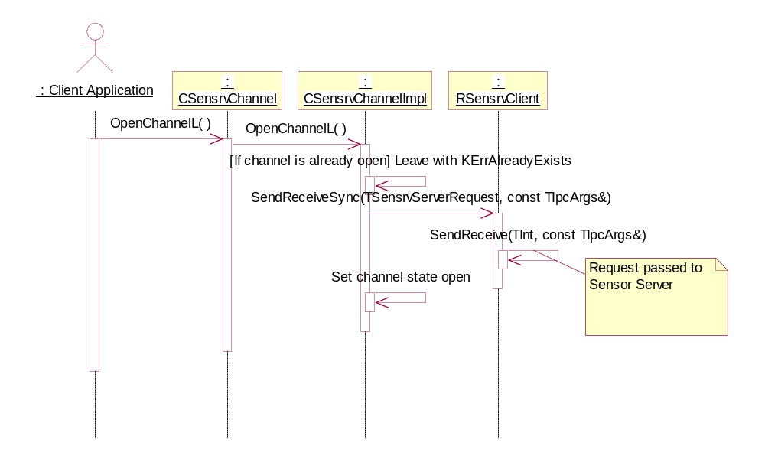
Figure 4.12 Opening channel, client handling
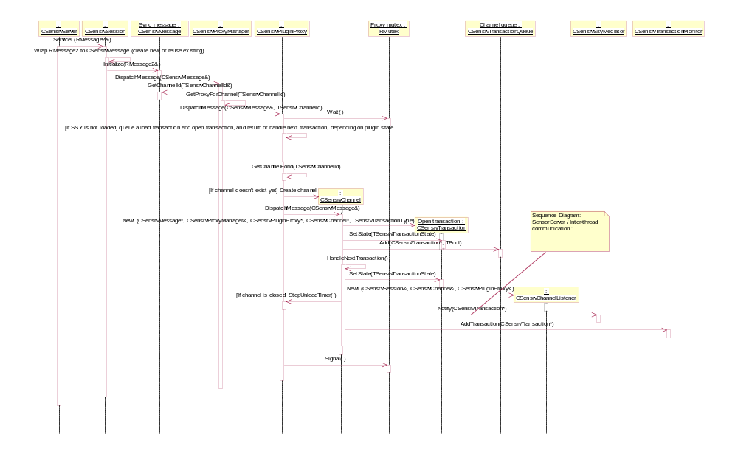
Figure 4.13 Opening channel, initial Sensor Server main thread handling
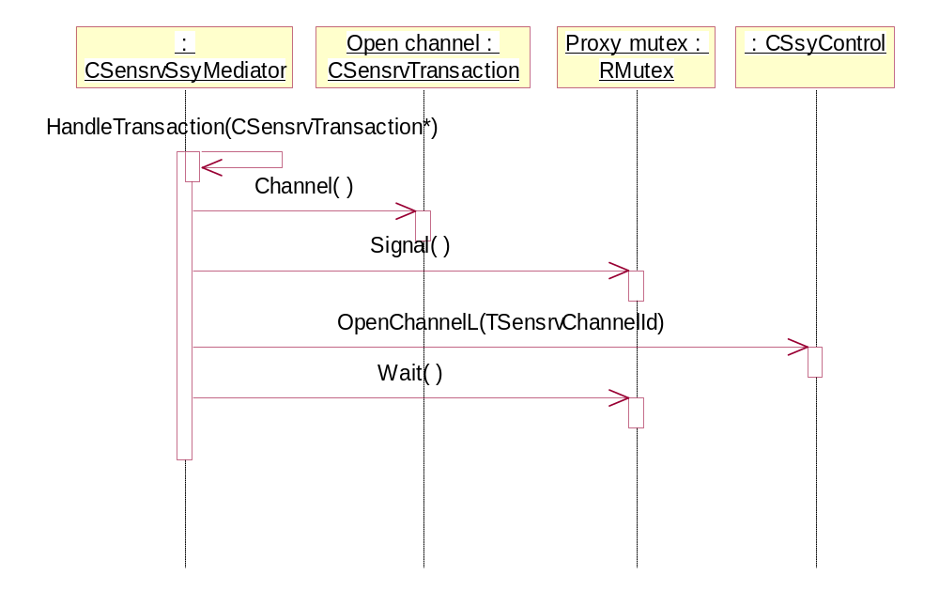
Figure 4.14 Opening channel, open transaction handling at SSY thread
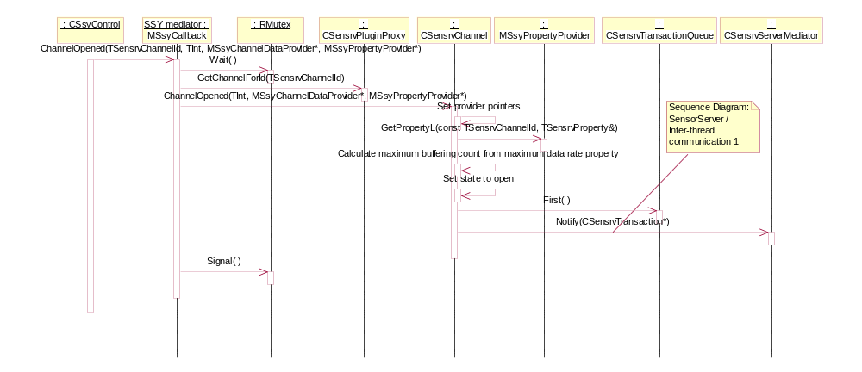
Figure 4.15 Opening channel, SSY callback handling
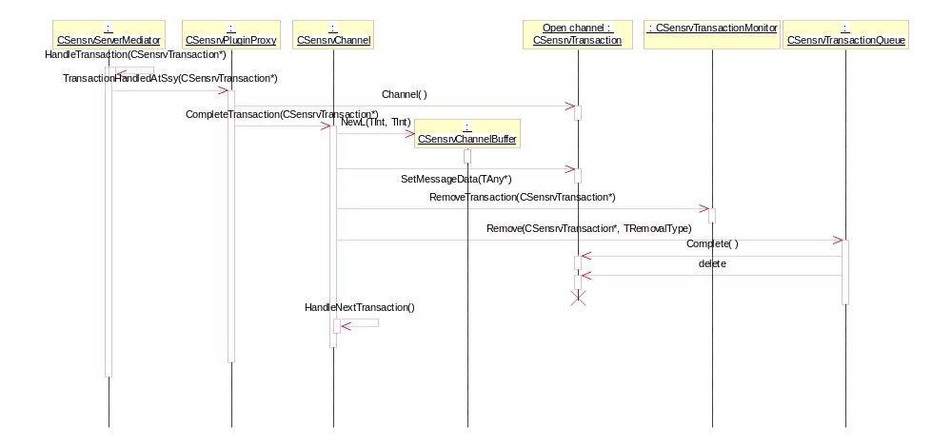
Figure 4.16 Opening channel, final open transaction handling at Sensor Server main thread

Closing a channel

Operation | Closing a channel.  void CSensrvChannel::CloseChannel()  void MSsyCallback:: ChannelClosed(TSensrvChannelId aChannelId)
Preconditions | A channel is open for the client.
Description | The client requests Sensor Server to close an open channel using CloseChannel(), and closes the server session. Sensor Server locates the proxy that handles the specified channel and passes the request to it.  Sensor Server deletes the channel listener assigned to the session.  If the channel has no other listeners, it also requests the channel closing from SSY using the ETransTypeCloseChannel transaction. Otherwise no SSY call is needed, as the channel must stay open for other listeners, so the transaction is completed immediately.  After SSY has closed the channel, it notifies the successful channel closing by calling MSsyCallback::ChannelClosed, which updates the channel state and notifies the server mediator that the transaction handling can be completed.  When execution returns to the server main thread, the channel buffer is deleted and the transaction completed.
Inputs | The channel information (given in the CSensrvChannel construction).
Modifies | Sensor Server deletes the CSensrvChannelBuffer object if needed. The CSensrvChannelListener object is always deleted.
Outputs
Postconditions | The channel is closed for this client.
Related To | CSensrvChannel, CSensrvChannelBuffer, CSensrvChannelListener, CSsyControl, CSsyCallback
Related Event | The client application wants to close a channel. See the use case in Section 2.3.3.
Exceptions | From the client point of view, none. Even if channel closing fails for some reason (OOM being the only likely candidate), the client closes the session, which causes a cleanup of the client’s listener. If the listener was the last one, this also triggers the channel closing. If this process fails (again OOM), the channel is left open and gets cleaned up eventually when SSY is unloaded.

Starting data listening

Operation | Starting data listening  void CSensrvChannel::StartDataListeningL( MSensrvDataListener* aDataListener, const TInt aDesiredCount, const TInt aMaximumCount, const TInt aBufferingPeriod )
Preconditions | The channel must be open for this client.
Description | The client requests data notifications for an open channel using StartDataListeningL().  If this is the first listening (conditions or data) start for the channel, Sensor Server creates the following reusable mediator transactions to reduce recurring memory allocations during listening and to ensure SSY is always able to notify the server thread when necessary:  - ETransTypeMediatorNewDataAvailable: the SSY mediator signals that there is new data in the buffer with this transaction.  - ETransTypeMediatorForceBufferFilled: The server thread forces SSY to call BufferFilledL with this transaction.  - ETransTypeMediatorForceChannelClose: The SSY mediator signals that an error has occurred during data listening and the channel must be closed. The server then proceeds to queue the channel close transaction and deletes all listeners and their transactions.  After constructing the transactions, Sensor Server checks the buffering parameters, adds new listener tail to the channel buffer and sets the client’s listener active. After this it notifies the SSY mediator to continue handling with the ETransTypeStartListening –transaction.  At the SSY mediator, if the channel state is not yet listening, SSY is ordered to start listening with the MSsyChannelDataProvider::StartChannelDataL() call. If the channel state is already listening, i.e. there are other clients listening for the channel, MSsyChannelDataProvider::ForceBufferFilledL() is called instead to flush the old data from the SSY buffer to the channel buffer, as the listener is only interested about the data items that are generated after it starts listening. This flush of data is ignored by the newly added listener. Start transaction is completed immediately, as the data is received asynchronously.  The buffering count given to SSY is calculated so that for each client listening to a channel, the remaining count to fill the next desired count amount is calculated and the lowest of the calculated values is used. This ensures that a situation where the data item count received from the actual sensor (i.e. SSY buffered data and the data available for the client in the channel buffer) exceeds the desired count never occurs, if the data in the channel buffer alone is not enough to match the desired count. I.e. if there is enough data for the client to be notified, it must not be delayed just because SSY is waiting for even more data before notifying Sensor Server.
Inputs | - Listener: A callback object for notifying the client application when new data arrives.  - Desired count: The desired number of data items received on each asynchronous data request (see Section 2.3.5). For channels with high sustained data rate, the desired count of more than one is recommended to improve the performance.  - Maximum count: The maximum number of data items received on each asynchronous data request. For channels with potentially high but sporadic data rate, where the desired count must be one so that no item is delayed, the maximum count can be used to reduce the IPC traffic between the client and the server.  - Buffering period: This is the maximum time new data is waited for. The period can be used when it is necessary to know if there is any new data periodically, such as in a game that is controlled by a sensor. It should never be used for passive background channel listening, as handling periodic timer events consume power unnecessarily.
Modifies | The client listener is set to the active data listening state, and the data listening is initiated from SSY if not already listening.
Outputs
Postconditions | Data listening is started.
Related To | CSensrvChannel, CSensrvChannelBuffer, CSensrvChannelListener, MSsyChannelDataProvider, CSsyControl
Related Event | The client wants to start listening for data. See the use case in Section 2.3.4.
Exceptions | If starting fails for any reason, it is first retried once at the client side, and if it fails as well, the channel is closed and reopened, after which starting is retried again. This is needed, as it is possible that SSY has been unloaded, probably because it has panicked. The automatic channel reopening in the start listening failure handling reloads SSY.  If the channel is not open for the client, an error code KErrNotFound is returned.  If the client is already listening for the channel, an error code KErrAlreadyExists is returned.  The most likely case to occur is an OOM situation. In this case, a Standard Symbian error code is returned, and the only solution is to try again later.

Receiving asynchronous data notification

Operation | Receiving channel data asynchronously.  void MSensrvDataListener::DataReceived( CSensrvChannel& aChannel, TInt aCount, TInt aDataLost )  TInt CSensrvChannel::GetData( TDes8& aData )
Preconditions | The client has started data listening successfully.
Description | After the client has started data listening successfully, it requests data from Sensor Server with asynchronous messages. These messages are stored on the Sensor Server side until at least the desired data count of data items is available.  When SSY has collected the requested count of data items from the sensor, it notifies Sensor Server with MSsyCallback::BufferFilled(), which validates the written data to channel buffer and adjust the buffer pointers accordingly. Sensor Server is notified of this with the ETransTypeMediatorNewDataAvailable transaction.  Handling of that transaction on Sensor Server copies the data to the messages of any clients that have exceeded the desired buffering count, and the messages are completed.  Upon receiving this completed message, the client immediately sends another message, unless listening has already been stopped. After this the client application is notified and can request data items using the GetData() method.  If the buffering period was specified when the listening was started, the MSsyCallback::BufferFilled() callbacks can be triggered by the Sensor Server buffering period timer. Whenever the timer expires, the ETransTypeMediatorForceBufferFilled transaction is sent to SSY, which causes calling of MSsyChannelDataProvider::ForceBufferFilledL().
Inputs
Modifies | The buffer pointers and the data availability values are adjusted accordingly.
Outputs | The channel data.
Postconditions | The client receives the channel data.
Related To | CSensrvChannel, CSensrvChannelBuffer, CSensrvChannelListener, MSsyChannelDataProvider, CSsyControl, CSsyCallback
Related Event | Starting listening. See the use case in Section 2.3.5.
Exceptions | If SSY notifies an error code instead of the count of written data items in MSsyCallback::BufferFilled(), the channel is closed, which results in the cancellation of all client messages.  The errors in data listening are passed to the client via MSensrvDataListener::DataError(). If there is any error, listening is retried and if it fails again, the channel is closed and reopened, before trying yet again.  Receiving the error code ESensrvMinor means that some minor error occurred during listening. If it is not followed by ESensrvFatal, listening was successfully restarted.  If an unrecoverable error occurred during listening, ESensrvFatal is returned. The channel is closed.

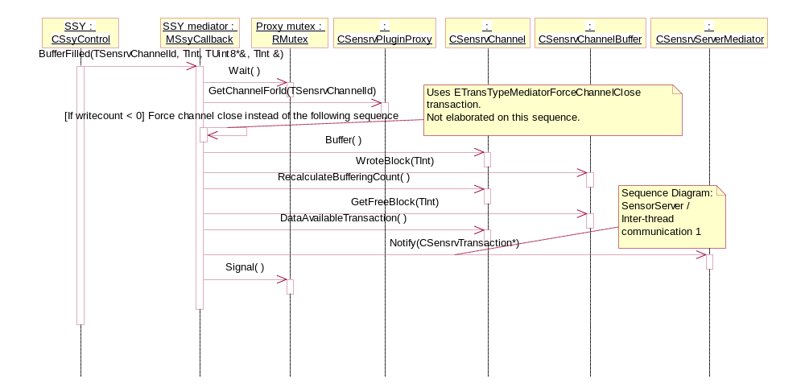
Figure 4.17 Data receiving, SSY notifies about new data in buffer
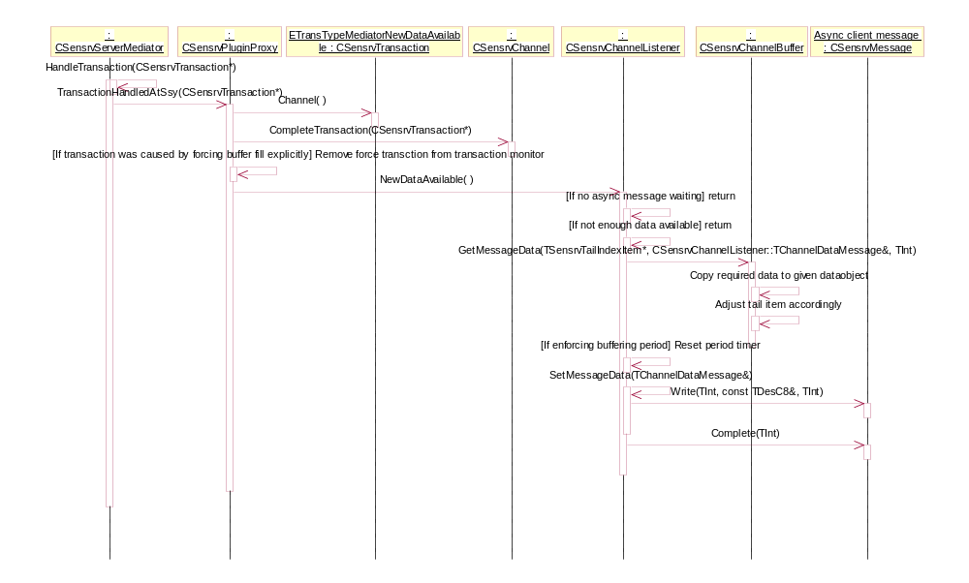
Figure 4.18 Data receiving, new data notification handling at Sensor Server main thread

Stopping data listening

Operation | Stop data listening.  void CSensrvChannel::StopDataListening()
Preconditions | The client has started the data listening successfully.
Description | The client requests data listening stopping using StopDataListening().  If there are other clients also listening to the same channel, stopping only entails deactivating this client’s listener. If the client was the last listener, SSY is also notified using the ETransTypeStopListening transaction.
Inputs
Modifies | The client listener is set to the inactive data listening state, and data listening is stopped from SSY if no more listeners.
Outputs
Postconditions | Data listening is stopped.
Related To | CSensrvChannel, CSensrvChannelBuffer, CSensrvChannelListener, MSsyChannelDataProvider, CSsyControl
Related Event | The client application wants to stop data listening. See the use case in Section 2.3.6.
Exceptions | From the client application point of view, none. If stopping fails because of an OOM error somewhere, the channel may be left in the listening state without any clients. Such channel is eventually cleaned up by the timed SSY unloading.

Getting a single property

Operation | Getting a single property.  void CSensrvChannel::GetPropertyL( const TSensrvPropertyId aPropertyId, const TInt aItemIndex, TSensrvProperty& aProperty )
Preconditions | The channel must be open for the client.
Description | The client specifies the property ID and the property index (if the property scope is a channel item) in a GetPropertyL() call. The server passes the request to the SSY mediator using the ETransTypeGetProperty transaction. The SSY mediator uses the channel’s MSsyPropertyProvider::GetPropertyL() to get the property details which are written to the client message and the message is completed.
Inputs | The property ID and the item index.
Modifies
Outputs | The client gets the property details.
Postconditions | The client has the property details.
Related To | CSensrvChannel, MSsyPropertyProvider, CSsyControl, TSensrvProperty
Related Event | The client wants the property details. See the use case in Section 2.3.7.
Exceptions | If the channel is not open or the property does not exist, KErrNotFound is returned.  The most likely case to occur is an OOM situation. In this case, a Standard Symbian error code is returned, and the only solution is to try again later.

Getting all properties

Operation | Getting all properties.  void CSensrvChannel::GetAllPropertiesL( RSensrvPropertyList& aChannelPropertyList)
Preconditions | The channel must be open for this client.
Description | The client requests all properties of a channel with a GetAllPropertiesL() call. The server passes the request to the SSY mediator using the ETransTypeGetAllProperties transaction. The SSY mediator uses the channel’s MSsyPropertyProvider::GetAllPropertiesL() to get the property details which are written to the client message along with the count of properties and the message is completed.  If the client message does not have sufficient space for writing all properties, only the count is written and KErrOverflow returned, and the client requests all properties again with a message that includes a bigger descriptor.
Inputs
Modifies
Outputs | An array of all property details.
Postconditions | The client has the details of all properties of the channel.
Related To | CSensrvChannel, MSsyPropertyProvider, CSsyControl, TSensrvProperty
Related Event | The client wants all property details. See the use case in Section 2.3.7.
Exceptions | If the channel is not open, KErrNotFound is returned.  The most likely case to occur is an OOM situation. In this case, a Standard Symbian error code is returned, and the only solution is to try again later.

Setting a single property

Operation | Setting a single property.  TInt CSensrvChannel::SetProperty( const TSensrvProperty& aProperty )
Preconditions | The channel must be open for the client. The client must have the WriteDeviceData capability.
Description | The client sets the property ID, the property index (if the property scope is a channel item) and the new value to the TSensrvProperty object and passes it to Sensor Server with SetProperty(). The server passes the request to the SSY mediator using the ETransTypeSetProperty transaction. The SSY mediator first uses the channel’s MSsyPropertyProvider::CheckPropertyDependenciesL to check which channels the setting of the property affects. The client priorities of all clients of all channels are compared, and if the client does not have the highest priority, setting is not done. If the client has the highest priority, MSsyPropertyProvider::SetPropertyL() is used to set the property details.  Since SSY notifies all affected channels except the one whose provider was used that the property has changed (see Section 4.3.16), other clients of the setter channel are explicitly notified after the setting.
Inputs | The property ID, the item index and the new value.
Modifies | The property value at SSY is modified.
Outputs | The property change notification is initiated by SSY for other affected channels and by Sensor Server directly for other same channel clients.
Postconditions | The property has a new value.
Related To | CSensrvChannel, MSsyPropertyProvider, CSsyControl, TSensrvProperty
Related Event | The client application wants to set a property value. See the use case in Section 2.3.8.
Exceptions | If the channel is not open or the property does not exist, KErrNotFound is returned.  If the client application does not have the necessary capabilities to set the property, KErrPermissionDenied is returned.  If there is a higher priority client currently active on one of the channels the property affects, KErrAccessDenied is returned. Retrying later may work.  If the new value is outside the min/max range of the property or the property is read-only, KErrArgument is returned.  The most likely case to occur is an OOM situation. In this case, a Standard Symbian error code is returned, and the only solution is to try again later.

Starting property listening

Operation | Start listening to property change notifications.  void CSensrvChannel::SetPropertyListenerL( MSensrvPropertyListener* aChannelPropertyListener )
Preconditions | The channel must be open for the client.
Description | The client application requests property change notifications using SetPropertyListenerL() with a non-NULL value. Sensor Client sends an asynchronous request to Sensor Server to receive the property change notifications.  Sensor Server stores the asynchronous client message until a notification is received from SSY.
Inputs | The callback object for notifying the client application about property changes.
Modifies | Sensor Server stores client message to the client’s listener object and sets the client’s listener to the property listening state.
Outputs
Postconditions | The client is listening for notifications about changed properties.
Related To | CSensrvChannel, CSensrvChannelListener, MSsyPropertyProvider, CSsyControl, TSensrvProperty
Related Event | The client application wants to start listening for notifications. See the use case in Section 2.3.9.
Exceptions | If the channel is not open or the property does not exist, KErrNotFound is returned.  If the client is already listening for property change notifications, KErrAlreadyExists is returned.  The most likely case to occur is an OOM situation. In this case, a Standard Symbian error code is returned, and the only solution is to try again later.

Receiving property change notifications

Operation | Receiving property change notifications.  void MSsyCallback::PropertyChanged( const TSensrvChannelId aChannelId, const RSensrvChannelList& aAffectedChannels, const TSensrvProperty& aProperty )
Preconditions | Property listening must be started by the client.
Description | SSY notifies Sensor Server about the changed properties using PropertyChanged(). Sensor Server distributes the notification to all clients of the affected channels that are listening for property changes. The notification is done using the stored asynchronous property change messages. If the property change message is not available, the change is queued until the client has processed the previous message and re-requests the changes.
Inputs | - The channel ID of the channel whose property provider is used for notification.  - A list of the affected channels. If this notification was caused by Sensor Server calling SetPropertyL(), the channel whose property provider was used to set the property is not included in the list.  - Property details of changed property.
Modifies | The property queues if the client message is not immediately available.
Outputs | Change notification messages to the listening clients of the affected channels.
Postconditions | The clients of the affected channels are aware of the property changes.
Related To | CSensrvChannel, CSensrvChannelListener, MSsyPropertyProvider, CSsyControl, TSensrvProperty
Related Event | The property is changed. See the use case in Section 2.3.10.
Exceptions | The errors in property listening are passed to the client via MSensrvPropertyListener::PropertyError(). If there is any error, listening is retried and if it fails again, the channel is closed and reopened, before trying yet again.  Receiving the error code ESensrvMinor means that some minor error occurred during listening. If it is not followed by ESensrvFatal, listening was successfully restarted.  If an unrecoverable error occurred during listening, ESensrvFatal is returned. The channel is closed.

Stopping property listening

Operation | Stopping property listening.  void CSensrvChannel::SetPropertyListenerL( MSensrvPropertyListener* aChannelPropertyListener )
Preconditions | Property listening must be started by the client.
Description | The client application requests stopping the property change notifications using SetPropertyListenerL() with a NULL value. Sensor Client sends a request to Sensor Server to stop the property change notifications.  Sensor Server stops sending property change notifications for the client.
Inputs | The NULL callback indicates stopping listening.
Modifies | Sensor Server deletes and cancels the asynchronous client message for the property change notifications and sets the client’s listener to Not listening for property changes state.
Outputs
Postconditions | The client no longer receives notifications about property changes.
Related To | CSensrvChannelListener
Related Event | The client no longer wants to get property change notifications. See the use case 2.3.11.
Exceptions | If the channel is not open or the property does not exist, KErrNotFound is returned.

Adding channel condition set

Operation | Adding a new condition set to be listened for.  void CSensrvChannel::AddConditionL( CSensrvChannelConditionSet& aChannelConditionSet )  TBool CSensrvConditionEvaluator::CheckConditionValidity(  const CSensrvChannelCondition* aCondition1,  const CSensrvChannelCondition* aCondition2 )
Preconditions | The channel must be open for the client.
Description | The client specifies the conditions to be listened for in a condition set given as an AddConditionL() parameter aChannelConditionSet. The set is checked for completeness, serialized and sent to Sensor Server. Sensor Server further validates both the conditions and the set internally (general set consistency and completeness) and using the Condition Evaluator plug-in method CheckConditionValidity() (condition indexes and values). If the set passes validation, it is added to iAddedConditionSetList.  If condition listening or data listening is already started when a set is added, the buffer fill is forced and the next new data block received from SSY is ignored for the newly added set.
Inputs | The set to be added.
Modifies | The set is added to iAddedConditionSetList.
Outputs
Postconditions | The set is ready to be compared against the incoming data.
Related To | CSensrvChannelListener, CSensrvConditionEvaluator, CSensrvConditionSet
Related Event | The client wants to add a new condition to be listened for. See the use case in Section 2.3.12.
Exceptions | If the channel is not open, KErrNotFound is returned.  If the condition set is already added, KErrAlreadyExists is returned.  If the condition set is not valid, KErrArgument is returned.  The most likely case to occur is an OOM situation. In this case, a Standard Symbian error code is returned, and the only solution is to try again later.

Removing channel condition set

Operation | Removing a condition set from listening.  void CSensrvChannel::RemoveConditionL( CSensrvChannelConditionSet& aChannelConditionSet )
Preconditions | The channel must be open for the client.
Description | The client application specifies the condition set to remove in an aChannelConditionSet parameter of RemoveConditionL. Sensor Client extracts set ID from the set and requests Sensor Server to remove corresponding set. The sets with matching ID in iAddedConditionSetList and iMetConditionSetList are removed. If no matching set is found, the operation still completes without error.
Inputs | A set to be removed.
Modifies | The set is removed from iAddedConditionSetList and iMetConditionSetList.
Outputs
Postconditions | The set is no longer compared against the incoming data.
Related To | CSensrvChannelListener, CSensrvConditionSet
Related Event | The client wants to remove a set from listening. See the use case in Section 2.3.13.
Exceptions | If the channel is not open, KErrNotFound is returned.  The most likely case to occur is an OOM situation. In this case, a Standard Symbian error code is returned, and the only solution is to try again later.

Starting condition listening

Operation | Starting condition listening.  void CSensrvChannel::StartConditionListeningL ( MSensrvChannelConditionListener* aChannelConditionListener, const TInt aObjectCount, const TInt aBufferingPeriod )
Preconditions | The channel must be open for the client.
Description | The client requests condition met notifications for an open channel using StartConditionListeningL().  Listening starting for conditions and data is similar on the Sensor Server side, the main difference being that if just listening for conditions, data is not passed on to the client. See Section 4.3.9 for the start listening details.
Inputs | - Listener: The callback object for notifying the client application when a new condition met notification arrives.  - Object count: The desired number of data items requested from SSY before the conditions are evaluated. For channels with high sustained data rate, the object count of more than one is recommended to improve the performance. If the same client is also listening for data, the desired count specified there is compared to the object count specified here and the lower value is used for both.  - Buffering period: This is the maximum time new data is waited for. The period can be used when it is necessary to know if there is any new data periodically, such as in a game that is controlled by a sensor. It should never be used for passive background channel listening, as handling periodic timer events consume power unnecessarily. If the same client is also listening for data, the buffering period specified there is compared to the buffering period specified here and the lower value is used for both.
Modifies | The client listener is set to the active conditions listening state, and data listening is initiated from SSY if not already listening.
Outputs
Postconditions | Condition listening is started.
Related To | CSensrvChannel, CSensrvChannelBuffer, CSensrvChannelListener, MSsyChannelDataProvider, CSsyControl
Related Event | The client wants to start listening for conditions. See the use case 2.3.14.
Exceptions | If starting fails for any reason, it is first retried once at the client side. If it also fails, the channel is closed and reopened, after which starting is retried again. This is needed, as it is possible that SSY has been unloaded, probably because it has panicked. An automatic channel reopening in start listening failure handling reloads SSY.  If the channel is not open for the client, KErrNotFound is returned.  If the client is already listening for conditions on the channel, KErrAlreadyExists is returned.  The most likely case to occur is an OOM situation. In this case, a Standard Symbian error code is returned, and the only solution is to try again later.

Receiving asynchronous condition met notification

Operation | Receiving channel condition met notifications asynchronously.  void MSensrvChannelConditionListener::ConditionMet( CSensrvChannel& aChannel, CSensrvChannelConditionSet& aChannelConditionSet, TDesC8& aValue )  TBool CSensrvConditionEvaluator::EvaluateCondition(const CSensrvChannelCondition* aCondition1, const CSensrvChannelCondition* aCondition2, const TDesC8& aData)
Preconditions | The client has started condition listening successfully.
Description | After the client has started condition listening successfully, it requests notifications from Sensor Server with asynchronous messages. These messages are stored on the Sensor Server side until one of the conditions added to Server is met, unless there are already met conditions in iMetConditionSetList, in which case the first one of those are immediately removed and used to complete the message.  Handling of the ETransTypeMediatorNewDataAvailable transaction on Sensor Server evaluates the data against all added condition sets using CSensrvConditionEvaluator::EvaluateCondition. Any condition that is met by one of the new data items is removed from iAddedConditionSetList and added to iMetConditionSetList.  After the evaluation of all data items has been done, if there are any conditions in iMetConditionSetList, the first one of those is removed and its ID and related data item are copied to the asynchronous client message, which is then completed to notify the client.  Upon receiving this completed message, the client calls the MSensrvChannelConditionListener::ConditionMet()method immediately and then send another asynchronous message, unless listening has already been stopped.
Inputs
Modifies | The buffer pointers, the condition data availability and the condition lists are adjusted accordingly.
Outputs
Postconditions | The met condition has been notified to the client and removed from Sensor Server.
Related To | CSensrvChannel, CSensrvChannelBuffer, CSensrvChannelListener, MSsyChannelDataProvider, CSsyControl, CSsyCallback, CSensrvConditionEvaluator
Related Event | Receiving channel condition notifications. See the use case in Section 2.3.15.
Exceptions | The errors in condition listening are passed to the client via MSensrvDataListener::ConditionError(). If there is any error, listening is retried and if it fails again, the channel is closed and reopened, before trying yet again.  Receiving the error code ESensrvMinor means that some minor error occurred during listening. If it is not followed by ESensrvFatal, listening was successfully restarted. Some condition met notifications may have been lost.  If an unrecoverable error occurred during listening, ESensrvFatal is returned. The channel is closed.

Stopping condition listening

Operation | Stopping condition listening.  void CSensrvChannel::StopConditionListening()
Preconditions | The client has started condition listening successfully.
Description | The client requests condition listening stopping using StopConditionListening().  If there are other clients also listening to the same channel, stopping only entails deactivating this client’s listener. If the client was the last listener, SSY is also notified using the ETransTypeStopListening transaction.  Any conditions that are not yet met or have not yet been notified to the client are removed when listening is stopped.
Inputs
Modifies | The client listener is set to the inactive condition listening state, and data listening is stopped from SSY if there are no more listeners.  iAddedConditionSetList and iMetConditionSetList are cleared.
Outputs
Postconditions | Condition listening is stopped.
Related To | CSensrvChannel, CSensrvChannelBuffer, CSensrvChannelListener, MSsyChannelDataProvider, CSsyControl
Related Event | The client application wants to stop condition listening. See the use case in Section 2.3.16.
Exceptions | From the client application point of view, none. If stopping fails because of an OOM error somewhere, the channel may be left in the listening state without any clients. Such channel is eventually cleaned up by a timed SSY unloading.

Starting channel change listening

Operation | Starting to listen for channel change notifications.  void CSensrvChannelFinder:: SetChannelListenerL( MSensrvChannelListener* aChannelListener )
Preconditions
Description | The client application requests channel change notifications using SetChannelListenerL() with a non-NULL value. Sensor Client sends an asynchronous request to Sensor Server to receive channel change notifications.  Sensor Server stores the asynchronous client message until a change is detected.
Inputs | The callback object for notifying the client application about channel changes.
Modifies | Sensor Server stores the client message to the client’s session object and creates the channel change queue.
Outputs
Postconditions | The client is listening for notifications about changed channels.
Related To | CSensrvChannelFinder, CSensrvSession, CSensrvEcomChangeListener
Related Event | The client application wants to start listening for notifications. See the use case in Section 2.3.17.
Exceptions | If the client is already listening for channel change notifications, KErrAlreadyExists is returned.  The most likely case to occur is an OOM situation. In this case, a Standard Symbian error code is returned, and the only solution is to try again later.

Receiving channel change notifications

Operation | Receiving channel change notifications.  void MSsyCallback:: RegisterChannelsL( RSensrvChannelInfoList& aChannelInfoList )
Preconditions | Channel change listening must be started by the client.
Description | SSY notifies Sensor Server about the changed channels using RegisterChannelsL(). Sensor Server distributes the notification to all interested clients that are listening for channel changes using the stored asynchronous channel change messages. If the channel change message is not available, the change is queued in the client’s CSensrvSession object until the client has processed the previous message and re-requests the changes.  SSY always registers all of the channels it offers at the time, and Sensor Server compares those to the previously registered channels to determine what has changed. The channels can also be removed if the plug-in providing the channels is uninstalled. In this case RegisterChannelsL() is not called, as SSY is already uninstalled. Instead, CSensrvProxyManager notifies the sessions directly when it is notified about the plug-in removal.
Inputs
Modifies | The channel change notification queues of sessions if the client message is not immediately available.
Outputs | The change notification messages to the listening clients.
Postconditions | The interested clients are aware of channel changes.
Related To | CSensrvChannelFinder, CSensrvSession, CSensrvEcomChangeListener  MSsyCallback, CSensrvChannelChangeQueue
Related Event | The property is changed. See the use case in Section 2.3.18.
Exceptions | The errors in channel change listening are passed to the client via MSensrvChannelListener:: ChannelDetectionError(). If there is any error, listening is retried.  Receiving the error code ESensrvMinor means that some minor error occurred during listening. If it is not followed by ESensrvFatal, listening was successfully restarted.  If an unrecoverable error occurred during listening, ESensrvFatal is returned. The finder session has been closed.

Stopping channel change listening

Operation | Stopping channel change listening.  void CSensrvChannelFinder:: SetChannelListenerL( MSensrvChannelListener* aChannelListener )
Preconditions | Channel change listening must be started by the client.
Description | The client application requests stopping channel change notifications using SetChannelListenerL() with a NULL value. Sensor Client sends a request to Sensor Server to stop the channel change notifications.  Sensor Server stops sending channel change notifications for the client.
Inputs | The NULL callback indicates stopping listening.
Modifies | Sensor Server deletes and cancels the asynchronous client message for the channel change notifications and deletes the channel change notification queue.
Outputs
Postconditions | The client no longer receives notifications about channel changes.
Related To | CSensrvSession
Related Event | The client no longer wants to get channel change notifications. See the use case in Section 2.3.19.
Exceptions | None. The client application does not get any more notifications even if stopping somehow fails at Sensor Server. In this case, the server side cleanup is done when the client’s finder session terminates.

Transaction timeout

Operation | Transaction timeout.  void CSensrvPluginProxy::HandleTransactionTimeout()
Preconditions | A transaction is added to the transaction monitor.
Description | Whenever transactions are being handled by SSY, they are monitored for execution time. If the time between adding a transaction to the transaction monitor and receiving a notification for the transaction from the SSY mediator exceeds the configured transaction timeout, HandleTransactionTimeout() is called. This simply cleans up the proxy (see Section 4.3.5), as it indicates a probable deadlock or some such condition on the SSY thread. Since the SSY thread is not responding, the cleanup includes forcibly terminating the SSY thread.
Inputs
Modifies | The proxy is cleaned up.
Outputs
Postconditions | The proxy is cleaned up.
Related To | CSensrvPluginProxy, CSensrvTransactionMonitor
Related Event | The transaction timeout.
Exceptions

Unloading SSY due to inactivity

Operation | Unloading SSY due to inactivity.  void CSensrvPluginProxy::TimerFired(TInt aTimerId)
Preconditions | None of the channels provided by the plug-in are opened by the clients.
Description | The plug-ins that are loaded consume considerable amount of memory as there is a separate stack and heap for the SSY thread. It makes therefore sense to terminate the unnecessary thread and unload SSY, if nobody uses them. This is done by calling CSensrvPluginProxy::StartUnloadTimerIfNeeded() when the last client closes a channel, and also at startup. The timer is stopped if any client opens a channel from that proxy.  If the timer expires, the client count is double-checked one last time, and if no clients are found, the proxy is cleaned up (see Section 4.3.5).
Inputs
Modifies | The proxy is cleaned up.
Outputs
Postconditions | The proxy is cleaned up.
Related To | CSensrvPluginProxy, CSensrvChannelListener
Related Event | Unload timer timeout.
Exceptions

Shutting down Sensor Server

Operation | Shutting down Sensor Server.  The Client-Server API function: ESensrvSrvReqShutdownServer
Preconditions | The client must shut down the server.
Description | Normally the client is not allowed to shutdown Sensor Server, as Sensor Server is meant to be running continuously. However, to facilitate testing this has to be possible, so ESensrvSrvReqShutdownServer is protected with SID only policy, which allows calls only from the STIF Test Framework process.  When shutting down, Sensor Server simply cleans up the proxies and after all proxies have notified that they are cleaned up, it stops the active scheduler, which causes the server to be cleaned up and the process main thread to exit.
Inputs
Modifies | Sensor Server is deleted.
Outputs
Postconditions | The Sensor Server process is no longer running.
Related To | CSensrvProxyManager, CSensrvPluginProxy
Related Event | The test framework must clean up Sensor Server.
Exceptions

Backup and Restore
This component does not participate in backup and restore.

Variation
Sensor Services itself does not currently support variation beyond leaving the server executable out of the device altogether. All device specific functionality is implemented in the dynamically loaded SSY ECom plug-ins, the design of which is not within the scope of this document.

System resource usage

Files
This component does not use any files.

Other data

Databases
This component does not use any databases.

Central Repository
This component uses Central Repository for storing configuration settings. See reference document [1] for details.

Publish and Subscribe
This component does not use Publish and Subscribe.

Memory consumption
The memory consumption listed here is a total of the sensorserver.exe, sensrvclient.dll and sensrvutil.dll sizes.
Sensor Server can potentially use a lot of heap, if there are channels with high data rate and/or large data item size. For example, the accelerometer sensor may have a data rate of 40Hz and provide a time stamped set of three integers as data item (20 bytes). If the buffer is configured to hold five seconds worth of data, the channel buffer size is 20*40*5 = 4000 bytes.

Memory/Build | Consumption
User data area | None
WINSCW UDeb | Approximately 1 MB (there is a lot of traces)
ARMV5 URel | Approximately 25 kB

Task allocation
Sensor Server runs in its own process which is started by the first connecting client. Sensor Server starts a separate thread for each loaded SSY plug-in. Each SSY thread has its own heap.

Performance
Fast sensors can cause performance problems, if channel data is requested one item at a time. Sensor Services supports channel data requesting in larger blocks, which significantly cuts down IPC traffic. However, sometimes it is not possible to request data in large blocks, for example when the data is sporadic and each data item is interesting.
Sensor Server runs in a high priority process to ensure as little data loss as possible. However, this may cause problems with other applications, such as Media Player.

Timers

Timer | Purpose | Interval | Lifetime
SSY unload timer | Unloading SSY when there are no active clients. | X seconds, as configured in the Central Repository key KSensrvSsyInactivityPeriodKey. | Only active when no clients are active, and triggered only once.
Transaction timeout timer | Detecting a stalled SSY thread. | Y seconds, as configured in the Central Repository key KSensrvTransactionTimeoutKey. | Only active when there are active transactions.
SSY thread graceful shutdown timer | Triggering forced termination of the SSY threads if graceful cleanup takes too long. | Z seconds, as configured in the Central Repository key KSensrvThreadTerminationPeriodKey. | Only active during the SSY thread cleanup, and triggered only once.
Buffering period timer | Forcing a Buffer Filled call from SSY if the client has specified a maximum buffering period. | 15 or more milliseconds, depending on what value the client has specified. | Only active when the client is listening for the channel data and has a specified maximum buffering period.
ECom registration timer | When an ECom registration change is detected, it is possible that getting the new implementation list fails. If this happens, a timer is started to retry the operation later. | One second. | Only activated if the ECom implementation list getting fails.
Proxy cleanup timer | The proxy manager cleans up the proxies for any uninstalled plug-ins. However, if SSY is loaded at the time, the related thread needs to be shut down before the proxy can be deleted. This timer is used to wait for the proxy cleanup to complete. | One second. | Only activated when an active plug-in is uninstalled.

Security

Capabilities of this component

Capability | Justification
CAP_SERVER | Sensor Server is an S60 protected server, and therefore has the default S60 server capabilities.
CAP_CLIENT_DLL | Sensor Client and Sensor Util are S60 client DLLs, and therefore have the default S60 client DLL capabilities.

All client server interface functions are protected. See reference document [1] for more details.

Input and output validation
Input parameters are checked for sanity where necessary on the server side on all client-server functions and SSY callback methods.

Environmental assumptions
This component does not make any assumptions about its environment.

Additional enforcements
Shutting down Sensor Server is allowed only by the STIF Test Framework process.

Exception handling
If an error that cannot be satisfactorily resolved within the Sensor Server process occurs during a client server call, it is propagated to Sensor Client. Depending on the operation, Sensor Client ignores the error, passes the error to the client application or retries the operation.
Channel closing and stopping data or property listening are examples of operations where errors are ignored, as the client application is not able to do anything about the error anyway. In case of the stopping data listening, this can result in the server side client listener still actively listening for data even though the client is no longer requesting it with asynchronous messages, or the channel still listening for data when there are no active listeners. This should not cause any problems beyond consuming unnecessary processing power. There is not much that can be done about this, however, as it is an OOM situation where this is only likely to happen.
Property getting and setting are examples of methods where the error is passed directly to the client application.
The errors during data listening or starting to listen for data or property changes utilize retrying the operation. If the operation retry does not immediately succeed, the channel and the client session are closed and reopened, and the client state is restored to what is desired. This close/reopen has two benefits: firstly, it cleans up everything related to the client session, and secondly, it prompts reloading of SSY if it has been unloaded or has panicked.
In operations that return variable size data, such as channel finding or getting all properties, KErrOverflow is utilized to indicate insufficient space in the message. In these cases, Sensor Client allocates more space and executes the same request again.

Usage

Building
To build Sensor Server, Sensor Client and Sensor Util, go to the \sensorserver\group folder and give the following commands on command line:
- bldmake bldfiles to create build files.
- abld build to build all targets.

User's guide
Usage of the Sensor Services APIs is described in detail in reference documents [2] and [3].

