S60 5.x
Tilt Compensation SSY
Design Document

Team name | Author
D RD S60 CSU OS System and Product SW FI | Timo M. Pääkkönen

Change history:

Version | Date | Status | Comments
2.0 | 12.12.2008 | Approved | Updates concerning the Tilt Compensation component usage and added Central Repository keys.
1.0 | 30.04.2008 | Approved

Table of contents:

1. Document control 5
1.1 References 5
1.2 Documentation conventions 5
1.3 Abbreviations 5
1.4 Definitions 5
2. General 6
2.1 Introduction 6
2.2 Component environment 6
2.3 Use cases 7
2.3.1 Creating and Initializing 8
2.3.2 Opening the magnetic north channel 8
2.3.3 Closing the magnetic north channel 9
2.3.4 Creating and opening the accelerometer channel 9
2.3.5 Creating and opening the magnetometer channel 9
2.3.6 Starting data listening 10
2.3.7 Stopping data listening 10
2.3.8 Buffer full 10
2.3.9 Calculating Tilt 11
2.4 Services required 11
2.4.1 From the Symbian OS subsystems 11
2.4.2 From the Domestic OS subsystems 11
2.4.3 From HW 11
2.5 Services provided 12
2.5.1 UI 12
2.5.2 SW IF 12
3. UI control hierarchy 13
4. Design 14
4.1 Class diagrams 14
4.1.1 Framework 14
4.1.2 Component 14
4.2 Class descriptions 15
4.2.1 Structs, type definitions and enumerations 16
4.2.1.1 Common.h enumerations 16
4.2.1.2 Configuration.h enumerations/structs 16
4.2.1.3 tcevent.h enumerations 17
4.2.1.4 tcstate.h enumerations 17
4.2.1.5 tcstatelistendata.h enumerations 17
4.2.1.6 tctransaction.h enumerations 17
4.2.2 Flag definitions 17
4.2.3 State diagrams 18
4.2.3.1 Tilt channel state diagram 18
4.3 Operations 18
4.3.1 Creating the channel 18
4.3.2 Opening a channel 19
4.3.3 Listening to the Tilt channel data 20
4.3.4 Stopping the channel data listening 21
4.3.5 Closing a channel 22
4.3.6 Setting a property 23
4.4 Backup and Restore 24
5. Variation 25
5.1 Variable component/feature 25
6. System resource usage 26
6.1 Files 26
6.2 Other data 26
6.2.1 Databases 26
6.2.2 Central Repository 26
6.2.3 Publish and Subscribe 26
6.3 Memory consumption 26
6.4 Task allocation 26
6.5 Performance 26
6.6 Timers 26
7. Security 27
7.1 Capabilities of this component 27
7.2 Input and output validation 27
7.3 Environmental assumptions 27
7.4 Additional enforcements 27
8. Exception handling 28
9. Usage 29
9.1 Building 29
9.2 User's Guide 29

Document control

References
- Sensor API Specification Document

Documentation conventions
Code is shown with the Courier New font.
The used color diagram conventions are described below:

Convention | Description
 | A class which is declared in Tilt Compensation SSY.
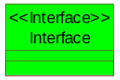 | An abstract interface.
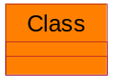 | A class which is declared by some other component.

Abbreviations
API | Application Programming Interface
OS | Operating System
SSY | Sensor System

Definitions
ECom | A Symbian OS framework for loading plug-ins.
Sensor System | An ECom plug-in component that provides sensor channels to Sensor Server.

General
This document describes the design of the Tilt Compensation SSY component.

Introduction
Tilt Compensation SSY is a plug-in component which implements the sensor adaptation API, SSY. Tilt Compensation SSY does not utilize directly any sensor HW interface and is rather a software SSY by nature. Instead Tilt Compensation SSY listens to data received from the accelerometer and magnetometer sensors.
Tilt Compensation SSY’s main responsibility is to resolve the 3D vectors from accelerometer and magnetometer and convert this to 2D plane. The idea is to provide an angle that has compensated the phone’s Tilt angle in relation to the magnetic north which can be utilized in a compass or map applications. This enables more efficient navigation service implementation since the Tilt angle is already provided by the system with the accelerometer and magnetometer sensors. The actual compensation is calculated by the Tilt compensation library provided by adaptation. The compensation library is loaded dynamically using RLibrary and the compensation parameters are read from Central Repository. If the compensation library or the parameters are not available, the loading of the SSY fails.
The design of the Tilt Compensation SSY is described in more detailed level in the following sections.

Component environment
The main dependecies of Tilt Compensation SSY are described below.
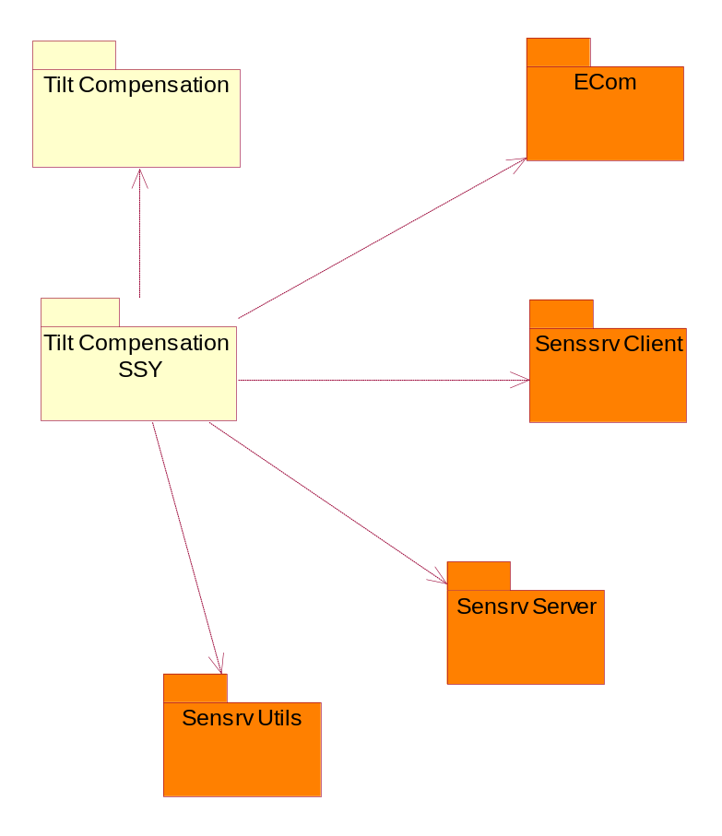
Figure 2.1 Component environment

Use cases
The most important use cases in Tilt Compensation SSY are described below.
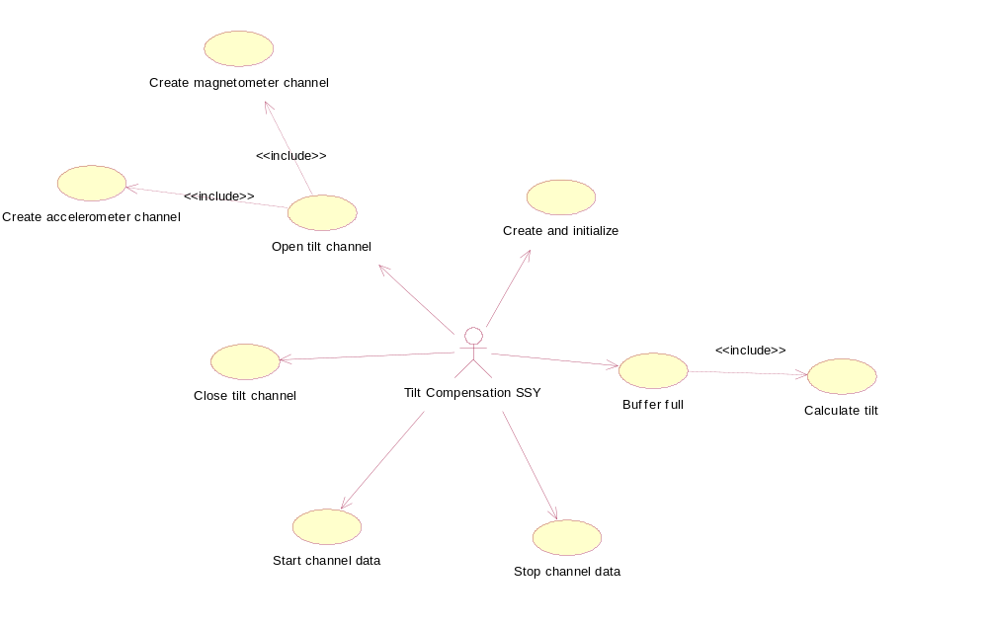
Figure 2.2 Tilt Compensation SSY use cases

Creating and Initializing
Summary | Tilt Compensation SSY is created and initialized.
Actor(s) | Tilt Compensation SSY, a Sensor Server client.
Frequency | Low.
Preconditions
Description | A client searches for the magnetic north channel. Sensor server loads Tilt Compensation SSY. Tilt Compensation SSY registers the magnetic north channel to be ready to use. Tilt Compensation SSY loads the Tilt Compensaiton library dynamically. If the loading fails, loading of the SSY fails as well.
Exceptions
Postconditions | Tilt Compensation SSY is successfully created and initialized.
Illustrations | The FindChannel operation, see Section 4.3.1.

Opening the magnetic north channel
Summary | The Tilt channel is opened.
Actor(s) | Tilt Compensation SSY, a Sensor Server client
Frequency | Low.
Preconditions | Tilt Compensation SSY must be initialized, see Section 2.3.1.
Description | A client opens the magnetic north channel. Tilt Compensation SSY searches for the accelerometer channel and creates the accelerometer channel. Tilt Compensation SSY searches for the magnetometer and accelerometer channels and creates both channels. Both the accelerometer channel and the magnetometer channel are opened.
Exceptions | Opening a channel fails if:  - Accelerometer channel cannot be created and opened.  - Magnetometer channel cannot be created and opened.
Postconditions | The magnetic north channel is successfully opened.
Illustrations | See Section 4.3.2, Opening a channel.

Closing the magnetic north channel
Summary | The magnetic north channel is closed.
Actor(s) | Tilt Compensation SSY, a Sensor Server client.
Frequency | Low.
Preconditions | The magnetic north channel must be initialized. See Section 2.3.1.
Description | The client closes the magnetic north channel. Tilt Compensation SSY closes both the accelerometer and magnetometer channels.
Exceptions | If the magnetic north channel is not opened, nothing is done.
Postconditions | The magnetic north channel is successfully closed.
Illustrations | See Section 4.3.5, Closing a channel.

Creating and opening the accelerometer channel
Summary | The accelerometer channel is created and opened.
Actor(s) | Tilt Compensation SSY, a Sensor Server client.
Frequency | Low.
Preconditions | Tilt Compensation SSY must be initialized, see Section 2.3.1.
Description | The accelerometer channel is searched. If the accelerometer channel is found, it is created. When the accelerometer channel is successfully created, the channel is opened.  The accelerometer channel is only created once. Afterwards the channel is only opened.
Exceptions | If the accelerometer channel cannot be found, the accelerometer channel creation fails.
Postconditions | The accelerometer channel is successfully created and opened.
Illustrations | See Section 4.3.2, Opening a channel.

Creating and opening the magnetometer channel
Summary | The magnetometer channel is created and opened.
Actor(s) | Tilt Compensation SSY, a Sensor Server client.
Frequency | Low.
Preconditions | Tilt Compensation SSY must be initialized, see Section 2.3.1.
Description | The magnetometer channel is searched. If the magnetometer channel is found, it is created. When the magnetometer channel is successfully created, the channel is opened.  The magnetometer channel is only created once. Afterwards, the channel is only opened.
Exceptions | If the magnetometer channel cannot be found, the accelerometer channel creation fails.
Postconditions | The magnetometer channel is successfully created and opened.
Illustrations | See Section 4.3.2, Opening a channel.

Starting data listening
Summary | The magnetic north channel data are started.
Actor(s) | Tilt Compensation SSY.
Frequency | Low.
Preconditions | The following preconditions must be met:  - Tilt Compensation SSY must be initialized, see Section 2.3.1.  - The magnetic north channel must be opened, see Section 2.3.2.
Description | A client starts the magnetic north channel data. Tilt Compensation SSY receives start channel data notification with the desired data count. The accelerometer and magnetometer channel data are started.
Exceptions | Starting the data listening fails if:  - The accelerometer channel data cannot be started.  - The magnetometer channel data cannot be started.
Postconditions | The magnetic north channel data are started successfully.
Illustrations | See Section 4.3.3, Listening to Tilt channel data.

Stopping data listening
Summary | The magnetic north channel data are stopped.
Actor(s) | Tilt Compensation SSY.
Frequency | Low.
Preconditions | The following preconditions must be met:  - Tilt Compensation SSY must be initialized, see Section 2.3.1.  - The magnetic north channel must be opened, see Section 2.3.2.  - The magnetic north channel data must be started, see Section 2.3.6.
Description | A client stops the Tilt channel data. Tilt Compensation SSY receives a notification that channel data must be stopped. The accelerometer and magnetometer channel data are stopped.
Exceptions | Stopping data listening does not do anything if the channel data listening is not started.
Postconditions | The magnetic north channel data are successfully stopped.
Illustrations | See Section 4.3.4, Stopping the channel data listening.

Buffer full
Summary | Data buffer is filled and data are sent to client(s).
Actor(s) | Tilt Compensation SSY.
Frequency | High (max frequency is 10 Hz).
Preconditions | The following preconditions must be met:  - Tilt Compensation SSY must be initialized, see Section 2.3.1.  - The magnetic north channel must be opened, see Section 2.3.2.  - Channel data listening must be started, see Section 2.3.6.
Description | The magnetic north channel receives the accelerometer and magnetometer data and writes the compensated magnetic north data into the data buffer when the data buffer is full, in other words, when the desired data count is reached, Tilt Compensation SSY flushes the data buffer. Sensor Server sends the data buffer to client(s).
Exceptions
Postconditions | The Tilt SSY data buffer is successfully filled and sent to the client(s).
Illustrations | See Section 4.3.3, Listening to Tilt channel data.

Calculating Tilt
Summary | Tilt compensated angle for the 2D plane is calculated from the 3D accelerometer and magnetometer vectors.
Actor(s) | Tilt Compensation Plug-in.
Frequency | High (max frequency is 10 Hz).
Preconditions | The following preconditions must be met:  - Tilt Compensation SSY must be initialized, see Section 2.3.1.  - The magnetic north channel must be opened, see Section 2.3.2.  - Channel data listening must be started, see Section 2.3.6.  - A new accelerometer and magnetometer data must be received.  - The Tilt compensation library must be successfully loaded.  - The Tilt paramters must be successfully read from the Central Repository.
Description | When the magnetic north channel receives new accelerometer and magnetometer XYZ data, Tilt compensation is calculated. It must be noticed that the calculation is done by the current data rate (approximately 1-10 times per second). The calculation is done through the Tilt compensation API which is implemented by adaptation. The new calculated Tilt data is written into the data buffer.
Exceptions | If Tilt calculation fails, the data buffer is not updated.
Postconditions | The Tilt calculation is successfully done and the data buffer updated.
Illustrations | See Section 4.3.3, Listening to the Tilt channel data.

Services required

From the Symbian OS subsystems
The services required from Symbian OS are described below.

API | Description
E32 | Symbian OS base services.
ECom | ECom plug-in framework.
Sensor Services | Sensor plug-in API, Sensor channel API.
Sensor adaptation | Tilt Compensation API.

From the Domestic OS subsystems
This component does not have any direct interfaces to the Domestic OS side subsystems.

From HW
This component has no direct HW interfaces.

Services provided

UI
This component does not provide any UI.

SW IF
This component does not provide direct services for other components. Instead, clients need to use Sensor services provided by the Sensor Server framework.

UI control hierarchy
This component does not provide any kind of UI control hierarchy.

Design
This chapter describes the Tilt Compensation SSY design.

Class diagrams

Framework
All the used stereotypes are listed below in class diagrams.
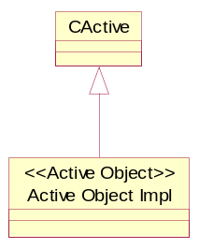
Figure 4.3 Used stereotypes

Component
Figure 4.4 describes the detailed design of Tilt Compensation SSY. The design and classes are briefly described after the diagram.
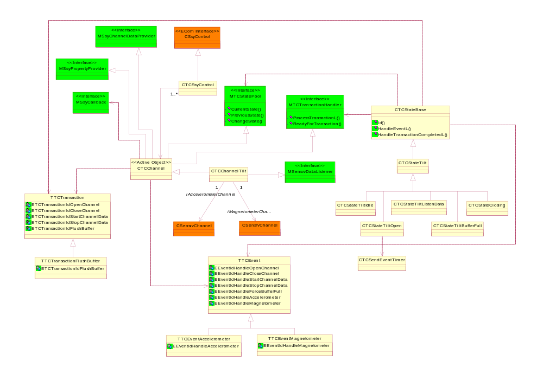
Figure 4.4 Tilt Compensation SSY design diagram
The main entrypoint in Tilt Compensation SSY is the CTCSsyControl. CTCSsyControl class implements the CSsyControl interface. This is the SSY ECom plug-in main interface. CTCSsyControl itself is only a container for the supported channels and does not provide any kind of logic.
CTCChannel is the base class for all channels. CTCChannel is an abtract interface and cannot be instantiated. CTCChannel provides a basic state machine which all derived channels can utilize. A derived channel class can utilize existing common states or create own channel specific states. CTCChannelTilt is derived from CTCChannel. CTCChannelTilt’s responsibility is to provide Tilt channel specific data, on other words compensated Tilt data. CTCChannelTilt implements Tilt specific state machine, which is described in Section 4.2.3.
CTCStateBase is the base class for all states. CTCStateBase is an abstract interface and cannot be instantiated. Instead, a derived common or channel specific state must be defined. States are identified by the channel type ID and state ID. Channel type ID defines the state owner and state ID identifies the state itself. There are five basic states: Idle, open, listen data, buffer full and closing. Every channel can create its own channel specific states.
CTCStateTilt is the base class for all Tilt channel specific states. In a similar way than CTCStateBase interface, CTCStateTilt only provides the base for all Tilt channel specific states. CTCStateTiltIdle, CTCStateTiltOpen, CTCStateTiltListenData, CTCStateTiltBufferFull and CTCStateClosing are all Tilt channel specific states.
Channels are controlled by events. TTCEvent is the base class for all events. The event is identified with a unique ID and with possible data. If the event contains event specific data, a derived class must be implemented. TTCEventAccelerometer and TTCEventMagnetometer are special events which also contains event specific data. TTCEventAccelerometer contains new accelerometer XYZ axis data and TTCEventMagnetometer contains new magnetometer XYZ axis data.

Class descriptions

Class | Description | Header file
CTCChannel | CTCChannel is the base class for all channels. This class provides a basic state machine which all derived channels can utilize. | Tcchannel.h
CTCChannelTilt | CTCChannelTilt channel is the class for the Tilt channel. CTCChannelTilt is inherited from CTCChannel and it provides means to handle the Tilt channel. | Tchanneltilt.h
TTCEvent | TTCEvent event class that is used in supplying the event that occurred between different states. The TTCEventClass is a base class for all events. | Tcevent.h
TCEventAccelometer | TCEventAccelometer is a class that is inherited from TCEvent class. It describes an event that occurred in the accelometer channel. | Tceventaccelometer.h
TTCEventMagnetometer | TTCEventMagnetometer is a class that is inherited from TCEvent class. It describes an event that occurred in the magnetometer channel. | Tceventmagnetometer.h
TTCEventProperty | TCEventProperty class abstracts a property event. | Tceventproperty.h
CTCSendEventTimer | CTCSendEventTimer class is used in creating such sequences that are requested from the Sensor Channel API. As the timer is triggered, the SSY checks if the data needs to be sent to the client and sends the data if needed. | Tcsendeventtimer.h
CTCSsyControl | CTCSsyControl is the control class for this SSY plug-in. This class is used in constructing the Tilt channel. | Tcssycontrol.h
CTCState | CTCState class is used in describing in which state the Tilt channel plug-in is. | Tcstate.h
MTCStatePool | MTCStatePool is an abstract class for handling the state in the Tilt channel plug-in. | Tcstatepool.h
CTCStateTilt | CTCStateTilt is the base class for all Tilt channel states. | Tcstatetilt.h
CTCStateTiltBufferFull | CTCStateTiltBufferFull is the state class for the state when the channel is in the Buffer full state. | Tcstatetiltbufferfull.h
CTCStateTiltClosing | CTCStateTiltClosing is the state class for the state when the channel is in the Closing state. | Tcstatetiltclosing.h
CTCStateTiltIdle | CTCStateTiltIdle is the state class for the state when the channel is in the Idle state. | Tcstatetiltidle.h
CTCStateTiltListenData | CTCStateTiltListenData is the state class for the state when the channel is in the Data listening state. | Tcstatetiltlistendata.h
CTCStateTiltOpen | CTCStateTiltOpen is the state class for the state when the channel is in the Open state. | Tcstatetiltopen.h
TTCTransaction | TTCTransaction is a container class for the transaction information. | Tctransaction.h
TTCTransactionFlushBuffer | TTCTransactionFlushBuffer is a class for the transaction flush buffer. | Tctransactionflushbuffer.h
MTCTransactionHandler | MTCTransactionHandler class is a handler for transactions. This class can be used to execute specific actions. | Tctransactionhandler.h
TCUtil | TCUtil is a utilization class. | Tcutil.h

Structs, type definitions and enumerations

Common.h enumerations
Enumeration's name | Description
TPanicCodes | This enumeration defines panic codes.

Configuration.h enumerations/structs
Struct’s/Enumeration’s name | Description
TChannelInfo | This structure defines information of the channel.
TChannelProperties | This structure defines information of the channel properties.
KTiltSsyChannels | The channel info of the Tilt channel.
KTiltSsyChannelProperties | The channel properties of the Tilt channel.

tcevent.h enumerations
Struct’s/Enumeration’s name | Description
TTCEventId | An enumeration of an event identification.

tcstate.h enumerations
Struct’s/Enumeration’s name | Description
TCStateType | An enumeration of a state type.
TCStateId | An enumeration of a state identification.

tcstatelistendata.h enumerations
Struct’s/Enumeration’s name | Description
TTiltDataBit | An enumeration for bit flags to indicate the Data compensation state.

tctransaction.h enumerations
Struct’s/Enumeration’s name | Description
TTCTransactionId | An enumeration for transaction identification.

tcprivatecrkeys.h definitions

Struct’s/Enumeration’s name | Description
KTiltCompensationParameterK | Tilt compensation parameter k.
KTiltCompensationParameterM | Tilt compensation parameter m.
KTiltCompensationParameterTresholdAngle1 | Tilt compensation parameter threshold angle 1.
KTiltCompensationParameterTresholdAngle2 | Tilt compensation parameter threshold angle 2.

Flag definitions
No flag definitions.

State diagrams

Tilt channel state diagram
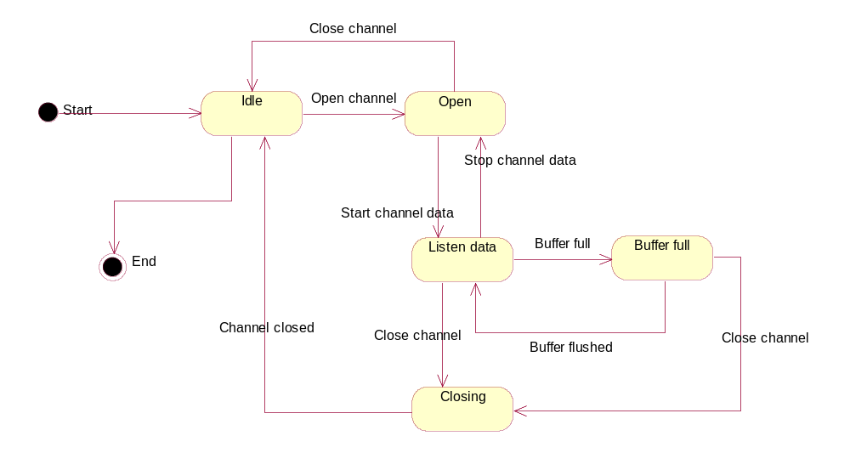
Figure 4.5 Statemachine describing the dynamic behavior of the Tilt channel
The state diagram for Tilt channel SSY is presented in Figure 4.5. The channel is constructed as a client opens the magnetic north channel from Sensor Server. The channels initial state is the Idle state. From the Idle state the channel can be opened or destroyed. After the channel is opened, it is possible for the client to listen to the magnetic north channel data. As the client starts the data listening, data is transmitted to the client through Sensor Server. The data are sent to the client with the frequency that the client wanted when the buffer is filled. After the buffer is flushed to Sensor Server, Tilt SSY goes back to listen the Data state. If the client requests that the channel is closed after the buffer is flushed, the component goes to the Closing state and from there to the Idle state. In the Listen data state, the client can also stop listening to the data, and after the request, the channel goes to the Open state. From the Open state the channel can be closed.

Operations

Creating the channel
Operation | Creating a magnetic north channel.
Preconditions
Description | The client of Sensor Server uses FindChannelL operation to create the magnetic north channel.
Inputs
Modifies | Creates the magnetic north channel.
Outputs | The channel instance of the Tilt channel.
Postconditions | The channel instance is created and handed over to the client.
Related To | CTCSSYControl
Related Event
Exceptions | Sensor Server cannot be created.

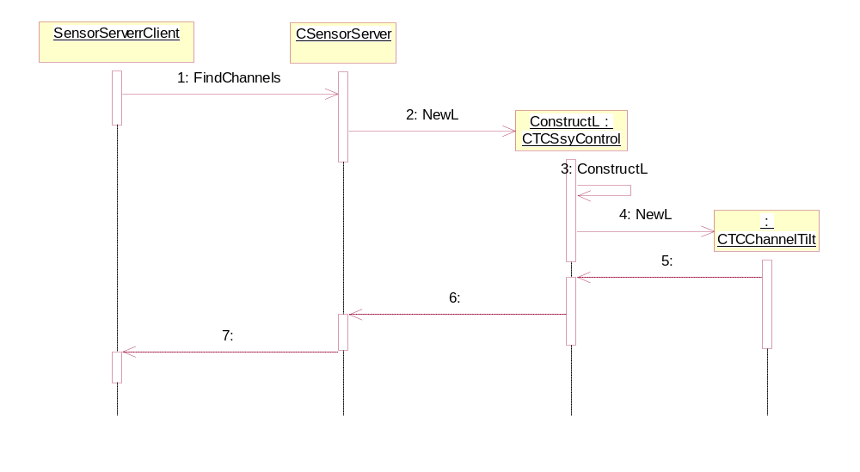
Figure 4.6 Creating Tilt channel

Opening a channel
Operation | Opening a magnetic north channel.
Preconditions | The north channel is created.
Description | The channel is opened.
Inputs
Modifies | The Channel state is set open.
Outputs | A channel is opened.
Postconditions | A channel is opened.
Related To | CTSSYControl, CTCChannelTilt.
Related Event
Exceptions | Sensor Server cannot be opened.  Magnetometer channel does not exist.  Accelometer channel does not exist.

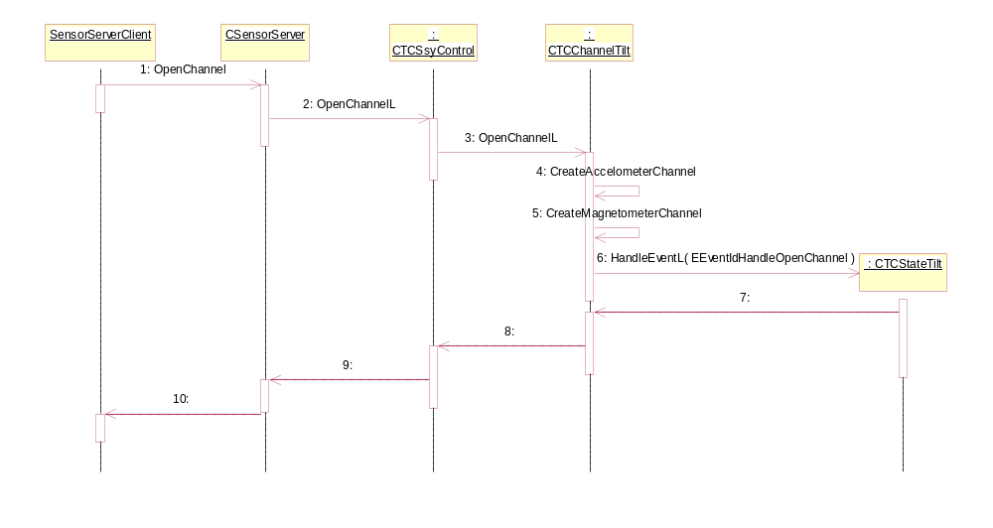
Figure 4.7 Opening the channel

Listening to the Tilt channel data
Operation | Listening to the magnetic north channel data.
Preconditions | The client starts to listen to data that the magnetic north channel is offering.
Description | The client of Sensor Server starts to listen to the magnetic north channel data. The magnetic north channel listens to the magnetometer and accelerometer channel data. The channel uses a timer which expires at the rate which the channel user has defined in the channel properties. As the timer expires, the channel sends the Tilt compensated data to Sensor Server which provides the events to the client.
Inputs
Modifies | The Channel state is set to data listening. Data is sent to the client.
Outputs | Channel is set to the Listening state. Tilt channel data.
Postconditions | Channel is in the Data listening state.
Related To | CTSSYControl, CTCChannelTilt, CTCSendEventTimer, CTCStateTiltListenData.
Related Event
Exceptions | Sensor Server cannot be opened.  Magnetometer or accelerometer data are not received by the Tilt channel.

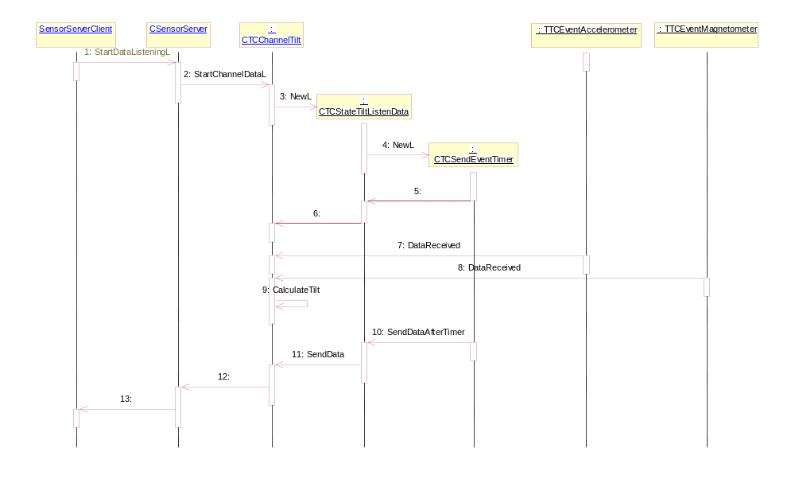
Figure 4.8 Listening to the channel

Stopping the channel data listening
Operation | Stopping the channel data listening.
Preconditions | The client stops to listen to data that the magnetic north channel is offering.
Description | The client of Sensor Server stops to listen to magnetic north channel data.
Inputs
Modifies | The channel state is set to data listening.
Outputs
Postconditions | Data listening is stopped.
Related To | CTSSYControl, CTCChannelTilt.
Related Event
Exceptions

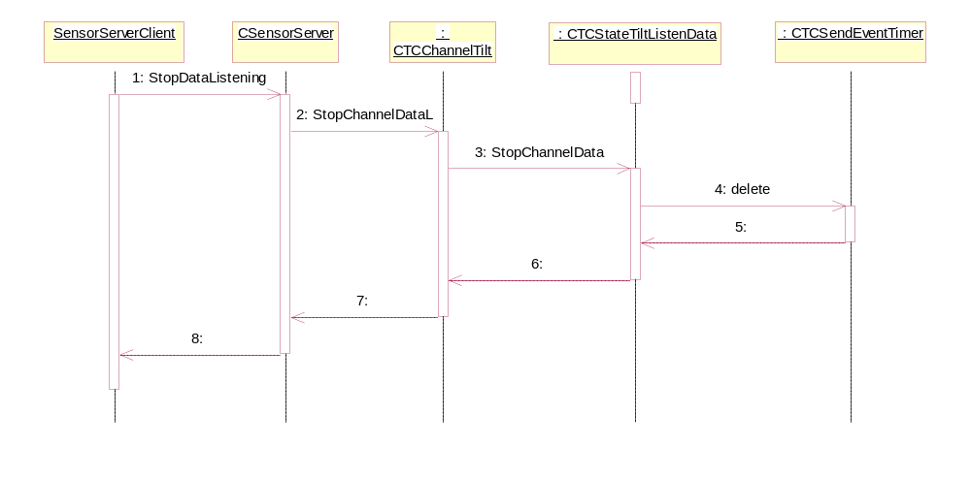
Figure 4.9 Stopping the listening of the channel

Closing a channel
Operation | Closing a channel.
Preconditions | The magnetic north channel is open.
Description | The client closes the magnetic north channel.
Inputs
Modifies | The magnetic north channel is closed.
Outputs
Postconditions | The magnetic north channel is closed.
Related To | CTSSYControl, CTCChannelTilt.
Related Event
Exceptions

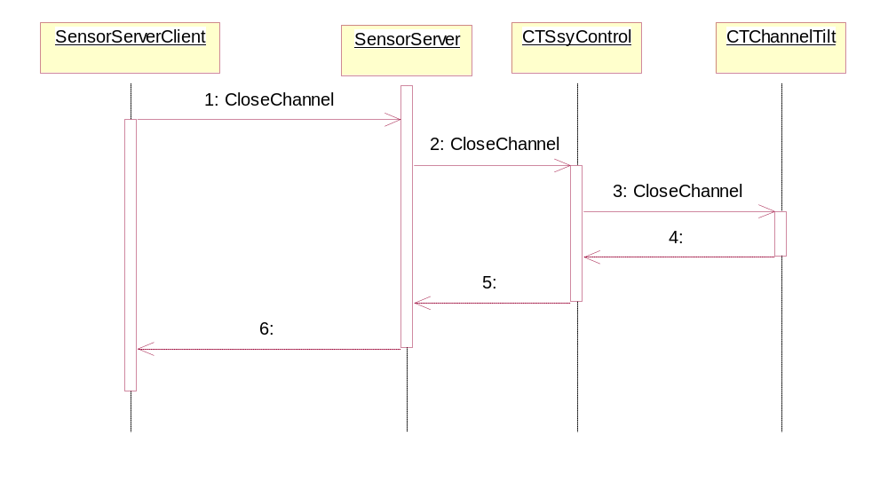
Figure 4.10 Closing the channel

Setting a property
Operation | Setting a property.
Preconditions | The magnetic north channel is open.
Description | The client sets a property for the magnetic north channel.
Inputs | The set property.
Modifies | The Tilt SSY properties.
Outputs
Postconditions | The magnetic north channel is closed.
Related To | CTSSYControl, CTCChannelTilt.
Related Event
Exceptions

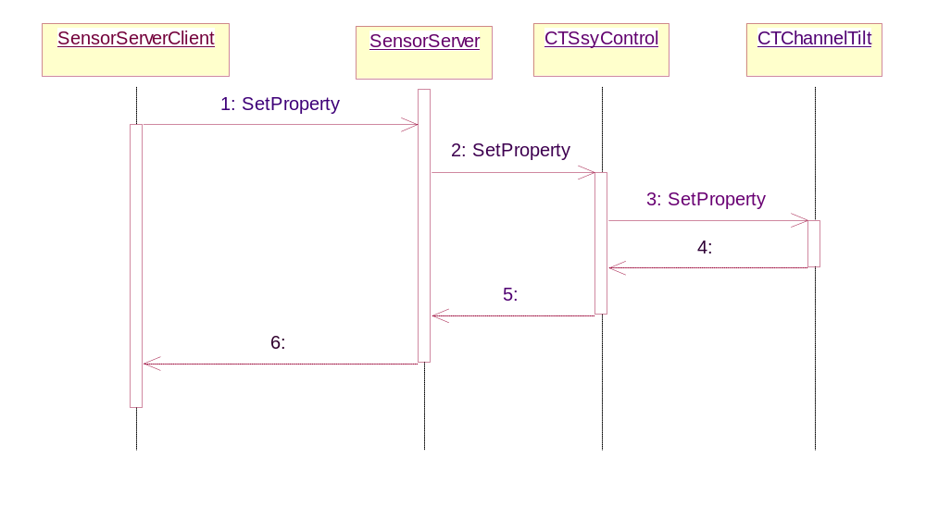
Figure 4.11 Setting a property

Backup and Restore
No backup or restore is needed for Tilt SSY.

Variation

Variable component/feature
The component can be variated by build time variation by excluding or including the component from/to ROM.

System resource usage

Files
No other files than DLL files.

Other data

Databases
No databases used.

Central Repository
This component defines Central Repository keys in tcprivatecrkeys.h, see section 4.2.1.7.

Publish and Subscribe
No Publish and Subscribe keys used.

Memory consumption
Memory/Build | Consumption
[User data area] | -
[WINS UDeb] | [354,196 bytes]
[ARMI URel] | [6,284 bytes]
[THUMB URel] | -

Task allocation
Tilt Compensation SSY is run in the Sensor Server process.

Performance
No performance issues.

Timers
Timer | Purpose | Interval | Lifetime
SendEventTimer | A timer used to serve the user’s requested frequency for data. | User-defined. 1-10 s. | When Tilt SSY is used.

Security
No security issues.

Capabilities of this component
The component is an ECom plug-in. The component has CAP_ECOM_PLUGIN capabilities defined.

Capability | Justification
CAP_ECOM_PLUGIN | These capabilities are generally used for ecom plugins.

Input and output validation
The input data that are received from the accelerometer sensor and magnetometer sensor are converted to Tilt data. The data received from these two sensors is validated that it is magnetometer or accelerometer data. Then it is converted to Tilt data.

Environmental assumptions
The accelerometer and magnetometer sensors should exist in the environment. The Tilt Compensation library should exist in the environment.The Tilt Compensation library is provided by licencee. The Central Repository files should exist in the environment.

Additional enforcements
This component does not have any additional security enforcements.

Exception handling
This component uses basic Symbian OS error handling.

Usage
See the Sensor Channel API and Sensor Definitions API documentation in reference document [1].

Building
bldmake bldfiles
abld build

User's Guide
No user’s guide is required.

