Contents
1 Introduction 2
1.1 Purpose and Scope 2
2 Example bus transactions 3
2.1 Bus transactions without Double-Buffering 3
2.2 Bus transactions with Double-Buffering enabled 4
3 API Overview 5
3.1 MMC Hardware Configuration 5
3.2 Command Descriptor API’s 5
3.3 Double-Buffering Callback 6
4 Detailed breakdown of porting tasks 7
4.1 Task 1 – Migrate to the new Command Descriptor API’s 7
4.2 Task 2 – Separate Command Setup and Data Transfer phase 8
4.3 Task 3 – Implement the Double Buffering State Machine 10
4.4 Task 4 – Report support for Double Buffering to the PSL 12
4.5 Choosing the size of the PSL buffer 12
5 Testing 13
6 Document History 14

Introduction
To facilitate the use of DMA in the MMC subsystem, the Platform Specific Layer (PSL) allocates a chunk of physically contiguous RAM during initialisation of the MMC Kernel Extension, passing a reference to the MMC media driver (MEDMMC). The media driver uses this buffer (known as the PSL buffer) as a block cache and intermediate buffer when copying data to/from the user-side process issuing IO requests.
When large read or write operations are performed on the memory card that exceed the length of the PSL buffer (for example, writing a 500KB image to contiguous FAT clusters), the Media Driver splits the request into multiple fragments, each requiring a new MMC command to be sent across the bus and a status command to be issued after the transfer has completed. The overhead of these extra command and status operations introduces a significant overhead in performance.
It is possible to reduce this overhead by increasing the size of the PSL buffer to reduce command fragmentation, but at the expense of increased memory utilisation.
Symbian OS v9.4 introduces support for MMC Double-Buffering, where a small PSL buffer can be used to perform large data transfers without the need to split the request into multiple fragments.

Purpose and Scope
This document describes how to configure the Platform Specific Layer of the MMC subsystem to enable the use of Double Buffering to realise the benefits described above. To assist in the porting process, an overview of the new APIs is provided, followed by a list of tasks describing how to use these new APIs within the PSL.
This document assumes that the reader is familiar with the MMC subsystem and has an understanding of the MMC System Specifications.

Example bus transactions
To give an overview of the benefits of double-buffering, this section shows examples of the typical bus transactions that occur without and with double-buffering enabled.
Note: These diagrams are informative only, and as such do not show all possible transactions such as the SET_BLOCK_LEN and STOP_TRANSMISSION commands, or DAT0 busy signalling while in the RCV state.

Bus transactions without Double-Buffering
The following diagram shows the typical bus transactions that would occur for a write operation, where the operation is split up into 3 transactions (this could be the case, for example, if the PSL buffer is 64K in size and an application has requested to write a 192K file to the card).
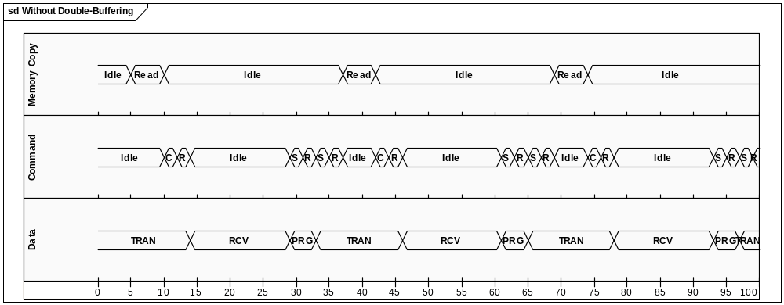
The first waveform (Memory Copy) represents the time spent in the Media Driver while it copies data from the user side buffer to the PSL buffer in preparation for a transfer to the MMC Controller (in other words, performing an IPC copy from the client process to kernel memory in preparation for DMA). Note that the driver is idle for significant periods of time while the MMC controller sends commands and data to the MMC card.
The second waveform (Command) represents the commands issued to the card from the controller, and the responses sent from the card. In particular, this shows the WRITE_MULTIPLE_BLOCK command, used to prepare the card for incoming data, and the SEND_STATUS command, used by the MMC controller to determine that the write operation is successful and to poll for the card becoming ready for the next data transfer. Note that several SEND_STATUS commands may be issued after a data transfer before the card enters the TRAN state and is ready for the next command.
C | CMD25 (WRITE_MULTIPLE_BLOCK) | Prepares the card to write a number of blocks of data.
S | CMD13 (SEND_STATUS) | Request that the card return information about its current status (ready for data, programming, busy etc.) and the result of the previous operation.
R | R1 Response | A response packet sent by the card to the controller.
The bottom waveform (Data) represents the state of the data bus:
 | TRAN | Transfer state – The card is selected and ready for data.
 | RCV | Receive State – The card is receiving data.
 | PRG | Programming state – The card has is busy programming.
From this diagram, it can be seen that significant overhead is incurred due to fragmentation of the data transfer, namely:
- Each fragment requires a command/status phase before the card is ready to receive data.
- Several status commands are required in order to poll for completion.
- There is zero bus utilisation while the MMC Media Driver is copying data from the client.

Bus transactions with Double-Buffering enabled
The following diagram shows the typical bus transactions that would occur for the same write operation described in the previous section, but with double-buffering enabled:
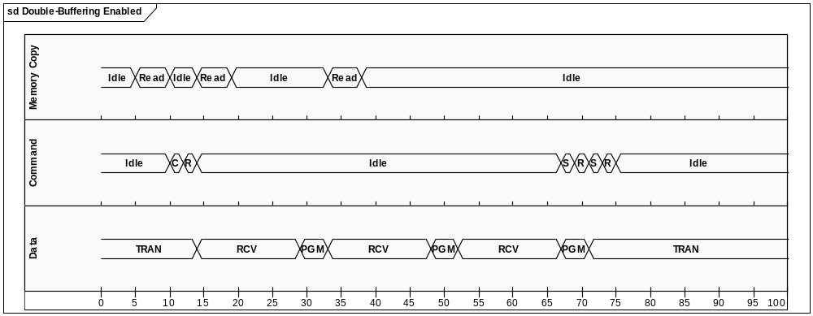
Note the key differences between this and the previous diagram:
- Only one command/status setup phase is required as the request is no longer split up into multiple fragments.
- IPC copies between the client process and PSL buffer are performed while the MMC bus is active - as soon as the MMC Card enters the RCV state (i.e. – data is being transferred from the controller to the card under DMA control), the MMC Media Driver is preparing the next buffer, leading to increased bus and CPU utilisation.

API Overview
To facilitate porting of the PSL, the following new APIs have been provided. Before describing the porting process in more detail, an overview of the new APIs is provided:

MMC Hardware Configuration
The TMMCMachineInfo::THardwareConfig enumeration, used by the PSL to return information about the capabilities of the device, has been extended to include the following flags:

enum THardwareConfig
{
ESupportsDoubleBuffering = 0x02, /** Reported by the PSL to enable double-buffering */
EMaxTransferLength_256K = 0x100, /** Maximum Data Transfers Length == 256K */
EMaxTransferLength_512K = 0x200, /** Maximum Data Transfers Length == 512K */
EMaxTransferLength_1M = 0x300, /** Maximum Data Transfers Length == 1M */
EMaxTransferLength_2M = 0x400, /** Maximum Data Transfers Length == 2M */
EMaxTransferLength_4M = 0x500, /** Maximum Data Transfers Length == 4M */
EMaxTransferLength_8M = 0x600, /** Maximum Data Transfers Length == 8M */
EMaxTransferLength_16M = 0x700, /** Maximum Data Transfers Length == 16M */
}
If the PSL supports double-buffering of data transfers, ESupportsDoubleBuffering should be returned by the PSL’s implementation of DMMCStack::MachineInfo. If this value is not returned (i.e. – by a legacy PSL that hasn’t migrated to use the new functionality), then the MMC subsystem does not enable the double-buffered mode of operation.
Should the platform be capable of supporting double-buffered transfers, but limited by the hardware in terms of the maximum transfer length (for example, because the DMA controller is unable to transfer more than 1Mbytes in one operation), then the PSL should also return one of the EMaxTransferLength_XXX values. This will instruct the MMC subsystem to split a single data transfer greater than the reported value up into multiple commands.

Command Descriptor APIs
Before the introduction of Double-Buffering, the PSL obtains the block size and length of the requested transfer by accessing the following public members of TMMCCommandDesc (TMMCCommandDesc is a structure that contains all details of the current command, including command number, payload, status etc.).
TMMCCommandDesc::iBlockLength; /** The total length of the data to be tranferred. */
TMMCCommandDesc::iTotalLength; /** The block length to be used in a data transaction */
The Double Buffering implementation performs multiple data transfers within a single bus transaction. To facilitate this, the PSL buffer is internally segmented into two buffers - the active buffer and the buffer being prepared for the next transfer. The PSL must obtain the length of the next active buffer using the following API:
/**
* Returns the buffer length in bytes. If the current request is double-buffered, this returns
* the amount of data available in the currently active buffer.
*
* If the command is not double-buffered, the total amount of data to be transferred is returned.
*
* @return Buffer length in bytes
*/
inline TUint32 TMMCCommandDesc::BufferLength() const
Note that the meaning of TMMCCommandDesc::TotalLength has not changed – this still describes the total length of the transaction, which should be used during the command setup phase.
In order to determine the block length of the transaction, the following API must be used:
/**
* Returns the block length required for the current command in bytes.
*
* @return Block length in bytes
*/
inline TUint32 TMMCCommandDesc::BlockLength() const
Finally, the following API is provided to allow the PSL to determine if the current transaction is to be double-buffered.
/**
* Returns ETrue if the current command is enabled to use Double-Buffering.
*
* @return ETrue if the current command is enabled to use Double-Buffering.
*/
inline TBool TMMCCommandDesc::IsDoubleBuffered() const

Double-Buffering Callback
The API DMMCSession::RequestMoreData() is used by the PSL to instruct the MMC subsystem to prepare the next buffer for data transfer, and would typically be called while the hardware is busy performing a DMA transfer for the current buffer (thus allowing the MMC Media Driver to copy data to/from the client process ready for the next transfer while the MMC card is transferring it’s current payload):
/**
* Called by the PSL to request the next blocks of data to be transferred from the media driver
* to the PSL. This would typically be called while the hardware is busy transferring the current
* block of data, allowing the media driver to copy data from the client in parallel.
*
* This method will set the state machine to block on KMMCBlockOnMoreData, so the PSL must block
* the state machine using an SMF_WAITS (or equivalent). When the Media Driver has populated the
* next buffer, the current command descriptor will be updated and the state machine unblocked.
*
* @return ETrue if all conditions are met to perform double-buffering (ie - command is enabled
* for double-buffering and the last transfer has not already been
* satisfied). If successful, upon exit the state machine will be
* blocked with the KMMCBlockOnMoreData condition and the Media
* Driver's data transfer callback invoked.
*/
inline TBool DMMCSession::RequestMoreData()
As described, calling this API sets the static KMMCBlockOnMoreData blocking condition so the PSL must ensure that SMF_WAITS (or equivalent) is utilised to suspend the PSL state machine until the media driver has processed the current buffer. Upon completion, the command descriptor is populated with the details of the next buffer to be transferred.
The KMMCBlockOnMoreData blocking condition set by this API can be set in conjunction with the KMMCBlockOnASSPFunction condition, hence providing the ability for the hardware to perform useful work (for example, transfer the current buffer to/from the card) while the media driver is busy preparing the next buffer. In this case, the PSL is unblocked when both the hardware and media driver have completed their tasks.

Detailed breakdown of porting tasks
To enable the use of double-buffering, the PSL must be modified in the following manner:
- Migrate to new Command Descriptor APIs
- Separate the Command and Data phase
- Implement the Double Buffered State Machine
- Report support for Double Buffering to the PIL
Here follows a detailed breakdown of tasks to assist you in the porting process.

Task 1 – Migrate to the new Command Descriptor APIs
As described in Section 3.2, the total transfer length and block size should be determined using the new command descriptor APIs, TMMCCommandDesc::BufferLength() and TMMCCommandDesc::BlockLength().
- Locate all references in the PSL source code for iBlockLength and replace this with a call to TMMCCommandDesc::BlockLength().
- Locate all references in the PSL source code for iTotalLength. There are likely to be two areas where this is used:
  - Testing the progress of the data transfer and setting up the MMC command - leave these references alone, as iTotalLength still represents the total amount of data to be transferred.
  - Setting up the DMA controller to transfer a number of blocks of data – replace these with a call to TMMCCommandDesc::BufferLength(), as this describes the size of the current buffer in use (with double-buffering still disabled, this should be equal to iTotalLength at this stage).
Now run regression tests (see section 5) to verify that the PSL still operates in the non-double-buffered mode of operation.

Task 2 – Separate Command Setup and Data Transfer phase
Before the introduction of double-buffering, a single MMC command is always associated with a single buffer into which the hardware transfers data. With double-buffering enabled, multiple buffers are used to transfer data within a single command. Therefore, the PSL may need to be modified to separate the command and data transfer phases.
The following code shows a simplified example of a PSL that is implemented to setup the command and data transfers in separate stages:
TMMCErr DExampleMMCStack::IssueMMCCommandSM()
{
enum states
{
EStBegin=0,
EStSetUpCommand,
EStWaitComplete,
EStEnd
};

TMMCCommandDesc& cmd = Command();

SMF_BEGIN

/** ...omitted for clarity */

SMF_STATE(EStSetUpCommand)

/**
* Set up the controller to issue the command. Depending on
* the command type, this will prepare DMA transfers and wait
* for a response to be received before unblocking the stack.
*/
BlockCurrentSession(KMMCBlockOnASSPFunction);

SetupCommand(cmd);

If(iDataTransfer)
SetupDataTransfer(cmd);

/**
* Wait for all events to be received
* - command sent, data transferred, response received
*/
SMF_WAITS(EStWaitComplete);

SMF_STATE(EStWaitComplete)

/**
* Command issued, data transferred and response received.
* - check for and report any errors
*
* - Note, functionality omitted for clarity – in practice this will
* check the controller status and wait for more events as appropriate.
*/
TMMCErr err = KMMCErrNone;

if(iResponseExpected)
err = ExtractResponse();

if(iDataTransfer && err == KMMCErrNone)
err = CheckDataTransferErrors();

if(err)
SMF_RETURN(err);

SMF_END
}

Additionally, the current implementation of your PSL may rely solely on the MMC controller to indicate the completion of data transfer when all blocks have been transmitted or received. To prepare for the next stage, the DMA controller must be modified to block the stack when DMA transfer is initiated, and unblock when the current DMA transfer has completed. This must be done in conjunction with waiting for the final completion interrupt to occur to signal completion of the while transfer.
For example, the following code shows how the KMMCBlockOnASSPFunction blocking condition is set prior to initiating DMA Transfer. When DMA transfer has completed, the stack is unblocked in the DMA complete service routine, DmaService().

void DExampleMMCStack::SetupDataTransfer(const TMMCCommandDesc& aCmd)
{
TUint8* bufPtr = reinterpret_cast<TUint8*>(aCmd.iDataMemoryP);
TUint32 bufLen = aCmd.BufferLength();
/** ...omitted for clarity */
BlockCurrentSession(KMMCBlockOnASSPFunction);
iDmaController::Start(aCmd.Direction(), bufPtr, bufLen);
}
void DExampleDmaController::DmaService()
{
/** ...omitted for clarity */
Session().iState |= KMMCSessStateDoDFC;
UnBlockCurrentSession(KMMCBlockOnASSPFunction, KErrNone);
}

Before moving onto the next task, run regression tests (see section 5) to ensure that the PSL is still operating correctly in the non-double-buffered mode of operation.

Task 3 – Implement the Double Buffering State Machine
Now the PSL can be updated to implement the double buffering state machine, making use of the DMMCSession::RequestMoreData()API introduced in section 3.3.
TMMCErr DExampleMMCStack::IssueMMCCommandSM()
{
enum states
{
EStBegin=0,
EStSetUpCommand,
EStWaitDataTransfer
EStWaitComplete,
EStEnd
};

TMMCCommandDesc& cmd = Command();

SMF_BEGIN

/** ...omitted for clarity */

SMF_STATE(EStSetUpCommand)

/**
* Set up the controller to issue the command. Depending on
* the command type, this will prepare DMA transfers and wait
* for a response to be received before unblocking the stack.
*/
BlockCurrentSession(KMMCBlockOnASSPFunction);

SetupCommand(cmd);

If(iDataTransfer)
{
/**
* Kick off DMA transfer for the first buffer.
* …the stack will be blocked on KMMCBlockOnASSPFunction until DMA complete
*/
SetupDataTransfer(cmd);

/**
* DMA is now active. Now request the Media Driver to prepare the next
* buffer in parallel. While active, the stack will be blocked with
* the KMMCBlockOnMoreData blocking condition and unblocked when complete.
*/
Session().RequestMoreData();
}

/**
* Wait for DMA and Media Driver completion.
*/
SMF_WAITS(EStWaitDataTransfer);

SMF_STATE(EStWaitDataTransfer)
/**
* DMA is complete and the Media Driver has prepared the next buffer.
* - Start the next DMA transfer and request more data from the media driver.
*/

if(cmd.BufferLength() > 0)
{
/**
* There is more data to transfer.
* ..start DMA transfer, prepare the next buffer and wait for completion.
*/
SetupDataTransfer(cmd);
Session().RequestMoreData();
SMF_WAITS(EStWaitDataTransfer);
}

/**
* There is no more data to transfer.
* ..do whatever we need to do to wait for hardware completion
*/

// …omitted for clarity

SMF_WAITS(EStWaitComplete);

SMF_STATE(EStWaitComplete)

/**
* Command issued, data transferred and response received.
* - check for and report any errors
*
* - Note, functionality omitted for clarity – in practice this will
* check the controller status and wait for more events as appropriate.
*/
TMMCErr err = KMMCErrNone;

if(iResponseExpected)
err = ExtractResponse();

if(iDataTransfer && err == KMMCErrNone)
err = CheckDataTransferErrors();

if(err)
SMF_RETURN(err);

SMF_END
}

Before moving onto the next task, run regression tests (see section 5) to ensure that the PSL is still operating correctly. Note that we haven’t actually enabled double-buffering yet, so by running regression tests you can check that the PSL is still operating correctly before it is fully enabled.

Task 4 – Report support for Double Buffering to the PSL
Having completed the previous tasks, the final stage is to report to the MMC subsystem that the PSL can accept double-buffered data transfers. This is achieved by setting the ESupportsDoubleBuffering flag in the implementation of the PSL’s implementation of the DMMCStack::MachineInfo method as follows:
void DVariantMmcImpOmap::MachineInfo(TMMCMachineInfoV4& aMachineInfo)
{
<…snip…>
aMachineInfo.iFlags = TMMCMachineInfo::ESupportsDoubleBuffering |
TMMCMachineInfo::EMaxTransferLength_1M;
<…snip…>
}
In the above example, the maximum data transfer has been limited to 1MBytes to reflect the limitations of the DMA controller.
Now run regression tests (see section 5) to ensure that the PSL is operating with double-buffering enabled.

Choosing the size of the PSL buffer
If you refer back to section 2.2 you will see that although IPC between the user-side process and the PSL buffer occurs concurrently with data being transferred to the MMC card, the first data transfer requires an initial memory copy before the command can be issued. Therefore, selection of a smaller PSL buffer size will result in lower command setup latency.
However, a smaller buffer will result in the PSL needing to set up DMA transfers and invoke the double-buffering call-back function more frequently. Depending on the characteristics of your system, the time taken to perform these actions could far exceed the time taken to transfer the active buffer to/from the card, leading to overrun and decreased bus utilisation as the MMC bus is stalled waiting for more data.
Therefore, you should decide through benchmarking and analysis the most appropriate buffer size for your system, taking the above factors into account.

Testing
The standard E32 and F32 automated tests should be executed to verify basic operation of the MMC subsystem, along with the MMC specific manual test, T_MMCDRV.
In particular, the following test case is used to perform transfers well in excess of the PSL buffer size to ensure that double-buffering is exercised.

/**
@SYMTestCaseID PBASE-T_MMCDRV-0558
@SYMTestCaseDesc Test Long Read/Write Boundaries
@SYMTestPriority High

@SYMTestActions

Perform and Write/Read/Verify for the given length (L) of data across the following boundaries.
Depending on the length, this will also perform a partial write/read at the end sector.

--------------
| Start | End |
|--------------|
| 0 | L |
| 507 | L-507 |
| 10 | L |
| 0 | L-3 |
| 27 | L-512 |
| 0 | L-509 |
| 3 | L-3 |
--------------

For each combination, the write/read/verify operations are performed in the following sequence:

a: Write and Read in single 512-byte blocks.
b: Write in a single operation (multiple blocks), Read in 512-Byte blocks.
c: Write in 512-Byte blocks, Read in a single operation (multiple-blocks).
d: Write and Read in a single operation (multiple-blocks).

In the cases where a partial read/write operation occurs (ie - the start and/or end position
don't lie within a sector boundary), the original contents of the start and/or end sectors are
read and stored at the start of the test, and compared with the contents of the sectors at the
end of the test to ensure that unwritten data within the sectors remain unaffected.

@SYMTestExpectedResults All tests must pass

@SYMPREQ1389 REQ6951 Double Buffering and SD Switch
*
*/

Ideally, T_MMCDRV should be performed on a version of the PSL with double buffering enabled and disabled, with a variety of PSL buffer sizes configured (ranging from, say, 32K to 256K). The test is currently unable to dynamically configure the size of the PSL buffer, so manual configuration of the PSL will be required to verify all configurations.
For performance measurements, T_FSYSBM should be executed with and without double-buffering enabled.

Document History

Date | Version | Status | Description
08/02/08 | 0.1 | Draft | 1st draft for review
21/02/08 | 1.00 | Issued | 1st release after review by SWE, LPD and LTC

In fact, this statement is only strictly true for a write operation – a read operation performs a copy after the final block has been read.

