Contents
1 Purpose and audience 2
2 Background 2
2.1 Fair Scheduling 2
2.2 Read Caching 2
2.3 Read Ahead 3
2.4 Write Caching 3
3 Configuring File Caching 3
3.1 File open mode 3
3.2 Global cache settings 4
3.3 Per-drive cache settings 5
4 File System & File System Extension support for caching 6
4.1 The MExtendedFileInterface interface 6
4.2 Local Buffer Support 7
5 Recommendations 8
5.1 Enabling write caching 8
5.2 Interaction with demand-paging 8
6 Further Information 8
6.1 References 8
6.2 Open Issues 8
6.3 Glossary 8
6.4 Document History 8
Appendix A - Results 8
A.1 Reading from / writing to the cache (with no media access) 10
A.2 NAND-flash (FAT16) 11
A.2.1 Read-once 11
A.2.2 Write (append) 11
A.2.3 Write (update) 11
A.3 SD (FAT16) 12
A.3.1 Read-once 12
A.3.2 Write (append) 12
A.3.3 Write (update) 12
A.4 MMC (FAT16) 13
A.4.1 Read-once 13
A.4.2 Write (append) 13
A.4.3 Write (update) 13
A.5 NOR-flash (LFFS) 14
A.5.1 Read-once 14
A.5.2 Write (append 14
A.5.3 Write (update) 14
A.6 Notes 15
A.6.1 Why does read-once performance on NAND degrade with read-caching on? 15
A.6.2 Why can’t read-ahead manage to keep the read-cache permanently full ? 15
A.6.3 Why the sharp step-down in performance when updating a file on MMC / SD with a buffer size less than 4K ? 15
A.6.4 Why isn’t the read/write performance better with small block sizes when reading entirely from the cache ? 15
A.6.5 Why is writing to the file cache slower than reading from it ? 16
A.6.6 Why is write caching on LFFS so ineffective ? 17

Purpose and audience
The purpose of this document is to provide information and guidelines on enabling and configuring file caching on Symbian OS. File caching was introduced in Symbian OS v9.5.
Previous knowledge of the Symbian OS File Server and components is assumed throughout.

Background
File caching consists of four main areas:
- Fair Scheduling.
- Read Caching.
- Read Ahead
- Write Caching.

Fair Scheduling
The current design of the file server supports processing of client requests concurrently as long as those requests are made to different drives in the system. For example, a read operation may take place on the NAND user area partition while a write operation is taking place concurrently to the MMC card.
However, requests to the same drive are serialised on a first come first served basis, which under some circumstances leads to bad user experience. Consider the following scenario:
- An incoming call arrives while a large video file is being written to the NAND user area (by an application that writes the file in very large chunks).
- In order to display the caller’s details, the phone needs to read from the contacts database which is also stored on the NAND user area.
- The write operation takes a very long time to complete, so the call is lost.
This is one of many scenarios where the single threaded nature of the file server may lead to unresponsive behaviour and a bad user experience.
In order to improve the responsiveness of the system, a fair scheduling policy has been implemented such that large requests are split up into more manageable chunks, thus providing clients of the file server with a more responsive system when the file server is under heavy load.

Read Caching
Read caching aims to improve file server performance by addressing the following use case:
- A client (or multiple clients) issues repeated requests to read data from the same locality within a file. Data that was previously read (and is still in the cache) can be returned to the client without continuously re-reading the data from the media. Note that read caching is of little benefit for clients/files that are typically accessed sequentially in large blocks and never re-read.

Read Ahead
Clients that read data sequentially (particularly using small block lengths) impact system performance due to the overhead in requesting data from the media. Read ahead caching addresses this issue by ensuring that subsequent small read operations may be satisfied from the cache after issuing a large request to read ahead data from the media.
Read ahead caching builds on read caching by detecting clients that are performing streaming operations and speculatively reading ahead on the assumption that once the data is in the cache it is likely to be accessed in the near future, thus improving performance.
The number of bytes requested by the read ahead mechanism is initially equal to double the client’s last read length or a page i.e. 4K (whichever is greater) and doubles each time the file server detects that the client is due to read outside of the extents of the read ahead cache, up to a pre-defined maximum (128K).

Write Caching
Write caching is implemented to perform a small level of write back (lazy write) caching, which overcomes inefficiencies of clients that perform small write operations by consolidating multiple file updates into a single larger write operation, thus taking advantage of media that is written on a block basis as well as minimising the overhead of metadata updates that the file system performs.
By implementing write back at the file level (rather than the level of the block device) the possibility of file system corruption is removed as the robustness features provided by rugged FAT and LFFS are still applicable.
Furthermore, by disabling write back by default, allowing either the licensee to specify the policy on a per drive basis, providing API’s on a per session basis and respecting flush and close operations, the risk of data corruption is minimised. Note that the possibility of data loss increases, although the LFFS file system already implements a simple write-back cache of 4K in size so the impact of this should be minimal.

Configuring File Caching

File open mode
The TFileMode enumeration has been extended to support additional run-time file-caching configuration. The new values are as follows:
EFileWriteBuffered =0x00000800, // Enables write buffering
EFileWriteDirectIO =0x00001000, // Disables write buffering
EFileReadBuffered =0x00002000, // Enables read buffering
EFileReadDirectIO =0x00004000, // Disables read buffering
EFileReadAheadOn =0x00008000, // Enables read ahead.
EFileReadAheadOff =0x00010000 // Disables read ahead.
These flags will only take effect if caching is either ENABLED or ON for a particular drive (see section [3.2]). If none of the above are specified the default setting will be used, i.e. OFF if the global property is OFF/ENABLED and ON if the global property is ON.

Global cache settings
Once the file system has been changed to support the new API, there are a number of file-caching properties which need to be considered, namely
Property | Type | Comments | Default value
GlobalCacheEnabled | boolean | 0, 1, ON or OFF | ON
GlobalCacheSize | integer | Size of disconnected chunk shared by all files in kilobytes | 32768K (32MB)
GlobalCacheMaxLockedSize | integer | Maximum amount of locked RAM in kilobytes for all files | 1024K (1 MB)
LowMemoryThreshold | integer | Low memory threshold expressed as a percentage of total RAM. If the amount of RAM drops below this value, attempts to allocate memory for file caching will fail. | 10 %
FileCacheSize | integer | Maximum amount of locked or unlocked RAM per file | 256K
FairSchedulingLen | integer | Read & write request greater than the fair scheduling length will be split up into 2 or more requests. | 128K
FileCacheRead | string | OFF, ENABLED or ON | ENABLED
FileCacheReadAhead | string | OFF, ENABLED or ON | ON
FileCacheWrite | string | OFF, ENABLED or ON | ENABLED
FileCacheReadAsync | boolean | 0, 1, ON or OFF  If set , media driver reads on this drive are considered to be asynchronous i.e. interrupt driven | ON
ClosedFileKeepAliveTime | integer | Time after which a file will be removed from closed file queue in milliseconds | 3000 ms (3 secs)
DirtyDataFlushTime | integer | Time after which a file containing dirty data will be flushed in milliseconds | 3000 ms (3 secs)

Notes:
Each of the three properties (FileCacheRead / FileCacheReadAhead / FileCacheWrite) may be in one of 3 states:
Property Setting
OFF OFF - may never be turned ON
ENABLED OFF by default but may be turned ON by appropriate file open mode
(e.g. EFileReadBuffered)
ON ON by default but may be turned OFF by appropriate file open mode
(e.g. EFileReadDirectIO)
FileCacheReadAsync: if set to 1/ON, media driver reads on this drive are considered to be asynchronous i.e. interrupt driven. This results in read-aheads being issued before completing a client read request. If set to 0/OFF, media driver reads on this drive are considered to be synchronous i.e. issuing a read-ahead is likely to block any client thread which will normally be running at lower priority than the media driver's thread. In this case read-aheads only happen during periods of inactivity so as to improve latency. This is achieved by lowering the process of the drive thread if there is only one read-ahead request in the drive thread's queue.
Default values for all drives are stored in the file:
f32\sfile\sf_file_cache_defs.h

Per-drive cache settings
The global and drive-specific cache property defaults defined in “sf_file_cache_defs.h” may be overridden for a particular drive by appropriate entries in the “ESTART.TXT” file, the format of which has been enhanced to support an “.INI” file-style syntax. Here is an excerpt taken from an ESTART.TXT file for reference hardware:
C: 0 ELOCAL FAT 0 FS_FORMAT_COLD,FS_SYNC_DRIVE # IRAM
D: 1 ELOCAL FAT 0 FS_SCANDRIVE # MMC (textshell)
I: 2 ELOCAL FAT 0 FS_FORMAT_CORRUPT # NAND - USER DATA
K: 8 ELFFS LFFS 0 FS_FORMAT_CORRUPT # LFFS

[DriveD]
FileCacheSize 256
FairSchedulingLen 128
FileCacheRead ON
FileCacheReadAhead ON
FileCacheWrite ON
ClosedFileKeepAliveTime 3000
DirtyDataFlushTime 3000
FileCacheReadAsync ON

[DriveI]
FileCacheWrite ENABLED

[DriveK]
FileCacheWrite ENABLED

[FileCache]
GlobalCacheEnabled ON
GlobalCacheSize 32768
GlobalCacheMaxLockedSize 1024
LowMemoryThreshold 10

In this example write caching has been enabled on drives I and K and has been turned ON by default on drive D.
N.B. Most of the properties in the above example have their default values so are somewhat redundant but are given for illustrative purposes.

File System & File System Extension support for caching

The MExtendedFileInterface interface
For fair scheduling to be enabled, the file system mounted on a particular drive must support the CFileCB::MExtendedFileInterface interface. That is, the CFileCB-derived object returned by CFileSystem::NewFileL() must be derived from CFileCB::MExtendedFileInterface in addition to CFileCB. The file server determines whether this is the case by calling CFileCB::GetInterface(CFileCB::EExtendedFileAPI, …). The CFileCB::MExtendedFileInterface interface is as follows:
class MExtendedFileInterface
{
public:
virtual void ReadL(TInt64 aPos,TInt& aLength,TDes8* aDes,const RMessagePtr2& aMessage, TInt aOffset) = 0;
virtual void WriteL(TInt64 aPos,TInt& aLength,const TDesC8* aDes,const RMessagePtr2& aMessage, TInt aOffset) = 0;
virtual void SetSizeL(TInt64 aSize) = 0;
};
The need for the new API is as follows:
- It enables fair scheduling – requests may now be split into one or more segments making use of the “aOffset” parameter.
- It builds in preliminary support for large files by changing the file’s position parameter (aPos) from a TInt to a TInt64.
Currently the FAT, FAT32 and LFFS file systems have been modified to support the new API.
The file system indicates its support for the MExtendedFileInterface interface by intercepting the CFileCB::EExtendedFileAP enumeration in the CFileCB::GetInterface() method as in the following example:
TInt CFatFileCB::GetInterface(TInt aInterfaceId,TAny*& aInterface,TAny* aInput)
{
switch(aInterfaceId)
{
case EExtendedFileAPI:
((CFileCB::MExtendedFileInterface*&) aInterface) = this;
return KErrNone;

// etc.
default:
return CFileCB::GetInterface(aInterfaceId,aInterface,aInput);
}
}

Local Buffer Support
For file caching to be enabled, the file system must support reading and writing to local buffers i.e. buffers that are created and owned by the file server itself rather than by a client of the file server.
Within the file server, a remote client’s read or write buffer is encapsulated within an RMessagePtr2 object. An RMessagePtr2 object encapsulating a local buffer will have its handle set to KLocalMessageHandle; for such a an RMessagePtr2 object, it is illegal to call any of the read / write methods provided by RMessagePtr2
If a third-party file system or file system extension indicates that it “supports” local buffers, this implies that it does not call any RMessagePtr2 ReadL() or WriteL() methods – or does so only after examining the handle to make sure that it’s safe to do so.
N.B., The local media subsystem already supports “local” buffers, i.e. it recognises that if the handle is KLocalMessageHandle, then the buffer is owned by the file server and it need not issue an IPC call to read from / write to the buffer
The file server needs to know whether the file system and all file system extensions mounted on a particular drive fully support local buffers before enabling caching. To this end, it calls CMountCB::LocalBufferSupport(). The file system must handle the CMountCB::ELocalBufferSupport enumeration in its CMountCB::GetInterface() method and pass the request on to the first proxy drive as in the following example:

TInt CFatMountCB::GetInterface(TInt aInterfaceId,TAny*& aInterface,TAny* /*aInput*/)
{
TInt r= KErrNone;
switch(aInterfaceId)
{
// file caching supported, so pass query on to first proxy drive
case CMountCB::ELocalBufferSupport:
r = LocalDrive()->LocalBufferSupport();
break;
default:
r=KErrNotSupported;
}
return r;
}

If there are no file system extensions loaded, then the query will eventually be handled by CLocalProxyDrive::GetInterface() which returns KErrNone to indicate that TBusLocalDrive and the local media sub-system support local buffers.
If there are any file system extensions present then they must handle the CProxyDrive:: ELocalBufferSupport enumeration as in the following example:
TInt CBitExtProxyDrive::GetInterface(TInt aInterfaceId,TAny*& aInterface,TAny* aInput)
{
switch(aInterfaceId)
{
// file caching supported, so pass query on to next proxy drive
case ELocalBufferSupport:
return CBaseExtProxyDrive::LocalBufferSupport();

default:
return CBaseExtProxyDrive::GetInterface(aInterfaceId, aInterface, aInput);
}
}

Recommendations

Enabling write caching
It should be noted that write caching must be handled with care, as this could potentially result in loss of user data. Database access needs special consideration: corruption may occur if the database is written to expect write operations to be committed to disk immediately or in a certain order (write caching may re-order write requests). For these reasons, it is probably safer to leave write caching OFF by default and to consider enabling it only on a per-application basis.

Interaction with demand-paging
Note that when ROM-paging is enabled, the kernel maintains a “live list” of pages which are currently being used to store demand paged content. It is important to realise that this list also contains (non-dirty) pages belonging to the file cache. The implication of this is that reading some data into the file cache (or reading data already stored in the file cache) may result in code pages being evicted from the live list. Having a large number of clients reading through or from the file cache can consequently have an adverse effect on performance. For this reason it is probably not a good idea to set the FileCacheSize property to too large a value – otherwise a single application reading a single large file through the cache is more likely to cause code page evictions, if the amount of available RAM is restricted.

Further Information

References
No. | Document Reference | Version | Description
[[R1]

Open Issues

Glossary
Term | Definition

Document History
Date | Version | Status | Description
11^{t} Jan 2007 | 0.1 | Draft | Draft for review
12^{t} May 2007 | 0.2 | Draft | Added performance results (appendix A)
16th May 2007 | 0.3 | Draft | Changed FileCacheRead from ON to ENABLED
22nd May 2007 | 1.0 | Issued | Updated to include review comments from Stefan Williams & changed status to issued.

- Results

The results below come from running T_FSYSBM in UREL mode on reference hardware. The timings were taken by sequentially reading / updating / appending to a 1MB file. The FileCacheSize was set to 1024 (1 MB).

The command lines use to run the tests were as follows:
To enable read caching only (marked as “read cache on” in the charts below)
T_fsysbm <drive> +r –w +f
To enable read and write caching with no flushing (“write caching on”)
T_fsysbm <drive> +r +w -f
To enable read and write caching with a flush after all writes (“write caching + flush”)
T_fsysbm <drive> +r +w +f

T_fsysbm has been modified to perform 6 read/write tests as follows:
- read a 1MB file (which is not in the cache)
- re-read a 1MB file (which is therefore in the cache)
- append 1MB to a newly created file, flushing afterwards
- append 1MB to a newly created file, with no flush
- update an already-existing 1 MB, flushing afterwards
- update an already-existing 1 MB, with no flush

Note that test cases 2,4 and 6 involve no media access, as the file fits entirely in the cache – with the exception of the update tests at buffer sizes below 4K where a read-before-write is required. The results for these tests are given only once [A.1] as they should be (almost) the same for all media.

The MMC card used was a 1GB MMCMobile Sandisk MMC card
The SD card was a 64MB TransFlash SanDisk SD card

  - Reading from / writing to the cache (with no media access)
The results below show the results for reading from a 1 MB file and updating and appending to a 1MB file with no flushing. For all cases there should be next to no media access (see [Appendix A -]). For illustrative purposes, the results are compared with non-cached (pre-PREQ914) results from NAND.
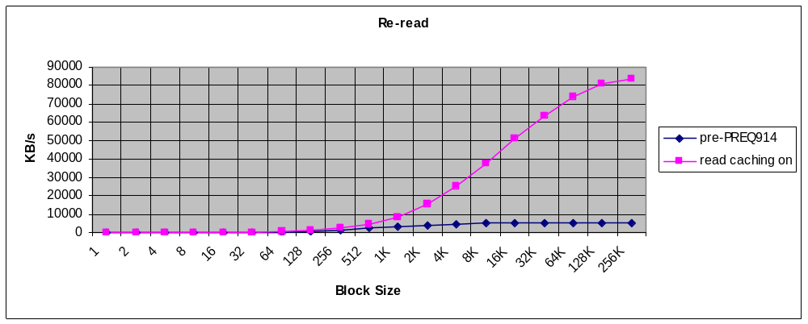
See A.6.5
See A.6.4
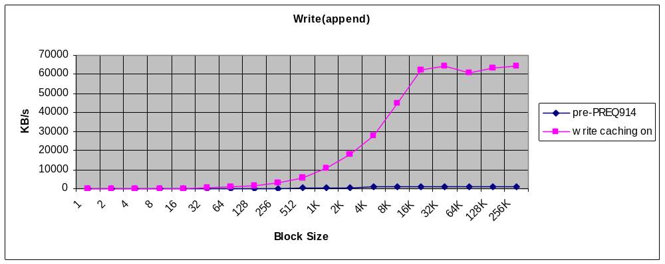
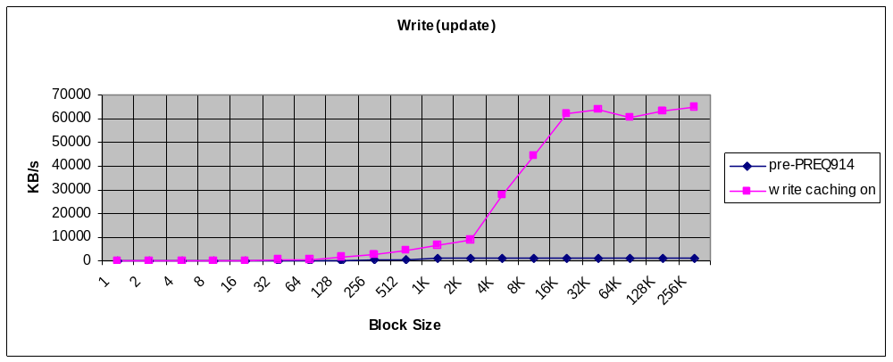

  - NAND-flash (FAT16)
    - Read-once
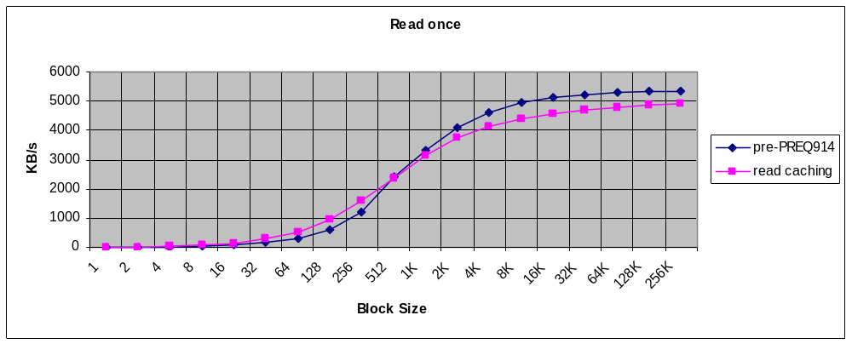
See A.6.1
    - Write (append)
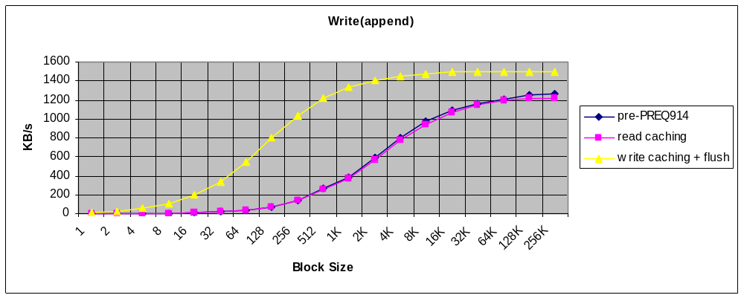
    - Write (update)
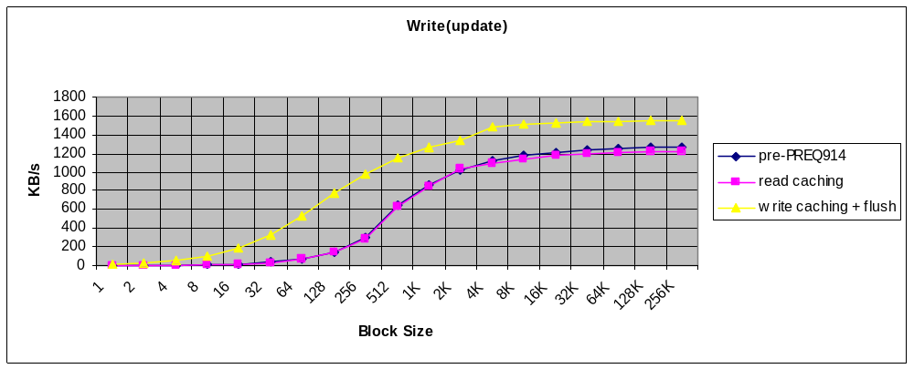

  - SD (FAT16)
    - Read-once
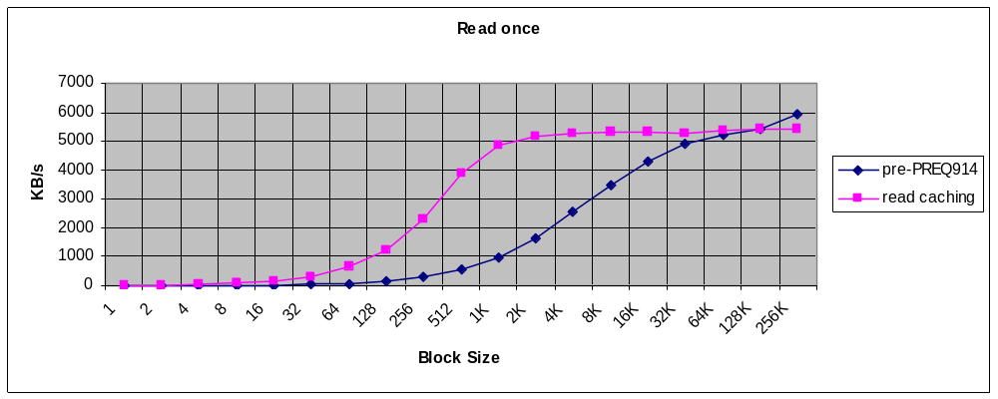
    - Write (append)
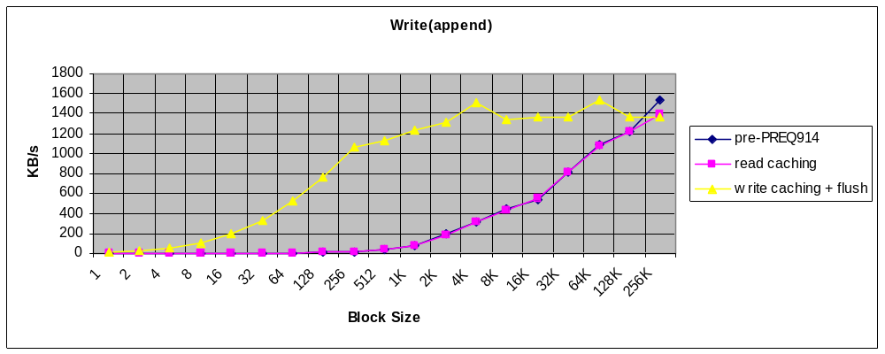
    - Write (update)
See A.6.3
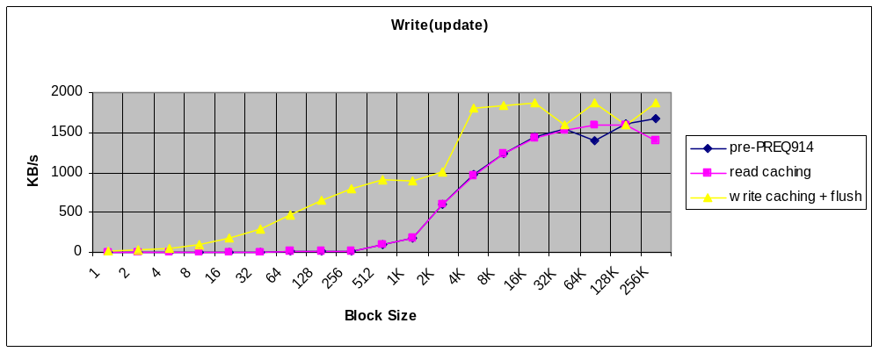
  - MMC (FAT16)
    - Read-once
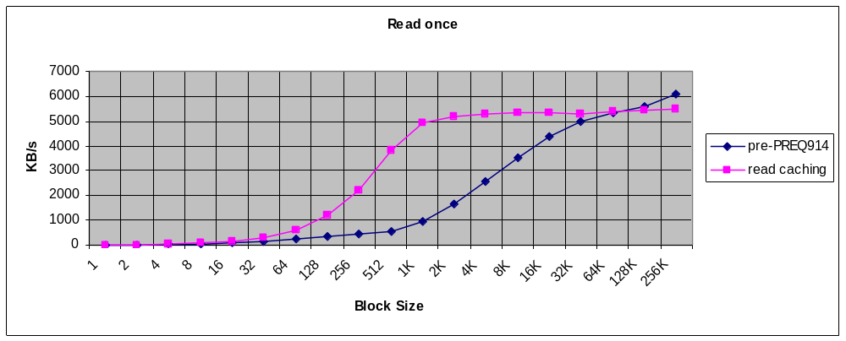
    - Write (append)
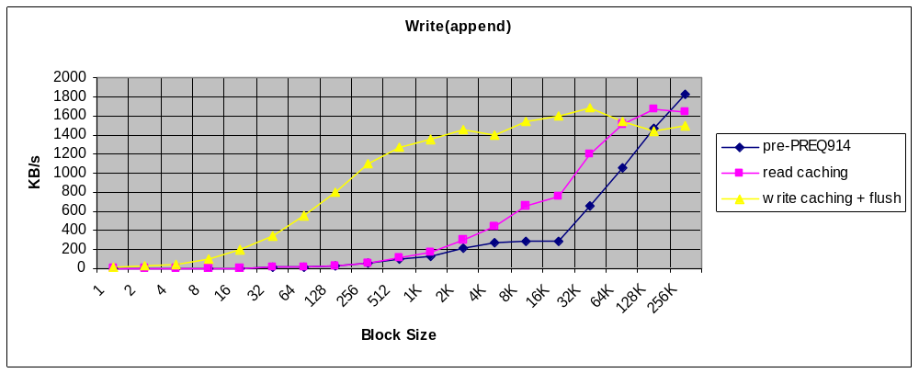
    - Write (update)
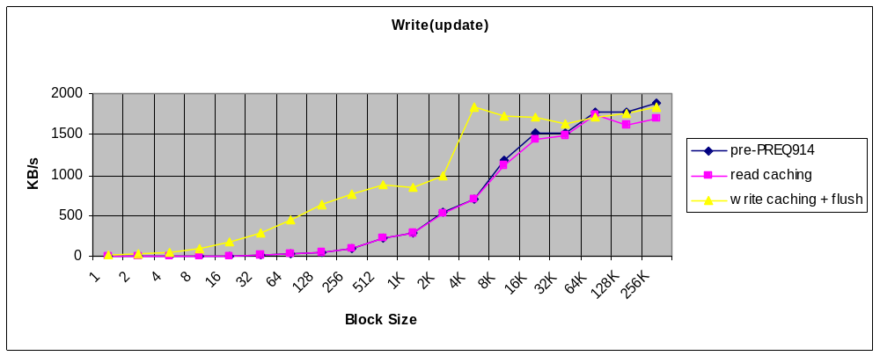

  - NOR-flash (LFFS)
    - Read-once
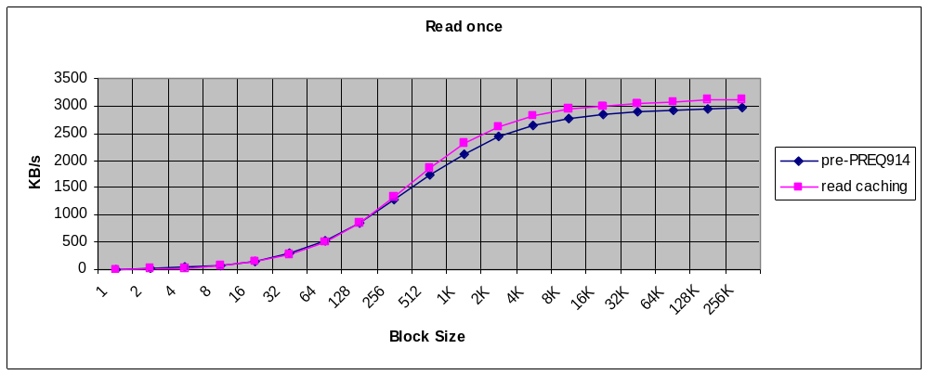
    - Write (append
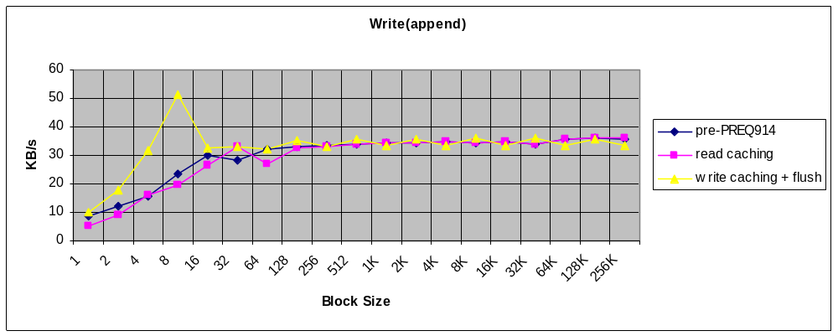
See A.6.6
    - Write (update)
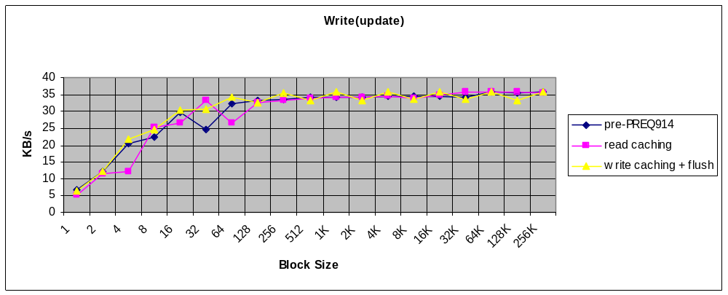

  - Notes
    - Why does read-once performance on NAND degrade with read-caching on?
The read-once results on NAND show a noticeable degradation for buffer sizes of 512 bytes and above. This is largely due to the extra IPC copy required (media driver to-file server cache) and to a lesser extent to the overhead of the file caching code itself. For smaller buffer sizes, the effects of read-ahead (i.e. being able to read larger chunks from the media) outweigh the effects of the extra copy. Generally speaking, the faster the media, the more likely it is that there will be a noticeable degradation. Note that random (i.e. non-sequential) reads are likely to be especially affected, since read-ahead will be switched off.
    - Why can’t read-ahead manage to keep the read-cache permanently full ?
The T_FSYSBM read tests issue one read after another with no other processing involved, so the likelihood that the test application will drain the read-ahead buffer increases with the block size. Once the read-ahead buffer is empty, the test application has to wait for the read-ahead to occur.
There is a further problem with NAND on the hardware in question, since the NAND media driver does not support DMA (and is not interrupt driven either). This means that when the media driver is reading from NAND, all other threads are effectively stalled. Conversely, the MMC/SD stack does support DMA, and so there is some scope for concurrency i.e. a read-ahead can be in progress while the test application is reading from the cache.
    - Why the sharp step-down in performance when updating a file on MMC / SD with a buffer size less than 4K ?
For write-updates with write caching on, the relatively large drop in performance at buffer sizes below 4K is due to “read-before-write”. In general all write-updates which are not an exact multiple of 4K will require one or possibly two reads if the data is not already in the cache. There is similar read-before-write behaviour required even when caching is off for most media (NAND, MMC..) but the smallest write in this case is typically 512 bytes rather than 4096.
    - Why isn’t the read/write performance better with small block sizes when reading entirely from the cache ?
This is largely because for every small read / write, the overhead of the IPC and running the File Server code and the file-caching code is relatively large.
The theoretical maximum through-put for reading from a file that is already in the cache can be estimated as follows (for UREL builds) by adding together the time taken to send a message and the time taken to do the IPC copy. Note that this calculation doesn’t take into account the time spent running any other code (!)
T_PROC1 reports the following for number of IPC messages per second:
Count = 87493 in 1 second
i.e. 1/87493 = 11.4 microsecs per message
T_IPCBM reports the following for an IPC copy:
65536 byte writes: 14643/10s 682.9us
so n bytes will take roughly (n / 65536) * 682 microseconds
So.....for a 1 MB file, the time taken in microseconds will be:
((1048576 / blockSize) * 11.4) + ((1048576 / 65536) * 682)
Or in kilobytes per second:
(1024 * 1000000) / (((1048576 / blockSize) * 11.4) + ((1048576 / 65536) * 682))
This theorectical maximum is plotted below against the Re-Read results from NAND:
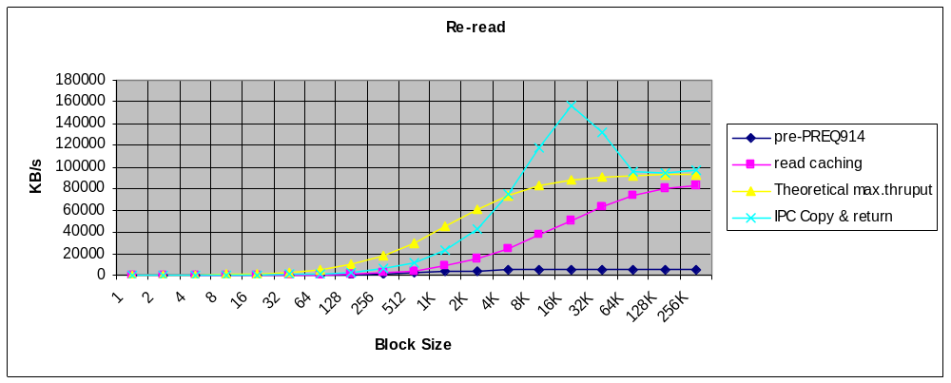
Also plotted on this graph (“IPC Copy and return”) is the result from temporarily changing the TFsFileRead::Initialise() function as follows:
TInt TFsFileRead::Initialise(CFsRequest* aRequest)
//
//
//
{
CFsMessageRequest& msgRequest = *(CFsMessageRequest*) aRequest;

if (msgRequest.CurrentOperationPtr()) // initialised already ?
return KErrNone;

TInt r = DoInitNoParse(aRequest);
if (r != KErrNone)
return r;

CFileShare* share = (CFileShare*) aRequest->ScratchValue();
CFileCB* file = &share->File();

TDrive& drive = share->File().Drive();

if (drive.DriveNumber() == EDriveD)
{
static TBuf8<1024*1024> testBuf;
TInt len = aRequest->Message().Int1();
TPtrC8 ptr(testBuf.Ptr(), len);
msgRequest.Write(0, ptr);
return KErrCompletion;
}

//etc…

This effectively disables most of the file caching code and gives perhaps a more realistic “theoretical maximum” – at least for small block sizes - than the calculated value. Note that the spike at 16K is probably due to a specific detail of the reference hardware (the processor’s 32K data cache).
    - Why is writing to the file cache slower than reading from it ?
The graphs in section A.1 show that:
- Re-reading a file from the cache with a block size of 128K results in a throughput of 80,702 KBytes/sec
- writing to a file for the first time (when the entire file fits in the cache) results in a throughput of 63,512 KBytes/sec
- One might expect the throughput in both cases to be roughly the same, as there is no media access involved. The difference can be explained by understanding that for a re-read, the cache memory is already committed; writing to a file for the first time involves committing the cache memory. Whenever memory is committed, the kernel wipes the contents (for security reasons) and this takes an appreciable amount of time. Rewriting the same file produces a similar throughput to rereading - 84,380 KBytes/sec – slightly faster in fact, probably because the cache memory does not need to be locked or unlocked.

    - Why is write caching on LFFS so ineffective ?
Because LFFS is transaction-based and splits up large writes into smaller ones.

