Porting the MultiMediaCard controller - SDIO card supplement (V9.x)

A guide for porting to another hardware plaform

This material, including documentation and any related computer programs, is protected by copyright controlled by Nokia. All rights are reserved. Copying, including reproducing, storing, adapting or translating, any or all of this material requires the prior written consent of Nokia. This material also contains confidential information, which may not be disclosed to others without the prior written consent of Nokia.
Contents:
1. Introduction 4
1.1 Purpose and Scope 4
2. Brief review of SDIO systems 4
2.1 SDIO Card 4
2.2 Card Registers 5
2.3 Commands 5
2.4 Bus Timing 6
3. Overview of the Symbian OS SDIO card controller 7
3.1 SDIO Card Classes 8
4. Porting the controller 9
4.1 Source Code Organisation 9
4.2 Implementation of Platform Specific Layer 10
4.2.1 Hardware Registers 10
4.2.2 DSDIOStack derived class 10
4.2.2.1 Class definition 10
4.2.2.2 TMMCErr IssueMMCCommandSM() 11
4.2.2.3 void EnableSDIOInterrupt(TBool aEnable) 12
4.2.2.4 TUint32 MaxBlockSize() const 13
4.2.2.5 Allowing direct commands (CMD52) during extended commands (CMD53) 13
4.2.3 DSDIOPSU derived Class 15
4.2.3.1 PsuInfo() 15
5. Reference implementations 16
5.1 ARM OMAP2420 H4 reference platform 16
5.2 Enabling the SDIO card configuration on the ARM OMAP2420 H4 board 16
6. Testing the port 17
6.1 Unit Test Code 17
6.2 Tracing 17
7. Further Information 19
7.1 References 19
7.2 Glossary 19
Appendix A - State machine calling sequences 22
A.1 Powering up stack containing a single SDIO Card 22
A.2 Powering up stack containing a single SDIO combo Card 23
A.3 Extended read/write (using CMD53) 24
A.4 State Machine – IssueCommandCheckResponseSM (Send command to PSL) 25
A.5 State Machine – CIMIoReadWriteDirectSM (Read/write using CMD52) 25
A.6 State Machine – CIMIoModifySM (Modify a register) 25
A.7 State Machine – CIMIoFindTupleSM (Find the function’s tuple) 26
A.8 State Machine – GetIoCommonConfigSM (Read common config) 26
Appendix B - SDIO card specific state machine functions 28

Introduction

Purpose and Scope
The software MultiMediaCard/SD/SDIO card controller provides support for MMC/SD/SDIO cards within the E32 kernel. This supplement document together with the Base MMC porting guide [R1] and the SD controller porting supplement [R2] describes how to port this controller for a new SDIO card hardware interface.

This document describes the Symbian OS V9.4/V9.5 release of the SDIO card controller.
The reader is assumed to be familiar with the SD Memory Card Specification v2.0 and the SDIO Card Specification v2.0.

Brief review of SDIO systems

SDIO Card
The SDIO (SD Input/Output) card is based on and compatible with the SD memory card. This compatibility includes mechanical, electrical, power, signalling and software. The intent of the SDIO card is to provide high-speed data I/O with low power consumption for mobile electronic devices. A primary goal is that an SDIO card inserted into a non-SDIO aware host shall cause no physical damage or disruption of that host or its software. In this case, the SDIO card should simply be ignored. Once inserted into an SDIO aware host, the detection of the card proceeds via normal means although with some extensions. In this state, the SDIO card is idle and draws a small amount of power.

During the normal initialization and interrogation of the card by the host, the card identifies itself as an SDIO card. The host software then obtains the card information in a tuple (linked list) format and determines if that card’s I/O function(s) are acceptable to activate. This decision is based on such parameters as power requirements or the availability of appropriate software drivers. If the card is acceptable, it is allowed to power up fully and start I/O function(s) built into it.

The SDIO card protocol is designed to be a super-set of the SD memory card protocol, which in turn is a superset of the MultiMediaCard protocol. Similarly to the SD memory card protocol, SDIO cards use a star topology with each card in the stack having dedicated CMD and DATA signals. MultiMediaCards employ a bus topology with the CMD and DATA signals being common to all cards in the stack. This affects the way that a card stack is initialized. The host controller is able to select each distinct card socket in turn rather than having to repeatedly broadcast the initialization sequence to the entire bus until it fails to get a card response. However, to simplify the handling of a card stack, most commands may still be sent concurrently to the entire SD or SDIO card stack using an RCA (Relative Card Address) to address a particular card, as they can for MultiMediaCards.

SDIO cards use two commands to read and write data to the IO function of the card. IO_RW_DIRECT (CMD52) is used to send control commands and do byte level data transfers. IO_RW_EXTENDED (CMD53) is used to do block transfer of data. In rev 2.0 of the SDIO specification a High Speed mode was introduced for IO functions. The High Speed mode for SDIO cards increases the bus speed up to 50MHz. High Speed mode is enabled by setting the EHS (Enable High Speed) bit in the CCCR (Common Card Control Registers) using the IO_Direct command (CMD52).

SDIO cards can also provide memory storage and these cards are known as Combo cards. In addition to the SDIO commands such as IO_RW_DIRECT, these cards also support the SD commands to read and write to the memory portion of the card. More details on writing to the memory function can be found in the Porting the MultiMediaCard controller – SD card supplement (v9.x) [R2].
The SDIO controller also supports the Code Storage Area (CSA) but does not support open-ended (auto increment) data transfers.

Card Registers
The SD specification [R7] defines 6 interface registers, OCR, CID, CSD, RCA, DSR and SCR; an SDIO only card eliminates some of the registers and changes some of the bits in the remaining registers. These changes are described below:
Card Register | Description | SD Card | SDIO Card | Combo Card
CID | Card Identification register. | M | O | M
CSD | Card Specific Data register. | M | X | M
RCA | Relative Card Address. | M | M | M
OCR | Operating Conditions register.  (The SDIO OCR contains the logical AND of the voltage ranges of all of the individual I/O functions. The format for SDIO is only 24bits long.  Combo Cards may support 2 OCRs, an I/O OCR as described above and a OCR as defined by the SD specification [RXX]) | M | M | M
DSR | Driver Stage register. | M | X | O
SCR | SD card configuration register. | M | X | M

Where M is mandatory, O is optional and X is not supported.

Commands
SDIO cards use three commands (see below) for SDIO configuration and data transfer, namely CMD5 (IO_SEND_OP_COND), CMD52 (IO_RW_DIRECT) and CMD53 (IO_RW_EXTENDED). For combo cards which have an SD memory card function, the existing SD card commands are compatible.
The following table describes the major additional commands used by SDIO cards which are referred to subsequently throughout this document:-
Command | Abbreviation | Description
CMD5 | IO_SEND_OP_COND | Used during initialisation to determine the presence of an SDIO card and to set the working voltage.
CMD52 | IO_RW_DIRECT | Used to address one register on the SDIO card.
CMD53 | IO_RW_EXTENDED | Used to address multiple registers with one SDIO command.

Bus Timing
As with MMC & SD cards, during card identification mode the host clocks the bus at the identification clock rate. The SDIO Card Specification [R4] sets the maximum frequency during identification mode as 400 KHz before moving into data transfer mode.
The SDIO card specification defines three different types of SDIO cards; High-Speed, Full-Speed and Low-Speed.

High-Speed cards support a full clock range of 0-50Mhz. Full-Speed cards support a full clock range of 0-25Mhz, whereas Low-Speed cards support a full clock range of 0-400Khz.

Overview of the Symbian OS SDIO card controller
As already mentioned, the SDIO card protocol is designed to be a super-set of the SD card protocol. The SDIO Card Controller shares some of its functionality with the SD controller, for combo cards the majority of the SD card functionality is the same. The Symbian OS SDIO card controller is implemented as a set of SDIO card classes, each of which is derived from the corresponding SD card classes.

The SDIO card controller provides support for SDIO cards (with or without memory support) within the E32 kernel. It manages access to the SDIO card hardware interface and provides an API for class drivers (such as Bluetooth and Wifi) to access SDIO card functions. The Platform Independent Layer (PIL) is implemented in the EPBUSSDIO.DLL as a kernel extension. It is for base port engineers to write the Platform Specific Layer (PSL) to their own ASSP.

Throughout the rest of this document, the SDIO card controller will be referred to simply as ‘the controller’. SDIO cards, SD memory cards or MultiMediaCards will be referred to as ‘cards’.
The following diagram shows the high level architecture for a sample SDIO driver and SDIO controller (PIL and PSL layers).
SDIO Logical Channel
File Server
User side
Kernel side
side
SDIO Driver
EPBUSSDIO.DLL
(SDIO PIL Layer)
Generic Peripheral Bus Layer
MMC Layer

SDIO Layer
Layer
SD Card Layer

EPBUSSDIOV.DLL
(Variant SDIO PSL Layer)
MMC/SD/SDIO Hardware Interface
SDIO Class Driver
SD Media Driver

SDIO Card Classes
When implementing a port for an SDIO card hardware interface the platform specific stack object and its associated classes should be derived from the SDIO card PIL classes. The below diagram shows the important SDIO PIL classes and the PSL classes which are required to implement new and changed methods.
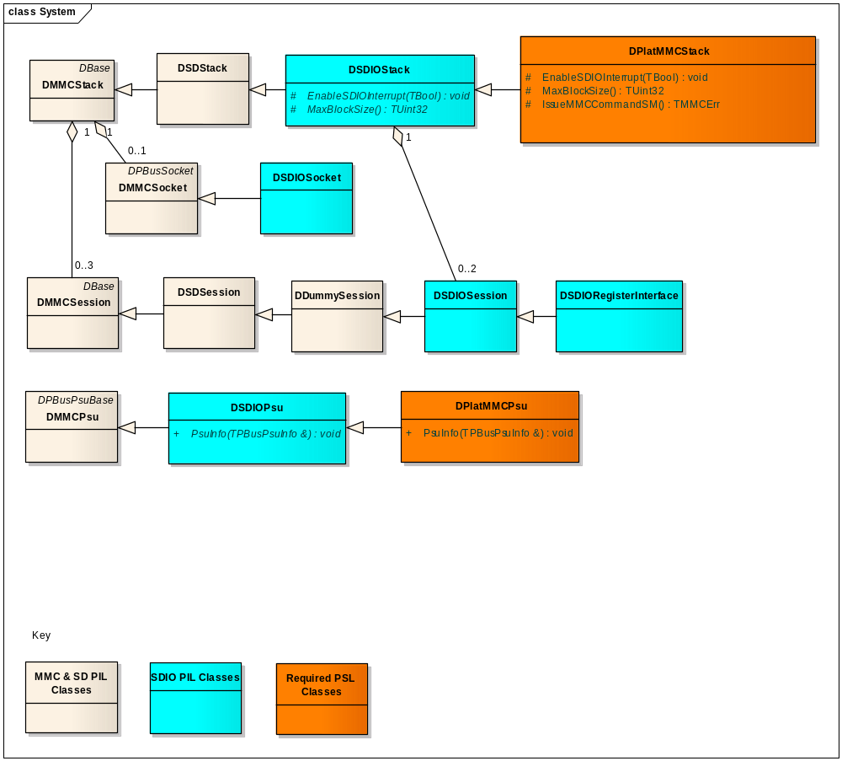
These SDIO card specific classes are described in the SDIO support for Symbian OS [R3].

Porting the controller

Source Code Organisation
The location of the source code and header files for the platform independent layer (PIL) of the MultiMediaCard controller are described in the MultiMediaCard controller porting guide [R1].
The location of the source code and header files for the platform independent layer (PIL) of the SD Card controller are described in the SD Card controller porting guide supplement [R2].
Table 1 below details the source code and header files for the SDIO card specific aspects of the PIL, the files are all located here:-
/os/kernelhwsrv/kernel/eka/drivers/pbus/mmc/sdcard/sdcard3c/sdio/...

FILE | DESCRIPTION
callback.h callback.inl callback.cpp | Notification functionality between SDIO stack clients.  Classes: TSDIOFunctionCallback
cisreader.h cisreader.cpp | SDIO Tuple parsing functionality.  Classes: TCisReader
function.h function.inl function.cpp | SDIO common function capabilities interface.  Classes: TSDIOFunctionCaps, TSDIOFunction
interrupt.h interrupt.cpp | SDIO Interrupt functionality.  Classes: TSDIOInterruptController, TSDIOInterrupt
regifc.h regifc.cpp | SDIO register interface  Classes: DSDIORegisterInterface
sdio.h  sdio.inl  sdiosession.cpp  sdiosocket.cpp  sdiostack.cpp | SDIO specific stack, session, socket & CardArray objects.  Classes: TSDIOResponseR5, TSDIOTupleInfo, DSDIOSession, DSDIOStack, DSDIOSocket
sdiocard.h sdiocard.inl sdiocard.cpp | SDIO Specific card objects.  Classes: TSDIOCardConfig, TSDIOCard
sdiodefs.h | SDIO specific register and register offset definitions
sdioinit.h sdioinit.cpp | SDIO specific initialisation functionality.  Classes: TSDIOCardControllerInterface
sdiopsu.h sdiopsu.inl sdiopsu.cpp | SDIO specific PSU functionality.  Classes: DSDIOPsu
Table 1 SDIO PIL source code and header files

Implementation of Platform Specific Layer
In addition to those functions described in the MultiMediaCard and SD controller porting guides [R1, R2] which need to be implemented for the PSL, the following sections detail functions that either need to be created or implemented for SDIO card specific functionality.

It is assumed that the MMC and SD card support has been implemented in the PSL. For performance reasons MMC and SD card support will most likely be using DMA and physical memory addressing to transfer data between memory and the card, see the MMC Direct Physical Addressing How To Document in the Symbian OS Library [R6]. For SDIO, however, many commands and transfers will be a small number of bytes (or possibly even only 1 byte) and so Programmatic I/O using virtual memory addressing must be implemented alongside DMA. For larger data transfers it is for the base port engineer to find the optimal balance between PIO and DMA.

Hardware Registers
Platform specific documentation will specify any supported SDIO configuration registers, the values/offsets of which must be declared such that they can be made use of within the DSDIOStack derived class.

DSDIOStack derived class

Class definition
The DSDIOStack derived class in the PSL layer will have to be amended to implement the extra member functions and alter some functions specifically to handle SDIO cards.
The class definition will change to include the new functions and extra members to handle SDIO interrupts.

class DPlatMMCStack : public DSDIOStack
/**
* This class manages the MMC stack. It sends commands to the MMC Controller
* and waits for the response. It sends any errors in the transaction
* to the upper layer.
*
*/
{
public:
. . .
// Issuing commands to the bus will require changing to handle the new commands and responses
TMMCErr IssueMMCCommandSM();

// From DSDIOStack
// New member function, enable or disable SDIO interrupts
virtual void EnableSDIOInterrupt(TBool aEnable);

// New member function, return the maximum permitted block size for a data transfer
virtual TUint32 MaxBlockSize() const;

. . .
};

TMMCErr IssueMMCCommandSM()
This method issues the commands to the hardware and should be the first porting activity. In this function IO_OP_COND (CMD5), IO_RW_DIRECT (CMD52) and IO_RW_EXTENDED (CMD53) commands should be intercepted if necessary and any hardware specific registers set according to your platform’s documentation. Also the additional R4 and R5 response types should also be handled in this function.

For instance the hardware platform may require the CRC7 check to be omitted when receiving the R4 response to an IO_OP_COND (CMD5) command. It may also require the SDIO interrupt to be disabled before an IO_RW_DIRECT (CMD52) is issued.
void DPlatMMCStack::IssueMMCCommandSM()
{
TMMCCommandDesc& cmd = Command();
…
// CMD5
// Disable the CRC7 check for R4 responses
if (cmd.iCommand == ECmd5)
{
// Clear the MMC_CRC7_R4_ENABLE bit
// MMC_SDIO_REG_SLOT0 is a 32-bit hardware register for SDIO in slot 0
AsspRegister::Modify32(MMC_SDIO_REG_SLOT0, MMC_CRC7_R4_ENABLE, 0);
}
else
{
// Set the MMC_CRC7_R4_ENABLE bit
AsspRegister::Modify32(MMC_SDIO_REG_SLOT0, 0, MMC_CRC7_R4_ENABLE);
}

// CMD52
// Disable SDIO interrupts for CMD 52
if (cmd.iCommand == ECmd52)
{
EnableSDIOInterrupt(EFalse);
}

…
}

The above code is only used as an example of what may be applicable for the target hardware platform, the platform’s documentation should be referred to find out exactly what changes are required for SDIO.

The IssueMMCCommandSM() function needs to support the various SDIO transfer mechanisms, SDIO drivers are instantiated at run time and as such their memory must be allocated dynamically. This allows device driver manufacturers to possibly use 2 different types of memory; virtual or physically allocated (DChunk). Currently 2 different methods of data transfer are supported for SDIO; Programmatic Input/Output using virtual addressed memory and DMA using DChunk. The flag KMMCCmdFlagDMARamValid within the TMMCCommandDesc object to indicate which kind of memory transfer should be used. Refer to the How To Use DMA For SDIO Data Transfers.doc in the Symbian OS Library [R6] for DMA details.

When Programmatic I/O is used for data transfer the base port engineer may have to write code to respond to hardware interrupts in order to queue the next section of data to be transferred. Refer to the target hardware platform’s documentation for details of any interrupts which may need to be handled.

void EnableSDIOInterrupt(TBool aEnable)
This is an abstract method which requires implementing in the PSL layer. The aEnable flag indicates whether the interrupt should be enabled or disabled. A code sample may look like:
void DPlatMMCStack::EnableSDIOInterrupt(TBool aEnable)
{
if (aEnable)
{
// Set the Interrupt Enable Master Bit
// MMC_SDIO_REG_SLOT0 is a 32-bit hardware register for SDIO in slot 0
AsspRegister:: Modify32(MMC_SDIO_REG_SLOT0, SDIO_IENM, 0);
}
else
{
// Set the Interrupt Enable Master Bit
AsspRegister:: Modify32(MMC_SDIO_REG_SLOT0, 0, SDIO_IENM);
}
}

In the interrupt hander routine within the PSL, the SDIO interrupt register should be tested and the card slot should be ascertained. If the interrupt has occurred notification can be passed onto the PIL layer. Code similar to the following could be used
void DPlatMMCInterrupt::Service(TAny* aSelf)
{
. . .
// Get access to the stack
DPlatMMCStack* stack = (reinterpret_cast<DPlatMMCInterrupt*>(aSelf))->Stack();

// MMC_SDIO_REG_SLOT0 is a 32-bit hardware register for SDIO in slot 0
TInt32 sdioReg = AsspRegister::Read32(MMC_SDIO_REG_SLOT0);
// Test for the SDIO interrupt
if (sdioReg & KMMC_SDIO_IntPending)
{
// Trigger the PIL’s interrupt handler for slot 0
stack->HandleSDIOInterrupt(0);
return;
}

// MMC_SDIO_REG_SLOT1 is a 32-bit hardware register for SDIO in slot 1
sdioReg = AsspRegister::Read32(MMC_SDIO_REG_SLOT1);
// Test for the SDIO interrupt
if (sdioReg & KMMC_SDIO_IntPending)
{
// Trigger the PIL’s interrupt handler for slot 1
stack->HandleSDIOInterrupt(1);
return;
}

. . .
}
If the time taken to ascertain which card triggered the interrupt is or could be significant then the SDIO interrupt handler should be in its own DFC to ensure real-time performance standards are kept.

TUint32 MaxBlockSize() const
Required by extended RW commands. This function needs to return the maximum block size in bytes capable of being transferred by the hardware on the SDIO bus. For SD this is mandated to be a power of 2 (512, 1024, 2048) bytes but for SDIO this can be anything in between 1 and 2048 bytes.

A typical implementation could be 512 bytes as below.
TUint32 DPlatMMCStack::MaxBlockSize() const
{
return(512);
}

Allowing direct commands (CMD52) during extended commands (CMD53)
It is possible to run the IO_RW_DIRECT (CMD52) command during execution of an IO_RW_EXTENDED (CMD53) command. This can only occur during a DMA transfer and has to be allowed directly by the PSL. The PIL SDIO stack provides two methods to enable CMD52/CMD53 interoperability, namely BlockIOSession and UnblockIOSession. BlockIOSession is used to signal that an extended command is being processed by DMA and allowing direct commands.

void DPlatMMCStack::IssueMMCCommandSM()
{
TMMCCommandDesc& cmd = Command();
…
// Block the IO session for an extended DMA command
if ((cmd.iSpec.iCommandType == ECmdTypeADTCS) && (cmd.iCommand == ECmd53) && (iDmaEnabled))
{
BlockIOSession(DSDIOStack::ESDIOBlockOnData);
}
…
}
When the DMA transfer is complete, the UnblockIOSession should be called.

void DPlatMMCStack::DmaComplete(TInt aError)
{
…
// Unblock the IO session for an extended DMA command
UnblockIOSession(DSDIOStack::ESDIOBlockOnData, aError);
…
}
If the DMA transfer is extremely efficient and can complete before the stack has any time to process any direct commands, it is possible to yield control to allow direct commands to be run. The following code will allow direct commands to run during a stack yield.

void DPlatMMCStack::DmaComplete(TInt aError)
{
…
// Unblock the IO session for an extended DMA command
DMMCSession* blockedSessionP = UnblockIOSession(DSDIOStack::ESDIOBlockOnData, KErrNone);
if ((!blockedSessionP) && (Command().iSpec.iCommandType == ECmdTypeADTCS) && (Command().iCommand == ECmd53))
{
// The session was not blocked but a CMD53 was run, allow the stack to run any CMD52s (Address direct command)
YieldStack(ECmdTypeADC);
}
…
}

DSDIOPSU derived Class

PsuInfo()
Method must be modified to provide support for SDIO card power timeout. For the SDIO stack the inactivity timeout is set to small period and the “card not locked” timeout is set to the reference board variant inactivity timeout.

The “card not locked” timeout indicates the amount of time in seconds the card should power down after if it is not in use by any clients. The inactivity timeout indicates after what period of inactivity a card should go to sleep mode (low power, 1 bit mode) where clients are still registered.

void DPlatMMCPsu::PsuInfo(TPBusPsuInfo& anInfo)
{
…
// Only for SDIO
anInfo.iNotLockedTimeOut = 5; // Power down after 5 seconds of non-use (no clients registered)
anInfo.iInactivityTimeOut = 1; // Enter Sleep mode within 1 Second of inactivity (clients registered)
…
return;
}

Testing the port

Unit Test Code
There is a unit test application called SDIOTest to perform basic validation of a port of SDIO. The source code can be found at:
/os/kernelhwsrv/kerneltest/sdiotest/source

The test involves running the SDIOTest application on a text shell ROM. The ROM can be built by including the SDIOTests.iby.

SDIOTest.exe will test the Controller in isolation, at the Controller’s client interface level. Since the Controller’s client API is a kernel side interface, this requires a test driver (D_SDIOIF.LDD) as well as the test program itself (SDIOTEST.EXE). Rather than being a 'go/no-go' type test, SDIOTEST is a test utility which can perform a (small) variety of operations. These are selected by the operator hitting the corresponding key for that operation.

Build SDIOTEST for the appropriate CPU target architecture (e.g. ARMI,THUMB etc). D_SDIOIF has to be built for the appropriate platform (e.g. MINT).

Include these two test components in a ROM, run the SDIOTEST and perform the following sequence:-
- Without a card inserted, power up the stack (hit P) and check that it reports that no card is present.
- Now insert a card, power it up and check that it reports that a card is present.
- Now that the card is powered up, read the card info (hit I) and check the data returned about the card against the expected card data (by referring to the datasheet for the card).
- Now read the card common control registers (hit R) and check that the values correspond to the expected card data.
- Now read the card common config (hit C) and check that the values correspond to the expected card data.
- Now read information about the IO function (hit F) and check whether the card function data corresponds to the functionality of the card.
- Finally quit the test (hit Q).

Tracing
In order to help diagnose issues with the PSL port Unified Tracing Framework (UTF) tracing can be viewed using the Symbian Analysis Workbench (SAW). Calls into the SDIO PIL layer are shown and calls from the PIL into the PSL are also shown with the EBorder classification and the PIL UID of 0x10004087.

In order to enable greater tracing, internal trace points can be enabled by re-compiling the SDIO PIL layer with the internal tracing points enabled. These can be enabled by including a #define SYMBIAN_TRACE_SDIO_VERBOSE in the file utraceepbussdio.h. Trace points are shown with the EInternals and EState classifications.

To dump the contents of data being passed between SDIO class drivers and the unit test code and PSL layer extra trace points can be enabled by including a #define SYMBIAN_TRACE_SDIO_DUMP in the file utraceepbussdio.h. Trace points are shown with the EDump classification.

Further Information

References
No. | Document Reference | Version | Description | Source
 | - | - | Base Porting Guide – Multimedia Card (MMC) Controller | Symbian OS Library
 | SGL.TS0019.303 | 4.40 | Porting the MultiMediaCard controller - SD Controller Porting Guide Supplement (V9.x) | Symbian
 | SGL.TS0019.304 | 3.00 | General Word 2003 template A4 Portrait | Symbian
 | - | 2.0  Feb 2008 | Simplified SDIO Card Spec | SDA
 | - | Jan 2002 | Host/Ancillary Product License Agreement | SDA
 |  |  | Base – How To Use DMA For SDIO Data Transfers | Symbian OS Library
 | - | 2.0  Sep 2006 | SD Memory Card Specification - Part 1 – Physical Layer Specification | SDA

Glossary
Term | Definition
ASSP | Application-Specific Standard Part. An integrated part consisting of CPU, MMU, cache and peripherals. Designed and marketed by a silicon vendor and intended to be used in a class of devices
Block | The basic transfer unit - a number of bytes.
CCCR | Common Card Control Registers. A selection of registers used to control SDIO cards.
ComboCard | An SDIO card with a memory function
DMA | Direct Memory Access. A method to allow block data transfer allowing peripherals direct access to memory independent of the CPU.
E32 | The software component containing implementations of the kernel for a number of hardware platforms, associated device drivers and the User Library.
MMCA | MultiMediaCard Association. An international organization created to promote the adoption of the MultiMediaCard as the storage standard for telecommunications products.
MultiMediaCard | A data storage device providing small-size, high capacity storage to handheld communication devices.
MultiMediaCard stack | A set of MultiMediaCards connected to the same bus.
PIL | Platform Independent Layer. Software layer of the MultiMediaCard / SD card controller which is generic to all MultiMediaCard / SD card platforms and therefore independent of the hardware interface. (See also PSL).
PIO | Programmatic Input Output. Uses the CPU to transfer data between a peripheral and memory, as opposed to DMA.
PSL | Platform Specific Layer. Software layer of the MultiMediaCard / SD card controller which is specific to the hardware interface. (See also PIL).
RCA | Relative Card Address
SAW | Symbian Analysis Workbench. Tools for Carbide.c++ to read and analyse trace points.
SD Association | Association formed by MEI, Sandisk and Toshiba to promote the adoption of SD Memory cards.
SDIO | Secure Digital Input Output. A card exposing input/output functionality such as Bluetooth Wifi.
SD Memory Card | Secure Digital Memory Card. A flash based memory card designed to provide secure high capacity data storage.
SPI | Serial Peripheral Interface
UTF | Unified Tracing Framework. Symbian OS framework for outputting and collecting trace points.
3C Entity LLC | The licensing company for the SD Memory card technology formed by 3 Companies: MEI, Sandisk and Toshiba (LLC - Limited Liability Company).
4C Entity LLC | The licensing company for the SD Memory card security technology formed by 4 Companies: IBM, Intel, MEI, Toshiba (LLC - Limited Liability Company).
- State machine calling sequences
  - Powering up stack containing a single SDIO Card
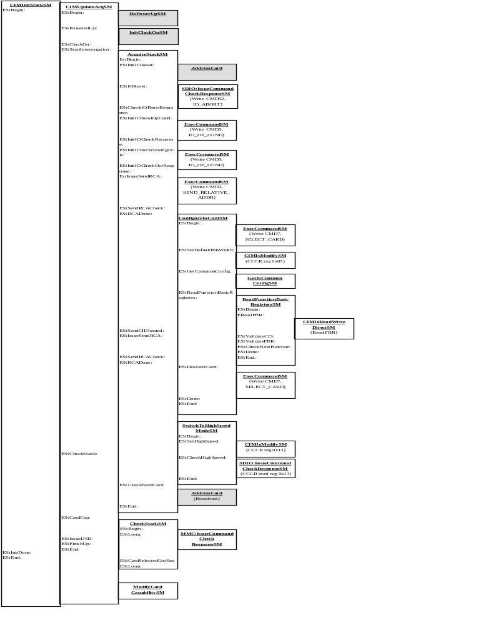

  - Powering up stack containing a single SDIO combo Card

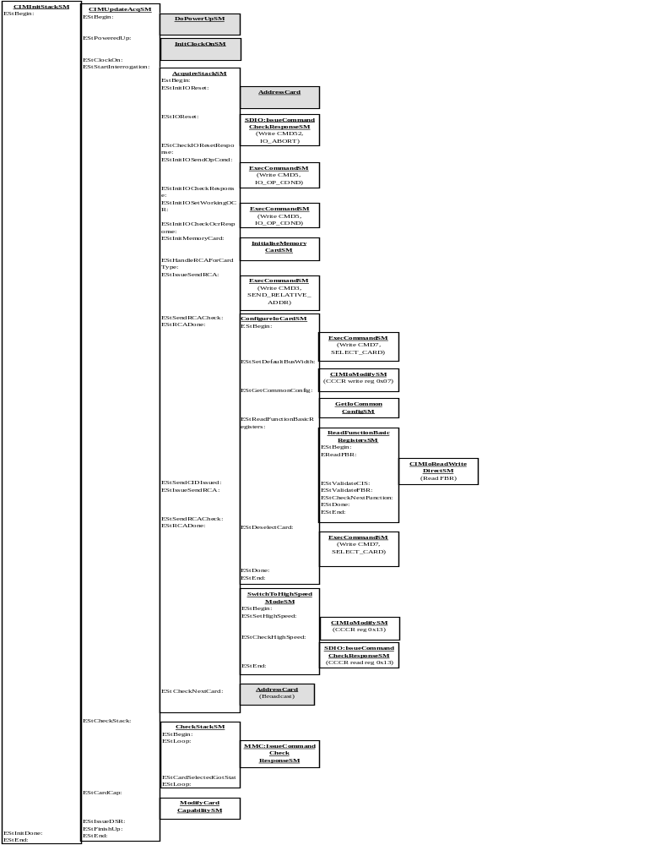
  - Extended read/write (using CMD53)
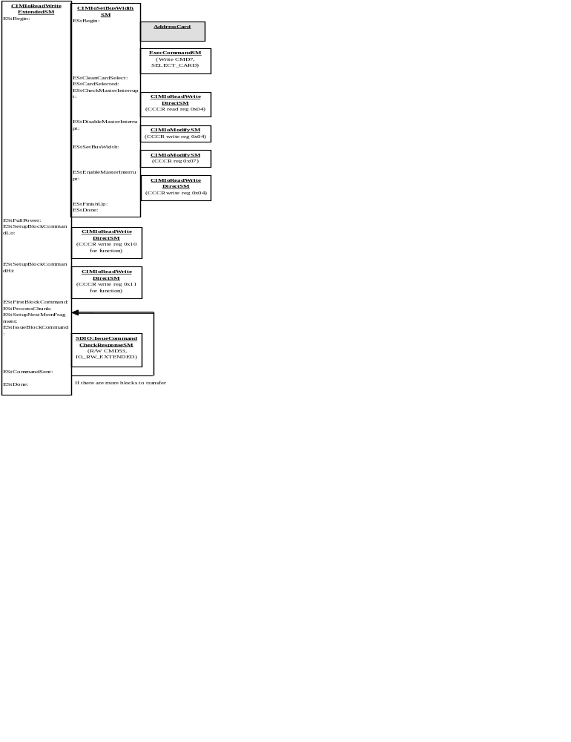

  - State Machine – IssueCommandCheckResponseSM (Send command to PSL)
ExecCommandSM
EStBegin:
EStRetry:
EStAnalyseCommand:
EStIssueCommand:

EStCommandIssued:
EStEnd:

MMC:IssueCommandCheckResponseSM
EStBegin:
EStIssueCommand:

EStCommandIssued:
EStEnd:

IssueMMCCommandSM

SDIO:IssueCommand
CheckResponseSM
EStBegin:
EStRetry:

EStCommandSent:
EStDone:
EStEnd:

  - State Machine – CIMIoReadWriteDirectSM (Read/write using CMD52)
CIMIoReadWrite
DirectSM
EStBegin:
EStSendCommand:

EStCommandSent:
EStDone:
EStEnd:

SDIO:IssueCommand
CheckResponseSM
(IO_RW_DIRECT – CMD52)_

  - State Machine – CIMIoModifySM (Modify a register)
CIMIoModifySM
EStBegin:
EStReadRegister:

EStModifyWriteRegister:

EStDone:
EStEnd:

CIMIoReadWrite
DirectSM
(Read register)

CIMIoReadWrite
DirectSM
(Write register)

  - State Machine – CIMIoFindTupleSM (Find the function’s tuple)
CIMFindTupleSM
EStBegin:
EStReadTupleId:

EStGotTupleId:

EStFoundTuple:
EStDone:
EStEnd:

EstModifyWriteRegister:

EStDone:
EStEnd:
CIMIoReadWrite
DirectSM
(Read Tuple ID)

CIMIoReadWrite
DirectSM
(Read Tuple Length)

  - State Machine – GetIoCommonConfigSM (Read common config)
CIMIoReadWrite
DirectSM
(Read FN0 block size)
CIMIoReadWrite
DirectSM
(Read MAX_TRAN_SPEED)
CIMIoReadWrite
DirectSM
(Read CCCR)
CIMIoReadWrite
DirectSM
(CCCR write reg 0x07)
CIMIoReadWrite
DirectSM
(CCCR write reg 0x08)
GetIoCommon
ConfigSM
EStBegin:

EStGotCommonCisPointer:
EStFindCommonTuple:

EStFoundCommonTuple:

EStGotTupleExtensionType:

EStGotFn0BlockSize:

EStGotMaxTranSpeed:

EStGotIOReadCCCR:

EStIOParseCCCR:
EStSetE4MI:

EStDone:
EStEnd:
CIMFindTupleSM
CIMIoReadWrite
DirectSM
(CCCR read reg 0x09)
CIMIoReadWrite
DirectSM
(Read TPLFE_TYPE)

Platform Specific Layer Function
KEY:
Platform Independent Layer Function
- SDIO card specific state machine functions
The following table contains a brief description of the SD card state machine child functions:-
State Machine Function | Description
AcquireStackSM() | This member function acquires new cards into the SDIO stack. Each card has its own CMD and DAT lines and can be addressed individually by the controller in turn. Note that the initialization of the memory portion of a combo card is supported within this function.  This function performs the following sequence of operations on each of the cards in the stack:  It starts by addressing the next card position in the stack and checking whether there is a card present in this position. If there is it resets the IO card by setting the RES bit in the IO_ABORT register of the CCCR. It then sets the bus width to 1.  The stack then ascertains the capabilities of the card by send the IO_SEND_OP_COND (CMD5) command to the card.  If the R4 response indicates there are no IO functions on the card and that the card contains memory the SD stack’s InitialiseMemoryCardSMST()is called. If there is no memory the card is marked inactive.  For cards which do have an IO function, the required voltage is checked. If the card’s required voltage is not supported, the presence of memory is checked and the SD stack’s InitialiseMemoryCardSMST()is called otherwise the card is marked inactive.  For IO cards, the voltage is now set and the memory portion of a combo card is initialised.  Next it requests that the card publishes a relative card address by issuing the SEND_RCA command (CMD3). Any clashes amongst the RCAs received are resolved.  The memory portion of a combo card is now configured before the IO portion (see ConfigureIoCardSMST below).  Finally the next card in the chain is acquired.  Implemented at the PIL layer.
ConfigureIoCardSM() | This member function configures an SDIO card.  Firstly it selects the specified card, and sets the bus width to 1. The Common Config tuples are now read (see CIMGetIoCommonConfigSMST below). Finally the card’s basic registers are read (see CIMReadFunctionBasicRegistersSMST below) before deselecting the card.  Implemented at the PIL layer.
CIMGetIoCommonConfigSM() | This member function reads the common configuration from the IO portion of the card.  Firstly it finds the Mandatory CIS Tuples. It then extracts the function 0 tuple and reads the MAX_TRAN_SPEED.  It then reads the Card Common Control Registers (CCCR) using the IO_RW_EXTENDED (CMD53) command and parses the response and stored the data in the card’s TSDIOCardConfig (this includes the SDIO revision version and CCCR version).  The LSC and 4BLS bits are read to determine whether low-speed mode or 4-bit bus mode are supported.  If 4-bit bus mode is supported this is now enabled.  Implemented at the PIL layer.
CIMReadFunctionBasicRegistersSMST | This member function interrogates the FBR of the card’s functions.  Firstly it reads the FBR from the card for this function. The CIS is validated and the first FBR tuple is now parsed to store the function’s capabilities. The next function’s FBR is now read until there are no more IO functions.  Implemented at the PIL layer.
CIMIoIssueCommandCheckResponseSMST | This member function will issue a standard command (CMD52 or CMD 53) and check on the response.  The controller sends the relevant (CMD52 or CMD53) command, and then waits for a response from the card. If a CMD53 receives an abort (IO_ABORT) the controller sends a CMD 52 with param of 0x00 to perform an abort.  Implemented at the PIL layer.
CIMIoReadWriteDirectSMST | This member function will write a CMD52 to the card.  Implemented at the PIL layer.
CIMIoReadWriteExtendedSMST | This member function will write a CMD53 to the card.  Firstly the maximum block size is determined for the relevant function, and a bus width of 4 is requested.  Then the ability to use multi-block IO is determined for the function. If the card allows multi-block IO and more than one block transfer is required the length of the data of the total data is set (using CMD52).  Memory is allocated for the transfer of the data. If multi-block IO is supported the block transfers are now performed (using CMD53), otherwise byte transfers are performed (using CMD53). These are repeated until the transfer is complete.  Implemented at the PIL layer.
CIMIoModifySMST | This member function will modify a register on the card.  Firstly it reads the register using CMD52, it then changes the word and writes the register back again using CMD52.  Implemented at the PIL layer.
CIMIoInterruptHandlerSMST | This member function reads the interrupt register from the card and services the interrupts.notifies clients.  Firstly the master interrupt enable bit (MIEN) is set within the CCCR using CIMIoModifySMST above. The PSL layer interrupts are enabled the interrupt register is read and then PSL layer interrupts are disabled. The master interrupt bit (MIEN) is cleared and the interrupt is serviced. This repeats until there are no more interrupts.  Implemented at the PIL layer.
CIMIoFindTupleSMST | This member function will find and read a specific tuple for a card’s function.  Firstly the tuple is read for the first position and if the tuple identifier is not the same as the desired tuple the next tuple is read and checked. When the desired tuple is found the member function completes.  Implemented at the PIL layer.
CIMIoSetBusWidthSMST | This member function sets the bus width for data transfers.  Firstly the appropriate card is selected, and the current bus width is checked against the requested bus width. If the desired bus width is already set, the member function completes.  For MMC cards and locked SD cards the bus width change is not supported and so the member function completes.  For SDIO cards with a requested 4 bit bus, if the card is a low speed card which does not support a 4 bit bus the member function completes.  The master interrupt is disabled.  The CCCR register is now set to the correct bus width using CIMIoModifySMST. For SDIO combo cards and SD cards, the bus width is set using the ACMD6 command.  The master interrupt is enabled.  Implemented at the PIL layer.
CIMReadWriteMemoryBlocksSMST | This member function ensures that the bus width is set to 4 for transfers if the SDIO card has gone to sleep.
SwitchToHighSpeedModeSMST | This member function will attempt to switch the bus speed to 50MHz if the card supports it.  Implemented at the PIL layer.

These state machine calling sequences are detailed further in Appendix A.

