Contents
1 Introduction 2
1.1 Purpose and Scope 2
2 Overview 2
2.1 Hardware Environment 2
2.2 Software Environment 2
2.3 Running the test application 2
3 t_cfileman 2
4 Description 2
4.1 Framework flow diagram 2
5 Testing 3
5.1 API Validation 3
5.2 Test Cases 4
5.3 Test Tags 5
6 Test Results Interpretation 5
7 Further Information 6
7.1 References 6
7.2 Glossary 6
7.3 Document History 6

Introduction

Purpose and Scope
This document outlines how to use the automated CFileMan test framework for testing the CFileMan APIs on supported hardware platforms.
This document can be used as a reference for any engineer who is working on CFileMan for both maintenance and development purpose.
The reader is assumed to have an understanding of the behaviour of the CFileMan APIs but for more general information the reader should refer to the Symbian OS guide.

Overview
CFileMan is a component that offers much more powerful file management services than RFs and RFile APIs as it accepts options with recursion, wildcards in both synchronous mode and asynchronous mode.
More information on CFileMan can be found in Symbian OS Library:
Symbian OS v9.X » Symbian OS reference » C++ component reference » Base F32_EKA2 » CFileMan
This test framework is developed in order to ensure a good level of coverage for CFileMan. The framework is easily maintainable and flexible in order to allow extension should new requirements arise in future.

Hardware Environment
The test environment consists of a PC running Windows connected to the test device (HRP). Currently it has been tested using Windows XP.

Software Environment
The test application t_cfileman is part of the f32tests and is included on any ROM built with type alltests or f32tests

Running the test application
The test application is run by the command
t_cfileman <drive>
Note: If no drive is specified, C drive is considered default.
The source drive is fixed to C and the target drive depends on the user’s input via the command prompt.

t_cfileman

Description
The t_cfileman application consists of the following files:
t_cfileman_cases.h:- Contains the test cases
t_cfileman.cpp:- Contains framework functions
t_cfileman_aux.h:- Contains the declaration for the various data structures
t_cfileman_aux.cpp:- Contains framework support functions
These files are located under …/f32test/cfileman/…

Framework flow diagram
The framework is divided into the following modules:

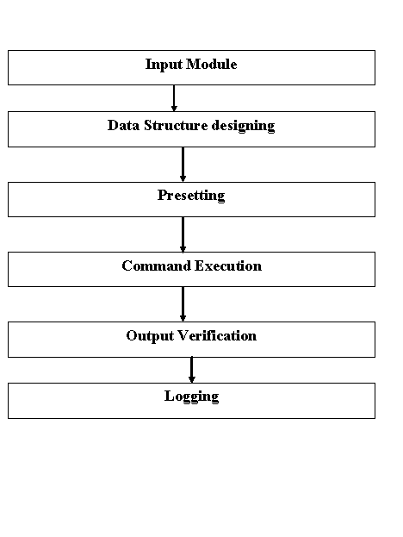
The explanation of the above modules is as follows:
- Input Module: This module includes a header file t_cfileman_cases.h consisting of the test data.
- Data structure designing: This module includes the data structures for the different test parameters depending on the modes, attributes and the kind of APIs (Unitary/Binary).
- Presetting: This module is used to preset the initial source, target and comparing directories before the next execution depending on the information of the next test
- Command Execution: This module includes the actual test execution
- Output Verification: This module is to verify the results. i.e. comparing the actual results with the expected and correct results
- Logging: This module is used to print the notifications of the failed test cases
Note: Refer section 4.1 for better understanding.

Testing
The t_cfileman application carries out an automatic testing by fetching the test data from the t_cfileman_cases.h file. The details of the API tests are not included in this document. Refer [R1]
The APIs tested are:
  - Delete
  - RmDir
  - Move
  - Rename
  - Copy
  - CopyH

API Validation
The concept used to design this framework is to control the entire test validation process. The actual results after command execution is compared with the expected results which is created during the data setup (before the command execution), which means that user can validate a test case by comparing it with the expected behaviour.
The pictorial representation of the API validation is shown below:

Source Directory

Target Directory
Source Compare Directory
(Expected Results)
Target Compare Directory
(Expected Results)
Command Execution

Test Cases
The test cases contain all the information needed for execution and validation.
For example:
{
830, ECFMCopy, 0, KErrNone, KErrNone, KErrNone,
&gFixedDriveValid, (TText*)L"?:\\Src\\FILE2.TXT",
(TText*)L"?:\\Src\\", {ALL, EMPTY},
(TText*)L"?:\\SrcCom\\", {ALL, EMPTY},
&gDriveToTest, (TText*)L"?:\\Trg\\",
(TText*)L"?:\\Trg\\", {EMPTY, EMPTY},
(TText*)L"?:\\TrgCom\\", {{1,EOB}, EMPTY}
}
The parameters in the above test case set-up refers to the following respectively:
- TestCase Id
- API
- Switch
- Synchronous return code
- Asynchronous return code
- Asynchronous status
- Source drive
- Src command to be passed to API
- Source path
- Files to be created in above source path
- Compare path for source after command execution
- Files to be create in the source compare path
- Target drive
- Target command to be parsed to API
- Target path
- Files to be created in the above target path
- Compare path for target after the command execution
- Files to be created in the target compare path.
This set-up has all overall control over the test case behaviour verification

Test Tags
The test data input (t_cfileman_cases.h) file contains the tags for each of the test cases.
The test tag format is as below:
For example:
//! @SYMTestCaseID PBASE-T_CFILEMAN-0830
//! @SYMTestType CIT
//! @SYMTestAPI CFileMan::Copy()
//! @SYMTestCaseDesc 1.Tests API with 'Non-Recursive, Non-Overwrite, EmptyTarget' option
//! Copy a file FILE2.TXT from source to the target.
//! @SYMTestActions Copies the specified files from source to the target.
//! @SYMTestExpectedResults 1.KErrNone in success case
//! @SYMTestPriority High
//! @SYMTestStatus Implemented
This helps in the traceability and also provides the detailed description for each of the test cases.
The documentation tool used to extract the above tags: Doxytesttag_V1.0.15Beta3.zip
Note: The above tool extracts the tags only from a .cpp file. Since this framework has the test cases listed in a header file, a perl script is used to move the tags from the header file into a .cpp file format.
Syntax: perl -S genfile.pl <your filename> <new filename>
The perl script is located at:
…/f32test/cfileman/utility/…
The cpp file thus created is an input to the Doxytesttag tool, which generates a XML file and a support file (testtagXMLtoHTML.xsl) to view the tags in HTML format
The relevant files are located at:
…/f32test/cfileman/documentation/…

Test Results Interpretation
The t_cfileman application is based on RTest framework. Therefore the results can be seen in the epocwind.out file while running tests on emulator and through a hyper-terminal while running on hardware.
When a test has passed the test id is printed such as for example: “Test 900 passed”.
When a test fails, the contents of the actual source, target and their compare folders are printed out which makes it easier to identify the reason of failure, and also prints a statement such as for example: “Test failure: Case 900”.

Further Information

References
 | Document Reference | Version
 | CFileManQuality Enhancement_Test Framework Design | 1.0

Glossary
The following technical terms and abbreviations are used within this document.
Term | Definition
HRP | Hardware Reference Platform

Document History
Date | Version | Status | Description
25-09-2008 | 1.0 | Issued | Document Issued

