1. Introduction 2
1.1 Purpose and Scope 2
2. Overview of Software Impact 2
2.1 Impact of Threading Model 2
2.2 Migration to SMP Safe 3
3. SMP Software Essentials 3
3.1 Overview 3
3.2 Inter-thread signaling 3
3.2.1 Using RSemaphore 3
3.2.2 Using Rendezvous() 4
3.3 Locking shared memory 4
3.3.1 Using RMutex or RFastLock 4
3.3.2 Using RReadWriteLock 5
4. Common Error Patterns In Symbian OS 8
4.1 Overview 8
4.2 Asynchronous IPC 9
4.3 Missing Locks around shared data 9
4.4 Thread Priority Ordering Assumptions 9
4.5 Missing WaitForRequest 10
4.6 Execution speed assumptions 10
4.7 Publish and Subscribe assumptions 11
4.8 Premature recreation of named objects 12
4.9 Strict memory order assumptions 14
4.10 Unofficial IPC mechanisms 14
5. SMPSAFE and Compatibility Modes 15
5.1 SMP Safety 15
5.2 Compatibility Modes 15
5.2.1 Description 15
5.2.2 Enabling compatibility modes 15
6. SMP Analysis, Debugging and Profiling 16
6.1 Overview 16
6.2 The Crazy Scheduler 16
6.2.1 Introduction 16
6.2.2 Modes of operation 16
6.2.3 Effects on code 17
6.3 Profiling Tools 18
6.3.1 Introduction 18
6.3.2 Symbian Analysis Workbench (SAW) 18
6.3.3 PI Profiler and Bappea Analyser 19
7. Further Information 20
7.1 People 20
7.2 References 20
7.3 Document History 21

Introduction

Purpose and Scope
This document is intended to describe the impact of symmetric multiprocessing (SMP) on user-side code developed for Symbian OS and to recommend approaches for mitigating this impact. This material should be useful for migration of existing user-side software to the SMP environment as well as for the development of new software.
It is assumed that the reader is familiar with the fundamental hardware and software concepts of SMP. References are provided for background and further reading.

Overview of Software Impact

Impact of Threading Model
A fundamental impact on software caused by moving from a unicore system to one using SMP is the potential for multiple threads to run concurrently. Threads from a single process may be distributed across multiple CPUs, or clients may run on a different CPU to a server. Such multi-threaded code needs to be examined to ensure that it is safe to run in an SMP environment.
There are several situations where multi-threaded code might be impacted due to single-processor assumptions made at the design stage. Such problems include:
- Asynchronous inter-thread communication – single-threaded code that communicates between, say, client and server is actually multi-threaded.
- Shared memory – shared chunks as well any shared data structures
- Thread-to-thread synchronization – either directly or by relying on each other’s progress
- Timing assumptions – assumptions the code makes about when other things will have completed
Since SMP is a fundamental behavioural change within the OS, it is likely to expose latent bugs within multi-threaded software; anything relying on performance guarantees is likely to break.
It should be noted that existing single-threaded code should be left as-is unless there is an appreciable performance benefit to be gained under SMP through reworking it as multi-threaded. In general, most things which need to be multi-threaded already are.
Section 3 considers APIs essential for correct synchronization and memory sharing in an SMP environment. Section 4 presents some common error patterns and the ways these can be avoided.

Migration to SMP Safe
Once code has been validated as being SMP-safe, the keyword “SMPSAFE” should be added to relevant MMP files. Any code not marked as such is run in what is known as a “compatibility mode”, whereby an attempt is made to protect the code from the effects of the new architecture as far as possible. This is intended to be transitional: it is for applications which cannot be tested because SMP hardware is unavailable or for code which requires substantial reworking in order to be made SMP safe. The available compatibility modes are discussed further in Section 5.

SMP Software Essentials

Overview
As previously mentioned, many applications will remain single threaded under SMP. However, developers who choose to write multi-threaded applications will need to appreciate the synchronization issues that inevitably accompany multi-threading. Ideally, threads carry out independent tasks and are able to proceed independently without needing to access a shared resource. In reality, it is sometimes necessary for a thread to use shared variables or to pause until another thread has reached a certain point.
The overriding concern is to ensure that persistent shared data does not become corrupted. To this end, we must take care with inter-thread signalling using semaphores (usually for data setup, initialization) and shared memory locking using mutexes (to protect persistent shared data). These issues are examined below. We will also consider a new light-weight user-side synchronisation mechanism known as Read/Write locking.

Inter-thread signaling

Using RSemaphore
The standard use-case for inter-thread signaling is to ensure that a thread does not execute a task until a task upon which it depends has been completed by another thread. A general strategy here is to use a shared RSemaphore object. A brief recap of the behaviour of this class is as follows:
- RSemaphore count is given an initial value at construction.
- Signal() increments the semaphore count. If the count is 0 or greater, the highest priority thread waiting on the semaphore is marked ready to run
- Wait() decrements the semaphore count. If the count is negative, the calling thread suspends.
- Separate threads can call Wait() and Signal() independently
The code fragment below illustrates a scenario where there is dependency between two threads.
// Thread 1 // Thread 2
PrepareData(); sem.Wait();
sem.Signal(); DisplayData();
- An RSemaphore object “sem” is created with an initial token value of 0. Both threads are given access to this object.
- Thread 2 reaches its Wait() call first and suspends, since the token count is negative
- Thread 1 performs the task and calls Signal(), incrementing the token count
- Thread 2 resumes and performs the dependent task.
- Alternatively, if the call to Signal() precedes the call to Wait() then thread 2 would not suspend. Either way, we have ensured that the tasks are carried out in the correct order without relying on thread priorities.

Using Rendezvous()
The Rendezvous() method may be used if we require that a parent process/thread knows when a child process/thread is in an initialized state after it has been constructed. This is typically used when a client starts a transient server and needs to wait until the server is ready to receive its requests.
The general usage pattern is as follows:
- Parent process/thread creates child process/thread
- Call Rendezvous(TRequestStatus) on the child object
- Resume the object
- WaitForRequest(TRequestStatus)
- Once initialization is complete, the child object calls Rendezvous(KErrNone) and the parent thread can proceed.
See section 4.7 for a code example illustrating this, along with a potential pitfall in an SMP environment.

Locking shared memory

Using RMutex or RFastLock
Modifiable data that is accessible from more than one thread must be protected by a lock. An initial approach here would be to use RMutex. Its behaviour may be summarized as follows:
- Use case is different to RSemaphore
  - Token count initialized to 1
  - Token count can only be 1 or 0
  - Calls to Wait() and Signal() by a thread must be paired
  - Thread panics if Signal() is called without first calling Wait()
  - Wait() acquires the lock, thread suspends if the lock is already held by another thread
  - Signal() releases the lock, highest priority waiting thread is released.
One way of associating an RMutex with a resource is to encapsulate the mutex in the same object as the resource to be locked. For example:

Class CAccount : public CBase
{
…
private:
CMoney* iBalance;
RMutex iBalanceMutex;
};
Methods that modify the iBalance member, such as Withdraw() and Deposit(), would acquire and release the mutex:
Tint CAccount::Withdraw(TUint aAmt)
{
Tint result;
iBalanceMutex.Wait();
result = iBalance->Withdraw(aAmt);
iBalanceMutex.Signal();
return result;
}
However, with this approach there is nothing to stop one thread from holding on to the lock for a long time frequently. Thus the other thread rarely gets to acquire the lock. If this becomes a problem, message passing using client-server or message queues could be a better approach from a design point of view.
Alternatively, the API described in the next section could be of assistance here.

Using RReadWriteLock

Overview
The RReadWriteLock API has been introduced to provide user-side code with an efficient means of managing shared resources. In brief,
- These locks are shareable between threads in the same process
- There may be any number of concurrent readers
- The user is able to choose writer, alternate, or reader priority

Use cases

Writer priority
Multiple threads try to gain a lock for reading (1, 2). They all succeed until a writer (3) appears. The writer and all subsequent readers/writers (4, 5) are blocked until all the initial readers have released the lock. The writer then gains the lock. When it releases the lock, any other writers (5) gain the lock in the order in which they requested the lock. When all waiting writers have gained and released the lock, all waiting readers gain the lock (4, 6).

Reader 1
Reader 2
Writer 3
Reader 4
Writer 5
Reader 6

This is aimed at clients that need to prioritise writers or want readers to have the most up-to-date information possible

An example might be a multimedia database where multiple threads monitor various methods of writing to the device, e.g. USB, Bluetooth, SD card insertion, and update a central database of multimedia files. The database manager will want to block readers until all updates have been written. This ensures that client apps, such as a music player, present as up-to-date information as possible.
This is the default case and the one most likely to be useful in a multiple-readers scenario.

Alternate priority
Multiple threads try to gain a lock for reading or writing. All readers (1, 2) succeed until a writer (3) appears. The writer and all subsequent readers/writers (4, 5) are blocked until all the initial readers have released the lock. The writer (3) then gains the lock. Any following readers (4) are blocked until the writer releases the lock, etc.

Reader 1
Reader 2
Writer 3
Reader 4
Writer 5
Reader 6

A different case arises if a writer (7) has the lock and the next pending thread is also a writer (8). When the writer (7) releases the lock, it is given in preference to a pending reader (9) instead. In this way a coarse-grained balance is maintained between reading and writing. This is a strictly-alternating priority: only one reader is given the lock at a time when there are still pending writers, in contrast to a many-readers priority.

Writer 7
Writer 8
Reader 9
Reader 10

This is aimed at clients that have multiple writer threads with a roughly even balance of reading and writing.
An example might be a device monitoring application, whereby various threads monitor, e.g., CPU activity, power consumption, network access, etc, and write their values to a central store. Clients may then access the data through proxy threads that read from the store. Neither monitor threads nor reader threads want to be held up unduly, so an alternating approach is taken to give a balanced level of access to all threads.

Reader priority
Multiple threads try to gain a lock for reading or writing. All readers (1, 2) succeed. Any writers (3) are blocked. Subsequent readers (4) also gain the lock while any other reader has it. When all readers have released the lock, the writer (3) then gains it. Readers (6) that ask for the lock while a writer (5) has it are blocked until the writer releases the lock.

Reader 1
Reader 2
Writer 3
Reader 4
Writer 5
Reader 6

This is aimed at clients that need to prioritise reading, minimising the time readers have to wait for the lock.

An example might be a browser cache, whereby no-one can access the contents until they have been downloaded (i.e. written into the cache) but then multiple threads may want to read the data for script parsing, page rendering, form filling, etc.

Great care needs to be taken, however, to ensure that writers are not starved of lock access. Frequent, multiple read accesses can result in a pending writer never gaining the lock. This priority must only be used when writer starvation is known to not be a problem. In the browser example above, it is assumed that the writer has free access to the cache because the application has suspended all readers when a new page is requested. The lock then is in actuality only used as a semaphore, gating the readers until the data is ready, and this operation could be performed almost as easily with an actual semaphore.

API Usage
After instantiation, an RReadWriteLock may be created with one of the three priorities described above:
- TInt r = TheLock.CreateLocal(RReadWriteLock::EWriterPriority);
- TInt ret = TheLock.CreateLocal(RReadWriteLock::EAlternatePriority);
- TInt ret = TheLock.CreateLocal(RReadWriteLock::EReaderPriority);
A thread may then attempt to acquire the lock as a reader or writer as follows:
- TheLock.ReadLock();
- TheLock.WriteLock();
Acquisition of the lock depends on the priority given to it at creation time and on the type of thread currently holding the lock, as described in section 3.3.2.2. A thread will block at a call to Read/WriteLock() until it is able to acquire the lock. However, if non-blocking behaviour is required the following methods may be used:
- TheLock.TryReadLock();
- TheLock.TryWriteLock();
Two further locking methods exist:
- TheLock.TryUpgradeReadLock();
This method tries to atomically release a read lock and gain a write lock. It succeeds if the calling thread is the only reader. Furthermore, there must be no pending writers or the priority must be reader.
- TheLock.DowngradeWriteLock();
This atomically releases a held write lock and gains a read lock. Pending readers are unblocked if the priority is reader or there are no pending writers.
The lock can be released, by readers or writers, simply by calling
- TheLock.Unlock();
Note that this must match a successful call to one of the locking methods described above.

Common Error Patterns In Symbian OS

Overview
Several problem areas have been identified during the SMP development phase which may render code SMP-unsafe. Many of these error patterns are latent problems outside an SMP context but it may have taken an SMP environment to fully reveal them. A common theme to all these error patterns is that they make invalid assumptions about the order of code execution in a multi-threaded system. There are many ways this can manifest itself, categorised here:
- Asynchronous IPC
- Missing locks around shared data
- Thread priority ordering assumptions
- Missing WaitForRequest
- Execution speed assumptions
- Publish & Subscribe (P&S) notification assumptions
- Premature recreation of named objects
- Strict memory ordering assumptions
- Unofficial IPC mechanisms
Each of these will now be considered.

Asynchronous IPC
Asynchronous Inter-Process Communication (IPC) may be used within the client-server framework. Here, the address of a descriptor is passed to the server. Since the call is asynchronous, the call to the server may return before the server has processed the client request. Persistence of the data passed to the server must be carefully managed.
For example, consider the code fragment below:
void REngSession::SendData(TRequestStatus& aStatus)
{
TPckg<TData> dataPkg (iData);
TIpcArgs args(&dataPkg);
SendReceive(ESendData, args, aStatus);
}
Here, a TData object is being wrapped in a package descriptor before being copied to a Symbian OS server. The server will be running in a separate thread to the client (and usually in a separate executable) and will be able to copy the object using RMessage2::ReadL.
At the end of the function the lifetime of the local variables ends and we have no guarantee that the server thread has run by that time. So the client-side data could disappear before the server makes its copy, resulting in invalid data being processed by the server. Therefore, it is essential that data which is to be copied by inter-thread communication is not in local scope. The solution here is to ensure that the package descriptor is on the heap by also making it a member variable of REngSession (e.g. iDataPckg).
This is not a new requirement. However, in some cases the problem may have gone undetected because the server thread, being of a relatively high priority, will read the data before it disappears. In an SMP system, with threads running concurrently, the likelihood of such broken code being exposed is much greater.

Missing Locks around shared data
Modifiable data which is accessible from more than one thread must be protected by a lock, as discussed in some detail in section 3.3

Thread Priority Ordering Assumptions
Code which assumes a higher priority thread will always execute before a lower priority thread will need to be rewritten in order to become SMP safe. In most cases, it is best to think of thread priority as nothing more than a hint to the scheduler. In an environment where multiple processors are being activated and deactivated dynamically it is not safe to make any assumptions concerning which threads will run at a given time.
Consider the case below where a mutex is acquired by two threads with different priorities:
// High priority thread (T1) // Low priority thread (T2)
iMutex.Wait(); iMutex.Wait();
DoFirstThing(); DoSecondThing();
iMutex.Signal(); iMutex.Signal();
Even on a single processor system it is unwise to assume that T1 would acquire the lock before T2. For example, T1 could be suspended because of a page fault. While it is suspended, the scheduler could run T2, causing it to acquire the lock and execute DoSecondThing(), which is not the desired behaviour. In an SMP context both threads could be running concurrently, making it even harder to predict which thread will acquire the lock first.
While a mutex may be used to prevent concurrent access to a shared resource, it cannot be used to force two threads to perform actions in a certain sequence. The solution is to use an RSemaphore initialized with a value of 0, allowing one thread to suspend until another thread signals that it is safe to proceed. We would use this in the above example as follows:
// T1 // T2
DoFirstThing(); iSemaphore.Wait();
iSemaphore.Signal(); DoSecondThing();
Now, T2 waits for explicit notification from T1. We are completely agnostic about the relative thread priorities. Should T2 execute first, the semaphore would be decremented and the thread blocked before executing DoSecondThing(). It can only proceed once T1 has executed DoFirstThing() and signaled the semaphore.

Missing WaitForRequest
This is a common error pattern, where a client thread fails to explicitly wait for a request in a server thread to complete. In many environments defective code like this happens to work because the server thread pre-empts the client thread and services the request before the client thread has time to execute any subsequent code. In an SMP environment, however, the client thread could run concurrently with the server thread.
The code fragment below has been taken from a test found to fail under SMP.
TRequestStatus status;
backupSession->CloseAll(MBackupObserver::EReleaseLockNoAccess, status);
TheTest(status == KErrPermissionDenied); // Test fails here, status == KRequestPending
In an SMP environment, the client thread continues executing and failure occurs at the given line because the server has not yet serviced the request. The client thread should explicitly wait for the request to be completed, as follows:
TRequestStatus status;
backupSession->CloseAll(MBackupObserver::EReleaseLockNoAccess, status);
User::WaitForRequest(status);
TheTest(status == KErrPermissionDenied); // Test passes

Execution speed assumptions
It is unsafe to infer success or failure of code from time taken for it to execute. Test results will show differences under SMP, since a single processor in an SMP environment is likely to perform worse than a uni-processor device due to lower processor speed. A fully representative picture of performance under SMP will only be possible once short term expedients, such as locking all threads belonging to a process to a single CPU, are no longer necessary.

Publish and Subscribe assumptions
If an application hosts two active objects, each of which subscribe to a separate property by calling RProperty::Subscribe(), one might expect that notification would be received first (in the active object’s RunL method) from the property which is published first. However, this is not guaranteed. When a property is set an interrupt will occur, and with SMP an interrupt might be processed on any available processor. So it is possible that a subscriber could receive notification from the property which was set second before the property that was set first.
It could happen that two subscribers to properties P1 and P2 are in separate threads. In this case, if the subscriber to P2 needs to know that the subscriber to P1 has received notification, then explicit synchronization should be added between the threads by using an RSemaphore; the subscriber to P1 would call Signal() and subscriber to P2 would call Wait().
Consider the example below, where a test application checks that another application has initialized using a Publish and Subscribe property.
First, consider this code fragment from the main application (InitialiseLocale):
// initialiselocale.cpp
void CExtendedLocaleManager::ConstructL()
{
TUid LocalePropertyUid;
LocalePropertyUid.iUid = KUidLocalePersistProperties ;
...
//now call RProcess::Rendezvous to indicate initialiseLocale is completed with no error
RProcess().Rendezvous(KErrNone);

// Set property to indicate initialisation complete
User::LeaveIfError(RProperty::Set(LocalePropertyUid, EInitialisationState, ELocaleInitialisationComplete));

// All ready to go! Start the active sheduler.
CActiveScheduler::Start();
}

Now consider this code fragment from the test application (t_initialiselocale):
// t_initialiselocale.cpp
void TestLocaleChanges()
{
RProcess process;
...
TInt r = process.Create(KInitialiseLocaleExeName, KNullDesC);
if(r == KErrNone)
{
TRequestStatus stat;
process.Rendezvous(stat);
process.Resume(); // Start the process going
//wait for the locale initialisation to complete first before testing
User::WaitForRequest(stat);
TEST2((stat.Int()==KErrNone)||(stat.Int()==KErrAlreadyExists),ETrue);
TInt flag;
TUid initLocaleUid=TUid::Uid(KUidLocalePersistProperties);
r=RProperty::Get(initLocaleUid,(TUint)EInitialisationState,flag);
TEST2(r,KErrNone);
//check for the P&S flag that indicates localeinitialisation complete
TEST2(flag,ELocaleInitialisationComplete); //Test failed !
...
The problem manifested itself in an SMP environment because the t_initialiselocale main thread reached the test marked "Test failed" before the setting of this property in the InitialiseLocale main thread was published. Hence the test failed.
The solution was to simply move the setting of the KUidLocalePersistProperties property in InitialiseLocale to before the Rendezvous. It could then be guaranteed that the property would be published by the time t_initialiselocale had rendezvoused with InitialiseLocale.

Premature recreation of named objects
This category of problems relates to the asynchronous cleanup of objects owned by the kernel. On the user-side this involves classes derived from RHandleBase, corresponding to a DObject in the kernel.
These problems take the following form:
1a. An RHandleBase derived object is created user-side.
1b. A corresponding DObject is created kernel-side.
2. Something is done with that object.
3a. All user-side handles to that object are destroyed
3b. Deletion of the corresponding DObject is initiated.
4a. A 2nd RHandleBase derived object with the same name is created user-side.
4b. A 2nd corresponding DObject with the same name is created kernel-side.
The problem is that all DObject names must be unique and 3b is not guaranteed to complete before 4b starts, therefore 4b (and 4a)) may fail with KErrAlreadyExists.
This most commonly manifests itself during thread clean up and so this case warrants more detailed discussion. When a thread either exits or is killed externally, the thread itself runs an exit handler inside the kernel. This runs at a slightly higher priority than normal application threads and does part of the clean up, including completing logons. The last thing the exit handler does is queue a DFC which gets executed by the supervisor thread inside the kernel. This completes the clean up, including freeing the thread stacks and closing the DThread object itself. If no other threads or processes have open handles on the DThread, it will be completely deleted at this point.
On a single processor system, the following code would always work provided the thread running it has a lower priority than the supervisor thread and there are no undertakers in the system (which is true for a lot of test code):
RThread t;
TInt r = t.Create(KName, ...);
assert(r==KErrNone);
TRequestStatus s;
t.Logon(s);
assert(s.Int()==KRequestPending);
t.Resume();
User::WaitForRequest(s);
// read exit information for thread and do something with it
t.Close(); // thread actually disappears here
r = t.Create(KName,...); // recreate with same name
assert(r==KErrNone);
The exit handler and supervisor would both run ahead of the calling thread, so by the time the t.Close() line is executed there would only be one handle remaining on the DThread. If there are undertakers in the system, the supervisor thread exit handler would open a handle on the exiting thread for each undertaker. The thread would not then go away until all those handles were closed and the code above would potentially fail.
On an SMP system the code above would clearly fail, since regardless of thread priorities or undertakers, the supervisor thread could run on a separate CPU from the thread calling Close() and there is no guarantee that on return from Close() the thread would have been destroyed.
A similar issue exists where, instead of recreating the thread with the same name, a kernel heap check is performed to ensure all kernel memory has been cleaned up.
How can we fix this? There are three possibilities:
1. Recreate the thread with a different name.
2. Wait some time before recreating the thread (or performing the heap check). This is almost always a bad idea as there is no way of knowing how long to wait and this may be different on any future system.
3. Wait for the object concerned to be completely destroyed.
In general, option 1 is preferred. For code that is likely to encounter the problem in practice, APIs should be provided to aid with creating objects with a unique name
Using a different name is easy in the above code example but it's not possible when checking for kernel memory leaks (as in a lot of test code). In this case, solution 3 can be employed, with the aid of RHandleBase::NotifyDestruction (in e32cmn.h) and CLOSE_AND_WAIT (in e32test.h). This solution is acceptable in a closed system, where there is control over all handles to the object being recreated but in general there is no way of knowing whether some component has an open handle to a thread (or what component it might be). Any component can open a thread by name and hold the handle forever, jamming the system while it waits for the handle to be closed. So in practice it's usually safer to recreate it with a different name (option 1). For this reason RHandleBase::NotifyDestruction and CLOSE_AND_WAIT are marked as @internalTechnology.

Strict memory order assumptions
Weak memory ordering is a data access optimization which introduces uncertainty over the execution sequence of the code. This will have no observable effect on data which is only accessible from a single thread. On the other hand, it significantly complicates the use of shared data.
Consider the following simple example:
// Thread 1 // Thread 2
b = 0; while (b != 1)
a = 1; ;
b = 1; _ASSERT_DEBUG(a == 1);
Here, thread 2 assumes that the statements in thread 1 execute in the order they appear in the source code. However, it is quite possible that the statements are executed in the following order, causing thread 2 to assert.
b = 0;
b = 1;
a = 1;
The solution here is to use memory barriers to ensure correct ordering. However, it is recommended that existing Symbian mechanisms that provide wrappers for barriers be used here (see next section).

Unofficial IPC mechanisms
In most cases it is easier to use official mechanisms which wrap up the use of barriers, these being:
- Client / Server
- Properties (Publish and Subscribe)
- Message queues
It is recommended that developers wishing to share data between threads in separate processes make use of these mechanisms rather than attempting to use barriers directly. In cases where a non-standard approach appears to be required, take advice from a design authority who has mastered the subtleties of barriers before deciding whether to use them yourself.

SMPSAFE and Compatibility Modes

SMP Safety
A binary’s SMP safety is indicated by a flag in its header. This is set by the postlinker at build time, according to the presence or absence of the SMPSAFE keyword in the MMP file – the default is to assume that the binary is unsafe. Adding the keyword implies that the code has been reviewed and rewritten as necessary to account for any SMP issues, as described above.
In some cases, such as where code requires substantial reworking to provide SMP safety, it may be desirable to run the existing unsafe code on the SMP kernel. This is intended to be useful during initial development and migration phases to provide stability. For this reason, SMP compatibility modes are provided.

Compatibility Modes

Description
Two compatibility modes have been provided:
- Basic compatibility mode
- Enhanced compatibility mode
In the basic mode, the affinity of all threads in unsafe processes is set to CPU 0. This ensures that they cannot be run concurrently, as CPU 0 can only do one thing at a time. Furthermore, it ensures that they are executed in priority order as on a single CPU’s subscheduler.
The enhanced mode is the default. It works by creating a thread group for each unsafe process and placing all threads of that process into the process’s thread group. Within a thread group, only one thread is permitted to run at a time, and priority ordering is always respected. However, the group may still move as a whole from one CPU to another. This gives the same guarantees as regards the scheduling of threads within a process as the basic compatibility mode. However, this is without the performance hit of statically assigning all unsafe code to CPU 0.

Enabling compatibility modes
Both compatibility modes are enabled by kernel configuration flags. There is no way to toggle these flags at runtime – either must be set during ROM building. Note that both modes should not be used simultaneously.
To enable basic compatibility mode for a specific platform, the macro “SMPUNSAFECPU0(on)” should be placed in the baseport’s iby/oby file (kernel.hby needs to be #included to provide the definition of the macro).
To enable enhanced compatibility mode, the macro “SMPUNSAFECOMPAT(on)” should be placed in the baseport’s iby/oby file.
Caveats regarding usage of compatibility modes
The compatibility modes are intended to be used only as a transitional measure to allow unsafe code to continue to run under SMP until this code has been made SMP safe.
Code run in compatibility mode is unable to profit from the advantages offered by SMP, since thread groups are tied to a single core. In this regard, as mentioned previously, the basic compatibility mode has a more adverse effect on performance than the enhanced mode, since threads are all constrained to run on CPU0 without the possibility of migrating to different CPUs.
Furthermore, running code in SMP compatibility mode will not provide the same behaviour as a unicore environment. Issues include:
- A client running on a different CPU to a server. Asynchronous calls may cause problems in this case.
- Shared memory IPC will experience issues unless it uses appropriate synchronization
In short, it is preferable to make code SMP safe rather than use the compatibility modes on a long-term basis.

SMP Analysis, Debugging and Profiling

Overview
It is widely accepted that debugging multithreaded code can be challenging. This section is intended to provide some guidance on techniques and tools that may aid in migrating code to SMP safe status. Analysis may also identify possible code changes to enhance performance under SMP.

The Crazy Scheduler

Introduction
As previously discussed, assumptions regarding thread priorities and their impact on scheduling become an issue in an SMP environment, where multiple threads can execute simultaneously on multiple cores.
The Crazy Scheduler (CS) is a test tool designed to assist in detecting these issues. It runs on single-CPU platforms, including the emulator, and attempts to simulate some of the unexpected things that will occur on an SMP system. This is intended only as a starting point for verification prior to testing code on an SMP hardware platform.

Modes of operation
The CS has 2 modes of operation - Crazy Delays and Crazy Priorities. Both modes will expose potential errors under SMP conditions but they may not find the same problems as each other. The two modes should not be enabled simultaneously as this may cause system deadlocks or livelocks, and will not expose any additional errors. For maximum test coverage, two test runs should be performed, one with each mode.
Crazy Priority mode does not impact system performance as heavily as Crazy Delay mode. For some time-sensitive tests it may be possible to only use Crazy Priority mode (for example test cases that involve talking to external devices that may otherwise time out).
Crazy Priority mode can only be enabled at ROM build time (or boot time, for the emulator); it cannot be toggled at run time. Crazy Delay mode can be enabled/disabled at either run time or ROM build time.

Effects on code

Crazy delays
Once enabled, the Crazy Delay mode introduces delays whenever a thread is woken up from a blocked state. The thread is not allowed to run until the next timer tick (every 1ms on most hardware, 5ms on the emulator). Other threads will continue to run in the meantime.
In addition, threads that die for any reason will sleep briefly before cleaning up resources that they are using and completing any pending logons.
The most obvious effect this has on regular code occurs when a client thread makes an asynchronous request to a server. The client code will simply continue to run, even if the server is a higher priority than the client thread. If the code correctly uses the built-in IPC mechanisms (for example by calling User::WaitForRequest on the request it just issued), then the client thread will be blocked until the server handles the request. No change in behaviour will be observed other than a loss of performance (the small but frequent delays accumulate, slowing the overall system).
However, if the client code assumes the request is already handled by the time the client executes subsequent code (because the server is a higher priority), there will be a failure. The server thread will not have run yet and the request status will still be pending. This may cause a crash or other improper operation.
Other unsafe practices may be detected, not just the failure to wait on asynchronous requests. Here are some examples:
- Passing a stack-based descriptor via IPC. The client thread will keep running, and may overwrite the portion of the stack used for the descriptor before the server accesses it.
- Improper locking between threads. If two threads in the same process wake each other using semaphores or regular asynchronous requests, they will no longer pre-empt each other in strict order of priority, and shared data may be corrupted if the locking logic is wrong.
- Generally, any situation where changing the priorities of the threads involved would cause improper operation.
Such issues and means of mitigating them have been discussed in Section 4.

Crazy Priorities
In Crazy Priority mode, all threads (except the idle thread) are considered to be the same priority. The timeslice is also reduced to one tick (1ms on hardware, 5ms on emulator). As a result, all threads in the system are forced to round-robin with each other. Threads will run for their full timeslice unless they voluntarily give up the CPU.
This will effectively randomise the order of thread execution. Every time a thread wakes, it will be re-added to the rotation in an arbitrary position, and so the sequence of threads will change gradually as the system continues to run.
Kernel threads and device driver threads are included - they will be given the same priority as user threads.
The threads being tested, along with any threads that they may be communicating with, may run in any sequence. Threads that would not normally run due to having a low priority will be given an equal chance to execute. This may change the sequence of events in any situation involving IPC, and so expose bugs with improper use of locking.
Some errors exposed by Crazy Priority mode may also be exposed by Crazy Delay mode; some may not. Therefore it's recommended to perform a test run with each mode if possible.

Caveats regarding usage
The Crazy Delay mode slows the entire system down (although it is still usable). Any testing that is time-critical may fail (for example, tests of performance or real-time functionality). Some failures like this may be considered acceptable but the code should not panic or crash the system.
The Crazy Priority mode has less impact on performance but real-time tasks are likely to run very slowly as they are no longer considered higher priority than non-real-time tasks.
CS only attempts to expose IPC and synchronization issues – comprehensive testing on SMP hardware is the best way to ensure that other possible issues with code have been identified.

Profiling Tools

Introduction
Profiling code from trace data is often a useful means of determining bottle necks within the system, allowing possible performance enhancements to be identified. This type of analysis is especially useful in an SMP environment where we wish to take full advantage of available CPUs. This section considers some of the tools available to aid in profiling Symbian OS software.

Symbian Analysis Workbench (SAW)
The Symbian Analysis Workbench (SAW) is a tool that unifies existing Symbian tracing tools and allows their trace data to be presented in an attractive graphical format within the Carbide IDE.
SAW can present trace data at the thread, function and binary level. This is likely to be useful under SMP in showing threads per CPU and the amount of CPU time taken up by each of the threads. The most processor-intensive functions can also be identified.
Below are some examples of SAW being used to analyse SMP trace data per thread (left) and per function (right).
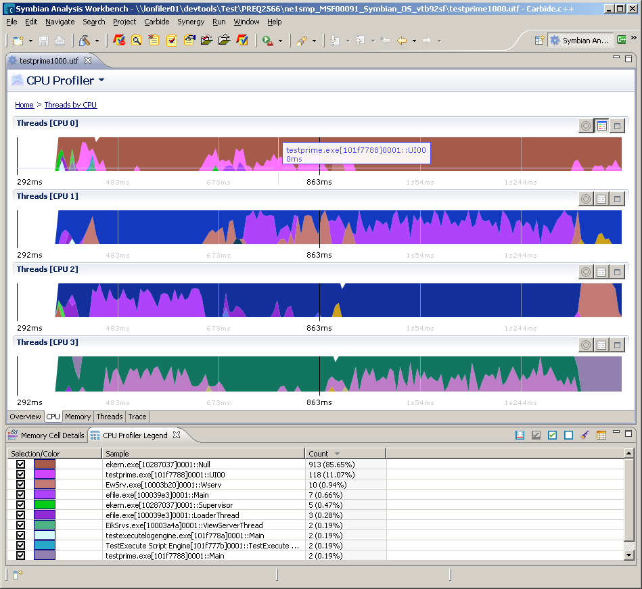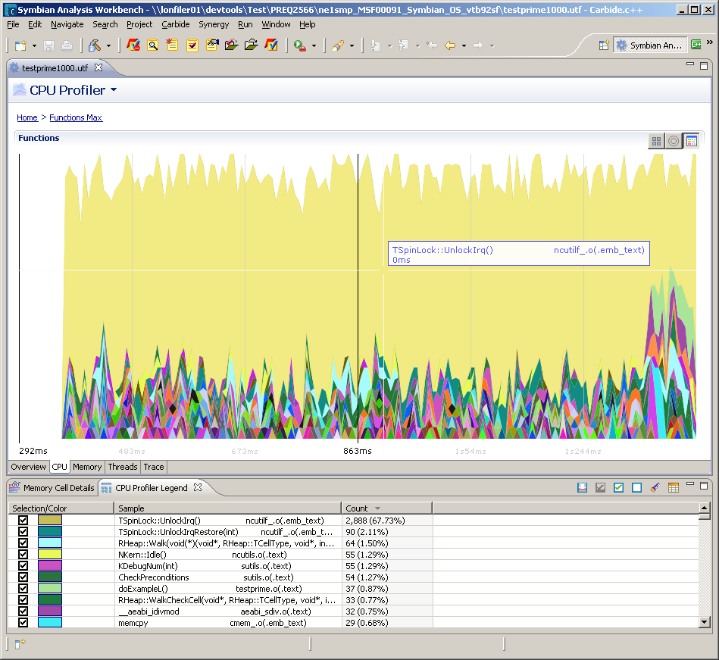
Further information on installation and configuration of SAW may be obtained from the sources listed in the references section.

PI Profiler and Bappea Analyser
Performance Investigator (PI) Profiler is a tool for collecting several performance related measurements from an S60 device, based on sampling at regular intervals. Like SAW, this tool also integrates with the Carbide IDE to provide graphical analysis of collected trace data.
PI Profiler is intended as a replacement for Bappea (Benchmarking of Application Architecture Engine), which performs a similar role.
Below are some examples of Bappea used in an SMP environment to analyse thread distribution per CPU (left) and binary distribution per CPU (right).
Further information on Bappea and PI Profiler may be obtained from the sources listed in the references section.
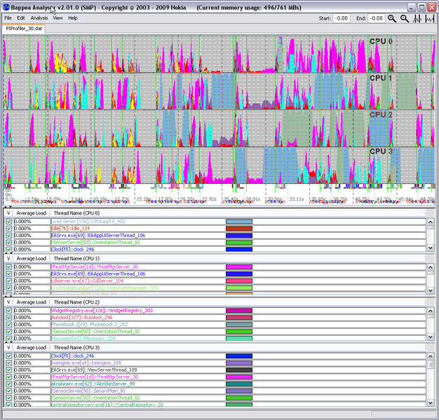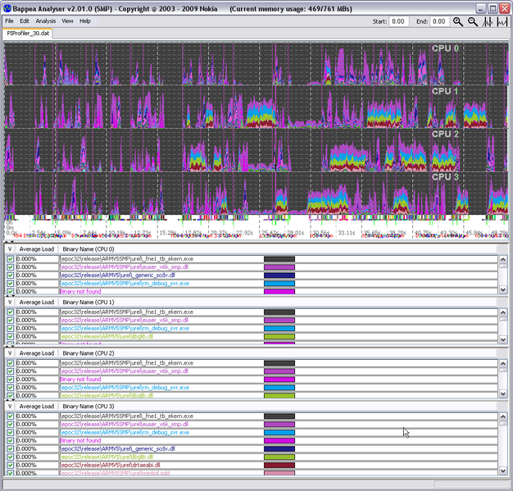

Further Information

Document History
Date | Version | Status | Description
02-07-2009 | 0.1 | Draft | First draft
7-07-2008 | 1.0 | Released | Update to include review comments

