S60 3.x
DRM Audio Player
Design Document

Team name | Author
Telephone | Pekka Nurminen

Change history:

Version | Date | Status | Comments
1.0 | 15.11.2005 | Approved

Table of contents:

1. Document control 5
1.1 Documentation conventions 5
2. General 6
2.1 Introduction 6
2.2 Subsystem environment 6
2.3 Services required 7
2.3.1 From the Symbian OS subsystems 7
2.3.2 From the Domestic OS subsystems 7
2.3.3 From HW 7
2.4 Services provided 7
2.4.1 UI 7
2.4.2 SW IF 7
3. Design 8
3.1 Class diagrams 8
3.1.1 Subsystem 8
3.2 Class descriptions 9
3.2.1 API definitions 10
3.2.1.1 CDrmAudioPlayerUtility 10
3.2.2 MDrmAudioPlayerCallback 19
3.2.2.1 MdapcInitComplete 19
3.2.2.2 MdapcPlayComplete 19
3.2.3 CMMFDrmAudioPlayerUtility 20
3.2.4 RDrmSession 20
3.2.4.1 Send 20
3.2.4.2 Send 20
3.2.4.3 Send 20
3.2.4.4 Send 21
3.2.5 CDrmPlayServerSession 21
3.2.5.1 ServiceL 21
3.2.5.2 DispatchMessageL 21
3.2.5.3 NewFilePlayerL 21
3.2.5.4 NewDesPlayerL 22
3.2.5.5 NewDesPlayerReadOnlyL 22
3.2.5.6 NewPlayerL 22
3.2.5.7 OpenFileL 22
3.2.5.8 OpenFileByHandleL 23
3.2.5.9 OpenFileBySourceL 23
3.2.5.10 OpenDesL 23
3.2.5.11 OpenUrlL 23
3.2.5.12 Play 23
3.2.5.13 Stop 24
3.2.5.14 SetVolume 24
3.2.5.15 SetRepeats 24
3.2.5.16 SetVolumeRamp 24
3.2.5.17 Duration 25
3.2.5.18 MaxVolume 25
3.2.5.19 Pause 25
3.2.5.20 Close 25
3.2.5.21 GetPosition 26
3.2.5.22 SetPosition 26
3.2.5.23 SetPriority 26
3.2.5.24 GetVolume 26
3.2.5.25 GetNumberOfMetaDataEntries 27
3.2.5.26 GetMetaDataEntryL 27
3.2.5.27 SetPlayWindow 27
3.2.5.28 ClearPlayWindow 27
3.2.5.29 SetBalance 28
3.2.5.30 GetBalance 28
3.2.5.31 GetBitRate 28
3.2.5.32 RegisterForAudioLoadingNotification 28
3.2.5.33 GetAudioLoadingProgressL 29
3.2.5.34 ControllerImplementationInformationL 29
3.2.5.35 CustomCommandSync 29
3.2.5.36 CustomCommandAsync 29
3.2.6 CDRMPlayServer 29
3.2.6.1 New 30
3.2.6.2 NewSessionL 30
3.3 Operations 31
3.3.1 Creating an instance 31
3.3.2 Playing a file 32
3.4 Backup and Restore 32
4. Variation 33
5. System resource usage 34
5.1 Files 34
5.2 Other Data 34
5.2.1 Databases 34
5.2.2 Central Repository 34
5.2.3 Publish and Subscribe 34
5.3 Memory consumption 34
5.4 Task allocation 34
5.5 Performance 34
5.6 Timers 34
6. Security 35
6.1 Capabilities of this component 35
6.2 Input and output validation 35
6.3 Environmental assumptions 35
6.4 Additional enforcements 35
7. Exception handling 36
8. Usage 37
8.1 Building 37
8.2 User's guide 37

Document control

Documentation conventions
Code in the text is written in the Courier New font.

General

Introduction
The DRMAudioPlayer module is used by third party applications to play DRM encrypted audio. This module is meant to replace CMdaAudioPlayerUtility for third party applications that are not DRM-trusted when data caging is in effect. When an application uses CMdaAudioPlayerUtility, the audio controller plug-in that provides the file handling and decryption for audio clients resides in the process of the application. Therefore unencrypted data is handled in the application process. This is a violation of the platform security rules in case of a third party application that does not have the DRM capability. DRMAudioPlayer provides the same APIs to the client as are provided by CMdaAudioPlayer, but with a process boundary, which prevents unencrypted data from being handled in the client process.

Subsystem environment
The module is used by a third party application that plays DRM encrypted audio. It introduces a process boundary between DRMPlayUtility and DRMPlayServer. DRMPlayServer uses CMdaAudioPlayerUtility.
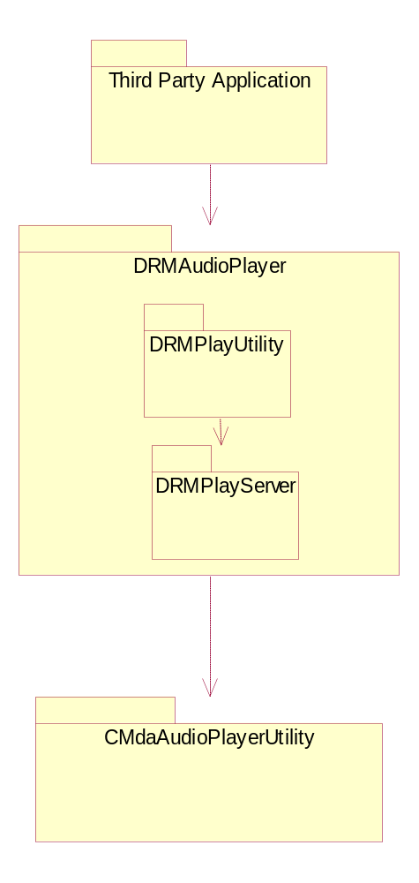
Figure 2.1 Subsystem environment

Services required

From the Symbian OS subsystems
CMdaAudioPlayerUtility and the relevant audio controller plug-in are required.

From the Domestic OS subsystems
The subsystem does not have any direct interfaces to the Domestic OS side subsystems.

From HW
This application has no direct hardware interfaces

Services provided

UI
This module has no UI components.

SW IF
An API providing normal audio playback services is provided.

Design

Class diagrams

Subsystem
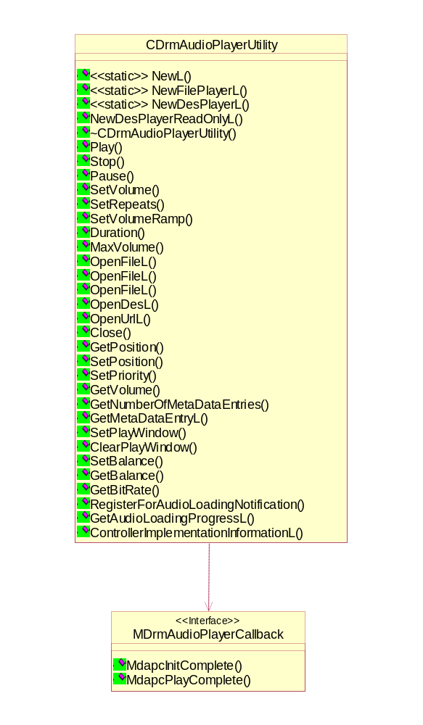
Figure 3.2 External interface of the module
Figure 3.2 shows the class diagram of the classes that are exposed to the client. The client should inherit from MDrmAudioPlayerCallback and create an instance of CDrmAudioPlayerUtility.
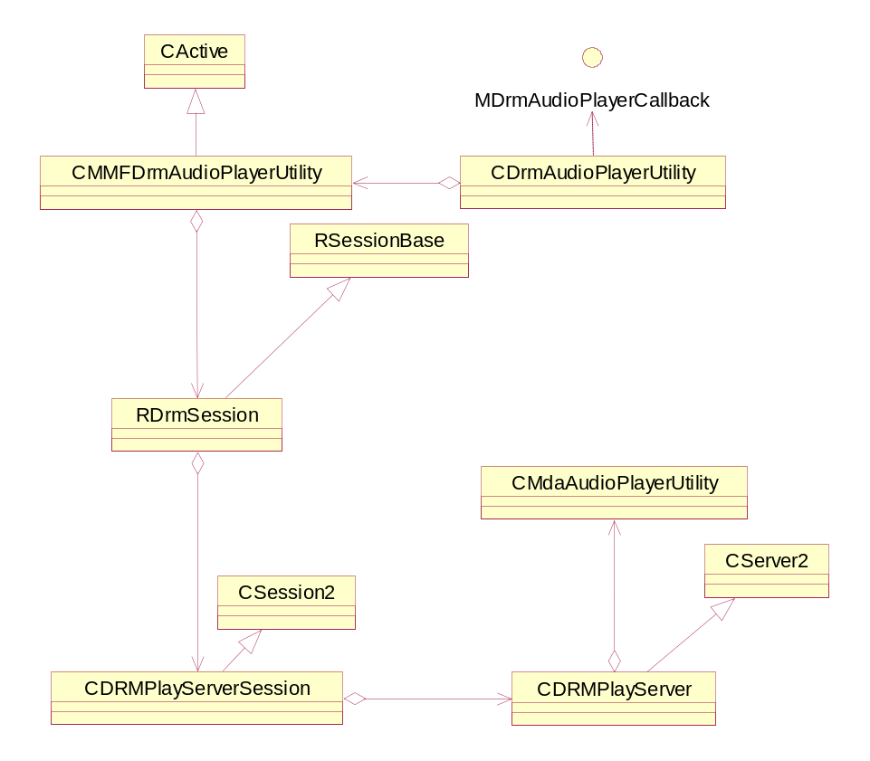
Figure 3.3 Internal class design
Figure 3.3 shows the internal class structure of the module.

Class descriptions
There are two classes visible outside of this module.

Class | Description | Header file
CDrmAudioPlayerUtility | An interface class to the actual DRM Audio Player implementation. | DrmAudioSamplePlayer.h
MDrmAudioPlayerCallback | An abstract class to be implemented by users of DRM Audio Player that want to receive event notifications. | DrmAudioSamplePlayer.h
CMMFDrmAudioPlayerUtility | Implementation of CDrmAudioPlayerUtility. | MmfClientDrmAudioPlayer.h
RDrmSession | Client side session class interface to the server. | MmfDrmSession.h
CDrmPlayServerSession | Server side session class interface to the server. | DrmPlaySession.h
CDrmPlayServer | Server which interfaces to CMdaAudioPlayerUtility. | DrmPlayServer.h

API definitions

CDrmAudioPlayerUtility
The CDrmAudioPlayerUtilty class is the client interface for the DRM Audio Player. This class provides an interface which is identical to the interface provided by CMdaAudioPlayerUtility. This class is to be used by third party applications which need to play DRM encrypted data but do not have DRM capability.

NewFilePlayerL

Declaration: | CDrmAudioPlayerUtility* NewFilePlayerL()
Description: | Creates an instance of the utility and opens the file referenced in the aFilename parameter.
Input param: | - aFileName: Filename of the audio file to open  - aCallback: Client who wishes to receive event notifications.  - aPriority: This client's relative priority. This is a value between -100 and +100 and represents a relative priority. A higher value indicates a more important request.  - aPref: The required behaviour if a higher priority client takes over the sound output device.
Output param:
Return value: | Instance of CDrmAudioPlayerUtility.
Asynchronous: | No.

NewDesPlayerL

Declaration: | CDrmAudioPlayerUtility * NewDesPlayerL()
Description: | Constructs and initializes a new instance of the audio player utility for playing sampled audio data from a descriptor. The audio data must be in a supported format (e.g. WAV and AU).  The function leaves if the audio player utility object cannot be created.  When initialization of the audio player utility is complete, successfully or otherwise, the callback function MDrmAudioPlayerCallback::MapcInitComplete() is called.
Input param: | - aData: A descriptor containing the audio data. This descriptor must remain in existence for the lifetime of this audio player utility object.  - aCallback: The audio player observer interface.  - aPriority: This client's relative priority. This is a value between -100 and +100 and represents a relative priority. A higher value indicates a more important request. The absolute priority at which a client application runs depends on the EPOC platform.  - aPref: The required behavior if a higher priority client takes over the sound output device.
Output param:
Return value: | Instance of CDrmAudioPlayerUtility.
Asynchronous: | No.

NewDesPlayerReadOnlyL

Declaration: | CDrmAudioPlayerUtility * NewDesPlayerReadOnlyL ()
Description: | Constructs and initializes a new instance of the audio player utility for playing sampled audio data from a read only descriptor. The audio data must be in a supported format (e.g. WAV and AU).  The function leaves if the audio player utility object cannot be created.  When initialization of the audio player utility is complete, successfully or otherwise, the callback function MDrmAudioPlayerCallback::MapcInitComplete() is called.
Input param:
Output param:
Return value: | Instance of CDrmAudioPlayerUtility.
Asynchronous: | No.

NewL

Declaration: | CDrmAudioPlayerUtility * NewL()
Description: | Creates an instance of CDrmAudioPlayerUtility.
Input param:
Output param:
Return value: | Instance of CDrmAudioPlayerUtility.
Asynchronous: | No.

Play
Declaration: | void Play()
Description: | Begins playback of the initialized audio sample at the current volume and priority levels.
Input param:
Output param:
Return value:
Asynchronous: | Yes.

Stop

Declaration: | void Stop()
Description: | Stops playback of the audio sample as soon as possible.
Input param:
Output param:
Return value:
Asynchronous: | Yes.

SetVolume

Declaration: | void SetVolume()
Description: | Changes the current playback volume to a specified value.
Input param:
Output param:
Return value:
Asynchronous: | No.

Duration

Declaration: | const TTimeIntervalMicroSeconds& Duration()
Description: | Returns an integer representing the maximum volume that the audio clip can support.
Input param:
Output param:
Return value: | const TTimeIntervalMicroSeconds&.
Asynchronous: | No.

MaxVolume

Declaration: | void MaxVolume()
Description: | Returns an integer representing the maximum volume that the audio clip can support.
Input param:
Output param:
Return value:
Asynchronous: | No.

OpenFileL

Declaration: | void OpenFileL(const TDesC& aFileName);
Description: | Opens an audio clip from a file.
Input param: | aFileName: Filename of the file to be opened.
Output param:
Return value:
Asynchronous: | Yes.

OpenFileL

Declaration: | void OpenFileL(const RFile& aFile)
Description: | Opens an audio clip from a file.
Input param:
Output param: | aFile: Filehandle of the file to open.
Return value:
Asynchronous: | Yes.

OpenFileL

Declaration: | void OpenFileL(const TMMSource& aSource)
Description: | Opens an audio clip from a file.
Input param:
Output param: | aSource: Source of the file to open.
Return value:
Asynchronous: | Yes.

OpenDesL

Declaration: | void OpenDesL(const TDesC8& aDescriptor)
Description: | Opens an audio clip from a descriptor.
Input param: | aDescriptor: The descriptor containing the audio clip.
Output param:
Return value:
Asynchronous: | Yes.

OpenUrlL

Declaration: | void OpenUrlL(const TDesC& aUrl, TInt aIapId = KUseDefaultIap, const TDesC8& aMimeType=KNullDesC8)
Description: | Opens an audio clip from a URL.
Input param: | - aUrl: URL of the audio clip.  - aIapId: Access point ID.  - aMimeType: Mime type.
Output param:
Return value:
Asynchronous: | No.

Pause

Declaration: | TInt Pause
Description: | Pauses playback of the audio clip.
Input param:
Output param:
Return value:
Asynchronous: | No.

Close

Declaration: | void Close
Description: | Closes the current audio clip.
Input param:
Output param:
Return value:
Asynchronous: | No.

GetPosition

Declaration: | TInt GetPosition(TTimeIntervalMicroSeconds& aPosition)
Description: | Returns the current playback position in microseconds from the start of the clip.
Input param:
Output param: | aPosition: Current audio clip position in microseconds from the beginning.
Return value: | Error code.
Asynchronous: | No.

SetPosition

Declaration: | void SetPosition(const TTimeIntervalMicroSeconds& aPosition)
Description: | Returns the current playback position in microseconds from the start of the clip.
Input param: | aPosition: Audio clip position in microseconds from the beginning.
Output param:
Return value:
Asynchronous: | No.

SetPriority

Declaration: | TInt SetPriority(TInt aPriority, TMdaPriorityPreference aPref)
Description: | Set the priority for playback..
Input param: | aPriority: Priority for playback.
Output param:
Return value: | Error code.
Asynchronous: | No.

GetVolume

Declaration: | TInt GetVolume(TInt& aVolume)
Description: | Returns the current playback volume.
Input param: | aVolume: Volume to set.
Output param:
Return value: | Error code.
Asynchronous: | No.

GetNumberOfMetaDataEntries

Declaration: | TInt GetNumberOfMetaDataEntries(TInt& aNumEntries)
Description: | Gets the number of meta data entries in the current audio clip.
Input param:
Output param: | aNumEntries: Number of metadata entries.
Return value:
Asynchronous: | No.

GetMetaDataEntryL

Declaration: | CMMFMetaDataEntry* GetMetaDataEntryL(TInt aMetaDataIndex)
Description: | Gets the metadata entry based on the index passed.
Input param: | aMetaDataIndex: Index of the metadata entry.
Output param:
Return value: | Metadata entry.
Asynchronous: | No.

SetPlayWindow

Declaration: | TInt SetPlayWindow(const TTimeIntervalMicroSeconds& aStart, const TTimeIntervalMicroSeconds& aEnd)
Description: | Defines the size of the current playback window.
Input param: | - aStart : The position defining the start of the window, measured in microseconds. If this value is less than zero, it is set to zero. If this value is greater than aEnd, it is swapped with aEnd.  - AEnd: The position defining the end of the window, measured in microseconds. If this value is greater than the value returned by Duration(), it is set to the value of Duration(). If this value is less than aStart, it is swapped with aStart.
Output param:
Return value: | Error code.
Asynchronous: | No.

ClearPlayWindow

Declaration: | void Cancel()
Description: | Cancels the current request and any started requests.
Input param:
Output param:
Return value:
Asynchronous: | No.

SetBalance

Declaration: | TInt SetBalance(TInt aBalance = KMMFBalanceCenter)
Description: | Sets the current playback balance.
Input param: | aBalance: The balance value to set.
Output param:
Return value: | Error code.
Asynchronous: | No.

GetBalance

Declaration: | TInt GetBalance(TInt& aBalance)
Description: | Returns the current playback balance.
Input param:
Output param: | ABalance: the current playback balance.
Return value: | Error code.
Asynchronous: | No.

GetBitRate

Declaration: | TInt GetBitRate(TUint& aBitRate)
Description: | Returns the current bit rate.
Input param:
Output param: | abitRate: The bit rate.
Return value: | Error code.
Asynchronous: | No.

RegisterForAudioLoadingNotification

Declaration: | Void RegisterForAudioLoadingNotification (MAudioLoadingObserver& aCallback)
Description: | Allows user to register for audio loading callback.
Input param: | aCallback: Observer.
Output param:
Return value:
Asynchronous: | No.

GetAudioLoadingProgressL

Declaration: | void GetAudioLoadingProgressL(TInt& aPercentageProgress)
Description: | Gets the progress of audio loading.
Input param:
Output param: | aPercentageProgress: Upon return, contains the percentage progress.
Return value:
Asynchronous: | No.

ControllerImplementationInformationL

Declaration: | const CMMFControllerImplementationInformation& ControllerImplementationInformationL()
Description: | Returns controller implementation parameters.
Input param:
Output param:
Return value: | Controller implementation parameters.
Asynchronous: | No.

CustomCommandSync

Declaration: | TInt CustomCommandSync(const TMMFMessageDestinationPckg& aDestination, TInt aFunction, const TDesC8& aDataTo1, const TDesC8& aDataTo2, TDes8& aDataFrom)
Description: | Sends a custom command synchronously to the controller plug-in.
Input param: | - aDestination: The destination of the custom command, consisting of the unique ID of the interface of this custom command and a special handle ID MMFObjectHandleController to indicate that the custom command is to be handled by the controller plug-in.  - aFunction: The function number to indicate which function is to be called on the controller's custom command interface.  - aDataTo1: A reference to data to be copied to the controller plug-in. The exact contents of the data are dependent on the custom command interface of the controller. Can be NULL.  - aDataTo2 : A reference to data to be copied to the controller plug-in. The exact contents of the data are dependent on the custom command interface of the controller. Can be NULL.
Output param: | aDataFrom : A reference to an area of memory to which the controller plug-in will write any data to be passed back to the client. Cannot be NULL.
Return value: | Error code.
Asynchronous: | No.

CustomCommandSync

Declaration: | TInt CustomCommandSync(const TMMFMessageDestinationPckg& aDestination, TInt aFunction, const TDesC8& aDataTo1, const TDesC8& aDataTo2)
Description: | Sends a custom command synchronously to the controller plug-in.
Input param: | - aDestination: The destination of the custom command, consisting of the unique ID of the interface of this custom command and a special handle ID MMFObjectHandleController to indicate that the custom command is to be handled by the controller plug-in.  - aFunction: The function number to indicate which function is to be called on the controller's custom command interface.  - aDataTo1: A reference to data to be copied to the controller plug-in. The exact contents of the data are dependent on the custom command interface of the controller. Can be NULL.  - aDataTo2 : A reference to data to be copied to the controller plug-in. The exact contents of the data are dependent on the custom command interface of the controller. Can be NULL.
Output param:
Return value: | Error code.
Asynchronous: | No.

CustomCommandAsync

Declaration: | TInt CustomCommandAsync(const TMMFMessageDestinationPckg& aDestination, TInt aFunction, const TDesC8& aDataTo1, const TDesC8& aDataTo2, TDes8& aDataFrom, TRequestStatus& aStatus)
Description: | Sends a custom command asynchronously to the controller plug-in.
Input param: | - aDestination: The destination of the custom command, consisting of the unique ID of the interface of this custom command and a special handle ID MMFObjectHandleController to indicate that the custom command is to be handled by the controller plug-in.  - aFunction: The function number to indicate which function is to be called on the controller's custom command interface.  - aDataTo1: A reference to data to be copied to the controller plug-in. The exact contents of the data are dependent on the custom command interface of the controller. Can be NULL.  - aDataTo2 : A reference to data to be copied to the controller plug-in. The exact contents of the data are dependent on the custom command interface of the controller. Can be NULL.  - aStatus: Active object request status.
Output param: | aDataFrom : A reference to an area of memory to which the controller plug-in will write any data to be passed back to the client. Cannot be NULL.
Return value: | Error code.
Asynchronous: | No.

CustomCommandAsync

Declaration: | TInt CustomCommandAsync(const TMMFMessageDestinationPckg& aDestination, TInt aFunction, const TDesC8& aDataTo1, const TDesC8& aDataTo2, TRequestStatus& aStatus)
Description: | Sends a custom command asynchronously to the controller plug-in.
Input param: | aDestination: The destination of the custom command, consisting of the unique ID of the interface of this custom command and a special handle ID MMFObjectHandleController to indicate that the custom command is to be handled by the controller plug-in.  aFunction: The function number to indicate which function is to be called on the controller's custom command interface.  aDataTo1: A reference to data to be copied to the controller plug-in. The exact contents of the data are dependent on the custom command interface of the controller. Can be NULL.  aDataTo2 :A reference to data to be copied to the controller plug-in. The exact contents of the data are dependent on the custom command interface of the controller. Can be NULL.  aStatus: Active object request status.
Output param:
Return value: | Error code.
Asynchronous: | No.

MDrmAudioPlayerCallback
An observer class used by clients of CdrmPlayerUtility.

MdapcInitComplete

Declaration: | virtual void MdapcInitComplete(TInt aError, const TTimeIntervalMicroSeconds& aDuration) = 0
Description: | Called by CDrmPlayerUtility when initialization is complete.
Input param:
Output param: | aError: Error code.  aDuration: Length of clip.
Return value:
Asynchronous: | N/A

MdapcPlayComplete

Declaration: | virtual void MdapcPlayComplete(TInt aError) = 0
Description: | Called by CDrmPlayerUtility when playing is complete.
Input param:
Output param: | aError: Error code.
Return value:
Asynchronous: | N/A

CMMFDrmAudioPlayerUtility
The CMMFDrmAudioPlayerUtility class is the implementation of the CDrmAudioPlayerUtility class. Therefore the method descriptions will not be repeated here.

RDrmSession
The RDrmSession class is the client side server session class. It contains methods used for sending messages to the server.

Send

Declaration: | TInt Send(TInt aFunction)
Description: | Sends synchronous message without message arguments.
Input param: | aFunction: Enum value representing the server side function the message is to be sent to.
Output param:
Return value: | Error code.
Asynchronous: | N/A

Send

Declaration: | TInt Send(TInt aFunction,const TIpcArgs& aArgs)
Description: | Sends synchronous message with message arguments.
Input param: | - aFunction: Enum value representing the server side function the message is to be sent to.  - aArgs: IPC arguments.
Output param:
Return value: | Error code.
Asynchronous: | N/A

Send

Declaration: | void Send(TInt aFunction,TRequestStatus& aStatus)
Description: | Sends asynchronous message without message arguments.
Input param: | - aFunction: Enum value representing the server side function the message is to be sent to.  - aStatus: Active Object request status.
Output param:
Return value:
Asynchronous: | N/A

Send

Declaration: | void Send(TInt aFunction,const TIpcArgs& aArgs,TRequestStatus& aStatus)
Description: | Sends asynchronous message with message arguments.
Input param: | aFunction: Enum value representing the server side function the message is to be sent to.  aArgs: IPC arguments  aStatus: Active Object request status.
Output param:
Return value:
Asynchronous: | N/A

CDrmPlayServerSession
The CDrmPlayServerSession class is the server side implementation of the server session.

ServiceL

Declaration: | void ServiceL(const RMessage2 &aMessage)
Description: | Inherited from CSession2. Handles the servicing of a client request that has been passed to the server.
Input param: | aMessage: The message containing the details of the client request.
Output param:
Return value:
Asynchronous:

DispatchMessageL

Declaration: | TInt DispatchMessageL(const RMessage2 &aMessage)
Description: | Dispatches incoming message to the intended function.
Input param: | aMessage: The message containing the details of the client request
Output param:
Return value: | Error message.
Asynchronous:

NewFilePlayerL

Declaration: | void NewFilePlayerL(const RMessage2 aMessage)
Description: | Calls corresponding function in CMdaAudioPlayerUtility.
Input param: | aMessage: The message containing the details of the client request.
Output param:
Return value:
Asynchronous:

NewDesPlayerL

Declaration: | void NewDesPlayerL(const RMessage2 aMessage)
Description: | Calls corresponding function in CMdaAudioPlayerUtility.
Input param: | aMessage: The message containing the details of the client request.
Output param:
Return value:
Asynchronous:

NewDesPlayerReadOnlyL

Declaration: | void NewDesPlayerReadOnlyL(const RMessage2 aMessage)
Description: | Calls corresponding function in CMdaAudioPlayerUtility.
Input param: | aMessage: The message containing the details of the client request.
Output param:
Return value:
Asynchronous:

NewPlayerL

Declaration: | void NewPlayerL(const RMessage2 aMessage)
Description: | Calls corresponding function in CMdaAudioPlayerUtility.
Input param: | aMessage: The message containing the details of the client request.
Output param:
Return value:
Asynchronous:

OpenFileL

Declaration: | void OpenFileL(const RMessage2 &aMessage)
Description: | Calls corresponding function in CMdaAudioPlayerUtility.
Input param: | aMessage: The message containing the details of the client request.
Output param:
Return value:
Asynchronous:

OpenFileByHandleL

Declaration: | void OpenFileByHandleL(const RMessage2 &aMessage)
Description: | Calls corresponding function in CMdaAudioPlayerUtility.
Input param: | aMessage: The message containing the details of the client request.
Output param:
Return value:
Asynchronous:

OpenFileBySourceL

Declaration: | void OpenFileBySourceL(const RMessage2 &aMessage)
Description: | Calls corresponding function in CMdaAudioPlayerUtility.
Input param: | aMessage: The message containing the details of the client request.
Output param:
Return value:
Asynchronous:

OpenDesL

Declaration: | void OpenDesL(const RMessage2 &aMessage)
Description: | Calls corresponding function in CMdaAudioPlayerUtility.
Input param: | aMessage: The message containing the details of the client request
Output param:
Return value:
Asynchronous:

OpenUrlL

Declaration: | void OpenUrlL(const RMessage2 &aMessage)
Description: | Calls corresponding function in CMdaAudioPlayerUtility.
Input param: | aMessage: The message containing the details of the client request.
Output param:
Return value:
Asynchronous:

Play

Declaration: | void Play()
Description: | Calls corresponding function in CMdaAudioPlayerUtility.
Input param:
Output param:
Return value:
Asynchronous:

Stop

Declaration: | void Stop()
Description: | Calls corresponding function in CMdaAudioPlayerUtility.
Input param:
Output param:
Return value:
Asynchronous:

SetVolume

Declaration: | void SetVolume(const RMessage2 &aMessage)
Description: | Calls corresponding function in CMdaAudioPlayerUtility.
Input param: | aMessage: The message containing the details of the client request.
Output param:
Return value:
Asynchronous:

SetRepeats

Declaration: | void SetRepeats(const RMessage2 &aMessage)
Description: | Calls corresponding function in CMdaAudioPlayerUtility.
Input param: | aMessage: The message containing the details of the client request.
Output param:
Return value:
Asynchronous:

SetVolumeRamp

Declaration: | void SetVolumeRamp(const RMessage2 &aMessage)
Description: | Calls corresponding function in CMdaAudioPlayerUtility.
Input param: | aMessage: The message containing the details of the client request
Output param:
Return value:
Asynchronous:

Duration

Declaration: | void Duration(const RMessage2&aMessage)
Description: | Calls corresponding function in CMdaAudioPlayerUtility.
Input param: | aMessage: The message containing the details of the client request.
Output param:
Return value:
Asynchronous:

MaxVolume

Declaration: | TInt MaxVolume()
Description: | Calls corresponding function in CMdaAudioPlayerUtility.
Input param: | aMessage: The message containing the details of the client request.
Output param:
Return value:
Asynchronous:

Pause

Declaration: | TInt Pause()
Description: | Calls corresponding function in CMdaAudioPlayerUtility.
Input param:
Output param:
Return value:
Asynchronous:

Close

Declaration: | void Close()
Description: | Calls corresponding function in CMdaAudioPlayerUtility.
Input param:
Output param:
Return value:
Asynchronous:

GetPosition

Declaration: | TInt GetPosition(const RMessage2 &aMessage)
Description: | Calls corresponding function in CMdaAudioPlayerUtility.
Input param: | aMessage: The message containing the details of the client request.
Output param:
Return value:
Asynchronous:

SetPosition

Declaration: | void SetPosition(const RMessage2 &aMessage)
Description: | Calls corresponding function in CMdaAudioPlayerUtility.
Input param: | aMessage: The message containing the details of the client request.
Output param:
Return value:
Asynchronous:

SetPriority

Declaration: | TInt SetPriority(const RMessage2 &aMessage)
Description: | Calls corresponding function in CMdaAudioPlayerUtility.
Input param: | aMessage: The message containing the details of the client request.
Output param:
Return value:
Asynchronous:

GetVolume

Declaration: | TInt GetVolume(const RMessage2 &aMessage)
Description: | Calls corresponding function in CMdaAudioPlayerUtility.
Input param: | aMessage: The message containing the details of the client request.
Output param:
Return value:
Asynchronous:

GetNumberOfMetaDataEntries

Declaration: | TInt GetNumberOfMetaDataEntries(const RMessage2 &aMessage)
Description: | Calls corresponding function in CMdaAudioPlayerUtility.
Input param: | aMessage: The message containing the details of the client request.
Output param:
Return value:
Asynchronous:

GetMetaDataEntryL

Declaration: | void GetMetaDataEntryL(const RMessage2 &aMessage)
Description: | Calls corresponding function in CMdaAudioPlayerUtility.
Input param: | aMessage: The message containing the details of the client request.
Output param:
Return value:
Asynchronous:

SetPlayWindow

Declaration: | TInt SetPlayWindow(const RMessage2 &aMessage)
Description: | Calls corresponding function in CMdaAudioPlayerUtility.
Input param: | aMessage: The message containing the details of the client request.
Output param:
Return value:
Asynchronous:

ClearPlayWindow

Declaration: | TInt ClearPlayWindow()
Description: | Calls corresponding function in CMdaAudioPlayerUtility.
Input param:
Output param:
Return value:
Asynchronous:

SetBalance

Declaration: | TInt SetBalance(const RMessage2 &aMessage)
Description: | Calls corresponding function in CMdaAudioPlayerUtility.
Input param: | aMessage: The message containing the details of the client request.
Output param:
Return value:
Asynchronous:

GetBalance

Declaration: | TInt GetBalance(const RMessage2 &aMessage)
Description: | Calls corresponding function in CMdaAudioPlayerUtility.
Input param: | aMessage: The message containing the details of the client request.
Output param:
Return value:
Asynchronous:

GetBitRate

Declaration: | TInt GetBitRate(const RMessage2 &aMessage)
Description: | Calls corresponding function in CMdaAudioPlayerUtility.
Input param: | aMessage: The message containing the details of the client request.
Output param:
Return value:
Asynchronous:

RegisterForAudioLoadingNotification

Declaration: | void RegisterForAudioLoadingNotification(const RMessage2 &aMessage)
Description: | Calls corresponding function in CMdaAudioPlayerUtility.
Input param: | aMessage: The message containing the details of the client request.
Output param:
Return value:
Asynchronous:

GetAudioLoadingProgressL

Declaration: | void GetAudioLoadingProgressL(const RMessage2 &aMessage)
Description: | Calls corresponding function in CMdaAudioPlayerUtility.
Input param: | aMessage: The message containing the details of the client request.
Output param:
Return value:
Asynchronous:

ControllerImplementationInformationL

Declaration: | void ControllerImplementationInformationL(const RMessage2 &aMessage)
Description: | Calls corresponding function in CMdaAudioPlayerUtility.
Input param: | aMessage: The message containing the details of the client request.
Output param:
Return value:
Asynchronous:

CustomCommandSync

Declaration: | TInt CustomCommandSync(const RMessage2 &aMessage)
Description: | Calls corresponding function in CMdaAudioPlayerUtility.
Input param: | aMessage: The message containing the details of the client request.
Output param:
Return value:
Asynchronous:

CustomCommandAsync

Declaration: | void CustomCommandAsync(const RMessage2 &aMessage)
Description: | Calls corresponding function in CMdaAudioPlayerUtility.
Input param: | aMessage: The message containing the details of the client request.
Output param:
Return value:
Asynchronous:

CDRMPlayServer
The CDRMPlayServer class is the class that accepts client requests and forwards them to the server-side client session.

New

Declaration: | static CDRMPlayServer* New()
Description: | Creates server.
Input param:
Output param:
Return value: | Server instance.
Asynchronous:

NewSessionL

Declaration: | virtual CSession2* NewSessionL(const TVersion& aVersion,const RMessage2& aMessage) const
Description: | Creates server session.
Input param:
Output param:
Return value: | Server session.
Asynchronous:

Operations

Creating an instance
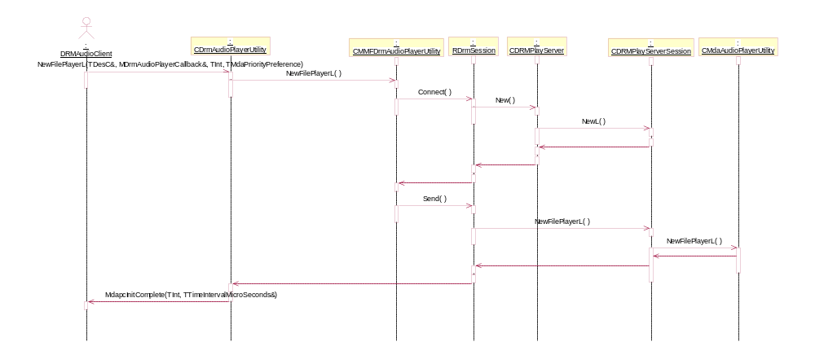
Figure 3.4 Creating an instance
Figure 3.4 shows the sequence diagram of creating an instance of CDrmAudioPlayer, passing in the file name of a file to open. The client calls the appropriate NewXxx() function (NewFilePlayerL in this case) which causes the server to be started and a session is returned to the utility implementation. Then a NewFilePlayer message is sent to the session, and the session creates an instance of the CMdaAudioPlayerUtility using the NewFilePlayerL() call.

Playing a file
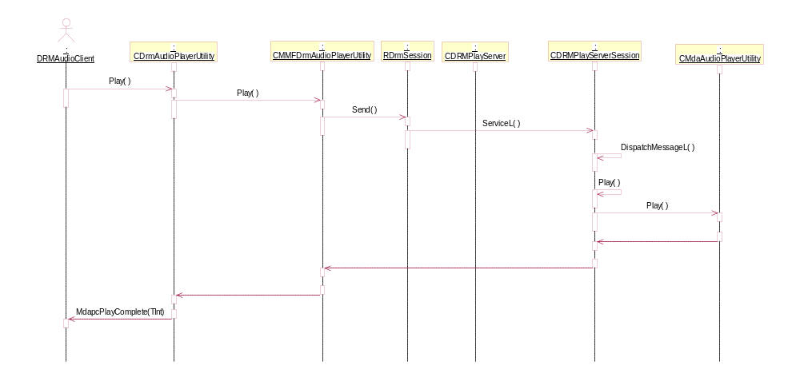
Figure 3.5 Playing an audio clip
Figure 3.5 shows the steps required to play an audio clip. The client calls the Play() method on CDrmAudioPlayUtility. Then the same method is called on the CMMFDrmAudioPlayerUtility (the implementation class). The message is sent across the process boundary to the server-side session, which in turn calls the corresponding method on the CMdaAudioPlayerUtility.
After playing is complete the MdapcPlayComplete() callback is called on the client.
The other methods work using the same mechanism as the two examples above.

Backup and Restore
This component does not deal with databases and is not affected by Backup and Restore.

Variation
Variation is not required for this component.

System resource usage

Files
This component does not use any files.

Other Data

Databases
This component does not use any databases.

Central Repository
This component does not use central repository

Publish and Subscribe
This component does not use publish and subscribe

Memory consumption
The size of DrmAudioPlayUtility.dll is 8 kb.
The size of DRMPlayServer.exe is 7.5 kb

Task allocation
Creating an instance of CDrmPlayerUtility causes the DRM Play Server to be launched.

Performance
This component does not perform processors intense operations.

Timers
This component does not use any timers.

Security
The purpose of this component is to create a process boundary between the manipulation of a DRM unencrypted audio file and the third party client.

Capabilities of this component
This component has capability ALL –TCB. It is assumed that the client of this component will not have DRM capability.

Capability | Justification
ALL –TCB | The server side of this component needs to have full control over DRM unencrypted data.

Input and output validation
This component does not require or make any validation for data.

Environmental assumptions
The assumption is that the client of this component will not have DRM capability.

Additional enforcements
This component does not have any additional security enforcements.

Exception handling
The creation of this utility may leave but can be trapped using the TRAP harness.

Usage

Building
cd \s60\DrmAudioPlayer\group
bldmake bldfiles
abld build

User's guide
Link against DrmAudioPlayUtility.
Create and use DRM Audio Player using the following code example.
class CDrmPlayClient : public CBase,
public MDrmAudioPlayerCallback
{
.
.
.
//from MDrmAudioPlayerCallback
void MdapcInitComplete(TInt aError,
const TTimeIntervalMicroSeconds& aDuration);

void MdapcPlayComplete(TInt aError);
.
.
.
}

Void CDrmPlayClient::ConstructL()
{
iDrmUtility = CDrmAudioPlayerUtility::NewL();
}

void CDrmPlayClient::PlayMethod()
{
iDrmUtility->Play();
}

void CDrmPlayClient:: MdapcInitComplete(TInt aError,
const TTimeIntervalMicroSeconds& aDuration)
{
//handle initialization
}

void CDrmPlayClient:: MdapcPlayComplete(TInt aError)
{
//handle play complete
}

CDrmPlayClient::~CDrmPlayClient
{
delete iDrmUtility;
}

