S60 3.0
Equalizer Utility
Design Document

Team name | Author
S60 Apps MM PD Audio | Jeffery Wang

Change history:

Version | Date | Status | Comments
1.0 | 11.07.2006 | Approved

Table of contents:
1. Document control 4
1.1 References 4
1.2 Documentation conventions 4
1.3 Abbreviations 4
1.4 Definitions 4
2. General 5
2.1 Introduction 5
2.2 Component environment 5
2.3 Use cases 6
2.3.1 Create Preset 6
2.3.2 Modify Preset 6
2.3.3 Delete Preset 7
2.3.4 Reset Preset 7
2.3.5 Apply Preset 7
2.3.6 Get Preset 8
2.3.7 Disable Equalizer 8
2.4 Services required 8
2.4.1 From the Symbian OS subsystems 8
2.4.2 From the Domestic OS subsystems 8
2.4.3 From HW 9
2.5 Services provided 9
2.5.1 UI 9
2.5.2 SW IF 9
3. Design 10
3.1 Class diagrams 10
3.2 Class descriptions 11
3.2.1 Equalizer Utility 12
3.2.2 Flag definitions 18
3.3 Operations 19
3.3.1 CreatePresetL 19
3.3.2 ApplyPresetL 19
3.3.3 ResetPresetL 20
3.3.4 DeletePresetL 21
3.3.5 DisableEqualizerL 22
3.3.6 GetPresetL 22
3.3.7 ModifyPresetL 23
3.3.8 Presets 24
3.3.9 Equalizer 25
3.3.10 BassBoost 25
3.3.11 NumberOfPreDefinedPresets 26
4. Variation 27
5. System resource usage 28
5.1 Memory consumption 28
5.2 Task allocation 28
5.3 Timers 28
6. Security 29
6.1 Capabilities of this component 29
6.2 Input and output validation 29
6.3 Environmental assumptions 29
6.4 Additional enforcements 29
7. Usage 30
7.1 Building 30
7.2 User's guide 30

Document control

References
- ECom Architecture Overview | http://www.symbian.com/
- Multimedia Framework Architectural Description | A Symbian document
- MMF Controller Framework Design Document | A Symbian document
- MMF DevSound API | A Symbian document
- S60 Effects API Specification Document

Documentation conventions
Code is shown with the Courier New font.

Abbreviations
API | Application Program Interface
DLL | Dynamic Link Library
HW | Hardware
ID | Identifier
MMF | Multimedia Framework

Definitions
ECom | Symbian OS Common Object Model. This is a Symbian GT (General Technology) component that allows for the dynamic registry of libraries. The libraries must be built in conformance with the ECom specifications. ECom libraries can be plugged to any framework. MMF relies on ECom for registering and loading the pluggable components. See reference document [1] for details.

General
Audio Equalizer Utility allows applications to create and modify Equalizer settings for the Equalizer audio effect. This can be used by applications to save audio presets for the audio stream. There are also some predefined presets, which can be applied to the audio stream.

Introduction
Equalizer Utility is used by multimedia applications to be able to apply audio Equalizer effects to the audio stream.

Component environment
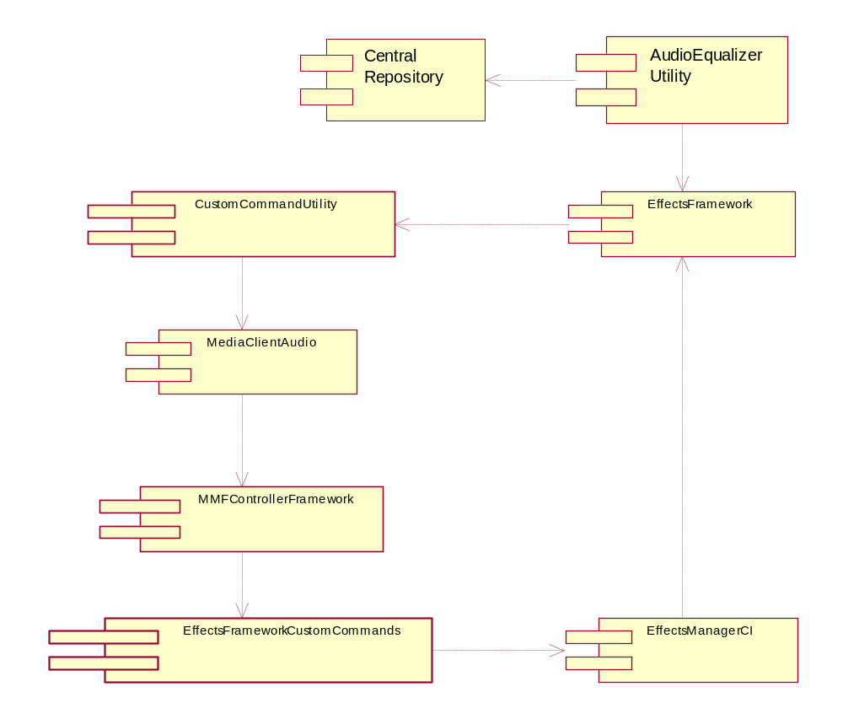
Figure 2.1 Component framework

Use cases
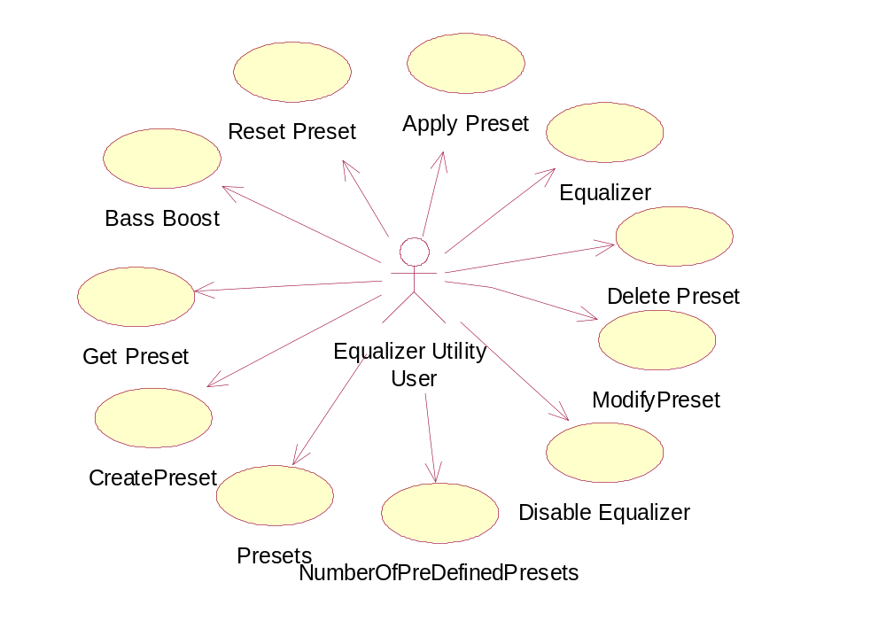
Figure 2.2 Use case diagram

Create Preset
Summary | An application such as Music Player is trying to create audio Equalizer settings and save the preset in Central Repository for future use.
Actor(s) | The application that is trying to create the preset.
Frequency | When the application has the Equalizer settings for the preset that is being created.
Preconditions | There should be an Equalizer object populated with the settings.
Description | When the application tries to create the preset, Equalizer Utility checks whether the preset has a unique name. If not, Equalizer Utility returns KErrAlreadyExists. Otherwise it saves the name and the Equalizer settings in Central Repository.
Exceptions | Deleting the Audio Player Utility object will delete the audio Equalizer Utility and cancel the Create Preset request.
Postconditions
Illustrations

Modify Preset
Summary | An application such as Music Player is trying to modify audio Equalizer settings and save the preset in Central Repository for future use.
Actor(s) | The application that is tying to modify the preset.
Frequency | When the application has the Equalizer settings for the preset that is being modified.
Preconditions | There should be an Equalizer object populated with the settings.
Description | When the application tries to modify the preset, Equalizer Utility checks whether the preset has a unique name. If not, Equalizer Utility returns KErrAlreadyExists. Otherwise, it saves the name and the Equalizer settings in Central Repository.
Exceptions | Deleting the Audio Player Utility object will delete the audio Equalizer Utility and cancel the Modify Preset request.
Postconditions
Illustrations

Delete Preset
Summary | An application such as Music Player is trying to delete audio Equalizer settings and save the changes in Central Repository for future use.
Actor(s) | The application that is trying to delete the preset.
Frequency | When the application has the index of the preset in the array.
Preconditions | There should be an array of the names of the current presets in Central Repository.
Description | When the application tries to delete the preset, Equalizer Utility checks whether the preset is a pre-defined or user-defined preset. If it is a pre-defined preset, Equalizer Utility returns KErrNotSupported. If the preset is a user-defined one, it deletes the preset from Central Repository and updates the utility array.
Exceptions | Deleting the Audio Player Utility object will delete the audio Equalizer Utility and cancel the Delete Preset request.
Postconditions
Illustrations

Reset Preset
Summary | An application such as Music Player is trying to reset audio Equalizer settings and restore the preset from the initialization file to Central Repository for future use.
Actor(s) | The application that is trying to reset the preset.
Frequency | When the application has the index of the preset in the array.
Preconditions | There should be an array of the names of the current presets in Central Repository.
Description | When the application tries to reset the preset, Equalizer Utility checks whether the preset is a pre-defined or user-defined preset. If it is a pre-defined preset, Equalizer Utility resets the preset from the initialization file. If the preset is a user-defined one, it deletes the preset from Central Repository and updates the utility array.
Exceptions | Deleting the Audio Player Utility object will delete the audio Equalizer Utility and cancel the Reset Preset request.
Postconditions
Illustrations

Apply Preset
Summary | An application such as Music Player is trying to apply an audio Equalizer preset to the audio stream.
Actor(s) | The application that is trying to apply the preset.
Frequency | When the application has the index of the preset in the array.
Preconditions | There should be an array of the names of the current presets in Central Repository.
Description | When the application tries to apply the preset, Equalizer Utility reads the Equalizer settings for the given preset and applies the settings to the Equalizer object.
Exceptions | Deleting the Audio Player Utility object will delete the audio Equalizer Utility and cancel the Apply Preset request.
Postconditions
Illustrations

Get Preset
Summary | An application such as Music Player is trying to get the audio Equalizer settings for a particular preset.
Actor(s) | The application that is tying to get a preset equalizer.
Frequency
Preconditions | There should be an Equalizer object in Central Repository.
Description | When trying to get a particular preset for modification, it has to be retrieved from Central Repository and the Equalizer settings have to be stored in the Equalizer object.
Exceptions | Deleting the Audio Player Utility object will delete the audio Equalizer Utility and cancel the Get Preset request.
Postconditions
Illustrations

Disable Equalizer
Summary | An application such as Music Player is trying to disable the audio Equalizer effect for the audio stream.
Actor(s) | The application that is tying to disable the Equalizer effect.
Frequency
Preconditions | There should be a preset, which is enabled.
Description | Sending commands to disable the Equalizer effect. When the function is called and the reverb is already in the Disabled state, it will not do anything.
Exceptions | Deleting the Audio Player Utility object will delete the audio Equalizer Utility and cancel the Disable Equalizer request.
Postconditions
Illustrations

Services required

From the Symbian OS subsystems
Services of the Symbian OS plug-in infrastructure (ECom) are required. In addition, the MMF including the MMF Controller Framework is required.

From the Domestic OS subsystems
This component has no direct interfaces to the Domestic OS side subsystems.

From HW

Services provided

UI
This component is not a UI component.

SW IF
Audio Equalizer Utility provides a way for applications to maintain presets for audio streams. It allows the applications to create new presets or apply existing presets to the audio stream.

Design

Class diagrams
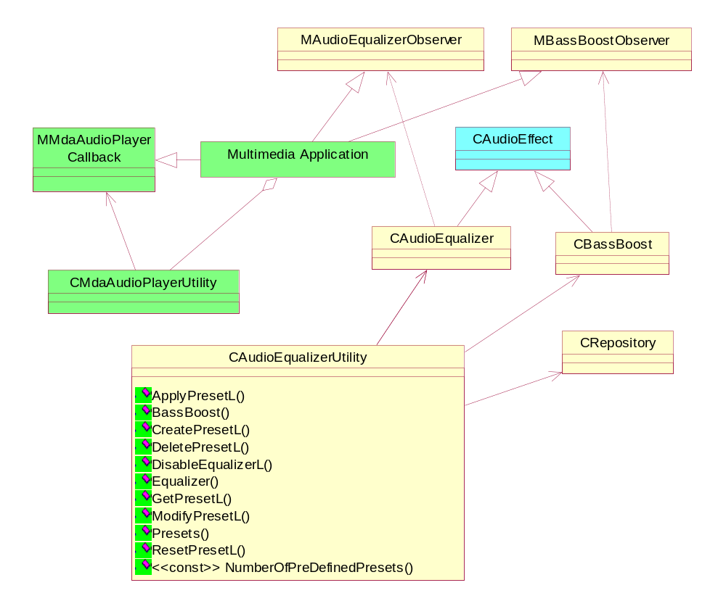
Figure 3.3 Audio Equalizer Utility class diagram

Class descriptions
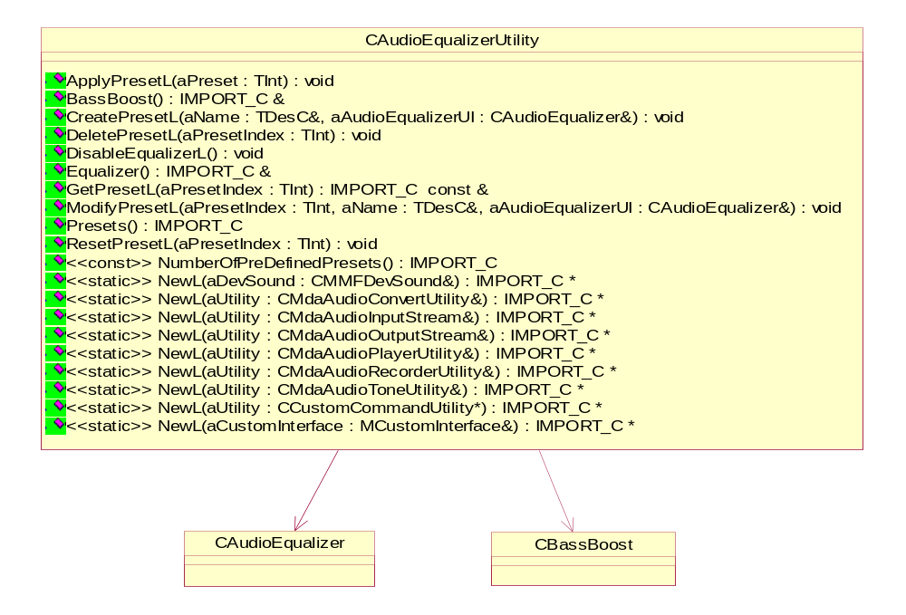
Figure 3.4 Audio Equalizer Utility class description
Class | Description | Header file
CAudioEqualizer  Utility | This is the base call, which creates an Audio Equalizer Utility object to be used by the client. | AudioEqualizerUtility.h
CAudioEqualizer | The Audio Equalizer effect class. Audio Equalizer Utility creates this object with the audio stream. | AudioEqualizerBase.h
CBassBoost | The audio Bass Boost effect class. Audio Equalizer Utility creates this object with the audio stream. | BassBoostBase.h
CentralRepository | The Central Repository class. Equalizer Utility creates Central Repository and initiates the data from the given initialization file. | CentralRepository.h
MAudioEqualizer  Observer | This is the observer for the Equalizer effect. This has to be implemented by the client that creates Equalizer Utility. | MaudioEqualizerObserver.h
MAudioBassBoost  Observer | This is the observer for the Bass Boost effect. This has to be implemented by the client that creates Equalizer Utility. | MaudioBassBoostObserver.h
CTempAudio  Equalizer | This is a Audio Equalizer subclass used for transferring data between the client and Equalizer Utility. | TempAudioEqualizer.h

Equalizer Utility
Equalizer Utility enables the audio client to use preset values stored in Central Repository with the Equalizer effect.
Headers:
AudioEqualizerUtility.h
Library:
AudioEqualizerUtility.dll

NewL – Factory Methods
CAudioEqualizerUtility* NewL(CMMFDevSound& aDevSound);

A static constructor that creates an Audio Equalizer Utility object.
Arguments:
CMMFDevSound& aDevSound: The DevSound associated with this effect.
Returns:
A pointer to CAudioEqualizerUtility.
Error handling:
This method will leave with these typical leave codes:
- KErrNoMemory: Unable to instantiate due to memory errors.
- KErrNotSupported: The effect is not supported.

CAudioEqualizerUtility* NewL(CMdaAudioConvertUtility& aUtility);

A static constructor that creates an Audio Equalizer Utility object.
Arguments:
CMdaAudioConvertUtility& aUtility: The convert utility that is to be associated with this effect.
Returns:
A pointer to CAudioEqualizerUtility.
Error handling:
This method will leave with these typical leave codes:
- KErrNoMemory: Unable to instantiate due to memory errors.
- KErrNotSupported: The effect is not supported.

CAudioEqualizerUtility* NewL(CMdaAudioInputStream& aUtility);

A static constructor that creates an Audio Equalizer Utility object.
Arguments:
CMdaAudioInputStream& aUtility: The input stream utility that is to be associated with this effect.
Returns:
A pointer to CAudioEqualizerUtility.
Error handling:
This method will leave with these typical leave codes:
- KErrNoMemory: Unable to instantiate due to memory errors.
- KErrNotSupported: The effect is not supported.

CAudioEqualizerUtility* NewL(CMdaAudioOutputStream& aUtility);

A static constructor that creates an Audio Equalizer Utility object.
Arguments:
CMdaAudioOutputStream& aUtility: The output stream utility that is to be associated with this effect.
Returns:
A pointer to CAudioEqualizerUtility.
Error handling:
This method will leave with these typical leave codes:
- KErrNoMemory: Unable to instantiate due to memory errors.
- KErrNotSupported: The effect is not supported.

CAudioEqualizerUtility* NewL(CMdaAudioPlayerUtility& aUtility);

A static constructor that creates an Audio Equalizer Utility object.
Arguments:
CMdaAudioPlayerUtility& aUtility: The play utility that is to be associated with this effect.
Returns:
A pointer to CAudioEqualizerUtility.
Error handling:
This method will leave with these typical leave codes:
- KErrNoMemory: Unable to instantiate due to memory errors.
- KErrNotSupported: The effect is not supported.

CAudioEqualizerUtility* NewL(CMdaAudioRecordUtility& aUtility);

A static constructor that creates an Audio Equalizer Utility object.
Arguments:
CMdaAudioRecordUtility& aUtility: The record utility that is to be associated with this effect.
Returns:
A pointer to CAudioEqualizerUtility.
Error handling:
This method will leave with these typical leave codes:
- KErrNoMemory: Unable to instantiate due to memory errors.
- KErrNotSupported: The effect is not supported.

CAudioEqualizerUtility* NewL(CMdaAudioToneUtility& aUtility);

A static constructor that creates an Audio Equalizer Utility object.
Arguments:
CMdaAudioToneUtility& aUtility: The tone utility that is to be associated with this effect.
Returns:
A pointer to CAudioEqualizerUtility.
Error handling:
This method will leave with these typical leave codes:
- KErrNoMemory: Unable to instantiate due to memory errors.
- KErrNotSupported: The effect is not supported.

CAudioEqualizerUtility* NewL(MCustomCommand& aUtility);

A static constructor that creates an Audio Equalizer Utility object.
Arguments:
MCustomCommand& aUtility: A utility that implements the MCustomCoimmand interface that is to be associated with this effect.
Returns:
A pointer to CAudioEqualizerUtility.
Error handling:
This method will leave with these typical leave codes:
- KErrNoMemory: Unable to instantiate due to memory errors.
- KErrNotSupported: The effect is not supported.

CAudioEqualizerUtility* NewL(MCustomInterface& aCustomInterface);

A static constructor that creates an Audio Equalizer Utility object.
Arguments:
MCustomInterface& aCustomInterface: A utility that implements the MCustomInterface interface that is to be associated with this effect.
Returns:
A pointer to CAudioEqualizerUtility.
Error handling:
This method will leave with these typical leave codes:
- KErrNoMemory: Unable to instantiate due to memory errors.
- KErrNotSupported: The effect is not supported.

ApplyPresetL
void ApplyPresetL(TInt aPresetIndex);

Used to apply preset values.
Arguments:
Tnt aPresetIndex: The index of the preset to apply. The index is the index into the array of presets retrieved with the method Presets().
Returns:
None.
Error handling:
This method will leave with these typical leave codes:
- KErrArgument: The argument value is out of range or invalid.

BassBoost
CBassBoost& BassBoost();

Gets the bass boost object.
Arguments:
None.
Returns:
A reference to the bass boost object.

CreatePresetL
void CreatePresetL(TDesC& aName, CAudioEqualizer& aAudioEqualizer);

Creates a user-defined preset with the specified Equalizer settings.
Arguments:
- TDesC& aName: The name of the user-defined preset.
- CAudioEqualizer& aAudioEqualizer: An Equalizer object configured to the values to be used in creating the user-defined preset.

Returns:
An updated list of the presets is returned if the operation is successful.
Error handling:
This method will leave with these typical leave codes:
- KErrArgument: The argument value is out of range or invalid.
- KErrNoMemory: An out of memory error was encountered.

DeletePresetL
void DeletePresetL(TInt aPresetIndex);

Deletes the specified user-defined preset.
Arguments:
TInt aPresetIndex: The index into the preset array retrieved with the method Presets().
Returns:
None.
Error handling:
This method will leave with these typical leave codes:
- KErrArgument: The argument value is out of range or invalid.

DisableEqualizerL
void DisableEqualizerL();

Disables the Equalizer effect.
Arguments:
None.
Returns:
None.

EQualizer
CAudioEqualizer& Equalizer();

Gets the Audio Equalizer object.
Arguments:
None.
Returns:
A reference to the Audio Equalizer object.

GetPresetL
void GetPresetL(TInt aPresetIndex);

Resets the specified preset.
Arguments:
TInt aPresetIndex: The index of the preset to be reset. The index is the index into the array of presets retrieved with the method Presets().
Note: If the preset index points to a preset that cannot be obtained, the method will leave with KErrArgument.
Returns:
None.
Error handling:
This method will leave with these typical leave codes:
- KErrNotFound: The argument value is out of range or invalid.

ModifyPresetL
void ModifyPresetL(TInt aPresetIndex, TDesC& aName, CAudioEqualizer& aAudioEqualizer);

Modifies a user-defined preset with the specified Equalizer settings.
Arguments:
- TInt aPresetIndex: The index into the preset array retrieved with the method Presets().
- TDesC& aName: The name of the preset to be used in modification.
- CAudioEqualizer& aAudioEqualizer: An Equalizer object configured to the values to be used in modifying the preset.

Returns:
None.
Error handling:
This method will leave with these typical leave codes:
- KErrArgument: The argument value is out of range or invalid.
- KErrNoMemory: An out of memory error was encountered.

NumberOfPreDefinedPresets
TUint32 NumberOfPreDefinePresets() const;

Gets the number of pre-defined presets.
Arguments:
None.
Returns:
The number of pre-defined presets.

Presets
TArray< TEfAudioEqualizerUtilityPreset> Presets();

Gets a list of the presets.
Arguments:
None.
Returns:
An array of all the presets (pre-defined and user-defined). The pre-defined presets are in the beginning of the list.

ResetPresetL
void ResetPresetL(TInt aPresetIndex);

Resets the specified preset.
Arguments:
TInt aPresetIndex: The index of the preset to reset. The index is the index into the array of presets retrieved with the method Presets().
Note: If the preset index points to a preset that cannot be reset, the method will leave with KErrArgument.
Returns:
None.
Error handling:
This method will leave with these typical leave codes:
- KErrArgument: The argument value is out of range or invalid.

Flag definitions
Audio Resource is feature that can be included in build using the __AUDIO_RESOURCE_INDICATIONS flag in bldvariant.hrh.

Flag | Description
__AUDIO_RESOURCE_INDICATIONS | If this is set in bldvariant.hrh, then Audio Resource is available. The adaptation layer needs to use the same flag.

Operations

CreatePresetL
Operation | CreatePresetL
Preconditions | Audio Equalizer Utility must be present.
Description | An application such as Music Player is trying to create audio Equalizer settings and save the preset in Central Repository for future use.
Inputs | TDesC& aName, CAudioEqualizer& aAudioEqualizer
Modifies | Creates the preset in Central Repository.
Outputs | The preset in Central Repository.
Postconditions | The preset aName is created in Central Repository.
Related To
Related Event | Happens when the client creates a new preset.
Exceptions

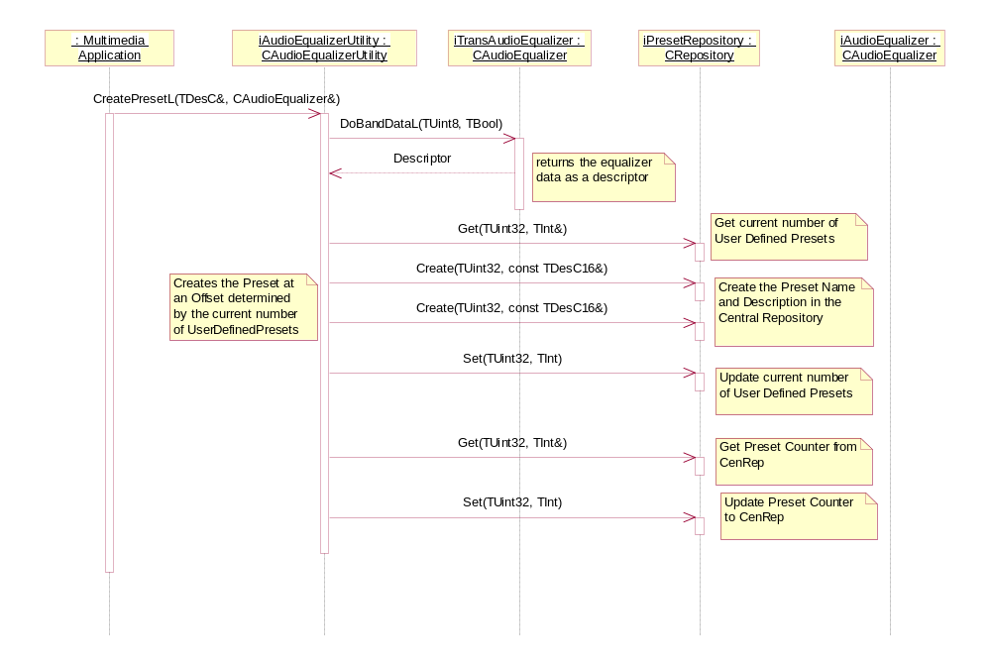
Figure 3.5 CreatePresetL

ApplyPresetL
Operation | ApplyPresetL
Preconditions | Audio Equalizer Utility must be present.
Description | An application such as Music Player is trying to create audio Equalizer settings and save the preset in Central Repository for future use.
Inputs | TInt aPresetIndex
Modifies | Applies a preset to the Equalizer effect.
Outputs
Postconditions | The Equalizer effect is loaded with the preset.
Related To
Related Event | Happens when the client applies a new preset to Equalizer.
Exceptions

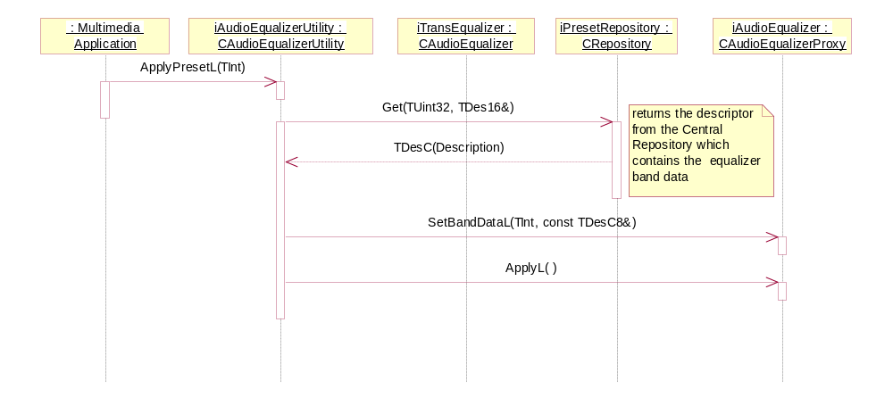
Figure 3.6 ApplyPresetL

ResetPresetL
Operation | ResetPresetL
Preconditions | Audio Equalizer Utility must be present.
Description | An application such as Music Player is trying to reset audio Equalizer settings of Central Repository.
Inputs | TInt aPresetIndex
Modifies | Resets the preset in Central Repository.
Outputs | The preset is restored from the INI file in Central Repository.
Postconditions | The preset is restored in Central Repository.
Related To
Related Event | Happens when the client resets the preset settings.
Exceptions

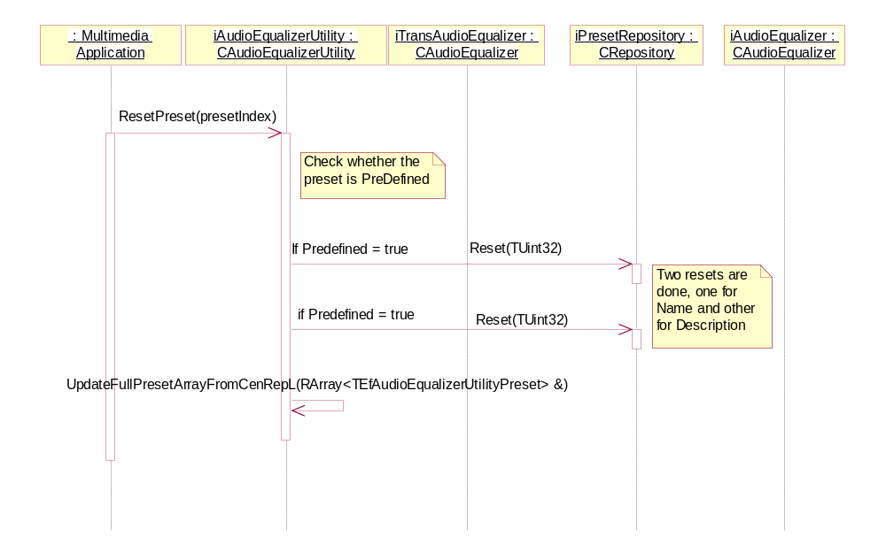
Figure 3.7 ResetPresetL

DeletePresetL
Operation | DeletePresetL
Preconditions | Audio Equalizer Utility must be present.
Description | An application such as Music Player is trying to delete a user-defined audio Equalizer setting from Central Repository.
Inputs | TInt aPresetIndex
Modifies | Deletes the preset from Central Repository.
Outputs | The preset is deleted from the INI file in Central Repository.
Postconditions | The preset is deleted in Central Repository.
Related To
Related Event | Happens when the client deletes the preset settings.
Exceptions

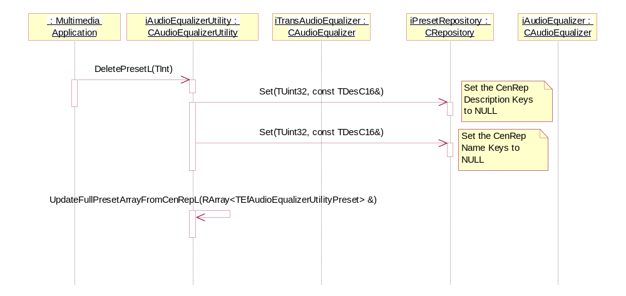
Figure 3.8 DeletePresetL

DisableEqualizerL
Operation | DisableEqualizerL
Preconditions | Audio Equalizer Utility must be present.
Description | An application such as Music Player is trying to disable the Equalizer effect.
Inputs
Modifies | Disables the Equalizer effect.
Outputs | The Equalizer effect is disabled.
Postconditions | The Equalizer effect is disabled.
Related To
Related Event | Happens when the client disables the preset settings.
Exceptions

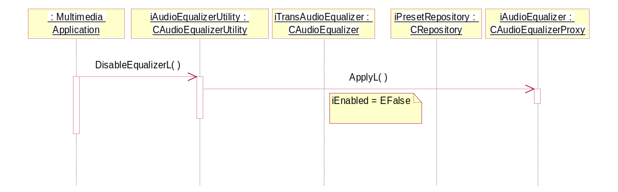
Figure 3.9 DisableEqualizerL

GetPresetL
Operation | GetPresetL
Preconditions | Audio Equalizer Utility must be present.
Description | An application such as Music Player is trying to retrieve audio Equalizer settings from Central Repository.
Inputs | TInt aPresetIndex
Modifies | Retrieves the preset from Central Repository.
Outputs | Returns the name of the given preset to the client.
Postconditions | The preset aName is returned to the client.
Related To
Related Event | Happens when the client retrieves a preset.
Exceptions

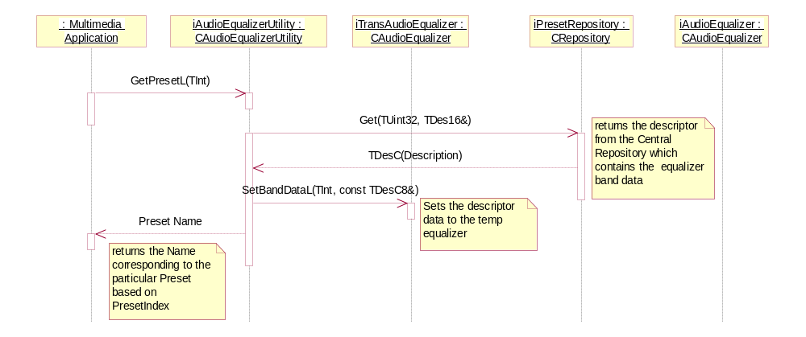
Figure 3.10 GetPresetL

ModifyPresetL
Operation | ModifyPresetL
Preconditions | Audio Equalizer Utility must be present.
Description | An application such as Music Player is trying to modify audio Equalizer settings and save the preset in Central Repository for future use.
Inputs | TInt aPresetIndex, TDesC& aName, CAudioEqualizer& aAudioEqualizer
Modifies | Modifies the preset in Central Repository.
Outputs | The modified preset in Central Repository.
Postconditions | The preset aName is modified in Central Repository.
Related To
Related Event | Happens when the client modifies an existing preset.
Exceptions

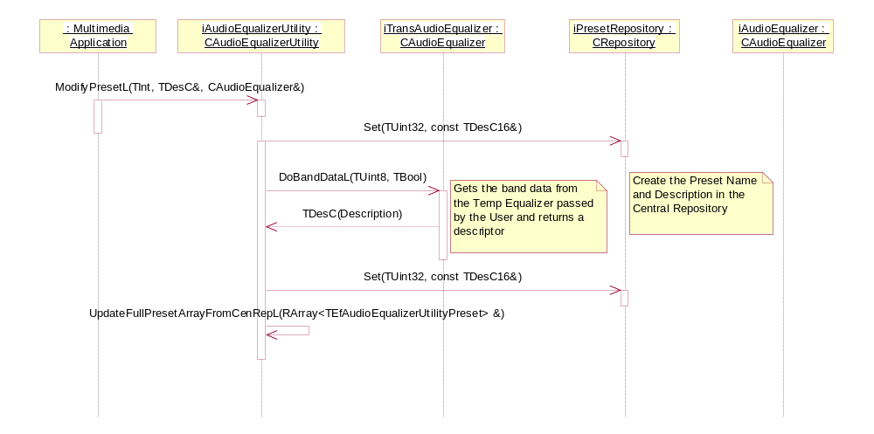
Figure 3.11 ModifyPresetL

Presets
Operation | Presets
Preconditions | Audio Equalizer Utility must be present.
Description | An application such as Music Player is trying to retrieve a list of the presets in Central Repository.
Inputs
Modifies | The preset array returned to the client.
Outputs | A preset array with a list of the presets is returned to the client.
Postconditions
Related To
Related Event | Happens when the client retrieves a list of the presets.
Exceptions

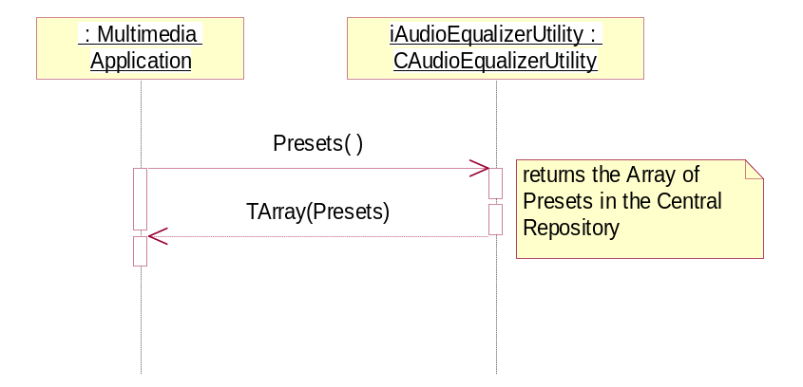
Figure 3.12 Presets

Equalizer
Operation | Equalizer
Preconditions | Audio Equalizer Utility must be present.
Description | An application such as Music Player is trying to retrieve a Equalizer object associated with a preset.
Inputs
Modifies | The Equalizer object returned to the client.
Outputs
Postconditions
Related To | Retrieving a preset from Central Repository.
Related Event
Exceptions

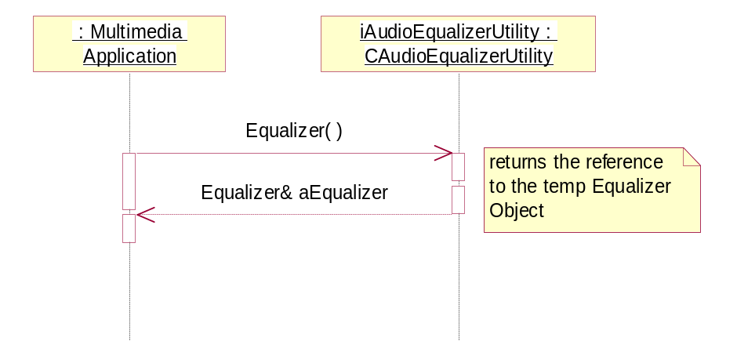
Figure 3.13 Equalizer

BassBoost
Operation | BassBoost
Preconditions | Audio Equalizer Utility must be present.
Description | An application such as Music Player is trying to retrieve a BassBoost object associated with a preset.
Inputs
Modifies | The BassBoost object returned to the client.
Outputs
Postconditions
Related To | Retrieving a preset from Central Repository.
Related Event
Exceptions

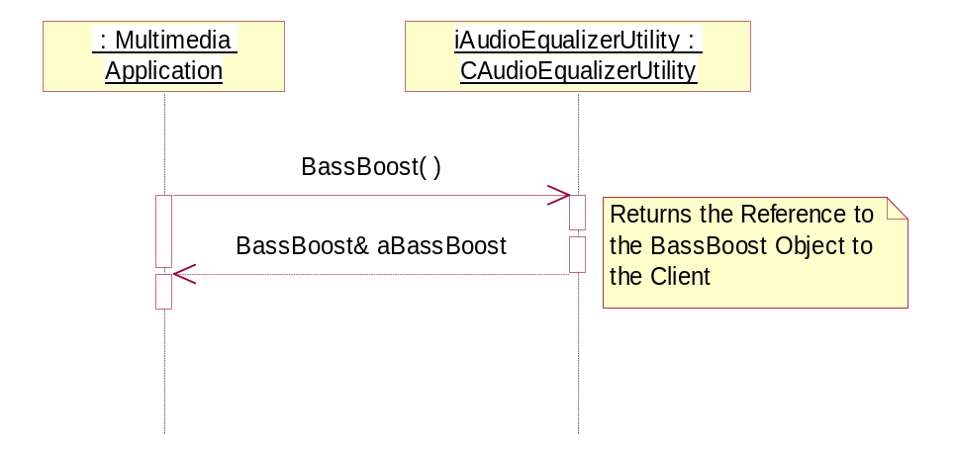
Figure 3.14 BassBoost

NumberOfPreDefinedPresets
Operation | NumberOfPreDefinedPresets
Preconditions | Audio Equalizer Utility must be present.
Description | An application such as Music Player is trying to retrieve the number of pre-defined presets in Central Repository.
Inputs
Modifies
Outputs | The number of pre-defined presets in Central Repository.
Postconditions
Related To
Related Event
Exceptions

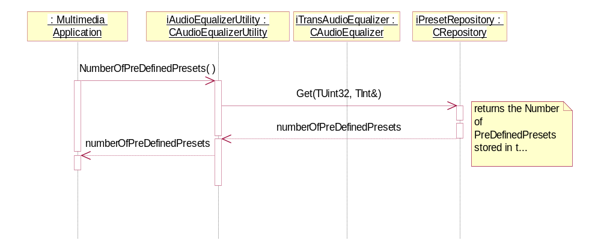
Figure 3.15 NumberOfPreDefinedPresets

Variation
Audio Equalizer Utility uses __AUDIO_EFFECTS_API as feature flag. It is also dependent on the adaptation layer (DevSound) to provide information about the Equalizer effect using a custom interface.

System resource usage
This component does not have any resource files.

Memory consumption
Memory/Build | Consumption
WINSCS URel | 60 Kb
ARMV5 URel | 4 Kb

Task allocation
The Audio Equalizer Utility object is owned by the application that uses it and it runs in its process.

Timers
This component does not use any timers.

Security

Capabilities of this component
Capability | Justification
ReadUserData | This capability is used when reading settings from Central Repository.
WriteUserData | This capability is used when writing settings to Central Repository.

Input and output validation
This component does not require or make any validation for data.

Environmental assumptions
This component does not make any assumptions about its environment.

Additional enforcements
This component does not have any additional security enforcements.

Usage

Building
Equalizer Utility is a part of Audio Enhancements. You can build it from the group folder (\AudioEqualizerUtility\group\) using abld build armv5. This API can only be used if the adaptation layer (DevSound) provides a custom interface.

User's guide
This application is not used by other components.

